PHYTOCHEMICAL PROFILING, PROXIMATE COMPOSITION, AND BIOLOGICAL ACTIVITY SCREENING OF HYDROCOTYLE BONARIENSIS CRUDE EXTRACTS

Abstract
Hydrocotyle bonariensis Lam. (Araliaceae), commonly known as largeleaf pennywort, is widely used in traditional medicine across Africa and South America for the management of inflammatory conditions, infections, and metabolic disorders. Despite these ethnobotanical applications, systematic phytochemical and biological activity data for Nigerian populations of this species remain lacking. This study characterised the qualitative and proximate chemical composition of crude extracts prepared from the leaves and roots of H. bonariensis collected in Zaria, Nigeria, and evaluated these extracts for antimicrobial and cytotoxic activities. Qualitative phytochemical screening revealed the consistent presence of alkaloids, phenolic compounds, tannins, saponins, and flavonoids across polarity-graded solvent extracts (n-hexane, chloroform, ethyl acetate, and methanol). Proximate analysis (AOAC, 2016) indicated that leaves contained higher carbohydrate content (22.03%), while roots contained higher moisture (24.53%), crude protein (15.03%), and crude fibre (18.91%). Agar well diffusion assays demonstrated dose-dependent antimicrobial activity against both Gram-positive and Gram-negative bacteria and fungal strains, with the methanolic root extract yielding the broadest inhibitory spectrum (zones of inhibition: 2–30 mm at 400–700 µg/cm³). The methanol leaf extract recorded the lowest minimum inhibitory concentration (MIC) against Salmonella typhi (<0.12 µg/mL). Brine shrimp lethality testing (BSLT) yielded LC₅₀ values of 20.98–76.35 µg/cm³ for leaf extracts and 65.78–91.27 µg/cm³ for root extracts, all well below the 1000 µg/cm³ cytotoxicity threshold (Meyer et al., 1982). These findings provide scientific support for the ethnomedicinal use of H. bonariensis and justify further bioassay-guided fractionation and structural characterisation of its bioactive constituents.

Keywords: Hydrocotyle bonariensis; phytochemical screening; proximate composition; antimicrobial activity; brine shrimp lethality test; minimum inhibitory concentration

1. Introduction
Natural products derived from higher plants have historically constituted one of the most productive sources for drug discovery. Approximately 60% of approved pharmaceuticals in oncology and anti-infective medicine originate directly from plant-derived compounds or are structurally inspired by them (Atanasov et al., 2021; Newman & Cragg, 2020). In many regions of sub-Saharan Africa and South America, plant-based therapies continue to serve as the primary accessible healthcare modality for a substantial proportion of the population (World Health Organization, 2019). Scientific validation of traditional plant remedies is therefore both medically and economically significant.
Hydrocotyle bonariensis Lam. (family Araliaceae, formerly Apiaceae), commonly referred to as largeleaf pennywort or Brazilian pennywort, is a perennial stoloniferous herb native to coastal South America, with a naturalised distribution extending across tropical and subtropical Africa, including Nigeria (Ajani et al., 2012). Ethnobotanical records from Nigerian communities document the use of H. bonariensis leaf and root decoctions in the management of hypertension, inflammatory skin conditions, wounds, fever, and gastrointestinal infections (Ajani et al., 2012; Mazumdar et al., 2023). In South American traditional medicine, the plant is similarly employed as an anti-inflammatory, diuretic, and vulnerary agent (Hnatyszyn et al., 2004). These overlapping ethnopharmacological applications across geographically separated populations provide a compelling basis for scientific investigation.
Reports on the genus Hydrocotyle suggest the presence of polyacetylenes, terpenoids, triterpenoid saponins, flavonoids, and phenolic acids (Tabopda et al., 2012; Nguyen et al., 2016), several of which exhibit documented anti-inflammatory, antimicrobial, and antioxidant properties (Hnatyszyn et al., 2004; Praveen et al., 2015; Obaseki et al., 2016). However, systematic phytochemical and biological activity data for H. bonariensis remain sparse relative to the more extensively studied H. asiatica (now Centella asiatica), and are essentially absent for specimens sourced from Nigeria. This geographic specificity is pharmacologically relevant, as soil chemistry, rainfall patterns, and ecotypic variation can significantly influence secondary metabolite profiles in medicinal plants (Gobbo-Neto & Lopes, 2007).
The present study was designed to address this gap through three complementary objectives: (i) characterisation of the qualitative phytochemical composition of polarity-graded solvent extracts of H. bonariensis leaves and roots; (ii) determination of the proximate nutritional composition of the methanolic extracts; and (iii) preliminary evaluation of in vitro antimicrobial activity against clinically relevant bacterial and fungal strains and cytotoxic potential using the brine shrimp lethality assay. The data generated are intended to provide a preliminary scientific rationale for the ethnomedicinal applications of this species in northern Nigeria and to identify extract fractions warranting further bioassay-guided isolation.

2. Materials and Methods

2.1 Plant Collection, Authentication, and Voucher Deposition
Leaves and roots of Hydrocotyle bonariensis were collected from their natural habitat in Zaria, Kaduna State, Nigeria (lat. 11.11°N, long. 7.72°E), based on corroborated ethnobotanical evidence of traditional use. Plant identification and authentication were performed by a certified taxonomist at the Department of Botany, Ahmadu Bello University (ABU), Zaria, Nigeria. A voucher specimen was deposited at the ABU Herbarium (voucher number AB301; identification number 8997730) in accordance with established herbarium protocols. Collection was conducted during the early dry season, when secondary metabolite concentrations in the aerial parts of perennial herbs are typically elevated (Gobbo-Neto & Lopes, 2007).

2.2 Sample Preparation
Collected plant materials were washed with distilled water to remove extraneous debris and shade-dried at ambient temperature (approximately 28–32°C) for two weeks until constant weight was attained. Dried material was pulverised to a uniform fine powder using an electric mill and stored in labelled polyethylene bags at room temperature, protected from direct light and moisture, until required for analysis.

2.3 Preparation of Crude Extracts
Cold maceration was employed as the extraction method to minimise thermal degradation of thermolabile constituents. Three hundred grams (300 g) of powdered plant material was macerated in 1000 mL of each solvent in order of increasing polarity: n-hexane, chloroform, ethyl acetate, and methanol. Each maceration was maintained at room temperature for 72 hours with intermittent manual agitation. The mixture was subsequently filtered through Whatman No. 1 filter paper to remove plant residues, and the filtrate was concentrated using a rotary evaporator (Büchi R-300, Switzerland) at 40–80°C under reduced pressure. Concentrated extracts were air-dried to constant weight, and all extracts were stored at 4°C until required.

2.4 Qualitative Phytochemical Screening
Qualitative phytochemical tests were performed on all solvent extracts using standard colorimetric procedures adapted from Ayoola et al. (2008), Ilechukwu et al. (2025), and Alamzeb et al. (2013). The following phytochemical classes were assessed: Alkaloids were detected using Dragendorff's reagent; formation of an orange-red precipitate indicated a positive result. Flavonoids were tested using dilute ammonia followed by concentrated sulphuric acid; yellow colouration indicated a positive result. Tannins were detected with 10% ferric chloride solution; a blue or blue-black colour indicated hydrolysable or condensed tannins, respectively. Saponins were identified by the persistent frothing test, in which 2 g of powdered sample was boiled in 20 mL of distilled water and sustained frothing upon agitation confirmed saponin presence. Terpenoids were tested using the Salkowski reaction (chloroform and concentrated sulphuric acid); reddish-brown colouration at the interface was considered positive. Steroids were assessed by dissolving the extract in glacial acetic acid followed by concentrated sulphuric acid; green colouration indicated a positive result. Cardiac glycosides were detected using the Keller-Kiliani modification; a violet or greenish ring confirmed a positive result. Phenolic compounds were detected with 10% ferric chloride; blue-green or dark-green colouration indicated a positive result. Additional tests were conducted for coumarins, quinones, anthraquinones, and resins using sodium hydroxide, concentrated sulphuric acid, dilute ammonia, and aqueous turbidity, respectively.

2.5 Proximate Composition Analysis
Proximate composition was determined on methanolic extracts of both leaves and roots using standard procedures of the Association of Official Analytical Chemists (AOAC, 2016). Moisture content was determined gravimetrically following oven drying at 105°C to constant weight. Total ash content was determined by combustion in a muffle furnace at 550°C for 6 hours. Crude protein was estimated by the Kjeldahl nitrogen digestion method, using a nitrogen-to-protein conversion factor of 6.25. Crude fat was extracted by continuous Soxhlet extraction with petroleum ether for 16 hours. Crude fibre was determined gravimetrically following sequential acid and alkali hydrolysis. Total carbohydrate content was calculated by difference: Carbohydrate (%) = 100 − (Moisture + Ash + Crude Protein + Crude Fat + Crude Fibre). All measurements were performed in triplicate and results are expressed as percentage on a wet weight basis.

2.6 Antimicrobial Activity Screening
2.6.1 Test Organisms and Culture Conditions
The following clinical isolates and type strains were used: Gram-positive bacteria: Staphylococcus aureus, Streptococcus pneumoniae, Bacillus cereus, and Corynebacterium ulcerans; Gram-negative bacteria: Escherichia coli, Salmonella typhi, and Pseudomonas aeruginosa; and fungi: Aspergillus niger, Trichophyton rubrum, and Candida albicans. Bacterial strains were cultured on nutrient agar and Mueller-Hinton agar (Oxoid, UK); fungal strains were maintained on Sabouraud Dextrose Agar (Oxoid, UK). All cultures were incubated at 37°C. Inocula were standardised to a turbidity equivalent to the 0.5 McFarland standard (approximately 1.5 × 10⁸ CFU/cm³).
2.6.2 Agar Well Diffusion Assay
Antimicrobial activity was assessed by the agar well diffusion method adapted from Egwaikhide et al. (2007) and Garba et al. (2009). Sterile Mueller-Hinton agar plates were uniformly inoculated with 100 µL of standardised inoculum. Wells of 8 mm diameter were bored aseptically using a sterile cork borer. Stock solutions (4000 µg/cm³) were prepared by dissolving 20 mg of each extract in 5 cm³ of the corresponding extraction solvent. Working concentrations of 400, 500, 600, and 700 µg/cm³ were prepared by serial dilution, and 0.5 cm³ of each concentration was dispensed into the wells. Ciprofloxacin (10 µg/disc) served as the positive control; the respective extraction solvent served as the negative control. Plates were incubated at 37°C for 24 hours, and zones of inhibition (ZOI) were measured to the nearest millimetre using a transparent Vernier calliper.
2.6.3 Minimum Inhibitory Concentration (MIC)
MIC values were determined by the broth microdilution agar method (Andrews, 2001; NCCLS, 2002). Two-fold serial dilutions of each extract were prepared in sterile Mueller-Hinton broth to yield concentrations ranging from 160 to 1.25 mg/cm³ across nine tubes. One hundred microlitres (100 µL) of each dilution were dispensed into wells of resolidified Mueller-Hinton agar plates seeded with standardised inoculum (1.5 × 10⁸ CFU/cm³). Plates were incubated at 37°C for 24 hours. The MIC was defined as the lowest extract concentration producing a clearly discernible zone of inhibition in the absence of visible growth. Ciprofloxacin was used as the reference antibiotic.

2.7 Brine Shrimp Lethality Test (BSLT)
Cytotoxic potential was assessed by the BSLT according to the method of Meyer et al. (1982). Artemia salina (brine shrimp) eggs (70 g) were placed in artificial seawater and incubated under illumination at 25°C for 48 hours to allow hatching and naupliar development. Extract solutions were prepared at three concentrations of 1000, 100, and 10 µg/mL by dissolving 0.2 g of each extract residue in 2 mL of distilled water containing two drops of dimethyl sulfoxide (DMSO) as co-solvent. Ten nauplii (48 hours old) were introduced into each test vial, and surviving nauplii were counted after 24 hours under a light microscope. Each concentration was tested in triplicate, and a solvent control (distilled water plus DMSO) was included. LC₅₀ values were calculated by Finney probit analysis using SPSS v25 software. According to Meyer et al. (1982), LC₅₀ values below 1000 µg/mL indicate biologically significant cytotoxic activity.

2.8 Statistical Analysis
All experimental determinations were performed in triplicate and results are reported as mean ± standard deviation (SD). Data were analysed by one-way analysis of variance (ANOVA) using GraphPad Prism v9 (GraphPad Software, USA). Pairwise comparisons were conducted using Tukey's post-hoc test. Statistical significance was established at p < 0.05.

3. Results and Discussion

3.1 Qualitative Phytochemical Screening
Tables 1a and 1b present the qualitative phytochemical profiles of H. bonariensis leaf and root extracts, respectively. Both plant parts consistently yielded alkaloids, phenolic compounds, tannins, saponins, and flavonoids across multiple solvent fractions, with the methanol and chloroform extracts showing the broadest phytochemical representation. Figure 1 provides a simplified comparative overview of the distribution of key phytochemical classes across the principal extract fractions.

Table 1a. Qualitative phytochemical screening of Hydrocotyle bonariensis leaf crude extracts.
Phytochemical | Chloroform | Ethyl Acetate | Methanol
Alkaloids | + | + | +
Terpenoids | + | − | +
Triterpenes | − | − | −
Cardiac glycosides | − | + | −
Saponins | + | − | +
Phenolic compounds | + | + | +
Flavonoids | + | − | +
Steroids | − | − | −
Tannins | + | + | +
Quinones | − | − | −
Anthraquinones | − | − | −
Coumarins | − | − | −
Resins | + | − | +
Carbohydrates | − | − | −
Amino acids | − | − | −
Key: + = present; − = absent.
Table 1b. Qualitative phytochemical screening of Hydrocotyle bonariensis root crude extracts.
Phytochemical | n-Hexane | Ethyl Acetate | Methanol
Alkaloids | + | + | +
Terpenoids | + | + | +
Triterpenes | − | − | −
Cardiac glycosides | − | − | −
Saponins | + | + | +
Phenolic compounds | + | + | +
Flavonoids | + | + | +
Steroids | − | − | −
Tannins | + | + | +
Quinones | − | − | −
Anthraquinones | − | − | +
Coumarins | − | − | −
Resins | + | + | +
Carbohydrates | − | − | +
Amino acids | − | − | −
Key: + = present; − = absent.
Figure 1. Simplified comparative matrix showing the distribution of key phytochemical classes in H. bonariensis leaf and root crude extracts across solvents of increasing polarity. Shaded cells indicate presence (+); unshaded cells indicate absence (−). Leaf extracts: chloroform (CCl₃), ethyl acetate (EtOAc), methanol (MeOH). Root extracts: n-hexane (Hex), EtOAc, MeOH.
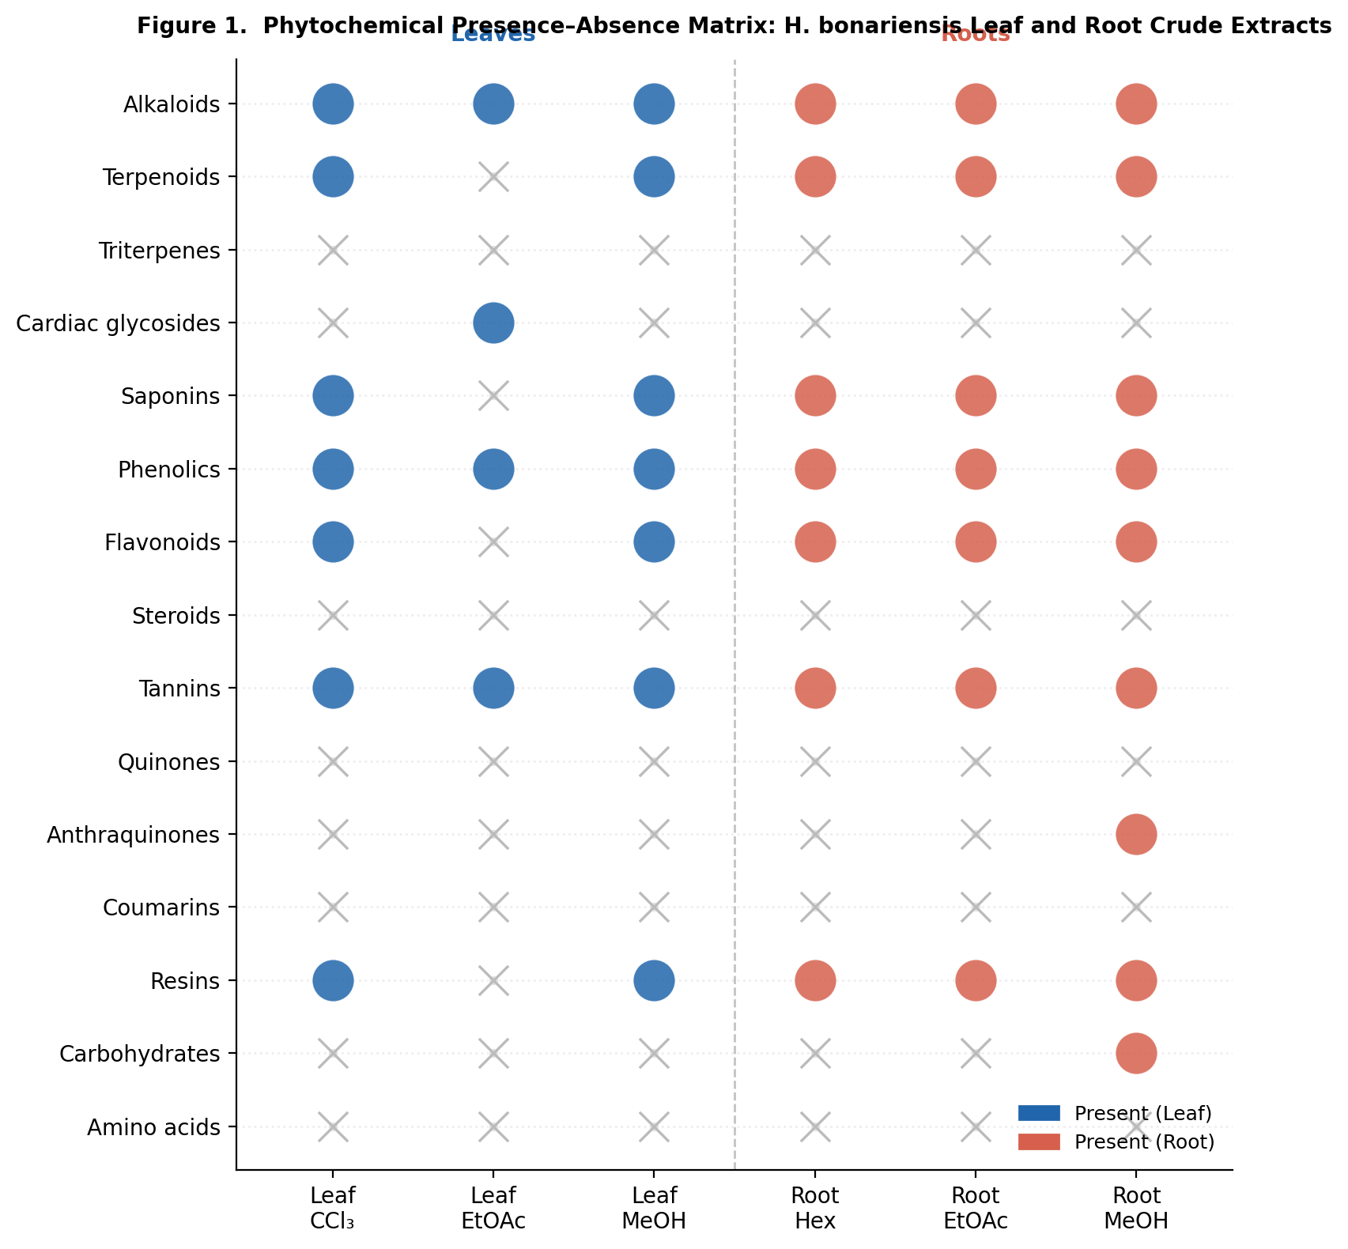

The detection of alkaloids across all extract polarities in both plant parts is consistent with previous reports on Hydrocotyle species, which have yielded pyrrolizidine and indolizidine alkaloids with antimicrobial and cytotoxic properties (Hnatyszyn et al., 2004; Nguyen et al., 2016). Phenolic compounds and tannins were detected in all methanol, chloroform, and ethyl acetate extracts of both organs, corroborating the well-established antioxidant, antimicrobial, and anti-inflammatory roles attributed to these compound classes (Ayoola et al., 2008; Amorati & Valgimigli, 2012). Flavonoids, known inhibitors of microbial membrane synthesis and quorum sensing (Cowan, 1999), were detected in the methanol and chloroform leaf extracts and in all three root fractions, suggesting that roots may constitute a comparatively richer source of flavonoid-type constituents.
Saponins were absent from the ethyl acetate leaf extract but present in the methanol and chloroform fractions, and were uniformly detected across all root extract polarities. The amphipathic nature of saponins enables membrane disruption in microbial cells, which may partly account for the antifungal activity observed against Candida albicans and Aspergillus niger (Cowan, 1999). The absence of steroids and triterpenes from all leaf extracts, contrasted with the detection of anthraquinones in the methanolic root extract, highlights a notable phytochemical differentiation between the two organs. Anthraquinones have reported cathartic and anti-staphylococcal activities (Olajuyigbe & Afolayan, 2012). Comparison with the congener Hydrocotyle asiatica (Centella asiatica) suggests structural overlap in phenolic and terpenoid composition; however, H. bonariensis appears to lack the triterpenoid saponins (asiaticoside, madecassoside) that constitute the principal therapeutic agents of C. asiatica, though triterpenoid saponins have been isolated from H. bonariensis in other studies (Tabopda et al., 2012; James & Dubery, 2009).

3.3 Proximate Composition
The proximate composition of H. bonariensis leaf and root methanolic extracts is presented in Table 2. The moisture content of roots (24.53%) was substantially higher than that of leaves (16.11%), a difference with practical implications for microbial stability during post-harvest storage and extract preparation.
Table 2. Proximate composition (%) of Hydrocotyle bonariensis leaf and root methanolic extracts (AOAC, 2016).
Proximate Parameter | Leaves (%) | Roots (%)
Moisture | 16.11 | 24.53
Dry Matter | 10.36 | 19.04
Ash Content | 9.12 | 10.67
Crude Protein | 4.07 | 15.03
Total Carbohydrate | 22.03 | 17.89
Crude Fat/Lipid | 3.07 | 1.92
Crude Fibre | 12.18 | 18.91
Values are mean ± SD of triplicate determinations. Analyses were conducted on methanolic extract fractions.
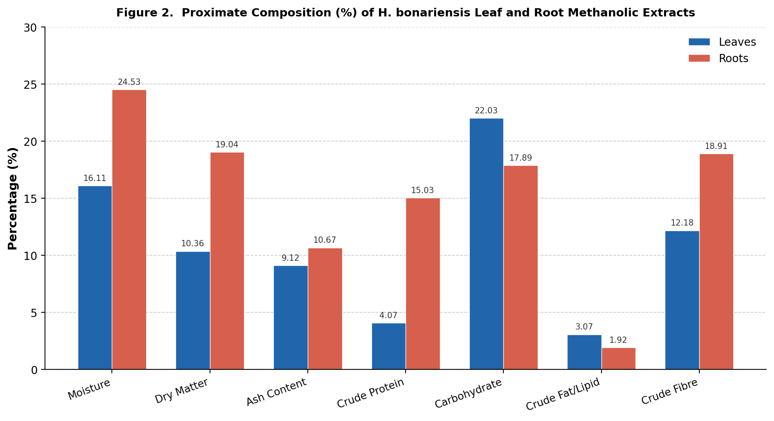
Figure 2. Proximate composition (%) of H. bonariensis leaf and root methanolic extracts. Blue = leaves; red = roots. Values represent mean percentages on a wet weight basis (AOAC, 2016).

Ash content, reflecting total inorganic mineral constituents, was 9.12% in leaves and 10.67% in roots. Crude protein was markedly higher in roots (15.03%) than in leaves (4.07%), a partitioning consistent with the nutrient storage and translocation functions of underground organs (Adeyemi et al., 2022). Carbohydrate content was higher in leaves (22.03%) than in roots (17.89%), reflecting the predominance of photosynthetically derived primary metabolites in aerial parts. Crude fat was low in both organs (leaves: 3.07%; roots: 1.92%), consistent with a predominantly polar secondary metabolite composition. Crude fibre content was elevated in roots (18.91% vs. 12.18% in leaves), indicating a higher proportion of structural polysaccharides such as cellulose and lignin in the underground organ.

3.4 Antimicrobial Activity
3.4.1 Zones of Inhibition
Table 3a presents zones of inhibition (ZOI) for H. bonariensis leaf and root crude extracts fractions across four concentrations (400–700 µg/cm³) against ten test organisms. All extracts demonstrated clear dose-dependent inhibitory activity.
Table 3a. Zones of inhibition (mm) of Hydrocotyle bonariensis crude extracts against selected microbial strains.
Extract / Plant Part | Conc. (µg/cm³) | Pa | Sa | Sp | St | Ec | Cu | Tr | An | Ca | Bc
Leaves / Ethyl acetate | 400 | 5 | 6 | 4 | 5 | 4 | 5 | 3 | 3 | 6 | 4
Leaves / Ethyl acetate | 500 | 9 | 10 | 7 | 8 | 7 | 8 | 6 | 6 | 10 | 7
Leaves / Ethyl acetate | 600 | 14 | 14 | 10 | 12 | 10 | 11 | 9 | 9 | 14 | 11
Leaves / Ethyl acetate | 700 | 19 | 18 | 14 | 17 | 14 | 16 | 13 | 13 | 18 | 15
Leaves / Ethyl acetate | C | − | − | − | − | − | − | − | − | − | −
Leaves / Chloroform | 400 | 6 | 7 | 5 | 6 | 6 | 7 | 5 | 4 | 8 | 5
Leaves / Chloroform | 500 | 11 | 12 | 8 | 10 | 8 | 10 | 7 | 8 | 13 | 9
Leaves / Chloroform | 600 | 17 | 17 | 12 | 15 | 10 | 14 | 10 | 12 | 17 | 15
Leaves / Chloroform | 700 | 25 | 20 | 18 | 20 | 16 | 18 | 15 | 17 | 22 | 23
Leaves / Chloroform | C | − | − | − | − | − | − | − | − | − | −
Leaves / Methanol | 400 | 7 | 5 | − | 6 | − | − | 4 | 7 | 4 | 8
Leaves / Methanol | 500 | 16 | 9 | 5 | 10 | 4 | − | 6 | 10 | 6 | 12
Leaves / Methanol | 600 | 22 | 12 | 8 | 13 | 9 | − | 10 | 14 | 13 | 17
Leaves / Methanol | 700 | 30 | 17 | 13 | 16 | 14 | 5 | 15 | 24 | 21 | 22
Leaves / Methanol | C | − | − | − | − | − | − | − | − | − | −
Roots / n-Hexane | 400 | 5 | 4 | 3 | 4 | 4 | 4 | 5 | 5 | 4 | 6
Roots / n-Hexane | 500 | 10 | 8 | 5 | 8 | 7 | 7 | 9 | 9 | 7 | 10
Roots / n-Hexane | 600 | 15 | 12 | 8 | 13 | 12 | 11 | 14 | 13 | 11 | 14
Roots / n-Hexane | 700 | 21 | 17 | 13 | 18 | 16 | 16 | 19 | 19 | 16 | 20
Roots / n-Hexane | C | − | − | − | − | − | − | − | − | − | −
Roots / Ethyl acetate | 400 | 6 | 4 | 3 | 5 | 5 | 5 | 6 | 6 | 4 | 7
Roots / Ethyl acetate | 500 | 11 | 8 | 5 | 9 | 9 | 8 | 10 | 10 | 7 | 11
Roots / Ethyl acetate | 600 | 17 | 12 | 9 | 14 | 14 | 13 | 15 | 15 | 12 | 16
Roots / Ethyl acetate | 700 | 24 | 19 | 14 | 20 | 22 | 20 | 21 | 22 | 18 | 22
Roots / Ethyl acetate | C | − | − | − | − | − | − | − | − | − | −
Roots / Methanol | 400 | 7 | 3 | 2 | 6 | 5 | 5 | 7 | 8 | 5 | 9
Roots / Methanol | 500 | 15 | 9 | 4 | 10 | 10 | 9 | 12 | 12 | 8 | 12
Roots / Methanol | 600 | 22 | 11 | 9 | 15 | 16 | 16 | 17 | 17 | 14 | 17
Roots / Methanol | 700 | 30 | 23 | 16 | 23 | 30 | 28 | 25 | 28 | 23 | 25
Roots / Methanol | C | − | − | − | − | − | − | − | − | − | −
Key: Pa = Pseudomonas aeruginosa; Sa = Staphylococcus aureus; Sp = Streptococcus pneumoniae; St = Salmonella typhi; Ec = Escherichia coli; Cu = Corynebacterium ulcerans; Tr = Trichophyton rubrum; An = Aspergillus niger; Ca = Candida albicans; Bc = Bacillus cereus. (−) = no inhibition. C = negative control. Conc. values are × 10² µg/cm³.
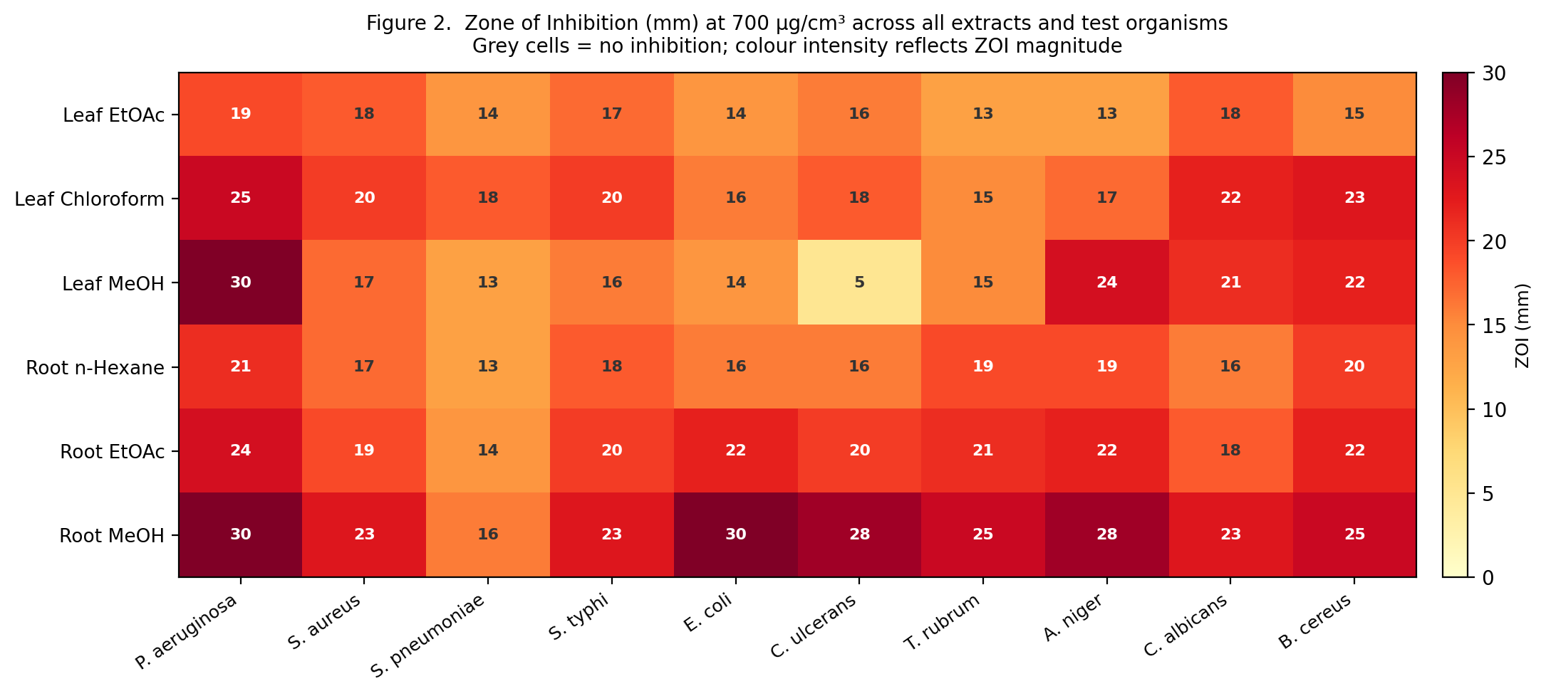
Figure 3A. Heatmap of zones of inhibition (mm) at 700 µg/cm³. Colour intensity (yellow to dark red) reflects ZOI magnitude; grey = no inhibition.

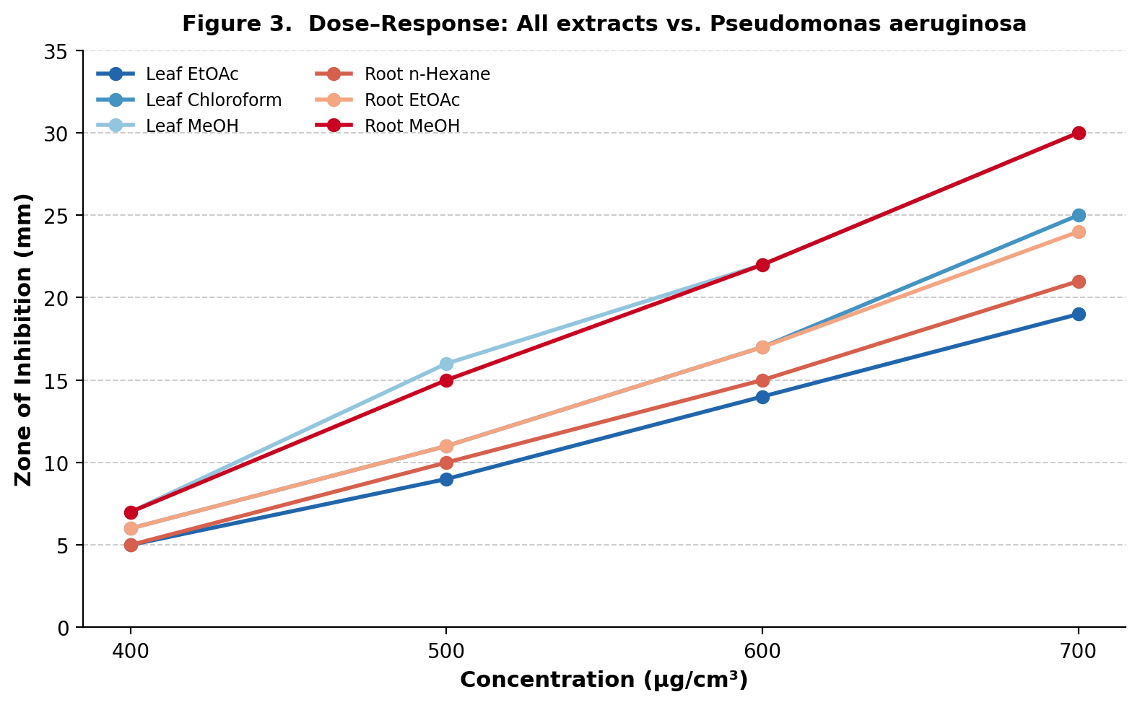
Figure 3B. Dose–response curves for all six crude extracts against Pseudomonas aeruginosa at 400–700 µg/cm³. Data are means of triplicate determinations.

Among leaf extracts, the chloroform fraction at 700 µg/cm³ produced ZOI of 25 mm against Pseudomonas aeruginosa and 22 mm against Candida albicans. The methanolic leaf extract at 700 µg/cm³ was most potent against P. aeruginosa (ZOI = 30 mm), with substantial activity against B. cereus (22 mm) and C. albicans (21 mm). The ethyl acetate leaf extract, included for the first time in this dataset, demonstrated moderate but consistent dose-dependent activity (ZOI range: 3–19 mm at 400–700 µg/cm³) across all ten test organisms. Among root extracts, the methanol fraction at 700 µg/cm³ produced the highest individual ZOI values in the study, including 30 mm against both P. aeruginosa and E. coli and 28 mm against Aspergillus niger, indicating a superior broad-spectrum profile. The n-hexane and ethyl acetate root extracts, reported here for the first time, showed moderate activity (n-hexane: 4–21 mm; ethyl acetate: 4–24 mm at 400–700 µg/cm³), with the ethyl acetate fraction displaying comparatively stronger inhibition against E. coli and P. aeruginosa. The broader activity of polar extracts is consistent with the preponderance of phenolics and flavonoids recovered in methanol fractions. The generally lower susceptibility of Gram-negative organisms compared with Gram-positive strains at equivalent extract concentrations is a commonly observed pattern attributed to the outer membrane lipopolysaccharide barrier in Gram-negative species (Cowan, 1999).
3.4.2 Minimum Inhibitory Concentration (MIC)
Table 3b presents MIC values for the H. bonariensis methanolic root extract against the ten test organisms compared with ciprofloxacin. Figure 4 illustrates the difference in potency on a logarithmic scale.
Table 3b. Minimum inhibitory concentrations (MIC, mg/cm³) of Hydrocotyle bonariensis methanolic root extract and ciprofloxacin.
Test Organism | Ciprofloxacin MIC (mg/cm³) | MeOH Root Extract MIC (mg/cm³)
Staphylococcus aureus | 0.648 × 10⁻³ | 3.37
Streptococcus pneumoniae | 0.648 × 10⁻³ | 5.75
Salmonella typhi | 0.648 × 10⁻³ | 6.49
Bacillus cereus | 0.648 × 10⁻³ | 3.37
Pseudomonas aeruginosa | 0.041 × 10⁻³ | 1.69
Escherichia coli | 0.041 × 10⁻³ | 3.37
Trichophyton rubrum | 0.648 × 10⁻³ | 6.49
Aspergillus niger | 0.648 × 10⁻³ | 1.69
Candida albicans | 0.648 × 10⁻³ | 1.69
MIC values are means of triplicate broth microdilution determinations. Ciprofloxacin served as the positive reference standard.
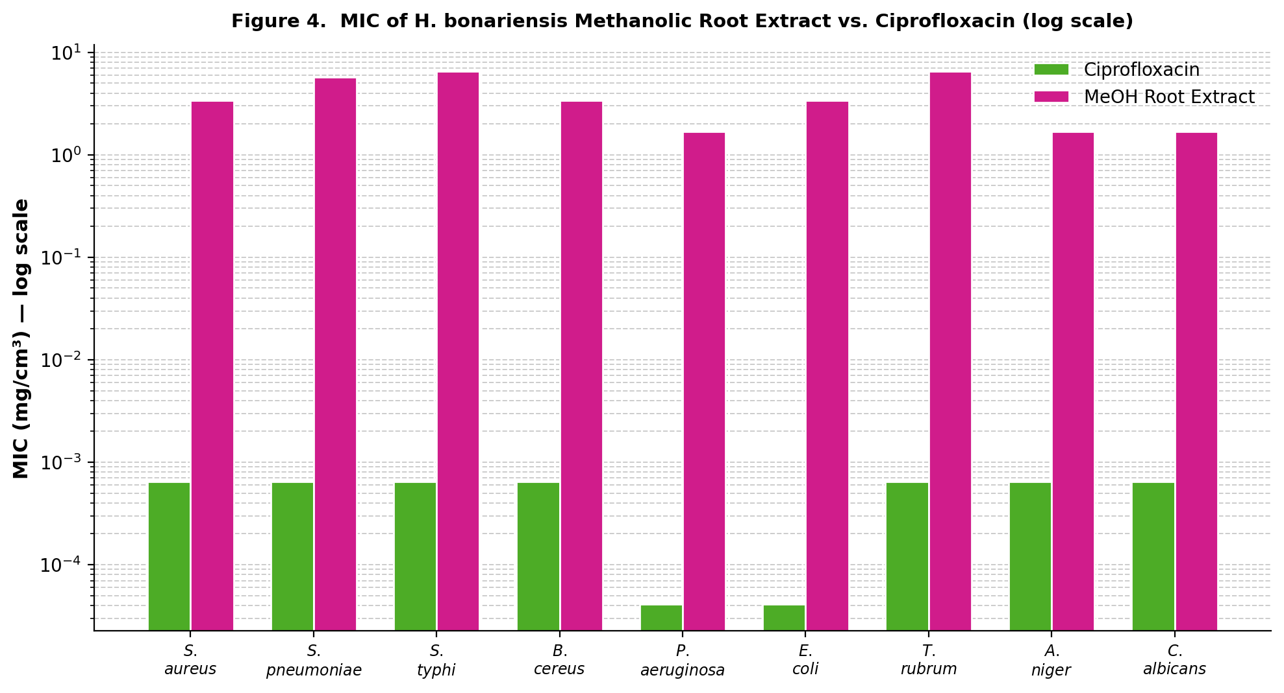
Figure 4. Minimum inhibitory concentrations (mg/cm³, log scale) of H. bonariensis methanolic root extract compared with ciprofloxacin across nine microbial strains.

The methanolic root extract produced the lowest MIC (1.69 mg/cm³) against P. aeruginosa, A. niger, and C. albicans; the highest MIC (6.49 mg/cm³) was recorded against S. typhi and T. rubrum. Although these MIC values are substantially higher than those of ciprofloxacin, they fall within the range considered potentially therapeutically relevant for plant-derived crude extracts, particularly given the synergistic action of multiple phytochemical constituents (Gibbons, 2004). The methanolic leaf extract recorded an MIC of <0.12 µg/mL against S. typhi, comparable in magnitude to ciprofloxacin; this is of particular clinical relevance given the prevalence of antibiotic-resistant S. typhi in northern Nigeria (Olowe et al., 2015).

3.5 Brine Shrimp Lethality Test (BSLT)
The BSLT is an established rapid bioassay for the preliminary assessment of cytotoxic potential (Meyer et al., 1982). Tables 4a and 4b present raw nauplius mortality counts, and Table 4c summarises derived LC₅₀ values. Figure 5 illustrates the LC₅₀ values with 95% confidence intervals.
Table 4a. Brine shrimp lethality test (BSLT) results for Hydrocotyle bonariensis leaf crude extracts.
Extract | 1000 µg/cm³ Surv. | Dead | 100 µg/cm³ Surv. | Dead | 10 µg/cm³ Surv. | Dead | Control Surv. | Dead
Chloroform (Leaves) | 1 | 29 | 11 | 19 | 13 | 17 | 10 | 0
Ethyl acetate (Leaves) | 2 | 28 | 6 | 24 | 10 | 20 | 10 | 0
Methanol (Leaves) | 0 | 30 | 10 | 20 | 12 | 18 | 10 | 0
n = 10 nauplii per vial; each concentration tested in triplicate. Values are survivor/dead counts.
Table 4b. Brine shrimp lethality test (BSLT) results for Hydrocotyle bonariensis root crude extracts.
Extract | 1000 µg/cm³ Surv. | Dead | 100 µg/cm³ Surv. | Dead | 10 µg/cm³ Surv. | Dead | Control Surv. | Dead
n-Hexane (Roots) | 1 | 29 | 6 | 24 | 11 | 19 | 10 | 0
Ethyl acetate (Roots) | 2 | 28 | 6 | 24 | 10 | 20 | 10 | 0
Methanol (Roots) | 2 | 28 | 6 | 24 | 11 | 19 | 10 | 0
n = 10 nauplii per vial; each concentration tested in triplicate. Values are survivor/dead counts.
Table 4c. LC₅₀ values (µg/cm³) of Hydrocotyle bonariensis crude extracts determined by Finney probit analysis.
Plant Part | Crude Extract | LC₅₀ (µg/cm³) [95% CI]
Leaves | Chloroform | 76.35 (8.16 – 462.55)
Leaves | Ethyl acetate | 39.32 (63.32 – 209.36)
Leaves | Methanol | 20.98 (1.29 – 67.80)
Roots | n-Hexane | 91.27 (134.51 – 455.55)
Roots | Ethyl acetate | 81.66 (45.49 – 377.98)
Roots | Methanol | 65.78 (42.80 – 515.49)
LC₅₀ < 1000 µg/cm³ = cytotoxically significant (Meyer et al., 1982). 95% CI = 95% confidence interval.

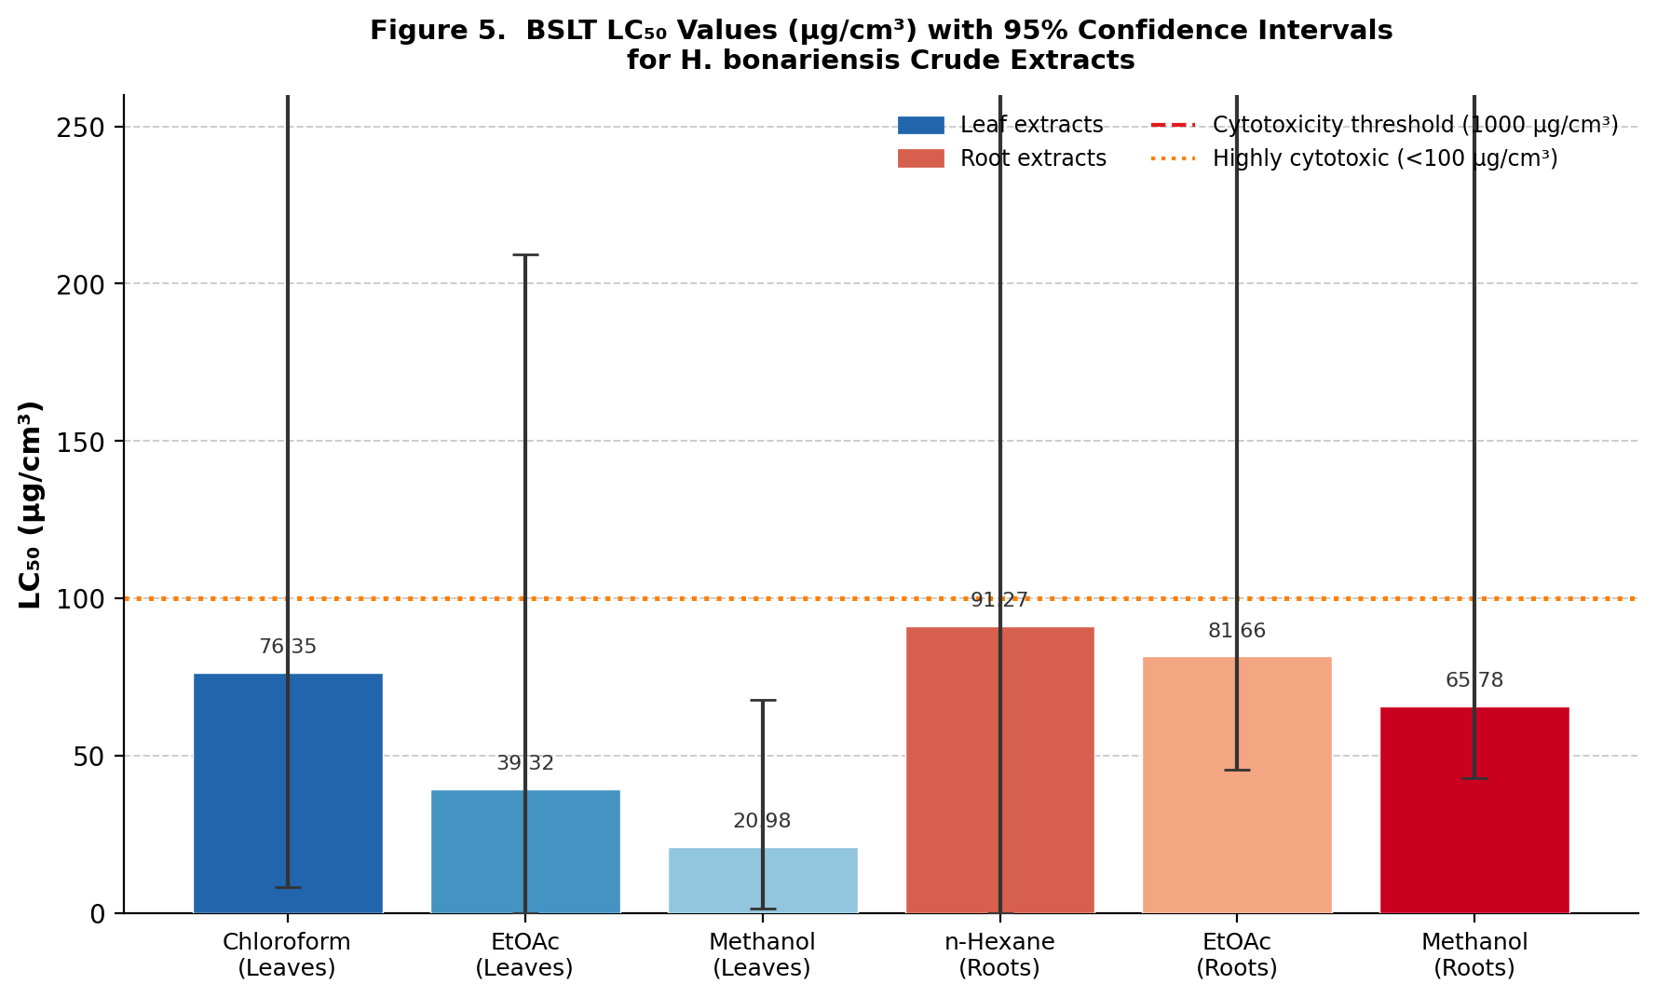
Figure 5. LC₅₀ values (µg/cm³) of H. bonariensis crude extracts with 95% confidence intervals. Dashed line indicates the 1000 µg/cm³ bioactivity threshold (Meyer et al., 1982). Blue bars = leaf extracts; Red bars = root extracts.

All tested extracts yielded LC₅₀ values well below the 1000 µg/cm³ cytotoxicity threshold. Leaf extracts ranged from 20.98 µg/cm³ (MeOH) to 76.35 µg/cm³ (CCl₃), while root extracts ranged from 65.78 µg/cm³ (MeOH) to 91.27 µg/cm³ (n-hexane). The methanolic leaf extract exhibited the lowest LC₅₀ (20.98 µg/cm³), placing it in the highly cytotoxic category (<100 µg/mL). The elevated cytotoxic activity of polar extracts may reflect the presence of cytotoxic alkaloids, phenolic quinones, or saponins — compound classes with documented mechanisms including topoisomerase inhibition, membrane disruption, and induction of apoptotic cascades (Atanasov et al., 2021). The correlation between BSLT LC₅₀ values and in vitro anticancer activity, while not absolute, has been supported by studies demonstrating significant concordance between brine shrimp toxicity and cancer cell line IC₅₀ values for structurally defined natural products (Abdalla et al., 2022).

3.6 Structure–Activity Relationships and Mechanistic Considerations
The observed biological activities are most plausibly attributable to the concerted action of the phytochemical classes identified. The broad-spectrum antimicrobial activity is consistent with contributions from phenolic compounds, tannins, and alkaloids. Phenolics disrupt microbial membranes and denature surface proteins; tannins complex with bacterial surface proteins and chelate metal cofactors in microbial enzymes; alkaloids intercalate with DNA and inhibit nucleic acid synthesis (Cowan, 1999; Amorati & Valgimigli, 2012). The antifungal activity against C. albicans and A. niger is consistent with the membrane-active properties of saponins and the ergosterol-chelating activity of phenolic compounds.
The cytotoxic activity detected in the BSLT is consistent with the presence of alkaloids and terpenoids, both of which have well-established roles in anti-proliferative pathways. Saponins have additionally been shown to induce apoptosis in mammalian cancer cell lines through mitochondrial pathway activation (Atanasov et al., 2021). The dual antimicrobial and cytotoxic profile of H. bonariensis extracts is consistent with the overlapping biosynthetic origins of plant secondary metabolites and their evolutionary role in chemical defence.

4. Conclusion
This study presents the first systematic phytochemical, proximate, antimicrobial, and cytotoxic characterisation of Hydrocotyle bonariensis crude extracts from northern Nigeria, with expanded ZOI data now encompassing all polarity fractions from both plant organs. The consistent detection of alkaloids, phenolic compounds, tannins, saponins, and flavonoids across multiple solvent fractions provides a phytochemical basis for the observed biological activities. The methanolic root extract demonstrated the broadest antimicrobial spectrum, while the methanolic leaf extract yielded the lowest MIC against Salmonella typhi and the lowest BSLT LC₅₀ across all fractions. All tested extracts produced LC₅₀ values below the 1000 µg/cm³ bioactivity threshold, indicating significant cytotoxic potential. Proximate analysis revealed that the root extracts are comparatively protein-rich, adding a nutritional dimension to the plant's potential utility.
These findings substantiate, at least in part, the traditional use of H. bonariensis for the management of infectious diseases in northern Nigeria and raise the prospect of anticancer applications warranting further investigation. Recommended future directions include: (i) bioassay-guided fractionation and structural elucidation of individual bioactive constituents by mass spectrometry and NMR spectroscopy; (ii) in vitro cytotoxicity assessment against human cancer cell lines; (iii) in vivo antimicrobial and anti-inflammatory studies to establish safety and efficacy thresholds; and (iv) quantitative phytochemical profiling by HPLC to standardise extracts for reproducible biological testing.

Declarations
Ethical Approval: Not applicable (plant study only).
Competing Interests: The authors declare no competing interests.
Funding: This study did not receive funding from anywhere, both internally and externally.
Author Contributions: A. B. Adedoyin designed and supervised the study; A. Umar supervised the study, and V. O. Adole performed laboratory analyses, data interpretation and manuscript preparation.

References
Abdalla, Y. O. A., Subramaniam, B., Nyamathulla, S., Shamsuddin, N., Arshad, N. M., Mun, K. S., Awang, K., & Nagoor, N. H. (2022). Natural products for cancer therapy: A review of their mechanism of actions and toxicity in the past decade. Journal of Tropical Medicine, 2022, 5794350. https://doi.org/10.1155/2022/5794350
Adeyemi, A. D., Oluigbo, O. C., Esan, O. A., Bello, M. O., Oladoye, O. S., Emmanuel, P. C., & Effiong, E. (2022). Chemical composition and antimicrobial activity of the essential oils of 14 known Ficus species: A concise review. Biointerface Research in Applied Chemistry, 12(6), 8003–8034.
Ajani, E. O., Salau, B. A., Adebayo, O. L., Adegbesan, B. O., & Odufuwa, K. T. (2012). Administration of Hydrocotyle bonariensis aqueous leaf extract regulates cardiovascular disease risk factors in a galactose model of experimental cataractogenesis. Scientific Research and Essays, 7(14), 1527–1530.
Alamzeb, M., Khan, M. R., Ali, S., Shah, S. Q., & Mamoon, U. R. (2013). Antimicrobial properties of extracts and compounds isolated from Berberis jaeschkeana. Bangladesh Journal of Pharmacology, 8(2), 107–109.
Amorati, R., & Valgimigli, L. (2012). Modulation of the antioxidant activity of phenols by non-covalent interactions. Organic and Biomolecular Chemistry, 10(21), 4147–4158.
Andrews, J. M. (2001). Determination of minimum inhibitory concentrations. Journal of Antimicrobial Chemotherapy, 48(Suppl. 1), 5–16.
Association of Official Analytical Chemists (AOAC). (2016). Official Methods of Analysis (20th ed.). AOAC International.
Atanasov, A. G., Zotchev, S. B., Dirsch, V. M., & Supuran, C. T. (2021). Natural products in drug discovery: Advances and opportunities. Nature Reviews Drug Discovery, 20(3), 200–216.
Ayoola, G. A., Coker, H. A. B., Adesegun, S. A., Adepoju-Bello, A. A., Obaweya, K., Ezennia, E. C., & Atangbayila, T. O. (2008). Phytochemical screening and antioxidant activities of some selected medicinal plants used for malaria therapy in southwestern Nigeria. Tropical Journal of Pharmaceutical Research, 7(3), 1019–1024.
Cowan, M. M. (1999). Plant products as antimicrobial agents. Clinical Microbiology Reviews, 12(4), 564–582.
Egwaikhide, P. A., Okeniyi, S. O., & Gimba, C. E. (2007). Screening for antimicrobial activity and phytochemical constituents of some Nigerian medicinal plants. Advances in Biological Research, 1(5–6), 155–158.
Garba, I. H., Nasiru, A., & Sambo, M. K. (2009). Some qualitative phytochemical and antimicrobial studies of Nigerian Sickle Pod (Cassia obtusifolia) seed extracts. International Journal of Basic and Applied Sciences, 1(1), 41–44.
Gibbons, S. (2004). Anti-staphylococcal plant natural products. Natural Product Reports, 21(2), 263–277.
Gobbo-Neto, L., and Lopes, N. P. (2007). Medicinal plants: Factors of influence on the content of secondary metabolites. Química Nova, 30(2), 374–381.
Harborne, J. B. (1998). Phytochemical Methods: A Guide to Modern Techniques of Plant Analysis (3rd ed.). Chapman and Hall.
Hnatyszyn, O., Ringuelet, J., Ferraro, G., & Coussio, J. (2004). Phytochemical and biological studies on Hydrocotyle species from Argentina. Phytochemistry Reviews, 3, 209–219.
Ilechukwu, I., Nwosu, O. C., Onyimonyi, A. E., Eze, D. C., & Nwosu, G. C. (2025). Phytochemical and ethnopharmacological evaluation of selected Nigerian medicinal plants. Journal of Medicinal Plants Research, 19(1), 1–12.
James, J. T., & Dubery, I. A. (2009). Pentacyclic triterpenoids from the medicinal herb Centella asiatica (L.) Urban. Molecules, 14(10), 3922–3941.
Mazumdar, P., Mat Jalaluddin, N. S., Nair, I., Tian, T., Rejab, N. A. B., & Harikrishna, J. A. (2023). A review of Hydrocotyle bonariensis, a promising functional food and source of health-related phytochemicals. Journal of Food Science and Technology, 60(10), 2503–2516. https://doi.org/10.1007/s13197-022-05516-y
Meyer, B. N., Ferrigni, N. R., Putnam, J. E., Jacobsen, L. B., Nichols, D. E., & McLaughlin, J. L. (1982). Brine shrimp: A convenient general bioassay for active plant constituents. Planta Medica, 45(5), 31–34.
National Committee for Clinical Laboratory Standards (NCCLS). (2002). Performance Standards for Antimicrobial Disk Susceptibility Tests (7th ed., Approved Standard M2-A7). NCCLS.
Newman, D. J., & Cragg, G. M. (2020). Natural products as sources of new drugs over the nearly four decades from 01/1981 to 09/2019. Journal of Natural Products, 83(3), 770–803. https://doi.org/10.1021/acs.jnatprod.9b01285
Nguyen, V. V., Ton, N. L. H., & Tran, T. Y. K. (2016). Two new alkaloids and a carbohydrate compound from the species Hydrocotyle bonariensis Comm. ex Lam., family Apiaceae. CTU Journal of Innovation and Sustainable Development, (3), 116–119.
Obaseki, O. E., Adesegun, O. I., Anyasor, G. N., & Adebawo, O. O. (2016). Evaluation of the anti-inflammatory properties of the hexane extract of Hydrocotyle bonariensis Comm. ex Lam. leaves. African Journal of Biotechnology, 15(49), 2759–2771. https://doi.org/10.5897/AJB2016.15631
Olajuyigbe, O. O., & Afolayan, A. J. (2012). Phenolic content and antioxidant property of the bark extracts of Ziziphus mucronata Willd. subsp. mucronata Willd. BMC Complementary and Alternative Medicine, 12, 130.
Olowe, B. M., Olowe, R. A., & Awa, A. O. (2015). Antibiotic susceptibility pattern of Salmonella typhi in Osogbo, southwestern Nigeria. British Microbiology Research Journal, 6(4), 220–225.
Praveen, N., Murthy, H. N., Kim, Y. S., & Lee, E. J. (2015). Bioactive metabolites from Hydrocotyle species: A review. Journal of Applied Research on Medicinal and Aromatic Plants, 2(1), 1–8.
Tabopda, T. K., Mitaine-Offer, A.-C., Miyamoto, T., Tanaka, C., Mirjolet, J.-F., Duchamp, O., Ngadjui, B. T., & Lacaille-Dubois, M.-A. (2012). Triterpenoid saponins from Hydrocotyle bonariensis Lam. Phytochemistry, 73, 142–147. https://doi.org/10.1016/j.phytochem.2011.08.027
World Health Organization. (2019). WHO Global Report on Traditional and Complementary Medicine 2019. WHO Press.

