Geospatial Assessment of Limestone Mining-Induced Land Use Change in Okpella, Edo State, Nigeria
Sanni Oseni Zuwedu*, Dalhatu Umar Sangari, Adamu Tanko Ogah, & Muhammadu Alkali
Department of Geography, Nasarawa State University, Keffi, PMB 1022.
Corresponding author: zuwedu@gmail.com*

Abstract
This study assessed limestone mining-induced land use and land cover change and its implications for agricultural land loss in Okpella, Edo State, Nigeria. A mixed-methods approach was adopted, integrating remote sensing, Geographic Information System (GIS) analysis, questionnaire surveys, and focus group discussions. Multi-temporal satellite images for 2002, 2014, and 2024 were classified using a supervised Random Forest algorithm to quantify land use changes, while descriptive and inferential statistics were used to analyze socio-economic data obtained from 400 respondents. Results indicate substantial land transformation over the study period. Agricultural land declined from 229.17 km² in 2002 to 104.29 km² in 2024, while mining areas increased from 0.36 km² to 9.52 km². Built-up areas also expanded gradually, while vegetation cover decreased consistently. Classification accuracy assessment showed strong reliability, with overall accuracies ranging from 88.89% to 92.86% and Kappa coefficients between 0.846 and 0.899. Regression analysis revealed a statistically significant relationship between limestone mining and land use change (R² = 0.387, p < 0.05), indicating mining as a key driver of spatial transformation in the study area. Respondents’ perceptions further confirmed that mining activities negatively affect soil quality, crop yields, and agricultural practices. The study concludes that limestone mining has significantly contributed to agricultural land loss and landscape transformation in Okpella. Sustainable land management strategies, stricter environmental regulation, and reclamation policies are recommended to balance mineral extraction with agricultural sustainability.
Keywords: Limestone mining; land use and land cover change; GIS and remote sensing; agricultural land loss; Okpella, Nigeria.
1. Introduction
Land use and land cover (LULC) change has emerged as one of the most significant indicators of environmental transformation, particularly in regions experiencing rapid resource extraction. Mining activities alter natural landscapes through vegetation clearance, excavation, infrastructure development, and the conversion of agricultural lands to industrial uses. While mining contributes substantially to economic development through employment generation, industrial growth, and revenue creation, it often results in considerable environmental costs, including land degradation, biodiversity loss, and reduced agricultural productivity (Venkata Sudhakar et al., 2022).
Limestone mining is one of the major drivers of land transformation in many developing countries due to the increasing demand for cement and construction materials. Previous studies have demonstrated that mining expansion is frequently associated with significant changes in land use patterns. In Plateau State, Nigeria, mining activities resulted in substantial reductions in farmland and increases in degraded land surfaces (Owolabi, 2020). Similarly, Obenade et al. (2025) reported extensive changes in land use in southeastern Nigeria, characterized by declining vegetation cover and increasing disturbed landscapes. Beyond Nigeria, studies in India have shown that limestone mining contributes to the conversion of cropland and vegetation into mining and industrial areas, leading to long-term environmental challenges (Prasad et al., 2019; Venkata Sudhakar et al., 2022).
Agricultural land is particularly vulnerable to mining-induced land use change. The conversion of fertile farmland to mining sites not only reduces the area available for cultivation but may also affect soil quality, water availability, and ecosystem services that support agricultural production. Evidence from Benue State, Nigeria, suggests that reductions in agricultural land have direct implications for food security and rural livelihoods (Ihemezie et al., 2019). As mining activities expand, concerns continue to grow regarding the sustainability of agricultural systems in mining communities.
Okpella, located in Edo State, Nigeria, hosts some of the largest limestone deposits in the country and has experienced increased mining activities over the past two decades. The presence of major cement industries has accelerated limestone extraction, resulting in noticeable changes in the physical landscape. Recent geospatial investigations in Okpella have reported alterations in land cover, increased land surface temperatures, and pressure on environmental resources associated with mining operations (Owolabi et al., 2025). However, despite these observations, there remains limited empirical evidence quantifying the extent of long-term land use transitions attributable to limestone mining and their implications for agricultural land availability.
Most existing studies have focused on the environmental impacts of mining, such as vegetation loss, land degradation, and water stress, with relatively little attention given to the spatial dynamics of agricultural land conversion in Okpella. Furthermore, few studies have integrated remote sensing, GIS techniques, and statistical modelling to evaluate the relationship between mining expansion and agricultural land loss over time. This represents an important knowledge gap, particularly in a region where agriculture remains a critical source of livelihood.
The findings of this study reveal substantial land use transformations between 2002 and 2024. Agricultural land declined from 229.17 km² to 104.29 km², while mining land increased from 0.36 km² to 9.52 km² during the same period. Regression analysis further demonstrated that limestone mining significantly influenced land use change, accounting for 38.7% of the observed variation in land use patterns. These trends suggest a progressive conversion of agricultural landscapes into mining areas, with implications for land management and sustainable development.
Therefore, the aim of this study is to assess the extent to which limestone mining has influenced land use and land cover change and contributed to agricultural land loss in Okpella, Edo State, Nigeria, using geospatial techniques and statistical analysis. Specifically, the study seeks to: (i) map and quantify land use and land cover changes between 2002 and 2024; (ii) determine the extent of agricultural land loss associated with mining expansion; and (iii) examine the relationship between limestone mining activities and land use change in the study area.
2. Materials and Methods
2.1 Study Area
The study was conducted in Okpella, Edo State, Nigeria. The area is characterized by extensive limestone deposits and hosts major cement production facilities, including Dangote Cement and BUA Cement. The local economy is largely driven by a combination of agriculture and mining activities. The increasing expansion of limestone quarrying has resulted in noticeable alterations in land use patterns, making the area suitable for assessing mining-induced land use change and agricultural land loss.
2.2 Research Design
The study adopted a quantitative approach. This design was considered appropriate because it allows for the integration of geospatial data analysis. The quantitative component involved GIS and remote sensing analysis of land use and land cover change.
2.3 Study Population and Sampling
The study population comprised residents of Okpella, including farmers, community members, miners, community leaders, and staff of Dangote Cement and BUA Cement. The estimated population was 500,669 persons, consisting of 500,652 residents and 17 identified miners from the two cement companies.
The sample size was determined using the Taro Yamane formula at a 5% margin of error, yielding a sample size of 400 respondents.
A simple random sampling technique was used to select 400 community respondents for questionnaire administration. In addition, purposive sampling was employed to include all available miners and relevant technical staff from Dangote and BUA cement companies due to their direct involvement in limestone extraction activities.
2.4 Data Sources and Collection
Both primary and secondary data were utilized in the study.
Primary data were obtained through structured questionnaires, field observations, and focused group discussions (FGDs). A total of 400 questionnaires were administered to residents of Okpella using a direct administration and retrieval method. The questionnaire captured information on perceived environmental and agricultural impacts of limestone mining.
Focused group discussions were conducted with miners and company staff to obtain in-depth qualitative insights into mining operations and environmental implications. Field observations were also used to document visible environmental changes around mining sites.
Secondary data included satellite imagery, Google Earth data, published literature, and geospatial datasets used for land use and land cover analysis.
Multi-temporal satellite images covering 2002, 2014, and 2024 were used to assess land use and land cover (LULC) changes in Okpella. The images were pre-processed, geo-referenced, and analyzed using Geographic Information System (GIS) software.
A supervised classification approach based on the Random Forest algorithm was used to classify land use into four categories: built-up areas, vegetation, agriculture, and mining areas. Training samples were derived from high-resolution Google Earth imagery and field validation points (Jensen, 2015; Campbell & Wynne, 2011; Breiman, 2001).
For classification accuracy, 70% of the samples were used for training while 30% were reserved for validation. Accuracy assessment was conducted using confusion matrices, overall accuracy, and Kappa coefficient.
2.6 Change Detection Analysis
Land use change was quantified by comparing classified images across the three study years (2002, 2014, and 2024). The extent of land conversion among classes was calculated, with particular emphasis on the transition from agricultural land to mining and built-up areas (Singh, 1989. Annual rates of change were also computed to determine the intensity of land use transformation over time.
2.7 Statistical Analysis
Descriptive statistics including frequencies and percentages were used to summarize respondents’ perceptions of mining impacts.
Inferential analysis was conducted using simple linear regression to examine the relationship between limestone mining and land use change, as well as between limestone mining and agricultural activities. The strength of relationships was evaluated using R², regression coefficients (β), F-statistics, and p-values at a 95% confidence level (p < 0.05). All statistical analyses were performed using SPSS version 27.
2.8 Land Use Transition Modelling
A land use transition model was developed using historical land use data from 2002, 2014, and 2024 to project future land use conditions. Trend analysis was applied to estimate potential land use distribution for 2034, focusing on the trajectory of agricultural decline and mining expansion under observed historical trends.
3. Results
3.1 Land Use Characteristics of the Study Area
Three major land-use categories were identified in Okpella: built-up areas, agricultural land, and mining land.
Built-up areas comprise residential buildings, rural settlements, transportation infrastructure, commercial establishments, industrial facilities, and agricultural support structures. Notable commercial land-use areas include Okugbe Market, Iddo Market, Udioche Market, Okhashe Market, and Ewo Market. Representative built-up features are shown in Plates 1.
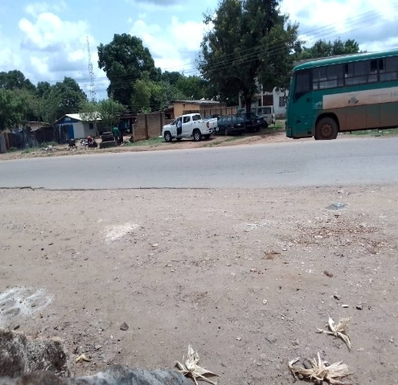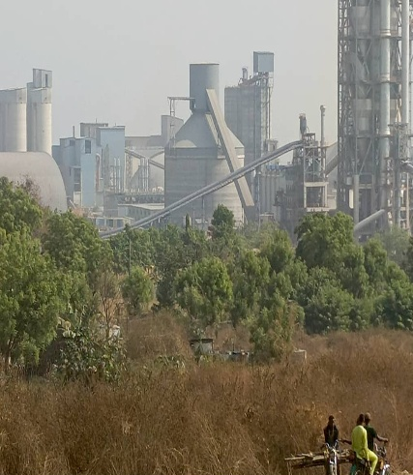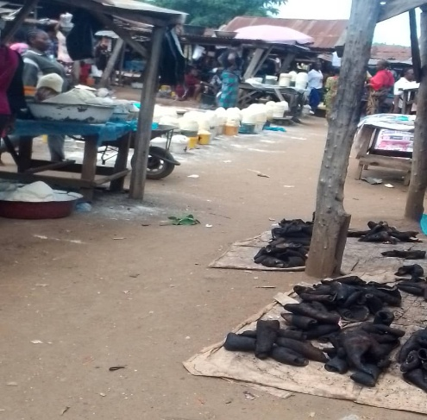
- (b) (c)
Plate 1: (a) Residential buildings along Factory Road, Iddo Okpella (lat. 7.2111 long. 6.2341), (b) BUA cement Plant Obu Okpella (lat. 7.2111 long. 6.2341), (c) Ewo market Okpella (lat. 7.279348, long. 6.352739).

Agricultural land use consists primarily of crop farming, including the cultivation of grains, vegetables, fruits, and other food crops. Agricultural areas constitute an important component of local livelihoods and food production systems within the study area (Plate 2).
Mining land use is characterized by areas dedicated to limestone extraction and quarrying activities. A total of seventeen active mining sites were identified within the major mining zone of Okpella.
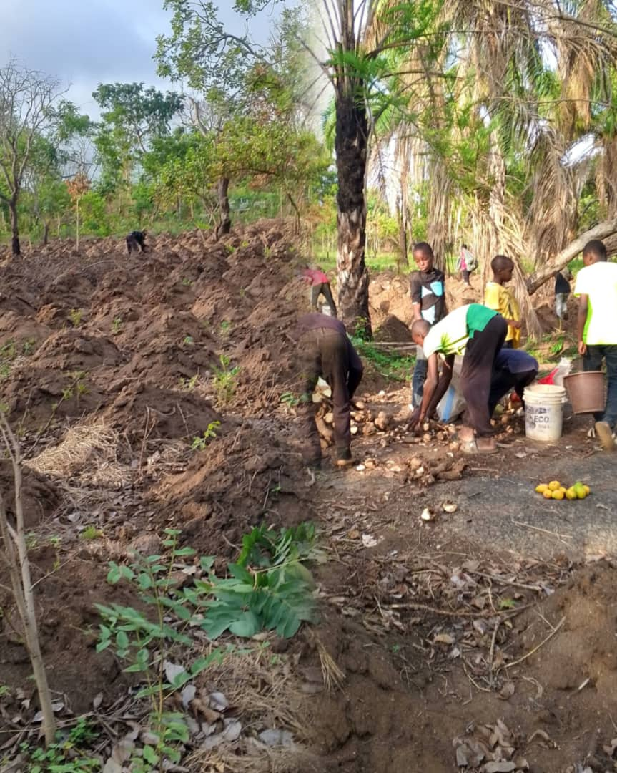
Plate 2: Crops Farm Okpella (lat. 7.321377, Long. 6.377895)

4.2 Land Use and Land Cover Change (2002–2024)
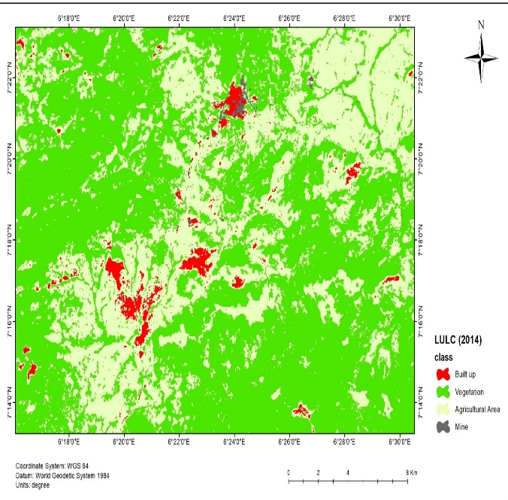
Land use and land cover (LULC) maps derived from remotely sensed imagery for 2002, 2014, and 2024 revealed substantial changes in land-use patterns across the study area (Figure 1).
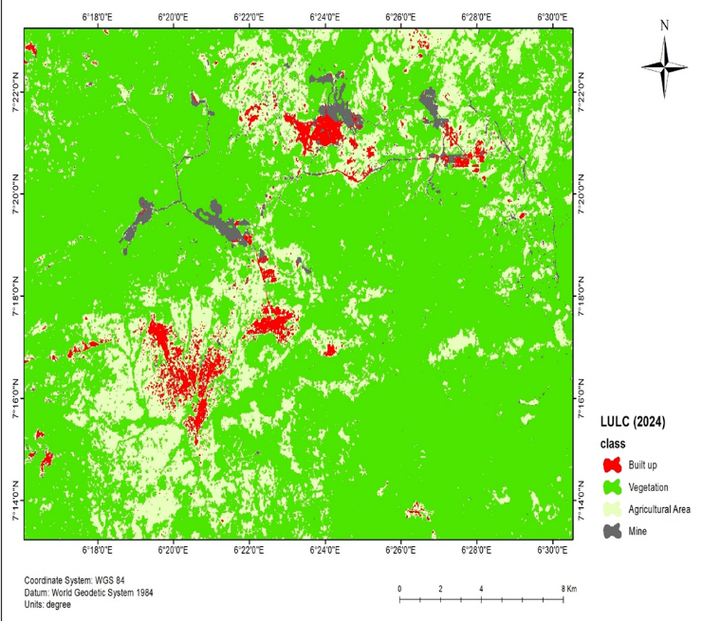
Figure 1: Imagery of Land Use and Land Cover 2014 and 2024 of Okpella.

4.2.1 Classification Accuracy Assessment
The supervised Random Forest classification achieved high classification accuracies across the three study periods. Overall classification accuracy ranged from 88.9% to 92.9%, while Kappa coefficients ranged from 0.846 to 0.899 (Tables 1-3).
Table 1: Classification Accuracy Assessment for 2002
Metric | Value
Overall Accuracy | 88.89%
Kappa Coefficient | 0.846

Table 2: Classification Accuracy Assessment for 2014
Metric | Value
Overall Accuracy | 92.86%
Kappa Coefficient | 0.899

Table 3: Classification Accuracy Assessment for 2024
Metric | Value
Overall Accuracy | 91.30%
Kappa Coefficient | 0.884

3.2.2 Land Use and Land Cover Dynamics
The spatial extent of agricultural land declined continuously throughout the study period, decreasing from 229.17 km² in 2002 to 181.11 km² in 2014 and further to 104.29 km² in 2024. Vegetation cover also decreased from 368.69 km² in 2002 to 258.27 km² in 2024.
In contrast, mining land increased substantially from 0.36 km² in 2002 to 1.38 km² in 2014 and 9.52 km² in 2024. Built-up land also expanded from 6.76 km² in 2002 to 12.29 km² in 2024 (Table 4).

Table 4: Land Use and Land Cover Distribution (2002–2024)
Class | 2002 (km²) | 2014 (km²) | 2024 (km²)
Agriculture | 229.17 | 181.11 | 104.29
Built-up | 6.76 | 9.27 | 12.29
Vegetation | 368.69 | 303.04 | 258.27
Mining | 0.36 | 1.38 | 9.52

4.3 Effects of Limestone Mining on Agriculture
Respondents reported substantial impacts of limestone mining on agricultural activities. A majority of respondents indicated that soil quality and quantity had been affected by mining activities, with 55.0% strongly believing and 20.0% believing that mining adversely affects soil conditions. Similarly, 62.5% strongly believed that mining contributes to reductions in crop yields, while 17.5% believed the same.
Regarding agricultural practices, 50.0% strongly believed that mining activities affect farming operations and 25.0% believed this effect exists. Concerning the continuation of farming alongside mining activities, 22.5% strongly believed and 45.0% believed that both activities could coexist.
4.4 Agricultural Land Loss
Analysis of land-use change indicated a substantial reduction in agricultural land over the study period. Agricultural land decreased from 229.17 km² in 2002 to 104.29 km² in 2024, representing an annual decline of 7.68 km². Conversely, mining land expanded from 0.36 km² to 9.52 km² during the same period, corresponding to an annual increase of 0.42 km² (Table 5).
Table 5: Land Use Change Between 2002 and 2024
Land Use | Area 2002 (km²) | Area 2024 (km²) | Annual Change (km²/year)
Agriculture | 229.17 | 104.29 | -7.68
Mining | 0.36 | 9.52 | +0.42

4.5 Relationship Between Limestone Mining and Land Use Change
Simple linear regression analysis revealed a statistically significant relationship between limestone mining and land-use change in Okpella (Table 6). Limestone mining explained 38.7% of the observed variation in land use (R² = 0.387). The regression model was significant (F = 230.646, p < 0.001), with a standardized regression coefficient (β) of 0.622.
Table 6: Regression Analysis of Limestone Mining and Land Use Change
Predictor | R | R² | F | β | T | P
Limestone Mining | 0.622 | 0.387 | 230.646 | 0.622 | 15.187 | <0.001
4.6 Relationship Between Limestone Mining and Agricultural Activities
The regression analysis examining the relationship between limestone mining and agricultural activities was statistically significant (F = 194.457, p = 0.001). The model explained 34.5% of the variation in agricultural activities (R² = 0.345). Limestone mining exhibited a standardized regression coefficient (β) of 0.589 and a t-value of 13.945 (Table 7).
Table 7: Regression Analysis of Limestone Mining and Agricultural Activities
Predictor | R | R² | F | β | T | P
Limestone Mining | 0.347 | 0.345 | 194.457 | 0.589 | 13.945 | 0.001
4.7 Projected Land Use Transition by 2034
The land-use transition model projected continued expansion of mining land and further decline in agricultural land by 2034. Agricultural land is projected to decline from 104.29 km² in 2024 to approximately 0 km² by 2034, while mining land is projected to increase from 9.52 km² to 24.29 km² (Table 8; Figure 1).
Table 8: Projected Land Use Transition by 2034
Year | Agriculture (km²) | Mining (km²)
2002 | 229.17 | 0.36
2014 | 181.11 | 1.38
2024 | 104.29 | 9.52
2034 | 0.00 | 24.29

4. Discussion of Results
The findings of this study reveal significant transformations in land-use patterns in Okpella between 2002 and 2024, driven primarily by the expansion of limestone mining activities. These changes have had profound implications for agricultural land availability, vegetation cover, and rural livelihoods.
4.1 Land Use Characteristics and Structure
The identification of three dominant land-use categories such as the built-up areas, agricultural land, and mining land reflects the typical rural–resource extraction landscape found in mineral-rich regions. Built-up areas in Okpella include residential settlements, markets, transportation networks, and industrial facilities such as the BUA cement plant. The presence of multiple market centers (e.g., Okugbe, Iddo, and Ewo markets) highlights ongoing socio-economic development and commercialization within the study area.
Agricultural land remains a critical component of local livelihoods, supporting subsistence and commercial crop production. However, mining land use, though initially minimal, has emerged as a rapidly expanding land-use category due to increasing demand for limestone in cement production. This pattern aligns with earlier studies which suggest that resource extraction tends to compete directly with agricultural land in rural economies (Mensah et al., 2015; Sonter et al., 2017).
4.2 Land Use and Land Cover Dynamics
The LULC analysis indicates a clear and consistent decline in both agricultural land and vegetation cover over the 22-year period. Agricultural land decreased from 229.17 km² in 2002 to 104.29 km² in 2024, while vegetation declined from 368.69 km² to 258.27 km². In contrast, mining land expanded dramatically from 0.36 km² to 9.52 km², and built-up areas nearly doubled.
These findings suggest a strong land-use conversion process, where agricultural and vegetated lands are increasingly being replaced by mining and infrastructure development. Such trends are consistent with global observations in mining regions, where extractive activities result in deforestation, land degradation, and reduced agricultural productivity (Hilson, 2002; Schueler et al., 2011). Importantly, the high classification accuracy (88.9%–92.9%) and strong Kappa values (0.846–0.899) confirm the reliability of the remote sensing analysis, indicating that the observed changes are robust and scientifically credible.
4.3 Impacts of Limestone Mining on Agriculture
Survey responses strongly support the spatial analysis results, indicating that limestone mining has significantly affected agricultural systems. A large proportion of respondents reported declines in soil quality, reduced crop yields, and disruptions to farming activities. These impacts can be attributed to several mining-related processes, including land clearing, topsoil removal, dust deposition, and water contamination. Dust emissions from quarrying operations are known to reduce photosynthetic efficiency in crops, while heavy machinery damages soil structure and fertility (Adjei et al., 2012). Despite these negative effects, a notable proportion of respondents believe that mining and agriculture can coexist. This suggests potential for integrated land management strategies, although such coexistence would require effective environmental regulation and rehabilitation measures.
4.4 Agricultural Land Loss
The study reveals a drastic reduction in agricultural land, with an annual loss of approximately 7.68 km². This rate of decline is alarming and indicates an unsustainable trajectory for local food production systems. In contrast, mining land increased at a rate of 0.42 km² per year, highlighting a clear imbalance in land-use priorities. The magnitude of agricultural land loss suggests that mining expansion is occurring at the expense of farming, thereby threatening food security and rural livelihoods. This finding is consistent with research indicating that mining-driven land-use change often leads to displacement of agricultural activities and loss of arable land (Bebbington et al., 2018).
4.5 Relationship Between Limestone Mining and Land Use Change
The regression analysis demonstrates a statistically significant relationship between limestone mining and overall land-use change (R² = 0.387, p < 0.001). The positive standardized coefficient (β = 0.622) indicates that increases in mining activities are strongly associated with transformations in land use. Although mining explains 38.7% of the variation, the remaining variation may be attributed to other factors such as population growth, urbanization, infrastructure development, and policy dynamics. Nevertheless, the strength and significance of the relationship confirm that mining is a major driver of landscape transformation in Okpella.
4.6 Relationship Between Limestone Mining and Agricultural Activities
The regression results also reveal a significant relationship between limestone mining and agricultural activities (R² = 0.345). The positive β value (0.589) suggests a strong interaction, likely reflecting the influence of mining expansion on agricultural decline or adaptation. The relatively high explanatory power of the model indicates that mining activities account for a substantial portion of the observed changes in agricultural practices. This supports the perception data from respondents and reinforces the conclusion that mining is reshaping the agricultural economy of the area.
4.7 Future Land Use Projections
The projected land-use scenario for 2034 is particularly concerning. The model predicts complete depletion of agricultural land (0 km²), coupled with a sharp increase in mining land to 24.29 km².
Such a projection, if realized, would have severe implications for food security, rural livelihoods, and environmental sustainability. The complete loss of agricultural land is not only economically detrimental but also ecologically unsustainable, as it may accelerate land degradation, biodiversity loss, and climate vulnerability.
This projection underscores the urgent need for policy interventions, including land-use planning, environmental regulation, and sustainable mining practices. Without such measures, the current trajectory suggests a transition toward a mining-dominated landscape at the expense of agriculture.
4.8 Limitations of the Study
Although classification accuracy was high, some misclassification of land-cover types may have occurred. The use of three temporal datasets (2002, 2014, and 2024) limits the ability to capture short-term land-use dynamics. The regression models explain only part of the observed changes, indicating that other factors not included in the analysis also influence land-use patterns. The perception-based data may be subject to respondent bias. Finally, the projection model assumes continuation of current trends, which may change under different policy or environmental conditions.
5. Conclusion
This study demonstrates that limestone mining has been a major driver of land-use and land-cover change in Okpella between 2002 and 2024. The findings reveal a consistent decline in agricultural land and vegetation cover, accompanied by rapid expansion of mining and built-up areas. Statistical analyses confirm that mining activities significantly influence both land-use patterns and agricultural systems, while community perceptions further highlight the adverse effects on soil quality, crop productivity, and farming practices. The rate of agricultural land loss is particularly concerning, with projections indicating the potential disappearance of agricultural land by 2034 if current trends persist. Such a trajectory poses serious risks to food security, environmental sustainability, and rural livelihoods in the study area.
Overall, the study underscores the urgent need for integrated land-use planning and sustainable resource management strategies that balance economic benefits from mining with the preservation of agricultural land and ecological integrity. Future efforts should therefore focus on strengthening environmental regulations, promoting land reclamation practices, and encouraging sustainable coexistence between mining and agriculture to mitigate long-term adverse impacts.
Conflict of Interest
The authors declare that there is no conflict of interest
References
Adjei, E., Oladejo, N. K., & Adetunde, I. A. (2012). The impact of mining activities on agricultural land and food security. International Journal of Science and Technology, 2(6), 21–27.
Bebbington, A. J., Abdulai, A. G., Bebbington, D. H., Hinfelaar, M., & Sanborn, C. (2018). Governing extractive industries: Politics, histories, ideas. Oxford University Press.
Breiman, L. (2001). Random forests. Machine Learning, 45(1), 5–32. https://doi.org/10.1023/A:1010933404324
Campbell, J. B., & Wynne, R. H. (2011). Introduction to remote sensing (5th ed.). Guilford Press.
Hilson, G. (2002). The environmental impact of small‐scale gold mining in Ghana: Identifying problems and possible solutions. The Geographical Journal, 168(1), 57–72.
Ihemezie, E. J., Onunka, C. N., & Umaru, I. I. (2019). The implication of agricultural land-use change on food security in Benue State, Nigeria. Journal of Tropical Agriculture.
Jensen, J. R. (2015). Introductory digital image processing: A remote sensing perspective (4th ed.). Pearson.
Mensah, A. K., Mahiri, I. O., Owusu, O., Mireku, O. D., Wireko, I., & Kissi, E. A. (2015). Environmental impacts of mining: A study of mining communities in Ghana. Applied Ecology and Environmental Sciences, 3(3), 81–94.
Obenade, M., Agwu, J. P., Ogbobe, E. G., et al. (2025). Environmental and agricultural impacts of temporal changes in land use land cover in Ebonyi State, southeastern Nigeria. International Journal of Ecosystems and Ecology Science.
Owolabi, A. (2020). Assessment of terrain and land use/land cover changes of mine sites using geospatial techniques in Plateau State, Nigeria. Journal of Mining and Environment.
Owolabi, A. O., Ogunro, O. T., & Ayodele, S. G. (2025). Evaluation of effects of limestone mining on land covers in Okpella, Nigeria. Journal of Mining and Environment.
Prasad, M., Sudharshan Reddy, Y., Balaji, E., et al. (2019). Application of geospatial technology in evaluating the impact of mining associated urbanization on agricultural lands. Nature Environment and Pollution Technology.
Schueler, V., Kuemmerle, T., & Schröder, H. (2011). Impacts of surface gold mining on land use systems in Western Ghana. Ambio, 40(5), 528–539.
Singh, A. (1989). Digital change detection techniques using remotely sensed data. International Journal of Remote Sensing, 10(6), 989–1003. https://doi.org/10.1080/01431168908903939
Sonter, L. J., Ali, S. H., & Watson, J. E. M. (2017). Mining and biodiversity: Key issues and research needs in conservation science. Proceedings of the Royal Society B, 284(1861), 20161817.
Venkata Sudhakar, C., Umamaheswara Reddy, G., & Usha Rani, N. (2022). Delineation and evaluation of the captive limestone mining area change and its influence on the environment using multispectral satellite images for industrial long-term sustainability. Cleaner Engineering and Technology.
Yamane, T. (1967). Statistics: An introductory analysis (2nd ed.). Harper & Row.

