Enhancing IoT Energy Efficiency Using Distributed Edge Computing Mechanisms

Introduction
The rapid advancement of digital communication technologies and smart computing systems has accelerated the growth of the Internet of Things (IoT) across various domains, including healthcare, transportation, agriculture, smart homes, industrial automation, environmental monitoring, and smart city infrastructures. IoT enables interconnected devices and sensors to collect, exchange, and process large volumes of real-time data for intelligent decision-making and automated operations. The increasing deployment of IoT devices has created highly dynamic and data-intensive environments that require efficient communication, computation, and storage mechanisms to maintain reliable system performance and service quality. Despite the significant benefits offered by IoT systems, energy consumption remains one of the major challenges affecting the sustainability and operational efficiency of IoT devices. Most IoT nodes are resource-constrained and operate using limited battery power, making energy management a critical concern in large-scale deployments. Continuous sensing, wireless communication, data transmission, and cloud-based processing consume substantial amounts of energy, resulting in reduced device lifetime, increased maintenance costs, and network instability. Traditional cloud computing architectures often rely on centralized data centers located far from end devices, which increases communication delay, bandwidth utilization, and energy overhead during data transmission and processing. To overcome these limitations, edge computing has emerged as an effective paradigm that brings computational and storage resources closer to IoT devices. Sah et al. [1] proposed a real-time inference framework for Industrial Internet of Things (IIoT) applications using distributed low-power edge clusters. Their work focused on minimizing processing delay and reducing energy utilization through decentralized edge-based inference mechanisms. By processing data at the network edge rather than transmitting all information to distant cloud servers, edge computing reduces latency, minimizes bandwidth consumption, and improves real-time responsiveness. Distributed edge computing mechanisms further enhance system scalability and energy optimization by utilizing multiple decentralized edge nodes for local data processing, intelligent task scheduling, and adaptive workload distribution. J. R et al. [2] introduced an edge-to-cloud deep learning framework designed for IoT environments. The proposed architecture integrated edge devices with cloud platforms to enable efficient data processing and intelligent decision-making. Their findings highlighted the importance of collaborative edge-cloud computing for reducing communication overhead and enhancing system responsiveness in large-scale IoT ecosystems. These mechanisms help reduce unnecessary communication overhead while improving resource utilization and operational efficiency within IoT ecosystems. Several existing studies have explored energy-aware IoT frameworks and edge-based architectures; however, many approaches still face challenges related to dynamic resource allocation, efficient task offloading, network congestion, and energy balancing among distributed nodes. In addition, the growing complexity of heterogeneous IoT environments demands scalable and intelligent energy optimization techniques capable of supporting real-time applications with minimal power consumption. Therefore, there is a need for an efficient distributed edge computing framework that can optimize energy utilization while maintaining high system performance and reliability. This paper proposes a distributed edge computing mechanism for enhancing energy efficiency in IoT environments. The proposed framework focuses on reducing energy consumption through intelligent task allocation, localized data processing, adaptive load balancing, and energy-aware communication strategies shown in fig. 1. The framework aims to improve response time, reduce network overhead, enhance resource utilization, and extend the operational lifetime of IoT devices. Experimental analysis is conducted to evaluate the effectiveness of the proposed approach in comparison with conventional cloud-centric models.
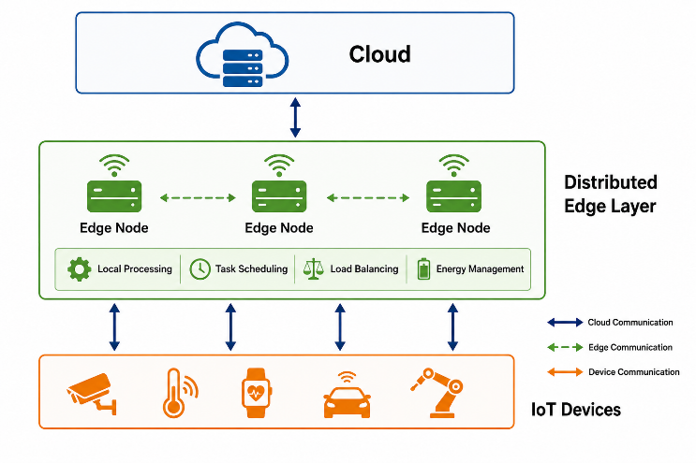
Fig. 1. Proposed Distributed Edge Computing Framework for Enhancing Energy Efficiency in IoT Devices
The remainder of this paper is organized as follows. Section II presents the related work and literature review associated with IoT energy optimization and edge computing techniques. Section III describes the proposed distributed edge computing framework and methodology. Section IV discusses the experimental setup and results of the proposed model. Finally, Section V concludes the paper and highlights future research directions related to sustainable and energy-efficient IoT systems.

Literature Survey
Recent advancements in Internet of Things (IoT) systems and edge computing technologies have significantly contributed toward improving energy efficiency, reducing latency, and enhancing computational performance in smart environments. Singh et al. [3] presented an energy-efficient IoT architecture for smart city applications by implementing adaptive edge computing techniques. The proposed framework emphasized sustainable urban development through optimized resource allocation and localized data processing. The study showed that adaptive edge mechanisms can significantly decrease energy consumption while improving network scalability and operational reliability in smart city infrastructures. Tiwari et al. [4] investigated efficient task offloading strategies in edge computing using priority-based queuing and energy optimization techniques. Their model aimed to reduce processing delay and optimize energy utilization by intelligently distributing computational tasks among edge nodes. Experimental results indicated considerable improvements in task execution efficiency and reduced energy overhead compared with conventional offloading methods. Dong et al. [5] proposed an attention-driven deep reinforcement learning model for efficient task offloading in mobile edge computing environments. The study utilized intelligent learning-based optimization techniques to dynamically allocate computational tasks based on network conditions and resource availability. The proposed approach achieved improved load balancing, lower latency, and enhanced energy efficiency in mobile IoT networks. Bhatia and Sood [6] developed a quantum-computing-inspired optimal power allocation mechanism for edge computing environments. Their research focused on minimizing power consumption while maintaining high-quality service delivery across distributed edge infrastructures. The proposed optimization mechanism demonstrated improved energy allocation and computational performance in IoT-enabled edge networks. Sharma and Kumar [7] explored the role of Artificial Intelligence (AI) in enhancing data security and privacy within smart city environments. Their study highlighted the significance of intelligent monitoring, anomaly detection, and secure communication frameworks for protecting IoT-generated data. The research emphasized that secure and energy-efficient smart city infrastructures require the integration of AI-driven optimization and privacy-preserving mechanisms. P. S N et al. [8] proposed an energy-aware and trustworthy edge intelligence framework for sustainable AI-driven smart cities. Their work focused on integrating edge intelligence with sustainable computing techniques to improve energy efficiency and system trustworthiness. The study demonstrated that intelligent edge-based resource management can significantly enhance computational sustainability and operational stability in smart urban environments. Byeon et al. [9] examined task offloading and edge resource allocation mechanisms for next-generation AIoT communication systems. Their research highlighted the importance of intelligent resource management strategies in reducing communication latency and optimizing edge device utilization. The proposed methods improved overall network efficiency and supported energy-aware communication in consumer IoT technologies. Patil et al. [10] introduced a predictive edge intelligence framework for real-time energy optimization in smart buildings. Their model utilized predictive analytics and localized edge processing to reduce unnecessary energy consumption and improve operational efficiency. The study demonstrated substantial improvements in energy management and real-time monitoring performance in intelligent building environments. Anitha and Sivaraman [11] proposed a hybrid machine learning and blockchain-based framework for enhancing data privacy in edge computing systems. Their research focused on secure data sharing and privacy preservation within distributed edge environments. The integration of blockchain with machine learning improved trust management, data integrity, and secure communication among IoT devices and edge nodes. Adudhodla et al. [12] developed a secure federated learning framework for anomaly detection in IoT networks using lightweight cryptographic hashing techniques. The proposed model enhanced network security and protected distributed IoT environments against malicious attacks while maintaining low computational overhead. Their findings indicated that lightweight security mechanisms can improve the reliability and scalability of IoT-edge communication systems.

Proposed MEthodology
This study proposes a distributed edge computing framework for enhancing energy efficiency in Internet of Things (IoT) environments through intelligent resource management, adaptive task scheduling, and localized data processing mechanisms. The primary objective of the proposed methodology is to minimize the overall energy consumption of IoT devices while improving computational efficiency, reducing communication latency, and extending network lifetime. The framework integrates distributed edge nodes between IoT devices and cloud infrastructure to enable efficient task execution and real-time data processing closer to the source devices. The proposed model also incorporates energy-aware optimization techniques for dynamic workload allocation, communication management, and resource utilization in heterogeneous IoT environments.

IoT Device Layer and Data Acquisition
The initial stage of the proposed framework consists of an IoT device layer responsible for collecting and transmitting real-time data from various smart environments. The IoT layer includes multiple resource-constrained devices such as environmental sensors, wearable devices, surveillance systems, industrial monitoring units, healthcare sensors, and smart transportation devices. These IoT nodes continuously generate large volumes of heterogeneous data related to environmental conditions, user activities, system operations, and device performance metrics. Since IoT devices operate with limited battery resources and constrained computational capabilities, continuous transmission of raw data to centralized cloud servers significantly increases communication overhead and energy consumption. To overcome this issue, the proposed framework enables intelligent local communication between IoT devices and nearby distributed edge nodes. The collected data packets are initially filtered, prioritized, and categorized according to their urgency, processing requirements, and communication cost. Redundant, low-priority, and unnecessary transmissions are minimized to reduce network congestion and preserve device energy. The data acquisition layer also monitors device energy levels, communication status, and network conditions to support adaptive energy optimization throughout the system.

Distributed Edge Computing and Localized Data Processing
The second stage of the proposed methodology introduces distributed edge computing mechanisms for localized data processing and intelligent computational management. Multiple edge nodes are deployed near IoT devices to provide low-latency computation, temporary storage, and real-time processing services. Instead of transmitting all generated data to distant cloud servers, the proposed framework processes delay-sensitive and computation-intensive tasks at nearby edge nodes, thereby reducing communication distance and minimizing energy expenditure. Each distributed edge node performs local data analysis, task scheduling, workload balancing, and resource monitoring based on current network conditions and device requirements. The framework utilizes adaptive edge coordination mechanisms to distribute computational tasks dynamically among available edge nodes according to processing capacity, queue length, and energy utilization. The proposed methodology also incorporates intelligent caching and local storage techniques to reduce repeated data transmission and improve response time. Edge nodes continuously exchange lightweight coordination information to maintain balanced resource allocation and ensure efficient communication among interconnected devices. By reducing unnecessary cloud communication and enabling localized decision-making, the proposed distributed edge layer significantly improves energy efficiency and overall IoT system performance.

Energy-Aware Task Scheduling and Optimization Mechanism
The third stage of the proposed framework focuses on implementing an energy-aware optimization mechanism for intelligent task scheduling and workload management. Computational tasks generated by IoT devices are classified into different categories based on latency sensitivity, processing complexity, bandwidth requirements, and energy consumption characteristics. The proposed framework dynamically determines whether tasks should be executed locally on IoT devices, processed at nearby edge nodes, or forwarded to the cloud infrastructure for advanced analytical operations. To optimize energy utilization, the framework employs adaptive scheduling algorithms that allocate tasks according to available computational resources, device battery levels, communication cost, and network traffic conditions. High-priority and real-time tasks are processed at edge nodes to minimize delay, while less time-sensitive analytical tasks are selectively transferred to the cloud layer. The scheduling mechanism continuously monitors processing loads and redistributes tasks among distributed edge nodes to maintain balanced computational performance and avoid excessive energy consumption. The optimization framework also includes dynamic load balancing strategies to prevent bottlenecks within the edge environment. Resource allocation decisions are updated in real time based on changing workload patterns and device activity levels.

Cloud Integration and Centralized Monitoring
The fourth stage of the proposed methodology integrates cloud infrastructure with distributed edge environments for centralized monitoring, large-scale data storage, and advanced analytical processing. Although most real-time tasks are handled at edge nodes, cloud servers provide long-term storage, historical data analysis, machine learning model updates, and system-wide management capabilities. The cloud layer receives summarized and processed information from distributed edge nodes instead of raw IoT data streams, thereby reducing communication overhead and optimizing network bandwidth utilization. Centralized monitoring mechanisms within the cloud infrastructure analyze system performance metrics such as device energy consumption, task execution efficiency, network latency, and resource utilization trends. The cloud environment also supports future scalability by enabling integration with large-scale smart city, industrial automation, and healthcare applications. The interaction between IoT devices, distributed edge nodes, and cloud infrastructure creates a collaborative computing ecosystem that balances computational efficiency and energy optimization. The proposed hierarchical framework ensures efficient coordination among all system layers while maintaining low energy consumption and high operational reliability.

Performance Evaluation and Comparative Analysis
The final stage of the proposed methodology focuses on evaluating the performance of the distributed edge computing framework using multiple energy and network-related performance metrics. Experimental analysis is conducted under different IoT workload conditions to assess the effectiveness of the proposed model in comparison with conventional cloud-centric architectures. The evaluation parameters include energy consumption, task execution delay, response time, throughput, network latency, resource utilization, communication overhead, and device lifetime extension. Energy consumption analysis is performed to measure the reduction in power utilization achieved through localized edge processing and adaptive task scheduling mechanisms. Latency and response time evaluations determine the capability of the proposed framework to support real-time IoT applications with minimal communication delay. The framework is also analysed for scalability, reliability, and load balancing efficiency under varying network conditions and increasing numbers of connected IoT devices. Comparative analysis demonstrates the advantages of distributed edge computing mechanisms in minimizing communication cost, optimizing computational resource allocation, and improving sustainable IoT operations. The overall results validate the effectiveness of the proposed methodology for achieving energy-efficient and high-performance IoT ecosystems using distributed edge computing strategies.

Result and Analysis
Multiple IoT simulation scenarios were used to evaluate the proposed distributed edge computing framework for enhancing energy efficiency in IoT environments. The performance of the proposed framework was compared with conventional cloud-based architectures and existing edge computing approaches using different IoT workloads, communication conditions, and resource utilization levels. The experimental evaluation focused on measuring energy consumption, latency reduction, throughput enhancement, communication overhead, and overall network efficiency. The obtained results demonstrate that the proposed distributed edge computing mechanism significantly improves computational performance while reducing energy utilization and communication cost in large-scale IoT systems.

System Configuration and Experimental Environment
The implementation and performance evaluation of the proposed distributed edge computing framework were conducted using a high-performance simulation environment designed for IoT and edge computing experimentation. The experimental system was configured using an Intel Core i7 processor with 16 GB RAM operating on the Ubuntu platform. The framework was implemented using Python-based simulation tools and networking libraries including CloudSim, EdgeSimPy, NumPy, Pandas, Matplotlib, and TensorFlow for workload generation, task scheduling, resource allocation, and performance analysis. The experimental environment consisted of multiple IoT devices, distributed edge nodes, and centralized cloud servers operating under heterogeneous network conditions. Various smart IoT devices including sensors, wearable devices, industrial monitoring systems, and smart home appliances continuously generated real-time data streams with different computational and communication requirements. The distributed edge nodes were responsible for local processing, adaptive task scheduling, load balancing, and temporary data storage operations. The cloud infrastructure performed centralized monitoring and large-scale analytical processing for non-delay-sensitive tasks. Several workload conditions were considered during experimentation, including low, medium, and high traffic scenarios. Different communication parameters such as bandwidth utilization, processing delay, task arrival rate, and device energy levels were analysed to evaluate the scalability and effectiveness of the proposed framework under dynamic IoT environments.

Performance Evaluation Metrics
The performance evaluation of the proposed distributed edge computing framework was conducted using multiple energy and network-related performance metrics represented through equations (1) to (5). Energy Consumption measures the total amount of power utilized during task execution and communication operations:
$$Energy Consumption=\sum_{i=1}^{n}{(}P_{i}×T_{i})---(1)$$
where $P_{i}$represents power consumption and $T_{i}$represents task execution time. Latency evaluates the transmission delay (TD) and processing delay (PD) experienced during IoT task execution:
$$Latency=PD+TD------(2)$$
Throughput determines the successful rate of data processing and transmission within the IoT network:
$$Throughput=\frac{Total Processed Tasks}{Total Execution Time}----(3)$$
Resource Utilization (RU) measures the efficiency of computational resource allocation across distributed edge nodes:
$$RU=\frac{Used Resources}{Total Available Resources}×100----(4)$$
Communication Overhead (CO) determines the amount of additional network traffic generated during data transmission:
$$CO=\frac{Control Packets}{Total Transmitted Packets}×100----(5)$$
The combined analysis of these performance metrics provides a detailed evaluation of the energy efficiency, scalability, computational reliability, and communication effectiveness of the proposed distributed edge computing framework.

Comparative Analysis of Energy Consumption
The experimental analysis compares the energy consumption performance of traditional cloud-based systems, conventional edge computing models, and the proposed distributed edge computing framework.
- Energy Consumption Comparison of Various Computing Models
Computing Model | Energy Consumption (J) | Device Lifetime (Hours) | Energy Efficiency (%)
Cloud-Based IoT System | 420 | 18 | 72.4
Conventional Edge Computing | 338 | 24 | 81.6
Adaptive Edge Framework | 291 | 29 | 87.3
Proposed Distributed Edge Framework | 236 | 36 | 94.1

In TABLE I, the proposed distributed edge computing framework achieved the lowest energy consumption and the highest energy efficiency compared with conventional cloud-centric and edge-based architectures. The localized task execution and intelligent workload distribution mechanisms minimized unnecessary communication overhead and reduced power-intensive cloud interactions. The proposed framework also extended IoT device operational lifetime due to adaptive energy-aware scheduling and optimized resource utilization strategies.
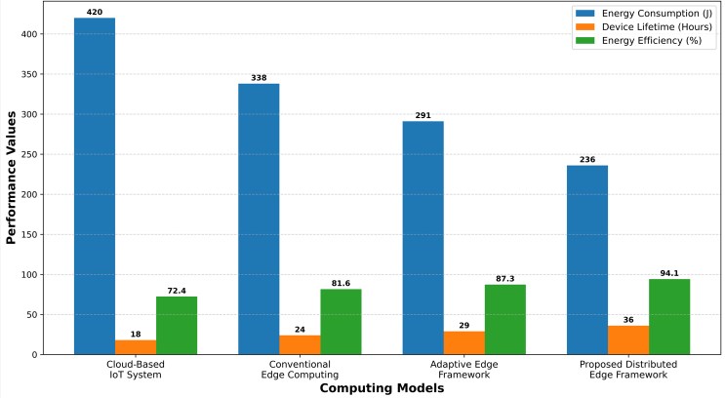
Fig. 2. Comparative Analysis of Energy Consumption in Different IoT Computing Models
Fig. 2 demonstrates that the proposed distributed edge computing framework significantly outperforms traditional architectures in terms of energy optimization and sustainable IoT operations.

Latency and Throughput Performance Analysis
The latency and throughput analysis evaluates the ability of the proposed framework to support real-time IoT applications under varying workload conditions.
- Comparative Latency, Response Time & Throughput Analysis of Computing Frameworks
Framework | Average Latency (ms) | Throughput (Tasks/s) | Response Time (ms)
Cloud-Based Architecture | 182 | 415 | 201
Traditional Edge Model | 126 | 562 | 139
Hybrid Edge System | 97 | 684 | 108
Proposed Distributed Edge Framework | 68 | 823 | 74

As shown in TABLE II, the proposed distributed edge framework achieved the lowest latency and response time while maintaining the highest throughput performance. The deployment of distributed edge nodes enabled localized processing of delay-sensitive IoT tasks, thereby reducing transmission delays and communication congestion. The intelligent load balancing mechanism further improved throughput efficiency by dynamically distributing workloads among available edge resources.
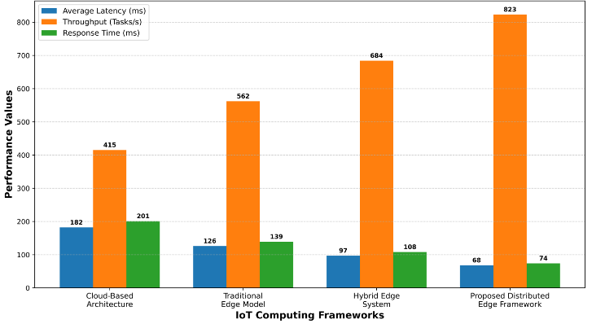
Fig. 3. Comparative Latency and Throughput Analysis of IoT Computing Frameworks
Fig. 3 illustrates that the proposed framework provides superior real-time processing performance and communication efficiency for large-scale IoT environments.

E. Scalability and Resource Utilization Analysis
The scalability analysis evaluates how effectively the proposed distributed edge framework maintains performance stability under increasing numbers of connected IoT devices.
- Scalability & Resource Utilization Performance under IoT Device Loads
Number of IoT Devices | Cloud Utilization (%) | Edge Utilization (%) | Proposed Framework Utilization (%)
500 Devices | 71.4 | 78.3 | 86.8
1000 Devices | 76.2 | 81.5 | 89.6
2000 Devices | 82.7 | 84.1 | 92.3
4000 Devices | 88.9 | 86.7 | 94.1
6000 Devices | 91.5 | 87.2 | 95.4

The scalability analysis indicates that the proposed distributed edge computing framework consistently maintains high resource utilization efficiency and stable network performance even as the number of connected IoT devices increases significantly shown in above TABLE III. The distributed coordination mechanism effectively balances workloads across multiple edge nodes, preventing computational bottlenecks and improving system scalability.
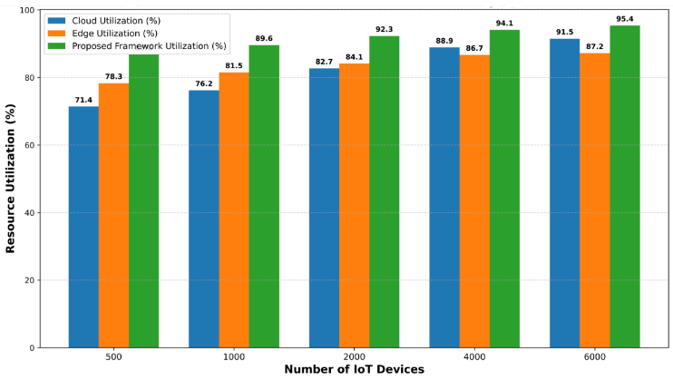
Fig. 4. Scalability Analysis of Distributed Edge Computing Framework under Different IoT Workloads
The comparative analysis presented in Fig. 4 confirms that the proposed framework provides superior scalability, resource optimization, and communication efficiency for next-generation energy-aware IoT applications operating in dynamic and large-scale smart environments.

Conclusion and Future Scope
The proposed framework effectively minimized communication overhead, reduced latency, optimized computational resource utilization, and improved the operational lifetime of IoT devices when compared with conventional cloud-based and traditional edge computing architectures. Experimental analysis demonstrated that the proposed framework achieved the lowest energy consumption of 236 J and the highest energy efficiency of 94.1%, significantly outperforming cloud-centric systems that recorded 420 J energy consumption and 72.4% efficiency. Similarly, the proposed model achieved superior real-time processing performance with a latency of 68 ms, throughput of 823 tasks/s, and response time of 74 ms, indicating substantial improvements in communication and computational efficiency. The scalability analysis further confirmed that the framework maintained stable resource utilization efficiency of 95.4% even under large-scale IoT workloads consisting of 6000 connected devices. The overall results validate that distributed edge computing mechanisms provide an effective and scalable solution for sustainable IoT operations in next-generation smart environments. In future work, the proposed framework can be extended by integrating artificial intelligence, federated learning, blockchain-based security mechanisms, and predictive resource management techniques to further improve autonomous decision-making, security, scalability, and energy optimization in heterogeneous IoT ecosystems and smart city infrastructures.

References
- D. K. Sah, M. Vahabi and H. Fotouhi, "Real-Time Inference for IIoT Using Distributed Low-Power Edge Clusters," 2025 IEEE 11th World Forum on Internet of Things (WF-IoT), Chengdu, China, 2025, pp. 1-3, doi: 10.1109/WF-IoT64238.2025.11270629.
- J. R, D. U, P. Mohandas, S. M, Y. N and A. A, "Edge-to-Cloud Deep Learning Framework for IoT Environments," 2026 3rd International Conference on Emerging Trends in Engineering and Medical Sciences (ICETEMS), Nagpur, India, 2026, pp. 1-8, doi: 10.1109/ICETEMS66917.2026.11469696.
- P. Singh, G. R. V, S. Ponmaniraj, A. Aggarwal and S. Kumari, "Energy-Efficient IoT Architectures for Smart Cities: Implementing Adaptive Edge Computing for Sustainable Urban Development," 2025 International Conference on Electronics, AI and Computing (EAIC), Jalandhar, India, 2025, pp. 1-6, doi: 10.1109/EAIC66483.2025.11214219.
- S. Tiwari, Z. Naaz and V. Sharma, "Efficient Task Offloading in Edge Computing Using Priority Based Queuing and Energy Optimisation," 2025 International Conference on Intelligent and Secure Engineering Solutions (CISES), Greater Noida Gautam Budh Nagar, India, 2025, pp. 743-747, doi: 10.1109/CISES66934.2025.11264850.
- H. Dong, Z. Dou, Y. Ji and J. Dong, "Attention-Driven Deep Reinforcement Learning for Efficient Task Offloading in Mobile Edge Computing," 2025 10th International Symposium on Advances in Electrical, Electronics and Computer Engineering (ISAEECE), Xi'an, China, 2025, pp. 223-228, doi: 10.1109/ISAEECE66033.2025.11160206.
- M. Bhatia and S. Sood, "Quantum-Computing-Inspired Optimal Power Allocation Mechanism in Edge Computing Environment," in IEEE Internet of Things Journal, vol. 11, no. 10, pp. 17878-17885, 15 May15, 2024, doi: 10.1109/JIOT.2024.3358900.
- V. Sharma and S. Kumar, "Role of Artificial Intelligence (AI) to Enhance the Security and Privacy of Data in Smart Cities," 2023 3rd International Conference on Advance Computing and Innovative Technologies in Engineering (ICACITE), Greater Noida, India, 2023, pp. 596-599, doi: 10.1109/ICACITE57410.2023.10182455.
- P. S N, D. K. J. Bahadur Saini, S. M. Jirankali, G. Varma, H. Khanum and S. Kolekar, "Energy-Aware and Trustworthy Edge Intelligence for Sustainable AI-Driven Smart Cities," 2026 7th International Conference on Mobile Computing and Sustainable Informatics (ICMCSI), Goathgaun, Nepal, 2026, pp. 415-422, doi: 10.1109/ICMCSI67283.2026.11412727.
- H. Byeon et al., "Consumer Technology in Task Offloading and Edge Resource Allocation: AIoT and Edge Computing for Next-Generation Communication," in IEEE Transactions on Consumer Electronics, vol. 71, no. 2, pp. 5356-5365, May 2025, doi: 10.1109/TCE.2025.3552205.
- D. V. Patil, S. Joshi, N. V, N. Yamsani, T. P. Priyanka and V. Kumar Shukla, "Real-Time Energy Optimization in Smart Buildings Using Predictive Edge Intelligence," 2025 International Conference on Intelligent and Secure Engineering Solutions (CISES), Greater Noida Gautam Budh Nagar, India, 2025, pp. 887-892, doi: 10.1109/CISES66934.2025.11265329.
- M.Anitha and K.Sivaraman, "Enhancing Data Privacy in Edge Computing Through Hybrid Machine Learning and Blockchain Technologies," 2026 IEEE International Conference for Convergence in Computing Technology (I3CTCON), Lonavala, India, 2026, pp. 1-6, doi: 10.1109/I3CTCON68242.2026.11507430.
- M. Adudhodla, M. Archana, K. D. Reddy, V. Swathi and B. Rambabu, "Secure Federated Learning Framework for Anomaly Detection in IoT Networks using Lightweight Cryptographic Hashing," 2025 4th International Conference on Innovative Mechanisms for Industry Applications (ICIMIA), Tirupur, India, 2025, pp. 472-477, doi: 10.1109/ICIMIA67127.2025.11200771.

