Analysis of Arbuscular Mycorrhizal Fungal Diversity Associated with Pigeon pea (Cajanus cajan L.) in Osmanabad District, Maharashtra, India.

Abstract
Arbuscular mycorrhizal fungi (AMF) play a crucial role in enhancing plant growth, nutrient uptake, and soil fertility through their symbiotic association with plant roots. The present study focuses on evaluate the diversity and distribution of arbuscular mycorrhizal fungi associated with pigeon pea (Cajanus cajan L.) cultivated in various talukas of Osmanabad District, Maharashtra. Root and rhizosphere soil samples were collected from 08 pigeon pea growing location to assess the extent of AMF root colonization and spore density in the soil. The highest root colonization was observed in Paranda Taluka (75 %), while the lowest colonization was recorded in Lohara Taluka (17%). The widespread occurrence of AMF across the study area suggests their ecological significance in pigeon pea agroecosystems. Among the identified fungal genera, Acaulospora and Glomus species were the predominant and most frequently isolated. The study highlights the ecological significance of AMF in pigeon pea cultivation and their potential role in improving soil health and supporting sustainable agricultural productivity in the Osmanabad region.
Keywords: Arbuscular mycorrhizal fungi, Pigeon pea, Root colonization, spore isolation.

Introduction:
Arbuscular mycorrhizal fungi (AMF) are beneficial soil microorganisms that form a mutualistic association with the roots of most terrestrial plants. In this symbiotic relationship, the host plant supplies carbohydrates to the fungus, while the fungus enhances the uptake of water and essential nutrients, particularly phosphorus, from the soil (Khaliq et al., 2022). This association plays a crucial role in improving plant growth, nutrient acquisition, stress tolerance, and soil health (Begum et al., 2019). Approximately 80-90% of vascular plant species and nearly 90% of cultivated plants establish symbiotic relationships with AMF, highlighting their ecological and agricultural significance (Berruti et al., 2014)
Pigeon pea commonly known as red gram or tur, is one of the oldest and most important pulse crops cultivated in India. It is the second most important pulse crop after chickpea and serves as a major source of dietary protein for millions of people. The seeds are commonly consumed as split pulse (dal) and are rich in proteins, minerals and essential amino acids such as lysine, threonine, cystine and arginine (Talari and Shakappa, 2018). Due to its deep root system and ability to fix atmospheric nitrogen, pigeon pea also contributes to the improvement of soil fertility and sustainability of cropping systems (Kakraliya et al., 2018).
India occupies the leading position in the world in terms of pigeon pea cultivation, accounting for about 79.65% of the global cultivated area and 67.28% of total production (Chaudhary et al., 2023). However, the average productivity of pigeon pea in India is relatively low (587 kg ha⁻¹) compared with some other countries, indicating the need for improved crop management practices and enhanced utilization of beneficial soil microorganisms (Singh et al., 2017).
In Maharashtra, pigeon pea is an important rainfed pulse crop and is frequently grown in intercropping systems with crops such as soybean and cotton. Osmanabad District is one of the major pigeon pea-growing regions of the state and has shown a positive annual growth rate of approximately 4.84% in pigeon pea production. Despite its agricultural importance, information regarding the diversity and distribution of AMF associated with pigeon pea in this region remains limited.
Considering the significant role of AMF in enhancing nutrient uptake, plant growth, and soil fertility, the present study was undertaken to investigate the occurrence, root colonization, spore population, and diversity of arbuscular mycorrhizal fungi associated with pigeon pea cultivated in different locations of Osmanabad District, Maharashtra. The findings of this study may contribute to the development of sustainable agricultural practices and improved pulse crop productivity.
Material and methods.
Sample Collection
A field survey was conducted from 08 pigeon pea growing locations, namely Bhoom, Paranda, Washi, Kalamb, Osmanabad, Lohara, Umarga, and Tuljapur in Osmanabad District, Maharashtra. From each location, 05 healthy plants were randomly selected for the collection of root and rhizosphere soil samples. Soil samples were collected from the root zone at a depth of 0-30 cm, transferred to sterile polythene bags, properly labelled, and transported to the laboratory for further analysis.

Assessment of AMF Colonization
Root samples were thoroughly washed under running tap water to remove adhering soil particles and cut into approximately 1cm long segments (Marais et al., 2017). The percentage of arbuscular mycorrhizal fungal (AMF) root colonization was determined using the gridline intersect method described by Giovannetti and Mosse in 1980 (Khakpour and Khara, 2012).
Isolation of AMF Spores
Arbuscular mycorrhizal fungal spores were isolated from 100 gm of rhizosphere soil using the wet sieving and decanting technique of Gerdemann and Nicolson (1963). The isolated spores were collected, counted under a stereomicroscope and expressed as the number of spores per 100 g of soil.
Identification of AMF Species
The isolated AMF spores were identified through microscopy observation on the basis of their morphological characteristics, including spore size, shape, colour, wall structure and subtending hyphae. Species identification was carried out using the taxonomic key and identification manual of Schenck and Perez (1990).
Results and Discussion
The present investigation was carried out to evaluate the extent of arbuscular mycorrhizal (AM) fungal association in pigeon pea cultivated across 08 talukas of Osmanabad district. Considerable variation was observed in root colonization, spore population, and AM fungal diversity among the sampling locations.
The diversity of AM fungi associated with pigeon pea varied among the 08 talukas of Osmanabad district. Bhoom exhibited the highest species richness, with 07 arbuscular mycorrhizal (AM) fungal species belonging mainly to the genera Glomus, Acaulospora, Gigaspora and Scutellospora. Osmanabad taluka recorded 06 species representing three genera, whereas Washi and Omerga each harboured 05 species. Paranda, Kallamb and Tuljapur recorded 04 species each, while Lohara showed the lowest diversity with only 03 species. Total 04 AM fungal genera, namely Glomus, Acaulospora, Gigaspora, and Scutellospora, were identified from pigeon pea rhizosphere soils.
Among the identified genera, Acaulospora was represented by the highest number of species (13), followed by Glomus (11), Gigaspora (5) and Scutellospora (5). The predominance of Acaulospora and Glomus across all sampling locations indicates their greater ecological adaptability and host compatibility with pigeon pea. Similar dominance of these genera has been reported by Belose and Chahar (2018), who observed that Glomus and Acaulospora constitute the major component of AM fungal communities associated with leguminous crops in Maharashtra and other parts of India.
Table 1. Root colonization, spore population and am fungal species associated with pigeon pea in Osmanabad District.

Sr. No. | Location | Root Colonization (%) | Type of Colonization | Spore Population (100 g⁻¹ soil) | Name of the AM Fungal Species Identified
1 | Bhoom | 36 | HV | 70 | Glomus mosseae, G.clarum, Scutellospora calospora, Gigaspora decipiens, A. laevis, A. rehmii, A. delicata
2 | Paranda | 34 | HV | 75 | G. versiforme, A. myriocarpa, G. ambisporum, G. constrictum
3 | Washi | 24 | HV | 60 | A. undulata, G. lamellosum, A. elegans, S. calospora, A. dentaculata
4 | Kallamb | 30 | HV | 60 | G. etunicatum, S. scutata, A. dilatata, G. maculosum
5 | Osmanabad | 28 | HV | 70 | A. rehmii, G. intraradices, A. reducta, A. tuberculata, G. deserticola, G. gigantea
6 | Lohara | 17 | HV | 68 | A. nicolsonii, G. geosporum, A. rugosa
7 | Omerga | 30 | HV | 55 | A. spinosa, G. candida, A. mellea, S. coralloidea, A. dilatata
8 | Tuljapur | 42 | HV | 59 | A. reducta, G. halan, S. cunninghamia, G. margarita
*HV = Presence of hyphae and vesicles.
Root colonization by AM fungi ranged from 17% to 42%. The highest colonization was recorded in Tuljapur (42%), followed by Bhoom (36%) and Paranda (34%), whereas the lowest colonization was observed in Lohara (17%). The presence of hyphae and vesicles in all root samples confirmed the establishment of AM fungal symbiosis in pigeon pea plants throughout the district. Differences in colonization levels among locations may be related to variations in soil characteristics, moisture availability, agricultural practices and the abundance of native AM fungal communities (Sarwade et al., 2025).
The spore population in rhizosphere soil also differed among the study sites. The highest spore count was observed in Paranda (75 spores per 100 g soil), followed by Bhoom and Osmanabad (70 spores per 100 g soil). In contrast, the lowest spore population was recorded in Omerga (55 spores per 100 g soil). The higher spore density observed in certain locations may indicate favourable environmental conditions for AM fungal growth, sporulation and survival.
Overall, the results demonstrate that pigeon pea grown in Osmanabad district maintains a strong association with indigenous AM fungi. The higher root colonization recorded in Tuljapur and the greater spore population observed in Paranda indicate that these locations provide favourable conditions for AM fungal development. The dominance of Acaulospora and Glomus highlights their ecological significance and potential use in improving nutrient uptake, soil fertility, and sustainable pigeon pea production. This study emphasizes the importance of conserving native AM fungal populations and exploring their utilization as biofertilizers in pulse cultivation.
Photo plate: Arbuscular Mycorrhizal (AM) Fungal Spore and Root Colonization Structures Associated with Pigeon Pea
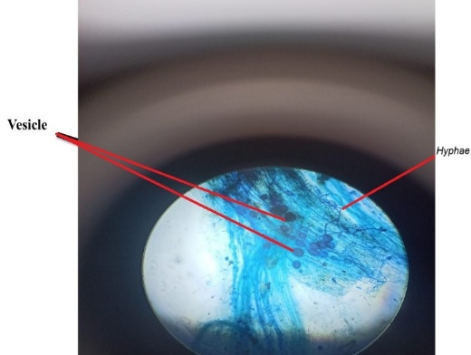
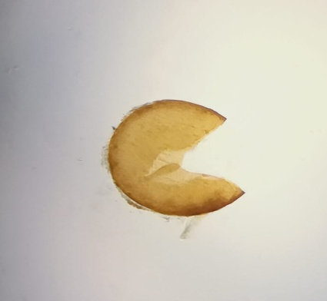
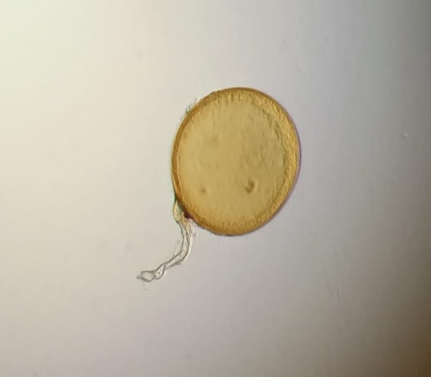
A
B
C

Morphological characteristics of arbuscular mycorrhizal fungi isolated from pigeon pea rhizosphere soil and root tissues: (A) Acaulospora spore, (B) Glomus spore and (C) stained root segment showing hyphal and vesicular colonization.

Conclusion
The present study demonstrated the widespread occurrence of arbuscular mycorrhizal (AM) fungi in pigeon pea rhizosphere soils of Osmanabad district. Root colonization ranged from 17-42%, while spore population varied from 55-75 spores per 100 g soil. A total 04 arbuscular mycorrhizal (AM) fungal genera, namely Acaulospora, Glomus, Gigaspora and Scutellospora, were identified, with Acaulospora and Glomus being the dominant genera. These fungi are likely to play a significant role in nutrient acquisition, especially phosphorus uptake, and may contribute to improved soil fertility and sustainable pigeon pea production in the semi-arid regions of Maharashtra.

Acknowledgement
The authors are grateful to the management and Principal of J.E.S. College, Jalna, for providing the necessary facilities to conduct this research work. We sincerely thank the Head, Department of Botany, for encouragement and support. We express our heartfelt gratitude to our research guide for valuable guidance and continuous support throughout the study. We also acknowledge the cooperation of our classmates and the farmers of the study region for their assistance during sample collection and field investigations.
Bibliography
Begum N., Qin C., Ahanger A., Raza S., Khan I., Ashraf M. and Zhang L. (2019): Role of arbuscular mycorrhizal fungi in plant growth regulation: implications in abiotic stress tolerance. Frontiers in plant science, 10: 1068.
Berruti A., Borriello R. and Orgiazzi A. (2014): Arbuscular Mycorrhizal Fungi and their Value for. Biodiversity: the dynamic balance of the planet, 159.
Chahar S. and Belose S. (2018): AM Fungal Diversity in selected medicinal trees of Sanjay Gandhi National Park, Borivali, Mumbai, India. International Journal of Life Sciences, 6(2): 517-522.
Chaudhary J., Khan A., Manzoor U. and Yadav A. (2023): Chapter-31 Improved Cultivation of Pigeon Pea. Capsule of Agriculture, 393.
Giovannetti M. and Mosse B. (1980): An evaluation of techniques for measuring vesicular arbuscular mycorrhizal infection in roots. New phytologist, 489-500.
Kakraliya K., Singh U., Bohra A., Choudhary K., Kumar S., Meena S. and Jat L. (2018): Nitrogen and legumes: a meta-analysis. In Legumes for soil health and sustainable management (pp. 277-314). Singapore: Springer Singapore.
Khakpour O. and Khara J. (2012): Spore density and root colonization by arbuscular mycorrhizal fungi in some species in the northwest of Iran. International research journal of applied and basic sciences, 3(5): 977-982.
Khaliq A., Perveen S., Alamer H., Zia Ul Haq M., Rafique Z., Alsudays M. and Attia H. (2022): Arbuscular mycorrhizal fungi symbiosis to enhance plant-soil interaction. Sustainability, 14(13): 7840.
Marais M., Swart A., Fourie H., Berry D., Knoetze R. and Malan P. (2017): Techniques and procedures. In Nematology in South Africa: A view from the 21st century (pp. 73-117). Cham: Springer International Publishing.
Sarwade P., Gaisamudre N., Bhise S. and Gaikwad S. (2025): Belowground Biodiversity: AM Fungi Research Trends in Maharashtra. Plantae Scientia, 8(3): 42-46.
Singh G., Virk K., Singh S., Singh K., Singh S. and Gill K. (2017): Thermal requirements, growth and yield of pigeonpea [Cajanus cajan (L.) Mill sp.] genotypes under different agroclimatic zones of Punjab. Journal of Applied & Natural Science, 9(4), 2377.
Sun, X. G., & Tang, M. (2012). Comparison of four routinely used methods for assessing root colonization by arbuscular mycorrhizal fungi. Botany, 90(11), 1073-1083.
Talari A. and Shakappa D. (2018): Role of pigeon pea (Cajanus cajan L.) in human nutrition and health: A review. Asian Journal of Dairy & Food Research, 37(3).

