EASEContent: A Unified AI-Integrated Collaboration Platform Based on a Modular Monolithic Event-Driven Architecture

Abhay Sharma  Department of Artificial Intelligence and Data Science  New Horizon Institute of Technology & Management  Thane, India  Deekshant Rahangdale  Department of Artificial Intelligence and Data Science  New Horizon Institute of Technology & Management  Thane, India | Soham Jambekar  Department of Artificial Intelligence and Data Science  New Horizon Institute of Technology & Management  Thane, India  Ass. Prof. Dr.Geetanjali V Kale  Department of Artificial Intelligence and Data Science  New Horizon Institute of Technology & Management  Thane, India

Abstract- Modern digital content production is distributed across roles and functions, namely scriptwriters, video editors, designers, and reviewers. Many SaaS tools have been developed, but content workflows remain fragmented across storage platforms, document editors, communication systems, and AI-based utilities. This fragmentation causes inefficiencies, inconsistent access control, and increased operational overhead. In this paper, we propose EASEContent, an integrated platform that combines media-centric workflows with a modular, monolithic event-driven system. The system includes secure authentication (Clerk), multipart direct-to-S3 uploads, adaptive streaming (ImageKit), asynchronous task processing (Redis using BullMQ), and AI-assisted scripting using OpenAI APIs. It minimizes backend memory overhead, enforces role-based access control, and keeps system consistency through webhook synchronization. The design approach, architectural features, security measures, and scalability are discussed in the paper. The contribution is to offer a technically coherent framework that unifies the key collaboration components to enable maintainability and simple deployment.
Keywords - SaaS platforms, monolithic architecture, event-driven systems, multipart upload, adaptive streaming, AI-assisted collaboration.

I. INTRODUCTION
The explosion of the creator economy has led to a radical reshaping of production of digital content. Video Content Production Teams often use a range of independent platforms for storage, script writing, authentication, notifications, and AI-generated edits. although these tools are indeed powerful in isolation, integration into consolidated workflows is still a challenge. Within the norm, creators use cloud storage technology for media management, document platforms to draft scripts, messaging tools for communication, and separate AI services for language support.
The problem with this fragmented toolchain is that it brings operational challenges associated with this problem, such as context switching, inconsistent access control, duplicate data processing, and slower feedback cycles. From a systems perspective, though, the issue is not the lack of functioning tools, but architecture as a whole. SaaS platforms today focus on only one functional domain, instead of enabling integrated workflow across many domains. This paper develops EASEContent, a collaborative platform aimed at overcoming workflow fragmentation with its modular monolithic structure and event driven in-house processing. The platform integrates:
Role management from a place of comfort in the workspace. Multipart direct-to-object storage for media uploads. Webhook-driven identity synchronization. AI-guided editing scripting on the editor's editor embedded with support for AI scripts from the editor for writing AI-assisted scripting within the editor. Adaptive streaming of video for viewing the review workflow. To this end, the main contribution of this work combines the architectural design and analysis of a single, yet well-designed unified system for the system, with a balance between integration depth and ease of deployment, and makes it easy to work in media driven collaborative application.
II. RELATED WORK
- Literature study
Paper | Key Findings
[1] | -Describes the multipart upload process in Amazon S3, enabling efficient large file uploads.  -Provides a robust mechanism for resuming failed uploads and reducing network congestion.
[2] | -Highlights AWS services that facilitate the development of live video streaming applications.  -Discusses techniques for building scalable and fault-tolerant video streaming systems.
[3] | -Introduces key integration patterns that help in designing scalable, maintainable enterprise applications. - Focuses on patterns for message routing, event-driven architecture, and message transformation.
[8] | -Discusses how SaaS platforms enhance collaboration through real-time communication and data sharing.  -Explores the impact of seamless integration, scalability, and customization on team productivity.
[4] | -Discusses how SaaS platforms enhance collaboration through real-time communication and data sharing.  -Explores the impact of seamless integration, scalability, and customization on team productivity
[8] | -Proposes a Notion-like SaaS platform with AI integration to enhance personal and team productivity.  -AI tools automate tasks, offering intelligent suggestions for task management and content creation.
[9] | -Investigates how algorithmic platforms shape creator behavior and the challenges creators face when interacting with algorithms.  -Highlights design opportunities to improve creator experience and transparency in algorithmic decision-making.
[10] | -Discusses how AI technologies enhance creative workflows in fields such as media, design, and content creation.  -Provides a systems perspective on integrating AI tools into creative processes for improved efficiency and innovation.
[11] | -Examines the effectiveness of collaborative authoring in creating video scene descriptions.  -Highlights the benefits of group involvement in improving the accuracy and richness of video metadata for accessibility purposes.
- Work flow structure
Collaboration tools based on the SAAS standard have been widely used to enhance distributed team work. According to the research & industry, cloud technologies enhance collaboration across teams in real time by enabling real-time collaboration of teams, based on industry reports and other sources. Research and reports in the literature suggests that tools based at the cloud have substantially improved the collaboration in real time. However most software is more for the editing or storage of the document, but less end to end workflow integration. From an architectural point of view, microservices are rapidly gaining popularity on large SaaS systems in that they are easier to deploy and provide better service isolation [2]. However, for all of these reasons microservices have introduced new complexity of operations, such as distributed tracing, inter-service communication delay, and deployment orchestration problem. Event driven architectures (EDA) provide another solution to enhance responsiveness, removing the heavy tasks from the main request-response cycle [3]. Asynchronous Queue-based systems, especially Redis-based ones, are now popular for notifications, background processing and media tasks. For big media uploads, multipart upload approaches are proposed, which help minimizing failures and achieving better performance in dispersed storage systems [1]. Direct upload with pre-signed URLs can reduce backend resource consumption and improve the possibility of scaling. Adaptive streaming with HTTP Live Streaming (HLS) is utilized for efficient video playback under diverse network conditions [2]. In particular, in collaborative review environments, this is critical, as users may access content with varying bandwidth resources. AI editing tools have been incorporated into SaaS editors for assisting in grammar cleaning, translation, and content generation [8]. But such integrations tend to be external add-ons rather than embedded into a cohesive workflow platform. EASEContent extends on these foundations, allowing for authentication, storage, streaming, asynchronous processing, and AI together in one seamless architecture.

III. METHODOLOGY
EASEContent was built with a design-based systems focus of consolidating broken content creation, with the help of a unified architectural architecture. The first phase involved dissecting existing creator toolchains and identifying technical deficiencies such as lack of efficient large file management, poor access control, using different platforms, and no built-in AI support. The system was designed to accommodate secure workspace-based role management, efficient media uploads, asynchronous task execution with integrated AI-assisted scripting, within a single deployment model on a modular service approach.
A modular monolithic architecture was chosen by considering the tradeoffs in microservices versus unified deployment models. Although microservices are scalable, they also have inter-service communication overheads and operational complexity. Due to the integrated structure of media workflows, the monolithic structure with internal modular separation was chosen. In order to keep this responsive, we employed an event-driven processing mechanism using Redis and BullMQ, where for heavier processing such as notifications and media related triggers asynchronously was allowed to execute. We optimized for large file uploads with a pre-signed, multipart direct-to-S3 approach, limiting backend memory dependency and enhancing reliability for heavy media access. The authentication and identity synchronization was done by Clerk secured webhook validation for ensuring consistency between identity provider and our application database. AI-assisted scripting was built into the framework using secure server-side API calls to OpenAI, which allowed us to correct grammar and render documents without presenting the client's own credentials. It was docker-based and ran inside a cloud-hosted environment with managed database and Redis service, combining infrastructure management and operational simplicity.

IV. SYSTEM ARCHITECTURE
The EASEContent architecture is summarized in Fig. 1, adheres to a modular monolithic architecture that allows core application logic to work together in a single backend while external managed services are integrated through defined interfaces. All client requests are sent via load balancer to an Express-based server. Authentication is externally managed by Clerk, with identity verification and session management done by Clerk and user state being maintained through user-state sync with secure webhooks ensuring the identity provider and the internal database are consistent. It uses Novu to process notifications for communication through asynchronous communication without blocking primary request-response flows. Redis-backed asynchronous processing layer allows handling of all media and workflow operations. The Upload Management Service creates pre-signed URLs to allow direct file transfer to Amazon S3, which provides security and scalability by not forcing large payloads to go to the backend. Stored media can be distributed externally to sites like YouTube, LinkedIn, and X via the Smart Publish Service, while ImageKit provides adaptive HLS streaming for review. The Drizzle ORM that connects to PostgreSQL handles workspace and asset management, providing transactional consistency. These components stand together under layer separation between authentication, storage, streaming, processing, and persistence while keeping deployment as simple as possible in a containerized environment.
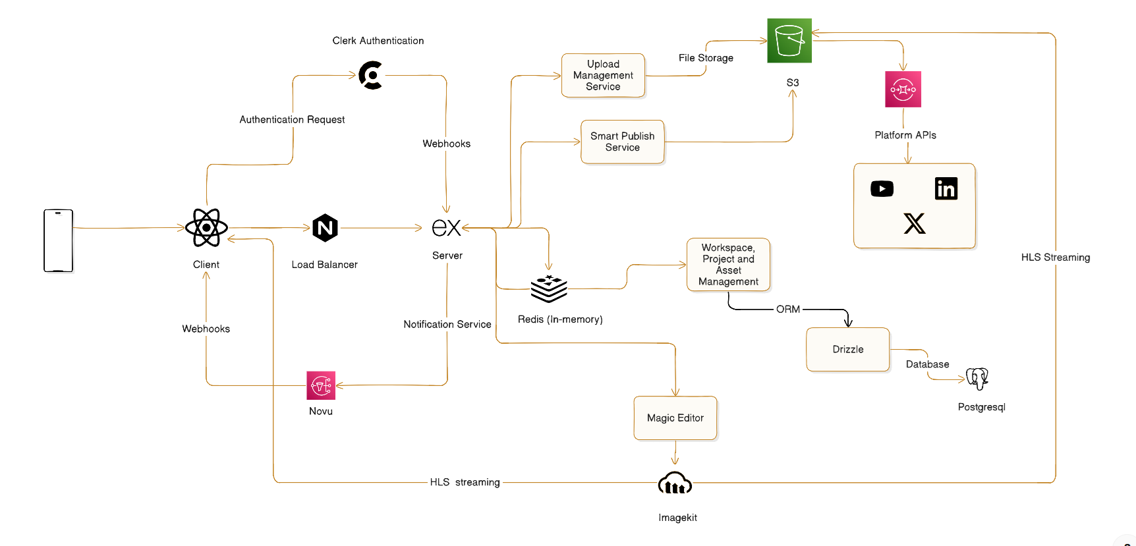
Fig. 1. System Architecture

V. SEQUENCE FLOW AND DESIGN ANALYSIS

A. Invitation and Role Management Workflow
The invitation workflow was designed to handle the secure and controlled onboarding of members into collaborative workspaces. When a workspace owner sends an invitation, the system first verifies if the user has ownership rights and confirms that the invitee is not currently part of the workspace. Next, a secure random token is created that represents an invitation and instead of storing it directly, it is hashed before saving to the database for extra security. Each invitation is given a time limit to avoid misuse. Notifications about the invitation are processed asynchronously so that the system-wide performance is not affected. When the invited user accepts the request, membership is added through a database transaction, allowing updates performed safely and with consistency. Upon acceptance of the invitation, the user's membership is added by the transactional operation of a database to ensure data integrity, consistency, and reliability at each step during the onboarding phase. The invitation token is invalidated immediately after successful acceptance to prevent reuse and enhance security. Audit logs are maintained for invitation creation, acceptance, and expiration events to ensure traceability and accountability within the system. The system also performs consistency checks to prevent race conditions when multiple operations occur simultaneously. This workflow ensures that workspace onboarding remains secure, scalable, and reliable even as the number of users and workspaces grows. Overall, the invitation mechanism promotes controlled collaboration while maintaining strong security and data integrity across the platform.
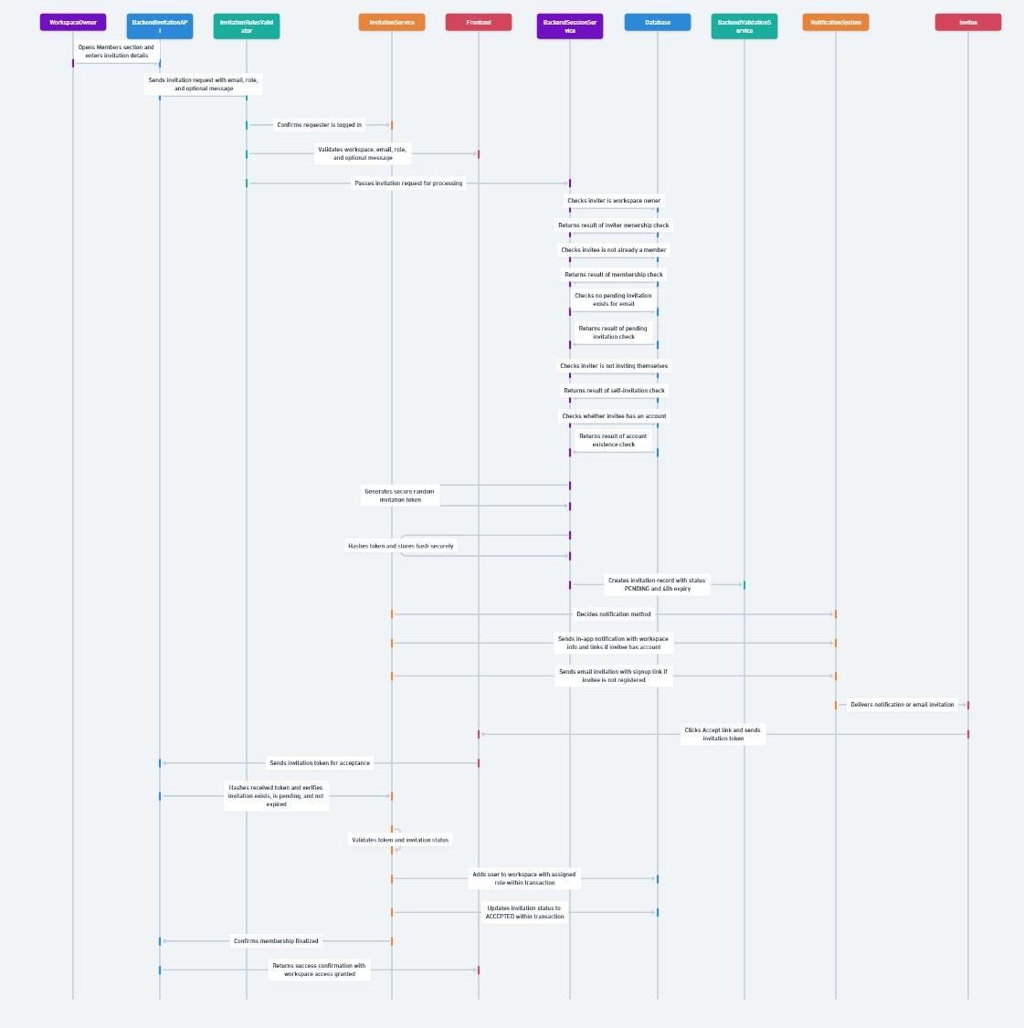
Fig. 2. Invitation and Role Assignment Flow

B. Multipart Direct-to-S3 Upload Mechanism
Unlike routing uploads through a backend server, the system uses a pre-signed URL mechanism to handle large media files efficiently. Users trigger an upload, and the backend prepares an upload plan and generates pre-signed URLs. The client then uploads files directly with these URLs to Amazon S3. For bigger files, we chunk the upload and upload in parallel with the multipart upload option. This system eases load on the backend server, and doesn’t rely on unnecessary memory usage, resulting in increased reliability in case of network interruptions. More so, the platform can best serve the kind of media-heavy workflows that involve video editing and review.

C. Webhook Synchronization Model
As authentication is performed externally by Clerk, a webhook-based synchronization mechanism is used to maintain proper internal database alignment with user identity changes. Clerk sends a webhook request to the backend whenever any user-related event happens. Initially, the webhook signature is verified to ascertain legitimacy, and the system validates and processes the payload. The correct handler updates the internal database records according to the type of event. This means that user registration, updates, and authentication states stay consistent between the external authentication provider and the application’s authorization logic.
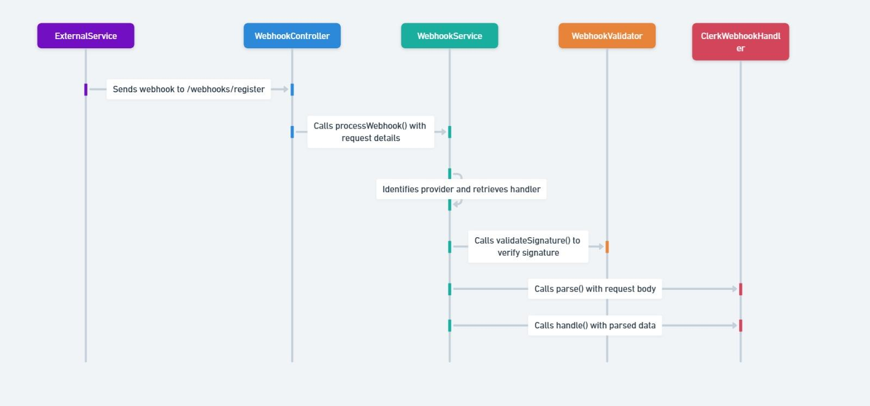
Fig. 3. Webhook Synchronization Flow

VII. DISCUSSION, SCALABILITY, AND FUTURE DIRECTIONS
The modular monolithic architecture of this new architecture is an easy deployment concept that supports scalable operation. Vertical scaling can occur through resource sharing at the container level, and since the API layer remains largely stateless, horizontal replication is feasible under increased traffic conditions. This enables Redis-backed asynchronous processing with reducers that alleviate block jobs due to overhead workload, such as notifications and media-related triggers, being assigned to the background of the systems.
Additionally, our direct-to-S3 multipart upload approach guarantees that the back end memory burden is largely independent of the size of the file used for the system, thus allowing you to scale your media dependent workloads up or down nicely. The current architecture provides a good compromise between integration and complexity, but empirical benchmarking on production-scale loads to assess performance can be explored in future work. Gradual decomposition to distributed services may also be studied to show the limits for scalability at high concurrency. There is also opportunity for extended architectural independence from managed external services and enhanced resilience for massive deployments. These directions help us to drive the system towards enhanced robustness and broader applicability.
VIII. CONCLUSION
EASEContent creates a new way to break down workflow fragmentation in a media-rich collaborative environment with a cohesive software that builds in many features. With a modular monolithic organization and event-driven internal processing, it's a secure, scalable place for teams to work effectively together. The platform’s attributes such as secure workspace-based role management, multipart direct-to-object storage, webhook-driven identity synchronization, AI-assisted scripting and adaptive video streaming help to enhance collaboration, productivity and responsive workflows. The biggest benefit of EASEContent lies in its ability to balance the depth of integration with ease of deployment --a two-in-one solution that has emerged as a viable option for organizations coping with complex media workflows. EASEContent tackles both the technical and operational aspects of cooperation, being a cutting-edge platform aimed at meeting evolving standards in today’s media-focused working conditions.
REFERENCES
[1] Amazon Web Services, “UploadPart – Amazon S3 API Reference.”,May 29, 2014.
[2] Amazon Web Services, “Build Highly Available Live Video Streaming on AWS.”,September 2025.
[3] G. Hohpe and B. Woolf, Enterprise Integration Patterns,10 October 2003.
[4]Klamp.ai, “How SaaS Platforms Enable Real-Time Collaboration Across Teams.”2024
[5] Clerk, “Webhooks: Getting Started.”
[6] Redis Documentation, Queue-Based Asynchronous Processing.
[7] R. Pantos, “HTTP Live Streaming,” IETF Draft.
[8]IJSET, “SaaS-Based Notion Clone with AI Integration.”
[9]Y. Choi, E. J. Kang, M. K. Lee, and J. Kim, "Creator-friendly Algorithms: Behaviors, Challenges, and Design Opportunities in Algorithmic Platforms," in Proc. CHI '23, 2023
[10]E. Author, "AI-augmented creative workflows: A systems perspective," ACM Comput. Surv., 2023.
[11]R. Natalie et al., "The Efficacy of Collaborative Authoring of Video Scene Descriptions," in Proc. ASSETS '21, 2021.
[12]T. Author, "Row-level security and encryption strategies for content platforms," Data Security J., 2022
[13]PlayMedia. 2020. Beginner’s Guid to Audio Description.https://go.3playmediacom/hubfs/WP%20PDFs/Beginners-Guide-to-Audio-Description.pdf. 2021
[14]Amazon.2020.AmazonPolly. https://aws.amazon.com/polly/.2020
[15]Myriah Anderson. 2020. The 13 most popular types of videos on YouTube [Infographic]. https://www.impactplus.com/blog/most-popular-types-of-videos on-youtube-infographic. 2020
[16]Fabricio Balcazar, Bill L Hopkins, and Yolanda Suarez. 1985. A critical, objective review of performance feedback. Journal of Organizational Behavior Management
[17]Stacy M Branham and Shaun K Kane. 2015. Collaborative accessibility: How blind and sighted companions co-create accessible home spaces. In Proceedings of the 33rd Annual ACM Conference on Human Factors in Computing Systems.
[18]A Case Study of Algorithmically-Influenced Collective Action on TikTok.
[19]A Position Paper on Amazon Web Services (AWS) Simple Storage Service (S3) Buckets
[20]Monolithic Architecture in 2025: Smart Choice or Legacy Trap.
[21]R. Su and X. Li, “Modular Monolith: Is This the Trend in Software Architecture?” arXiv preprint arXiv:2401.11867, 2024.
[22]L. F. Al-Qora’n and A. Al-Said Ahmad, “Modular Monolith Architecture in Cloud Environments: A Systematic Literature Review,” Future Internet, vol. 17, no. 11, 2025.
[23]A. Kuciuk, “Microservices Architecture: Accelerating Feature Development and Scalability Through Monolith Decomposition,” International Journal of Engineering and Computer Science, vol. 14, no. 3, pp. 25600-25608, 2025.
[24]L. Lazzari and K. Farias, “Event-Driven Architecture and REST Architectural Style: An Exploratory Study on Software Modularity,” Journal of Applied Research and Technology, vol. 21, no. 4, pp. 450-460, 2023.
[25]A. R. Benitez et al., “On the Impact of Event-Driven Architecture on Performance: An Exploratory Study,” Future Generation Computer Systems, vol. 148, pp. 45-58, 2024.

