Site-specific Surface PGA Assessment via Site Response Analysis for the SOGIP Area, Sipitang, Sabah

ABSTRACT

This paper presents a site-specific assessment of Surface Peak Ground Acceleration (PGA) for the Sabah Oil and Gas Industrial Park (SOGIP) located in Sipitang, Sabah, Malaysia, motivated by increasing seismic activity in the region and the limitations of regional-scale seismic hazard maps in representing local ground conditions for critical infrastructure. Regional PGA estimates commonly assume uniform subsurface conditions and may therefore underestimate or overestimate seismic demand at specific sites, underscoring the need for localised evaluation that accounts for geological and geotechnical variability. The study uses subsurface data from 23 boreholes distributed across the project area, with borehole logs interpreted to establish stratigraphic profiles and engineering soil properties influencing seismic wave propagation. Site classification was carried out in accordance with MS EN 1998-1:2015 (Malaysia National Annex to Eurocode 8) to determine soil categories and associated amplification characteristics. Equivalent-linear seismic site-response analyses were subsequently performed using DEEPSOIL to model ground-motion amplification from bedrock to the ground surface under varying seismic input motions. Prior to spatial averaging based on borehole cluster locations, the computed results indicate that surface PGA values range from 0.0137g to 0.0552g when adopting a reference bedrock PGA of 0.02g. For higher reference, bedrock PGA values of 0.03g, including rationalised inputs of 0.027g and 0.031g, yield surface PGA values between 0.0153g and 0.0821g. These calculated values exceed the existing regional seismic hazard map for Sipitang, which indicates bedrock PGA values of approximately 0.010g–0.020g for a 475-year return period, demonstrating significant local site amplification effects governed by subsurface conditions. The findings emphasise the importance of conducting site-specific seismic hazard assessments for major industrial developments to improve seismic design parameters, support disaster risk mitigation strategies, and enhance structural resilience in rapidly developing seismic-prone regions of Sabah.

INTRODUCTION
Malaysia is generally considered a region of low to moderate seismicity; however, the state of Sabah in East Malaysia is recognised as the country's most seismically active region. The seismotectonic framework of Sabah is heavily influenced by the complex active plate boundaries of Southeast Asia, particularly the interactions among the Eurasian, Philippine Sea, and Indo-Australian plates (Hutchings & Mooney, 2021). Furthermore, regional seismicity is driven by nearby subduction zones, such as the Sulu and Celebes Sea trenches, as well as an intricate network of local active faults. Tongkul (2021) highlighted that active fault lines in Sabah significantly elevate the local earthquake risk, emphasising that historical seismic events in the region are primarily of tectonic origin rather than mere tremors radiating from distant neighbouring countries.

Historically, structural design in Malaysia largely omitted seismic provisions due to a perceived lack of significant threat. Early global and regional Probabilistic Seismic Hazard Analyses (PSHA) classified Malaysia as a low-hazard zone (Giardini et al., 2003; Petersen et al., 2007; 2008). However, subsequent localised studies by Adnan et al. (2008) demonstrated that local active faults in East Malaysia could generate substantial ground motions, prompting a paradigm shift in the nation's engineering practices. This evolution culminated in the publication of the Malaysia National Annex to Eurocode 8 (MS EN 1998-1:2015), which formalised baseline bedrock Peak Ground Acceleration (PGA) values for seismic design. Recent literature has continued to refine these baseline hazard estimates. For instance, Adnan (2022) and Harith et al. (2025) incorporated local active fault systems, such as the Kuala Penyu fault, into their seismic hazard models, updating bedrock PGA estimates for the Sipitang region to between 0.027g and 0.031g.

While these updated regional models represent a major advancement in characterising baseline bedrock hazards, they fundamentally assume uniform reference rock outcrops. Peak Ground Acceleration (PGA), a critical parameter in geotechnical engineering used to evaluate foundation loading, assess site response, and estimate liquefaction risk, can be profoundly altered by overlying soil deposits. It is a well-established geotechnical principle that soft, cohesive soils, such as marine clays and loose silts, can severely amplify low-frequency ground motions due to impedance contrasts between the soil and the underlying bedrock (Idriss, 1990; Dobry et al., 2000). As seismic waves transition from stiff bedrock into softer surface layers, they decelerate and increase in amplitude to conserve energy, leading to significantly higher surface PGAs than those recorded at the bedrock level. Consequently, relying solely on regional-scale bedrock maps can severely underestimate the actual surface seismic demand.

Despite improvements in Malaysia's regional hazard mapping, there remains a critical shortage of site-specific micro-zonation studies that utilise rigorous 1D equivalent-linear site response analyses in East Malaysia. This gap is particularly concerning for critical infrastructures situated on highly variable coastal and reclaimed marine deposits. One such critical facility is the Sabah Oil and Gas Industrial Park (SOGIP), located in the Sipitang district, approximately 150 km south of Kota Kinabalu (SOGDC-SOGIP, 2022). As the first integrated industrial park specifically designated for oil, gas, and heavy industries in Sabah, SOGIP spans 5,539 acres in a sheltered area of Brunei Bay (Figure 1). Given its extensive development investments, critical assets, and proximity to major global shipping lanes like the Asian Supply Base in Labuan, effective structural design is paramount.

Currently, the SOGIP industrial complex lacks the detailed, site-specific seismic data necessary to capture local soil and geological variations, posing risks of over- or under-designing critical infrastructure. To address this urgent research gap, this study focuses on conducting a site-specific soil response seismic hazard assessment for the SOGIP area. By integrating comprehensive borehole data with the established bedrock PGA from MS EN 1998-1:2015 (2017), this study employs an overarching data analytics approach to evaluate the attenuation and amplification of seismic wave propagation from bedrock to the surface. The primary objective is to develop localised, borehole-derived surface PGA spectra, soil amplification factors, and site periods. Ultimately, this micro-zonation assessment will provide engineers and urban planners with the critical, high-resolution inputs required to design safe and resilient infrastructure against earthquake hazards in the Sipitang region.

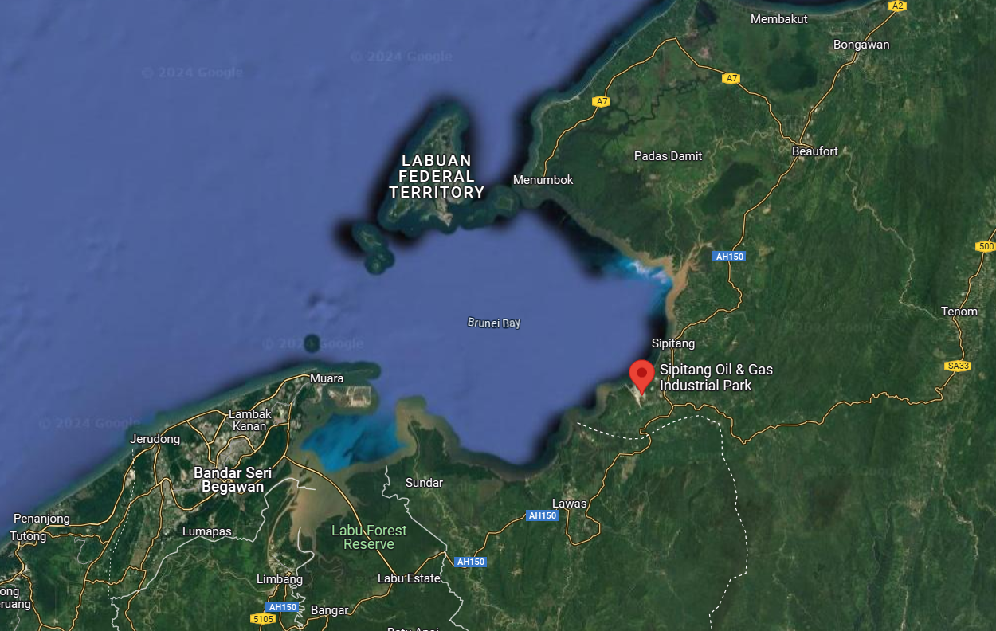
Figure 1. Location of SOGIP on Google Map

PROBLEM IDENTIFICATION

Problem Statement
The Sabah Oil and Gas Industrial Park (SOGIP) serves as a critical catalyst for Malaysia's industrial and economic expansion. Given its proximity to active seismotectonic sources, ensuring the seismic resilience of its infrastructure is of paramount importance. Currently, however, seismic hazard assessments for the region rely heavily on generalised regional bedrock models. These macro-level models fundamentally fail to account for the unique, highly variable marine and alluvial soil deposits present at the SOGIP site.

By overlooking critical site-specific factors such as local soil amplification, stratigraphic resonance, and impedance contrasts, regional predictions introduce significant uncertainty into the structural design process. The absence of localised surface Peak Ground Acceleration (PGA) data risks both the under-design (compromising safety) and over-design (compromising economic feasibility) of critical industrial facilities. Ultimately, this lack of high-resolution seismic data limits engineers' ability to apply cost-effective, performance-based design measures. Therefore, a rigorous, site-specific surface PGA assessment utilising localised geotechnical, seismological, and geological data is essential to guarantee the long-term sustainability and structural integrity of the SOGIP development.

To bridge this critical research gap, a robust analytical framework is required to systematically integrate extensive geotechnical borehole records, geological profiles, and regional seismological data. By employing computational ground motion modelling and systematic data processing, this study transforms raw subsurface data into actionable engineering insights. This integrated approach enables the creation of highly localised micro-zonation maps and accurate predictions of localised seismic responses, providing a quantitative baseline for reliable infrastructure planning in complex geological settings.

OBJECTIVES OF THE RESEARCH

To address identified gaps in localised seismic hazard data, this research aims to conduct a comprehensive, site-specific seismic ground response assessment for the SOGIP development area. Specifically, this study sets out to achieve the following objectives:

- To characterise and classify the localised subsurface stratigraphy and dynamic soil properties (Vs) of the SOGIP site using extensive borehole data.
- To derive site-specific surface Peak Ground Acceleration (PGA) spectra and localised soil amplification factors by executing 1D equivalent-linear ground response analyses.
- To evaluate the adequacy of the regional Malaysian Seismic Hazard Map (2017) against localised site effects and formulate data-driven recommendations for resilient structural design.

METHODOLOGY

Borehole Data Collection
To construct a robust and representative geotechnical model of the SOGIP site, comprehensive subsurface investigation records were compiled and analysed. The primary dataset comprises 23 strategically distributed geotechnical boreholes, carefully selected to capture the site's local geology's spatial variability and complex stratigraphy. To ensure holistic coverage of the industrial park's diverse topography and planned infrastructure, the boreholes are categorised into three distinct operational zones: 8 along the proposed onshore pipeline route, 8 within the primary onshore facility footprint, and 7 in the nearshore marine environment. This wide spatial distribution is particularly critical for capturing the geotechnical transition from terrestrial alluvial deposits to deep, soft marine clays. The depth of exploration for these boreholes varied across the site, primarily dictated by the localised depth required to reach a competent stratum or engineering bedrock. Identifying this competent layer is a fundamental prerequisite for establishing the seismic boundary conditions and input motion depths for the subsequent 1D equivalent-linear ground response analysis.

From the detailed borehole logs, essential geotechnical and geological parameters were systematically extracted for each soil stratum. The in-situ field data incorporated into the model included continuous soil classification and stratigraphy, Standard Penetration Test (SPT-N) blow counts recorded at regular depth intervals, and the stabilised elevation of the groundwater table. Furthermore, to accurately characterize the physical and index properties of the soil which directly influence strain-dependent dynamic soil behavior, such as modulus degradation and damping, extensive laboratory test results were integrated. These laboratory parameters included natural moisture content, bulk unit weight, and Atterberg limits (Liquid Limit and Plastic Limit) to properly classify cohesive layers. The spatial distribution and zoning of all 23 boreholes utilized in this assessment are illustrated in Figure 2.
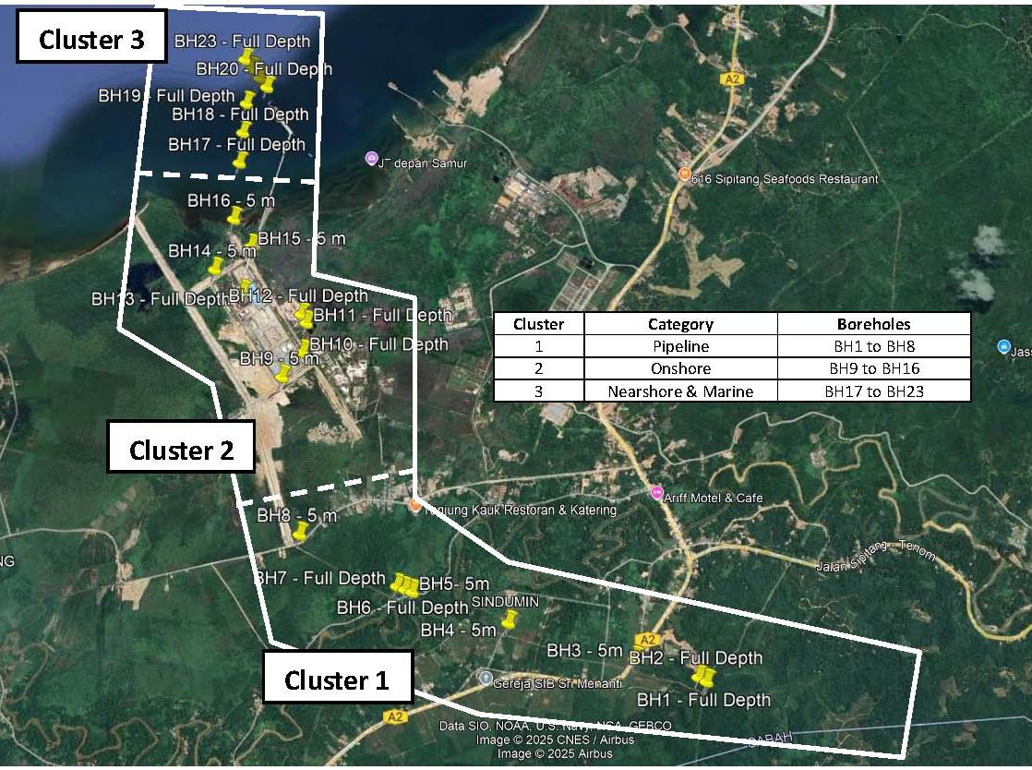
Figure 2. Borehole locations in the SOGIP area in Sipitang, Sabah (BH1 – BH23)

Site Classification
In accordance with the Malaysian National Annex to Eurocode 8 (MS EN 1998-1:2015), the local site conditions were classified based on the geotechnical properties of the uppermost 30 meters of the subsurface profile. In the absence of direct geophysical measurements for the time-averaged shear wave velocity (V_{s}), the standard permits the use of the equivalent Standard Penetration Test blow count N_{SPT,30} as a reliable empirical proxy for determining the seismic Ground Type.

To determine this parameter, the average SPT-N value over the upper 30 meters N_{SPT,30} was calculated using a depth-weighted harmonic mean. This methodology strictly adopts the same mathematical formulation utilised to calculate V_{s.} Specifically, the total depth of 30 meters is divided by the sum of the ratios of each individual soil layer's thickness (h_{i}) to its corresponding field SPT-N value (N_{i}). This rigorous classification framework was systematically applied to the extensive dataset of all 23 boreholes across the SOGIP site. By evaluating the stratigraphic profile, the presence of soft cohesive layers, and the computed N_{SPT,30} values, each borehole location was assigned a specific seismic Ground Type to establish the appropriate site amplification baseline. The detailed stratigraphic parameters, calculated N_{SPT,30} values, and the resulting Eurocode 8 site classifications for the onshore pipeline, onshore facility, and marine zones are comprehensively summarised in Tables 1, 2, and 3, respectively.

Table 1. Soil classification based on MS ES 1998-1:2015 for Cluster 1

Table 2. Soil classification based on MS ES 1998-1:2015 for Cluster 2

Table 3. Soil classification based on MS ES 1998-1:2015 for Cluster 3

Soil Parameters Input
Soil parameters used in the site response analysis were derived from 23 borehole logs and laboratory test data across the SOGIP area in Sipitang, Sabah. Key parameters include unit weight, shear-wave velocity (Vs), damping ratio, and modulus-reduction curves. These parameters were essential for modelling the dynamic behaviour of subsoil layers under earthquake loading.

Standard Penetration Test (SPT) values were used to estimate shear wave velocity when direct measurements were unavailable, using well-established empirical correlations appropriate for local soil conditions. Laboratory tests such as Atterberg limits, grain size distribution (sieve and hydrometer), and oedometer tests provided information on soil classification, compressibility, and consistency. Strain-dependent damping ratios and shear modulus degradation curves were assigned based on soil classification, utilising the classical models of Seed and Idriss (1970) for granular soils and Vucetic and Dobry (1991) for cohesive soils. Although more recent pressure-dependent models exist in the literature, the Vucetic and Dobry (1991) curves were explicitly adopted because they remain a highly robust and industry-standard method for capturing the plasticity-dependent nonlinear behaviour of the distinct cohesive marine clays present at the SOGIP site. These established curves provide a conservative and widely validated baseline for the equivalent-linear site response modelling utilised in this study.

The soil profile was simplified into representative layers for each borehole, and dynamic properties were assigned accordingly. These inputs formed the basis for a one-dimensional equivalent-linear analysis using software such as DEEPSOIL. Tables 4, 5, and 6 are examples of summarising the soil input parameters prepared for this research project.

Table 4. Example of soil parameters input for soil response analysis

Table 5. Example of soil parameters input for soil response analysis (continued)

Table 6. Example of soil parameters input for soil response analysis (continued)

Input Ground Motions
A minimum of three (3) input ground motions were selected to generate the site-specific soil response from the bedrock. These include records from the 1995 Kobe, 1999 Chi-Chi, and 1999 Kocaeli earthquakes. These specific ground motion records were strategically selected because their seismological parameters, including magnitude (7.4 to 7.6), shallow crustal fault mechanisms, and rich frequency content, serve as highly appropriate proxies for the seismic hazard scenarios threatening Sabah. Furthermore, these records feature long, significant durations capable of mobilising the nonlinear behaviour and strain-dependent damping of the soft clay and marine deposits found at the SOGIP site. The selected motions were scaled to match the target bedrock peak ground acceleration (PGA) values based on two references: (i) MS EN 1998-1:2015/2017, with a target PGA of 0.02g, and (ii) combined findings from recent studies by Adnan (2022), who reported a PGA of 0.031g for a FEED project in Sipitang, and Harith et al. (2025), who presented a PGA of 0.027g in her latest journal publication.

Therefore, for this study, two target PGA values at the bedrock of 0.02g and 0.03g were adopted to conduct the soil response analysis. Refer to Fig. 3 for the scaled input acceleration time history for types of earthquake input motions.

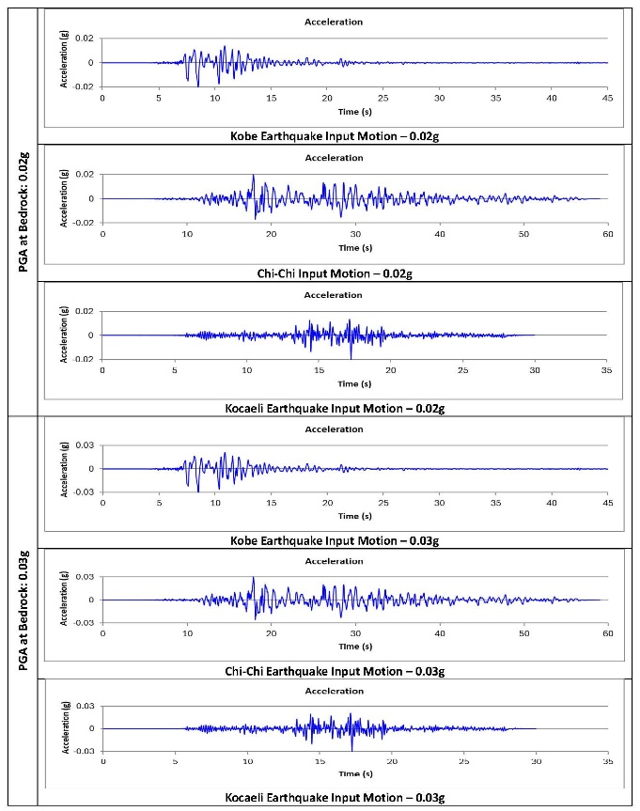
Fig. 3. Example of scaled input acceleration time history

Site Response Analysis
DEEPSOIL v7.0 was used for equivalent-linear 1D site response analysis. Input motions were applied at the base rock interface, and surface acceleration time histories were recorded. The surface PGA was extracted as the peak output acceleration.

.

RESULTS AND DISCUSSION

Subsurface Conditions
The SOGIP onshore and marine sites exhibited a range of soil types, including soft clay, firm clay, stiff clay, silt, and dense sand, underlain by weathered sandstone, siltstone, or hard clay. The observed heterogeneity in subsurface conditions plays a critical role in seismic wave propagation and amplification behaviour. Soft clay and loose silty layers, particularly in the upper soil strata, tend to exhibit lower shear stiffness and higher compressibility, which significantly increase ground motion amplification due to impedance contrast with underlying stiffer materials. In contrast, dense sand and weathered rock layers contribute to reduced amplification due to higher stiffness and energy dissipation capacity.

The variability across clusters indicates that local stratigraphic differences govern site response behaviour, underscoring the need for microzoning rather than relying on uniform site classification. This spatial variability is particularly important in coastal and reclaimed zones, where marine deposits may amplify seismic waves more significantly than inland deposits. Groundwater depth ranged from the surface or the seabed to 4.2 m. For marine boreholes, the SPT-N could not be found until the termination depth of 70.95m. The lateral soil stratigraphy variations of the site are shown in Figures 5, 6, 7, 8, and 9.

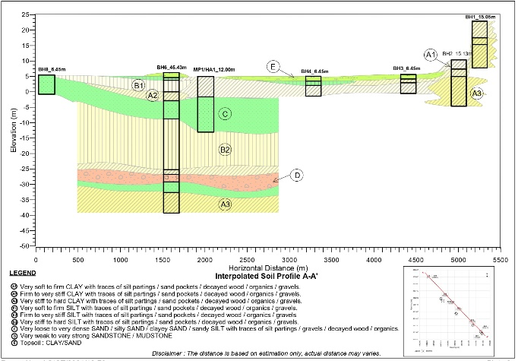
Figure 5. Lateral variation subsurface profile for BH1, 2, 3, 4, 6, & 8

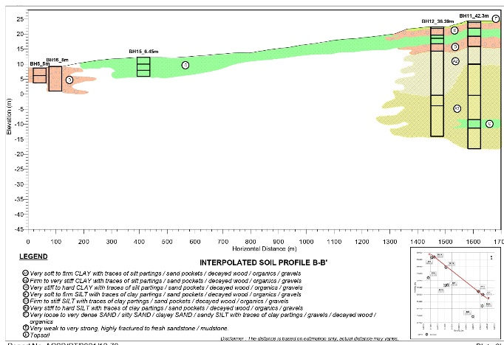
Figure 6.. Lateral variation subsurface profile for BH5, 11, 12, 15, & 16
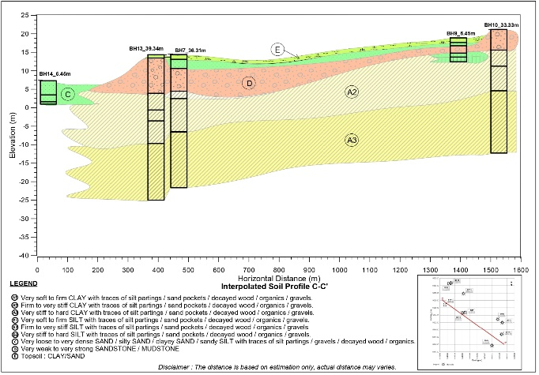
Figure 7. Lateral variation subsurface profile for BH7, 9, 10, 13, & 14

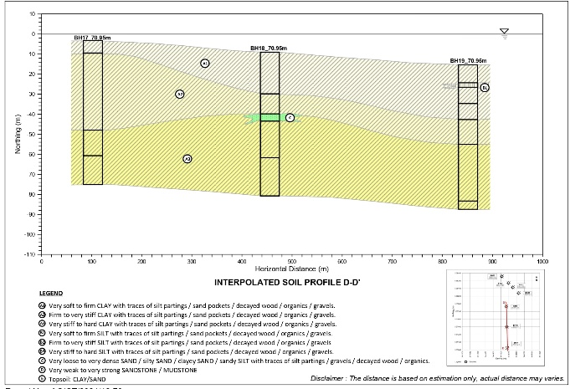
Figure 8. Lateral variation subsurface profile for BH17, 18, & 19

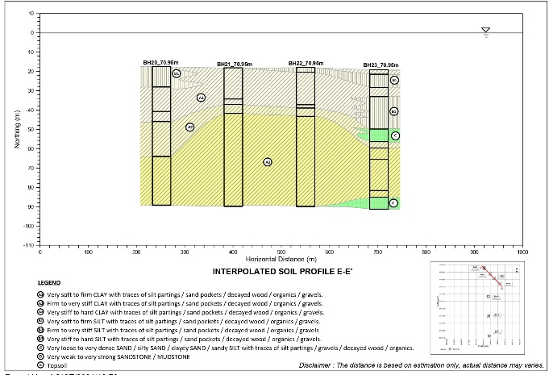
Figure 9. Lateral variation subsurface profile for BH20, 21, 22, & 23

Soil response analysis requires approximate engineering bedrock depth data. According to Roslee et al. (2020), the engineering bedrock depth in Luyang, Kota Kinabalu, Sabah, was estimated to be between 4 m and 32.5 m below the original ground level. It should be noted that estimating the engineering bedrock depth introduces uncertainty into the site response analysis. The adopted assumptions are based on regional geological studies, given the absence of direct geophysical measurements, such as downhole or MASW testing. Variations in actual bedrock depth may influence the fundamental site period and amplification characteristics.

However, the adopted approach represents a practical engineering approximation commonly used in preliminary seismic assessments. Future studies incorporating direct shear-wave velocity profiling are recommended to refine bedrock depth estimates and improve the reliability of site response predictions. As such, several assumptions have been made regarding the extended depth of boreholes for soil response analysis, as listed in Table 7. Because depth to engineering bedrock governs the fundamental site period, overestimating the depth could shift the resonance to longer periods, while underestimating it could artificially concentrate amplification at higher frequencies. Future structural designs utilising these site-specific spectra should account for a margin of error in the long-period range (T_{D}) to accommodate this uncertainty.

Table 7. Assumption on the extended depth of the borehole to the engineering bedrock
No. | Description of Conditions | Extended Depth from Existing Terminated BH
1 | Weathered rock or hard clay encountered | 10 m more depth to bedrock
2 | Terminated BH SPT-N= 40-50 | 15 m more depth to bedrock
3 | Terminated BH SPT-N= 25-40 | 20 m more depth to bedrock
4 | Shallow depth BH, no SPT-N=50 | 30 m more depth to bedrock
5 | All Marine BHs | 30 m more depth to bedrock

Shear Wave Velocities, V_{s}
To estimate the shear wave velocity of the soil profile, empirical correlations relating Standard Penetration Test (SPT-N) values to Vs were utilised. Several established formulas were selected based on their proven suitability for Malaysian and tropical soil conditions. For each soil stratum, the Vs values derived from these selected methods were calculated and subsequently averaged. This averaging technique mitigates the inherent statistical scattering of individual empirical models, thereby reducing uncertainty and yielding a more robust and reliable estimate of the soil’s dynamic stiffness. While these empirical correlations are widely adopted, they inherently introduce variability due to differences in soil type, stress history, and local geological conditions. It is acknowledged that direct site-specific geophysical measurements, such as Multichannel Analysis of Surface Waves (MASW) or downhole testing, would yield more accurate velocity profiles. Nevertheless, in the absence of direct geophysical data, this averaged empirical approach is considered a highly practical and acceptable methodology for regional-scale seismic assessments
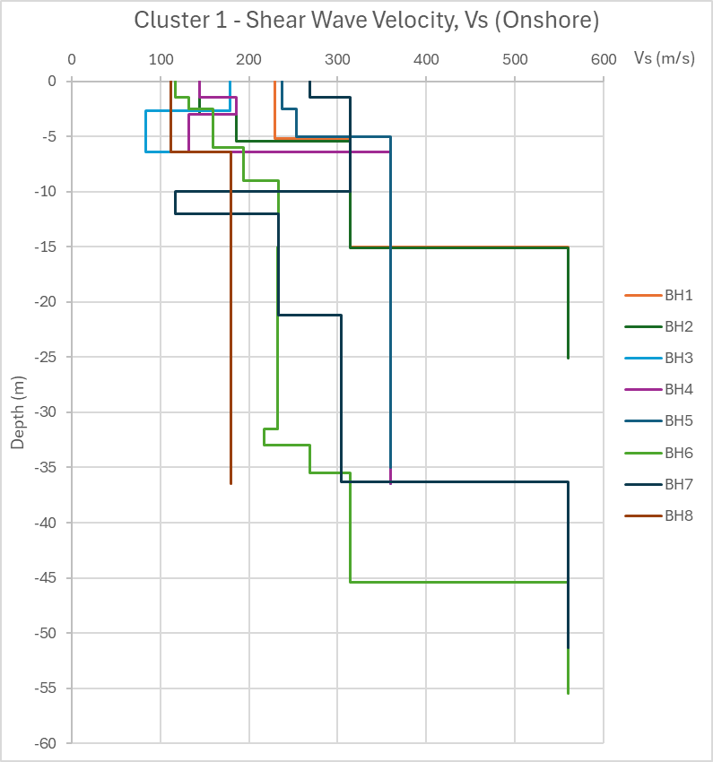
Figure 10. Shear wave velocity for Cluster 1

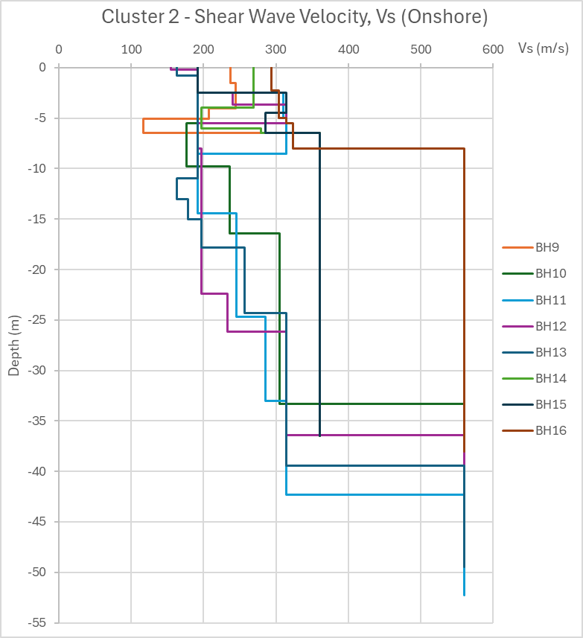
Figure 11. Shear wave velocity for Cluster 2
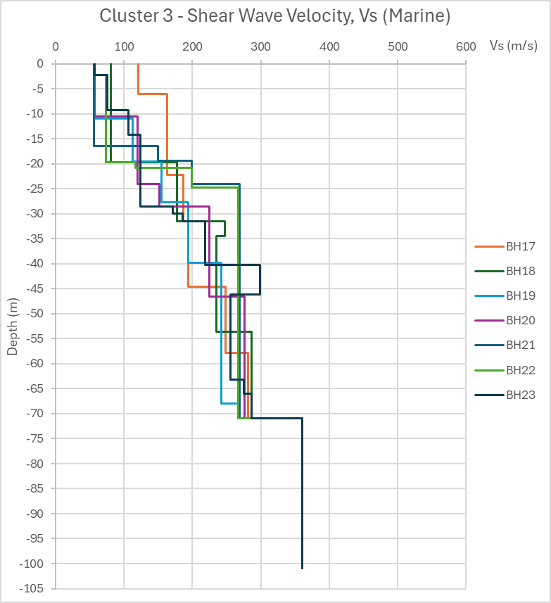
Figure 12. Shear wave velocity for Cluster 3

These average Vs values are then used in the DEEPSOIL software to carry out soil response analysis. This method is a practical solution when field measurements are unavailable, yet it still allows for a meaningful site-specific assessment of surface PGA. All 23-borehole shear wave velocity plots are divided into 3 clusters as per Figures 10, 11, and 12.

Soil Response Analysis
In this study, three representative ground motion records from past earthquake events (Kobe 1995, Chi-Chi 1999, and Kocaeli 1999) were selected and used as input motions in the DEEPSOIL software. These records were appropriately scaled to match the target bedrock Peak Ground Acceleration (PGA) values of 0.02g and 0.03g for the SOGIP area in Sipitang, Sabah. In accordance with Eurocode 8 (EC8), scaled input motions were used to derive key seismic design parameters via equivalent-linear site response analysis. Figures 13–18 present the computed surface acceleration time histories and corresponding response behaviour for the different input motions and borehole clusters. The results consistently demonstrate amplification of ground motion from bedrock to the surface across all clusters, with the degree of amplification varying with both input motion characteristics and local subsurface conditions. A clear trend observed in the figures is that softer soil profiles exhibit more pronounced amplification, particularly within the low- to mid-frequency range. This behaviour is attributed to the lower stiffness and higher deformability of soft clay and silty layers, which tend to resonate with incoming seismic waves. In contrast, soil profiles dominated by denser or stiffer materials exhibit lower amplification, reflecting higher shear stiffness, more effective energy dissipation, and reduced impedance contrast between layers.

Variations in response among the three earthquake records are also evident. Each input motion possesses distinct frequency content, duration, and energy distribution, which influence the resulting surface response. Ground motions with dominant frequencies closer to the soil profile's natural period tend to produce greater amplification due to resonance. This explains the observed differences in surface PGA across clusters under identical bedrock input levels.

Furthermore, increasing the bedrock PGA from 0.02g to 0.03g results in an overall increase in surface acceleration; however, the amplification response does not scale linearly. This behaviour reflects the strain-dependent characteristics of soil captured in the equivalent-linear analysis, where stiffness degradation and increased material damping occur at higher strain levels, thereby moderating the amplification response. The variability in amplification observed across the different clusters highlights the influence of spatial heterogeneity in subsurface conditions within the SOGIP area. Marine and near-coastal deposits, which are typically characterised by thicker, soft soil layers, exhibit higher amplification compared to inland locations with relatively stiffer stratigraphy. These findings underscore the limitations of generalised seismic design assumptions and reinforce the necessity of site-specific analysis to accurately capture local ground response characteristics.
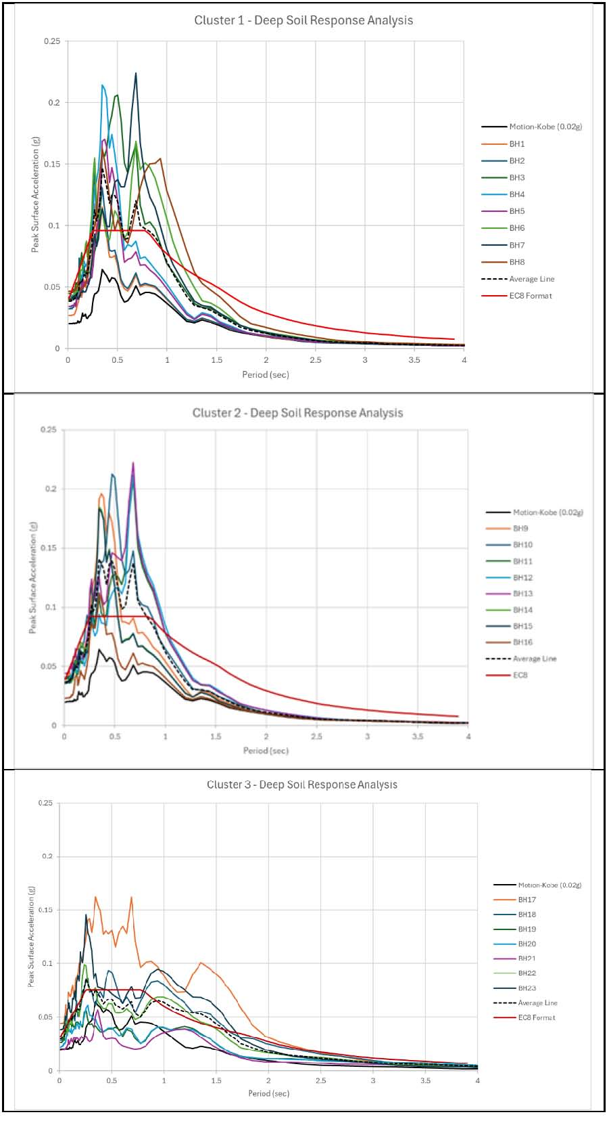
Figure 13. Soil response analysis graph for Kobe EQ-0.02g
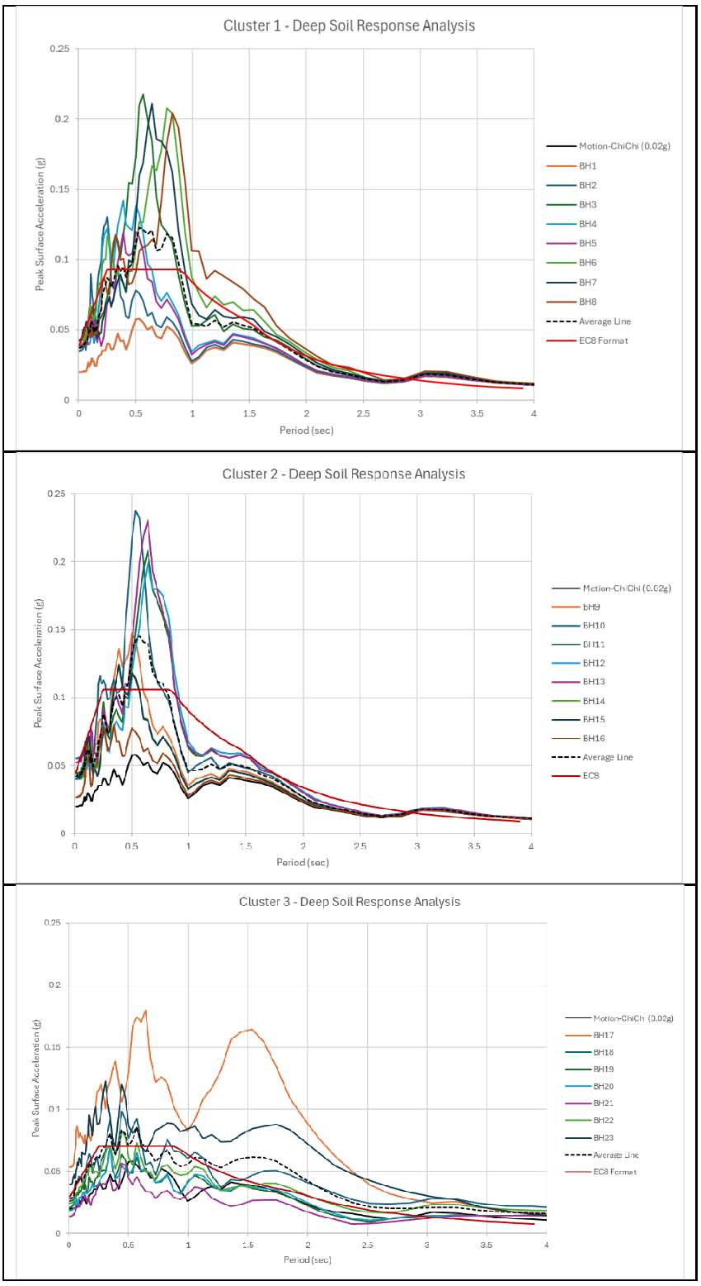
Figure 14. Soil response analysis graph for Chi-Chi EQ-0.02g

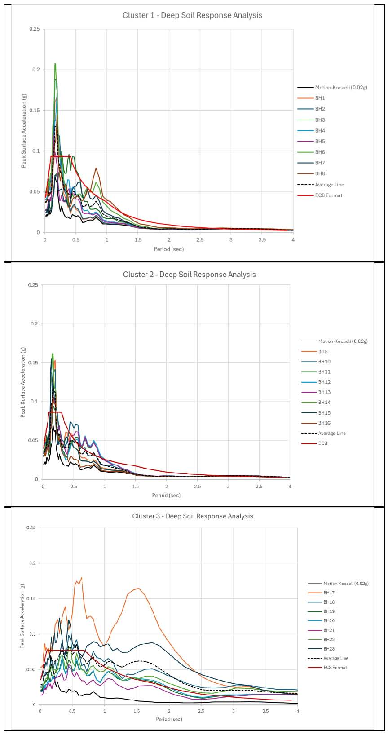
Figure 15. Soil response analysis graph for Kocaeli EQ-0.02g

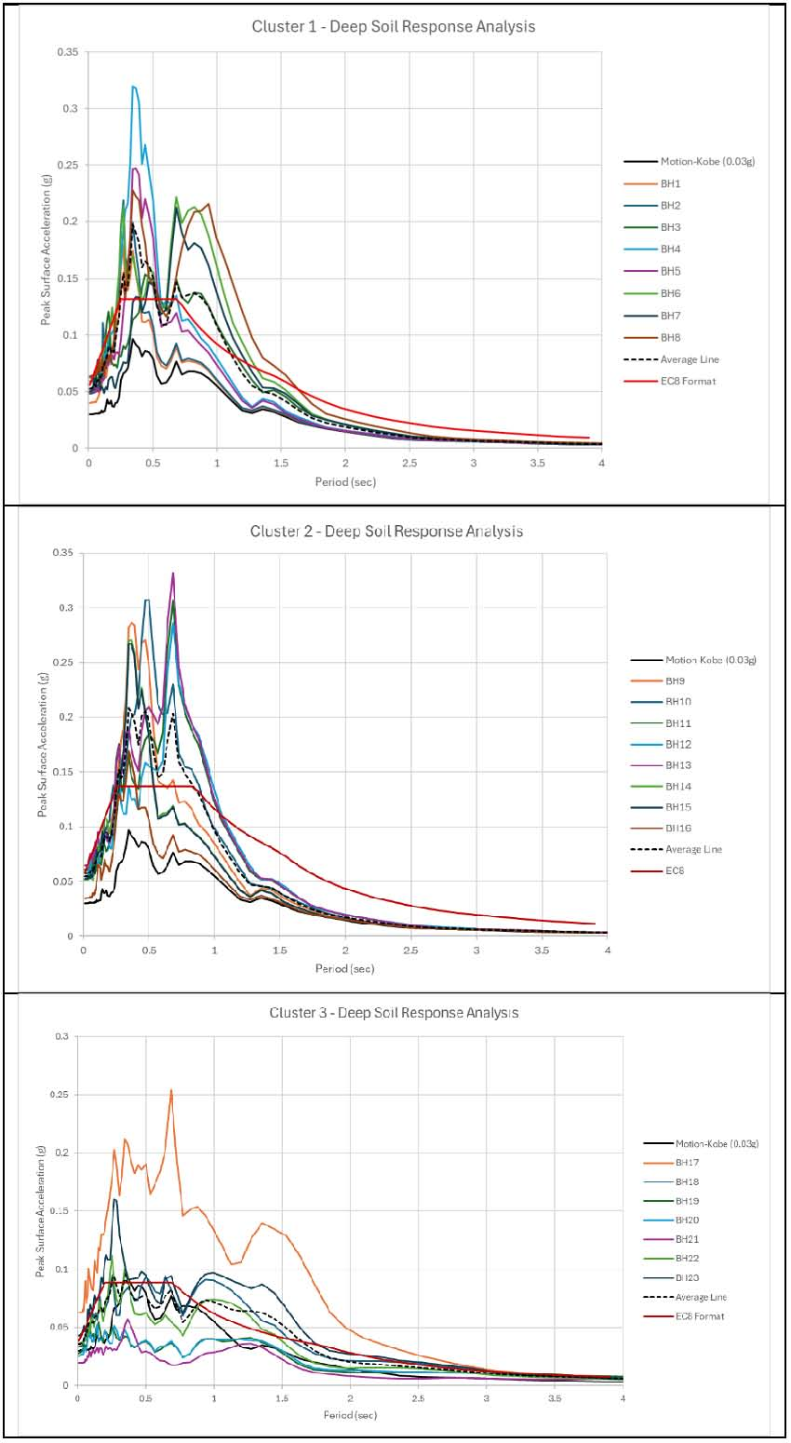
Figure 16. Soil response analysis graph for Kobe EQ-0.03g

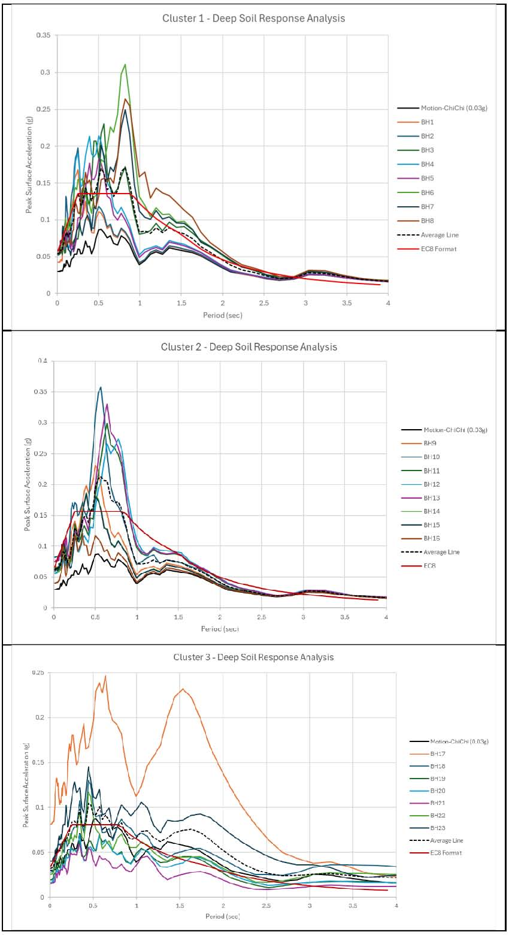
Figure 17. Soil response analysis graph for Chi-Chi EQ-0.03g

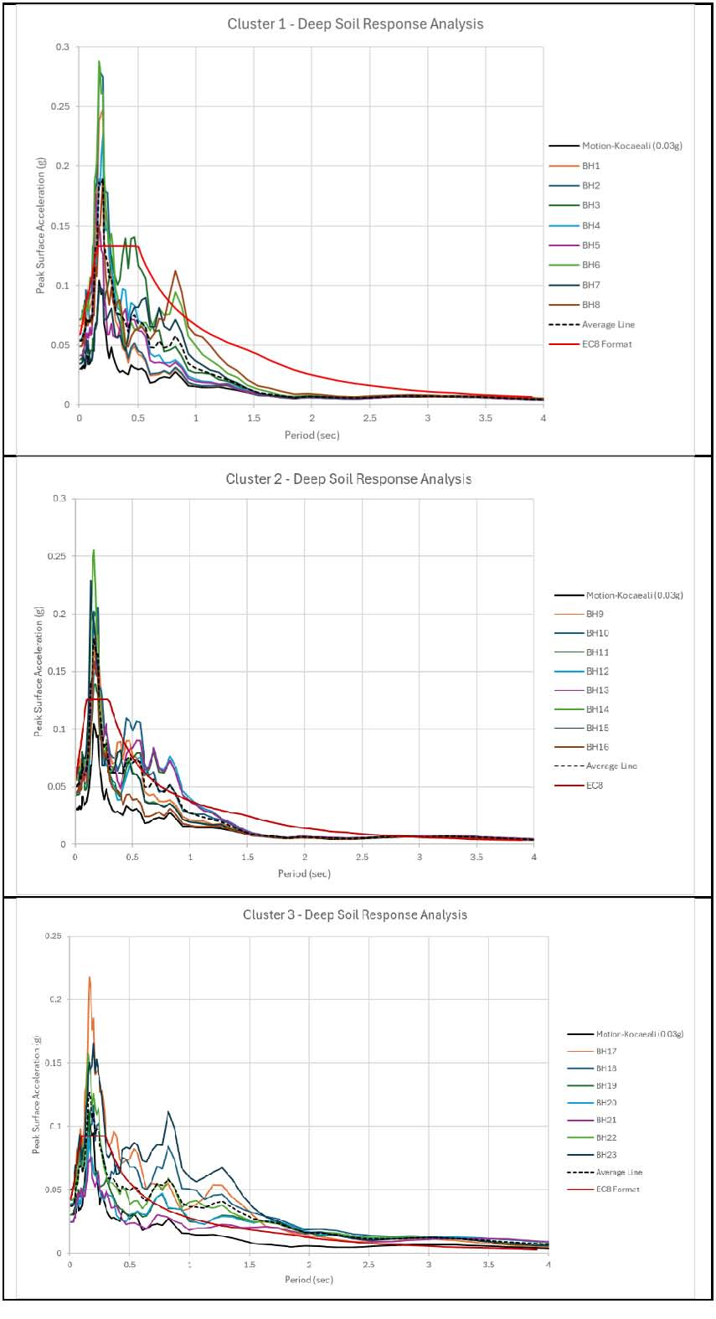
Figure 18. Soil response analysis graph for Kocaeli EQ-0.03g

Soil Amplification Factor Evaluation
Based on various soil response analyses, the data sets and results have been carefully studied to ensure the outcomes are practical and eliminate possible errors. The studies on amplification effects for both cases of PGA at bedrock (0.02g and 0.03g) have been tabulated in Tables 8 and 9. The results, before averaging the datasets concerning cluster locations, indicate that surface PGA values range from 0.0137g to 0.0552g based on a bedrock PGA of 0.02g (MS EN 1998-1:2015/2017), and from 0.0153g to 0.0821g for higher reference bedrock PGAs 0.03g (rationalized PGA value of 0.027g (Harith et al., 2025) and 0.031g (Adnan, 2022)).

Table 8. Summary of soil amplification effects based on PGA of 0.02g at Bedrock

Table 9. Summary of soil amplification effects based on PGA of 0.03g at Bedrock

Horizontal Elastic Response Spectra
These results are derived from the average response spectra curves generated through the soil amplification factors, site periods characteristics, acceleration response spectra curves for 5% damping ratios, EC8 spectra shape parameters, and surface motion characteristics used for structural design inputs. Please refer to Figures 19 and 20 for further information about the response spectra curves based on various input motions, clusters, and PGA values. Tabulation of results and recommendations for clusters is available in Tables 10, 11, and 12.

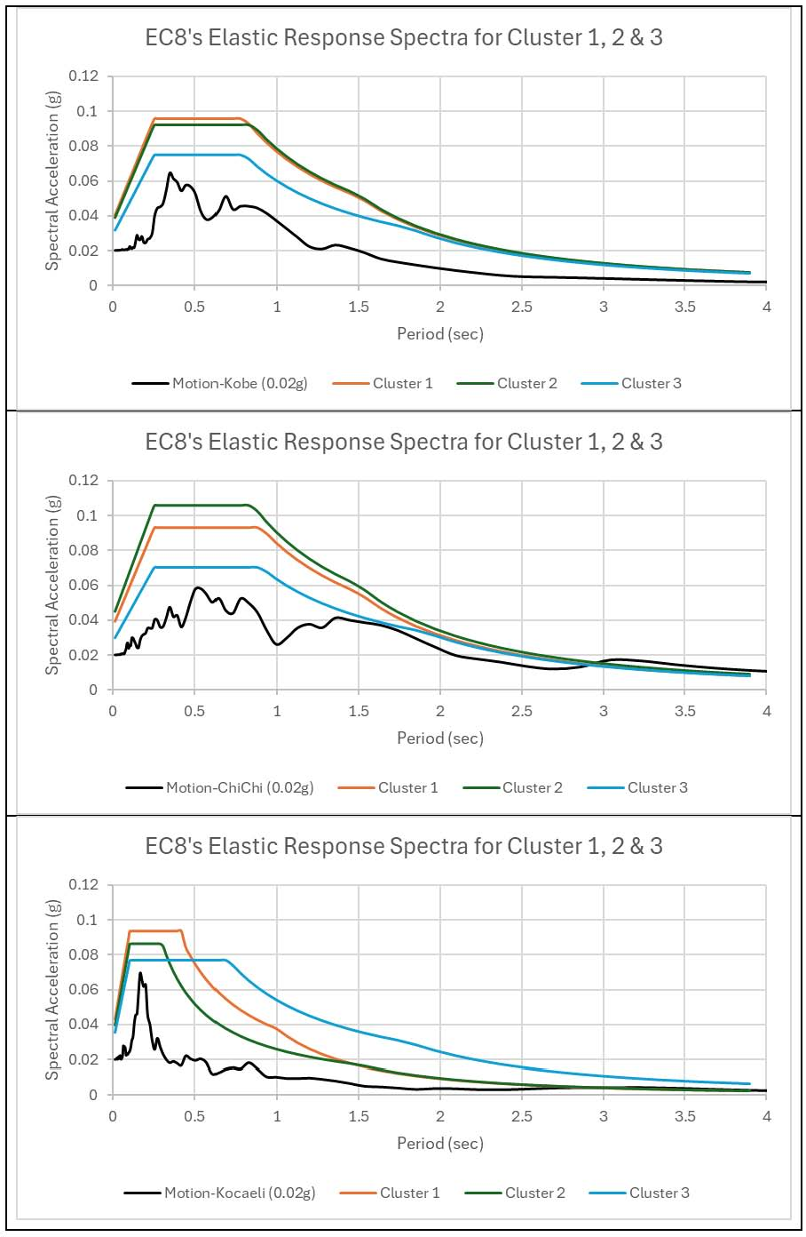

Figure 19. EC8 Response Spectra for 0.02g input motions

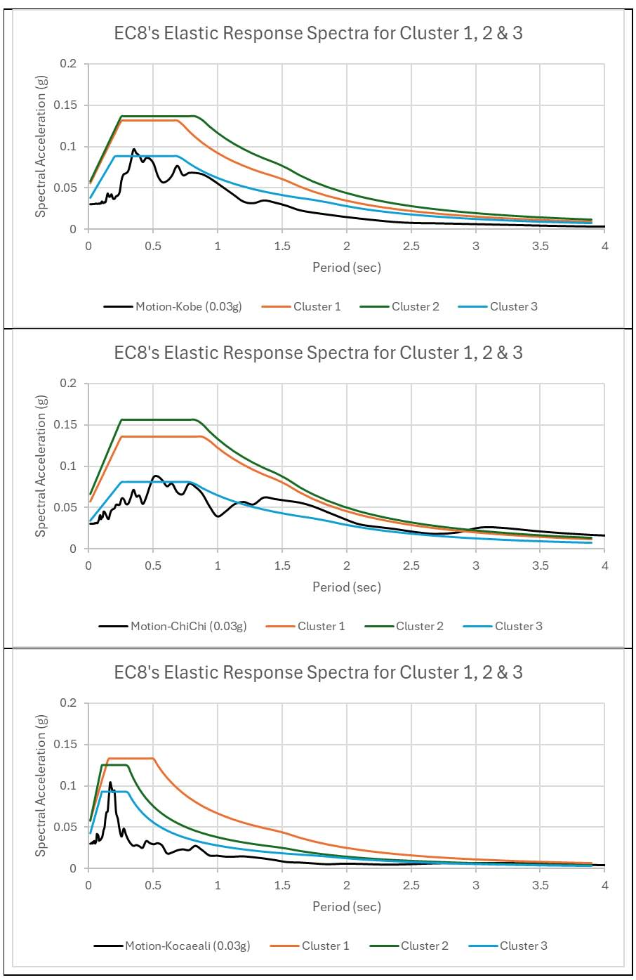
Figure 20. EC8 Response Spectra for 0.03g input motions
Table 10. Summary of response spectra shape parameters for Cluster 1
Bedrock PGA  (g) | Input Motions | Soil Amplification Factor, S | T_{B}  (s) | T_{C} (s) | T_{D} (s)
0.02g | Kobe EQ 1995 | 1.9110 | 0.25 | 0.80 | 1.50
0.02g | Chi-Chi EQ 1999 | 1.8614 | 0.25 | 0.90 | 1.50
0.02g | Kocaeli EQ 1999 | 1.8631 | 0.10 | 0.40 | 1.00
0.03g | Kobe EQ 1995 | 1.7551 | 0.25 | 0.70 | 1.50
0.03g | Chi-Chi EQ 1999 | 1.8041 | 0.25 | 0.90 | 1.50
0.03g | Kocaeli EQ 1999 | 1.7722 | 0.15 | 0.50 | 1.50

Table 11. Summary of response spectra shape parameters for Cluster 2
Bedrock PGA  (g) | Ground Input Motions | Soil Amplification Factor, S | T_{B}  (s) | T_{C} (s) | T_{D} (s)
0.02g | Kobe EQ 1995 | 1.8438 | 0.25 | 0.85 | 1.50
0.02g | Chi-Chi EQ 1999 | 2.1201 | 0.25 | 0.85 | 1.50
0.02g | Kocaeli EQ 1999 | 1.7222 | 0.10 | 0.30 | 1.50
0.03g | Kobe EQ 1995 | 1.8173 | 0.25 | 0.85 | 1.50
0.03g | Chi-Chi EQ 1999 | 2.0785 | 0.25 | 0.85 | 1.50
0.03g | Kocaeli EQ 1999 | 1.6665 | 0.10 | 0.30 | 1.50

Table 12. Summary of response spectra shape parameters for Cluster 3
Bedrock PGA  (g) | Ground Input Motions | Soil Amplification Factor, S | T_{B}  (s) | T_{C} (s) | T_{D} (s)
0.02g | Kobe EQ 1995 | 1.5008 | 0.25 | 0.80 | 1.80
0.02g | Chi-Chi EQ 1999 | 1.4031 | 0.25 | 0.90 | 1.90
0.02g | Kocaeli EQ 1999 | 1.5309 | 0.10 | 0.70 | 1.80
0.03g | Kobe EQ 1995 | 1.1798 | 0.20 | 0.70 | 1.80
0.03g | Chi-Chi EQ 1999 | 1.0765 | 0.25 | 0.80 | 1.80
0.03g | Kocaeli EQ 1999 | 1.2311 | 0.10 | 0.30 | 1.80

Surface PGA Results
Previous relevant studies indicate PGA values at bedrock for the Sipitang area in Sabah, as shown in Table 13. While the computed surface PGA from this study is summarised in Table 14. The computed surface PGA values are consistently higher than those shown in the Malaysian Seismic Hazard Map (2017), suggesting bedrock PGA values of approximately 0.01g to 0.02g. This indicates that reliance solely on regional hazard maps may lead to underestimation of seismic demand at the site. The increase in PGA due to local site effects underscores the importance of accounting for soil amplification in seismic design. For critical infrastructure such as oil and gas facilities, even moderate increases in PGA can significantly impact structural performance and safety margins.

Table 13. The range of PGA at bedrock values for Sipitang, Sabah
Reference | 10% PE (g) / 475 Yrs
(Giardini, 2003) | 0.04g – 0.08g
(Petersen M. D., 2007; Petersen M. D., 2008) | 0.02g – 0.04g
(Leyu C. H., 2009) | 0.04g
(Adnan, 2008) | 0.06g – 0.08g
(MSEN1998-1:2015, 2017) | 0.01g – 0.02g
(M. Pagani et al., 2018) | 0.01g – 0.02g
(Adnan, 2022), The Kuala Penyu fault is included | 0.031g
(Harith et al., 2025), The Kuala Penyu fault is included | 0.027g

Table 14. The peak surface acceleration (surface PGA) computed from this study
Bedrock PGA  (g) | Locations | Soil Amplification Factor, S | Surface PGA  (g)
0.02g | Cluster 1 (Pipeline) | 1.9110 | 0.0382
0.02g | Cluster 2 (Onshore) | 1.8614 | 0.0372
0.02g | Cluster 3 (Marine) | 1.8631 | 0.0373
0.03g | Cluster 1 (Pipeline) | 1.7551 | 0.0527
0.03g | Cluster 2 (Onshore) | 1.8041 | 0.0541
0.03g | Cluster 3 (Marine) | 1.7722 | 0.0532

Implications for Engineering Design
The results indicate that local amplification factors ranging from 1.0765 to 2.1201 (Tables 10–12 and 14) are primarily attributed to the presence of soft surface soil layers across multiple locations within the SOGIP area. In several instances, these amplification factors exceed the values recommended in MS EN 1998-1:2015 (Table N.A.1, Annex C, and Annex D), suggesting that standard code provisions may not fully capture the influence of local subsurface conditions. Consequently, reliance solely on national-scale PGA values may lead to underestimation of seismic demand, particularly for critical infrastructure.

The observed increase in surface PGA has significant implications for the design of industrial facilities in SOGIP. Elevated seismic demand directly influences the design requirements of shallow and deep foundations, storage tanks, pipelines, and retaining structures. Flexible systems, such as pipelines and offshore facilities, are particularly vulnerable to ground deformation and amplification, making them more sensitive to site-specific seismic response.

These findings highlight the importance of adopting site-specific response spectra in place of standard code-based spectra to better reflect actual ground behaviour. Such an approach not only enhances structural safety but also enables more economical and performance-based design solutions.

Furthermore, the presence of soft, potentially saturated soil layers indicates increased susceptibility to seismic-induced ground failures, including liquefaction and slope instability. These hazards should be explicitly considered in the design and risk assessment of infrastructure within the study area.

CONCLUSIONS

This study demonstrates the critical importance of conducting site-specific seismic hazard assessments in seismically influenced regions such as Sipitang, Sabah. By integrating borehole-derived subsurface data with one-dimensional site response analysis, the study provides a more realistic representation of ground-motion characteristics than generalised regional approaches. The results confirm that local soil conditions play a dominant role in modifying seismic wave propagation, with amplification factors reaching up to 2.1 times the regional baseline, thereby significantly increasing surface PGA.

The computed surface PGA values for the SOGIP area, ranging from 0.0372g to 0.0541g, consistently exceed those inferred from national seismic hazard maps. This highlights the limitation of relying solely on regional PGA values for engineering design, as such approaches may underestimate seismic demand and compromise the safety and performance of critical infrastructure. The findings strongly support the adoption of site-specific response spectra to better capture local ground behaviour and improve the reliability of seismic design practices.

Nevertheless, this study is subject to several limitations, including the use of empirical correlations for shear wave velocity estimation, assumptions regarding engineering bedrock depth, and the application of equivalent-linear analysis. These simplifications may introduce uncertainties in the predicted ground response. Future work incorporating direct geophysical measurements and advanced nonlinear analysis is recommended to further enhance the accuracy of seismic hazard evaluations.

Overall, this study provides valuable insights into the influence of subsurface conditions on seismic response and establishes a practical framework for incorporating geotechnical data into site-specific PGA assessment. The outcomes are particularly relevant for the design and risk assessment of industrial developments in SOGIP and similar coastal and geologically variable environments.

RECOMMENDATIONS

Based on the findings of this study, several recommendations are proposed to enhance the reliability of seismic hazard assessment and support safer infrastructure development in the SOGIP area, Sipitang, Sabah. Firstly, it is strongly recommended that site-specific Peak Ground Acceleration (PGA) values be incorporated into seismic design practices, particularly for lifeline systems and high-importance structures such as industrial facilities, pipelines, storage tanks, and critical infrastructure. The use of generalised regional seismic parameters may lead to underestimation of seismic demand, whereas site-specific inputs provide a more accurate representation of local ground conditions and associated risks.

Secondly, future studies should extend the current analysis by incorporating nonlinear site response modelling to better capture soil behaviour under strong ground motion. In addition, direct shear wave velocity profiling techniques, such as Multichannel Analysis of Surface Waves (MASW) and Seismic Cone Penetration Testing (SCPT), are recommended to improve the accuracy of subsurface dynamic properties and reduce uncertainties associated with empirical correlations.

Furthermore, the development of a localised seismic design spectrum tailored specifically for the SOGIP area is highly encouraged. Such a spectrum would provide engineers with more reliable design parameters that reflect the actual site conditions, thereby improving both structural safety and design efficiency.

Finally, it is recommended that detailed seismic microzonation studies be carried out as a subsequent step. Microzonation would enable spatial mapping of seismic hazards across the SOGIP area, allowing for more informed land-use planning, risk assessment, and infrastructure design at a finer scale.

Acknowledgements
The author thanks Khalifa Consult Sdn. Bhd., Perunding Ranhill Worley Sdn. Bhd. / Ranhill Worley Sdn. Bhd., and PETRONAS for facilitating access to the Soil Investigation report for their past FEED project in Sipitang, Sabah. Also, special thanks to the research supervisor at UTM Skudai, Johor, Prof. Ir. Ts. Dr. Ahmad Safuan Bin Abdul Rashid, for his guidance. Appreciation is extended to relevant journal publications for the opportunity to present this work. A special thanks to the Universiti Teknologi Malaysia, which supported this work under Geran Penyelidik Baharu – Enhanced Local Seismic Hazard Assessment through Borehole Data Integration and Site Response Analysis (Q.J130000.2722.04K92).

References
- Adnan, A., Hendriyawan, M. A., Selvanayagam, B., & Marto, A. (2008). Development of seismic hazard maps of east Malaysia. Advance in earthquake engineering applications. Penerbit UTM.
- Adnan, A., Hendriyawan, H., & Irsyam, M. (2004). Selection and development of appropriate attenuation relationship for Peninsular Malaysia. Malaysian Science and Technology Congress.
- Alexander, Y., Liau, A., Hamzah, M., Ramli, M. Y., Mat Taib, M. B., Ali, A., & Tjia, H. D. (2008). JMG MAGDM assessment of the seismic threats to Malaysia from major earthquakes in the Southeast Asian region.
- Cao, T., & Petersen, M. D. (1996). Seismic hazard estimate from background seismicity in southern California. Bulletin of the Seismological Society of America, 86, 1372–1381.
- Dobry, R., Borcherdt, R. D., Crouse, C. B., Idriss, I. M., Joyner, W. B., Martin, G. R., & Seed, R. B. (2000). New site coefficients and site classification system used in recent building seismic code provisions. Earthquake Spectra, 16(1), 41–67.
- Erdik, M., & Durukal, E. (2004). Strong ground motion. In Recent advances in earthquake geotechnical engineering and microzonation (pp. 67–100). Springer.
- Giardini, D., Grünthal, G., Shedlock, K., & Zhang, P. (2003). The GSHAP global seismic hazard map. In International geophysics (Vol. 81, pp. 1233–1239). Academic Press.
- Harith, N. S. H., Tongkul, F., & Adnan, A. (2025). Investigation of peak ground acceleration on the Kuala Penyu fault and its influence on the Malaysia National Annex. International Journal of Sustainable Construction Engineering and Technology, 16(1), 154–166.
- Hutchings, S. J., & Mooney, W. D. (2021). The seismicity of Indonesia and tectonic implications. Geochemistry, Geophysics, Geosystems, 22(9), e2021GC009812.
- Idriss, I. M. (1990). Response of soft soil sites during earthquakes. In Proceedings of the H. Bolton Seed Memorial Symposium.
- Idriss, I. M. (1991). Earthquake ground motions at soft soil sites. In Second International Conference on Recent Advances in Geotechnical Earthquake Engineering and Soil Dynamics.
- Kramer, S. L., & Stewart, J. P. (2004). Geotechnical aspects of seismic hazards. In Earthquake engineering: From engineering seismology to performance-based engineering. CRC Press.
- Leyu, C. H. (2009). Seismic and tsunami hazards and risks study in Malaysia: Summary for policy makers. MOSTI.
- Lizurek, G. R. (2015). Mining-induced seismic event on an inactive fault. Acta Geophysica, 63, 176–200.
- Lillie, R. J. (2015). Beauty from the beast: Plate tectonics and the landscapes of the Pacific Northwest. Wells Creek Publishers.
- Mayne, P. W., & Kemper, J. B. (1988). Profiling OCR in stiff clays by CPT and SPT. Geotechnical Testing Journal, 11(2), 139–147.
- Michel, G. W., Becker, M., Angermann, D., Reigber, C., & Reinhart, E. (2000). Crustal motion in East and Southeast Asia from GPS measurements. Earth, Planets and Space, 52, 713–720.
- Michel, G. W., Yu, Y. Q., Zhu, S. Y., et al. (2001). Crustal motion and block behaviour in Southeast Asia from GPS measurements. Earth and Planetary Science Letters, 187, 239–244.
- Mohd Zainudin, M. Z. (2015). Geological map of Sabah (4th ed.). Minerals and Geoscience Department Malaysia.
- MS EN 1998-1. (2017). Malaysia National Annex to Eurocode 8: Design of structures for earthquake resistance—Part 1. Department of Standards Malaysia.
- Nabilah, A. B., Ahmadi, A., Harith, N. S. H., Adnan, A., & Suhatril, M. (2023). Development of elastic design response spectra for low to moderate seismic regions. Asian Journal of Civil Engineering.
- Nguyen, V. Q., Aaqib, M., Nguyen, D. D., Luat, N. V., & Park, D. (2020). Site-specific response analysis: A case study in Hanoi, Vietnam. Applied Sciences, 10.
- Pagani, M., Garcia-Pelaez, J., et al. (2018). Global earthquake model seismic hazard map (Version 2018.1). GEM Foundation.
- Parham, P. R. (2016). Late Cenozoic sea-level record from Malaysia. Bulletin of the Geological Society of Malaysia, 62, 91–115.
- Pacheco, J. F., Scholz, C. H., & Sykes, L. R. (1992a). Changes in frequency–size relationship. Nature, 355, 71–73.
- Pacheco, J. F., & Sykes, L. R. (1992b). Seismic moment catalog of large earthquakes. Bulletin of the Seismological Society of America, 82, 1306–1349.
- Petersen, M. D. (2007). Documentation for Southeast Asia seismic hazard maps. USGS.
- Petersen, M. D. (2008). New USGS Southeast Asia seismic hazard maps. Proceedings of WCEE.
- Pitilakis, K. (2004). Site effects. In Recent advances in earthquake geotechnical engineering. Kluwer.
- Rodriguez-Marek, A., Bray, J. D., & Abrahamson, N. A. (2000). Geotechnical seismic site response evaluation. WCEE Proceedings.
- Rosaidi, M. (2001). Earthquake monitoring in Malaysia. Seismic Risk Seminar.
- Seed, H. B., Murarka, R., Lysmer, J., & Idriss, I. M. (1976). Relationships between acceleration and distance. Bulletin of the Seismological Society of America, 66, 1323–1342.
- Simons, W. J. F., Socquet, A., Vigny, C., et al. (2007). GPS in Southeast Asia. Journal of Geophysical Research, 112, B06420.
- Surat, T. (2001). Case history of earth tremors in Malaysia. Seismic Risk Seminar.
- Tongkul, F. (2017). Active tectonics in Sabah. Universiti Malaysia Sabah.
- Tongkul, F. (2021). Earthquake science in Malaysia. ASM Science Journal, 14, 1–12.
- Vucetic, M., & Dobry, R. (1991). Effect of soil plasticity on cyclic response. Journal of Geotechnical Engineering, 117(1), 89–107.
- Wang, P. C., & Zhang, S. Z. (2016). Accretionary processes in Borneo. Geological Journal, 51, 464–489.
- Wannier, M. (2017). Geological mapping in Sabah. Bulletin of the Geological Society of Malaysia, 64, 37–49.
- Zikiri, M. F., Roslee, R., & Madri, A. N. (2020). Landslide hazard identification using geoelectrical mapping. Earth Sciences Pakistan, 4(2), 81–87.

