Material Design and Performance Evaluation of 3D-Printed Lightweight Foamed Concrete Using a PVA-Stabilized Sodium Lauryl Sulfate Foaming System
Ariel Bongabong¹*, Maria Sheila Ramos^{1,2}, Wei-Ting Lin³, Fortia Louise Adeliene Alfeche^{1,2}, Brian Christian Magalong^{1,2}, Nicholas Lasquite¹, Al Niño Bura-ay¹, Raul Lucero Jr¹
¹Graduate School of Engineering, Mindanao-State University – Iligan Institute of Technology, Andres Bonifacio Ave, Iligan City, Lanao del Norte, 9200, Philippines
²BPRL, Mindanao-State University – Iligan Institute of Technology, Andres Bonifacio Ave, Iligan City, Lanao del Norte, 9200, Philippines
³Department of Civil Engineering, National Ilan University, Yilan County, Yilan, Taiwan
*Corresponding Author: Ariel Bongabong
ABSTRACT
Three-dimensional printing of lightweight foamed concrete (3DP-LFC) offers a sustainable construction approach by reducing material waste, minimizing labor requirements and job-site risks, and enabling greater architectural flexibility for complex geometries. Most existing studies on 3D-printed LFC employ protein-based foaming agents; however, studies on conventionally cast LFC suggest that stabilized synthetic foaming systems can achieve comparable performance. This study investigates the feasibility of using a cost-efficient and readily available polyvinyl alcohol (PVA)–stabilized sodium lauryl sulfate (SLS) foaming system for the production of 3D-printed LFC. All mixtures were designed with a fixed calcium-to-silicon (Ca/Si) ratio of 0.8865 to maintain chemical consistency. Key mixture parameters, including mixing speed, water-to-cementitious ratio (W/C), and foam-to-mortar ratio (F/M), were systematically varied to identify formulations suitable for extrusion-based additive manufacturing. The selected mixtures were subsequently evaluated through mechanical, physical, and thermal characterization. The developed mixtures achieved dry densities ranging from 1.0124 to 1.2415 g/cm³, porosity values between 33.53% and 66.77%, compressive strengths of 4.52–8.26 MPa, and thermal conductivity values of 0.15–0.17 $\frac{W}{m·K}$. These results demonstrate that the PVA-stabilized SLS foaming system is an effective alternative foaming agent for 3D-printed LFC. In addition, mixing speed was found to significantly influence compressive strength primarily through its effect on pore formation rather than hydration product development. An inverse relationship between the W/C ratio and the F/M ratio was also observed in achieving mixtures with suitable printability and target density. Overall, this study provides practical mixture design insights for producing structurally stable and thermally efficient 3D-printed lightweight foamed concrete, highlighting the potential of stabilized synthetic foaming systems for additive manufacturing applications in construction.
Keywords: 3D printing, Lightweight Foam Concrete, Sodium Lauryl Sulfate, PVA, Printability
INTRODUCTION
Lightweight Foam Concrete (LFC) is a highly porous cementitious material containing stable air voids, which reduces density and enhances thermal and acoustic properties. Its density typically ranges from 400 to 1850 kg/m³ (Amran et al., 2015), depending on the mix composition and entrained air. LFC can be produced via the pre-formed foaming method, where foam is added to the cement slurry, or the mixed foaming method, where foam forms during mixing (Markin et al., 2019). Both approaches improve the physical and mechanical performance of the material, and ongoing research continues to explore alternative foaming agents to optimize foam stability and structural characteristics.
Two main types of foaming agents are widely used in LFC: protein-based and synthetic. Protein-based foams, derived from animal by-products such as horns, blood, and bones, can produce optimized concrete properties at densities around 1200 kg/m³ (Hashim & Tantray, 2021). Synthetic foams, including sodium lauryl sulfate (SLS) and hydrogen peroxide (H₂O₂), generate stable air bubbles and maintain adequate compressive strength in mixtures above 1000 kg/m³ (Alexandra H. & Istvan K., 2020; Indu et al., 2010; Liu et al., 2019; Munachiso & Nimisoere, n.d.; Siva et al., 2015). Recent studies have shown that combining SLS with stabilizing polymers such as polyvinyl alcohol (PVA) enhances foam stability and uniformity, producing mechanical performance comparable to protein-based agents (Falliano et al., 2020; Kirubajiny Pasupathy, 2022). These characteristics make LFC attractive in construction due to its low density, thermal insulation, acoustic absorption, fire resistance, and cost-efficiency (Falliano et al., 2019; Markin et al., 2019).
Despite these advantages, conventional LFC (C-LFC) production still generates construction waste, requires significant labor, and poses safety risks (Markin et al., 2019). Three-dimensional printing (3DP) offers a solution by reducing waste, labor, and accident risks while enabling complex and intricate architectural designs (Markin et al., 2021). However, research on 3DP-LFC is limited, and most studies rely on protein-based foaming agents such as Foamin C and Oxal PLB6 (Falliano et al., 2019; Markin et al., 2019; Ospanova et al., 2014; Ou et al., 2022). In contrast, synthetic foaming agents, widely used in conventional LFC, have been scarcely investigated for 3D printing (Kauffer & May, 2010).
This study therefore explores the use of a formulated synthetic foaming agent in 3DP-LFC, aiming to improve foam stability, printability, and mechanical performance. By applying synthetic foam systems to 3D printing, this research seeks to address limitations in conventional cement-based construction while supporting the United Nations Sustainable Development Goals, particularly Industry, Innovation and Infrastructure (SDG 9) and Sustainable Cities and Communities (SDG 11).
METHODOLOGY
A Type-I Portland cement with a specific gravity of 3.15 and fineness of 331 $\frac{m^{2}}{kg}$, Ground Granulated Blast Furnace Slag (GGBS) of fineness 6000 Pa from CHC Resources Corporation, and Reactive Ultra-Fine Fly Ash (RUFA) (particle size of 0.1 μm to 10 μm) from Power Plants in Taiwan are utilized as dry materials are utilized. A synthetic foaming agent consisting of Lab-Grade Sodium Lauryl Sulfate and Polyvinyl Alchol Grade BP-24 with $M_{w}$ = 101200, purchased from Dalkem. Moreover, laboratory apparatuses and equipment for concrete making was provided at National Ilan University, Civil Engineering Laboratory. A UM2205 3D Printer was used during the 3D printing process.
Following the method of (Markin et al., 2019), a preliminary investigation was performed to determine the effective range and printability of LFC mixtures. Through XRF and iteration, cementitious components or dry materials (GGBS, RUFA, OPC) composition was fixed to obtain a C/S ratio within 0.8 – 0.9 and obtain superior mechanical property (Fan et al., 2023; Hou et al., 2021; Kunther et al., 2017).
For the process of foaming agent making, measurements of SLS and PVA will follow the effective concentrations in the related studies: a) the preparation of foaming agent will be prepared with a concentration molar ratio [SLS]/[PVA] of 0.25 where the SLS is 2 wt% concentration (note: 0.5% concentration is 1 part SLS and 200 parts water) and PVA is fixed at $0.3 \frac{base mol}{L}$ (Liu et al., 2019; Markin et al., 2019, 2021; Ospanova et al., 2014; Siva et al., 2015). The water to cementitious ratio for preliminary experiment is set at 0.30 – 0.50 in accordance to literatures (Falliano et al., 2019, 2020; Markin et al., 2019, 2021) and foam to mortar ratio is performed at 0.05 – 0.20.
Since LFC is to be applied in 3DP, it is imperative that the flow of mortar must be determined because a flowy mortar would result in collapse during printing. Hence, a flow table test and slump test need to be performed in accordance with ASTM C1437. Moreover, it is also necessary to determine the setting time of said mortar due to residues produced during printing — possibly damaging the 3D printer. Thus, the time of setting of LFC mortar will be determined based on the penetration resistance using a Vicat needle. If printability is not possible, then mixing protocol needs to be adjusted until satisfied. A schematic diagram for the process is shown in Figure 1.
Figure 1. Mixture Design Methodology and Experimental Program
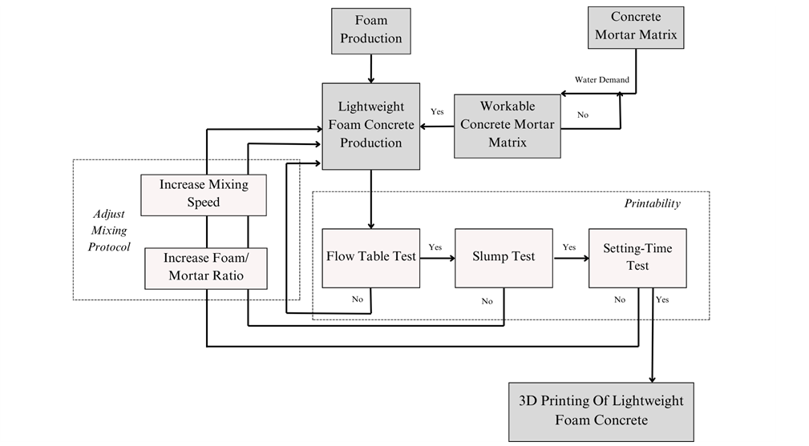

In preliminary stage, dry materials at fixed ratio were thoroughly mixed for even distribution. Water to cementitious ratio is then employed at 0.30 – 0.50, alongside foam to mortar ratio of 0.05 – 0.2, to determine the effective range. Table 1 describes the mixing procedure.
Table 1. Mixing procedure for lightweight foam concretes
Time [min:s] Action | Speed [rpm] | Action | Time [min:s] Action
0:00 – 3:00 | 139 | Mixing of dry materials until homogeneous | 0:00 – 3:00
3:00 – 5:00 | 139 | Addition of water and mix until homogeneous | 3:00 – 5:00
5:00 – 6:00 | 285 | Mixing at high speed | 5:00 – 6:00
6:00 – 7:00 | 0 | Rest and scrape | 6:00 – 7:00
7:00 – 8:00 | 285 | Addition of 40% foaming agent | 7:00 – 8:00
8:00 – 9:00 | 285 | Addition of 40% foaming agent | 8:00 – 9:00
9:00 – 10:00 | 285 | Addition of 20% foaming agent | 9:00 – 10:00
It is important to mix the dry materials to improve homogeneity, as such, a whisk-like mixing apparatus is adapted instead of a spear-like to improve mixing capability under low rpms. Moreover, the addition of water with respect to the objective preliminary range was tested to determine the effective range. Alongside this, a foaming agent was added to the homogenized mortar under mixed-foaming method to incorporate air voids and obtain LFC. Mixtures and mixing parameters that satisfy the screening indicated by Figure 1 was subjected to 3D Printing.
Chosen mixtures from the best fit investigation were subjected for 3D Printing and was prepared in bulk (approximately 8kg worth of mortar). It underwent extrusion method using the UM2205 3D Printer (NIU, Yilan, Taiwan). A feed hopper with cone shaped extension was used as extrusion medium having a 25mm tube with a 10mm nozzle outlet. A printing speed of 40 mm/s was selected based on preliminary extrudability investigations. Printing process was controlled via control board with pre-programmed script. Printed specimens have dimensions 5cm × 5cm × 25cm for width, height, and length respectively. A total of 4 - 5 samples was printed for material testing.
After printing, the samples were left at a chamber at room temperature for setting. After 2 - 3 hours, the samples were cut to form a 5cm × 5cm × 5cm cube. The time chosen for cutting was intended for an easier cutting where the samples are hard enough to cut without damaging its structure. It was then cured at curing room with a temperature of 20 C, a relative humidity of 60%, and in the absence of wind and was labeled 3, 7, 14, and 28 days for compressive testing. Loading area was even-tempered with fast-setting gypsum. Refer to Figure 2.
Figure 2. Printing of 3DP-LFC Mixtures
A pycnometer was used to determine the porosity of the samples. Following the ASTM D5550-14, a helium gas was used by the pycnometer. For the sample preparation, the printed samples were saw-cut into dimension of 1×1×1 $cm^{3}$ without using water and was dusted using an aspirator. The cut samples were then weighed before placing inside the pycnometer machine. A 2 cm diameter tube was utilized as sample holder for samples due to the volume of prepared samples. The program did 5 runs for every sample to obtain accurate results.
The thermal conductivity of samples was determined using a FOX200 heat flow meter. A hollow specimen of 5×20×20 $cm^{3}$ outer volume and a 5×5×5 $cm^{3}$inner volume was used as a place holder for the printed 5×5×5 $cm^{3}$ specimens. The hollow specimen was a spent LFC intended for a comparable thermal conductivity which is in accordance to ASTM C518. Each sample had a measurement period of approximately 60 – 180 minutes.
Scanning electron microscopy (SEM) was used to visualize the microstructure of the foam concrete. The SEM unit JSM-IT200, InTouchTm, JEOL Scanning Electron Microscope was operated at high vacuum and 10kV, whereby samples from compressive strength test aftermath were gold sputtered for 1 minute to induce conductivity and improve better imaging. Chosen samples were within the height range of 5mm<x<6mm.
RESULTS AND DISCUSSION
Chemical composition or oxides shown in Table 1 and was used to obtain the best Ca/Si ratio for dry materials --- approximately in the range of 0.8 – 0.9. Upon multiple iteration using the excel solver, this produced a Ca/Si ratio of 0.8865 which is within the acceptable range of 0.8 - 0.9 for superior mechanical properties (Fan et al., 2023; Hou et al., 2021; Kunther et al., 2017). The obtained values for RUFA, GGBS, and OPC were 0.35, 0.40, and 0.25, respectively. The dry materials ratio was fixed for all samples and was categorized as mass ratio.
Following the procedure shown in Figure 1, a preliminary investigation was upheld to determine LFC mixture best suited for 3D Printing. The researcher aimed to obtain the parameters for printability lightweight foam concrete: (1) fresh density range: 0.5 - 1.1 $\frac{g}{cm^{3}}$, (2) dry density range: 0.3 – 0.9 $\frac{g}{cm^{3}}$, (3) flowability range: 60 - 100%, (4) setting time: 3 - 48 hrs., (5) slump range: 6 - 9 in. Using Design Expert v13.0 a best fit for constraints was obtained and is shown in Figure 3.
Figure 3. Best Fit for Constrained Factors
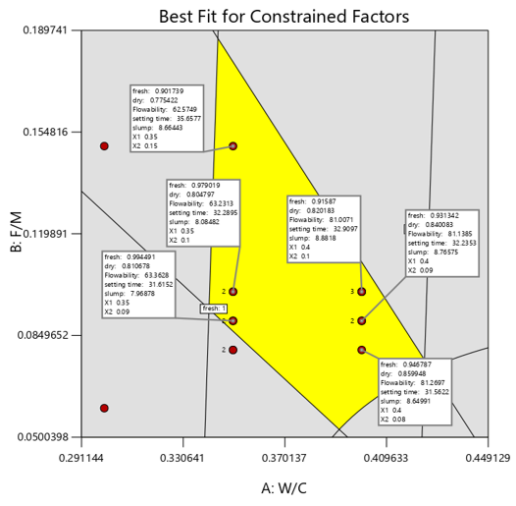
The yellow region indicates the parameter combinations that satisfy the criteria for producing lightweight and printable foam concrete. The red markers represent the optimal solutions obtained at a mixing speed of 285 RPM; notably, no feasible solutions were identified at 139 RPM. This absence of viable solutions at the lower mixing speed is attributed to insufficient mechanical energy generated by the rotation, which limits effective foam formation and results in fresh and dry densities exceeding the specified constraints.
A total of four feasible points were identified for a water–cement (W/C) ratio of 0.35, while three points were identified for a W/C ratio of 0.40. Based on these results, selected mixtures were used for the 3D printing trials. The mixtures chosen for printing correspond to (W/C, F/M) ratios of (0.35, 0.10), (0.35, 0.15), and (0.40, 0.10). Nevertheless, considering that printability of Lightweight Foam Concrete (LFC) may still be achieved at 139 RPM despite densities exceeding the target range, mixtures produced at this mixing speed were also printed for comparative evaluation. The selected mix designs used for the 3D printing of LFC are summarized in Table 2.
Table 2. Mix Design of samples and their Fresh & Dry density
SAMPLE CODE | CEMENTITOUS |  |  | W/C | F/M | RPM | Fresh Density,  $$\frac{g}{cm^{3}}$$ | Dry Density,  $$\frac{g}{cm^{3}}$$
SAMPLE CODE | RUFA | OPC | GGBS
M1 | 0.35 | 0.25 | 0.40 | 0.35 | 0.10 | 139 | 1.5132 | 1.3257
M2 | 0.35 | 0.25 | 0.40 | 0.35 | 0.15 | 139 | 1.4445 | 1.3144
M3 | 0.35 | 0.25 | 0.40 | 0.4 | 0.10 | 139 | 1.7568 | 1.5139
M4 | 0.35 | 0.25 | 0.40 | 0.4 | 0.10 | 285 | 1.1124 | 1.0845
M5 | 0.35 | 0.25 | 0.40 | 0.35 | 0.15 | 285 | 1.0658 | 1.0124
M6 | 0.35 | 0.25 | 0.40 | 0.35 | 0.10 | 285 | 1.4189 | 1.2415
Although identical water-to-cement (W/C) and foam-to-mortar (F/M) ratios were applied across several mixtures, the samples mixed at lower rotational speeds (M1, M2, and M3) exhibited relatively higher fresh and dry densities. This observation can be attributed to the requirement for sufficient mixing energy when producing foam concrete, particularly under the mixed-foaming method adopted in this study. At lower rotational speeds, the mixing energy is inadequate to promote effective air entrainment within the cementitious matrix, thereby limiting foam generation and resulting in mixtures with higher density. In contrast, samples mixed at higher rotational speeds (M4, M5, and M6) demonstrated lower densities, indicating more effective foam incorporation during mixing.
Among the mixtures prepared at higher rotational speeds, M6 (W/C = 0.35, F/M = 0.10) exhibited the highest density. This behavior can be attributed primarily to its relatively lower water content, which contributes to the formation of a denser cementitious matrix. Although the lower foam content would generally lead to reduced density through air entrainment, the denser matrix in M6 likely caused partial instability and rupture of some entrained bubbles during mixing, thereby maintaining a comparatively higher density. During the 3D printing process, however, mixture M4 experienced structural collapse after the deposition of the fourth layer. This behavior is likely associated with a supersaturated lightweight foam concrete (LFC) mixture, in which excessive pore formation during mixing resulted in internal instability and bubble rupture as additional layers were deposited. The collapse may also be related to an inappropriate extrusion rate that exceeded the fresh structural capacity of the highly porous mixture.
Furthermore, it was observed that the dry densities of several samples exceeded the target density range. This outcome may be attributed to the extrusion-based printing process, wherein the foam structure is subjected to pressure as the material passes through the nozzle. Such pressure can destabilize the entrained bubbles, leading to partial foam collapse and consequently higher final density.
The compressive strength of the printed specimens at different curing ages is presented in Figure 4. Among the mixtures prepared at 139 RPM, the mixture with W/C = 0.40 and F/M = 0.10 (M3) exhibited the highest compressive strength. However, its counterpart mixed at 285 RPM (M4) showed one of the lowest compressive strengths, comparable to that of M5. This reduction in strength at higher rotational speed can be explained by the increased interaction between water and the foaming agent during high-speed mixing, which promotes greater foam generation. The resulting increase in air voids reduces the overall density of the material, thereby decreasing its compressive strength.
Interestingly, mixtures M1 and M2 exhibited similar compressive strengths despite having different F/M ratios. This suggests that, at lower rotational speeds, the structural framework of the 3D printed lightweight foam concrete (3DP-LFC) is largely established prior to significant foam incorporation. Consequently, the influence of the foaming agent on compressive strength is relatively limited at low mixing speeds. In contrast, at higher rotational speeds, the foaming agent plays a more substantial role in determining the compressive strength of the printed specimens. As previously noted, the excessive bubble formation in mixture M4 resulted in printing failure after the fourth layer, indicating high porosity, low density, and consequently reduced strength. Mixture M5 exhibited a compressive strength similar to that of M4 but was successfully printed without structural collapse.
Among the high-RPM mixtures, M6 demonstrated the highest compressive strength and even exceeded the strength values obtained for M1 and M2. This finding indicates that the combination of W/C = 0.35 and F/M = 0.10 at higher rotational speed promotes the formation of a more stable and mechanically robust microstructure. As a result, mixture M6 achieved the peak compressive strength among the tested high-RPM samples, reaching a value of 8.25 MPa.
Figure 4. Compressive Strength of 3DP-LFC samples
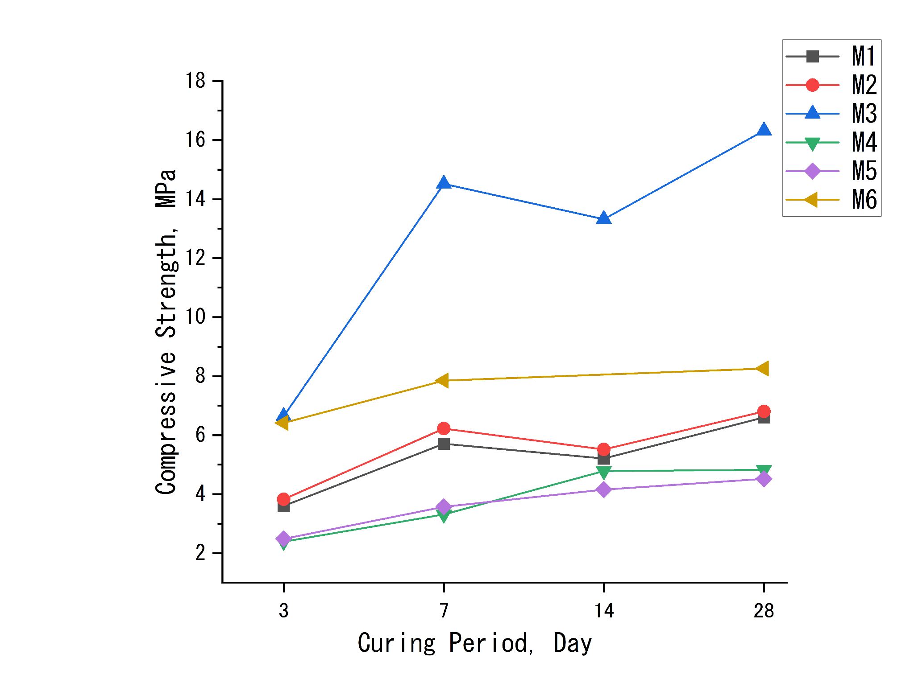
Porosity measurements were conducted using a pycnometer (ULTRAPYC 1200e) in accordance with ASTM D5550. To ensure measurement reliability, each specimen was tested through five consecutive runs. The samples were cut into approximately 1 cm × 1 cm × 1 cm cubes to accurately determine their geometric (bulk) volume.
The pycnometer determines the true solid volume of the specimen by measuring the volume occupied by the solid phase while excluding internal pores. Porosity was then calculated based on the difference between the bulk volume of the sample and the true volume measured by the pycnometer. The resulting porosity values for each mixture are presented in Table 3.
Samples produced at lower mixing speeds (M1, M2, and M3) exhibited comparatively lower porosity values, which correspond to their higher measured densities. Among these, M3 showed the lowest porosity, a characteristic that significantly contributed to its improved mechanical performance. As illustrated in Figure 4, this mixture demonstrated superior compressive strength relative to the other samples, likely due to its denser and more rigid microstructure.
Conversely, mixture M5, despite exhibiting the lowest density and compressive strength, recorded a relatively high porosity value of 66.77%, with M4 showing a similar trend under comparable mixing conditions. This behavior indicates that increased foam incorporation during higher-RPM mixing promotes the formation of a more porous internal structure, which consequently reduces both density and mechanical strength.
Table 3. Porosity and Thermal Conductivity of printed samples
Sample Code | Actual Volume, $cm^{3}$ | Solids Volume, $cm^{3}$ | Std dev, Porosity | Porosity, % | Thermal Conductivity, $\frac{W}{mK}$ | Std dev, Thermal conductivity
M1 | 1.0500 | 0.8138 | 0.0123 | 22.50 | 0.1697 | 0.0231
M2 | 1.2100 | 0.9555 | 0.0074 | 21.03 | 0.1720 | 0.0089
M3 | 1.100 | 0.9654 | 0.0077 | 12.24 | 0.2011 | 0.0191
M4 | 1.7940 | 0.6745 | 0.0077 | 62.40 | 0.1640 | 0.0081
M5 | 1.3200 | 0.4387 | 0.0071 | 66.77 | 0.1566 | 0.0091
M6 | 0.9500 | 0.6125 | 0.0086 | 35.53 | 0.1691 | 0.0103
Previous studies have reported that the thermal conductivity of lightweight concrete generally ranges from 0.2 to 1.9 W/m·K, while that of normal weight concrete (NWC) ranges from 0.6 to 3.3 $\frac{W}{m·K}$ $(Real et al., 2016; Yun et al., 2013)$ In comparison, foamed concrete typically exhibits significantly lower thermal conductivity values, ranging from 0.021 to 0.042 W/m·K, depending on its density. The thermal conductivity of the printed samples in this study is presented in Table 3 and was measured using a FOX 200 Heat Flow Meter. Previous investigations have demonstrated a strong correlation between porosity and thermal conductivity, where higher porosity generally results in lower thermal conductivity due to the increased presence of entrained air within the material.
Microstructural analysis of the 3D-printed lightweight foamed concrete (3DP-LFC) was conducted, with particular emphasis on mixture M5, as illustrated in Figure 5. Foam concrete typically contains several types of pores, including gel pores, capillary pores, and entrained or entrapped air voids, as discussed by Markin et al., 2019. In the present study, the analysis focused specifically on-air voids with diameters exceeding 10 μm, while gel and capillary pores were not considered. Figure 5, obtained through scanning electron microscopy (SEM), provides a detailed visualization of the surface morphology and pore distribution within the sample.
The SEM images clearly demonstrate the effectiveness of the stabilized sodium lauryl sulfate (SLS) foaming agent in generating air voids capable of withstanding the extrusion forces associated with the 3D printing process. The entrained air bubbles exhibit varied geometries, with diameters ranging from tens to several hundreds of micrometers. These voids are distributed discretely throughout the cementitious matrix rather than forming a continuous interconnected pore network (see Figure 5a–b). The surrounding matrix regions display a relatively dense microstructure with minimal capillary porosity, which can be attributed to the reduced residual water content employed during aggregate hydration. Furthermore, the SEM observations reveal the presence of hydration products such as calcium silicate hydrate (C-S-H) and calcium hydroxide (C-H), along with residual anhydrous spherical particles of reactive ultra-fine ash (RUFA) and ground granulated blast furnace slag (GGBS), which are commonly observed after a 28-day curing period.
In addition, Figure 5b highlights the presence of crystalline formations within the pore spaces, a phenomenon similarly reported by Chen et al., 2021; Yun et al., 2013. These crystalline structures contribute to a distinctive surface morphology within the concrete matrix. The consistent occurrence of such crystalline formations across the examined specimens suggests complex physicochemical interactions between the supplementary cementitious materials (RUFA and GGBS) and the SLS-based foaming system, warranting further investigation into their formation mechanisms and potential influence on material properties.
The primary load-bearing framework in foam concrete is formed by the solid matrix walls separating the entrained air voids, as illustrated in Figure 3.3d. Within these matrix walls, a woven and flower-like microstructure is observed, which contributes to microstructural densification and enhances the mechanical performance of the material. This dense matrix network, combined with the presence of isolated large air voids generated during the foaming process, plays a significant role in providing foam concrete with high thermal insulation capacity, improved compressive strength, and relatively low permeability, as reported by V. Markin.
However, the SEM analysis also reveals the presence of very small voids embedded within the matrix (Figure 5c). Similar observations have been reported by Markin et al., 2019, indicating that these microvoids may introduce weak or non-cohesive interfaces within the hardened structure. Such features could potentially compromise the physical and mechanical integrity of foam concrete. Consequently, further research aimed at controlling or minimizing the formation of these microvoids is necessary to optimize the long-term performance and durability of 3D-printed foam concrete materials.

Figure 5 a-d. Scanning Electron Microscopy of M5. a) Pore at $×1000$ magnification, b) Pore wall and Pore surface at $×3000$ magnification, c) Pores $<1μm$ at $×10k$ magnification, and d) Flower-like structure
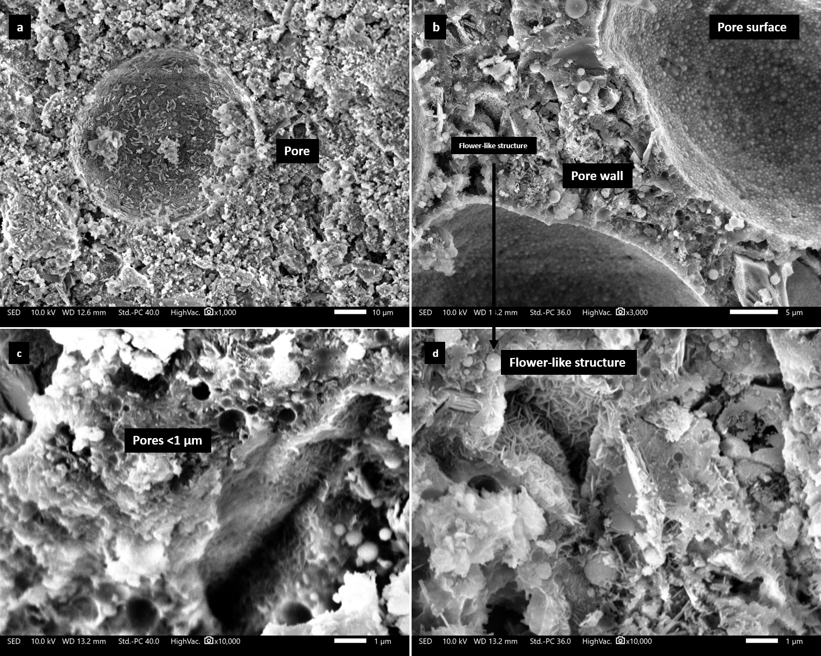
The energy-dispersive X-ray spectroscopy (EDS) results presented in Figure 6 were obtained from samples prepared at mixing speeds of 139 RPM (M3) and 285 RPM (M5) to evaluate the influence of mixing speed on the material’s mechanical performance. These samples were selected due to their contrasting compressive strengths, with M3 exhibiting the highest strength and M5 the lowest among the tested mixtures. Although both samples possessed identical water-to-cement (W/C) and foam-to-mortar (F/M) ratios, the analysis aimed to determine whether variations in mixing speed affected the formation of strength-contributing hydration products, particularly calcium silicate hydrate (C–S–H) generated from the hydration of alite and belite phases.
The results indicate that the formation of these hydration products showed minimal variation between the two mixing conditions, suggesting that mixing speed does not significantly influence the chemical development of the primary strength-bearing phases. However, the structural integrity of the material was notably affected by mixing speed. Higher rotational speeds promoted increased air entrainment and pore formation, which in turn reduced the compressive strength of the material. This observation is consistent with the compressive strength results for M3 and M5 shown in Figure 4, where mixtures with similar W/C and F/M ratios exhibited significantly different strengths due primarily to differences in pore structure induced by mixing speed.
Further elemental analysis revealed that both the bulk matrix and the pore regions contained similar elemental constituents, although their relative concentrations varied. In particular, sodium (Na) concentrations were significantly higher within the pore regions, which is consistent with the sodium-based composition of the foaming agent sodium lauryl sulfate (SLS) used in this study. Additionally, the presence of strong oxygen signals suggests the existence of hydroxides or unreacted oxides originating from supplementary cementitious materials such as ground granulated blast furnace slag (GGBS) and reactive ultra-fine ash (RUFA).
Notably, sulfur (S) was also detected in the samples, likely originating from the SLS foaming agent. Interestingly, sulfur was not significantly detected within the primary concrete matrix phase, suggesting that it may have been partially volatilized during the preparation of the foaming agent or during the production process of the 3D-printed lightweight foamed concrete (3DP-LFC) mortar. This observation may indicate a reduced likelihood of sulfur-containing gaseous emissions under conditions involving combustion or elevated temperatures.
Figure 6. Energy Dispersive X-ray Spectroscopy
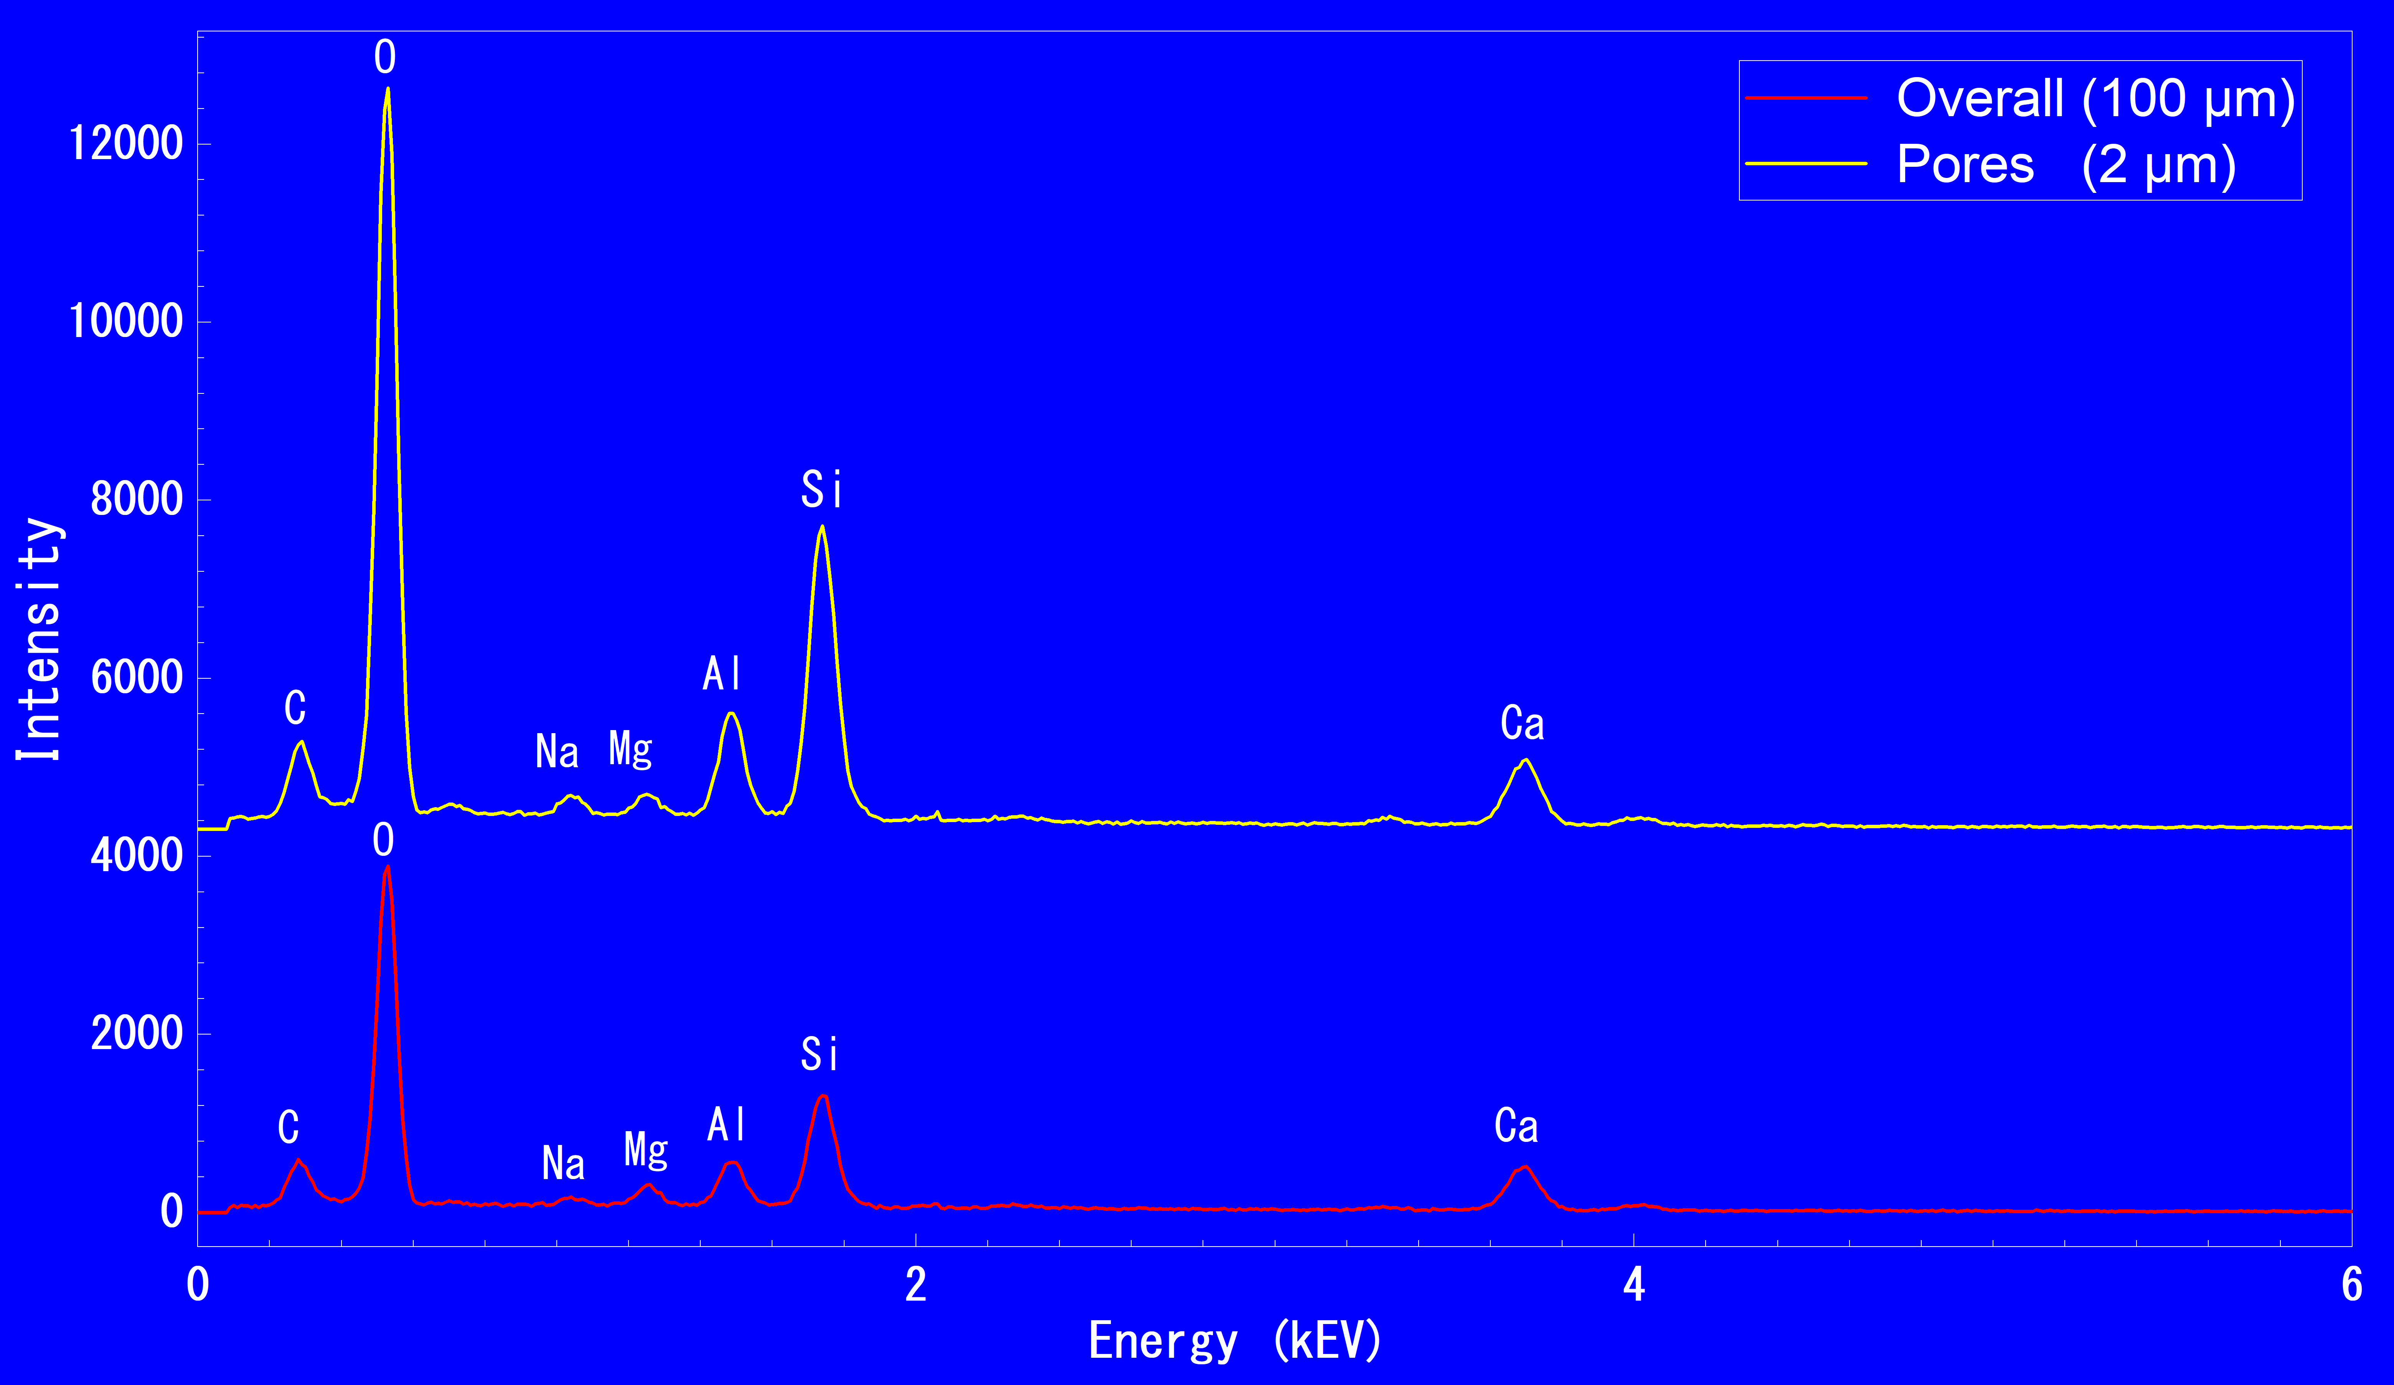
CONCLUSION
The study demonstrated that the combination of reactive ultra-fine ash (RUFA), ground granulated blast furnace slag (GGBS), and ordinary Portland cement (OPC), together with polyvinyl alcohol (PVA)-stabilized sodium lauryl sulfate (SLS) as the foaming system, can produce printable lightweight foam concrete with desirable properties. The resulting 3D-printed lightweight foamed concrete (3DP-LFC) exhibited dry densities ranging from 1.0124 to 1.2415 g/cm³, porosity values between 33.53% and 66.77%, compressive strengths of 4.52–8.26 MPa, and thermal conductivity values between 0.15 and 0.17 W/m·K.
- The results further indicate that the production of LFC is more effective at higher mixing speeds, as these conditions enable the mixtures to achieve the targeted performance range (see Figure 3). In addition, an increase in the water-to-cement (W/C) ratio was observed to reduce the required foam-to-mortar (F/M) ratio, indicating an inverse relationship between these parameters in achieving optimal mixture characteristics.
- Elemental analysis using energy-dispersive X-ray spectroscopy (EDS) revealed that mixing speed does not significantly affect the formation of strength-contributing hydration products in 3DP-LFC. Instead, its primary influence lies in modifying the internal structure of the material, particularly by promoting increased void formation at higher rotational speeds. This structural change ultimately leads to a reduction in mechanical strength due to increased porosity.
- The use of a Ca/Si ratio of 0.8890 was found to facilitate the formation of hydration products such as calcium silicate hydrate (C–S–H) and calcium hydroxide (C–H) crystals, which contributed to the mechanical performance of the LFC within the targeted density range. Microstructural observations further revealed that the pore walls consist of a relatively dense cementitious matrix, which plays a significant role in enhancing the material’s mechanical properties.
- The observed pore sizes ranged from approximately 10 μm to 100 μm, indicating that the stabilization of the SLS foaming system by PVA was effective in maintaining bubble integrity during both the extrusion process and the subsequent curing period. This confirms the suitability of the PVA-stabilized SLS system for application in 3D-printed lightweight foamed concrete.
- Additionally, the microstructural analysis revealed interesting features on the pore surfaces, including crystalline formations—possibly vaterite or aragonite—as well as the presence of microvoids smaller than 1 μm within the matrix. These observations suggest complex physicochemical interactions within the material system and warrant further investigation to better understand their formation mechanisms and potential influence on long-term material performance.
- Finally, it should be noted that only three mixture points within the identified feasible region (yellow area) of the best-fit graph, along with their lower-RPM counterparts, were selected for experimental testing and printing trials. Therefore, it is recommended that future studies investigate additional mixture combinations within this feasible region to obtain more comprehensive data and to further optimize the performance of 3DP-LFC mixtures.
REFERENCES
- Alexandra, H. and Istvan, K., “The investigation of sodium lauryl sulphate as foam stabilizer in cement foams,” Materials Science and Engineering. Accessed: Jan. 14, 2025. doi: 10.32974.mse.2020.011
- Amran, Y. H. M., N. Farzadnia, and A. A. A. Ali, “Properties and applications of foamed concrete; A review,” Elsevier Ltd., Dec. 30, 2015. doi: 10.1016/j.conbuildmat.2015.10.112
- Chen, G., F. Li, P. Jing, J. Geng, and Z. Si, “Effect of Pore Structure on Thermal Conductivity and Mechanical Properties of Autoclaved Aerated Concrete,” Materials, vol. 14, no. 2, p. 339, Jan. 2021. doi: 10.3390/MA14020339
- Fan, M. X., F. X. Chen, X. Y. Zhang, R. K. Wang, and R. Yu, “Effect of Ca/Si ratio on the characteristics of alkali-activated ultra-high-performance concrete (A-UHPC): From hydration kinetics to microscopic structure development,” Constr. Build. Mater., vol. 394, p. 132158, Aug. 2023. doi: 10.1016/J.CONBUILDMAT.2023.132158
- Falliano, D., D. De Domenico, G. Ricciardi, and E. Gugliandolo, “3D-printable lightweight foamed concrete and comparison with classical foamed concrete in terms of fresh state properties and mechanical strength,” Constr. Build. Mater., vol. 254, Sep. 2020. doi: 10.1016/j.conbuildmat.2020.119271
- Falliano, D., E. Gugliandolo, D. De Domenico, and G. Ricciardi, “Experimental investigation on the mechanical strength and thermal conductivity of extrudable foamed concrete and preliminary views on its potential application in 3D printed multilayer insulating panels,” in RILEM Bookseries, vol. 19, Springer Netherlands, 2019, pp. 277–286. doi: 10.1007/978-3-319-99519-9_26
- Hashim, M. and M. Tantray, “Comparative study on the performance of protein and synthetic-based foaming agents used in foamed concrete,” Case Studies in Construction Materials, vol. 14, p. e00524, Jun. 2021. doi: 10.1016/J.CSCM.2021.E00524
- Hou, L., J. Li, Z. Lu, and Y. Niu, “Influence of foaming agent on cement and foam concrete,” Constr. Build. Mater., vol. 280, p. 122399, Apr. 2021. doi: 10.1016/J.CONBUILDMAT.2021.122399.
- Indu, G., S. Ranjani, and K. Ramamurthy, “Analysis of the Foam Generated Using Surfactant Sodium Lauryl Sulfate,” Int. J. Concr. Struct. Mater., vol. 4, no. 1, pp. 55–62, Jun. 2010. doi: 10.4334/IJCSM.2010.4.1.055
- Kauffer, Z. and P. May, “Sodium lauryl sulfate: The main cleaning agent in soap and detergent,” 2010. doi: 10.6084/m9.figshare.5255146
- Kirubajiny Pasupathy, S. R. J. S., “Enhancing the properties of foam concrete 3D printing using porous aggregates,” Cem. Concr. Compos., vol. 133, Jul. 2022
- Kunther, W., S. Ferreiro, and J. Skibsted, “Influence of the Ca/Si ratio on the compressive strength of cementitious calcium–silicate–hydrate binders,” J. Mater. Chem. A, vol. 5, no. 33, pp. 17401–17412, Aug. 2017. doi: 10.1039/C7TA06104H
- Liu, T., G. Shi, G. Li, and Z. Wang, “Lightweight foamed concrete with foam agent addition,” in IOP Conference Series: Materials Science and Engineering, Apr. 2019. doi: 10.1088/1757-899X/490/3/032033
- Markin, V., V. N. Nerella, C. Schröfl, G. Guseynova, and V. Mechtcherine, “Material design and performance evaluation of foam concrete for digital fabrication,” Materials, vol. 12, no. 15, Aug. 2019. doi: 10.3390/ma12152433
- Markin, V., M. Krause, J. Otto, C. Schröfl, and V. Mechtcherine, “3D-printing with foam concrete: From material design and testing to application and sustainability,” Journal of Building Engineering, vol. 43, Nov. 2021. doi: 10.1016/j.jobe.2021.102870
- Munachiso, O. and B. O. Nimisoere, “Comparative Study on The Strength of Lightweight Foamed Concrete Prepared Using Different Reagents,” International Journal of Advanced Research and Publications.www.ijarp.org
- Ospanova, Z. B., K. B. Musabekov, and M. M. Asadov, “An effect of surfactants of different nature on stabilization of foaming systems containing polyvinyl alcohol,” Russian Journal of Applied Chemistry, vol. 87, no. 3, pp. 355–359, 2014. doi: 10.1134/S1070427214030185
- Ou, X. et al., “Animal-Protein-Based and Synthetic-Based Foamed Mixture Lightweight Soil Doped with Bauxite Tailings: Macro and Microscopic Properties,” Materials, vol. 15, no. 18, Sep. 2022. doi: 10.3390/ma15186377
- Real, S., M. G. Gomes, A. Moret Rodrigues, and J. A. Bogas, “Contribution of structural lightweight aggregate concrete to the reduction of thermal bridging effect in buildings,” Constr. Build. Mater., vol. 121, pp. 460–470, Sep. 2016. doi: 10.1016/J.CONBUILDMAT.2016.06.018
- Siva, M., K. Ramamurthy, and R. Dhamodharan, “Sodium salt admixtures for enhancing the foaming characteristics of sodium lauryl sulphate,” Cem. Concr. Compos., vol. 57, pp. 133–141, Mar. 2015. doi: 10.1016/J.CEMCONCOMP.2014.12.011
- Yun, T. S., Y. J. Jeong, T. S. Han, and K. S. Youm, “Evaluation of thermal conductivity for thermally insulated concretes,” Energy Build., vol. 61, pp. 125–132, Jun. 2013. doi: 10.1016/J.ENBUILD.2013.01.043

