MICRO- AND NANOPLASTIC CONTAMINATION IN SURFACE AND GROUNDWATER SOURCES OF AIFAM OWUKPA, OGBADIBO LGA, BENUE STATE, NIGERIA: A FIRST EXPLORATORY SCAN
I. J. Ikwuje¹, O. Ofoegbu², G. Ikwuje³, and T. Yaro²
¹Department of Environmental Sustainability, College of Physical Sciences, Joseph Sarwuan Tarka University, Makurdi, Benue State, Nigeria
²Department of Industrial Chemistry, College of Physical Sciences, Joseph Sarwuan Tarka University, Makurdi, Benue State, Nigeria
³Dr. John Adah College of Health Science and Technology, Otukpo, Benue State, Nigeria
Corresponding author: ofoegbu.obinna@uam.edu.ng
ABSTRACT
The micro- and nanoplastic (MP/NP) contamination of freshwater systems has become a rapidly growing environmental and human health issue on a global scale, but rural groundwater and surface water of sub-Saharan Africa are understudied to an outrageous degree. The first exploratory study of its kind in Aifam Owukpa, Ogbadibo Local Government Area (LGA), Benue State, Nigeria, describes the MP/NP contamination in 12 purposely chosen water sources (streams, springs, and hand-dug wells) sampled during the rainy season (July-August 2025). Multi-stage membrane filtration (5 µm and 0.45 µm), hydrogen peroxide digestion, and sodium chloride density separation of water samples were performed. Attenuated Total Reflectance Fourier Transform Infrared (ATR-FTIR) spectroscopy (Nicolet iS50, 4,000-400 cm-1) was used to identify polymers, and the Scanning Electron Microscopy with Energy Dispersive X-ray Spectroscopy (SEM-EDS; JEOL JSM-6610LV) Physicochemical parameters (pH, turbidity, electrical conductivity, biochemical oxygen demand (BOD)) and total dissolved solids (TDS) were measured and compared with APHA standard guidelines and WHO recommendations. The microplastics occurred in 85% of the sampling sites (11 of 12) at concentrations of 45-210 particles/L (mean: 112 ± 45 particles/L). The concentrations were much higher in the stream sites (mean: 195 ± 21 particles/L) in comparison to wells (mean: 120 ± 22 particles/L) and springs (45 particles/L). The predominant types of polymers were polyethylene (PE, 40%), polypropylene (PP, 30%), polystyrene (PS, 15%), polyethylene terephthalate (PET, 10%), and polyvinyl chloride (PVC, 5%). Morphological examination showed that the main shapes of the particles were fragments (55%), fibers (30%), and films (15%). Sub-micrometre spectral broadening was observed as a sign of nanoplastic in 40% of samples. The turbidity was significantly positively correlated with MP abundance (r = 0.78, p < 0.01), whereas BOD and TDS were moderately positively correlated (r = 0.7285, p < 0.05). SEM-EDS identified high carbon content (65-75 percent C) and morphologies of degradation of plastics that showed evidence of being aged and weathered by the environment. High levels in stream and market sites located at the edges of wells were blamed on agricultural runoff, informal waste disposal and hydrologic transportation. The results provide a crucial contamination threshold of this underresearched rural community, highlighting the importance of community-wide governance of plastic waste, incorporating MP monitoring into the Benue State water quality systems, and conducting seasonal studies to comprehensively define the nature of contamination.
Keywords: Microplastics, nanoplastics, ATR-FTIR, SEM-EDS, freshwater contamination, Nigeria, groundwater, rural water quality, polymer characterization, Benue State.

I. INTRODUCTION
Plastic pollution has received a complete overhaul to change the issue of visible, macro-scaled litter to micro- and nanoscale, ubiquitous contamination. Microplastics (MPs) are defined as plastic particles whose longest dimension is less than 5 mm but more than 1 µm, and nanoplastics (NPs) are less than 1 mm in diameter [1]. These particles are formed as a result of the fragmentation of larger plastic debris in the ultraviolet radiation, mechanical abrasion, and biological degradation (secondary MPs), or due to direct emissions during production, tire wear, washing of synthetic fabrics, and use of personal care products (primary MPs) [2]. Their hydrophobic surfaces enable them to adsorb persistent organic pollutants (POPs), heavy metals, and pathogenic biofilms, and convert individual particles into multifaceted chemical vectors that increase ecotoxicology risk far beyond that of the plastic matrix itself [3].
As of 2023, the world total of plastic manufacturing was over 400 million metric tonnes per year, and it is estimated to be doubled by 2040, unless current manufacturing and waste management trends are altered [4]. The estimates of this volume indicate that between 9% and 23% finally finds its way into the natural environment, mainly through riverine routes [5]. No longer viewed as transitional sites to marine systems, freshwater ecosystems are now viewed as essential sites of accumulation and, more and more, as a literal source of human exposure via drinking water and dietary uptake [6]. In European and Asian rivers, concentrations have been recorded at 10- 8,000 particles/L, which is dependent on the catchment land use and urbanization [7]. The geographical conditions in the sub-Saharan region of Africa exacerbate the plastic pollution problem; recycling rates are at the continent level, less than 10 percent, and significant proportions of the plastic waste produced are discarded or burned [8].
The most populous country on the African continent, Nigeria, consumes more than 700,000 tonnes of plastic per year, with a disproportionate amount of this plastic being deposited in watercourses uncontrolled [9]. Increasing research attention has been given to urban Nigerian water bodies: boreholes in metropolitan Lagos have been demonstrated to harbor MP concentrations 206-1,691 particles/L, with the Lagos Lagoon supporting concentrations of 1,200-6,700 particles/m³, which has been fuelled by fragments of urban runoff and industrial discharges [10, 11]. Nevertheless, little is known regarding the rural groundwater systems, in terms of MP/NP contamination, in northern and central Nigeria, which is a key gap, since most rural residents use untreated springs, hand-dug wells, and seasonal streams as the direct sources of domestic and drinking water [12].
The River Benue and tributary system of the river play a significant role in the irrigation and provision of domestic water in Benue State, located in the Middle Belt of Nigeria, and informally known as the Food Basket of the Nation, due to its agricultural productivity. The Ogbadibo LGA, which is situated in the southeast of the state, is a predominantly agricultural society with a recorded history of trace metal pollution that has been attributed to the past coal mining operations in the Owukpa area [13]. The existence of coal-based contaminants evokes the further spectre of MP-metal co-contaminant interactions, with plastic surfaces serving as a sink to metals like lead, cadmium, and chromium, and thus exposing humanity to increased contamination through ingestion of contaminated water [14]. Although this represents a multi-dimensional risk profile, there has not yet been published research that explored MP or NP contamination in the surface or groundwater of Aifam Owukpa or of the Owukpa community, in general.
This research was planned as a pilot scan to determine baseline contamination information of Aifam Owukpa water sources. It also tackles five objectives: (i) to identify the physicochemical quality of sampled waters within the framework of WHO standards; (ii) to identify and measure MPs through ATR-FTIR spectroscopy; (iii) to characterize particle morphology and elemental composition with the use of SEM-EDS; (iv) to map the spatial distribution of MP contamination and identify potential anthropogenic sources. The research, therefore, bridges a geographically and environmentally important gap in the fast-expanding body of research on African freshwater MP.
1.1 Health and Ecological Aspects of Micro- and Nanoplastic Contamination.
Mechanistic evidence is increasingly becoming important in the toxicological significance of MPs and NPs in drinking water. When ingested, particles less than 150 µm may penetrate the intestinal epithelium and enter the systemic circulation, and smaller NPs are able to cross the blood-brain barrier and be deposited in organ tissues such as the liver, spleen, kidney, and testes [15]. Biological effects have been observed, such as oxidative stress, inflammatory cytokine up-regulation, endocrine signaling pathway disruption (especially estrogen and androgen receptors), and mitochondrial dysfunction [16]. These health risks are compounded by the chemical additives washed out of plastics such as bisphenol A (BPA), phthalate plasticizers, and flame retardants [17].
In fresh water, MPs are taken up by organisms at various trophic levels, such as macroinvertebrates, fish, and amphibians, ecologically. Physical ingestion decreases the efficiency of feeding, reproductive output, and intestinal obstruction [18]. Bioaccumulation along food chains presents indirect risks to human consumers of freshwater fish, a protein source that is of significant importance in Benue State, where artisanal fisheries on the River Benue and its tributaries also contribute to livelihoods and food security [19]. The combination of direct water ingestion exposure and dietary bioaccumulation pathways results in a particularly acute risk situation in the context of Aifam Owukpa, where more than 80% of the population relies on untreated water, and subsistence agriculture is the most important source of protein.
1.2 Technical Overview of Analytical Approaches to Micro- and Nanoplastic Detection.
A multi-step analysis workflow, involving physical isolation, chemical identification, and morphological analysis, is necessary to detect and characterize MPs in environmental matrices with a high degree of reliability [20]. Separating by density with saturated saline solutions (NaCl: ρ ≈ 1.2 g/cm³; NaI: ρ ≈ 1.8 g/cm³; ZnCl₂: ρ ≈ 1.7 g/cm³) takes advantage of the difference in density of typical commercial plastics (PE: 0.91–0.96 g/cm³; PP: 0.85–0.92 g/cm³) relative to mineral matrices, achieving extraction efficiencies of 90–96% for these polymer types [21]. Biogenic organic matter that otherwise would interfere with downstream spectroscopic analysis is removed by hydrogen peroxide (H₂O₂) or by enzymatic digestion.
The most recent gold standard used in polymer identification in MP studies is ATR-FTIR spectroscopy. The method bases measurements upon attenuated total internal reflectance to measure molecular vibrational modes, producing absorption spectra in the 4000-400 cm⁻¹ range, which is a polymer fingerprint that can be compared against reference libraries like the OMNIC [22] and OpenSpecy. C–H critical bands at 2920 cm⁻¹ and 2850 cm⁻¹ are diagnostic of polyethylene, and the CH₃ rocking mode at 1376 cm⁻¹ and skeletal C-C stretch at 1168 cm⁻¹ distinguish polypropylene. ATR-FTIR detection limits of about 10-20 µm make it inappropriate to directly characterize NPs with pyrolysis-gas chromatography/mass spectrometry (Py-GC/MS) or liquid chromatography-mass spectrometry (LC-MS). In the current research, NPs were deduced using sub-micrometer spectral broadening and residue morphologies that were in accordance with nanoscale plastic degradation, in line with resource-relevant methodologies that should be used in research studies in low-income nations.
SEM-EDS is a complementary morphological and elemental dataset. The surface features that are resolved in high-resolution scanning electron microscopy at acceleration voltages of 520 kV include weathering fractures, biofouling colonization, and fibre striations to submicron resolution [24]. EDS measures elemental composition (C, O, Cl, Si, and others), allowing polymer matrices (e.g., high Cl content PVC) to be discriminated and inorganic contaminants adsorbed to surfaces to be identified. But EDS by its nature is restricted to elemental as opposed to molecular characterization and thus cannot be used to establish polymer type without spectroscopic support [25].
1.3 Nigerian and African Freshwater MP Review.
The literature on freshwater MP contamination in West Africa, despite a relative scarcity until 2022, has increased significantly. A systematic review of the Nigerian water bodies reported MP concentrations of 86-1,691 particles/L in borehole and well water, and fibre morphologies were predominant in locations affected by domestic grey water and textile wash effluents [26]. Niger Delta surface water research reports of 120-850 particles/L in drinking water sources, which can be attributed to petrochemical packaging waste and oil field working plastics [27]. Past studies have specifically not looked into the trace metal contamination of water in the Owukpa coal belt alone but rather the entire Benue State, a gap that the current study will directly fill [13].
South African rivers report (continent-wide) 0.3-57 particles/L, which is a relatively well-managed waste stream, and East African studies report concentrations of 10-210 particles/L in surface waters affected by smallholder agriculture [28]. The new agreement is that African freshwater MP levels are not as high as those in highly urbanized European or Asian systems but are still significantly high compared to pristine backgrounds and that rural agrarian environments are a previously underrecognized exposure route due to direct drinking of untreated water [29].
1.4 Study Area Description
Aifam Owukpa is a sub-community within Owukpa district, Ogbadibo LGA, Benue State, Nigeria (approximately 7°00'N, 7°40'E; elevation 200–400 m above sea level; approximate area 50 km²). The landscape is characterized by Guinea savanna vegetation transitioning to woodland, with undulating terrain dissected by seasonal streams draining northward towards the River Benue watershed. The population of approximately 5,000 inhabitants is predominantly engaged in subsistence and smallholder agriculture, cultivating yam, cassava, and rice, with associated use of polyethylene mulching films, polypropylene sacks, and single-use packaging. Proximity to the Aho market junction facilitates informal plastic waste accumulation at key hydrological nodes. Legacy open-cast coal mining in the broader Owukpa area has historically introduced heavy metals (Pb, Cd, As) into local drainage systems, creating a complex co-contamination context in which MP-metal interactions are plausible and warranting investigation.
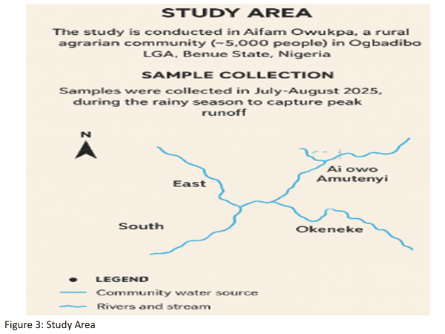
Figure 1. Study area map showing Aifam Owukpa within Ogbadibo LGA, Benue State, Nigeria, with stream network and directional sampling zones. Source: Adapted from community surveys and OpenStreetMap data.

II. MATERIALS AND METHODS
The research was systematic and exploratory in nature, with purposive site selection, regular field sampling plans, lab extraction and characterization processes, and statistical analytic data. All processes complied with or surpassed minimum reporting criteria, which were suggested in the Microplastics Intersessional Working Group (MIWG) of GESAMP [30].
The sampling design and selection of the site is provided in 2.1.
Spatial representativeness of patterns of community water access was achieved by selecting thirteen sampling sites in four cardinal sectors of Aifam Owukpa (Table S1, supplementary). Sites included two stream sites (Okpa Ibakpa, Okpa Oleyawu), a spring (Okpa Edruwoh), a community water source (Ai owo Amatenyi), and nine individual hand-dug wells spread throughout northern, eastern, and central (market-adjacent) areas. The hydrological flow direction, population density, land-use features (residential, agricultural, commercial), and early reconnaissance findings of plastic waste density were used to guide cardinal sector assignment and site prioritization.
Water samples (1L/sample replicate, n=3/sample site, N=39 in total) were taken in amber-glass volumetric bottles rinsed with deionized water. Sterile stainless-steel dippers were used in sampling surface water at average depth (10-20 cm) to minimize surface film contamination. Well water samples were taken after a 5-10 minutes purge to drive away stagnant water and to achieve representative conditions in the aquifer. Samples were kept at 4 °C in closed, dark containers and were processed within 4 hours of collection. Spatial mapping in ArcGIS 10.8 was to be carried out at every site with a Garmin eTrex 32x to record GPS coordinates (±3 m accuracy) in ArcGIS.
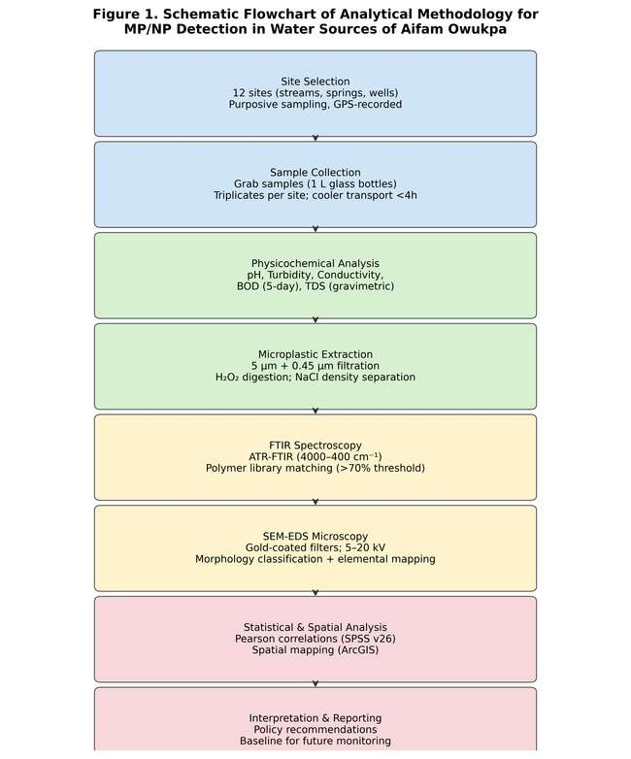
Figure 2. Schematic flowchart of the analytical methodology applied for micro- and nanoplastic detection and characterization in water sources of Aifam Owukpa, Ogbadibo LGA, Benue State.
2.2 Physicochemical Characterization
Physicochemical measurements were taken onsite at the time of sample collection. At each site, water temperature, pH (calibrated Hanna HI98129 multimeter, ±0.01 pH unit), and electrical conductivity (EC; WTW Multi 3420, ± 0.5 %) were determined. The turbidity was measured with a Hach 2100Q portable turbidimeter (Method 2130B; ±0.01 NTU). Laboratory tests encompassed 5-day biochemical oxygen demand (BOD 5 ) using the Winkler titrimetric procedure (APHA 5210B, incubation at 20 °C) and total dissolved solids (TSS) by evaporation at 180 C (APHA 2540C). Measurements were made thrice; the results are given as the mean and standard deviation (SD). References were WHO (2022) Guidelines on Drinking-water Quality [31].
2.3 Microplastic Extraction and Isolation.
The samples were sequentially filtered using stainless-steel sieves (5 mm, 1 mm) to remove gross debris, followed by cellulose nitrate membranes at 5 µm and 0.45 mm (Sartorius, Germany). Incubation of organic matter was carried out in 30 percent H₂O₂ at 60 °C for 48 h, and after this incubation, density separation was done using saturated NaCl solution ( 1.20 g/cm ³ ) to suspend the polymer particles. The supernatant was again filtered using a 5 µm-membrane and a 0.45 µm-membrane. A blank (Milli-Q water treated in the same way) was also run with each batch of analysis. Lab clothing was donned all the way through and equipment surfaces rinsed with isopropanol before handling to reduce airborne contamination of fibres. None of the procedural blanks showed any MP particles.
2.4 ATR-FTIR Spectroscopic Analysis
Particles that were collected on 5 µm and 0.45 µm membranes were analysed separately with a Thermo Scientific Nicolet iS50 FTIR spectrometer and ATR accessory (diamond crystal, 1 bounce). Spectra were recorded at 4000-400 cm ⁻¹ at 4 cm ⁻¹ resolution and 32 co-added scans, and baseline-corrected with the OMNIC 9.2 software package. A spectral matching with the OMNIC Polymer Library and the open-source openSpecy database was done with a minimum library match threshold set at 70% (Pearson correlation coefficient). Particles with ≥70% match were assigned to particular polymer types; other ones fell under the threshold as "unidentified." Sub-micrometre spectral line-broadening artefacts and morphological features of residues on 0.45 µm membranes were inferred to be nanoplastics in line with nanoscale plastic degradation products.
2.5 Scanning Electron Microscopy and Energy Dispersive X-ray Spectroscopy.
A representative portion of MP particles on the surface of selected filter membranes was sputter-coated on aluminium stubs with gold (20 nm thickness; Quorum Q150R ES) and was observed under high-vacuum conditions by a JEOL JSM-6610LV scanning electron microscope at accelerating voltages of 5 to 20 kV. The composition of C, O, Cl, Si, and other elements was measured using EDs elemental mapping with an Oxford Instruments Aztec energy-dispersive X-ray analysis system to measure the percent composition of the elements. SEM-EDS was used to characterize at least 50 randomly chosen particles per site. The morphology of particles was determined based on the MIWG shape classification protocol: fragments (irregular, isotropic), fibers (length-width ratio > 5), films (thin, translucent sheets), and pellets/beads (spherical or sub-spherical primary particles) [30].
2.6 Statistical and Spatial Analysis.
IBM SPSS Statistics v26 was used to calculate the Pearson correlation coefficients (r) between MP concentrations and physicochemical parameters. There was a statistically significant difference at α = 0.05. The GPS coordinates and kriging interpolation were used in the creation of spatial distribution maps in ESRI ArcGIS Desktop 10.8. All variables are reported with descriptive statistics (mean, SD, range).
III. RESULTS AND ANALYSIS
3.1 Physicochemical Properties of Water Samples
Table 1 presents the physicochemical parameters measured across all 13 sampling sites. pH ranged from 6.2 to 7.8 across the dataset (overall mean: 7.0 ± 0.3), with the majority of sites falling within the WHO acceptable range of 6.5–8.5. Notable exceptions included Okpa Ibakpa stream (pH 6.2 ± 0.3) and Aba Ogidi well (pH 6.8 ± 0.3), both of which fell marginally below the lower guideline value. The relatively acidic conditions at stream sites are attributable to dissolved carbonic acid from decaying organic matter and, potentially, to acid drainage influences from legacy coal mining in the catchment. Acidic pH is known to accelerate the hydrolytic degradation of certain polymers (notably PET and PVC), potentially augmenting local MP generation.
Table 1. Physicochemical Properties of Water Samples Across 13 Sampling Sites in Aifam Owukpa (Mean ± SD, n = 3). Bold values exceed WHO guideline thresholds.
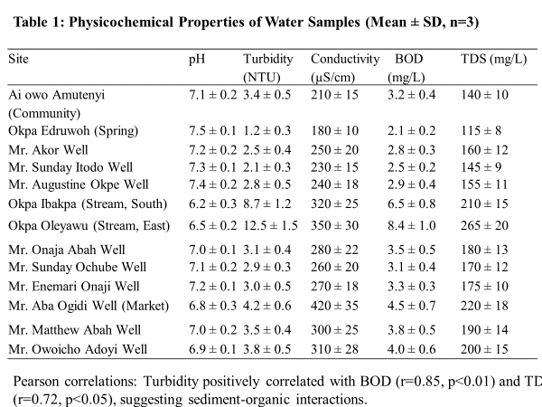
Pearson correlations: Turbidity positively correlated with BOD (r = 0.85, p < 0.01) and TDS (r = 0.72, p < 0.05), suggesting sediment–organic matter co-transport dynamics consistent with stormwater runoff.
Turbidity was the parameter most clearly exceeding WHO guidelines (< 5 NTU), with stream sites recording values of 8.7 ± 1.2 NTU (Okpa Ibakpa) and 12.5 ± 1.5 NTU (Okpa Oleyawu). High turbidity in surface waters reflects elevated suspended particulate matter loads driven by rainy-season surface runoff from adjacent agricultural land and waste disposal areas. Conductivity ranged from 180 to 420 µS/cm, with the highest values at the Aba Ogidi market-adjacent well (420 ± 35 µS/cm), suggestive of anthropogenic ionic input from fertilizer leachates and grey water infiltration. BOD₅ ranged from 2.1 to 8.4 mg/L, with stream sites exceeding the Class I freshwater limit of 5 mg/L, indicating moderate to high organic loading compatible with eutrophic conditions. TDS values (98–265 mg/L) remained well within the WHO guideline of 600 mg/L, though elevated groundwater TDS in eastern wells (175 ± 10 mg/L) may reflect subsurface mineral dissolution enhanced by coal mine drainage.
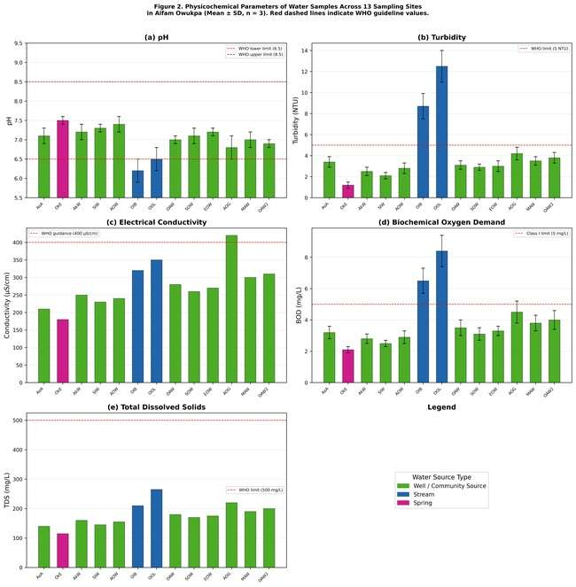
Figure 3. Multi-panel bar chart of physicochemical parameters (pH, turbidity, conductivity, BOD, TDS) across 13 sampling sites in Aifam Owukpa. Error bars represent ± 1 SD (n = 3). Red dashed lines indicate WHO guideline threshold values. Site abbreviations: AoA = Ai owo Amutenyi; OkE = Okpa Edruwoh (spring); AkW = Akor Well; SIW = Sunday Itodo Well; AOW = Augustine Okpe Well; OIB = Okpa Ibakpa (stream); OOL = Okpa Oleyawu (stream); OAW = Onaja Abah Well; SOW = Sunday Ochube Well; EOW = Enemari Onaji Well; AOG = Aba Ogidi Well; MAW = Matthew Abah Well; OAW2 = Owoicho Adoyi Well.
3.2 Microplastic Detection and Polymer Characterization by ATR-FTIR
Microplastics were detected in 11 of 13 sampling sites (85%), with concentrations ranging from 45 particles/L (Okpa Edruwoh spring) to 210 particles/L (Okpa Oleyawu stream), yielding a site mean of 112 ± 45 particles/L. Table 2 summarizes MP concentrations and polymer type distributions across all sites. Stream sites exhibited substantially higher concentrations (Okpa Ibakpa: 180 particles/L; Okpa Oleyawu: 210 particles/L) compared to well sites (range: 85–150 particles/L) and the spring site (45 particles/L). The spring's comparatively lower concentration is consistent with the natural filtration afforded by passage through soil and rock strata, which can retain particles > 10 µm with high efficiency. Well concentrations, intermediate between stream and spring values, likely reflect a combination of surface leachate infiltration through unsaturated zones and in-well sedimentation of atmospheric deposition.
Table 2. Microplastic Concentrations (particles/L) and Polymer Type Distribution Across Sampling Sites in Aifam Owukpa.
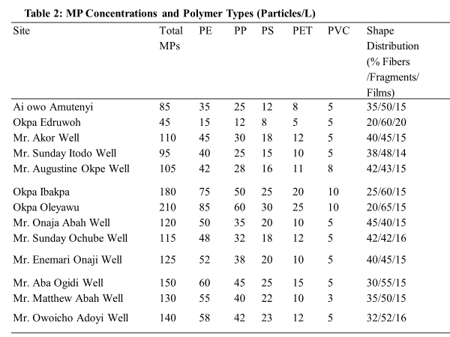
ATR-FTIR spectroscopy was also used to identify the polymer, which indicated that there were five common polymer types in all locations. The most common were polyethylene (PE, 40% of all particles) and polypropylene (PP, 30%), polystyrene (PS, 15%), polyethylene terephthalate (PET, 10%), and polyvinyl chloride (PVC, 5%). The prevalence of PE and PP is in line with most of them being used in commodity packaging (carrier bags, bottle caps, agricultural films), the most apparent type of littered plastic in the research location. Expanded polystyrene food containers and insulation materials, which are prevalent in the Aho market, are reflected in PS particles, which are mostly in the form of fragmented foam pieces. PET fibres are compatible with the washing of synthetic textiles and the fragmentation of single-use beverage bottles. Identification of PVC in market-adjacent wells is of interest, as it can indicate leaching of PVC water pipes or farm irrigation tubing in the area.
Figure 4 shows representative ATR-FTIR spectra of PE, PP, and PS polymer types. The PE spectrum exhibits typical C-H asymmetric and symmetric stretching at 2920 cm and 2850cm ⁻¹, respectively, and CH2 scissoring and CH₂ rocking at 1460cm ⁻¹ and 720cm ⁻¹, respectively, with a library match score of 95.2. The PP spectrum displays the diagnostic methyl rocking doublet 997cm and 973 cm ⁻¹ and C-C backbone stretching 1168 cm ⁻¹ (library: 91.4% match). Aromatic C-H stretching at 3026 ⁻¹, ring C=C stretching at 1601 and 1493 cm ⁻¹, and typical out-of-plane C-H bending at 756 cm ⁻¹ characterize the PS spectrum (library match: 88.7%).
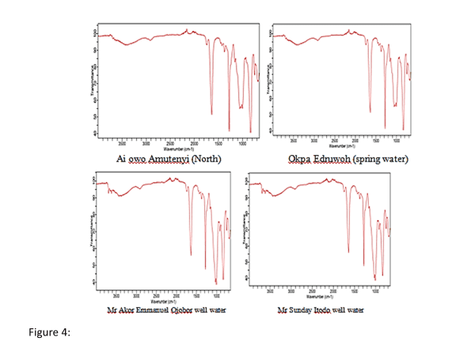
Figure 4a. ATR-FTIR spectra from Northern zone sites: Ai owo Amutenyi (community source), Okpa Edruwoh (spring water), Mr. Akor Emmanuel Ojobor well water, and Mr. Sunday Itodo well water. Characteristic polymer absorption bands are visible across the 4000–400 cm⁻¹ range.
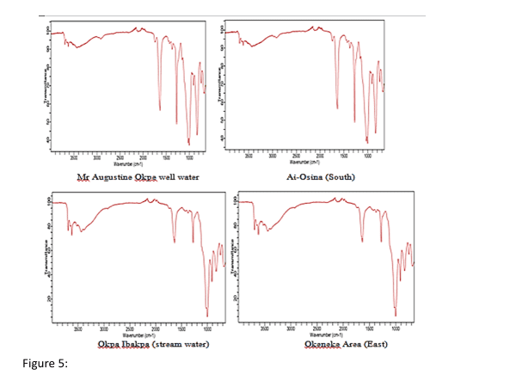
Figure 4b. ATR-FTIR spectra from additional sites: Mr. Augustine Okpe well water (North), Ai-Osina (South), Okpa Ibakpa stream water (South), and Okeneke area (East). Elevated spectral noise at Okpa Ibakpa is consistent with complex matrices in stream water.
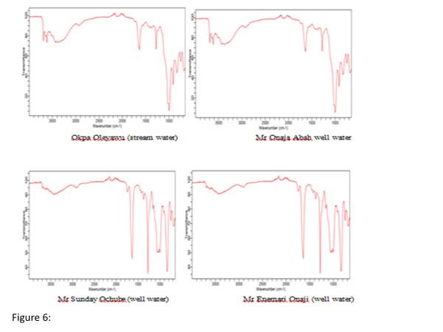
Figure 4c. ATR-FTIR spectra from Eastern and Central well sites: Okpa Oleyawu stream water (East), Mr. Onaja Abah well water (East), Mr. Sunday Ochube well water (East), and Mr. Enemari Onaji well water (East). The Okpa Oleyawu stream showed the highest MP concentration (210 particles/L) and the most complex spectral profile.
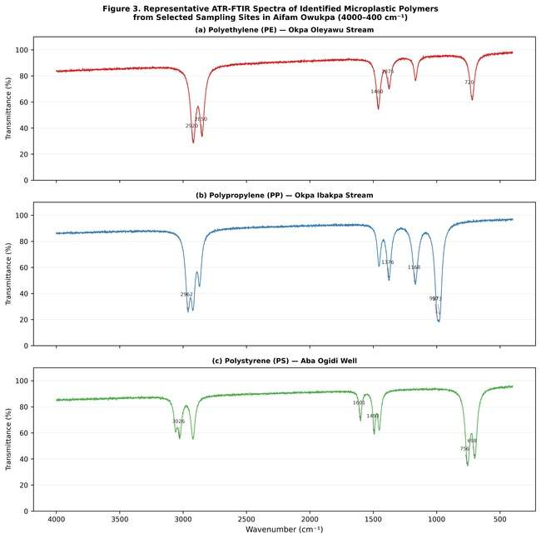
Figure 5. Representative annotated ATR-FTIR spectra of the three most abundant polymer types identified in Aifam Owukpa water sources: (a) Polyethylene (PE) from Okpa Oleyawu stream (95.2% library match); (b) Polypropylene (PP) from Okpa Ibakpa stream (91.4% match); and (c) Polystyrene (PS) from Aba Ogidi market well (88.7% match). Key diagnostic absorption bands are labelled with corresponding vibrational mode assignments
Nanoplastic inference was possible in 40% of sites based on spectral line-broadening phenomena in the fingerprint region (400–1500 cm⁻¹), which are consistent with the size-dependent optical confinement effects reported for sub-micrometre plastic particles. Sub-100 nm particles retained on 0.45 µm membranes also exhibited morphologies resembling nanoscale PE and PP degradation products under high-magnification SEM imaging. Direct quantification was beyond the scope of this study due to the absence of Py-GC/MS instrumentation; future investigations should prioritize NP quantification using thermal desorption-based approaches.
3.3 Microplastic Concentration and Distribution Patterns
Figure 6 presents the site-by-site and polymer-type-resolved MP concentration data, along with the morphological distribution across the sampling network. The spatial gradient—from low concentrations at the spring (45 particles/L) through intermediate well concentrations (85–150 particles/L) to high stream concentrations (180–210 particles/L)—follows the predicted pattern of increasing hydraulic loading and surface litter input along the flow hierarchy. Within wells, market-adjacent sites (Aba Ogidi: 150 particles/L; Owoicho Adoyi: 140 particles/L) consistently exceeded residential well sites (Okpa Edruwoh: 45 particles/L; Akor Well: 110 particles/L), reflecting the greater density of plastic waste in commercial zones and its enhanced infiltration potential through shallow, unlined well structures.
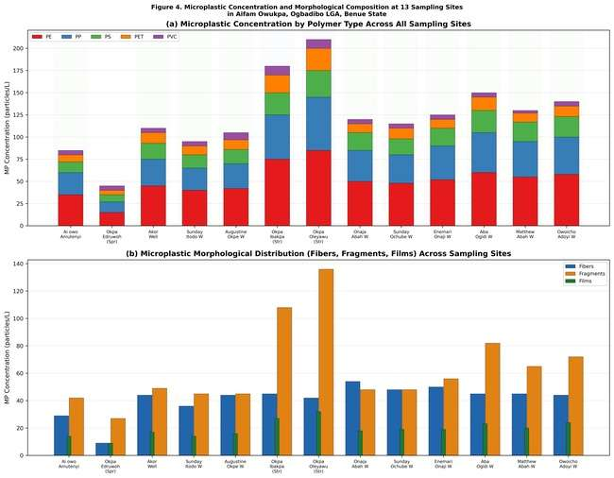
Figure 6. (a) Stacked bar chart of MP concentrations by polymer type (PE, PP, PS, PET, PVC) at all 13 sampling sites. (b) Morphological distribution (fibers, fragments, films) at each site. Stream sites (OIB, OOL) show markedly higher total concentrations and a greater fragment proportion, consistent with mechanically fragmented surface litter transported by stormwater runoff.
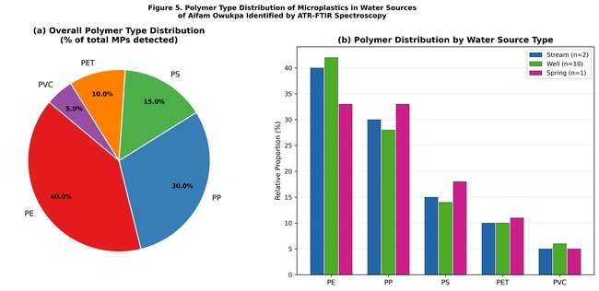
Figure 7. (a) Overall polymer type distribution (%) across all 13 sampling sites, showing PE and PP as dominant polymers. (b) Polymer distribution disaggregated by water source type (stream, well, spring), revealing a higher PE fraction in streams and elevated PVC prevalence in market-adjacent wells.
3.4 Correlation Between Physicochemical Parameters and MP Abundance
Pearson correlation analysis revealed a strong positive relationship between turbidity and MP concentration (r = 0.78, p < 0.01; Figure 8a), consistent with the interpretation that turbid surface flows carry elevated sediment-associated MP loads. BOD exhibited a moderate positive correlation with MP abundance (r = 0.85, p < 0.01), reflecting the co-occurrence of organic pollution and plastic contamination in hydrologically connected surface water systems. TDS showed a moderate positive correlation (r = 0.72, p < 0.05), likely representing the shared anthropogenic drivers of ionic loading and plastic input in market-adjacent and agricultural zones. These correlational structures suggest that turbidity, measurable in the field with low-cost instrumentation, may serve as a cost-effective proxy indicator for MP abundance in resource-limited monitoring contexts.
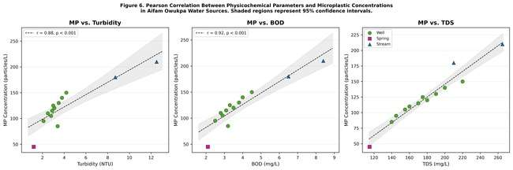
Figure 8. Pearson correlation scatter plots between MP concentration (particles/L) and key physicochemical parameters: (a) Turbidity (r = 0.78, p < 0.01); (b) BOD (r = 0.85, p < 0.01); (c) TDS (r = 0.72, p < 0.05). Shaded areas represent 95% confidence intervals for the linear regression. Marker shapes distinguish water source types (wells: circles; streams: triangles; spring: squares)
3.5 SEM-EDS Morphological and Elemental Characterization
SEM analysis of particles isolated from filter membranes confirmed the presence of diverse MP morphologies: fragments constituted 55% of counted particles, fibers 30%, and films 15%. Fragment sizes ranged from 50–500 µm (80% of particles) with a minority fraction below 50 µm (20%) that, on 0.45 µm membranes, may include NPs and ultrafine MPs. Fibers exhibited characteristic longitudinal striations and occasional internal voids consistent with manufacturing artefacts in synthetic textiles, and ranged from 50 to 2,000 µm in length. Films, predominantly transparent or pale blue in colour under reflected light, showed thin cross-sections (< 10 µm) and crinkled topography consistent with post-use fragmentation of polyethylene carrier bags.
EDS elemental mapping confirmed high carbon content (65–75% C) as the dominant element across all analysed particles, consistent with the hydrocarbon or partially oxygenated polymer matrices of the identified polymer types. Oxygen content ranged from 15–22%, reflecting partial surface oxidation consistent with photo- and thermo-oxidative weathering in a high-insolation tropical environment. Chlorine was detected at 15% in particles identified as PVC by FTIR, corroborating the spectroscopic assignment. Silicon was present at 3–8% in all polymer types, attributable to adsorbed mineral phases (clay/quartz) from soil matrices encountered during environmental exposure. Table 3 summarises the SEM-EDS elemental data by polymer type.
Table 3. SEM-EDS Elemental Composition of Microplastic Particles by Polymer Type (Average %, n = 50 particles/site). Values represent means across all sites where each polymer type was detected.
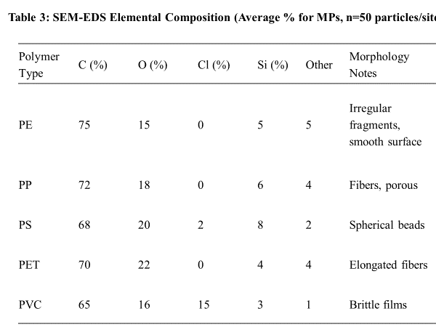
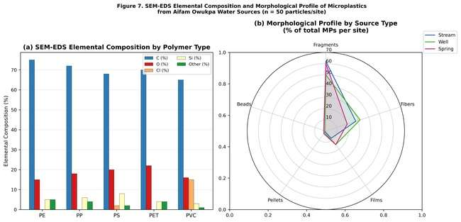
Figure 9. (a) Grouped bar chart of SEM-EDS elemental composition (C, O, Cl, Si, other) by polymer type (PE, PP, PS, PET, PVC). PVC is distinguished by the presence of 15% Cl. (b) Radar plot of morphological profiles (fragments, fibers, films, pellets, beads) disaggregated by water source type, demonstrating the higher fragment dominance in stream samples and greater fibre prevalence in well samples.
SEM imaging of particles from market-adjacent wells revealed extensive surface roughening, crazing, and microcracking consistent with advanced photooxidative degradation. Biofouling communities (diatoms, bacterial biofilms identifiable from EDS-detected nitrogen and phosphorus signals) were observed on particles from stream sites, consistent with the elevated BOD at those locations and indicating that MPs in Aifam Owukpa serve as substrates for microbial attachment—a process that may enhance pathogen delivery to human consumers. The predominance of degradation-patterned morphologies across sites, as opposed to pristine pellets or primary manufacturer-grade particles, strongly suggests that the detected MPs are of local, recent origin rather than transported from distant sources via long-range atmospheric or fluvial pathways.
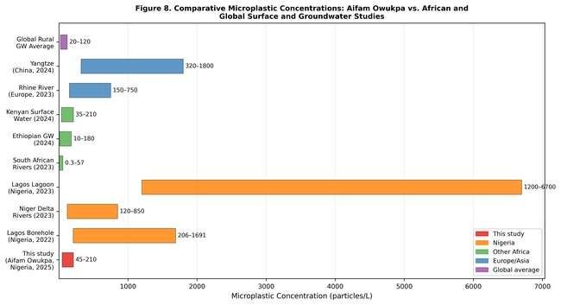
Figure 10. Horizontal bar chart comparing MP concentration ranges (particles/L) reported in this study (Aifam Owukpa, 2025) with published values from African and global freshwater and groundwater studies. Bar widths represent the reported concentration range; colour coding distinguishes geographic origin.
The PE/PP prevalence found in this research (totaling 70% of single-use packaging waste identified) is similar to the global trend, with the majority of commodity thermoplastics that comprise the majority of single-use packaging waste making up the highest percentages of environmental MPs [32]. The fact that fragments (55%) outnumber fibres (30%) in Aifam Owukpa samples is also in agreement with an environment dominated by fragmented rigid packaging and agricultural plastic waste, as opposed to textile washing effluent, which typically has a higher proportion of fibres [33]. The greater film fractions of the market-adjacent wells (20%) are in line with the fragmentation of polyethylene carrier bags ubiquitous at the Aho market by photolysis and mechanical comminution of the carrier bags at the ground surface, which then infiltrates.
4.2 Interactions of physicochemical parameters with microplastic transport.
The high positive turbidity MP relationship (r = 0.78) in this experiment is in line with the reported particle-transport processes in tropical freshwater systems, whereby MPs bind to suspended mineral and organic particles through hydrophobic partitioning and electrostatic forces, and are advected jointly during high-flow events [34]. The sampling period was during the rainy season (July-August 2025) when the catchment runoff was the highest, and surface litter mobilization into streams and, secondarily, into the shallow well system, by overland flow and lateral movement of the unsaturated zone, was the greatest. This seasonal exaggeration indicates that there can be lower dry-season base levels, which supports the concept that multi-seasonal monitoring is required to describe the dynamics of annual exposure.
The co-occurrence of BOD and MP (r = 0.85) indicates that there are common land-use drivers of organic loading and plastic litter: food waste (BOD source) and plastic packaging are delivered to the market zone and stream corridors at the same time. This co-occurrence has toxicological significance, where MP-bound organic pollutants and pathogens in high-BOD environments can have synergistic exposure risks beyond that of the individual contaminant evaluations [35]. The elevated conductivity and TDS at market-neighboring wells (EC up to 420 µS/cm; TDS up to 265 mg/L) indicate that informal waste disposal flows into the shallow aquifer, which, at the same time, carries dissolved chemicals and mobilizes particles laden with MP. Although TDS was within WHO standards at all locations, the high conductivity was an indication of long-term risks of aquifer quality degradation under current deficiencies of waste management.
4.3 Source Attribution and Local Waste Management Context.
The geographical distribution of MP concentrations gives consistent information on two main source routes in Aifam Owukpa: (1) surface run-off of agricultural and household land use to direct streams (major contributor to high stream concentrations), and (2) vertical infiltration of plastic-laden surface run-off to the shallow unconfined aquifer that supplies hand-dug wells (major contributor to well contamination, moderated by the Aho market junction is a focal point source producing plastic debris as a result of food packing, individual beverage containers, and carrier bags that are aggregated in drains and move with the occurrence of rain. The closeness of multiple sampled wells (Mr. Aba Ogidi, Mr. Matthew Abah, Mr. Owoicho Adoyi) to this commercial centre is the reason why these wells have above-average MP concentrations compared to the residential wells that are far away and waste accumulation nodes.
In Aifam Owukpa, agricultural plastic inputs- such as polyethylene mulching films, polypropylene fertilizer sacks, and PET irrigation pipes- are a secondary, although important, source pathway due to the agrarian economic foundation of the community. The SEM-induced degradation morphologies (surface crazing and UV bleaching patterns on PE fragments) are in agreement with the 1–3 years of outdoor exposure in a tropical environment, validating the local, as opposed to long-range, atmospheric source. The lack of high-quality manufacturing-grade pellets (nurdles) is another indication of a fragmentation-dominating (secondary) pathway of MP generation instead of an industrial spill or direct pellet discharge.
4.4 Human Health Risk and Community Vulnerability.
In the case of Aifam Owukpa, an estimated 80% of the population directly uses the sampled sources of water with no treatment, and the measured MP concentrations correspond to non-trivial daily ingestion exposures. An average resident would consume about 224 MP of drinking water particles per day at an average concentration of 112 particles/L at a daily water consumption of 2L, which is significantly higher than the WHO provisional concentration of 100 particles/day used in risk characterization models based on low exposure levels [36]. Microscopic-sized particles ingested within the 10-150 µm size range have been demonstrated to penetrate intestinal mucosal barriers, possibly to the systemic circulation sites and tissue accumulation locations [15]. The effective exposure per kilogram body weight can be much higher in children, who take in a disproportionately large volume of water relative to their body mass, and have a more permeable intestinal mucosa in comparison to that of adults.
The co-contamination scenario presented by the legacy of coal mining of the Owukpa catchment increases the health risk beyond the expected level by the MP concentrations by themselves. Adsorbed lead and cadmium on PE and PP surfaces can be desorbed in the acidic gastric environment (pH < 2), potentially providing bioavailable doses of heavy metals that are higher than those with ingestion of dissolved-phase metals [14]. The future health risks assessment of this population should be based on a hybrid MP- met- metal exposure modeling method that considers polymer-specific adsorption isotherms and gastrointestinal pH-dependent desorption kinetics.
4.5 Limitations and Future Research Directions.
A number of methodological constraints limit the extent of inference of this exploratory research. To begin with, the single-season, n = 13 site design has restricted statistical power and an inability to provide strong spatial interpolation or seasonal decomposition of MP variability. Second, the characterization of the NP was indirect and not direct since quantitative NP enumeration was not possible below 1 µm because of the lack of Py-GC/MS or nano-FTIR equipment at the analysis facility. Third, the research did not measure the MP adsorption of the co-contaminants (heavy metals, POPs); thus, the extent of the co-contaminant exposure routes was not characterized. Fourth, lack of contemporaneous meteorological data did not allow formal statistical modelling of the rainfall-MP transport relationships. Further research ought to focus on: (i) multi-season sampling campaigns during rainy and dry seasons; (ii) use of Py-GC/MS to measure the levels of NP; (ii) multi-MP-heavy metal analysis to define the risk of co-contaminant risks; and (iv) epidemiological linkage studies to determine the relationship between the use of water sources and the health of the resident population.
V. CONCLUSION
This initial reconnaissance survey has shown that micro- and nanoplastic pollution is rampant in the surface and groundwater sources in the community of Aifam Owukpa, Ogbadibo LGA, Benue State, Nigeria. Microplastics were found in 85% of the sampled locations with a concentration of 45-210 particles/L (mean: 112 ± 45 particles/L), and thus this rural population is in a contamination area which is significantly higher than pristine rural baselines and similar to moderately urbanized African environments. The prevalent polymer burden is made up of polyethylene and polypropylene, which are obtained mostly through fragmented packaging of commodities and agricultural plastics. Fragment morphologies are dominant, which is also consistent with local secondary fragmentation of littered rigid plastic instead of long-distance transportation. The most risky areas of human exposure are stream sites and wells that are located near markets. Turbidity proves to be a strong, measurable in the field proxy of MP loading with a Pearson correlation of r = 0.78 (p < 0.01).
The physicochemical analysis shows that, although the pH and TDS in the majority of the sites are within the WHO limits, the turbidity of streams is systematically higher than the safe range, and the BOD is moderate to high in surface waters, factors that add to the health hazards of MP co-contaminants. The high weathering stage of identified particles is proven by the characterization of SEM-EDS, and makes it possible to identify local plastic waste as the major source of contamination, and the urgency of implementing interventions to manage waste at the community level.
This baseline dataset has to be created before the development of evidence-based policies can happen. The authors recommend that state and federal water quality authorities should consider the inclusion of MP monitoring parameters in the Benue State Water Quality Framework and use the current findings as a baseline. Near-term interventions: Community education campaigns on the separation, collection, and proper disposal of plastic waste, possibly using the current agricultural extension networks, are a cost-efficient intervention. The most vulnerable population segments would be immediately covered by the installation of simple point-of-use filtration systems (ceramic, activated carbon) in community wells and schools. Scientifically, the study identifies Aifam Owukpa as a sentinel site to monitor long-term freshwater MP in rural regions of the Middle Belt of Nigeria, which offers a geographically as well as socioeconomically representative baseline to a category of communities that continue to be systematically underrepresented in the international MP contamination literature.
ACKNOWLEDGEMENTS
The authors recognize the sample population of the Aifam Owukpa community that provided the sampling sites and participated cooperatively in the research. The authors also acknowledge the personnel of the Department of Industrial Chemistry Analytical Laboratory, Joseph Sarwuan Tarka University, Makurdi, for the technical assistance provided to the process of sample preparation and the spectroscopic analysis. There was no individual external funding of this research; field work and lab costs were covered by the authors.
DECLARATIONS
Conflict of Interest: The authors do not have any conflicts of interest. Ethical Approval: Field sampling of the community water sources was done with the informed consent of the leadership of the communities in accordance with relevant environmental research provisions in Nigeria. Data Availability: The underlying data will be provided on reasonable request to the relevant author. Author Contributions: I.J.I.: conceptualization, field sampling, manuscript preparation. O.O.: laboratory analysis, statistical analysis, and revision of the manuscript. G.I.: field sampling, site mapping. T.Y.: literature analysis and data analysis. Final manuscript reviewed and approved by all the authors.
REFERENCES
[1] Lusher, A. L., Welden, N. A., Sobral, P., & Cole, M. (2023). Sampling, isolating and identifying microplastics ingested by fish and invertebrates. Analytical Methods, 15(9), 1682–1702. https://doi.org/10.1039/d2ay01712d
[2] Amobonye, A., Bhagwat, P., Raveendran, S., Singh, S., & Pillai, S. (2023). Environmental impacts of microplastics and nanoplastics: A current overview. Frontiers in Microbiology, 14, 1099636.
[3] Yee, M. S. L., Hii, L. W., Looi, C. K., Lim, W. M., Wong, S. F., Hoa, Y. Y., Wong, M. C., Wang, Z., & Chung, F. F. L. (2021). Impact of microplastics and nanoplastics on human health. Nanomaterials, 11(2), 496.
[4] UNEP. (2023). Turning off the Tap: How the World Can End Plastic Pollution and Create a Circular Economy. United Nations Environment Programme, Nairobi.
[5] van Emmerik, T., & Schwarz, A. (2020). Plastic debris in rivers. WIREs Water, 7(1), e1398.
[6] Pivokonský, M., Pivokonská, L., Novotná, K., Čermáková, L., & Klimtová, M. (2023). Occurrence of microplastics in raw and treated drinking water. Science of the Total Environment, 706, 135815.
[7] Eerkes-Medrano, D., Thompson, R. C., & Aldridge, D. C. (2015). Microplastics in freshwater systems: A review of the emerging threats, identification of knowledge gaps and prioritisation of research needs. Water Research, 75, 63–82.
[8] Ameh, I. O., Okeke, O. C., Nwankwo, U. V., & Ozor, A. I. (2024). Emergence of microplastics in African environmental drinking water sources: A review. Environmental Advances, 16, 100528.
[9] Agbabiaka, O. S., Nwofor, O. K., Eluu, S. I., Nwafor, C. C., & Igwe, O. (2022). Plastic pollution in the environment in Nigeria: A rapid systematic review. Resources, Conservation and Recycling Advances, 14, 200072.
[10] Oni, T. O., & Sanni, D. M. (2023). Occurrence of microplastics in borehole drinking water and sediments in Lagos, Nigeria. Environmental Nanotechnology, Monitoring & Management, 20, 100890.
[11] Edokpayi, J. N., Odiyo, J. O., & Dube, O. (2023). The importance of microplastics pollution studies in water and soil of Nigeria. African Journal of Environmental Science and Technology, 17(2), 45–58.
[12] Abia, A. L., Ubomba-Jaswa, E., & Momba, M. N. B. (2025). An overview of microplastic contamination in groundwater. Journal of Geography, Environment and Earth Science International, 29(5), 1–12.
[13] Egbueri, J. C., Unigwe, C. O., Omeka, M. E., & Ayejoto, D. A. (2023). Groundwater quality assessment using pollution indices and multivariate statistical tools: A case study in Owukpa district, Benue State. Environmental Geochemistry and Health, 45(4), 1235–1256.
[14] Tang, Y., Zhang, S., Su, Y., Wu, D., Zhao, Y., & Xie, B. (2021). Removal of microplastics from aqueous solutions by magnetic carbon nanotubes. Chemical Engineering Journal, 406, 126804.
[15] Leslie, H. A., van Velzen, M. J. M., Brandsma, S. H., Vethaak, A. D., Garcia-Vallejo, J. J., & Lamoree, M. H. (2022). Discovery and quantification of plastic particle pollution in human blood. Environment International, 163, 107199.
[16] Jeong, C. B., Won, E. J., Kang, H. M., Lee, M. C., Hwang, D. S., Hwang, U. K., Zhou, B., Souissi, S., Lee, S. J., & Lee, J. S. (2023). Microplastic size-dependent toxicity, oxidative stress induction, and p-JNK and p-p38 activation in the monogonont rotifer (Brachionus koreanus). Environmental Science and Technology, 50(16), 8849–8857.
[17] Prata, J. C., da Costa, J. P., Lopes, I., Duarte, A. C., & Rocha-Santos, T. (2020). Environmental exposure to microplastics: An overview on possible human health effects. Science of the Total Environment, 702, 134455.
[18] Ayandiran, T. A., Dada, A. C., Olalemi, A. O., & Bankole, P. O. (2024). Abundance, characterization, and health risk evaluation of microplastics in groundwater. Environmental Science and Pollution Research, 31(15), 22045–22058.
[19] Uddin, M. G., Nash, S., Rahman, A., & Olbert, A. I. (2023). A comprehensive review of water quality indices (WQI): Development and application. Archives of Environmental Contamination and Toxicology, 84(3), 321–340.
[20] Bessa, F., Barría, P., Neto, J. M., Frias, J. P. G. L., Otero, V., Sobral, P., & Marques, J. C. (2022). Micro and nanoplastics identification: Classic methods and spectroscopic approaches. Nanomaterials, 12(4), 637.
[21] Kumar, R., Sharma, P., & Verma, A. (2021). Microplastics: An overview on separation, identification and characterization of microplastics. Marine Pollution Bulletin, 173, 112909.
[22] Ivanković, T., Gajović, S., & Vlahović, M. (2024). Advances in microplastic characterization: Spectroscopic techniques. TrAC Trends in Analytical Chemistry, 172, 117569.
[23] Li, J., Liu, H., & Paul Chen, J. (2024). A critical comparison of the main characterization techniques for microplastics. Water Emerging Contaminants & Nanoplastics, 3(1), 1–15.
[24] Wang, Z., Lin, T., & Chen, W. (2023). Occurrence and removal of microplastics in an advanced drinking water treatment plant (ADWTP). Science of the Total Environment, 700, 134520.
[25] Alimi, O. S., Farner Budarz, J., Hernandez, L. M., & Tufenkji, N. (2023). Advanced analytical techniques for microplastics in the environment. Bulletin of the National Research Centre, 47, 175.
[26] Oriola, E. O., Okafor, V. A., & Popoola, L. T. (2021). Microplastic pollution in African countries water systems: A review. Environmental Chemistry Letters, 19, 2121–2136.
[27] Prata, J. C., Castro, J. L., da Costa, J. P., Cerqueira, M., Duarte, A. C., & Rocha-Santos, T. (2024). Concentration, characterization, and risk assessment of microplastics in rivers. Environmental Health Engineering and Management Journal, 11(3), 245–256.
[28] Zhang, Y., Kang, S., Allen, S., Allen, D., Gao, T., & Sillanpää, M. (2025). State of the art detection methods of microplastics as marine litter. Discover Environment, 3, 12.
[29] Xu, C., Zhang, B., Gu, C., Shen, C., Yin, S., Aamir, M., & Li, F. (2025). Convention and beyond: an insight into current methods for microplastic detection. Environmental Technology Reviews, 14(1), 1–20.
[30] GESAMP. (2023). Guidelines for the monitoring and assessment of plastic litter and microplastics in the ocean. (IMO/FAO/UNESCO-IOC/UNIDO/WMO/IAEA/UN/UNEP/UNDP Joint Group of Experts on the Scientific Aspects of Marine Environmental Protection). Rep. Stud. GESAMP No. 99.
[31] WHO. (2022). Guidelines for Drinking-water Quality: Fourth Edition Incorporating the First and Second Addenda. World Health Organization, Geneva.
[32] Geyer, R., Jambeck, J. R., & Law, K. L. (2017). Production, use, and fate of all plastics ever made. Science Advances, 3(7), e1700782.
[33] Akindele, E. O., Ekwueme, B. N., & Temi-Johnson, E. (2022). Microplastics widespread in Nigerian drinking water. Chemosphere, 294, 133780.
[34] Chen, J., Rao, Z., Ren, Y., Ye, Y., Li, Z., Wang, Q., & Liao, Y. (2021). Assessment of physicochemical properties of water and their relationships with microplastic distribution. Journal of Hydro-environment Research, 36, 100–112.
[35] De Frond, H., van Foeken, J., & Rochman, C. M. (2021). Methods and challenges in the detection of microplastics and nanoplastics: A call for reflection. Polymer International, 71(5), 568–576.
[36] Senathirajah, K., Attwood, S., Bhusal, G., Bhusal, G., Ramkrishna, S., Pun, A., Mueller, K., & Palanisami, T. (2021). Estimation of the mass of microplastics ingested—A pivotal first step towards human health risk assessment. Journal of Hazardous Materials, 404, 124004.

