A Unified Behavioral Attack DNA Framework for Global Cyber Threat Detection Using Multi-Dataset Learning

Introduction
An increased amount of digitalized systems and capabilities to communicate with the systems have rendered the modern computing environment as a highly complex and integrated environment. The use of digitalized systems has become ubiquitous in the simplest forms of everyday life, from
cloud computing and IoTs through to massive enterprise networks. While the increase in connectivity has led to great technological advances, this has also resulted in attackers having an increasingly large surface area for attacks, which makes cybersecurity an extremely important aspect for any organization or government globally [19].
Today’s cyberattacks are not just a simple single hit but a highly sophisticated attack process that uses vulnerabilities in different layers of an organization’s systems. Today’s cyberthreats, such as advanced persistent threats (APTs), are typically stealthy, adaptable, and long-term and can slip through normal protective strategies. The attack process includes stages such as reconnaissance, lateral movement, privilege escalation, and data theft, and these will not be easy to detect with traditional methods [17].
Cybersecurity measures that exist at present rely mainly on signature-based and centralized analytics of data. Although signature-based approaches may be used for detecting threats that have occurred already, they cannot detect zero-day attacks or changing threat patterns. Moreover, centralized approaches depend heavily on aggregation of large volumes of raw data, thus making them hard to scale up with great latency and problems of privacy [19]. Those limitations make clear the necessity of introducing more scalable techniques.
The enforcement of data sovereignty and privacy laws in the recent past has further complicated the situation for cybersecurity. There is less sharing of critical data by organizations across both borders and organizational limits, rendering any collaboration-based threat intelligence systems less useful. The contradiction is that while it is important to collaborate internationally in order to identify such distributed cyber threats, the raw data sharing is constrained. Consequently, organizations tend to run on limited visibility, limiting their chances of identifying coordinated attacks [11], [12].
In order to overcome these issues, a new framework is required which will allow detecting the global threats without using raw data sharing. A possible solution here is to change the focus of the raw log analysis to behavioral intelligence. Behavioral methods are used to examine system activity patterns, like the duration of connections, packet transmission, and dynamic flow of data instead of the individual events. These patterns give a more advanced abstraction of system behavior and can effectively detect anomalies and maintain the privacy of data [17].
In this paper, we present the concept of Attack DNA, a single behavioral model of network operation based on structured characteristics of duration, number of packets, number of bytes and flow rate. The suggested methodology converts the heterogeneous and dataset-specific features to a common feature space, making it possible to combine various intrusion detection datasets including CIC-IDS2017, NSL-KDD, UNSW-NB15, and TON-IoT. Such standardization makes it easier to learn across datasets and enhances generalization to various network settings [15], [16].
The offered system compares the sequence-based and feature-based machine learning models, namely Long Short-Term Memory (LSTM) networks and Random Forest classifiers. Whereas LSTM models can learn the temporal dependencies in sequential data [8], [18], feature-based models like the Random Forest can learn discriminative patterns in structured inputs. Also, a geographical analysis is added to study the differences in attack trends among various geographical sources, which offers insights into the behaviour of cyber threat at a global level and assists in the distributed analysis [11], [12].
In general, this paper shows that the standardization of behavioral features provides scalable and interpretable and cross-dataset intrusion detection. The proposed solution helps close the gap between heterogeneous data sets and offer a single analytical framework to lead to more resilient and universally applicable cybersecurity solutions.

Literature Survey
The field of modern cybersecurity has developed towards intelligent, adaptive, and privacy-conscious detection systems to cope with the growing complexity of cyber threats. The already existing work can be revisited in the light of the data heterogeneity, behavioral modeling, and feasible deployment constraints, which directly coincide with the goals of the proposed Attack DNA framework.

Challenges in Multi-Dataset and Heterogeneous Intrusion Detection
One of the significant weaknesses that are affecting the current research in intrusion detection is the inability to interoperate with different datasets and environments. Wang et al. [15], [16] tackled this problem by suggesting an attention-based Bidirectional LSTM model to be trained on multi-domain datasets, which shows better generalization. The model, however, has high data requirements in terms of labeled data and high computing power, and is also not scalable to real-world applications. This underlines the necessity to have a single feature space that can simplify the process of cross-dataset learning.
Likewise, Zhang et al. [19] highlighted the significance of deep learning methods on cyber-physical systems but pointed out that most models are trained on single datasets, which decreases their ability to adapt to settings. Imrana et al. [7] also proved that the sequence-based models work well in limited datasets but fail when used in heterogeneous data sources.
Hybrid methods like the ones suggested by Said et al. [14] and Bi et al. [3] enhance the feature extraction with the help of CNN-BiLSTM and autoencoder-based models, respectively. But these models are more complex and are not common to all datasets. All these limitations emphasize the fact that a common behavioral representation does not exist and is the focus of the current work the Attack DNA framework mapping various datasets to a common feature space.

Behavioral Modeling versus Temporal Dependency in Attack Detection
The recent studies have been aimed at modeling behavioral patterns of cyber attacks based on sequence models and probabilistic models. Yang et al. [18] developed a BiLSTM-based intrusion detection system that could learn temporal dependencies and had high performance in sequential data settings. Kang et al. [8] proposed ActDetector, which is a multi-stage attack modeling through sequence embeddings and LSTM networks, and it can effectively model the attack progression.
More probabilistic modeling based on Markov chains and Bayesian networks to forecast attack evolution was also investigated by Cheimonidis and Rantos [4]. Although they are useful in modeling attack sequences, they are very dependent on temporal continuity and predetermined structures and as such they cannot be used in aggregated or non-sequential data.
The correlations of domain and IP features to identify advanced persistent threats were suggested by Xuan [17], and the authors showed that behavioral features were more effective than static signatures. However, this approach makes use of specific techniques for feature engineering and is not generalizable to different datasets.
This research indicates a clear contradiction, whereby sequential behavior can be well captured using temporal modeling; however, these techniques do not always work when analyzing the heterogeneity and aggregation of the dataset. This is the reason why the Attack DNA technique was created, as it aims to address the core behaviors (duration, packet count, byte count, and flow rate) that remain constant between datasets.

Privacy, Collaboration, and Real-World Threat Intelligence Collection
Learning that is distributed and based on deception techniques has been implemented as a means to address the requirements for conducting privacy-preserving and collaborative intrusion detection. A system for intrusion detection using federated learning was proposed by Raza et al. [11], which facilitates model training without the exchange of raw data. Despite its effectiveness, this technique introduces overhead to communications and systems.
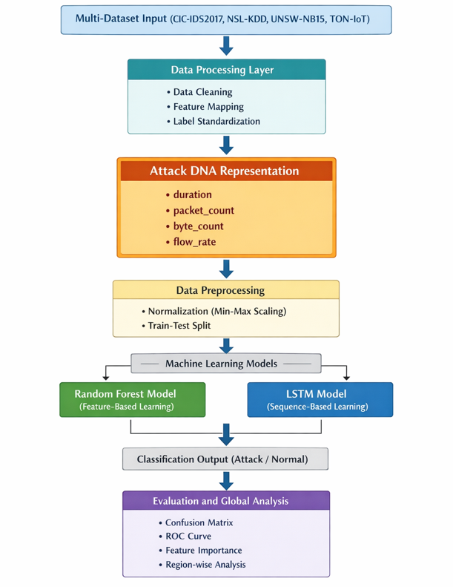
Revathi and Kingslin [12] extended the idea of using blockchain with federated learning, together with the use of cryptographic algorithms, to ensure the security and unalterability of collaboration. However, they are complex computing methods that are challenging to deploy on a massive scale. The work of Liu et al. [9] proposed the use of secure multi-party computation for sharing data securely; yet the technique is not efficient for real-time intrusion detection.
On the other hand, Alohali et al. [1] utilized blockchain technology together with Explainable AI techniques to improve transparency in cyber security systems, though issues related to scalability arise. These pieces emphasize the need of privacy but also indicate the trade-off between security and efficient operation of the system.
Simultaneously, deception-based methods like honeypots have been extensively used in order to record real-world attacker actions. Rabah et al. [13] suggested an ensemble learning model that combines honeypot information in detecting real-time DDoS attacks with a high degree of accuracy, consuming a lot of resources. Naik et al. [10] proposed a dynamic honeypot system that is adaptively learnable, but it is not very scalable.
Franco et al. [6] gave a review of honeypot architectures, highlighting their applicability in behavioural data gathering, and Ali et al. [2] showed their real-life application to SSH attack detection. Also, Fan et al. [5] demonstrated the role of interpretability in the detection systems based on an RNN.
All these studies prove that the systems that preserve privacy and use deception are beneficial in terms of threat intelligence but are not usually integrated with single and scalable detection systems. The suggested Attack DNA framework fills this gap with allowing privacy-preserving behavioral abstraction and global collaboration without sharing of raw data.

Proposed Methodology
This section outlines how the proposed framework to detect global cyber threats can be designed and implemented with a single behavioral representation called Attack DNA. The methodology is concerned with the process of converting heterogeneous intrusion detection data to a uniform feature space and testing various machine learning paradigms that assess their ability to work in this type of environment. The limitations of the current systems to deal with cross-dataset variability and the absence of a shared abstraction of behavior, as mentioned in previous literature [7], [19], are what prompt the proposed approach.

System Overview
The system proposed takes a behavior-based and data-centric perspective of intrusion detection. Unlike the classical approaches that are based on raw data analysis and use specific features from datasets, the proposed model is focused on abstracting from the data and using its generalized version in representing the behaviour of the network, thus shifting to a new trend of cyber security research. The tendency of moving from raw data to behavioral models improves flexibility and resilience against new threats [17].
The whole structure consists of several stages, including the stage of dataset collecting, features extraction, preprocessing, training and evaluating of model. As the first step we consider the process of features extraction from the raw data of different origins. As the base for representation of Attack DNA, we use mapping of extracted attributes into a single space of features. Such structure of architecture helps to overcome the problem of differences between datasets that is considered as a significant disadvantage of existing IDS [15],[16].

Fig. 3.1 Proposed Architecture of the Attack DNA Framework for Global Cyber Threat Detection
Figure 3.1 shows the structure of the Attack DNA proposal. The multiple inputs are taken as data and converted to behavioral forms, followed by classification and analysis on a global level. Two types of learning methods have been used for this purpose. The first one is the sequence-based LSTM learning model [8], [18] while the second one is the feature-based Random Forest classifier model for learning [11], [12]. An additional analysis layer has been incorporated in the Attack DNA framework, which is region-aware to identify geographical variations of the cyber-attacks, thus ensuring privacy-based global analysis [11], [12].

Dataset Collection and Integration
It is planned to utilize a number of datasets for detecting intrusion benchmark purposes, among them are CIC-IDS2017, NSL-KDD, UNSW-NB15, and TON-IoT (in general, these collections of data can be considered as representative in terms of different network environments and attack types). Previous research proved the lack of domain adaptability of standard models trained on a single dataset [15], [16].
However, the datasets have varying structures of their features, and thus it is impossible to merge them in any form. To overcome this challenge, an official method of integration is followed, and the features whose inclusion in the analysis would be helpful due to their ability to explain network behavior are selected and then mapped into a common pool of standardized attributes. Such a technique facilitates the uniform handling of diverse datasets, as well as makes the process independent of the properties of individual datasets [17].
For the purpose of creating an atmosphere for a global cyber threat, each data set would be tagged with a regional name (such as US, EU, India, Global), and cross-regional comparisons could be made based on the data sets. This structure enables distributed threat modeling without any exchange of data, thus meeting the requirements of privacy-driven practices in the realm of cybersecurity [11], [12]. The outcome is a unified data set that merges multiple sources of information into one coherent system.

Attack DNA Feature Engineering
The key contribution of this paper in terms of novel inputs is that it introduces Attack DNA, which is a behavioral model that extracts network behavior into a few generalized attributes. The key difference between this approach and the traditional approaches, wherein high-dimensional attributes specific to the dataset are considered, is that this approach focuses on using low-dimensional attributes that can be generalized over different datasets [17].
The selected characteristics consist of time, packet count, byte count, and flow rate, which constitute the key time-based and volume-based characteristics of network flows. They can either be mined directly or indirectly derived from the available characteristics, enabling a consistent data representation irrespective of the dataset, thus overcoming the shortcomings of multi-domain intrusion detection systems [15], [16].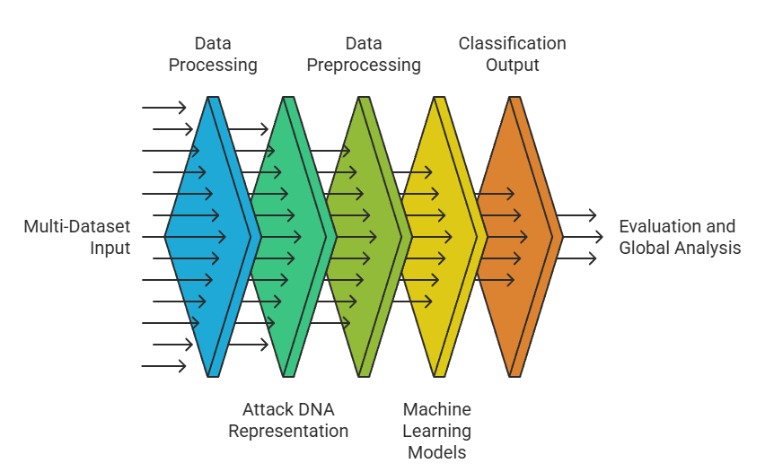
Fig. 3.2 Conceptual Flow of Attack DNA-Based Cyber Threat Detection Pipeline
Figure 3.2 depicts the conceptual transformation process, according to which the input raw multi-dataset data are gradually transformed into the Attack DNA representations and then used for classification and analysis purposes. The approach avoids any use of dataset-specific structures, which increases the interpretability of the method through mapping diverse types of data into a common feature space and therefore no dependency on dataset-specific structures. All features have clear behavioral significance, which enables learning general trends rather than dataset-specific trends.

Data Preprocessing and Model Design
After feature extraction, preprocessing of the data is done to provide a homogeneous and machine learning friendly data. This involves the process of dealing with missing and invalid values, elimination of inconsistency and the handling of undefined or infinite values. Min-Max normalization is used to standardize the feature scales, which converts all features into the same scale and enhances the stability and convergence of the model, which is widely used in intrusion detection systems [19].
Also, the labels of classes are transformed into binary values (attack and normal) and region identifiers are saved to be analyzed later. The resulting data can be seen as a clean and structured model of behavior that can be trained on to overcome the problems of heterogeneous data integration that have been mentioned in earlier studies [15], [16].
In order to assess the efficiency of the suggested Attack DNA representation, feature-based and sequence-based learning methods are both discussed, allowing comparison of the modeling strategies on unified behavioral data.
- Random Forest Model
The general choice of classifier is the Random Forest because it is effective with structured and tabular data. Being an ensemble method of learning, it builds a number of decision trees with random sample of the features and combines their output to enhance classification.
Random Forest is the best choice to implement this framework since it is nonlinear, resistant to noise, and does not assume a time-dependent relationship. Moreover, it offers measures of feature importance, thus making behavioral attributes interpretable. These characteristics render it suitable to behavior-based intrusion detection as has been witnessed in previous research [17].

- LSTM Model
A Long Short-Term Memory (LSTM) network is used to determine the suitability of sequence-based learning to intrusion detection. LSTM models are constructed to represent time dependencies in sequential data, and have been extensively applied to detect cyber threats [8], [18].
In this paper, the dataset is restructured into a sequential one to pass through LSTM. Nevertheless, the integrated dataset is not inherently continuous in time, because it is an aggregate of various sources. Due to this fact, the LSTM model is considered a comparative baseline instead of the main detection mechanism. This is consistent with previous results that sequence-based models do not work well in non-temporal or heterogeneous data settings [4], [7].

Global Region-Based Analysis
To expand the framework further to include more than the traditional intrusion detection, a region-based analysis is added to give the world a view of cyber threats. Each data sample is accompanied by a region label, which allows comparing data to geographically distributed environments.
Statistical analysis is conducted to analyze the distribution of classes, frequency of attacks, and the behavioral differences of the regions. This helps to identify the threat patterns in the region and helps in global analysis of cyber threats. These regionally sensitive and distributed views are becoming a significant focus of contemporary cybersecurity models [11], [12].
The suggested framework will help identify a global threat on a global scale with behavioral abstraction and region-based insight without the need to share data directly.

Experimental Results and Evaluation

This segment will assess the proposed Attack DNA framework by applying various intrusion detection datasets to the statistical analysis, visualization and model-based analysis. These techniques will be assessed for their applicability, scalability, and flexibility in different environments. The assessment will focus on the effectiveness of classification, interpretability, and ability to generalize the learned knowledge to other homogeneous data sources.

Dataset Distribution Analysis
The structure of the combined data set is evaluated before applying the model to gain knowledge about the distribution of classes and regions.
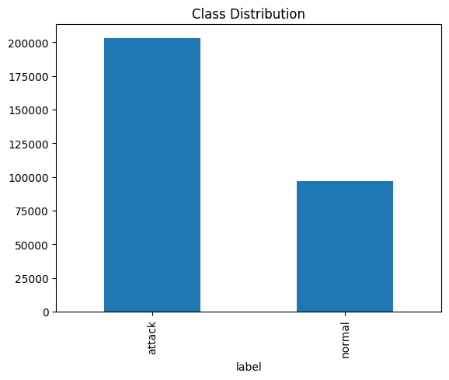
Fig. 4.1 Class Distribution of Integrated Dataset
Figure 4.1 depicts the distribution of the normal and attack samples. The dataset is quite imbalanced with many attacks present. This imbalance represents the actual circumstances of intrusions, which always have more attacks than normal traffic [19]. Such an imbalance requires the application of complex models capable of handling imbalanced datasets.
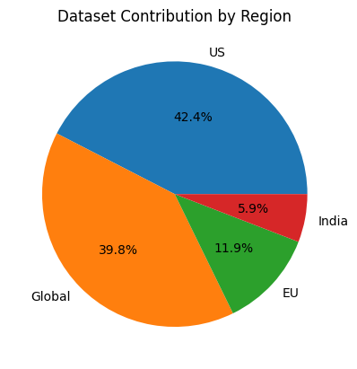
Fig. 4.2 Region-wise Dataset Distribution
Figure 4.2 shows distribution of the data across the geographical region and it can be seen that there are many sources of geographical contributions. This helps in achieving heterogeneity in the traffic flow pattern as well as increases the generalization capability of the model in different scenarios [15], [16]. The key point is to understand not just the notion of imbalance in classes but also regional diversity that directly influences model training and performance evaluation.

Region-wise Attack Analysis
Distribution of attacks is studied region-wise to understand the global attack patterns.
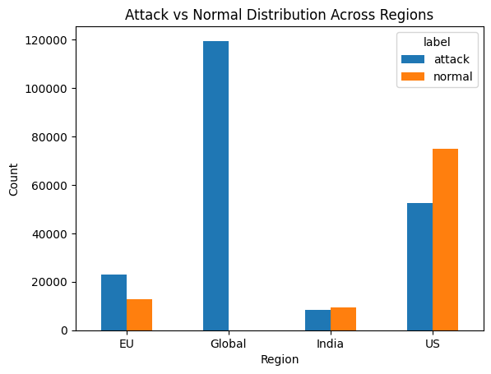
Fig. 4.3 Region-wise Attack Distribution
The attack and normal samples are compared in the regions (Figure 4.3), and the attack intensity is quite different. Such differences can be explained by the differences in the composition of the dataset, simulated attack conditions and the underlying network dynamics.
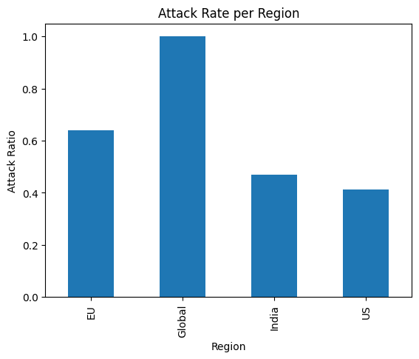
Fig. 4.4 Region-wise Attack Rate Analysis
The rate of attack (attack samples/total samples) is presented in Figure 4.4 and makes a normalized comparison of the regions. This highlights the reality that areas are more likely to be at a higher relative threat level although they have less data. These findings underscore the fact that cyber threat distribution is not uniform and the necessity to incorporate the region-sensitive analysis into intrusion detection systems. All these perspectives become even more applicable in distributed cybersecurity models [11], [12].

Model Performance (Random Forest)
Random Forest model is regarded as the primary classifier of the Attack DNA representation.
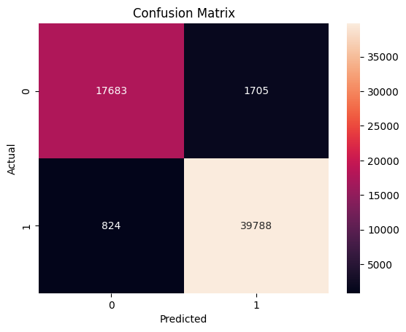
Fig. 4.5 Model Performance Comparison
Comparison of the models performance is done in Figure 4.5, where it is evident that the Random Forest is more accurate in this scenario compared to LSTM.
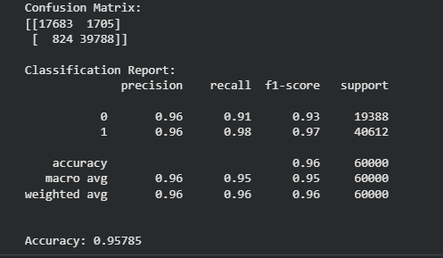
Fig. 4.6 Confusion Matrix for Random Forest Model
Figure 4.6 presents the confusion matrix indicating that the true positive and true negative rates are high and the false rates are low. This means that the model can distinguish the normal and malicious traffic well.
The accuracy, recall and F1-score are also performance metrics that confirm that the model is robust especially in identifying the instances of attack. The attack class recall is particularly important because it decreases the chances of undetected threats [17]. In general, the performance of Random Forest is high (95.78%) and stable, and the algorithm is appropriate to feature-based intrusion detection in aggregated and multi-datasets.

Model Performance (LSTM)
The LSTM model is tested to determine sequence-based learning on the integrated data.
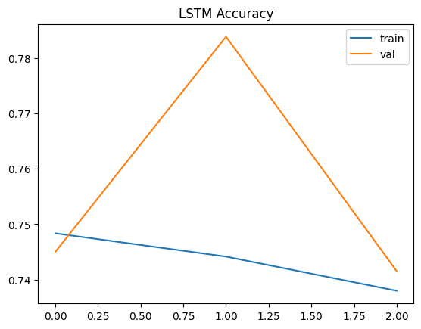
Fig. 4.7 Confusion Matrix for LSTM Model
The confusion matrix (Figure 4.7) indicates that the misclassification rates were higher than in the case of Random Forest, especially in the classification of attack and normal samples.
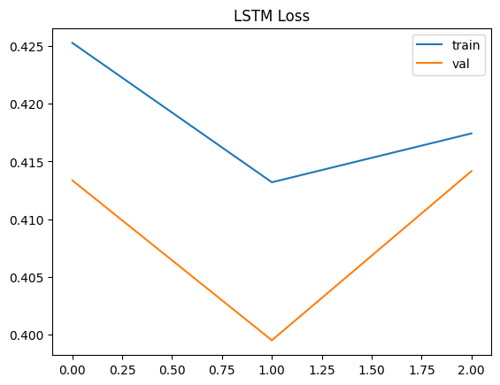
Fig. 4.8 Training and Validation Loss of LSTM Model
Figure 4.8 demonstrates training and validation loss, which converges slightly fluctuating between epochs.
The comparatively poor performance may be explained by the absence of an inherent time structure of the dataset since the dataset is aggregated samples of multiple sources. The LSTM models are intended to exploit sequential dependencies [8], [18], and therefore will not work as well where such continuity is not present [4], [7]. In spite of these limitations, the LSTM model offers useful insights to the applicability of sequence-based approaches in heterogeneous settings.

Model Comparison
A comparative study of Random Forest and LSTM shows that there are differences in the effectiveness of the model.
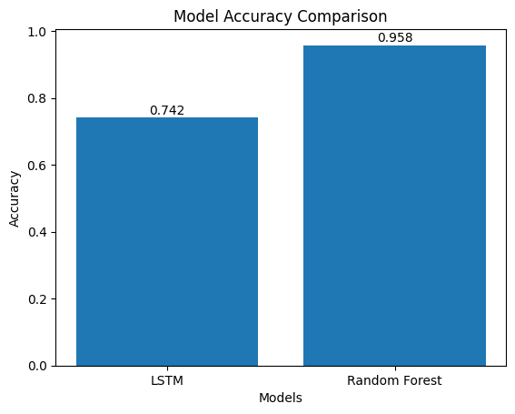
Fig. 4.9 Model Accuracy Comparison
As Figure 4.9 indicates, the Random Forest is much more accurate and stable in comparison with LSTM. The performance difference shows feature-based learning is more appropriate to datasets with weak time dependencies.
This analogy helps to understand the crucial point: sequence-based models are superior in time-series data, whereas feature-based models can be more flexible to aggregated and heterogeneous data. This is in line with the results of earlier researchers on the limitations of temporal modeling [4], [7].

ROC Curve Analysis
The model performance at various classification thresholds is measured by Receiver Operating Characteristic (ROC) curves.
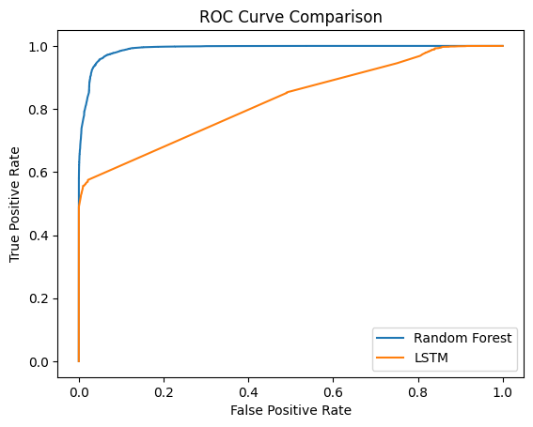
Fig. 4.10 ROC Curve Comparison of Models
As Figure 4.10 indicates, Random Forest has a larger Area Under Curve (AUC) which means that it can better discriminate between attack and normal classes. The curve shows a good balance between the true positive and false positive rates. The LSTM model, on the other hand, has a curve that is less pronounced, indicating less confidence in the classification. The analysis of ROC gives an assessment that is independent of threshold, which again supports the strength and validity of the Random Forest model in this context.

Feature Importance Analysis
The Random Forest model is used to conduct feature importance analysis to increase its interpretability.
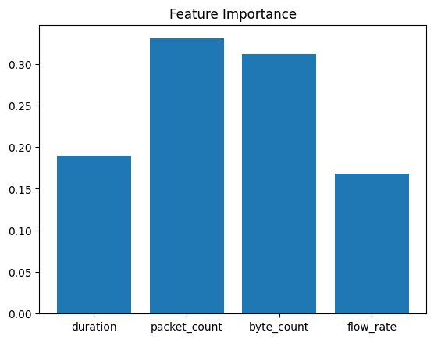
Fig. 4.11 Feature Importance Analysis
According to Figure 4.11, the most significant traits are the number of packets and the number of bytes, which suggests that the volume and intensity of traffic can be used as major signs of malicious activity. Flow rate and duration are also used to aid classification and capture the behavior of transmission and time aspects.
One of the key strengths of the suggested approach is the ability to recognize and decipher meaningful features, as it offers transparency in model decision-making. This enhances trust and usability in practical cybersecurity uses [17]. In general, the findings show that the Attack DNA framework is a good predictor of meaningful behavioral patterns, which can be accurately, interpretively, and scalably used to detect cyber threats in various settings.

Conclusion And Future Work
This paper has proposed a cohesive model of cyber threat detection in the world through a behavioral model known as Attack DNA. The proposed approach can be used to analyze heterogeneous intrusion detection datasets consistently, scalably, and dataset-independently by converting heterogeneous intrusion detection data into a common feature space defined by duration, packet count, the number of bytes, and flow rate.
The results of the experiment demonstrate that feature-based models in particular Random Forest are better than sequence-based models such as LSTM in aggregating multiple datasets. This leads to an important point that there is no high degree of temporal continuity, then structured behavioral representations are more effective in intrusion detection. Additionally, the introduction of the geographical analysis provides interesting data on the variations of cyber threats in different geographical contexts, which demonstrates the international character and the universality of the framework.
Overall, the proposed system will address such vital problems in cybersecurity as heterogeneity of data, non-standardization, and lack of interpretability. It is an efficient and pragmatic method of recognizing cyber threat in distributed and data starved environments because it emphasizes on the principle of behavioral abstraction.
In future work, this framework can be extended to include real time-series data to leverage sequence-based models such as LSTM and Transformer architectures. Further practicality can be achieved with integration of real time data streams and deployment in Security Information and Event Management (SIEM) systems. Also, it is possible to introduce explainable AI methods and higher-level ensemble approaches, which could enhance the results and interpretability and make the system more resilient and suitable to real-world cybersecurity tasks.

References
[1] M. A. Alohali, M. Aljebreen, N. Ahmad, S. Alahmari, S. S. Albouq, A. Alqazzaz, H. Alkhiri, and Y. Said, “Privacy Preserving Blockchain Integrated Explainable Artificial Intelligence with Two Tier Optimization for Cyber Threat Detection,” 2025.
[2] W. Ali, A. Sajid, T. A. Ghodke, R. Malik, N. Malik, and K. Kaushik, “Honeypot Comparison of Attack Detection and Mitigation of SSH Attack,” 2024.
[3] J. Bi, Z. Guan, H. Yuan, and J. Zhang, “Improved Network Intrusion Classification with Attention-Assisted Bidirectional LSTM and Optimized Sparse Contractive Autoencoders,” 2024.
[4] P. Cheimonidis and K. Rantos, “A Proactive and Time-Sensitive Cyber Risk Assessment Model Integrating Markov Chains and Bayesian Networks,” 2025.
[5] M. Fan, Z. Si, X. Xie, Y. Liu, and T. Liu, “Text Backdoor Detection Using an Interpretable RNN Abstract Model,” 2021.
[6] J. Franco, A. Arış, B. Canberk, and S. Uluagac, “A Survey of Honeypots and Honeynets for IoT, IIoT, and CPS,” 2021.
[7] Y. Imrana, Y. Xiang, L. Ali, and Z. Abdul-Rauf, “A Bidirectional LSTM Deep Learning Approach for Intrusion Detection,” 2021.
[8] J. Kang, H. Yang, Y. Zhang, Y. Dai, M. Zhan, and W. Wang, “ActDetector: A Sequence-Based Framework for Network Attack Activity Detection,” 2022.
[9] Q. Liu, Y. Zhan, and B. Wang, “Secure and Efficient Cloud-Based Multi-Party Private Set Intersection with Union Protocol,” 2025.
[10] N. Naik, C. Shang, P. Jenkins, and Q. Shen, “D-FRI-Honeypot: A Secure Sting Operation Using Dynamic Fuzzy Rule Interpolation,” 2021.
[11] M. Raza, M. J. Saeed, M. B. Riaz, and M. A. Sattar, “Federated Learning for Privacy-Preserving Intrusion Detection in Software-Defined Networks,” 2024.
[12] P. Revathi and S. Kingslin, “A Review of Privacy-Preserving Intrusion Detection for Healthcare Edge-IoT,” 2026.
[13] M. A. O. Rabah, H. Drid, Y. Medjadba, and M. Rahouti, “Detection and Mitigation of DDoS Attacks Using Ensemble Learning and Honeypots in SDN-UAV Architecture,” 2024.
[14] R. Ben Said, Z. Sabir, and I. Askerzade, “CNN-BiLSTM: A Hybrid Deep Learning Approach for Network Intrusion Detection,” 2023.
[15] X. Wang, J. Liu, and C. Zhang, “Network Intrusion Detection Based on Multi-Domain Data and Ensemble Bidirectional LSTM,” 2023.
[16] X. Wang, J. Liu, and C. Zhang, “Network Intrusion Detection Based on Multi-Domain Data and Ensemble Bidirectional LSTM,” 2023. (duplicate study version)
[17] C. D. Xuan, “Detecting APT Attacks Based on Network Traffic Using Machine Learning,” 2021.
[18] Y. Yang, S. Tu, R. H. Ali, H. Alasmary, M. Waqas, and M. N. Amjad, “Intrusion Detection Based on Bidirectional Long Short-Term Memory with Attention Mechanism,” 2023.
[19] J. Zhang, L. Pan, Q.-L. Han, C. Chen, and S. Wen, “Deep Learning Based Attack Detection for Cyber-Physical System Cybersecurity: A Survey,” 2022.

