Enhancing Phonemic Awareness: Addressing Difficulties in Letter-Sound Recognition Through Multisensory Engagement Strategies for Grade 1 Learners

A Thesis Presented to
The Faculty of the College of Education
Misamis University
Ozamiz City

In Partial Fulfillment
of the Requirements for the Degree
Bachelor of Elementary Education

By

BYLROSE T. FUERTES

May 2025

APPROVAL SHEET
This research paper, “Enhancing Phonemic Awareness: Addressing Difficulties in Letter-Sound Recognition Through Multisensory Engagement Strategies for Grade 1 Learners,” prepared and submitted by Bylrose T. Fuertes, in partial fulfillment of the requirements for the degree of Bachelor's in Elementary Education, has been examined and is recommended for acceptance and approval for Oral Examination.

Eunice A. Agcol
Adviser

Approved by the Thesis Committee on Oral Examination with a grade of ______.

GENELYN R. BALUYOS, EdD
Member

JAME S. BAZAR, MAEdBEVERLY B. DIONIO, MAEd
Member Member

Accepted and approved in partial fulfillment of the requirements for the subject EDUC 4E.

GENELYN R. BALUYOS, EdD
Dean, College of Education

Date: May 2025

ACKNOWLEDGEMENT

The researcher extends sincere gratitude to the following individuals, whose unwavering support and guidance have been instrumental in the completion of this study:
To Dr. Genelyn R. Baluyos, Dean of the College of Education and instructor, for her expertise and mentorship, which provided invaluable insights and direction throughout the research process.
To Mr. Eugenio C. Bucog, School Principal of Ozamiz City Central School, for his permission and support, which facilitated the smooth accomplishment of this research.
To Mrs. Eunice A. Agcol, my cooperating teacher, for her dedicated assistance, support, and collaboration, which greatly enriched the research experience.
To the family and partner, whose solid support has been a constant source of inspiration and motivation, fueling the determination to pursue this endeavor.
To the friends and classmates, whose collaborative efforts and encouraging words fostered a supportive environment, and to the Grade 1 pupils, for their enthusiastic cooperation and invaluable contributions to the research.
Above all, profound gratitude is extended to Almighty God for His grace and unwavering guidance throughout this research journey.

-Bylrose

DEDICATION

This research is dedicated with all my heart to my beloved family and friends. Their unwavering love, support, encouragement, and understanding have been my foundation of strength throughout my journey. To my dedicated instructor, cooperating teacher, and supportive classmates, whose confidence in me propelled my efforts in this endeavor. Moreover, to Almighty God, the infinite source of wisdom, knowledge, and strength, for guiding and sustaining me every step of the way to the success of this study.
-Bylrose

ABSTRACT

Phonemic awareness deficiency is common among children in the Philippines, and many struggle with reading because they lack the sound recognition skills needed for fluent reading. This study examines the effectiveness of multisensory engagement strategies in enhancing phonemic awareness and letter-sound recognition among Grade 1 learners. Recognizing that these foundational skills are essential for reading and overall literacy, the study employed a classroom-based action research design during a six-week intervention. 25 Grade 1 pupils who initially demonstrated low phonemic awareness participated in the intervention. Various activities, including visual aids, auditory songs, tactile materials, and kinesthetic games, were integrated into daily instruction to create an enriched learning environment. Data collection involved administering standardized tests before and after the intervention, taking observational notes, and conducting structured teacher interviews. Statistical analysis revealed that posttest scores increased significantly while performance variability decreased, indicating a positive impact of the multisensory strategies. Multisensory engagement can effectively address challenges in letter-sound recognition and support early reading development. The researcher recommends that future researchers include a larger group of students from different classroom settings. They should also examine how these teaching methods affect learning over the long term.

Keywords: phonemic awareness, letter sound recognition, multisensory engagement, early literacy, Grade 1 learners

TABLE OF CONTENTS

Page
TITLE PAGE . . . . . . . . . . i
APPROVAL SHEET . . . . . . . . . ii
ACKNOWLEDGEMENT . . . . . . . . iii
DEDICATION . . . . . . . . . iv
ABSTRACT . . . . . . . . . . v
TABLE OF CONTENTS . . . . . . . . vi
LIST OF TABLES . . . . . . . . . viii
1 CONTEXT AND RATIONALE . . .. . . . 1
- PROPOSED INTERVENTION . . . . . . 4
- ACTION RESEARCH QUESTIONS . . . . . 5
- ACTION RESEARCH METHODS . . . . . . 6

Research Design . . . . . . . . 6
Site . . . . . . . . . . 6
Participants . . . . . . . . . 7
Data Gathering Methods . . . . . . . 7
Ethical Issues . . . . . . . . 10
Data Analysis . . . . . . . . 11
5 RESULTS AND DISCUSSION . . . . . . 11
Student’s Retention Level on the Concepts
of Angles Before Manipulating Real Objects . . . . 12

Student’s Retention Level on the Concepts
of Angles After Manipulating Real Objects . . . . 13

Significant Difference in the Student’s Retention
Level on the Concepts of Angles Before and After
Manipulating Real Objects . . 14

Other Developments Observed Among the Students
After Manipulating Real Objects . . . . 16

6 SUMMARY, FINDINGS, CONCLUSION . . . . . 21
AND RECOMMENDATIONS

Summary . . . . . . . . 21

Findings . . . . . . . . 22

Conclusions. . . . . . . . . 22

Recommendations . . . . . . . 23

REFERENCES . . . . . . . . . 24

APPENDICES
Appendix A –Researcher-made Test . . . . . 28
Appendix B – Sample of the Filled Out Questionnaire . . . 32
Appendix C – Consent Letter . . . . . . 35
Appendix D – Statistical Computation . . . . . 36
Appendix E – Transcript of Interview . . . . . 38
Appendix F – Documentations . . . . . . 41 Appendix G – Final Grammarly Report . . . . . 44
CURRICULUM VITAE . . . . . . . 45

LIST OF TABLES

Table Page
1 Student’s Retention Level on the Concepts
of Angles Before Manipulating Real Objects . . 13

2 Student’s Retention Level on the Concepts
of Angles After Manipulating Real Objects . . 14

3 Significant Difference in the Student’s Retention
Level on the Concepts of Angles Before and After
Manipulating Real Objects . . . 16

- Context and Rationale

Phonemic awareness deficiency is a major challenge in early literacy, especially in low-income areas where quality education is limited. Research indicates that about 80% of children who have difficulty recognizing and manipulating sounds (phonemes) in words develop this deficiency when they do not receive proper training (Adams, 1990). In the Philippines, many children struggle with reading because they lack the sound recognition skills needed for fluent reading. This shortfall often leads to delays in language processing and results in fewer children reaching proficient reading levels (Librea et al., 2023).
Poor sound recognition affects not only academic performance but also everyday communication and learning. Phonemic Awareness Training offers a structured method to address these challenges. This training teaches children how to identify, segment, and blend sounds in words through activities such as rhyming, letter-sound association, and sound manipulation (Cudis, 2022). Studies show that this approach significantly improves reading fluency and comprehension, making it one of the most effective interventions for enhancing early literacy.
This study aims to implement Phonemic Awareness Training at Ozamiz City Central School (OCCS) for Grade 1 students, given the observed reading difficulties among young learners. The research will examine how structured phonemic exercises can improve word recognition, fluency, and comprehension. By using multisensory engagement strategies, the program aims to build essential reading skills. In addition, the initiative supports Sustainable Development Goal (SDG) 4, which promotes inclusive and quality education through effective literacy programs (Reading Rockets, 2025).
Local government initiatives also play a vital role by supporting teacher training, improving curriculum development, and providing the needed learning resources. Community involvement and parental support further help build children’s confidence in reading, offering a practical solution to improve literacy among learners facing significant challenges.

II. Strategy

The intervention in this study is designed to address difficulties in phonemic awareness and letter-sound recognition among Grade 1 learners through multisensory engagement strategies. Phonemic awareness is a key predictor of reading success because it enables children to recognize, isolate, and manipulate sounds within words. Young learners who struggle with letter-sound recognition require explicit instruction through hands-on activities and repeated practice to develop stronger decoding abilities and processing skills.
Research has shown that students at risk for reading difficulties often struggle with phonemic awareness, which, in turn, affects word recognition, fluency, and comprehension (Mitchell et al., 2023). Early intervention programs that emphasize interactive, multisensory approaches have been demonstrated to significantly improve these skills (Piasta & Wagner, 2010). This study will integrate movement-based learning, auditory reinforcement, and visual cues through activities such as sound-box tasks, kinesthetic letter tracing, and interactive digital programs. Parental involvement and local government support will reinforce the intervention by ensuring sustained teacher training, appropriate curriculum planning, and sufficient resource allocation.

III. Action Research Questions

This research aimed to determine the effectiveness of Phonemic Awareness Training among Grade 1 students at Ozamiz City Central School (OCCS) by addressing the following questions:
1. What is the level of phonemic awareness and letter-sound recognition skills among students before the implementation of multisensory engagement strategies?
2. What is the level of these skills after the implementation of the multisensory engagement strategy?
3. Is there a significant difference in the students’ phonemic awareness and letter-sound recognition skills before and after the intervention?
Answering these questions will help determine whether a structured Phonemic Awareness Training program can effectively address reading difficulties. The study aims to improve literacy rates among child learners while supporting inclusive, high-quality education in line with SDG 4.

IV. Action Research Method

This study used a classroom-based action research design to enhance Grade 1 students' phonemic awareness and letter-sound recognition skills through targeted, multisensory instructional strategies. The research followed a cyclical process of planning, acting, observing, and reflecting, which enabled ongoing improvements in teaching practices and student learning outcomes (Stringer, 2014). Over six weeks, the intervention will include daily phonemic awareness activities such as phoneme segmentation, blending tasks, and sound-box exercises.
These activities will be designed to actively engage students through visual and auditory methods, thereby reinforcing letter-sound connections. In addition, technology-assisted tools such as phonics-based software will be incorporated; these tools provide personalized learning experiences, real-time feedback, and additional practice opportunities (Mitchell et al., 2023). Data will be collected through pre- and post-assessments that measure phonemic awareness and letter-sound recognition, along with ongoing observations, formative assessments, teacher reflections, and student feedback. This flexible and responsive action research design will allow the teacher-researcher to adjust instructional techniques in real time based on the data collected. Ultimately, the intervention aims to bridge the gap for struggling readers by developing their foundational reading skills, ensuring sustained progress, and contributing to improved literacy outcomes in line with SDG 4

Instrument

The researchers will use the following instruments:
1. Phonemic Awareness Tests: Pretests and posttests will be created to assess students' phonemic awareness and letter-sound recognition skills before and after the intervention. Standardized phonemic awareness tests were administered. These tests measured the ability to recognize individual sounds in words, blend and segment phonemes, and identify letter-sound associations. The pretest was used to determine pupils' initial proficiency levels, while the posttest evaluated improvements following the six-week intervention. In addition to standardized tests, informal reading assessments were also conducted during the implementation phase to monitor progress and identify specific challenges.
2. Lesson Plans: Structured lesson plans guide the implementation of phonemic awareness activities to meet the study's objectives. The lesson plans and instructional materials were evaluated by Mrs. Eunice A. Agcol, a literacy specialist. They experienced elementary educators, as well as other expert educators and critical teachers, to verify their effectiveness in promoting phonemic awareness. Their review focused on how well the activities align with established literacy frameworks, adapt for differentiated instruction, and suit early learners. Based on their feedback, adjustments were made to enhance overall instructional quality.
3. Phonemic Awareness Strategies: Specific strategies, such as rhyming, word families, and sound isolation, will be used to improve phonemic awareness and letter-sound recognition. Additional techniques include phoneme segmentation and blending exercises, teacher-led modeling, and interactive games for multisensory reinforcement. These methods are applied during both group and individual sessions to provide varied and repeated practice for all learners.

Data Gathering Methods
A. Pre-Implementation Phase. During this phase, the researcher will identify challenges Grade 1 pupils face in letter-sound recognition and review related studies to gain a deeper understanding. A research proposal will be prepared and submitted for approval. Lesson plans focusing on phonemic awareness strategies will be designed. Pretest and posttest assessments will measure students' progress. All activities, including data collection and intervention, will occur through face-to-face interactions.
B. Implementation Phase. The implementation phase will commence with a pretest to assess Grade 1 participants' initial phonemic awareness and letter-sound recognition skills. The intervention, incorporating targeted phonemic awareness strategies, will be conducted over a specified period. The researcher will continuously monitor participants' progress, observing their letter-sound recognition, engagement, and motivation. A posttest will evaluate improvement in phonemic awareness and letter-sound recognition. Data will then be gathered, tallied, analyzed, and interpreted to determine the intervention's effectiveness.
C. Post-Implementation Phase. In the post-implementation phase, the researcher will draw conclusions based on data collected from Grade 1 students, provide recommendations, and finalize the research report on enhancing phonemic awareness and addressing difficulties in letter-sound recognition. The findings will be shared with educators, administrators, and parents to ensure effective communication and inform future instructional practices.
D. Ethical Consideration. The study will follow ethical standards by obtaining informed consent from all participants before their involvement. Participants will be fully informed about the objectives, potential benefits, and significance of the study, as well as their rights under the Data Privacy Act of 2012. All personal data collected will remain confidential and anonymized throughout the research process.
Data Analysis. The analysis will begin with calculating the mean and standard deviation to summarize the levels of phonemic awareness and letter-sound recognition before and after the intervention. A t-test analysis will be used to determine whether there is a significant difference in student performance before and after implementing the intervention. In addition, thematic analysis will be applied to the interview data to identify common themes and gain insights into participants’ experiences and perspectives regarding the phonemic awareness strategies (Braun & Clarke, 2006).
V. Results and Discussion

Significant improvements in pupils' phonemic awareness and letter-sound recognition were observed following the implementation of multisensory engagement strategies (National Reading Panel, 2000). The multisensory approach, which combined visual, auditory, tactile, and kinesthetic techniques, greatly enhanced learners' engagement during reading activities (Reading Rockets, 2025). A clear difference emerged between pretest and posttest results: before the intervention, most Grade 1 pupils exhibited limited phonemic awareness and struggled to accurately identify letter sounds (Adams, 1990). There was a marked improvement in their ability to recognize and associate letters with their corresponding sounds (Snow & Juel, 2005).
For example, the pretest results (Table 1) revealed that the majority of students fell within the "Needs Improvement" category, with an overall mean score of 8.92 and a standard deviation of 4.83 (Ehri et al., 2001). This indicates that most students had difficulty linking phonemes with letters, suggesting that their initial literacy instruction was insufficiently varied and stimulating (National Reading Panel, 2000).
The detailed analysis of both quantitative (test scores) and qualitative (teacher observations and student feedback) data supports the conclusion that multisensory engagement positively affects the development of phonemic awareness. These results align with prior research demonstrating that explicit, multisensory instruction can significantly enhance early reading skills (Ehri, 2005).
These findings strongly imply that phonemic awareness training through multisensory strategies in early literacy programs can dramatically enhance phonemic awareness and letter-sound recognition. When children engage their visual, auditory, tactile, and kinesthetic senses, they are better able to connect sounds with letters in a meaningful way.
Educators should create learning environments that are both engaging and dynamic by incorporating a variety of activities, such as letter tiles, interactive reading games, and phoneme-blending exercises. This approach not only boosts students' reading skills quickly but also builds their confidence and sparks a lifelong love for reading. Results also imply that using a blend of visual, auditory, tactile, and kinesthetic activities helps create an engaging learning environment where students become enthusiastic and successful readers for life.

Table 1. Students’ Level of Phonemic Awareness and Letter-Sound Recognition Skills Before the Intervention of the Multisensory Engagement Strategy
Proficiency Level | Frequency | Percentage | M | SD
Excellent | 2 | 8.00 | 19.00 | 0.00
Developing | 1 | 4.00 | 15.00 | -
Needs Improvement | 22 | 88.00 | 7.73 | 3.71
Overall Performance | 25 | 100.00 | 8.92 | 4.83

Note: Scale – 19–20: Excellent; 17–18: Proficient; 15–16: Developing; 13–14: Beginning; 0–12: Needs Improvement.

After the intervention, the posttest results (Table 2) showed substantial gains. The data indicate that many students moved into higher performance categories, with 44% reaching the Excellent level and only 4% remaining in the Needs Improvement category. The overall mean score increased significantly to 16.96, with a lower standard deviation of 2.78, indicating improved performance and greater consistency across the group.
Table 2. Student’s Level of Phonemic Awareness and Letter-Sound Recognition Skills After the Intervention of Multisensory Engagement Strategy
Proficiency Level | Frequency | Percentage | M | SD
Excellent | 11 | 44.00 | 19.46 | 0.52
Proficient | 4 | 16.00 | 17.25 | 0.50
Developing | 6 | 24.00 | 15.33 | 0.52
Beginning | 3 | 12.00 | 13.00 | 0.00
Needs Improvement | 1 | 4.00 | 10.00 | -
Overall Performance | 30 | 100.00 | 16.96 | 2.78
Note: Scale – 19–20: Excellent; 17–18: Proficient; 15–16: Developing; 13–14: Beginning; 0–12: Needs Improvement.

Table 2 shows the levels of phonemic awareness and letter-sound recognition skills of the students after the multisensory engagement intervention. Out of 30 students, 44% achieved an Excellent level with an average score of 19.46, indicating a strong grasp of the skills; 16% reached a Proficient level with a mean score of 17.25; 24% were at the Developing level with an average score of 15.33; 12% were at the Beginning level with a mean score of 13; and only 4% remained in the Needs Improvement category with an average score of 10. Overall, the mean score was 16.96 with a standard deviation of 2.78, suggesting that most students improved and performed consistently well within the Developing to Proficient range. This result indicates that the multisensory strategy was effective in boosting students' reading skills, although a very small number still require further support.

Variables | M | SD | t-value | p-value | Decision
Before the Multisensory  After the Intervention | 8.92 | 4.83 | -  9.60 | -  0.00 | -  Reject Ho
Table 3. Significant Difference in the Student’s Level of Phonemic Awareness and Letter-Sound Skills Before and After the Intervention of the Multisensory Engagement Strategy
Ho: There is no difference in the students’ level of phonemic awareness and letter-sound recognition skills before and after the intervention.
¹ Decision: Reject the null hypothesis (Ho), indicating that the multisensory engagement strategy significantly improved performance.

Table 3 presents the results of a t-test comparing students' performance before and after the multisensory engagement intervention. The average score before the intervention was 8.92 with a standard deviation of 4.83, and this increased to 9.60 after the intervention. With a p-value of 0.00 (p < 0.01), the findings are statistically significant, indicating that the observed improvement is very likely due to the intervention rather than chance. In simple terms, this analysis shows that the multisensory strategy made a clear, positive difference in students' phonemic awareness and letter-sound recognition skills, allowing us to confidently reject the null hypothesis that there was no change.

VI. Summary, Findings, Conclusions, and Recommendations
Summary
This action research explored how multisensory engagement strategies could improve phonemic awareness and letter-sound recognition among Grade 1 pupils. Twenty pupils who initially demonstrated low performance in these foundational literacy skills participated in activities using visual aids, auditory songs, tactile materials, and kinesthetic games. Pre-intervention assessments revealed that a large proportion of the pupils performed poorly at associating sounds with letters. In contrast, post-intervention results indicated significant improvement, with the pupils achieving higher and more consistent performance. The statistical analysis confirmed that the improvements observed were highly significant.

Findings
1. The study revealed that prior to the intervention, a majority of Grade 1 pupils exhibited
difficulty in phonemic awareness and letter-sound recognition. Their pretest scores indicated weak associations between sounds and letters, with many pupils classified in the "Needs Improvement" category. After implementing multisensory engagement strategies, posttest results showed a notable enhancement in phonemic awareness, with many pupils moving into the "Outstanding" proficiency range. This confirmed the effectiveness of multisensory techniques in reinforcing early reading skills.
2. Statistical analysis demonstrated a significant increase in overall mean scores following
the intervention. Before the study, pupils displayed inconsistent performance, with varying levels of proficiency in recognizing and manipulating phonemes. Post-intervention, their scores showed more uniform improvement, indicating that multisensory activities helped bridge gaps in phonemic awareness and letter-sound recognition across all learners.
3. The standard deviation in phonemic awareness scores decreased considerably after the
intervention, meaning that pupils exhibited more consistent abilities in recognizing and associating sounds with letters. This suggests that the multisensory approach not only improved performance but also led to more stable and reliable literacy development among learners.
4. Observations showed that pupils demonstrated increased engagement and enthusiasm when participating in multisensory activities. Kinesthetic games encouraged active learning, tactile materials helped pupils retain letter shapes, auditory songs reinforced sound recognition, and visual aids provided clearer references for identifying letters. Pupils expressed enjoyment in learning phonemic skills through interactive strategies, making reading instruction more meaningful and accessible.
5. Teachers reported that multisensory engagement strategies significantly helped struggling learners improve their phonemic awareness. They observed that pupils who previously had difficulty recognizing sounds became more confident in identifying and manipulating phonemes. Educators also noted that integrating multiple sensory elements into daily literacy instruction made phonemic awareness lessons more effective, leading to lasting improvements in foundational reading skills.
6. The t-test conducted on the pretest and posttest scores confirmed that the observed improvements were statistically significant. The calculated t value and p value indicated that the changes in phonemic awareness and letter-sound recognition skills were not due to chance but rather the direct effect of the multisensory intervention. This reinforces the effectiveness of multisensory strategies in strengthening early literacy development.
7. The study’s results align with previous research emphasizing the importance of multisensory techniques in literacy instruction. Existing studies suggest that integrating visual, auditory, tactile, and kinesthetic elements improves phonemic awareness among early learners. The findings support the notion that multisensory strategies should be further explored in literacy programs to enhance reading outcomes for struggling students.
8. Based on the success of this intervention, the study suggests that multisensory strategies could be expanded to other foundational literacy skills, such as word decoding, blending, and segmenting. The positive results observed indicate that incorporating multisensory elements in curriculum design may be beneficial for early education, particularly for students with reading difficulties.

Conclusions
1. This action research explored how multisensory engagement strategies could improve phonemic awareness and letter-sound recognition among Grade 1 pupils. It aimed to show that using a mix of sensory methods can help children build stronger reading skills.
2. Twenty pupils who initially demonstrated low performance in foundational literacy skills were selected for the study. They were chosen because they needed extra support to develop basic reading abilities.
3. The pupils took part in various activities that involved visual aids, auditory songs, tactile materials, and kinesthetic games. These activities offered different ways for the students to engage with letters and sounds.
4. Pre-intervention assessments revealed that many pupils struggled to associate sounds with letters. This finding highlighted that their current reading instruction was not varied enough to meet their needs.
5. After the multisensory intervention, the pupils showed significant improvement in recognizing and linking letters with sounds. Their performance improved and became more consistent compared to pre-intervention results.
6. The statistical analysis confirmed that the improvements observed were highly significant. This provides strong support for the effectiveness of using multisensory engagement strategies in early literacy programs.

Recommendations

1. In view of the limitations encountered in this study, such as the small sample size and the focus on a single classroom setting, future research should consider expanding participant groups and including diverse educational settings to validate the findings. This approach will allow for a better understanding of how these strategies work across different learning environments.
2. The study did not include a control group to compare the effects of the multisensory intervention. Future researchers should incorporate control groups to help clearly measure the true impact of these instructional approaches.
3. The current study only examined the short-term effects of the multisensory strategy. Researchers are encouraged to use longitudinal designs to assess the long-term impact on early literacy, thereby showing how lasting these benefits are.
4. These measures will help establish the strength of multisensory strategies and may provide additional insights into their effectiveness in improving other foundational reading abilities. Future work in this area can further confirm the extent to which these methods enhance overall early reading skills.

IX. Action Research Work Plan and Timeline
In conducting this study, the proponent will strictly adhere to the timetable shown below.
Activities | Date | Resources Needed
Identify challenges faced by pupils in descriptive writing | November 11 – 22, 2024 | Laptop, articles, journals
Draft the research proposal and secure permissions | November 25 – 30, 2024 | Research materials, laptop, printer
Submission of Proposal & Letter of Consent | December 1-6, 2024 | Proposal document, consent forms, and email for submission
Preparation and Planning | December 9 – 10, 2024 | Laptop
Development of Pretest and Posttest | December 13 –15, 2024 | Laptop
Pretest Administration | February 24-28, 2025 | Test papers, answer sheets, pens
Implementation of Padlet | February 24- March 14, 2025 | Gadget (cellphone, tablet, laptop)
Posttest Administration | March 17-21, 2025 | Test papers, answer sheets, pens
Data Analysis and Interpretation | April 1-4, 2025 | Computer, software for analysis
Report Writing and Final Review | April 7-9, 2025 | Laptop, research notes
Submission of Final Research | April 10, 2025 | Printed report, submission folder

VII. References

Adams, M. J. (1990).
Beginning to read: Thinking and learning about print. MIT Press.
Alhumsi, M. H., & Shabdin, A. A. (2016).
The relationship between phonemic segmentation skill and EFL word recognition: A review of the literature. International Journal of Linguistics, 8(2), 31–46.
Apel, K., & Swank, L. K. (2023).
The relationships among phonemic awareness, developmental spelling, pseudoword reading, and sight-word reading in adolescent students who struggle with reading. Reading Research Quarterly.
Becker, R., & Sylvan, L. (2021).
Coupling articulatory placement strategies with phonemic awareness instruction to support emergent literacy skills in preschool children: A collaborative approach. Language, Speech, and Hearing Services in Schools, 52(2), 661–674.
Boyer, N., & Ehri, L. C. (2011).
Contribution of phonemic segmentation instruction with letters and articulation pictures to word reading and spelling in beginners. Scientific Studies of Reading, 15(5), 440–470.
De Graaff, S., Hasselman, F., Verhoeven, L., & Bosman, A. M. (2011).
Phonemic awareness in Dutch kindergartners: Effects of task, phoneme position, and phoneme class. Learning and Instruction, 21(1), 163–173.
Degé, F., & Schwarzer, G. (2011).
The effect of a music program on phonological awareness in preschoolers. Frontiers in Psychology, 2, 124.
Ehri, L. C. (2022).
What teachers need to know and do to teach letter–sounds, phonemic awareness, word reading, and phonics. The Reading Teacher, 76(1), 53–61.
Ehri, L. C., Nunes, S. R., Stahl, S. A., & Willows, D. M. (2001).
Systematic phonics instruction helps students learn to read: Evidence from the National Reading Panel's meta-analysis. Review of Educational Research, 71(3), 393–447.
Epstein, J. L. (2011).
School, family, and community partnerships: Preparing educators and improving schools (2nd ed.). Routledge.
Graham, S., Harris, K. R., & Fink, B. (2000).
Is handwriting causally related to learning to write? Treatment of handwriting problems in beginning writers. Journal of Educational Psychology, 92(4), 620–633.
Kuppen, S. E., & Bourke, E. (2017).
Rhythmic rhymes for boosting phonological awareness in socially disadvantaged children. Mind, Brain, and Education, 11(4), 181–189.
Le Roux, M., Geertsema, S., Jordaan, H., & Prinsloo, D. (2017).
Phonemic awareness of English second language learners. South African Journal of Communication Disorders, 64(1), 1–9.
Librea, N. K., Luciano, A. M., Sacamay, M. L., Libres, M. D., & Cabanilla Jr., A. (2023).
Low reading literacy skills of elementary pupils in the Philippines: A systematic review. International Journal for Research in Applied Science and Engineering Technology, 11(4), 49480.
Mertler, C. A. (2019).
Action research: Improving schools and empowering educators (6th ed.). SAGE Publications.
Mitchell, A., Thompson, J., & Williams, S. (2023).
Evidence-based phonemic awareness instruction for students at risk of reading difficulties. Journal of Literacy Research, 55(3), 201–225.
National Reading Panel. (2000).
Teaching children to read: An evidence-based assessment of the scientific research literature on reading and its implications for reading instruction. National Institute of Child Health and Human Development.
Piasta, S. B., & Wagner, R. K. (2010).
Developing early literacy skills: A meta-analysis of alphabet learning and instruction. Reading Research Quarterly, 45(1), 8–38.
Reading Rockets. (2025).
Phonological and phonemic awareness. Reading Rockets.
Rokhman, M. F., Lintangsari, A. P., & Perdhani, W. C. (2020).
EFL learners’ phonemic awareness: A correlation between English phoneme identification skill and word processing. JEES (Journal of English Educators Society), 5(2), 135–141.
Stringer, E. T. (2014).
Action research (4th ed.). SAGE Publications.
Ukrainetz, T. A., Nuspl, J. J., Wilkerson, K., & Beddes, S. R. (2011).
The effects of syllable instruction on phonemic awareness in preschoolers. Early Childhood Research Quarterly, 26(1), 50–60.
Vazeux, M., Doignon-Camus, N., Bosse, M. L., Mahé, G., Guo, T., & Zagar, D. (2020).
Syllable-first rather than letter-first to improve phonemic awareness. Scientific Reports, 10(1), 22130.

Appendix A
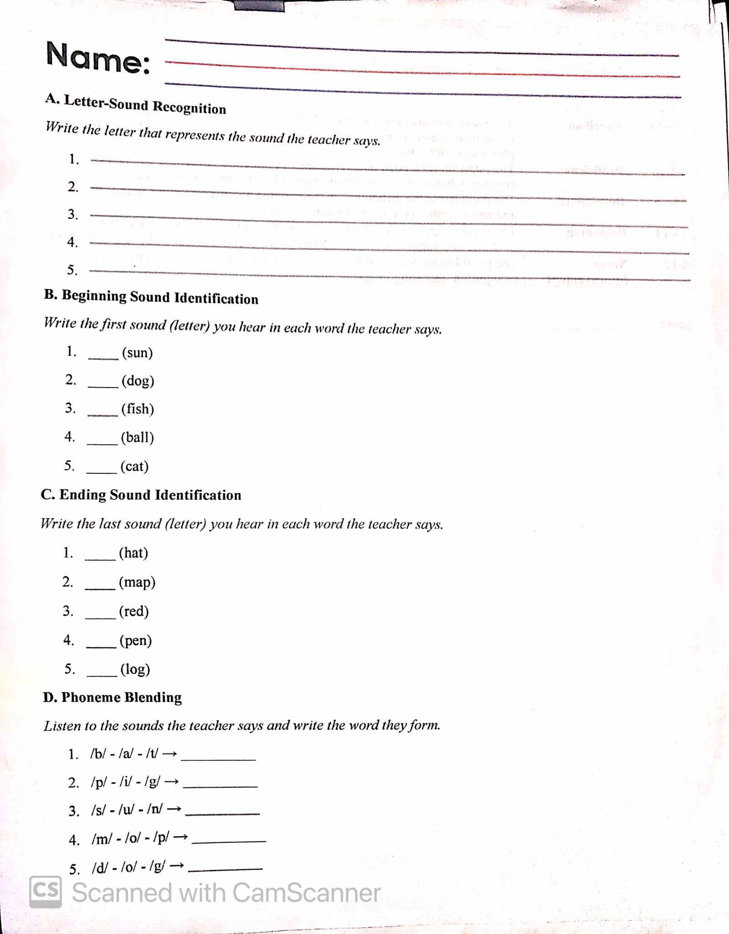

Appendix B
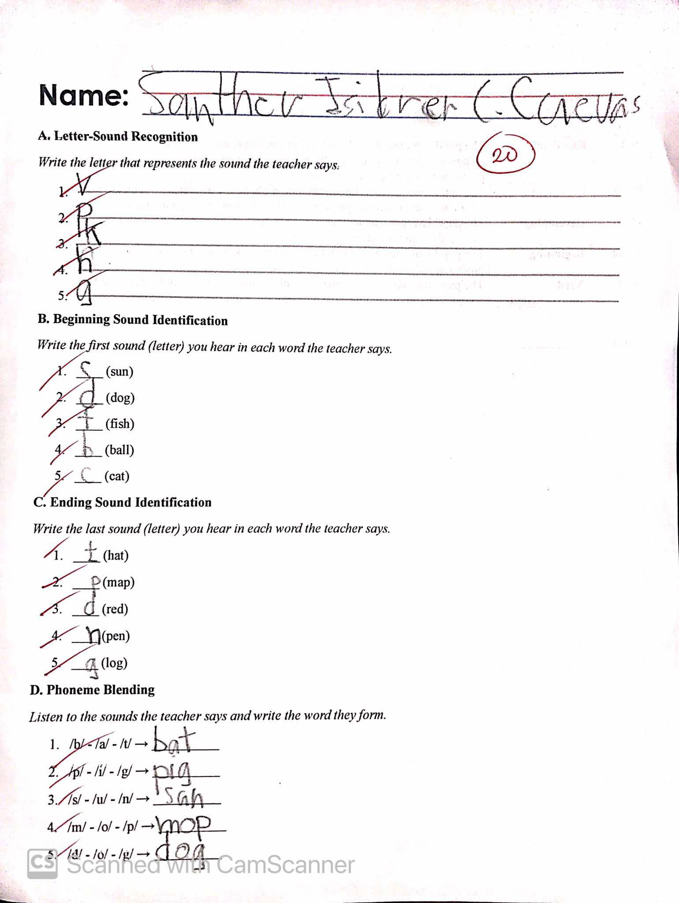

Appendix C
INFORMED CONSENT FORM

- I volunteer to participate in the research undertaking to be conducted by Bylrose T. Fuertes from the College of Education, Misamis University. I understand that the research is designed to gather information about enhancing phonemic awareness by addressing difficulties in letter-sound recognition through multisensory engagement strategies for Grade 1 learners. I will be one of the participants surveyed for this research.
- My participation in this research is voluntary. I understand that I will not be paid for my participation. I may withdraw and discontinue participation at any time without penalty. If I decline to participate or withdraw from the study, no one will be told.
- This research will involve my participation. I understand that most questions will be interesting and related to learning activities. If, however, I feel uncomfortable in any way during the survey session, I have the right to decline to answer any question or to end the survey.
- I understand that the information to be gathered will be kept confidential. I will not be identified in the paper. Only the researcher and her adviser will have access to the research data.
- I understand that this research has been reviewed and approved by the College of Education of Misamis University.
- I have read and understood the explanation provided to me. I have had all my questions answered to my satisfaction, and I voluntarily agree to participate in this study.
- I have been given a copy of this consent form.

_________________________ February 18, 2025
Participant’s Signature Date

For further information, please contact:

Bylrose T. Fuertes (bengkaytolleno@gmail.com)
Appendix D

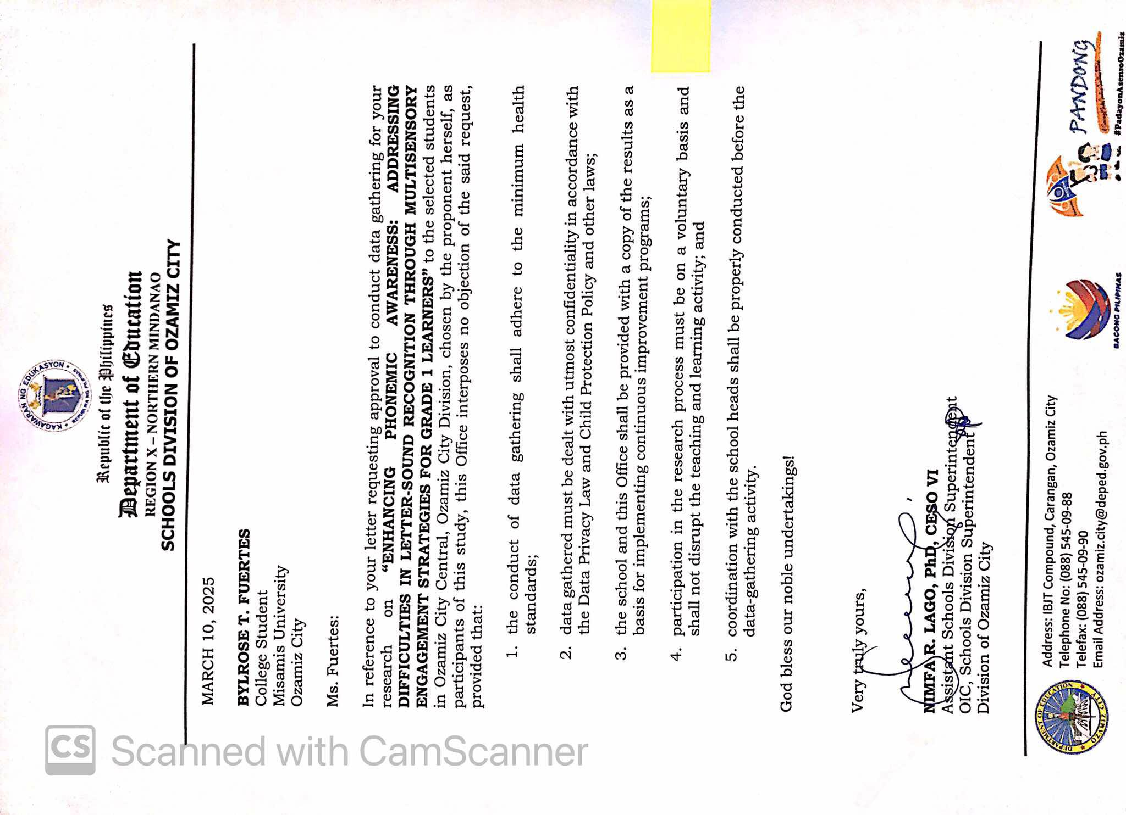

Appendix E

PARENTAL CONSENT

I, a student researcher at Misamis University, majoring in Bachelor of Elementary Education, General, hereby request your permission for your child/children, ages 6–8, to participate in our study.

This action research aims to enhance pupils’ phonemic awareness by addressing difficulties in letter-sound recognition through multisensory engagement strategies. As part of this study, your child will participate in group activities that use a variety of sensory methods, including visual aids, auditory cues, movement, and hands-on tasks. These activities are designed to help them recognize letter sounds more effectively, connect letters to sounds, and strengthen their foundational reading and language skills.

Through this approach, your child will be given opportunities to listen, speak, see, and move as they learn, making the process enjoyable and effective. These strategies are specifically intended to support Grade 1 learners in overcoming challenges in letter-sound recognition and improving their overall literacy development.

Your participation will greatly help the success of our study.

Thank you very much!

BYLROSE T. FUERTES
Researcher

Noted:

EUNICE A. AGCOL
Cooperating Teacher

ACKNOWLEDGMENT
I have read this consent form and give my consent for my child/children to participate in this study.
Guardian’s name: ________________________Date: ____________________

Contact no.: _____________________________Signature: ________________

KAPAHINTULUTAN NG BATA

Ako, si ____________________, ay kusang-loob na pumapayag na maging bahagi ng pag-aaral na pinamagatang "Enhancing Phonemic Awareness: Addressing Difficulties in Letter-Sound Recognition Through Multisensory Engagement Strategies for Grade 1 Learners", edad 6–8, sa _____________________. Nauunawaan ko na bilang bahagi ng pananaliksik na ito, ako ay lalahok sa mga pangkatang talakayan, pagsusuri sa mga tunog ng mga letra, at pagsasagawa ng mga multisensory na gawain upang higit na maunawaan ang koneksyon ng tunog at letra sa pagbasa. Ang lahat ng aking sagot at opinyon ay gagamitin lamang para sa layunin ng pag-aaral na ito at mananatiling kumpidensyal.

Ako ay hindipinilit o tinakotsakahitanomangparaan ng pag-aaralnaito.

____________________________________________
Lagda ng participantPetsa:

Saksi:
____________________________________________
Pangalan at Lagda ng MagulangPetsa:

Appendix F

- What is the student’s level of phonemic awareness and letter-sound recognition skills before the intervention of the Multisensory Engagement Strategy?
Tally for Discrete Variables: Pretest Code

Pretest
CodeCountPercent
12288.00
314.00
528.00
N=25

One-way ANOVA: Pretest versus Pretest Code

Means

Pretest
CodeNMeanStDev95% CI
1227.7273.706(6.126, 9.328)
3115.00*( 7.49, 22.51)
5219.000.00(13.69, 24.31)

Pooled StDev = 3.62042

- What is the student’s level of phonemic awareness and letter-sound recognition skills after the intervention of the Multisensory Engagement Strategy?
Tally for Discrete Variables: Posttest Code

Posttest
CodeCountPercent
114.00
2312.00
3624.00
4416.00
51144.00
N=25

One-way ANOVA: Posttest versus Posttest Code

Means

Posttest
CodeNMeanStDev95% CI
1110.00*(8.98,11.02)
2313.000.00( 12.41,13.59)
3615.3330.516(14.916, 15.751)
4417.2500.500(16.738, 17.762)
51119.4550.522(19.146, 19.763)

Pooled StDev = 0.490439

- Is there a significant difference in students’ levels of phonemic awareness and letter-sound skills before and after the Multisensory Engagement Strategy intervention?
Paired T-Test and CI: Pretest, Posttest

Paired T for Pretest - Posttest

NMeanStDevSE Mean
Pretest258.9204.8300.966
Posttest2516.9602.7760.555
Difference25-8.0404.1880.838

95% CI for mean Difference: (-9.769, -6.311)
T-Test of mean difference = 0 (vs ≠ 0): T-Value = -9.60P-Value = 0.000

Appendix G

Documentations
Pre- Implementation Phase
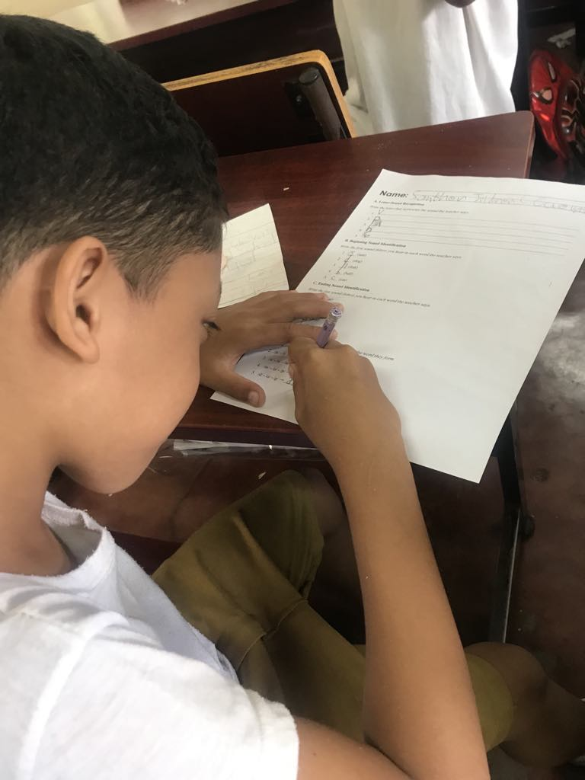
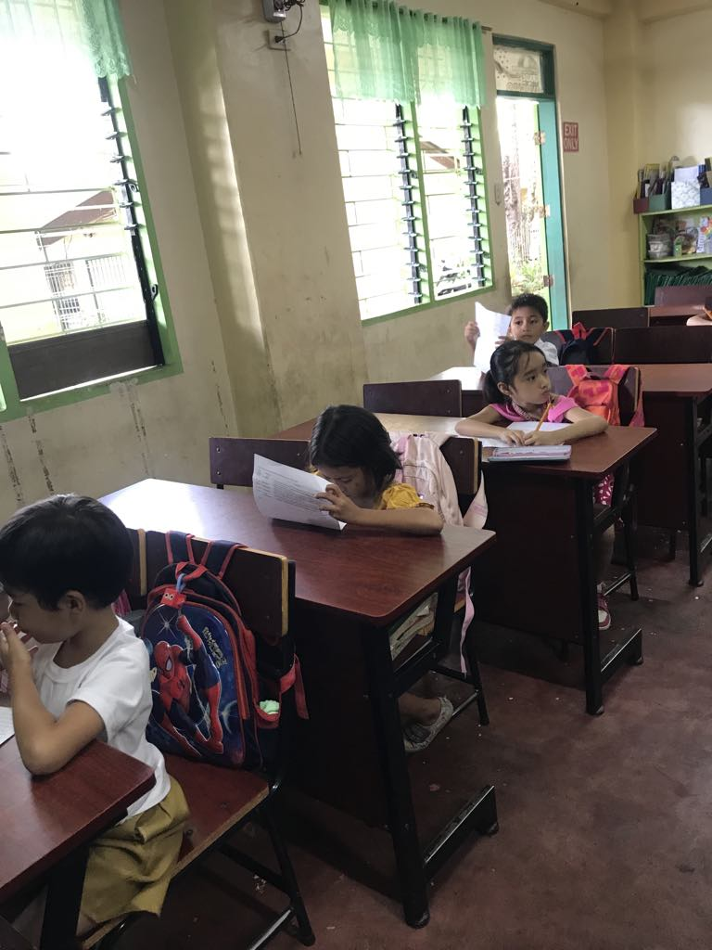
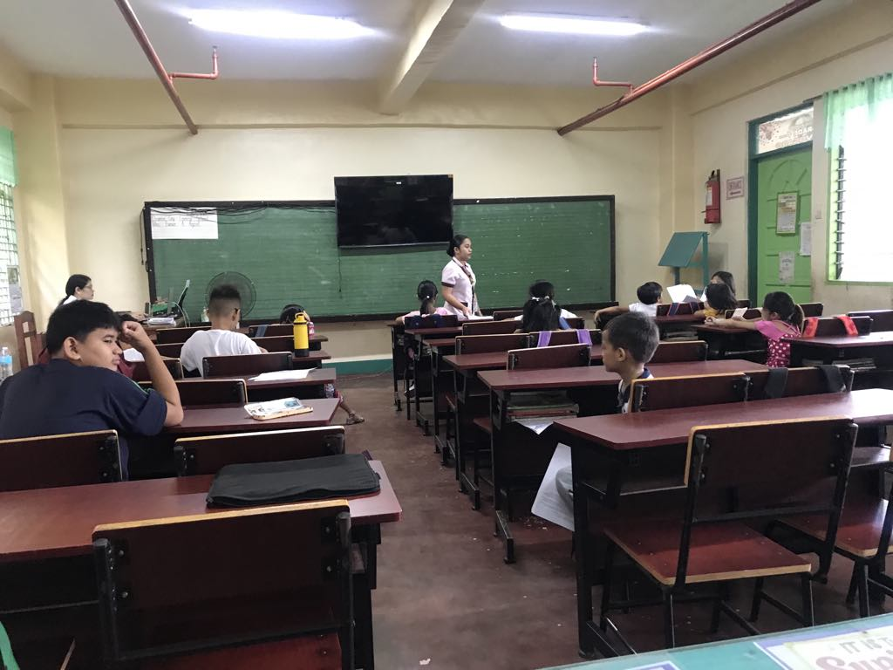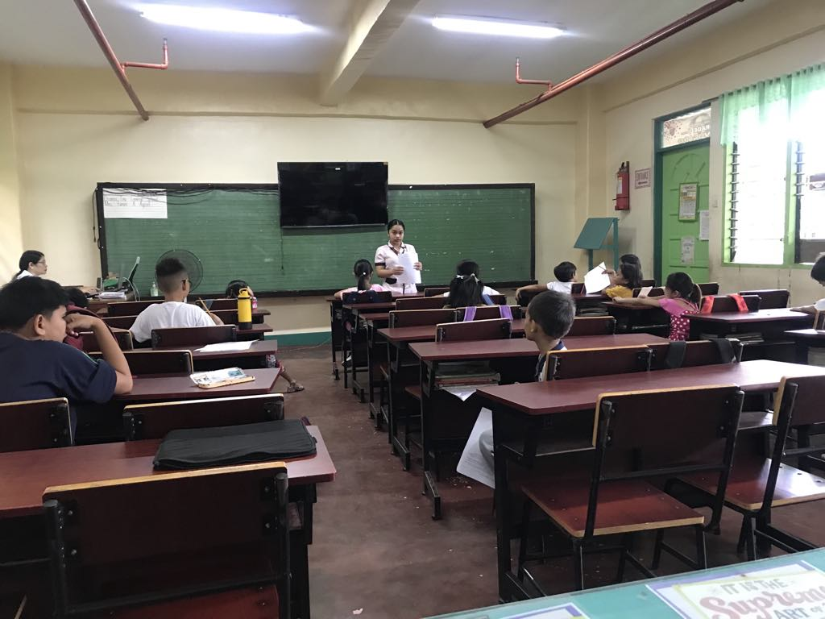

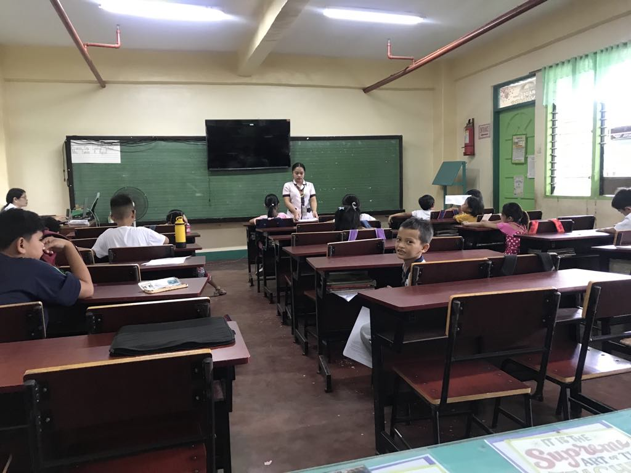
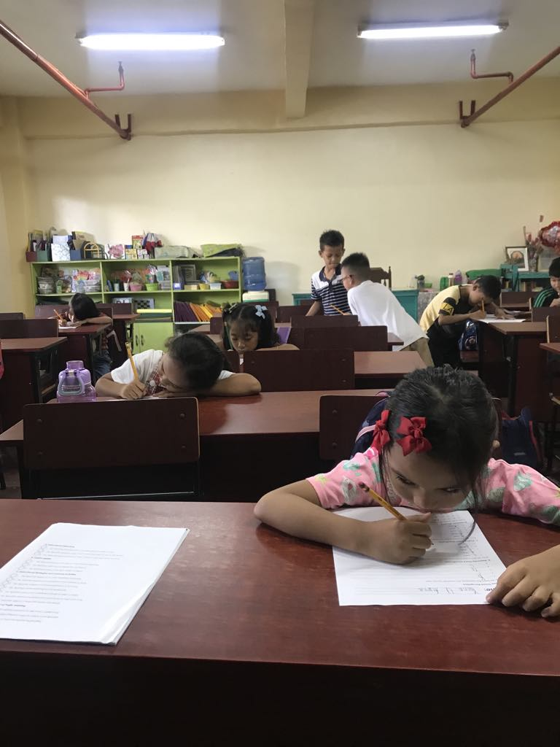

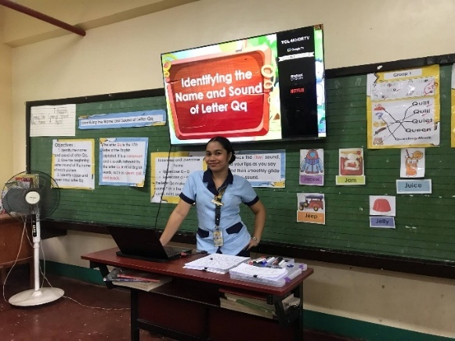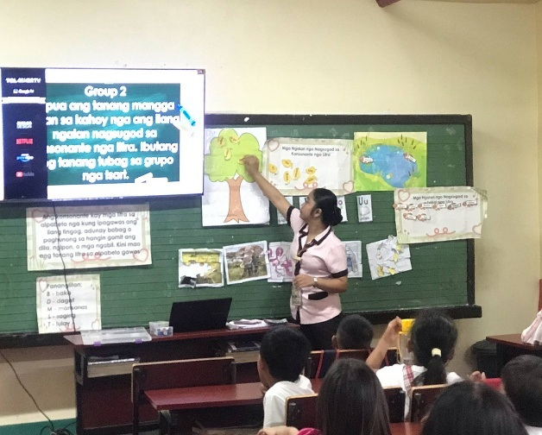

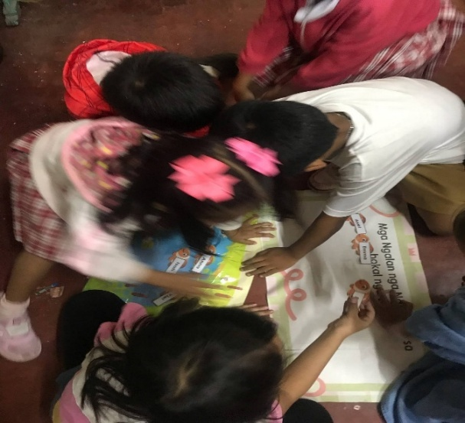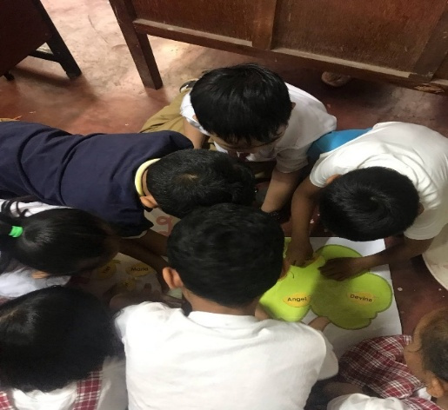

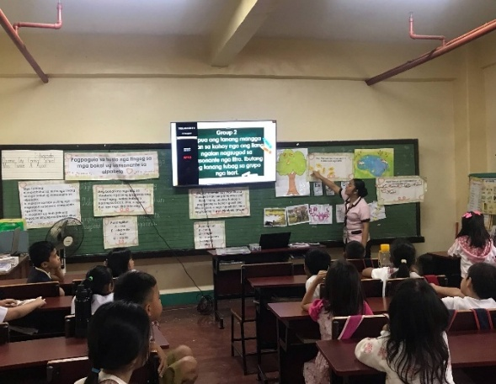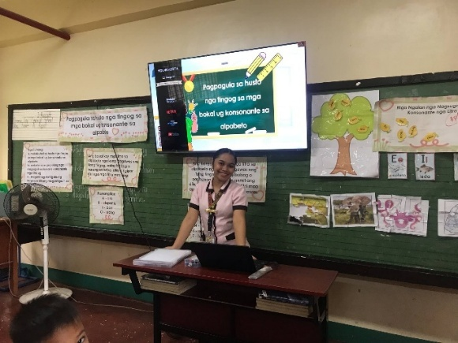


CURRICULUM VITAE

PERSONAL DATA
Name: Bylrose T. Fuertes
Date of Birth: July, 02, 2002
Place of Birth: Ozamiz City
Address: P-Mauswagon , Maningcol, Ozamiz City, Misamis Occidental, 7200
Status: Single
Citizenship: Filipino
Religion: UPC
Email Address: bylrosefuertes02@gmail.com

EDUCATION
Tertiary: Bachelor of Elementary Education
Misamis University
H.T. Feliciano St., Ozamiz City, Misamis Occidental

Secondary: Senior High School
Aloran Trade High School
CR7F+57H, Aloran, Misamis Occidental
Humanities and Social Sciences (HUMSS)
2020 – 2021

Junior High School
Jimenez National Comprehensive High School-JNCHS
Jimenez, Misamis Occidental
2018 – 2019

Primary: Malagasang II Elementary School
Imus , Cavite City
2014-2015

