Traditional Arts Management as a Mechanism for Strengthening Cultural Capital and the Sustainability of Murut Tahol Handicrafts in Sabah, Malaysia

Abstract— Traditional handicrafts of the Murut Tahol community in Sabah, Malaysia represent a manifestation of cultural capital that reflects ethnic identity, symbolic systems, and the social structure of the community. In the era of globalization and the expansion of the creative economy, traditional arts are increasingly exposed to commercialization, which may threaten cultural authenticity if not managed strategically. This study aims to examine the role of traditional arts management in strengthening cultural capital and supporting the sustainability of Murut Tahol handicrafts. This research employs a qualitative approach through field observations and interviews with craft practitioners to analyse the relationship between knowledge transmission, craft production processes, commercialization, and sustainability. The findings indicate that the sustainability of handicrafts depends on the strengthening of intergenerational knowledge transmission, active community participation in customary practices, and community-based commercialization strategies that preserve symbolic integrity. This study contributes to the enhancement of a conceptual framework for indigenous arts management by emphasizing that the transformation of cultural capital into economic capital can be achieved sustainably without compromising traditional values.

Keywords: Cultural sustainability, Cultural capital, Murut Tahol, Sabah handicrafts, Traditional arts management.

I. INTRODUCTION

Traditional arts among indigenous communities are not merely aesthetic products but systems of meaning embedded within social structures, customs, and ethnic cultural identities. Handicrafts contain symbolic values that are transmitted across generations through informal socialization processes within families and communities. Field observations conducted in Murut Tahol settlements in Keningau, Nabawan, and Tenom reveal that traditional handicrafts constitute an important component of the social, economic, and cultural structures of the Murut Tahol community in Sabah. Handicrafts function not only as material objects but also as a medium of cultural communication that symbolizes identity, social status, and community values. In daily life, the production and use of crafts such as rattan weaving, bead ornaments, and traditional tools demonstrate the close relationship between people, the natural environment, and inherited belief systems. This illustrates that handicrafts form part of a broader social system that integrates both economic and symbolic dimensions within the community.

However, economic transformations driven by globalization and the growth of the creative economy have altered the function and position of traditional crafts. Handicrafts are increasingly incorporated into tourism markets and the creative industries, resulting in processes of commercialization (Cohen & Cohen, 2012; Richards, 2018). These developments raise important questions regarding how the cultural capital embedded in handicrafts can be preserved amidst economic transformation. Traditional arts management becomes a crucial element in determining the direction and nature of such changes. Without management approaches grounded in community participation and cultural values, commercialization risks eroding symbolic meanings and reducing handicrafts to mere market commodities (Smith, 2006). Therefore, this study investigates the relationship between traditional arts management, cultural capital, and sustainability within Murut Tahol handicrafts in Sabah.

Although previous studies have extensively discussed traditional handicrafts within the frameworks of cultural heritage and the creative economy, research specifically examining the role of traditional arts management as a mechanism for transforming cultural capital among indigenous communities remains limited. Research by Kindoyop and Othman (2023) demonstrates that traditional handicrafts among ethnic communities in Sabah play an important role in strengthening cultural identity and serving as a medium for transmitting community values. Accordingly, this study seeks to address this gap by examining the function of traditional arts management in balancing commercialization and cultural sustainability among the Murut Tahol community in Sabah.

II. LITERATURE REVIEW

Ethnic arts and crafts are not merely material products; they are also manifestations of cultural heritage embedded with symbolic meanings, collective memory, and ethnic identity. Ismail and Ling (2005) argue that Sabah’s ethnic arts are closely associated with customary structures and the collective narratives of local communities. Kindoyop, Jusilin, and Tugang (2019) further explain that traditional craft designs are rooted in local wisdom, integrating practical functions with symbolic meanings, and therefore require an understanding of their underlying cultural context in order to preserve cultural integrity. Throsby (2017) emphasizes that cultural goods simultaneously possess both economic and symbolic value. Similarly, Smith (2006) argues that the sustainability of material heritage depends on the preservation of values and symbolic meanings within the community. These perspectives suggest that traditional arts management among the Murut Tahol should be understood as a process of preserving and reinterpreting cultural capital, in which economic adaptation and commercialization must be balanced with social and symbolic sustainability, consistent with the principles of sustainable development (Soini & Birkeland, 2014).

Cultural Capital and Indigenous Cultural Production

The concept of cultural capital was introduced by Bourdieu (1986), as discussed in Bennett, Savage, Silva, Warde, Gayo-Cal, and Wright (2009), as a form of symbolic resource that influences social position and power structures within society. Cultural capital is generally classified into three primary forms: embodied, objectified, and institutionalized cultural capital. In traditional handicraft production in Sabah, the skills and knowledge required to produce handicrafts represent embodied cultural capital, acquired through processes of social learning and intergenerational transmission. The handicraft products themselves constitute objectified cultural capital, embodying both symbolic and economic value. Within the creative economy, cultural capital functions not only as a symbolic resource but also as an economic asset that can be transformed into income-generating opportunities (Throsby, 2010).

The relationship between cultural preservation and economic development is mutually reinforcing, whereby culture can contribute to economic achievement, while economic success can strengthen efforts to sustain cultural practices and heritage (Hinch & Butler, 2007; Roddin, Yusof, Awang, & Warman, 2017). Consequently, cultural capital becomes a crucial element in the management of traditional handicrafts, supporting the production of competitive cultural products while ensuring that the symbolic values and community identities embedded within them are preserved throughout processes of commercialization and economic transformation.
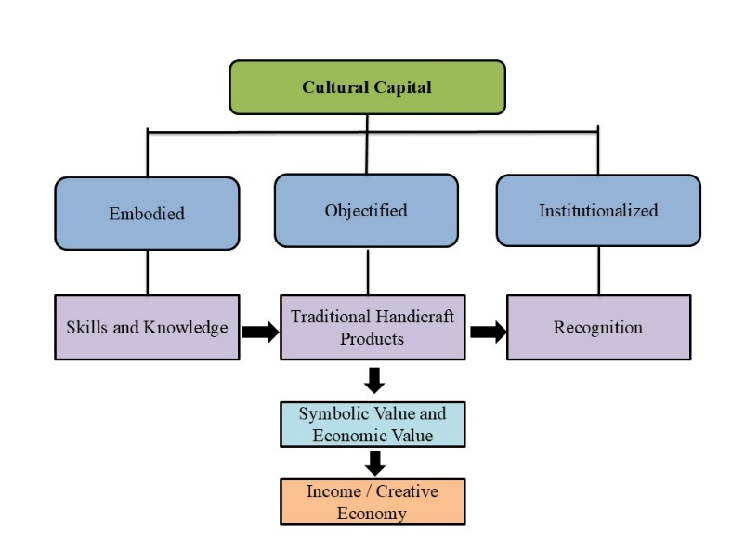
Figure 1: Framework of Cultural Capital in Traditional Handicraft Production in Sabah

Figure 1 shows the three forms of cultural capital identified by Bourdieu, namely embodied, objectified, and institutionalized cultural capital. Embodied cultural capital encompasses the skills and knowledge required for producing traditional handicrafts, including bamboo weaving, bead embroidery, and wood carving. These skills are transformed into tangible handicraft products, representing objectified cultural capital that embodies both symbolic and economic value. Furthermore, formal recognition through certifications, awards, and artisan status constitutes institutionalized cultural capital, which enhances the social and economic standing of craft producers within the community and the broader market.

Heritage Commercialization and the Creative Economy

The development of the creative economy and cultural globalization has accelerated the commercialization of cultural heritage and its transformation into economic assets and marketable products (Throsby, 2010). Traditional handicrafts are now positioned as high-value products within tourism markets and cultural industries. However, academic debates suggest that commercialization is often associated with the risk of losing cultural authenticity (Cohen & Cohen, 2012; Shepherd, 2015).

Commercialization can contribute to the continuity of cultural heritage provided that local communities maintain control over production and marketing processes (Richards, 2018). Throsby (2010) further argues that cultural goods embody two interrelated forms of value, namely economic value and cultural value. Therefore, sustainable management should balance both dimensions in order to ensure long-term viability. Community participation in cultural heritage management is a crucial element in safeguarding the continuity and symbolic integrity of heritage resources (Suhaimi, Ariffin, Ahmad, Ibrahim, Pauzi, Ghazalli, & Yusof, 2023). Consequently, the central issue is not whether commercialization takes place, but rather how the process is planned, managed, and regulated.

Cultural Sustainability and Community Based Management

Cultural sustainability refers to the ability of a community to preserve and transmit its cultural heritage across generations while adapting to social change (Soini & Birkeland, 2014). Blake (2008) argues that intangible cultural heritage cannot be separated from the active participation of communities, as cultural transmission occurs through living practices and ongoing processes of knowledge transfer within society. Similarly, Smith (2006) emphasizes that heritage is a social process that continuously evolves through community interpretations and lived experiences. Traditional handicrafts are not merely economic activities but also reflect the continuity of cultural heritage amidst contemporary transformations (Sait, Mersat, & Kiong, 2017).

A cultural sustainability approach requires a balance between innovation and the preservation of meaning. While adaptation and innovation are necessary for the continued relevance of cultural practices, they must not compromise the symbolic significance and cultural values embedded within them. Without effective management, market-driven adaptations may alter symbolic structures and gradually detach cultural products from their original meanings and functions. Consequently, community-based management plays a crucial role in ensuring that traditional handicrafts remain culturally meaningful while adapting to changing social and economic conditions.

III. METHODOLOGY

This study adopts a qualitative research approach to explore the relationship between cultural capital, handicraft production, and commercialization among the Murut Tahol community in Keningau, Nabawan, and Tenom, Sabah. Informants consisted of traditional artisans, craft entrepreneurs, and customary leaders selected through purposive sampling based on their extensive experience and active involvement in the production and management of traditional handicrafts. Data were collected through semi-structured interviews, field observations, and document analysis to examine how skills, symbols, and cultural identities that constitute forms of cultural capital are embedded in handicraft production and adapted within contemporary market environments.

The data were analysed using thematic analysis following Braun and Clarke (2006), focusing on the interconnected processes of cultural capital formation, handicraft production, and commercialization. This analytical approach facilitated an in-depth understanding of how symbolic values and ethnic identity are maintained while traditional handicrafts participate in economic activities. To ensure the credibility and reliability of the findings, data triangulation was employed by comparing evidence obtained from interviews, observations, and documentary sources. This process strengthened the validity of the interpretations and provided a comprehensive understanding of the relationship between cultural capital and the sustainability of Murut Tahol handicrafts.

Figure 2: Relationship between Cultural Capital, Handicraft Production, Commercialization, and Sustainability

Figure 2 illustrates a conceptual framework that positions Murut Tahol handicrafts as a manifestation of cultural capital, encompassing traditional knowledge, intergenerational skills, symbolism, and social meanings embedded within the community’s social structure. Drawing upon Bourdieu’s (1986) theory of cultural capital, craft skills and practices constitute embodied cultural capital, while handicraft products represent objectified cultural capital that embodies the cultural identity, values, and lived experiences of the Murut Tahol community.

Through commercialization, cultural capital is converted into economic capital, reflecting Throsby’s (2010) argument that cultural goods simultaneously possess cultural and economic value. Nevertheless, cultural sustainability depends on maintaining the continuity of cultural meanings and social functions across generations despite market transformations (Soini & Birkeland, 2014). Consequently, the sustainable management of Murut Tahol handicrafts requires a community-based approach that balances economic objectives with the preservation of cultural symbolism, identity, and integrity. Such an approach ensures that commercialization strengthens rather than diminishes the cultural significance of handicrafts, allowing them to remain living expressions of cultural heritage rather than mere market commodities.

Ultimately, this study demonstrates that cultural capital and economic development need not be mutually exclusive. When supported by effective traditional arts management and strong community participation, commercialization can become a mechanism for cultural strengthening rather than cultural erosion, ensuring the continued vitality of Murut Tahol handicrafts as living expressions of indigenous cultural heritage.

IV. RESEARCH FINDINGS

This study demonstrates that traditional arts management is not merely a process of cultural organization or administration, but also functions as a mechanism for the transformation of cultural capital within a contemporary economic context. Consistent with Bourdieu’s (1986) framework, the findings indicate that embodied cultural capital, in the form of traditional skills and knowledge, can be converted into economic capital through strategically managed commercialization processes. However, this transformation is not a one-way process; rather, it involves continuous negotiation between cultural values and market demands. In this regard, community-based management plays a crucial role in ensuring that adaptation to market conditions does not erode the symbolic meanings and cultural identity embedded in traditional handicrafts.

Furthermore, the findings support Throsby’s (2010) argument that cultural products possess two fundamental forms of value, namely economic value and symbolic value, both of which must be balanced. These findings differ from some earlier studies that view commercialization primarily as a threat to cultural authenticity. Instead, the study suggests that community-based management offers a new perspective for understanding the relationship between commercialization and cultural sustainability. Overemphasis on either economic or symbolic value may lead to imbalance, resulting in either excessive commodification or weakened economic competitiveness. Therefore, the effectiveness of traditional arts management within the Murut Tahol context lies in its ability to integrate both dimensions through flexible strategies grounded in local cultural values.

From the perspective of cultural sustainability, this study emphasizes that active community participation is a critical factor in ensuring the continuity of cultural heritage. Without community control, commercialization risks transforming handicrafts from living cultural practices into commodities detached from their original social and cultural contexts. Consequently, a community-based management approach is not only relevant but also essential for achieving genuine cultural sustainability.

The findings focus on the role of traditional arts management in linking cultural capital, commercialization, and the sustainability of Murut Tahol handicrafts. The analysis generated three interrelated themes: traditional arts management as a mechanism for preserving cultural capital, management strategies in the commercialization of traditional handicrafts, and community-based management as the foundation of cultural sustainability

Traditional Murut Tahol Handicrafts as a Manifestation of Cultural Capital

Traditional handicrafts among the Murut Tahol ethnic community reflect a rich form of cultural capital encompassing identity, belief systems, and the social structure of the community. Among the most prominent forms of handicrafts are traditional costume ornaments and bead embroidery, which are produced with meticulous craftsmanship and imbued with specific symbolic meanings. The uniqueness of Murut Tahol traditional attire can be observed through the use of beads, embroidery, and accessories that carry distinct meanings within customary and ceremonial contexts. Traditional Murut Tahol attire also plays an important role in customary rituals, cultural celebrations, and the expression of social status within the community. The incorporation of beads, embroidery, and accessories in traditional clothing demonstrates the role of handicrafts as a medium for expressing identity and social status. In this context, traditional handicrafts can be understood as a manifestation of objectified cultural capital, whereby cultural values are materialized in tangible forms. Table 1 presents selected examples of Murut Tahol bead embroidery handicrafts together with their descriptions.

Table 1: Murut Tahol Bead Embroidery Handicrafts and Their Descriptions
Bead Embroidery Handicrafts | Description
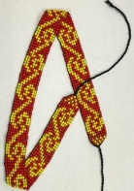  Salupai  Source: Author's fieldwork (2024) | Salupai is a traditional headdress crafted from fine beads and worn as an integral component of Murut Tahol ceremonial attire. Its design features repetitive Pinansiit motifs and the use of vibrant colours, particularly red and yellow, which symbolize the cultural identity, aesthetic values, and artistic traditions of the Murut Tahol community. Beyond its decorative function, the salupai serves as a cultural symbol that reflects the community’s heritage, social identity, and continuity of traditional craftsmanship.
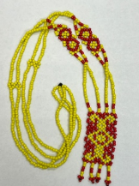  Sisihot  Source: Author's fieldwork (2024) | Sisihot is a traditional necklace made from coloured beads and worn as an accessory to traditional attire. Its design features intricate bead-weaving patterns and vibrant colours, particularly yellow and red, symbolizing beauty and cultural identity.
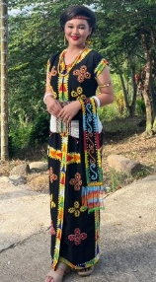  Pinongkoloh  Source: Author's fieldwork (2024) | Pinongkoloh is a traditional garment worn by Murut women, made from black fabric and decorated with brightly coloured bead embroidery. Its design features neatly arranged traditional motifs that symbolize cultural identity, beauty, and the fine craftsmanship of the Murut Tahol community.

Table 1 illustrates selected bead embroidery handicrafts of the Murut Tahol community, namely salupai, sisihot, and pinongkoloh, which constitute integral components of traditional attire. Beyond their decorative function, these handicrafts serve as cultural markers that communicate identity, social values, and ethnic heritage through the use of traditional motifs and bead colours. The dominant colours which are red, yellow, white, green, and black are characteristic of traditional Murut Tahol beadwork and embody the community’s cultural symbolism, aesthetic values, and artistic traditions.

Furthermore, woven handicrafts crafted from natural materials such as rattan, bamboo, and wood reflect the close relationship between the Murut Tahol community and their natural environment. The findings reveal that woven products originally designed for everyday use have gradually been transformed into heritage products through processes of cultural production, adaptation, and commercialization. This transformation demonstrates how traditional crafts continue to evolve while maintaining their cultural significance. Table 2 presents selected examples of bamboo weaving handicrafts produced by the Murut.

Table 2: Murut Tahol Bamboo Weaving Handicrafts and Their Descriptions
Bamboo Weaving Handicrafts | Description
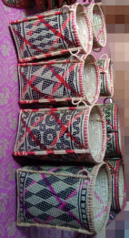  Buyuung mawatik  Source: Author's fieldwork (2024) | Buyuung Mawatik is a traditional bamboo-woven handicraft used as a storage container for personal belongings and daily necessities. Its cylindrical form, sturdy construction, geometric weaving patterns, and traditional colours such as red and black reflect the craftsmanship, cultural identity, and traditional knowledge of the Murut Tahol community.
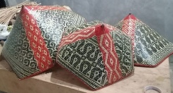  Silaung  Source: Author's fieldwork (2024) | Silaung is a traditional bamboo woven hat used during rice cultivation to protect the wearer from the sun and rain. Its colourful geometric patterns reflect the cultural identity and weaving craftsmanship of the Murut Tahol community.
  Lalandau  Source: Author's fieldwork (2024) | Lalandau is a traditional Murut Tahol headdress made from woven bamboo and decorated with tuwou bird feathers. Its symmetrical design, geometric weaving patterns, and traditional colours such as red and black symbolize cultural identity, status, and community pride, and it is commonly used in customary ceremonies and traditional performances.

Table 2 illustrates several examples of bamboo weaving handicrafts among the Murut Tahol community, namely buyuung mawatik, silaung, and lalandau. These handicrafts perform diverse functions, ranging from storage containers and protective agricultural equipment to ceremonial head ornaments used in customary rituals and cultural performances. The sophisticated weaving techniques, geometric motifs, and traditional colour combinations such as red and black highlight the community’s expertise in bamboo craftsmanship and reflect their cultural aesthetics and identity.

Furthermore, woodcrafts produced by the Murut Tahol community demonstrate the continuity of indigenous knowledge and traditional craftsmanship that have been preserved through intergenerational transmission. These cultural objects embody not only technical skills but also symbolic meanings, social values, and cultural memories embedded within the community’s way of life. Consequently, traditional handicrafts should be understood not merely as material artifacts but as components of a broader indigenous knowledge system that plays a significant role in sustaining cultural heritage and reinforcing cultural continuity within Murut Tahol society.

Table 3: Murut Tahol Woodcarving Handicrafts and Their Descriptions
Woodcarving Handicrafts | Description
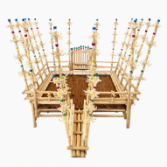  Sasangian  Source: Author's fieldwork (2024) | Sasangian is a traditional ceremonial structure made of wood and bamboo, featuring a rectangular open design with benches and a central table used for customary gatherings, particularly wedding ceremonies. Its symmetrical construction, traditional carvings, and symbolic colours such as red, yellow, blue, and white reflect the cultural identity and artistic traditions of the Murut Tahol community.
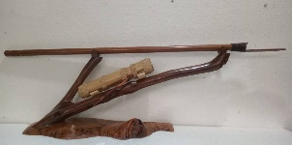  Sapuk, luva am kabon Sculpture  Source: Author's fieldwork (2024) | This sculpture depicts sapuk, luva am kabon (the blowpipe, blowpipe darts, and dart container), carved from wood using traditional craftsmanship. It highlights the importance of the blowpipe as a hunting tool and symbolizes the cultural heritage, indigenous knowledge, and traditional identity of the Murut Tahol community.
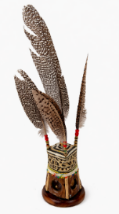  Lalandau Sculpture  Source: Author's fieldwork (2024) | This craft is a carved wooden representation of the Lalandau, a traditional Murut Tahol headdress, decorated with a carved gong motif at its base. It symbolizes cultural identity, aesthetic values, and the traditional artistic heritage of the Murut Tahol community.

Table 3 illustrates selected examples of woodcarving handicrafts produced by Murut Tahol artisans, namely the sasangian, sapuk, luva am kabon sculpture, and lalandau sculpture, which constitute significant components of the community’s cultural heritage. These crafts perform diverse functions, ranging from ceremonial and ritual purposes to representations of traditional hunting practices and cultural adornment, while showcasing the technical expertise and artistic sophistication of Murut Tahol woodcarving traditions.

The incorporation of traditional motifs, balanced compositions, and decorative features such as symbolic colours and bird feathers reflects the community’s cultural identity, aesthetic principles, and indigenous worldview. Beyond their practical and decorative functions, these cultural objects serve as tangible expressions of heritage, embodying collective memory, traditional knowledge, and cultural values that have been preserved and transmitted through generations. As manifestations of objectified cultural capital, these handicrafts contribute to the continuity and sustainability of Murut Tahol cultural heritage in contemporary society.

Traditional Arts Management as a Mechanism for Preserving Cultural Capital

Traditional arts management within the Murut Tahol community serves as a vital mechanism for preserving and strengthening cultural capital through the production, transmission, and safeguarding of traditional handicrafts. This process is sustained through the informal transfer of craft-making skills within family networks, the regulation of traditional motifs and designs, and the active involvement of customary leaders in determining the cultural appropriateness of symbols and representations used in handicraft production. Such practices not only ensure aesthetic and symbolic authenticity but also maintain the social meanings embedded within customary institutions and collective cultural identity. As a result, traditional arts management functions as a continuous mechanism for the intergenerational transmission of traditional knowledge, cultural values, and symbolic meanings.

The findings further indicate that traditional knowledge is increasingly vulnerable to erosion due to social change, migration, and the declining engagement of younger generations in traditional arts and cultural practices. Drawing upon Bourdieu’s (1986) theory of cultural capital, traditional arts management can be understood as a mechanism for preserving embodied cultural capital through the transmission of skills, knowledge, and cultural practices embedded within everyday community life. Simultaneously, it contributes to the preservation of objectified cultural capital by safeguarding the material forms, motifs, and symbolic meanings represented in traditional handicrafts. Consequently, traditional arts management extends beyond administrative coordination and cultural programming; it constitutes a strategic cultural process that sustains cultural identity, collective memory, and cultural integrity. Through this process, Murut Tahol handicrafts continue to function as living expressions of cultural heritage, reinforcing both cultural continuity and community resilience in the face of contemporary social and economic transformations.

Management Strategies in the Commercialization of Traditional Handicrafts

The commercialization of Murut Tahol handicrafts is driven by a range of management strategies that facilitate the integration of cultural heritage into contemporary market systems. Participation in cultural festivals, collaboration with governmental and cultural institutions, the adoption of digital marketing platforms, and the adaptation of handicraft products to evolving consumer preferences have enabled the cultural values embedded within traditional knowledge and symbolic representations to be transformed into economic value. Drawing upon Bourdieu’s theory of cultural capital, this process may be understood as the conversion of cultural capital into economic capital through institutional and market-based mechanisms. In this regard, the skills and expertise of artisans constitute embodied cultural capital, while handicraft products themselves represent objectified cultural capital that can be mobilized for economic gain.

Nevertheless, the commercialization process is characterized by continuous negotiation between cultural preservation and market demands. Consistent with Throsby’s (2010) assertion that cultural goods embody both cultural and economic value, market-oriented strategies must be carefully managed to prevent the reduction of handicrafts to purely commercial commodities. Within the Murut Tahol context, successful commercialization is evaluated not solely in terms of financial outcomes but also through the community’s capacity to maintain control over the meanings, functions, and symbolic significance of traditional crafts. Consequently, culturally informed commercialization can serve as a mechanism for economic development while safeguarding cultural integrity. Conversely, commercialization that prioritizes market interests at the expense of cultural values risks transforming handicrafts from living cultural practices into commodified products disconnected from their original social and cultural meanings. Therefore, sustainable commercialization requires management strategies that effectively balance economic objectives with the preservation of cultural identity, symbolism, and heritage values.

Community Based Management as the Foundation of Cultural Sustainability

The sustainability of Murut Tahol handicrafts is closely linked to the extent of active community participation in management processes, including production practices, motif selection, symbolic representation, and marketing strategies. Community-based management enables customary leaders, artisans, and community members to maintain cultural authority over the forms, meanings, and functions of traditional handicrafts. Such an approach ensures that adaptations to market demands remain aligned with customary norms, cultural values, and collective identity.

These findings are consistent with the principles of community based cultural governance, which emphasize the role of local communities as the primary custodians, interpreters, and decision-makers in the management of their cultural heritage. Within this framework, cultural sustainability should not be understood solely as a product of economic growth but rather as a process that depends upon the community’s ability to regulate commercialization in ways that safeguard cultural meanings and symbolic integrity. Through community control over production and marketing decisions, commercialization can serve as a mechanism for cultural strengthening, supporting both economic resilience and cultural continuity.

In contrast, market driven production that operates without adequate community oversight may prioritize commercial interests at the expense of cultural significance. Such conditions risk transforming traditional handicrafts from living cultural practices into commodified products detached from their original social and cultural contexts. Consequently, community-based management functions as a critical mechanism that bridges economic objectives and cultural integrity, ensuring that Murut Tahol handicrafts remain sustainable as both economic resources and living expressions of cultural heritage.

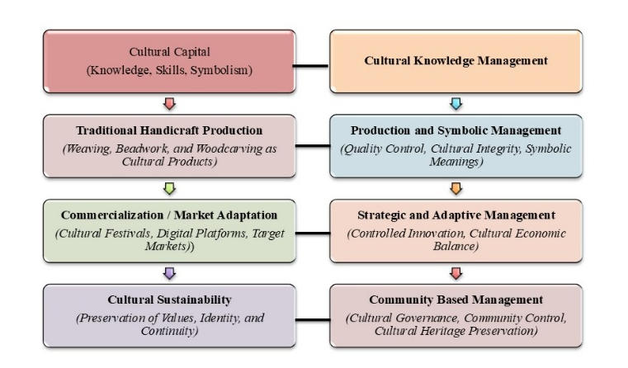
Figure 3: Traditional Arts Management Framework for Cultural Capital Management among the Murut Tahol Community

Overall, the three themes identified in this study demonstrate the interrelated relationship between cultural capital, handicraft production, commercialization, and cultural sustainability. This relationship is summarized in Figure 3, which illustrates the role of management as a connecting mechanism throughout the entire process. Figure 3 shows that cultural capital, encompassing traditional knowledge, skills, and symbolism, is managed through cultural knowledge management before being translated into the production of traditional handicrafts. Subsequently, the production process is regulated through production and symbolic management to ensure that cultural integrity and symbolic meanings are preserved throughout the creation of cultural products. During the commercialization phase, strategic and adaptive management plays a crucial role in aligning handicraft products with target markets while maintaining their cultural values. This approach enables controlled innovation and adaptation without compromising the authenticity and symbolic significance of the crafts.

Furthermore, cultural sustainability is achieved through community-based management, which emphasizes cultural governance, community control, and the preservation of cultural heritage. This approach ensures that cultural resources remain under community stewardship and that economic activities continue to support the transmission of cultural values and identities across generations. Findings indicate that traditional arts management functions as an intermediary mechanism that regulates the balance between economic transformation and cultural preservation. Consequently, the sustainability of Murut Tahol handicrafts can only be achieved when commercialization processes are guided by cultural values and remain under the control of the community itself. Through this balance, traditional handicrafts are able to function not only as economic resources but also as living expressions of cultural heritage that sustain cultural identity, symbolic meanings, and community continuity.

V. DISCUSSION

Balancing Commercialization And Cultural Sustainability

Traditional arts management within the Murut Tahol community serves as a strategic mechanism that connects the preservation of cultural capital with economic transformation. The transmission of traditional skills, the regulation of traditional motifs, and the authority exercised by customary leaders contribute to the continuity of both embodied cultural capital and objectified cultural capital, consistent with Bourdieu’s (1986) theoretical framework. In this context, handicrafts are not merely material products but also cultural mediums that sustain collective identity, cultural values, and the social structure of the community.

At the same time, commercialization through management strategies such as participation in cultural festivals, collaboration with cultural institutions, and digital marketing initiatives enables cultural values to be translated into economic value. This process reflects Throsby’s (2010) argument that cultural goods possess dual dimensions of value, namely cultural value and economic value. However, the findings reveal the challenges involved in balancing cultural values with market demands. Cultural sustainability can only be achieved when communities retain control over the meanings, symbolic significance, and social functions of their handicrafts. Therefore, commercialization within the Murut Tahol context should not be regarded as an inherent threat to cultural heritage. Rather, it is a conditional process that requires a careful balance between the preservation of cultural identity and adaptation to contemporary economic realities. Through community-based management, commercialization can function as a mechanism for cultural strengthening while simultaneously supporting economic sustainability.

VI. CONCLUSION

Traditional arts management within the Murut Tahol community serves as a crucial mechanism for strengthening cultural capital and ensuring the sustainability of traditional handicrafts in Sabah. The findings demonstrate that the transmission of traditional skills, the regulation of cultural motifs and symbols, and the active involvement of community members contribute significantly to the preservation of both embodied and objectified cultural capital, consistent with Bourdieu’s theoretical framework. At the same time, carefully managed commercialization strategies enable the transformation of cultural value into economic value without compromising the integrity of cultural heritage. The study further reveals that the sustainability of Murut Tahol handicrafts depends not only on market performance but also on the community’s capacity to retain authority over the interpretation, production, and management of its cultural resources. Through community-based cultural governance, economic adaptation and cultural preservation can be balanced effectively, ensuring that traditional handicrafts remain relevant, competitive, and meaningful within contemporary society. Therefore, traditional arts management should be understood not merely as an administrative process but as a strategic cultural mechanism that mediates the relationship between cultural capital, commercialization, and cultural sustainability, allowing Murut Tahol handicrafts to continue as living expressions of indigenous identity, heritage, and collective memory. The findings also provide practical implications for policymakers and cultural agencies in developing community-based strategies for safeguarding indigenous cultural heritage while enhancing economic opportunities for local artisans.

VII. ACKNOWLEDGMENT

The authors gratefully acknowledge the financial support provided by the Centre for Research and Innovation, Universiti Malaysia Sabah (UMS) through the Graduate Research Assistance Grant (GUG0684-1/2024), which made this research possible.

VIII. REFERENCES

- Bennett, T., Savage, M., Silva, E. B., Warde, A., Gayo-Cal, M., & Wright, D. (2009). Culture, class, distinction. Routledge.
- Blake, J. (2008). UNESCO's 2003 Convention on Intangible Cultural Heritage: The implications of community involvement in “safeguarding”. In L. Smith & N. Akagawa (Eds.), Intangible heritage (pp. 45–73). Routledge.
- Bourdieu, P. (1986). The forms of capital. In J. G. Richardson (Ed.), Handbook of theory and research for the sociology of education (pp. 241–258). Greenwood Press.
- Braun, V., & Clarke, V. (2006). Using thematic analysis in psychology. Qualitative Research in Psychology, 3(2), 77–101. https://doi.org/10.1191/1478088706qp063oa
- Cohen, E., & Cohen, S. A. (2012). Authentication: Hot and cool. Annals of Tourism Research, 39(3), 1295–1314. https://doi.org/10.1016/j.annals.2012.03.004
- Ibrahim, I. H., & Ling, J. W. K. (2005). Warisan seni etnik Sabah: Prosiding Seminar Warisan Seni Etnik Sabah 2002. Pusat Penataran Ilmu dan Bahasa, Universiti Malaysia Sabah.
- Kindoyop, S., & Othman, N. A. (2023). Pengurusan kraf tangan tradisi etnik Dusun Tindal di Sabah. Jurnal Gendang Alam, 13(2). https://doi.org/10.51200/ga.v13i2.4734
- Kindoyop, S., Jusilin, H., & Tugang, N. (2019). Kearifan dan konsep rekaan kraf anyaman warisan Dusun Tindal di Sabah. Jurnal Gendang Alam, 9, 1–16.
- Richards, G. (2018). Cultural tourism: A review of recent research and trends. Journal of Hospitality and Tourism Management, 36, 12–21. https://doi.org/10.1016/j.jhtm.2018.03.006
- Roddin, R., Yusof, Y., Awang, H., & Warman, S. (2017). Nilai transformasi komuniti Mah Meri dalam pelancongan peribumi. Journal of Global Business and Social Entrepreneurship (GBSE), 3(6), 47–57.
- Sait, E. K. L., Mersat, N. I., & Kiong, W. S. (2017). Traditional handicrafts and the use of natural resources among the Iban of Balai Ringin, Serian. Journal of Borneo-Kalimantan, 3(2). https://doi.org/10.33736/jbk.625.2017
- Smith, L. (2006). Uses of heritage. Routledge.
- Soini, K., & Birkeland, I. (2014). Exploring the scientific discourse on cultural sustainability. Geoforum, 51, 213– 223. https://doi.org/10.1016/j.geoforum.2013.12.001
- Suhaimi, S. M. S. S. M., Ariffin, W. N. J. W., Ahmad, M. F., Ibrahim, M. A., Pauzi, H. M., Ghazalli, F. S., & Yusof, N. M. (2023). Digitalization of handicraft entrepreneurship in Malaysia. International Journal of Academic Research in Business and Social Sciences, 13(5), 58–68. https://doi.org/10.6007/IJARBSS/v13- i5/16997
- Throsby, D. (2010). The economics of cultural policy. Cambridge University Press.
- Yamashita, S., & Eades, J. S. (Eds.). (2003). Globalization in Southeast Asia: Local, national, and transnational perspectives (Vol. 1). Berghahn Books.

INFORMANTS
1. Agubat @ Elizabeth Andaun (70 years old), Kampung Biah, Sabah. Traditional costume custodian and expert bead embroiderer (Interview, 24 June 2024).
2. Koyok Binti Tamaing (74 years old), Kampung Murni D, Nabawan, Sabah. Traditional costume custodian and embroiderer (Interview, 5 March 2023).
3. Suriah @ Mainah Ampasok (65 years old), Kampung Biah, Keningau, Sabah. Bead embroiderer and pinongkoloh costume entrepreneur (Interview, 25 May 2024).
4. Linih Barah (35 years old), Kampung Tinura, Tenom, Sabah. Kelarai weaver and handicraft entrepreneur (Interview, 14 October 2025).
5. Jimmy Robert (53 years old), Kampung Pansailon, Nabawan, Sabah. Traditional woodcraft carver and artisan (Interview, 11 November 2025).

