Quantitative Risk Assessment Models for Extinguishing and Controlling Hydrogen Fires and Explosions Across the Hydrogen Energy Cycle

Abstract
Hydrogen is widely regarded as a clean energy carrier for decarbonising mobility and stationary power, yet its wide flammability range, low ignition energy and high flame speed make fire and explosion the governing hazards across the supply chain. This study develops and applies a quantitative risk assessment (QRA) framework to estimate, evaluate and control fire and explosion risks for seven representative objects spanning the hydrogen energy cycle: a solar hydrogen production plant, a liquid-hydrogen (LH₂) depot, a fuelling station, an on-board vehicle tank, a fuel-cell combined heat and power (CHP) unit, a road tanker and a gaseous-hydrogen (GH₂) pipeline. Accident scenarios were identified using HAZOP and FMEA. Event frequencies were derived from a combined fault-tree and event-tree analysis (FTA/ETA) with lognormal basic-event data propagated through 10,000 Monte-Carlo trials, while road-transport and pipeline frequencies were obtained from historical accident statistics. Physical consequences—dispersion, jet fire, pool fire, fireball, flash fire and vapour-cloud explosion—were simulated with PHAST Professional v6.4 (DNV) and converted to fatality levels using thermal-radiation and overpressure probit relations. Individual and societal (F-N) risks were benchmarked against the ALARP/ALARA acceptance criteria and against an equivalent liquefied-petroleum-gas (LPG) study. Continuous releases dominated loss of containment (~94%), with tank overpressure as the leading initiator (~50%); fires accounted for ~60% of outcomes and explosions ~5%. The overall societal risk of the hydrogen cycle was 8.5 × 10⁻³/year, dominated by the fuelling station (39%) and the on-board vehicle tank (35%). Although individual risks for hydrogen storage exceeded those of LPG, the maximum effect distances and societal risks were consistently smaller, indicating that hydrogen poses a lower public risk than LPG of comparable tank size. The framework identifies critical weak points and prioritised risk-reduction measures for the safe deployment of hydrogen infrastructure.
Keywords: Hydrogen safety; Quantitative risk assessment (QRA); Fire and explosion; PHAST consequence modelling; Fault-tree and event-tree analysis; ALARP criteria; Liquefied petroleum gas (LPG) comparison

1. Introduction
Hydrogen is increasingly viewed as a cornerstone of a low-carbon energy system because it can be produced from renewable resources, stored, and reconverted to electricity or used directly as a fuel without emitting greenhouse gases at the point of use. Its high gravimetric energy density and versatility make it attractive for both mobile and stationary applications. Realising a large-scale “hydrogen economy”, however, requires an integrated infrastructure of production, transportation, storage, refuelling and end-use, every link of which introduces potential failure points where hydrogen may be released to the environment.
The safe handling of hydrogen differs fundamentally from that of conventional fuels because of its distinctive physical behaviour: high buoyancy and diffusivity promote rapid dispersion, but a very wide flammability range (4–75% by volume), a low minimum ignition energy (~0.02 mJ) and a high laminar flame speed make ignition easy and combustion rapid. Consequently, fire and explosion are the dominant flammability hazards in hydrogen systems. When hydrogen has historically been handled within the chemical and process industries by trained personnel, the migration of hydrogen into the public domain—where untrained users interact with the fuel at refuelling stations, in vehicles and in domestic CHP units—raises new and largely unquantified safety questions.
This work addresses that gap by establishing the safety-technological conditions for the public use of hydrogen as an energy carrier. The objective is to quantify the fire and explosion risk associated with hydrogen across its energy cycle, to identify the weak points that contribute most to that risk, and to recommend prioritised risk-reduction measures. The risks are further benchmarked against a comparable LPG system so that hydrogen can be judged relative to an established, publicly accepted technology.

1.1 Scope and contribution
Quantitative risk assessment (QRA) is adopted as the system-analytic method. The contributions of this paper are: (i) a unified QRA of seven study objects that together represent the complete hydrogen energy cycle, rather than a single installation studied in isolation; (ii) an integrated FTA/ETA frequency model with Monte-Carlo uncertainty propagation coupled to PHAST consequence simulation; (iii) a consistent evaluation of both individual and societal risk against the ALARP/ALARA criteria; and (iv) a like-for-like comparison with LPG that places hydrogen risk in a familiar regulatory context. The remainder of the paper is organised as follows. Section 2 reviews related work and the research gap. Section 3 details the QRA methodology and governing models. Section 4 describes the study objects and simulation setup. Section 5 presents and discusses the frequency, consequence and risk results, including the LPG comparison. Sections 6 and 7 give the conclusions and future scope.

2. Literature Review
Research on hydrogen safety has expanded alongside interest in the hydrogen economy, drawing on the mature body of chemical-process risk-analysis practice consolidated by the AIChE/CCPS guideline series (AIChE/CCPS, 2000). These guidelines codify hazard identification, frequency estimation through fault-tree and event-tree analysis, and consequence modelling for vapour-cloud explosions, flash fires and BLEVEs, and they form the methodological backbone for most subsequent hydrogen QRA studies.
Alcock et al. (2001) compiled the existing safety data on hydrogen and benchmarked it against comparable fuels, establishing that hydrogen's wide flammability range and low ignition energy are partly offset by its rapid buoyant dispersion, which limits the persistence of flammable clouds in open air. Cadwallader and Herring (1999) reviewed the safety issues specific to hydrogen as a vehicle fuel, highlighting embrittlement, permeation and the difficulty of detecting near-invisible hydrogen flames. Cancelli et al. examined release from cryogenic tanks, underlining the additional hazards introduced by liquid hydrogen, including loss of vacuum, cold embrittlement and two-phase discharge.
On the consequence-modelling side, the PHAST technical framework developed by DNV (2002) provides validated source, dispersion, fire and explosion sub-models and has become a de-facto standard for industrial consequence analysis. Vilchez, Carol and Casal (1996) demonstrated the use of major-hazard databases to construct event trees for flammable materials, an approach mirrored in the present study. For societal-risk benchmarking, Ball and Floyd's work on societal risk and the Dutch risk-policy framework (Bottelberghs) supply the F-N curve formalism and the ALARP/ALARA acceptance limits used here.
Although these studies individually address hazard data, cryogenic release, consequence modelling or acceptance criteria, most concentrate on a single installation type—typically a refuelling station or a storage vessel. Comparative QRA studies that span the entire hydrogen cycle and that explicitly benchmark hydrogen against an established public fuel such as LPG remain scarce. The present work addresses this gap by applying a single, internally consistent QRA framework to seven objects covering production, storage, distribution, transport and end-use, and by comparing the resulting individual and societal risks with an equivalent LPG study (Table 6). This breadth allows the relative contribution of each link in the hydrogen cycle to be ranked and the dominant risk drivers to be identified across the system rather than within one component.

3. Methodology
The study follows the five-stage QRA process: hazard identification, frequency estimation, consequence modelling, risk estimation and risk evaluation. Figure 1 summarises the workflow, in which probabilistic frequency analysis and physical consequence analysis are developed in parallel and combined to produce individual and societal risk measures that are finally evaluated against acceptance criteria.
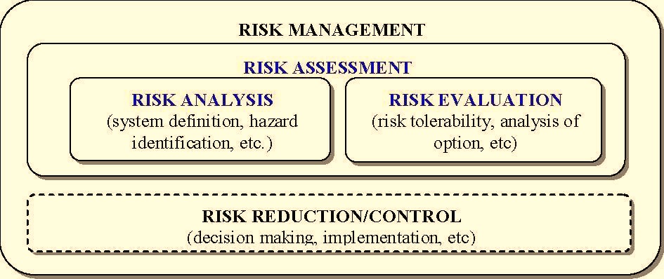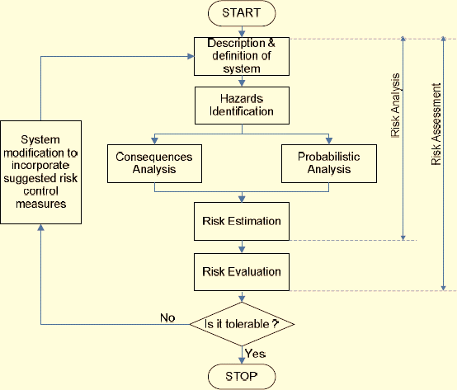
Fig. 1. Quantitative risk assessment (QRA) framework integrating hazard identification, frequency estimation (FTA/ETA), consequence modelling (PHAST) and risk evaluation against acceptance criteria.

3.1 Hazard identification
Hazards were identified using a Hazard and Operability (HAZOP) study supported by Failure Modes and Effects Analysis (FMEA) and a Fire & Explosion Index screening. Guide words (no flow, more flow, reverse flow, more pressure, less temperature, etc.) were applied node-by-node to each study object to enumerate deviations, causes, consequences and existing safeguards. The screening confined the detailed QRA to the items holding the largest hydrogen inventory for the longest time—storage vessels, on-board tanks, tankers and pipelines—since these dominate the risk.

3.2 Frequency estimation: fault-tree and event-tree analysis
Loss-of-containment (LOC) events were grouped into two top events, instantaneous release (catastrophic tank rupture releasing the full inventory) and continuous release (leak or line rupture). For the four stationary objects (production plant, depot, fuelling station and CHP plant), top-event frequencies were synthesised from component failure-rate data using fault-tree analysis (FTA). Basic-event failure rates were treated as lognormally distributed and propagated through 10,000 Monte-Carlo trials, so that each top-event frequency is reported as a mean together with the 5th, 50th and 95th percentiles and the 95% uncertainty factor K₉₅.
For the on-board vehicle tank and the road tanker, release frequencies were obtained from historical road-traffic accident rates r combined with annual travel distance and conditional probabilities of spill and ignition, following Eq. (1):
F_{rel} = r × L_{a} × P_{spill} × P_{ign} (1)
where F_{rel} is the expected release frequency, L_{a} the annual distance travelled, and P_{spill} and P_{ign} the conditional probabilities of spill and ignition. Pipeline failure frequencies were taken from European gas-pipeline base-failure data, disaggregated by cause (external interference, corrosion, construction defect, ground movement) and by hole size, and scaled by reduction factors appropriate to hydrogen service.
The accident-outcome frequencies (early explosion, fireball, pool fire, jet fire, flash fire, late explosion, or no effect) were then obtained by multiplying each top-event frequency by the conditional branch probabilities of the relevant event tree. Separate event trees were used for liquid- and gaseous-hydrogen releases (Figure 2) to reflect their different ignition and phase behaviour.
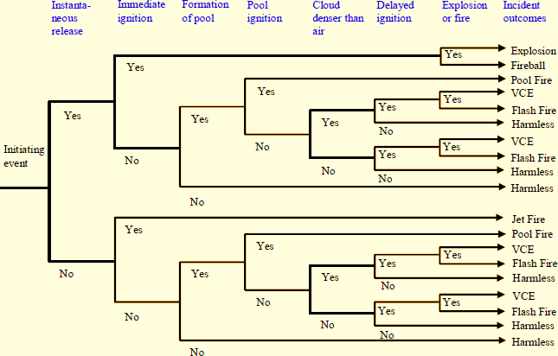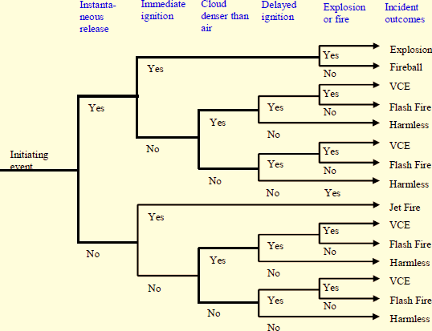
Fig. 2. Event-tree diagrams mapping continuous and instantaneous releases of liquid and gaseous hydrogen to fire and explosion outcomes with their conditional probabilities.

3.3 Consequence modelling
Physical consequences were simulated with PHAST Professional v6.4 (DNV). Source terms for choked and two-phase discharge were computed from the storage pressure P_{v}, aperture area A and discharge coefficient C_{D}. For an idealised gas release the mass flow rate follows Eq. (2):
Q = C_{D}A P_{v} √( γ M_{w} / R T × (2/(γ+1))^{(γ+1)/(γ−1)} ) (2)
where Q is the release rate, γ the specific-heat ratio, M_{w} the molecular weight, R the universal gas constant and T the storage temperature. Dispersion was modelled with the Unified Dispersion Model; jet fire, pool fire, fireball, flash fire and vapour-cloud explosion were modelled with the corresponding PHAST sub-models, and explosion overpressure was estimated with a TNT-equivalence model. Thermal-radiation fatality was evaluated through a probit relation linking incident radiation q and exposure time t to lethality, while explosion fatality was assigned conservatively from peak-overpressure damage thresholds.

3.4 Risk estimation and evaluation
Individual risk and societal risk were obtained by combining consequence effect zones with outcome frequencies on a population grid of 231 inhabitants per km². For each outcome the factored area A_{f} (effect-zone area weighted by fatality level) was multiplied by frequency F and population density to give the expected number of fatalities N. The contribution of each outcome to risk is expressed as the triplet (scenario, frequency, consequence) of Eq. (3):
R = Σ F_{i} × N_{i} (3)
Individual risk was plotted as a risk-versus-distance transect, and societal risk as a frequency-number (F-N) curve obtained by ranking outcomes in order of increasing consequence and accumulating their frequencies. Both measures were evaluated against the ALARP (UK Health and Safety Executive) and ALARA (Dutch National Environmental Policy Plan) acceptance criteria proposed for hydrogen by the European Integrated Hydrogen Project (EIHP2).

4. Experimental Setup and Study Objects
Seven study objects were defined to represent the complete hydrogen energy cycle from production through transport to end-use. Each object was characterised by its storage phase (gaseous GH₂ or liquid LH₂), inventory capacity and operating conditions, and a tailored set of accident scenarios was developed for it. Table 1 summarises the objects and their principal characteristics; these inventories and the associated scenario lists are the inputs to the frequency and consequence models of Section 3.
Table 1. Hydrogen study objects representing the energy cycle and their principal characteristics.
No. | Study object | Storage | Role in cycle | Dominant hazard considered
1 | Solar H₂ production plant | GH₂ | Production | Gaseous release → jet fire / late explosion
2 | H₂ fuelling station | LH₂ | Distribution / end-use | Two-phase release → fireball / flash fire
3 | H₂ fuel-cell CHP unit | LH₂ | Stationary end-use | Domestic release → flash fire / jet fire
4 | H₂ depot (liquefaction) | LH₂ | Storage | Large LH₂ inventory → pool fire / fireball
5 | H₂ private car (on-board) | LH₂ | Mobile end-use | Collision release → jet fire / flash fire
6 | H₂ road tanker | LH₂ | Transport | Traffic accident → fireball / flash fire
7 | H₂ pipeline | GH₂ | Transport | Line rupture → jet fire / late explosion
Storage phase: GH₂ = compressed gaseous hydrogen; LH₂ = liquid (cryogenic) hydrogen.
The distinctive flammability of hydrogen relative to other fuels governs the severity of these scenarios. Table 2 lists the deflagration and detonation properties used to parameterise the consequence models, including the wide flammability and detonability ranges and low ignition energy that distinguish hydrogen from methane and propane.
Table 2. Deflagration and detonation properties of hydrogen compared with other fuels.
Property | Hydrogen | Methane | Propane | Gasoline
Flammability range (vol % in air) | 4.0–75.0 | 5.3–15.0 | 2.1–9.5 | 1.0–7.6
Detonability range (vol % in air) | 18.3–59.0 | 6.3–13.5 | 3.1–7.0 | 1.1–3.3
Minimum ignition energy (mJ) | 0.02 | 0.29 | 0.26 | 0.24
Laminar burning velocity (m/s) | 2.65–3.25 | 0.37–0.45 | 0.43–0.52 | 0.37–0.43
Auto-ignition temperature (°C) | 585 | 540 | 487 | 228–471
Values are representative literature figures used to configure the PHAST fire and explosion sub-models.

5. Results and Discussion
The QRA results are presented in the sequence frequency → consequence → risk, followed by evaluation against acceptance criteria and comparison with LPG.

5.1 Frequency estimation results
Table 3 summarises the overall hydrogen-release frequencies of the seven objects. The mean release frequency across the cycle is approximately 1.9 × 10⁻³/year (about once in 517 years). Continuous releases dominate loss of containment, accounting for roughly 94% of events, with instantaneous (catastrophic-rupture) releases contributing only about 6%. GH₂ storage exhibits lower release frequency than LH₂ storage because the cryogenic liquid introduces additional failure modes—loss of vacuum, cold embrittlement and tank under-pressure. Tank overpressure is the leading contributor to rupture (>50%), followed by external and spontaneous events; for LH₂ an additional ~30% derives from tank under-pressure.
Table 3. Overall expected hydrogen-release frequencies of the study objects (1/yr).
No. | Study object | Storage | 5% | Mean | 95% | Source
1 | Solar H₂ plant | GH₂ | 1.8E–06 | 3.6E–05 | 1.3E–04 | FTA
2 | H₂ fuelling station | LH₂ | 4.7E–05 | 7.1E–04 | 2.5E–03 | FTA
3 | H₂ fuel-cell CHP | LH₂ | 5.1E–06 | 1.4E–04 | 5.4E–04 | FTA
4 | H₂ depot | LH₂ | 5.6E–06 | 1.2E–04 | 4.6E–04 | FTA
5 | H₂ private cars | LH₂ | — | 7.1E–04 | — | Data
6 | H₂ road tanker | LH₂ | — | 6.9E–05 | — | Data
7 | H₂ pipeline | GH₂ | 7.5E–04 | 1.5E–04 | 3.9E–03 | Data
— | Overall | — | — | 1.9E–03 | — | —
FTA = fault-tree analysis with Monte-Carlo propagation; Data = historical accident/base-failure statistics.
Applying the event trees to these top-event frequencies yields the distribution of accident outcomes. Across the cycle, fire outcomes (jet fire, pool fire, fireball, flash fire) dominate at about 60% of events; explosions account for only about 5%, because hydrogen explosions require confinement and high ignition energy; the remaining ~35% of releases have no harmful effect on the population. Table 4 gives a representative outcome breakdown for the gaseous-hydrogen production plant, where jet fire (≈67%) is the dominant fire mode and late explosion contributes ~7%.
Table 4. Representative accident-outcome frequencies for the GH₂ production plant (1/yr).
Accident outcome | Conditional prob. | 5% | Mean | 95%
Early explosion | 0.008 | 1.4E–08 | 2.7E–07 | 9.8E–07
Fireball | 0.030 | 5.4E–08 | 1.1E–06 | 3.9E–06
Jet fire | 0.475 | 8.5E–07 | 1.7E–05 | 6.2E–05
Late explosion | 0.043 | 7.7E–08 | 1.5E–06 | 5.6E–06
Flash fire | 0.171 | 3.1E–07 | 6.1E–06 | 2.2E–05
No effect | 0.273 | 4.9E–07 | 9.8E–06 | 3.5E–05
Overall | 1.000 | 8.6E–06 | 3.6E–05 | 9.0E–05
Conditional probabilities are taken from the GH₂ event tree (Fig. 2).

5.2 Consequence modelling results
PHAST simulations show that the buoyant, high-momentum hydrogen jet disperses rapidly: centre-line concentration falls below the lower flammability limit within a short distance of the release point, so flammable clouds are short-lived in open air (Figure 3). Fire and explosion consequences scale with inventory—larger hydrogen mass produces larger effect zones—so the fuelling station and depot generate the most extensive thermal footprints. Figure 4 illustrates the decay of incident thermal radiation with distance for jet fires from different release events, which underpins the 1%-fatality effect zones used in the risk calculation.
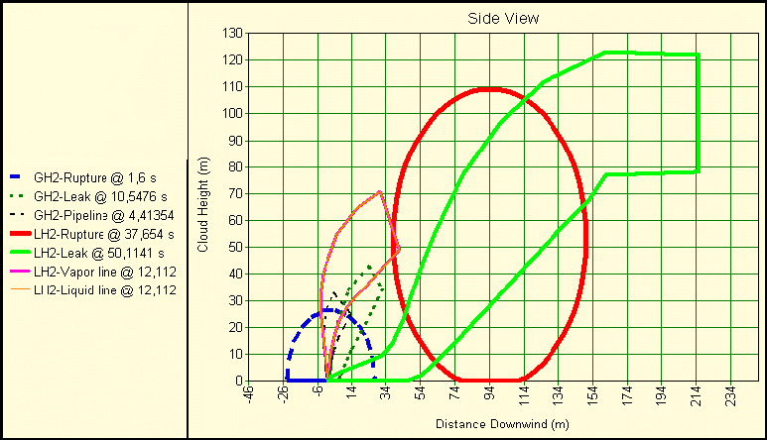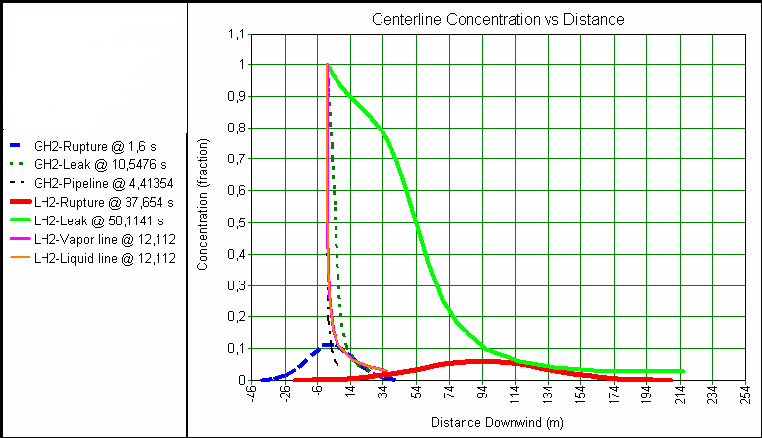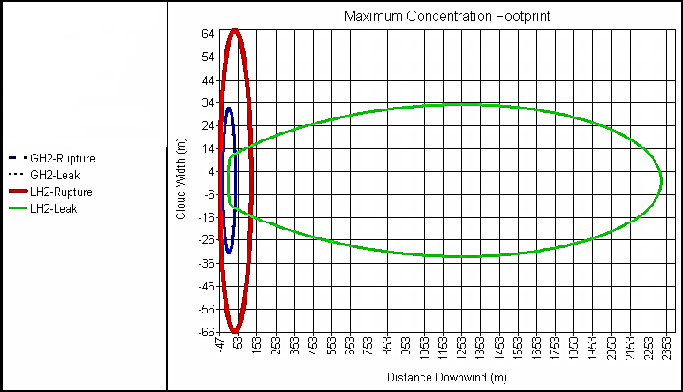
Fig. 3. Centre-line hydrogen concentration versus downwind distance for representative production and end-use releases, showing rapid dilution below the lower flammability limit.
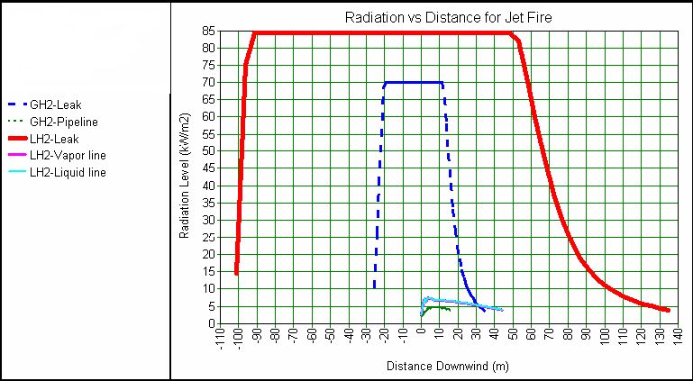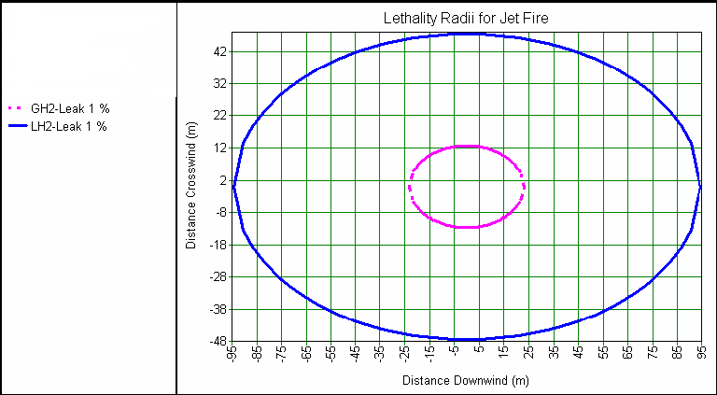
Fig. 4. Incident thermal radiation versus distance for jet fires arising from different release events, used to define 1% fatality effect zones.

5.3 Risk estimation results
Combining consequence and frequency results gives the individual and societal risk of each object. The overall societal risk of the hydrogen cycle is 8.5 × 10⁻³/year (about once in 118 years). Table 5 ranks the objects by their contribution: the LH₂ fuelling station is the single largest contributor (39%), followed closely by the on-board vehicle tank (35%); together these two end-use/distribution objects account for nearly three-quarters of the total risk, while the production plant contributes least (2.7%). Figures 5 and 6 show the individual-risk transects and the societal F-N curves for the hydrogen cycle.
Table 5. Overall mean individual/societal risk of the hydrogen study objects and their contribution.
Study object | 5% | Mean | 95% | Share
GH₂ at production plant | 1.1E–05 | 2.3E–04 | 8.5E–04 | 2.7%
LH₂ at depot | 2.3E–05 | 5.5E–04 | 2.1E–03 | 6.5%
LH₂ at fuelling station | 2.2E–04 | 3.3E–03 | 1.1E–02 | 39%
LH₂ at CHP plant | 2.3E–05 | 6.5E–04 | 2.5E–03 | 7.7%
LH₂ in private car | 9.5E–04 | 3.0E–03 | 1.3E–02 | 35%
LH₂ tanker truck | — | 3.7E–04 | — | 4.4%
GH₂ pipeline | — | 4.1E–04 | — | 5.0%
Overall risk | — | 8.5E–03 | — | 100%
Risk values in 1/yr; share is the percentage contribution to the overall cycle risk.
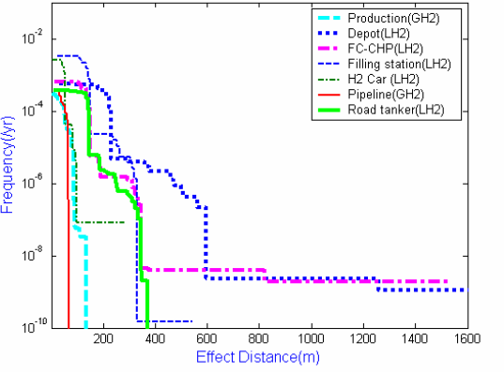
Fig. 5. Individual-risk transects (risk versus distance) for the seven hydrogen study objects.
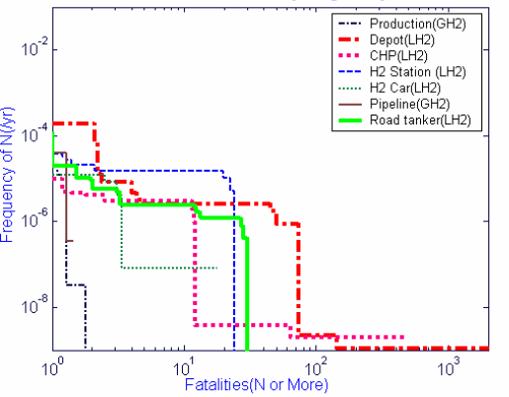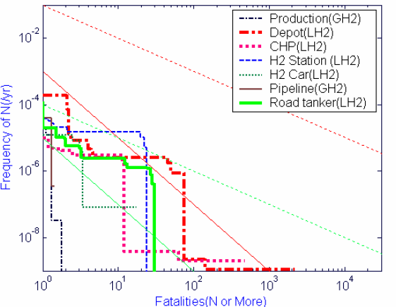
Fig. 6. Societal risk (F-N) curves for the hydrogen energy cycle plotted against the UK ALARP and Dutch ALARA acceptance criteria.

5.4 Evaluation against acceptance criteria
Evaluated against the EIHP2/ALARP criteria, the individual risk of the hydrogen objects lies almost entirely above the Dutch acceptability limit of 1 × 10⁻⁶/year and, for the storage objects, above the UK limit of 1 × 10⁻⁴/year—so risk-reduction measures are required if these plants are operated for the public. The societal risk, however, is globally lower than the individual risk: the transport objects and the GH₂ production plant and pipeline fall within the acceptable region of the UK ALARP envelope, while the LH₂ storage objects fall in the tolerable (reduce-if-practicable) ALARA band. In practice this means hydrogen public facilities are admissible provided risk is reduced as far as reasonably practicable, subject to cost-benefit analysis.

5.5 Comparison with LPG
To place these results in a familiar context, the hydrogen objects were compared with equivalent LPG (propane) objects of similar function and size. Although the individual risks of hydrogen storage exceed those of LPG, the maximum effect distances of hydrogen are smaller: hydrogen jet-fire intensity radii are about 60% lower, while LPG flash-fire impact is about 58% lower than hydrogen—reflecting hydrogen's high energy density and very wide flammability range, which lengthen flash-fire reach but shorten radiant-fire reach. Critically, the societal (F-N) risks of every hydrogen object are lower than those of the corresponding LPG object. A qualitative ranking of catastrophic-rupture outcomes (Table 6) confirms that, for comparable tank sizes, hydrogen poses lower overall consequences than LPG.
Table 6. Qualitative ranking of catastrophic-rupture consequences for hydrogen and LPG tanks.
Accident outcome | LH₂ 12 m³ | LPG 20 m³ | LPG 12 m³ | LPG 2 m³
Early explosion | 3 | 1 | 2 | 4
Late explosion | 3 | 1 | 2 | 4
Flash fire | 1 | 2 | 3 | 4
Fireball | 3 | 1 | 2 | 4
Average rank | 2.5 | 1.25 | 2.25 | 4
Severity rank: 1 = highest, 2 = high, 3 = moderate, 4 = low. A higher average indicates lower overall consequence.
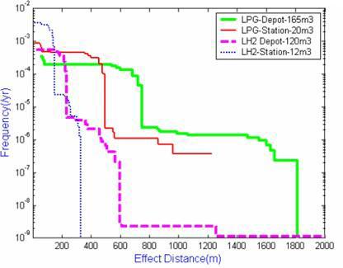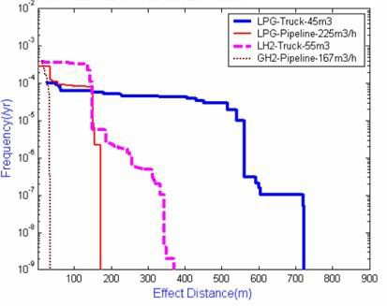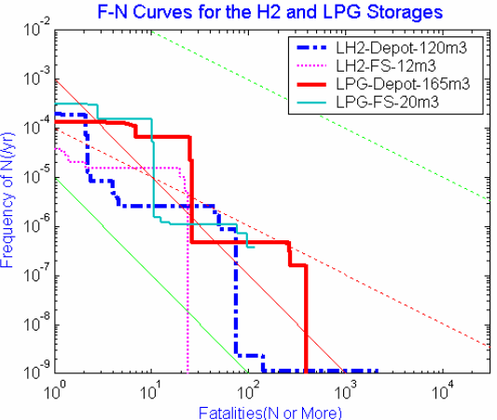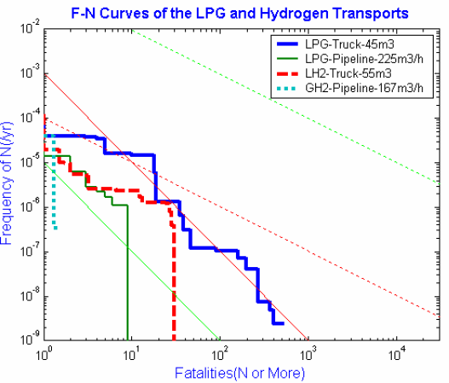
Fig. 7. Comparison of individual risk and societal F-N curves between hydrogen and LPG storage and transport objects.

5.6 Practical implications and limitations
The risk ranking points to clear, prioritised mitigations. Because tank overpressure dominates rupture, the highest-value measures are redundant, high-reliability over-pressure protection (relief valves and rupture discs), strict overfill-prevention procedures and operator training, particularly at fuelling stations and on-board vehicle tanks, which together drive ~74% of cycle risk. For LH₂ objects, vacuum-loss protection (e.g., a nitrogen-fed vacuum breaker) and withdrawal/pressure-building safeguards address the additional under-pressure failure mode, while material selection mitigates embrittlement and fatigue. For continuous releases, remotely or automatically actuated emergency shut-off devices limit inventory loss where hand valves cannot. The principal limitations of the study are the reliance on lognormal expert-judgement data for under-developed basic events, simplifications inherent in the PHAST physical models, and the conservative overpressure-fatality assignment adopted in place of probit relations that under-predict explosion lethality; these are the main sources of uncertainty in the reported frequencies and risks.

6. Conclusion
A unified quantitative risk assessment was performed for seven objects spanning the complete hydrogen energy cycle, combining HAZOP/FMEA hazard identification, fault-tree and event-tree frequency analysis with Monte-Carlo uncertainty propagation, and PHAST consequence modelling, with results evaluated against ALARP/ALARA criteria and benchmarked against LPG. Continuous releases dominate loss of containment (~94%), tank overpressure is the leading rupture initiator (~50%, plus ~30% under-pressure for LH₂), and fires account for ~60% of outcomes versus ~5% for explosions. The overall societal risk of the cycle is 8.5 × 10⁻³/year, dominated by the fuelling station (39%) and on-board vehicle tank (35%). Although hydrogen storage shows higher individual risk than LPG, its smaller effect distances and consistently lower societal risk indicate that hydrogen poses a lower public risk than LPG of comparable tank size. With redundant over-pressure protection, robust operating procedures, vacuum-loss safeguards for LH₂, and emergency shut-off devices, the residual risk of hydrogen infrastructure can be reduced to a level that is as low as reasonably practicable, supporting the safe public deployment of hydrogen as an energy carrier.

7. Future Scope
Several extensions would strengthen the present assessment. Coupling experimental release-and-ignition trials with CFD simulation for each object type would improve consequence accuracy and validate the PHAST results. A structured expert-elicitation panel would refine the multiplier and basic-event estimates that currently rely on judgement. Egress-and-evacuation modelling under different fire scenarios would yield more realistic consequence values, and the analysis of complex chained-event scenarios would capture escalation effects not represented by the present event trees. Finally, developing statistical reporting pipelines that allow risk to be computed directly from incident databases, and extending the framework to green-hydrogen production, distribution and end-use, would keep the assessment current as the hydrogen economy matures.

Acknowledgements
The authors gratefully acknowledge the guidance and supervision of the Mechanical Engineering Department, Gandhinagar Institute of Technology, Gandhinagar University, and the support of the institute in providing the computational resources used for the PHAST consequence simulations.

References
AIChE/CCPS. (2000). Guidelines for chemical process quantitative risk analysis (2nd ed.). American Institute of Chemical Engineers, New York.
AIChE/CCPS. (1994). Guidelines for evaluating the characteristics of vapour cloud explosions, flash fires, and BLEVEs. American Institute of Chemical Engineers, New York.
AIChE/CCPS. (1995). Guidelines for chemical transportation risk analysis. American Institute of Chemical Engineers, New York.
AIChE/CCPS. (1996). Guidelines for use of vapour cloud dispersion models (2nd ed.). Center for Chemical Process Safety, New York.
Alcock, J. L. (2001). Compilation of existing safety data on hydrogen and comparative fuels. European Integrated Hydrogen Project (EIHP2).
Ball, D. J., & Floyd, P. J. (1998). Societal risk (Final report). School of Health, Biological and Environmental Sciences.
Barbir, F. (1999). Safety issues of hydrogen in vehicles. Energy Partners, West Palm Beach, FL.
Barreto, L., Makihira, A., & Riahi, K. (2003). The hydrogen economy in the 21st century: A sustainable development scenario. International Journal of Hydrogen Energy, 28(3), 267–284.
Bottelberghs, P. H. (2000). Risk analysis and safety policy development in the Netherlands. Journal of Hazardous Materials, 71(1–3), 59–84.
Cadwallader, L. C., & Herring, J. S. (1999). Safety issues with hydrogen as a vehicle fuel (INEEL/EXT-99-00522). Idaho National Engineering and Environmental Laboratory.
Cancelli, C., Demichela, M., & Piccinini, N. (2005). Release of hydrogen from a cryogenic tank. Process Safety and Environmental Protection, 83(1), 17–23.
Crabtree, G. W., Dresselhaus, M. S., & Buchanan, M. V. (2004). The hydrogen economy. Physics Today, 57(12), 39–44.
Det Norske Veritas. (2002). PHAST technical manual (Software v6.4). DNV, United Kingdom.
Dunn, S. (2002). Hydrogen futures: Toward a sustainable energy system. International Journal of Hydrogen Energy, 27(3), 235–264.
Edeskuty, F. J., & Stewart, W. F. (1996). Safety in the handling of cryogenic fluids. Plenum Press, New York.
European Integrated Hydrogen Project. (2004). EIHP2: Risk acceptance criteria for hydrogen refuelling and storage. European Commission.
Health and Safety Commission. (1991). Major hazard aspects of the transport of dangerous substances. HMSO, London.
Schmidt, D., Krause, U., & Schmidtchen, U. (1999). Numerical simulation of hydrogen gas releases between buildings. International Journal of Hydrogen Energy, 24(5), 479–488.
TNO. (1980). Analysis of the risks inherent in the importation of LPG in bulk at four sites in the Netherlands. Ministry of Health and Environmental Protection, TNO.
TNO. (1983). LPG: A comparative analysis of the risks inherent in the storage, transhipment, transport and use of LPG and motor spirit. TNO, The Netherlands.
Vilchez, J. A., Carol, S., & Casal, J. (1996). Using major hazard database systems to develop event trees for flammable materials. CERTEC, Universitat Politècnica de Catalunya, Spain.
Züttel, A. (2003). Materials for hydrogen storage. Materials Today, 6(9), 24–33.
Baykara, S. Z. (2004). Hydrogen as a fuel: A critical technology? International Journal of Hydrogen Energy, 30(5), 545–553.
Bockris, J. O’M. (2002). The origin of ideas on a hydrogen economy and its solution to the decay of the environment. International Journal of Hydrogen Energy, 27(7–8), 731–740.
Contini, S. (1995). A new hybrid method for fault tree analysis. Reliability Engineering & System Safety, 49(1), 13–21.
Cox, R. A. (1980). Accidental LPG release: Discharge, dispersion, ignition and potential effects on people and buildings. Conference on Risk and Safety Management in the Gas Industry. Hong Kong.
Yürüm, Y. (1995). Production and utilization of hydrogen and future aspects. Kluwer Academic Publishers, Dordrecht.
Zimmerman, R. D. (1990). Cost-effective risk assessment for process design. McGraw-Hill, New York.

