A low cost, multi-wavelength optical source enabling independent WDM channels using a single SOA and ASE inputs
David I. Forsyth¹ and A.J Abdullah Al-Gburi¹
¹ Department of Electronics and Computer Engineering Technology (FTKEK), Universiti Teknikal Malaysia Melaka (UTeM), Jalan Hang Tuah Jaya, 76100 Durian Tunggal, Melaka, Malaysia.
Corresponding e-mail: david@utem.edu.my

Abstract
A multi-channel wavelength division multiplexed (WDM) transmission system using non-degenerate four-wave mixing (FWM) in a semiconductor optical amplifier (SOA) with spectrum-sliced ASE inputs from a single LED high powered incoherent source is presented. Three incoherent ASE inputs generate twelve SOA output channels, nine of them FWM, and all modulated at 10 Gb/s after the FWM process to avoid phase-noise limitations. SOA input power saturation characteristics were investigated and eye diagram analysis confirms high-quality transmission for each FWM channel, with an average achievable link length of 63.9 km, proving the validity of the scheme. By decoupling carrier generation from data encoding, this post-FWM architecture enables clean performance despite incoherent seeds, offering a low-cost, scalable solution for WDM in access and metro networks and wavelength conversion if required.
Keywords: Semiconductor Optical Amplifier (SOA), Four-Wave Mixing (FWM), ASE, Spectrum Slicing, WDM, OptiSystem, Optical Communications

1. Introduction
The demand for high-capacity, cost-effective optical networks still continues to drive innovations in wavelength division multiplexing (WDM) technologies [1]. Conventional multi-wavelength sources rely on arrays of distributed feedback lasers or optical frequency combs, which increase system cost and complexity, especially in access and metro networks [2].
Semiconductor optical amplifiers (SOAs) are attractive for their nonlinear properties, enabling wavelength conversion and signal regeneration - particularly through four-wave mixing (FWM) [3], [4]. They also possess highly desirable intensity noise reduction capabilities due to their saturation effects [5], a key feature in this work. Traditionally, arrays of expensive coherent laser inputs are required for efficient mixing, but here incoherent sources, like inexpensive broadband amplified spontaneous emission (ASE) from a high powered LED are considered, whilst mitigating the phase noise and low coherence inherent in these systems [5].
Spectrum slicing of ASE sources partially mitigates these limitations by generating narrowband quasi-coherent carriers suitable for WDM [5]. Recent work has demonstrated significant reach extension in spectrum-sliced WDM systems using SOA enhancements, achieving transmission distances of up to 340 km for a single channel [6]. Previous novel experimental work has also shown that FWM in SOAs is feasible using total spectrum-sliced ASE inputs [7], establishing the practical viability of this approach. More recently, simulation-based studies have shown that such systems can be accurately modeled using commercial software tools such as OptiSystem [8], confirming that the nonlinear interactions required for efficient FWM can be reproduced numerically with appropriate parameter selection.
This present work is a direct variation of [7] and [8], extending that these prior studies by introducing a critical architectural change: modulation is applied after the FWM process rather than before. In these prior studies, modulation was applied to the ASE slices before FWM generation, which resulted in some phase-noise transfer and degradation in signal quality. By contrast, this work extracts the FWM-generated carriers first, then modulates them independently at 10 Gb/s. This post-FWM modulation approach decouples carrier generation from data encoding, enabling clean eye diagrams and high-fidelity transmission. Additionally, the effect of SOA input power on FWM quality and therefore achievable link lengths is investigated, providing practical design guidelines for real-world deployment. Section 2 presents the theoretical background, section 3 describes the system design, section 4 presents the results, section 5 provides discussion and finally section 6 concludes the paper.
2. Theoretical Background
When multiple optical fields at frequencies $f_{1},f_{2},f_{3}$ propagate through a non-linear medium such as an SOA, nonlinear interactions produce new FWM products, expressed as:
- Degenerate FWM: $2f_{i}-f_{j}$
- Non-degenerate FWM: $f_{i}+f_{j}-f_{k}$

The number of generated frequency components (M) increases rapidly with the number of input channels [9], the formula being

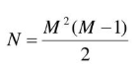
where N = the number of inputs

This effect for the case of three inputs is analogous with an AND gate, as shown in figure 1:

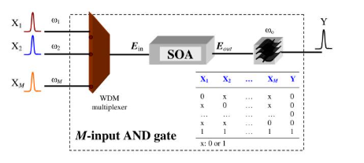
Figure 1: schematic of SOA FWM with 3 inputs

In this study, the nine newly FWM-generated channels were extracted and individually modulated from a three-input source coupled into a single SOA, making the total number of channels transmitted as twelve. In practice, limitations such as gain saturation, ASE noise and spectral overlap constrain usable channels [6]. The actual frequency values of all the channels transmitted are shown in Table 1 - the values in red being the three input signals

Table 1: channel frequencies transmitted
channel nos. | Output Frequency (THz)
1 | 192.4
2 | 192.7
3 | 192.8
4 | 193.0
5 | 193.1
6 | 193.4
7 | 193.5
8 | 193.7
9 | 193.8
10 | 194.1
11 | 194.2
12 | 194.5

Modulating following the FWM process ensures the generated carriers are independent, avoiding degradation due to incoherence of the ASE inputs [7], [8]. This method also allows the system to scale efficiently to multiple channels.

3. System Design
The proposed system is modeled using OptiSystem, with its WDM architecture shown in figures 2 and figure 3.
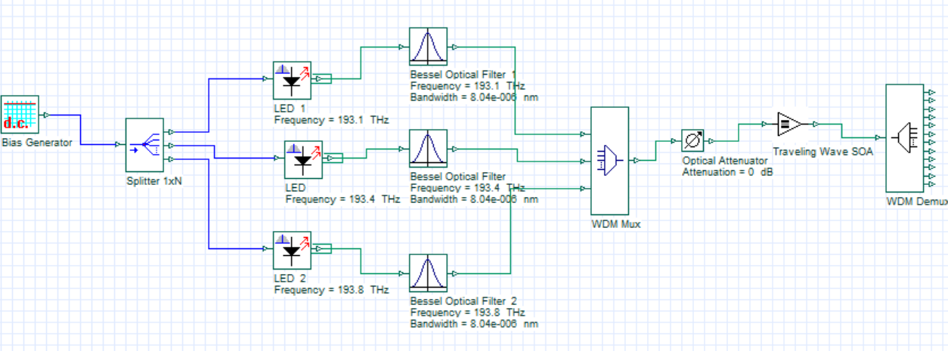

Figure 2: schematic SOA FWM with 3 inputs and 12 outputs
The overall design is structured around a centralized Semiconductor Optical Amplifier (SOA) that acts as a nonlinear medium for four-wave mixing (FWM), followed by a post-FWM modulation stage that constitutes the principal novelty of this work.
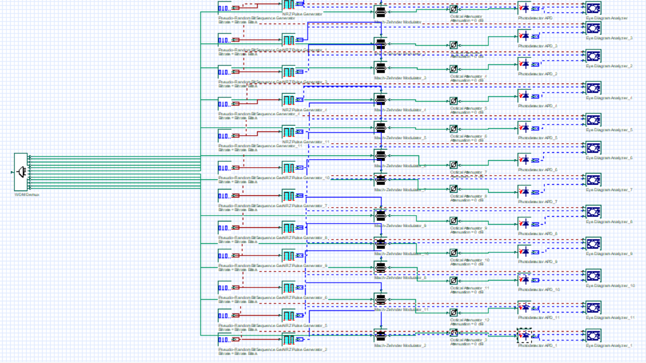
Figure 2
in
Figure 3: Block diagram of the proposed system showing demultiplexing and post-FWM modulation (inset: from figure 2)
In the transmitter section shown in figure 2, an incoherent high-powered LED Amplified Spontaneous Emission (ASE) source is spectrally sliced using three ultra-narrowband bessel optical bandpass filters. The channel spacing of these filters is optimized for FWM efficiency, and the resulting filtered ASE signals serve as the inputs to the SOA. The SOA, which acts as the nonlinear medium, is operated in a regime that balances nonlinear interaction, gain saturation and noise performance to generate FWM products from the three input channels multiplexed into the SOA. The post figure 2 set-up is shown in figure 3, with the transmitter section as an inset. In the receiver and modulation section, a 1 x 12 optical demultiplexer first extracts the 12 channels. Each of these clean optical carriers is then modulated with data using external intensity modulators at 10 Gb/s, sent across simulated link lengths, detected with photodetectors and low-pass filters, and then finally evaluated via eye diagrams and electrical analyzers to assess Q-factor and SNR, respectively. This architecture improves the credibility of the simulation results and more closely aligns with a practical implementation where a shared SOA acts as a centralized multi-wavelength comb generator.
Also, to investigate the system performance, an optical attenuator is placed before the SOA to vary the total input power into it. This allowed us to investigate the intensity noised reduction capabilities of the SOA in our ASE based system [5, 7]. Additionally, a further attenuator is placed on each arm to test the newly generated FWM signals link capabilities. With the average single mode fibre loss being 0.2 dB/km, we could easily establish the maximum link length in km. The power sweep into the SOA, covering the range from the low-gain linear regime to saturation, enables a comprehensive assessment of FWM conversion efficiency, optical signal-to-noise ratio (OSNR), eye diagram quality and channel uniformity. This analysis provides insight into optimal operating conditions and maximum achievable link lengths, complementing recent work on SOA-enhanced spectrum-sliced systems [6, 10] that demonstrated significant link length extension through SOA deployment.

4. Results
The system’s performance was evaluated through spectrum analysis, eye diagram assessment and a systematic investigation of SOA input power. Figure 4 shows the three spectrum-sliced ASE inputs to the SOA centered at 193.1 THz, 193.4 THz, and 193.8 THz:
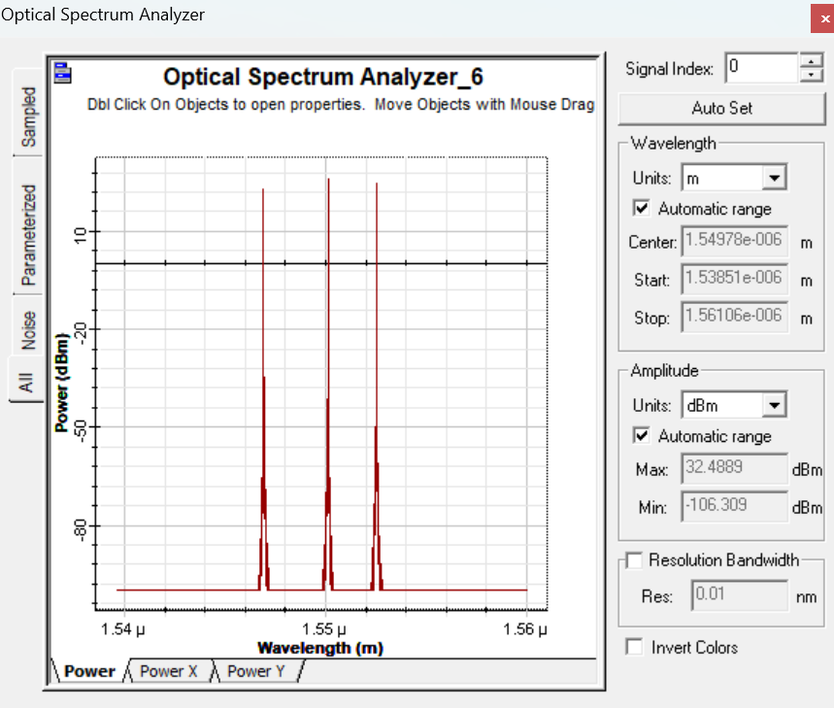
Figure 4: three spectrally sliced ASE inputs to the SOA
The total input power to the SOA was varied using the attenuator placed before it. In figure 4 the total input power was measured to be 29.6 dBm (highly saturated) for 0 dB attenuation, each frequency being almost equal in power. When the SOA bias was maximized to 1A the resulting SOA output spectrum, shown in Figure 5, displays multiple frequencies generated from the three inputs with acceptable conversion efficiency. Based on sufficient OSNR, output power, and spectral separation, a total of 12 channels spanning from approximately 192.4 THz to 194.5 THz were extracted for modulation (see Table 1).
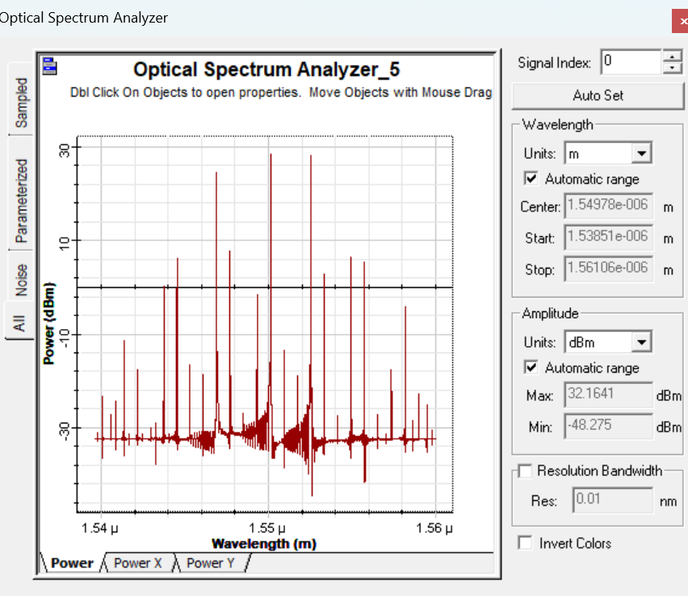
Figure 5: 12-channel output spectrum from the SOA
Following extraction, all nine FWM-generated channels were independently modulated at 10 Gb/s, as well as the original 3 input channels. To concisely represent system performance, three representative channels were selected for display: one near the lower edge of the FWM spectrum (channel 2 at 192.7 THz), one close to the center (channel 6 at 193.4 THz), and one near to the upper edge (channel 11 at 194.2 THz). Channel 6 was not FWM, therefore the eye yielded much higher quality. The eye diagrams for these three channels without attenuation are presented in figures 6 (a), (b) and (c), respectively. All three eyes were clear and showed very acceptable Q-factors.
(a)
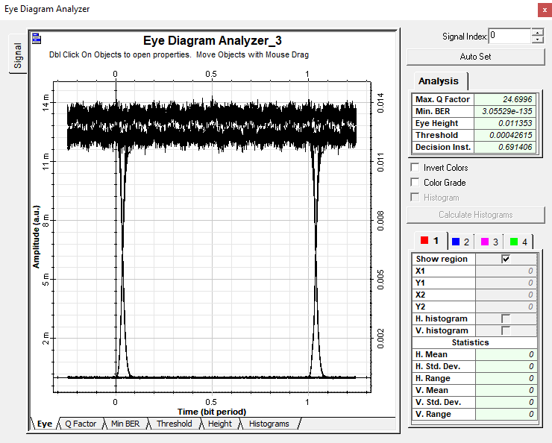
(b)
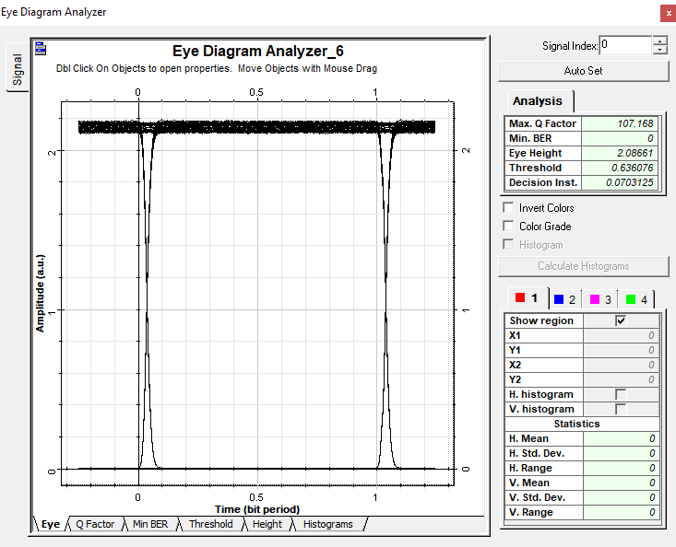
(c)
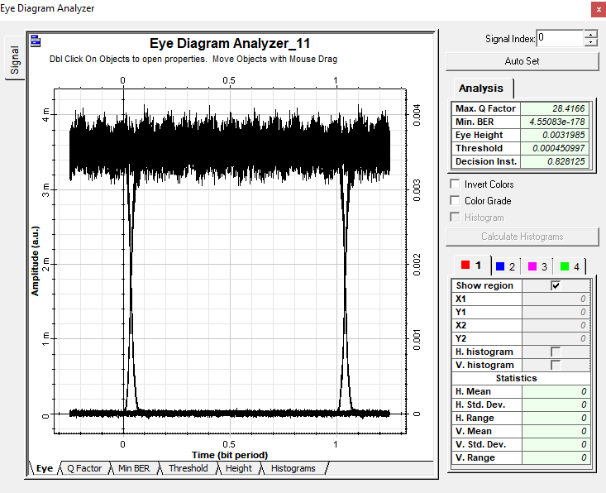
Figure 6: eye diagrams of three representative channels selected for display (a) channel 2 at 192.7 THz (b) channel 6 at 193.4 THz and (c) channel 11 at 194.2 THz
The remaining seven FWM channels showed comparative eye quality, with the average Q-factor measured to be about 24 over all nine FWM channels. This confirms that the post-FWM modulation approach effectively avoids the phase-noise transfer associated with incoherent ASE sources, enabling high-quality transmission across all generated channels. The SOA input power was then varied systematically using the attenuator placed before it (shown in figure 2) to characterize its impact on FWM conversion efficiency and signal quality. A power meter placed after the attenuator and before the SOA recorded the power into the SOA. Figures 7 and 8 plot the eye diagram Q-factor and OSNR of the two FWM channels 2 and 11 as a function of total SOA input power. Eye diagram and electrical carrier analyzers were used for this, respectively.
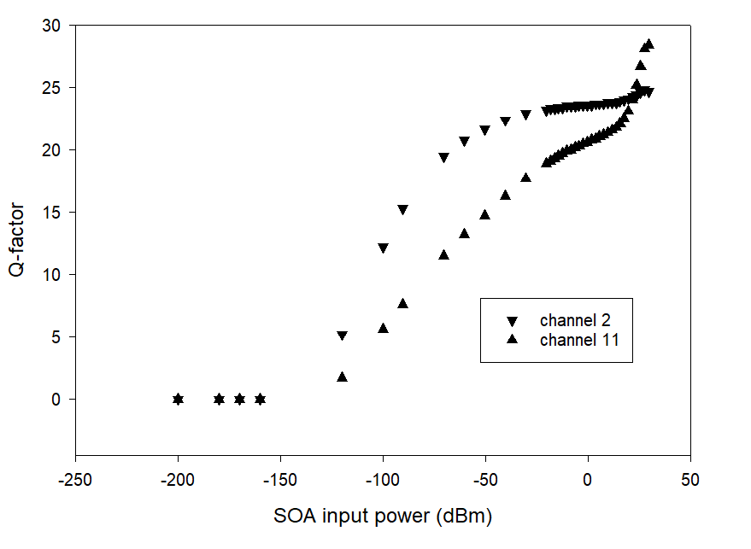
Figure 7: Q-factors received vs. SOA input power for FWM channels 2 and 11
From figure 7 it can be seen that the Q-factor of the selected channels generally increases with SOA input power, reaching a maximum value of around 28 for channel 11 and around 25 for channel 2 at the peak SOA input power (29.6 dBm). The SOA is deeply saturated at this point, giving rise to intensity noise reduction and therefore significant improvement in the Q-factor.
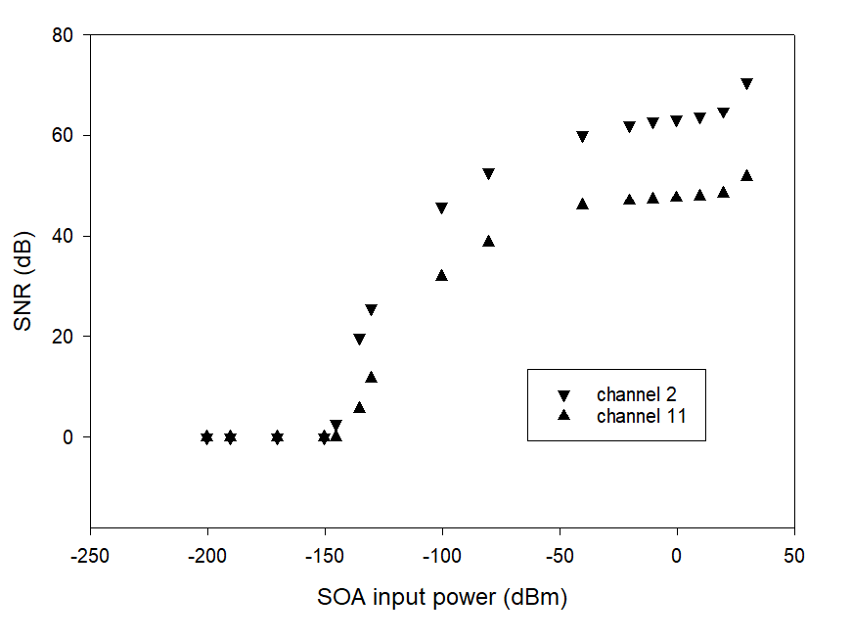
Figure 8: SNRs received vs. SOA input power for FWM channels 2 and 11
From figure 8 it can be seen that the measured SNR of the selected channels generally increases with SOA input power, reaching a maximum value of around 50 dB for channel 11 and around 70 dB for channel 2 at the peak SOA input power (29.6 dBm). The SOA is very highly saturated at this point, giving rise to intensity noise reduction and therefore significant improvement in the SNR.
Table 2 shows the allowable maximum link lengths of all channels created before signal degradation occurs and the Q-factor goes below 6. The non FWM channels, which could obviously travel a lot further, are shown in red. The SOA input was optimized to the maximum of 29.6 dBm, as this was the best input value inferred from the Q and SNR data in figures 7 and 8. The link lengths were effectively created using an optical attenuator on each channel to degrade the input eyes along the simulated route. Assuming normal fibre loss for single mode fibre to be around 0.2 dB/km, the data here shows that the maximum FWM link length achievable was channel 8 at 95 km, and the minimum channel 12 at 10 km. The maximum length for the non FWM signals was channel 5 at 195 km, the minimum channel 9 at 174 km.
Table 2: maximum channel link lengths
channel nos. | Output Frequency (THz) | Max. link length (km)
1 | 192.4 | 45
2 | 192.7 | 80
3 | 192.8 | 85
4 | 193.0 | 70
5 | 193.1 | 195
6 | 193.4 | 190
7 | 193.5 | 60
8 | 193.7 | 95
9 | 193.8 | 174
10 | 194.1 | 85
11 | 194.2 | 55
12 | 194.5 | 10
The average link length for the nine FWM signals was found to be 63.9 km, proving the viability of the technique.
5. Discussion
The proposed architecture offers several system advantages. It acts as a low-cost multi-wavelength source, where a single SOA replaces multiple DFB lasers or frequency combs [3-5]. The design is scalable, as additional ASE slices can generate proportionally more FWM channels. The post-generation modulation avoids phase-noise issues associated with incoherent sources, representing the principal variation from [8]. Furthermore, the system maintains a compact footprint suitable for access and metro network deployments. The simulation methodology also accounts for tool limitations, improving result credibility and complementing experimental SOA-enhanced system work [4, 7].
However, several limitations were identified. FWM efficiency varies across the spectrum, resulting in unequal channel power that may require gain flattening or selective channel use. Also, inter-channel crosstalk from too closely spaced channels introduced additional FWM interactions, which made the eyes imperfectly clear in channels which were too close together. Finally, system performance remains dependent on precise SOA operating conditions, including bias current and input power.

6. Conclusions
A 12-channel WDM system operating at 10 Gb/s per channel has been demonstrated using nine FWM-generated carriers generated from an SOA along with 3 spectrum-sliced ASE inputs. Post-FWM modulation yields a majority of clean eye diagrams, therefore confirming signal integrity. Investigation of SOA input power effects provides practical guidance on optimal operating points and maximum pre-SOA link loss, informing achievable transmission distances of up to 95 km under optimal conditions.
This work represents a variation of the prior simulation study in [8], with the key distinction being the application of modulation after the FWM process rather than before. In [8], modulation was applied to the ASE slices prior to FWM, which can result in phase-noise transfer and degraded signal quality. By contrast, this work extracts the FWM-generated carriers first, then modulates them independently at 10 Gb/s. This post-FWM modulation architecture decouples carrier generation from data encoding, enabling mainly clean eye diagrams despite the use of incoherent seed sources.
Furthermore, the systematic analysis of SOA input power provides practical link budget guidance, addressing a gap in existing simulation-based studies where FWM efficiency is often idealized. Critically, this work confirms that FWM in SOAs using spectrum-sliced ASE inputs - first practically demonstrated experimentally in [7] - can be accurately simulated in OptiSystem, and that the architecture can be extended to a multi-channel WDM system with post-generation modulation to achieve high-quality transmission. These results align with recent findings [6, 10] that demonstrate significant reach extension in spectrum-sliced systems using saturated SOAs to reduce intensity noise, suggesting that the post-FWM modulation approach could further enhance such long-haul transmission. The proposed architecture presents a low-cost, scalable solution for multi-wavelength generation and WDM transmission in next-generation spectrum sliced ASE access and metro optical networks where wavelength conversion may be required.

Acknowledgments
Special thanks to the Photonics Engineering (PERG) Research group at Universiti Teknikal Malaysia Melaka (UteM), Melaka, Malaysia for the use of their simulation software.

Corresponding author: David Forsyth, Department of Electronics and Computer Engineering Technology (FTKEK), Universiti Teknikal Malaysia Melaka (UTeM), Jalan Hang Tuah Jaya, 76100 Durian Tunggal, Melaka, Malaysia; david@utem.edu.my.

References
[1] G. Keiser, Optical Fiber Communications, 5th ed. New York, NY, USA: McGraw-Hill (2015)
[2] R. Ramaswami, K. N. Sivarajan, and G. H. Sasaki, Optical Networks: A Practical Perspective, 3rd ed. San Francisco, CA, USA: Morgan Kaufmann (2010)
[3] H. Li, G. T. Kanellos, and D. Nesset, "Four-wave mixing in SOAs for wavelength conversion," IEEE Photon. Technol. Lett., vol. 22, no. 15, pp. 1124–1126 (2010)
[4] K. Inoue and T. Mukai, "Signal wavelength conversion using four-wave mixing in semiconductor optical amplifiers," J. Lightwave Technol., vol. 14, no. 6, pp. 1237–1245 (1996)
[5] J. Zhang, N. Cheng, X. Gao, Y. Li, and F. Zhao, "Performance enhancement of spectrum-sliced WDM systems using semiconductor optical amplifiers," IEEE Photonics J., vol. 12, no. 3, pp. 1–9 (2020)
[6] D. I. Forsyth, "210 km long incoherent WDM spectrum-sliced system running at 10 Gb/s incorporating semiconductor optical amplifier (SOA) enhancements," Int. J. Res. Innov. Appl. Sci., vol. 11, no. 1, pp. 396–400, Jan. 2025, doi: 10.51584/IJRIAS.2026.11010034 (2026)
[7] D. I. Forsyth and M. J. Connelly, "Spectrum-sliced wavelength conversion using four-wave mixing from a semiconductor optical amplifier," in Proc. Optical Amplifiers and Their Applications (OAA), Budapest, Hungary (2005)
[8] D. I. Forsyth, K. R. Tariq, and A. J. Abdullah Al-Gburi, "Fully spectrum-sliced four-wave mixing wavelength conversion in a semiconductor optical amplifier," Przegląd Elektrotechniczny, vol. 5, pp. 215–218, doi: 10.15199/48.2024.05.40 (2024)
[9] J. Qin et al., "Simultaneous multichannel wavelength multicasting and XOR logic gate multicasting for three DPSK signals based on four-wave mixing in quantum-dot semiconductor optical amplifier," Opt. Express, vol. 22, no. 24, pp. 29413–29423, doi: 10.1364/OE.22.029413 (2014)
[10] D. I. Forsyth and A. Wong Yoon Khang, "650 km long incoherent DWDM spectrum-sliced system running at 10 Gb/s utilizing a single high-powered LED source and semiconductor optical amplifiers (SOAs) as pre-amps," Int. J. Res. Innov. Appl. Sci., vol. 11, no. 2, pp. 1810–1818, doi: 10.51584/IJRIAS.2026.110200169 (2026)

