MENTAL HEALTH OF PEOPLE WITH CHRONIC ILLNESS (PWCI)

ABSTRACT
Chronic illness is closely related to mental health conditions. The culmination of mental health problems is suicide. 60% of suicides are caused by depression. One chronic illness in the elderly adds one risk of suicide, two chronic illnesses means two risks and so on. Suicide prevention measures are of course very important. Effectively, this can only be done once there is a clear picture of the mental health conditions of people with chronic illnesses. Therefore, this study was designed to obtain an overview of the mental health conditions of PWCI with a descriptive design. A total of 117 PWCI respondents spread across 3 villages (Banyuraden, Nogotirto, Trihanggo) were obtained using the Accidental Sampling technique using the SRQ-20 instrument. The data analysis technique used frequency distribution and classified data, presented in tabular form.
The results showed that there were more male PWCI respondents in the Neurotic category, the older they were, the more they experienced psychiatric problems, and the PWCI's who did not go to school and did not work also experienced the most psychiatric problems. The most common forms of psychiatric problems are insomnia (48.7%), headache complaints (44.4%) and 4.3%, although small but very dangerous, namely the thought of wanting to end life (suicide). The conclusion is that half of the PWCI 's mental health is healthier (59.8%) and the rest are in the category of psychiatric problems (Neurotic).
Keywords: Mental Health; Chronic Illness ; Suicidies; Neurotic. Insomnia.

INTRODUCTION
The burden of chronic illness that lasts one year or more, can increase an individual 's​ risk for suicidal behavior. Chronic diseases are associated with decreased quality of life, low self-efficacy, and psychological distress, and can negatively impact work and interpersonal relationships. People with Multiple Chronic Diseases/Illness (PWCI) are at risk of experiencing mental health problems that tend to harm them, especially depression (CDC, 2019; Wei and KJ, 2019; Zhu et al, 2018; Sav et al, 2015).
Suicide is one of the most significant public health problems worldwide. According to the latest data available from the WHO report for 2014 entitled "Preventing Suicide: A Global Imperative", an estimated 804,000 people committed suicide worldwide in 2012 (WHO, 2014). The suicide rate varies from one society to another with respect to the social viewpoint and the meaning associated with suicide. Even the latest report for the general population, nearly one billion people live with psychiatric problems (IHME, 2018), three million people die every year from harmful alcohol use, and one person dies every 40 seconds from suicide (WHO, 2018).
Figures revealed by the World Health Organization in a World Health Statistics report published in 2014 show that chronic diseases are responsible for 86% of deaths in Turkey. Of these diseases, the most common are cardiovascular disease (47%), Cancer (22%) and chronic lungs disease (8%) (Jakab et al. 2014). In the same veins, figures published by the Statistical Institute of Turkey (TÜİK) for 2016 show that diseases of the circulatory system rank first among the causes of death with 39.8%, followed by benign and malignant tumors with 19.7% and diseases of the respiratory system causing 11.9% of deaths. On the other hand, the most common chronic diseases of the circulatory system are ischemic heart disease (40.5%), cerebrovascular disease (23.6%), other heart diseases (20.4%) and hypertension (9.7%) (Turkish statistics Kurumu 2016).
Chronic disease is a condition that cannot be cured by medical intervention and requires periodic monitoring and supportive care to reduce the degree of the disease and to maximize the person 's function and responsibility for self -care (Özdemir and Taşçı, 2013). Chronic diseases themselves can be a source of stress because of their impact on the individual 's life that disrupts the harmony of life, difficulties resulting from the symptoms, findings and treatment of the disease, disorders of relationships in the family, loss of certain abilities, changes in body image and other similar factors (Tüzer 2001; Cashews 2008). For this reason, in addition to struggle to overcome physical problems caused by chronic diseases, it is also very useful the importance of overcoming his psychosocial problems. Patients have to grapple with psychosocial problems in many disease groups such US: diabetes, types of Cancer, cardiovascular disorders, skin diseases, diseases of the respiratory system system (Kılıç 2011 ). Individuals diagnosed with this disease suffer from several psychosocial problems such US worry, anger, hopelessness, hopelessness, anxiety, withdrawal, loss of status in family and workplace, decreased self-confidence, fear of death, fear of not being independent/dependent on others, depressed mood and social isolation (Sertöz and Cashews 2004; Grandma et al. 2014; Bags 2014). On the other hand, factors such as the impact of chronic diseases on the patient 's quality of life, usually make them dependent on others, giving rise to depression, which, in turn, induces hopelessness, anxiety and suicidal ideation (Ahn et al. 2010).
Chronic illness can affect the ability to be active, leading to social isolation, and is associated with increased levels of anxiety and depression. Research in the existing literature has reported a high risk of suicide associated with a number of medical conditions or chronic diseases, such as diabetes mellitus (DM), HIV/AIDS, chronic kidney disease, asthma, cancer, congestive heart failure, epilepsy, multiple sclerosis (MS) and stroke. However, the mechanism underlying this relationship has not been widely explored, and the results of several studies suggest that some age groups experience uncontrolled depression (Karasouli et al. 2014).
It is very important for health professionals to review patients with chronic illnesses in terms of depression and suicide. Health service providers, especially health centers and more specifically doctors and nurses, are considered "at the forefront" in suicide and depression prevention. This is of course because nurses, in particular, have more opportunities to interact with patients, so the opportunity to take countermeasures is much more possible (Lee et al. 2014).
Based on the above, chronic diseases negatively impact a person in terms of physical, mental and social well-being, thus making them dependent on integral care. Among health workers, nurses are in the most strategic positions, in terms of knowledge and skills, attitudes and experience, which allows them to carry out the holistic care of people with chronic diseases. They must keep physical symptoms under control, help patients and families adjust to lifestyle changes imposed by the disease, assess anxiety, depression and especially the possibility of suicide that the disease can provoke. Therefore, this research is expected to be able to reveal mental health problems for the elderly with chronic diseases so that it has great significance, namely providing a base for health centers , especially to take policies to overcome suicide for the elderly with chronic diseases.

RESEARCH METHODS
This type of research is descriptive, namely wanting to find out a real picture of the mental health condition of the elderly with chronic illness (PWCI) today (during the research). The descriptive research method according to Sugiyono (2018) is a research conducted to determine the value of independent variables, either one or more variables (independent) without making comparisons or connecting with other variables. This means that this study only wants to know how the state of the variables themselves is without any influence or relationship with other variables such as experimental research or correlation.
The research was carried out in the Gamping 2 Health Center area and the time was from July to December. The population is community members with chronic diseases in the Gamping 2 Health Center area. With a health cadre base, there are 36 people who have been trained and spread across 3 villages (Banyuraden, Nogotirto, and Trihanggo) a total of 117 respondents or samples of 117 PWCI were obtained. Each cadre is given the task of 3-4 PWCI who are in the neighborhood where their respective cadres live, exist and are willing when visited by cadres to be used as respondents (incidental sampling). The variable of this study is a single variable, namely PWCI mental health. The operational definition is the current condition of the respondent 's​ mind and/or feelings (PWCI) indicated by the yes/no answer that best describes his current thoughts and or feelings (when the research is carried out) on the SRQ (Self Reporting Questionnaire: valid and realistic, commonly used by WHO and various related studies around the world) either independently or through the help of mental health cadres. Emotional mental disorder (Neurotic) is enforced if the respondents experiences 5 answers/complaints/responses "yes" or more than questions 1 to 20.

RESULT
- Characteristics of Respondents
The following are the results of the research on the characteristics of PWCI respondents in the Gamping II Health Center area:
Table 1. Frequency Distribution of Respondent Characteristics
N=11 7
No | Characteristics​​ | F rekwensi | Percentage​
1 | Gender  Man  Woman | 38  79 | 32 , 5  67 , 5
2 | Age  Early Adulthood (18-40 years)  Middle Adult (41-60 years)  Late Adulthood (61 years and above) | 6  5 0  61 | 5 , 2  4 2 , 7  5 2, 1
3 | Education  No school  Elementary School  Junior High School  High School  D 3  S1 | 11  39  24  3 1  4  8 | 9.4​  33 , 3  20 , 5  26 , 5  3 , 5  6.8
4 | Work  Housewife  Laborer  Trader  Retired  Self-employed  Students  Farmer  Private sector employee  Lecturer  Unemployment | 54  18  4  11  4  3  2  5  1  15 | 46 , 1  15 , 4  3.4  9.4  3.4  2.6  1.7  4.3  0.8  12.9

Based on table 1. The results of the study were obtained that most of the respondents were women or mothers, which was 67.5%, with the majority (52.1%) of the age in the late adult category, namely 61 years old, then middle or middle age which reached 42.7%.
ODPK is seen from the level of education, most of them are elementary schools (SD) which reach 33.3% with the majority of housewives (IRT) employed. The second most with the level of high school education (26.5%) and the next order is junior high school education, thus it can be concluded that the majority of respondents with the level of elementary and high school education.
- Respondent's Chronic Illness
Diagram 1. Type of Respondent's Illness
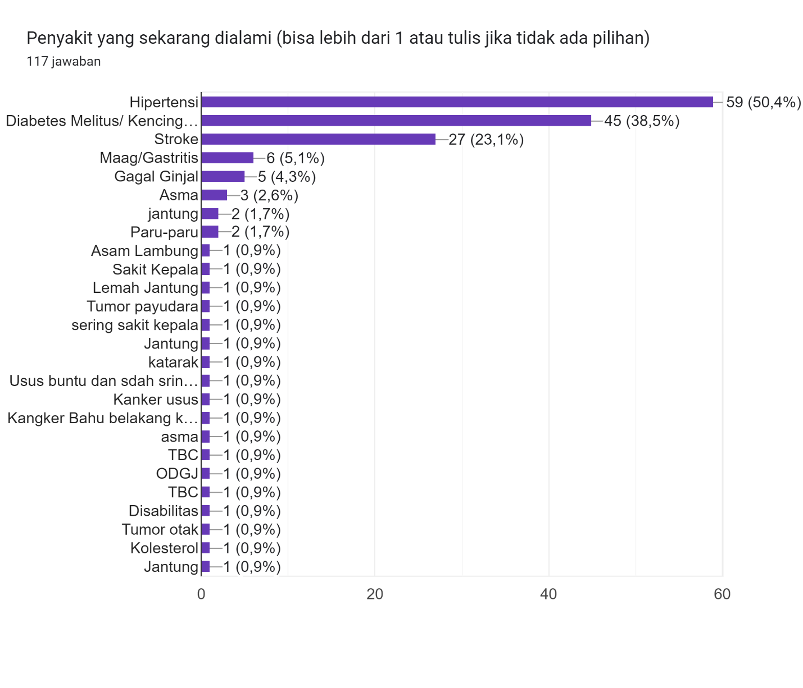

Table 2. Number of Chronic Illness experienced by respondents

Many illness experienced | Total | Percentage
1 illness | 81 | 69.2
2 Illness | 35 | 30
> 2 Illness | 1 | 0.8

Diagram 2. Duration of Respondent's Illness
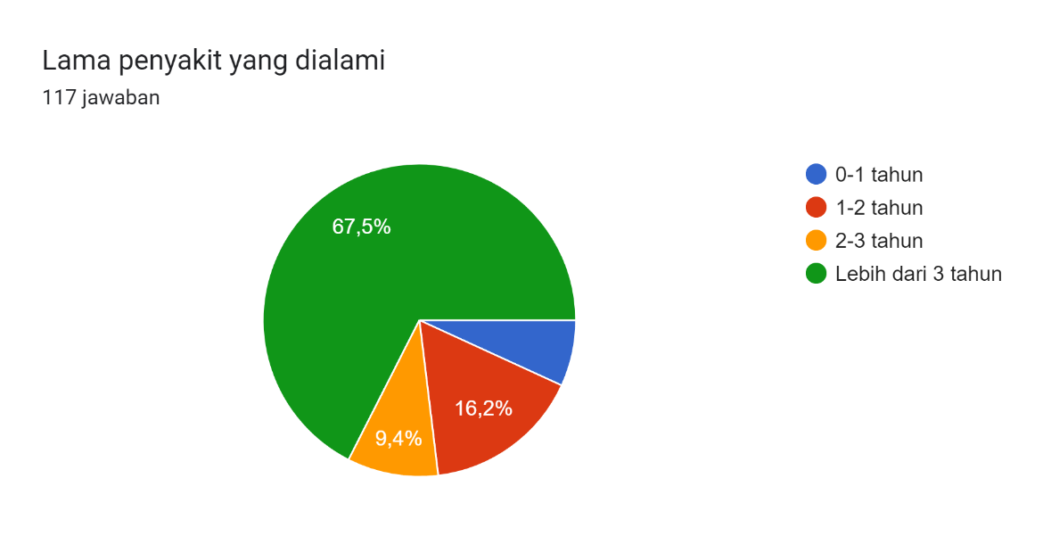
Diagram 3. Family caregivers
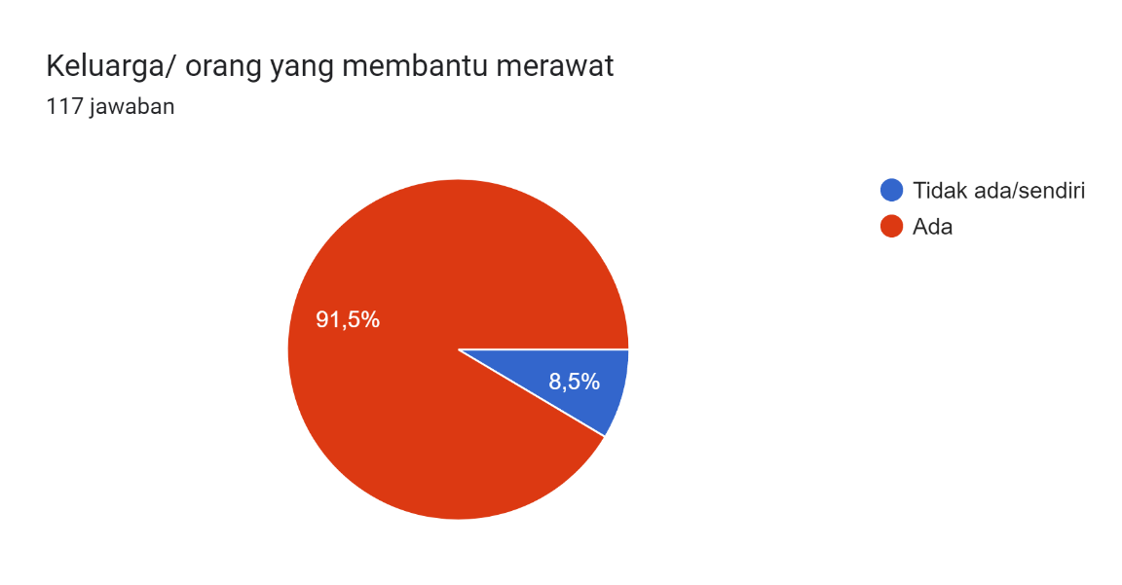
Based on diagrams 1, 2, and 3, as well as table 2, a picture of chronic diseases that rank first with the most PWCI in the Gamping II Health Center area is Hypertension, followed by Diabetes Mellitus and Stroke 3rd place. Then there were 30% of respondents with chronic diseases that they experienced more than one disease (for example: hypertension with diabetes mellitus), while the rest were mostly with one disease (for example: hypertension alone or diabetes mellitus only).
Regarding the duration or duration of the illness experienced, the majority of respondents (67.5%) experienced more than 3 years, the rest 1-3 years. As for whether or not there is a family or person who helps to take care of him/accompany him, almost all PWCI respondents have family members who take care of him and only about 10% take care of him or without a family to accompany him.
- Respondent's Mental Health

The mental health picture of PWCI in the Gamping II Community Health Center area is reflected in the mental health conditions of the respondents as follows:
Table​ 2 . Frequency Distribution of Respondents' Mental Health
N=11 7
Conditions | Frequencies​​​ | Pro centa g e​
Healthy  Neurotic | 70  47 | 5 9.8  40 , 2

Source: Primary Data, October-November 202 2
Based on table 2. above, it is known that the mental health picture of PWCI in the Gamping II Health Center area through 117 respondents is almost 60% of respondents in a mentally healthy condition (complaints related to mental problems are less than 5 items) or no indication of mental health disorders. There are 40% of respondents with Neurotic (People with Mental Problems) conditions or in the category of mild mental disorders because complaints related to mental problems have 5 yes answers to 1-20 SRQ-20 questions.
A more detailed picture of the mental health of PWCI, both those in the healthy category and Neurotic, can be described as follows:
Table​ 3 . Overview of Respondents' Mental Health Problems
N=11 7
NO | Mental Health Problems | Distribution
NO | Mental Health Problems | ∑ | %
1 | Headaches | 52 | 44 , 4
2 | Appetite poor | 38 | 32 , 5
3 | Not sleeping well | 57 | 4 8 , 7
4 | M already feels scared | 30 | 25.6
5 | C gold, tense, or worried | 44 | 3 7 ,6
6 | Shaking hands | 25 | 22 , 5
7 | It's hard to think clearly | 44 | 3 7, 6
8 | Not happy | 26 | 22.2
9 | more often | 16 | 13.7​
1 0 | Difficulty enjoying daily activities | 46 | 39.3​
1 1 | Difficulty making decisions | 47 | 4 0, 2
1 2 | Abandoned daily activities/ tasks | 38 | 32 , 5
1 3 | T unable to play a role in this life | 38 | 32 , 5
1 4 | Loss of interest in many things | 34 | 29 , 1
1 5 | M feels worthless | 20 | 17 , 1
1 6 | Having thoughts of ending life | 5 | 4 , 3
1 7 | M feels tired all the time | 36 | 30.8
1 8 | I feel unwell in my stomach | 4 5 | 38.5​
19 | I'm sure someone means something bad | 6 | 5 , 1
2 0 | There are disturbing thoughts or unusual things | 16 | 13.7

Source: Primary Data, October-November 202 2
Table 3 provides a detailed overview of the mental health issues experienced by people with mental health conditions (PWCI ). The most common complaint or problem experienced by respondents was sleep disturbances, or insomnia. Nearly half of respondents (48.7%) complained of not sleeping well.
The second most common mental health problem is headaches. 44.4 % of respondents complained of frequent headaches. The least common , but also the most dangerous, is suicidal thoughts or thoughts of ending one's life ( 4.3 % ). This means that approximately 4 out of 117 people with mental health problems (PWCI) at the time of this study had suicidal thoughts . Meanwhile, those with a tendency toward depression, as seen from the symptoms they displayed, included 17.1% feeling worthless, 22.2% feeling unhappy, 13.7% crying more often, 30.8% feeling tired all the time, and 29.1% losing interest in many things.
A more broad description of mental health is to link the level of mental health with the characteristics of the respondents, as follows:
Table 5. Mental Health Overview With Respondent Characteristics
N=11 7
No | Characteristics | Mental Health Level |  | Total
No | Characteristics | Score <5  (Healthy Mind) | Score >5  (ODMK) | Total
1 | Gender  Man  Woman | 18  53 | 20/52.6%  26/32.9% | 38  79
2 | Age  15-40 years  41-60 years  >60 years | 4  32  35 | 2/33.3%  18/36%  26/42.6% | 6  50  61
3 | Education  No school  Elementary School  JUNIOR HIGH SCHOOL  High School/Vocational School  D3  S1 | 3  23  9  24  3  7 | 7/63.6%  16/41%  15/62.5%  7/22.6%  1/25%  1/12.5% | 11  39  24  31  4  8
4 | Work  Housewife/housewife  Laborer  Trader  Retired  Self-employed  Students  Farmer  Private sector employee  Lecturer/teacher  Unemployment | 36  11  4  5  4  2  1  3  1  5 | 18/33.3%  7/38.9%  0  6/54.5%  0  1/33.3%  1/50%  2/40%  0  10/66.7% | 54  18  4  11  4  3  2  5  1  15

, it can be seen that more male respondents (52.6%) experienced Neurotic compared to those who were not mentally healthy. Similarly , when compared to female respondents (32.9%), more male respondents experienced Neurotic.
The age groups of respondents ranged from early adulthood, middle adulthood, to late adulthood. The older the age, the higher the risk of experiencing mental health problems (Neurotic): 3.3%, 36%, and 42.6%. Similarly, when comparing those with mental health and those with mental health problems (Neurotic), the highest percentage of those experiencing Neurotic was in the late adulthood group (aged over 61 years).
Regarding the respondents' very diverse education levels, ranging from those who did not attend school, elementary school, junior high school and high school to university, all of them experienced emotional mental disorders, although in varying quantities (Neurotic). Based on table 5, the tendency is that from low to high levels of education, the risk or proportion of experiencing mental health problems is lower. The highest proportion of respondents experiencing Neurotic was those who did not attend school (63.5%), followed by those at the junior high school level and those at the elementary school level.
Finally, the relationship between occupation and respondents' mental health, as shown in Table 5 above, shows that the group of respondents with the most mental health problems were those who were unemployed (66.7%). The second highest number were retirees, and the third highest were respondents who worked as farmers. Respondents who did not experience mental health problems were teachers/lecturers, private sector employees, and traders.

DISCUSSION
  - Characteristics of PWCI

The findings of this study indicate a high incidence of chronic diseases in women (67.5%) compared to men (32.5%) in the Gamping 2 Community Health Center area, Gamping, Sleman, Yogyakarta, Indonesia. This is similar to previous research conducted in China that the majority of people with diabetes are women ( Joshi, Song, and Lee, 2017). This is further strengthened by the findings of research in Nigeria that women are the majority of people with diabetes ( Faronbi, Ajadi, and Gobbens, 2020) . In fact, the results of research in Bali, which is the same country as this study and only a different province, are different, namely that the majority of people with diabetes are men ( Astiti, Herawati, and Subawa, 2020). Upon further investigation, the research in Bali turned out to have respondents specifically with diabetes mellitus and was conducted on patients who came to the hospital, while this research was conducted in the community for all categories of chronic diseases.
Regarding chronic diseases, this study found the three most common diseases: hypertension, diabetes mellitus, and stroke. This finding aligns with research in Nigeria and China, which found that hypertension, followed by diabetes mellitus, were the most common chronic diseases ( Faronbi, Ajadi, and Gobbens, 2020; Joshi, Song, and Lee, 2017 ) . Furthermore, this finding is supported by the results of a 2018 basic health study on the most common chronic diseases in Indonesia. This reinforces the claim that chronic disease is a global problem affecting the lives of people in both developed and developing countries.
Research by Astiti, Herawati, and Subawa (2020) on Age and Gender Factors in People with Type 2 Diabetes in Bali found that the majority of people with type 2 diabetes were over 55 years old and male. Meanwhile, research on 10,434 people with type 2 diabetes in China found that the majority were women (58.6%), aged over 55 years, 70% of whom were married ( Joshi, Song, and Lee, 2017). Does this correspond to the nature of women who tend to hold mental burdens compared to men? Certainly, various research results show that women are more vulnerable to mental disorders, namely 16% of women experience emotional disorders and 9% of men (Riskesdas, 2007; Kompas, 2010; in Armiyati and Susanti, 2015). This is also in line with this study of diagnosed people with mental illness (PWCI) aged 15-81 years, with the majority aged 55 years and above (70%). The majority were also women (67.2%), and most were housewives with elementary school to high school education. The higher the level of education, the broader the perspective, so the risk of experiencing mental disorders is certainly lower than those with lower levels of education. This is of course not solely related, but correlated with other factors such as economic level and quality of life, thus better able to manage factors that influence mental disorders. Findings from Eduardo and Suryani's (2020) research show that those experiencing mental emotional disorders are more common among people with lower levels of education.
These findings are consistent with a previous study of chronic diseases in 4,444 older adults. The study also found that multimorbidity was common in 27.0% of older adults in China and Nigeria. This is supported by previous research showing that multimorbidity is particularly common in older adults, aged 35-37, and that approximately two-thirds of people of retirement age have at least two chronic diseases.
Approximately half (51.5%) of respondents reported at least one chronic illness lasting 1-5 years (43.3%). The prevalence of hypertension was 36.1%, diabetes 13.9%, and arthritis 13.4%. Respondents with chronic illnesses had significantly lower quality of life, particularly related to physical health, social relationships, and the environment (all p<0.05) compared to those without chronic illnesses. Predictors related to quality of life included age, marital status, education level, chronic illness, and prognosis ( Faronbi, Ajadi, and Gobbens, 2020) .
  - Mental Health of People with Disabilities (PWCI)

Sayekti and Hendrati (2015) found in their research that 60% of elderly people experience sleep disorders (insomnia). The findings also revealed that the majority of respondents with mental health problems (PWCI) experienced insomnia. The essence of insomnia is feeling dissatisfied or unable to sleep soundly. This indicates a mental health problem, even if mild. However, when this occurs in people with PWCI, it can exacerbate their chronic illness.
Yang et al. (2021) reported that chronic illness, mental health problems, and poor social relationships are associated with negative self-evaluations. Therefore, people with chronic illnesses can experience negative self-evaluations and other mental health problems, and vice versa. Likewise, people with mental health problems (PWCI) can disrupt social relationships, and vice versa. The findings in this study reinforce each other, as evidenced by 17.1% of respondents feeling worthless, 32.5% feeling unimportant in life, and 5.1% believing that someone has malicious intentions toward them.
Chronic illness is the most common cause of daily pain among people living with HIV/AIDS (PLWH) in China, including depression (Ma et al., 2021). Interestingly, the presence of more than one chronic illness increases the risk of pain. Even more interesting, it merits further study, as this also increases levels of depression. The findings of this study corroborate this finding. 69.2% of people living with HIV/AIDS had one chronic illness, 30% had two, and the remaining 0.8% had more than two. Furthermore, the majority of people living with HIV/AIDS had had the illness for more than three years, and 40% were categorized as having mental health problems.
The mental health problems experienced by respondents were both physical, biological, and psychosocial. 44.4% complained of frequent headaches, 32.5% of anorexia, 38.5% of dyspepsia, and 37.6% of anxiety, tension, or worry, even to the point of having thoughts of suicide (5.1%). Joshi, Song, and Lee (2017) in their research stated that chronic illness is positively associated with suicidal ideation. One chronic illness corresponds to a suicide risk of one, two chronic illnesses mean a suicide risk of two, and so on.
Types of chronic diseases positively associated with suicidal ideation include cardiovascular disease, stroke, ischemic heart disease, cancer, diabetes, and kidney failure, while hypertension was excluded (Joshi, Song, and Lee, 2017). In this study, all of these diseases were present, only the composition was different. Hypertension, which was excluded, was positively associated with suicidal ideation and was the most common chronic disease in this study (ranked 1: 50.4%). Diabetes followed in second place, followed by stroke, and so on. Serious attention should be paid to the presence of depression in these chronic diseases, as this has been found to increase not only suicidal ideation but also suicide attempts. Therefore, findings from research on mental health issues in people with mental health conditions (PWCI) are crucial so that suicide attempts can be identified and prevented.
The presence of depression in people with mental health problems (PWCI) can be identified from several complaints: unhappiness (22.2%), crying more often (13.7%), difficulty enjoying daily activities (39.3%), loss of interest in many things (29.1%), and feeling tired all the time (30.8%). If these complaints are responded to early, without having to wait for a diagnosis of depression, it will certainly be very effective. Because self-diagnosis not only takes time and effort to come to a health service, which is no less important, if the diagnosis is confirmed as depression, it will further trigger the chronic disease and the level of depression itself, which ultimately makes it easier.
The least common but most dangerous mental health problem is the desire to end one's life or commit suicide. This is certainly a very serious issue. If someone experiences suicidal thoughts, it means there is a real problem in the family or community . Systems theory states that if a subsystem is problematic, it reflects a problem in the system itself , and vice versa.
Suicide is a common occurrence, partly due to cultural factors. Discussing suicide seems taboo, both from the perspective of the perpetrator and their family or community. Yogyakarta , for example, known as a cultural city, ranks first nationally for suicide rates. This reality is certainly interesting to examine further. National data from 2016, reported by the Kompas newspaper, stated that suicide in Indonesia occurred at a rate of one person per hour. This is certainly a very serious matter.
Suicide is essentially a behavior, meaning it can be learned. In short, suicide is certainly preventable. Conceptually, changing the perception that suicide is taboo and making it a normal behavior is essential. At least when there's a stimulus for suicide, talk about it begins. Its practical application, of course, requires research to be more accurate. The results and findings of this study will at least contribute to this and the development of future research.

CONCLUSIONS AND SUGGESTIONS
- Conclusion

Referring to the objectives and results of the research, the following conclusions can be drawn:
- PWCI respondents can be described as the majority being women , late adulthood , housewives, and having elementary-high school education .
- Regarding the description of his mental health as follows:
- Male PWCI respondents were more likely to experience Neurotic than those with mental health. Similarly, compared to female PWCI respondents, male respondents were more likely to experience Neurotic.
- Respondents' age groups ranged from early adulthood, middle adulthood, to late adulthood. The older the age, the higher the risk of experiencing mental health problems (Neurotic). Similarly, when comparing those with mental health problems to those without mental health problems, the highest percentage of Neurotic experienced was in late adulthood (aged 61 and over).
- Regarding the respondents' educational levels, which varied widely, from those with no education, elementary school, junior high school, and high school to university degrees, all experienced mental and emotional disorders, albeit to varying degrees (Neurotic). The highest proportion of respondents with no education experienced Neurotic.
- Regarding employment , the group of respondents with the most mental health problems were those who were unemployed (66.7%). The second-highest number were retirees, and the third-highest were farmers. Respondents who did not experience mental health problems were teachers/lecturers, private sector employees, and traders.
- Suggestion
- This recommendation is certainly aimed more at policymakers, particularly those at community health centers (Puskesmas). Regarding the research findings, which show a significant number of people with mental health problems (PWCI) in the Gamping 2 Community Health Center area, they should immediately collaborate with various parties, especially the Community Health Police (Polkesyo), so that concrete programs can be implemented to prevent mental disorders in the community. Most importantly, for people with mental health problems who are contemplating suicide, prompt follow-up action is needed, involving cadres.
- For subsequent researchers, research is needed that connects mental health variables with respondent characteristics and interventions, especially for people with mental health problems (Neurotic), so that further mental disorders can be prevented.

BIBLIOGRAPHY
Armiyati and Susanti, 2015, Analysis of Women Vulnerable to Mental Disorders, Research Report , Muhammadiyah University of Ponorogo.

Astiti, MYD, Herawati, S., and Subawa, AAN, 2020, Age and Gender as Risk Factors for Increased Serum Glutamic-iruvic Transaminase (SGPT) Levels in Type 2 Diabetes Mellitus Patients at Sanglah General Hospital, Jurnal Medika Udayana (JMU), Vol. 10, No. 9, P: 78-81.

Eduardo and Suryani, 2020, Description of Emotional Mental Disorders in Residents of Banfanu Village, North Central Timor, NTT Province, Journal of Biomedicine and Health , Vol. 3 No. 2 ; 49-57.

Faronbi, JO., Ajadi, AO., and Gobbens, RJ., 2020, Associations of chronic illnesses and socio-demographic factors with health-related quality of life of older adults in Nigeria: A cross-sectional study, Ghana Med J , 54(3): 164-172.

Harista, RA. and Lisiswanti, R, 2015, Depression in Diabetes Mellitus Patients, Type 2, Majority , Vol. 4; No. 9; P: 73-77.

Joshi, P., Song, HB., and Lee, SA., 2017, Association of chronic disease prevalence and quality of life with suicide-related ideation and suicide attempt among Korean adults , Indian Journal of Psychiatry , Vol. 59, Iss.: 3, P:352-358.

Ministry of Health , (2018). https://promkes.kemkes.go.id/pengertiankesehatan-mental

Kompas. 2016. Every hour, one person commits suicide. September 8, 2016 .

Littlefield, Lyn., Stitzel, Anna., Giese, and Jill. 2014 , A workplace prevention approach to employee mental health. Perspective: Mental Health and wellbeing in Australia . Paragon Printers Australasia.

Ma, Y., Xiang, Q., Yan, C., Liao, H., and Wang, J., 2021, Relationship between chronic diseases and depression: the mediating effects of pain , BMC Psychiatry , 21:436.

Myers, DG 2012. Psychology social. Edition 10. Jakarta : Salaba Humanike

Muhith, Abdul. 2015. Education nursing soul: Theory And application. Yogyakarta: Andi offset

National Center for Chronic Disease Prevention and Health Promotion (NCCDPHP)., 2021, About Chronic Diseases. Centers for Disease Control and Prevention . https://www.cdc.gov/chronicdisease/about/index.htm

Notoatmodjo, S. 2012. Health promotion and health behavior. Jakarta: Rineka Creation

Peace be upon you. 2009. Methodology Research Nursing: Guidelines Practical Compilation. Surabaya : Salemba medical

Nurses Experience Depression and Stigmatization”, Kompas , August 4, 2020, page 1 .

Raghupathi, W., & Raghupathi, V. , 2018 , An Empirical Study of Chronic Diseases in the United States: A Visual Analytics Approach. International journal of environmental research and public health, 15(3), 431.

Ridlo, IA, 2020, The Covid-19 Pandemic and Challenges to Mental Health Policy in Indonesia, INSAN: Journal of Psychology and Mental Health, Vol. 5(2), 155- 164 .
Research Health Basic (Riskesdas). , 2013 , Health Research and Development Agency Ministry Republic of Indonesia year 2013. Accessed on January 9, 2017 from http://www.depkes.go.id/resources/download/general/Hasil%20Riskesdas% 20 2013.pdf

Rozali, Sitasari and Langgogeni, 2021, Improving Mental Health During the Pandemic, Jurnal Abdimas Vol.7 No.2, Esa Unggul University, Jakarta.

Satrianegara , MF . , 2014 , The Influence of Religiosity on Levels of Depression , Anxiety , Stress , and Quality of Life of Chronic Disease Sufferers in Makassar City ( Integration and Health Based Epidemiological Survey Study ) , Journal of Health , Vol .​​​​​​ II No. 1, P: 288-304.

Sayekti, Nilam PIW and Hendrati, Lucis Y., 2015, Analysis of Depression Risk, Sleep Hygiene Level and Chronic Diseases with Insomnia Incidence in the Elderly, Periodical Journal of Epidemiology , Vol.3, No.2:181-193.

Sukardi. 2013. Methodology study education: competence And practice. Jakarta: Earth of Letters

“WHO Warns of Mental Health Crisis During Pandemic”, May 15, 2020, https://www.republika.co.id/berita/qab7hz459/who-peringatkan-krisis-kesehatan-mental-selama-pandemi, accessed June 29 , 202 1 .

Winurini, 2020, Mental Health Problems Due to Covid-19, Brief Information on a Brief Study of Current and Strategic Issues , Vol. XII, No. 15/I/Puslit/August/2020 .

Yang, H., Deng, O., Geng, Q., Tang, Y., Ma, J., Ye, W., Gan, Q., Rehemayi, R. , Gao , https://doi.org/10.1038/s41598-021-94318-x.

Zulkarnain and Fatimah. (2019). Mental Health and Happiness. Mawa'izh: Journal of Da'wah and Social Humanitarian Development. Vol. 10, no. 1 (2019), pp. 18-38. DOI: https://doi.org/10.32923/maw.v10i1. 715

