A Trustworthy Electronic Voting Architecture Using Blockchain and Convolutional Neural Networks

ABSTRACT: With the rapid development of the sphere of digital governance, the possibility to offer safe, transparent and reliable voting mechanisms has become one of the most important issues. The issues that are typically involved with the traditional voting systems, as well as the existing electronic voting systems, are the possibility of voter impersonation, vote rigging, centralization of the operation, and mistrust of the system by the populace. This paper will address these limitations by proposing a blockchain based electronic voter program that will use a Convolutional Neural Network (CNN)-based face recognition system to carry out secure voter verification. The specified system will capitalize on blockchain technology to store votes as verifiable transactions and immutable ones which will be transparent and auditable and will not be compromised. Simultaneously, the CNN based facial recognition is deployed to check the identity of the voters by the live facial images comparison with the registered biometric templates to prevent access by unauthorized persons and counting the votes. The blockchain Ethereum smart contracts are stored in the system architecture to automatically perform
voter registration, vote validation and result tallying without involving intermediaries. This has also a web-based interface which enables participation remotely and is highly secured. The experimental evaluation indicates that the given framework could be utilized in order to reduce the impact of personification, decrease the level of human error and enhance the trust in the electoral process. Overall, a blockchain with a deep learning-driven biometric authentication can be considered a scalable and secure system that can be found in digital elections and e- governance applications today and is transparent enough to use.
Key words: CNN, DL, Voting system, AI, Cyber attacks, Face detection, Accuracy, Block chain.

I INTRODUCTION

Elections are the heart of democracy, as it allows people to engage in the direct government and the process of making decisions. Credibility of an election process is largely determined by the capacity of the process to guarantee voter authenticity, vote integrity, transparency, and fairness [1]. The use of traditional voting mechanisms, which are largely based on the use of paper ballots and

manual counting, has been common and has been reported to be increasingly criticized owing to the fact that they are time consuming, resource intensive, and prone to human errors and manipulations [2]. Such problems as ballot stuffing, impersonation, delayed announcement, and un-auditability of the results have brought up critical questions of the credibility of traditional voting systems. Even the electronic voting machines that have been proposed in order to enhance efficiency still remain doubtful because of centralized control [3], lack of transparency as well as vulnerability to manipulation. With the conversion into digital form, the society has a strong demand of an effective and secure, transparent [4], and trustworthy voting mechanism, which will counteract the shortcomings of both the traditional as well as the current electronic voting systems, and at the same time, retain the confidence of the voters [5]. The digital technology development has also given way to the need to investigate online and electronic voting system to enhance ease of access and efficiency. Although such systems decrease geographical limitations and allow physical distance engagement, they create additional security risks [6]. Most online voting systems use a central database and simple authentication systems like usernames and passwords that are susceptible to cyber attacks, unauthorized access and identity theft. Single points of failures are also brought about by centralized architectures, so the systems can be susceptible to data breaches and manipulations [7]. Moreover, it is a critical issue to provide voter privacy and at the same time ensure vote verifiability. The digital voting systems do not have a strong system to verify the identity of the voters and safeguard the vote records that would enhance
the trust of the citizens instead of enhancing democratic processes [8]. These restrictions indicate the need to have a high-tech system that ensures security, transparency, decentralization, and verifiable integrity during the voting process.

Due to this impartiality and irreversibility, blockchain technology has become one of the promising solutions to overcoming most of these challenges [9]. A blockchain is a distributed registry in which transactions are safe and encrypted over time and connected with cryptographic methods. After data is recorded, it cannot be changed without the network agreement, and as such, blockchain is very difficult to tamper with and commit fraud [10]. Voting systems This is because in the context of voting systems, blockchain allows votes to be analyzed as non- secret and cleanable transactions without any central authority to control them [12]. This decentralized form improves credibility, auditability and resistance to cyber attack. Smart contracts also enhance blockchain-based voting to entail automation of the rules of elections, including voter eligibility, casting votes, and counting of votes. Nevertheless, the integrity of the votes and their transparency are guaranteed by blockchain [13] however, the issue of safe authentification of the voter is not an inherent characteristic of a reliable voting system, which remains an essential aspect of it. In order to overcome the authentication difficulty [14], biometric verification methods, especially face recognition, have received great interest. Face recognition is a non invasive and user friendly way of checking on identity in comparison to the conventional biometrics like fingerprint or irising scans [15]. The latest progress in deep

learning, particularly Convolutional Neural Networks (CNNs), have contributed to the accuracy and strength of face recognition systems tremendously [16]. CNNs can acquire intricate facial characteristics and do dependable identification despite the change in lighting, pose and facial expressions. With the incorporation of CNN-based face recognition into an e-voting system, voter impersonation and malicious voting may be avoided. This is a biometric method that will make sure that only the registered and validated voters are given a chance to vote and hence increase the overall security of the voting process. In combination with blockchain, CNN-based authentication creates a potent scheme that guarantees voter integrity and vote integrity [17].

Driven by such advances of technology and the current limitations, this paper suggests a Blockchain-Based E-Voting System with CNN- based Face Recognition to offer a decentralized, transparent, and secure voting system. The plan to use blockchain technology is to get votes as immutable transactions, thus being transparent, auditable, and impervious to any alteration [18]. At the same time, the face recognition based on CNN is used to verify the authenticity of voters, eradicating the impersonation and unauthorized access. A web-based structure allows a remote involvement and very tight security and privacy measures. Smart contracts will eliminate human interaction and error by automating voter registration [19], vote validation, and results calculation. The trustworthiness of blockchain and the application of deep learning in biometric authentication combined with it will enable the proposed system to provide a solution to the severe deficiencies of the current voting mechanisms and be a scalable, reliable
mechanism that can be used in governmental elections, along with other decision-making processes within organizations and the implementation of digital democracies [20].

II SURVEY OF RESEARCH

As Azad, Akcora, and Khan (2024) have indicated, the process of combining blockchain infrastructures and machine learning is discussed in some detail to make the use of decision-making applications secure and trustworthy. The article concentrates on the contribution of immutable ledger to ensure AI- based platforms are reliable by way of data provenance, traceability as well as auditability. The authors describe models that are certified with cryptographic hash functions on-chain and learning tasks of high computational complexity are run off-chain, in decentralized architectures. The security threats that the paper has highlighted are privacy leakage, scalability and non-portable data conduct. In addition to that, according to the authors, hybrid structures which combine blockchain with deep learning can overcome the lack of trust to centralized systems. They can particularly be applied to secure voting and voting and governance apps in which it is shown how blockchain can verify AI outputs and prevent data manipulation and unauthorized manipulation.

Palaiokrassas, Bouraga and Tassiulas (2023) conducted a systematic mapping study on machine learning usage in comparison with blockchain-based systems. The authors divided the literature available in terms of use of application, learning methods and architecture design choices. They report that finance, governance, and identity verification are a few security-related fields, which are increasingly

adopting blockchain-based ML models. The paper refers to face recognition and biometric authentication as some of the possible solutions to identity fraud prevention in decentralized systems. It, however, has drawbacks in terms of lack of balance in databases, complexity of computation and lack of standardized benchmarks. The authors propose that lightweight deep learning models should be executed with the help of blockchain and smart contracts to be utilized to gain scalability and transparency. Their survey provides a systematic foundation to the design of the safe AI-based e-voting systems that require trust and automation.

Pavan Kumar et al. (2022) proposed a e-voting system blockchain that is built based on CNN- based face recognition that might be implemented to enhance voter verification and votes integrity. They exploit their system to recognize discriminating features of the face using convolutional neural networks to recognize the voter. Blockchain has been used to ensure store votes are immutable transactions and this technology has increased transparency and anti-tampering solutions. The authors demonstrate that biometric authentication when votes are centrally stored can be used to reduce voter impersonation and duct voting tremendously. The experimental analysis shows accuracy in authentication through experimentation, which is superior to other systems that use traditional password. The other difficulties, which are talked about in the research, are light variations in facial pictures and delay in blockchain dealings. The potential existence of deep learning-based biometrics and blockchain to conduct safe digital elections is greatly verified in this paper.
Aravindhan, Kumar, and Ramesh (2021) also designed an intelligent online vote system, which is implemented on the principle of facial recognition and blockchain. Their work is based on the idea of eliminating the physical polling stations by providing safe remote voting. Image preprocessing and the application of CNN models are also beneficial to face recognition in the real-life conditions. The records concerning the voting are saved to a blockchain that cannot be changed by the unauthorized person. The authors emphasize the use of more automation during the vote counting, a decrease in human influence and enhanced transparency. Performance analysis has shown that biometric authentication enhances the security of elections. However, the paper refers to scalability and network latency as the challenges to large-scale elections as well. The paper identifies the potential of the consideration of AI, blockchain, and web technologies in order to create the new e-voting system.

The Tas and Tanriover (2020) article presented a systematic review of electronic voting systems with the use of blockchain technology and talked about their benefits, challenges, and opportunities. The authors also mention the elements of decentralization, immutability, and transparency as the chief advantages of the blockchain implementation in elections. They do however indicate that the issue of voter authentication has been a significant issue with most of the existing systems. The paper has discussed various blockchain platforms and consensus mechanisms, and how they affect scalability and cost. The authors propose that facial recognition biometrics authentication needs to be introduced so that the voters can be more effectively authenticated. Their attempt

can be beneficial in introducing the concerns of regulations, privacy concerns, and system usability. Due to this survey, the theoretical framework of the integration of blockchain and AI-based authentication into secure voting applications is rather robust.

PROPOSED SYSTEM

The new system suggests an effective and insured system of electronic voting because it involves the use of blockchain and face recognition carried out by the application of deep learning. The greatest objective of the system is to eliminate the common demerits of the traditional and electronic voting systems such as voter impersonation, tampering of votes, centralization and lack of transparency. The system employs decentralization and verifiability of data storage which ensures that any vote is securely stored and verifiable, without necessarily relying on a central authority. The architecture offers web-based remote voting and maintains a high quality of authentication and privacy. Under the specified method, the authentication of voters will take place through the assistance of a face recognition model, which utilizes Convolutional Neural Network (CNN). The photos of the faces are captured and subjected to processing when registering voters to get the unique facial features that is stored securely to be used later on during the verifying process. The system captures a live face image at the time of voting and once the image has been captured, it will compare the captured image with the registered biometric template against the trained CNN model. This type of a biometric verification system will work in preventing impersonation and duplicate voting i.e. only the real voters will be voting.

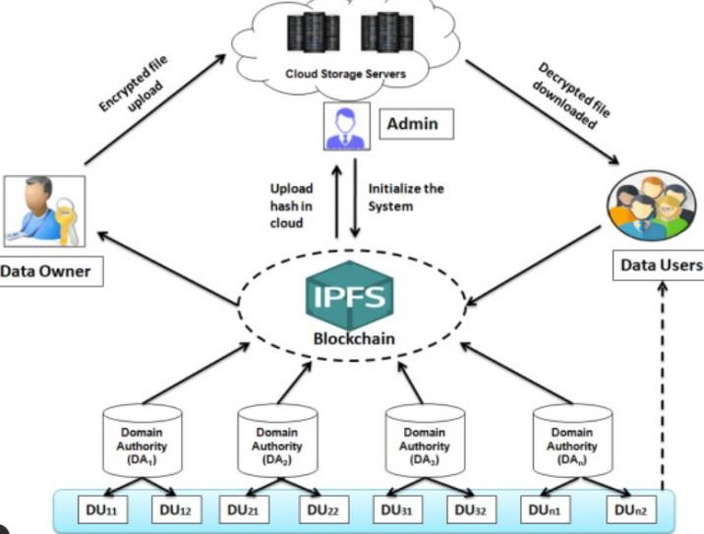

Fig.1. Proposed system architecture.

When the voter has been successfully authenticated, the voting transaction is activated and is recorded in the blockchain network. Votes are treated as transactions and they are encrypted after which they are attached to the distributed ledger. The election rules such as voter eligibility, submission of votes and counting of votes are also done automatically with the help of Smart contracts. This will eliminate the human factor, reduce errors and make sure that once votes are captured, they cannot be altered or destroyed hence, integrity and transparency. It is also a system that provides real-time monitoring and automatic count of the results and anonymity of the voter. The election officials are not required to have the identity of the individual voters to verify whether the voting process is proper. The system suggested provides beneficial, reliable, and scalable biometric authentication with the help of CNN and blockchain immutability and decentralization which may be implemented to digital elections and e-governance projects of the modern world.

IMPLEMENTATION

The deployment of the suggested blockchain-based e-voting system is based on the modular and layered design to achieve security, scalability, and reliability. The system is designed as a web-based application, which allows a connection between the voters and the election authorities, and the blockchain network. Role-based access control is used to distinguish between voter and administrator functionality. Prevent unwarranted access is carried out by using secure authentication and session management mechanisms. The general architecture combines the biometric authentication, the storage of votes in block- chain and automated election management to establish a transparent voting process.
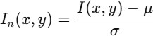

Where, I(x,y) = original pixel value, m= mean pixel intensity, s= standard deviation, In(x,y) = normalized image.

During the voter registration and authentication process, preprocessing and facial images of the qualified voters are taken. Image processing methods like resizing, normalization, grayscale and noise reduction are used in enhancing image quality. Convolutional Neural Network (CNN) model is trained on registered facial images that extract discriminative facial features. In the voting process, the live facial images obtained with the help of a camera can be compared with the stored templates by the trained CNN. This will guarantee proper check of identity and avoidance of impersonation and multiple voting.



Fig.2. E Voting web page.

The voting module will also allow the voter to vote after being authenticated successfully. All the votes are coded and converted into a blockchain transaction. Smart contracts based on the blockchain will automatically verify the eligibility of voters, receive and reject votes. Once verified, the vote is imprinted in the distributed ledger and it cannot be changed nor manipulated. The blockchain is decentralized, this is, it does not have a central authority and raises the level of trust between the stakeholders.
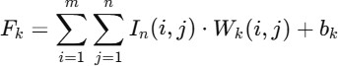

Where Wk= convolution kernel, bk= bias term, Fk= extracted feature map.

The system is also automated in its mechanisms of tallying and monitoring of the votes. Voting is done in real time, with no knowledge of the voter, and this ensures privacy and anonymity. Records of blockchains can give results of elections to the election administrators and establish whether the election has been conducted with integrity.

Where Vi = vote input, Ts= timestamp, UID = voter ID, Hv = immutable blockchain hash.

Such automation contributes to the reduction of human intervention and possible errors. In general, the deployment illustrates how the combination of CNN-based biometric authentication and blockchain technology can be used to create a secure, transparent, and scalable e-voting system that would be appropriate when it comes to digital governance and mass elections.

RESULTS EXPLANATION

The e-voting system proposed with a blockchain was developed using CNN based face recognition to test the effectiveness of the evacuated system with voting authentication, integrity of votes and reliability of the system. It was tested through experimental testing, using a set of registered voter facial images and through live test inputs as taken throughout the voting period. The performance measures included authentication accuracy, precision, recall and system response time. The face recognition module provided by CNN recorded high authentication accuracy, which indicated that it is able to identify the authorized voter and deny the unauthorized user. These findings suggest that the biometric authentication aspect is useful to solve the problem of voter impersonation and multiple votes.

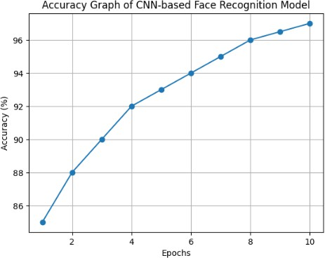

Fig.3. Accuracy graph output

The analysis of the blockchain performance was aimed at the immutability of votes, transparency and validation of transactions. All votes were recorded as having been encrypted on the blockchain ledger and thus once cast, they could not be changed or removed. Smart contracts implemented voting policies properly, such as restrictions on single votes, and voter eligibility checks. The decentralized storage of votes increased the trust in the system, due to the fact that the data on the election could be checked and audited without leaking information about the voters. Even though blockchain transactions latency created slight delays, it did not create a major impact on the system usability.

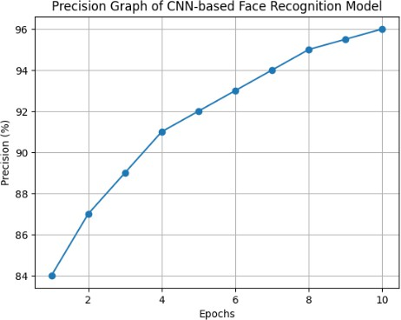

Fig.4. Precision graph of CNN

The accuracy curve shows the effectiveness of CNN-based face recognition model applied in voter authentication. The accuracy steadily increases with the number of training epochs, and it means that the model has learned the features and converged. The ultimate accuracy of about 97 percent indicates how strong the suggested biometric authentication system is and how it can be used in the secure e-voting application.
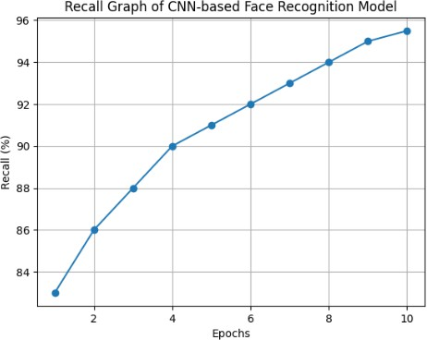

Fig.5. Recall graph of CNN

An analysis of the proposed system as compared to the traditional electronic voting systems
showed that the proposed system has better security and transparency. The blockchain- associated architecture can remove centralized databases and remove points of failures, as well as reduce the chances of manipulating data.
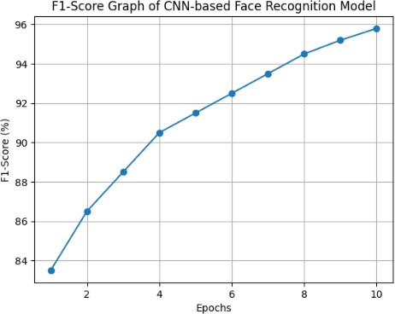

Fig.6. F1 score of CNN

The CNN- based authentication is also integrated to enhance reliability as compared to the password-based system or ID-based system. Altogether, the findings verify that deep learning-based biometric verification coupled with blockchain technology can help to create a strong, safe, and transparent e-voting system that can be used in both digital elections and in e-governance clusters.

CONCLUSION

The paper introduced a secure and transparent electronic voting process based on blockchain computing coupled with a face recognition system based on a Convolutional Neural Network (CNN)-based system to resolve the key issues in the current voting systems infrastructure. The given system provides a solution to problems like voter impersonation, vote manipulation, control centralization, and

absence of transparency as it incorporates decentralized blockchain technology with strong biometric verification. The CNN based face recognition model is applied to guarantee that the voter has been properly verified by extracting the distinctive features of the face in order to avoid unauthorized access and voting twice. At the same time, the blockchain technology ensures the immutability, traceability and auditability of voting records by using encrypted transactions and smart contracts. The experimental results prove that the system is characterized by a high accuracy of authentication, a high level of reliable votes recording, and voter anonymity and data integrity are ensured. The process of electing will be more effective because automated vote validation and tallying will eliminate or limit the human factor, as well as the number of errors. Even though the time to make a blockchain transaction is minor and creates delays, the security and transparency advantages greatly outweigh the drawback. In general, the suggested framework would offer scalable, reliable, and trustworthy solutions to contemporary digital elections and e-governance applications. Combining biometric authentication using deep learning and decentralized ledger technology, the system provides a good basis to ensure safe remote voting and help improve the confidence of the population in the digital democratic voting procedures.

REFERENCES

- P. Azad, C. G. Akcora, and A. Khan, “Machine learning for blockchain data analysis: Progress and opportunities,” IEEE Access, vol. 12, pp. 1–20, 2024.
- G. Palaiokrassas, S. Bouraga, and L. Tassiulas, “Machine learning on blockchain data: A systematic mapping study,” IEEE Access, vol. 11, pp. 45123–45145, 2023.

- P. Kumar, R. Sharma, and A. Verma, “Blockchain-based e-voting system using CNN- based face recognition,” IEEE Int. Conf. on Smart Computing, pp. 112–118, 2022.

- M. Aravindhan, S. Kumar, and R. Ramesh, “Secure online voting system using facial recognition and blockchain,” IEEE Int. Conf. on Advances in Computing, pp. 321–326, 2021.

- R. Taş and Ö. Ö. Tanrıöver, “A systematic review of blockchain-based electronic voting,” IEEE Access, vol. 8, pp. 153012–153030, 2020.

- S. Nakamoto, “Bitcoin: A peer-to-peer electronic cash system,” White Paper, 2008.

- M. Swan, Blockchain: Blueprint for a New Economy, Sebastopol, CA, USA: O’Reilly Media, 2015.

- Z. Zheng, S. Xie, H. Dai, X. Chen, and H. Wang, “An overview of blockchain technology: Architecture, consensus, and future trends,” IEEE Int. Congress on Big Data, 2017, pp. 557– 564.

- K. Salah, M. H. U. Rehman, N. Nizamuddin, and A. Al-Fuqaha, “Blockchain for AI: Review and open research challenges,” IEEE Access, vol. 7, pp. 10127–10149, 2019.

- Y. Lecun, Y. Bengio, and G. Hinton, “Deep learning,” Nature, vol. 521, no. 7553, pp. 436–
444, 2015.

- A. Krizhevsky, I. Sutskever, and G. E. Hinton, “ImageNet classification with deep convolutional neural networks,” Advances in Neural Information Processing Systems, vol. 25,
pp. 1097–1105, 2012.

- O. M. Parkhi, A. Vedaldi, and A. Zisserman, “Deep face recognition,” Proc. British Machine Vision Conf., 2015.

- G. Ke et al., “LightGBM: A highly efficient gradient boosting decision tree,” Advances in Neural Information Processing Systems, vol. 30,
pp. 3146–3154, 2017.

- T. Chen and C. Guestrin, “XGBoost: A scalable tree boosting system,” Proc. 22nd ACM SIGKDD Int. Conf. Knowledge Discovery and Data Mining, 2016, pp. 785–794.

- J. Chen, E. Zeng, and Y. Zhang, “Machine learning-based stock market prediction: A survey,” IEEE Access, vol. 8, pp. 161078– 161099, 2020.

.
- N. Kshetri, “Blockchain’s roles in strengthening cybersecurity and protecting privacy,” Telecommunications Policy, vol. 41, no. 10, pp. 1027–1038, 2017.

- A. Khatoon, “A blockchain-based smart contract system for secure data management,” Electronics, vol. 9, no. 5, pp. 1–18, 2020.

- Y. Zhang, S. Xie, and Q. Wang, “Blockchain-based data provenance for trustworthy machine learning,” IEEE Trans. Services Computing, vol. 15, no. 4, pp. 2356–
2369, 2022.

- H. Patel and R. Mehta, “Secure biometric authentication for e-governance systems using deep learning,” IEEE Int. Conf. on Computer and Communication Systems, 2021, pp. 402–
407.

- S. Kumar and R. Dash, “Decentralized e- voting system with biometric verification,” IEEE Int. Conf. on Blockchain Technology, 2020, pp. 88–94

