A Conceptual Framework for Web-Based Interactive Dashboards in Business Management Using Agile-Oriented Web Design

Abstract

There are numerous enterprises that continue to rely on static reporting and disjointed data, which complicates the ability of managers to monitor performance, identify patterns, and make prompt decisions. These traditional methods often hinder analysis, increase manual effort, and limit adaptability to changing conditions. Interactive dashboards provide an efficient solution by integrating diverse data into a cohesive visual interface, offering real-time insights and improving decision-making efficacy. This article introduces a web-based interactive dashboard that emphasizes four primary features: drilldowns, time interval widgets, advanced data options, and the ability to disclose or conceal chart information. Drilldowns enable users to investigate granular information from summary views, time interval widgets facilitate flexible comparisons across different eras, advanced data options provide control over presented content, and toggling chart values maintains clarity and readability of charts. The dashboard utilizes PHP for server-side processing, CSS for responsive design, and JavaScript libraries such as Chart.js for interactive charts. By integrating these attributes with intuitive online design, the dashboard enables managers to examine data more efficiently, minimize manual reporting, and expedite informed, data-driven decisions.

Keywords: Interactive Dashboard, Data Visualization, Business Management Systems, Web-Based Application, Agile Software Development

Introduction

Companies today generate and handle massive amounts of data across numerous operational domains. Traditional corporate management systems often rely on static reporting and fragmented data sources, obstructing managers from obtaining a comprehensive view of performance. This fragmented approach may lead to prolonged decision-making, increased manual effort, and limited flexibility to changing organizational conditions. Managers frequently face challenges in trend analysis, tracking key performance indicators, and consolidating data from multiple departments, which can negatively affect operational efficiency and strategic planning. As business increasingly rely on data-driven decision-making, there is a pressing need for tools that can integrate, visualize, and clarify complex datasets efficiently.

In the realm of business administration, interactive dashboards have become increasingly significant as instruments for enhancing data visibility and decision-making. Through the consolidation of data into a centralized and visually intuitive platform, dashboards facilitate informed decision-making, trend analysis, and continuous monitoring. Interactive elements, including drilldowns, time interval widgets, sophisticated data options, and the ability to display or conceal chart values, offer users a higher degree of control over data exploration. By reducing manual processing and improving data clarity, these capabilities contribute to more responsive and efficient business operations.

This study aims to illustrate the conceptual design of a web-based interactive interface for business administration that incorporated these essential aspects. The main objective is to demonstrate the capability of an interface to augment management performance, enable informed decision-making, and boost data accessibility. The dashboard utilizes standard web technologies, including PHP for server-side processing, CSS for responsive interface design, and JavaScript libraries like Chart.js for interactive visualizations, to establish a practical framework for incorporating interactive data analysis into daily business operations.

The expected outcome of this work is a user-focused, web-based dashboard that transforms raw business data into actionable insights. The dashboard facilitates dynamic data interaction for managers, enhances information visualization, simplifies analysis, improves operational monitoring, and support expedited, effective, data-driven decision-making across organizational contexts.

LITERATURE REVIEW

Existing research extensively highlights the inadequacies of standard company reporting systems. Conventional reports are often presented as static tables periodic summaries that capture historical performance but provide little support for ongoing analysis. Although these reports are useful for record-keeping, they often lack flexibility, interactivity, and timeliness. As a result, managers may find it difficult to explore data in detail, compare results across different time periods, or react quickly to new issues. In increasingly fast-changing business environments, the continued dependence on manually generated reports and disconnected data sources has been identified as a key obstacle to effective and timely decision-making.

Conversely, interactive dashboards are consistently emphasized as a more effective alternative for business surveillance and analysis. Dashboards consolidate data from multiple sources into a single visual interface, facilitating real-time access to critical information, as emphasized by prior research. Visual components, including charts and graphs, enhance data interpretation, while interactive controls enable users to customize views to suit their requirements. In contrast to static reporting, dashboards support quicker analysis, reduce manual effort, and improve situational awareness. The literature has identified several important advantages of interactive dashboards over traditional reporting approaches, which are summarized in Table 1.

Table 1: Advantages of Interactive Dashboard Compared to Traditional Reporting

Aspect | Traditional Static Reporting | Interactive Dashboard
Data Access | Periodic and delayed | Real-time or near real-time
User Interaction | Limited or none | High, user-driven exploration
Data Exploration | Fixed views | Flexible and dynamic views
Decision Support | Reactive | Proactive and responsive
Reporting Effort | High manual effort | Reduced manual reporting

Interactive elements are a defining characteristic of modern displays, as they enable for comprehensive data analysis. Various frequently used features, such as drilldowns, temporal controls, filtering options, chart customization, and interactive tooltips, are delineated in the literature. These attributes allow users to analyze the fundamental patterns and relationships within the data, thus transcending transient insights. Nevertheless, research suggests that dashboards are most effective when they focus on a carefully selected range of significant features, rather than unnecessary complexity. The most frequently employed interactive dashboard characteristics in business management contexts are illustrated in Table 2, which delineates prevalent characteristics that have been identified in previous studies.

Numerous established systems referenced in the literature illustrate the practical implementation of interactive dashboards in various field [1-10], including business and management contexts [11-30]. Business intelligence platforms and web-based management systems are progressively including dashboard components to facilitate sales monitoring, inventory management, and performance tracking. These systems typically utilize web technologies and JavaScript-based visualization tools to deliver responsive and interactive user experience. Previous implementations demonstrate that dashboards augment transparency, facilitate interdepartmental collaboration, and bolster data-driven decision-making. This work develops a web-based dashboard that emphasizes critical interactive elements and usability, enhancing current studies on successful dashboard design for corporate management applications.

Table 2: Common Features of Interactive Dashboards

Feature | Description
Drilldowns | Navigate from summary data to detailed views
Time Interval Widgets | Compare data across different time periods
Advanced Data Options | Filter, sort, and configure displayed data
Show/Hide Chart Values | Improve visual clarity and focus
Drill-Throughs | Access related data across reports
Cross-Tab Filters | Apply filters across multiple charts
Chart Zoom | Zoom into specific data ranges
Custom Tooltips | Display contextual data on interaction
Dashboard Linking | Connect multiple dashboard views

Many organizations use commercial business intelligence platforms that offer advanced visualization and analytical tools [31-40], but these solutions often come with high licensing costs, require specialized technical skills, and provide limited flexibility for adapting to specific operational needs. The proposed work differs by presenting a lightweight, web-based interactive dashboard that emphasizes simplicity, adaptability, and practical usability. Instead of relying on complex analytical modules, the dashboard focuses on a selected set of essential interactive features; such as drilldowns, time interval widgets, advanced data options, and the ability to show or hide chart values; that directly support everyday business management tasks. Built using standard web technologies, the proposed approach enables easier customization, deployment, and integration without dependence on proprietary platforms. This design highlights a user-centered and cost-effective alternative that retains the core benefits of interactive data visualization while offering greater control over system design and functionality.

METHODOLOGY

This study utilizes the Agile software development methodology to guide the design and creation of the proposed web-based interactive dashboard. Agile was chosen for its iterative characteristics, adaptability, and focus on ongoing user feedback, which are ideal for systems necessitating regular enhancement of functionality and user interfaces. The Agile lifecycle in this context consists of iterative phases: planning, analysis, design, implementation, testing, and evaluation. Each iteration facilitates the progressive enhancement of dashboard functionalities, permitting modifications based on usability assessments and changing business needs. This approach supports early identification of issues, improves system quality, and ensured alignment between technical development and user needs. The Agile software development workflow utilized in this investigation is depicted in Figure 1, which emphasizes the iterative stages of planning, design, implementation, testing, and review.
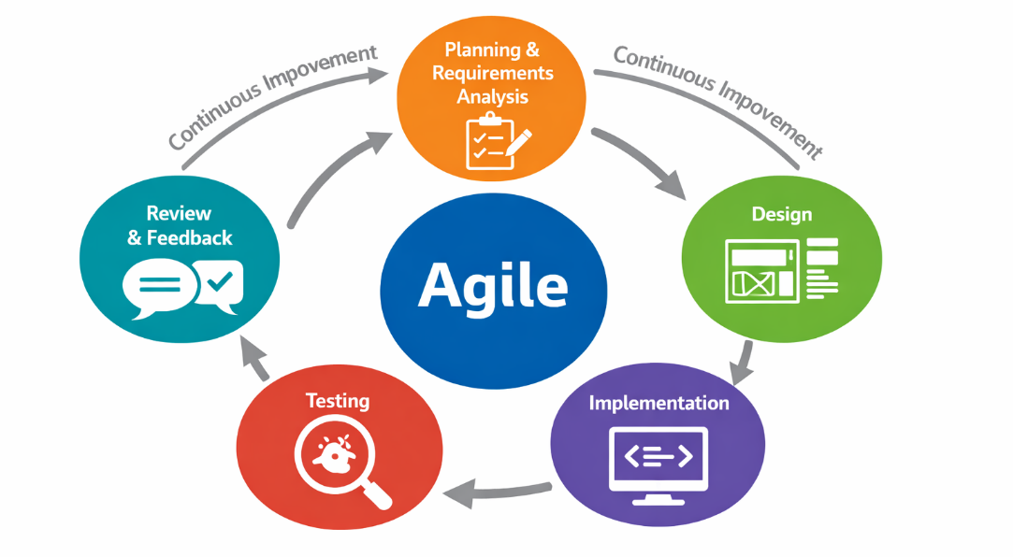
Figure 1: Agile software development workflow for the proposed interactive dashboard

Planning

The planning phase is the first step in the Agile software development lifecycle and sets the foundation for the interactive dashboard work. At this stage, the work’s primary objectives are established by evaluating current business challenges and user expectations for the system. Stakeholder feedback is analyzed to delineate the dashboard’s scope. Ascertain the date to be shown, and pinpoint the essential interactive features to incorporate.
High-level requirements are then organized and prioritized into development iterations to allow addition, possible risks, technical limitations, and system dependencies are identified early to help avoid issues later in the development process. Overall, this planning phase provides a clear path for development, ensuring that the work remains focused, practical, and user-centered throughout the Agile lifecycle.

Analysis

The analysis phase involves comprehensively analyzing the problem the interactive dashboard aims to address and delineating the system’s required functionalities. This phase involves an examination of existing company reporting processes to pinpoint prevalent issues, including static reports, restricted data flexibility, and delays in obtaining pertinent information. This assessment highlights the need for a more engaging and adaptive dashboard. Analyzing requirements involves three primary activities: technological analysis, user analysis, and project analysis.

The primary objective of user analysis is to ascertain the individuals who will utilize the interface, the information they require, and the manner in which they interact with data in their daily work. By analyzing user roles and expectations, the system requirements can be customized to facilitate genuine decision-making tasks. Technical analysis is performed to assess the viability of the proposed solution by identifying suitable technologies, data sources, and system restrictions. This includes considering performance, integration, and scalability issues. Together, these analyses bring business needs, user perspectives, and technical considerations into a single view, creating a clear and practical foundation for the design and development phases that follow.

Design

The design process entails transforming the concepts and requirements from the analytical phase into a definitive plan for developing the interactive dashboard. The method commences by outlining the system architecture, detailing the data flow, server information processing, and user engagement on their devices. This phase ensures that the dashboard can support interactive features, display data efficiently, and uphold stability and scalability. Subsequently, storyboards are developed to visually delineate the primary screens, navigation pathways, and positioning of essential features. Storyboards allow the team to envision user interactions with the dashboard and support design alterations before coding begins. The user interface is crafted to be intuitive and user-centric, incorporating fluid navigation, readily accessible input buttons, and outputs presented clearly and comprehensibly. Design metaphors promote intuitive interactions, while charts, icons, and other visual elements
augment the dashboard’s engagement and informational value. The design phase emphasizes usability and visual clarity, ensuring the dashboard is both functional and appealing, so building a solid foundation for the development phase.

Implementation

The implementation phase is where all planning and design efforts converge, resulting in the formation of the interactive dashboard. The process commences with the configuration of the development environment, ensuring that both server and client-side tools are prepared and that the system architecture facilitates seamless functionality. PHP oversees data processing and server functions on the backend, while CSS and JavaScript augment the dashboard with a responsive, user-centric, and visually appealing interface. Interactive charts and visualizations, built using tools like Chart.js, let users dive into data instantly and uncover insights in real time.
To keep the development process smooth and reliable, version control and configuration management are used, so every change is carefully tracked, collaboration among the team stays organized, and the system remains stable as new features are added. Following the Agile methodology, development happens in short, iterative cycles of coding, testing, and refinement. Each cycle focuses on building functional parts, checking usability, and improving based on feedback. Step by step, the dashboard grows from a simple prototype into a fully functional, user-friendly, and dependable system that not only meets technical requirements but also truly supports the people who will use it every day.

The implementation step involves converting the dashboard design into a fully operational system and developing the requisite interactive features that facilitate intuitive data exploration. This study implements and evaluated four key components to enhance administrative data analysis: drilldowns, time interval widgets, advanced data options, and the capability to display or hide chart values. Each feature is crafted to afford administrators adaptable control over the date they oversee, facilitating real-time decision-making and streamlining intricate reporting duties.

Drilldowns: By selecting a product from a summary graphic, users can access detailed monthly sales data for that product.

Time interval widgets: Prompt the administrator to select the desired time frame – yearly, monthly, or weekly sales; using buttons, allowing dynamic adjustment of the displayed data according to business needs.

Advanced data options: Allow the administrator to view the underlying sales data in a table format directly from the charts. By selecting a chart and clicking a settings button, the raw data appears in a structured table, providing both visual and tabular perspectives.

Show or hide chart values: Allows the administrator to choose which data series to display, making it easier to focus on the information that matters most and avoid being overwhelmed by too much data.

The implementation of these functionalities utilizes PHP or backend data processing, CSS for style, and JavaScript libraries like Chart.js for interactive charting. They collectively embody the heart of the dashboard’s interactivity, allowing administrators to efficiently and effortlessly analyze and modify data.

Table 3 summarizes the implementation approach and advantages of the four interactive dashboard features: drilldowns, time interval widgets, advanced data options, and show or hide chart values; highlighting how each feature was designed and developed to support administrative data exploration and decision-making.

Table 3: Implementation and benefits of the interactive dashboard features developed in this study

Feature Name | Description/Implementation in this Study | Advantage/Benefit in This Study | Figure of Feature Designed & Implemented
Drilldowns | Allows admin to click on a specific product to view monthly sales details. Implemented using Chart.js click events and PHP to fetch detailed data. | Provides detailed insight into individual product performance without cluttering the main dashboard. Enables deeper, actionable analysis. | Product drilldown showing monthly sales  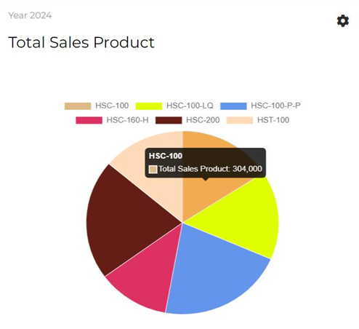  - Drilldowns Feature (Before)  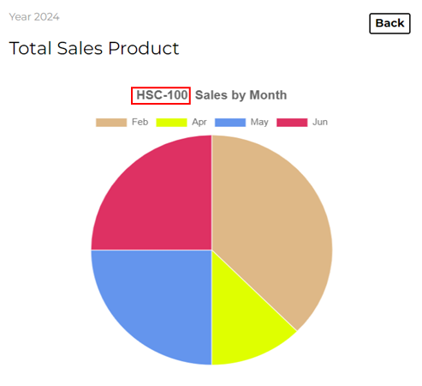  - Drilldowns Feature (After)
Time Interval Widgets | Button allow admin to choose the time frame (yearly, monthly, weekly) to display sales data. Implemented using JavaScript event listeners and dynamic data queries via PHP. | Offers flexibility to analyze trends over different periods, supporting timely decision-making. | Time interval selection buttons  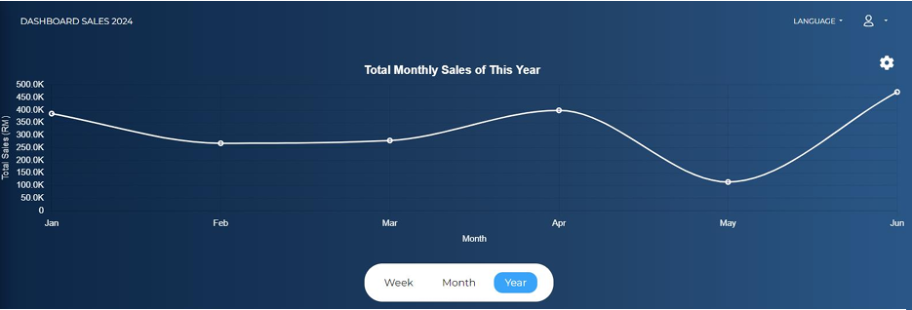  - Yearly Sales  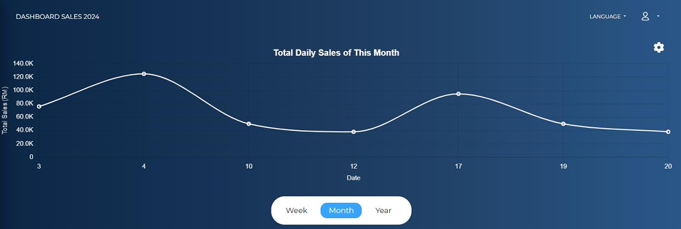  - Monthly Sales  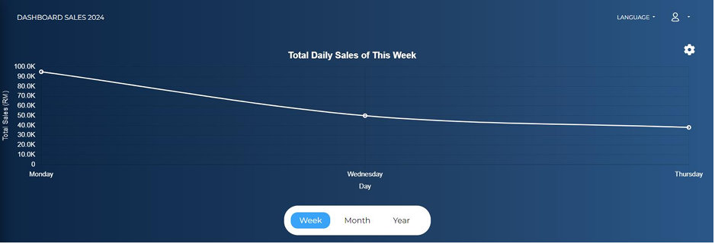  - Weekly Sales
Advanced Data Options | Admin selects a chart and clicks a settings button to view the underlying raw sales data in table form. Implemented using a combination of Chart.js and PHP to render the table dynamically. | Provides dual perspectives (visual and tabular), allowing administrators to verify chart data and gain more detailed insights | 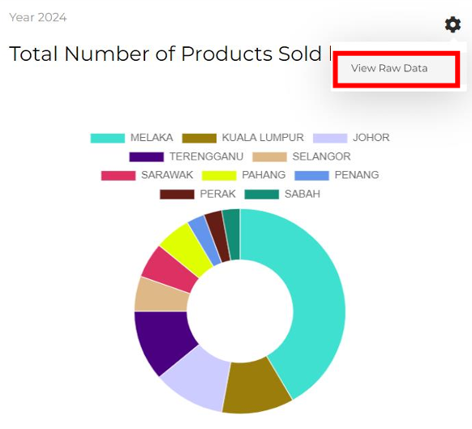  - Settings button in chart  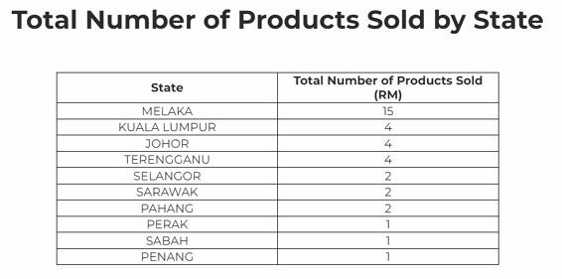  - Raw data displayed in table
Show or Hide Chart Values | Let admin toggle specific data series in a chart on or off. Implemented using Chart.js dataset visibility toggles. | Reduces information overload by focusing only on relevant data, improving clarity and user control. | Toggle chart values button  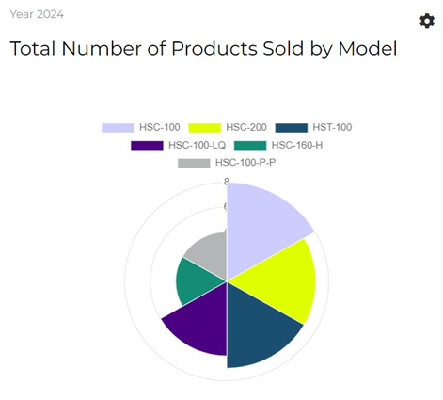  - Show Chart Value  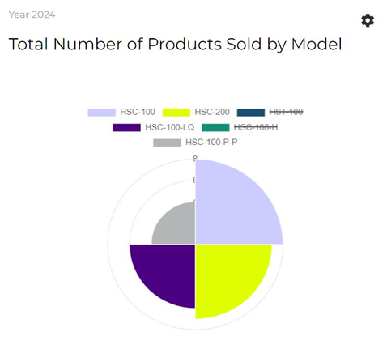  - Hide Chart Value

DISCUSSION

The interactive dashboard system exhibits both advantages and drawbacks, which can be assessed to ascertain its efficacy in achieving the specified goals and facilitating corporate management functions. The evaluation process, executed during the testing phase, is crucial for identifying key elements by integrating user feedback and performance observations. This evaluation highlights the system’s practical utility and identifies areas for improvement, ultimately boosting the overall quality and usability of the dashboard.

User feedback from the evaluation phase pointed out a few areas where the system could be improved. For instance, not having a data export or printing option makes it less convenient for users who need to keep proper records as part of their daily work. Several users encountered challenges in concentrating on certain features due to the inability the magnify the charts or view them in full screen. Furthermore, the popup windows were regarded as quite intrusive, as they can interrupt workflow and reduce the overall smoothness of the experience. In conclusion, while the system fulfills its core function, feedback suggests that simple improvements could boost user comfort and functionality.

Despite the existence of these constraints, the interactive interface demonstrates a unique advantage in surmounting the typical challenges associated with traditional reporting systems. The system enhances the speed and precision of processes by reducing the need for manual labor through the automation of data visualization and calculations. It additionally enables users to access pertinent information more promptly, thereby facilitating the review and analysis of data in a timely manner. The dashboard also presents information in a structured and organized manner, which assists users in making more informed decisions and gaining a better understanding of performance trends. On the whole, these features enable more efficient and manageable work processes, which in turn contribute to more streamlined daily operations.

Subsequent to the assessment results, numerous improvements are suggested to strengthen the system. Improving the user interface design to enhance visual attractiveness and reduce intrusiveness will elevate overall user happiness. Incorporating further services, like data export capabilities and enhanced chart interaction elements, would augment the system’s utility. Integration with external platforms, such as social or communication tools, may enhance the system’s usability and accessibility.

The interactive dashboard signifies advancement in the modernization of commercial data management techniques. By addressing the identified limitations and incorporating user-driven improvements, the system has considerable potential to evolve into a more robust, efficient, and user-focused solution that enhanced decision-making and operational performance.

This study’s results indicate that the implementation of an Agile approach in web design can be highly beneficial when developing interactive displays for business purposes. By developing the system step by step and keeping user needs at the center, the dashboard can easily adapt as requirements change over time. Features like drilldowns, time-based view, detailed data options, and flexible chart controls make it much easier to explore and understand their data. Instead of making things overly complicated, the framework keeps the design simple, clear, and flexible, so users can work with the date more naturally and make quicker decisions. In the end, this study shows that even with basic web technologies, a well-thought-out and user-friendly dashboard can make a meaningful difference in everyday business work.

CONCLUSION

To summarize, this study’s objectives were met satisfactorily. The interactive dashboard addresses the need for a more efficient approach to manage and visualize corporate data. During the literature review, several existing systems were examined and compared to better understand what makes an interactive dashboard useful and practical. This process helped clarify the problem being addressed, ensured that the work remained relevant, and supported the development of clear and well-defined system requirements.

The design phase then played an important role in turning these requirements into meaningful features and functionalities. Key interactive elements were carefully selected and refined to match user needs and system goals. The final dashboard achieves a mix between practical functionality and user-centric design. The system illustrated how an interactive dashboard can facilitate a more lucid and effective approach to data management, enhancing comprehension and streamlining daily operations.

This study presents a simple and practical framework for building web-based interactive dashboards for business management by combining Agile development with user-focused web design. The goal is to address common issues found in traditional reporting systems, such as rigid reports, slow access to information, and limited interaction with data. Employing an Agile methodology enhances the development process’s flexibility, facilitating incremental system improvements informed by user feedback. Simultaneously, the integration of interactive elements, including drilldowns, temporal selection, advanced data visualization, and customizable chart displays, enables more comprehensive data exploration and comprehension. The utilization of widely recognized web technologies such as PHP, CSS, and JavaScript illustrates that dashboards can be developed in a straightforward and accessible manner.

Overall, the framework shows how interactive dashboards can make everyday work feel simpler and more manageable. When data is presented in a clear and organized way, it becomes much easier for users to find what they need, notice patterns, and make confident decisions. While this work lays a strong foundation, there is still room to grow, whether by improving the user experience, adding more useful features, or linking the system with other tools. In the end, this study highlights the value of building dashboards that are not only functional, but also easy to use and genuinely helpful in real working environments.

ACKNOWLEDGEMENT

This research constitutes the culminating project in Information and Communication Technology undertaken at the Faculty of Information and Communication Technology, Universiti Teknikal Malaysia Melaka (UTeM). The authors express their profound gratitude to UTeM for its tremendous support, resources, and advice during this work. We are deeply grateful to all participants who dedicated their time, effort, and insights, as their involvement was essential to the successful completion of this study. The commitment and collaboration of all participants have greatly enhanced the research process and results.

REFERENCES

- Dong E, Du H, Gardner L. An interactive web-based dashboard to track COVID-19 in real time. The Lancet infectious diseases. 2020 May 1;20(5):533-4.
- Perdue LA, Trevino SD, Grant S, Lin JS, Tanner‐Smith EE. Creating Interactive Data Dashboards for Evidence Syntheses. Cochrane Evidence Synthesis and Methods. 2025 Jul;3(4):e70035.
- Bach B, Freeman E, Abdul-Rahman A, Turkay C, Khan S, Fan Y, Chen M. Dashboard design patterns. IEEE transactions on visualization and computer graphics. 2022 Sep 26;29(1):342-52.
- Schulze A, Brand F, Geppert J, Böl GF. Digital dashboards visualizing public health data: a systematic review. Frontiers in Public Health. 2023 May 4;11:999958.
- Cisdeli P, Santiago GN, Hernandez C, Carcedo A, Prasad PV, Stamm M, Lingenfelser J, Ciampitti I. A digital interactive decision dashboard for crop yield trials. Computers and Electronics in Agriculture. 2025 Apr 1;231:110037.
- Arjun S, Murthy LR, Biswas P. Interactive sensor dashboard for smart manufacturing. Procedia Computer Science. 2022 Jan 1;200:49-61.
- Meier FL, Jäger L, Senn O, Markun S, Burgstaller JM. Effectiveness of interactive dashboards as audit and feedback tools in primary care: A systematic review. Plos one. 2025 Jun 27;20(6):e0327350.
- Li R, Qu QX, Lu Z. Interactive design of digital car dashboard interfaces. InInternational Conference on Digital Human Modeling and Applications in Health, Safety, Ergonomics and Risk Management 2017 May 14 (pp. 343-353). Cham: Springer International Publishing.
- Chen CM, Wang JY, Hsu LC. An interactive test dashboard with diagnosis and feedback mechanisms to facilitate learning performance. Computers and Education: Artificial Intelligence. 2021 Jan 1;2:100015.
- AlAbdulaali A, Asif A, Khatoon S, Alshamari M. Designing multimodal interactive dashboard of disaster management systems. Sensors. 2022 Jun 5;22(11):4292.
- Rahman MA, Alam MS, Mrida MS. How interactive dashboards improve managerial decision-making in operations management. American Journal of Advanced Technology and Engineering Solutions. 2025 Feb 14;1(01):122-46.
- Martins N, Martins S, Brandão D. Design principles in the development of dashboards for business management. InPerspectives on design II: research, education and practice 2021 Oct 2 (pp. 353-365). Cham: Springer International Publishing.
- Sultana R. Artificial intelligence in data visualization: Reviewing dashboard design and interactive analytics for enterprise decision-making. International Journal of Business and Economics Insights. 2025 Sep 15;5(3):01-29.
- Zingde S, Shroff N. The role of dashboards in business decision making and performance management. A Road Map to Future Business; Institute of Management, Nirma University: Ahmedabad, India. 2020 Nov;227.
- Linden I. Proposals for the integration of interactive dashboards in business process monitoring to support resources allocation decisions. Journal of decision systems. 2014 Jul 3;23(3):318-32.
- Eckerson WW. Performance dashboards: measuring, monitoring, and managing your business. John Wiley & Sons; 2010 Nov 9.
- Harris F, Tanner P. The Impact of Interactive Dashboards on Managerial Performance in Global Supply Chain Operations. ScienceOpen Preprints. 2025 Nov 28.
- Kobi J. Developing dashboard analytics and visualization tools for effective performance management and continuous process improvement. International Journal of Innovative Science and Research Technology (IJISRT). 2024 Jun;9(10.38124).
- Kothandapani HP. Drivers and barriers of adopting interactive dashboard reporting in the finance sector: an empirical investigation. Reviews of Contemporary Business Analytics. 2019;2(1):45-70.
- Shilnikova EV, Odinokov SA. Bilding the dashboard to monitor and analyze data when forecasting risks in integrated management systems. In2020 International Conference Quality Management, Transport and Information Security, Information Technologies (IT&QM&IS) 2020 Sep 7 (pp. 27-31). IEEE.
- Kahl G, Warwas S, Liedtke P, Spassova L, Brandherm B. Management dashboard in a retail scenario. InWorkshop on location awareness in dual and mixed reality. International conference on intelligent user interfaces (IUI-11) 2011 (pp. 22-25).
- Furmankiewicz J, Furmankiewicz M, Ziuziański P. Implementation of business intelligence performance dashboard for the knowledge management in organization. Zeszyty Naukowe. Organizacja i Zarządzanie/Politechnika Śląska. 2015.
- Wyne MF, Reeves J, Montes FX, Gurbach TJ. Business intelligence dashboard for academic program management. In2015 ASEE Annual Conference & Exposition 2015 Jun 14 (pp. 26-312).
- Santiago Rivera D, Shanks G. A dashboard to support management of business analytics capabilities. Journal of Decision Systems. 2015 Jan 2;24(1):73-86.
- Abd Rahman NH, Basir MZ. User-Cantered Analytics Dashboard Design for Effective Business Management Decisions. International Journal of Advanced Research in Computational Thinking and Data Science. 2025;8(1):13-22.
- Msibi NC, Mkhwanazi S, Mazibuko S. Designing digital dashboards for business performance: Principles and evidence. International Journal of Information Systems. 2025 Oct 10;12(4):88-103.
- Rahman MA, Alam MS, Mrida MS. How interactive dashboards improve managerial decision-making in operations management. American Journal of Advanced Technology and Engineering Solutions. 2025 Feb 14;1(01):122-46.
- Gami SJ, Shah K, Katru CR, Nagarajan SK. Interactive data quality dashboard: Integrating real-time monitoring with predictive analytics for proactive data management. International Journal of Computer Sciences and Engineering. 2024;12(3):89-98.
- Limrattanabunchong C, Kajornkasirat S. A Business Intelligence Dashboard to Enhance Decision-Making Using Machine Learning. In2025 IEEE International Conference on Industrial Technology & Computer Engineering (ICITCE) 2025 Sep 13 (pp. 93-98). IEEE.
- Burnay C, Lega M, Bouraga S. Business intelligence and cognitive loads: Proposition of a dashboard adoption model. Data & Knowledge Engineering. 2024 Jul 1;152:102310.
- Balakrishnan C, MR PK, Gajalakshmi P, Palaisamy G. Advanced Visualization Tools, Algorithms, and Techniques: Advancements and Applications Across Domains. In2025 11th International Conference on Communication and Signal Processing (ICCSP) 2025 Jun 5 (pp. 1-6). IEEE.
- Uddin MK. A review of utilizing natural language processing and AI for advanced data visualization in real-time analytics. Global Mainstream Journal. 2024 Apr 20;1(4):10-62304.
- Goel PK. Advanced Data Visualization Methods for Predictive Analytics in Business. InData Visualization Tools for Business Applications 2025 (pp. 45-66). IGI Global Scientific Publishing.
- Osamika D, Adelusi BS, Kelvin-Agwu MT, Mustapha AY, Forkuo AY, Ikhalea N. A review of data visualization tools and techniques in public health: Enhancing decision-making through analytics. World Sci. News. 2025;203:401-38.
- Liang H, Liu W. DrBioRight: an AI research assistant for cancer data analysis. Cancer Research. 2026 Apr 3;86(7_Supplement):16-.
- Liu Y, Draetta EL, Caughlin KR, Lau A, Fonseca A, Chu T, Cho KS, Dai Y, Liu Y, Wang J, Jiang J. A unified framework for cross-platform spatial omics analysis and deep spatial profiling. Cancer Research. 2026 Apr 3;86(7_Supplement):5505-.
- Telmoud CA, Tourad MC, Lachgar M, Nanne MF. AIoTU: An open-source IoT and machine learning platform for smart agriculture and yield prediction. SoftwareX. 2026 Jun 1;34:102613.
- Kokošar J, Turkay C, Ausec L, Štajdohar M, Zupan B. Visual analytics framework for survival analysis and biomarker discovery from gene expression data. PloS one. 2026 Mar 20;21(3):e0325399.
- Othman NA, Uyop NY, Osman MN, Sedek KA. Interactive Big Data Visualization for Child Mortality Risk Among Children Aged 5–14 in Asia. Journal of Computing Research and Innovation. 2026 Mar 1;11(1):72-83.
- Aguero J, Garces-Iniesta JJ, Calvo-Asensio M, Vila-Frances J, Moreno A, Lozano-Edo S, Gil-Molina M, Murillo-Varona G, Rad-Garcia G, Rodriguez-Serrano M, Buendia-Fuentes F. Advanced data analytics workflow in echocardiography: application in patients with aortic stenosis. European Heart Journal-Cardiovascular Imaging. 2026 Jan;27(Supplement_1):jeaf367-004.

