Design and Development of a Low-Cost Mobile Robotic Arm for Industrial Automation and Future Multimodal Control Integration

Glory E
Department of Electronics and Communication Engineering, Chennai Institute of Technology Chennai, Tamil Nadu, India gloryezhil11@gmail.com
Neha S
Department of Electronics and Communication Engineering, Chennai Institute of Technology Chennai, Tamil Nadu, India nehasuresh0409@gmail.com

Abstract- This project is about making a cheap, self- driving mobile robot with a small robotic arm that can do simple pick-and-place tasks. An Arduino UNO, a four-wheel drive base, and a 4-DOF servo arm make up the system. IR sensors help the robot follow paths on the floor, and an ultrasonic sensor helps it stop before it hits something. The robot can move on its own, pick up light objects, and go back to where it started without any help from a person. Tests done in a controlled indoor setting showed that the prototype can reliably follow paths, avoid simple obstacles, and pick up small things. The main point is to show that you can get useful warehouse-style automation with cheap parts and simple logic. This makes the system good for learning, small labs, and small businesses that want to automate but can't afford to buy expensive industrial robots.
Keywords- Arduino, Mobile Robotic Arm, Embedded Systems, Line Following, Ultrasonic Obstacle Detection, Pick-and-Place Robot, Industrial Automation.

INTRODUCTION
People still perform basic tasks like moving objects and repeatedly performing the same tasks in many locations, such as warehouses, small factories, and labs. For this, large corporations employ expensive robots, but small and medium-sized businesses cannot afford them. They require special setup or fixed tracks to function, are too costly, and are difficult to maintain.
Large robotic arms and standard AGVs typically follow a predetermined route or remain stationary. As a result, they are useless in small spaces with limited space or a constantly changing layout. Therefore, there is a need for inexpensive, adaptable robots that can move around and pick objects without requiring a lot of setup. Robots that use the same system to move and pick are known as mobile manipulators. This is helpful because it eliminates the need for people to perform
repetitive tasks because the robot can go to the object on its own and lift it.
In this project, we created a mobile robot with a tiny robotic arm that is based on Arduino. It makes use of:
- Four-wheel drive for transportation,
- IR sensors for following lines,
- An ultrasonic sensor to stop ahead of obstacles
- A 4-DOF servo arm for selecting light objects.
The primary goal is to determine whether inexpensive, basic parts like Arduino, basic servos, and common sensors can still be used for automation. The robot was tested to see if it could pick light objects without falling, stop when something was in front of it, and follow a line correctly.
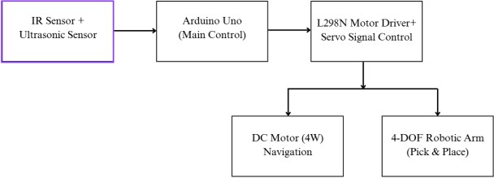

Figure 1: Workflow Flow

LITERATURE REVIEW
Because they can move, see their surroundings, and pick things without much assistance, robots are becoming more and more common in today's warehouses and logistics areas. According to many researchers, using multiple sensors yields better results than relying solely on one. For instance, Ušinskis et al. [1] demonstrate that combining inertial, infrared, and ultrasonic sensors enhances

navigation in dynamic industrial layouts. Additionally, Shili et al. [2] discuss an energy- efficient sensor fusion setup that is helpful for small embedded systems. Taleb et al. [3] note that the A* algorithm is still a reliable and good choice for indoor movement when it comes to route planning, which aligns with the concept employed in this project.
For Industry 4.0, mobile manipulators—basically, robots with the ability to move and pick and place— are becoming more prevalent. They lessen human labor and help cover more workspace. The usefulness of these robots for autonomous pick- move-place is discussed by Ghodsian et al. [7]. OMNIVIL, a mobile manipulator that safely interacts with people in model factories, is demonstrated by Engemann et al. [8]. Vatavuk et al.
[9] describe how a robot used RGB-D cameras and planning tools to move bricks during MBZIRC 2020. Additionally, Brightpick's Autopicker ([25]) demonstrates how mobile robots and arms are already being used for order picking in real warehouses, which further demonstrates the relevance of this project.
Additionally, low-cost or cost-effective platforms for small businesses are becoming more and more popular. AhaRobot, a low-cost dual-arm robot for research, was created by Cui et al. [11]. BEAM-1 was introduced by Peng et al. [12] for recycling tasks involving learned perception. Similar to the direction of our prototype, these works demonstrate that small and compact systems can still perform beneficial industrial tasks.
Positive perception is crucial for warehouse picking. A system that used deep learning to complete over 500,000 pick-and-place cycles and achieved 25– 30% better performance is demonstrated by Hudson et al. [6]. A low-cost bin-picking system that detects objects in cluttered areas using RGB + depth was developed by Gupta et al. [10]. Yao et al. [5] trained robots to push obstacles to clear their path, and Yang et al. [4] used reinforcement learning to determine when a robot should move or push objects. These concepts encourage combining adaptive behavior with classical A*, which we might employ in upcoming improvements.
Some researchers also try Arduino for automation because it’s cheap and easy to work with. Srivastava et al. [13] made a robot mixing Arduino + Raspberry Pi for ML obstacle avoidance. Asfora [14] built a line follower using Arduino and a camera. Yousefi
[16] showed a low-cost pick-and-place arm. These show that even on small boards, good results are possible. Other works show Arduino robots helping humans directly: Emu et al. [18] created a voice- controlled feeding robot for disabled users, and Benzi et al. [19] talk about a safe control method so
humans and robots can carry things together.
In short, the current research shows that:
- Low-cost mobile manipulators are possible
- Multi-sensor systems perform better
- A* is still a strong option for indoor navigation
But many of the existing systems either use expensive hardware or only focus on one part (like only navigation or only picking). There are not many works that combine Arduino, multi-sensor navigation, A path planning*, and automatic pick- and-place in one compact system for warehouse- style use. This is the research gap, and this project tries to fill that gap by using ultrasonic + IR sensors, 4-wheel base, and a 4-DOF arm for a self-working low-cost warehouse robot.
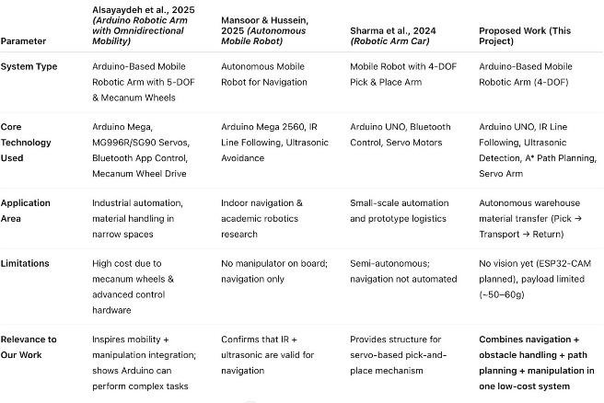

SYSTEM ARCHITECTURE

This system is basically a budget-friendly mobile robot that can drive itself around, grab and move small objects, and dodge obstacles—think of it as a simple warehouse robot. The whole thing breaks down into three main parts: the drive system, the robotic arm, and the sensor pack. Everything runs through an Arduino UNO, which sits at the heart of the setup and calls the shots. These pieces all talk to each other in a semi-autonomous loop. The sensors are always scanning the world around the robot. The Arduino takes in this data and fires off commands to the motors or servos based on what it sees. This cycle just keeps going, so the robot can react in real time to whatever pops up in its path. The system’s laid out in clear blocks, so you can see exactly how each section links up and communicates.

Power Supply Unit
A single battery powers the whole robot, feeding juice to the Arduino and every other part. It uses a 12V DC battery as the main power source. The

motors take the full 12V, while a regulated 5V line feeds the servos and control circuits. This battery packs enough punch to run all four DC motors and four servos at the same time without losing voltage.

Control Unit (Arduino UNO)
The Arduino UNO is the robot’s brain. It reads the sensor data and decides what to do next. It runs the line-following logic, processes signals, sends out PWM to control motor speed, tells the servos where to move, and stops or reacts if it spots something in the way. Right now, everything is one-way—the Arduino just gives commands, and nothing talks back. This is just a prototype, so no feedback loop yet.

Motor Driving Stage (L298N Module)
An L298N motor driver handles all four DC motors, letting the robot steer each side independently. That way, it can go forward, back, turn, or spin on the spot. Speed is controlled using PWM, and the module includes basic thermal and overload protection to keep things safe.

Sensor Perception System
The robot uses IR sensors and an ultrasonic sensor to sense its surroundings. The IR sensors spot black and white lines for navigation, and the ultrasonic sensor watches for obstacles, stopping the robot if it gets too close.

Robotic Arm Manipulation Unit
There’s a 4-DOF robotic arm riding on top, ready to handle objects. Servo motors move the base, shoulder, elbow, and gripper, all managed by a driver board. The arm can pick up small items— anything around 50 to 60 grams—and puts them down with decent accuracy.

Overall Block Diagram
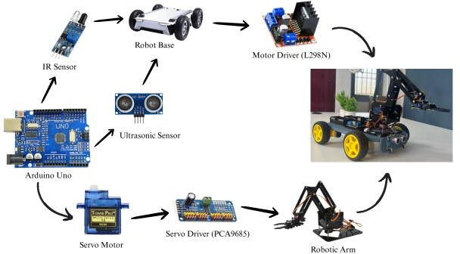

Figure 2: Overall Block Diagram

Task Execution Flow
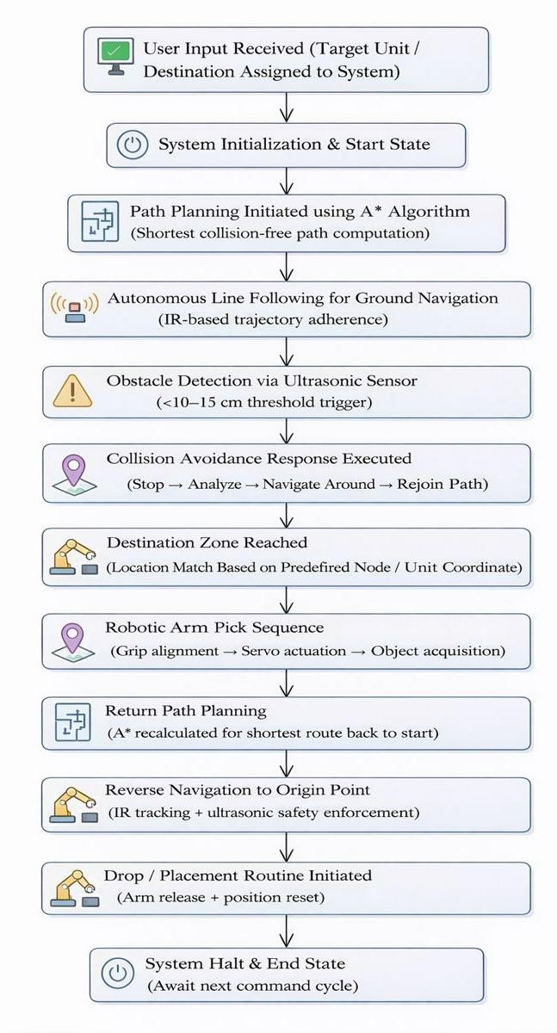
Figure 3: Task Execution Flow

WORKING PRINCIPLE
This robot’s pretty impressive, honestly. It just rolls around on its own, scoops up small stuff, dodges whatever’s in its way—and get this, it does all that with just a basic sensor setup and a simple robotic arm. For getting around, it chops its workspace into little squares and runs a straightforward A* algorithm to pick out the quickest, safest route. It’s always watching for obstacles, never missing a beat.

Task Initialization
You tell the robot what you want—where to go, what to grab. It maps your target to a spot in its workspace. As soon as you give the signal, the Arduino UNO kicks everything into gear: motors, servos, sensors, the whole deal. Once it’s ready, the robot just hangs out, on standby, waiting for your green light.

Path Planning and Navigation
Once it’s got its marching orders, it runs the A* algorithm and picks the best path. It checks out all the options, then settles on the shortest, safest way through. With four wheels, it can turn on a dime by changing the speed on each side. IR sensors keep it

tracking a dark line on the floor, making sure it doesn’t wander off. The Arduino is always keeping an eye out, tweaking motor speed if the robot starts to drift.

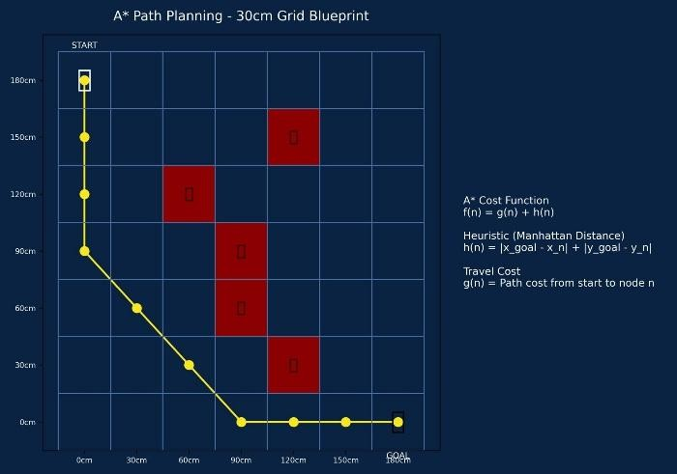
Figure 4: Path Planning and Navigation

Obstacle Detection and Avoidance
While it’s rolling along, an ultrasonic sensor keeps scanning ahead. If something pops up close—like within 10 or 15 centimeters—it hits the brakes and flips into avoidance mode. Sometimes it just waits for whatever’s in the way to move. Other times, it steers around and jumps right back onto its path. Either way, it knows how to stay out of trouble.

Object Handling and Return
Once the robot gets to its target, it gets down to business. The 4-DOF arm runs through its steps to grab the item. The gripper handles small things easily—50 or 60 grams, no problem. After it picks up the object, the robot figures out the way back, using the same navigation tricks, and drops the item off where you want it. When it’s finished, it heads back home and waits for the next job.

HARDWARE IMPLEMENTATION
This robot keeps things simple and affordable, but it actually does what you need. It cruises around on four wheels, grabs and drops stuff with a 4-DOF arm, and uses sensors to dodge whatever’s in the way. Everything runs off an Arduino UNO, which makes life easier. The main idea here? Build a robot that moves smoothly, dodges obstacles, and handles basic pick-and-place jobs—no fancy extras, no big spending.

Microcontroller Unit
The Arduino UNO runs the show. It reads the sensors, drives the motors, and controls the arm.Inside, you’ve got an ATmega328P chip at 16
MHz. It supports UART, I2C, and SPI, so hooking up motor drivers or servos is pretty easy. We picked the UNO because it’s cheap, everywhere, and the libraries cut down on debugging headaches.

Locomotion and Motor Driver
This thing moves using a four-wheel differential drive. The left and right wheels spin at different speeds, so turning feels smooth. An L298N motor driver handles all four DC motors, giving you forward, reverse, spins, and sharp turns. The Arduino sends out PWM signals to control the speed. It’s really made for indoor spaces—labs, small warehouses, that sort of place.

Sensor Integration
IR sensors help it follow lines, spotting the difference between a black line and the floor. There’s also an ultrasonic sensor up front to catch obstacles. If something pops up, the robot either stops or steers away so it doesn’t crash.

Sensor | Purpose | Placement
IR Sensors (x2) | Line following | Underside of chassis
Ultrasonic Sensor | Obstacle detection | Front side of chassis

Manipulator and Power System
A 4-DOF arm does the grabbing, powered by
servos picked for the right amount of force. A 12V battery keeps everything running, and voltage regulators bring that down to 5V for the Arduino,
sensors, and servos. With capacitors and regulators in place, the power stays steady, so the robot doesn’t glitch out halfway through a task.
DOF | Joint | Purpose
1 | Base Rotation | Align arm with object
2 | Shoulder Lift | Vertical reach adjustment
3 | Elbow Joint | Forward extension of arm
4 | Gripper | Object gripping and release

Chassis Structure
The chassis is built from acrylic or PVC sheets, so it’s both lightweight and sturdy. Everything’s laid out to keep the robot balanced—even when the arm’s swinging around or lifting something.

Completed Hardware Model
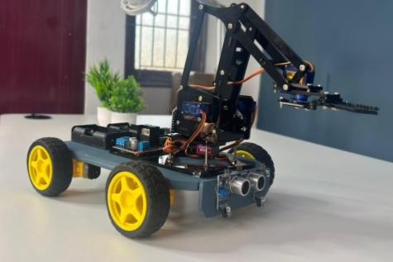
Figure 5: Completed hardware model

RESULTS AND DISCUSSION
This Arduino robot—with its own little robotic arm—went through a bunch of indoor tests to see how well it could move, dodge stuff, and actually pick things up. I watched everything: how closely it stuck to the path, whether it caught obstacles when it should, how often it managed to grab things, and how fast it got through each task.

Navigation Performance
The robot’s IR sensors let it follow a black line on the floor. Out of ten test runs, it stayed on track about 85 to 90% of the time, and I didn’t have to interfere much. Matte floors? No problem. Shiny ones? Not so great—the sensors got tripped up by reflections and lost the line now and then. Usually, if it drifted, it could correct itself, unless something blocked the way. So, the line-following worked pretty well, but lighting and floor type mattered a lot.

Obstacle Detection
For spotting obstacles, I put some stuff in front of the robot and watched the ultrasonic sensor do its thing. It stopped right at 10 to 15 cm, just like I’d set. When things got really close, the sensor struggled a bit— there’s a blind spot—but for the most part, it nailed it.
Object Distance | Robot Response
20–30 cm | Normal navigation (no action)
10–15 cm | Accurate halt + arm standby  sequence
< 8 cm | Delay in detection, requiring correction

Pick-and-Place and Task Cycle
The robotic arm did its job as long as objects weren’t too weird or out of reach. The robot could finish a whole pick-move-return-place cycle by itself if the path was clear. Most mistakes happened at line
junctions or when the arm just missed grabbing something.

Overall, this robot proved you don’t need a huge budget to get basic automation going. It’s not flawless, but it’s accurate and reliable enough to get the job done.

APPLICATIONS
This robot can be used in various industries and human robot interactive environments for its low- cost,easy to use and for its multi-functional capability.
- Warehouse Automation
- Material Handling in Manufacturing Units
- Sorting and Packaging Lines
- R&D Platform for Robotics
- Educational Demonstration

ADVANTAGES & LIMITATIONS

Advantages
  - Low cost, easy to make
  - Moving + Picking in one robot
  - Works mostly by itself
  - Can change or upgrade easily

Limitations
  - No Visual Understanding Yet
  - Accuracy Issues in Arm Movement
  - Depends on the Surface and Lighting
  - Limited Connectivity Features

FUTURE ENHACEMENTS
Even though the current prototype can move by itself and do pick-and-place work, there is still a lot of room to make it better. By adding new features in the future, we can make the robot smarter, faster, and more useful for real factory or industry use.
  - Vision-Based Object Detection
  - Gesture and Voice-Control Interface
  - Reinforcement Learning for Path Optimization
  - Improved Manipulator Capability
  - Real-Time Monitoring and IoT Integration
  - Multi-Robot Coordination
- CONCLUSION
We put together a mobile robot with Arduino and slapped on a robotic arm, hoping it could

handle basic pick-and-place jobs in a warehouse. It rolls around on four wheels, uses IR sensors to follow lines, dodges obstacles with an ultrasonic sensor, and picks things up with a 4-DOF servo arm. The whole setup lets the robot zip around, steer clear of stuff in its way, and grab small objects—no one has to babysit it. In our indoor tests, it picked up lightweight items about 80 to 85% of the time, which isn’t bad.

This prototype isn’t just another classroom project, but it’s nowhere near the price of those massive industrial robots. It gives colleges, small labs, and startups a simple, budget- friendly way to try out automation. The design’s modular, too, so you can swap parts or add new tricks whenever you feel like it. Sure, it’s not flawless—it can’t lift heavy things, the sensors sometimes get confused, and there’s no camera yet. But we’ve proven that even a cheap robot can pull off real automation.

Honestly, if you’re looking to build a more advanced autonomous robot down the line, starting with this project just makes sense.

REFERENCES

- Ušinskis V. et al., Sensor-Fusion Based Navigation for Autonomous Mobile Robot, 2025.
- Shili M. et al., Energy-Aware Sensor Fusion Architecture for Autonomous Mobile Robots, 2025.
- Taleb M. A. et al., Automotive Navigation for Mobile Robots: Comprehensive Survey, 2025.
- Yang T. et al., Efficient Navigation Among Movable Obstacles using a Mobile Manipulator via Hierarchical Policy Learning, 2025.
- Yao L. et al., Local Path Planning among Pushable Objects based on Reinforcement Learning, IROS 2024.
- Hudson N. et al., Stow: Robotic Packing of Items into Fabric Pods, 2025.
- Ghodsian N. et al., Mobile Manipulators in Industry 4.0, Applied Sciences, 2023.
- Engemann H. et al., OMNIVIL—Autonomous Mobile Manipulator for Flexible Production, Sensors, 2020.
- Vatavuk I. et al., Mobile Manipulation in Wall-
Building: MBZIRC 2020, 2022.
- Gupta A. et al., Low-Cost Bin Picking for E- Commerce Warehouses, 2021.
- Cui H. et al., AhaRobot: Low-cost Open Bimanual Mobile Manipulator, 2025.
- Peng Y. et al., BEAM-1: Battery Disassembly Autonomous Mobile Manipulator, 2024.
- Srivastava Y. et al., ML-Based Reactive Navigation Robot, 2021.
- Asfora B. A., Computer Vision Line Follower using Arduino, 2021.
- Akanda M. R. K. et al., Delivery Line Tracking Robot, 2024.
- Yousefi M., Arduino Controlled Pick-and-Place Arm, 2021.
- Barma B. et al., Library Automation using Microcontroller Robotic Arm, 2018.
- Emu M. E. et al., Voice-Controlled Feeding Robotic Arm, 2023.
- Benzi F. et al., Whole-Body Control for Passive Collaborative Manipulation, 2022.
- He K. et al., Mobile Manipulator Human Handovers in Motion, 2022.
- Karunakaran H., Subbaraj G. R., Trajectory Control for Differential-Drive Manipulators, 2023.
- Sharma E. et al., Adaptive Compliant Robot Control with Failure Recovery, 2023.
- Mangalindan D. H. et al., Trust-Aware Supervised Autonomy, 2024.
- Air-Cobot Consortium., Collaborative Aircraft Inspection Robot, 2013–Present.
- Brightpick Robotics., Autonomous Picker AMRs, Technical Whitepaper, 2024–25.

