Exponentiated Generalized Weibull Distribution Function; Properties and Application
Awopeju Kabiru Abidemi¹ , Alfred Adewole Abiodun² , and Bright F. Ajibade³
¹Department of Statistics, Faculty of Physical Sciences, Nnamdi Azikiwe University, Awka, Anambra State, Nigeria.
²Department of Statistics, Faculty of Physical Sciences, University of Ilorin, Ilorin, Kwara State, Nigeria.
³Department of General Studies, Petroleum Training Institute, Effurun, Warri, Delta State,Nigeria.
Corresponding Author: ak.awopeju@unizik.edu.ng

Abstract
Weibull distribution is one of the commonly used distributions in modeling. It is widely used among researchers and from the literature it can be observed that it has some shortcomings. To address some of the challenges of Weibull distribution, there is need for a more robust distribution in its category. Using Exponentiated approach and three-parameter Weibull distribution as baseline function, a newly generalized distribution was formed called Exponentiated Generalized Modified Weibull distribution. One of the properties of a proper probability density function was used to ascertain that the resulting function is a proper probability density function. Statistical properties of the newly generated distribution were studied and graphs of probability density and cumulative density functions of the distribution were plot using varying parameter values. Monte Carlo simulation approach was used for the test of homogeneity of the distribution and it was observed that the parameters in the distribution approach the true value as sample size increases. The distribution was compared with some of the existing distributions in its category and it was observed that the distribution outperform the existing distributions using secondary data. Therefore, it was concluded that Exponentiated Generalized Modified Weibull distribution can be adopted in modeling event involving distributions of its category.
Keywords: Probability density function, cumulative density function, survival function, hazard function and modeling

1. Introduction
According to Lawless [11], some of the commonly used lifetime distributions are exponential, Weibull, gamma, Rayleigh, Pareto and Gompertz have monotonic hazard rate functions. However, certain lifetime data (mortality, life cycles and data from some biological and medical studies) require non-monotonic shapes such as bathtub shape, the unimodal (upside-down bathtub) or modiﬁed unimodal shape. The Weibull distribution in particular, is one of the most important, desirable and widely used lifetime distributions. It has been used in many ﬁelds with many applications including engine failure, clinical trials etc. The Cummulative Density Function of Weibull distribution has a closed form which gives a simple expression of its survival and hazard functions. It is a ﬂexible distribution that can be used to ﬁt different kinds of lifetime data sets in different ﬁelds. It has a physical meaning and its parameters can be estimated. The two-parameter Weibull distribution is speciﬁed by the Cumulative Distribution Function CDF
$$F\left(x\right)=1-e^{(-αx^{θ})}, x>0$$
where $α>0 and θ>0$ are the scale and shape parameters respecitvely. The corresponding Probability Density Function PDF can be derived from the CDF by deferentiating the CDF.
The Probability Density Function of Weibull distribution is as follows;
$$f\left(x\right)=αθx^{θ-1}e^{(-αx^{θ})}, x>0$$
The corresponding hazard function, h(x) is
$$h\left(x\right)=αθx^{θ-1}, x>0$$
which can be increasing, decreasing or constant depending on the value of θ.
Unfortunately, Weibull distribution does not exhibit some kind of non-monotonic hazard rate shape which serves as one of the shortcomings of the distribution (Aldahlan and Afify, [2]). For many years, using different techniques, researchers have developed various modiﬁed forms of the Weibull distribution to achieve non-monotonic shapes.
The two-parameter ﬂexible Weibull extension of Bebbington et al., [4] has a hazard function that can be increasing, decreasing or bathtub shaped. Zhang and Xie [17] studied the characteristics and application of the truncated Weibull distribution which has a bathtub shaped hazard function.
A three-parameter model, called the exponentiated Weibull distribution, was introduced by Mudholkar and Srivastave [13] and another three-parameter model was introduced by Marshall and Olkin [12]. Extended Weibull distribution was proposed by. Xie et al., [16] which has three parameters and it was referred to as modiﬁed Weibull extension with a bathtub shaped hazard function.
The modiﬁed Weibull (MW) distribution by Lai et al [10] multiplies the Weibull cumulative hazard function with a new function which was later generalized to exponentiated form by Carrasco et al [5]. Chen [6] also put forward a certain variant of the Weibull distribution in what is today referred to as the Chen distribution with non-monotone properties.
Since Weibull distribution is an essential part of survival model, the modified weibull distributions generated by researchers was expected to lead to more robust survival models in the course of analysis. In the same vein, the gamma and exponential distributions have been worked on by researchers which have resulted to various modifications of these distributions.
As part of the motivation for this research, the behaviour of a modified Weibull distributions was considered and generalized to derive a new distribuiton in the same category. The research is aimed at proposing a new generalized Weibull-class Survival Distribution by generalizing the Modified Weibull Distribution. Also, to establish statistical properties of the generalized distribution and estimate the parameters of the newly generalized Exponentiated Modified Weibull distribution. Simulation study was used in the study to ascertain the homogenous property of the distribution and the distribution was compared with existing distributions in its category formeasure of its suitability in the field of Statistics.
The study contributes to the pool of literature in the study area and stand to validate or nullify some of the existing literatures. It serves as guide for the users of Statistics in the field of human endevour such as weather prediction, rainfall prediction, determination of failure rate of an event, survival of patients in terms of a particular ailment.

2.0 Material and Methods
Considering the Modified Weibull Distribution by Lai et al. [10] with cumulative density function and probability density function given respectively by
$$F\left(x\right)=1-exp\left[-βx^{γ}e^{{λx}^{ }}\right], (1)$$
$$f\left(x\right)=β\left(γ+λx\right)x^{γ-1}e^{{λx}^{ }}exp\left[-βx^{γ}e^{{λx}^{ }}\right], (2)$$
$$x>0, β>0, λ>0, γ>0,$$
where $β and λ$ are scale parameters while $γ$ is shape parameter. The primary goal of the research is to generalize above distribution in Equations (2) using the exponentiated generalized system of Cordeiro et al. [8].
Cordeiro et al. [8] proposed a method for generating new distributions by generalization using the cumulative density function of the form
$G\left(x\right)={\left[{1-\left(1-F\left(x\right)\right)}^{k}\right]}^{s}, k,s>0,$(3)
where $k and s$ are shape parameters. In Equation (3), $F\left(x\right)$ is taken to be the cumulative density function of any desired distribution. In this regard, we shall take $F\left(x\right)$ to be the Modified Weibull distribution in Equation (1). Observe that in the distribution, there are three parameters. Putting $F\left(x\right)$ in (1) into Equation (3) leads to more flexible five-parameter distribution since the parameters $k, and s$ were added.
Using F(x) of the Modified Weibull distribution, the Cumulative Density Function of the Exponentially Generated Modified Weibull Distribution (EGMW) is defined as;
$G\left(x\right)={\left[1-{\left(1-(1-e^{-βx^{r}e^{λx}}\right)}^{k}\right]}^{s} (4)$
Simply,
$G\left(x\right)={\left[\left(1-e^{-kβx^{r}e^{λx}}\right)\right]}^{s}$, $k,β,r.λ,s,x>0$ (5)
Therefore, the cumulative density function of Exponentiated Generated Modified Weibull distribution is ${\left[\left(1-e^{-kβx^{r}e^{λx}}\right)\right]}^{s}$
Taking the derivative of the cumulative density function of the Exponentiated Generated Modified Weibull distribution results to a probability density function;
$f\left(x\right)=kβsx^{⋋-1}\left(⋋ +rx\right)e^{rx}e^{-kβx^{⋋}e^{rx}}\left[{1-e}^{{-kβx}^{⋋}e^{rx}}\right]$^{s-1}, (6)
$x>0, s >0, k>0, β >0, ⋋ >0$, r>0

Area under Curve of the newly Generated Distribution
It is necessary to show that the newly genralized distribution is a proper probability density function using one of the properties of continuous probability density functions. One of the properties of a proper pdf is
$$\int_{-∞}^{∞}{f\left(x\right)dx=1}$$
Let f(x) be the probability density function of Exponentiated Generated Modified Weibull distribution, then;
$\int_{∞}^{∞}{f\left(x\right)dx=kβs}\int_{0}^{∞}{x^{⋋-1}\left(⋋+ rx\right)e^{rx}e^{-kβx^{⋋}e^{rx}}}\left[{1-e}^{{-kβx}^{⋋}e^{rx}}\right]$^{s-1}$dx$
Let $u= e^{-kβx^{⋋}e^{rx}}$ then
$$dx \frac{du}{-kuβx^{⋋-1}\left(⋋ + rx\right)e^{rx}}$$
By substitution,
$= \int_{1}^{0}{-s\left(1-u\right.)^{s-1}du}$
$$= s\int_{1}^{0}{\left(1-u\right.)^{s-1}du}=1$$
Hence, the expression is a complete probability density function.
Survival Characteristics of Exponentiated Generated Modified Weibull Distribution
Since it has been established that the newly generated probability density functions are proper probability density function, then, the survival characteristics of the distributions can be obtained. Let the probability distribution function of a distribution be f(x) and the corresponding Cumulative Density Function be F(x). The Survival function S(x) is;
$S\left(x\right)=(1-F\left(x\right))$ (7)
Hazard function (h(x)) of the distribution becomes;
$h\left(x\right)=\frac{f(x)}{S(x)}$ (8)
herefore, hazard function can be expressed as
$h\left(x\right)=\frac{f(x)}{S(x)}$ = $\frac{f(x)}{(1-F\left(x\right))}=\frac{F^{|}(x)}{(1-F\left(x\right))}$ (9)
Using the above expression, the cumulative density function and probability density function of Exponentiated Generated Modified Weibull distribution are
$F\left(x\right) = \left[{1-e}^{{-kβx}^{⋋}e^{rx}}\right]$^{s}, $x >0, s >0, k >0, β >0, ⋋ >0, r>0$
and
$f\left(x\right)=kβsx^{⋋-1}\left(⋋ +rx\right)e^{rx}e^{-kβx^{⋋}e^{rx}}\left[{1-e}^{{-kβx}^{⋋}e^{rx}}\right]$^{s-1}, $x>0, s >0, k>0, β >0, ⋋ >0, r>0.$
The survival function becomes;
$S\left(x\right)=1-{\left[{1-e}^{{-kβx}^{⋋}e^{rx}}\right]}^{s}$ (10)
The hazard function is;
$h\left(x\right)=\frac{kβsx^{⋋-1}\left(⋋ +rx\right)e^{rx}e^{-kβx^{⋋}e^{rx}}{\left[{1-e}^{{-kβx}^{⋋}e^{rx}}\right]}^{s-1}}{1-{\left[{1-e}^{{-kβx}^{⋋}e^{rx}}\right]}^{s} }$ (11)

Graphs of the Exponentiated Generated Modified Weibull Distribution
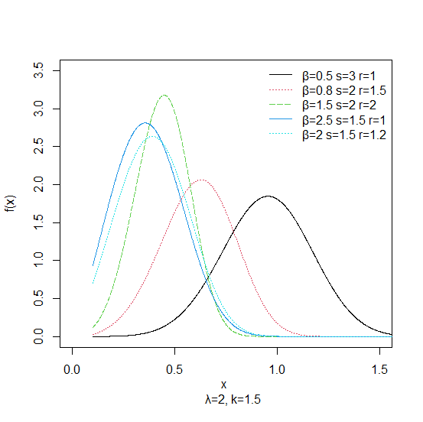
Figure 1: Probability density function of EGMW distribution for lambda = 2, k = 1.5 and varying values of beta, s and r parameters
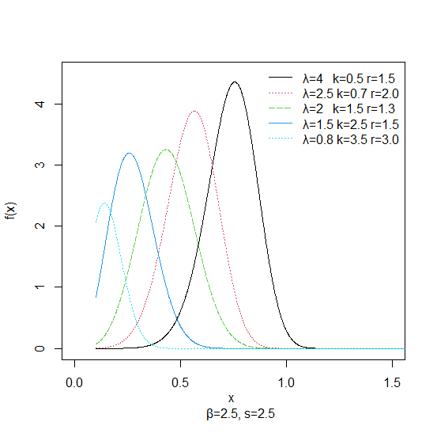
Figure 2: Probability density function of EGMW distribution for beta = s = 2.5 and varying values of lambda, k and r parameters

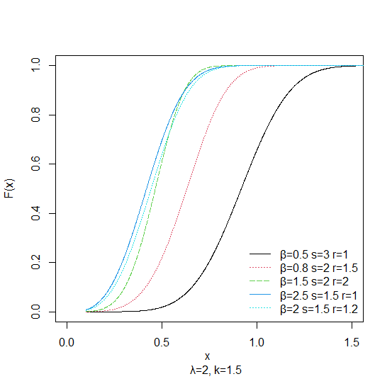
Figure 3: cumulative density function of EGMW distribution for Lambda = 2, k = 1.5 and varying values of beta, s and r parameters

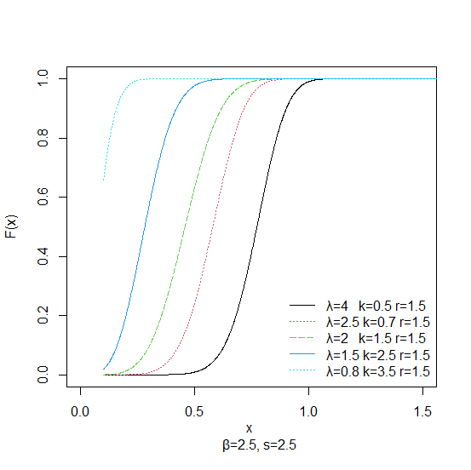
Figure 4: cumulative density function of EGMW distribution for beta = s = 2.5 and varying values of lambda, k and r parameters

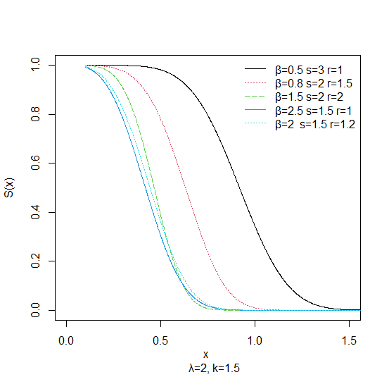
Figure 5: Survival function plot of EGMW distribution for Lambda = 2, k = 1.5 and varying values of beta, s and r parameters

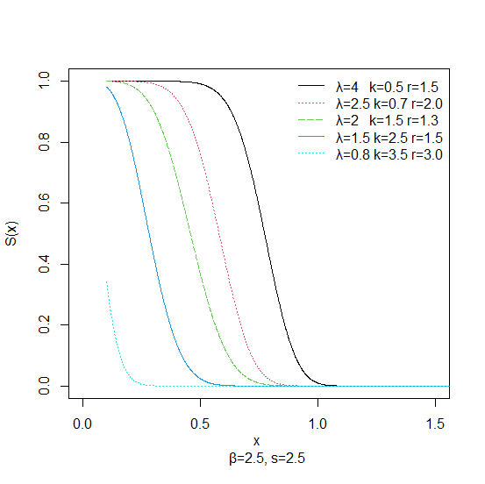
Figure 6: Survival function plot of EGMW distribution for beta = s = 2.5 and varying values of lambda, k and r parameters

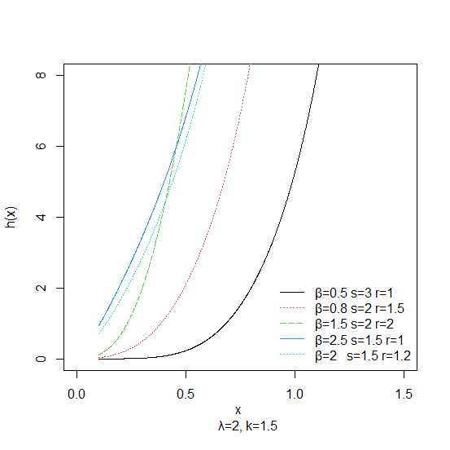
Figure 7: Hazard function plot of EGMW distribution for Lambda = 2, k = 1.5 and varying values of beta, s and r parameters

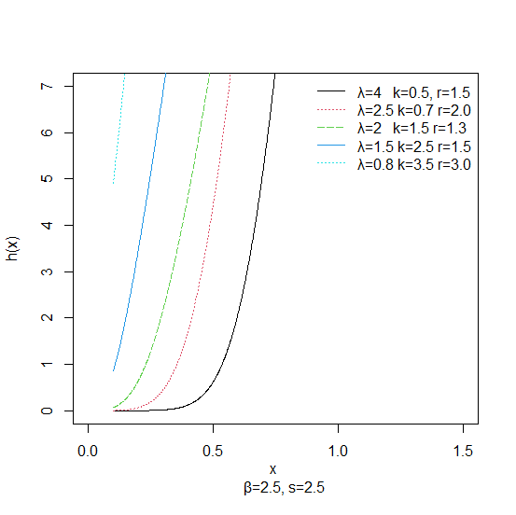
Figure 8: Hazard function plot of EGMW distribution for beta = s = 2.5 and varying values of lambda, k and r parameters

Properties of Exponentially Generated Modified Weibull (EGMW) Distribution
Statistical properties of the newly generated distribution were discussed in this section. The properties include moments, moment generating function, characteristic function, median, quantile function, mean, variance, mean deviation, incomplete moment, Lorenz and Bonferroni curves, conditional moments, order statistics and maximum likelihood of the estimates.
- Moments
The expression for the p^{th} non-central moment of EGMW distribution is given in the following theorem;
Theorem 1: Suppose that the random variable X follows the EGMW distribution, then, its p^{th} non-central moment is given as
$$E\left[X^{p}\right]=kβs \sum_{j=0}^{∞}{\left(\begin{aligned}s-1 \\ j\end{aligned}\right)\left(-1)^{j}\right.}\sum_{m=0}^{∞}{\frac{\left(-kβ\right.\left(1+j\right))^{m}Γ\left(p+⋋+⋋m\right)}{m!\left(-r\right.\left(m+1\right))^{\left(p+⋋+⋋m\right)}}}\left[⋋-\frac{p+⋋+⋋m}{m+1}\right]$$
and its mean is given as
$$E\left[X\right]=kβs \sum_{j=0}^{∞}{\left(\begin{aligned}s-1 \\ j\end{aligned}\right)\left(-1)^{j}\right.}\sum_{m=0}^{∞}{\frac{\left(-kβ\right.\left(1+j\right))^{m}Γ\left(1+⋋+⋋m\right)}{m!\left(-r\right.\left(m+1\right))^{\left(1+⋋+⋋m\right)}}}\left[⋋-\frac{1+⋋+⋋m}{m+1}\right]$$

Proof
The p^{th} non-central moment is defined by
$$E\left[X^{p}\right]= \int_{0}^{∞}{x^{p}}f\left(x\right)dx$$
Suppose $f\left(x\right)$ is the pdf of EGMW distribution, then
$E\left[X^{p}\right]=kβs \int_{0}^{∞}{x^{p+⋋-1}\left(⋋+ rx\right)e^{rx}e^{-kβx^{⋋}e^{rx}}}\left[{1-e}^{{-kβx}^{⋋}e^{rx}}\right]$^{s-1}$dx$ (12)
Using binomial expansion approach,
$$\left[1-e^{-kβx^{⋋}e^{rx}}]^{s-1}\right.=\sum_{j=0}^{∞}{\left(\begin{aligned}s-1 \\ j\end{aligned}\right)}\left(-1\right.)^{j}e^{-kβx^{⋋}e^{rx}j} (13)$$
Substituting Equation (13) into Equation (12), we have
$$E\left[X^{p}\right]=kβs \sum_{j=0}^{∞}{\left(\begin{aligned}s-1 \\ j\end{aligned}\right)\left(-1)^{j}\right.}\int_{0}^{∞}{x^{p+⋋-1}\left(⋋+ rx\right)e^{rx}e^{-kβx^{⋋}e^{rx}\left(1+j\right)}dx} \left(14\right)$$
Apply power series, the exponential function is
$$e^{-kβx^{⋋}e^{rx}\left(1+j\right)}= \sum_{m=0}^{∞}{\frac{\left(-kβ\right.\left(1+j\right))^{m}x^{⋋m}e^{rmx}}{m!}} (15)$$
Substituting Equation (15) into Equation (14), it results to;
$$E\left[X^{p}\right]=kβs \sum_{j=0}^{∞}{\left(\begin{aligned}s-1 \\ j\end{aligned}\right)\left(-1)^{j}\right.}\sum_{m=0}^{∞}{\frac{\left(-kβ\right.\left(1+j\right))^{m}}{m!}}\int_{0}^{∞}{x^{p+⋋+⋋m-1}\left(⋋+ rx\right)e^{x\left(r+rm\right)}dx} (16)$$
Consider the integrand in Equation (16);
$$\int_{0}^{∞}{x^{p+⋋+⋋m-1}\left(⋋+ rx\right)e^{x\left(r+rm\right)}dx}= \frac{Γ\left(p+⋋+⋋m\right)}{\left(-r\left(m+1\right))^{\left(p+⋋+⋋m\right)}\right.}\left[⋋-\frac{p+⋋+⋋m}{m+1}\right]$$

By substitution Equation (16) becomes;
$$E\left[X^{p}\right]=kβs \sum_{j=0}^{∞}{\left(\begin{aligned}s-1 \\ j\end{aligned}\right)\left(-1)^{j}\right.}\sum_{m=0}^{∞}{\frac{\left(-kβ\right.\left(1+j\right))^{m}Γ\left(p+⋋+⋋m\right)}{m!\left(-r\right.\left(m+1\right))^{\left(p+⋋+⋋m\right)}}}\left[⋋-\frac{p+⋋+⋋m}{m+1}\right] (17)$$

The mean is obtained by setting $p=1$ in Equation (17);
$$E\left[X\right]=kβs \sum_{j=0}^{∞}{\left(\begin{aligned}s-1 \\ j\end{aligned}\right)\left(-1)^{j}\right.}\sum_{m=0}^{∞}{\frac{\left(-kβ\right.\left(1+j\right))^{m}Γ\left(1+⋋+⋋m\right)}{m!\left(-r\right.\left(m+1\right))^{\left(1+⋋+⋋m\right)}}}\left[⋋-\frac{1+⋋+⋋m}{m+1}\right] (18)$$

The $q^{th}$ central moment is given in the following theorem.
Theorem 2: Suppose that the random variable X follows the EGMW distribution, then its $q^{th}$ central moment is given as

$$E\left[X-μ\right.]^{q}=kβs \sum_{p=0}^{q}{\left(\begin{aligned}q \\ p\end{aligned}\right)}\left(-μ)^{q-p}\right.\sum_{j=0}^{∞}{\left(\begin{aligned}s-1 \\ j\end{aligned}\right)}\left(-1)^{j}\right.$$
$$\sum_{m=0}^{∞}{\frac{\left(-kβ\right.\left(1+j\right))^{m}Γ\left(p+⋋+⋋m\right)}{m!\left(-r\right.\left(m+1\right))^{\left(p+⋋+⋋m\right)}}}\left[⋋-\frac{p+⋋+⋋m}{m+1}\right]$$

and its variance is given as
$$E\left[X-μ\right.]^{2}=kβs \sum_{p=0}^{2}{\left(\begin{aligned}q \\ p\end{aligned}\right)}\left(-μ)^{2-p}\right.\sum_{j=0}^{∞}{\left(\begin{aligned}s-1 \\ j\end{aligned}\right)}\left(-1)^{j}\right.$$
$$\sum_{m=0}^{∞}{\frac{\left(-kβ\right.\left(1+j\right))^{m}Γ\left(p+⋋+⋋m\right)}{m!\left(-r\right.\left(m+1\right))^{\left(p+⋋+⋋m\right)}}}\left[⋋-\frac{p+⋋+⋋m}{m+1}\right]$$

Proof
The $q^{th}$ central moment is defined by
$$E\left[X-μ\right.]^{q}=kβs \sum_{p=0}^{q}{\left(\begin{aligned}q \\ p\end{aligned}\right)}\left(-μ)^{q-p}\right.E\left[X^{p}\right] (19)$$
Where $μ=E\left[X\right]$ and $E\left[X^{p}\right]$ are given in Equation (17). By substitution,
$$E\left[X-μ\right.]^{q}=kβs \sum_{p=0}^{q}{\left(\begin{aligned}q \\ p\end{aligned}\right)}\left(-μ)^{q-p}\right.\sum_{j=0}^{∞}{\left(\begin{aligned}s-1 \\ j\end{aligned}\right)}\left(-1)^{j}\right.$$
$$\sum_{m=0}^{∞}{\frac{\left(-kβ\right.\left(1+j\right))^{m}Γ\left(p+⋋+⋋m\right)}{m!\left(-r\right.\left(m+1\right))^{\left(p+⋋+⋋m\right)}}}\left[⋋-\frac{p+⋋+⋋m}{m+1}\right] (20)$$
which is the central moment of EGMW distribution.
Its variance is obtained by setting $q=2$ in Equation (20) to obtain
$$E\left[X-μ\right.]^{2}=kβs \sum_{p=0}^{2}{\left(\begin{aligned}q \\ p\end{aligned}\right)}\left(-μ)^{2-p}\right.\sum_{j=0}^{∞}{\left(\begin{aligned}s-1 \\ j\end{aligned}\right)}\left(-1)^{j}\right.$$
$\sum_{m=0}^{∞}{\frac{\left(-kβ\right.\left(1+j\right))^{m}Γ\left(p+⋋+⋋m\right)}{m!\left(-r\right.\left(m+1\right))^{\left(p+⋋+⋋m\right)}}}\left[⋋-\frac{p+⋋+⋋m}{m+1}\right] (21)$

- Moment Generating Function
The moment generating function of the EGMW is given in the following theorem.
Theorem 3: Let X follows the EGMW, then moment generating function is
$$M_{x}(t)=kβs \sum_{p=0}^{∞}{\frac{t^{p}}{p!}}\sum_{j=0}^{∞}{\left(\begin{aligned}s-1 \\ j\end{aligned}\right)}\left(-1)^{j}\right.\sum_{m=0}^{∞}{\frac{\left(-kβ\right.\left(1+j\right))^{m}Γ\left(p+⋋+⋋m\right)}{m!\left(-r\right.\left(m+1\right))^{\left(p+⋋+⋋m\right)}}}\left[⋋-\frac{p+⋋+⋋m}{m+1}\right]$$

Proof
The moment generating function of a random variable X is given by
$$M_{x}\left(t\right)=E\left(e^{tx}\right)= \sum_{r=0}^{∞}{\frac{t^{p}}{p!}} E\left[X^{p}\right]. (22)$$
If X follows EGMW distribution, then its moment is given in Equation (17) into Equation (22),
$$M_{x}\left(t\right)=$$
$kβs \sum_{p=0}^{∞}{\frac{t^{p}}{p!}}\sum_{j=0}^{∞}{\left(\begin{aligned}s-1 \\ j\end{aligned}\right)}\left(-1)^{j}\right.\sum_{m=0}^{∞}{\frac{\left(-kβ\right.\left(1+j\right))^{m}Γ\left(p+⋋+⋋m\right)}{m!\left(-r\right.\left(m+1\right))^{\left(p+⋋+⋋m\right)}}}\left[⋋-\frac{p+⋋+⋋m}{m+1}\right]$ (23)
$$(23)$$

- Characteristics function
The characteristics function of the distribution is given in the following theorem.
Theorem 4: Suppose that the random variable X follows EGMW distribution, then, its characteristics function is
$$∅x\left(it\right)=kβs \sum_{p=0}^{∞}{\frac{\left(it\right.)^{p}}{p!}}\sum_{j=0}^{∞}{\left(\begin{aligned}s-1 \\ j\end{aligned}\right)}\left(-1)^{j}\right.\sum_{m=0}^{∞}{\frac{\left(-kβ\right.\left(1+j\right))^{m}Γ\left(p+⋋+⋋m\right)}{m!\left(-r\right.\left(m+1\right))^{\left(p+⋋+⋋m\right)}}}\left[⋋-\frac{p+⋋+⋋m}{m+1}\right]$$

Proof
The characteristic function of a random variable X is given by
$$∅x\left(it\right)=kβs \sum_{p=0}^{∞}{\frac{\left(it\right.)^{p}}{p!}} E\left(X^{P}\right),$$
where the non-central moment is given in Equation (17). By substitution, the characteristics function is;
$$∅x\left(it\right)=kβs \sum_{p=0}^{∞}{\frac{\left(it\right.)^{p}}{p!}}\sum_{j=0}^{∞}{\left(\begin{aligned}s-1 \\ j\end{aligned}\right)}\left(-1)^{j}\right.\sum_{m=0}^{∞}{\frac{\left(-kβ\right.\left(1+j\right))^{m}Γ\left(p+⋋+⋋m\right)}{m!\left(-r\right.\left(m+1\right))^{\left(p+⋋+⋋m\right)}}}\left[⋋-\frac{p+⋋+⋋m}{m+1}\right]$$
(24)
- The $q^{th}$ quantile function
It is the real solution of
$$F\left(x_{q}\right)=q$$
By substitution,
$\left(1-e^{-kβ{x_{q}}^{⋋}e^{{rx}_{q}}})^{s}=q\right.$ (25)
$$\left(e^{-kβ{x_{q}}^{⋋}e^{{rx}_{q}}}\right)=1-q^{\frac{1}{n}}$$
$$-kβx\frac{⋋}{q}e^{{rx}_{q}}=In\left(1-{0.5}^{\frac{1}{n}}\right)$$
$x\frac{⋋}{q}e^{{rx}_{q}}= -\frac{1}{kβ} In \left(1-q^{\frac{1}{n}}\right)$ (26)

The quantile function is the numerical solution to Equation (26).

- The Median
The median is obtained by setting $q=0.5$ in Equation (26).
$x_{0.5}5^{⋋}e^{{rx}_{0.5}}= - \frac{1}{kβ} In \left(1-{0.5}^{\frac{1}{n}}\right)$ (27)

The median is the numerical solution to Equation (27).

- Re’nyi Entropy
It is defined by
$$I_{R}\left(δ\right)= \frac{1}{1-δ}\log\left[I\left(δ\right)\right]$$

Where $I\left(δ\right)= ∫_{R}f^{δ}\left(x\right)dx, δ>0 and δ ≠1.$ If X has the EGMW, then
$$I\left(δ\right)=\left(kβs)^{δ}\right.\int_{0}^{∞}{x^{δ\left(⋋-1\right)}\left(⋋+rx)^{δ}e^{rδx}e^{\left(-kβx^{⋋}e^{rx})^{δ}\right.}\left(1-e^{-kβx^{⋋}e^{rx}})^{δ\left(s-1\right)}\right.\right.} (28)$$
Similarly,
$$\left(1-e^{-kβx^{⋋}e^{rx}})^{δ\left(s-1\right)}\right.= \sum_{j=0}^{∞}{\left(\begin{aligned}δ\left(s-1\right) \\ j\end{aligned}\right)}\left(-1)^{j}\right.e^{-kβx^{⋋}e^{{rx}_{j}}}$$

Substituting the expression into Equation (28), gives;
$$I\left(δ\right)=\left(kβs)^{δ}\right.\sum_{j=0}^{∞}{\left(\begin{aligned}δ\left(s-1\right) \\ j\end{aligned}\right)}\left(-1)^{j}\right.\int_{0}^{∞}{x^{δ\left(⋋-1\right)}\left(⋋+rx)^{δ}e^{rδx}\right.}e^{-kβx^{⋋}e^{rx}\left(δ+j\right)}(29)$$

The exponential function in the integrand becomes,
$$e^{-kβx^{⋋}e^{rx}\left(δ+j\right)}= \sum_{m=0}^{∞}{\frac{\left(-kβ\right.\left(1+j\right))^{m}x^{⋋m}e^{rmx}}{m!}} (30) \left(4.87\right)$$

By substituting Equation (30) into Equation (29), Equation (29) becomes;
$$=\left(kβs)^{δ}\right.\sum_{j=0}^{∞}{\left(\begin{aligned}δ\left(s-1\right) \\ j\end{aligned}\right)}\left(-1)^{j}\right.\sum_{m=0}^{∞}{\frac{\left(-kβ\right.\left(1+j\right))^{m}}{m!}}\int_{0}^{∞}{x^{δ\left(⋋-1\right)}\left(⋋+rx)^{δ}e^{x\left(rδ+rm\right)}\right.}x^{⋋m}$$
(31)
Solving the integrand in Equation (31);
$$\int_{0}^{∞}{x^{δ\left(⋋-1\right)}\left(⋋+rx)^{δ}e^{x\left(rδ+rm\right)}\right.}x^{⋋m}= \sum_{k=0}^{∞}{\frac{\left(\begin{aligned}s \\ k\end{aligned}\right)⋋^{δ-k}r^{k}Γ\left(⋋δ-δ+⋋m+k+1\right)}{\left(-\left(r^{δ}+rm\right))^{⋋δ-δ+⋋m+k+1}\right.}}$$
(32)
Substituting Equation (32) into Equation (31) gives;
$$I\left(δ\right)=\left(kβs)^{δ}\right.\sum_{j=0}^{∞}{\left(\begin{aligned}δ\left(s-1\right) \\ j\end{aligned}\right)}\left(-1)^{j}\right.\sum_{m=0}^{∞}{\frac{\left(-kβ\right.\left(1+j\right))^{m}}{m!}}\sum_{k=0}^{∞}{\left(\begin{aligned}δ \\ k\end{aligned}\right)}⋋^{δ-k_{r}k}\frac{Γ\left(⋋δ-δ+⋋m+k+1\right)}{\left(-\left(r^{δ}+rm\right))^{⋋δ-δ+⋋m+k+1}\right.}$$
(33)
Hence, the entropy becomes
$$I_{R}\left(δ\right)= \frac{1}{1-δ}\log\left[\left(kβs)^{δ}\right.\right.\sum_{j=0}^{∞}{\left(\begin{aligned}δ\left(s-1\right) \\ j\end{aligned}\right)}\left(-1)^{j}\right.\sum_{m=0}^{∞}{\frac{\left(-kβ\right.\left(1+j\right))^{m}}{m!}}x \sum_{k=0}^{∞}{\left(\begin{aligned}δ \\ k\end{aligned}\right)}⋋^{δ-k_{r}k}\left.\frac{Γ\left(⋋δ-δ+⋋m+k+1\right)}{\left(-\left(r^{δ}+rm\right))^{⋋δ-δ+⋋m+k+1}\right.}\right]$$
(34)

- Incomplete moments
This is defined as
$V_{P}\left(z\right)=\int_{0}^{z}{x^{p}}f\left(x\right) dx.$ (35)
Using the relationship in Equation (14),
$v_{p}\left(z\right)=kβs\sum_{j=0}^{∞}{\left(\begin{aligned}δ\left(s-1\right) \\ j\end{aligned}\right)}\left(-1)^{j }\right.\int_{0}^{z}{x^{p+⋋-1}}\left(⋋+rx\right)e^{rx}e^{-kβx^{⋋}e^{rx}\left(1+j\right)}dx$ (36)
Applying the relationship in Equation (18),
$$v_{p}\left(z\right)=kβs\sum_{j=0}^{∞}{\left(\begin{aligned}δ\left(s-1\right) \\ j\end{aligned}\right)}\left(-1)^{j}\right.\sum_{m=0}^{∞}{\frac{\left(-kβ\right.\left(1+j\right))^{m}}{m!}}\int_{0}^{z}{x^{p+⋋-1}}\left(⋋+rx\right)e^{rx}e^{-kβx^{⋋}e^{rx}\left(1+j\right)}dx$$
(37)
The integrand in Equation (37) gives
$$\int_{0}^{z^{β}}{x^{p+⋋+⋋m-1}}\left(⋋+rx\right)e^{x\left(r+rm\right)}dx=\frac{⋋}{\left[-\left(r+rm\right)]^{p+⋋+⋋m}\right.}γ\left(p+⋋+⋋m, z^{β}\right)+ \frac{⋋}{\left[-\left(r+rm\right)]^{p+⋋+⋋m}\right.}γ\left(p+⋋+⋋m, z^{β}\right)$$
$(38)$The integrand in Equation (38) is an incomplete gamma. Therefore,
$$v_{p}\left(z\right)=kβs\sum_{j=0}^{∞}{\left(\begin{aligned}δ\left(s-1\right) \\ j\end{aligned}\right)}\left(-1)^{j}\right.\sum_{m=0}^{∞}{\frac{\left(-kβ\right.\left(1+j\right))^{m}}{m!}}\left[\frac{⋋}{\left[-\left(r+rm\right)]^{p+⋋+⋋m}\right.}γ\left(p+⋋+⋋m, z^{β}\right)\right.$$
$$+ \left.\frac{r}{\left[-\left(r+rm\right)]^{p+⋋+⋋m+1}\right.}γ\left(p+⋋+⋋m, z^{β}\right)\right]$$
(39)
The first incomplete moment is obtained by setting $p=1$ in Equation (39).
$$V_{1}\left(z\right)=kβs\sum_{j=0}^{∞}{\left(\begin{aligned}δ\left(s-1\right) \\ j\end{aligned}\right)}\left(-1)^{j}\right.\sum_{m=0}^{∞}{\frac{\left(-kβ\right.\left(1+j\right))^{m}}{m!}}\left[\frac{⋋}{\left[-\left(r+rm\right)]^{1+⋋+⋋m}\right.}γ\left(1+⋋+⋋m, z^{β}\right)\right.$$
$$+ \left.\frac{r}{\left[-\left(r+rm\right)]^{1+⋋+⋋m+1}\right.}γ\left(1+⋋+⋋m, z^{β}\right)\right]$$
(40)

- Mean Deviation
The mean deviation about the mean of EGMW distribution is given by
$$δ_{1}\left(x\right)=\int_{0}^{∞}{\left|x-μ\right|f\left(x\right)dx=}2μ_{1}^{'}F\left(μ_{1}^{'}\right)-2V_{1}\left(μ_{1}^{'}\right). (41)$$

The mean deviation about the median of EGMW distribution is defined as
$$δ_{2}\left(x\right)=\int_{0}^{∞}{\left|x-M\right|f\left(x\right)dx=μ_{1}^{'}-2V_{1}\left(μ_{1}^{'}\right). } (42)$$
where $μ_{1}^{'}$=E(X) which is the first non-central moment of EGMW in Equation (18). F($μ_{1}^{'}$) can be obtained from the cumulative density function of the EGMW distribution, M is the median of the EGMW distribution in Equation (27) and $V_{1}\left(μ_{1}^{'}\right)$ can be derived from the first incomplete moment of EGMW distribution in Equation (40).

- Bonferroni and Lorenz curves
Bonferroni curve of the EGMW distribution is defined as
B($π$)=$\frac{V_{1}(q)}{(πμ_{1})}$ (43)

$$V_{1}\left(q\right)=kβs\sum_{j=0}^{∞}{\left(\begin{aligned}\left(s-1\right) \\ j\end{aligned}\right)}\left(-1)^{j}\right.\sum_{m=0}^{∞}{\frac{\left(-kβ\right.\left(1+j\right))^{m}}{m!}}\left[\frac{⋋}{\left[-\left(r+rm\right)]^{1+⋋+⋋m}\right.}γ\left(1+⋋+⋋m, z^{β}\right)\right.$$
$$+ \left.\frac{r}{\left[-\left(r+rm\right)]^{1+⋋+⋋m+1}\right.}γ\left(1+⋋+⋋m+1, z^{β}\right),q\right]$$
(44)

$$πμ_{1}^{'}=πkβs\sum_{j=0}^{∞}{\left(\begin{aligned}\left(s-1\right) \\ j\end{aligned}\right)}\left(-1)^{j}\right.\sum_{m=0}^{∞}{\frac{\left(-kβ\right.\left(1+j\right))^{m}Γ\left(1+⋋+⋋m\right)}{m!{-r(m+1))}^{\left(1+⋋+⋋m\right)}}}\left[⋋-\frac{1+⋋+⋋m}{m+1}\right]$$
(45)
By substitution,
$$B\left(π\right)=\frac{kβs\sum_{j=0}^{∞}{\left(\begin{aligned}\left(s-1\right) \\ j\end{aligned}\right)}\left(-1)^{j}\right.\sum_{m=0}^{∞}{\frac{\left(-kβ\right.\left(1+j\right))^{m}}{m!}}\left[\frac{⋋}{\left[-\left(r+rm\right)]^{1+⋋+⋋m}\right.}γ\left(1+⋋+⋋m, z^{β}\right)\right.+\left.\frac{r}{\left[-\left(r+rm\right)]^{1+⋋+⋋m+1}\right.}γ\left(1+⋋+⋋m+1, z^{β}\right),q\right]}{kβs\sum_{j=0}^{∞}{\left(\begin{aligned}\left(s-1\right) \\ j\end{aligned}\right)}\left(-1)^{j}\right.\sum_{m=0}^{∞}{\frac{\left(-kβ\right.\left(1+j\right))^{m}Γ\left(1+⋋+⋋m\right)}{m!{-r(m+1))}^{\left(1+⋋+⋋m\right)}}}\left[⋋-\frac{1+⋋+⋋m}{m+1}\right]}$$
(46)
where $q=W\left(π\right)$ can be calculated from the quantile function, $V_{1}\left(q\right)$ can be obtained from the first incomplete moment and $μ_{1}^{'}$ is the first central non-moment.
Lorenz curve of the EGMW is defined as
$L\left(π\right)=\frac{V_{1}\left(q\right)}{μ_{1}^{'}}$ (47)
$$L\left(π\right)=\frac{kβs\sum_{j=0}^{∞}{\left(\begin{aligned}\left(s-1\right) \\ j\end{aligned}\right)}\left(-1)^{j}\right.\sum_{m=0}^{∞}{\frac{\left(-kβ\right.\left(1+j\right))^{m}}{m!}}\left[\frac{⋋}{\left[-\left(r+rm\right)]^{1+⋋+⋋m}\right.}γ\left(1+⋋+⋋m, z^{β}\right)\right.+\left.\frac{r}{\left[-\left(r+rm\right)]^{1+⋋+⋋m+1}\right.}γ\left(1+⋋+⋋m+1, z^{β}\right),q\right]}{kβs\sum_{j=0}^{∞}{\left(\begin{aligned}\left(s-1\right) \\ j\end{aligned}\right)}\left(-1)^{j}\right.\sum_{m=0}^{∞}{\frac{\left(-kβ\right.\left(1+j\right))^{m}Γ\left(1+⋋+⋋m\right)}{m!{-r(m+1))}^{\left(1+⋋+⋋m\right)}}}\left[⋋-\frac{1+⋋+⋋m}{m+1}\right]}$$
$$(48)$$

- Conditional Moments
The $pth$ conditional moment of EGMW is given in the following theorem.
Theorem 5: Suppose that the random variable X follows the EGMW, then its $pth$ conditional moment is given by

$${E\left[X^{p}\right.}/X>\left.t\right]=\frac{kβs}{F\left(t\right)}\sum_{j=0}^{∞}{\left(\begin{aligned}s-1 \\ j\end{aligned}\right)}\left(-1)^{j}\right.\frac{\left(-kβ\left(1+j\right))^{m}\right.}{m!} x$$
$$\left[A⋋\left(Γ\right.\left(p+⋋+⋋m\right)-γ\left(p+⋋+⋋m,t^{β}\right)+Br\left(Γ\right.\left(p+⋋+⋋m\right)-γ\left(p+⋋+⋋m,t^{β}\right)\right]$$
Where A = ${\left(\frac{1}{-\left(r+rm\right)}\right)}^{p+⋋+⋋m}$ and B = ${\left(\frac{1}{-\left(r+rm\right)}\right)}^{p+⋋+⋋m+1}$
Proof
The $p^{th}$ conditional moment is defined by
$${E\left[X^{p}\right.}/X>\left.t\right]=\frac{1}{\overline{F}\left(t\right)}\int_{t}^{∞}{x^{p}}f\left(x\right)dx.$$
Where $\overline{F}\left(t\right)=1-F\left(t\right)$. If $f\left(x\right)$ is the pdf of EGMW then
${E\left[X^{p}\right.}/X>\left.t\right]=\frac{1}{\overline{F}\left(t\right)}\int_{t}^{∞}{x^{p+⋋-1}}\left(⋋+rx\right)e^{rx}e^{-kβx^{⋋}e^{rx}}{\left[1-e^{-kβx^{⋋}e^{rx}}\right]}^{s-1}dx$ (49)
${E\left[X^{p}\right.}/X>\left.t\right]=\frac{kβs}{F\left(t\right)}\sum_{j=0}^{∞}{\left(\begin{aligned}s-1 \\ j\end{aligned}\right)}\left(-1)^{j}\right.\int_{t}^{∞}{x^{p+⋋-1}}\left(⋋+rx\right)e^{rx}e^{-kβx^{⋋}e^{rx}\left(1+j\right)}dx$ (50)
E$\left[{X^{p}}/{X >t}\right]= \frac{kβs}{\overline{F}(t)}\sum_{j=0}^{∞}{\left(\begin{matrix}s-1 \\ j\end{matrix}\right)}{(-1)}^{j}\sum_{m=0}^{∞}{\frac{{\left(-kβ\left(1+j\right)\right)}^{m}}{m!}}\int_{t}^{∞}{x^{p+λ+λm-1}\left(λ+rx\right)e^{x(r+rm)}dx (51)}$
Consider the integrand in Equation (51)
$$\int_{t}^{∞}{x^{p+λ+λm-1}\left(λ+rx\right)e^{x\left(r+rm\right)}dx=λ\int_{t}^{∞}{x^{p+λ+λm-1}e^{x\left(r+rm\right)}dx+r}\int_{t}^{∞}{x^{p+λ+λm-1}e^{x\left(r+rm\right)}dx}} (52)$$
but
$$λ\int_{t}^{∞}{x^{p+λ+λm-1}e^{x(r+rm)}dx=λ {\left(\frac{1}{- (r+rm)}\right)}^{p+λ+λm}}\int_{t}^{∞}{y^{p+λ+λm-1}e^{-y}dy (53) }$$
and
$r\int_{t}^{∞}{x^{p+λ+λm-1}e^{x\left(r+rm\right)}dx}=$r ${\left(\frac{1}{- (r+rm)}\right)}^{p+λ+λm+1}\int_{t}^{∞}{y^{p+λ+λm }e^{-y}dy (54)}$
The integrand in Equation (53) can be expressed as
$$\int_{t}^{∞}{y^{p+λ+λm-1}e^{-y}dy=\int_{0}^{∞}{y^{p+λ+λm-1}e^{-y}dy-\int_{0}^{t^{β}}{x^{p+λ+λm-1}e^{-y}dy }(55) }}$$
The first integrand is a complete gamma function and the second integrand is an incomplete gamma function. Therefore,
$$\int_{0}^{∞}{y^{p+λ+λm-1}e^{-y}dy-\int_{0}^{t^{β}}{x^{p+λ+λm-1}e^{-y}dy = Γ\left(p+λ+λm\right)-γ\left(p+λ+λm,t^{β}\right)} (56) }$$

Similarly, the integrand in Equation (54) also gives
$$\int_{0}^{∞}{y^{p+⋋+⋋m}e^{-y}dy-\int_{0}^{t^{β}}{y^{p+⋋+⋋m}e^{-y}dy=Γ\left(p+⋋+⋋m\right)}}-γ\left(p+⋋+⋋m+1,t^{β}\right)$$
(57)
Hence (52) becomes
$$\int_{t}^{∞}{x^{p+⋋+⋋m-1}\left(⋋+rx\right)e^{x\left(r+rm\right)}dx}=\left[A⋋\left(Γ\right.\right.\left(p+⋋+⋋m\right)-γ\left(p+⋋+⋋m,t^{β}\right)+$$
$$βr\left(Γ\left(p+λ+λm+1\right)-γ\left(p+λ+λm+1,t^{β}\right)]\right. (58)$$

Substituting Equation (58) into Equation (51), gives the conditional moment of the distribution.
$$E[X^{p}/X>t]=\frac{kβs}{\overline{F}\left(t\right)}\sum_{j=0}^{∞}{\left(\begin{aligned}s-1 \\ j\end{aligned}\right)}\left(-1)^{j}\right.\frac{\left(-kβ\left(1+j\right))^{m}\right.}{m!} x$$
$$\left[A⋋\left(Γ\right.\left(p+⋋+⋋m\right)-γ\left(p+⋋+⋋m,t^{β}\right)+Br\left(Γ\right.\left(p+⋋+⋋m\right)-γ\left(p+⋋+⋋m,t^{β}\right)\right]$$
Where A= ${\left(\frac{1}{-\left(r+rm\right)}\right)}^{p+⋋+⋋m}$ and B = ${\left(\frac{1}{-\left(r+rm\right)}\right)}^{p+⋋+⋋m+1}$

- The Order Statistics
The pdf of order statistics of EGMW distribution is defined as
$fx_{pin}= \frac{n!}{\left(p-1\right)!\left(n-p\right)!}f_{x}\left(x\right)\left(F_{x}(x))^{p-1}\left(1-F_{x}\left(x\right))^{n-P}. \right.\right.$ (59)
Substituting the probability density function and cumulative density function of the EGMW distribution into (59) gives; $fx_{pin}= \frac{n!}{\left(p-1\right)!\left(n-p\right)!} kβsx^{⋋-1}\left(⋋+rx\right)e^{rx}e^{-kβx^{⋋}e^{rx}}{\left[1-e^{-kβx^{⋋}e^{rx}}\right]}^{s-1}$
$X (\left(1-e^{-kβx^{⋋}}e^{rx}\right.)^{s})^{P-1}(1-(1-e^{-kβx^{⋋}e^{rx}})^{s})^{n-p}$ (60)
where P= 1, 2, . . . n.
The probability density function of the maximum order statistics when p = n is given by
$fx_{nin^{\left(X\right)}}$=$nkβsx^{⋋-1}\left(⋋+rx\right)e^{rx}e^{-kβx^{⋋}e^{rx}}\left(1-e^{-kβx^{⋋}}e^{rx}\right.)^{s-1}(\left(1-e^{-kβx^{⋋}}e^{rx})^{s})^{n-1}\right.$
(61)
The probability density function of the minimum order statistic when p = 1 is given by $fx_{nin^{\left(X\right)}}=nkβsx^{⋋-1}\left(⋋+rx\right)e^{rx}e^{-kβx^{⋋}e^{rx}}\left(1-e^{-kβx^{⋋}}e^{rx}\right.)^{s-1}(1-\left(1-e^{-kβx^{⋋}}e^{rx})^{s})^{n-1}\right.$ (62)

12. Parameter Estimation
Suppose $X_{1,….}X_{n}$ are independent random variables with sample size n from Exponentially Generated Modified Weibull distribution, its likelihood function is given by
$l=(kβs)^{n}e^{r}Σ_{i=1}^{n}x_{i}e^{-kβ }Σ_{i=1}^{n}x_{i}^{⋋}e^{rx_{i}}\prod_{i=1}^{n}{x_{i}^{⋋-1}\left(⋋+rx_{i}\right)\left(1-e^{-kβx^{⋋}}e^{rx_{i}}\right.)^{s-1}}$ (63)
its log-likelihood function is given by $\ln{l}=n\ln\left(kβs\right)+r \sum_{i=1}^{n}{x_{i}-kβ \sum_{i=1}^{n}{x_{i}^{⋋}e^{rx_{i}}+ \left(⋋-1\right)\sum_{I=1}^{n}{\ln{x_{I}+ \sum_{I=1}^{n}{\ln\left(r+ x_{i}\right)+ \left(s-1\right)\sum_{I=1}^{n}{\ln\left(1-e^{-kβx_{i}^{⋋}e^{rx_{i}}}\right)}}}}}}$ (64)
The estimates of parameters β, k, r, ⅄ and s are obtained by taking the derivative of the log-likelihood function with respect to each parameter and equating to zero. The following system of equations were obtained;
$\frac{dl}{dβ}=\frac{n}{β}-k\sum_{i=1}^{n}{x_{i}^{⋋}e^{rx_{i}}}+k\left(s-1\right)\frac{\sum_{i=1}^{n}{x_{i}^{⋋}}e^{rx_{i}}e^{-kβx_{i}^{⋋}e^{rx_{i}}}}{1-e^{-kβx_{i}^{⋋}e^{rx_{i}}}}=0 (65)$
$\frac{dl}{dk}=\frac{n}{k}-β\sum_{i=1}^{n}{x_{i}^{⋋}e^{rx_{i}}}+β\left(s-1\right)\frac{\sum_{i=1}^{n}{x_{i}^{⋋}}e^{rx_{i}}e^{-kβx_{i}^{⋋}e^{rx_{i}}}}{1-e^{-kβx_{i}^{⋋}e^{rx_{i}}}}=0 \left(66\right)$
$\frac{dl}{ds}=\frac{n}{s}+\sum_{i=1}^{n}{In \left(1-e^{-kβx_{i}^{⋋}e^{rx_{i}}}\right)}=0 \left(67\right)$
$\frac{dl}{dr}=\sum_{i=1}^{n}{x_{i}}+\sum_{i=1}^{n}{\frac{x_{i}}{⋋+rx_{i}}}-kβ\sum_{i=1}^{n}{x_{i}^{⋋-1}e^{rx_{i}}}+kβ\left(s-1\right)\frac{\sum_{i=1}^{n}{x_{i}^{⋋}}e^{rx_{i}}e^{-kβx_{i}^{⋋}e^{rx_{i}}}}{1-e^{-kβx_{i}^{⋋}e^{rx_{i}}}}=0 \left(68\right)$
$$\frac{dl}{d⋋}=\sum_{i=1}^{n}{Inx_{i}}+r\sum_{i=1}^{n}{{\left(⋋+rx_{i}\right)}^{-1}}-kβ\sum_{i=1}^{n}{x_{i}^{⋋-1}e^{rx_{i}}}+kβ\left(s-1\right)\frac{\sum_{i=1}^{n}{x_{i}^{⋋}}e^{rx_{i}}e^{-kβx_{i}^{⋋}e^{rx_{i}}}}{1-e^{-kβx_{i}^{⋋}e^{rx_{i}}}}=0 \left(69\right)$$
The above equations are non-linear in parameters. A numerical optimization method can be used to obtain the inherent parameters.
3.0 Simulation Study of the Exponentiated Generated Modified Weibull Distribution
This is necessary to determine the homogeneity property of the generalized distribution. For the distribution to be stable the estimates must be closer to the true values of the parameters, otherwise, the distribution is not stable. Using Monte Carlo simulation approach, three replicates were formed at different sample sizes; 50, 100, 200 and 500. Among the parameters in the model, in the first group, beta was fixed at 0.5 and lambda at 0.5. In the second category, beta was fixed at 1.0 and lambda at 0.5. In the third category, beta was fixed at 0.5 and lambda at 1.0. For all the replicates, s was fixed at 0.1, k at 2.0 and r at 0.1. From the output in Table 1, it can be observed that as sample size increases, the biasness of the estimates reduces leading to significant reduction in the Mean Square Error of the estimates. Also, it can be observed that increase in sample sizes lead to closeness of the estimates to the true value of the parameters. Therefore, it can be concluded that the distribution is stable.
Table 1: Simulation Output of EGMW distribution for Varying parameter Values
s = 0.1, k = 2.0, r = 0.1 |  | = 0.5, = 0. 5 |  |  | = 1.0, = 0. 5 |  |  | = 0.5, = 1. 0
N | Par | Est | BIAS | MSE | Est | BIAS | MSE | Est | BIAS | MSE
50 |  | 0.71523 | 0.21523 | 0.04650 | 1.13644 | 0.13644 | 0.01862 | 0.02841 | 0.47159 | 0.22241
 |  | 0.48466 | 0.01534 | 0.00025 | 0.48761 | 0.01239 | 0.00015 | 0.95415 | 0.04585 | 0.00302
 | s | 0.09548 | 0.00452 | 0.00002 | 0.09155 | 0.00845 | 0.00007 | 0.09129 | 0.00871 | 0.00008
 | k | 2.00303 | 0.00303 | 0.00002 | 2.03629 | 0.03629 | 0.00132 | 1.76726 | 0.23274 | 0.49247
 | r | 0.04053 | 0.05947 | 0.00358 | 0.02922 | 0.07078 | 0.00502 | 0.01313 | 0.08687 | 0.00766
N | Par | Est | BIAS | MSE | Est | BIAS | MSE | Est | BIAS | MSE
100 |  | 0.73753 | 0.23753 | 0.05672 | 1.07459 | 0.07459 | 0.00557 | 0.01829 | 0.48171 | 0.23222
 |  | 0.47816 | 0.02184 | 0.00048 | 0.48819 | 0.01181 | 0.00014 | 0.57582 | 0.42418 | 0.26486
 | s | 0.09358 | 0.00642 | 0.00004 | 0.09184 | 0.00816 | 0.00007 | 0.06532 | 0.03468 | 0.00160
 | k | 2.00512 | 0.00512 | 0.00003 | 2.02565 | 0.02565 | 0.00066 | 3.47920 | 1.47920 | 3.05754
 | r | 0.02287 | 0.07713 | 0.00604 | 0.03815 | 0.06185 | 0.00387 | 0.00871 | 0.09129 | 0.00839
N | Par | Est | BIAS | MSE | Est | BIAS | MSE | Est | BIAS | MSE
200 |  | 0.70361 | 0.20361 | 0.04338 | 1.06057 | 0.06057 | 0.00369 | 0.04702 | 0.45298 | 0.20592
 |  | 0.47822 | 0.02178 | 0.00050 | 0.48277 | 0.01723 | 0.00030 | 0.86761 | 0.13239 | 0.03383
 | s | 0.09336 | 0.00664 | 0.00005 | 0.08942 | 0.01058 | 0.00011 | 0.08508 | 0.01492 | 0.00029
 | k | 2.00701 | 0.00701 | 0.00005 | 2.02393 | 0.02393 | 0.00058 | 2.33738 | 0.33738 | 0.61982
 | r | 0.02283 | 0.07717 | 0.00614 | 0.02134 | 0.07866 | 0.00630 | 0.01607 | 0.08393 | 0.00720
N | Par | Est | BIAS | MSE | Est | BIAS | MSE | Est | BIAS | MSE
500 |  | 0.65577 | 0.15577 | 0.02563 | 1.03566 | 0.03566 | 0.00136 | 0.06011 | 0.43989 | 0.19538
 |  | 0.48026 | 0.01974 | 0.00041 | 0.48268 | 0.01732 | 0.00030 | 0.88523 | 0.11477 | 0.01847
 | s | 0.09357 | 0.00643 | 0.00004 | 0.09107 | 0.00893 | 0.00008 | 0.08573 | 0.01427 | 0.00025
 | k | 2.00874 | 0.00874 | 0.00008 | 2.01521 | 0.01521 | 0.00024 | 2.54293 | 0.54293 | 0.56739
 | r | 0.02651 | 0.07349 | 0.00558 | 0.02926 | 0.07074 | 0.00508 | 0.01402 | 0.08598 | 0.00743

4.0 Model Comparison
As part of perfomance test, there is need to compare the distribution with existing ones in the same category using secondary data. Two cases were used having data from research of other researchers. See the output below;
The data is on the breaking stress of carbon fibres of 50 mm length (GPa). The data has been previously used by Nichols and Padgett [14], Cordeiro and Lemonte [7], Al-Aqtash et al. [3] and Oguntunde et al. [15]. The data is as follows:
Table 2: Breaking Strength of Carbon Fibres of 50mm Length (GPa)
0.39 | 0.85 | 1.08 | 1.25 | 1.47 | 1.57 | 1.61 | 1.61 | 1.69 | 1.80
1.84 | 1.87 | 1.89 | 2.03 | 2.03 | 2.05 | 2.12 | 2.35 | 2.41 | 2.43
2.48 | 2.50 | 2.53 | 2.55 | 2.55 | 2.56 | 2.59 | 2.67 | 2.73 | 2.74
2.79 | 2.81 | 2.82 | 2.85 | 2.87 | 2.88 | 2.93 | 2.95 | 2.96 | 2.97
3.09 | 3.11 | 3.11 | 3.15 | 3.15 | 3.19 | 3.22 | 3.22 | 3.27 | 3.28
3.31 | 3.31 | 3.33 | 3.39 | 3.39 | 3.56 | 3.60 | 3.65 | 3.68 | 3.70
3.75 | 4.20 | 4.38 | 4.42 | 4.70 | 4.90

Table 3: Output of Analysis of the data on Existing and Newly Generalized Distribution
Distributions | Parameter Estimates | Log-Likelihood | AIC | Rank
Weibull Exponential |  | -85.7833 | 171.5667 | 2
Exponentiated Generalized Modified Weibull Distribution (EGMW) | = 0.02360  = 0.14926  S = 5.47633  K = 18.41287  r = 0.51670 | -85.3731 | 170.7462 | 1

From Table 3, the proposed distribution, EGMW distribution, has higher log-likelihood value and lower AIC value compare with Weibull Exponential distribution. Therefore, it can be concluded that EGMW distribution modelled the data better than the distribution compared with.

Case II
Using a data set previously used by Ahmed et al. [1] on lenght of 10mm from Kandu and Raqab [9]. The data set consists of 63 observations
Table 4: Lenght of 10mm Extracted from work of Kanda and Raqab [9]
1.901 | 2.132 | 2.203 | 2.228 | 2.257 | 2.35 | 2.361 | 2.396 | 2.397 | 2.445
2.454 | 2.474 | 2.518 | 2.522 | 2.525 | 2.532 | 2.575 | 2.614 | 2.616 | 2.618
2.624 | 2.659 | 2.675 | 2.738 | 2.74 | 2.856 | 2.917 | 2.928 | 2.937 | 2.937
2.977 | 2.996 | 3.03 | 3.125 | 3.139 | 3.145 | 3.22 | 3.223 | 3.235 | 3.243
3.264 | 3.272 | 3.294 | 3.332 | 3.346 | 3.377 | 3.408 | 3.435 | 3.493 | 3.501
3.537 | 3.554 | 3.562 | 3.628 | 3.852 | 3.871 | 3.886 | 3.971 | 4.024 | 4.027
4.225 | 5.395 | 5.02

It was used to show the suitability and superiority of Transmitted Weibull-Pareto (TWPa) distribution over Weibull pareto (WPa), Transmuted Weibull Lonax (TWL), Transmutted Complimentary Weibull (TCW) and McDonald Lomax (McL) distributions. Using the data for modelling, the output is as shown below;

Table 5: Output of the Analysis of 10mm data modelling
Models | Estimates | AIC
EGMW | = 1.3943  = 2.3323  S = 0.0032  K = 0.4372  r = 3.2104 | 65.983
TWPa | a=0.1885  b=0.0909  c=14.4535  d=0.7280 | 127.282
Wpa | a=0.1834  b=0.0755  c=13.9522 | 127.790
TWL | a=0.3922  b=0.6603  c=0.5287  d=8.4451  e=0.7364 | 129.688
McL | a=45.9249  b=48.3024  c=18.1192  d=195.4633  e=353.1435 | 140.597
TCW | a=0.2022  b=3.3482  c=0.3076  d=-0.0001 | 134.895

Table 5 shows the superiority of Exponentiated Generalized Modified Weibull distribution over five distributions. It can be deduced that in modeling the data extracted from the work of Ahmed et al. (2016) on lenght of 10mm, the most appropriate model is Exponentiated Generalized Modified Weibull distribution as it has the lowest AIC value among the distributions compared with.

5.0 Summary of Finding and Conclusion
In this paper, Exponentiated approach was used as a method a generalization of distribution using the cumulative density function of a well-known distribution which served as the baseline function. For generalization of a distribution for better performance, a modified Weibull distribution with three parameters was used as baseline function which result to a five parameters modified Weibull distribution called Exponentiated Generated Modified Weibull (EGMW) distribution. The generator proposed by Cordairo et al. [8] lead to a cumulative density function from which a probability density function was formed. The newly generated distribution, EGMW, was tested for completeness using one of the properties of a proper probability density function. The test of completeness was done using the property called area under curve and it yielded 1 as a result of integral of the probability density function.
To buttress the point, statistical properties of the EGMW were studied which include moment, moment generating function, characteristic function, median, quantile function, mean, variance, mean deviation, incomplete moment, Lorenz and Bonferroni curves, conditional moments, order statistics. Parameters in the formulated model were estimated using the method of Maximum Likelihood.
Graph of probability density function, cumulative density function, survival function and hazard function of the distribution were plot using different parameter values. Also, Monte Carlo simulation approach was used for the study of stability (homogeneity) of the distribution. In the simulation, three replicates were used at varying parameter values and different sample sizes of 50, 100, 200 and 500. Biasness and Mean Square Error (MSE) were used for the appropriateness of the estimates. It was observed that the estimates approach true values of the parameters as sample size increases which lead to significant reduction in the biasness and MSE. Based on these facts, it was concluded that the resulting distribution is stable and can be used for modeling.
For more fact finding, the newly generalized distribution was compared with existing distributions in its category using secondary data. Two cases were considered involving data on breaking stress of carbon fibres of 50 mm length (GPa), previously used by Nichols and Padgett [13], Cordeiro and Lemonte [7], Al-Aqtash et al. [3] and Oguntunde et al. [14] and data on length of 10mm rod previously used by Kandu and Raqab [9] and Ahmed et al. [1]. In the ranking of the distributions, for the first case, AIC and Loglikelihood were used. In the second case, AIC was used for the rating. It was observed that EGMW performed better than the distributions compared with in the two cases involving different set of data. Therefore, the newly generated distribution is recommended for usage in studies involving probability ensity function of its category.

References
[1] Ahmed Z. A., Zohdi M. N., Haitham M. Y., Yehia M. G. and Nadeem S. B (2015); The Transmuted Weibull Lomax Distribution: Properties and Application. Pakistan Journal of Statistics and Operation Research. Vol.XI, No.1, pp151-168
[2] Aldahlan, M.A., Afify, A.Z., 2020. The odd exponentiated half-logistic exponential distribution: estimation methods and application to engineering data. Mathematics 8 (10), 1684.
[3] Al-Aqtash, R., C. Lee and F. Famoye (2014). Gumbel-weibull distribution: Properties and applications. J. Mod. Applied Stat. Methods, 13: 201-225
[4] Bebbington, M., Lai, C. D. and Zitikis, R. (2007).A Flexible Weibull Extension. Reliability
Engineering and System Safety, 92, 719-726.
[5] Carrasco, J. M. F., Ortega, E. M. M. and Cordeiro, G. M. (2008).A generalized modified Weibull distribution for lifetime modelling. Computational Statistics and Data Analysis, 53, 450-462.
[6] Chen, Z. (2000): A new two-parameter lifetime distribution with bathtub shape or increasing failure rate function. Statistics and Probability Letters, 49(2), 155-161.
[7] Cordeiro, G.M. and A.J. Lemonte (2011). The β-Birnbaum-Saunders distribution: An improved distribution for fatigue life modeling. Comput. Stat. Data Anal., 55: 1445-1461.
[8] Cordeiro, G.M., Ortega, G.M., and Cunha, D.C. (2013). The exponentiated generalized class of distributions, Journal of Data Science,11, 1 - 27.
[9] Kundu, D. and Raqab, M. Z. (2009). Estimation of R = P (Y < X ) for threeparameter Weibull distribution. Statistics and Probability Letters. Vol. 79, 1839-1846. [8] Lai C, Xie M, and Murthy D (2003) A modified Weibull distribution. IEEE Trans Reliab 52(1):33–37.
[10] Lai C, Xie M, and Murthy D (2003) A modified Weibull distribution. IEEE Trans Reliab 52(1):33–37.
[11] Lawless, J. F. (1982).Statistical Models and Methods for Lifetime Data. New York: John Wiley and Sons
[12] Marshall A. N., and Olkin, I..(1997). A New Method for Adding a Parameter to a Family of Distributions with Applications to the Exponential and Weibull Families, Biometrica 84, 641-652.
[13] Mudholkar, G. S. and Srivastava, D. K. (1993).Exponentiated Weibull family for analyzing bathtub failure-rate data.IEEE Transactions onReliability, 42(2): 299-302.
[14] Nichols, M.D. and W.J. Padgett (2006): A bootstrap control chart for Weibull percentiles. Quality Reliabil. Eng. Int., 22: 141-151.
[15] Oguntunde P. E., Balogun O. S., Okagbue H. I., and Bishop S. A. (2015): The Weibull-Exponential Distribution: Its properties and Applications. Journal of Applied Sciences, 15; 1305-1311.
[16] Xie M, TangY.and Goh T. N. (2002). A Modified Weibull Extension with Bathtub Failure Rate Function. ReliabEngSystSaf 76:279-285.
[17] Zhang, T. and Xie, M. (2011) On the Upper Truncated Weibull Distribution and Its Reliability Implications. Reliability Engineering and System Safety, 96, 194-200.

