
Development of a Single-point Optical Scanning System for Teaching Transmission Electron Microscopy Principles

ABSTRACT
This study presents the development and evaluation of a single-point optical scanning instructional system designed to simplify the teaching of Transmission Electron Microscopy (TEM) principles through hands-on and visualization-based learning. Many students struggle to understand TEM concepts such as scanning, signal detection, and image reconstruction due to the abstract nature of electron optics and limited access to advanced microscopy equipment. To address this challenge, the researchers developed a low-cost macro-scale instructional model using visible-light components including a laser module, optical sensors, stepper motors, and an Arduino-based control system to simulate the imaging principles of TEM. The study employed a mixed-methods project-based research design with pre-test and post-test evaluation to assess the instructional effectiveness of the developed model among student participants. Results showed a significant improvement in conceptual understanding, with mean scores increasing from 8.20 to 12.40, representing a 51.22% increase after exposure to the instructional demonstration. The findings indicate that interactive and low-cost instructional systems can effectively bridge the gap between theoretical and practical understanding of advanced scientific concepts. The study highlights the educational potential of hands-on STEM instructional tools in improving student engagement, conceptual clarity, and accessibility to complex microscopy principles, particularly in resource-limited educational settings.
Keywords: transmission electron microscopy, single-point optical scanning, STEM education
INTRODUCTION
This study explored the challenges students face in understanding the imaging principles of Transmission Electron Microscopy (TEM), particularly scanning, signal detection, and image reconstruction, due to the abstract nature of electron optics and limited access to microscopy equipment. To address this educational gap, the researchers developed a single-point optical scanning instructional model that uses visible-light components such as lasers, sensors, and stepper motors to simulate TEM imaging principles on a macro scale. The study emphasized the importance of hands-on and visual learning approaches in improving conceptual understanding of complex scientific topics, especially in resource-limited educational settings in the Philippines. The project aimed to determine whether the developed model could improve students’ understanding of TEM concepts through interactive demonstrations and pre-test/post-test evaluation methods (Smith et al., 2022; DOST, 2021; Zaman & Patel, 2023).
The Objective of this paper was to design a system where TEM learning can be achieved easier and better through a hands-on experience.

Figure 1
Conceptual Framework
INPUT
PROCESS
OUTPUT

OUTCOME
TEM Learning Challenges

Instructional Tool
Design and Construction of the Instructional Model

Classroom Implementation and Instructional Demonstration

Pre-test and Post-test Surveys to Assess Understanding
Improved Student Understanding of TEM Principles

Increased Conceptual Clarity

Evidence of Learning Gains

Greater Knowledge and Confidence in STEM Topics

REVIEW OF RELATED LITERATURE
The literature review established both the scientific foundation and educational relevance of the developed instructional model. Foundational theories in electron optics and wave-particle duality explained how TEM achieves atomic-scale imaging through electron manipulation using electromagnetic lenses (de Broglie, 1924; Gabor, 1946; Ruska, 1987). Advances in aberration correction, cryogenic electron microscopy, STEM imaging, and AI-assisted tomography further demonstrated the evolution and importance of electron microscopy in scientific research (Haider et al., 1998; Benjin & Liu, 2019; Wang, 2022; Galaz-Montoya et al., 2024). Educational studies also showed that interactive, low-cost, and model-based instructional tools significantly improve student engagement and conceptual understanding of abstract scientific concepts (Lim et al., 2024; Wolf et al., 2020; Low et al., 2025). The reviewed studies collectively supported the need for an accessible instructional system capable of translating advanced microscopy principles into observable and hands-on learning experiences.
METHODOLOGY
The study employed a mixed-methods project-based research design incorporating both prototype development and pre-test/post-test evaluation procedures. The researchers designed and assembled a single-point optical scanning system composed of a laser module, optical sensors, stepper motors, Arduino-based microcontrollers, and visualization software to simulate the imaging principles of TEM. Participants, consisting of students and science teachers from Mindanao State University – Maigo School of Arts and Trades, observed the instructional demonstration and completed surveys assessing their understanding before and after interaction with the model. Quantitative data analysis focused on mean scores and percentage improvements, while qualitative observations and feedback were used to evaluate the instructional effectiveness and operational performance of the prototype (Best & Kahn, 2006).
PRESENTATION, ANALYSIS, AND INTERPRETATION OF DATA
The developed instructional prototype successfully demonstrated the fundamental principles of Transmission Electron Microscopy using a visible-light scanning system composed of lasers, sensors, motorized scanning components, and image reconstruction software. Results from the pre-test and post-test surveys showed a significant improvement in students’ conceptual understanding, with mean scores increasing from 8.20 to 12.40 and producing a 51.22% improvement after exposure to the instructional model. The findings suggested that the interactive and observable nature of the prototype helped students better understand abstract concepts such as point-by-point scanning, signal detection, and image reconstruction. Furthermore, the study demonstrated that low-cost and locally assembled instructional materials can effectively simulate advanced scientific equipment for educational purposes, making complex STEM concepts more accessible in resource-limited learning environments (Panganiban, 2020; Umanah & Sunday, 2025).
Figure 2
Schematic Diagram of the Single-Point Optical Scanning Instructional System
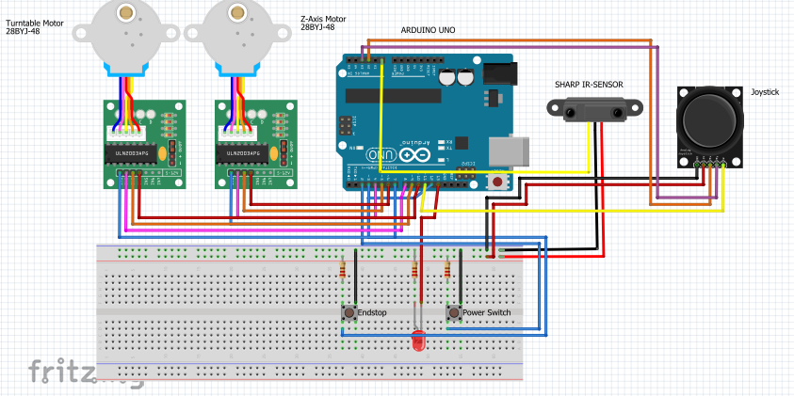
Figure 3
Sharp GP2Y0A51SK0F IR Sensor
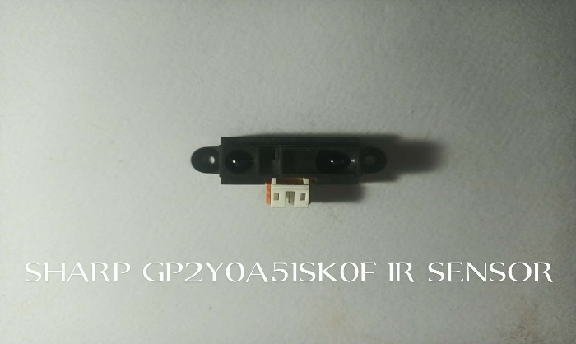
Figure 4
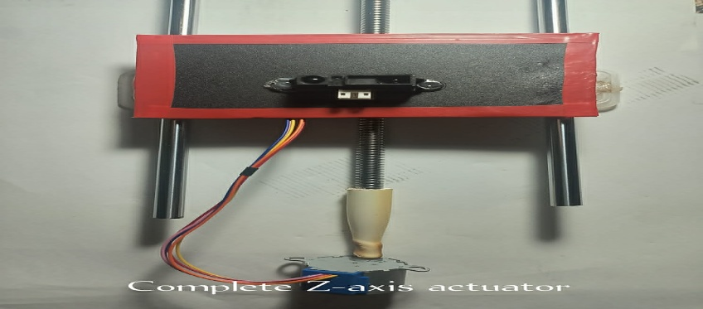
Complete Z-Axis Actuator

Figure 5
Turntable Format
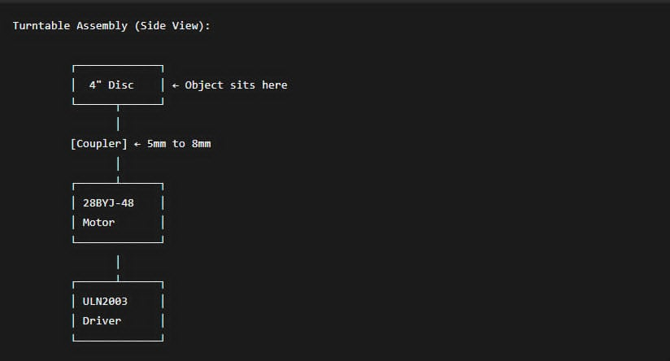
Figure 6
Arduino UNO
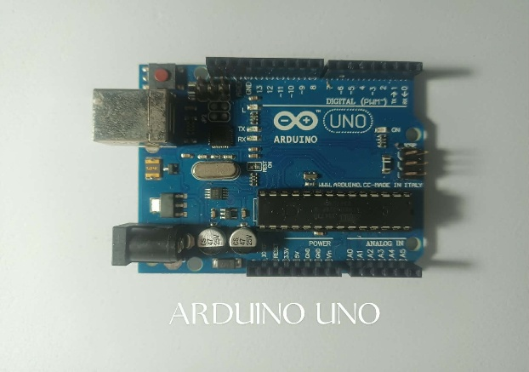
Table 1
Budgeting and Cost of Materials
No. | Product | Description | Quantity | Unit Price | Total Price
1 | KY-008 Laser Module | Light source for scanning | 1 | 32 | 32
2 | 28BYJ-48 Stepper Motor | Controls scanning movement | 2 | 50 | 100
3 | ULN2003 Microcontroller | Controls the stepper motor | 1 | 20 | 20
4 | Adafruit  TSL2591 | Light intensity sensor | 1 | 605 | 605
5 | Tactile Switches | Limit switch for movement | 5 | 27 | 135
6 | Sharp 0A51SK | Infrared sensor | 1 | 435 | 435
7 | Arduino UNO | Main system controller | 1 | 605 | 605
8 | 5V Power Supply | Power source for the system | 1 | 100 | 100
9 | 8mm Threaded Rod | Z-axis Actuator  Part | 1 | 284 | 284

Table 1
Budgeting and Cost of Materials Continuation
No. | Product | Description | Quantity | Unit Price | Total Price
11 | 8mm Steel Support Shaft | Z-Axis Actuator  Part | 1 | 248 | 248
12 | 2 Axis analog Joystick | Manual Controls | 1
13 | Breadboard | Perf Board substitute | 1
14 | Jumper Cable | Solid Core wire Substitute | 20
15 | Linear Bearings | Reduces friction | 2 | 180 | 360
Table 2
Pre-test and Post-test Scores of Students
Students | Pre-test Scores | Post-test Scores
1 | 8 | 12
2 | 7 | 13
3 | 7 | 10
4 | 4 | 12
5 | 7 | 11
6 | 10 | 13
7 | 8 | 12
8 | 11 | 14
9 | 10 | 14
10 | 10 | 13
Table 3
Pre-Test and Post-Test Scores Mean
Participant Group | Mean Pre-test Score | Mean Post-test Score
Students | 8.20 | 12.40
Table 4
Percentage Increase
Participant Group | Percentage Increase
Students | 51. 22 %
SUMMARY, CONCLUSIONS, AND RECOMMENDATIONS
The study concluded that the single-point optical scanning instructional model is an effective and affordable teaching tool for demonstrating the imaging principles of Transmission Electron Microscopy. The system successfully transformed abstract and invisible scientific processes into observable and interactive learning experiences, significantly improving students’ conceptual understanding and engagement. The findings supported the hypothesis that hands-on instructional tools enhance comprehension of advanced scientific concepts while also offering a practical alternative to expensive laboratory equipment. The researchers recommended integrating similar model-based learning tools into STEM instruction, expanding future studies using larger participant groups, improving software visualization capabilities, and further developing low-cost educational technologies for teaching complex scientific systems (Lim et al., 2024; Low et al., 2025).
REFERENCES
- Adachi, Y., Yamamoto, N., & Sannomiya, T. (2023). Focused light introduction into transmission electron microscope via parabolic mirror.. Ultramicroscopy, 251, 113759 . https://doi.org/10.1016/j.ultramic.2023.113759
- Adi, N. H., & Azra, F. (2023). Students’ difficulties in learning atomic structure. Journal of Education and Learning (EduLearn), 17(2), 267–274. https://doi.org/10.11591/edulearn.v17i2.22475
- Alcorn, F. M., Jain, P. K., & van der Veen, R. M. (2023). Time-resolved transmission electron microscopy for nanoscale chemical dynamics. Nature Reviews Chemistry, 7(4), 256–272. https://doi.org/10.1038/s41570-023-00469-y
- Aycan, S., Altun, E., Yerdelen, S., & Göksu, V. (2019). Students’ mental models of the atom and their difficulties in learning abstract atomic concepts. Journal of Baltic Science Education, 18(1), 9–23. https://doi.org/10.33225/jbse/19.18.09
- Benjin, X., Liu, J., & others. (2020). Developments, applications, and prospects of cryo- electron microscopy (cryo-EM). Protein Science, 29(1), 39–52. https://doi.org/10.1002/pro.3805
- Cheng, Y. (2018). Single-particle cryo-EM—How did it get here and where will it go. Science, 361(6405), 876–880. https://doi.org/10.1126/science.aat4346
- Dablio, A. R., Lagmay, M., Margarito, M., de Yro, P. A., & others. (2024). Philippines’ success in interlaboratory comparisons of nanoparticle geometric size measurements. Measurement Sensors, 38, Article 101527. https://doi.org/10.1016/j.measen.2024.101527
- Da Cunha, M. B., dos Santos, F. M. T., & Giordan, M. (2023). Students’ use of quantum and Bohr models of the atom: A representational versus conceptual understanding. Research in Science Education, 53, 151–170. https://doi.org/10.1007/s11165-021- 10023-1
- de Broglie, L. (1924). Recherches sur la théorie des quanta [Research on the quantum theory] (Doctoral dissertation, University of Paris). Annales de Physique, 10(3), 22–128.
- Dongre, A., Joshi, A., & Kapadia, M. (2012). Enhancing Conceptual Understanding through Hands-on Practical Tools in Science Education. arXiv. https://arxiv.org/abs/1205.1141
- Ferri, M., Ranucci, E., Romagnoli, P., & Giaccone, V. (2017). Antimicrobial resistance: A global emerging threat to public health systems. Critical Reviews in Food Science and Nutrition, 57(13), 2870–2891. https://doi.org/10.1080/10408398.2015.1077192
- Gabor, D. (1946). Theory of electron optics: A new approach to electron microscopy. Panganiban, R. E. (2020). The effectiveness of indigenous and low-cost teacher-made science instructional materials in selected third year students of the Balayan National High School. Instabright International Journal of Multidisciplinary Research, 2(1), 49–52. Retrieved from https://instabright.online/index.php/journal/article/view/8
- Freed, N., et al. "An Interactive Online Electron Microscopy Platform Integrating Classroom Lectures and Lab Practice." Microscopy Today, vol. 28, 2020, pp. 46 - 51. https://doi.org/10.1017/s1551929520000656.
- Galaz-Montoya, J. G. (2024). The advent of preventive high-resolution structural histopathology by artificial-intelligence-powered cryogenic electron tomography. Frontiers in Molecular Biosciences, 111390858. https://doi.org/10.3389/fmolb.2024.1390858
- Haider, M., Uhlemann, S., Schwan, E., Rose, H., Kabius, B., & Urban, K. (1998). Electron microscopy image enhanced. Nature, 392(6678), 768–769. https://doi.org/10.1038/33823
- Jefimenko, O. D. (1996). Derivation of relativistic force transformation equations from the Lorentz force law. American Journal of Physics, 64(6), 618-620.
  - https://doi.org/10.1119/1.18165
- Koguchi, M., Tsunekawa, Y., Tsunoyama, K., & Banerjee, I. A. (2015). Electron tomography: A three-dimensional analytic tool for hard and soft materials research. Advanced Materials, 27(38), 5638–5663. https://doi.org/10.1002/adma.201501015
- Kumar, A., Sharma, P., & Singh, R. (2022). The Role of Virtual Microscopy in Science Education: Benefits and Challenges. Computers & Education, 180, 104458. https://www.sciencedirect.com/science/article/pii/S0377123722000181
- Lam, Matilynn, et al. "An Introduction to Scanning Electron Microscopy and Science Communication Skills for Undergraduate Chemistry Students." Journal of Chemical Education, 2023. https://doi.org/10.1021/acs.jchemed.3c00076.
- Lim, Sin Ting, et al. "An Educational CT Scanner Prototype Using Optical Scanning." 2024 Multimedia University Engineering Conference (MECON), 2024, pp. 1-5. https://doi.org/10.1109/mecon62796.2024.10776174.
- Liu, X., & Lesniak, K. M. (2016). Progression in students’ understanding of the matter concept from elementary to high school. Journal of Research in Science Teaching, 53(5), 683– 708. https://doi.org/10.1002/tea.21312
- Liu, Zhongwei. "Design and Implementation of an Integrated Teaching Approach for Transmission Electron Microscopy Laboratory Education." International Journal of Multidisciplinary Research and Growth Evaluation, 2025. https://doi.org/10.54660/.ijmrge.2025.6.6.1103-1106.
- Low, Darren Yi Sern, et al. "Improving Student Motivation and Learning in Chemical Engineering Education: A Case of Scanning Electron Microscopy with Virtual 3D Technology." Education for Chemical Engineers, 2025. https://doi.org/10.1016/j.ece.2025.100498.
- Magnani, L., Rossi, M., & Bianchi, F. (2025). Accessibility Challenges in Microscopy Education: A Review of Low-Cost Alternatives. Journal of Microscopy Education, 12(1), 45–59. https://pubmed.ncbi.nlm.nih.gov/39611369/
- Nguyen, K. X., Yuan, R., Brown, H. G., Chen, M., Sunku, S. S., & Ercius, P. (2024). Achieving sub-0.5-angstrom–resolution ptychography in an uncorrected scanning transmission electron microscope. Science, 384(6694), 522–527. https://doi.org/10.1126/science.adl2029
- Padilla, Hurtado, and Juan Pablo. "Electron microscopes as educational tools: The use of a Scanning Electron Microscope to develop 3D models for educational programs." Microscopy and Microanalysis, vol. 26, 2020, pp. 65 - 66. https://doi.org/10.1017/s1431927620000562.
- Pennycook, S. J., Lupini, A. R., Varela, M., & Hetherington, C. J. D. (2003). Sub-Ångstrom resolution through aberration-corrected STEM. Microscopy and Microanalysis, 9(S02), 926–927. https://doi.org/10.1017/S1431927603444632
- Prameela, Suhas Eswarappa, et al. "Looking at education through the microscope." Nature Reviews. Materials, vol. 5, 2020, pp. 865 - 867. https://doi.org/10.1038/s41578-020-00246-z.
- Proceedings of the Royal Society A: Mathematical, Physical and Engineering Sciences, 197(1051), 454–467. https://doi.org/10.1098/rspa.1949.0005
- Ruska, E. (1987). The development of the electron microscope and of electron microscopy. Reviews of Modern Physics, 59(3), 627–638. https://doi.org/10.1103/RevModPhys.59.627
- Ullah, N., Qazi, R. A., Ullah, S., & Khan, S. (2022). Application and importance of scanning and transmission electron microscopes in science and technology. Contributions, Section of Natural, Mathematical and Biotechnical Sciences, 43(1–2), 27–37. https://doi.org/10.20903/masa/nmbsci.2022.43.13
- Waheed, Malaika, et al. "Design and development of a portable compound microscope for interactive bioscience learning." , vol. 13024, 2024, pp. 130240Q - 130240Q-6. https://doi.org/10.1117/12.3022127.
- Wolf, Vanessa, et al. "Utilization of Remote Access Electron Microscopes to Enhance Technology Education and Foster STEM Interest in Preteen Students." Research in Science Education, vol. 52, 2020, pp. 617 - 634. https://doi.org/10.1007/s11165-020-09964-4.
- Zhang, Chengyi, et al. "Integrating Laser-scanning Technology into a Construction Engineering and Management Curriculum." 2021 ASEE Virtual Annual Conference Content Access Proceedings, 2024. https://doi.org/10.18260/1-2--37361.
- ZEISS Microscopy Education. (2024). Teaching Microscopy in Resource-Limited Settings. Carl Zeiss Microscopy. https://www.zeiss.com/microscopy/en/applications/education-teaching.html

