SMARTPOS BUDGETEER: DESIGN AND IMPLEMENTATION OF A PYTHON-BASED SALES, INVENTORY, AND EXPENSE MANAGEMENT SYSTEM USING OOP PRINCIPLES

ABSTRACT
Manual management of sales, inventory, and expenses in small retail establishments often results in inaccurate calculations, delayed transactions, inconsistent stock tracking, missing records, and challenges in report generation. This study developed SmartPOS Budgeteer, a Python-based, GUI-driven system using Object-Oriented Programming (OOP) to automate sales transactions, inventory monitoring, expense recording, refund handling, and activity logging. The graphical interface was built using Tkinter, and data storage was managed through SQLite and MySQL for permanent record keeping. Functional testing showed that the system effectively processes transactions, updates inventory, handles refunds, validates inputs, and generates reports. By combining POS and expense management functionalities, SmartPOS Budgeteer offers a unified, user-friendly, and efficient solution for small retail stores, enhancing accuracy, accountability, and decision-making.
Keywords: SmartPOS Budgeteer, Point-of-Sale, Inventory Management, Expense Tracking, Python, Tkinter, OOP, SQLite, MySQL
INTRODUCTION

Background of the Study
Small retail businesses face challenges in managing sales, monitoring inventory, and tracking expenses. Manual systems such as handwritten ledgers or spreadsheets are prone to human error, time-consuming, and often lack real-time data tracking. Errors in sales recording, stock shortages, and mismanaged expenses can lead to financial losses and operational inefficiencies.
Point-of-Sale (POS) systems automate sales transactions, track inventory, and generate reports, while expense management systems help monitor and categorize business expenditures. However, small businesses often require a combined solution that integrates sales, inventory, and expense tracking into a single system for efficiency and accuracy.
SmartPOS Budgeteer was developed to address these challenges by providing a Python-based, object-oriented solution that combines sales management, inventory monitoring, and expense tracking. By integrating these functionalities, the system enables store owners to accurately record sales, update inventory, track expenses, process refunds, and generate reports, reducing manual work and operational errors.

Problem Statement
The study seeks to answer the following questions:
- How can sales, inventory, and expenses be efficiently tracked in a unified system for small retail operations?
- How can the system automate calculations, stock updates, and expense logging?
- How can a graphical user interface improve usability for business owners and staff?
- How can Object-Oriented Programming and database integration improve system reliability and maintainability?

Objectives of the Study
General Objective:
To develop SmartPOS Budgeteer, a Python-based, OOP-driven system for managing sales, inventory, and expenses in a small retail business.
Specific Objectives:
- Design and implement a sales management module for recording and processing transactions.
- Develop an inventory management module for tracking product stock and status.
- Create an expense management module for logging and monitoring business expenditures.
- Implement database storage using SQLite/MySQL to ensure permanent and accurate record-keeping.
- Design a user-friendly GUI for easy navigation and system operations.
- Conduct functional testing to validate accuracy, reliability, and usability.

Significance of the Study
For Business Owners: Enables accurate tracking of sales, inventory, and expenses, helping make informed decisions and improve efficiency.
For Employees: Simplifies sales and inventory operations, reducing manual workload and minimizing errors.
For Future Developers: Provides a framework for developing integrated business management systems using Python and OOP.
For Small Businesses: Demonstrates the benefits of unified systems over manual tracking, including time-saving, error reduction, and enhanced reporting capabilities.

Scope and Limitations
The study focuses on developing a desktop-based sales, inventory, and expense management system for small retail businesses. The system includes modules for:
- Sales recording and checkout
- Inventory tracking and updates
- Expense logging and report generation
- Refund processing and activity tracking
- Database integration and GUI-based navigation
The system is limited to desktop use and local database storage. Advanced features such as cloud backup, networked multi-user access, online payment integration, or mobile applications are outside the scope of this study and may be considered in future iterations.

REVIEW OF RELEVANT THEORY, STUDIES, AND LITERATURE
This chapter presents the relevant theories, previous studies, and literature that support the development of SmartPOS Budgeteer, a Python-based system that integrates sales, inventory, and expense management using Object-Oriented Programming (OOP). It includes discussions on POS systems, inventory management, expense tracking, database management, Python OOP, GUI applications, and related research studies.

Point-of-Sale Systems
A Point-of-Sale (POS) system is a computerized platform that automates sales transactions, computes totals, maintains product inventory, and generates sales reports. POS systems are widely used in retail businesses to improve operational efficiency and reduce manual errors (Garados et al., 2026).
Studies indicate that POS systems:
- Automate billing and sales computation
- Update inventory in real-time after transactions
- Provide accurate transaction records for financial reporting
By combining sales and inventory operations, POS systems help store owners track product movement, reduce human errors, and maintain accurate records of sales transactions.

Inventory Management Systems
Inventory management involves monitoring stock levels, tracking product movement, and maintaining accurate product records. Manual inventory management often results in errors such as overstocking, stockouts, and misplaced records.
Computerized inventory systems improve efficiency by:
- Maintaining real-time stock updates
- Generating alerts for low-stock items
- Allowing editing, adding, or removing inventory records
Madamidola et al. (2024) emphasize that integrating inventory tracking with POS systems helps businesses optimize stock management, prevent losses, and provide accurate reporting.

Expense Management Systems
Expense management systems are used to track, categorize, and summarize expenditures. In small businesses, managing expenses manually can lead to missing entries, incorrect calculations, and inefficient budgeting.
Automated expense trackers provide:
- Categorization of expenses (e.g., utilities, purchases, operational costs)
- Real-time updates on spending and totals
- Reports for daily, weekly, and monthly expenses
Bhavani et al. (2025) demonstrated that digital expense management increases accuracy, reduces errors, and improves financial decision-making in small retail operations.

Database Management
Database systems are critical for storing sales, inventory, and expense records. SQLite and MySQL provide lightweight, file-based, and relational database solutions that allow permanent storage, efficient querying, and CRUD operations.
Benefits of database integration in business systems include:
- Permanent storage and retrieval of records
- Prevention of duplicate entries
- Efficient report generation
Silberschatz, Korth, & Sudarshan (2019) emphasize that relational databases are essential in business systems to maintain data consistency, integrity, and reliability.

Python Programming and Object-Oriented Programming
Python is widely used for developing desktop business applications due to its simplicity and extensive libraries. Object-Oriented Programming (OOP) enhances maintainability and scalability by encapsulating data and methods into reusable classes.
In SmartPOS Budgeteer:
- Classes represent entities like products, sales transactions, and expenses
- Methods handle operations like adding products, processing sales, updating inventory, and generating reports
- OOP principles allow modularity and easier debugging
Bhavani et al. (2025) and Birajdar (2025) support that Python OOP improves system reliability, extensibility, and maintainability in small business applications.

Graphical User Interface (GUI) Design
GUI-based systems provide visual, interactive interfaces that allow users to operate the system without programming knowledge. SmartPOS Budgeteer uses Tkinter to implement forms, tables, buttons, and menus for:
- Adding, editing, or deleting products and expenses
- Processing sales and refunds
- Displaying reports and summaries
Shneiderman et al. (2016) highlight that a well-designed GUI increases usability, reduces errors, and enhances operational efficiency.

Related Studies
- Dimentieva et al. (2026) developed a web-based POS system with inventory management using Rapid Application Development, showing increased efficiency and user satisfaction.
- Suya et al. (2026) implemented a smart grocery POS system, reducing stock errors and improving reporting speed.
- Madamidola et al. (2024) developed an inventory management system integrated with financial tracking for small businesses.
- Bhavani et al. (2025) created a GUI-based expense tracker system, improving financial record accuracy and usability.
- Trappey, Trappey, & Hwang (1996) emphasized that computerized retail systems enhance decision-making, operational control, and data organization.
These studies collectively demonstrate that integrating POS, inventory, and expense management in a single system improves accuracy, efficiency, and usability for small businesses.

Synthesis
The reviewed literature emphasizes that:
- Manual tracking is error-prone and inefficient.
- Python OOP provides modularity and maintainability.
- Database integration ensures permanent, organized records.
- GUI interfaces improve usability and operational efficiency.
- Integration of sales, inventory, and expense modules provides unified control for small business operations.
SmartPOS Budgeteer applies these principles by combining sales, inventory, and expense management into a single Python-based OOP system, improving efficiency, accuracy, and usability for small retail businesses.

METHODOLOGY
This chapter presents the research design, system development process, database design, tools and technologies, system features, testing procedure, and evaluation methods used in developing SmartPOS Budgeteer, a Python-based system integrating sales, inventory, and expense management.

Research Design
The study employed a system development approach suitable for designing and implementing a desktop-based application for small retail businesses. This approach follows the software development life cycle (SDLC), which includes planning, system design, development, database integration, testing, and implementation.
The system addresses common issues in manual retail operations, including:
- Incorrect sales computation
- Stock mismanagement
- Missing or inconsistent expense records
- Delays in reporting
SmartPOS Budgeteer combines sales, inventory, and expense modules into a single platform using Python OOP for modularity and maintainability.

System Development Process

Planning
The planning stage involved identifying the key problems in managing small retail operations manually. Requirements were gathered for:
- Sales transaction processing
- Inventory tracking and updates
- Expense recording and reporting
- Refund handling and activity logging
- User authentication and secure access

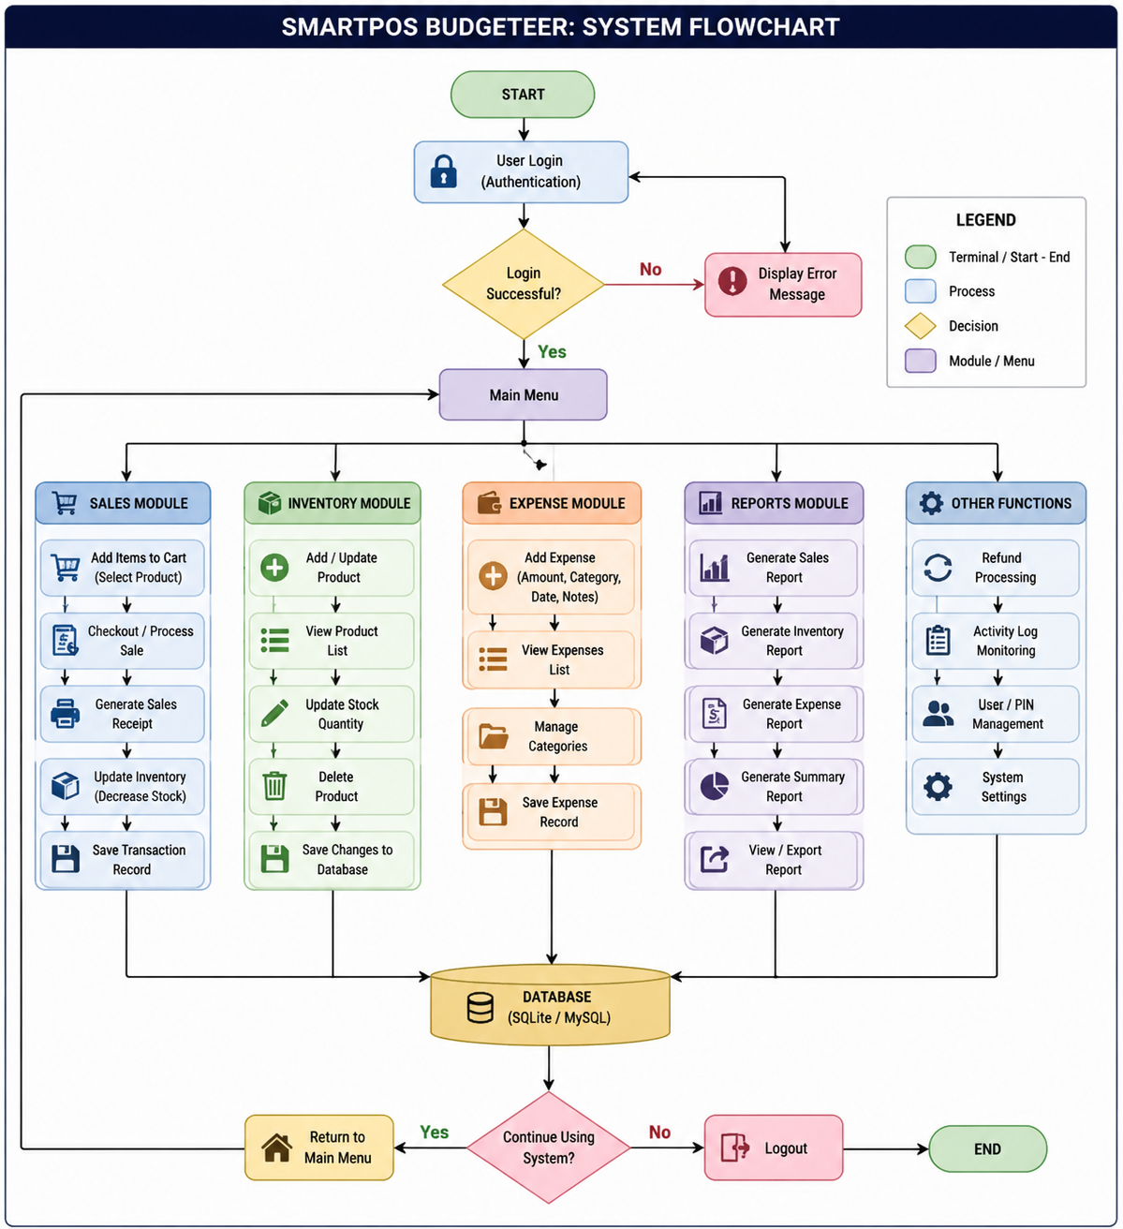

Figure 1. Flowchart of the SmartPOS Budgeteer system
Illustrating the complete workflow from user login and authentication to accessing the Main Menu. The diagram highlights the integrated modules—Sales, Inventory, Expense, and Reports—with database interactions, decision points, and navigation flow, demonstrating the OOP-based structure and systematic process of managing small retail operations

System Design
System design included the creation of:
- Flowcharts showing the sequential operations of each module
- Class diagrams demonstrating the OOP structure
- GUI mockups for the graphical interface using Tkinter
The main modules were defined as:
- Sales Module – Processes customer transactions, calculates totals, updates inventory.
- Inventory Module – Manages product records including adding, updating, and deleting products.
- Expense Module – Records, categorizes, and summarizes operational expenses.
- Refund Module – Handles returned products and updates stock/expense records.
- Reports Module – Generates summaries of sales, inventory, and expenses.
- Exit/Logout Module – Safely closes the system while ensuring data integrity.

Development
The system was implemented using Python and follows Object-Oriented Programming (OOP) principles.
- Classes represent entities such as Product, Sale, Expense, and Transaction.
- Methods handle operations such as adding, updating, deleting records, and generating reports.
- Tkinter GUI provides a user-friendly interface for data entry, module navigation, and transaction monitoring.

Database Integration
The system integrates both SQLite and MySQL for persistent storage:
- SQLite stores local, file-based records for quick retrieval.
- MySQL is used for permanent storage of sales, inventory, and expense records.
Database tables include:
Table Name | Purpose
products | Stores product details: ID, name, price, stock
sales_history | Records sales transactions and totals
expenses | Stores expense records and categories
activity_log | Tracks system activities and admin actions
sqlite_sequence | Maintains auto-increment IDs for records
The database ensures data persistence, supports CRUD operations, and enables efficient report generation.

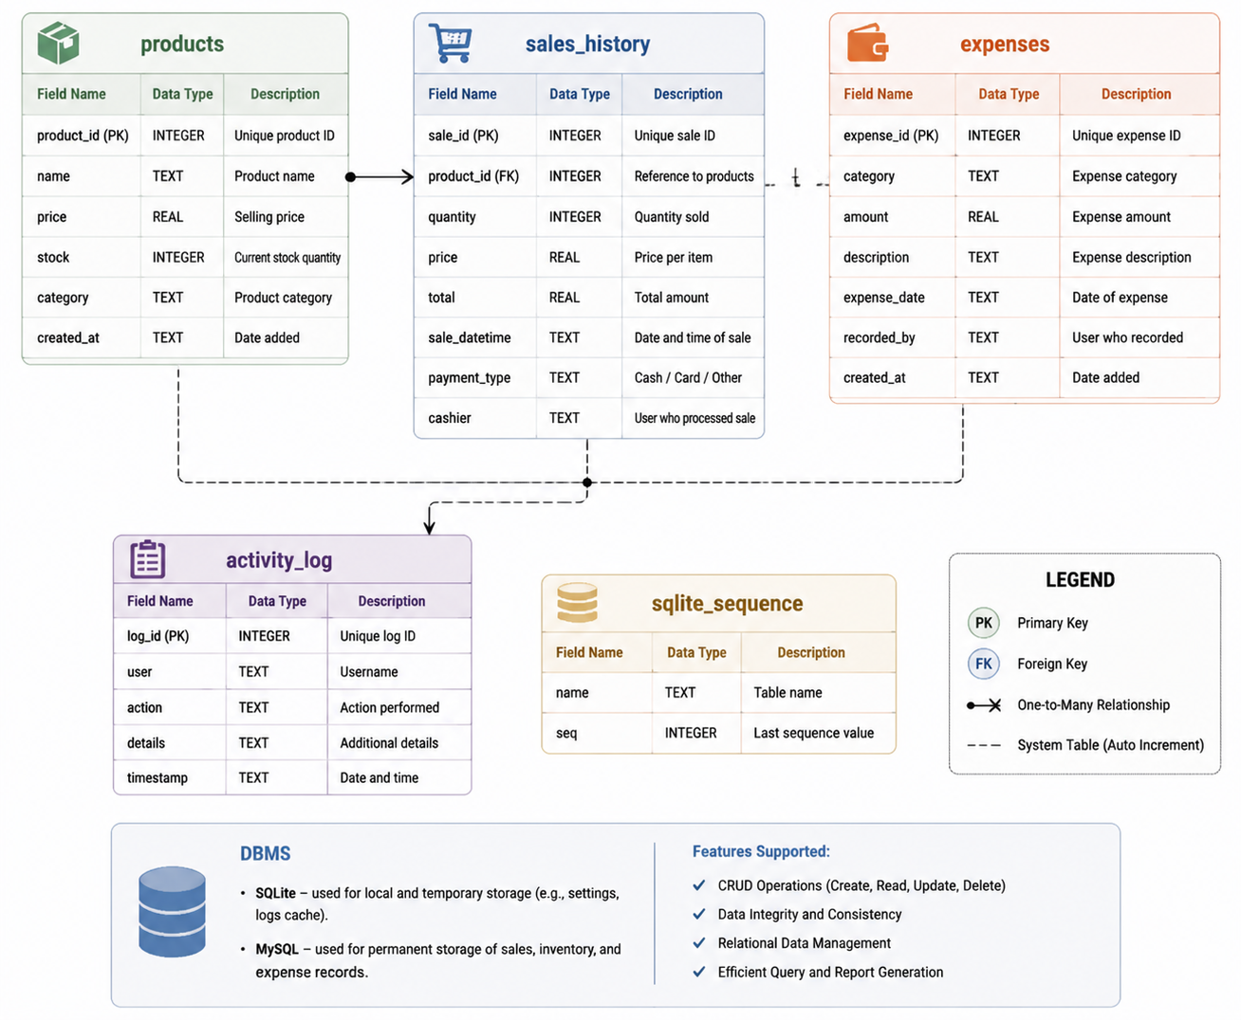

Figure 2. Database integration diagram of the SmartPOS Budgeteer system
It shows the relationships between SQLite (local database) and MySQL (primary database) tables, including products, sales_history, expenses, activity_log, and sqlite_sequence. The diagram illustrates data flow, table relationships, and system modules, highlighting data persistence, CRUD operations, and secure storage for sales, inventory, and expense management.

Graphical User Interface
The GUI is designed to allow users to interact with the system visually instead of using command-line instructions. GUI features include:
- Forms for product, sale, and expense entry
- Tables for displaying inventory, sales, and expense records
- Buttons for CRUD operations, report generation, and module navigation
- Dashboards showing totals, daily/monthly summaries, and alerts

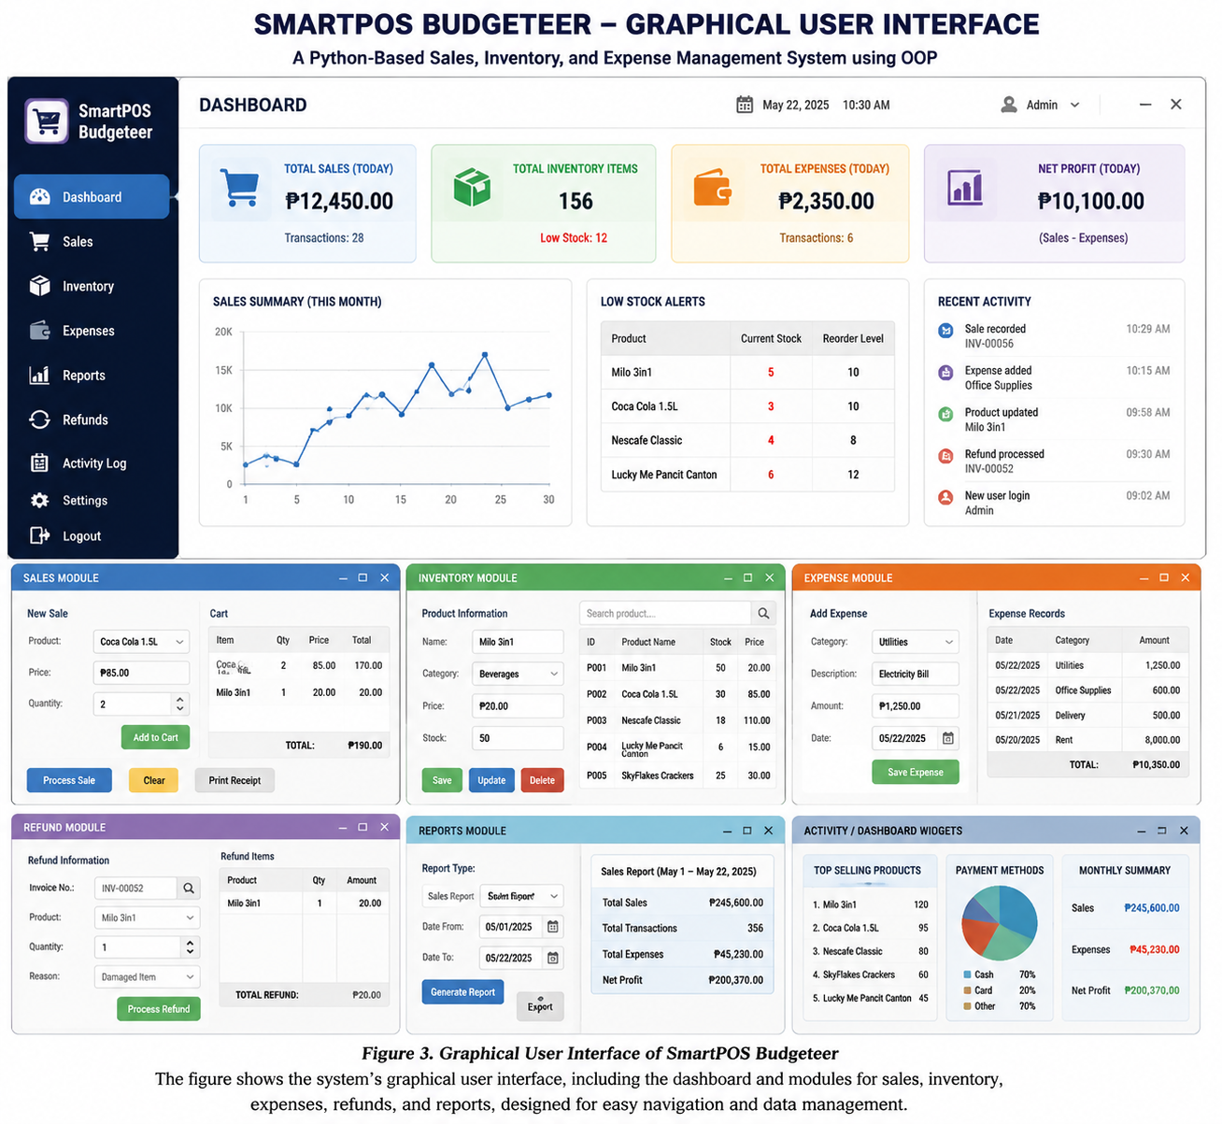

Figure 3. Graphical User Interface of SmartPOS Budgeteer
The figure shows the system’s graphical user interface, including. The dashboard and modules for sales, inventory, expenses, refunds and reports designed for easy navigation and data management.

Testing Procedure
Functional testing was conducted to validate all modules:
- Add, edit, delete operations for products, sales, and expenses
- Borrowing/Refund simulations for sales returns
- Input validation for empty fields, duplicates, or invalid data
- Report generation for accuracy of totals and summaries
- Database connectivity ensuring all records are saved and retrievable
All test cases were executed, and modules were confirmed to function as intended.

Implementation
The final system was deployed as a desktop application for small retail store operations. Users can perform all transactions, monitor inventory and expenses, generate reports, and log system activity through the GUI interface.

Tools and Technologies Used
- Programming Language: Python – system logic, calculations, and data operations
- GUI Framework: Tkinter – interactive user interface
- Database: SQLite and MySQL – persistent record storage
- Development Tools: VS Code – coding, testing, and debugging
- UI/UX Design: Figma – interface mockups and workflow design

System Features
- Sales Module: Process sales, update stock, and record transactions
- Inventory Module: Add, edit, delete products, and monitor stock levels
- Expense Module: Record operational expenses and generate summaries
- Refund Module: Handle returned items and update records
- Report Module: Generate daily, monthly, and summary reports
- Activity Logging: Track administrative operations for accountability
- Exit Module: Safely close system while maintaining data integrity

Summary
The methodology followed a system development approach combining Python OOP, GUI design, and database integration. Functional testing confirmed that SmartPOS Budgeteer performs accurate sales, inventory, and expense management, while generating reports and maintaining permanent records.
The system provides a unified, efficient, and user-friendly solution for small retail operations.

RESULTS AND DISCUSSION
This chapter presents the results and discussion of the developed SmartPOS Budgeteer system, highlighting the system overview, main features, graphical interface, functional testing results, and overall system performance.

System Overview
SmartPOS Budgeteer was developed as a unified desktop application for small retail operations. The system integrates sales processing, inventory management, and expense tracking, providing store owners with a single platform to manage business operations efficiently.

Figure 4. Graphical User Interface of the SmartPOS Budgeteer system, showing the main dashboard and individual modules for Sales, Inventory, Expenses, Refunds, Reports, and Activity widgets. The interface provides an organized layout with summary metrics, tables, forms, and charts for easy navigation, real-time tracking, and efficient management of retail operations.
The system uses:
- Python with Object-Oriented Programming for modular, maintainable code
- Tkinter GUI for a user-friendly interface
- SQLite/MySQL databases for persistent storage of sales, inventory, and expense records
The system starts with PIN authentication to secure access. After successful login, the user can navigate to modules for Sales, Inventory, Expenses, Refunds, and Reports, with all operations updating the database in real-time.

System Features and Results

Sales Module
The Sales module allows staff to record customer purchases, compute totals automatically, and update inventory quantities.
Result:
- All valid sales were recorded correctly in the database
- Stock was deducted automatically from inventory
- Invalid or duplicate entries were blocked through input validation

Inventory Module
This module manages products including adding, editing, and deleting inventory items.
Result:
- Product records were successfully added, updated, and deleted
- Stock quantities were tracked accurately in real-time
- Searching and filtering of products returned correct results

Expense Module
The Expense module tracks operational costs, categorizes expenses, and allows for report generation.
Result:
- Expenses were correctly saved and categorized
- Daily, monthly, and total expense summaries were accurate
- Invalid entries were blocked, ensuring correct financial tracking

Refund Module
The Refund module processes returned items, updates stock, and reverses sales transactions if necessary.
Result:
- Refunds were accurately recorded in the database
- Inventory was restored correctly after a refund
- Reports reflected adjusted sales totals

Report Generation
The Reports module generates summaries for sales, expenses, refunds, and net totals.

Result:
- Reports matched database entries
- Users could generate daily, monthly, and overall summaries
- Dashboard totals reflected correct calculations of sales, stock, and expenses

Graphical User Interface
The GUI, implemented using Tkinter, includes:
- Forms for sales, expenses, and inventory entry
- Tables displaying sales, stock, and expense records
- Buttons and menus for module navigation
- Dashboard with summary metrics
Result:
- Users could easily navigate modules and perform operations
- Visual interface reduced the need for technical knowledge
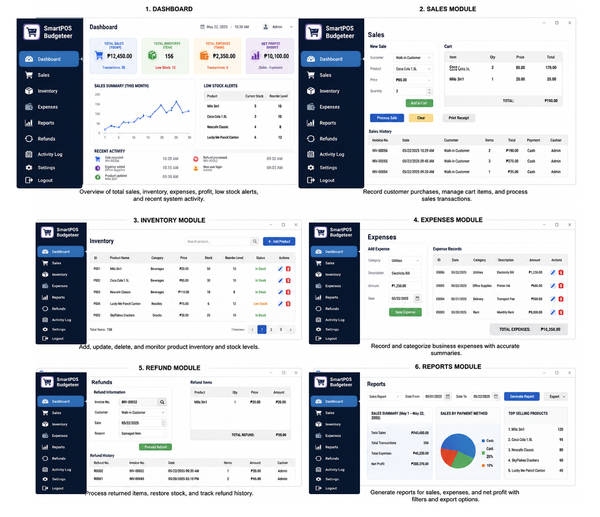
- Dashboard provided quick insights into sales, stock, and expenses

Figure 5. Graphical User Interface of the SmartPOS Budgeteer system displayed in six separate modules: Dashboard, Sales, Inventory, Expenses, Refunds, and Reports. Each module features intuitive panels, forms, tables, and summary widgets, designed for easy navigation, efficient transaction processing, inventory and expense management, and quick access to reports.

System Testing Results
Functional testing was conducted for all modules. Sample test cases include:
Test Case | Action | Expected Result | Actual Result | Status
Blank Input | Left a required field empty | System blocks saving | Blocked with warning | PASS
Invalid Sales Entry | Entered incorrect quantity or negative value | Error message shown | Error displayed | PASS
Duplicate Product ID | Added a product with existing ID | System blocks entry | Duplicate blocked | PASS
Add Expense | Recorded a valid expense | Expense saved | Successfully saved | PASS
Borrow/Refund | Processed sale return | Stock restored and transaction reversed | Updated successfully | PASS
Generate Report | Requested summary | Report matches database | Correct report generated | PASS
Inventory Update | Edited product details | Changes saved | Saved successfully | PASS
Exit System | Closed application | Data remains saved | Data persisted | PASS

All modules passed functional testing, demonstrating reliability and accuracy of the system.

Discussion of Findings
The results show that SmartPOS Budgeteer successfully combines POS, inventory, and expense management in a single system:
- Automated sales and inventory management improves efficiency and reduces human errors
- Expense tracking allows better financial oversight
- GUI improves usability, enabling non-technical users to operate the system
- Database integration ensures permanent, organized storage of records
- Refund handling maintains accurate stock and sales history
The system eliminates many inefficiencies found in manual record-keeping, reduces calculation errors, and provides quick access to reports for decision-making.

CONCLUSIONS AND RECOMMENDATIONS

Conclusions
Based on the development, testing, and evaluation of SmartPOS Budgeteer, the following conclusions were drawn:
- Integration of Modules: The system successfully integrates sales processing, inventory management, and expense tracking in a single Python-based OOP application, providing a unified platform for small retail business management.
- Automation of Operations: Automated sales computation, stock updates, and expense tracking reduces human error, improves transaction accuracy, and streamlines business operations.
- Database Reliability: Integration with SQLite and MySQL ensures permanent storage, efficient record retrieval, and organized data management.
- Graphical User Interface: The Tkinter-based GUI enables users to interact with the system efficiently without prior technical knowledge, improving usability and operational efficiency.
- Functional Performance: Functional testing confirmed that all modules—including sales, inventory, expenses, refunds, and report generation—perform correctly. Input validation prevents invalid or duplicate entries, maintaining data integrity.
- Decision Support: The system provides quick access to sales, inventory, and expense reports, assisting store owners in monitoring business performance and making informed decisions.
Overall, SmartPOS Budgeteer provides a reliable, accurate, and user-friendly solution for managing small retail operations, combining multiple business management tasks in a single system.

Recommendations
Based on the study’s findings and observed limitations, the following recommendations are proposed for future improvements:
- User Access Control: Implement role-based access to differentiate between administrators, cashiers, and managers, improving security and accountability.
- Barcode Integration: Include barcode scanning for faster product selection during sales transactions.
- Receipt Printing: Add a receipt generation and printing module for customer transactions.
- Enhanced Reporting: Include visual analytics, summaries, and export options (PDF/Excel) for sales, inventory, and expense reports.
- Cloud Backup: Implement cloud storage to ensure data security and enable remote access.
- Multi-User Network Support: Enable multiple users to access the system concurrently in a networked environment.
- Mobile/Web Interface: Consider developing mobile or web-based versions for broader accessibility.
- Low Stock Alerts: Integrate notifications for low-stock items to improve inventory control.
- Usability Testing: Conduct further usability evaluations with real store operators to refine the system workflow and interface.
- System Scalability: Future versions may include integration with online payments, loyalty programs, or accounting modules to enhance business management.
In conclusion, while SmartPOS Budgeteer successfully achieves its core objectives, implementing these recommendations will enhance system functionality, usability, and scalability, making it more suitable for broader retail business applications.

ACKNOWLEDGEMENT
The researchers would like to express their heartfelt appreciation to Engr. Meshelle N. Fabro, PCpE, for her dedicated mentorship, professional guidance, and expert supervision throughout the completion of this study. Her valuable insights, constructive suggestions, and continuous encouragement significantly contributed to the successful development and improvement of this research.
The researchers also extend their sincere gratitude to the Eulogio “Amang” Rodriguez Institute of Science and Technology (EARIST), particularly the Department of Computer Engineering, together with its faculty members, for providing the academic knowledge, technical resources, and institutional support necessary for the accomplishment of this project. The institution’s commitment to excellence in education, innovation, and research played an essential role in the success of this study.
Special thanks are also given to the families and friends of the researchers for their unwavering support, patience, understanding, and motivation. Their encouragement served as a source of inspiration and strength throughout the challenges encountered during the research process.
Above all, the researchers offer their deepest gratitude to Almighty God for the wisdom, guidance, strength, and perseverance bestowed upon them throughout this endeavor. This work is humbly dedicated to His glory, acknowledging that every achievement was made possible through His grace and blessings.

REFERENCES
Bhavani, V. T., Chinthana, S., Aishwarya, K., Shweta, B., & Nirmala, S. (2025). Implementation of an expense tracker using Python. International Journal for Multidisciplinary Research.
Birajdar, R. S. (2025). Personal expense tracker: Advancing financial management through software solutions. IIP International Multidisciplinary Research Journal.
Bourgeois, D. T., Smith, J. L., Wang, S., & Mortati, J. (2019). Information systems for business and beyond. Saylor Foundation.
Dimentieva, A., Li, J., Zhao, G., Li, J., Chen, X., & Wong, D. S. (2026). Designing cloud-based electronic health record system with attribute-based encryption.
Garados, M., Smith, J., & Wang, S. (2026). POS impact on operational performance and financial success.
Ismail, M. F., Nasir, N., Rahaman, W. E. W. A., Rashid, A. A., & Rusli, M. H. M. (2024). InventsimQD: GUI-based teaching application for quantity discounts inventory models. MYJIEAS, 4(01), 332–339.
Madamidola, A., Daramola, O. A., Akintola, K. G., & Adeboje, O. T. (2024). A review of existing inventory management systems. IJRES, 12(9), 40–50.
Python Software Foundation. (n.d.). Python documentation. https://docs.python.org/
Python Software Foundation. (n.d.). Tkinter — Python interface to Tcl/Tk. https://docs.python.org/3/library/tk.html
Shneiderman, B., Plaisant, C., Cohen, M., Jacobs, S., Elmqvist, N., & Diakopoulos, N. (2016). Designing the user interface: Strategies for effective human-computer interaction (6th ed.). Pearson.
Silberschatz, A., Korth, H. F., & Sudarshan, S. (2019). Database system concepts (7th ed.). McGraw-Hill Education.
Suya, F., Li, J., Zhao, G., Li, J., Chen, X., & Wong, D. S. (2026). Smart inventory management for mini grocery stores.
Trappey, C. V., Trappey, A. J. C., & Hwang, S.-J. (1996). A computerized quality function deployment approach for retail services. Computers & Industrial Engineering, 30(4), 611–622.

ABOUT THE AUTHORS
Jules Barcena is a Bachelor of Science in Computer Engineering student at Eulogio “Amang” Rodriguez Institute of Science and Technology (EARIST). He is a hardworking and determined student who is passionate about learning new technologies and improving his skills in programming and computer systems. Despite the challenges that come with college life, he remains committed to achieving his academic goals and continuously developing his knowledge in the field of technology. He enjoys exploring different areas of computer engineering, learning new concepts, and working on projects that help enhance his technical abilities. Through dedication, perseverance, and continuous learning, he hopes to become a successful computer engineer in the future.
Lhemuel M. Braw Jr. is currently pursuing a degree in Computer Engineering at Eulogio "Amang" Rodriguez Institute of Science and Technology. He is dedicated on learning about technology and continuously works toward achieving his academic and professional goals. Lhemuel is passionate and responsible student who is eager to develop his technical knowledge and explore different fields in engineering. He is committed to overcoming challenges in his studies while improving his analytical thinking, problem-solving, and programming skills. Through continuous learning, determination, and self-improvement, he aspires to become a skilled computer engineer in the future.
Pamela Ann T. Casta is a passionate and goal-oriented student currently studying at Eulogio "Amang" Rodriguez Institute of Science and Technology. She is eager to expand her knowledge and develop valuable skills that will help in achieving future career goals. As a responsible and hardworking individual, she continuously works on improving academic performance, communication skills, and technical abilities. She enjoys participating in school activities, learning new technologies, and collaborating with others to gain more experience and understanding. Despite challenges and difficulties, she remains motivated and determined to succeed. With dedication, perseverance, and confidence, she hopes to make a positive contribution to society and become successful in the chosen profession someday.
Ma. Socorro B. Garin is a Computer Engineering student at the Eulogio “Amang” Rodriguez Institute of Science and Technology. She is passionate about technology and dedicated to improving her knowledge and skills in programming, computer systems, and engineering. She is hardworking, responsible, and determined to achieve her academic goals while continuously learning new things that can help her grow both personally and professionally. Despite challenges, she remains motivated and committed to becoming a successful computer engineer in the future.
Hannah L. Rosento is a first-year Bachelor of Science in Computer Engineering student at the Eulogio “Amang” Rodriguez Institute of Science and Technology (EARIST) Manila Campus. She is known for being hardworking, adaptable, and determined to continuously improve her abilities through learning and experience. She is interested in programming, GUI design, and system development. Through the development of the system, she gained experience in coding, debugging, documentation, and teamwork. This project helped her improve her problem-solving skills and deepen her understanding of object-oriented programming and database management. She hopes to continue learning more about software development while enhancing her technical and analytical skills in the field of computer engineering.
Bizzy Amerie R. Reyes is a sophomore Bachelor of Science in Computer Engineering student at the Eulogio "Amang" Rodriguez Institute of Science and Technology (EARIST). Driven by a strong passion for technology and computer systems, his academic focus centers on software development, artificial intelligence, and hardware design. He aspires to engineer innovative, tech-driven solutions that solve real-world challenges and advance modern technology.
Patrick Jake D. Valentin is currently pursuing his degree in Computer Engineering at the Eulogio "Amang" Rodriguez Institute of Science and Technology. He is deeply committed to his technological education and consistently strives to reach his academic and career objectives. Driven by a strong interest in technology and systemic design, he consistently explores ways to deepen his expertise in hardware-software integration, system analysis, and engineering principles. He places a high value on sharpening his critical thinking and collaborative abilities, understanding that seamless teamwork and clear communication are essential for delivering reliable technical solutions. Through hard work, a commitment to lifelong learning, and practical engineering experience, he aims to establish himself as a skilled, forward-thinking, and resourceful computer engineer in the technology industry.
Engr. Meshelle N. Fabro is a licensed Professional Computer Engineer and educator at the Eulogio “Amang” Rodriguez Institute of Science and Technology (EARIST). She is currently pursuing a Master of Science in Computer Engineering at Bulacan State University and has professional industry experience as a Technical Engineer at Hewlett-Packard (HP) and an IT Engineer at IBM.She is also a TESDA CSS NC II and Trainers Methodology Level I (TM1) holder, demonstrating her commitment to technical excellence and competency-based education. Passionate about teaching and innovation, she is dedicated to guiding Computer Engineering students in becoming industry-ready, competent, and highly skilled individuals equipped for the evolving demands of the technology industry.

