A MINI RESEARCH PROJECT ON

"A STUDY OF ROLE OF WOMENS' HOUSEHOLD FINANCIAL DECISION MAKING WITH REFERENCE TO KUNDAPURA TALUK"

1.1 INTRODUCTION:

Finance refers to monetary resources and the study and discipline of money, currency, assets, and liabilities. As a subject of study, it is related to but distinct from economics, which is the study of the production, distribution, and consumption of goods and services. Based on the scope of financial activities in financial systems, the discipline can be divided into personal, corporate, and public finance. In these financial systems, assets are bought, sold, or traded as financial instruments, including currencies, loans, bonds, shares, stocks, options, and futures. Assets can also be banked, invested in, and insured to maximize value and minimize losses. In practice, risks are always present in any financial action or entity. Due to its wide scope, a broad range of subfields exists within finance. Asset-, money-, risk-, and investment management aim to maximize value and minimize volatility. Financial analysis assesses an action or entity's viability, stability, and profitability. Some multidisciplinary fields include mathematical finance, financial law, financial economics, financial engineering, and financial technology. These fields are the foundation of business and accounting. In some cases, theories in finance can be tested using the scientific method, covered by experimental finance. The early history of finance parallels the early history of money, which is prehistoric. Ancient and medieval civilizations incorporated basic functions of finance, such as banking, trading, and accounting, into their economies. In the late 19th century, the global financial system was formed. In the middle of the 20th century, finance emerged as a distinct academic discipline, separate from economics. The earliest doctoral programs in finance were established in the 1960s and 1970s. Today, finance is also widely studied through career-focused undergraduate and master's level programs. Financial decision-making encompasses evaluating options, making choices,and taking actions related to financial matters. It involves assessing risks, considering available resources, and aligning decisions with long-term objectives. Effective decision-making is essential for financial success, whether managing personal finances or steering a business toward profitability. Financial decision-making is a crucial aspect of business management. It involves choosing between available alternatives to achieve financial goals. From budgeting to investment choices, every decision impact financial stability and growth. In this article, we'll explore the significance of financial decision-making and strategies to enhance it.

1.2 OBJECTIVES OF THE STUDY:
The specified objectives of the study were to:
- To examine the level of women’s participation in household financial decisions.
- To identify the factors influencing women’s involvement in financial matters.
- To analyse the impact of women’s financial decision-making on household wellbeing.
- To assess societal and cultural attitudes towards women managing household finances.
- To understand decision-making dynamics.

1.3 SCOPE OF THE STUDY:
This study aims to investigate women’s household financial decision-making, focusing on their level of involvement, factors influencing their decisions, and the impact of their empowerment and well-being.

1.4 LIMITATIONS OF THE STUDY:
- The findings of the study may not apply to all women or households.
- The sample size may be limited, which could affect the accuracy of the findings.
- It is a very time-consuming process.
- It was also very disappointing for me at times when the feedback given by the employees was below expectations.

1.5 METHODOLOGY OF THE STUDY:
The data required for this study were collected through primary and secondary data.

PRIMARY DATA
In this study, primary data were collected through women’s use of a questionnaire. The questionnaire was administered to a hundred women.

SECONDARY DATA
Secondary data for this study was collected from: -
Websites, Books, and other records.

1.6 CHAPTER SCHEME:
- Introduction.
- History of the Study Area.
- Data Analysis and Interpretation.
- Findings, Suggestions and Conclusion

2.1 HISTORY OF THE STUDY AREA:
Women play a crucial role in household financial decision-making, influencing budgeting, spending, saving, and investing. Research on women’s household financial decision-making explores the factors that shape their financial choices, including:
- Socioeconomic factors: Income, education, and employment status.
- Cultural and social norms: Gender roles, family dynamics, and community expectations.
- Financial literacy: Knowledge and skills related to personal finance, investing, and money management.
- Power dynamics: Decision-making authority and control over household finances.

Understanding women’s household financial decision-making is essential for:
- Promoting financial inclusion: Empowering women to participate in financial decision-making.
- Improving household well-being: Enhancing financial stability and security for families.
- Advancing gender equality: Recognizing women’s agency and autonomy in financial matters.

Studies on this topic aim to:
- Identify key factors influencing women’s financial decision-making.
- Analyse decision-making processes: Understanding how women make financial choices.
- Develop targeted interventions: Supporting women’s financial empowerment.
By exploring these aspects, research can inform policies, programs, and initiatives that promote women’s financial autonomy and well-being. The provided text offers a comprehensive introduction to studies on women’s household financial decision-making. It highlights the significance of understanding the factors influencing women’s financial choices, such as:
- Socioeconomic factors
- Cultural and social norms
- Financial literacy
- Power dynamics
The text also emphasizes the importance of this research for:
- Promoting financial inclusion
- Improving household well-being
- Advancing gender equality

By identifying key factors, analysing decision-making processes, and developing targeted interventions, studies can inform policies and initiatives supporting women’s financial empowerment. Some potential research questions or areas of exploration based on this introduction could include:
- How do socioeconomic factors impact women’s financial decision-making authority?
- What role does financial literacy play in women’s household financial management?
- How can policies and programs promote women’s financial inclusion and empowerment?

Overall, the text provides a solid foundation for exploring the complexities of women’s household financial decision-making.

2.2 IMPACT
Women’s involvement in household financial decision-making has significant implications for various aspects of family life, including educational outcomes, financial security, and gender equality. Women’s involvement in financial decision-making leads to more effective budgeting, saving, and investing. Women’s financial decisions prioritize family needs, such as education, healthcare, and nutrition. Women’s financial management skills contribute to household financial stability and security. Women’s participation in financial decision-making promotes their empowerment and autonomy. Women’s financial decisions lead to more efficient allocation of resources, benefiting the entire household. Women’s financial decisions often prioritize children’s education, leading to better educational outcomes. Women’s involvement in financial decision-making leads to increased savings and investment for the future. Women’s financial decision-making contributes to reducing poverty and improving overall household well-being. Women’s involvement in financial decision-making promotes financial inclusion and access to financial services. Women’s financial decision-making fosters cooperation and communication within families. Women’s financial autonomy and decision-making authority can enhance their social status and respect within families and communities. Women’s financial decisions prioritize healthcare, improving family members’ health outcomes. Women’s financial decision-making can have long-term benefits for future generations, including improved economic prospects and financial stability. Women’s financial empowerment and decision-making can help break cycles of poverty and promote economic mobility. Women’s financial decisions prioritize healthcare, leading to improved health outcomes for family members. Women’s financial management skills can reduce financial stress and anxiety within families. Women’s financial decisions often prioritize education, leading to better educational outcomes and opportunities for children.

FINDINGS:
- Women often have limited control over household finances,
- Education and income levels impact women’s financial decision-making power.
- Financial literacy is crucial for women’s effective financial decision-making.
- Cultural and social norms can influence women’s roles in financial decision-making.
- Women’s financial empowerment benefits communities.

DATA ANALYSIS AND INTERPRETATION

Tables and Pie Charts

3.1. Turn for support when faced with financial challenges
Particular | No. of Responses | Percentage
Partner | 30 | 30
Family member | 57 | 57
Friend | 11 | 11
Financial advisor | 2 | 2
Total | 100 | 100

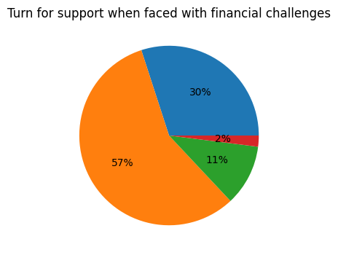

Partner Financial Adviser Family Member Friend
INTERPRETATION:
The diagram and table indicate that family members provide 57% support when facing financial challenges. The significance of only 2% in financial difficulties is considerable.

3.2. Feel like you're shouldering the majority of financial responsibility
Particular | No. of Responses | Percentage
Often | 25.7 | 25.7
Sometime | 52.5 | 52.5
Rarely | 18.8 | 18.8
Never | 3.0 | 3.0
Total | 100 | 100

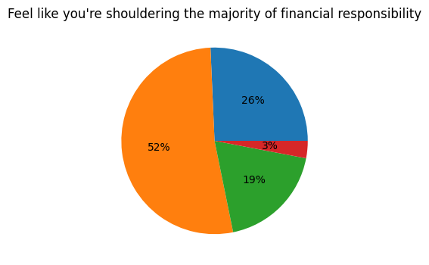
Often Sometime Rarely Never
INTERPRETATION:
The diagram and table above indicate that the respondents feel they carry the main burden of financial responsibility. The largest group, 52.5%, reported that they sometimes feel this way, while a small minority, 3.0%, stated that they never feel like they shoulder most of the financial responsibility.

3.3. Investment decisions in your household
Particular | No. of Responses | Percentage
You | 23 | 23
Your partner | 35 | 35
Someone else | 31 | 31
Both of you jointly | 11 | 11
Total | 100 | 100

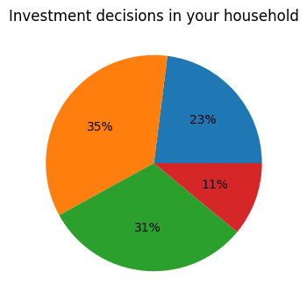

You Your Partner Someone else Both of you jointly

INTERPRETATION:
The diagram and table indicate that 35% of surveyed households have primary responsibility for making investment decisions, while 11% of respondents make decisions jointly.

3.4. Prioritise your own financial goals v/s those of your family
Particular | No. of Responses | Percentage
I prioritise my own goals | 30.7 | 30.7
I prioritise my family's goals | 43.6 | 43.6
I balance both equally | 24.8 | 24.8
I don't prioritise either | 1.0 | 1.0
Total | 100 | 100

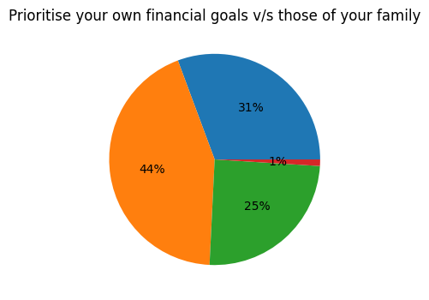
I balance both equally
I don’t priorities either.
I prioritise my family’s goals
I balance both equally

INTERPRETATION:
The above diagram and table show the respondents. Prioritise their financial goals compared to those of their family. The largest segmentC43.6%) and the minority (1.0%) indicated that they don't prioritise either.

3.5. Are you handle unexpected financial expenses?
Particular | No. of Responses | Percentage
I use emergency fund | 43.6 | 43.6
I use credit cards | 30.7 | 30.7
I cut back on discretionary other | 16.8 | 16.8
Other | 8.9 | 8.9
Total | 100 | 100

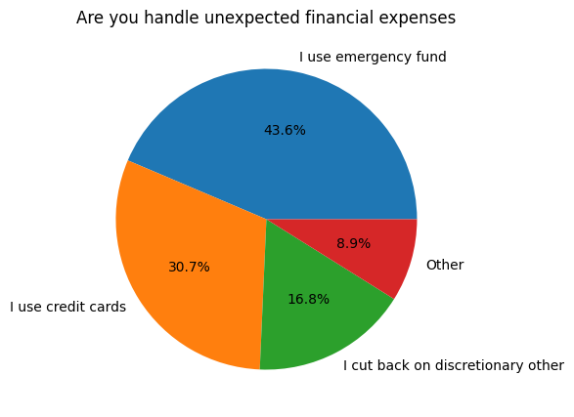
I use emergency fund I cut back on discretionary

I use credit cards others
INTERPRETATION:
The above diagram and table show that illustrates, the different ways responders handle unforeseen financial casts. The mast common approach, (43.6%) is to use an emergency fund and minority, (8.9%) utilize other methods.

FINDINGS:
1. Women often have limited control over household finances.
2. Education and income levels impact women's financial decision-making power.
3. Financial literacy is crucial for women's effective financial decision-making.
4. Cultural and social norms can influence women's roles in financial decision-making.
5. Women's financial empowerment benefits communities.

SUGGESTIONS:
- Make financial advisors more accessible.
- Create reliable online resources for financial education.
- Teach people about personal finance.
- Encourage partners and family members to make financial decisions together.
- Offer resources for people who make financial decisions alone.
- Study how people make financial decisions.
- Explore how social networks can help with financial education.

CONCLUSION:
Women’s financial decision-making is a crucial aspect of their economic independence and well-being. By understanding their financial preferences and behaviours, we can develop targeted solutions to support their financial empowerment. Ultimately, empowering women financially can have a positive impact on their lives and the lives of those around them. It can also help bridge the gender gap in financial inclusion and promote more equitable distribution of resources. By supporting women’s financial decision-making, we can foster a more inclusive and sustainable financial ecosystem.

ANNEXURE: QUESTIONNAIRE

“THE STUDY ON ROLE OF WOMENS’ HOUSEHOLD FINANCIAL DECISION-MAKING WITH REFERENCE TO KUNDAPURA TALUK”

Dear Sir/Madam

We, the faculties of Dr B.B. Hegde First Grade College, Kundapura, are conducting a mini research project about the “The Study Of Role Of Women’s’ Household Financial Decision Making With Reference To Kundapura Taluk". We hereby request you to co-operate with us by filling this questionnaire. The information given by you will be kept confidential.

Thanking you
Yours sincerely,
Mrs. Surekha
Mrs. Rashmitha Shetty

QUESTIONNAIRE

We, the faculties of Dr. B.B. Hedge First Grade college, Kundapura, are conducting a research study titled “THE STUDY ON ROLE OF WOMENS’ HOUSEHOLD FINANCIAL DECISION MAKING WITH REFERENCE TO KUNDAPURA TALUK”. We kindly request your participation by answering a few questions enclosed here. Your response will be used solely for the study and will be kept confidential. Thank you for your time and cooperation.

- Do you manage household finances?
  - Yes

  - No

- Who has more control over household financial decision?
  - You

  - Your partner

  - Both of you equally

  - Someone else

- Do you have a financial advisor?
  - Yes

  - No

- How do you typically make financial decision?

  - Alone

  - With partner

  - With family/friends

  - With financial advisor

- What is your preferred method of learning about personal finance?
  - Online resources

  - Financial advisor

  - Books/workshops

  - Family/friends

- Have you ever experienced financial abuse or control?
  - Yes
  - No
  - Unsure

7. What is the most significant financial goal for you?
a) Saving for retirement
b) Paying off debt
c) Building on emergency fund
d) Other

8. What is the most significant financial stressor in your life?
a) Debt
b) Saving for retirement
c) Paying for education
d) Other

9. What is the most significant financial influencing your financial decisions?
a) Financial goals
b) Family responsibilities
d) Other
c) Social pressures

10. What is the most significant financial benefit of having emergency fund?
a) Reduced financial stress
b) Increased financial flexibility
c) Improved financial stability
d) All of the above

11. Who you turn for support when faced with financial challenges?
a) Partner
b) Family member
c) Friend
d) Financial advisor

12. How often do you feel like you're shouldering the most of the financial responsibility?
a) Often
b) Sometime
c) Rarely
d) Never

13. Who makes investment decisions in your household?
- You

- Your partner

- Someone else

- Both of you jointly

14. How do you prioritise your own financial goals v/s those of your family?
- I prioritise my own goals
- I prioritise my family’s goals
- I balance both equally
d) I don’t prioritise either
15. How do you handle unexpected financial expenses?
- I use emergency fund
- L use credit cards
- I cut back on discretionary spending
- Other

16. What is the most significant financial risk face in your career?
- Jobless

- Reduced income

- Limited career advancement

- Other

17. How important is it for you to be involved in household financial decision-making?
- Very important

- Somewhat important

- Not very important

- Not at all important

18. Who typically makes financial decisions in your household?
- You

- Your partner

- Both of you jointly

- Someone else

THANK YOU

