Unveiling Shared and Disease-Specific Metabolic Disruptions in Three Chronic Cardiovascular Diseases

Abstract
Multimorbidity, defined as the coexistence of multiple chronic conditions, is a growing global health challenge. Understanding the metabolic relationships among these conditions, as well as identifying specific metabolites that can differentiate between them, will offer valuable biological insights into their co-occurrence. We employed untargeted plasma metabolomics and machine learning to analyze metabolic changes and associations linked to three chronic cardiovascular diseases—deep venous thrombosis (DVT), hypertension (HPT) and coronary heart disease (CHD)—in a cohort of 196 subjects. Our analysis revealed that 134 metabolites that were common to at least two of these diseases, representing 54.3% of the total 409 significant metabolite-disease associations. The results shows that lipids, amino acids and peptides, hypoxanthine, carnitines and Glucose exhibited interconnected roles across multiple chronic cardiovascular diseases. Additionally, numerous carnitines were found to be specifically linked to DVT and CHD, while the DVT displayed pronounced disruptions in amino acid metabolism. By employing logistic regression models, we identified differential metabolites associated with the three chronic cardiovascular diseases, which demonstrated strong diagnostic performance in both the discovery and validation cohorts. Altogether, our study uncovered extensive and interconnected metabolic dysregulation across the three chronic cardiovascular diseases. The identified differential metabolites hold potential for diagnosing these conditions and offer valuable insights for future clinical interventions and management strategies grounded in metabolomics approaches.
Keywords: Multimorbidity; metabolomics; metabolites; chronic cardiovascular disease; associations; deep venous thrombosis

Introduction
Comprehensive molecular analysis of human blood holds the potential to uncover novel disease pathways, enhance risk assessment, and facilitate targeted prevention and management strategies. (Karczewski & Snyder, 2018). The development and advancement of chronic cardiovascular diseases are shaped by a multifaceted interplay of factors, such as genetic predisposition, environmental influences and lifestyle choices (Jaagura et al., 2024; Mars et al., 2020). The disruption of shared pathways indicates a high degree of interconnectedness, and gaining insight into how these associations influence the coexistence of chronic conditions is essential. Notably, one in three patients presents two or more chronic conditions simultaneously, a phenomenon referred to as multimorbidity (Jurisson et al., 2021).
The simultaneous presence of chronic cardiovascular conditions, such as deep venous thrombosis (DVT), hypertension (HPT) and coronary heart disease (CHD), is frequently observed, and prior research has demonstrated a strong interconnection between these conditions and also with other diseases (Omar et al., 2017; Pietzner et al., 2021; Yang & Zheng, 2019). As a result, it is critical to differentiate disease-specific biomarkers from those associated with the progression of coexisting conditions, referred to as comorbidities (Fromentin et al., 2022). To achieve precise characterization of disease patterns, comprehensive health data, including detailed medical histories for each patient, is required.
Metabolomics has become a highly effective approach for analyzing the dynamic alterations of small molecules, offering fresh insights into the exploration of disease phenotypes (Sung et al., 2018). Over recent decades, numerous studies have employed metabolomics to identify metabolic biomarkers and elucidate molecular mechanisms underlying DVT, CHD, and HPT(Ameta et al., 2017; Jiang et al., 2018; Teruya et al., 2023). However, these investigations have faced significant limitations, including small sample sizes and non-prospective study designs. Crucially, most research has examined these cardiovascular conditions in isolation, making it impossible to directly compare disease-specific metabolic signatures across these cardiovascular diseases. Several key factors complicate these comparisons: First, studies often identify different sets of metabolites, creating inconsistencies in the data. Second, variations in study conditions make it challenging to directly compare association estimates across different research projects.
However, insights into the shared underlying pathological mechanisms of less evidently connected diseases remain limited. Molecular profiling holds the potential to systematically and concurrently uncover pathways across a broad spectrum of incident diseases, enabling objective and large-scale evaluation. Given the interconnected nature of various chronic diseases, researchers are increasingly prioritizing the investigation of metabolic relationships across multiple conditions.
Based on our knowledge, Pietzner et al. (Pietzner et al., 2021) conducted the first comprehensive profiling uncovered shared metabolic pathways related to the multimorbidity of 27 common non-communicable diseases using metabolomics data from the EPIC-Norfolk cohort. Another major prospective study employing targeted metabolomics and lipidomics has revealed both common and distinct metabolic patterns associated with various chronic metabolic disorders (Y. Zhang et al., 2024). While these investigations included CHD and HPT, they omitted DVT and lacked detailed comparative analyses of shared versus disease-specific metabolic alterations across all the conditions. Furthermore, these previous studies only accounted for age and sex as potential confounders when identifying metabolic biomarkers, potentially overlooking other important variables. Our study addresses these gaps by providing a more comprehensive comparison of metabolic signatures across DVT, CHD, and HPT while incorporating additional confounding factor. Therefore, a comprehensive prospective LC-MS based metabolomics study examining DVT, CHD and HPT within the same cohort could overcome these limitations while revealing crucial insights into both shared and distinct metabolic dysregulations.
Methods
Study Design and Sample Collection
The study involved male and female subjects with ages above 18 years who were admitted and diagnosed with chronic cardiovascular diseases in Dala Orthopedic Hospital, Kano (Nigeria) between October, 2024 and December 2025. Subjects with known metabolic diseases, pregnant or breastfeeding women, and patients with evidence of chronic use of drugs affecting metabolism were excluded from the study. Before the fasting venous blood samples were collected, none of the patients were taking anticoagulants or antiplatelet medications. These blood samples were taken within 12 hours of their admission to the hospital. D-Dimer measurement and Lower limb Doppler ultrasound was performed to confirm the DVT status of the subject’s following trauma. The DVT group were subjects diagnosed with distal DVT in the lower extremities. Hypertension was identified when the systolic blood pressure (SBP) was 140 mmHg or higher and the diastolic blood pressure (DBP) was 90 mmHg or greater. CHD patients who self-report CHD were diagnosed by coronary angiography and long-term treatment with antihypertensive and lipid-lowering drugs. CHD was diagnosed if coronary angiography revealed at least one significant stenosis, which was defined as a luminal narrowing of 50% or more in the main coronary arteries or their major side branches. Healthy controls were identified through clinical diagnosis as individuals without any history of metabolic disease, with normal results from coronary angiogram examination and doppler ultrasound for absence of CHD and DVT, no HPT.
The study comprised 196 subjects, encompassing both healthy individuals and those diagnosed with one or more cardiovascular diseases. The participants exhibited at least one chronic metabolic disease, including DVT; n = 57, HPT; n = 66, and CHD; n = 51. A total 50 subjects were used as independent validation cohorts. All fasting plasma samples were obtained from Hospital. Prior to sample collection, written informed consent was obtained from all participants. The study adhered to the principles outlined in the Declaration of Helsinki. Plasma samples were collected following an overnight fast and stored at −80 °C until further processing.
Determination of Clinical Characteristics of the Subjects
Coagulation tests were conducted in the clinical laboratory of Honghui Hospital utilizing an Automatic Coagulation Analyzer manufactured by Sysmex, Japan. Biochemical assays were conducted using an autoanalyzer (Siemens ADVIA 2400, Munich, Germany). Total serum cholesterol and triglyceride levels were assessed using the enzymatic hydrolysis and oxidation (CHOD-POD) method and the GPO-PAP enzymatic method, respectively. High-density lipoprotein cholesterol (HDL-C) and low-density lipoprotein cholesterol (LDL-C) levels were determined using the direct assay method.
Sample Preparation
Blood Sample Collection
Blood sample from each subject following overnight fast was collected into a EDTA anticoagulated tube. Subsequently, the tubes containing samples were centrifuged at 1500 g for 10 min at 4°C to obtained plasma which was then stored at −80°C for further analysis. Details of metabolite extraction can be found in the supplementary methods. A quality control (QC) sample was prepared by combining equal aliquots of the supernatant from every sample.
LC-MS Analyses and Data Processing
Metabolomic analyses were performed using ultra-high performance liquid chromatography-tandem mass spectrometry (UHPLC-MS/MS) with a Vanquish UHPLC system (Thermo Fisher Scientific, Germany) coupled to an Orbitrap Q Exactive™ HF-X mass spectrometer (Thermo Fisher Scientific, Germany). Separation was achieved using a UPLC BEH Amide column (2.1 mm × 100 mm, 1.7 μm). The UPLC column oven temperature was set at 25°C, while the auto-sampler temperature was maintained at 4°C, and the injection volume was 3 μL. The mobile phase was composed of 25 mmol/L ammonium acetate and 25 ammonia hydroxides in water (pH = 9.75) as component (A) and acetonitrile as component (B). The QE HFX mass spectrometer was employed for its capability to collect MS/MS spectra in information-dependent acquisition (IDA) mode, managed by the acquisition software (Xcalibur, Thermo). In this mode, the acquisition software continuously evaluates the full scan MS spectrum. For the QC samples, we perform segmented data acquisition in IDA mode (Top 12 precursor ions) according to different MZ intervals to ensure that enough MS/MS information can be captured. For the experimental samples, we used the full scan mode. The electrospray ionization (ESI) source conditions were configured as follows: sheath gas flow rate at 25 Arb, auxiliary gas flow rate at 20 Arb, capillary temperature at 350°C, full MS resolution at 60,000, MS/MS resolution at 7,500, collision energy at 10/30/60 in NCE mode, and spray voltage at 3.6 kV (positive) or -3.2 kV (negative), respectively.
For every batch, the sequence of sample acquisitions was randomized, and quality control (QC) injections were included after every 10 sample injections. The raw data were converted into the mzXML format and analyzed using an in-house program developed in R, which was built on the XCMS platform (Colin A. Smith, 2006). Subsequently, an in-house MS/MS database, known as BiotreeDB, was utilized for the annotation of metabolites, with a similarity score threshold established at 0.4. The in-house software package and database have been extensively utilized in numerous metabolic research studies (Gong et al., 2021; X. Zhang et al., 2021). For features identified in both positive and negative modes, we selected the one that had the higher annotation score for further analysis. In a separate analytical batch, all metabolic peaks underwent a noise reduction process. Following this data filtration process, the abundances of the remaining peaks were normalized by dividing them by the intensity of the internal standard (IS). The data were then log-transformed and adjusted to be median-centered within each batch. Metabolites that were consistently measured across all batches were retained and combined for subsequent analysis (Gong et al., 2021; Q. Liu et al., 2022; Xiao et al., 2022). Further information regarding plasma metabolomics analysis, inbuilt library used, metabolic data processing and normalization can be found in the Supplementary Methods.
Statistical Analysis
We employed linear regression models to uncover significant associations between metabolites and chronic cardiovascular diseases (DVT, CHD and HPT), with adjustments made for sex, age and BMI (adjusted p < 0.001). Principal component analysis (PCA) was performed using R (version 4.3.2) to observe sample clustering and group separation, as well as identifying outliers. To achieve a more distinct group separation and a deeper insight into classification variables between multimorbidity group and single disease group, we employed supervised Orthogonal partial least squares discriminant analysis (OPLS-DA). The relative abundances of differential metabolites were normalized by centering at zero and scaling to unit variance prior to statistical analyses.
Construction of metabolite-disease associations Network
The Cytoscape software (version 3.10.2) was utilized to create visual representations of metabolite-disease associations based on metabolite classifications.
Selection of Diagnostic Biomarkers and Model Construction using Machine Learning
Binary logistic regression models were employed to select significant differential metabolites after adjusting for sex, age and BMI. The odds ratios (ORs) of the identified differential metabolites were computed using R (version 4.3.2). We constructed a prediction model based on biomarkers selected using logistic regression (R function lm). ROC analysis was used to assess the performance of the diagnostic models constructed. To reduce selection bias and increase predictive accuracy, a 5-fold cross-validation was used to improve the precision and reduce the selection bias. The data was randomly divided into 70% and 30% as train data and test data to train the model and evaluate the performance of the model, respectively (Al-Akwaa et al., 2018; Xia Shen, 2021). Similarly, sensitivity, specificity, accuracy metrics calculated the performance scores of the prediction models. All analyses were performed using R software (version 4.2.3, http://www.R-project.org).
Correlation between Differential Metabolites and Clinical Parameters
Correlation between differential metabolites and clinical parameters were determined using the Pearson correlation coefficient. Pearson correlation coefficients were calculated and visualized using R (version 4.3.2).
Result
Clinical Characteristics of Subjects
The clinical characteristics of all 196 participants are detailed in Table 1 and 2 in both discovery cohort.
Table 1: Clinical Characteristics in the Discovery Cohort
Parameters | HPT (N= 36) | DVT (N= 47) | CHD (N= 31) | HC (N= 32)
Gender:  Male n (%) | 27 (75.0%) | 21 (44.6) | 22 (70.9) | 20 (62.5)
Age  (Mean ± SD) | 61.8 (± 9.4) | 58.5 (±12.4) | 62.3 (± 8.7) | 56.5 (± 9.2)
BMI (kg/m²) | 23.24 (± 1.7) | 25.45 (± 2.6) | 26.22 (± 2.4) | 24.17 (± 3.4)
Cardiovascular parameters
Mean (± SD)
Heart Rate (BPM) | 82.2 (± 7.0) | 80.0 (± 5.0) | 85.4 (± 8.5) | 83.6 (± 6.8)
SBP (mmHg) | 147.3 (± 10.8) | 126.4 (± 10.2) | 122.4 (± 5.5) | 120.5 (± 6.2)
DBP (mmHg) | 88.6 (± 8.4) | 78.2 (± 9.3) | 77.2 (± 10.2) | 75.4 (± 8.7)
Coagulation Parameters
Mean (± SD)
PT(S) | 13.5 (±2.2) | 7.3 (±2.0) | 12.4 (±1.0) | 10.7 (±1.2)
PT-INR | 1.7 (±0.04) | 0.5 (±0.08) | 1.5 (±0.07) | 1.8 (±0.04)
APTT (S) | 31.3 (±5.2) | 12.5 (±4.1) | 25.2 (±2.8) | 27.3 (±3.4)
TT (S) | 16.4 (±2.0) | 7.3 (±1.6) | 19.4 (±1.4) | 21.4 (±1.6)
Fbg (g/L) | 1.3 (±0.6) | 5.3 (±0.8) | 1.8 (±1.2) | 2.1 (±0.4)
DD (mg/L) | 1.1. (±0.4) | 5.9 (±0.7) | 1.5 (±0.8) | 1.4 (±0.4)
FDP (mg/L) | 14 (±1.6) | 10.3 (±1.3) | 16.1 (±1.7) | 18.6 (±2.2)
NB: SBP, systolic blood pressure; DBP, diastolic blood pressure; PT, prothrombin time; TT, thrombin time; Fbg, fibrinogen; DD, D-dimer; FDP, fibrinogen degradation products; PT-INR, prothrombin time-international normalized ratio; APTT, activated partial thromboplastin time.
Table S2: Clinical Characteristics in the Validation Cohort
Parameters | HPT (N = 13) | DVT (N = 11) | CHD (N=13) | HC (N = 13)
Gender:  Male n (%) | 6 (46.1) | 7 (63.6) | 5 (38.5) | 8 (61.5)
Age  (Mean ± SD) | 58.6 (±15.2) | 62.5 (± 16.5) | 60.4 (± 13.2) | 59.6 (± 7.4)
BMI (kg/m²) | 26.6 (± 2.0) | 23.5 (± 3.2) | 24.0 (± 2.9) | 22.3 (± 4.3)
Cardiovascular parameters
Mean (± SD)
Heart Rate (BPM) | 78.3 (± 7.3) | 82.5 (± 6.7) | 83.1 (± 9.4) | 83.4 (± 7.7)
SBP (mmHg) | 154.5 (± 12.8) | 119.2 (± 8.0) | 117.7 (± 11.5) | 112.3 (± 10.6)
DBP (mmHg) | 93.1 (± 8.5) | 71.0 (± 5.8) | 78.5 (± 7.9) | 73.2 (± 5.0)
LDL-C (mmol/L) | 3.1 (± 0.9) | 2.2 (± 0.6) | 2.4 (± 1.3) | 1.2 (± 0.6)
HDL-C (mmol/L) | 1.4 (± 0.5) | 3.1 (± 0.9) | 1.3 (± 0.4) | 3.2 (± 0.5)
TG (mmol/L) | 2.1 (± 0.4) | 2.3 (± 0.5) | 2. 0(± 0.2) | 1.1(± 02)
TC (mmol/L) | 5.5 (± 0.9) | 5.4 (± 1.2) | 3.5 (± 0.4) | 1.2 (± 0.3)
Coagulation Parameters
Mean (± SD)
PT(S) | 12.6 (±1.2) | 6.8 (±1.4) | 12.9 (±3.1) | 10.2 (±2.4)
PT-INR | 0.9 (±0.06) | 0.5 (±0.06) | 0.9 (±0.06) | 0.8 (±0.04)
APTT (S) | 24.8 (±3.7) | 18.7 (±3.3) | 27.8 (±6.6) | 29.4 (±4.2)
TT (S) | 15.4 (±2.3) | 8.6 (±1.9) | 9.7 (±1.7) | 10.1 (±2.4)
Fbg (g/L) | 2.1 (±0.6) | 5.4 (±1.6) | 3.8 (±0.2) | 2.7 (±0.4)
DD (mg/L) | 2.1 (±0.6) | 4.2 (±0.5) | 2.4 (±1.0) | 2.0 (±0.3)
FDP (mg/L) | 17.0 (±3.0) | 11.3 (±2.4) | 10.4 (±1.7) | 19.6 (±2.5)

Untargeted Plasma Metabolomics Analysis
We performed untargeted LC-MS based metabolomic analyses using 354 fasting plasma samples (226 discovery cohort). A total of 483 plasma metabolites were identified, encompassing a broad range of compounds, including carbohydrates, amino acids, peptides, lipids, energy-related metabolites, nucleobases, and others (Figure 1A). The stability of metabolomics analysis techniques was evaluate using Quality control (QC) samples. An overview of the distribution and frequency of patients suffering from chronic cardiovascular diseases was presented in Figure 1B. Notably, 84 patients (42.9%) exhibited comorbidities involving two or more chronic cardiovascular conditions.
Metabolic Profiles of Three Cardiovascular Diseases
We analyzed metabolic changes in plasma samples from patients with cardiovascular diseases using linear regression models, with adjustment made for sex, age and BMI. DVT was associated with 145 metabolites, HPT was associated with 124 and CHD was associated with 140 (adjusted p < 0.001). The metabolites associated with each cardiovascular disease are detailed in Figure 1C.
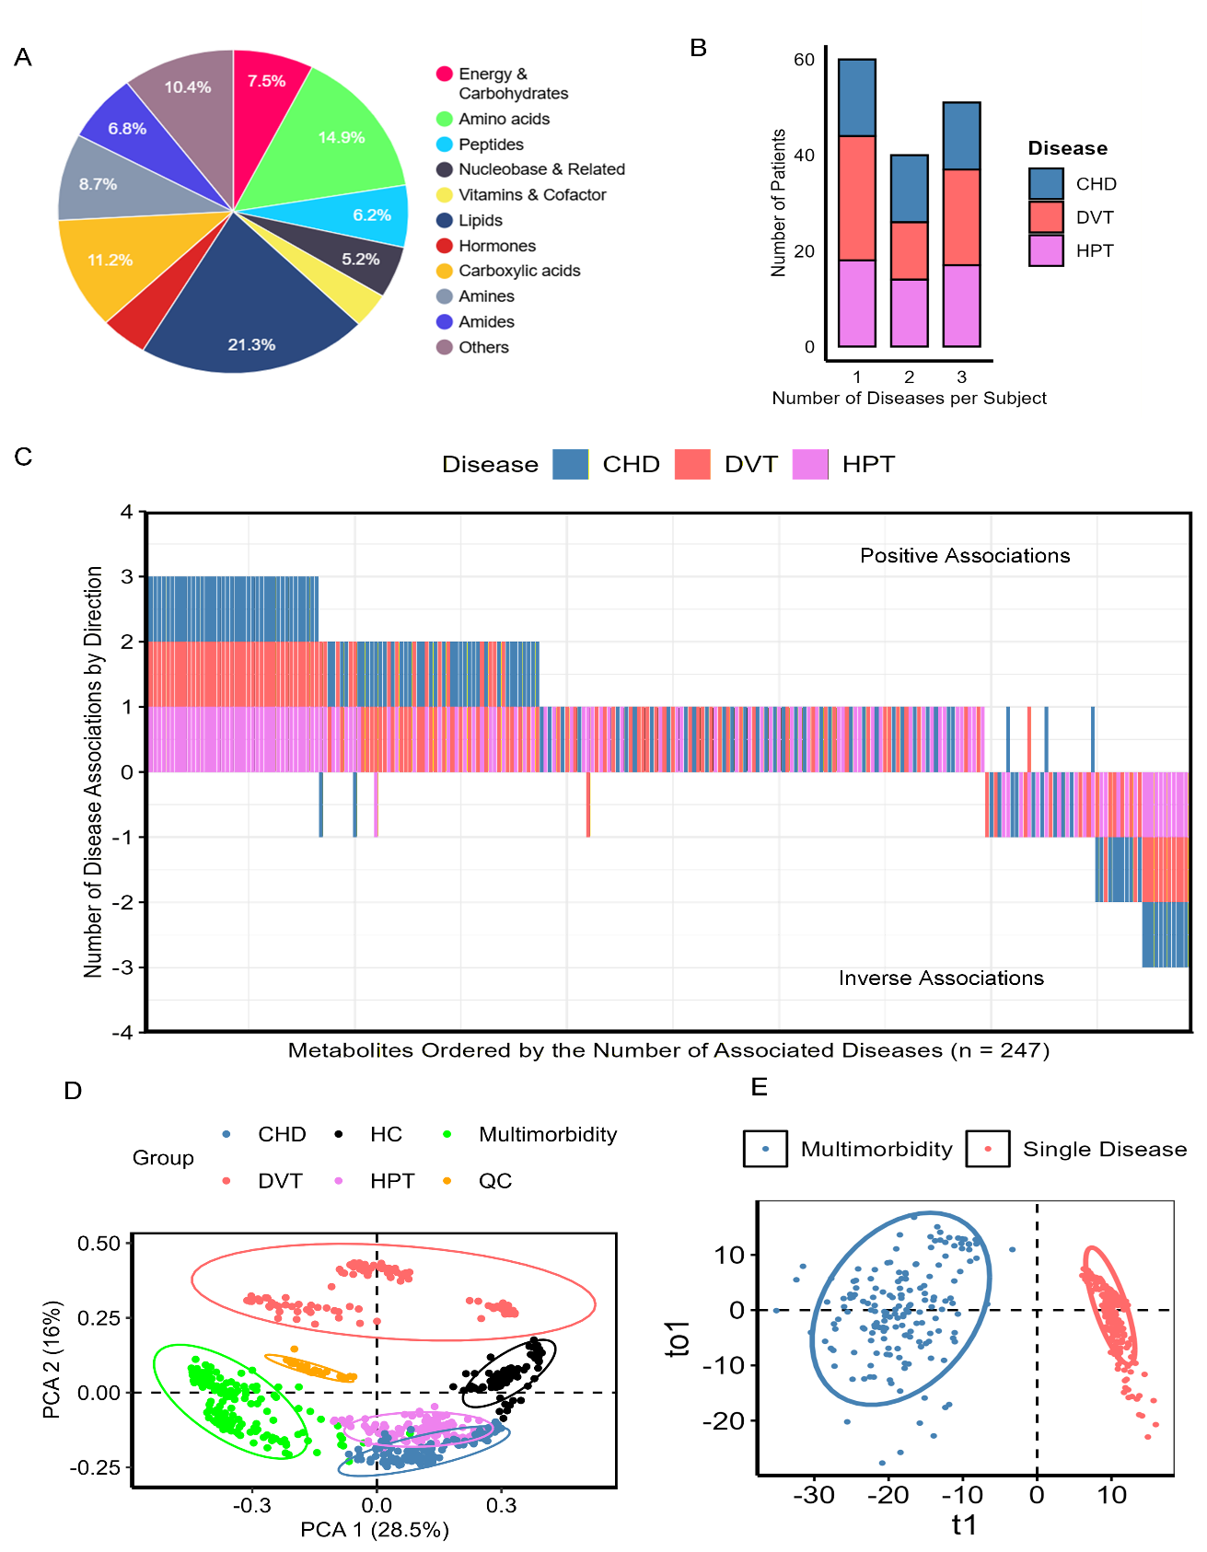
Figure 1. Analysis of the untargeted plasma metabolome. (A) Categories of metabolites identified through untargeted metabolomics in plasma samples. (B) The count of subgroups with one or more chronic cardiovascular diseases (C) Brick plot illustrates the ranking of metabolites based on the number of associated diseases. The metabolite-disease associations were determined using linear regression models adjusted for age and sex. A significance threshold of P < 0.001 was applied, considering three diseases (DVT, CHD, and HPT) tested for each metabolite. The x-axis represents the rank of each metabolite according to the number of associated diseases, while the y-axis indicates the number of diseases associated with each metabolite. Positive values on the y-axis signify positive associations, whereas negative values indicate inverse associations. The color of each box corresponds to the specific disease associated with the metabolite. (D) PCA score plot displaying all differential metabolite data. "Multimorbidity" refers to individuals with two or more chronic cardiovascular diseases, with each dot's color representing a specific chronic cardiovascular disease. (E) OPLS-DA score plot comparing multimorbidity and single-disease groups.

A comprehensive analysis revealed that 247 metabolites exhibited significant associations with at least one chronic cardiovascular disease (Figure 1E). Notably, 134 of these metabolites, accounting for 54.3%, were identified as differential metabolites that were shared in two or more chronic cardiovascular diseases. These findings highlight extensive and overlapping alterations in the metabolome among individuals with cardiovascular diseases.
With the exception of a few metabolites associated with DVT, CHD and HPT, all shared differential metabolite exhibited consistent increases or decreases across the disease groups (Figure 1C). This consistent trend in the differential metabolites implies that therapeutic strategies focused on one cardiovascular disease could potentially exert favorable influences on other cardiovascular conditions.
Additionally, all differential metabolites were incorporated into the PCA to provide a comprehensive overview of the metabolic changes in the plasma of patients with chronic cardiovascular diseases (Figure 1C). The results revealed a clear trend of separation between patients with multimorbidity and the healthy control group. OPLSDA analysis was conducted in order to obtain a robust classification between patients with multimorbidity and single disease. The OPLS-DA score plot indicated a clear distinction between the groups (Figure 1D). Individuals with multiple chronic cardiovascular diseases demonstrate more pronounced metabolic deviations than those with a singular disease, indicating a more profound level of metabolic disturbance. Among individuals with a single disease, those diagnosed with DVT exhibited a distinct pattern of separation.
Metabolic Interaction and Specificity among Three Cardiovascular Diseases
Uncovering shared metabolic features across multiple cardiovascular diseases can provide novel insights that extend beyond the study of individual conditions, while also enabling a systematic exploration of both shared and distinct pathophysiological mechanisms. In this study, we established metabolite-disease association network to explore the metabolic connectivity and specificity among chronic cardiovascular diseases (Figure 2 and 3). Our analysis uncovered interconnected metabolic pathways among cardiovascular diseases, spanning various metabolite classes, while also emphasizing the unique metabolic signatures associated with DVT.
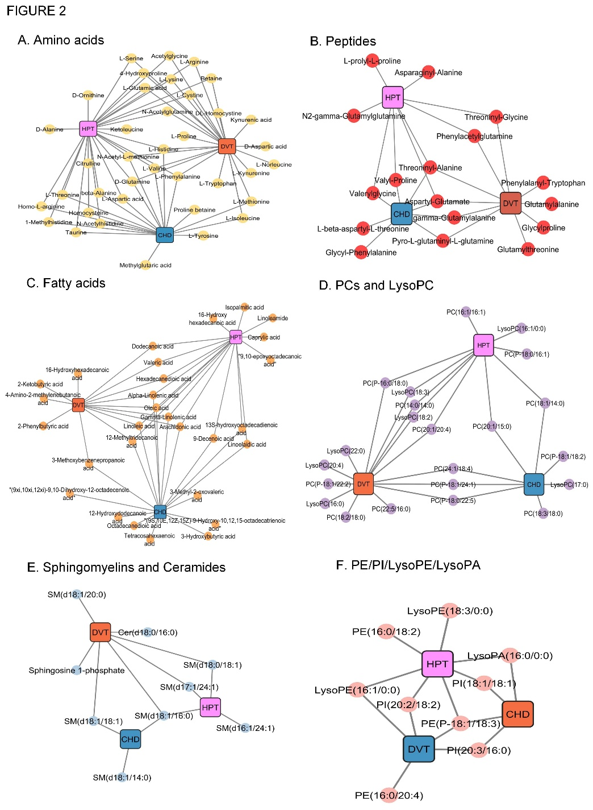
Figure 2. Associations between 247 differential metabolites (indicated by colored dots) and three chronic cardiovascular diseases (marked by colored squares). The insets (A–F) illustrate the connections between chronic cardiovascular diseases and specific metabolite categories. Metabolite-disease relationships were analyzed using linear regression models adjusted for age, sex, and BMI. A significance level of adjusted p < 0.001 was used, accounting for the three diseases examined for each metabolite. The networks were organized and color-coded by biochemical groups; for example, the "Amino acid" graph exclusively displays associations involving metabolites derived from amino acid-related compounds.
Analysis of the metabolome revealed a significant alteration of amino acids in patients with DVT, CHD and HPT (Figure 2A). Specifically, the amino acids L-histidine, L-valine, L-Phenylalanine, and N-Acetyl-L-methionine were associated to all three chronic cardiovascular diseases.
Our findings also revealed associations between several acetylated amino acids and multiple chronic cardiovascular diseases (Figure 2A). N-acetyl-L-methionine was linked to all three chronic cardiovascular diseases, while N-acetyl-glutamine and N-acetylglycine were associated with DVT and HPT, and N-Acetylhistidine was associated with CHD and HPT (Figure 2A). Dipeptides such threonyl-alanine and asparetyl-glutamate showed interactions with all the diseases (Figure 2B). Also, dipeptides such as phenylacetyl-glutamine and threoninyl-glycine were associated with DVT and HPT. Phenylalanyl-tryptophan was found to associated with DVT only. Fatty acids, including alpha-linolenic acid, arachidonic acid and linoleic acid, were associated with all the diseases (Figure 2C), with similar patterns in both CHD and HPT (Figure 2C). Phospholipid disturbance (PCs, LPCs) were common to all diseases (Figure 2D) while sphingolipids such as sphingomyelins (SMs), ceramide (Cer) and sphingosine-1-phosphate (S1P) were uniquely associated with DVT (Figure 2E). Other lipids such as Phosphatidylethanolamine (PEs), phosphatidylinositol (PIs), lysophosphatidylethanolamine (LPEs) and lysophosphatic acid (LPAs) were coomon to all diseases (Figure 2F). Carnitine alterations were primarily linked to DVT and CHD (Figure 3A). Almost 70% of TCA cycle and bile acid intermediates were linked to DVT (Figure 3B & 3C). The correlations between DVT and clinical parameters were further evaluated to enhance understanding of the metabolic specificity associated with DVT (Figure S2). DVT showed stronger correlations with D-D and LDL-C than CHD/HPT, which had weak correlations (r=0.1-0.17) with coagulation markers (DD, PT, Fbg, FDP) and no link to blood pressure, heart rate, PT-INR or APTT. TC showed minimal correlation with DVT, highlighting DVT's distinct metabolic profile.

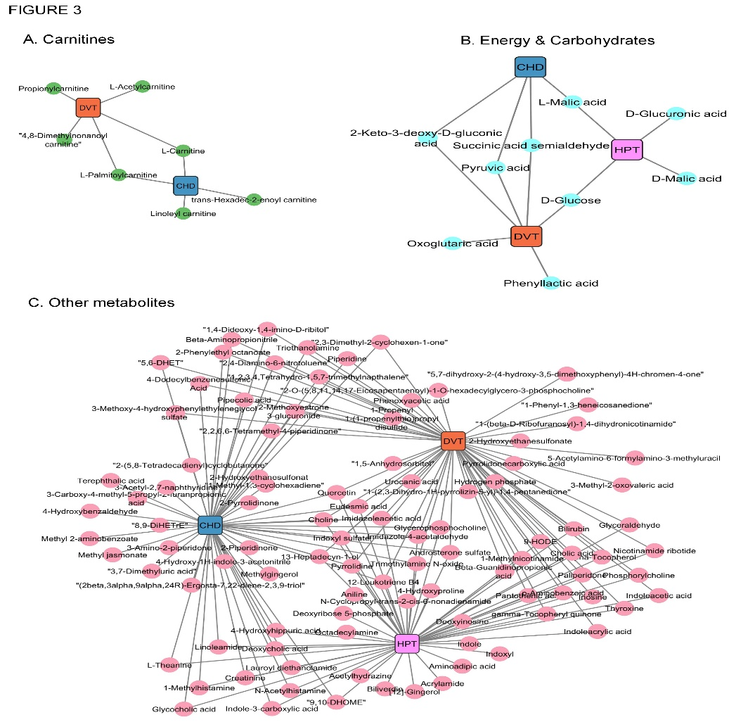

Figure 3. Associations between 247 differential metabolites (depicted as colored dots) and three chronic cardiovascular diseases (represented by colored squares). The insets (A–C) highlight the connections between chronic cardiovascular diseases and specific classes of metabolites. Associations between metabolites and diseases were determined using linear regression models adjusted for age, sex, and BMI. A significance threshold of adjusted p < 0.001 was applied, considering the three diseases evaluated for each metabolite. The networks were categorized and color-coded based on biochemical categories; for instance, the "Amino acid" graph includes only associations involving metabolites related to amino acid compounds.

Machine Learning Identified Potential Diagnostic Biomarkers for Three Cardiovascular Diseases
The identification of biomarkers presents promising targets for the diagnosis and clinical management of chronic cardiovascular diseases using a metabolomics approach. In this research, a logistic regression model was constructed for each cardiovascular disease, leading to the identification of metabolites that differ in association with these diseases (Figure 4A−C). Additionally, certain metabolites were found to be uniquely linked to individual chronic cardiovascular diseases. For example, elevated levels of Indoleacetic acid, Pyruvic acid, Oxoglutaric acid, LysoPC(16:0), 2-Phenylbutyric acid and Phenylalanyl-Tryptophan were specifically linked to the elevated risk of DVT.
Our study revealed a specific association between 1-Methylnicotinamide, Imidazole-4-acetaldehyde, Linoleic acid Methylglutaric acid, L-Beta-Aspartyl-L-Threonine and CHD. Additionally, the majority of the differential metabolites were identified in at least two cardiovascular conditions, demonstrating consistent association pattern (Figure 4B). The findings of our study revealed that SM(d18:1/16:0) and hypoxanthine were identified as differential metabolites shared in DVT, CHD, and HPT. Furthermore, elevated levels of these metabolites were found positively correlated with elavated risk of developing these diseases.
Also, based on our study, several differential metabolites— revealed Trimethylamine N-oxide, Aspartyl-Glutamate, N-Acetylhistidine, 12-Methyltridecanoic acid, Arachidonic acid and 5,6-DHET—were found to be shared between CHD, and HPT. Elevated levels of these metabolites were positively associated with an increased risk for CHD and HPT. D-ornithine demonstrated the strongest association with HPT, identifying it as a potential early biomarker for the condition. Furthermore, our findings revealed that elevated levels of Pyro-L-glutaminyl-L-glutamine, Threoninyl-Glycine and Sphingosine 1-phosphate were linked to the risk of DVT and HPT. In this study, elevated levels of L-Carnitine, PC (24:1/18:4), Cer(d18:1/16:0) and L-Palmitoylcarnitine were associated with an increased risk of both DVT and CHD.
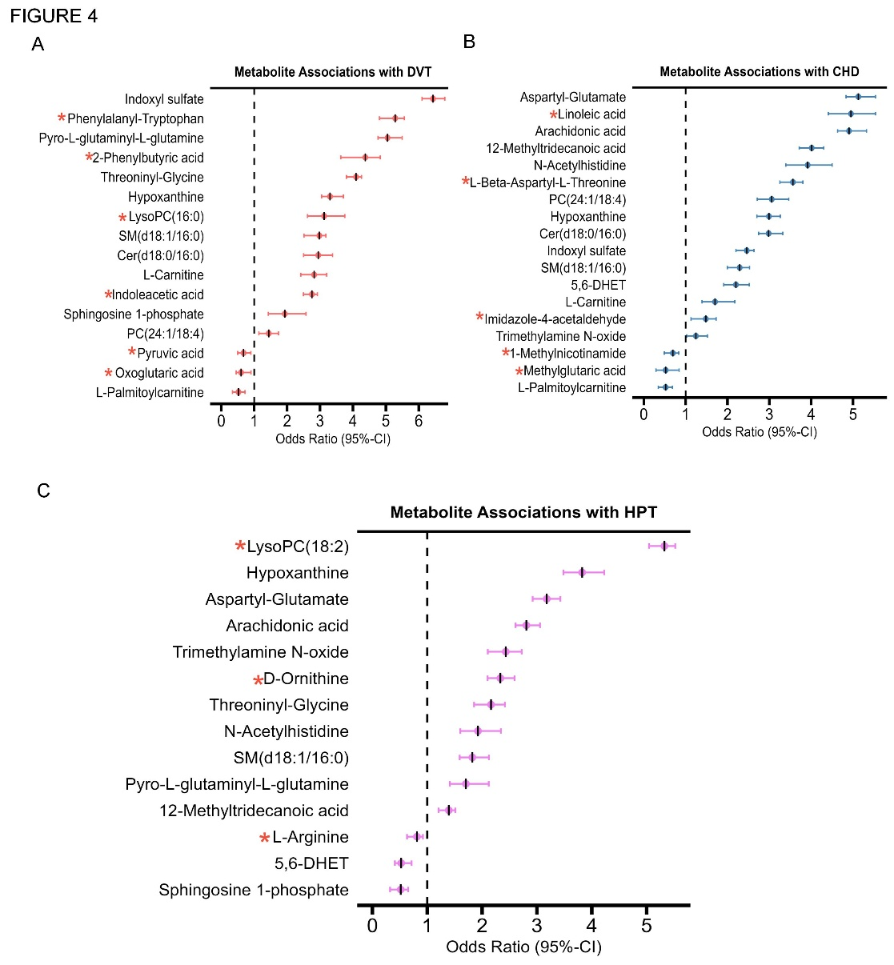
Figure 4. Differential metabolites associated with three chronic cardiovascular diseases. (A–C) Differential metabolites specific to each chronic cardiovascular disease. Odds ratios (ORs) and 95% confidence intervals (CIs) were derived from logistic regression analysis. ORs are represented by colored dots, and 95% CIs are indicated by the width of the lines. Differential metabolites linked to only one chronic cardiovascular disease are highlighted with an asterisk. The risks of chronic cardiovascular diseases were expressed as ORs per 1 standard deviation increase in the levels of differential metabolites, along with their corresponding 95% CIs. Data were adjusted for age, sex, and BMI for analysis.

Potential Diagnostic Biomarkers for the Discrimination of Three Cardio-metabolic Diseases
The receiver operating characteristic (ROC) curve was constructed based on the differential metabolites identified by the logistic regression model for each respective disease. The ability of these differential metabolites to discriminate between the corresponding chronic cardiovascular diseases was assessed by calculating the area under the curve (AUC) in both the discovery and validation cohorts. The findings of our research indicate that the three chronic cardiovascular diseases were successfully differentiated from the healthy control, achieving commendable AUC values. In the discovery cohort, the AUC values for the three chronic cardiovascular diseases varied between 0.909 and 0.960, while in the validation cohort, they ranged from 0.912 to 0.957. Table S3 provides comprehensive details on the AUC values, sensitivity, and specificity for the three chronic cardiovascular diseases in both the discovery and validation cohorts. Owing to the metabolic interconnections among multiple cardiovascular diseases, the diagnostic precision for a particular disease may be compromised by the coexistence of other chronic cardiovascular conditions. For instance, the identified biomarkers demonstrated strong diagnostic performance for DVT, with AUC values of 0.960 and 0.957 in the discovery and validation cohorts, respectively (Figure 5A). However, when other cardiovascular diseases were included in the healthy control group, the AUC values for DVT decreased to 0.917 and 0.939 in the discovery and validation cohorts respectively, indicating a reduction in discrimination efficiency. This suggests that the model's performance is influenced by the presence of comorbid cardiovascular conditions, highlighting the importance of population heterogeneity in predictive modeling. Similarly, the identified biomarkers were used to differentiate CHD patients from the healthy control (HC) group. The model demonstrated strong discriminatory performance, with AUC values of 0.924 in the discovery cohort and 0.932 in the validation cohort (Figure 5B).
Notably, when individuals with other chronic cardiovascular diseases were incorporated into the HC group, the AUC values remained nearly unchanged at 0.909 (discovery cohort) and 0.912 (validation cohort), indicating no significant loss in predictive capability. These findings suggest that the model maintains robust classification accuracy even when accounting for broader cardiovascular disease heterogeneity. A similar scenario was observed in HPT (Figure 5C). Therefore, the finding of our study demonstrated a decrease in diagnostic potential in both the discovery and validation cohorts when other chronic cardiovascular diseases were included as healthy control (HC) groups in case of DVT. These underscore the need to consider the influence of coexisting diseases on metabolite profiles in metabolomics research on chronic cardiovascular diseases. To achieve more robust and distinctive etiological insights, it is essential to correct for multiple confounding factors and carefully consider the interplay between different conditions.

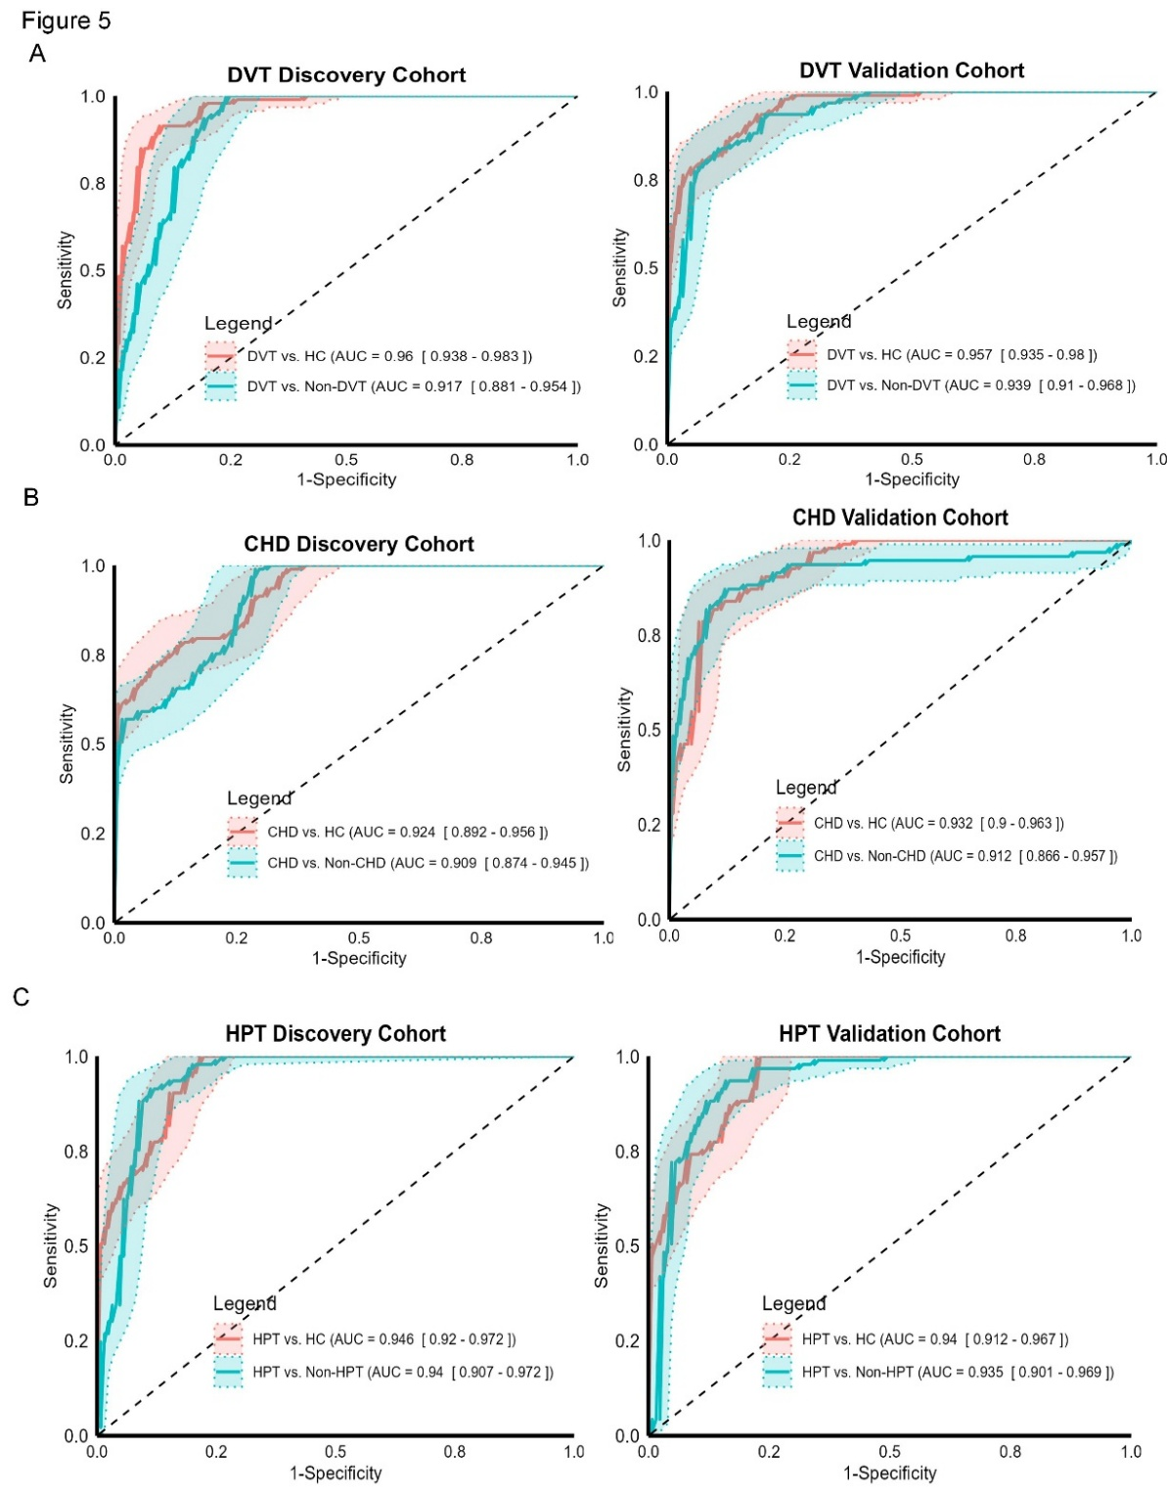
Figure 5. The discriminative capability of differential metabolites for DVT, CHD, and HPT. (A) ROC curves demonstrating the ability of differential metabolites to distinguish DVT from the healthy group or the non-DVT group in both discovery and validation cohorts. (B) ROC curves illustrating the performance of corresponding differential metabolites in differentiating CHD from the healthy group or the non-CHD group across discovery and validation cohorts. (C) ROC curves showing the effectiveness of corresponding differential metabolites in distinguishing HPT from the healthy group or the non-HPT group in discovery and validation cohorts.
Discussion
This study provides insights into metabolic perturbations underlying three cardiovascular diseases: DVT, CHD, and HPT. Analysis of 196 fasting plasma samples identified 483 metabolites, with 247 showing significant disease associations. The most notable finding was the extensive metabolic overlap between conditions, with 54.3% of altered metabolites shared across ≥2 diseases, alongside important disease-specific signatures. These results advance understanding of cardiovascular pathophysiology and suggest new diagnostic and therapeutic opportunities.
Substantial overlap in metabolic disturbances among DVT, CHD, and HPT suggests common underlying mechanisms. Branched-chain amino acids (BCAAs), particularly L-valine, were consistently elevated across all three conditions, aligning with evidence implicating BCAAs in cardiovascular pathology (Jiang et al., 2018; L. Zhang et al., 2021). Elevated BCAA levels may promote mTOR activation, mitochondrial dysfunction, and oxidative stress, contributing to endothelial dysfunction and atherosclerotic progression (L. Zhang et al., 2021). Furthermore, BCAAs may enhance platelet activation, supporting their pro-thrombotic effects (Jiang et al., 2024; Xu et al., 2020). These findings suggest that BCAA reduction strategies could simultaneously benefit multiple cardiovascular conditions.
Lysophosphatidylcholines (LPCs), generated through phospholipase A2 (PLA2)-mediated hydrolysis of phosphatidylcholines (Ke et al., 2018; Sun et al., 2010), were markedly elevated across all disease groups. LPCs promote endothelial dysfunction, macrophage activation, and oxidative stress (Lavi et al., 2007; Polonis et al., 2020), extending their known role in hypertension (Caillon & Schiffrin, 2016) to thrombotic disorders. The consistent elevation of arachidonic acid and other polyunsaturated fatty acids further emphasizes the central role of lipid-mediated inflammation in cardiovascular diseases (Palmu et al., 2022). LPC, the predominant lysophospholipid, has been implicated in the pathogenesis of atherosclerosis and inflammatory disorders. Evidence suggests that LPC modulates diverse cellular functions across multiple cell types—such as smooth muscle cells, endothelial cells, and monocytes—thereby contributing to disease progression (Makide et al., 2009).
9-HODE—an oxylipin metabolite derived from linoleic acid—was associated with HPT and DVT (Al Ashmar et al., 2024; Nieman et al., 2014). While oxylipins broadly contribute to cardiovascular diseases like hypertension (Nayeem, 2018), the specific role of 9-HODE in HPT remains understudied. A study has reported significantly elevated serum 13-HODE levels in patients with essential hypertension, correlating positively with mean blood pressure. (Wang et al., 2009). 9-HODE compromise vascular reactivity and tone (Touyz et al., 2018), promotes inflammation via cytokines IL-1β, IL-8 (Ku et al., 1992; Terkeltaub et al., 1994), and activating NF-κB (Al Ashmar et al., 2024). Additionally, it is recognized as an oxidative stress biomarker linked to atherosclerosis, diabetes, chronic inflammation, obesity, and cancer.
Despite these commonalities, each condition exhibited distinct metabolic fingerprints. DVT showed alterations in sphingolipid metabolism, particularly sphingosine-1-phosphate (S1P) and ceramide. These findings support emerging concepts of sphingolipid involvement in thrombosis (Franczyk et al., 2021; Sung et al., 2018), potentially through enhanced endothelial activation and leukocyte recruitment (Myers et al., 2020 ). Perturbations in energy metabolism specific to DVT included reductions in TCA cycle intermediates (succinate, malate) which may reflect mitochondrial dysfunction in venous thrombosis (Sung et al., 2018; K. Zhang et al., 2024) or increased utilization by inflammatory cells. The potential role of succinate in macrophage polarization (Trauelsen et al., 2021) and its effects on thrombosis (H. Liu et al., 2022) warrants attention as a potential therapeutic target for venous thromboembolism.
The association of D-ornithine with HPT suggests potential involvement of the urea cycle in blood pressure regulation, possibly through effects on nitric oxide metabolism. These disease-specific signatures advance pathophysiological understanding and provide opportunities for more precise diagnostic approaches.
Our study identified multiple microbiota-associated metabolites, including trimethylamine N-oxide (TMAO) in CHD and HPT, as well as indoleacetate in DVT. TMAO, in particular, serves as a critical intermediary linking gut microbial activity to host pathophysiology. Elevated circulating TMAO levels have been implicated in a range of adverse effects, such as perturbations in steroid and bile acid metabolism, endothelial dysfunction, and an elevated risk of atherosclerosis and major adverse cardiovascular events (Liu et al., 2021). Indoleacetate, a tryptophan-derived microbial metabolite, functions as an endogenous activator of the nuclear receptor AhR. Our findings may reveal the potential involvement of microbiota-derived metabolites in the pathogenesis and progression of CHD, HPT and DVT, which may serve as valuable biomarkers for diagnostic and therapeutic interventions in cardiovascular diseases.
Machine learning analyses yielded clinically relevant insights. High AUC values in disease classification demonstrate the diagnostic potential of metabolic profiling. However, reduced accuracy with comorbidities highlights challenges for clinical translation, likely reflecting shared metabolic disturbances and systemic cardiovascular metabolic dysfunction. The biomarker panels identified for each condition show promise. Indoxyl sulfate, a protein-bound uremic toxin derived from gut microbiota-mediated tryptophan metabolism, has been implicated in cardiovascular pathogenesis. A recent study demonstrated that indoxyl sulfate exacerbates oxidative stress by modulating NADPH oxidase-dependent redox signaling pathways, thereby accelerating the progression of chronic heart failure, arrhythmias, and CHD (Gao & Liu, 2017).
The extensive metabolic overlap suggests certain therapeutic strategies may have pleiotropic benefits across cardiovascular conditions. Targeting BCAA metabolism could simultaneously address thrombotic risk, atherosclerotic progression, and blood pressure regulation. Similarly, modulation of LPC/PC metabolism through PLA2 inhibition might attenuate multiple aspects of cardiovascular inflammation (Ke et al., 2018). Disease-specific signatures point to opportunities for targeted interventions. The prominent sphingolipid disturbances in DVT suggest S1P receptor modulators or ceramide inhibitors could have particular utility in venous thrombosis.
Our study has several limitations. First, the participants were exclusively Chinese, which may limit the generalizability of our findings to other populations. Second, this was a single-center study; future research should validate the diagnostic effectiveness of the metabolite biomarkers in a larger, multi-center cohort of cardiovascular disease patients.
In summary, this study delineates shared and distinct metabolic alterations in DVT, CHD, and HPT, advancing cardiovascular pathophysiology understanding and revealing novel diagnostic and therapeutic avenues.
Data availability
The raw metabolomics data produced in this study are available from the corresponding author on reasonable request.
Conflict of Interests Disclosure
The authors declare no competing interests.
References
Al-Akwaa, F. M., Yunits, B., Huang, S., Alhajaji, H., & Garmire, L. X. (2018, Dec 1). Lilikoi: an R package for personalized pathway-based classification modeling using metabolomics data. Gigascience, 7(12). https://doi.org/10.1093/gigascience/giy136

Al Ashmar, S., Anwardeen, N. R., Anlar, G. G., Pedersen, S., Elrayess, M. A., & Zeidan, A. (2024). Metabolomic profiling reveals key metabolites associated with hypertension progression. Frontiers in Cardiovascular Medicine, 11. https://doi.org/10.3389/fcvm.2024.1284114

Ameta, K., Gupta, A., Kumar, S., Sethi, R., Kumar, D., & Mahdi, A. A. (2017, May 19). Essential hypertension: A filtered serum based metabolomics study. Scientific Reports, 7(1), 2153. https://doi.org/10.1038/s41598-017-02289-9

Caillon, A., & Schiffrin, E. L. (2016, Mar). Role of Inflammation and Immunity in Hypertension: Recent Epidemiological, Laboratory, and Clinical Evidence. Current Hypertension Reports, 18(3), 21. https://doi.org/10.1007/s11906-016-0628-7

Colin A. Smith, E. J. W., Grace O’Maille, Ruben Abagyan, and Gary Siuzdak. (2006). XCMS: Processing Mass Spectrometry Data For Metabolite Profiling-Using Nonlinear Peak Alignment. Analytical Chemistry, 78, 779-787.

Franczyk, B., Gluba-Brzozka, A., Lawinski, J., Rysz-Gorzynska, M., & Rysz, J. (2021, Jul 29). Metabolomic Profile in Venous Thromboembolism (VTE). Metabolites, 11(8). https://doi.org/10.3390/metabo11080495

Fromentin, S., Forslund, S. K., Chechi, K., Aron-Wisnewsky, J., Chakaroun, R., Nielsen, T., Tremaroli, V., Ji, B., Prifti, E., Myridakis, A., Chilloux, J., Andrikopoulos, P., Fan, Y., Olanipekun, M. T., Alves, R., Adiouch, S., Bar, N., Talmor-Barkan, Y., Belda, E., Caesar, R., Coelho, L. P., Falony, G., Fellahi, S., Galan, P., Galleron, N., Helft, G., Hoyles, L., Isnard, R., Le Chatelier, E., Julienne, H., Olsson, L., Pedersen, H. K., Pons, N., Quinquis, B., Rouault, C., Roume, H., Salem, J. E., Schmidt, T. S. B., Vieira-Silva, S., Li, P., Zimmermann-Kogadeeva, M., Lewinter, C., Sondertoft, N. B., Hansen, T. H., Gauguier, D., Gotze, J. P., Kober, L., Kornowski, R., Vestergaard, H., Hansen, T., Zucker, J. D., Hercberg, S., Letunic, I., Backhed, F., Oppert, J. M., Nielsen, J., Raes, J., Bork, P., Stumvoll, M., Segal, E., Clement, K., Dumas, M. E., Ehrlich, S. D., & Pedersen, O. (2022, Feb). Microbiome and metabolome features of the cardiometabolic disease spectrum. Nature Medicine, 28(2), 303-314. https://doi.org/10.1038/s41591-022-01688-4

Gao, H., & Liu, S. (2017, Sep 15). Role of uremic toxin indoxyl sulfate in the progression of cardiovascular disease. Life Sciences, 185, 23-29. https://doi.org/10.1016/j.lfs.2017.07.027

Gong, Y., Ji, P., Yang, Y. S., Xie, S., Yu, T. J., Xiao, Y., Jin, M. L., Ma, D., Guo, L. W., Pei, Y. C., Chai, W. J., Li, D. Q., Bai, F., Bertucci, F., Hu, X., Jiang, Y. Z., & Shao, Z. M. (2021, Jan 5). Metabolic-Pathway-Based Subtyping of Triple-Negative Breast Cancer Reveals Potential Therapeutic Targets. Cell Metabolism, 33(1), 51-64 e59. https://doi.org/10.1016/j.cmet.2020.10.012

Jaagura, M., Kronberg, J., Reigo, A., Aasmets, O., Nikopensius, T., Vosa, U., Bomba, L., Estonian Biobank research, t., Estrada, K., Wuster, A., Esko, T., & Org, E. (2024, Oct 22). Comorbidities confound metabolomics studies of human disease. Scientific Reports, 14(1), 24810. https://doi.org/10.1038/s41598-024-75556-1

Jiang, W., Yang, L., Dang, Y., Jiang, X., Wu, L., Tong, X., Guo, J., & Bao, Y. (2024, Apr). Metabolomic profiling of deep vein thrombosis. Phlebology, 39(3), 154-168. https://doi.org/10.1177/02683555231215199

Jiang, X., Zeleznik, O. A., Lindstrom, S., Lasky-Su, J., Hagan, K., Clish, C. B., Eliassen, A. H., Kraft, P., & Kabrhel, C. (2018, Nov 20). Metabolites Associated With the Risk of Incident Venous Thromboembolism: A Metabolomic Analysis. Journal of the American Heart Association, 7(22), e010317. https://doi.org/10.1161/JAHA.118.010317

Jurisson, M., Pisarev, H., Uuskula, A., Lang, K., Oona, M., & Kalda, R. (2021, Oct 5). Prevalence of chronic conditions and multimorbidity in Estonia: a population-based cross-sectional study. BMJ Open, 11(10), e049045. https://doi.org/10.1136/bmjopen-2021-049045

Karczewski, K. J., & Snyder, M. P. (2018, May). Integrative omics for health and disease. Nat Rev Genet, 19(5), 299-310. https://doi.org/10.1038/nrg.2018.4

Ke, C., Zhu, X., Zhang, Y., & Shen, Y. (2018). Metabolomic characterization of hypertension and dyslipidemia. Metabolomics, 14(9). https://doi.org/10.1007/s11306-018-1408-y

Ku, G., Thomas, C. E., Akeson, A. L., & Jackson, R. L. (1992, Jul 15). Induction of interleukin 1 beta expression from human peripheral blood monocyte-derived macrophages by 9-hydroxyoctadecadienoic acid. Journal of Biological Chemistry, 267(20), 14183-14188.

Lavi, S., McConnell, J. P., Rihal, C. S., Prasad, A., Mathew, V., Lerman, L. O., & Lerman, A. (2007, May 29). Local production of lipoprotein-associated phospholipase A2 and lysophosphatidylcholine in the coronary circulation: association with early coronary atherosclerosis and endothelial dysfunction in humans. Circulation, 115(21), 2715-2721. https://doi.org/10.1161/CIRCULATIONAHA.106.671420

Liu, H., Zhang, H., Zhang, X., Chen, Q., & Xia, L. (2022). Role of succinic acid in the regulation of sepsis. International Immunopharmacology, 110. https://doi.org/10.1016/j.intimp.2022.109065

Liu, Q., Li, B., Li, Y., Wei, Y., Huang, B., Liang, J., You, Z., Li, Y., Qian, Q., Wang, R., Zhang, J., Chen, R., Lyu, Z., Chen, Y., Shi, M., Xiao, X., Wang, Q., Miao, Q., Fang, J. Y., Gershwin, M. E., Lian, M., Ma, X., & Tang, R. (2022, May). Altered faecal microbiome and metabolome in IgG4-related sclerosing cholangitis and primary sclerosing cholangitis. Gut, 71(5), 899-909. https://doi.org/10.1136/gutjnl-2020-323565

Liu, W., Guo, P., Dai, T., Shi, X., Shen, G., & Feng, J. (2021, May 7). Metabolic Interactions and Differences between Coronary Heart Disease and Diabetes Mellitus: A Pilot Study on Biomarker Determination and Pathogenesis. Journal of Proteome Research, 20(5), 2364-2373. https://doi.org/10.1021/acs.jproteome.0c00879

Makide, K., Kitamura, H., Sato, Y., Okutani, M., & Aoki, J. (2009, Sep). Emerging lysophospholipid mediators, lysophosphatidylserine, lysophosphatidylthreonine, lysophosphatidylethanolamine and lysophosphatidylglycerol. Prostaglandins and Other Lipid Mediators, 89(3-4), 135-139. https://doi.org/10.1016/j.prostaglandins.2009.04.009

Mars, N., Koskela, J. T., Ripatti, P., Kiiskinen, T. T. J., Havulinna, A. S., Lindbohm, J. V., Ahola-Olli, A., Kurki, M., Karjalainen, J., Palta, P., FinnGen, Neale, B. M., Daly, M., Salomaa, V., Palotie, A., Widen, E., & Ripatti, S. (2020, Apr). Polygenic and clinical risk scores and their impact on age at onset and prediction of cardiometabolic diseases and common cancers. Nature Medicine, 26(4), 549-557. https://doi.org/10.1038/s41591-020-0800-0

Myers, D., Lester, P., Adili, R., Hawley, A., Durham, L., Dunivant, V., Reynolds, G., Crego, K., Zimmerman, Z., Sood, S., Sigler, R., Fogler, W., Magnani, J., Holinstat, M., & Wakefield, T. (2020 ). A New Way to Treat Proximal Deep Venous Thrombosis using E-Selectin Inhibition. J Vasc Surg Venous Lymphat Disord., 8(2), 268–278. https://doi.org/10.1016/j.jvsv.2019.08.016

Nayeem, M. A. (2018, Jul). Role of oxylipins in cardiovascular diseases. Acta Pharmacologica Sinica, 39(7), 1142-1154. https://doi.org/10.1038/aps.2018.24

Nieman, D. C., Shanely, R. A., Luo, B., Meaney, M. P., Dew, D. A., & Pappan, K. L. (2014, Jul 1). Metabolomics approach to assessing plasma 13- and 9-hydroxy-octadecadienoic acid and linoleic acid metabolite responses to 75-km cycling. American Journal of Physiology: Regulatory, Integrative and Comparative Physiology, 307(1), R68-74. https://doi.org/10.1152/ajpregu.00092.2014

Omar, A. A., Nagah, M. A., Nesreen, A. M., Tariq, M. A. A., Yasir, W. A., Munif, S. A., Abdurhman, A. A., Amjad, H. A., Abdullah, H. A., & Ahmed, S. A. (2017). Deep Venous Thrombosis among hypertensive patients in King Abdulaziz University (KAU) Hospital, Jeddah, Kingdom of Saudi Arabia. Electronic Physician, 9(10), 5472-5477. https://doi.org/10.19082/5472

Palmu, J., Tikkanen, E., Havulinna, A. S., Vartiainen, E., Lundqvist, A., Ruuskanen, M. O., Perola, M., Ala-Korpela, M., Jousilahti, P., Wurtz, P., Salomaa, V., Lahti, L., & Niiranen, T. (2022, Mar 1). Comprehensive biomarker profiling of hypertension in 36 985 Finnish individuals. Journal of Hypertension, 40(3), 579-587. https://doi.org/10.1097/HJH.0000000000003051

Pietzner, M., Stewart, I. D., Raffler, J., Khaw, K. T., Michelotti, G. A., Kastenmuller, G., Wareham, N. J., & Langenberg, C. (2021, Mar). Plasma metabolites to profile pathways in noncommunicable disease multimorbidity. Nature Medicine, 27(3), 471-479. https://doi.org/10.1038/s41591-021-01266-0

Polonis, K., Wawrzyniak, R., Daghir-Wojtkowiak, E., Szyndler, A., Chrostowska, M., Melander, O., Hoffmann, M., Kordalewska, M., Raczak-Gutknecht, J., Bartosinska, E., Kaliszan, R., Narkiewicz, K., & Markuszewski, M. J. (2020). Metabolomic Signature of Early Vascular Aging (EVA) in Hypertension. Frontiers in Molecular Biosciences, 7, 12. https://doi.org/10.3389/fmolb.2020.00012

Sun, G. Y., Shelat, P. B., Jensen, M. B., He, Y., Sun, A. Y., & Simonyi, A. (2010, Jun). Phospholipases A2 and inflammatory responses in the central nervous system. Neuromolecular Medicine, 12(2), 133-148. https://doi.org/10.1007/s12017-009-8092-z

Sung, Y., Spagou, K., Kafeza, M., Kyriakides, M., Dharmarajah, B., Shalhoub, J., Diaz, J. A., Wakefield, T. W., Holmes, E., & Davies, A. H. (2018, May). Deep Vein Thrombosis Exhibits Characteristic Serum and Vein Wall Metabolic Phenotypes in the Inferior Vena Cava Ligation Mouse Model. European Journal of Vascular and Endovascular Surgery, 55(5), 703-713. https://doi.org/10.1016/j.ejvs.2018.01.027

Terkeltaub, R., Banka, C. L., Solan, J., Santoro, D., Brand, K., & Curtiss, L. K. (1994, Jan). Oxidized LDL induces monocytic cell expression of interleukin-8, a chemokine with T-lymphocyte chemotactic activity. Arteriosclerosis and Thrombosis, 14(1), 47-53. https://doi.org/10.1161/01.atv.14.1.47

Teruya, T., Sunagawa, S., Mori, A., Masuzaki, H., & Yanagida, M. (2023, Feb 11). Markers for obese and non-obese Type 2 diabetes identified using whole blood metabolomics. Scientific Reports, 13(1), 2460. https://doi.org/10.1038/s41598-023-29619-4

Touyz, R. M., Alves-Lopes, R., Rios, F. J., Camargo, L. L., Anagnostopoulou, A., Arner, A., & Montezano, A. C. (2018, Mar 15). Vascular smooth muscle contraction in hypertension. Cardiovascular Research, 114(4), 529-539. https://doi.org/10.1093/cvr/cvy023

Trauelsen, M., Hiron, T. K., Lin, D., Petersen, J. E., Breton, B., Husted, A. S., Hjorth, S. A., Inoue, A., Frimurer, T. M., Bouvier, M., O'Callaghan, C. A., & Schwartz, T. W. (2021, Jun 15). Extracellular succinate hyperpolarizes M2 macrophages through SUCNR1/GPR91-mediated Gq signaling. Cell Reports, 35(11), 109246. https://doi.org/10.1016/j.celrep.2021.109246

Wang, D., Strandgaard, S., Iversen, J., & Wilcox, C. S. (2009, Feb). Asymmetric dimethylarginine, oxidative stress, and vascular nitric oxide synthase in essential hypertension. American Journal of Physiology: Regulatory, Integrative and Comparative Physiology, 296(2), R195-200. https://doi.org/10.1152/ajpregu.90506.2008

Xia Shen, C. W., Ningning Liang, Zhen Liu, Xinde Li, Zheng-Jiang Zhu, Tony R. Merriman, Nicola Dalbeth, Robert Terkeltaub, Changgui Li, and Huiyong Yin. (2021). Serum Metabolomics Identifies Dysregulated Pathways and Potential Metabolic Biomarkers for Hyperuricemia and Gout. Arthritis & Rheumatology, 73(9), 1738–1748. https://doi.org/10.1002/art.41733

Xiao, Y., Ma, D., Yang, Y. S., Yang, F., Ding, J. H., Gong, Y., Jiang, L., Ge, L. P., Wu, S. Y., Yu, Q., Zhang, Q., Bertucci, F., Sun, Q., Hu, X., Li, D. Q., Shao, Z. M., & Jiang, Y. Z. (2022, May). Comprehensive metabolomics expands precision medicine for triple-negative breast cancer. Cell Research, 32(5), 477-490. https://doi.org/10.1038/s41422-022-00614-0

Xu, Y., Jiang, H., Li, L., Chen, F., Liu, Y., Zhou, M., Wang, J., Jiang, J., Li, X., Fan, X., Zhang, L., Zhang, J., Qiu, J., Wu, Y., Fang, C., Sun, H., & Liu, J. (2020). Branched-Chain Amino Acid Catabolism Promotes Thrombosis Risk by Enhancing Tropomodulin-3 Propionylation in Platelets. Circulation, 142(1), 49-64. https://doi.org/10.1161/circulationaha.119.043581

Yang, W., & Zheng, Y. (2019). Causes of deep venous thrombosis after fracture in patients with coronary heart disease and intervention efficiency of argatroban. Journal of Clinical Medicine in Practice 20(045) https://doi.org/DOI: 10.7619/jcmp.201920013

Zhang, K., Wang, P., Huang, W., Tang, S.-H., Xue, H., Wu, H., Zhang, Y., Rong, Y., Dong, S.-S., Chen, J.-B., Zou, Y., Tian, D., Yang, N., Liang, Y., Liu, C., Li, D., Zhang, K., Yang, T.-L., & Guo, Y. (2024). Integrated landscape of plasma metabolism and proteome of patients with post-traumatic deep vein thrombosis. Nature Communications, 15(1). https://doi.org/10.1038/s41467-024-52262-0

Zhang, L., Zhang, Y., Ma, Z., Zhu, Y., & Chen, Z. (2021, Nov 30). Altered amino acid metabolism between coronary heart disease patients with and without type 2 diabetes by quantitative (1)H NMR based metabolomics. Journal of Pharmaceutical and Biomedical Analysis, 206, 114381. https://doi.org/10.1016/j.jpba.2021.114381

Zhang, X., Coker, O. O., Chu, E. S., Fu, K., Lau, H. C. H., Wang, Y. X., Chan, A. W. H., Wei, H., Yang, X., Sung, J. J. Y., & Yu, J. (2021, Apr). Dietary cholesterol drives fatty liver-associated liver cancer by modulating gut microbiota and metabolites. Gut, 70(4), 761-774. https://doi.org/10.1136/gutjnl-2019-319664

Zhang, Y., Zhao, H., Zhao, J., Lv, W., Jia, X., Lu, X., Zhao, X., & Xu, G. (2024, Aug 2). Quantified Metabolomics and Lipidomics Profiles Reveal Serum Metabolic Alterations and Distinguished Metabolites of Seven Chronic Metabolic Diseases. Journal of Proteome Research, 23(8), 3076-3087. https://doi.org/10.1021/acs.jproteome.3c00760

