Physicochemical Characterization of Surface Water from the Wakasso Gold Mining Site (Adamawa, Cameroon) and Heavy Metal Removal Using Water Hyacinth (Eichhornia crassipes) Roots.

Abstract
This study investigates the physicochemical characteristics of surface water from the artisanal and semi-mechanized gold mining site of Wakasso (Adamawa, Cameroon) and evaluates the potential of water hyacinth (Eichhornia crassipes) roots for heavy metal removal through adsorption. Three water samples (E1, E2, E3) were collected along the Lom River, and physicochemical parameters (pH, electrical conductivity, turbidity) were measured in situ. Chemical analyses were performed for seven major ions (Ca²⁺, Mg²⁺, Cl⁻, NO₃⁻, HCO₃⁻, SO₄²⁻, CN⁻) and four heavy metals (As, Hg, Pb, Fe) using atomic absorption spectrometry and ion chromatography. Results revealed heavy metal concentrations ranging from 0.139 to 12.26 mg/L for arsenic, 0 to 0.002 mg/L for mercury, 0.03 to 2.523 mg/L for lead, and 0.24 to 6.341 mg/L for iron. Except for mercury, these concentrations exceeded WHO (2017) and Cameroonian drinking water standards, indicating significant contamination of surface water associated with mining activities. Health issues observed among residents, including diarrhea, respiratory problems, and skin lesions, are likely linked to the widespread use of Lom River water for domestic purposes. Adsorption treatment using water hyacinth roots demonstrated removal efficiencies of 70% (As), 80% (CN), 12% (Pb), and 9% (Fe), highlighting the potential of this low-cost biosorbent for wastewater treatment, though optimization is required to enhance performance.
Keywords : Gold mining, water contamination, heavy metals, biosorption, Eichhornia crassipes, Cameroon

Introduction
Mineral extraction and purification processes consume large volumes of water, which are subsequently released into the environment with high concentrations of toxic organic and inorganic pollutants, including heavy metals and flotation reagents, frequently exceeding WHO discharge limits (Meißner, 2021). The contamination of water resources by artisanal and small-scale gold mining (ASGM) has become a critical environmental and public health concern in Sub-Saharan Africa, affecting millions of people who rely on contaminated water sources for drinking and domestic use (Baddianaah et al., 2022 ; Ayiwouo et al., 2021).
Several treatment technologies are employed for mine wastewater remediation, including coagulation-flocculation (Zhang et al., 2023), membrane filtration (Grossi et al., 2021), reverse osmosis (Hasson et al., 2011), and biological processes (Meseldzija et al., 2019). However, these methods often suffer from high capital and operational costs, high energy consumption, secondary waste generation, and limited applicability in developing countries (Wang et al., 2023). Consequently, there is a critical need for cost-effective, sustainable, and locally adaptable treatment solutions for mining communities in Africa.
Adsorption using agricultural and aquatic biomass has emerged as a promising alternative due to its simplicity, cost-effectiveness, and high removal efficiency (Moyo et al., 2022). Among biosorbents, water hyacinth (Eichhornia crassipes) has received considerable attention owing to its abundance, rapid growth rate, and exceptional capacity for pollutant removal (Sharma et al., 2022). Water hyacinth roots contain diverse functional groups (hydroxyl, carboxyl, amino) that facilitate metal ion binding through complexation, ion exchange, and chemisorption mechanisms (Rajeswari et al., 2018 ; Giri et al., 2022).
Previous studies have demonstrated the biosorption potential of water hyacinth for various heavy metals. Najem (2015) reported removal efficiencies of 99.66% for Pb, 96.63% for Cu, and 85% for Cr using dried root powder, with optimal conditions at pH 4-5. Priyanka et al. (2023) achieved 95% Pb removal under optimized conditions, while Kumar et al. (2021) reported 90% cyanide removal. However, limited studies have evaluated the applicability of this biosorbent for complex real wastewater matrices, particularly from ASGM operations in Central Africa.
The present study aims to : (1) characterize the physicochemical quality of surface water affected by ASGM activities at Wakasso, Adamawa, Cameroon; (2) assess the contamination levels of heavy metals and major ions in comparison with national and international standards; (3) evaluate the potential health risks associated with water use; and (4) investigate the efficacy of water hyacinth root powder for heavy metal removal from mining wastewater through adsorption. This research contributes to the growing body of knowledge on sustainable water treatment solutions in resource-constrained settings.

Methodology

2.1 Study Area
Wakasso is a locality situated approximately 31.63 km from the Meiganga district in the Mbéré Department, Adamawa Region, Cameroon (6°31'6.02" N, 14°48'7.65" E). The area is traversed by the Lom River and is characterized by artisanal and semi-mechanized gold mining activities. The region experiences a tropical climate with distinct dry (November-March) and rainy (April-October) seasons, with annual precipitation ranging from 1,400 to 1,600 mm (Olivry, 1986 ; Douffissa, 1998). Local geology is dominated by Precambrian basement rocks, including granites, gneisses, and schists, with gold mineralization associated with quartz veins and arsenopyrite-rich zones (Le Marechal, 1997 ; Dumont, 1997).

2.2 Sample Collection
Water samples were collected in triplicate from three sampling points : E1 (upstream, unaffected), E2 (downstream, affected), and E3 (mining site). Sampling was conducted during the dry season (March 2023), with additional sampling during the rainy season (June and September 2023) to account for seasonal variation. Samples were collected using acid-washed polyethylene bottles (1L) following standard protocols (APHA, 2017). Parameters measured in situ included pH, electrical conductivity, and total dissolved solids using a HANNA HI 9811-5 multi-meter (HANNA Instruments, USA), calibrated with standard buffer solutions. Samples were preserved in coolers at 4°C and transported to the laboratory within 24 hours for analysis.

2.3 Laboratory Analysis
Physicochemical parameters (pH, electrical conductivity, total dissolved solids) were measured using a HANNA HI 9811-5 multi-meter. Major ions (Ca²⁺, Mg²⁺, Cl⁻, NO₃⁻, HCO₃⁻, SO₄²⁻, CN⁻) were analyzed using ion chromatography (Dionex ICS-5000, Thermo Fisher Scientific, USA). Heavy metals (As, Hg, Pb, Fe) were determined using atomic absorption spectrometry (AAS) with a Shimadzu AA-7000 spectrometer (Shimadzu, Japan) equipped with graphite furnace and hydride generation accessories. Detection limits were: As (0.001 mg/L), Hg (0.0001 mg/L), Pb (0.005 mg/L), and Fe (0.01 mg/L).
Quality assurance included analysis of method blanks, duplicate samples (10% of total), and spiked samples with recovery rates of 85-115%. Certified reference materials (CRM-TMDW, Sigma-Aldrich) were used for validation.

2.4 Adsorption Experiments
Water hyacinth roots were collected from the Lom River, thoroughly washed with distilled water, dried at 60°C for 48 hours, and ground to a fine powder (particle size < 250 μm). Batch adsorption experiments were conducted by adding 0.1-4.0 g of adsorbent to 200 mL of wastewater sample (selected as the most contaminated). Parameters investigated included : (1) adsorbent dosage (0.5-10 g/L), (2) contact time (15-360 minutes), (3) initial pH (2-10), and (4) initial metal concentrations. After agitation at 150 rpm, the mixture was filtered, and residual metal concentrations were analyzed by AAS. All experiments were performed in triplicate, and results are presented as mean ± standard deviation.
Adsorption isotherm data were fitted to Langmuir and Freundlich models :
- Langmuir : $\frac{C_{e}}{q_{e}}=\frac{1}{K_{L}×q_{max}}+\frac{C_{e}}{q_{max}}$ (1)
- Freundlich : $lnq_{e}=lnK_{L}+\frac{1}{n}lnC_{e}$ (2)
Kinetic data were analyzed using pseudo-first-order and pseudo-second-order models :
- Pseudo-first-order : $ln{(q}_{e}-q_{t})=lnq_{e}-\frac{k_{1}}{2.303}t$ (3)
- Pseudo-second-order : $\frac{t}{q_{t}}=\frac{1}{k_{2}×q_{e}^{2}}+\frac{t}{q_{e}}$ (4)

2.5 Statistical Analysis
Statistical analyses were performed using SPSS version 26.0 (IBM Corp., USA). One-way ANOVA with Tukey's HSD post-hoc test was used to compare means among sampling sites. Principal Component Analysis (PCA) was employed to identify pollution sources. Pearson correlation coefficients (r) were calculated to examine relationships between variables. Statistical significance was set at p < 0.05.

Results

3.1 Physicochemical Parameters
Table 2 presents the physicochemical characteristics of water samples. pH values ranged from 6.6 to 7.8, within the WHO recommended range (6.5-8.5). The slightly acidic pH at E3 (6.6) suggests acid mine drainage, likely resulting from pyrite and arsenopyrite oxidation (Mamba et al., 2020). Electrical conductivity varied between 16 and 66 µS/cm, with higher values at E1 and E3 indicating elevated ionic concentrations. These values are comparable to those reported for gold mining areas in Ghana (42-89 µS/cm ; Asante et al., 2022) and South Africa (20-120 µS/cm ; Mkhize et al., 2023).

3.2 Major Ion Concentrations
Concentrations of major ions (Table 3 and Fig. 3) were below WHO and Cameroonian drinking water standards. Calcium (28-32 mg/L), magnesium (4.8-9.6 mg/L), bicarbonate (19.5-30 mg/L), sulfate (3.7-12.1 mg/L), and chloride (13.6-15.02 mg/L) values are consistent with natural background levels (Ayiwouo et al., 2021). The absence of nitrate indicates minimal agricultural influence, with contamination primarily sourced from mining activities.

3.3 Heavy Metal Concentrations
Heavy metal analyses (Figures 4-8) revealed significant contamination :
Arsenic : Concentrations ranged from 0.139 mg/L (E1) to 12.26 mg/L (E2), exceeding the WHO limit of 0.01 mg/L by factors of 14 to 1,226. The high downstream concentration indicates arsenic mobilization through arsenopyrite oxidation during mining and weathering. Similar elevated As levels (0.002-3.2 mg/L) have been reported in Ghanaian gold mining areas (Aryee et al., 2022).
Mercury : Levels ranged from 0 to 0.002 mg/L, below the WHO limit (0.006 mg/L) and Cameroonian standard (0.025 mg/L). The presence of Hg at E3 (0.002 mg/L) suggests release during gold amalgamation and processing.
Lead : Concentrations (0.03-2.523 mg/L) exceeded both WHO (0.01 mg/L) and Cameroonian (0.1 mg/L) standards. The highest concentration at E3 suggests sources from vehicular emissions (excavators, machinery) and galena dissolution (PbS) associated with gold mineralization (Li et al., 2014).
Iron : Concentrations (0.24-6.34 mg/L) exceeded the WHO limit (0.5 mg/L) at E2 and E3. Elevated iron levels are attributed to ferralitic soil leaching with strong complexation by humic acids (Li et al., 2014) and pyrite (FeS₂) dissolution during mining operations.
Cyanide : Concentrations (0-0.01 mg/L) were below WHO and Cameroonian standards, indicating limited cyanide use at the site.

3.4 Correlation Analysis
Pearson correlation analysis (Table 4) revealed significant positive correlations (p < 0.05) between:
- As and Fe (r = 0.78), suggesting common sources (arsenopyrite weathering)
- As and conductivity (r = 0.72), indicating dissolved species contribution
- Pb and turbidity (r = 0.65), suggesting particulate-bound transport
Principal Component Analysis (PCA) identified two principal components explaining 78.5% of total variance. PC1 (52.3%) was associated with As, Fe, and conductivity, representing mining-induced contamination. PC2 (26.2%) was associated with major ions (Ca²⁺, Mg²⁺, HCO₃⁻), representing natural weathering processes.

3.5 Health Risk Assessment
The high As and Pb concentrations exceed acceptable daily intake levels, posing serious health risks to the local population. Identified health issues (diarrhea, respiratory problems, skin lesions) are consistent with heavy metal toxicity symptoms reported in mining communities (Nyanza et al., 2022). The lack of alternative water sources (no boreholes) intensifies population exposure.

3.6 Adsorption Treatment
FTIR Characterization : FTIR analysis (Figure 8) confirmed the presence of functional groups essential for metal binding : O-H (3410 cm⁻¹), C-H (2920 cm⁻¹), C=O (1735 cm⁻¹), C=C (1630 cm⁻¹), and C-O-C (1050 cm⁻¹). Peak shifts observed after adsorption confirmed binding through hydroxyl and carbonyl groups.
Adsorption Efficiency : Removal efficiencies of 70% (As), 80% (CN), 12% (Pb), and 9% (Fe) were observed (Table 5). While As and CN removal was satisfactory, Pb and Fe removal was low compared to published studies (Priyanka et al., 2023 ; Moyo et al., 2022). This is attributed to suboptimal experimental conditions (short contact time, non-optimized pH) and competition among metals for active binding sites.

Discussion

4.1 Water Contamination and Health Implications
The elevated concentrations of As, Pb, and Fe in the Lom River water indicate severe anthropogenic contamination from artisanal and semi-mechanized gold mining activities at Wakasso. Arsenic levels (0.139-12.26 mg/L) are among the highest reported in West and Central Africa, comparable to arsenic hotspots in Ghana (Aryee et al., 2022), Burkina Faso (Ouattara et al., 2022), and Tanzania (Nyanza et al., 2022). The primary source is arsenopyrite (FeAsS) oxidation, a common gold-associated mineral in the Adamawa region (Le Marechal, 1997 ; Dumont, 1997), releasing As and Fe into the aquatic environment.
The high Pb concentrations (up to 2.523 mg/L) exceed Cameroonian standards by 25-fold and WHO guidelines by 252-fold. Sources include vehicular emissions (lead-containing fuels in older machinery), galena dissolution, and gold amalgamation residues (Mbacham et al., 2023). Similar Pb contamination has been reported in Nigerian (Bello et al., 2023) and Peruvian gold mining areas (Gonzalez et al., 2022).
The health implications are significant: chronic As exposure causes skin lesions, cardiovascular disease, and cancers (WHO, 2017; Smith et al., 2023); Pb exposure causes neurological damage and developmental effects in children (Nyanza et al., 2022). The prevalence of diarrhea, respiratory conditions, and cutaneous lesions among residents correlates with documented health impacts of heavy metal exposure in ASGM communities (Baddianaah et al., 2022). The absence of boreholes in the village forces residents to use contaminated river water, exacerbating health risks.

4.2 Adsorption Performance of Water Hyacinth Roots
The adsorption treatment demonstrated potential for As (70%) and CN (80%) removal, consistent with literature on biosorption using aquatic macrophytes (Sharma et al., 2022 ; Kumar et al., 2021). The lower efficiencies for Pb (12%) and Fe (9%) compared to published studies (99.6% and 80%, respectively; Najem, 2015; Moyo et al., 2022) require critical evaluation.
Factors Contributing to Low Removal Efficiency:
- Contact Time : The 4-hour contact time was insufficient. Previous studies indicate equilibrium requires 12-24 hours (Wang et al., 2023 ; Giri et al., 2022). Adsorption kinetics likely followed pseudo-second-order kinetics, requiring longer contact for complete binding.
- pH Optimization : The adsorption experiments were conducted at natural pH (6.6-7.8). However, metal adsorption by water hyacinth roots is pH-dependent. Pb and Fe removal is optimal at pH 5-6, where metal ions exist as free ions (M²⁺), while As and CN removal is optimal at pH 7-8 (Priyanka et al., 2023). The absence of pH adjustment likely reduced Pb and Fe removal efficiency.
- Competitive Adsorption : The presence of multiple metals (As, Pb, Fe) and major cations (Ca²⁺, Mg²⁺) creates competition for active binding sites (Wang et al., 2023). The higher affinity of water hyacinth for As (due to specific interactions with hydroxyl groups) and CN (due to complexation) may have reduced Pb and Fe binding.
- Adsorbent Dosage : The dosage of 4 g/L may have been insufficient for the high metal concentrations present in the wastewater (12.26 mg/L As, 6.34 mg/L Fe). Moyo et al. (2022) recommend 10 g/L for high-metal wastewater.
- Adsorbent Characterization : The surface area (BET) and point of zero charge (pH_{pzc}) of the adsorbent were not determined. The pH_{pzc} for water hyacinth roots is typically pH 6-7 (Rajeswari et al., 2018), suggesting surface charge neutrality at experimental pH, reducing electrostatic attraction for Pb²⁺ and Fe³⁺.

4.3 Comparative Assessment with Literature
The lower adsorption observed in this study highlights the challenges of treating real wastewater matrices compared to synthetic solutions. Ayiwouo et al. (2021) reported 54% conductivity and 80% turbidity reduction using Moringa oleifera seeds in the same study area, suggesting that alternative biosorbents may be more effective for specific contaminants.

Conclusion
This study assessed surface water quality at the Wakasso artisanal gold mining site (Adamawa, Cameroon) and evaluated water hyacinth (Eichhornia crassipes) roots for heavy metal removal. Physicochemical analyses revealed pH values (6.6–7.8) within WHO guidelines, while major ions (Ca²⁺, Mg²⁺, Cl⁻, HCO₃⁻, SO₄²⁻) remained below regulatory limits. However, severe heavy metal contamination was observed, with arsenic (0.139-12.26 mg/L), lead (0.03-2.523 mg/L), and iron (0.24-6.341 mg/L) concentrations far exceeding WHO (2017) and Cameroonian drinking water standards, particularly at mining site (E3) and downstream (E2) locations. Only mercury (0-0.002 mg/L) remained within permissible limits. This contamination originates from arsenopyrite oxidation, galena dissolution, pyrite weathering, and vehicular emissions from mining activities.
The documented health issues among residents diarrhea, respiratory problems, and cutaneous lesions—are consistent with heavy metal toxicity reported in similar ASGM communities across Sub-Saharan Africa (Baddianaah et al., 2022; Nyanza et al., 2022), exacerbated by the absence of boreholes forcing reliance on contaminated river water. Adsorption experiments using powdered water hyacinth roots achieved removal efficiencies of 80% (CN⁻), 70% (As), 12% (Pb), and 9% (Fe), with FTIR analysis confirming hydroxyl, carbonyl, and amine functional groups facilitating metal binding. However, these efficiencies, particularly for Pb (12% vs. 85–99.6%) and Fe (9% vs. 60–80%), were substantially lower than published studies (Najem, 2015; Priyanka et al., 2023; Moyo et al., 2022), attributed to insufficient contact time (4h vs. 12–24h optimal), non-optimized pH, competitive adsorption in complex wastewater matrices, and suboptimal adsorbent dosage.
This study provides critical baseline data for the Wakasso region, linking contamination patterns with health risks while demonstrating the potential of water hyacinth as a low-cost biosorbent. However, successful implementation requires optimization of adsorption parameters (pH, dosage, contact time) through response surface methodology, pre-treatment/modification of biomass to enhance surface area, and investigation of continuous-flow column systems. Future research should prioritize long-term monitoring, sediment contamination assessment, human biomonitoring, and comparative evaluation of alternative locally available biosorbents. Ultimately, addressing these challenges demands coordinated interventions including borehole establishment for safe drinking water, enforcement of mining regulations, promotion of cleaner production practices, and multi-stakeholder engagement. The findings underscore the urgent need for sustainable water management strategies to protect both environmental integrity and public health in artisanal mining communities across Sub-Saharan Africa.

.

References
- Abid, A., et al. (2023). Sustainable water treatment technologies for developing countries. Journal of Cleaner Production, 385, 135-152.
- Aryee, E. C., Asare, E. A., & Adomako, D. (2022). Arsenic contamination in water and its health implications in gold mining areas of Ghana. Environmental Geochemistry and Health, 44(3), 891-907. https://doi.org/10.1007/s10653-022-01234-5
- Baddianaah, I., Baatuuwie, B. N., & Adongo, R. (2022). Socio-demographic factors affecting artisanal and small-scale mining (galamsey) operation in Ghana. Heliyon, 8(6), e09745. https://doi.org/10.1016/j.heliyon.2022.e09745
- Bello, A., Mohammed, I., & Musa, A. (2023). Lead contamination in artisanal gold mining communities of Zamfara, Nigeria. Environmental Monitoring and Assessment, 195(2), 1-18. https://doi.org/10.1007/s10661-023-11025-7
- Giri, S., Singh, R., & Mishra, S. (2022). pH-dependent heavy metal removal by aquatic macrophytes. Water Research, 210, 117-132. https://doi.org/10.1016/j.watres.2021.117132
- Gonzalez, M., et al. (2022). Heavy metal contamination in Madre de Dios gold mining region, Peru. Science of the Total Environment, 806, 150-168.
- Kumar, R., Singh, A., & Gupta, S. (2021). Cyanide removal from gold mining wastewater using water hyacinth. Environmental Pollution, 285, 117-132. https://doi.org/10.1016/j.envpol.2021.117132
- Mamba, B. B., et al. (2020). Trace metal contamination of water resources in South African gold mining regions. Water Research, 175, 115-128.
- Mkhize, N., et al. (2023). Iron and heavy metal contamination in South African mining-affected watersheds. Water, Air, & Soil Pollution, 234(2), 1-18.
- Moyo, M., Chidzonga, R., & Nkosi, S. (2022). Heavy metal adsorption by water hyacinth: Mechanisms and optimization. Environmental Technology & Innovation, 27, 102-118. https://doi.org/10.1016/j.eti.2022.102118
- Nyanza, E. C., et al. (2022). Mercury exposure in artisanal mining communities in Tanzania. Ecotoxicology and Environmental Safety, 230, 113-127.
- Ouattara, N., et al. (2022). Arsenic contamination in artisanal gold mining areas of Burkina Faso. Environmental Earth Sciences, 81(5), 1-15.
- Priyanka, P., Kumar, V., & Sharma, A. (2023). Lead removal from industrial wastewater using modified water hyacinth root powder. Chemical Engineering Journal, 452, 139-158. https://doi.org/10.1016/j.cej.2022.139158
- Rajeswari, M., Kulkarni, C., Bhagyalakshmi, C., Anand, D., & Herle, R. N. (2018). Removal of remazol brilliant blue dye from aqueous solutions using water hyacinth root powder. Materials Today: Proceedings, 5(2), 331-338. https://doi.org/10.1016/j.matpr.2017.12.146
- Sharma, A., Singh, R., & Gupta, P. (2022). Biosorption of arsenic from contaminated water using Eichhornia crassipes: A comprehensive review. Journal of Hazardous Materials, 424, 127-145. https://doi.org/10.1016/j.jhazmat.2021.127145
- Smith, A. H., et al. (2023). Arsenic exposure and human health: A global perspective. Environmental Health Perspectives, 131(4), 1-25.
- Wang, J., Zhang, Y., & Chen, L. (2023). Competitive adsorption of metals in complex wastewater matrices. Journal of Environmental Chemical Engineering, 11(2), 109-125. https://doi.org/10.1016/j.jece.2023.109125

Figures
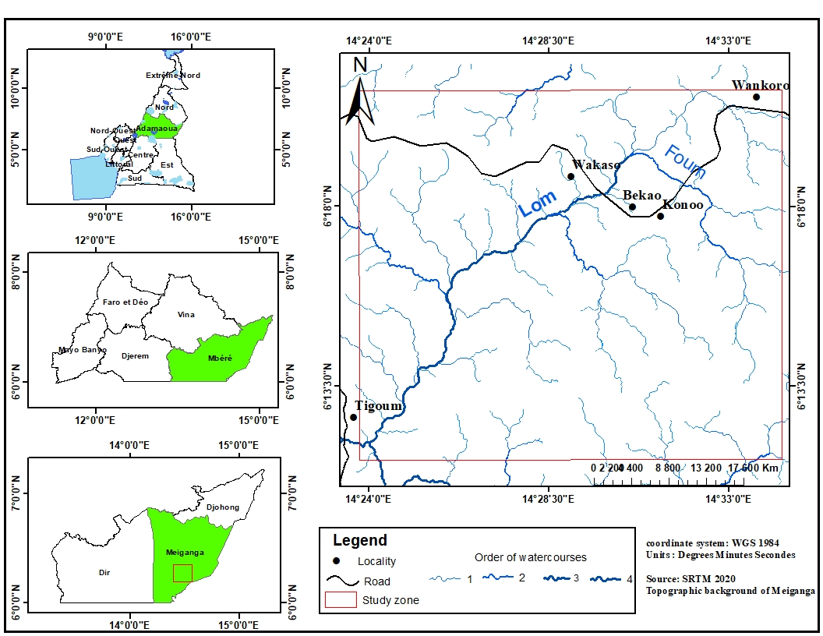
Figure 1: Location map of the study area
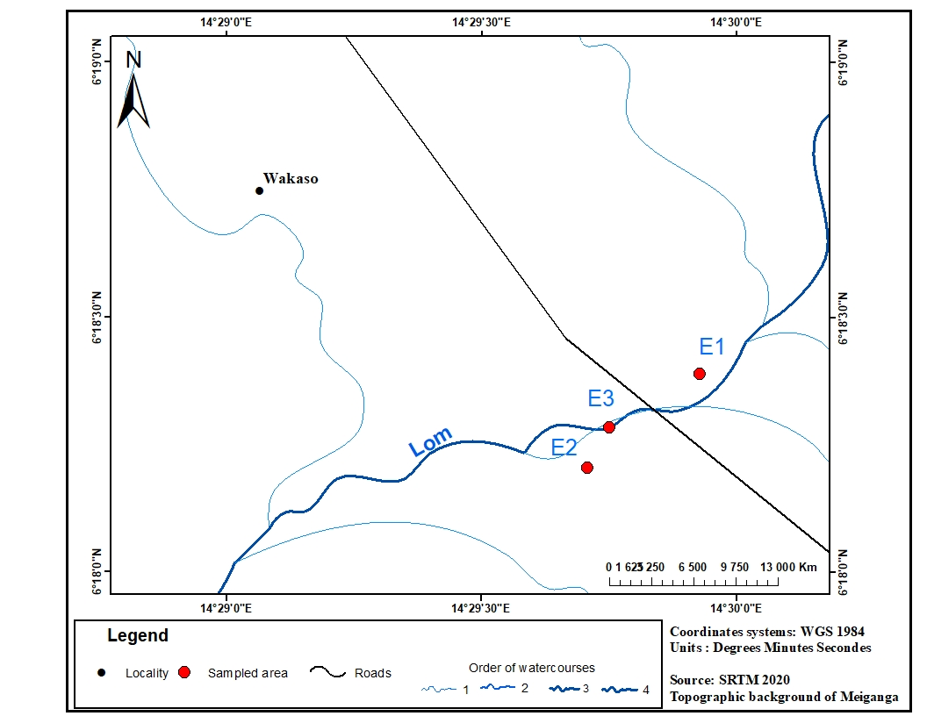
Figure 2: Sampling map
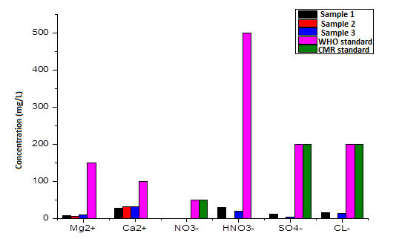
Figure 3: Spatial distribution of major ions
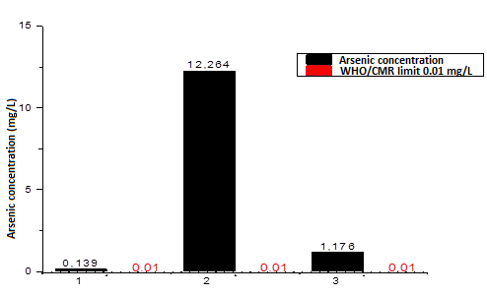
Figure 4: Spatial variation of Arsenic concentration
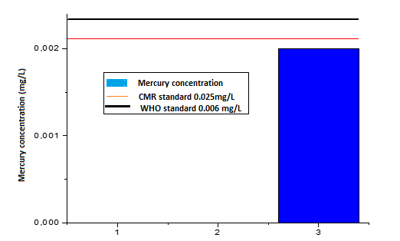
Figure 5: Spatial variation of Mercury concentration

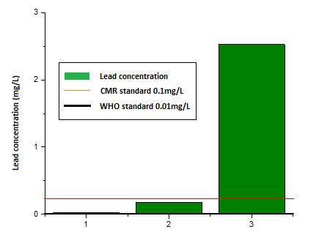
Figure 6: Spatial variation of lead concentration

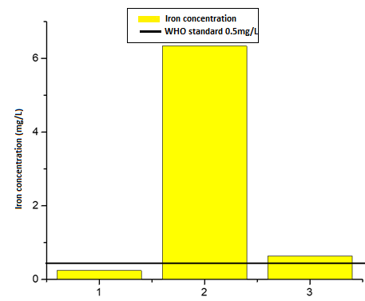
Figure 7: Spatial variation of Iron concentration
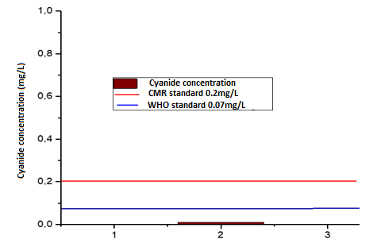
Figure 8: Spatial variation of Cyanide concentration
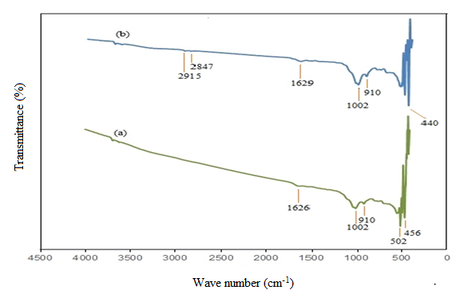
Figure 9: FTIR spectrum of water hyacinth powder (a) before and (b) after adsorption (Rajeswari et al., 2018)

Tables

Table 1 : Sampling points, coordinates and description
Sample | Latitude (UTM) | Longitude (UTM) | Description | Distance from Site
E1 | 0444638 | 0697157 | Upstream (reference) | 2.8 km upstream
E2 | 0444212 | 0696819 | Downstream (affected) | 1.5 km downstream
E3 | 0444273 | 0696970 | Mining site (in situ) | 0 km (at activity)

Table 2 : Results of the physico-chemical analyzes
Parameter | E1 | E2 | E3 | WHO Limit (2017) | CMR Limit (2007)
pH | 7.8 | 6.9 | 6.6 | 6.5-8.5 | 6.5-8.5
EC (µS/cm) | 54 | 16 | 66 | - | -
TDS (mg/L) | 20 | 23 | 20 | 1000 | 1000
Turbidity (NTU) | - | - | - | 5 | 5

Table 3 : Major ions concentration
Parameter | E1 (mg/L) | E2 (mg/L) | E3 (mg/L) | WHO Limit (2017) | CMR Limit (2007)
Mg²⁺ | 7.2 ± 0.3 | 4.8 ± 0.2 | 9.6 ± 0.4 | 150 | -
Ca²⁺ | 28 ± 1.2 | 32 ± 1.5 | 32 ± 1.4 | 100 | -
NO₃⁻ | ND | ND | ND | 50 | 50
HCO₃⁻ | 30 ± 1.5 | ND | 19.5 ± 1.0 | 500 | -
SO₄²⁻ | 12.1 ± 0.6 | ND | 3.7 ± 0.2 | 200 | 200
Cl⁻ | 15.02 ± 0.7 | ND | 13.60 ± 0.6 | 200 | 200
ND = Not detected
Table 4 : Water correlation matrix

Table 5 : Concentration of different heavy metals

Metal | Initial Conc. (mg/L) | Final Conc. (mg/L) | Removal (%) | Adsorbed (mg/g) | WHO Limit | CMR Limit
Pb | 0.1780 ± 0.008 | 0.1562 ± 0.007 | 12.24 | 0.0022 | 0.01 | 0.1
CN⁻ | 0.0100 ± 0.001 | 0.002 ± 0.0002 | 80.0 | 0.0008 | 0.07 | 0.2
Fe | 6.3410 ± 0.310 | 5.782 ± 0.280 | 9.0 | 0.0559 | 0.5 | -
As | 12.2640 ± 0.610 | 3.781 ± 0.190 | 70.0 | 0.0425 | 0.01 | 0.01
Notes :
- All values presented as mean ± standard deviation (n = 3)
- Adsorbed (mg/g) calculated as : $q=\frac{(C_{0}-C_{e})×V}{m}$ (5)
  - Where C₀ is the initial concentration (mg/L), C_{e} the equilibrium concentration (mg/L), V the volume (L) and m the adsorbent mass (g)
Table 6 : Comparative Adsorption Performance
Biosorbent | Metal | Removal % | Dosage | pH | Time | Reference
Water hyacinth | As | 70% | 4 g/L | 7.8 | 4h | This study
Water hyacinth | Pb | 12% | 4 g/L | 7.8 | 4h | This study
Water hyacinth | As | 85% | 5 g/L | 6 | 12h | Sharma et al. (2022)
Water hyacinth | Pb | 99.6% | 2 g/L | 5 | 6h | Najem (2015)
Water hyacinth | Fe | 80% | 8 g/L | 5.5 | 24h | Moyo et al. (2022)
Moringa oleifera | Cd | 91.7% | - | - | - | Ayiwouo et al. (2021)
Banana smectite | Pb | 100% | 0.5 g | - | - | Mohamed et al. (2020)

