VERONICA: Design and Implementation of a Synchronous Desktop-Based Intelligent Voice Interface

- Introduction

In recent years, the emergence of voice-enabled computing devices has transformed human-computer interaction. Voice-enabled devices are now used in mobile computing, smart homes, and many types of workplace technologies. Voice control has become an essential component of modern user interaction.
The widespread deployment of such systems motivates improvements in basic reliability, efficiency, system integrity, and security. Mandatory cloud processing entails loss of data privacy for commercial systems. The audio quality of research systems is better, but they may be computationally intensive and architecturally inefficient. Open-source implementations are a good starting point, but usually are not resilient enough for production. This work presents VERONICA as a comprehensive solution to the above requirements. It uses practical engineering techniques to overcome the above stated deficiencies. Our work primarily focuses on methodologies to easily reproduce and adapt to later researchers. Instead of focusing solely on state-of-the- art methods, this work emphasizes practical and reliable solutions.
With regard to acoustic fidelity through computationally intensive deep learning, we value
dependability, simplicity, and operational baselines that are feasible in a variety of deployment scenarios.

- Ease of Use

The VERONICA system is developed with high usability and interaction simplicity. The system’s usability is achieved in two ways: by using natural voice commands that allow users to interact without requiring predefined command syntax. The system also requires no prior initialization or training other than microphone access, which means that first-time users can use the system immediately. Most functions in the system can be performed using just one voice command, and there are also mechanisms for recovering from recognition errors without restarting the system.

PROBLEM STATEMENT
Existing voice interfaces suffer from the following limitations such as reduced accuracy in noisy environments, synchronization problems due to parallel processing, a lack of understanding of the context, privacy risks due to the dependency on the cloud, and high computational resource usage. These are the disadvantages that can affect the reliability, responsiveness, and trustworthiness of the current voice interfaces. This research will work towards the design of a reliable voice interface that can address these disadvantages.

RESEARCH OBJECTIVES AND PROPOSED CONTRIBUTIONS
This research aims for measurable improvements in several technological areas. The following list describes the research aims and contributions.

Abbreviations and Acronyms
AI – Artificial Intelligence, NLP – Natural Language Processing, I/O – Input / Output, CPU – Central Processing Unit, OS – Operating System, RAM – Random Access Memory, UI – User Interface, TTS – Text-to-Speech, VERONICA – Voice-Enabled Responsive Operational Network with Intelligent Contextual Architecture

Specific Research Targets
Design a voice reception and commands processing system with a minimum 90% accuracy under typical office conditions with moderate background acoustic interference.
It is essential to implement audio output synthesis fully

independent of web services and ensure privacy of information while providing acceptable voice quality.
VERONICA is a sequential processing architecture that removes all the concurrency conflicts. VERONICA is modular in nature, which makes it easy to scale new features without affecting the existing features of our assistant. VERONICA can operate effectively on normal PCs/desktops without any external resources.

Expected Contributions
Proof of concept to show that complex conversation UIs can be effectively implemented using widely available programming libraries rather than frameworks such as IBM Watson. Validation of the ability of forty-plus different operational functionalities to coexist within a single architectural framework without accumulating complexity.
This demonstrates that resource-efficient implementation facilitates deployment in various computing platforms, regardless of whether it is a traditional/modern computing device. Real-world implementation of privacy- respecting voice interfaces that prevent the mandatory processing of user data in the cloud and yet remain performant.
The systematic inclusion of error handling, recovery, and graceful degradation techniques to provide production- quality reliability.

Some common mistakes observed in other software:
Cloud services are highly dependent on networks, which cause latency, dependency, and privacy issues, making them less preferred for use in offline or resource-constrained settings. A lack of synchronization in multi-threading or asynchrony results in a race condition, a lag in responses, and inconsistencies in real-time systems.
Having many configuration settings (API keys, accounts, hardware calibration data) makes the service less accessible. The inability to handle recognition errors and invalid entries gracefully leads to unresponsive behavior and poor usability.

- SYSTEM ARCHITECTURE
In the VERONICA system, the system consists of multiple steps that must be executed sequentially for effective operation.in sequence for an effective result. “VERONICA” captures user audio input, and it converts speech into text by using speech recognition.
It identifies user intent and executes corresponding actions. After all steps are completed, the system generates a response and converts it into speech.
At each step the system maintains contextual consistency throughout the interaction.
What’s more, the VERONICA system continually analyses and processes the user’s interactions in order to guarantee a fluid communication between the user and the system. It uses natural language processing techniques to understand commands accurately and give intelligent responses. The system also manages the flow of data between modules such as speech recognition, intent analysis, action execution and text to speech conversion. By maintaining context and sequential processing, VERONICA delivers a seamless, interactive, and user-friendly experience for real-time communication and task execution.

The system workflow is illustrated in Fig. 1.

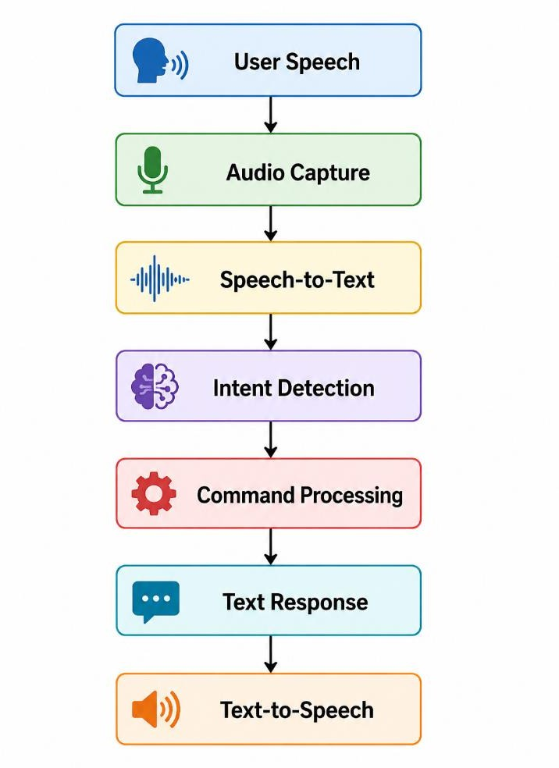
Fig. 1. Workflow of the VERONICA Voice Processing Pipeline
Each step must be completed before the next begins. As it is a system that follows a sequential pattern, the error detection is efficient. There is a reduction in error because the system does not perform multiple steps at a time.
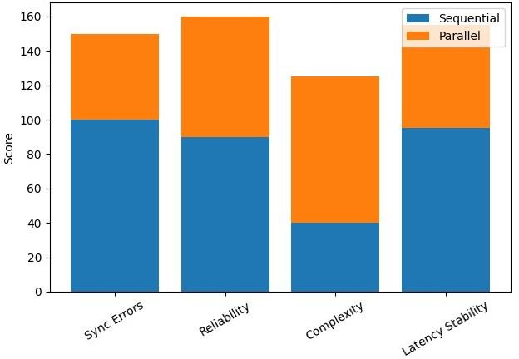

Fig. 2. Comparison of Sequential and Parallel Processing Models in Terms of Reliability, Complexity, and Stability

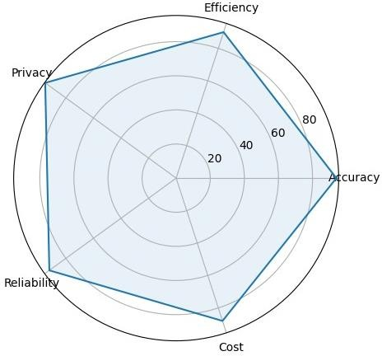

Table I. System Architectural modules

- METHODOLOGY
The audio signals are sampled at a rate of 16 kHz. The signals are then processed offline using speech recognition modules. The recognized text is processed using rule-based intent detection systems. These commands are processed using modular command handlers. System responses are produced in natural language and are synthesized offline.

Contextual information is cached locally to handle multi-turn dialogues.

- EXPERIMENTAL EVALUATION
The system was tested with over 400 test cases to comprehensively evaluate system performance. Test cases included arithmetic calculations, information retrieval, system-level commands, entertainment-related functions, and dialogue- based interactions.
The system was evaluated across multiple functional categories to assess its versatility. The experiments were conducted in conditions with varying noise levels.
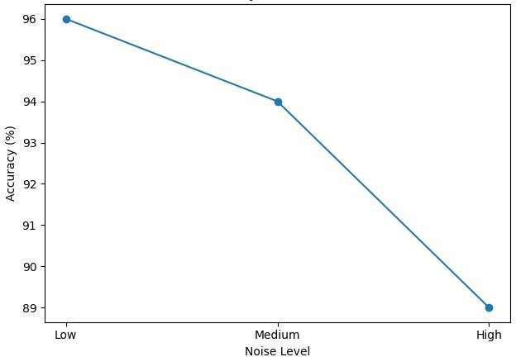

Fig. 3. Impact of Noise Levels on Speech Recognition Accuracy
The responses of the system were monitored for accuracy, reliability, and consistency in all test scenarios.

The multi-dimensional performance analysis is illustrated in Fig. 2.
Fig. 4. Multi-Dimensional Performance Analysis of VERONICA

Metric | Observed Value | Assessment
Speech Recognition Accuracy | 94% | High
Task Execution Success Rate | 98% | Excellent
Synchronization Failures | 0 | Optimal
Average Response Time | 1.3 seconds | Efficient
Memory Usage | 48–62 MB | Low

Table II. Operational Performance Report
Module | Function | Execution Model
Audio Capture | Microphone input  acquisition and normalization | Sequential
Speech Recognition | Offline audio-to- text conversion | Sequential
Intent Analysis | Command interpretation and  parameter extraction | Sequential
Command Execution | System task execution | Sequential
Speech Synthesis | Text-to-speech generation | Sequential
Context Management | Conversation history maintenance | Sequential

- Discussion

The system maintains acceptable response times, thus ensuring smooth user interaction.
Although cloud-based systems can have a higher accuracy in some tasks such as face recognition, they suffer from dependency on network availability.
As shown in Fig. 5, VERONICA demonstrates higher efficiency across varying resource usage levels compared to cloud-based and traditional systems.
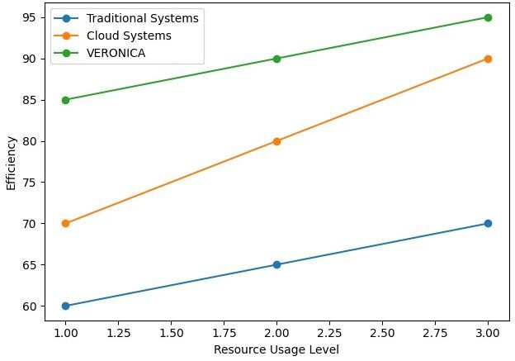

Fig. 5. Efficiency vs Resource Usage Comparison Between VERONICA, Cloud, and Traditional Systems
The proposed method provides higher reliability because of deterministic execution and offline processing. User privacy is improved since all the processing is done locally without the transmission of data to the cloud. The system is deployable in a desktop environment with minimal configuration and infrastructure support.

CONCLUSION AND FUTURE WORK
This paper presents VERONICA, a synchronous and privacy-preserving intelligent voice interface for the desktop setting. The proposed system demonstrates that conversational computing can be effectively implemented without relying on the cloud and without the need for complex concurrent architectures.
Synchronous execution guarantees correct system functioning and prevents problems associated with concurrency. Local processing enhances user data privacy and system security. The experimental results confirm the efficiency and usability of the proposed approach.
Future work will concentrate on making the system multilingual to improve accessibility. Learning algorithms that are adaptive will be investigated to enhance personalization and system intelligence. The ability to have better multi-turn conversations will be achieved through the development of enhanced contextual reasoning capabilities. This work demonstrates that high-performance voice interfaces can be achieved without reliance on cloud infrastructure, making the system suitable for privacy-critical and resource-constrained environments.

ACKNOWLEDGEMENT
The authors would like to thank the Department of Computer Science and Engineering, Galgotias University, for providing the academic environment and resources necessary to carry out this research work.
Special thanks are also given to the project supervisor for their valuable guidance, support, and feedback during the development of the system and the writing of the paper. The authors would like to thank the faculty members who contributed technical knowledge and motivation at different points in the research process.
Appreciation is also extended to peers and colleagues for their suggestions and help during testing and evaluation of the system.
Recognition with Deep Recurrent Neural Networks,” ICASSP, 2013.

- A. Graves et al., “Connectionist Temporal Classification,” ICML, 2006.

- H. Sak, A. Senior, and F. Beaufays, “LSTM-based RNN Architectures for Speech Recognition,” arXiv, 2014.

- M. A. Anusuya and S. K. Katti, “Speech Recognition by Machine: A Review,” arXiv, 2010.

- M. Yadav and A. Alam, “Speech Recognition: A Review,” International Journal, 2018.
- A. Waibel and K. F. Lee, Readings in Speech Recognition, Morgan Kaufmann, 1990.

- I. Goodfellow, Y. Bengio, and A. Courville, Deep Learning, MIT Press, 2016.

- J. O. Smith, Spectral Audio Signal Processing, W3K Publishing, 2011.

- S. E. Levinson, “Speech Recognition Technology: A Critique,” PNAS, 1995.

- A. Dhouib et al., “Automatic Speech Recognition: A Systematic Review,” Applied Sciences, 2022.

- A. Mehrish et al., “A Review of Deep Learning Techniques for Speech Processing,” arXiv, 2023.

- OpenAI, “Whisper: Robust Speech Recognition via Large-Scale Weak Supervision,” 2022.

- F. Jelinek, “Statistical Methods for Speech Recognition,” MIT Press, 1997.

- S. Furui, “Digital Speech Processing,” CRC Press, 2018

REFERENCES
  - Jurafsky and J. H. Martin, Speech and Language Processing, Pearson, 2023.

  - L. Rabiner, “A Tutorial on Hidden Markov Models,” Proceedings of the IEEE, 1989.
  - A. Vaswani et al., “Attention Is All You Need,” NeurIPS, 2017.

  - S. Young et al., “The HTK Book,” Cambridge University Engineering Department, 2006.

  - A. Hannun et al., “Deep Speech: Scaling up End-to-End Speech Recognition,” arXiv preprint arXiv:1412.5567, 2014.

  - J. Allen, Natural Language Understanding, 2nd ed., Benjamin/Cummings, 1995.

  - R. López-Cózar and Z. Callejas, “Multimodal Dialogue Systems,” International Journal of Speech Technology, 2006.

  - L. R. Rabiner and B. H. Juang, Fundamentals of Speech Recognition, Prentice Hall, 1993.
  - A. Graves, A. Mohamed, and G. Hinton, “Speech

