IOT-Based Tracking And Alert System

Monika Dattatray Mohite, Vivek Suresh Mane, Shreyash Sanjay Desai, Aishwarya Gopal Kumbhar,
Department of Computer Science and Engineering,
Annasaheb Dange College of Engineering and Technology,
Ashta, Maharashtra, India

Tabbasum Akbar Walandkar,
Assistant Professor,
Department of Computer Science and Engineering Department ,
tabbasumsmagdum@gmail.com
Annasaheb Dange College of Engineering and Technology,
Ashta, Maharashtra, India

Abstract—Rapid urbanization and rising safety concerns highlight the need for technologies that can deliver quick and reliable assistance during emergencies. Conventional safety tools, such as manual phone calls or mobile applications, often fail due to stress, network issues, or delays, underscoring the necessity for more robust solutions. This paper presents an Internet of Things (IoT)–based alert and tracking system designed to provide real-time support. The proposed system combines Global Positioning System (GPS) for precise location monitoring with Global System for Mobile (GSM) communication to transmit alerts instantly to pre-registered contacts. A dedicated SOS button allows immediate activation, after which the device automatically shares live location details with guardians or authorities. Compactness, simplicity, and energy efficiency are emphasized, enabling applications in personal safety, child protection, elderly care, and asset tracking. By integrating IoT, GPS, and GSM technologies, the system offers a practical and cost-effective solution to improve responsiveness and enhance safety outcomes in critical situations.
Keywords—IoT, GPS, GSM, emergency alert system, real-time tracking, personal safety.

INTRODUCTION
Research work in the field of safety and emergency response system design has been an area of interest. In today's fast-paced life, many accidents, crimes, and terror attacks have endangered personal safety. Unprotected areas and remote regions have long been a serious threat to the lives of women, children, and senior citizens. Conventional manual phone call systems and public help centers are not very efficient, as they rely on the premise that a person in danger can reach and call for help. Panic conditions, lack of location information, and delayed communication are some of the reasons why such systems are not very effective in emergency conditions. There is a need for technology-driven automated tracking and alert systems to enable quicker response and real-time monitoring.
The first solution was the panic button alarm system. This was a hardware-based system that was used to send an emergency alert to the security team, who then responded to the feeling of danger as quickly as possible[1]. Smartphones that utilize cell phone technology for safety solutions. Safety applications could share their location and notify their emergency contacts. Many GPS-based women’s safety applications have been created to send distress signals and their location to pre-defined contacts in case of an emergency[2]. Another solution w as the use of Android for cell phones, the SOS application, Voice, and Cell phone operation. Communication-dependent functionality, convenience, and accessibility have been improved[3].
With the advancement of technology, intelligent mobile safety systems emerged that had the capability to detect danger automatically. Real-time threat detection applications were developed that monitored user inputs and notified emergency contacts [4]. Special SOS devices were also developed that had the capability to send GPS locations via GSM networks with the press of a single button, even without internet connectivity [5]. GPS and GSM-based vehicle tracking and management systems were used to track vehicles, prevent theft, and improve transportation safety [6].
The researchers also concentrated on child protection systems. Intelligent monitoring systems utilized sensors and machine learning algorithms to identify irregular situations and alert guardians automatically [7]. RFID-based monitoring systems were implemented in a school setting to track children and alert parents of boarding and drop-off activities [8]. IoT-based child tracking systems also allowed parents to track real-time location information using mobile apps and GPS communication [9].
Studies on the social implications of IoT solutions involved research and projects related to interactions between parents and children, autonomy of children, and the psychological implications of using tracking technology. There have been developments in IoT solutions that restrict the use of smartphones or electronic games, which has improved interactions between parents and children [10]. There have been studies on the social implications of these technologies. Children may become too reliant on an IoT solution, which will decrease their autonomy, or they may develop a strong dislike for the technology, which will cause psychological rejection [11]. In transportation safety, an IoT-based accident detection system automatically detected accidents and alerted hospitals and emergency services, decreasing response time and deaths [12].
Personal safety devices improved monitoring functions by integrating location, health, and environmental sensors [13]. RFID-based transport safety systems ensured that children were transported safely and avoided missing cases while traveling to school [14]. Smart monitoring devices were also designed to track people and send real-time safety alerts [15]. Furthermore, GSM and GPS emergency alert devices facilitated effective communication and location transfer even in regions without internet access [16].
Although there are many systems and concepts of systems that currently exist, most of these are smartphone-dependent, requiring internet access and/or user operation, which is likely to fail under the stressful conditions of an emergency. Mobile safety applications require the direct engagement of a user with a device, which may not be feasible under unexpected danger.
To overcome the aforementioned problems, in this paper, we present an IoT-based GPS-GSM-LTE Tracking and Alert System. The proposed system is designed and developed using a compact low-cost GPS module with low-power microcontroller and GSM module with LTE-enabled U-SIM for wireless communication. The SOS trigger is implemented using a panic/SOS button for automatic alert generation and real-time location tracking by sending location coordinates to multiple registered mobile numbers. The proposed system was tested initially for automatic emergency alert generation, real-time location coordinates and Google map link forwarding, receiving emergency alert, and tracking message transmission over the GSM network. The performance of the proposed system is found to be effective with real-time alert transmission and the system is applicable for safety-critical applications for real-time tracking and alerting at low cost and low power consumption without the need for user interaction for alert generation and location detection. The drawback of the proposed system is only its limited communication range and subscription cost of the LTE network in real-time tracking applications perspective. The proposed system is applicable for women safety, child monitoring, elderly care, and asset tracking applications [17].

OBJECTIVES
The primary objectives of the proposed system are as follows: 1. To develop a system for tracking the real-time location of a person, vehicle, or asset.
2. To determine if the tracked individual or asset is in distress.
3. To implement a distress button to trigger alerts and send notifications or messages to the concerned recipient’s mobile device.
4. To integrate all tracking and alert functions into a single compact IoT device.

LITERATURE SURVEY
Several researchers have contributed to the development of IoT-based tracking and alert systems aimed at improving personal safety and real-time emergency response. Studies highlight the use of GPS, GSM, RFID, and AI technologies to enable quick distress alerts, accurate location tracking, and user-friendly safety solutions. The summary below presents key research contributions relevant to this domain.

Sr. No | Area of Research | Contribution | Reference
 | Panic Button Alarm Systems | Designed low-cost panic button alarm using Arduino, GPS, and Wi-Fi for real-time security monitoring. | Awodeyi et al. (2018)
 | A GPS Based Women Safety Application | Developed an Android app with GPS tracking, SOS messaging, and location shar ing for women’s safety. | Siddaraj-u and Sumana- shree (2023)
 | Review on Android-Based Safety Applications | Reviewed Android safety apps focusing on GPS tracking, alert generation, and communicate-on tools. | Mahale et al. (2025)
 | Threat Eye Safety Alert System | Developed alert system using NLP and speech recognition for hands-free threat detection. | Tejaset-al. (2025)
 | GPS and GSM Based Vehicle Tracking and Security System | Created NodeMCU-based SOS button with GPS and GSM to send SMS alerts with coordinates. | Pangave et al. (2025)
 | Child Safety Using RFID & Raspberry Pi | Implemented GPS–GSM device for live vehicle tracking, route monitoring | Lahire  (2016)
 | Intelligent Child Safety System Using ML and IoT | Wearable device with sensors + GPS/GSM + Decision Tree ML to detect distress. | Prabhakar et al. (2023)
 | IoT Based Child Safety Management using Raspberry Pi and RFID | RFID + Ras-pberry Pi for school bus attendance and tracking. | Jabirul-lah et al. (2020)
 | IoT Based Child Tracking and Safety System | GPS + GSM tracker with SOS button linked to app. | Salunkhe et al. (2023)
 | IoT-Based Real Time Location Sharing and Tracking System | GPS/GSM tracker with cloud dash board for location updates. | Kumar et al. (2025)
Table 1: Summary of Existing Research on IoT-Based Alert and Tracking Systems

BACKGROUND CONCEPT

The IoT-Based Alert and Tracking System relies on several foundational technologies that enable real-time communication, location detection, and emergency alerts. The key background concepts are described below:
- Internet of Things (IoT):
IoT refers to the interconnection of physical devices equipped with sensors, software, and communication modules that collect and exchange data over the internet. In this project, IoT connects components like GPS and GSM modules with a microcontroller to send automated alerts and location details.
- Global Positioning System (GPS):
GPS is a satellite-based navigation system that provides accurate geographic location (latitude and longitude). It helps in tracking the real-time position of the user or asset, which is crucial during emergencies.
- Global System for Mobile Communication(GSM):
GSM technology enables sending messages or making calls through cellular networks. In the proposed system, the GSM module transmits SOS alerts and location data to pre-registered contacts via SMS.
- Microcontroller (Arduino/ESP Series):
A microcontroller acts as the central processing unit that controls sensor inputs and communication outputs. It coordinates the GPS and GSM modules and triggers alerts when the SOS button is pressed.
- Emergency SOS Mechanism:
The SOS button is a user-activated component that immediately sends a distress message containing the user’s live location to guardians or authorities, ensuring timely assistance.

PROPOSED METHODOLOGY

The system also offers optimal routes for visually disabled individuals, considering user preferences to either avoid obstacles or opt for busy roads. The findings showed that the proposed smart safe city welfare system for the visually disabled and socially insecure citizens of smart cities is a low-cost solution for ensuring their safety and well-being.

The GSM module is always monitoring the cellular network and accessing it whenever there is a need to send a message. A message format is followed to send the latitude and longitude coordinates of the device through SMS to the predefined emergency contact. The contact can easily copy and paste the coordinates into Google Maps to obtain the location link after receiving the SMS. This is an efficient, cost-effective, and easy-to-implement solution.

The distress message is then sent through the GSM module to the predefined server and then to the mothership. If the server fails to receive the distress message within 10 seconds, the mothership will continuously try to contact the server to confirm network connectivity and alert the emergency response team with the last known location of the device in case the device is disconnected. The mothership also archives all the emergency messages for future retrieval.

For communication to be established, the controller initializes the GSM module. The GSM module is also responsible for communicating with the user’s cellphone. This system utilizes the cellular network because it has the largest coverage area and can operate anywhere as long as there is a cellular network available. After the initialization process, the GSM module calls the pre-registered number on the SIM card. If the call is successful, the GSM module sends the GPS location to the cellphone. If the call is not answered, the GSM module attempts to establish a connection several times because there is sufficient signal strength.

The system also provides continuous tracking capability. After sending the first alert message, the device periodically updates and sends the location at fixed time intervals, enabling the responders to track the movement in real-time. Power management strategies like sleep mode operation are employed during normal conditions to save battery power and facilitate long-term functionality.

In conclusion, the proposed methodology combines real-time GPS tracking, GSM emergency communication, and the SOS alert feature in a single compact IoT device. The proposed solution ensures rapid response, reduced interaction, and functionality even in scenarios where smartphones and internet access are not available. The proposed system thus meets the objectives of tracking the user, sensing distress, sending emergency alerts, and integrating all functions in a single portable safety solution for women, children, the elderly, and field workers.

WORKFLOW OF SYSTEM

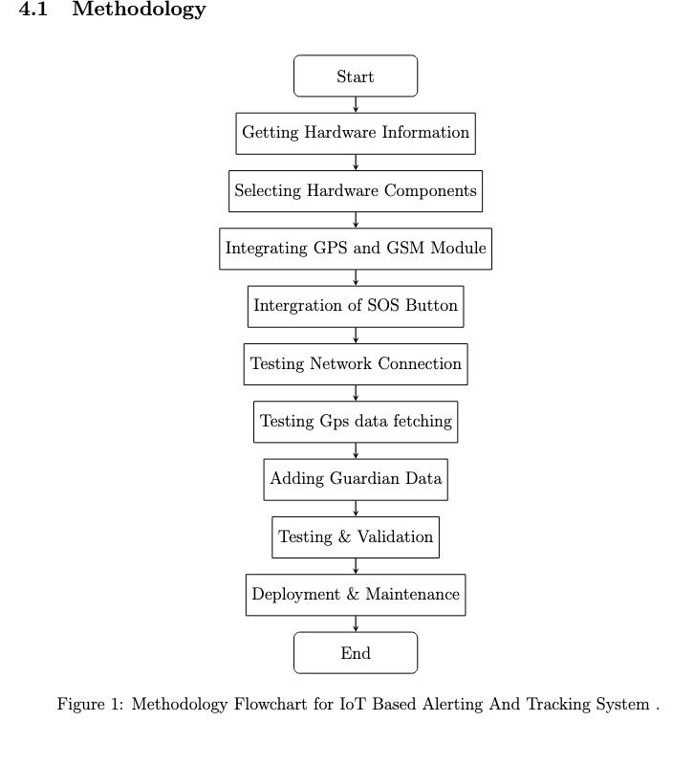

Fig 1: Workflow

1. Requirement Analysis: The requirement analysis marks the beginning of the development process, which clearly stipulates both functional and non-functional requirements of the IoT-Based Alerting and Tracking System. The requirements include identifying whether the system should be able to offer real-time GPS tracking, GSM-based SMS alerts, and a mechanism for triggering SOS. In this stage, the project team will assess user expectations, emergency response goals, environmental conditions, power constraints, and compatibility of hardware. Feasibility regarding cost, ease of use, portability, and reliability also fall under this category. By defining these requirements upfront, the team creates a clear blueprint that guides hardware selection, system architecture, and software workflow throughout the project.
2. Getting Hardware Information: Gather detailed information about the different IoT hardware components. The team researches types of microcontrollers, GPS mod ules, GSM modules, antennas, and power supplies available on the market. Datasheets are reviewed, technical documentation is studied, and performance reviews are re searched for communications interfaces, voltage levels, accuracy ratings, and integration challenges. This will assure that, when the team reaches the selection process, it is fully prepared with a deep understanding of component limitations and strengths.
3. Hardware Component Selection: After gaining knowledge of the hardware, the ideal components are chosen according to the requirements of the project. Each com ponent is focused on: low power usage, accuracy, fast GPS lock, reliable GSM connectivity, and compact size. The typical parts picked include the ESP32 microcontroller, NEO-6M GPS module, and SIM800L GSM module due to their stability and common usage in IoT applications. Other items being picked are the SOS button, wiring, battery modules, and supporting electronics that will be needed for proper operation of said system.
4. GPS and GSM Module Integration: After the selection of components, the phase of integration takes over. The GPS module is wired into the ESP32 via UART communication pins to capture latitude and longitude real values. Similarly, GSM is connected for sending SMS alerts using AT commands. Power supply management, antenna placement, and noise reduction are critically taken care of to ensure signal reception stability. This acts as the core communication layer of the tracking system.
5. Integration of SOS Button: After integrating the modules, the SOS button is wired to a digital GPIO pin of the microcontroller. The system is programmed in such a way that the pressing of the button works like an emergency trigger. Thus, the microcontroller continuously detects this input from the button and triggers the alert mechanism right away when turned on. This stage provides quick and definite button functionality, which is very much needed during an emergency.
6. Testing Network Connection: Once the integration of GSM is complete, testing of network connectivity is done. This includes verification of the registration of the SIM card, the ability of the GSM module to connect to the network, and appropriate signal strength at variable locations. Reliability in sending SMS by GSM is checked to confirm that the device performs well under real network conditions.
7. Testing GPS Data Fetching: In this step, the GPS module is tested for its ac curacy and speed in fetching real-time coordinates. The system is placed in different indoor and outdoor environments to check how fast the module locks on satellite signals. Latitude and longitude readings are checked with mobile GPS readings to ensure correctness. Reliable GPS performance is critical for accurately tracking an emergency.
8. Adding Guardian Data: Finally, after proper functionality of GPS and GSM, the details of guardians or family members are programmed as emergency contact details. These pre-defined numbers will receive SOS alert messages when required. The format of SMS notifications, including Google Maps links, is also verified to ensure receivers face no issues with usability.
9. Testing and Validation: System tests are thoroughly performed by simulating any kind of emergency. The SOS button is clicked several times to measure the response time, speed of SMS delivery, and position accuracy of GPS. Stability of hardware connections, responsiveness of algorithms, and reliability of communication modules are validated. This phase ensures that the system behaves consistently across various conditions.
10. Deployment and Maintenance: After successful validation, the system is enclosed into a stable prototype and deployed for real-world usage. Maintenance activities such as battery health monitoring, firmware updates, GSM signal checks, and component inspection are planned to ensure long-term reliability. The device is then ready for actual emergency use cases including personal safety, child monitoring, or elderly tracking.

- SYSTEM ARCHITECTURE:
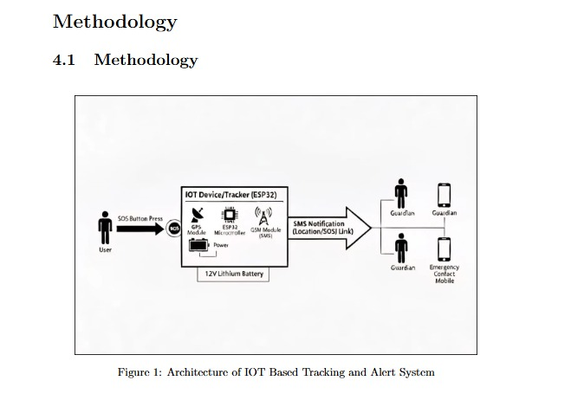

Fig 2: Architecture of IoT Based Tracking and Alert System

Figure 2 shows the overall architecture of the IoT-Based Tracking and Alert System and presents how an emergency signal travels from the user to the guardians. In the left side of Figure 2, the user is presented with an SOS button. This button is the main input to the system: when the user feels unsafe or faces an accident, he/she simply presses this SOS button instead of unlocking a phone or opening an app. The button press acts as a hardware trigger and immediately wakes up the internal electronics of the device. In the centre of Figure 2, the core unit is labelled ”IoT Device/Tracker [ESP32]”. This block represents the embedded hardware that controls the whole system. From Figure 2, the ESP32 microcontroller is interfaced with multiple modules: a GPS module for acquiring live latitude and longitude, a GSM module for sending SMS, and a wireless communication interface (like Wi-Fi/Bluetooth) if extended connectivity is required. Upon pressing the SOS button, the first operation the ESP32 performs is to read the GPS coordinates from the GPS module, then format the location information into a structured emergency message, followed by forwarding this message to the GSM module for transmission. The same central block in Figure 2 also comprises the power management section powered by a 12 V lithium-ion battery. It means that the device is completely portable and can operate independently without any wired power source. The right-hand side of Figure 2 illustrates how the alert leaves the device and reaches the guardians: in particular, once the GSM module sends the SMS notification, an emergency message which includes the location of the user or an SOS link is sent to one or more registered mobile numbers. In Figure 2, the recipients are labelled as Guardian or Emergency Contact Mobile. Parents, family members, and any trusted contact can thus receive the alert in a parallel manner, and by tapping on the location/SOS link contained within the SMS, the guardian can open the position of the user directly in a map application and promptly decide what action to take. Figure 2 depicts in detail the complete flow of data within the system: the action of a user-that is, pressing an SOS button-is converted to a digital event within the tracker based on ESP32, processed with the GPS data, and then sent through GSM as an SMS notification to guardians. It also shows that the whole architecture is self contained, battery-powered, and capable of working even when the user does not have access to a smartphone or internet connectivity. Figure 2 depicts the functional behaviour and the communication path of the proposed IoT-Based Tracking and Alert System.

IMPLEMENTATION DETAILS

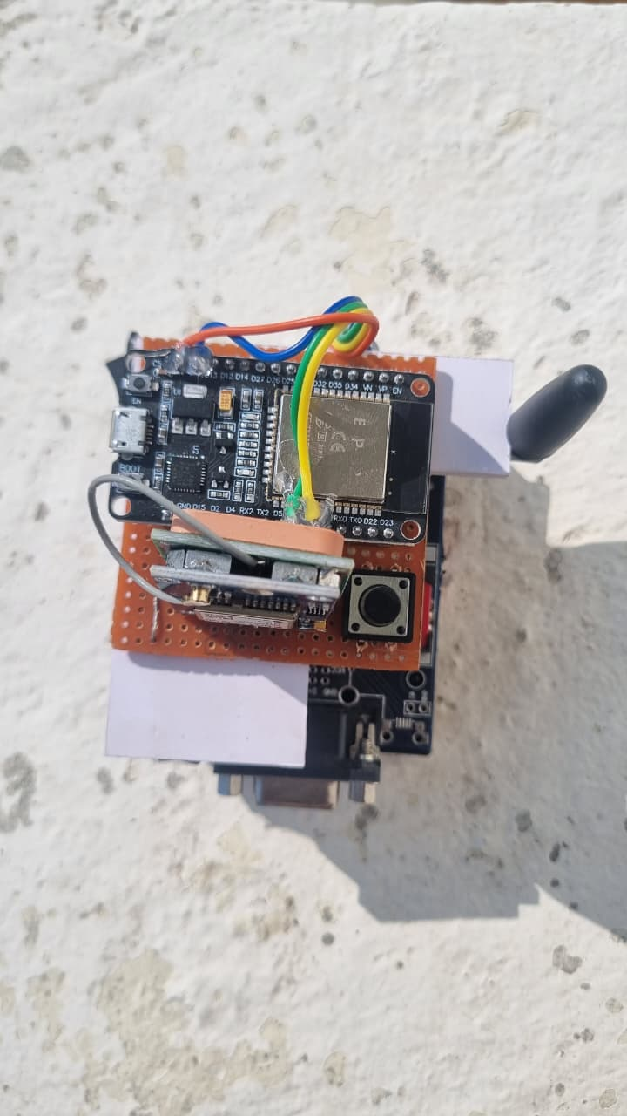
Output 1:

Fig 3: Hardware Prototype of the GPS and GSM-Based Alert System

Figure 3 illustrates a fully assembled hardware prototype of the IoT-Based Tracking and SOS Alert System, which incorporates three major technological components: GPS, GSM, and the ESP32 microcontroller in one compact, portable device. In Figure 3, all com ponents are mounted on a general-purpose PCB (perforated board), on which each module is carefully placed and interconnected to ensure that mechanical stability can be achieved along with efficient wiring and reliable system performance. At the centre of the hardware layout in Figure 3 is an ESP32 development board acting as the core processing unit of the whole device. It handles GPS data acquisition, GSM communication, SOS button sensing, decision-making logic, and the coordination between all functional modules. The GPS module is directly interfaced to the ESP32 via the UART communication lines, as clearly highlighted in Figure 3. It continuously receives the signals from satellites and updates the device with fresh latitude–longitude coordinates. In an emergency situation, on pressing the SOS button, the ESP32 requests updated GPS coordinates from it instantly, and thus the alert message sent out will carry the most recent and accurate location of the device. Below the ESP32, Figure 3 presents the GSM/4G communication module with an external antenna to enhance signal reception. The module is important in sending the emergency SMS carrying the GPS coordinates to the pre-registered mobile numbers. From Figure 3, the antenna improves network stability significantly, reduces delays in communication, and avoids message failure during urgent situations when the mobile signal is too weak or erratic. The SOS push button is located on the front side of the PCB, as indicated in Figure 3. It serves as a manually actuating device for the user in emergency situations. It is placed in such a manner that it is readily accessible by the user in instant cases of fear, injury, or threat. Pressing the button will trigger the programmed workflow of ESP32: getting GPS information, composing the alert message, and seamlessly sending it over through the GSM module. Figure 3 also shows the Micro-USB power interface, which powers up the entire system. In that way, this device can be operated with widely available power sources like a mobile charger, power bank, or DC adaptor, adding more portability to the system. Even though several hardware components are used, the internal assembly as shown in Figure 3 still looks tidy because of good soldering, short paths for wiring, and neatly connected jumpers. These wires interconnect UART, GPIO, and power pins among modules; thus, there is low interference, stable communication, and long-term reliability for the device. Overall, Figure 3 confirms that the hardware prototype successfully implements GPS tracking capability, GSM-based alert transmission, and ESP32-based control processing within a compact and efficient design. The structured layout, reliable wiring, and stable hardware performance further validate the technical feasibility of the IoT-Based Tracking and Alert System. This prototype is now qualified for field testing and is able to deliver valid real time position data and rapid emergency notifications, hence it can be applied to a variety of practical and cost-effective usages.

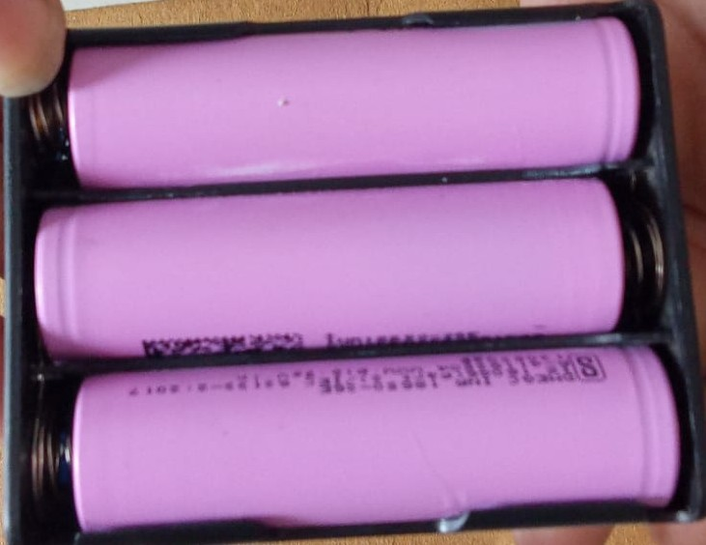
Output 2:

Fig 4: Battery

Figure 4 presents the complete power supply unit used in the IoT-Based SOS Alert and Tracking System, which plays a major role in providing energy to drive all the hardware components. Referring to Figure 4, the power module is completed with three cylindrical lithium-ion batteries that are safely positioned inside a compact plastic battery holder. With this approach, a portable, lightweight, and reliable energy platform is achieved that can sup port continuous field operation in harsh environments. Energy storage in IoT and embedded systems is normally based on lithium-ion batteries due to their high energy density, low weight, stable discharge characteristics, and very long cycle life-all contributing to consistent operation of the ESP32 microcontroller, GSM module, and GPS receiver under real-time workloads. As indicated in Figure 4, each Li-ion cell supplies a nominal voltage of 3.7V with a general capacity in the range of 2000mAh to 3000mAh. These can be configured in series or parallel, depending on system requirements. The series configuration increases the output voltage to supply the operational requirements of components such as the GSM modem, which requires higher voltage during bursts of SMS transmission. A parallel configuration, on the other hand, increases the general capacity in ampere-hours, thus enabling the system to operate for a much longer period of time before needing to be recharged. This flexible multi-cell arrangement ensures that the device receives a continuous, stable DC power sup ply, which is extremely important in maintaining reliable communication, especially in the case of high-current GSM operations. Figure 4 also highlights that the holder is designed with spring loaded metallic terminals that provide secure electrical connections yet allow for the easy removal and replacement of individual cells. The modularity of this component enhances the maintainability of the system and allows for long-term use without any special servicing. A typical power system of this nature is supported by a BMS or a TP4056 charging protection module. As presented in Fig 4, these kinds of circuits protect the cells against accidental overcharge, over-discharge, short circuiting, and excessive current draw. Such protection is especially important for portable IoT gadgets that may undergo unorthodox charging, varied environmental conditions, or prolonged periods of operation. Another ad vantage coming from Figure 4 is the low self-discharge rate of lithium-ion batteries, enabling the system to hold adequate charge over extended periods. This feature is highly desirable in emergency-based devices where charging frequently may not be feasible. The compact and lightweight construction as shown in Figure 4 ensures that the power unit does not contribute any unnecessary bulk to the prototype, thus preserving easy transportability and handling. Since lithium-ion batteries are rechargeable and reusable, they also support green hardware engineering by minimizing battery disposal and facilitating long-term deployments. Finally, Figure 4 depicts an illustration that, with the lithium-ion battery configuration, a durable, efficient, and reliable power solution is possible to drive the ESP32 microcontroller, the GPS module, and the GSM communication system securely. With high capacity, embedded safety mechanisms, structural robustness, and long operational life, the IoT-Based SOS Alert System is apt for real-world scenarios that demand continuous and reliable power availability.

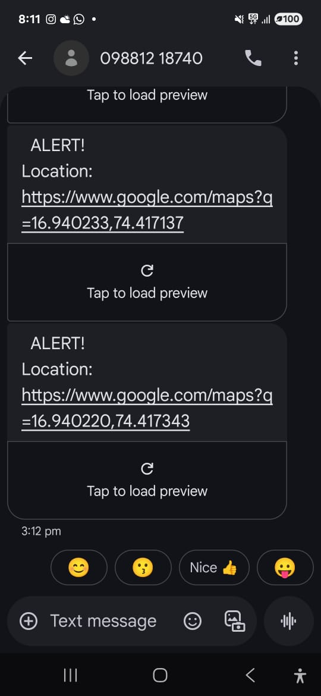
Output 3:

Fig 5: Alert Message with GPS Location Link Sent via GSM Module

Figure 5 illustrates the SMS alert notifications that have been successfully received on a mobile device from the implemented IoT-Based SOS Alert and Tracking System. This output verifies that the integrated hardware prototype comprising the ESP32 microcontroller, the GPS module, and the GSM communication module is functioning accurately and generating real-time location data without errors. Figure 5 shows that when the SOS button on the device is triggered by the user, the ESP32 immediately communicates with the GPS module for the most recent geographic coordinates. The coordinates comprise latitude and longitude values, presenting the exact physical position of the user at the instance of time when an alert is generated; this enhances both accuracy and reliability during emergencies. After processing the GPS data, ESP32 formulates the information into a formatted emergency message. Figure 5 shows a formatted message being passed to the GSM module, which in turn sends the SMS alert to the pre-defined emergency contact numbers. At the start of every message is the keyword ”ALERT!”, in a bid to convey to the recipient that the communication requires urgent and immediate action. Next is a clickable Google Maps link that has embedded GPS coordinates. As shown in Figure 5, this link allows recipients to instantly view the sender’s current location by simply tapping on it, instead of taking the time to manually enter the coordinates and shave precious vital response time. The various notifications in Figure 5 also illustrate that repeated or continuous location notifications are possible with the system for every key press of the SOS button. This makes sure that the recipient will always receive the latest location, especially in situations related to movement, abduction, vehicle travel, and dynamic emergencies. This enables instant mapping-based tracking of users by guardians, parents, and emergency response services to precisely identify the user’s location and thus expedite the rescue process effectively. Figure 5 confirms that everything in the communication chain works smoothly, from the activation of the SOS button to GPS data fetching, message processing, GSM transmission, and SMS delivery. Correct receipt of real-time alerts signifies proper synchronization among the hardware parts where the GPS module fetches coordinates correctly, the ESP32 executes data formatting and execution logic properly, and the GSM modem transmits SMS alerts over the mobile network successfully. In a nutshell, Figure 5 confirms that the IoT-Based SOS Alert System works effectively end-to-end under real field conditions. It shows that this device serves as a strong, active, and at the same time mobile solution for emergency communication, which can be used in numerous practical scenarios such as personal safety, women’s security, child or elderly tracking, monitoring lone workers, and vehicle or field-worker safety. The dependability of the messages received in real time, as depicted in Figure 5, confirms that the system meets its goal: to provide appropriate and timely alerts whenever necessary.

Output 4:
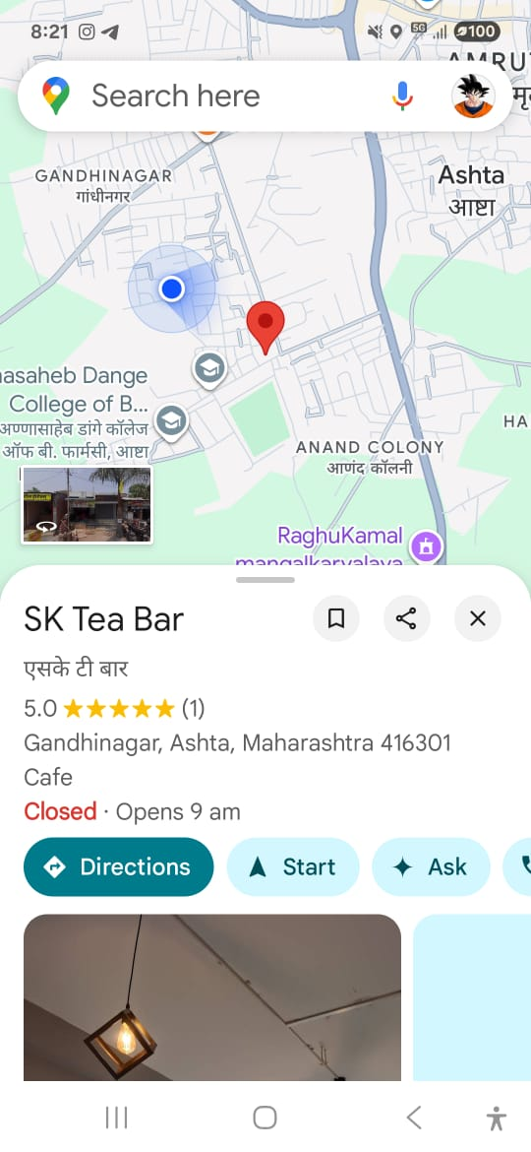

Fig 6: Output Display on Google Maps Showing the Device Location

Figure 6 depicts the IoT-Based GPS and GSM Emergency Alert System output at the final stages, amply demonstrating the complete end-to-end working of the device when real-time tracking has been initiated by triggering the device’s SOS button. In Figure 6, when the alert switch on the hardware prototype is pressed, the ESP32 microcontroller instantaneously initiates the data-acquisition process by sending a request to the onboard GPS module to capture the exact latitude and longitude of the current position of the device. The GPS coordinates, which are obtained directly from live signals captured from orbiting satellites, signify the exact physical location of the user at the instance of distress. After obtaining the location, the ESP32 formats the coordinates into a structured Google Maps URL that is compatible with all smartphones. This formatted link is further sent to the GSM module, which sends it as an SMS to the pre-configured emergency contacts. Figure 6 shows that when the recipient clicks the clickable Google Maps link, the location opens instantly on the map interface, visibly confirming the device’s exact position. The red marker seen in Figure 6 pinpoints the location that is sensed by the GPS module-near ”SK Tea Bar, Gandhinagar, Ashta, Maharashtra 416301”-which indicated accurate coordinate transmission. The blue dot reflected in the figure shows the current position of the recipient’s mobile phone, while the visible distance between the blue and red markers verified the precision and reliability of the real-time tracking process. Figure 6 confirms that each link in the communication chain is functioning properly:
• The GPS module successfully acquires satellite-based location data
• Information is processed and formatted correctly by the ESP32
• The GSM module sends the SMS alert fast and reliably
This seamless workflow ensures that the location of the user can be identified within seconds in cases of emergencies. The map interface shown in Figure 6 further enhances usability by offering an intuitive and direct way for guardians, parents, or emergency responders to track the user’s position without manually entering any coordinates. In practical applications, real-time visualization as shown in Figure 6 enhances the system’s value in many safety scenarios, such as women’s safety, child and elderly monitoring, missing persons tracking, vehicle recovery, outdoor worker protection, and fast coordination of emergency responses. The proposed system makes the entire process of emergency location just a button click away, following which instantaneous map-based tracking allows for much quicker reaction times during critical situations. In general, Figure 6 proves the correctness and robustness of the IoT-Based GPS and GSM Alert System and establishes its high suitability for real world deployment in various types of safety-oriented environments.

PERFORMANCE ANALYSIS
The proposed tracking and alerting device based on IoT technology is developed using an ESP32 microcontroller, which is connected to a GPS module (TinyGPS++) and a GSM communication module (SIM800/SIM900). Upon pressing the emergency push button, the microcontroller retrieves the real-time location coordinates and sends an SMS with a Google Maps link to the pre-defined contacts. To assess the efficiency of the proposed system, mathematical models are employed.

- GPS Localization Accuracy:

The GPS module gives the latitude and longitude coordinates through the TinyGPS++ library:

Latitude=gps.location.lat()
$$Longitude=gps.location.lng()$$

However, there are positioning errors in the GPS readings, which depend on the visibility of the satellites, atmospheric conditions, and multipath interference. Hence, the accuracy of the localization process is measured by the Euclidean distance error between the actual and the localized position.
Let:
(xa,ya) = Actual coordinates (obtained from Google Maps reference point)
(xr, yr)= Coordinates reported by the device
The localization error $E$is calculated as:
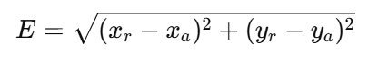

This equation determines how far the reported location deviates from the true position of the user. A lower value of $E$indicates higher tracking accuracy of the proposed system.

- Emergency Response Time Analysis:
In the code implemented, the emergency process starts when the SOS button connected to BUTTON_PIN is pressed. The system then reads GPS data and sends an SMS using AT commands through the GSM module.

The total response time of the system is made up of a series of operations that are done one after the other. These operations include:
- Acquisition of GPS coordinates
- Processing by the microcontroller
- Transmission of the GSM message
- Delivery of the message via the cellular network
The total emergency response delay is expressed as:
$$T_{total}=T_{gps}+T_{proc}+T_{gsm}+T_{net}$$
Where:
$T_{gps}$= Time required to obtain valid GPS fix
$T_{proc}$= Processing time of ESP32 controller
$T_{gsm}$= SMS sending time using AT command (AT+CMGS)
$T_{net}$= Cellular network delivery time

For multiple trial, the average reponse time calculated as:

where $T_{i}$represents the response time recorded during each experiment and $n$is the number of observations.

- Communication Reliability:
The code sends SMS alerts to three predefined phone numbers (PHONE1, PHONE2, and PHONE3). The reliability of the alert system is measured based on the successful delivery of messages.
$$Reliability=\frac{N_{success}}{N_{total}}$$

Where:
- $N_{success}$= Number of successfully delivered SMS alerts
- $N_{total}$= Total number of emergency attempts
The reliability percentage is given by:
$$Reliability(\%)=\frac{N_{success}}{N_{total}}×100$$
This metric evaluates the dependability of GSM-based emergency communication in real-world conditions.

DISCUSSION
The proposed IoT-Based Alert and Tracking System ensures real time emergency communication using GPS for location tracking and GSM for message transmission. Compared to earlier panic button or RFID-based systems, this project offers a compact, low-cost, and user-friendly design suitable for people of all age groups. The SOS button provides immediate response during emergencies, eliminating the need to access a smartphone or mobile app. The system’s portability and simplicity make it ideal for personal safety, child tracking, elderly monitoring, and vehicle tracking.

CONCLUSION
The IoT-Based Tracking and Alert System thus demonstrates how to design and implement a reliable, portable, and real-time emergency response solution that overcomes the drawbacks of existing smartphone based safety applications, manual panic systems, and limited-range tracking solutions. During the project, several experiments, feasibility analyses, and the results of implementation together affirm that integrating GPS for location tracking, GSM for message transmission, and a microcontroller unit into one compact sys tem offers an effective way to ensure personal safety, asset monitoring, and emergency communication in real-world scenarios. The architecture of the system allows for continuous background location acquisition, one-touch emergency activation, and immediate SMS alert delivery, proving that the device operates even in environments where smartphones fail due to network problems, battery limitations, or user inability to interact with the device during distress. Stable GPS performance, correct coordinate generation, robust GSM based alert transmission, and reliable SOS activation are shown in the outputs of the implementation. Testing and evaluation demonstrated the capability of the device to work under a wide range of conditions, with low power consumption and minimum hardware complexity. The operational feasibility further underscores its usability for women, children, elderly people, remote workers, travelers, and medical patients, making it suitable for both personal and in stitutional deployment. This system addresses the shortcomings in the existing literature by incorporating the aspects that were missing in prior systems: operability without dependence on smartphones, offline operability, portability, and instant emergency communication. The gap between traditional panic systems and IoT based advanced safety solutions is met with accuracy, dependability, real-time response, ease of use, and low cost, together with technical scalability. The project thus succeeds in its core mission of devising a practical, effective, real-time safety and alerting solution with substantial potential to enhance societal response to emergencies.

FUTURE SCOPE

The Tracking and Alert System using IoT is using GPS to track the real-time geo-location and GSM communication to send alerts during emergencies. With the increasing use of AI and IoT in daily life, the proposed system can make use of these technologies to provide an intelligent and advanced solution. This paper highlights the challenges and opportunities to upgrade the system from an alerting device to a smart safety solution with predictive capabilities for events, real-time data analysis, and autonomous functionality.

For future development, this system can be integrated with a mobile application and cloud server. The real-time live location, route travel, history movement, and device malfunction/disruption can be tracked and retrieved by the user through the mobile application and cloud server. The cloud storage can store the user route travel, timestamp, and alerts log to be provided to the authorities or family members if needed for route identification. Likewise, if the device is helpful to the authorities for preventive safety planning, it will be done on the basis of his cloud data location and route identification if he is not sending alert messages from routes for a long time.

The current system is triggered only when the SOS button is pressed; however, in the future, machine learning algorithms can be incorporated to automatically identify any abnormal situations. By employing motion sensors, accelerometers, and activity recognition algorithms, the system can detect whether the user has fallen, been impacted suddenly, is abnormally inactive, or has unusual movements. In such scenarios, rather than waiting for the user to alert the system, the system will automatically trigger an emergency alert, thereby enhancing the user’s safety when unconscious or in an accident situation. This method can also be employed to alert the user when they are approaching high-risk zones.

The system can be developed further into a wearable health-tracking device by incorporating sensors such as heart rate sensors, body temperature sensors, oxygen saturation sensors, and blood pressure sensors. The sensors can monitor vital parameters continuously and alert the user when abnormal health situations are identified. This will be particularly beneficial for senior citizens, patients with chronic ailments, and people living alone. The device can automatically alert emergency medical services when critical situations are identified.
In the coming versions, the geo-fencing feature can be added. The safe zones such as home, school, office, or hostel can be set in advance in the system. When the user crosses a restricted zone, an alert message is sent automatically to the guardians of the user. This feature can be of immense use for child safety, dementia patients, and workers in the industrial sector. It also sends an alert to the user when entering a crime-prone zone or a restricted zone.

Voice-controlled emergency systems are also very helpful for senior citizens or physically disabled people who may not be able to access their mobile phone or wear a panic button at all times. The system can be developed in such a way that it connects to a smart home assistant like Alexa or Google Home, such that a mere call for help would send the alert.
It is also possible to integrate this system with the centralized emergency response infrastructure. These may include police control rooms, hospitals, ambulance services, and disaster management centers. Once the alert is triggered, the closest emergency service provider can automatically receive the victim’s real-time location. This will also help in further reducing the rescue time and managing public safety.

Long-lasting batteries are a crucial requirement for devices that have to be used for a long time without any interruptions. In the future, our device can benefit from the latest low-power microcontrollers, more intelligent sleep-mode scheduling, and the ever-maturing solar-assisted charging circuit design. With the help of some energy-harvesting technologies, the device will be able to run for a very long time without frequent recharging, which is very useful for outdoor workers or travelers.
Generally, the future development of the concept can be felt as the emergence of a new generation of systems that will change the perspective of the emergency alert system from being reactive and warning-dependent to intelligent and autonomous safety systems. The new generation of systems will be able to sense the environment of the user and gather information that can be used to estimate possible dangers to warn the user.

REFERENCES
[1] Awodeyi, A. I., Obomighie, M., Opeyemi, M. S., Abraham, A. A., & Abayomi-Zannu, T. P. (2018). Design and Construction of a Panic Button Alarm System for Secu rity Emergencies. International Journal of Engineering and Techniques (IJET), 4(3), 649–652. DOI: 10.29126/23951303/IJET-V4I3P105.

[2] Siddaraju K, M., Sumanashree Y S (2023). A GPS Based Women Safety Application. International Journal of Creative Research Thoughts(IJCRT), 11(6), 898–903. ISSN: 2320-2882.

[3] Mahale, K. I., Yogesh Balasaheb B., Waghmare Dnyaneshwar D., Vikhe Nitin B., & Karmare Pratiksha S. (2025). A Review on Android-Based Safety Applications for Women’s Security. International Journal of Advanced Research in Science, Communi cation and Technology (IJARSCT), 5(6), 1–10. DOI: 10.48175/568472.

[4] Tejas, S., Shilpa, & R. (2025). Threat Eye– An Application of Safety Alert System for Real-Time Threat Detection. nternational Journal of Scientific Engineering and Research (IJSER),14(2), 1–10. DOI: 10.70729/SE25203124752.

[5] Pangave, V., Nyamagoudar, P., Bangale, A., Naik, A., & Dasmohapatra, M. (2025). Emergency SOS Button Using GPS GSM Functionality. International Journal for Multidisciplinary Research (IJFMR), 7(2), 1–7. E-ISSN: 2582-2160.

[6] Lahire, A. D. (2016)., GPS & GSM Based Vehicle Tracking and Security System. International Journal of Engineering Research and Development (IJERD), 12(6), 55–60. e-ISSN: 2278-067X, p-ISSN: 2278-800X.

[7] Prabhakar, E., Naveena, J., Vahinitha, G., & Sai Teja, G. (2023). Intelligent Child Safety System Using Machine Learning in IoT Devices. International Journal of Novel Research and Development (IJNRD), 8(4), 491–496. ISSN: 2456-4184.

[8] Jabirullah, M., Amru, M., Raviteja, D. (2020).IoT Based Child Safety Management Using Raspberry Pi and RFID Technology. IOP Conference Series: Materials Science and Engineering, 981(4), 042079. DOI: 10.1088/1757-899X/981/4/042079.

[9] Salunkhe, S. S., Patil, S., Pawar, S., & Waghmode, M. (2023). IoT Based Child Tracking and Safety System. Journal of Emerging Technologies and Innovative Research (JETIR), 10(5), 302–305. ISSN: 2349-5162.

[10] Kumar, A., Kumar, S., Rathor, S., & Gupta, P. K. (2025). IoT Based on Real Time Location Sharing and Tracking System.International Journal of Modern Science and Research Technology (IJMSRT), 3(4), 334–339. ISSN: 2584-2706. DOI: 10.5281/zen odo.15342388.

[11] Mallapur, S., Karunyahanshika, P., Pooja, S. W., Vaishnavi, P. A., & Vaishnavi, N. M. (2025).IoT-Powered Emergency Button for Women’s Safety. Journal of Scientific Research and Technology, 3(7), 297–308. ISSN: 2583-8660.

[12] Tao, J., Ali, R., Ahmad, S., & Ali, F. (2025).IoT-Based Smart Accident Detection and Early Warning System for Emergency Response and Risk Management. International Journal of Advanced Computer Science and Applications (IJACSA), 16(3), 660–672. DOI: 10.14569/IJACSA.2025.016308.

[13] Chowdhury, U., Paul, S., Sen, A., Sarkar, P. P., Basak, S., Chowdhury, P., & Bhat tacharya, A. (2019).Multi-Sensor Wearable for Child Safety. 2019 IEEE UEMCON Conference Proceedings, 1–6. DOI: 10.1109/UEMCON47517.2019.8992950.

[14] Al-Lawati, A., Al-Jahdhami, S., Al-Belushi, A., Al-Adawi, D., Awadalla, M. H. A., & Al-Abri, D. (2015).RFID-Based System for School Children Transportation Safety Enhancement. Proceedings of the 8th IEEE GCC Conference and Exhibition, 1–6. DOI: 10.1109/IEEEGCC.2015.7060047.

[15] Sawant, N. D., Badgujar, D. V., & Kudande, D. V. (2020).Smart and Secure IoT Based Child Monitoring System. International Journal of Scientific Research in Computer Science, Engineering and Information Technology (IJSRCSEIT), 6(2), 332–336. DOI: 10.32628/CSEIT206288. ISSN: 2456-3307.

[16] Samy, M. P. A., Naveena, E., Parimala, G., & Ramya, G. (2024).The GSM and GPS Based Emergency Alert Device.Fuzzy Systems and Soft Computing, 19(2), 040. DOI: 10.36893/FSSC.2024.V19I2.040. ISSN: 1819-4362.

[17] Patel, S. A. K., Wakti, P., Nakade, Y., Pathode, N., & Gahlod, R. (2024).Women’s Safety Research App Article. International Journal of Trend in Scientific Research and Development (IJTSRD), 8(5), 600–606. ISSN: 2456–6470.

