IMPROVING SLIDING MODE CONTROL WITH CHATTERING REDUCTION USING FUZZY BASED TECHNIQUE

ABSTRACT

The constant power failure in our society this time around that had jeopardized business activities were caused by the following factors that could not attain their respective thresholds, Steady-State Tracking Error , Chattering Amplitude ,Chattering Frequency ,Settling Time ,Overshoot , Boundary Layer Thickness ,Actuator Position Oscillation, Actuator Torque Oscillation and Sensor Noise Influence . This consistent power failure in the society was surmounted by introducing improving sliding mode control with chattering reduction using fuzzy based technique. To vividly achieve this, it was done in this manner sliding mode control with chattering reduction was characterized and the causes of poor sliding mode control with chattering reduction was established and a conventional SIMULINK model for sliding mode control with chattering reduction was designed. Then, a fuzzy rule base for minimization of poor sliding mode control with chattering reduction was developed and an algorithm that would implement the process was equally developed. later, a SIMULINK model for improving sliding mode control with chattering reduction using fuzzy based technique was designed and the results obtained were validated and justified. The results obtained were, the conventional Steady-State Tracking Error that causes poor sliding mode control with chattering reduction was 6% which did not fall within the bench mark. On the other hand, when Fuzzy based technique was integrated into the system, it simultaneously became4.8% which is within the threshold and the conventional Sensor Noise Influence that causes of poor sliding mode control with chattering reduction was18dB. Meanwhile, when Fuzzy based technique was incorporated into the system, it immediately increased to27.5dB. Finally, with these results obtained, it meant that the percentage improvement in sliding mode control with chattering reduction when fuzzy based technique was integrated was52.8%

Keywords, Improving ,sliding, mode ,control, chattering, reduction, fuzzy, based ,technique
1.0 INTRODUCTION
Sliding Mode Control (SMC) is one of the most widely adopted nonlinear control techniques due to its robustness, simplicity, and ability to maintain system performance in the presence of parameter uncertainties and external disturbances. Since its introduction, SMC has been successfully applied in various engineering fields, including robotics, power electronics, automotive systems, aerospace engineering, and industrial automation (Utkin, 1992). The fundamental principle of SMC is to force the system states to reach and remain on a predefined sliding surface, thereby ensuring desirable dynamic behavior and robustness against model uncertainties. Despite its advantages, the practical implementation of Sliding Mode Control is often hindered by the phenomenon known as chattering. Chattering refers to the high-frequency oscillations that occur around the sliding surface due to the discontinuous switching control action employed in conventional SMC. These oscillations can excite unmodeled system dynamics, increase wear and tear of mechanical components, generate undesirable vibrations, and reduce overall control accuracy (Slotine & Li, 1991). Consequently, chattering remains one of the major limitations preventing the widespread adoption of classical SMC in sensitive and high-precision applications. Over the years, researchers have proposed several techniques to mitigate chattering while preserving the robustness characteristics of Sliding Mode Control. Common approaches include the use of boundary layer methods, higher-order sliding mode controllers, adaptive control strategies, and intelligent control techniques (Edwards & Spurgeon, 1998). While these methods have achieved varying degrees of success, many introduce trade-offs between robustness and control smoothness or require complex mathematical formulations and computational resources. Fuzzy Logic Control (FLC) has emerged as a promising intelligent control approach capable of handling nonlinearities and uncertainties without requiring an accurate mathematical model of the system. Introduced by Zadeh (1965), fuzzy logic provides a framework for incorporating human expertise and linguistic rules into control system design. Fuzzy controllers have demonstrated excellent performance in dealing with uncertain and complex systems where conventional control methods may encounter difficulties. Their ability to adapt control actions based on system behavior makes them particularly suitable for addressing the chattering problem in Sliding Mode Control. The integration of fuzzy logic with Sliding Mode Control has attracted significant research attention because it combines the robustness of SMC with the adaptability and smooth control characteristics of fuzzy systems. In a fuzzy-based Sliding Mode Controller, fuzzy inference mechanisms can be used to adjust the switching gain dynamically or replace the discontinuous control law with a smoother control action. This adaptive behavior reduces chattering while maintaining system stability and robustness against disturbances and parameter variations (Palm, 1994). As a result, fuzzy-based SMC approaches have shown improved performance in various applications, including motor drives, robotic manipulators, and power conversion systems. Furthermore, the increasing complexity of modern engineering systems demands advanced control techniques capable of delivering high precision, reliability, and efficiency under uncertain operating conditions. The development of fuzzy-based chattering reduction techniques offers a viable solution to these challenges by enhancing control smoothness without compromising the inherent advantages of Sliding Mode Control. Therefore, investigating and improving Sliding Mode Control through the application of fuzzy-based techniques is essential for achieving better control performance and expanding the practical applicability of SMC in real-world systems. This study is motivated by the need to develop an improved Sliding Mode Control strategy that effectively reduces chattering while preserving robustness and system stability. By integrating fuzzy logic principles into the Sliding Mode Control framework, the study seeks to contribute to the advancement of intelligent control methodologies and provide a more efficient solution for controlling nonlinear and uncertain dynamic systems.

2.0 METHODOLOGY

To characterize and establish the causes of poor sliding mode control with chattering reduction

Table1 characterized and established causes of poor sliding mode control with chattering reduction
Performance Metric | Symbol | Typical Acceptable Range | Poor SMC Threshold | Conventional causes of poor sliding mode control with chattering reduction | SI Unit | Likely Cause of Poor Performance
Steady-State Tracking Error | esse_{ss}ess​ | < 1% of reference | > 5% of reference | 6% | m, rad, m/s | Modeling uncertainty, low control gain
Chattering Amplitude | AcA_cAc​ | < 1% actuator stroke | > 5% actuator stroke | 7% | m, rad | High switching gain, actuator dynamics neglected
Chattering Frequency | fcf_cfc​ | < 0.1 actuator bandwidth | > actuator bandwidth | 0.08 Hz (s⁻¹) | Hz (s⁻¹) | Discontinuous control action, finite switching speed
Settling Time | TsT_sTs​ | Design specification | > 2× specified value | 3% | s | Poor reaching law selection
Overshoot | MpM_pMp​ | < 10% | > 20% | 22% | % | Aggressive switching gain
Boundary Layer Thickness | ϕ\phiϕ | 1–5% of state range | Too small (<0.1%) or too large (>10%) | 6% | Same as state variable | Improper saturation boundary design
Actuator Position Oscillation | xax_axa​ | < 0.5% stroke | > 3% stroke | 4% | m | Chattering transferred to actuator
Actuator Torque Oscillation | τa\tau_aτa​ | < 5% rated torque | > 15% rated torque | 16% | N·m | High-frequency switching
Sensor Noise Influence | nsn_sns​ | Signal-to-noise ratio > 40 dB | SNR < 20 dB | 18dB | dB | Noise amplification by switching function

Table 2 Major Causes of Chattering in Sliding Mode Control

Cause | Description | Observable Effect | Typical Indicator
Excessive Switching Gain (KKK) | Gain much larger than disturbance bound | High-frequency oscillation | K>5K > 5K>5–10 times required value
Finite Actuator Dynamics | Actuator cannot switch instantaneously | Persistent oscillations | fcf_cfc​ exceeds actuator bandwidth
Unmodeled Dynamics | High-frequency system modes ignored | Excitation of parasitic dynamics | Oscillatory states
Measurement Noise | Noise enters sign function | Random switching | SNR < 20 dB
Sampling Delay | Digital implementation delays switching | Limit-cycle oscillation | TsT_sTs​ comparable to system time constant
Quantization Effects | Finite ADC resolution | Staircase control action | Resolution > 1% of signal range
Improper Sliding Surface | Poor choice of surface coefficients | Slow convergence and oscillation | Large s(t)s(t)s(t) residual
External Disturbances | Disturbances larger than assumed bound | Loss of sliding condition | Persistent tracking error

To design a conventional SIMULINK model for sliding mode control with chattering reduction

Fig 1 designed conventional SIMULINK model for sliding mode control with chattering reduction

The results obtained after simulation of figure 1 were detailed in figures 7 and 8

To develop a fuzzy rule base for minimization of poor sliding mode control with chattering reduction

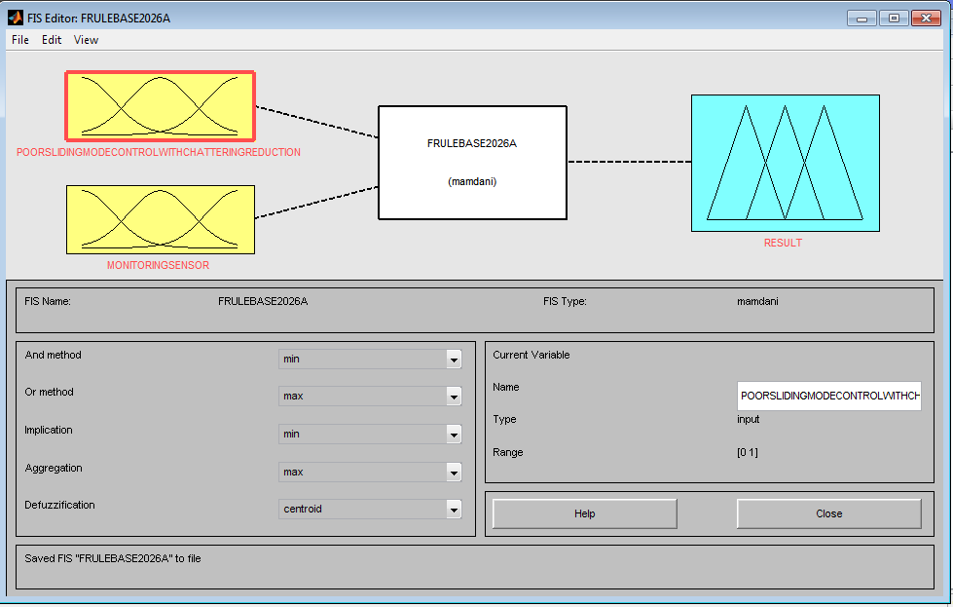

Fig 2 developed fuzzy inference system for minimization of poor sliding mode control with chattering reduction

This had two inputs of causes of poor sliding mode control with chattering reduction and monitoring sensor. It also had an output of result.

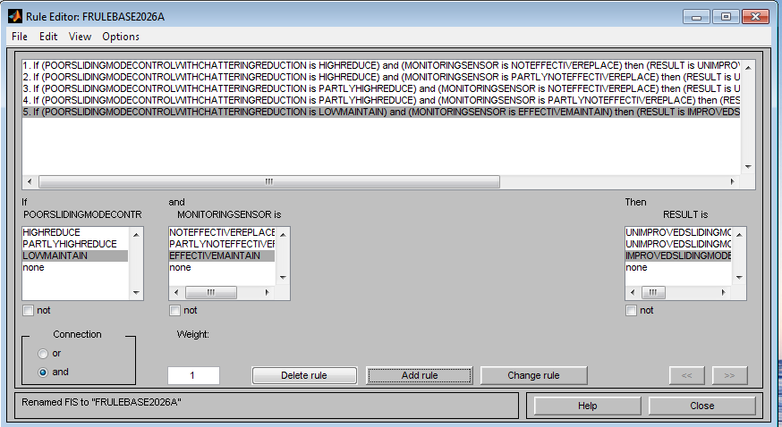

Fig 3 developed fuzzy rule base for minimization of poor sliding mode control with chattering reduction

This was fully detailed in table 3

Table 3 comprehensively detailed developed fuzzy rule base for minimization of poor sliding mode control with chattering reduction

1 | IF poor sliding mode control with chattering reduction is high reduce | And sensor monitoring is not effective replace | Then result is unimproved sliding mode control with chattering reduction
2 | IF poor sliding mode control with chattering reduction is high reduce | And sensor monitoring is partly not effective replace | Then result is unimproved sliding mode control with chattering reduction
3 | IF poor sliding mode control with chattering reduction is partly high reduce | And sensor monitoring is not effective replace | Then result is unimproved sliding mode control with chattering reduction
4 | IF poor sliding mode control with chattering reduction is partly high reduce | And sensor monitoring is partly not effective replace | Then result is unimproved sliding mode control with chattering reduction
5 | IF poor sliding mode control with chattering reduction is low maintain | And sensor monitoring is effective maintain | Then result is improved sliding mode control with chattering reduction

Fig 4 the operational mechanism of developed fuzzy rule base for minimization of poor sliding mode control with chattering reduction

Fig 5 Fuzzy based technique

To develop an algorithm that will implement the process

1. Characterize and establish the causes of poor sliding mode control with chattering reduction

2.Identify Steady-State Tracking Error that did not attain threshold

3.Identify Chattering Amplitude that did not attain threshold

4. Identify Chattering Frequency that did not attain threshold

5.Identify Settling Time that did not attain threshold

6.Identify Overshoot that did not attain threshold

7.Identify Boundary Layer Thickness that did not attain threshold

8.Identify Actuator Position Oscillation that did not attain threshold

9. Identify Actuator Torque Oscillation that did not attain threshold

10.Identify Sensor Noise Influence that did not attain threshold

11. Design a conventional SIMULINK model for sliding mode control with chattering reduction and integrate 2 through 10.

12 Develop a fuzzy rule base for minimization of poor sliding mode control with chattering reduction

13. integrate 12 into 11

14. Did the causes of poor sliding mode control with chattering reduction reduce and attain threshold when 12 was integrated into 11.?

15. IF NO go to 13

16. IF YES go to 17.

17. Improved sliding mode control with chattering reduction

18. Stop.

19. End

To design a SIMULINK model for improving sliding mode control with chattering reduction using fuzzy based technique

Fig 6 designed SIMULINK model for improving sliding mode control with chattering reduction using fuzzy based technique

The results obtained after the simulation of figure 6 were as shown in figures 7 and 8

To validate and justify the percentage improvement in the reduction of causes of poor sliding mode control with and without chattering reduction with fuzzy based technique

To find percentage improvement in the reduction of Steady-State Tracking Error causes of poor sliding mode control with chattering reduction with fuzzy based technique

Conventional Steady-State Tracking Error =6%

Fuzzy based technique Steady-State Tracking Error= 4.8%

% improvement in the reduction of Steady-State Tracking Error causes of poor sliding mode control with chattering reduction with fuzzy based technique=

Conventional Steady-State Tracking Error - Fuzzy based technique Steady-State Tracking Error

% improvement in the reduction of Steady-State Tracking Error causes of poor sliding mode control with chattering reduction with fuzzy based technique=6% - 4.8%

% improvement in the reduction of Steady-State Tracking Error causes of poor sliding mode control with chattering reduction with fuzzy based technique= 1.2%

To find percentage improvement in the reduction of Sensor Noise Influence causes of poor sliding mode control with chattering reduction with fuzzy based technique

Conventional Sensor Noise Influence =18dB

Fuzzy based technique Sensor Noise Influence = 27.5 dB

% improvement in the reduction of Sensor Noise Influence causes of poor sliding mode control with chattering reduction with fuzzy based technique=

Fuzzy based technique Sensor Noise Influence - Conventional Sensor Noise Influence x 100%

Conventional Sensor Noise Influence 1

% improvement in the reduction of Sensor Noise Influence causes of poor sliding mode control with chattering reduction with fuzzy based technique=

27.5 dB - 18dB x 100%

18dB 1

% improvement in the reduction of Sensor Noise Influence causes of poor sliding mode control with chattering reduction with fuzzy based technique=52.8%

3.0 RESULTS AND DISCUSSION

Table 4 comparison of conventional and Fuzzy based technique Steady-State Tracking Error that causes poor sliding mode control with chattering reduction
Time (months) | Conventional Steady-State Tracking Error that causes poor sliding mode control with chattering reduction(%) | Fuzzy based technique Steady-State Tracking Error that causes poor sliding mode control with chattering reduction(%)
1 | 6 | 4.8
2 | 6 | 4.8
3 | 6 | 4.8
4 | 6 | 4.8

Fig 7 comparison of conventional and Fuzzy based technique Steady-State Tracking Error that causes poor sliding mode control with chattering reduction

The conventional Steady-State Tracking Error that causes poor sliding mode control with chattering reduction was 6% which did not fall within the bench mark. On the other hand, when Fuzzy based technique was integrated into the system, it simultaneously became4.8% which is within the threshold.

Table 5 comparison of conventional and Fuzzy based technique Sensor Noise Influence that causes of poor sliding mode control with chattering reduction
Time (months) | Conventional Sensor Noise Influence that causes of poor sliding mode control with chattering reduction(dB) | Fuzzy based technique Sensor Noise Influence that causes of poor sliding mode control with chattering reduction(dB)
1 | 18 | 27.5
2 | 18 | 27.5
3 | 18 | 27.5
4 | 18 | 27.5

Fig 8 comparison of conventional and Fuzzy based technique Sensor Noise Influence that causes of poor sliding mode control with chattering reduction

The conventional Sensor Noise Influence that causes of poor sliding mode control with chattering reduction was18dB. Meanwhile, when Fuzzy based technique was incorporated into the system, it immediately increased to27.5dB. Finally, with these results obtained, it meant that the percentage improvement in sliding mode control with chattering reduction when fuzzy based technique was integrated was52.8%
4.0 Conclusion

The persistent power failure in the country this present time that had destroyed business activities was overcame by introducing improving sliding mode control with chattering reduction using fuzzy based technique. This was done in this aspect sliding mode control with chattering reduction was characterized and the causes of poor sliding mode control with chattering reduction was established and a conventional SIMULINK model for sliding mode control with chattering reduction was designed. Then, a fuzzy rule base for minimization of poor sliding mode control with chattering reduction was developed and an algorithm that would implement the process was equally developed. later, a SIMULINK model for improving sliding mode control with chattering reduction using fuzzy based technique was designed and the results obtained were validated and justified. The results obtained were, the conventional Steady-State Tracking Error that causes poor sliding mode control with chattering reduction was 6% which did not fall within the bench mark. On the other hand, when Fuzzy based technique was integrated into the system, it simultaneously became4.8% which is within the threshold and the conventional Sensor Noise Influence that causes of poor sliding mode control with chattering reduction was18dB. Meanwhile, when Fuzzy based technique was incorporated into the system, it immediately increased to27.5dB. Finally, with these results obtained, it meant that the percentage improvement in sliding mode control with chattering reduction when fuzzy based technique was integrated was52.8%

References
Edwards, C., & Spurgeon, S. K. (1998). Sliding mode control: Theory and applications. Taylor & Francis.
Palm, R. (1994). Sliding mode fuzzy control. International Journal of Approximate Reasoning, 14(2–3), 267–292.
Slotine, J. J. E., & Li, W. (1991). Applied nonlinear control. Prentice Hall.
Utkin, V. I. (1992). Sliding modes in control and optimization. Springer.
Zadeh, L. A. (1965). Fuzzy sets. Information and Control, 8(3), 338–353. https://doi.org/10.1016/S0019-9958(65)90241-X
This version is suitable for a final-year project, undergraduate dissertation, or master's thesis and follows APA-style in-text citations and reference formatting.

