Analyzing the Gravity Variations due to
Groundwater Storage and Sea Level Changes in the Indian Oceanic Region
T.H.V.S.Wijerathne¹, D.R.Welikanna²
¹²Department of surveying and Geodesy, Sabaragamuwa University of Sri Lanka, Ratnapura, Sri Lanka

ABSTRACT
Sri Lanka has been recognized as one of the places with the lowest gravitational measurement on Earth. The factors contributing to this phenomenon remain largely unexplored. The study examined the impact of Groundwater Storage Percentile (GWSP) and fluctuations in Sea Level on regional gravitational anomalies by utilizing satellite-based remote sensing data. An analysis of GRACE and GRACE-FO models, along with gravity data from the International Centre for Global Earth Models (ICGEM), CG-6 terrestrial gravity measurements, Bureau Gravimétrique International (BGI) terrestrial and marine gravity data, and Global Land Data Assimilation System (GLDAS) hydrological information was conducted to discern how the redistribution of mass resulting from hydrological and oceanographic activities influences gravity across terrestrial and oceanic regions. The investigation spanned the timeframe from 2018 to 2022 and employed methodologies including kriging interpolation, Pearson correlation, and time series regression to identify spatial and temporal trends. The results unveiled important statistical connections among gravity anomalies and sea level indicators. The correlation coefficient of gravity to sea surface height (SSH) was R² = 0.6183, and it registered R² = 0.6029 against sea level anomaly (SLA), which suggests that more than 60% of gravity variations could be attributed to ocean mass redistribution. This connection of gravity to GWSP was even stronger and reached R² = 0.7577, validating that groundwater changes are an important determining factor that acts upon gravity in the surveyed region. Long-term gravity observation results from high as well as low gravity sites proved overall stability defined by small fluctuations that could represent climatic action or small tectonic activity. This study revealed the potential of satellite methods to monitor gravity variations resulting from mass changes in very large and remote areas. It offered useful information about regional gravity anomalies of Sri Lanka without recourse to expensive ground survey, and it enriched general knowledge about geophysical and hydrologic processes.

Keywords: GRACE and BGI Gravity Data, Gravity, Groundwater Storage, Sea Level Change, Indian Oceanic Region

INTRODUCTION
Ice sheet melting, tectonic movements affect gravity changes. But Sri Lanka’s low unexplored gravity is not caused to these kinds of geophysical conditions. The mystery sparked interest in exploring whether variations in GWS and SLV could explain these gravity changes. The primary aim of this study was to investigate gravity variations in the Indian Oceanic region, particularly around Sri Lanka, using space-based techniques. Satellite gravity data from grace only gravity models, CG-6 gravity observations along with hydrological and sea level datasets, were used to analyze the impact of mass redistribution on local gravity fields.
The study was guided by the following research questions:
- Are there identifiable trends in gravity variations in the Indian Oceanic region?
- Do GWS and SLV contribute significantly to these variations?
- Can these factors explain the extremely low gravity in Sri Lanka?
By addressing these questions, the research aims to improve understanding of regional gravity anomalies and highlight the effectiveness of satellite-based methods for large scale geophysical monitoring.

LITERATURE REVIEW
Newton’s Law of Universal Gravitation, which states that gravitational force is directly proportional to the product of two masses and inversely proportional to the square of the distance between them. In geodesy, the principle explains how gravity varies with changes in mass distribution on and within the Earth (Hofmann-Wellenhof & Moritz, 2016). Complementing, the concept of the geoid an equipotential gravitational surface forms the basis for understanding regional gravity anomalies. Spherical harmonics are also fundamental, allowing Earth’s gravity field to be mathematically modeled at global and regional scales (Barthelmes, 2013). These theories directly support the research aim to examine how mass redistribution, particularly from GWS and SLV, influences gravity in the Indian Oceanic region. They provide the framework to analyze gravity changes through satellite derived data.
Empirical studies utilizing GRACE satellite data have demonstrated the effectiveness of gravimetry in detecting GWS changes. (Rodell et al. (2009)) revealed significant groundwater depletion in northern India using GRACE and GLDAS models. Similarly, (Frappart and Ramillien (2018)) employed GRACE data to monitor groundwater trends in Southeast Asia, showing clear temporal variability. (Han et al. (2010)) linked SLR in the Indian Ocean to mass redistribution and regional climate variability. Caron et al. (2018) also emphasized that SLV is closely tied to gravitational changes, particularly in regions vulnerable to glacial melt and hydrological shifts.
The studies collectively support the methodology and objectives of present research. By building upon these frameworks, the study extends the analysis to Sri Lanka an area where few gravity based hydrological studies have been conducted thus filling a significant gap in the geophysical understanding of the region.

METHODOLOGY
The research adopted a quantitative, satellite-based approach to analyze gravity variations caused by GWS and SLV in the Indian Oceanic region, with a focus on Sri Lanka. The study did not involve human participants, relying entirely on satellite derived datasets. The researcher’s role involved data collection from space-based platforms, processing, and analysis using geospatial and statistical tools.
The selected study area spans latitudes 25°N to -2.5°N and longitudes 64.5°E to 91°E. The period of study was from January 2018 to December 2022, based on data availability. Three major datasets were used, temporal gravity data from GRACE/GRACE-FO (CSR, JPL) and static gravity models from ICGEM (EGM2008), BGI land gravity data and CG-6 gravity observation for validating the space-based gravity data. Sea Level data, including Sea Level Anomaly (SLA) and Sea Surface Height (SSH), from NASA’s Sea Level Portal and Copernicus Marine Services. GWS from GLDAS and GWSP from GRACE hydrology data. All datasets were downloaded in compatible formats (GeoTIFF, NetCDF, and CSV), clipped to the study area, and temporally aligned for consistency. Data processing was performed using QGIS software. Ordinary kriging interpolation was applied to visualize spatial gravity variation. Pearson correlation and linear regression were used to analyze relationships between gravity, sea level, and GWS. Polynomial regression was applied to identify and predict long term gravity trends. High and low gravity zones were selected to observe local variations, and time series graphs were generated to evaluate gravity behavior over the selected period. The methodological framework enabled efficient, large-scale analysis of gravitational changes due to hydrological and oceanic mass redistribution. The satellite-based approach also provided a cost-effective alternative to ground-based gravity surveys across the vast Indian Oceanic region.

RESULTS AND DISCUSSION

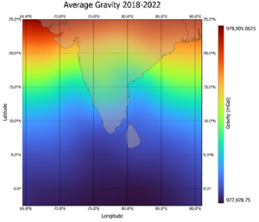
Figure 1:Kriging interpolation for observed gravity variation (EGM2008)

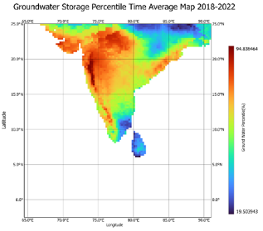
Figure 2: Groundwater Storage Percentile
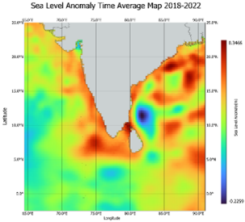
Figure 3 : Sea Level Anomaly

Analysis of gravity data between 2018 and 2022 showed consistent spatial patterns of gravity anomalies. Gravity values were higher over land regions and significantly lower over the ocean, especially south of Sri Lanka. Static models (EGM2008) also confirmed a persistent low gravity zone in the southern part of the Sri Lanka. Time series analysis at selected high and low gravity points indicated general stability in gravity values, with only minor fluctuations.
To identify extreme variations, observations need to be conducted over a long period of time. Unlike parameters such as rainfall or wind, gravity changes very slowly.

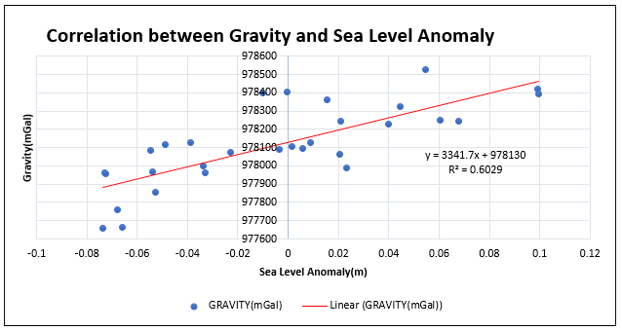
Figure 4: Correlation Between Sea Level Anomaly
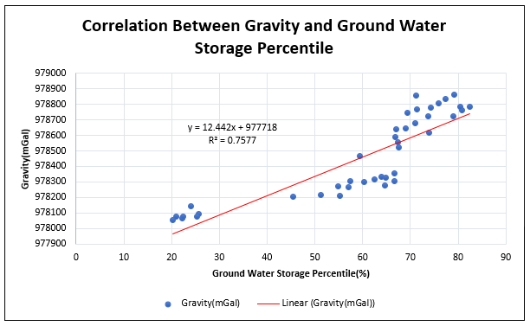

Figure 5 : Correlation between Ground Water Percentile with Gravity
Statistical analysis revealed strong correlations between gravity and both sea level and GWS data. SSH showed a positive correlation with gravity (R² = 0.6183), while SLA had an R² of 0.6029. The result indicates that over 60% of gravity variations in the region may be attributed to sea level changes, likely due to oceanic mass redistribution. GWSP showed an even stronger correlation with gravity (R² = 0.7577), highlighting the impact of GWS on gravitational variations. These results confirm that both oceanic and hydrological mass movements contribute significantly to gravity changes. Although Sri Lanka is not associated with major tectonic or glacial activity, the data suggest that variations in groundwater and sea level significantly influence the region’s gravity. The combined effect of decreased GWS and regional SLR likely contributes to the unusually low gravity observed in and around Sri Lanka according to the above finding correlations. If SLR is long term the gravity should be increased. But in the Sri Lankan Oceanic region not showing that much SLR. The use of GRACE and related models provides strong evidence that hydrological and oceanographic processes are key contributors to the local gravity anomaly. The findings demonstrate the value of satellite-based gravity data for understanding environmental and geophysical changes in complex regions like the Indian Ocean.

IMPLICATIONS/CONCLUSIONS
Recent investigations analyzed gravitational force anomalies in the Indian Ocean area and cited Sri Lanka as a site that has recorded some of the weakest gravity measurements globally. By employing information from the satellite missions GRACE and GRACE-FO as well as from hydrological models and sea level recordings and static gravity standards, the investigation analyzed regional gravitational motion resulting from mass redistribution. This work discovered that gravitational forces are unchanging but rather fluctuate because of an array of environmental parameters, most of which being ocean mass distribution alterations and variations in terrestrial water supply. The measurements revealed strong statistical associations between gravity anomalies, sea level fluctuations, and GWSP. Among these parameters, GWSP revealed the strongest connection to gravity and thus confirmed GSW as the dominant agency of regional gravitational patterns. Furthermore, SLR appeared to be an important contributor, whereas a combined effect of decreasing mass on Earth and ocean mass redistribution was identified as the most realistic explanation of anomalously low gravity recordings to the south of Sri Lanka. From a methodological perspective, it was evident from the work that satellite gravimetry is an efficient as well as a reliable tool for monitoring large-scale geophysical processes, particularly where land-based surveying is inhibited or impracticable. By verifying associations between gravity as well as hydrological and oceanographic parameters, the work confirmed satellite gravimetry as a useful tool in ascertaining regional environmental changes. These results not only fortified geodetic knowledge but also further expanded the potential of application of gravimetry in hydrology as well as in climatic science. It is indicated that subsequent studies would include integrating terrestrial GNSS measurements with satellite gravimetric measurements to enhance accuracy. It is further indicated that new gravity models incorporated into machine learning methods could enhance predictive accuracy as well as spatial resolution. These methods would substantially promote gravitational fluctuation observation while having valuable applications in climate change adaptation, groundwater resource monitoring, and coastal development. They would especially offer valuable information to Sri Lanka and the Indian Ocean region, that increasingly contend with SLR and freshwater scarcity issues.

REFERENCES
- Barthelmes, F. (2013). Definition of functionals of the geopotential and their calculation from spherical harmonic models (Scientific Technical Report STR09/02). Deutsches GeoForschungsZentrum GFZ. https://doi.org/10.2312/GFZ.b103-0902-26
- Caron, L., Ivins, E. R., Larour, E., Adhikari, S., Nilsson, J., & Blewitt, G. (2018). GIA model statistics for GRACE hydrology, cryosphere, and ocean science. Geophysical Research Letters, 45(5), 2203–2212. https://doi.org/10.1002/2017GL076644
- Frappart, F., & Ramillien, G. (2018). Monitoring groundwater storage changes using the Gravity Recovery and Climate Experiment (GRACE) satellite mission: A review. Remote Sensing, 10(6), 829. https://doi.org/10.3390/rs10060829
- Han, W., Meehl, G.A., Rajagopalan, B., Fasullo, J.T., Hu, A., Lin, J., Large, W.G., Wang, J.W., Quan, X.W., Trenary, L.L., Wallcraft, A., Shinoda, T., Yeager, S., 2010. Patterns of Indian Ocean sea-level change in a warming climate. Nat. Geosci. 3, 546–550. https://doi.org/10.1038/ngeo9
- Hofmann-Wellenhof, B., & Moritz, H. (2016). Physical geodesy (2nd ed.). Springer.
- Rodell, M., Velicogna, I., & Famiglietti, J. S. (2009). Satellite-based estimates of groundwater depletion in India. Nature, 460, 999–1002. https://doi.org/10.1038/nature08238

