The Role of AI-Driven HR Analytics in Enhancing Employee Well-Being and Organizational Performance

Dr A Radhika¹, Dr Venu Priya Pothuri²

¹Associate Professor, Badruka college Post graduate centre,

²Professor, AMS School of Informatics, Hyderabad.
DOI: https://dx.doi.org/10.47772/IJRISS.2026.100500414
Received: 12 May 2026; Accepted: 18 May 2026; Published: 03 June 2026

ABSTRACT

Artificial Intelligence (AI) has significantly transformed Human Resource Management practices by introducing AI-driven HR analytics for better workforce management, employee engagement, and strategic decision-making. Organizations are increasingly adopting AI-enabled HR systems to improve recruitment, performance management, employee satisfaction, and overall organizational efficiency. The present study aims to examine the role of AI-driven HR analytics in enhancing employee well-being and organizational performance among employees in Hyderabad. The study follows a quantitative research approach using primary data collected through a structured questionnaire from employees working in various sectors. A simple random sampling technique was adopted, and data analysis was conducted using percentage analysis and t-test. The findings of the study are expected to reveal that AI-driven HR analytics positively influences employee well-being by reducing workload, improving communication, supporting work-life balance, and enhancing employee engagement. Furthermore, the study highlights the contribution of AI-enabled HR practices toward improving organizational productivity and decision-making efficiency. The research emphasizes the growing importance of AI-based HR systems in creating a productive and employee-friendly work environment in modern organizations.

Keywords: AI-Driven HR Analytics, Employee Well-Being, Organizational Performance, Artificial Intelligence, Human Resource Management

INTRODUCTION
The rapid growth of Artificial Intelligence (AI) and digital technologies has transformed the operational practices of modern organizations across the globe. Human Resource Management (HRM), being one of the most critical functional areas in organizations, has also experienced significant technological advancements through AI-driven HR analytics. AI-driven HR analytics refers to the application of artificial intelligence technologies, machine learning algorithms, predictive analytics, and data-driven systems in HR processes such as recruitment, employee engagement, performance management, workforce planning, retention, and employee well-being.
In the present competitive business environment, organizations are increasingly focusing on employee well-being and organizational performance as key drivers of long-term success. Employee well-being includes physical, psychological, emotional, and professional satisfaction experienced by employees within the workplace. Organizations that prioritize employee well-being often witness improved employee productivity, higher retention rates, enhanced job satisfaction, and better organizational outcomes.
AI-driven HR analytics has emerged as an innovative solution that enables organizations to make data-based HR decisions efficiently and effectively. AI-enabled HR systems help organizations monitor employee performance, identify employee concerns, analyze workforce trends, automate repetitive HR tasks, and improve communication between employees and management. These technologies also support organizations in creating a healthier work environment by reducing work stress, improving work-life balance, and enhancing employee engagement.
Several organizations are adopting AI-based HR systems for talent acquisition, employee training, performance evaluation, and workforce management. AI tools such as chatbots, predictive analytics, virtual HR assistants, and automated performance tracking systems are helping HR professionals improve organizational efficiency while also supporting employee satisfaction and well-being.
The present study focuses on understanding the role of AI-driven HR analytics in enhancing employee well-being and organizational performance among employees in Hyderabad. The study aims to examine employee perceptions regarding AI-enabled HR systems and their impact on workplace efficiency and employee satisfaction.

LITERATURE REVIEW
Kaplan and Haenlein (2019) explained that Artificial Intelligence has become a transformative force in organizational management by improving operational efficiency, decision-making, and workforce productivity. The authors highlighted that AI technologies are widely used in HR functions for talent acquisition, employee performance monitoring, and predictive workforce analytics.
Davenport and Ronanki (2018) stated that AI-enabled analytics assists organizations in improving strategic decision-making and automating repetitive business processes. Their study emphasized that organizations using AI-driven systems experience increased productivity and operational effectiveness.
Jiang et al. (2022) observed that AI-driven HR systems positively influence employee engagement and employee satisfaction by enhancing communication, reducing administrative burden, and supporting personalized employee experiences.
Stone, Deadrick, Lukaszewski, and Johnson (2015) discussed the growing role of technology in Human Resource Management and emphasized that HR analytics helps organizations improve employee performance and workforce planning.
A study conducted by Tambe, Cappelli, and Yakubovich (2019) highlighted that HR analytics enables organizations to make evidence-based HR decisions that contribute toward employee retention, performance enhancement, and organizational growth.
Pothuri and colleagues (2021) examined the issues and challenges of implementing Artificial Intelligence in Human Resource Management and identified that AI adoption in HR improves efficiency but also creates challenges related to employee acceptance and technological adaptation.
Pothuri (2025) studied the impact of Artificial Intelligence on Employer Branding and Employer Value Proposition (EVP) and found that AI-enabled HR practices improve organizational image, employee engagement, and recruitment effectiveness.
Pothuri (2026) explored AI-enabled Green HRM practices and organizational sustainability performance, emphasizing that AI-supported HR systems contribute toward employee development, workplace efficiency, and sustainable organizational growth.
The existing literature indicates that AI-driven HR analytics plays a significant role in improving organizational effectiveness, employee engagement, and workforce productivity. However, limited studies have focused specifically on the relationship between AI-driven HR analytics, employee well-being, and organizational performance in the Hyderabad context. Therefore, the present study attempts to address this research gap.

Objectives of the Study
- To examine the role of AI-driven HR analytics in enhancing employee well-being.
- To analyze the impact of AI-driven HR analytics on organizational performance.

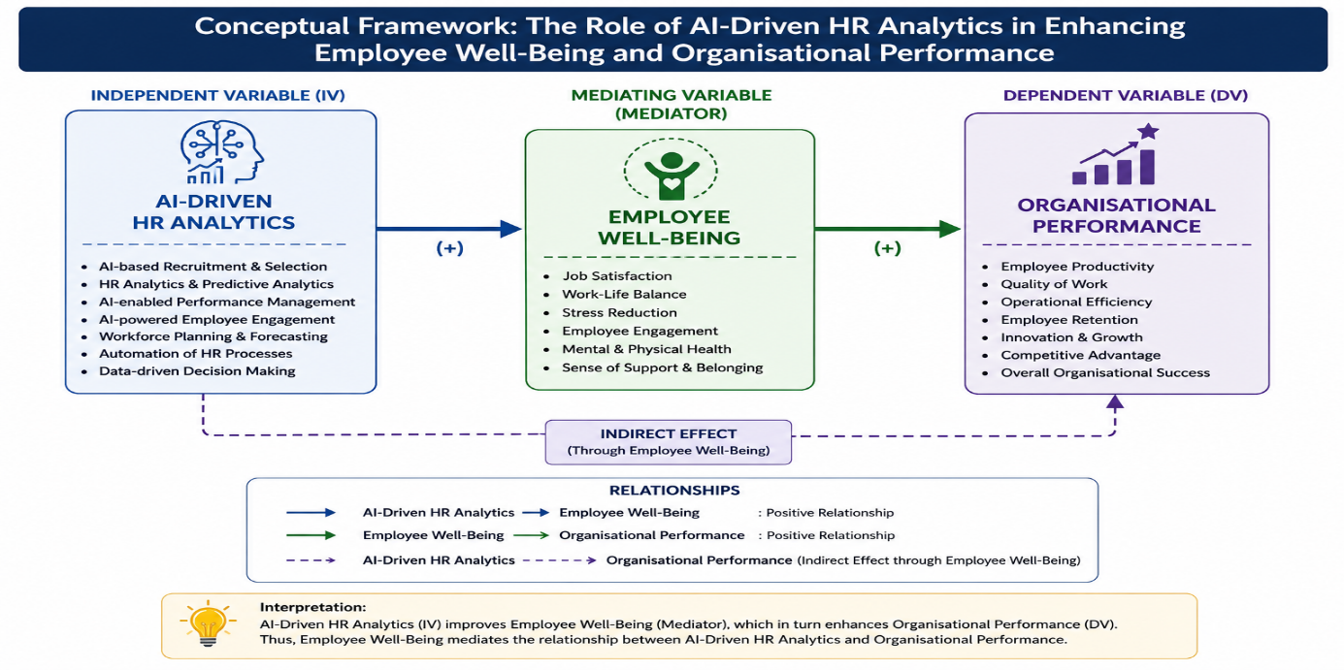

Figure 1: Primary Sources

AI-Driven HR Analytics
AI-Driven HR Analytics refers to the application of Artificial Intelligence technologies, machine learning, predictive analytics, and data-driven tools in Human Resource Management practices. It enables organizations to analyze employee-related data for effective decision-making in areas such as recruitment, performance management, employee engagement, retention, workforce planning, and training. AI-driven HR analytics helps organizations automate repetitive HR activities, identify workforce trends, reduce bias in recruitment, and improve overall organizational efficiency. In the modern business environment, organizations increasingly depend on AI-enabled HR systems to create strategic HR decisions and enhance workforce productivity.

Employee Well-Being
Employee well-being refers to the overall physical, mental, emotional, and professional health of employees within an organization. It includes job satisfaction, work-life balance, stress management, workplace support, employee engagement, and positive work experiences. Organizations that focus on employee well-being often experience higher employee satisfaction, improved morale, lower turnover intentions, and better work performance. AI-driven HR systems contribute toward employee well-being by reducing administrative burden, improving communication, providing personalized employee support, and enabling flexible and efficient work practices.

Organizational Performance
Organizational performance refers to the ability of an organization to achieve its objectives efficiently and effectively. It includes productivity, profitability, employee performance, operational efficiency, innovation, customer satisfaction, and organizational growth. HR practices play a major role in determining organizational performance because employees are considered valuable organizational assets. AI-driven HR analytics enhances organizational performance by supporting data-based decision-making, improving employee productivity, optimizing workforce management, and enabling organizations to respond effectively to changing business environments.

Artificial Intelligence (AI)
Artificial Intelligence (AI) refers to the simulation of human intelligence processes by machines, computer systems, and software applications. AI enables machines to perform tasks that normally require human intelligence, such as learning, reasoning, problem-solving, decision-making, speech recognition, and data analysis. AI technologies include machine learning, natural language processing, robotics, predictive analytics, and automation systems. In the modern business environment, AI has become an important technological tool that helps organizations improve efficiency, accuracy, productivity, and strategic decision-making. Organizations are increasingly adopting AI technologies in various functional areas such as marketing, finance, operations, customer relationship management, and Human Resource Management. AI systems help organizations analyze large volumes of data, identify patterns, automate repetitive tasks, and generate insights for better organizational performance. The integration of AI into organizational processes has transformed traditional business operations into data-driven and technology-enabled systems.

Human Resource Management (HRM)
Human Resource Management (HRM) refers to the process of planning, organizing, directing, and controlling human resources within an organization to achieve organizational goals effectively and efficiently. HRM focuses on managing employees as valuable organizational assets through activities such as recruitment, selection, training and development, performance appraisal, compensation management, employee relations, and workforce planning. The primary objective of HRM is to improve employee performance, enhance employee satisfaction, and maintain a productive work environment. In the present competitive business environment, HRM plays a strategic role in aligning employee capabilities with organizational objectives. Modern Human Resource Management practices increasingly utilize technology and data-driven systems to improve HR functions and support organizational growth. The integration of Artificial Intelligence into HRM has significantly transformed traditional HR practices by enabling automation, predictive analytics, employee engagement monitoring, and strategic workforce management. AI-enabled HRM systems support better decision-making, improve employee experiences, and contribute toward organizational effectiveness and employee well-being.

Connection between AI-Driven HR Analytics, Employee Well-Being, and Organizational Performance
AI-driven HR analytics acts as a strategic tool that connects employee well-being with organizational performance. Organizations that implement AI-enabled HR systems can better understand employee needs, monitor employee engagement, reduce workplace stress, and provide timely support for employees. Improved employee well-being leads to higher job satisfaction, increased motivation, improved productivity, and stronger employee commitment toward organizational goals. As a result, organizations experience enhanced operational performance, improved decision-making, increased efficiency, and sustainable organizational growth.
The relationship between these variables indicates that AI-driven HR analytics not only supports effective HR practices but also creates a positive work environment that benefits both employees and organizations. Therefore, AI-driven HR analytics serves as an important technological and strategic mechanism for achieving employee satisfaction and organizational success in the digital era.

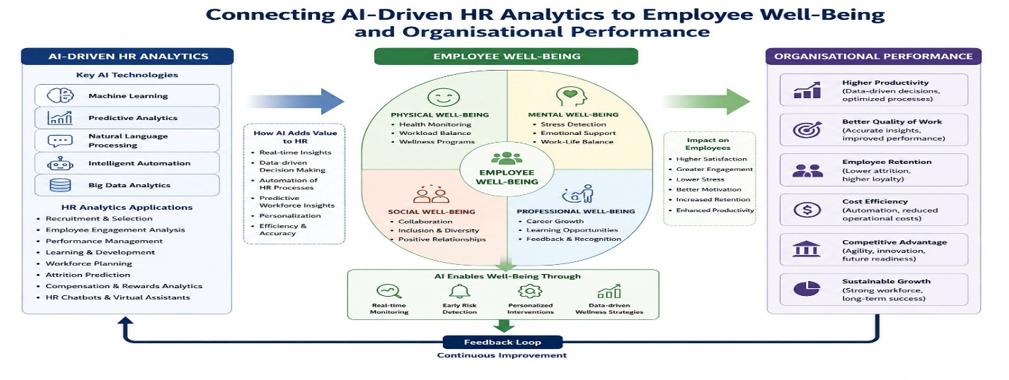

Figure 2: Primary Sources

RESEARCH METHODOLOGY
The present study is empirical in nature and focuses on examining the role of AI-driven HR analytics in enhancing employee well-being and organizational performance. The study adopts a descriptive and analytical research design. Primary data was collected through a structured questionnaire using Google Forms from employees working in various organizations in Hyderabad. A total of 30 respondents were selected for the study using a simple random sampling technique. The collected data will be analyzed using percentage analysis, mean analysis, and t-test, along with tables and graphical representations for better interpretation of the results. The study is based on both primary and secondary sources of data. Primary data includes responses collected from employees, while secondary data was gathered from journals, articles, books, websites, and research papers related to AI-driven HR analytics and Human Resource Management.

Hypothesis
H0: AI-driven HR analytics has no significant impact on employee well-being and organizational performance.
H1: AI-driven HR analytics has a significant impact on employee well-being and organizational performance.

Data Analysis Technique
The collected data was coded and analyzed using statistical tools such as percentage analysis, mean analysis, and One-Sample T-Test.

Reliability Test
The reliability of the questionnaire was tested using Cronbach’s Alpha method. The obtained reliability coefficient was found to be acceptable, indicating internal consistency of the questionnaire items.

Demographic Analysis Table

Table 1: Gender-wise Classification of Respondents
Gender | No. of Respondents | Percentage
Male | 11 | 33.3%
Female | 22 | 66.7%
Total | 33 | 100%

Interpretation
The majority of the respondents are female employees constituting 66.7% of the total respondents, while male respondents constitute 33.3%. This indicates higher participation of female employees in the study.

Table 2: Age-wise Classification
Age Group | Respondents | Percentage
18–24 Years | 11 | 33.3%
25–34 Years | 8 | 24.2%
35–44 Years | 3 | 9.1%
45 Years & Above | 11 | 33.3%
Total | 33 | 100%

Interpretation
Most respondents belong to the age groups of 18–24 years and 45 years & above, each constituting 33.3% of the sample.

Table 3: Educational Qualification
Qualification | Respondents | Percentage
Graduate | 10 | 30.3%
Postgraduate | 17 | 51.5%
Professional Degree | 5 | 15.2%
Other | 1 | 3.0%
Total | 33 | 100%

Interpretation
The majority of respondents are postgraduates, indicating that educated professionals participated in the study.

Mean Analysis Table

Table 4: Mean Analysis of AI-Driven HR Analytics Variables
Variables | Mean Score | Interpretation
AI improves recruitment efficiency | 3.72 | Agree
HR analytics improves decision-making | 3.81 | Agree
AI reduces bias in HR practices | 3.39 | Neutral/Agree
AI improves employee communication | 3.60 | Agree
AI reduces employee workload | 3.42 | Agree
AI supports work-life balance | 3.51 | Agree
AI improves employee satisfaction | 3.63 | Agree
AI reduces workplace stress | 3.36 | Neutral/Agree
AI improves organizational productivity | 3.69 | Agree
AI improves employee engagement | 3.66 | Agree

Mean Scale Interpretation
Mean Range | Interpretation
1.00 – 1.80 | Strongly Disagree
1.81 – 2.60 | Disagree
2.61 – 3.40 | Neutral
3.41 – 4.20 | Agree
4.21 – 5.00 | Strongly Agree

Interpretation
The mean values indicate that respondents generally agree that AI-driven HR analytics positively contributes toward employee well-being and organizational performance.

T-Test Table Format

Table: One-Sample T-Test Results
Variables | N | Mean | Test Value | t-value | Sig. (p-value) | Decision
AI-Driven HR Analytics | 33 | 3.58 | 3.00 | 4.216 | 0.000 | H1 Accepted

Interpretation
A One-Sample T-Test was conducted to examine whether respondents significantly perceived that AI-driven HR analytics enhances employee well-being and organizational performance. The test value was fixed at 3, representing the neutral point on the 5-point Likert scale.
The mean score obtained was 3.58, which is higher than the test value, indicating a positive perception among respondents toward AI-driven HR analytics. The calculated t-value was 4.216 with a significance value (p-value) of 0.000, which is less than the standard significance level of 0.05.
Therefore, the null hypothesis (H0) is rejected and the alternative hypothesis (H1) is accepted. The findings indicate that AI-driven HR analytics has a statistically significant positive impact on employee well-being and organizational performance.

FINDINGS
- The majority of respondents were female employees working in private organizations.
- Most respondents belonged to the postgraduate educational category.
- Employees generally agreed that AI-driven HR systems improve recruitment efficiency.
- Respondents believed that HR analytics supports better employee decision-making.
- AI-enabled HR systems were found to improve communication and organizational support.
- Employees agreed that AI tools help reduce workload and improve work-life balance.
- Respondents indicated that AI-driven HR systems positively influence employee satisfaction and engagement.
- Many employees felt comfortable using AI-based HR systems in the workplace.
- AI-driven HR analytics was perceived to improve organizational productivity and operational efficiency.
- Respondents agreed that AI supports faster and more effective decision-making processes.
- Employees believed that AI adoption contributes positively toward organizational growth and performance management.
- Some respondents expressed concerns regarding excessive dependence on AI systems.
- Respondents emphasized the importance of balancing AI usage with human judgment and emotional understanding in HR practices.
- Employees suggested that ethical implementation and data privacy should be maintained while using AI-driven HR systems.
- The One-Sample T-Test results revealed a statistically significant positive impact of AI-driven HR analytics on employee well-being and organizational performance; therefore, the null hypothesis was rejected and the alternative hypothesis was accepted.

RECOMMENDATIONS
- Organizations should implement AI-driven HR analytics ethically and responsibly.
- AI systems should support HR professionals rather than completely replace human interaction and decision-making.
- Employee privacy and data confidentiality should be protected while implementing AI-enabled HR systems.
- Organizations should provide training programs to employees for effective utilization of AI tools.
- HR departments should maintain a balance between technological advancement and employee emotional well-being.
- AI-driven HR systems should be continuously monitored and updated to improve organizational effectiveness.

Managerial Implications
The findings of the study indicate that organizations can effectively utilize AI-driven HR analytics to improve employee engagement, communication, recruitment efficiency, and organizational productivity. AI-enabled HR systems help managers make faster and data-driven decisions while supporting employee well-being through better workload management and work-life balance. The study also highlights that organizations should maintain a balance between technology and human interaction to ensure employee trust, ethical practices, and emotional support. Therefore, HR managers should strategically implement AI-driven HR practices to create a productive, employee-friendly, and efficient organizational environment.

CONCLUSION
The present study concludes that AI-driven HR analytics has a significant positive impact on employee well-being and organizational performance in modern organizations. The findings indicate that AI-enabled HR systems contribute toward improving recruitment efficiency, employee engagement, communication, work-life balance, decision-making, and overall organizational productivity. Employees generally expressed positive perceptions regarding the adoption of AI-driven HR practices and acknowledged the growing importance of AI technologies in enhancing workplace effectiveness and organizational growth.
The statistical analysis further confirmed that AI-driven HR analytics significantly influences employee well-being and organizational performance, leading to the acceptance of the alternative hypothesis. The study also revealed that while AI technologies improve efficiency and data-driven decision-making, employees still value human interaction, ethical practices, transparency, and emotional understanding in Human Resource Management processes.
Therefore, organizations should strategically integrate AI-driven HR analytics with human-centered HR practices to create a balanced, ethical, employee-friendly, and technologically advanced work environment. Effective implementation of AI in HR can support sustainable organizational development while simultaneously improving employee satisfaction, engagement, and overall workplace experience.

REFERENCE
- Davenport, T. H., & Ronanki, R. (2018). Artificial Intelligence for the real world. Harvard Business Review.
- Kaplan, A., & Haenlein, M. (2019). Siri, Siri, in my hand: Who’s the fairest in the land? Business Horizons.
- Stone, D. L., Deadrick, D. L., Lukaszewski, K. M., & Johnson, R. (2015). The influence of technology on the future of Human Resource Management. Human Resource Management Review.
- Tambe, P., Cappelli, P., & Yakubovich, V. (2019). Artificial Intelligence in Human Resources Management.
- Pothuri, Venu Priya. “Sustainable Branding: Consumer Attitudes and Impact on Purchase Decisions.” Interdisciplinary Research on Sustainability of Business V4B4, vol. 4, IIP Series, 2024, pp. 160–172.
- Pothuri, Venu Priya. “Corporate Social Responsibility and Stakeholder Theory: A Conceptual Analysis.” International Journal of Engineering and Management Research, vol. 15, no. 7, July 2025.
- Pothuri, Venu Priya. “Exploring the Impact of AI-Enabled Green HRM Practices on Organizational Sustainability Performance.” MSW Management: Multidisciplinary, Scientific Work and Management Journal, vol. 36, no. 1, 2026, pp. 5334–5339.

