Title: Management of Penetrating Zone II and III Neck Injury with Glass Foreign Bodies and Internal Jugular Vein Laceration Following Road Traffic Accident: A Case Report
ABSTRACT
Background
Penetrating neck injuries are potentially life-threatening because of the dense concentration of major neurovascular and aerodigestive structures within a confined anatomical space. Glass-related penetrating trauma can result in retained foreign bodies and significant vascular injury requiring emergency surgical intervention.
Case Report
A 27-year-old male patient of sustained penetrating trauma to the left side of the neck of zone II and III caused by shattered glass fragments. Emergency neck exploration under general anaesthesia revealed multiple glass fragments and a 1.5–2 cm rent in the left internal jugular vein which was repaired successfully. Layered wound closure was performed. The postoperative period was uneventful with preserved bilateral vocal cord mobility.
Conclusion
Penetrating neck trauma caused by glass foreign bodies may result in life-threatening vascular injuries. Early radiological evaluation and timely surgical exploration are essential for favourable outcomes.
Keywords
Penetrating neck injury; Internal jugular vein repair; Glass foreign body; Surgical emphysema; Neck exploration
INTRODUCTION
Penetrating neck injuries account for approximately 5–10% of traumatic injuries and are associated with significant morbidity due to the proximity of major vascular, neural, and aerodigestive structures.[1] Injuries involving Zone II of the neck are particularly important because of the high likelihood of vascular involvement and relative surgical accessibility.[2]
Glass-induced penetrating injuries are uncommon but potentially fatal because retained foreign bodies may lead to vascular compromise, infection, and delayed complications. Modern management relies on early imaging and selective surgical exploration.[3]
We report a case of penetrating left-sided neck injury with retained glass foreign bodies and internal jugular vein laceration successfully managed with emergency neck exploration and vascular repair.
CASE REPORT
A 27-year-old male presented to the emergency department following a road traffic accident. The patient was travelling in a bus which collided with a tree, following which he was propelled out of the window pane of the moving vehicle, causing shattered glass injury to the left side of the neck.
On arrival, the patient was conscious and in hypovolaemic shock. There was no history of loss of consciousness, vomiting, or seizures. Fluid resuscitation was started.
Clinical examination revealed a penetrating lacerated wound over the left side of the neck involving Zone II and extending into Zone III, measuring approximately 15 cm × 3 cm. The left sternocleidomastoid muscle was severed with profuse bleeding from the wound site.

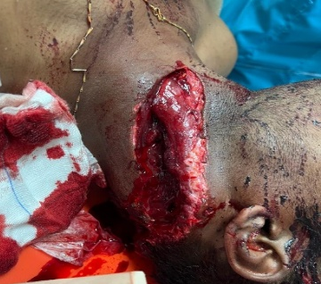
Figure 1: Penetrating neck wound involving Zone 2 and 3 of neck
Associated injuries included:
Lower labial mucosal laceration
Left temporal region laceration
Multiple lacerations over the left deltoid region
Left pinna laceration
FAST examination was negative.
Non-contrast computed tomography of the neck demonstrated extensive soft tissue injury with subcutaneous and intermuscular emphysema involving the left side of the neck. Multiple retained hyperdense foreign bodies consistent with glass fragments were identified within the left anterolateral neck. Air pockets were seen tracking along the medial and lateral aspects of the left common carotid artery. Associated fracture of the transverse process of the C3 vertebra was also noted.

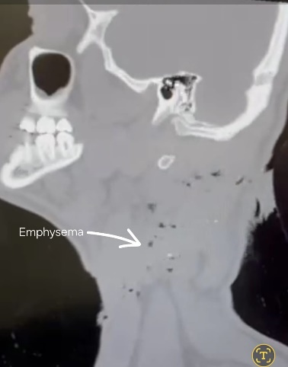
Figure 2: A-CT neck sagittal section demonstrating subcutaneous emphysema tracking along the left side of the neck following penetrating glass injury. B- Ct sagittal section shows foreign body. C- Ct axial section shows emphysema and foreign body as marked
The patient underwent emergency neck exploration under general anaesthesia. Intraoperatively, a deep lacerated wound measuring approximately 12 cm × 8 cm × 6 cm extending from the mastoid tip to the midpoint of the clavicle was identified. Multiple glass fragments were removed from the wound.
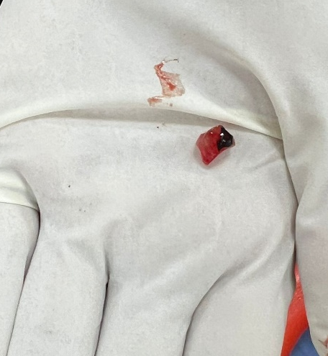
Figure 3: Largest glass piece recovered from the neck wound
The sternocleidomastoid muscle and parotid fascia were exposed with severe trapezius muscle laceration.
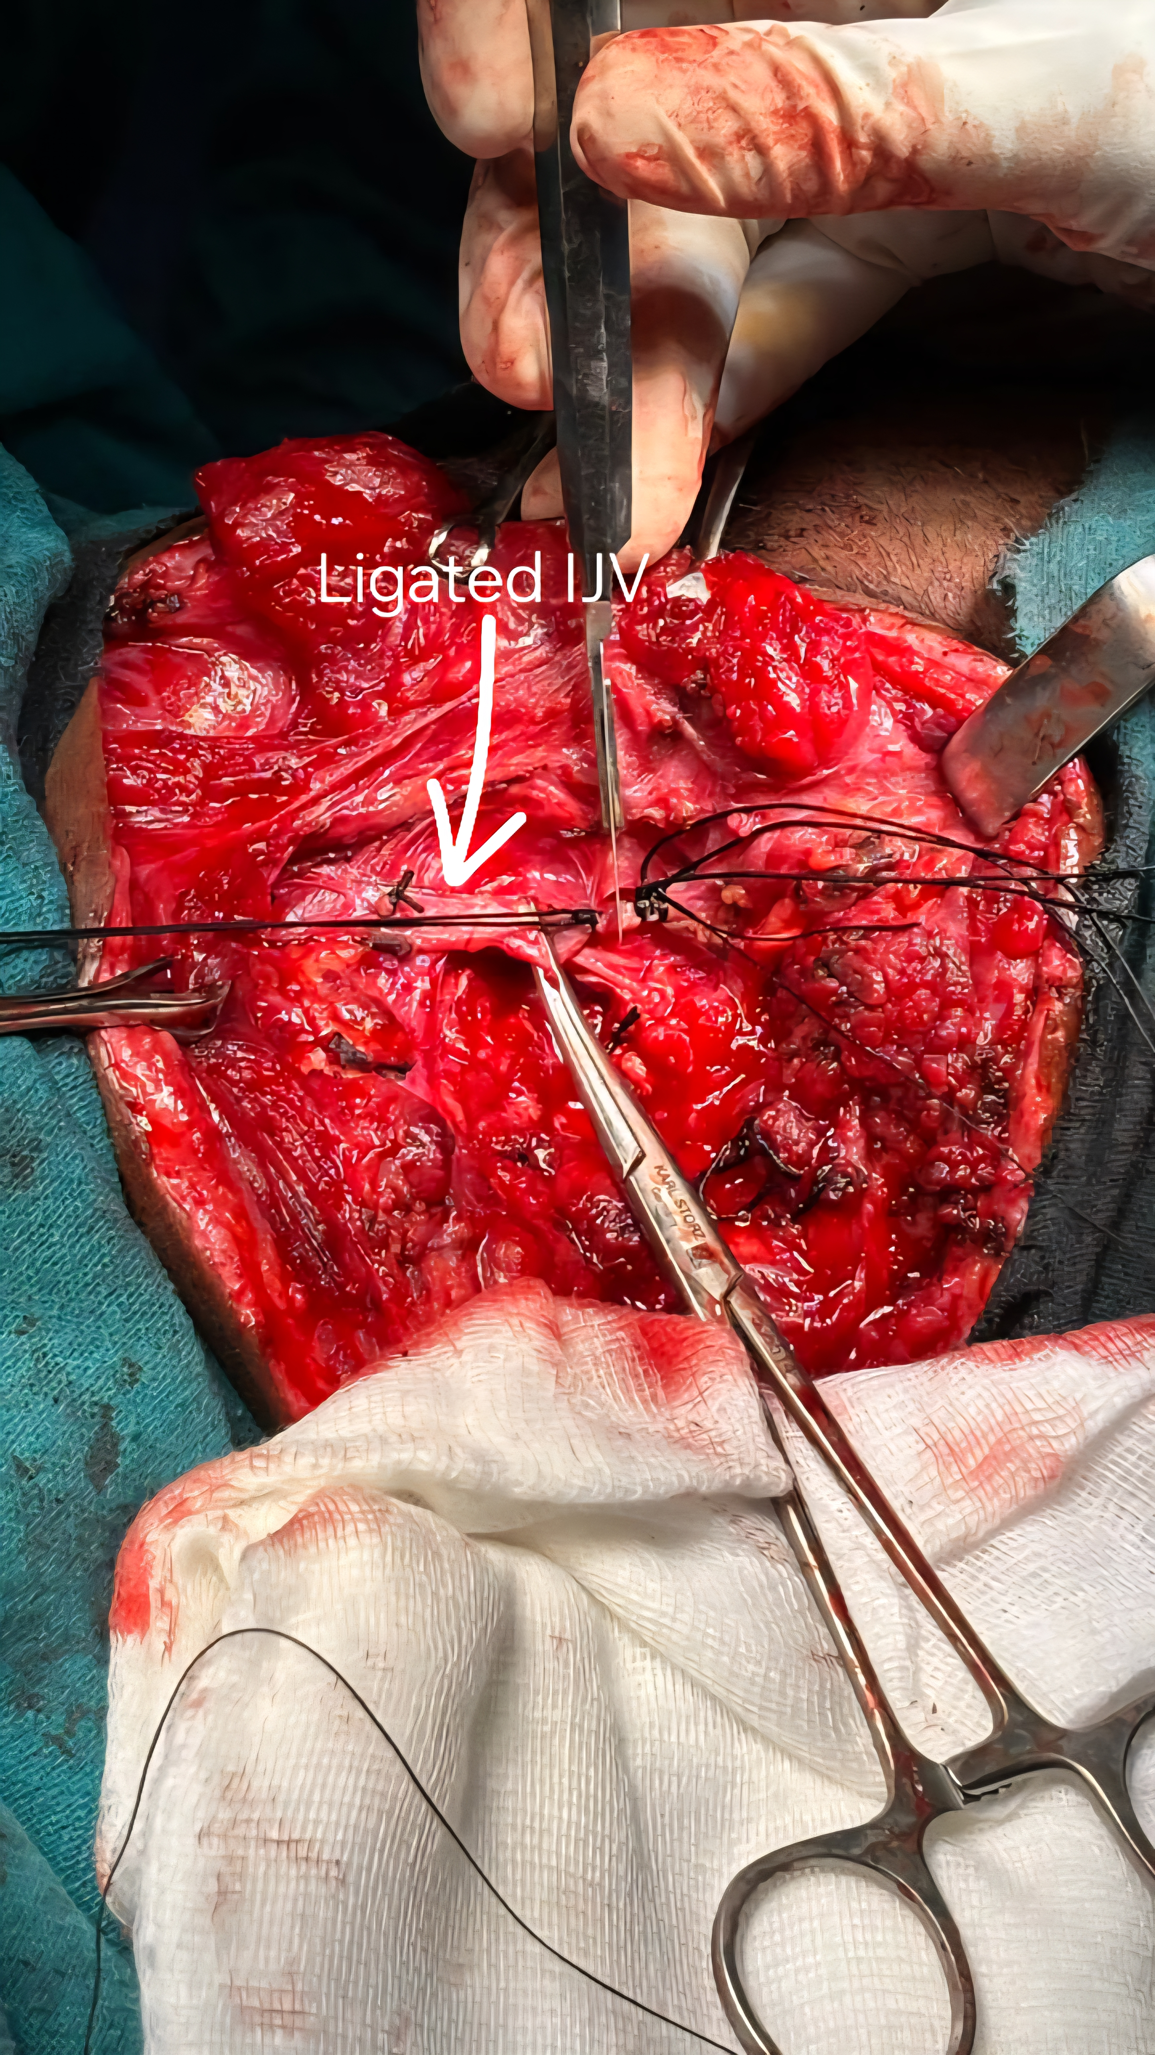
Multiple bleeding points were identified and ligated. A 1.5–2 cm rent in the left internal jugular vein was visualised and repaired successfully using Houseman’s ligature.

Figure 4: A – Internal Jugular vein (IJV) rent identified and clamped
B- IJV Ligated
The carotid artery was intact and preserved. Layered muscle and soft tissue repair was performed using 3-0 vicryl and 3-0 ethilon sutures. A Romovac drain was placed prior to closure.
The postoperative period was uneventful. Sutures were removed on postoperative day 8. Postoperative video laryngoscopy demonstrated bilateral mobile vocal cords. The patient recovered well and was discharged with oral antibiotics and follow-up advice.
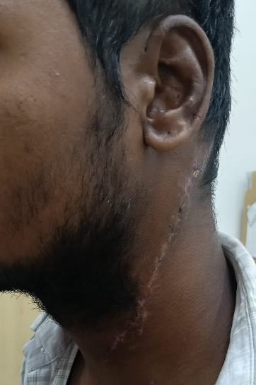 Figure 4: Healed post op wound
DISCUSSION
Penetrating neck trauma remains a challenging surgical emergency because apparently small external wounds may conceal major vascular or aerodigestive injuries.[1] Zone II injuries are the most common and frequently require prompt surgical exploration because of the high incidence of vascular trauma.[2]
Glass fragments produce irregular lacerations with extensive tissue damage and retained foreign bodies. CT imaging plays an important role in identifying retained fragments, surgical emphysema, and associated vascular injuries.[3]
Internal jugular vein injuries may present with active bleeding, expanding haematoma, or haemodynamic instability. Early surgical intervention is essential to prevent exsanguination and air embolism. Whenever feasible, venous repair is preferred over ligation to preserve venous drainage.[4]
The favourable outcome in this patient was attributed to early diagnosis, prompt imaging, meticulous exploration, removal of retained glass fragments, and successful vascular repair.
CONCLUSION
Penetrating glass-induced neck injuries are potentially life-threatening owing to the risk of major vascular injury and retained foreign bodies. Timely radiological evaluation and emergency surgical exploration remain crucial for optimal outcomes.
Statements and Declarations
The authors have no competing interests to declare that are relevant to the content of this article.

REFERENCES
- Demetriades D, Asensio JA. Penetrating injuries of the neck. Surg Clin North Am. 2001;81(6):1371-95.
- Nason RW, Assuras GN, Gray PR, Lipschitz J, Burns CM. Penetrating neck injuries: analysis of experience from a Canadian trauma centre. Can J Surg. 2001;44(2):122-6.
- Munera F, Cohn SM, Rivas LA, Quencer RM. Penetrating injuries of the neck and the increasing role of CTA in management. Radiographics. 2004;24(4):1087-109.
- Burgess CA, Dale OT, Almeyda R, Corbridge RJ. An evidence-based review of the assessment and management of penetrating neck trauma. Clin Otolaryngol. 2012;37(1):44-52.

