From Lux to Biology: A Critical Review of Artificial Light at Night and Circadian Health Implications
Uthayan Thurairajah ^{[0000-0003-1284-1790]}
Sustainable and Resilient Built Environment Group, Cardiff School of Art and Design, Cardiff Metropolitan University, Cardiff C52YB, UK
Email: uthayan.t.rajah@gmail.com

ABSTRACT
Artificial lighting is essential to modern society, enabling safety, productivity, and economic activity after dark. However, a growing body of research shows that light, especially artificial light at night (ALAN)—also acts as a biological signal that can disrupt the body’s internal clock (circadian system). This review critically examines how light exposure affects human health, drawing on key findings from chronobiology, neuroscience, and environmental health.
A structured landmark study approach was used to select twelve highly influential studies based on their scientific impact, methodological rigour, and role in shaping current understanding. These studies were grouped into four core domains: (1) discovery of the melanopsin-based non-visual photoreception system, (2) associations between ALAN, night work, and cancer risk, (3) dose–response relationships between light exposure and melatonin suppression, and (4) spectral sensitivity to short-wavelength (“blue”) light.
Across these domains, consistent evidence shows that biological responses to light are primarily influenced by three factors: the amount of light reaching the eye (corneal illuminance), the timing and duration of exposure, and the spectral composition of light, particularly blue-rich wavelengths. Importantly, commonly used lighting measures such as lux—designed for visual performance—do not adequately capture these biological effects.
This review identifies key gaps between scientific knowledge and real-world application, including inconsistent measurement of light exposure, limited long-term field studies, and insufficient integration of biologically relevant metrics into lighting standards. The main contribution of this work is to synthesise landmark evidence into a clear, interdisciplinary framework that bridges science, engineering, and policy. It highlights the need to move beyond conventional lighting metrics toward biologically informed design and regulation, such as incorporating spectral weighting, exposure timing considerations, and eye-level measurements into standards.
Policy and practical implications include revising outdoor and indoor lighting guidelines to minimise harmful nighttime exposure, informing public health recommendations, and guiding the design of LED systems that balance visibility with human well-being. This study is a focused, landmark-based critical review rather than a full systematic review, intended to clarify foundational evidence and accelerate its translation into practice amid the rapid global expansion of artificial lighting.
Keywords: Artificial light at night; circadian disruption; melanopsin; melatonin suppression; spectral sensitivity; LED lighting; light pollution; public health; exposure assessment

- INTRODUCTION
Artificial lighting is often framed as an unqualified societal benefit—enabling nocturnal mobility, extended work hours, and improved perceptions of safety. However, the same technology also produces an environmental and physiological exposure that is temporally misaligned with human biology when delivered during the biological night. The circadian system, coordinated by the suprachiasmatic nucleus, is synchronised primarily through ocular light input. As a result, ALAN can shift or fragment circadian phase, suppress nocturnal melatonin and degrade sleep continuity, with downstream implications for metabolic, immune and mental health regulation (Cho et al., 2015; Stevens et al., 2013). The source-level pre-equalisation, outdoor wireless control system, and lighting calculation method can control outdoor light pollution, outdoor trespass lighting (OTL) levels, and the health impacts on residents (Thurairajah et al., 2021a, 2021b, 2022a; Thurairajah U., 2022b, 2023b). Visibility can improve trespass lighting, glare, and health in outdoor lighting design (Thurairajah, U., 2023a, and 2023c). Artificial light exposure, including blue light, is a hidden risk factor for type 2 diabetes (Salomon et al., 2025; Wong et l., 2022). Light Pollution impacts human health (Cupertino et l., 2022).
Two contemporary developments intensify this concern. First, global urbanisation and expanded outdoor lighting have increased population-level exposure to skyglow and light trespass (Falchi et al., 2016). Second, solid-state lighting—especially blue-enriched LEDs—has become ubiquitous indoors and outdoors. Short-wavelength light is disproportionately effective at activating melanopsin-based photoreception, thereby increasing the circadian “dose” for a given photopic illuminance (Cajochen et al., 2011; Rea et al., 2010).
This paper provides a higher-impact, journal-oriented critical synthesis of pioneering studies that shaped current understanding of artificial light as a bioactive exposure. Rather than offering a broad narrative overview, the review is organised around four evidence pillars that map directly onto translational questions for standards and design:
- What is the biological photoreception pathway and its spectral sensitivity?
- How does circadian disruption scale with intensity, timing and duration?
- What evidence links ALAN and night work to cancer risk and other chronic outcomes?
- What measurements and policy limitations constrain the implementation of circadian-safe lighting?
The aim is to clarify what the strongest early evidence established, what remains uncertain, and how lighting practice can better align with human biological requirements. Figure 1. Conceptual model linking artificial light exposure characteristics (spectrum, intensity, timing, duration) to circadian signalling pathways, downstream physiological regulation, and long-term health risk, with parallel illustration of the measurement gap between photopic lux and biologically weighted corneal metrics.

Figure 1: The Conceptual Model linking artificial light exposure and Impact
(Source: by the author)
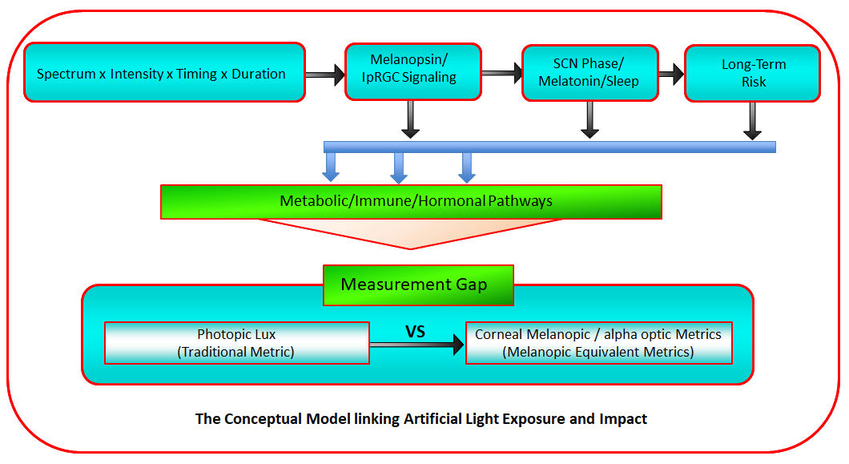
This review focuses on foundational studies that established mechanisms and dose/spectral sensitivities; it does not attempt a comprehensive systematic review of all ALAN outcomes.
2. BACKGROUND
Artificial light at night (ALAN) is now understood not only as a visibility and safety intervention, but also as a biologically active exposure that can disrupt circadian regulation when delivered during the biological night. This shift in framing is supported by convergent evidence across chronobiology, photobiology, neuroscience, and environmental health: ocular light exposure modulates the circadian system through a dedicated non-image-forming pathway; nocturnal melatonin suppression (NMS) exhibits dose–response behaviour with respect to intensity and exposure duration; and chronic circadian disruption—often captured through night work or nighttime light proxies—has been associated with long-term disease risk signals, including breast cancer, although correlations and effect size remain sensitive to confounding and exposure misclassification (Phillips et al., 2019; Walker et al., 2020; Patterson et al., 2022).
In parallel, outdoor lighting expansion and LED proliferation have increased the likelihood that ALAN exposures occur involuntarily through skyglow and light trespass, particularly in residential settings. These exposures are not well represented by conventional photopic illuminance (lux) alone, because circadian potency depends strongly on spectral composition—especially short-wavelength content—and on the timing of exposure relative to circadian phase. Consequently, both research and practice increasingly require biologically meaningful exposure characterisation to translate laboratory findings into design and standards (e.g., spectral power distribution and biologically weighted metrics), alongside practical controls such as shielding, dimming, and adaptive schedules.
This review adopts a landmark-focused structured critical approach to consolidate foundational evidence most relevant to translational questions in lighting design and policy. Twelve highly influential primary studies were purposively selected across four domains that represent key milestones in the field: (i) discovery and characterisation of melanopsin-mediated circadian photoreception; (ii) mechanistic and epidemiological evidence linking ALAN and night work to cancer-relevant pathways; (iii) intensity–response and exposure-duration characterisation for NMS; and (iv) spectral sensitivity evidence explaining why photopic lux is an incomplete proxy for biological impact. The aim is not exhaustive coverage of all ALAN outcomes, but clarification of what the pioneering evidence robustly established and how it informs present-day exposure measurement and circadian-informed lighting practice.
Table 1: Discovery of New Photoreceptors
No. | Study | Description
1a. | Study 1A | Describes and proves the discovery of melanopsin photoreceptors in the rat's retina.
1b. | Study 1B | Illustrates and proves the existence of the non-visual photoreceptor in the retina of the human being.
1c. | Study 1C | Shows a connection between the non-visual photoreceptor melanopsin and visual photoreceptors’ cones and rods.
Table 2: ALAN and tumour growth
No. | Study | Description
2a. | Study 2A | Investigates the light at night associated with tumour growth in rats.
2b. | Study 2B | Describes the evidence of contact with light in the bedroom (during the highest melatonin creation time) and resultant cancer.
2c. | Study 2C | Examines the relationship between BC and the nurses who worked alternating night shifts.
Table 3: The intensity of light and melatonin suppression
No. | Study | Description
3a. | Study 3A | Examines the influence of diverse ALAN intensities on melatonin substance in the male hamster.
3b. | Study 3B | Describes human NMS and the intensity of light.
3c. | Study 3C | Examines the added duration of contact to ALAN and the effect on NMS.
Table 4: Colour of light and melatonin suppression
No. | Study | Description
4a. | Study 4A | Verifies the capability of diverse visible wavelengths (colour) of ALAN to suppress melatonin in hamsters.
4b. | Study 4B | Examines the consequence of ALAN wavelength (colour) on NMS in humans.
4c. | Study 4C | Examines the elevated sensitivity of the circadian rhythm (CR) resetting to blue light.

Across domains, a central principle emerges: the magnitude of circadian impact varies with intensity, timing, duration, spectrum, and exposure pattern, and these parameters interact nonlinearly. The landmark studies selected here remain widely cited because they established the mechanistic basis for circadian photoreception, quantified the responsiveness of melatonin suppression to realistic light levels, demonstrated blue-weighted spectral sensitivity, and provided early evidence linking chronic nocturnal disruption to cancer-relevant pathways. Together, they motivate a translational shift from “visual adequacy” defined by photopic lux to biologically calibrated nighttime lighting, particularly in contexts where light trespass and residential exposure are prevalent.
DOMAIN SYNTHESIS
Domain 1: Identification of the Non-Image-Forming Photoreception Pathway
The first foundational domain established that circadian and endocrine light responses are not mediated solely by classical rod and cone photoreceptors. Animal electrophysiology demonstrated intrinsically photosensitive retinal ganglion cells (ipRGCs) projecting to the suprachiasmatic nucleus (SCN), implicating a dedicated non-image-forming photoreception pathway (Berson et al., 2002). Human action-spectrum experiments subsequently showed peak melatonin suppression sensitivity in the short-wavelength range (~460 nm), inconsistent with photopic or scotopic visual sensitivity curves (Brainard et al., 2001; Thapan et al., 2001).
Synthesis: These studies collectively demonstrated that melanopsin-containing ipRGCs form a distinct circadian photoreception system, with peak sensitivity in the blue region. This finding fundamentally altered lighting science by showing that photopic lux does not represent circadian potency.
Domain 2: Artificial Light at Night (ALAN) and Cancer Pathways
Mechanistic animal models demonstrated that light exposure during the biological night suppresses melatonin and is associated with enhanced tumour metabolism and growth (Dauchy et al., 1997). Parallel epidemiological investigations linked night work and nocturnal light exposure proxies to elevated breast cancer risk, particularly after prolonged exposure durations (Davis et al., 2001; Schernhammer et al., 2001).
Synthesis: Although observational data cannot establish definitive causality, convergence between mechanistic plausibility (melatonin suppression → hormonal modulation → tumour biology) and consistent epidemiological risk signals supports circadian disruption as a biologically credible contributor to cancer risk under chronic night exposure. These studies rely on exposure proxies and are vulnerable to confounding (chronotype, lifestyle, socioeconomic and occupational factors), so effect estimates should be interpreted cautiously.
Domain 3: Intensity–Response and Exposure Duration
Dose–response experiments demonstrated that melatonin suppression scales with illuminance and that biologically meaningful effects occur at levels encountered in indoor environments (Brainard et al., 1982; McIntyre et al., 1989). More recent work integrating illuminance, spectral composition, age group and exposure duration confirmed that circadian response is multi-parameter dependent and nonlinear (Nagare et al., 2019).
Synthesis: Circadian impact depends jointly on intensity, duration, spectrum and timing. Single threshold “safe lux” values are therefore biologically inadequate for nighttime standards.
Domain 4: Spectral Sensitivity and the Measurement Mismatch
Animal and human experiments consistently showed greater melatonin suppression and circadian phase shifting under short-wavelength (blue-enriched) light than under longer-wavelength light at equivalent irradiance (Brainard et al., 1984; Wright & Lack, 2001; Lockley et al., 2003). Importantly, circadian spectral sensitivity peaks near ~460 nm, whereas photopic visual sensitivity peaks at 555 nm.
Synthesis: Photopic lux is not biologically weighted for circadian response. This measurement mismatch underpins the need for α-opic and melanopic metrics in lighting research and standards.
SUPPLEMENTARY MATERIAL
Study-level details are provided in Supplementary Tables S1a–S4c.
Domain 1 – Photoreceptor Discovery
Supplementary Table S1a – Berson et al. (2002)
Category | Summary
Study Aim | Identify the retinal pathway mediating circadian phototransduction
Design | Rat electrophysiology and anatomical tracing
Exposure | Light stimulation of retinal ganglion cells
Key Finding | Discovery of intrinsically photosensitive retinal ganglion cells (ipRGCs) projecting to SCN; peak sensitivity ~465–485 nm
Limitation | Animal model: translational inference required
Implication | Established melanopsin-based non-image-forming pathway

Figure 2 shows the sustained depolarisation and quick action potentials induced in the ipRGC by the ALAN pulse are specified by a step below.
Figure 2: Typical Melanopsin Test in rats
(Source: Berson, D. et al., 2002)
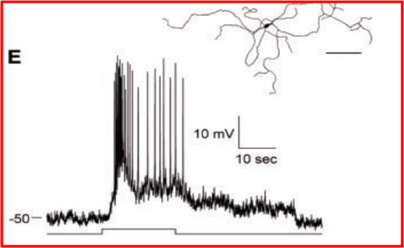
This paper intends to find the melanopsin evidence from the human retina and the connection between the melanopsin, cone, and rod photoreceptors, as shown in Study 1b.
Supplementary Table S1b – Brainard et al. (2001)
Category | Summary
Study Aim | Define the human action spectrum for melatonin suppression
Design | Laboratory, monochromatic light exposure, n=72
Exposure | 420–600 nm; multiple irradiances; 2–3:30 a.m.
Key Finding | Peak sensitivity 446–477 nm; action spectrum consistent with novel opsin
Limitation | Acute laboratory exposure only
Implication | Confirmed short-wavelength dominance in human circadian response

Figure 3 is a graphical illustration of the above study created by the author for pedagogical clarification. The author employed wavelength-dependent irradiance–response measurements, without attempting to visually reconstruct the original response curves.
Figure 3: Typical Melanopsin Test
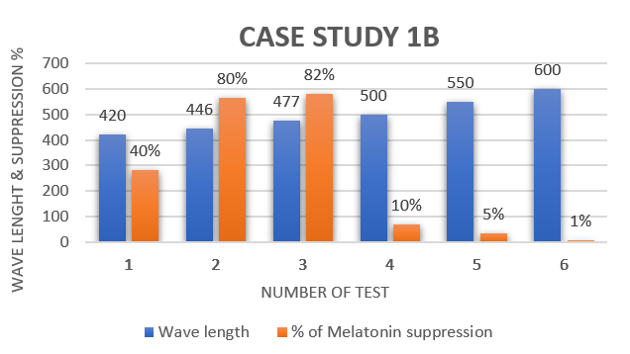
The next study is looking to prove a link between the NVP melanopsin and visual photoreceptors (cones and rods).
Supplementary Table S1c – Thapan et al. (2001)
Category | Summary
Study Aim | Test whether rods/cones mediate melatonin suppression
Design | Monochromatic exposure trials (n=22)
Exposure | 424–548 nm; irradiance-response curves
Key Finding | Poor fit to rod/cone spectra; best fit λ max ~459 nm
Limitation | Limited sample size
Implication | Strong evidence for non-rod, non-cone circadian photopigment

Figure 4 is a schematic representation of the above study for pedagogical clarification.
Figure 4: Typical Melanopsin Test
(Thapan et al., 2001)
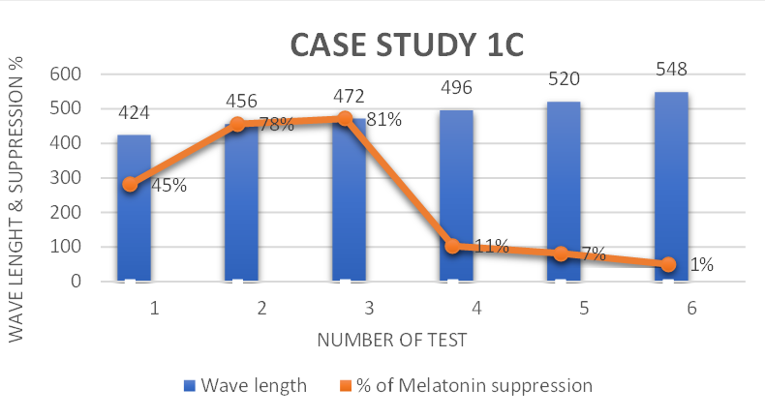

Domain 2 – ALAN & Cancer
Supplementary Table S2a – Dauchy et al. (1997)
Category | Summary
Study Aim | Examine impact of constant light on tumour growth
Design | Rat xenograft model
Exposure | 12L:12D vs light-contaminated vs 24L
Key Finding | Light suppressed melatonin and increased tumour metabolism
Limitation | Animal model; high exposure levels
Implication | Mechanistic link between ALAN, melatonin and tumour biology

Figure 5 is an illustrative graphical representation of the above study for pedagogical clarification.
Figure 5: Typical Cancer cells growth
(Dauchy et al., 1997)
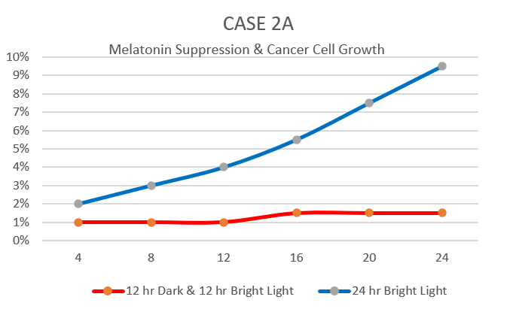
The melatonin and is suppressed by ALAN at night, increasing cancer cell growth (Walker et al., 2021; Phillips, 2019). Study 2b discusses the connection between the ALAN and an intensified danger of BC in women.
Supplementary Table S2b – Davis et al. (2001)
Category | Summary
Study Aim | Assess association between bedroom light and breast cancer
Design | Case–control (n≈1600)
Exposure | Self-reported nighttime light exposure
Key Finding | Increased risk associated with nighttime wakefulness and brighter bedrooms
Limitation | Self-reported exposure
Implication | Epidemiological support for the ALAN cancer hypothesis
Figure 6 is a conceptual graphical representation of the above study for pedagogical clarification.
Figure 6: Typical Cancer & light testing
(Davis et al., 2001)
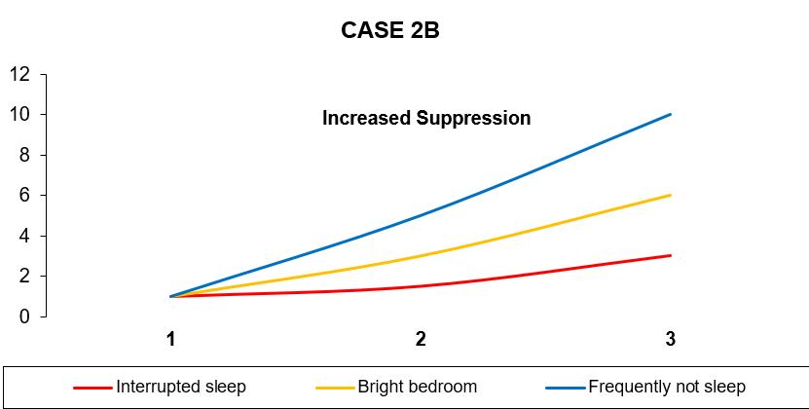
The next study is looking to prove a connection between the consequences of night work on BC.
Supplementary Table S2c – Schernhammer et al. (2001)
Category | Summary
Study Aim | Investigate rotating nightshift work and breast cancer risk
Design | Prospective cohort (78,562 women)
Exposure | Years of rotating night shifts
Key Finding | Elevated risk after ≥30 years (RR 1.36)
Limitation | Shift work as proxy for light exposure. The confounding factors inherent to shift work, including sleep disruption, metabolic effects, psychosocial stress, and chronotype.
Implication | Chronic circadian disruption linked to long-term risk

Figure 7 is a schematic representation of the above study for pedagogical clarification.
Figure 7: Typical light & cancer growth
(Schernhammer et al., 2001)

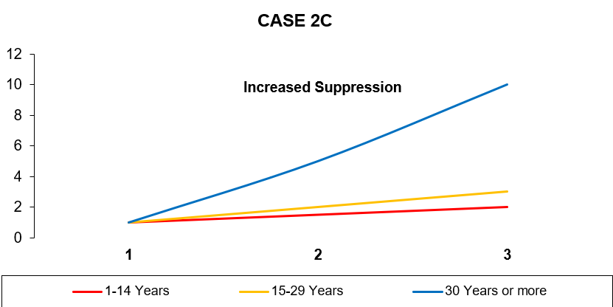
Domain 3 – Intensity–Response
As part of this paper, the author has selected the following three Studies by others to verify and confirm the intensity of light and NMS.
Supplementary Table S3a – Brainard et al. (1982)
Category | Summary
Study Aim | Determine melatonin suppression threshold
Design | Hamster laboratory experiment
Exposure | 0.01–5380 lux
Key Finding | Threshold between 0.11–1.08 lux
Limitation | Species differences
Implication | Very low light levels can alter circadian biology

Figure 8 is an illustrative graphical representation of the above study for pedagogical clarification.
Figure 8: Typical light intensity & melatonin testing
(Brainard et al., 1982)
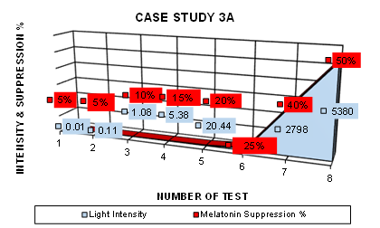
The amount of light increases the NMS (Brainard et al., 1982). Mammals may have different light sensitivity than humans. Therefore, the following Study will investigate the human subjects' evidence.
Supplementary Table S3b – McIntyre et al. (1989)
Category | Summary
Study Aim | Quantify intensity-dependent suppression in humans
Design | Controlled lab exposure
Exposure | 200–3000 lux for 1 hour
Key Finding | Graded suppression; significant effects at 350 lux
Limitation | Short duration
Implication | Common indoor lighting can suppress melatonin

Figure 9 is a conceptual graphical representation of the above study for pedagogical clarification.
Figure 9: Typical light intensity & melatonin suppression
(McIntyre et al., 1989)

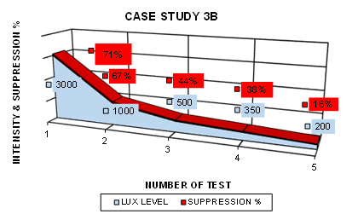
McIntyre et al. (1989) concluded that, “when examining the melatonin sensitivity of patient groups (such as bipolar affective disorders) to artificial light, an appropriate light intensity should be established in each laboratory. Light of less intensity (e.g., 200–350 lx) may be more suitable to dichotomize patient groups from control subjects” (Journal of Pineal Research, 6(2), pp. 149–156). Building on this recommendation, the present study examines nocturnal melatonin suppression (NMS) in response to low intensity light exposure
Supplementary Table S3c – Nagare et al. (2019)
Category | Summary
Study Aim | Evaluate light level, spectrum and duration interactions
Design | Laboratory; adolescents & adults
Exposure | 40–1000 lux; 2700K & 6500K; 0.5–3 h
Key Finding | Higher circadian stimulus (CS) → greater suppression; duration modifies response
Limitation | Acute exposure only
Implication | Multi-parameter circadian modelling is required

Figure 10 is a conceptual graphical representation of the above study for pedagogical clarification. The significant interaction between exposure duration and target CS level (p < 0.001). Points marked with an asterisk represent the earliest juncture at which melatonin suppression was significantly >10% (p <0.05; indicated by a dashed line).
Figure 10: Typical light intensity & melatonin
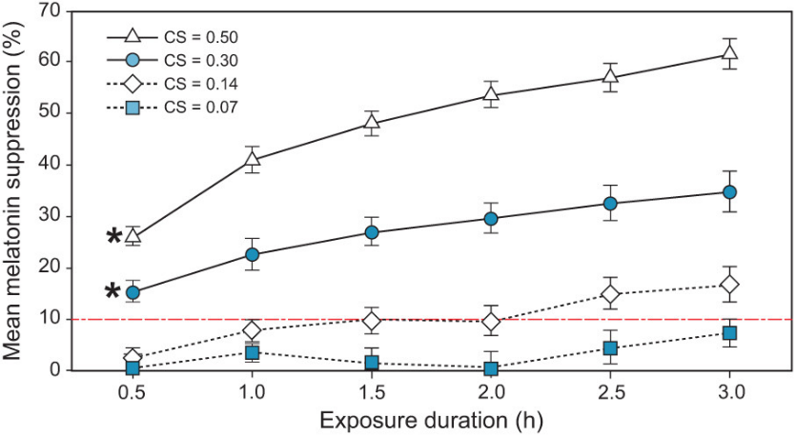
The results demonstrate that higher circadian stimulus (CS) values produce higher melatonin suppression. As the duration of light exposure increases, the melatonin suppression also gradually increases.
Domain 4 – Spectral Sensitivity
Supplementary Table S4a – Brainard et al. (1984)
Category | Summary
Study Aim | Compare wavelength effects in hamsters
Design | Controlled spectral exposure
Exposure | UV to red; equal irradiance
Key Finding | Blue most potent; red least potent
Limitation | Animal model
Implication | Spectral composition critically determines potency

Figure 11 is a schematic representation of the above study for pedagogical clarification.
Figure 11: Typical colour of light & melatonin
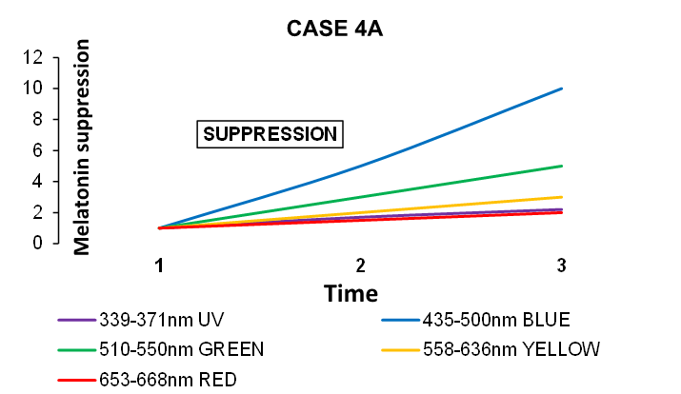
The observations indicate that “the retinal photopigment moderates the pineal gland's reaction to illumination in the hamster can be either rhodopsin or a different blue-sensitive chromophore” (Brainard et al., 1984). This study on Syrian hamsters indicates that 435-500nm blue wavelength suppresses more melatonin than other colours (ibid). Therefore, the following Study will investigate the human subjects' evidence for the NMS based on the colour of the spectrum.
Supplementary Table S4b – Wright & Lack (2001)
Category | Summary
Study Aim | Compare wavelength effects on NMS & phase delay
Design | Human crossover trial
Exposure | 470–660 nm LEDs
Key Finding | Short wavelengths (470–525 nm) most suppressive
Limitation | Small sample
Implication | Blue-enriched light disproportionately alters circadian phase

Figure 12 is an illustrative graphical representation of the above study for pedagogical clarification.
Figure 12: Typical colour of light & melatonin
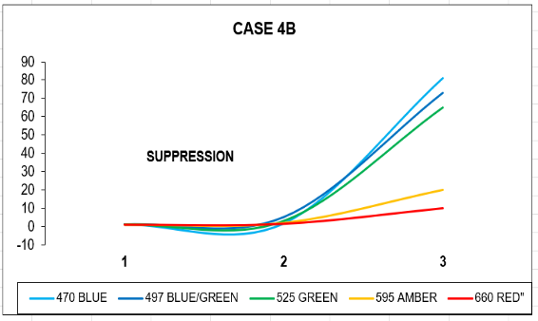
Collectively, these studies indicate that the shorter wavelengths of light showed the most significant NMS. The outcomes were consistent with the participation of a scotopic means in regulating the CR phase (Wright and Lack, 2001). The following study explores humans' circadian rhythm reset by short-wavelength light.
Supplementary Table S4c – Lockley et al. (2003)
Category | Summary
Study Aim | Test circadian phase resetting by wavelength
Design | 6.5h monochromatic exposure
Exposure | 460 nm vs 555 nm
Key Finding | 460 nm produced ~2× greater phase delay & suppression
Limitation | Long lab exposure; limited ecological realism
Implication | Photopic lux is insufficient for circadian quantification

Figure 13 is a conceptual graphical representation of the above study for pedagogical clarification.
Figure 13: Typical colour of light & melatonin suppression
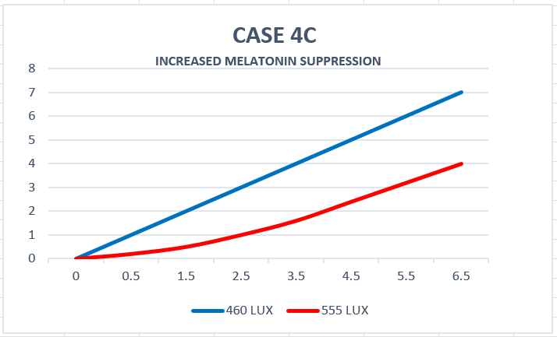
The author has selected the abovementioned credible and well-established primary Studies to back up the health effects due to exposure to ALAN. The first three Studies established the existence of a new photoreceptor. The second three Studies supported the biological plausibility and epidemiological signals linking ALAN and night work to cancer-relevant pathways. The third three Studies demonstrated intensity–response relations and the importance of exposure duration for NMS. The final three Studies confirmed blue-weighted spectral sensitivity and the resulting mismatch between photopic lux and circadian potency. Taken together, this evidence supports the conclusion that both spectral composition and intensity—in addition to timing and duration—shape health-relevant circadian outcomes in the built environment, with direct implications for light trespass mitigation and circadian-informed lighting design (Thurairajah et al., 2021b; Phillips et al., 2019).
3. Methodology
3.1 Study Selection and Rationale (PRISMA-Informed Structured Critical Review)

Selection Framework and Justification
This review adopted a domain-based evidence synthesis strategy, rather than a chronological or outcome-driven approach. This decision reflects the nature of artificial light at night (ALAN) health effects, which arise from interdependent biological mechanisms—retinal photoreception, circadian timing, endocrine signalling, spectral sensitivity, and exposure dynamics—that cannot be meaningfully evaluated within a single disciplinary or metric framework.
Accordingly, studies were selected to represent four complementary scientific domains:
(1) identification of the non-image-forming photoreception pathway;
(2) links between circadian disruption and disease-relevant pathways;
(3) intensity–response and exposure-duration relationships; and
(4) spectral sensitivity and measurement validity.
This approach prioritises mechanistic coherence and triangulation across study designs, rather than publication date or reported effect size. Only well-established, peer-reviewed primary studies were included. Eligible studies met one or more of the following criteria:
- introduced or decisively tested a novel biological mechanism;
- demonstrated reproducible physiological responses to nocturnal light exposure; or
- identified limitations of conventional lighting metrics (e.g., photopic lux) when applied to circadian biology.
This structured selection mitigates over-reliance on any single evidence type (animal, laboratory human, or epidemiological) and aligns with PRISMA guidance emphasising conceptual relevance and methodological rigor over volume or recency alone. A PRISMA-informed flow diagram (Figure 14) documents record identification, screening, landmark selection, and inclusion of the final 12 studies.
Figure 14 shows the study selection flow diagram (PRISMA-informed) showing the records identified → screened → landmark set → final 12 studies under four domains.
Figure 14: A study selection flow diagram showing the records screened and selection
(Source: by the author)
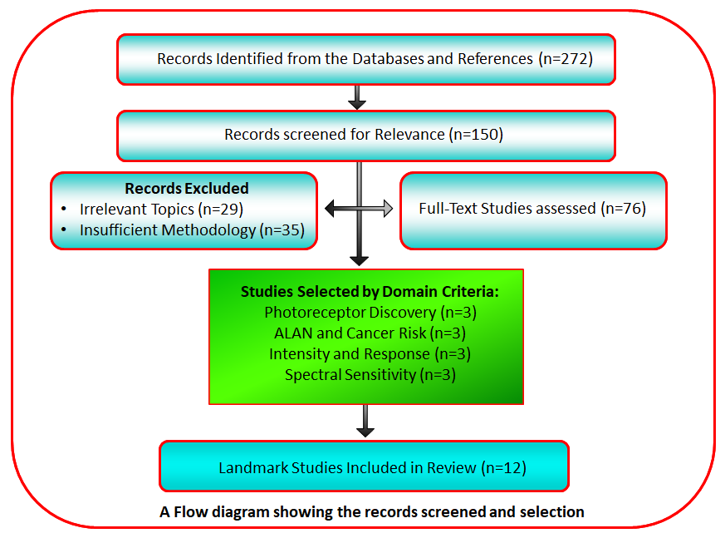
Domain-Specific Justification
Domain 1: Non-Image-Forming Photoreception
This domain addresses the prerequisite question of which retinal pathway mediates circadian and endocrine light responses. Three studies (Berson et al., 2002; Brainard et al., 2001; Thapan et al., 2001) were selected because, collectively, they established the existence, spectral sensitivity, and functional independence of the melanopsin-based photoreception system.
Berson et al. (2002) provided the first direct anatomical and electrophysiological evidence of intrinsically photosensitive retinal ganglion cells projecting to the suprachiasmatic nucleus, a discovery that is foundational and not superseded by later work. Brainard et al. (2001) and Thapan et al. (2001) independently demonstrated in humans that melatonin suppression peaks in the short-wavelength range and does not follow rod or cone action spectra. Together, these studies invalidate the assumption that visual photoreceptors or photopic lux adequately represent circadian sensitivity.
Domain 2: Circadian Disruption and Cancer-Relevant Pathways
This domain evaluates whether ALAN-induced circadian disruption plausibly links to disease-relevant biological pathways. Three studies (Dauchy et al., 1997; Davis et al., 2001; Schernhammer et al., 2001) were deliberately selected to span mechanistic animal evidence and large-scale human epidemiology.
Dauchy et al. (1997) demonstrated that nocturnal light suppresses melatonin and accelerates tumour metabolism in vivo, establishing mechanistic plausibility. Davis et al. (2001) and Schernhammer et al. (2001) provided early population-level evidence of associations between ALAN proxies (bedroom light, rotating night work) and breast cancer risk. These studies are not treated as causal proof; rather, their value lies in the convergence of findings across independent methodologies, with acknowledged limitations related to exposure proxies and confounding.
Domain 3: Intensity–Response and Exposure Duration
This domain addresses whether circadian effects occur at light levels typical of real environments, and whether responses scale with intensity and duration. Three studies (Brainard et al., 1982; McIntyre et al., 1989; Nagare et al., 2019) were selected to capture threshold sensitivity, graded responses, and multi-parameter interactions.
Brainard et al. (1982) demonstrated melatonin suppression at very low light levels, well below conventional lighting thresholds. McIntyre et al. (1989) confirmed that common indoor lighting can produce significant circadian effects in humans. Nagare et al. (2019) extended this work by integrating intensity, spectrum, age, and exposure duration, demonstrating non-linear and time-dependent responses. Collectively, these findings undermine the concept of a single “safe nighttime lux level” and support a multi-parameter exposure framework.
Domain 4: Spectral Sensitivity and Measurement Validity
This domain evaluates how light should be measured when assessing circadian impact. Three studies (Brainard et al., 1984; Wright & Lack, 2001; Lockley et al., 2003) were selected because they directly compared wavelength effects under controlled conditions.
Brainard et al. (1984) established disproportionate short-wavelength potency for melatonin suppression in animal models. Wright & Lack (2001) and Lockley et al. (2003) extended these findings to humans, demonstrating greater melatonin suppression and circadian phase shifts under short-wavelength light at equivalent irradiance. These studies directly expose the mismatch between photopic visual sensitivity (V(λ)) and circadian sensitivity, justifying the use of melanopic and α-opic metrics in circadian-informed lighting research and policy.
Integrated Synthesis Logic
Across domains, the selected studies form a logically ordered and biologically coherent evidence base:
(1) identifying the responsive system;
(2) establishing health relevance;
(3) characterising exposure–response dynamics; and
(4) resolving measurement validity.
Conclusions are derived from cross-domain consistency and biological plausibility, not from any single study. Design-specific limitations (animal models, short-term laboratory exposure, epidemiological proxies) are explicitly acknowledged, consistent with best practice in structured critical review.
Why Older Studies Were Retained
Older studies were intentionally retained where they represent foundational discoveries, first demonstrations of biological mechanisms, or measurement inflection points that remain scientifically valid. In circadian photobiology, later studies frequently build upon, rather than replace, these seminal findings. Excluding such work based on publication date alone would obscure the mechanistic lineage underpinning contemporary melanopic metrics, exposure models, and policy guidance.
Consistent with PRISMA principles, study inclusion was determined by conceptual relevance, methodological rigor, and mechanistic contribution, not recency. Citation volume was examined post-selection solely to demonstrate sustained scholarly uptake and replication, not to weight evidence or imply superiority. Retaining older landmark studies ensures interpretive continuity and prevents circular reliance on derivative literature.
4. RESULTS (Evidence Synthesis Across Four Domains)
4.1 Domain 1: Establishing the non-image-forming photoreception pathway
The foundational shift in the field was the recognition that circadian and endocrine light responses are not adequately explained by classical rod–cone vision alone. Berson et al. (2002) demonstrated intrinsic photosensitivity in retinal ganglion cells (ipRGC) projecting to circadian centres, implying a photoreceptive pathway dedicated to non-visual regulation. In parallel, human action-spectrum studies showed peak potency for melatonin suppression in the short-wavelength region, inconsistent with photopic sensitivity and strongly suggestive of a distinct opsin-based photopigment (Brainard et al., 2001; Thapan et al., 2001).
Integrated implication: these studies established that the biologically relevant “dose” of light depends strongly on spectrum, and that the circadian system can be strongly activated at levels that may not appear bright by photopic standards.
4.2 Domain 2: ALAN, tumour biology and breast cancer risk
In controlled animal work, Dauchy et al. (1997) provided mechanistic evidence consistent with the melatonin hypothesis: light contamination during the dark phase suppressed melatonin and was associated with altered tumour growth and metabolism in rats. Complementing this, human epidemiological studies examined night work and nocturnal light exposure proxies. Davis et al. (2001) reported patterns consistent with increased breast cancer risk among individuals with disrupted sleep timing and brighter bedroom environments, while Schernhammer et al. (2001), using the Nurses’ Health Study cohort, observed increased risk with prolonged rotating night-shift work, particularly over extended durations.
Integrated implication: while epidemiology cannot fully isolate correlations, the convergence of mechanistic plausibility and consistent risk signals among long-term night workers supports ALAN and circadian disruption as credible contributors to chronic disease risk pathways, warranting precautionary design and policy responses.
4.3 Domain 3: Intensity–response and the importance of timing and duration
Dose–response evidence shows that melatonin suppression is not limited to extreme light exposures. Early work in mammals demonstrated threshold-like behaviour at low illuminances (Brainard et al., 1982). In humans, McIntyre et al. (1989) demonstrated graded melatonin suppression across intensities, indicating that “typical” indoor lighting can significantly suppress nocturnal melatonin depending on timing and duration. More recently, Nagare et al. (2019) advanced the field by systematically evaluating wide light-level ranges, multiple spectra and exposure durations, highlighting that circadian impact increases with intensity and spectral potency, while duration modifies response magnitude and detectability over time.
Integrated implication: the circadian system responds to a multi-parameter exposure profile—intensity, duration and timing—meaning that single-threshold rules are insufficient for standards intended to protect biological night.
4.4 Domain 4: Spectral sensitivity and why photopic lux is not biologically sufficient
Spectral studies demonstrated that shorter wavelengths produce stronger melatonin suppression and circadian phase shifting than longer wavelengths at comparable irradiance or photon density (Brainard et al., 1984; Wright and Lack, 2001). Lockley et al. (2003) directly highlighted that photopic lux is not an appropriate metric for circadian resetting, because circadian sensitivity is blue-shifted relative to the photopic visual system. This measurement mismatch underpins the need for biologically weighted metrics such as Circadian Stimulus (CS) or melanopic measures (Rea et al., 2010).
Integrated implication: biologically relevant metrics are necessary to translate laboratory findings into design targets, procurement criteria and enforceable standards.
Figure 15 shows the Key translational takeaways for the Lighting Design Practice.

Figure 15: Key translational takeaways for Lighting Design Practice
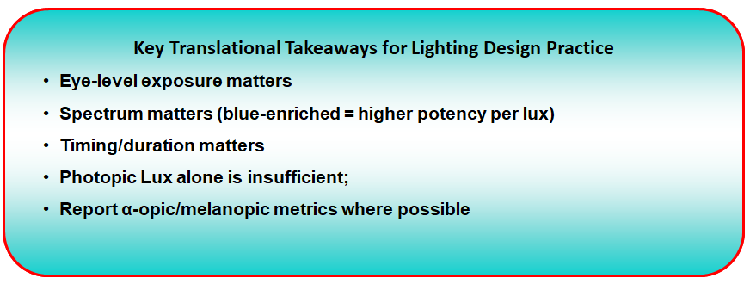
5. DISCUSSION
5.1 What the pioneering evidence collectively established
Across the four domains, a coherent picture emerges: artificial light is not merely a visual aid but a potent circadian signal, especially when delivered during the biological night and enriched in short wavelengths. The field’s early milestones—melanopsin pathway identification and action-spectrum mapping—explain why “ordinary” lighting can meaningfully alter endocrine and sleep-related physiology (Berson et al., 2002; Brainard et al., 2001; Thapan et al., 2001). Dose–response findings then clarified that risk is not exclusive to extreme exposures, while cancer-related studies linked circadian disruption to plausible long-term disease pathways, particularly under chronic night-work conditions (Dauchy et al., 1997; Schernhammer et al., 2001).
5.2 Translational gap: measurement remains the bottleneck
A recurring limitation is the inconsistency and incompleteness of exposure assessment. Many real-world studies rely on proxies (e.g., shift schedules, bedroom brightness categories, outdoor satellite radiance) that do not precisely represent corneal exposure, spectrum, timing or duration. Meanwhile, lighting practice often remains anchored to photopic lux, even though circadian potency depends on spectral weighting and retinal pathways distinct from vision (Lockley et al., 2003; Rea et al., 2010). This gap constrains both association inference and policy implementation.
Priority implication: future research and standards benefit from routine reporting of corneal illuminance/irradiance, spectral power distribution (or biologically weighted equivalents), exposure timing relative to circadian phase, and duration.
5.3 LEDs: amplified risk, but also the most scalable solution
LED adoption has increased short-wavelength content in many installations, which can elevate circadian impact for the same perceived brightness (Cajochen et al., 2011). However, LEDs also enable spectral tuning, dimming, and adaptive controls. This duality reframes the policy question: the goal is not to reduce lighting indiscriminately, but to deliver “right light, right place, right time, right spectrum,” with demonstrable circadian protection—particularly for residential bedrooms, healthcare, shift-work environments, and outdoor settings associated with light trespass and skyglow (Falchi et al., 2016; Figueiro and Rea, 2016).
5.4 Equity and urban exposure: who bears the burden?
Falchi et al. (2016) underscore that skyglow is now a global environmental condition. When outdoor lighting is poorly shielded or over-specified, it becomes an involuntary exposure, potentially concentrated in certain urban districts. This raises environmental justice questions: who receives the benefits of lighting (visibility, commerce) and who bears the costs (sleep disruption, light trespass, reduced nighttime darkness)?
5.5 What remains uncertain (and how to strengthen the evidence base)
Key uncertainties are not about whether ALAN affects circadian biology—that is strongly supported—but about long-term effect sizes across diverse populations and how interventions perform at scale. Future work should prioritise:
- Longitudinal studies with improved individual exposure measurement;
- Randomised or quasi-experimental trials of circadian-informed lighting interventions in workplaces and residential settings;
- Standardised reporting using biologically weighted metrics to enable meta-analysis; and
- Interactions with age, chronotype, ocular physiology and interindividual sensitivity (Nagare et al., 2019; Phillips et al., 2019).

6. CONCLUSION
The pioneering studies reviewed here transformed artificial lighting from a purely engineering concern into a public-health-relevant environmental exposure. Evidence across mechanistic, laboratory and epidemiological domains indicates that ALAN—particularly blue-enriched light delivered during the biological night—can suppress melatonin, disrupt circadian timing and plausibly contribute to chronic disease risk pathways, especially under long-term night-work conditions (Berson et al., 2002; Lockley et al., 2003; Schernhammer et al., 2001).
A central practical conclusion is that photopic lux alone is not a sufficient basis for circadian-safe lighting. Translation into policy and practice requires biologically weighted measures and enforceable design criteria, alongside shielding and controls that reduce light trespass and skyglow (Rea et al., 2010; Falchi et al., 2016).
Practical implications and recommendations
- Standards and guidance: Incorporate biologically informed metrics (e.g., melanopic weighting/CS) and explicit night-time limits for sensitive settings (bedrooms, healthcare, shift-work environments).
- Design and technology: Prioritise shielding, dimming, adaptive schedules, and reduced short-wavelength content during evening/night while maintaining safety requirements.
- Research: Strengthen exposure measurement (corneal, spectral, temporal profiling) and evaluate intervention effectiveness in real-world deployments.
- Public awareness: Promote behavioural strategies (reduced evening screen/bright light exposure; darkness-protective bedroom practices) alongside infrastructure change.
Managing artificial light as a bio-environmental exposure—rather than solely a visibility solution—is now essential for healthy, sustainable nighttime environments.
COMPETING INTERESTS DISCLAIMER:
Authors have declared that they have no known competing financial interests or non-financial interests, or personal relationships that could have appeared to influence the work reported in this paper.
Disclaimer (Artificial intelligence)

Author(s) hereby declares that NO generative AI technologies such as Large Language Models (ChatGPT, COPILOT, etc.) and text-to-image generators have been used during the writing or editing of this manuscript.

REFERENCES
Berson, D.M., Dunn, F.A., Takao, M. (2002) ‘Phototransduction by retinal ganglion cells that set the circadian clock, Science, 295(5557), pp. 1070-1073. Available at: https://www.science.org/doi/abs/10.1126/science.1067262. (Accessed: 28 February 2025).
Brainard, G. C., Haniﬁn, J. R., Greeson, J. M., Byrne, B., Glickman, G., Gerner, E. and Rollag, M. D. (2001) ‘Action spectrum for melatonin regulation in humans: Evidence for a novel circadian photoreceptor’, The Journal of Neuroscience, 21(16), pp. 6405-6412. Available at: https://www.jneurosci.org/content/21/16/6405 (Accessed: 20 June 2025).
Brainard, G.C., Richardson, B.A., Petterborg, L.J. and Reiter, R.J. (1982) ‘The effect of different light intensities on pineal melatonin content’, Brain Research, 233(1), pp.75-81. Available at: https://www.sciencedirect.com/science/article/abs/pii/0006899382909313. Accessed: 28 February 2021).
Brainard, G.C., Richardson, B.A., King, T.S. and Reiter, R.J. (1984) ‘The influence of different light spectra on the suppression of pineal melatonin content in the Syrian hamster’, Brain Research, 294(2), pp. 333-339. Available at: https://www.sciencedirect.com/science/article/abs/pii/000689938491045X (Accessed: 28 February 2021).
Cajochen, C., Frey, S., Anders, D., Späti, J., Bues, M., Pross, A., Mager, R., Wirz-Justice, A. and Stefani, O., 2011. Evening exposure to a light-emitting diodes (LED)-backlit computer screen affects circadian physiology and cognitive performance. Journal of Applied Physiology, Available at: https://pubmed.ncbi.nlm.nih.gov/21415172/ (Accessed: 28 February 2025).
Cho, Y., Ryu, S.-H., Lee, B.R., Kim, K.H., Lee, E. and Choi, J., 2015. Effects of artificial light at night on human health: A literature review of observational and experimental studies applied to exposure assessment. Chronobiology International, 32(9), pp.1294–1310. Available at: https://pubmed.ncbi.nlm.nih.gov/26375320/ (Accessed: 28 February 2025).
Cupertino, Marli do, Bianca Thiengo Guimarães, José Flávio Giardini Pimenta, Leonardo Victor Lima Dutra Almeida, Lorran Nunes Santana, Thalia Azevedo Ribeiro and Yuri Nunes Santana. (2022) “LIGHT POLLUTION: a systematic review about the impacts of artificial light on human health.” Biological Rhythm Research 54 (2022): 263 - 275. Available at: https://api.semanticscholar.org/CorpusID:254315745 (Accessed: 28 February 2026).
Dauchy, R.T., Sauer, L.A., Blask, D.E. and Vaughan, G.M. (1997) ‘Light contamination during the dark phase in "photoperiodically controlled" animal rooms: Effect on tumor growth and metabolism in rats’, Comparative Medicine, 47(5), pp. 511-518. Available at: https://www.ingentaconnect.com/content/aalas/cm/1997/00000047/00000005/art00009. (Accessed: 28 February 2021).
Davis, S., Mirick, D.K. and Stevens, R.G. (2001) ‘Night shift work, light at night, and risk of breast cancer’, Journal of the National Cancer Institute, 93(20), pp. 1557-1562. Available at: https://academic.oup.com/jnci/article/93/20/1557/2519561. (Accessed: 28 February 2021).
Falchi, F., Cinzano, P., Duriscoe, D., Kyba, C.C.M., Elvidge, C.D., Baugh, K., Portnov, B.A., Rybnikova, N.A. and Furgoni, R., 2016. The new world atlas of artificial night sky brightness. Science Advances, 2(6), p.e1600377. Available at: https://pubmed.ncbi.nlm.nih.gov/27386582/ (Accessed: 28 February 2025).
Figueiro, M.G. and Rea, M.S., 2016. Office lighting and personal light exposures in two seasons: Impact on circadian phase and mood. Lighting Research & Technology, 48(3), pp.352–364. Available at: https://doi.org/10.1177/14771535145640 (Accessed: 28 February 2025).
Lockley, S.W., Brainard G.C. and Czeisler, C.A. (2003) ‘High sensitivity of the human circadian melatonin rhythm to resetting by short wavelength light’, The Journal of clinical endocrinology and metabolism, 88(9), pp.4502-4505 Available at: https://pubmed.ncbi.nlm.nih.gov/12970330/ (Accessed: 28 February 2021).
McIntyre, I.M., Norman, T.R., Burrows, G.D. and Armstrong, S.M. (1989) ‘Quantal melatonin suppression by exposure to low intensity light in man’, Life Sciences, 45(4), pp. 327-332. Available at: https://pubmed.ncbi.nlm.nih.gov/2761346/ (Accessed: 28 February 2021).
Nagare R, Rea MS, Plitnick B, Figueiro MG. Nocturnal Melatonin Suppression by Adolescents and Adults for Different Levels, Spectra, and Durations of Light Exposure. Journal of Biological Rhythms. 2019;34(2):178-194. Available at: https://doi.org/10.1177/0748730419828056 (Accessed: 28 November 2024).
Phillips, A.J.K., Vidafar, P., Burns, A.C., McGlashan, E.M., Anderson, C., Rajaratnam, S.M.W., Lockley, S.W. and Cain, S.W. (2019) ‘High sensitivity and interindividual variability in the response of the human circadian system to evening light’, Proceedings of the National Academy of Sciences, 116(24), pp. 12019-12024. Doi: 10.1073/pnas.1901824116 Available at: https://www.pnas.org/doi/full/10.1073/pnas.1901824116 (Accessed: 28 February 2025).
Patterson, S.S, Maureen Neitz, Jay Neitz (2022) S-cone circuits in the primate retina for non-image-forming vision. Available at: https://www.sciencedirect.com/science/article/pii/S1084952121001130. (Accessed: 28 February 2025).
Rea, M.S., Figueiro, M.G., Bierman, A. and Bullough, J.D., 2010. Circadian light. Journal of Circadian Rhythms, 8(1), p.2. Available at: https://pubmed.ncbi.nlm.nih.gov/20377841/ (Accessed: 28 February 2025).
Stevens, R.G., Brainard, G.C., Blask, D.E., Lockley, S.W. and Motta, M.E., 2013. Adverse health effects of nighttime lighting: comments on American Medical Association policy statement. American Journal of Preventive Medicine, 45(3), pp.343–346. Available at: https://pubmed.ncbi.nlm.nih.gov/23953362/ (Accessed: 28 February 2025).
Schernhammer, E.S., Laden, F., Speizer, F.E., Willett, W.C., Hunter, D.J., Kawachi, I. and Colditz, G.A. (2001) ‘Rotating night shifts and risk of breast cancer in women participating in the nurses’ health study’, Journal of the National Cancer Institute, 93(20), pp. 1563-1568. Available at: https://academic.oup.com/jnci/article/93/20/1563/2519563 (Accessed: 28 February 2021).
Salomon I, Sam S, Rehman YU, Hope IM. (2025) Artificial light exposure at night: A hidden risk factor for type 2 diabetes. Sleep Med X. 2025 Jun 14;10:100146. Available at: https://doi.org/10.1016/j.sleepx.2025.100146 (Accessed: 28 February 2026).
Thapan, K., Arendt, J. and Skene, D.J. (2001) ‘An action spectrum for melatonin suppression: Evidence for a novel non-rod, non-cone photoreceptor system in humans’, The Journal of Physiology, 535(Part1), pp. 261-267. Available at: https://www.ncbi.nlm.nih.gov/pmc/articles/PMC2278766/ (Accessed: 28 February 2022).
Thurairajah, U., Littlewood, J.R. and Karani, G. (2021a) ‘A proposed method to pre-qualify sustainable energy-saving LED Luminaires for outdoor urban lighting applications’, in Littlewood, J., Howlett, R.J. and Jain, L.C. (eds.) Sustainability in Energy and Buildings 2020, Smart Innovation, Systems and Technologies, Series, 203. Singapore: Singer, pp. 357-367. Available at: https://doi.org/10.1007/978-981-15-8783-2_30 (Accessed: 28 March 2022).
Thurairajah, U., Littlewood, J.R. and Karani, G. (2021b) ‘A novel approach to controlling outdoor light pollution by adopting smart science and technology to improve residents’ quality of life in the built environment’, in Littlewood, J., Howlett, R.J. and Jain, L.C. (eds.) Sustainability in Energy and Buildings 2020, Smart Innovation, Systems and Technologies Series, 203. Singapore: Springer, pp. 369-380. Available at: https://doi.org/10.1007/978-981-15-8783-2_31 (Accessed: 28 May 2022).
Thurairajah, U., Littlewood, J.R. and Karani, G. (2022a) ‘A proposed method to pre-qualify a wireless monitoring and control system for outdoor lighting to reduce energy use, light pollution, and carbon emissions’, in Littlewood, J.R., Howlett, R.J., Jain, L.C. (eds.) Sustainability in Energy and Building 2021, Smart Innovation, Systems and Technologies Series, 264. Singapore: Springer, pp. 365-375. Available at: https://link.springer.com/chapter/10.1007/978-981-16-6269-0_31 (Accessed: 28 March 2022).
Thurairajah, U. (2022b). A comparative study: The benefits of a novel illuminance calculation method over a luminance calculation method for optimal roadway lighting design applications, Journal of Physics: Conference Series, 2224. Available at: https://iopscience.iop.org/article/10.1088/1742-6596/2224/1/012117 (Accessed: 28 June 2022).
Thurairajah, U. (2023a). A Novel Method to Prove the Visibility Distance of Candlelight and the Milky Way’s Vega Star and Apply this Knowledge to Outdoor Lighting Applications, SCIREA Journal of Physics. Vol. 8 , No. 1 , 2023 , pp. 1 - 18 . Available at: https://doi.org/10.54647/physics140512 (Accessed: 28 February 2023).
Thurairajah, U. (2023b). An Elite Roadway Illuminance Calculation (ERIC) Method Provides Optimum Performance and Cost-saving without Compromising Safety. Recent Progress in Science and Technology Vol. 8, 98–119. Available at: https://doi.org/10.9734/bpi/rpst/v8/5610A (Accessed: 28 September 2024).
Thurairajah, U. (2023c). Discovery of Threshold Visibility Limit (TVL) Using the Number of Photons Intruding into the Human Eye and Possible Application to Outdoor Lighting. Fundamental Research and Application of Physical Science Vol. 7, 82–102. Available at: https://doi.org/10.9734/bpi/fraps/v7/6642A (Accessed: 28 September 2024).
Walker, W.H., II; Bumgarner, J.R.; Walton, J.C.; Liu, J.A.; Meléndez-Fernández, O.H.; Nelson, R.J.; DeVries, A.C. (2020) Light Pollution and Cancer. Int. J. Mol. Sci. 2020, 21, 9360. Available at: https://doi.org/10.3390/ijms21249360 Accessed: 28 August 2025).
Wright, H.R. and Lack, L.C. (2001) ‘Effect of light wavelength on suppression and phase delay of the melatonin rhythm’, The Journal of Biological and Medical Rhythm Research, 18(5), pp. 801-808. Available at: https://www.tandfonline.com/doi/abs/10.1081/CBI-100107515?journalCode=icbi20 (Accessed: 28 February 2021).
Wong NA, Bahmani H. (2022) A review of the current state of research on artificial blue light safety as it applies to digital devices. Heliyon. 2022 Aug 15;8(8):e10282. Available at:
https://doi.org/10.1016/j.heliyon.2022.e10282 (Accessed: 28 February 2026).

