Usage, Awareness, and Satisfaction of Customers
Towards Credit Card Services Offered by Banks

Mr. Monti Kumar
Independent Researcher, Madhepura, Bihar
Ms. Muskan
Independent Researcher, Bareilly, Uttar Pradesh

1. ABSTRACT
The present study examines the awareness, usage, and satisfaction levels of customers regarding credit card services offered by banks, with special reference to Bihar, Jharkhand, and Uttar Pradesh. In recent years, credit cards have become an integral part of modern banking and have significantly transformed financial transaction practices. With the expansion of digital banking, online shopping, and cashless payment systems, credit card usage has increased considerably. A credit card, often referred to as plastic money, enables users to purchase goods and services without immediate payment, based on the “use now, pay later” concept. These cards offer several advantages, including convenience, seamless transactions, reward points, discounts, and flexible repayment options. However, users may encounter challenges such as hidden charges, high interest rates, and the risk of debt accumulation if not used prudently. Therefore, it is essential for banks to understand customers’ satisfaction levels and experiences with credit card services.
The primary objective of this study is to analyse customer satisfaction among respondents and identify the factors influencing their satisfaction with banking services. It further examines user preferences, behavioural patterns, and challenges associated with card usage. A descriptive research design has been adopted, and primary data were collected through a structured questionnaire. A total of 55 respondents were randomly selected from different banks across Northern India. Customer satisfaction was evaluated across five dimensions: product quality, service quality, convenience, trust, and value-added services. Additionally, aspects such as security, customer support, fees, and reward schemes were examined.
The findings indicate that a majority of respondents report positive perceptions of the convenience and benefits associated with credit cards. However, concerns such as hidden charges, lack of transparency, security issues, and delayed customer service responses remain significant. The findings suggest that banks should focus on enhancing service quality, improving transparency, strengthening security features, and offering efficient customer support. Such measures can improve customer satisfaction, foster trust, and promote long-term relationships. The findings may assist researchers, policymakers, and financial institutions in understanding consumer behaviour and improving credit card services in the evolving digital banking landscape.
Keywords: credit cards; customer satisfaction; usage; awareness; Northern India
2. INTRODUCTION
Credit cards exert a significant influence on individual financial health by shaping users’ credit scores, spending behaviour, and overall financial well-being. When managed responsibly, they can serve as effective financial tools that enhance financial stability and provide rewards and convenience.
Credit cards have become an integral part of the modern payment system and are widely used for purchasing goods and services without immediate cash payments. A credit card is a payment instrument issued by banks or financial institutions that allows customers to borrow funds within a predetermined credit limit. The borrowed amount can be repaid later, usually within a specified period, based on the “use now, pay later” concept. If repayment is made within the grace period—generally up to 56 days—no interest is charged. Owing to these features, such instruments are often referred to as “plastic money.”
Unlike debit cards, credit cards provide access to credit rather than utilising funds already available in a bank account. Banks typically issue these cards in association with major payment networks such as Visa, RuPay, and MasterCard. In this system, the issuing bank acts as an intermediary between the cardholder and the merchant, ensuring smooth transaction processing. If the cardholder fails to repay the amount on time, the issuing bank settles the payment with the merchant and subsequently recovers the amount from the customer. This mechanism has contributed to the widespread acceptance of such instruments in both online and offline transactions.
Although credit cards can contribute positively to personal financial management, they may also pose risks if not used carefully. Responsible usage, informed decision-making, and financial discipline are essential to avoid issues such as high interest charges and debt accumulation. Such instruments offer flexibility, rewards, and transactional convenience; however, consumers must exercise financial caution and discipline.
At the global level, credit card markets in developed regions such as the United States and the European Union are highly advanced and widely adopted. In contrast, many developing countries are still in the early stages of credit card market development. For instance, in Vietnam, the number of credit card users remains relatively low compared to the total population, although the market is expanding steadily. Although a large number of payment cards have been issued, many are debit or ATM cards primarily used for cash withdrawals rather than payments. Nevertheless, the increasing adoption of digital payment systems indicates strong potential for future growth in credit card usage.
In India, credit cards were introduced in the 1960s, but their adoption increased significantly after the 1990s with the expansion of the banking sector, consumer finance, and digital payment infrastructure. Today, such instruments offer several advantages, including convenience, quick payments, reward points, discounts, and EMI facilities. They are also useful in emergency situations requiring immediate liquidity. However, improper usage can result in financial challenges such as high interest liabilities and increasing debt.
In this context, it is essential to examine how consumers use credit cards and evaluate their level of satisfaction with banking services. Therefore, the present study focuses on analysing the demographic profile of credit card users, their transaction behaviour, reasons for usage, and overall satisfaction. It also aims to assess the effectiveness of credit cards as a financial tool for consumers.
2.1 Overview of Credit Card
A credit card is a payment instrument issued by financial institutions that enables users to make payments for goods and services. It operates under a contractual agreement in which the cardholder undertakes to repay the issuing institution for the amount incurred, along with applicable charges. The issuer maintains a revolving credit account and extends a predetermined line of credit, from which the cardholder can borrow funds to make purchases or obtain cash advances.
WHAT IS A CREDIT CARD?
"Credit Cards - Its credit to you!"
2.2 History of Credit Cards
Early forms of credit systems date back to the 19th century, however, modern credit cards emerged in the 1950s with the introduction of the Diners Club card, widely regarded as the first general-purpose credit card. This innovation enabled customers to conduct transactions across multiple merchants and settle their balances over time. The subsequent introduction of bank-issued cards, such as BankAmericard (now Visa) and Master Charge (now MasterCard), during the 1960s and 1970s significantly transformed the payment system by expanding accessibility and standardising credit-based transactions. In April 2009, the U.S. House of Representatives approved the Credit Cardholders’ Bill of Rights, which aimed to enhance consumer protection by restricting or eliminating unfair and abusive practices within the credit card industry.

2.3 Credit Cards in India
In India, the Central Bank of India introduced the first bank-issued credit card in 1980, followed by Andhra Bank in the same year, with both cards affiliated to the Visa network. MasterCard was introduced to Indian consumers by Vijaya Bank in 1988. A key distinguishing feature was the provision by Vijaya Bank allowing customers to withdraw cash from its branches. Eligibility for a credit card was primarily based on the income level of consumers.
The Indian credit card market is highly competitive, with approximately 74 players operating. However, the top five players account for nearly 78% of the total number of cards issued and about 75% of total credit card spending. HDFC Bank leads the market with approximately 28% share, followed by SBI Cards at around 18%, and subsequently by ICICI Bank, Axis Bank, and Citibank.

2.4 Salient Features
- Annual Fee: credit cards may involve an annual charge applied at the beginning of each membership year rather than the calendar year. For example, if an account is opened in March, the fee is typically charged annually in March. Many issuers waive the fee for the first year and may allow cardholders to redeem reward points to cover subsequent charges.
- Outstanding Balance: The outstanding balance refers to the unpaid amount carried forward on the account. If the full balance is not settled by the due date, interest charges are applied to the remaining amount.
- APR: The annual percentage rate represents the yearly cost of borrowing on a credit card. While issuers may advertise relatively low monthly interest rates (e.g., 3%), the effective annual rate can be significantly higher, potentially exceeding 40%, if the balance is not cleared in full.
- Cash Advance: Credit cards allow cardholders to withdraw cash from ATMs; however, such transactions typically involve high fees, generally ranging from 2.5% to 3% per transaction, thereby making it a costly source of funds.
2.5 Benefits
- Credit cards provide an interest-free grace period of up to 45 days, with at least 30 days of guaranteed credit, which is particularly beneficial for salaried individuals.
- They offer flexibility in repayment, allowing cardholders to either pay the full outstanding amount or make a minimum payment (typically around 5%). Additionally, they provide a secure alternative to carrying large amounts of cash.
- Credit cards also allow cash withdrawals from ATMs; however, such transactions involve high charges, generally ranging from 2.5% to 3% per transaction, making them a costly method of accessing funds.

2.6 Drawbacks
- The availability of credit is not an invitation to spend impulsively; therefore, card usage should be strategic and disciplined.
- Credit cards are an expensive borrowing instrument due to high interest rates and associated charges.
- While they can serve as a secure means of carrying funds, an emergency resource, or a tool for leveraging financial opportunities, improper usage may lead to financial strain and debt accumulation.

2.7 Credit Card System
- Interest Charges: Credit card interest structures vary in complexity. Full monthly payments generally prevent interest charges; however, carrying a balance results in interest being applied from the transaction date. Different balances may attract varying interest rates, which can change based on issuer policies or late payments.
- Grace Period: Credit cards typically offer a grace period ranging from 20 to 50 days, during which no interest is charged if the outstanding balance is paid in full. However, this benefit may be forfeited in cases of late payment or when balances are carried forward, leading to the application of finance charges. In some cases, interest may be charged to both existing balances and new transactions.
- Benefits to Customers: Credit card providers offer various incentives to attract customers. Cardholders may earn rewards such as travel points, cashback, or gift vouchers. Additionally, certain cards provide low or zero introductory interest rates, enhancing their attractiveness.
- Benefits to Merchants: Credit cards provide merchants with secure and reliable payment mechanisms, as issuing banks guarantee payment even if customers default. This reduces the risks associated with handling cash and minimizes theft. Furthermore, banks undertake credit verification, thereby simplifying the transaction process for merchants.
2.8 Need for the Study
Credit cards have become an integral component of modern financial transactions, facilitating cashless payments across both online and offline platforms. Their usage, which was previously concentrated among affluent individuals in urban areas, has now expanded to include middle-income groups and consumers in semi-urban and rural regions. The rapid growth of digital banking, e-commerce, and electronic payment systems has further increased the adoption of credit cards as a convenient mode of payment.
Credit cards can enhance personal financial management to a great extent. From providing a safety net during emergencies to earning rewards on everyday purchases, credit cards can play a crucial role in financial planning (IndusInd Bank).₃
However, the increasing adoption of credit cards has also introduced several challenges. Consumers may encounter issues such as fraud, payment defaults, unsolicited card issuance, high annual charges, and transaction failures. In some cases, credit cards may not function effectively on international platforms or outside the country, leading to inconvenience. As a result of these challenges, some consumers opt to obtain multiple cards from different issuers, while others remain hesitant to adopt such financial instruments.
Although banks offer various benefits, including reward points, cashback schemes, and enhanced security features, it remains uncertain whether consumers possess adequate awareness of these services or are fully satisfied with them. This highlights a gap in understanding the actual usage patterns, awareness levels, and satisfaction of credit card users.
In this context, the present study aims to examine the level of customer satisfaction with credit card services, analyse the utilisation of credit facilities across different activities, and identify the major challenges faced by cardholders. The findings of this study are expected to assist banks in improving service quality, strengthening security measures, and designing customer-oriented financial products to enhance overall satisfaction.

3. LITERATURE REVIEW

Simon and Saravanan (2012), The study aimed to examine the awareness, usage, and satisfaction of customers towards SBI credit card services. The research followed a descriptive design and used both primary and secondary data. Primary data were collected in Coimbatore city through a survey using convenience sampling, while secondary data were gathered from books and journals. Statistical tools such as percentage analysis and Chi-square analysis were used to analyse the data. The findings reveal that customers mainly use SBI credit cards for purchasing goods and booking travel tickets. The study also found that gender, age, education, and occupation do not significantly influence card usage reasons, whereas income level has a significant relationship with credit card usage.
Arpita Khare, et al. (2012), The purpose of this paper is to understand the moderating influence of Multi-item List of Value (MILOV) on credit card attributes, age, and gender in credit use among Indian customers. The research examines the impact of “lifestyle” variables (convenience, use patterns, and status) on credit card use. Data were collected through mall intercept technique in six metropolitan cities of India. A self-administered questionnaire was distributed to customers visiting the malls. They found that use and convenience emerged as the major determinants of credit card use among Indian customers. Use, convenience, and status attributes were moderated by “sense of belonging” and “sense of fulfilment” dimensions of MILOV. ₅
Vuong Duc Hoang Quan (2014), The study examined customer satisfaction toward credit card services using five service quality dimensions: tangibility, reliability, responsiveness, assurance, and empathy. Data were collected from 200 respondents in Ho Chi Minh City (Vietnam) using a rating-scale questionnaire and analysed through descriptive and correlation analysis. The results show that all five dimensions influence satisfaction, with assurance (security and trust) having the strongest impact, while tangibility has the weakest. The study also found that responsiveness and customer support services need improvement to enhance overall customer satisfaction with credit cards. ₆
Kabaleeswaran and Selvachandra (2015), The objective of the study was to examine whether there is a significant difference between demographic variables (such as gender, age, and education) and the level of customer satisfaction toward credit card services in Chennai city. The research methodology used primary data collected from 600 respondents through a structured questionnaire, and the data were analysed using simple percentage and ANOVA statistical methods. The findings show that most respondents were male, aged 31–40, and professionally educated, and there were significant differences between demographic variables and several factors of customer satisfaction toward credit card services. ₇
Dr. Majeesh T (2016), This study specifically aims to assess credit cardholder satisfaction toward credit card usage in Kannur. It explores demographic profiles, banking behaviours, the practical utility of credit cards, and reasons motivating their usage. This study is analytical in nature, incorporating both primary and secondary data. Analytical methods include percentage analysis, Average Analysis and other statistical techniques. They found that Credit card users primarily use their cards for online shopping and purchasing goods. The next most common uses are for bill payments, EMIs, and other types of payments. The least preferred use of credit cards is for withdrawing cash. Users express high satisfaction with the safety features of credit cards and the overall service provided by their bank. However, when it comes to overall satisfaction with their credit card experience, the study shows a moderate level of satisfaction across various aspects. One notable area of dissatisfaction among credit cardholders is the time it takes for banks to rectify errors. ₈
Maheswari & Palaneeswari (2017), The study aimed to measure the satisfaction level of credit cardholders and suggest improvements in credit card services offered by private sector banks in Sivakasi. The research used both primary and secondary data, with primary data collected from 150 respondents through a structured questionnaire using convenience sampling. Statistical tools such as percentage analysis, Chi-square test, scaling techniques, and Garrett ranking were used for analysis. The findings show that most respondents were males aged 30–40 years, and credit cards were mainly used for purchasing consumer goods and booking travel tickets. Reward points or cashback were the main reasons for using credit cards, and customer satisfaction was found to vary with age but not with gender, marital status, occupation, or income. ₉
Bhagyalakshmi and Lavanya (2018), The objective of the study was to examine the reasons for using credit cards, analyse the factors influencing the satisfaction level of credit card users from different banks, and identify the problems faced by credit cardholders. The research methodology used primary data collected through a structured questionnaire from 127 respondents in Pollachi Taluk, Coimbatore District, selected through convenience sampling. The data were analysed using statistical tools such as simple percentage, chi-square test, and weighted average methods. The findings show that most respondents were aged 21–30 years, many preferred SBI credit cards, and Visa cards were the most commonly used. Most users utilized credit cards monthly and repaid within 20 days. The study also found that customers had moderate levels of satisfaction, while some problems such as activation issues, fraud concerns, and service charges were reported. ₁₀
M. Prabhu (2018), This paper attempts to study the reasons for using credit card in Madurai City and to know the various challenges encountered by Credit Cardholders of ICICI Bank, HDFC Bank, TMB, Axis Bank and Karur Vasya Bank. The Study is based on both primary and secondary data. The study found that the main reasons of using Credit Cards are a benefit of reward points, cashback and benefit of extended payment period. He concluded that customer satisfaction in the electronic environment is determined by the website of banks, an efficiency of banks, competency of banks and information provided by banks. ₁₁
Robert and Maheshwar (2020), The objective of the study was to determine the effect of credit cards on customer satisfaction in Chennai and identify the factors influencing satisfaction. The research methodology used a descriptive research design with primary data collected through a questionnaire from 107 respondents using convenience sampling, and the data were analysed using SPSS with statistical tools such as frequency analysis, mean analysis, independent t-test, ANOVA, and regression analysis. The findings show that most respondents were male and aged 18–25, customers generally agreed with the benefits of credit cards, and usage and convenience significantly influence customer satisfaction. ₁₂
Divya E and Karthick (2021), The study examined customer preference and satisfaction toward credit card usage in Coimbatore city. Data were collected from 150 respondents using a questionnaire and analysed with percentage, chi-square, weighted average, and correlation methods. The results show that most respondents used ICICI and SBI credit cards, and Visa cards were the most preferred. The study found no significant relationship between age and card usage, but a positive relationship between age and type of credit card used. ₁₃
Dr. Reena, et al. (2021), The objective of the study was to analyse customer perception and satisfaction regarding credit card usage and to examine awareness, benefits, and problems faced by credit card users. The research methodology used primary data collected through a structured questionnaire from 104 respondents in Coimbatore city using the convenience sampling technique, and the data were analysed using percentage analysis and weighted average methods. The findings indicate that most respondents were young adults, mainly used credit cards for shopping, preferred private banks, and believed that credit cards help reduce transaction cost, save time, and minimize the risk of carrying cash. ₁₄
Parecha and Dabre (2021), The objective of the study was to examine the relationship between age and the satisfaction level of debit and credit cardholders and to determine whether there is a difference in satisfaction between debit and credit card users in Amravati city. The research methodology used a descriptive approach with primary data collected from 100 cardholders through a questionnaire using simple random sampling, along with secondary data from books and journals. Statistical tools such as Pearson correlation and F-test were used for analysis. The findings show a low negative and insignificant relationship between age and satisfaction, and no significant difference in satisfaction between debit and credit cardholders.₁₅
Sridevi and Kumar (2022), This paper mainly focuses on the usage and satisfaction of HDFC Bank credit card users in references to Coimbatore city. They found 75% of total users said that they prefer to use credit card because of benefits. And least of them use for low interest credit facility. Out of total only 42% of users are comfortable in using credit cards. ₁₆
Mercy, et al. (2022), The main objective of the study was to understand the demographic characteristics of credit card users and to examine how customers use credit cards in their daily transactions. The study followed a descriptive research design and used both primary and secondary data. Primary data were collected from 250 credit card users in Coimbatore city through a structured questionnaire using a convenience sampling method, while secondary information was gathered from journals and websites. To analyse the data, statistical tools such as the Chi-square test and One-way ANOVA were applied. The results of the study showed that there is no significant difference between the place of residence and customer satisfaction with credit card usage. However, monthly income was found to have a significant relationship with satisfaction regarding annual fees. The study also revealed that gender has a relationship with the purpose of obtaining a credit card and the duration for which credit cards are used. ₁₇
Muruganandam and Shakti (2023), This research endeavours to shed light on the dynamics of consumer behaviour by investigating their spending habits, preference and the factors influencing their choices when using credit card. Study encompasses a multi-dimensional approach, combining both qualitative and quantitative methods to gather and interpret data. the study found that most respondents use credit card because of a long interest free credit period and most of them are satisfied with their credit card. ₁₈
Kumar, et al. (2023), The objective of the study was to analyse customer satisfaction with credit card services and examine how demographic factors influence satisfaction among credit card users. The research methodology used an exploratory and descriptive design, collecting primary data through a structured questionnaire from 750 credit card users in Haryana (Hisar, Ambala, Rohtak, and Gurugram). Statistical tools such as mean, standard deviation, t-test, and ANOVA using SPSS were applied. The findings show that customers were generally satisfied with services like online shopping, bill payments, and ticket bookings, while demographic factors such as occupation, income, education, and residence significantly influenced satisfaction levels. ₁₉
Dr. R. Mohan (2023), The objective of the study was to examine customer awareness, usage, and satisfaction among credit cardholders and analyse factors influencing credit card possession and credit limits in Krishnagiri District (Tamilnadu). The research methodology used a survey approach with data collected from 300 bank customers and 300 credit cardholders through questionnaires and interviews across 25 bank branches, and the data were analysed using descriptive statistics, chi-square, correlation, ANOVA, factor analysis, and t-tests using SPSS. The findings show that income is the most significant factor determining the credit limit availed, while family income, expenditure, and asset value strongly influence differences between high and low credit limit groups. ₂₀
Reddy, et al. (2023), The objective of the study was to examine customer satisfaction with financial services provided by selected banks, particularly ICICI and HDFC. The research methodology used both primary and secondary data, where primary data were collected through questionnaires from 300 respondents in Hyderabad and Secunderabad using stratified random sampling. The data were analysed using weighted averages and chi-square tests. The findings show that customers were generally satisfied with banking services, with ATM services receiving the highest satisfaction, while credit card services received comparatively lower satisfaction, and HDFC Bank customers were slightly more satisfied than ICICI Bank customers. ₂₁
Hai, et al. (2024), The objective of the study was to examine how service quality and customer satisfaction influence credit card membership renewal among credit card users in Malaysia. The research methodology used a quantitative approach with primary data collected through an online structured questionnaire from 384 credit card users in Selangor, Malaysia, selected using stratified judgment sampling. Data were analysed using SPSS and Smart PLS. The findings show that service quality dimensions—tangibility, empathy, reliability, responsiveness, and assurance—significantly affect customer satisfaction and credit card renewal, with customer satisfaction acting as a mediating factor. ₂₂
Kavya and Rithika (2024), The study aims to examine the attitude of SBI credit cardholders towards SBI credit cards, understand the relationship between customers and SBI credit card services, measure the level of customer satisfaction with the services provided by SBI, and identify the factors that influence the use of SBI credit cards in the banking sector. Data were analysed using statistical tools such as percentage analysis, ranking analysis, and Chi-square analysis. The study concludes that State Bank of India has largely succeeded in satisfying its credit card customers in Coimbatore by providing value-added services and maintaining a customer-focused approach. Although improvements are needed in areas such as digital banking services and fee transparency, overall customer satisfaction remains positive. By addressing these issues and continuing to improve customer experience, the bank can further strengthen customer loyalty and its position in the competitive credit card market. ₂₃
Vikashini. S and Ms. Emiliya (2024), The study aimed to examine customer satisfaction with HDFC Bank’s credit card services and identify factors influencing customers to choose these cards. The research used an analytical design with both primary and secondary data. Primary data were collected from 125 HDFC credit cardholders through a structured questionnaire, while secondary data were obtained from websites and journals. Data analysis was done using percentage analysis, rank analysis, and chi-square tests. The findings show that most customers are satisfied with HDFC credit card services, with credit limit and benefits being key factors influencing usage. The study also found significant relationships between credit limit and income, and occupation and card usage frequency. ₂₄
Kumar R V and Priya (2025), This research focuses on the dynamics of consumer behaviour by investigating their spending habits, preference and the factors influencing their choices when using credit card and explore demographic profiles, banking behaviours, the practical utility of credit cards, and reasons motivating their usage. Questionnaire was collected on the basis of the various factors affecting industrial reaction statistical tools used for analysis of data. The data collected were analysed using Percentage analysis, Likert Scale Analysis, Ranking Scale Analysis, Chi-square test, Mean and Standard deviation. The study shows that most respondents are male (67.3%), aged 26–35 years (55.5%), and UG/PG educated (79.1%), with many working in professional or business occupations (45.5%) and unmarried (58.2%). A large number earn above ₹50,000, and most respondents use only one credit card, mainly for shopping, cashless transactions, emergency purposes, and pay-later facilities. Many respondents use their credit card once a month and have been using it for 1–2 years. The study also shows that UPI applications such as Google Pay, PhonePe, and Paytm are widely used along with credit cards. The Likert scale results indicate that customers generally agree with the quality, importance, and features of credit card services provided by banks. Additionally, hypothesis testing shows a significant relationship between gender and number of credit cards used, and between occupation and years of card usage. ₂₅
M. Prakash (2025), The study aimed to evaluate consumer satisfaction with debit and credit cards and identify factors influencing their usage. Data were collected through a survey using a structured questionnaire from debit and credit card users. The findings show that debit cards are preferred for daily transactions due to convenience, while credit cards are favoured for rewards and credit benefits. However, issues like high interest rates, hidden fees, and security concerns affect overall customer satisfaction. ₂₆
Kalaivani and Prakash (2025), The objective of the study was to analyse the demographic factors influencing the use of credit cards, understand customer preference and satisfaction towards credit card usage, and examine the spending behaviour of customers in Cuddalore district (Tamilnadu). The research methodology used both primary and secondary data, where primary data were collected from 150 credit card users through a structured questionnaire, and secondary data were gathered from websites, magazines, and published sources. Statistical tools such as percentage analysis, chi-square test, weighted average analysis, and correlation coefficient analysis were used. The findings show that most respondents use ICICI and SBI credit cards (28%), VISA cards are the most commonly used, there is no significant relationship between age and card usage, and a positive relationship exists between age and type of credit card used. ₂₇
Kathir, et al. (2025), The objective of the study was to analyse customer satisfaction with credit card services provided by the State Bank of India in Madurai city and to identify the reasons for using credit cards, their benefits, and the challenges faced by users. The research methodology used a survey-based approach with primary data collected through a structured questionnaire (Google Form) from 50 respondents using convenience sampling, along with some secondary sources. The findings show that most respondents were aged 18–30, about 40% were satisfied with credit card services, and many used credit cards mainly due to lack of bank balance and for large purchases. ₂₈

4. RESEARCH GAP
From the above literature review, four major research gaps were identified. Firstly, most of the previous studies mainly focused on users from small cities only. Secondly, many studies considered the sample population from selected banks only, which limits the generalizability of the findings. Thirdly, a large number of studies were conducted mainly in the southern part of India, leaving other regions less explored. Lastly, very few studies have attempted a comparative analysis, indicating a lack of comparative research in this area. While previous studies focus on satisfaction or usage separately, very few studies examine usage, awareness, and satisfaction together in Northern India

5. OBJECTIVES OF THE STUDY
The objective of this study is to examine the awareness, usage, and satisfaction of customers towards credit card services offered by banks with special reference to Bihar, Jharkhand and Uttar Pradesh
- To examine the user pattern of credit card.
- To examine the usage pattern of Card.
- To examine the level of awareness among credit card users regarding credit card policies and terms and conditions
- To evaluate the level of satisfaction of credit card users with respect to credit card facilities and services.

6. HYPOTHESIS
- There is no significant user pattern of credit cards.

- There is no significant pattern in the usage of credit cards among users.

- Credit card users do not have a significant level of awareness regarding credit card policies and terms and conditions.

- Credit card users are not significantly satisfied with credit card facilities and services.
7. METHODOLOGY

7.1 Geographical Coverage
In this research, the study mainly emphasizes the usage, awareness and satisfaction of credit card users in Bihar, Jharkhand and Uttar Pradesh region.

7.2 Target Population
The target population of this study consists of credit card users from the states of Bihar, Jharkhand, and Uttar Pradesh. The study focuses on individuals who own and actively use credit cards for various financial transactions such as purchasing goods and services, online payments, bill payments, and other daily expenses. These respondents form the main group from whom data is collected to understand their behaviour, usage patterns, awareness, and experiences related to card usage.
The study also emphasizes the socio-economic background of the respondents, including factors such as age, gender, education, occupation, income level, and place of residence. Analysing these characteristics helps in understanding how socio-economic conditions influence usage, awareness of credit card policies, and the level of satisfaction with credit card services. Focusing on users from Bihar, Jharkhand, and Uttar Pradesh also provides insights into the adoption and use of credit cards in developing and semi-urban regions.

7.3 Duration of Data Collection
The data collection was conducted between Aug 2025 to Dec 2025. The actual data collection was planned in a phased manner to cover maximum respondents. Data collection was done by using Google Forms.

7.4 Sample Size
The data for this study has been collected using the convenience sampling method. This study is based on the primary data collected from total of 55 respondents from Bihar, Jharkhand and Uttar Pradesh covering both rural and urban population. In which the male population is in the majority with 60%, but participation of female is also very significant. The participation of OBC is in majority with 40%, General is about 36%, SC is about 18% and rest 6% are from ST category. Designed a structured questionnaire to measure the usage, awareness and satisfaction of credit card users. This includes multiple-choice questions, Likert scales, and yes/no questions.

7.5 Tools and Techniques
The user pattern of credit cards was analysed using simple descriptive statistical methods such as frequency distribution, percentage analysis, tabular presentation, and graphical representation. The analysis was carried out with the help of Excel and Stata software. These tools helped in organizing and presenting the collected data in a clear and understandable manner.
To examine the usage pattern of credit cards, the Chi-square (χ²) test was applied to analyse the association between credit card usage frequency and various demographic variables such as gender, age group, marital status, caste, educational qualification, occupation, and income. This statistical technique helped in determining whether there exists a significant relationship between categorical variables and provided a basis for hypothesis testing.
To examine the awareness status, the study constructs an awareness index by taking reference from the Financial Awareness Index developed by Mandira Sharma.
The satisfaction level of consumers regarding credit card services provided by banks was measured using a rating scale method. In this method, respondents were asked to express their level of satisfaction with different aspects of credit card services such as charges, customer service, rewards, security, and overall service quality. The responses were recorded using a rating system, where respondents indicated their level of satisfaction on a predefined scale ranging from very satisfied to very dissatisfied. This method helped in quantifying the opinions of respondents and analysing the overall satisfaction level of credit card users toward the services provided by banks.

7.5.1 Construction of Awareness Index
By taking reference from the Financial Literacy Index developed by Mandira Sharma (2008), this study constructed an awareness index to measure the awareness level of credit card users regarding credit card policies, terms and conditions, and security practices. The index was developed using 10 indicators designed to assess respondents’ knowledge and understanding of various aspects of card usage. These indicators included questions related to payment of credit card bills (partial or full), reading the terms and conditions, and understanding monthly credit card statements.
The index also examined respondents’ awareness of reward point redemption, annual and joining fees, procedures for reporting fraud or blocking cards, and knowledge of credit scores and their relationship with usage. In addition, it considered respondents’ experiences with credit card fraud, late payment charges, and situations where credit limits were reduced or cards were blocked due to non-payment. Based on these indicators, an awareness index was constructed to classify respondents into different levels of awareness regarding usage.
For the construction of the Financial Awareness Index,
The study calculated the Awareness of each sampled individual. The minimum and maximum values were identified awareness status by household.

Fi = (Ai − mi) / (Mi − mi)
FA = financial Awareness index
Ai = Actual value of Financial Awareness
Mi = maximum value of Financial Awareness
mi = minimum value of financial Awareness

Index Value | Awareness Level
0 | No Awareness
0.01 – 0.33 | Low Awareness
0.33 – 0.66 | Medium Awareness
0.67 – 1 | High Awareness

8. DATA – ANALYSIS & INTERPRETATION
8.1 To examine the user pattern of credit Card.
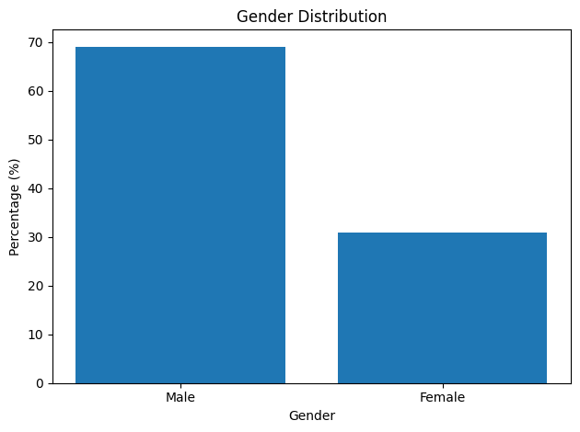
- Distribution of Respondents by Gender

This indicates that the majority of credit card users in the study are male. This distribution reflects a gender gap in usage among the respondents.

- Distribution of Respondents by Caste
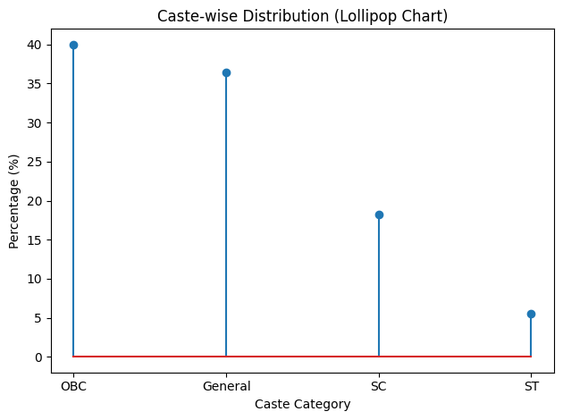

The data indicates that the majority of respondents belong to the OBC and General categories, whereas the representation of SC and especially ST respondents are comparatively lower in the study sample.
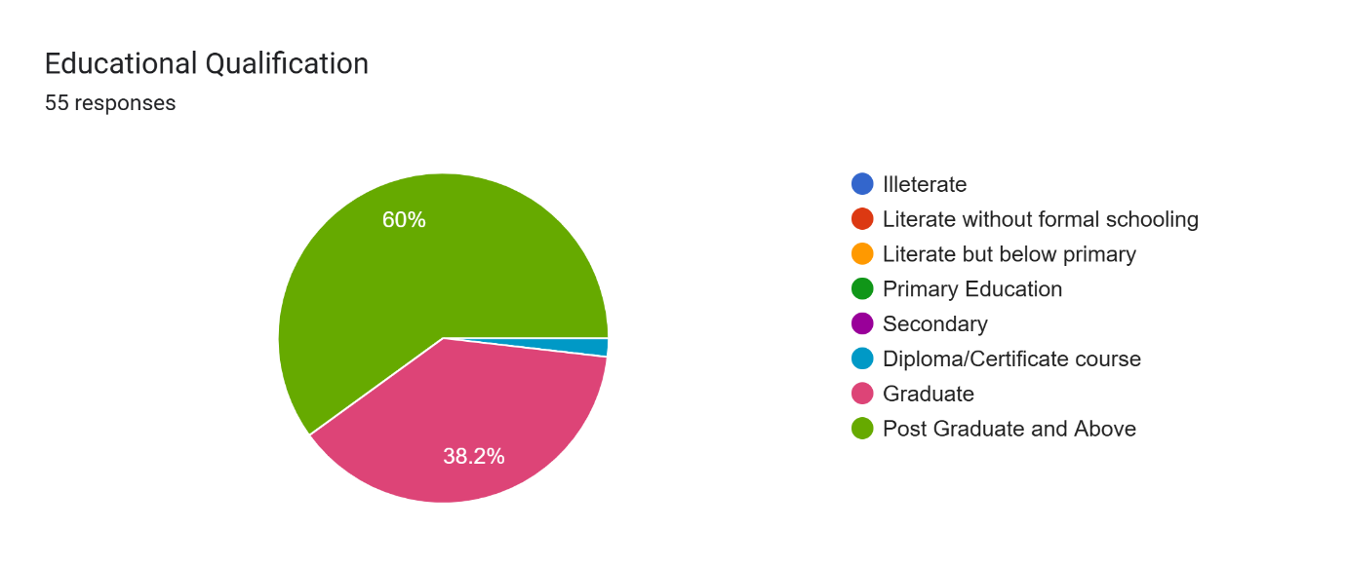
- Distribution of Respondents by educational qualification

The data suggests that card usage among the respondents is more common among individuals with higher educational qualifications, particularly those who are postgraduate or above.

- Distribution of Respondents by Age
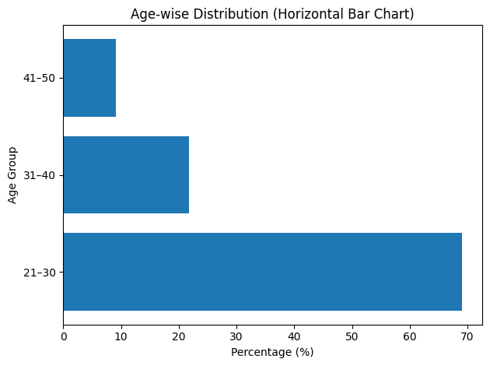
Overall, the data suggests that usage among the respondents is more common among young adults compared to adults and middle-aged individuals.

- Distribution of Respondents by occupation
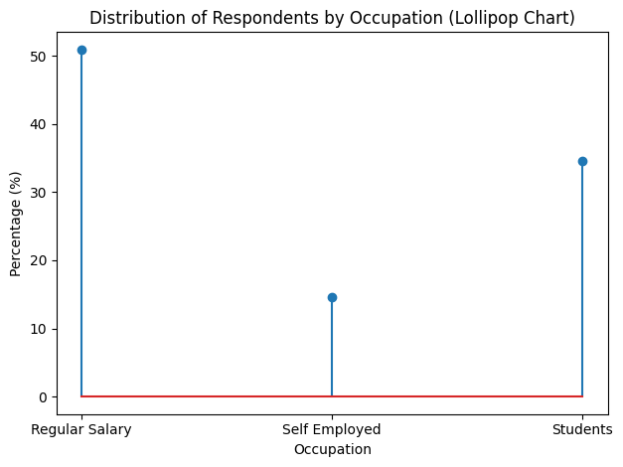

Out of the total respondents, the majority, 50.91% are regular salaried employees, indicating that most credit card users in the sample have a stable income source.

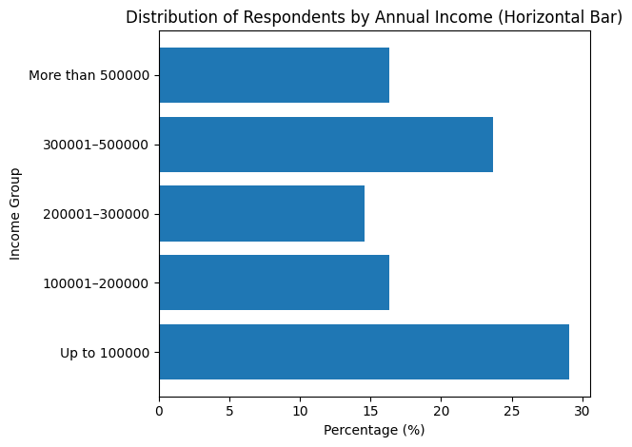
- Distribution of Respondents by annual income

The data indicates that respondents belong to different income groups, though a larger proportion falls in the lower income category.
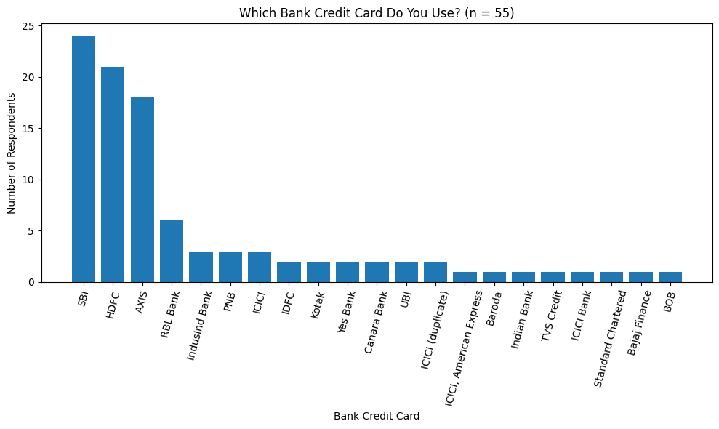
- Distribution of respondents by bank credit card used

The majority of respondents use SBI credit cards (43.6%), followed by HDFC (38.2%) and AXIS Bank (32.7%). A smaller proportion of respondents use credit cards from banks such as RBL Bank, IndusInd Bank, PNB, and ICICI. Only a few respondents reported using cards from other banks like Standard Chartered, Bajaj Finance, and Bank of Baroda. This indicates that SBI, HDFC, and AXIS dominate usage among the respondents.

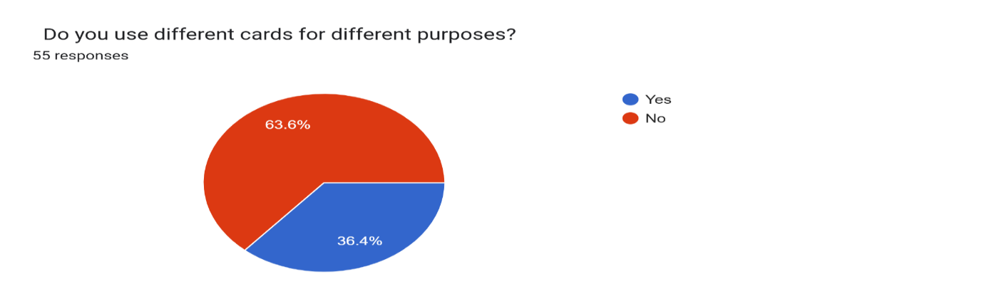
- Whether respondents use different credit cards for different purposes

The analysis reveals that a majority of respondents rely on one primary credit card, while a smaller proportion use multiple cards depending on the purpose of their spending.

The analysis identifies a well-defined user pattern, indicating that credit card usage is predominantly associated with younger, educated, and salaried individuals with moderate income levels and a preference for established banks. This reflects that credit card adoption is concentrated among financially active and digitally aware population segments.
Therefore, the null hypothesis is rejected.

8.2 To examine the usage pattern of credit Card.
To examine the usage pattern of credit cards, Chi-square tests and proportionate methods were applied to analyse the association between credit card usage frequency and various demographic variables, including gender, age group, marital status, caste, education, occupation, and income.
Variable | χ² Value | df | p-value | Significance Level | Interpretation
Gender | 7.6749 | 3 | 0.053 | 10% | Weak/Marginal Association
Age Group | 10.5558 | 6 | 0.103 | Not Significant | No Association
Marital Status | 18.9523 | 3 | 0 | 1% | Strong Association
Caste | 9.9198 | 9 | 0.357 | Not Significant | No Association
Educational Qualification | 8.8495 | 6 | 0.182 | Not Significant | No Association
Occupation | 9.2283 | 6 | 0.161 | Not Significant | No Association
Income | 16.7056 | 12 | 0.161 | Not Significant | No Association

This indicates that behavioural factors (marital status) have greater influence than socio-economic variables such as income and education.

- Purpose of using credit card
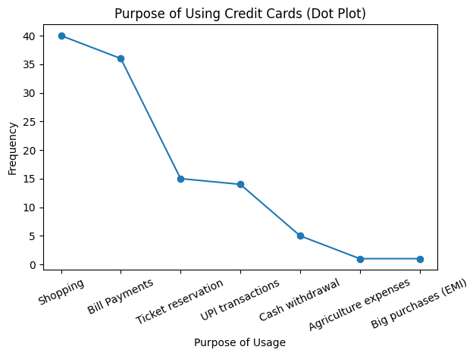

The findings indicate that shopping and online payments are the primary purposes for which respondents use credit cards, while other uses are comparatively limited.
- Motivational Factors Behind Credit Card Usage
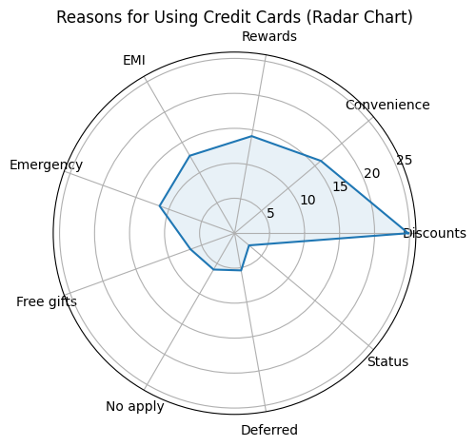

The data shows that financial benefits such as discounts, convenience, rewards, and EMI facilities are the major motivations for using credit cards.

- Credit Card Contribution to Monthly Household Expenditure
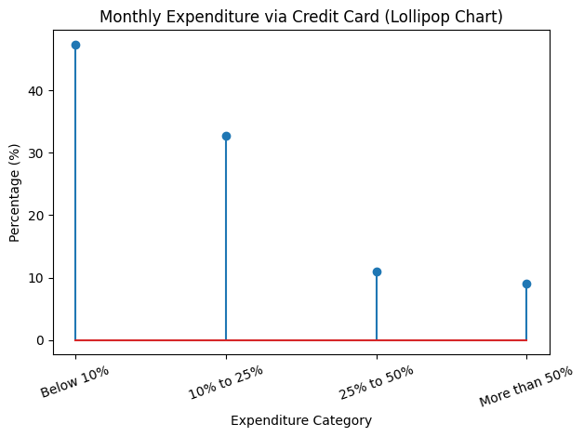

The results indicate that most respondents use credit cards only for a limited portion of their monthly expenses rather than as their primary payment method.
the findings demonstrate a clear usage pattern where credit cards are primarily used for shopping and bill payments, driven by discounts and convenience, and constitute a limited share of monthly expenditure. Therefore, the null hypothesis stating that there is no significant pattern in the usage of credit cards among users is partially rejected, as certain behavioural and demographic factors, particularly marital status, influence usage patterns. Thus, credit card usage is driven more by transactional convenience than financial necessity.

8.3 To examine the level of awareness among credit card users regarding
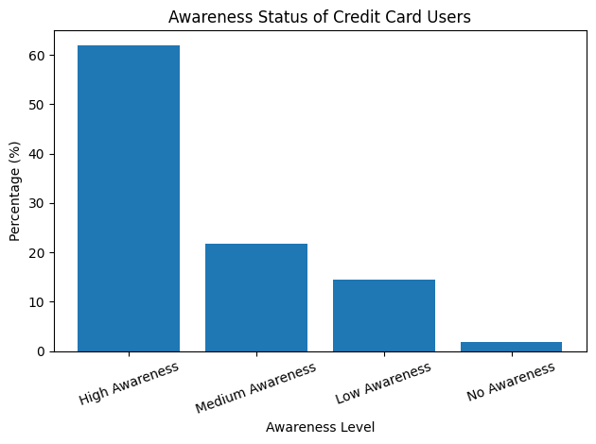
credit card policies and terms and conditions
The majority of respondents (61.82%) have a high level of awareness, indicating that most credit card users are well informed about the rules, conditions, and security measures related to card usage. About (21.82%) of respondents fall under the medium awareness category, suggesting that they have a moderate understanding of credit card policies and safety aspects. In addition, (14.55%) of respondents have low awareness, which indicates limited knowledge about credit card terms and conditions. Only 1 respondent (1.82%) reported having no awareness regarding credit card policies and safety issues.
The majority of respondents fall under the high awareness category, and a considerable proportion also has medium awareness. Only a small percentage of respondents have low or no awareness about credit card policies and terms and conditions. The data shows that most credit card users possess a good level of awareness about credit card policies, terms, and security practices, although a small proportion of users still lack sufficient knowledge. So, the study rejects the Null hypothesis that is Credit card users do not have a significant level of awareness regarding credit card policies and terms and conditions. High awareness indicates growing financial literacy among users.

8.4 To evaluate the level of satisfaction of credit card users with respect to
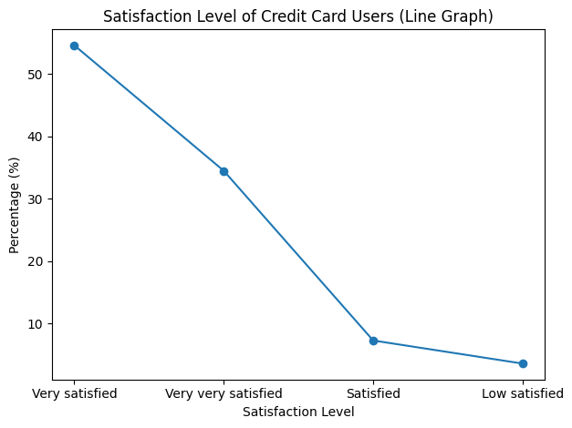
credit card facilities and services
The results indicate that the majority of respondents are satisfied with the services. About 54.55% of respondents are very satisfied, which represents the largest group. Additionally, 34.55% of respondents are extremely satisfied, indicating a very high level of satisfaction among many users. Only 7.27% of respondents are satisfied, while a very small proportion, 3.64%, reported low satisfaction.
The data shows that most credit card users have a positive perception of credit card services, as nearly 89% of respondents fall into the very satisfied or extreamly satisfied categories. This indicates that credit card providers are generally meeting the expectations of their customers, with only a small number of users expressing lower satisfaction.

The results clearly indicate that a large majority of respondents express a high level of satisfaction with credit card services. Therefore, the findings do not support the null hypothesis that credit card users are not significantly satisfied. Hence, the null hypothesis is rejected, and it can be concluded that credit card users are significantly satisfied with credit card facilities and services.

9. CONCLUSION
The study analyses the usage pattern, awareness level, and satisfaction of credit card users based on the responses of 55 participants. The findings show that card usage is more common among male respondents and young adults, indicating that younger people are more active users of credit cards. Most respondents are well-educated, with many having postgraduate or graduate qualifications, which suggests that education may play an important role in understanding and adopting credit card services. In terms of occupation, a large proportion of respondents are regular salaried employees, followed by students, indicating that people with a stable source of income are more likely to use credit cards. The results also show that SBI, HDFC, and Axis Bank are the most commonly used banks, while RuPay and Visa are the most preferred credit card networks.
The analysis further indicates that most respondents prefer to use a single credit card rather than maintaining multiple cards. Credit cards are mainly used for shopping and online bill payments, highlighting their role in everyday digital transactions. The frequency of usage shows that many respondents use credit cards occasionally, such as once a week or once a month, rather than on a daily basis. The findings also reveal that most users spend only a small portion of their monthly expenditure through credit cards, which means that credit cards are generally used as a supporting payment method rather than the primary mode of spending. Discounts during shopping, ease of payment, reward points, cashback benefits, and EMI facilities were found to be the main reasons motivating respondents to use credit cards.
The study also shows that the majority of respondents have a good level of awareness about credit card policies, terms and conditions, and security practices. Since most respondents fall into the high awareness category, the null hypothesis stating that credit card users do not have a significant level of awareness is rejected. In addition, the results indicate that most respondents are highly satisfied with the services provided by banks, with many reporting that they are very satisfied or extremely satisfied. As a result, the null hypothesis that users are not significantly satisfied with credit card services is also rejected. Overall, the study concludes that credit card users are generally aware of credit card policies, satisfied with the services provided by banks, and mainly use credit cards for convenience, benefits, and digital transactions. The study concludes that credit cards function primarily as a convenience-driven financial tool rather than a primary credit instrument.

10. POLICY RECOMMENDATIONS
Based on the findings of the study on credit card usage, awareness, and satisfaction, several policy recommendations can be suggested for banks to improve their services. Banks should focuses on increasing customer awareness by organizing financial education programs and digital campaigns to inform users about credit card policies, billing cycles, interest charges, fraud prevention, and credit scores management. In addition, banks should present terms and conditions in a simple and transparent manner so that customers can clearly understand the charges, penalties, and reward systems associated with credit cards.
Banks should also strengthen security measures by introducing advanced fraud protection systems, real-time transaction alerts, and easy card-blocking facilities. Since discounts, cashback, and reward points are major reasons for card usage, banks should continue offering attractive reward programs and promotional benefits to encourage usage. Furthermore, banks should promote responsible card usage by guiding customers about timely bill payments and financial management. Improving customer service, grievance redressal systems, and digital banking support can further enhance user satisfaction and build stronger trust among credit card users.

REFERENCES
- IndusInd Bank, “The Impact of Credit Cards on Your Financial Health” Sept 20th, 2023.
https://www.indusind.bank.in/iblogs/credit-card/the-impact-of-credit-cards-on-your-financial-health/
- One Card, “Impact of Credit Card on Personal Finance and Budgeting” June 03, 2024.
https://www.getonecard.app/blog/impact-of-credit-card-on-personal-finance-and-budgeting/
- IndusInd Bank, “The Role of Credit Cards in Personal Finance” June 4th, 2024

https://www.indusind.bank.in/iblogs/credit-card/the-role-of-credit-cards-in-personal-finance/
- Linda Mary Simon & DR. S. Saravanan, “A Study on Customers Satisfaction Towards Credit Card Services Provided by State Bank of India, with Special Reference to Coimbatore City” 2012: Vol -2 , Issue – 2 | ISSN - 2249-555X

- Arpita Khare, Anshuman Khare and Shveta Singh. “Factors affecting credit card use in India” 2012: Asia Pacific Journal of Marketing and Logistics Vol. 24, Iss: 2 pp. 236 – 256

- Vuong Duc Hoang Quan, “Customer satisfaction level towards credit card” 2014: Ho Chi Minh City Open University Journal of Science, No- 4(2)

- R. Kabaleeswaran and Dr. M. Selvachandra, “Customer Satisfaction Towards Credit Card Services – A Study With Special Reference to Chennai Metro” 2015: International Journal of Scientific Research, Volume: 4, Issue: 4 | ISSN No 2277 - 8179

- Dr. Majeesh T, “A study on customer satisfaction towards credit cards with special reference to Kannur district” 2016: International Journal of Novel Research and Development, Vol 1, Issue | ISSN: 2456-4184

- Mrs. R. Maheswari and Dr. T. Palaneeswari, “A study on customer satisfaction towards credit cards with special reference to private sector banks in Sivakasi” 2017: International Journal of Advance Research, Adv. Res. 5(6), 1520-1526 | ISSN: 2320-5407

- Dr. N. Bagyalakshmi & T. Lavanya, “A study on customer satisfaction and problems faced towards credit cards by credit card users” 2018: Journal of Emerging Technologies and Innovative Research, Volume 5, Issue 5 | ISSN-2349-5162

- M. Prabhu. “A study on consumer satisfaction towards credit cards with special reference to private sector banks in Madurai District” 2018: Shanlax International Journal of management, vol.6, Issue 1 | ISSN: 2321-4643

- William Robert, Maheshwar. A, “A study on effect of credit card on customer satisfaction in Chennai” 2020: Journal of Contemporary Issues in Business and Government Vol. 26, Issue 2 | P-ISSN: 2204-1990; E-ISSN: 1323-6903

- Divya E & Dr. C. Karthick, “A Study on Customer Preference and Satisfaction towards using credit cards with special reference to Coimbatore city” 2021: International Journal of Advances in Engineering and Management, Volume 3, pp: 1724-1728 | ISSN: 2395-5252

- Dr. R. Reena, S. Archana, S. R. Subhiksha, S. Kavipriya & D. Poovili, “A study on consumer perception toward credit card usage” 2021: Net Volatiles and Essent oils, 8(5): 4710-4717

- Ms. Harsha S. Parecha & Dr. Mahesh C. Dabre, “A study on the satisfaction level of debit and credit cardholders of nationalised banks in Amravati city” 2021: Inspira- Journal of Modern Management & Entrepreneurship, Vol 11, No. 03 | ISSN: 2231–167X

- Dr. R. Sridevi & A. Naveen kumar. “A study of on usage and satisfaction towards credit card users of HDFC Bank within Coimbatore city” 2022: International Journal for Science and Advance Research in Technology, vol 8, Issue 5 | ISSN:2395-1052

- Mrs. J. Rini Mercy, Ms. S. Devi & Dr. S. Nithya Sumathi, “A study on customer satisfaction towards credit cards with reference to Coimbatore city” 2022: South India Journal of Social Sciences, Vol. XX, No.2 | ISSN: 0972 8945

- Dr. S.S. Muruganandam & R. Shakthi, “A study on consumer spending via Credit cards” 2023: International Journal of Creative research Thoughts, vol 11, Issue 9 | ISSN: 2320-2882

- Dr. Deepak kumar, Dr. Jaideep Sharma, Dr. Md Chand Rashid & Dr. Mujibur Rahaman, “Customer satisfaction towards credit cards : An empirical evidence” 2023: Journal of research Administration, vol 5, No.2 | ISSN: 1539-1590

- Dr. R. Mohan, “A Study on Customer Awareness and Satisfaction among Credit Cardholders in Krishnagiri District” 2023: International Journal of Humanities and Social Science Invention, Volume 12 Issue 5 | PP:17-22 | ISSN (Online): 2319 – 7722, ISSN (Print): 2319 – 7714

- Seelam Jayadeva Reddy, Dr. Rupali Dilip Taru & Dr. Chandra Sekhar Pattnaik, “A study on customer satisfaction towards financial services at select banks” 2023: Anveshana’s International Journal of Research in Regional Studies, Law, Social Sciences, Journalism and Management Practices, Vol 8, issue 6 | ISSN-2455-6602 (O)

- Ong Boon Hai, GholamReza Zandi, Shaheen Mansori and Imran Ahmed Shahzad, “Impact of customer satisfaction and service quality on membership renewal: A study on Malaysian credit cardholders” 2024: Journal of Management World, 1: 21-29

- S. M Kavya & Rithika. S, “A Study on Customers Satisfaction towards Credit Card Services Provided by State Bank of India, with Special Reference to Coimbatore City” 2024: International Journal of Research Publication and Reviews, Vol 5, no 5, pp 211-216 | ISSN 2582-7421

- Vikashini. S. & Ms. W. Infant Emiliya, “A study on customers satisfaction towards credit card services provided by HDFC Bank” 2024: International Journal Of Research Culture Society, Volume - 8, Issue – 4 | ISSN(O): 2456-6683

- Nithish Kumar R V & Mrs. A. Sangeetha Priya, “A study on usage trends of credit card” 2025: International Research Journal of Education and Technology, Vol - 8 Issue – 4 | ISSN 2581-7795

- Mr. M. Prakash, “Consumer Satisfaction with Debit Card and Credit Card” 2025: International Research Journal of Education and Technology, Vol: 08 Issue: 04 | ISSN 2581-7795

- Ms. K. Kalaivani & Dr. C. Prakash, “A Study on Customer Preference and Satisfaction Towards Using Credit Cards with Reference to Cuddalore District” 2025: International journal of Creative Research Thoughts, Volume 13, Issue 9 | ISSN: 2320-2882

- A. Kathir, K. Sakthivel & N. Sowmiya, “A study of analysis of consumer’s satisfaction toward credit card service by State bank of India in Madurai city” 2025: International Educational Scientific Research Journal, VOLUME: 11 | ISSUE: 3 | E-ISSN NO: 2455-295X

- Mandira Sharma, “Index of Financial Inclusion” 2008: Indian Council for Research on International Economic Relations, PP 3-18.

