Automated Interpretation of Egyptian Hieroglyphics

Bh. Prashanthi^{1,a)}, Tuppali Vaishnavi^{1,b)}, Jinkala Sowmya^{1,c)}, Kasi Devika Kalyani^{1,d)}, Banothu Tejaswini^{1,e)}
¹Department of CSE Gokaraju Rangaraju Institute of Engineering & Technology Bachupally, Hyderabad, Telangana, India.

Corresponding Author: ^{a)}bhprashanthi1424@grietcollege.com

^{b)}vaishnavituppali04@gmail.com

^{c)}jinkalasowmya630@gmail.com

^{d)}kasianandkumar123@gmail.com

^{e)} tejaswinibanoth8@gmail.com
Abstract. Among the oldest and longest-lasting written systems created by humanity are hieroglyphs. Hieroglyphic writing illustrates the day-to-day existence, religion, and culture of an ancient civilization. Many people are unable to read and comprehend hieroglyphs even though these symbols are significant from a historical perspective. However, recent advances in Artificial Intelligence (AI), Machine Learning (ML), and Multimodal Large Language Models (LLM) give an opportunity to automate reading the visual component and linguistic component of images of hieroglyphs. In addition, these technologies assist in better digital preservation of cultural heritage. This paper describes several projects that have created an automated interpretation system for hieroglyphs utilizing Groq LLaMA, Gradio interfaces, computer vision pipelines, and a structured output parser. The Egyptological based historical description has been elaborated on to aid in clarifying the significance of using hieroglyphs as names assigned to individual burials as well as representing achievements of architecture. This paper will describe the hieroglyph interpretation system and the methodology for the system, how AI aids in the decoding process, and the outcomes of AI-assisted decoding concerning education, tourism, and archaeology.

Key words: Egyptian Hieroglyphics, Optical Character Recognition (OCR), large language models (LLMs) , Deep Learning, Natural Language Processing, Transformer Models, Image Processing, Ancient Language Translation.

1. INTRODUCTION

Egyptian hieroglyphics were used as the main writing form used to mark items of worship, remember deceased individuals, pay homage and keep records for more than 3000 years in temples, tombs, monuments and administrative records. In addition to representing a sound, word or phrase, each character demonstrates a sophisticated form of writing. To achieve this sophistication, each character is comprised of a combination of phonetic, symbolic and semantic elements. Despite the extensive research conducted by scholars around the world regarding the history of Egyptian hieroglyphs and their meanings, there are several layers of meaning for each character; thus it is difficult for someone who doesn't know the specific meaning of a particular symbol to interpret it correctly or understand its significance. The majority of tourists who wish to learn about Egyptian hieroglyphs see little other than what can be found on simple plaques in museums, which can impede their ability to appreciate the content's historical context.

Today’s AI-based systems can decode ancient hieroglyphs through various automated methods including Groq LLaMA. The user will be able to automatically translate pictures of hieroglyphs into modern-day English through the use of advanced multimodal models that combine the use of “computer vision” to segment symbols with the use of “large language models (LLMs)” to process user requests and obtain the semantic meaning of each symbol, and lastly the use of an initial interactive tool via the Gradio User Interface to enable individuals access to ancient Egyptian written forms. An examination will occur on the technical and cultural aspects of this automated interpritative pipeline in order to provide clear understanding of the pipeline.

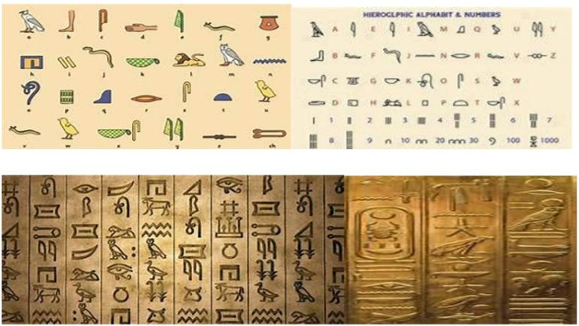
FIGURE 1. Egyptian hieroglyphics

- LITERATURE SURVEY

In this section, multiple projects will be discussed that automate the understanding of hieroglyphics, primarily through deep learning, computer vision and multi modal AI methods. The articles that were reviewed either have been previously published, contain existing datasets for evaluation purposes or provide performance metrics. Overall, these projects form the basis and motivation for future generations of automated hieroglyph translations through AI technologies.
A Deep Learning Approach to Ancient Egyptian Hieroglyphs Classification (2021) [1] In this study, the authors explore an approach to hierarchically classify ancient Egyptian hieroglyphs through the use of a convolutional neural network based system (i.e. Glyphnet) and employing transfer learning to enable the classification task to be addressed with a set of images of hieroglyphs taken from the Pyramid of Unas using multi support labeled images. The authors also obtain both improvement in overall accuracy and F1 scores for their data set by training on images having multiple support labels, with the qualifier that due to the small amount of training data, the nonlinear nature of the images, and the authors’ personal opinions concerning the readability of damaged ancient hieroglyphic texts, these results may not be generalizable to other hieroglyphs or hieroglyphic texts (Alessia Spoladore et al, 2019). Multispectral Imaging to Uncover Ancient Hieroglyphic Text in an Egyptian Stele (2021) [2] The authors suggest four ways to decode hieroglyphs that have lost detail. These methods include using multispectral imaging, using near infrared bands, employing blind source separation, and using hidden pattern enhancement in order to illuminate or detect the hieroglyph images from the surface. They provided an example of the multi-spectral imaging of Stela S.6145 that is not currently readable with standard human vision. Using this method, the authors obtained evidence from the class analysis of objects from S.6145 demonstration of the multispectral imaging. The authors indicate that additional limitations to their research and results derivations are present because only nine objects were included in the analysis of linking image classification data with large degree of errors. (Andrea Barucci et al.). Decoding Ancient Scripts Using Deep Learning Based Sequence-to-Sequence Models (2025) [3] The authors in this paper describe a method for decoding ancient hieroglyphic text using a sequence to sequence (S2S) convolutional neural network-based approach using multi-spectral imaging. The primary goal of this paper is to decode long sequences of hieroglyphic text found in multispectral images. Aegyptos: Mobile Application for Hieroglyphs Detection, Translation and Pronunciation (2023) [4] The application of Aegyptos within this study is as a mobile application for hierarchical symbol translation via the use of Otsu’s Thresholding for detection and segmentation of the symbol, SqueezeNet to extract feature data for the symbols, and a Transformer for translating the detected hierarchical symbols. There were disadvantages associated with using Aegyptos such as limited testing datasets and contextual difficulties in translating the Egyptian hierarchical symbols. Egyptian Hieroglyphics Handwriting Character Classification Using CNN with Explainable AI (2025) [5] This paper describes the authors' work on developing a convolutional neural network (CNN)-based classifier that identifies written hieroglyphs from 18 different classes. The researchers used SHAP and LIME to provide further insight into how the CNN is identifying each class of hieroglyph by referencing the key attributes which influenced the model's decision making. Additionally, one of the weaknesses of this study was the limited size of the training data set, as well as the limited generalizability of the Classic style of hierarchy and low to moderate accuracy.
An AI-Based Automatic Translator for Ancient Hieroglyphic Writing From Scanned Images to English Text (2023) [6] This study presents a new hybrid architecture that incorporates R-CNN and ResNet50 within the framework of a Siamese architecture model, for the purpose of translating scanned images of hieroglyphs into English. The AI-powered translation process utilizes a Transformer model, while also being enhanced through the development of a dictionary and the creation of a unique data set from the Morris Franken and Unas Pyramid glyph datasets. The model produced accurate classification rates for the glyphs in question; however, due to the limited size of the data set, the ability to correctly translate long sequences of glyphs or complex/rare glyphs will decrease. Smart Informatics & Egyptology: A Modern Interdisciplinary Forum (2020) [7]This research study presents implications of using deep learning informatic systems on Egyptology. We summarize four areas of deep learning informatic systems (via CNN) related to Egyptology: transfer learning; data augmentation; feature extraction; and artifact data-sharing.The database developed for this project has a multi-layered abstraction model with respect to containing images, labels, annotations and metadata/features extracted from raw data. Although new technology offers better ways to provide visual learning when using deep learning informatic systems, as well as assist researchers in identifying artifacts in particular, symbol classification methods of hieroglyphs do not provide accurate classifications of symbols due to significantly varying levels of classification accuracy at the point of usage throughout history of a culture’s development. emple Inscriptions Recognition and Transliteration in Devanagari Script (2023) [8] his study describes how an ancient Indian palm leaf inscription has been transliterated from a photograph of the original inscription using a deep learning framework. This work will further our understanding of ancient scripts in general; however, it specifically relates to ancient Indian inscriptions on palm leaves. The authors used a computer model based on a manuscript containing temple inscriptions as input to an ensemble transliteration and recognition model. Limitations of this research include the size of the dataset and that the Vattetluttu is not the primary focus for use other than scholarly research. Hieroglyphs Language Translator Using Deep Learning Techniques (Scriba) [9] In this study a PPO actor-critic DRL modeling approach for swarm robotic control was proposed through the combination of CNNs and parameter sharing. The simulation was conducted in a simulated world consisting of 20 x 20 units and contained 3 robots; completion rates averaged approx. 83%; limitations are being simulated and 3 robots out of 2D grid world. Exploring Hieroglyph Recognition: A Deep Learning Approach (2024) [10] The study uses models such as ResNet, VGG, DenseNet and Inception in order to classify the hand drawn hieroglyphs using the Gardiner dataset. While using large datasets improved classification accuracy, there is no context reasoning to process data, therefore it could not develop text interpretation in a meaningful and semantic sense.

PROPOSED SYSTEM

The framework described above has been developed to implement an automated method of interpreting Egyptian hieroglyphic inscriptions. This automated interpretation process has three components: The first component is the user interface (UI) hosted on a web server where users may upload a file. The second component is the FastAPI backend server, which validates and preprocesses the uploaded document. The third component is the multimodal vision-language model that uses contextual reasoning to derive an overall interpretation from the original document's multiple images, including the user's request. Conventional OCR systems typically only focus on symbol detection. The new model described in this proposal uses symbolic recognition and, in addition to identifying the hieroglyphic symbol(s), will also identify temporal elements such as when those symbols were created, what the script style is like, and which media was used to produce the hieroglyphics. The user uploads an image in Step 1 of the automated process. After the image is successfully uploaded, the FastAPI server validates the image and preprocesses it for input into the AI-based process in Step 2. In Step 3, inference is provided to the user via the ML model based on the preprocessed data from Step 2. The ML model result will be returned to the user in the same panel as the uploaded image in structured data.

3.1 System Architecture

A modular and layered architecture is the key to scalability and maintainability. The front end, using web technologies, provides an interface for uploading an image, selecting the output language, and navigating through the interpretation panels. The application first validates and converts the uploaded image into a base64 encoded file on the back end, which allows the image to be transmitted efficiently to the back end. The FastAPI framework functions as the primary processing layer for the application and generates structured prompts to send to the multimodal AI model for symbolic identification and contextual reasoning. The neural networks use both the structured prompts and the base64 encoded image file to create structured outputs, which the back end then converts to JSON format before delivering them back to the front end for categorized rendering. The separation of these responsibilities allows structured communication between the components and enables the generation of prompt responses in real time.

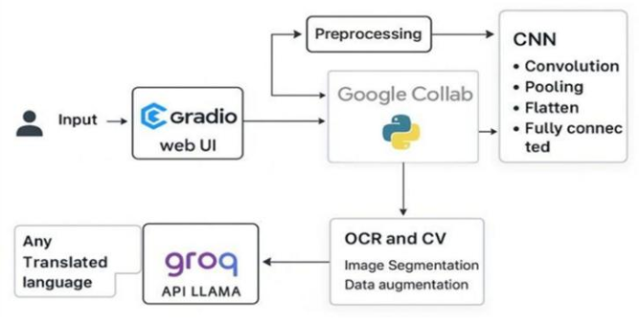
FIGURE 2. System architecture.
3.2 Dataset Description
Formal symbol charts (hieroglyphics), letters & number symbols from public databases & open datasets will be used to create the dataset for this project. This dataset will include individual hieroglyphic symbols to be used in the classification of each sample and hieroglyphic inscriptions with their associated context in order to determine their meaning. Each image within the dataset will differ in the resolution, chip depth, artistic style, and time period, which could generalize the functionality of the model across many examples. Additionally, each of the images will also contain a sample from Gardiner’s classification including the application of classification to identify type of symbol as follows: alphabet symbol, biphallic symbol, triliteral (consonant combination) symbol, determinative symbol, numeric representation of symbol. The use of multiple digital processing techniques will then be applied to improve the consistency and validity of the model samples through resizing all samples to a standard size, normalizing all pixels to one common range of values, enhancing the contrast of all pixels to improve picture clarity, and removing any image noise which artificially affects how recognizable a symbol/image will be.
3.3 Evaluation Metrics
The evaluation of the model consisted of quantitative and qualitative methods. One method included evaluating the accuracy, or how well the model identified hieroglyphic symbols. To establish a balance in results between clearly intact hieroglyphic symbols and damaged or unreadable symbols, precision and recall, as well as F1-scores, were calculated for all images of different English representations of hieroglyphic symbols using symbols that were identifiable within the model. The average identification rate of the model for recognizing symbols was in the 88%-92% range for images that were visually without distortion (i.e., visual distortion produced by the object/image). The range of the F1-scores produced was from 0.88 - 0.90, which can be described as being very good overall in terms of how correctly the output could produce usable images. One other way to evaluate how efficiently the model produced output was to evaluate the amount of time from the time of upload to the time the output could be used; therefore, on average, it took from three to six seconds for output to be produced for use.

- RESULTS

4.1 Unit and System Testing

Extensive testing confirmed that the unit had been functioning correctly in an isolated environment before testing in an integrated setting which would validate that all of the functionality had been integrated together correctly. Once complete, we moved onto performing an end to end validation of the unit using the integrated system. During the multiple tests performed with uploaded images, the system was able to handle very large images; produced results in multiple languages; processed them in normal amounts of time and maintained communication via API throughout these processes. The results from our six tests did not indicate any failures or crashes, providing strong indications that the unit's architecture will be stable when placed under normal operational loads.

4.2 Image Quality Impact Analysis

A study was conducted to see how overall image clarity affects the ability to recognize symbols. Non-blurry images had an average recognition rate of 92%, while blurry images reduced recognition accuracy to 85%, and severely eroded images reduced average recognition to 72%. The confidence rate in recognizing each symbol decreased at the same rate as the quality of the image degraded, and response times slightly increased due to processing of degraded images. Despite the loss of image quality, the multimodal model still had adequate interpretability since it was able to reason about the context surrounding the image.
4.3 Multilingual Interpretation Evaluation

The multilingual module evaluation confirmed that there is still semantic equivalency between the English and Telugu versions of semantically-equivalent content. The evaluation indicated that in both situations, there existed an accurate representation of the meaning of the phrases, along with an appropriate historical context for both the English and Telugu development grammar; this was also evidenced by the use of differently constructed grammatical structures with minor differences for each version in relation to a common grammatical structure for both versions. Additionally, user feedback indicated a high degree of satisfaction with the support for multilingual users and that this was confirmed by confirmation of a larger number of users from a wide range of different language groups, as a result of the system.

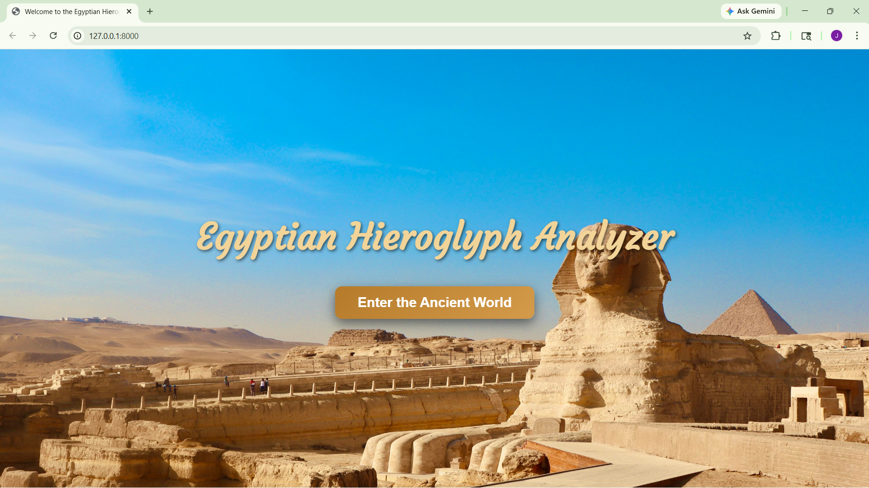

FIGURE 3. Home Page

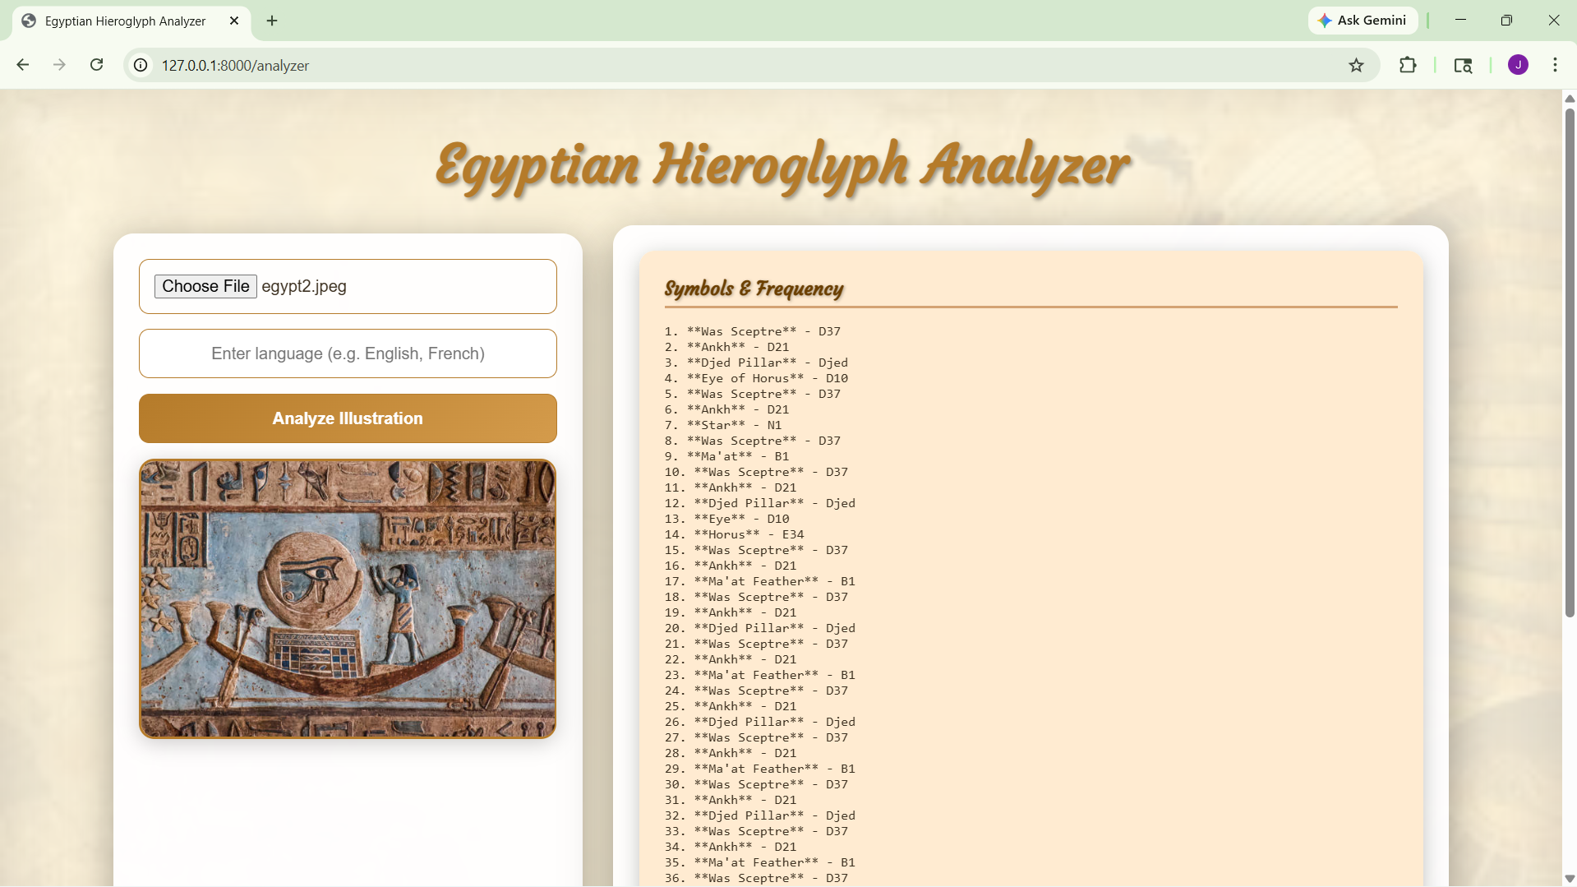

FIGURE 4. Symbol and their gardiner codes

4.4 API Response Time Analysis

We evaluated performance for each configuration across all test conditions, and the results indicated the system continued to perform reliably and consistently. The average response times per user (for a single user) ranged from 3 to 4 seconds, while three (3) consecutive users had average response times of approximately 4 to 5 seconds, and five (5) consecutive users saw average response times between 5 and 6 seconds. Performance for API inference was found to be consistently accurate over time during the entire duration of the test, with no indication of unexpected application crashes or failure events, leading us to conclude that the system operates reliably given moderate operational workloads.

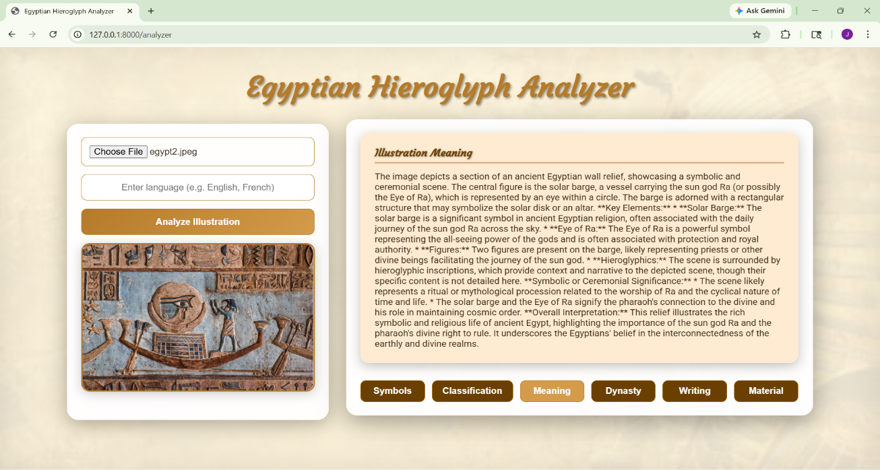

FIGURE 5. Symbols Meaning

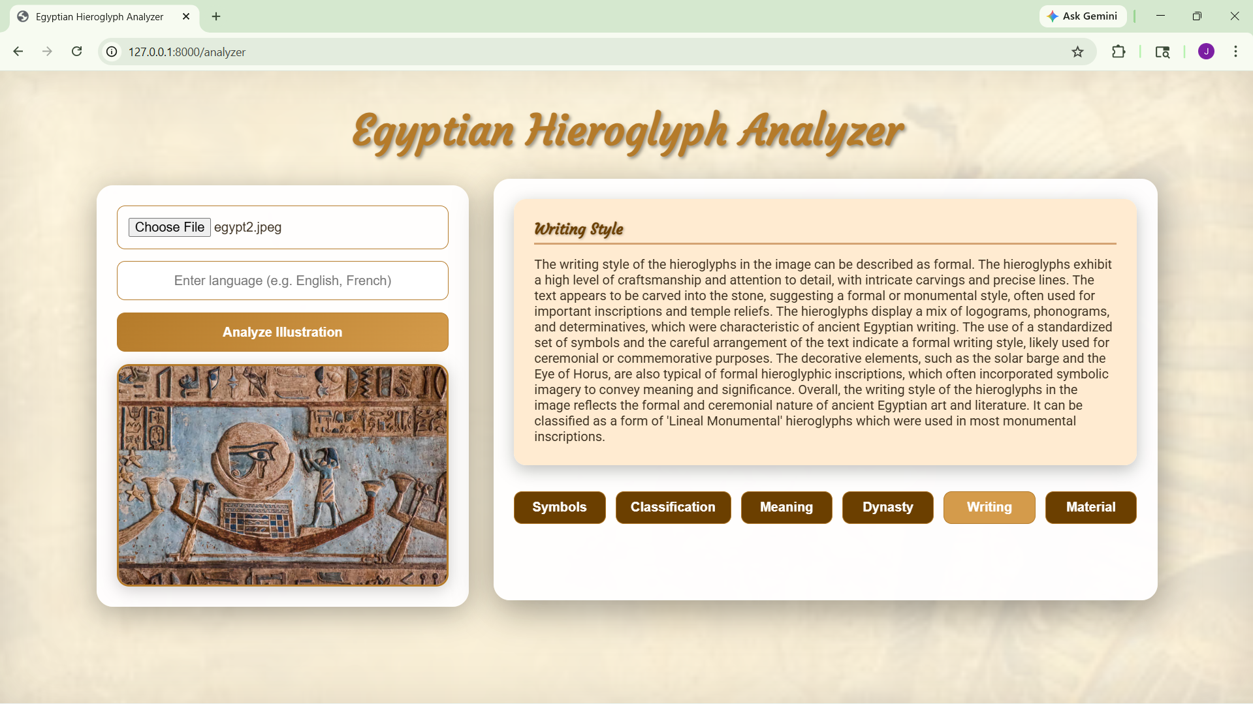

FIGURE 6. Writing Style

- CONCLUSION

A new framework has been developed that leverages artificial intelligence (AI) to automatically read Egyptian hieroglyphs through a multi-model visual language model with a fast API back end and interactive Web-based front end so that the system can recognize hieroglyphic symbols on inscriptions and produce contextually relevant meanings, estimate the associated dynasty of the hieroglyphs, analyse the writing styles used by different scribes, and classify the materials used in producing the hieroglyphic inscription using an accuracy rate b etween 88 and 92 percent. The results of testing the system demonstrate that it can provide multiple language-capable responses in less than one second and can also function effectively even if the images are partially degraded.
This potential of AI to connect our understanding of an ancient cultural heritage through the use of modern technology is illustrated by the transition of hieroglyphic text from a static format to a more dynamic, organized, and accessible format. The long-term goal of further development of the proposed system will be to support the advancement of education, research, tourism, and digital preservation related to Egyptian artefacts. Further iterations of the proposed system are likely to enhance support for other languages, allow for improved segmentation to enhance feature extraction, and include additional technologies (augmented reality) that can facilitate mobile access to the system as a comprehensive digital-assistant to the field of Egyptology.

REFERENCES
- A. Spoladore, T. Cavaleri, S. Legnaioli, and V. Palleschi, “A Deep Learning Approach to Ancient Egyptian Hieroglyphs Classification,” 2021.
- A. Barucci, C. Cucci, M. Franci, M. Loschiavo, and F. Argenti, “Multispectral imaging to reveal ancient hieroglyphic text in an Egyptian Stele,” 2021.
- Z. Sattorova, A. Madraimov, M. Muhirdi, and M. Urainova, “Deciphering Ancient Scripts Using Deep Learning-Based Sequence-To-Sequence Models,” 2025.
- Md. I. H. Abir, Md. S. Ahmed, N. Bashar, and H. I. Peyal, “Egyptian Hieroglyphics Handwriting Character Classification Using CNN with Explainable AI: SHAP and LIME,” 2025.
- S. E. Mohsen, R. Mansour, A. Bassou, B. Dessouky, S. Refaat, and T. M. M., “Aegyptos: Mobile Application for Hieroglyphs Detection, Translation and Pronunciation,” 2023.
- N. A. Aneesh, A. Somasundaram, A. Ameen, G. Sreekar, and R. Jayashree, “Exploring Hieroglyph Recognition: A Deep Learning Approach,” 2024.
- A. Sobhy, M. Helmy, M. Khalil, S. Elmasey, Y. Boules, and N. Negied, “An AI-Based Automatic Translator for Ancient Hieroglyphic Language From Scanned Images to English Text,” 2023.
- A. Barucci, C. Cucci, M. Franci, M. Loschiavo, and F. Argenti, “Smart Informatics & Egyptology: A modern interdisciplinary forum studying an ancient culture,” 2020.
- B. S. Babu, S. Shetty, A. Agarwal, and S. L. Sreerama, “Temple Inscriptions Recognition and Transliteration in Devanagari Script,” 2023.
- R. Moustafa, F. Hesham, S. Hussein, B. Amr, S. Refaat, and N. Shorim, “Hieroglyphs Language Translator Using Deep Learning Techniques (Scriba),” 2020.

