AeroTerra Bot: The Ultimate Transforming Vehicle

INTRODUCTION

The development of robots is advancing rapidly in engineering today. This has driven a demand for robots capable of versatile movement across various environments. Usually, robots are designed for a singular environment. For example, robots that move on the ground are effective at traversing terrain and can carry significant payloads. On the other hand, flying drones are highly agile and rapid but they often cannot handle obstacles on the ground.
There are situations in real-world scenarios, such as when searching for individuals or monitoring distant areas or deliver things to remote areas, where we need a vehicle that can move on both land and in the air seamlessly. Robotic systems require this capability to be truly versatile.
Hybrid robotic vehicles are still new. These are primarily observed in academic research environments. When you buy something like this it usually only does one thing. Moreover, there is a lack of accessible, user-buildable robots capable of readily transforming between different machine types. The primary challenge in designing a shape-shifting robot, akin to a transformer, lies in achieving seamless integration of its components. It is crucial to ensure that the mechanical linkages and actuation systems are sufficiently robust to prevent structural failure or excessive weight gain during transformation. These
hybrid robotic vehicles must be capable of seamless transformation.

The AeroTerra Bot is a remote-controlled vehicle. It is designed to bridge the capabilities of ground-based and aerial robotic systems. The project demonstrates a method for fabricating a functional transforming robot. The AeroTerra Bot integrates the advantages of a ground-based tank with the beneficial attributes of an aerial quadcopter. The developers of the AeroTerra Bot employed computer-aided design and advanced materials, such as carbon fiber, to ensure its structural integrity and light weight. This is crucial for the AeroTerra Bot's optimal performance in both modes.
This involves the development of a dependable mechanical transformation system using high-torque servos and linear actuators; the integration of a high-performance control system featuring a Teensy 4.0 microcontroller and custom PCB; and the implementation of the Dream Flight firmware to coordinate mode-switching and flight stabilization.
The project aims to deliver a robust prototype capable of switching between tank and quadcopter modes at the press of a single button.
The AeroTerra Bot excels at facilitating access to challenging environments. This capability stems from its ability to navigate areas inaccessible to conventional robotic systems. Furthermore, the AeroTerra Bot can access hazardous or extremely difficult-to-reach locations.
The AeroTerra Bot project also aligns effectively with several Sustainable Development Goals. Specifically, these include Quality Education and Industry, Innovation, and Infrastructure. The AeroTerra Bot project helps with Quality Education and Industry, Innovation and Infrastructure. The AeroTerra Bot does this by helping people learn about science and technology. It also helps us learn about ways to move around.

Theoretical contributions focus on overcoming kinematic constraints, optimal linkage systems for smooth transformation, and control algorithms for multi-mode function. Section II surveys existing literature on hybrid robots; Section III

details the methodology, including material selection and mechanical assembly; Section IV discusses the software and control logic; and Section V presents the testing results and potential applications.
Field applications are experimentally demonstrated in areas such as search-and-rescue, surveillance, and complex obstacle negotiation, but commercial viability is not yet established.

LITERATURE SURVEY
The creation of robotic systems is a significant area in robotics research(Ryalat et al., 2025). These systems are distinctive due to their ability to operate in both terrestrial and aerial environments(Hu et al., 2023). Researchers in robotics recognize the need for robots capable of agile terrestrial locomotion and flight(Sugihara et al., 2023). This capability allows hybrid robotic systems to access environments inaccessible to conventional robots(Fan et al., 2019). Hybrid robotic systems excel at navigating terrains and can utilize flight for rapid deployment(Zhang et al., 2023).
Evolution of Hybrid Terrestrial-Aerial Systems Early research explored hybrid systems to assess the feasibility of combining flight and ground movement simultaneously(Sreevishnu et al., 2018). The objective was to ascertain the possibility of integrating flight and ground locomotion into a single platform(Koshy et al., 2018). The AQT-HR is an example of this. It is a machine that operates both terrestrially and aerially(Zhang et al., 2023). There are also robots that are attached to something with a kind of string. These are known as tethered robots, designed for specific aerial and terrestrial tasks(Battocletti et al., 2024). Additionally, the Air Crab is a machine capable of flight and ground-based manipulation(Cao et al., 2024). Hybrid systems, like the AQT-HR and the Air Crab are noteworthy for their versatile capabilities(Cao et al., 2024; Zhang et al., 2023). Mechanical Design and Transformation Challenges, the primary challenge in designing reconfigurable robots lies in circumventing kinematic limitations and ensuring reliable morphological transformation(Moreno et al., 2018). Researchers have explored various approaches to robot articulation and actuation to facilitate seamless shape transitions(Matheou et al., 2023). The robots that can change shape are hard to make because they must be able to change shape in a way that's reliable. Researchers are working on the linkage systems and the control strategies that enable this(Matheou et al., 2020). The objective is to develop robots capable of flawless morphological transformation(Sun et al., 2023). When considering weight reduction, it is crucial to address the trade-off between increased strength and added mass, a significant design challenge(Ramezani et al., 2021). Therefore, to mitigate this issue, materials such as carbon fiber and high-temperature-resistant nylon are employed for weight reduction(Opalach et al., 2021). This approach ensures reliability and optimal performance while achieving weight reduction(Ramezani et al., 2021). Mechatronic integration is crucial in modern designs, which emphasize holistic system integration(Chhabra & Emami, 2010). They leverage control systems to streamline multi-mode actuation(Raduenz et al., 2022). This integration facilitates the management of multi-mode actuation, thereby enabling the smooth operation of modern designs(Deaconu et al., 2019). Control Systems and Software Architectures Control strategies for robots have evolved significantly. Previously, they involved simple remote operation. Currently, robotic control strategies are complex, employing advanced mathematical techniques to maintain hybrid robot stability(Brogliato et al., 1997). This is a critical aspect for hybrid robots(Brogliato et al., 1997). Localization is crucial for robots.
Various methods are employed to enable them to determine their position(Stączek, 2017). This includes using wave-based technologies, such as ultrasonics, to enhance the autonomous capabilities of reconfigurable robots(Semborski & Idźkowski, 2024). These advanced techniques will foster greater robotic independence, as localization is critical for enhancing the intelligence and self-sufficiency of reconfigurable robots(Stączek, 2017).
Firmware and Logic When we use firmware like dRehmFlight for our flight controller, it helps our high-torque servos and brushless motors work well together when we switch modes(Koch et al., 2019). This firmware is essential for the flight controller's proper operation with servos and motors(Martí-Saumell et al., 2023). Moreover, the preflight firmware enables mode switching, which is highly beneficial for our flight controller(Tomić et al., 2012).
Computational intelligence is a field of growing interest. Research focuses on how to use special computer models and neural networks to make agricultural and neuro-robotic systems more effective in decision-making and task execution. These systems can be used in different ways. Computational Intelligence is the key to making these systems more intelligent. Researchers are investigating how to utilize Computational Intelligence to improve the way these systems work. This approach is significant as it can facilitate make better decisions and get better results from these systems. Field Applications and Commercial Viability While many hybrid robots are currently limited to experimental demonstrations in university research, their potential utility in search-and-rescue, surveillance, and obstacle negotiation is well-documented(Oliveira & Ramezani, 2020; Sato et al., 2021). The primary goal of current DIY and academic prototypes is to move toward a robust, seamless mechanical transformation that can eventually achieve commercial viability.

PROBLEM STATEMENT
The field of robotics is primarily dominated by systems designed for specific applications. Mobile robots on the ground are adept at terrestrial locomotion and capable of carrying significant payloads(Amar et al., 2007), but they often get stuck when the ground is rough or when they encounter substantial obstacles(Datar et al., 2024). On the other hand, flying robots like quadcopters are very fast and can move quickly(Loquercio et al., 2021), but they do not have batteries that last very long(Saravanakumar et al., 2024), they are not robust in adverse weather(Greenwood, 2018), and they cannot carry heavy payloads for ground transport(Hardin et al., 2018). These issues are prevalent in mobile robotics; while mobile robots excel in certain applications, they are not universally suitable. There are some unresolved issues with hybrid platforms, despite their potential utility. Several important issues with these platforms have not been solved in existing research, and a lack of effective solutions in commercial offerings. Despite their advantages, hybrid platforms still present critical challenges that require attention. A significant challenge for reconfigurable robots lies in integrating their movable components. Ensuring the mechanical integrity of components during transformation, such as from a terrestrial vehicle to an aerial drone, is crucial. The robot must transition between configurations, such as tank and quadcopter, without mechanical failure. This represents a core technical challenge in the design of such robots. Mechanical complexity and reliability are very important for reconfigurable robots.
When considering hybrid vehicles, weight and structural integrity are crucial factors. Hybrid vehicles need to be strong so they can move on the ground. Simultaneously, hybrid vehicles must be lightweight to

achieve effective flight. The problem is that most hybrid vehicles are either too heavy to fly or they are too weak to handle rough ground. This presents a challenge for hybrid vehicles, as they require proficiency in both aerial and terrestrial locomotion. Hybrid vehicles must balance robust construction with minimal mass.
The problem is that there is a dearth of readily deployable solutions. Most extant robotic vehicles remain in the experimental phase, are prohibitively expensive, and are confined to large university laboratories. Crucially absent are simple, user-buildable remote-controlled prototypes that offer seamless transformation and utilize robust, lightweight materials. Hybrid robotic vehicles like these do not exist now. We need hybrid robotic vehicles that are easy to use and can be made by anyone.

SYSTEM ARCHITECTURE OVERVIEW

The architecture is designed to manage the complexity of a transforming vehicle by decoupling high-level user commands from low-level stabilization and actuation. Command and Control
Layer Remote Controller, acts as the primary interface, sending user-defined signals for movement (pitch, roll, yaw, throttle) and the mode-switching command.
Microcontroller: Serves as the central "brain" of the system, selected for its high processing speed and compatibility with complex flight algorithms. Flight Controller Firmware: A specialized VTOL-capable software layer handles real-time stabilization and coordinates the transition logic between modes. Actuation and Drive Layer The system routes signals through a Custom PCB to manage the specific power and data requirements of the hybrid hardware, Aerial Mode Actuators: Four Brushless DC Motors, regulated by Electronic Speed Controllers (ESCs), provide the necessary lift and thrust for quadcopter flight.
Terrestrial Mode Actuators: Two brushless motors are specifically geared to drive the tank treads for ground locomotion.
Transformation Mechanism: A combination of two High-Torque Servos and two Linear Actuators physically reconfigure the vehicle's frame to transition between its driving and flying states. Power and Physical Layer Structural Composition: The chassis utilizes high strength-to-weight materials, including 3D-printed Carbon Fiber-Reinforced Nylon (PAHT-CF) and CNC-machined 3mm Carbon Fiber sheets, to ensure the architecture remains light enough for flight while rigid enough for ground impact. Hybrid Wheel/Track System: The mechanical design integrates a "Hybrid Wheel" concept that allows the same structural footprint to support both tread-based ground movement and propeller-based flight.

Hardware Connections

The hardware is built around a fast Teensy 4.0 microcontroller. This microcontroller communicates with three parts of the system: the Power system, the Actuation system, and the Communication system. All three systems—the Power system, the Actuation system, and the Communication system—connect to the Teensy 4.0 microcontroller.
Central Processing Unit (Microcontroller) Connections, Teensy 4.0 is the thing that everything connects to. It features numerous pins and each pin is used for a specific type of signal.
The Teensy 4.0 uses these pins to do its job. PWM/Digital Pins:
Connected to the signal wires of the 4x Electronic Speed Controllers (ESCs) for flight and Motor Drivers for tank treads.

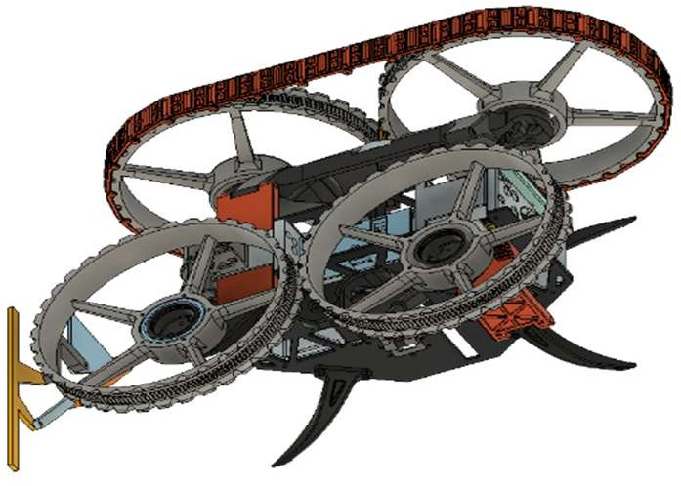

Fig. 1. 3-D diagram of aero terra bot
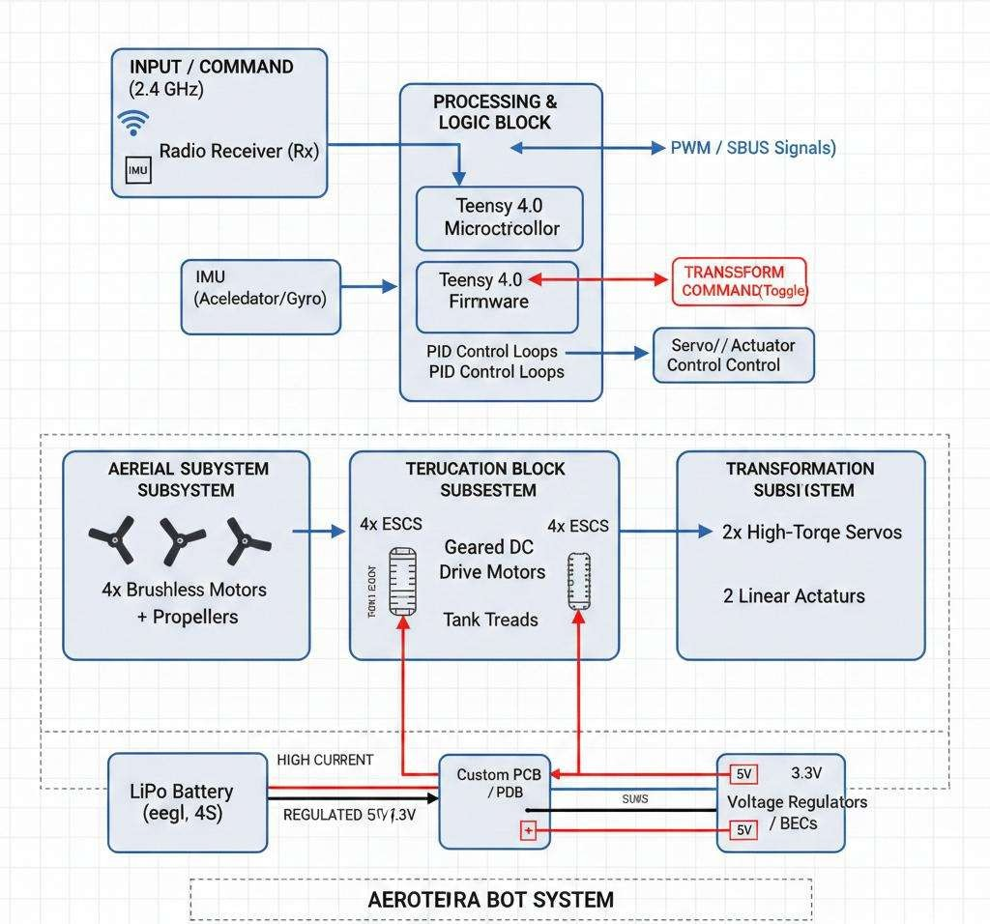

Fig. 2. Block diagram of aero terra bot

The high-speed PWM pins of the Servo Outputs connect to the 2x High-Torque Servos and 2x Linear Actuators, which helps trigger the transformation by sending appropriate signals.
I2C Bus (SDA/SCL): Interfaces with the MPU6050 IMU (Inertial Measurement Unit) to receive real-time orientation data for flight stabilization. The UART/SBUS Port connects to the Radio Receiver, which decodes commands from the transmitter and forwards them to the port.

Power Distribution Network: The brushless motors need a lot of power. The logic circuits need a very specific voltage. Therefore, a custom Power Distribution Board is utilized, specifically designed to meet the precise voltage requirements of the brushless motors and logic circuits. The Primary Loop handles the voltage, connecting the 3S or 4S LiPo Battery directly to the PDB, which then routes the voltage to the four flight ESCs. This configuration mandates either a 3S or 4S LiPo Battery for compatibility with the Primary Loop and PDB.

The Regulated Loop incorporates a 5V/3A Battery Eliminator Circuit that steps down the voltage to safely power the Teensy 4.0 and the Radio Receiver. The Transformation Loop provides a power supply (5 volts to 7.4 volts) for the Linear Actuators and Servos. This ensures the microcontroller remains unaffected when the Linear Actuators and Servos draw significant power during torque-intensive mechanical transitions, allowing the Transformation Loop to operate smoothly. Actuation Interfacing, the flight system utilizes four motors connected to the speed controllers with three-phase bullet connectors. These speed controllers receive a signal from the Teensy, which facilitates rapid speed changes for the flight motors. These motors can adjust their rotational speed in response to this signal. The Ground Drive uses geared DC motors that are connected to an H-bridge motor driver. This allows the ground drive to move in two directions. The ground drive features tank-style differential steering, facilitated by the coordinated operation of the geared DC motors and the H-bridge motor driver. The system operates such that the linear actuators and the servos are controlled by the software. Upon activation of the transformation switch, the Teensy simultaneously sends signals to the servos to rotate the arms and to the linear actuators to extend and retract the frame.

Grounding and Signal Integrity, to ensure stable operation and prevent electrical noise from the high-power motors interfering with the logic signals, a common ground strategy is employed for all equipment, including the ESCs, Teensy, and sensors(Jiang et al., 2024). This common ground strategy is crucial for the coordinated operation of components such as ESCs, the Teensy, and sensors(Jiang et al., 2024). Manufacturers utilize wiring such as twisted-pair or shielded cables for the Inertial Measurement Unit and receiver signals(Leng & He, 2020). This helps to reduce the Electromagnetic Interference that is caused by the big power leads that carry a lot of current(Bezprozvannych & Pushkar, 2020). Protection from electromagnetic interference is essential for these critical signals(Zhou et al., 2020).

HARDWARE CONNECTION

Component

Teensy 4.0 Pin Type

Connection Purpose, MPU6050 (IMU) I2C (SDA/SCL)

Flight Stabilization Feedback
Radio Receiver | UART/Serial | RC Command Input

Flight ESCs (4x) | PWM Outputs | Brushless Motor Control Drive Motors | Digital/PWM | Tank Tread Locomotion Linear Actuators | PWM/Digital | Frame Transformation High-Torque Servos | PWM | Arm Rotation/Positioning

OUTCOME

The Functional Hybrid Prototype is an advanced machine. It is a fully functional vehicle. The Functional Hybrid Prototype integrates features of a ground-based tank with the capabilities of a flying quadcopter. This enables it to perform functions typical of a tank while also possessing flight capabilities. This prototype is notable for its ability to combine these functionalities as a working machine. Easy Change, the robot has a way to switch from driving on the ground to flying in the air with just one button. This makes the transformation of the robot, from driving mode to flying mode easy. The robot can change from driving to flying with the press of a button. Mechanical Reliability, when we make Mechanical Reliability systems.
We want to make sure they are good and work well. This means we must design and build Mechanical Reliability parts like the linkages and the systems that make things move so that they work smoothly and do the same thing every time we use Mechanical Reliability systems. The Robot's Structure prioritizes a high strength-to-weight ratio, ensuring the robot is robust for ground operations yet lightweight enough for flight. Materials like carbon fiber-reinforced nylon and CNC-machined carbon fiber sheets are utilized to achieve this balance, which is crucial for the robot's operational effectiveness.

Integrated Control System, A stable and responsive control architecture utilizing a Teensy 4.0 microcontroller and custom flight firmware to coordinate high-torque servos, linear actuators, and brushless motors. Practical Field Application, Demonstrating the vehicle's potential for real-world missions, including search and rescue in difficult terrain, remote delivery, and mobile surveillance for security. STEM Educational Platform, serving as a technical demonstration and educational tool for robotics and STEM innovation, aligning with global sustainable development goals for quality education and industry innovation.

CONCLUSION
This paper presents the AeroTerra Bot. The AT BOT is a type of robot capable of easily transitioning between ground locomotion and aerial flight. The development of the AT BOT involved a multi-linkage system, powerful motors, and a Teensy 4.0 microcontroller. This capability allows it to dynamically transform its operational mode. The AT BOT project was successful, performing as intended. The carbon. Nylons that we used to make this thing were important. We needed to make sure it was strong enough to work on the ground like a tank. Also light enough to fly like a quadcopter. The carbon fiber was specially made to be very strong.
We also used a kind of computer program called dRehmFlight firmware. This program helped the quadcopter switch between modes easily and safely. It made sure everything was stable when it was changing from one mode to another. The carbon fiber and firmware worked together effectively. Beyond its technical specifications, the AT BOT contributes to broader objectives, such as the Sustainable Development Goals. Specifically, the AeroTerra Bot is good for innovation in infrastructure and education in science and technology. The AT BOT can fly over obstacles on the ground and drive in confined spaces using its specialized tank treads. This makes the AeroTerra Bot a good choice for things like searching for people who are lost, delivering things to remote places and watching over areas that're hard to get to.

FUTURE SCOPE
The AeroTerra Bot prototype really worked out well. This successful prototype serves as a starting point for the AT BOT. Future developments can focus on exploring advanced capabilities. Subsequent versions of the AT BOT will aim for increased autonomy, operating independently without human control. The next generation AT BOT will integrate intelligent decision-making capabilities through a synergistic combination of systems.
Autonomous Navigation and AI Integration: Currently, the robot requires manual control via a radio controller. Future enhancements will focus on developing advanced autonomous capabilities. The primary objective is to incorporate Computer Vision and Artificial Intelligence into the robot. This will enable the robot to avoid obstacles and autonomously navigate. To achieve this, we will integrate cameras with depth sensing capabilities, such as the Intel RealSense camera or LiDAR. The robot will be able to utilize Simultaneous Localization and Mapping for autonomous navigation in various environments, such as indoors or outdoors. SLAM excels at this by concurrently estimating its own position and constructing a map of its surroundings, enabling independent navigation(Cadena et al., 2016). The system features automatic mode switching. A computer determines the optimal locomotion method (driving or flying) based on terrain analysis. The computer analyzes the terrain to determine the most efficient mode, selecting either driving or flying to optimize the journey. Energy Optimization and Power Management: Hybrid robots face challenges related to energy consumption. This is due to their diverse locomotion requirements. Future research will investigate several areas, including: Regenerative Systems (implementing energy recovery during terrestrial braking or aerial descent); Dynamic Power Allocation (using AI-driven task scheduling to prioritize power to essential sensors and actuators, thereby extending battery life for long-duration missions. Advanced Battery Chemistry, Investigating Solid-State or higher energy-density Lithium-Polymer cells to reduce overall weight while increasing endurance. Swarm Robotics and Collaborative Operations the project could get big.

Become a Swarm Robotic System. This would facilitate large-scale operations. A group of AeroTerra Bots could communicate using a mesh network as well; this would enable them to do various tasks that they can do together, which would enable them to work better as a team and make collective decisions. Collaborative Mapping: Distribute search-and-rescue tasks across a wide disaster zone. Payload Handoff is important because it allows multiple robots to work together. This means they can carry supplies by planning their flight and drive paths, so they do not get in the way of each other. Payload Handoff makes it possible for multiple
Structural and Material Advancements, to make the strength-to-weight ratio even better future prototypes will be investigated: Generative Design: Generative Design utilizes computational methods to create components inspired by natural forms(Badhoutiya et al., 2023). These components feature a lattice structure, which enhances strength while minimizing weight(Khan & Riccio, 2024). This process involves using specialized computer programs to design these Generative Design components. The computer program is called AI-driven CAD. It helps us make these special lattice-structured chassis components, Smart Materials: Incorporating shape-memory
alloys (SMAs) or soft robotics for transformation mechanisms, potentially reducing the reliance on heavy mechanical servos and linear actuators.
Diversified Industrial Applications. The AT BOT system can be made to work in different areas because it is very flexible(Halim et al., 2022). This means the AT BOT architecture can be used for applications beyond general surveillance. The AT BOT system is good for specialized fields. Precision Agriculture, Equipping the robot with multispectral sensors to monitor crop health from the ground and spray fertilizers from the air. Industrial Inspection: Utilizing the tank mode for stable internal pipe inspections and the aerial mode for high-altitude external structure monitoring.

REFERENCES

- J. A. R. Marshall, "Are transformers truly foundational for robotics?" Nature Machine Intelligence, 2025.
- N. Sanghai, "Advances in Transformers for Robotic Applications," 2024.
- H. Ji et al., "Spatial Localization of a Transformer Robot Based on Ultrasonics," 2024.
- D. Zhang et al., "The development of a novel terrestrial/aerial robot (AQT-HR)," 2024.
- C. Premachandran, "A study on development of a hybrid aerial/terrestrial robot system," 2018.
- M. Ryalat, "Mechatronics Design and Control of a Hybrid Flying Ground Robot," 2024.
- M. Cao et al., "AirCrab: A Hybrid Aerial-Ground Manipulator," 2024.
- J. L. Chien et al., "Design and control of an aerial-ground tethered tendon robot," 2023.
- C. Guo et al., "Lightweight transformer-based neural network for agricultural robotics," 2024.
- S. Lu et al., "Multi-dimensional fusion: transformer and GANs-based neurorobotics," 2023.
- A. Alarcon et al., "Design and Kinematics of Variable-Geometry Linkages for Morphing Quadrotors," Journal of Mechanisms and Robotics, 2025.
- P. Casau et al., "Robust Transition Control for Hybrid Terrestrial-Aerial Unmanned Vehicles," IEEE Transactions on Control Systems Technology, 2024.
- S. Mintchev and D. Floreano, "A Bio-Inspired Morphing Drone for Multi-Modal Locomotion," Science Robotics, 2022.
- B. Zhou et al., "Magnetometer-Calibrated Hybrid Transformer for Robust Inertial Tracking in Robotics," IEEE Transactions on Mobile Computing, Jan. 2025.

