Perception–Reality Gap in Physical Strength During Menstruation Among Adolescent Girls

ABSTRACT
Menstruation is often associated with the feeling of weakness, but the actual physical ability remains the same. This study focuses on the gap difference between perceived and actual strength among girls at the time of menstruation, focusing on how inner feelings, emotions, internal beliefs and social messages shape self-perception. By analysing both subjective experiences and simple strength measures, the research shows how belief can influence confidence more boldly than physical reality.
KEY WORDS: Menstruation, Perceived Strength, Actual Strength, Self-Perception, Adolescent Girls, Physical Ability, Perception-Reality Gap
HYPOTHESIS
“During menstruation, girls believe they are weaker than they actually are.”
INTRODUCTION
Menstruation is often seen as a period when girls feel emotionally and physically different from usual. Many girls reported feeling tired, less confident, or weaker during this phase, even when their bodies are still able to perform daily activities. These feelings are not influenced by physical discomfort but also by emotions, personal beliefs, and long-standing ideas about menstruation. These beliefs can slowly influence how girls see their own strength. When someone keeps thinking she is weak during menstruation, she may start holding herself back without any clear physical reason. This study compares girls perceived and actual abilities during their periods. It pays attention to how emotions and personal thoughts affect this judgement. The purpose is not just to compare perception and performance but to understand why this difference exists. By doing so, the study tries to challenge the common idea that menstruation automatically means weakness and to support a more confident and realistic view of the female body.
PERCEIVED PHYSICAL WEAKNESS DURING MENSTRUATION
Perceived physical weakness during menstruation refers to how girls feel about their own strength at that time, rather than what their bodies are actually capable of doing. During their periods, many girls say they feel tired, low on energy, or less willing to take part in physical activities. Because of these feelings, they may assume that their strength has reduced, even though their actual physical ability may not always change in the same way. Many girls start feeling weak during menstruation even before they actually try to do anything. Sometimes it is not about what the body can or cannot do, but about what the mind has already decided. The feeling of weakness can start because of cramps, low energy, or simply not feeling completely comfortable. But it doesn’t come only from physical reasons. Many girls grow up hearing that periods mean rest, that it’s not the time to be very active, and that they should take it easy. These ideas stay in the background of the mind.
After hearing such things for years, it becomes easy to accept them as true. A girl may begin to assume she won’t be able to do much during that time, even before trying. Because of that assumption, she might step back from activities or not put in full effort, even when her body is actually capable of handling it.
They may not put in the same effort or may already assume that they will not perform well. Over time, this becomes normal. The belief feels real, even if there is no strong physical reason behind it.
So, in many cases, the weakness is more about perception than actual inability. Still, that perception matters a lot because it directly affects confidence and participation. That is why understanding this mental aspect becomes very important.
ACTUAL PHYSICAL STRENGTH AND PERFORMANCE
Actual physical strength is simply what the body can do. You can notice this through simple activities — like holding a position for some time, picking up something light, or continuing a movement without taking a break. In many cases, girls are still able to do these things during menstruation almost the same way they do on other days.
The difference usually comes from how they feel about it. If someone is already feeling uncomfortable or slightly low, she may assume that her performance will not be good. That thought comes first. But when she actually tries the task, the outcome is sometimes better than she expected. It makes you realise that the body may not have changed as much as the mind assumed.
It gives a clearer and practical view of strength. It shows that even if confidence decreases, physical ability may still remain stable. This difference between “feeling weak” and “being weak” is something that should not be ignored.
EMOTIONAL EXPERIENCES DURING MENSTRUATION
For some girls, emotions can feel stronger during menstruation. Mood changes are quite common at this time. A girl might feel irritated more easily, feel a bit sad without a clear reason, or become more sensitive to small things. These emotional shifts are a normal part of the experience for many.
These emotions can quietly affect the way they look at themselves. When someone is already feeling low emotionally, she might start thinking that she is not strong enough physically either. The emotional state and physical judgement sometimes get mixed up, even if they are not actually the same thing.
Sometimes emotional discomfort and physical weakness get mixed together. When someone feels unmotivated, tired, or frustrated, it can create the impression that the body is also not capable of much activity. Because of this, a girl may start assuming she cannot manage physical tasks, even when her actual strength may not have changed much. But emotional changes are temporary. They shift with time. Still, if they are not understood properly, they can influence self-confidence in a lasting way.
Emotional experiences during menstruation are not the same for everyone. Some girls may feel only slight changes, while others might feel them more strongly. From what I have noticed while looking into this topic, these emotions can affect the way girls judge themselves at that moment. If someone is already feeling low or irritated, she might start thinking that she is not capable of doing much physically either. Because of this, it becomes important to understand that emotions during this time are often temporary and do not always reflect actual physical ability.
INFLUENCE OF SOCIAL NARRATIVES AND CULTURAL BELIEFS
Society also influences how girls understand menstruation. From a young age, many girls hear that periods are a time when they should slow down or avoid certain activities. Over time, these ideas can shape how they think about their own strength during menstruation. Sometimes it is said directly, and sometimes it is shown through behaviour — like being told to rest, not to run, or not to participate in certain activities.
Gradually, these messages become part of thinking. Many girls start hearing different ideas about menstruation even before they experience it themselves. I have noticed that because of this, some girls already expect that their abilities will reduce during that time. At the same time, periods are still a topic that people often hesitate to talk about openly. In many places, there is still hesitation or silence around the topic, which makes it harder to question these beliefs or talk about them freely.
From what I have observed and understood while working on this study, the idea of weakness during menstruation does not always come only from personal experience. A lot of it grows from what we hear around us — at home, in school, or in casual conversations. When people repeatedly assume that girls will be less active or less capable during their periods, those expectations can slowly influence how girls see themselves. After some time, it becomes difficult to separate what is actually experienced from what has been heard and accepted as normal. So, the belief of weakness is not formed in isolation; it is shaped by the surroundings and the messages that are repeatedly heard.
PERCEPTION–REALITY GAP IN MENSTRUAL EXPERIENCES
While studying this topic, one thing became very noticeable — what girls expect from themselves during menstruation does not always match what they actually do. Many participants mentioned feeling weak or less capable. But when they actually tried simple activities that required strength, many of them were able to complete them without much difficulty. That difference is what I refer to as the perception–reality gap.
It seems that the feeling of weakness comes first, and performance is judged according to that feeling. The mind forms an assumption, and then everything is seen through that assumption. If someone already believes they will not perform well, they may not even notice when they actually do perform well. The belief quietly controls the judgement.
What makes this gap interesting is that it is not always based on physical change. This gap grows out of expectation, emotion, and past ideas about menstruation. Because of which girls may hold themselves back without clear physical evidence and rational thinking. Looking at both perception and actual performance side by side helps in understanding whether the belief of weakness is always accurate — and in many cases, it does not fully match reality.
COGNITIVE INTERPRETATION OF PAIN AND DISCOMFORT
Pain and discomfort during menstruation are real experiences. Cramps, fatigue, or heaviness can make the body feel different from usual. But what stood out during this study was not just the discomfort itself, it was how that discomfort was understood.
For some girls, pain immediately meant limitation. The moment the cramps started, the conclusion followed: “I won’t be able to do much today.” It is almost automatic. However, discomfort does not always reduce strength in a measurable way. The body may still function normally, but the mind may already decide that it cannot.
This analysis matters. When pain is seen as a signal of weakness, confidence drops. When it is seen as temporary and manageable, behaviour changes less. So, the difference is not only in the level of pain but in the meaning attached to it. That mental explanation can either increase self-doubt or keep it under control.
SELF-ESTEEM AND BODY AWARENESS DURING MENSTRUATION
During menstruation, many girls become more aware of their bodies. Small sensations feel bigger. Tiredness feels heavier. Even normal physical changes may feel uncomfortable. This increased awareness sometimes affects how girls feel about themselves.
A slight drop in confidence can slowly turn into self-doubt. If someone already feels emotionally low, she may start questioning her abilities too. It is not always dramatic. Sometimes it is subtle — just a small thought like, “Maybe I’m not at my best today.” But repeated thoughts like this can influence how strength is perceived.
Self-esteem plays a significant role over here; well, not clearly seen but sensed. When your confidence boosts, your ability of physical judgement increases. When confidence drops, abilities may seem smaller than they actually are. So, in many cases, the belief of weakness may be connected more to how a girl feels about herself in that moment rather than to actual physical limitation.
EMOTIONAL OVERGENERALISATION AND COGNITIVE BIAS
Another pattern that appeared is something that can be described as emotional overgeneralisation. This happens when a temporary feeling becomes a general conclusion. For example, feeling tired for a few hours turns into thinking, “I am weak.” Feeling irritated becomes, “I can’t handle anything today.”
The emotion may be temporary, but the judgement becomes broad. Instead of separating the feeling from ability, both get mixed together. Even if a girl performs well in a task, she may still hold on to the belief that she is weak simply because she does not feel energetic.
With time, this way of typical thinking may become habitual. The mind starts thinking about the experiences that support the idea of weakness and ignores the ones that conflict with it. This makes the belief stronger, even when actual performance says otherwise.
Understanding this pattern helps explain why the idea of weakness during menstruation can continue, even when physical evidence does not always support it. Sometimes it is not the body that limits performance, but the conclusion drawn from a passing emotion.
ANALYSIS OF DATA
I have conducted a survey with 22 participants in it. From which I get the following results.
Perceived Physical Strength
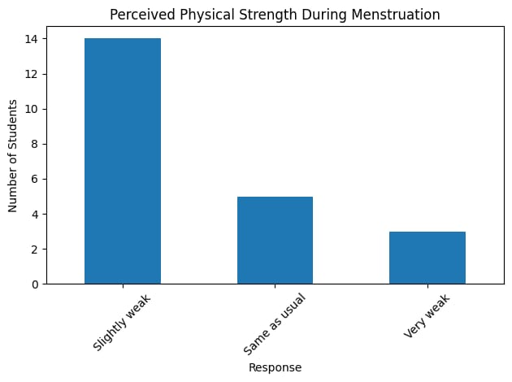
The majority of the students, i.e., 14 out of 22, are shown by the bar graph as feeling slightly weak during their menstruation, whereas 5 students only felt the same as usual, and 3 students felt very weak.
We can see a mild reduction in perceived strength from the above, showing most of the girl’s experience, but not extreme weaknesses.
Resulting in that, menstruation affects perceived strength moderately rather than severely.
Emotional Experience During Menstruation
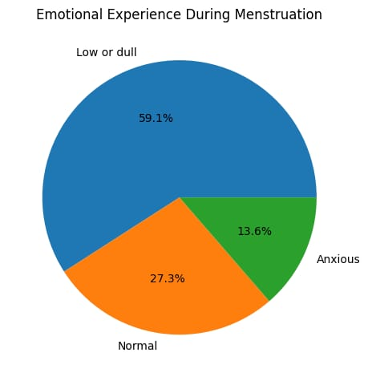
The above given pie chart reveals:
59.1% feel low or dull.
27.3% feel normal.
13.6% feel anxious.
This clearly shows that emotional fluctuations are more significant than the extreme weakness among respondents.
First Thought Before Performing a Physical Task
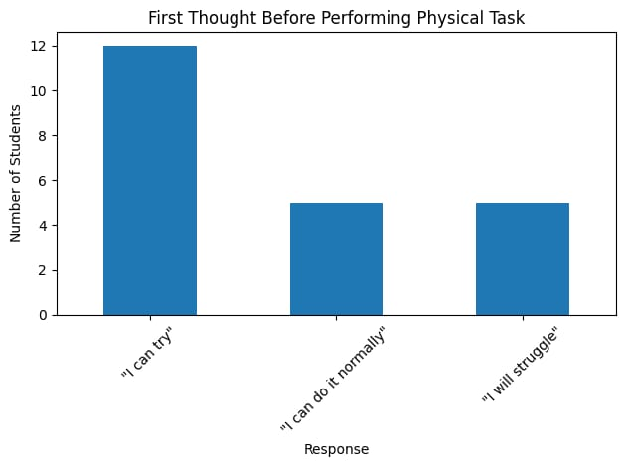
From the above-given bar graph, we can see that:
12 students said, "I can try."
5 said: “I can do it normally."
5 said: “I will struggle."
None selected: “I cannot do this."
Despite experiencing mild weakness or emotional changes, girls demonstrated a willingness to attempt the task, showing a positive mindset towards physical tasks.
Overall Pattern Observed
When we connect all three results
The majority feel slightly weak.
The majority feel emotionally low.
But the majority still believe, “I can try."
This reveals that physical weakness may not be the strongest factor. Emotional perceptions play a vital role in shaping performance expectations.

CONCLUSION
After analysing the responses, the study reveals that most of the girls experience only slight physical weakness during their menstruation rather than weakness. A large number of respondents reported changes in their feelings, such as low or dull. The respondents said that they feel weakness, but many of them still believed that they could try and do physical tasks, which showed the important role of perception and mindset.
Therefore, the hypothesis “During menstruation, girls believe they are weaker than they actually are” is true and is supported by the findings through this survey.
REFERENCES
- Carmichael, M. A., Thomson, R. L., Moran, L. J., & Wycherley, T. P. (2021). The impact of the menstrual cycle phase on athletes’ performance: A narrative review. International Journal of Environmental Research and Public Health, 18(4), 1667. https://doi.org/10.3390/ijerph18041667
- Ekerns, L., Hirschberg, A. L., Heijne, A., & Fridén, C. (2022). Perceived impact of the menstrual cycle on physical exercise and performance in 1,086 athletes. Frontiers in Physiology, 13, 954760. https://doi.org/10.3389/fphys.2022.954760
- Hooper, A. E. C., Bryan, A. D., & Eaton, M. (2011). Menstrual cycle effects on perceived exertion and pain during exercise among sedentary women. Journal of Women’s Health, 20(10), 1543–1549. https://doi.org/10.1089/jwh.2010.2042
- McNulty, K. L., Elliott-Sale, K. J., Dolan, E., Swinton, P. A., Ansdell, P., Goodall, S., Thomas, K., & Hicks, K. M. (2020). The effects of menstrual cycle phase on exercise performance in eumenorrheic women: A systematic review and meta-analysis. Sports Medicine, 50(10), 1813– https://doi.org/10.1007/s40279-020-01319-3
- Paludo, A. C., Nunes, E. A., da Silva, M. C., & da Silva, S. G. (2022). The effect of the menstrual cycle on perceptual responses in athletes: A systematic review with meta-analysis. Frontiers in Psychology, 13, 926854. https://doi.org/10.3389/fpsyg.2022.926854

