Development of an IoT-Based Real-Time Water Quality Monitoring System for Fish Farming

Abstract

Water quality monitoring is essential in aquaculture to ensure healthy fish growth and sustainable farming practices. In Malaysia, fish farmers commonly rely on manual methods to monitor key water quality parameters, including temperature and turbidity. However, these methods are labour-intensive, time-consuming, and prone to human error, resulting in delayed detection of water quality deterioration and inefficient data management. This study presents an Internet of Things (IoT)-based real-time water quality monitoring system to automate the monitoring process and improve aquaculture management. The system integrates an ESP32 microcontroller, a turbidity sensor, and a DS18B20 temperature sensor to continuously acquire water quality data. The collected data are transmitted wirelessly to the Blynk cloud platform for real-time monitoring, automatically recorded in Google Sheets, and visualized through Google Looker Studio to support historical data analysis. The developed prototype was evaluated through functionality testing to verify sensor connectivity, wireless communication, cloud synchronization, automated notifications, and data logging. The results demonstrate that the system successfully performs continuous data acquisition, real-time monitoring, cloud-based visualization, automated notifications, and historical data storage. The proposed system provides a practical and cost-effective solution for remote water quality monitoring in small-scale fish farming, supporting timely decision-making and more sustainable aquaculture management.

KEYWORDS: Internet of Things (IoT), Water Quality Monitoring, Aquaculture, Espressif Systems microcontroller with integrated Wi-Fi and Bluetooth (ESP32), Turbidity.
1.0 INTRODUCTION

Aquaculture is one of the fastest-growing agricultural sectors worldwide and plays an important role in food security and economic development. As the demand for fish continues to increase, maintaining good water quality has become essential for sustainable fish farming. Poor water quality can reduce fish growth, increase stress, promote disease outbreaks, and lead to economic losses for fish farmers [1] [2]. Water quality is commonly assessed using several physicochemical parameters, including temperature, pH, dissolved oxygen, electrical conductivity, ammonia, and turbidity. Among these parameters, turbidity is an important indicator of water clarity because it reflects the concentration of suspended particles such as sediments, algae, organic matter, and microorganisms. High turbidity reduces light penetration, limits photosynthesis, and lowers dissolved oxygen levels, negatively affecting fish health and growth. Therefore, continuous turbidity monitoring is essential for maintaining a healthy aquaculture environment [1].

However, water quality monitoring in many fish farming operations is still performed using conventional manual methods, where measurements are taken periodically using portable water quality instruments or laboratory-based analyses. Although these approaches generally provide accurate measurements, they are labour-intensive, time-consuming, and do not provide continuous real-time information. The delay between sample collection and result availability may prevent the early detection of deteriorating water quality, increasing the risk of fish stress, disease outbreaks, and production losses. Furthermore, manual monitoring requires frequent human intervention, making long-term data management less efficient. These limitations highlight the need for automated IoT-based monitoring systems capable of providing continuous real-time monitoring and timely decision-making for aquaculture management [3].

Recent advances in the Internet of Things (IoT) have enabled real-time environmental monitoring through the integration of sensors, microcontrollers, wireless communication, and cloud platforms. IoT-based monitoring systems can automatically collect, transmit, and display water quality data through web or mobile applications, allowing fish farmers to monitor water conditions remotely and make faster management decisions [4]. Numerous IoT-based water quality monitoring systems have been reported for aquaculture, integrating various sensors such as temperature, pH, dissolved oxygen, and turbidity. While these systems successfully demonstrate the feasibility of IoT-based monitoring, most adopt multi-parameter sensing architectures that increase hardware complexity, implementation cost, and maintenance requirements [5]. In addition, many studies focus primarily on prototype implementation and cloud connectivity, with limited emphasis on developing practical and affordable monitoring solutions for small-scale aquaculture operations. Consequently, there remains a need for a simple, low-cost, and easy-to-deploy monitoring system that enables continuous turbidity monitoring, real-time notifications, and cloud-based historical data storage for practical fish farming applications [6].

Therefore, this study proposes the development of a low-cost IoT-based turbidity monitoring system for real-time fish farming water quality assessment. The proposed system integrates an ESP32 microcontroller, turbidity sensor, DS18B20 temperature sensor, wireless communication, the Blynk cloud platform, and Google Sheets to provide continuous water quality monitoring. Unlike many existing systems that emphasize multi-parameter monitoring, the proposed system focuses on a simpler architecture centred on turbidity as the primary water quality indicator while incorporating temperature as a supporting parameter. The system also provides real-time notifications and cloud-based historical data storage, enabling fish farmers to remotely monitor water quality and respond promptly to abnormal conditions. The developed prototype is evaluated through functionality testing to verify its suitability for practical aquaculture applications.

2.0 RELATED WORK
This section reviews the application of IoT in aquaculture, discusses key water quality parameters relevant to fish farming, and analyses existing IoT-based water quality monitoring systems to identify current research gaps.
2.1 IoT in Aquaculture
The Internet of Things (IoT) refers to a network of interconnected devices capable of collecting, transmitting, and exchanging data through wireless communication to support real-time monitoring and decision-making [7]. In aquaculture, IoT technology has emerged as an effective solution for monitoring water quality by integrating sensors, microcontrollers, wireless communication, and cloud computing. These IoT-based monitoring systems automatically acquire, transmit, store, and visualize environmental data, such as temperature, pH, dissolved oxygen, and turbidity, through cloud platforms and mobile applications. This enables continuous remote monitoring, real-time alerts, and timely intervention, thereby improving fish farming productivity and sustainability [8] [4]. IoT applications can be classified into several categories, including Consumer IoT (CIoT), Industrial IoT (IIoT), Agricultural IoT (Agri-IoT), and the Internet of Medical Things (IoMT) [9]. Among these, Agricultural IoT (Agri-IoT) is particularly suitable for aquaculture because it enables continuous water quality monitoring through smart sensors, wireless communication, and cloud platforms. These capabilities allow fish farmers to remotely monitor pond conditions, receive real-time alerts, and make timely management decisions, thereby improving productivity and reducing operational costs [4] [8].
Several hardware platforms have been adopted for IoT-based aquaculture monitoring, including ESP32, ESP8266, and Raspberry Pi. Raspberry Pi offers higher computational capability and supports more complex data processing applications, making it suitable for advanced IoT deployments. However, its higher power consumption and implementation cost may limit its suitability for remote or battery-powered monitoring systems [10]. In contrast, the ESP32 provides an integrated microcontroller with built-in Wi-Fi and Bluetooth connectivity, sufficient processing capability, multiple GPIO interfaces, and low power consumption, making it well suited for real-time environmental monitoring applications. Furthermore, the ESP32 offers a cost-effective solution for small- and medium-scale aquaculture monitoring systems while simplifying hardware integration [4] [11].
A typical IoT-based aquaculture monitoring system consists of environmental sensors, a microcontroller, wireless communication, a cloud platform, and a user interface. Sensor data are continuously collected and transmitted via Wi-Fi to cloud services, where they are stored, analysed, and visualised through web dashboards or mobile applications such as Blynk. This architecture enables fish farmers to monitor water quality remotely, receive real-time notifications when abnormal conditions occur, and take timely corrective actions to maintain suitable farming conditions [4] [7]. Overall, previous studies indicate that the ESP32 provides an effective balance between processing capability, connectivity, power efficiency, and implementation cost. These characteristics make it a suitable platform for developing low-cost IoT-based water quality monitoring systems for small-scale aquaculture applications.

2.2 Water Quality Parameters
Although parameters such as pH, dissolved oxygen, ammonia, and electrical conductivity are also important indicators of water quality, this study focuses on turbidity and temperature because these parameters can be monitored continuously using low-cost sensors and provide a practical solution for real-time water quality monitoring in small-scale fish farming environments.
2.2.1 Turbidity
Turbidity is an important indicator of water quality that represents the concentration of suspended particles, including sediments, algae, organic matter, and microorganisms, in water. High turbidity reduces light penetration, limiting photosynthesis and decreasing dissolved oxygen levels, which negatively affect fish health, growth, and productivity [12]. Continuous turbidity monitoring is therefore essential because sudden increases in turbidity may indicate pollution events caused by runoff, excessive feeding, or waste accumulation, allowing fish farmers to detect water quality deterioration at an early stage and take corrective actions before fish health is affected. With the advancement of IoT technology, digital turbidity sensors can continuously measure water clarity and transmit real-time data to cloud platforms for remote monitoring and analysis, thereby improving monitoring efficiency and reducing the need for manual inspection [4]. Table 2.1 presents the turbidity categories adopted in this study for classifying water quality conditions in fish farming applications.
Table 2.1: Turbidity categories for fish farming water quality monitoring
Turbidity Level (NTU) | Category | Description
0-5 | Very clear | Excellent water clarity with minimal suspended particles. Suitable for healthy fish growth and optimal aquatic conditions.
5-10 | Clear | Good water quality with slight suspended particles. Generally suitable for routine fish farming operations.
10-50 | Moderately turbid | Noticeable suspended particles that may reduce light penetration and affect fish growth if maintained for prolonged periods.
50-100 | Highly turbid | Poor water clarity caused by excessive suspended solids or organic matter. May reduce dissolved oxygen and increase fish stress.
>100 | Extremely turbid | Very poor water quality indicating heavy sedimentation or pollution. Immediate corrective action is recommended to protect fish health.

Table 2.1 presents the turbidity categories adopted in this study for evaluating water quality in fish farming. Lower turbidity values indicate clearer water with fewer suspended particles, providing favourable conditions for fish growth. Conversely, higher turbidity levels reduce light penetration, limit photosynthesis, and may lower dissolved oxygen concentrations, thereby increasing stress and health risks to aquatic organisms. These threshold values are incorporated into the proposed IoT-based monitoring system to classify turbidity conditions and automatically trigger notification alerts whenever abnormal water quality is detected.

2.2.2 Temperature
Water temperature is one of the most important physical parameters affecting water quality in aquaculture because it directly influences fish metabolism, growth rate, immune response, and reproductive performance [2]. Temperature also affects dissolved oxygen concentration, where increasing water temperature reduces oxygen solubility and increases the risk of hypoxia, particularly in densely stocked fishponds [8]. Consequently, continuous temperature monitoring is essential for maintaining suitable environmental conditions, reducing fish stress, and minimizing the risk of mortality caused by prolonged temperature fluctuations. IoT-based water quality monitoring systems commonly employ waterproof digital temperature sensors, such as the DS18B20, to provide real-time temperature measurements and automated alerts whenever abnormal conditions are detected [4] [7]. The recommended temperature ranges for fish farming adopted in this study are presented in Table 2.2.

Table 2.2: Temperature categories for fish farming water quality monitoring.

Temperature Range | Category | Description
<25°C | Low | Water temperature below the optimal range may reduce fish metabolism and growth.
25°C -29°C | Normal | Optimal temperature range for most warm-water freshwater fish species.
>29°C | High | Elevated temperatures may reduce dissolved oxygen levels and increase fish stress if prolonged.

Table 2.2 presents the recommended temperature categories used in this study for fish farming water quality monitoring. The threshold values are incorporated into the proposed IoT-based monitoring system to classify water temperature into low, normal, or high conditions. These threshold values enable the proposed IoT-based monitoring system to continuously classify water temperature conditions, provide real-time visualization through the Blynk platform, and automatically generate alerts whenever abnormal temperature conditions are detected. Based on the recommended turbidity and temperature ranges presented in Tables 2.1 and 2.2, the proposed monitoring system employs these threshold values to classify water quality conditions and trigger notification alerts whenever abnormal readings are detected.
2.3 Existing IoT-Based Water Quality Monitoring Systems
Several IoT-based water quality monitoring systems have been developed to improve aquaculture management by enabling continuous monitoring of important water quality parameters. Most existing systems integrate multiple sensors to measure parameters such as temperature, pH, turbidity, dissolved oxygen, and total dissolved solids (TDS), while transmitting data to cloud platforms for real-time visualization and remote monitoring [2] [4]. Common cloud platforms include Blynk, ThingSpeak, and Google Cloud services, which enable users to monitor water quality through mobile applications and web-based dashboards while supporting real-time notifications and historical data analysis [4] [7].

Various hardware platforms have been adopted in previous studies, including ESP32, ESP8266, Arduino-based systems, and Raspberry Pi. Among these, the ESP32 has become one of the most widely used platforms because it integrates a microcontroller with built-in Wi-Fi and Bluetooth, offers low power consumption, and provides sufficient processing capability for real-time sensor monitoring and cloud communication [4] [7]. In contrast, Raspberry Pi provides greater computational capability for advanced data processing but generally requires higher power consumption, making it more suitable for large-scale or computationally intensive applications [10]. Several studies have also employed wireless communication technologies such as Wi-Fi, GSM, LoRaWAN, and NB-IoT to support reliable real-time data transmission and remote monitoring in aquaculture environments [4].

Although previous studies have demonstrated the effectiveness of IoT technologies for water quality monitoring, several limitations remain. Most systems monitor multiple water quality parameters, resulting in increased hardware complexity and implementation costs. In addition, many studies primarily focus on prototype implementation and cloud connectivity, while providing limited discussion on practical deployment for small-scale fish farming applications. Furthermore, not all systems integrate cloud-based historical data logging and automated notification services within a single monitoring platform, limiting their ability to support continuous monitoring and timely decision-making in practical aquaculture environments.

To further analyse the characteristics of existing IoT-based water quality monitoring systems, Table 2.3 compares selected studies in terms of hardware platform, monitored parameters, cloud platform, strengths, and limitations. This comparison provides a clearer understanding of current research trends and the gaps addressed by the proposed system.
Table 2.3: Comparison of existing IoT-based water quality monitoring systems
Author | Platform | Parameters | Cloud Platform | Strength | Limitation
Nasir & Mumtazah (2020) | Raspberry Pi | pH, Temperature, Turbidity | Cloud | Multi-parameter monitoring | High hardware cost
Reduan et al. (2021) | Arduino | pH, Temperature, Turbidity | GSM | Low measurement error | No cloud dashboard
Zhang et al. (2021) | ESP32 | Temperature | Blynk | User-friendly interface | Turbidity not included
Sutarno et al. (2022) | NodeMCU | pH, Temperature, Turbidity | IoT | Wireless monitoring | Multiple sensors increase cost

Table 2.3 highlights several important trends in existing IoT-based water quality monitoring systems. First, most previous studies employ multi-parameter monitoring approaches by integrating sensors such as pH, temperature, turbidity, dissolved oxygen, and total dissolved solids. Although these systems provide comprehensive water quality assessment, they also increase hardware complexity, implementation cost, and maintenance requirements. Second, Arduino-, NodeMCU-, and ESP32-based platforms are the most commonly adopted architectures because they provide a good balance between processing capability, power consumption, and affordability. Finally, while cloud platforms such as Blynk and ThingSpeak enable real-time remote monitoring, not all existing systems incorporate cloud-based historical data logging together with automated notification services, limiting their capability to provide comprehensive long-term monitoring and timely alerts.
Based on the identified research gaps, this study proposes a simple and cost-effective IoT-based monitoring system specifically designed for small-scale fish farming applications. Unlike many previous studies that employ multi-parameter monitoring architectures, the proposed system focuses on turbidity as the primary water quality parameter while incorporating temperature as a supporting parameter. The proposed system integrates an ESP32 microcontroller, the Blynk platform, and Google Sheets to provide real-time water quality monitoring, automated notifications, and cloud-based historical data storage. The identified research gaps and the proposed system architecture form the basis for the methodology presented in the next section.
3.0 METHODOLOGY
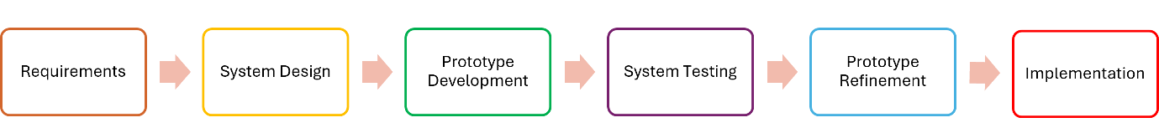
This study adopted the Prototype Model as the development methodology to design and implement the proposed IoT-based water quality monitoring system for fish farming applications. The Prototype Model was selected because it provides an iterative approach that allows the system to be developed, tested, refined, and improved before the final implementation [13] [14]. This approach is particularly suitable for IoT applications because both hardware and software components can be evaluated continuously throughout the development process, enabling iterative refinement and system validation [4] [7]. As illustrated in Figure 3.1, the development process consists of six phases: Requirements, System Design, Prototype Development, System Testing, Prototype Refinement, and Implementation. Each phase was systematically implemented to ensure the successful design, development, and evaluation of the proposed monitoring system.
Figure 3.1: Prototype model adopted in this study
Each phase is described in the following subsections.
3.1 Requirements
The requirements phase involved identifying the functional and technical requirements of the proposed monitoring system. A literature review was conducted to study IoT-based water quality monitoring systems, commonly used sensors, communication technologies, and cloud platforms. Based on the findings, the hardware and software components required for the system were identified, including the ESP32 microcontroller with built-in Wi-Fi, a turbidity sensor, a DS18B20 temperature sensor, Arduino IDE, the Blynk application, and Google Sheets. The functional requirements of the system were also determined, including real-time monitoring, wireless data transmission, notification alerts, and cloud-based data logging. Table 3.1 summarizes the hardware and software components used in the proposed IoT-based water quality monitoring system. The selected components were chosen based on their low cost, ease of integration, and suitability for real-time water quality monitoring in small-scale fish farming applications.

Table 3.1: Hardware and software components of the proposed IoT-based monitoring system
Component | Model/ Platform | Function
ESP32 | ESP32 Development Board | Main controller with built-in Wi-Fi for sensor data processing and wireless communication
Turbidity Sensor | SEN0189 | Turbidity measurement
Temperature Sensor | DS18B20 (Waterproof) | Temperature monitoring
Blynk | Cloud Platform | Real-time monitoring and notification
Google Sheets | Cloud Database | Historical data logging
Arduino IDE | Software | Development and programming of the ESP32

The selected hardware and software components were integrated to provide continuous data acquisition, wireless communication, cloud-based monitoring, and historical data storage, thereby fulfilling the functional requirements identified during the requirements analysis phase.

3.2 System Design
The system architecture was designed based on a client–server architecture, where sensor data are acquired and processed by the ESP32 microcontroller before being transmitted through its built-in Wi-Fi to the Blynk cloud server for real-time visualization via the Blynk mobile application. Simultaneously, the measured data are automatically stored in Google Sheets for historical analysis. A system flowchart was also developed to describe the operational sequence, including sensor initialization, data acquisition, wireless transmission, real-time monitoring, notification generation, and data storage. The threshold values summarized in Tables 2.1 and 2.2 were embedded within the ESP32 program to classify turbidity and temperature conditions as normal or abnormal, enabling the automatic generation of notification alerts.

3.2.1 System Flowchart

Figure 3.2 presents the system flowchart of the proposed IoT-based water quality monitoring system.
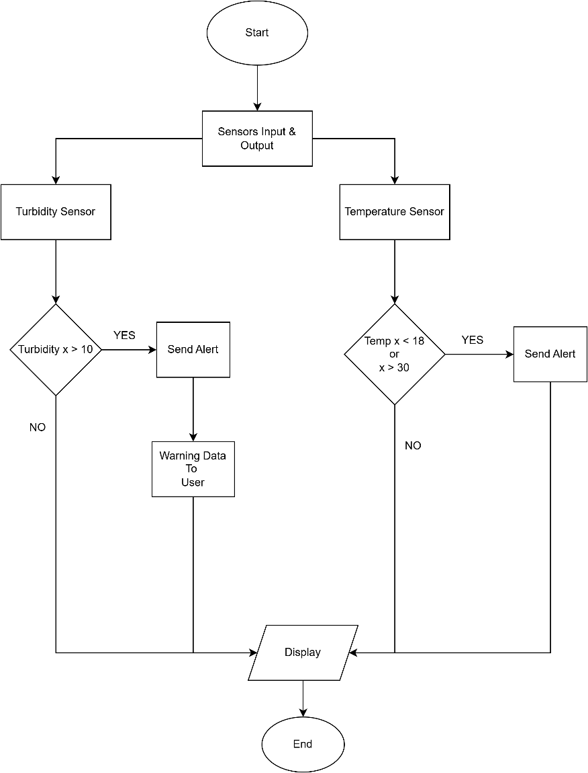
Figure 3.2: System flowchart

As shown in Figure 3.2, the monitoring process begins by initializing the turbidity and temperature sensors and establishing a Wi-Fi connection through the ESP32 microcontroller with built-in Wi-Fi. Once the connection is established, the ESP32 continuously acquires sensor readings and processes the measured values. The processed data are transmitted to the Blynk cloud platform for real-time visualization. The system then compares the measured values with predefined threshold values. If the readings exceed the acceptable limits, a notification is automatically sent to the user through the Blynk application. At the same time, all sensor readings are recorded in Google Sheets to maintain a historical record of water quality measurements. This process repeats continuously to provide real-time monitoring.

3.2.1 System Architecture

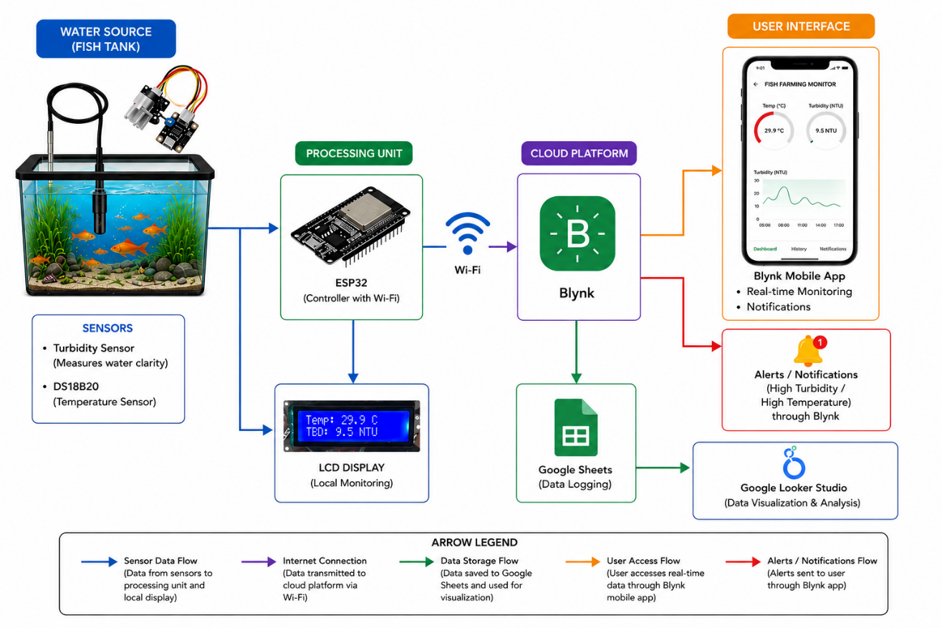
Figure 3.3 illustrates the overall architecture of the proposed IoT-based water quality monitoring system. As shown in Figure 3.3, the proposed IoT-based water quality monitoring system consists of a turbidity sensor and a DS18B20 temperature sensor that continuously measure the water quality parameters. The collected sensor readings are processed by the ESP32 microcontroller and transmitted wirelessly through its built-in Wi-Fi module to the Blynk cloud platform. The measured data are displayed in real time through the Blynk mobile application, enabling users to remotely monitor water quality conditions. In addition, the ESP32 displays the measured temperature and turbidity values on a local LCD screen for on-site monitoring. When the measured values exceed the predefined threshold levels, the Blynk platform automatically generates notification alerts to inform users of abnormal water conditions. All monitoring data are simultaneously stored in Google Sheets and further visualized using Google Looker Studio to provide historical data analysis and trend visualization. This architecture enables continuous remote monitoring, automated notifications, cloud-based data logging, and historical analysis, providing an effective and practical solution for fish farming water quality management.

Figure 3.3: Overall system architecture

3.3 Prototype Development
The prototype was developed by integrating the selected hardware components with the embedded software. The turbidity sensor and DS18B20 temperature sensor were connected directly to the ESP32 microcontroller, which performs both sensor data processing and wireless communication through its built-in Wi-Fi capability. The embedded software was developed using the Arduino IDE in C/C++, where the program continuously acquires sensor readings, compares them with predefined threshold values, transmits the measured data to the Blynk cloud platform, generates notification alerts, and records all monitoring data in Google Sheets.
3.4 System Testing
The functionality testing was performed using the test cases presented in Table 3.2. Each test case was designed to verify that the proposed IoT-based monitoring system operated as intended by comparing the expected system behaviour with the actual output under normal operating conditions.

Table 3.2: Functionality test cases for the proposed IoT-based monitoring system
Test Case | Expected Outcome
Sensor Connectivity | Sensor readings successfully acquired
Wi-Fi Connection | ESP32 connects successfully
Blynk Communication | Dashboard updated in real time
Notification | Alert generated
Google Sheets | Data stored automatically

As shown in Table 3.2, the functionality testing covered all major components of the proposed IoT-based monitoring system. Successful execution of these test cases confirms that the system is capable of acquiring sensor readings, transmitting data wirelessly, displaying real-time information through the Blynk platform, generating notification alerts when abnormal conditions occur, and automatically storing monitoring data in Google Sheets. The outcomes of these test cases are presented and discussed in the next section.
3.5 Prototype Refinement
Based on the functionality testing results, iterative improvements were made to enhance system stability, communication reliability, and user interface usability. The sensor configuration was optimized to improve reading consistency, the Blynk dashboard was refined to provide a clearer display of monitoring information, and the embedded program was updated to improve wireless communication and notification reliability. These refinements ensured that the prototype operated more efficiently under normal monitoring conditions.
3.6 Implementation
The completed prototype was deployed under normal monitoring conditions to continuously acquire turbidity and temperature measurements. The measured data were transmitted to the Blynk cloud platform for real-time visualization while simultaneously being stored in Google Sheets for historical analysis. Notification alerts were automatically generated whenever the measured values exceeded the predefined threshold levels. The deployed system provides continuous remote monitoring of fish farming water quality while supporting timely intervention through automated cloud-based notifications.

4.0 RESULT & DISCUSSION
4.1 System Functionality Testing

The functionality of the proposed IoT-based water quality monitoring system was evaluated to verify the performance of its major components, including sensor connectivity, wireless communication, cloud-based monitoring, notification services, and data logging. The objective of the testing was to ensure that the system operated as intended before deployment in a fish farming environment. A summary of the functionality testing is presented in Table 4.1.

Table 4.1: Summary of functionality testing
Test Case | Testing Objective | Expected Outcome | Actual Outcome | Status
Sensor Connectivity | Verify communication between the ESP32 and the turbidity and temperature sensors | Sensor readings successfully acquired | Both sensors were successfully detected, and the sensor readings were displayed correctly | Pass
Wi-Fi Connectivity | Verify the ESP32 connection to the wireless network | Successful Internet connection | ESP32 successfully connected to the Wi-Fi network | Pass
Blynk Communication | Verify real-time transmission of sensor data | Data displayed on Blynk dashboard | Sensor readings updated successfully in real time | Pass
Alert Notification | Verify notification when threshold exceeded | Notification sent to user | Alerts generated successfully for abnormal readings | Pass
Google Sheets Logging | Verify automatic storage of monitoring data | Sensor data recorded with timestamp | Data successfully stored in Google Sheets | Pass

Table 4.1 demonstrates that all predefined functionality test cases were successfully completed. Stable communication between the ESP32 microcontroller, the temperature and turbidity sensors, and the cloud platform was achieved throughout the testing process. No communication failures or data transmission errors were observed under normal operating conditions, indicating that the proposed monitoring system operated reliably.

The alert notification feature was evaluated by intentionally setting the measured values beyond the predefined threshold levels. The Blynk application successfully generated alert notifications, allowing users to respond promptly to abnormal water quality conditions. Furthermore, the Google Sheets logging function was tested to ensure that all sensor readings were automatically stored together with their corresponding timestamps. The successful logging process provides historical monitoring data for future analysis while eliminating the need for manual record keeping.

Overall, the functionality testing confirmed that all major modules of the proposed monitoring system operated as expected. The successful integration of the ESP32 microcontroller, sensor data acquisition, built-in Wi-Fi communication, cloud-based visualization, notification services, and automatic data logging demonstrates the operational reliability and feasibility of the proposed system for real-time fish farming water quality monitoring.

4.2 Water Quality Monitoring Results

Following the successful functionality testing, the proposed IoT-based water quality monitoring system was evaluated under normal operating conditions. The monitoring results obtained through the Blynk mobile application, notification services, Google Sheets, and Google Looker Studio demonstrate the capability of the developed system to continuously monitor water quality parameters, provide real-time notifications, and maintain historical monitoring records.
4.2.1 Real-Time Monitoring Dashboard

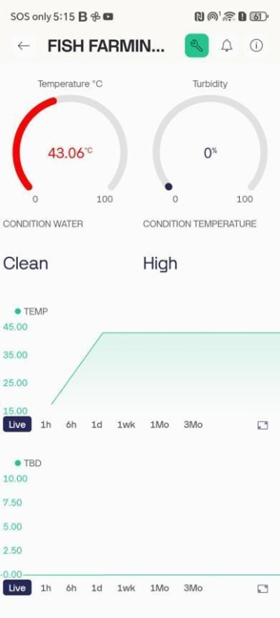

Figure 4.3: Real-time water quality monitoring dashboard in the Blynk application

Figure 4.3 presents the real-time monitoring dashboard developed using the Blynk application. During the monitoring period, the system recorded a temperature of 43.06°C and a turbidity value of 0 NTU, which were automatically classified as High and Clean, respectively. These classifications were generated based on the predefined threshold values embedded in the ESP32. The dashboard also provides historical trend graphs that continuously update as new sensor readings are received. These results demonstrate that the proposed system can successfully acquire, classify, and visualize water quality data in real time without requiring manual intervention.

4.2.2 Temperature Monitoring and Alert
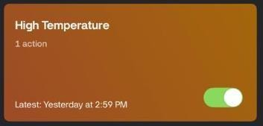
Figure 4.4: High temperature automation in Blynk

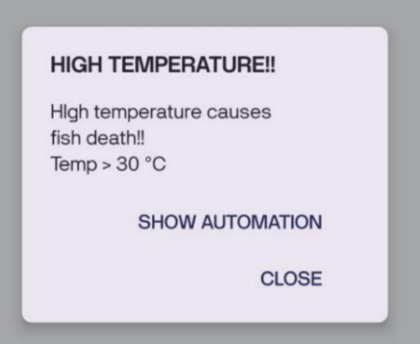

Figure 4.5: High temperature alert notification
Figures 4.4 and 4.5 demonstrate the complete temperature monitoring and notification process. When the measured temperature exceeds the predefined threshold, the Blynk automation is activated and immediately sends a push notification to the user. The successful generation of notification alerts demonstrates that the threshold-based monitoring algorithm operates correctly and enables users to respond promptly before prolonged exposure to elevated temperatures affects fish health.

4.2.3 Turbidity Monitoring and Alert
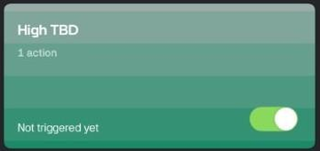

Figure 4.6: High turbidity automation in Blynk
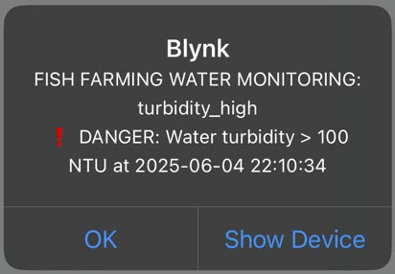

Figure 4.7: High turbidity alert notification
The proposed system continuously evaluates turbidity measurements against the predefined threshold values. The successful detection of abnormal turbidity conditions demonstrates that the proposed monitoring system is capable of classifying water quality according to the predefined threshold values. This enables users to receive early warnings whenever water quality deteriorates, thereby supporting timely intervention before adverse effects on fish health occur.
4.2.4 Cloud Data Logging
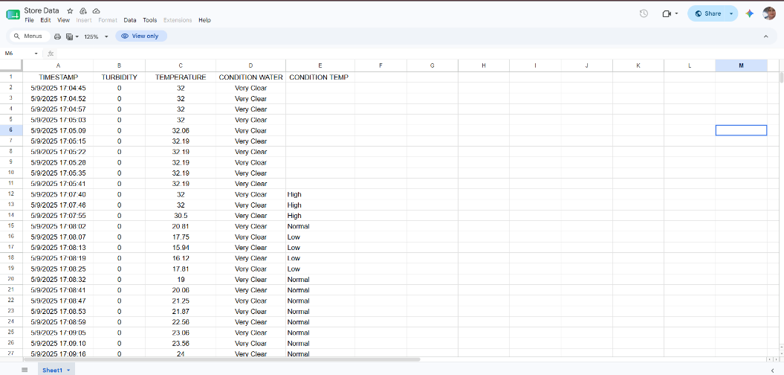

Figure 4.8: Sensor readings recorded in Google Sheets
The successful synchronization of sensor readings with Google Sheets demonstrates the reliability of the cloud-based data logging mechanism. Automatic storage eliminates manual recording errors while providing a historical database for trend analysis, performance evaluation, and future decision-making. This feature enables long-term monitoring of water quality without additional human intervention. Furthermore, the stored data can be exported for statistical analysis and long-term monitoring of water quality trends.

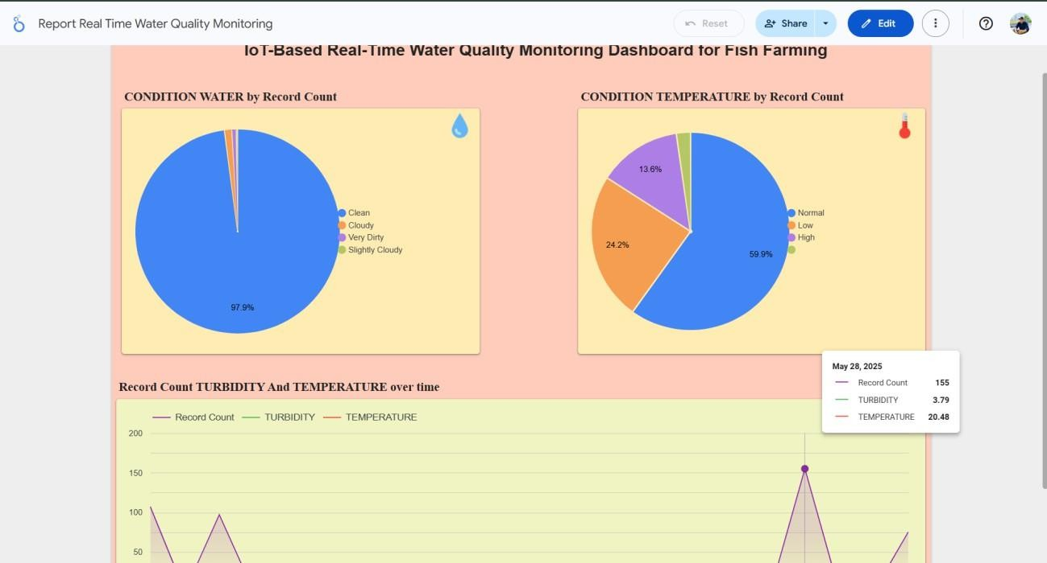
4.2.5 Data Visualization and Analysis

Figure 4.9: Cloud-based water quality monitoring dashboard using Google Looker Studio

The Google Looker Studio dashboard provides a comprehensive visualization of the historical monitoring data. The predominance of Clean water conditions (97.9%) indicates that the monitored fish pond maintained acceptable turbidity levels throughout most of the observation period. The successful detection of Cloudy and Very Dirty conditions confirms the ability of the proposed monitoring system to classify different turbidity conditions based on predefined threshold values. Similarly, the temperature analysis indicates that 59.9% of the recorded measurements were within the normal operating range. The remaining measurements were successfully classified as either Low or High temperature conditions, demonstrating that the monitoring system can continuously detect abnormal environmental changes. Overall, these findings demonstrate that the proposed monitoring system successfully integrates real-time sensing, wireless communication, cloud-based monitoring, automated notifications, and historical data visualization into a single low-cost IoT platform suitable for small-scale aquaculture applications.

4.3 Comparison with previous studies

Compared with previous IoT-based aquaculture monitoring systems, the proposed monitoring system employs cost-effective ESP32-based architecture while maintaining continuous cloud-based monitoring and real-time data transmission [4] [7]. In addition, the integration of Google Sheets and Google Looker Studio enables automatic historical data logging and interactive visualization, providing users with both real-time monitoring and long-term water quality analysis. These features enhance the practicality of the proposed system for small-scale fish farming applications by supporting timely decision-making and improved water quality management [2] [4]

Despite the promising results, the proposed system has several limitations. The current prototype monitors only turbidity and temperature, whereas other important water quality parameters, such as pH, dissolved oxygen, ammonia, and electrical conductivity, also influence water quality in aquaculture [1] [2]. Furthermore, the prototype was evaluated under laboratory-scale conditions. Future work should validate the proposed system under actual fish farming environments and integrate additional water quality sensors to provide a more comprehensive and reliable water quality monitoring solution. The incorporation of intelligent data analytics and predictive models could further enhance decision-making and support precision aquaculture (Olanubi et al., 2024).

5.0 CONCLUSION
This study proposed and implemented a low-cost IoT-based water quality monitoring system for fish farming applications using an ESP32 microcontroller, a turbidity sensor, and a DS18B20 temperature sensor. The system was designed to support continuous monitoring of water quality by integrating real-time sensing, built-in Wi-Fi communication, cloud-based monitoring, automated notifications, and historical data logging. The developed prototype successfully demonstrated continuous monitoring of turbidity and temperature through the Blynk mobile application while automatically storing sensor readings in Google Sheets for historical analysis. Functionality testing confirmed that all major system components, including sensor connectivity, wireless communication, cloud synchronization, notification services, and data logging, operated successfully. Furthermore, the Google Looker Studio dashboard provided effective visualization of historical monitoring data, enabling users to identify water quality trends and abnormal environmental conditions.
Compared with conventional manual monitoring approaches, the proposed system provides a simple, low-cost, and practical solution for real-time water quality monitoring in small-scale fish farming applications. By integrating the ESP32's built-in Wi-Fi, cloud-based monitoring, automated notification services, and historical data visualization within a single platform, the developed system improves monitoring efficiency while reducing the need for continuous manual observation. These features demonstrate the potential of IoT technology to support smarter and more sustainable aquaculture management.
Although the proposed system successfully demonstrated real-time monitoring of turbidity and temperature, several limitations remain. The current prototype monitors only two water quality parameters and was evaluated under laboratory-scale conditions. Future work should integrate additional sensors, such as pH, dissolved oxygen, ammonia, and electrical conductivity, to provide a more comprehensive assessment of water quality. Furthermore, long-term field evaluation in commercial fish farming environments and the incorporation of artificial intelligence techniques for predictive water quality analysis could further enhance the capability of the proposed monitoring system.
The integration of the Blynk platform, Google Sheets, and Google Looker Studio provides a unified cloud-based monitoring platform that supports real-time visualization, automated notifications, historical data logging, and trend analysis. This integration offers a practical and accessible solution for remote fish farm management, particularly for small-scale aquaculture operations.
ACKNOWLEDGEMENT
The authors would like to thank Universiti Teknikal Malaysia Melaka (UTeM) and Universiti Teknologi Mara, Cawangan Melaka, Kampus Jasin, for their support.

REERENCES

[1] Food and Agriculture Organization of the United Nations. (2024). The State of World Fisheries and Aquaculture 2024: Blue transformation in action. Food and Agriculture Organization (FAO).

[2] Flores-Iwasaki, M., Guadalupe, G. A., Pachas-Caycho, M., Chapa-Gonza, S., Mori-Zabarburú, R. C., & Guerrero-Abad, J. C. (2025). Internet of Things (IoT) sensors for water quality monitoring in aquaculture systems: a systematic review and bibliometric analysis. AgriEngineering, 7(3), 78.

[3] Jais, N. A. M., Abdullah, A. F., Kassim, M. S. M., Abd Karim, M. M., & Muhadi, N. A. (2024). Improved accuracy in IoT-Based water quality monitoring for aquaculture tanks using low-cost sensors: Asian seabass fish farming. Heliyon, 10(8).

[4] Olanubi, O. O., Akano, T. T., & Asaolu, O. S. (2024). Design and development of an IoT-based intelligent water quality management system for aquaculture. Journal of Electrical Systems and Information Technology, 11(1), 15.

[5] Susanti, N. D., Sagita, D., Apriyanto, I. F., Anggara, C. E. W., Darmajana, D. A., & Rahayuningtyas, A. (2022, January). Design and implementation of water quality monitoring system (temperature, ph, tds) in aquaculture using iot at low cost. In 6th International Conference of Food, Agriculture, and Natural Resource (IC-FANRES 2021) (pp. 7-11). Atlantis Press.

[6] Nugraha, I., Fahrudin, T. M., Rizqina, A., & Agvenia, K. (2025). IoT-Based Water Quality Monitoring System to Enhance Sustainability and Business Performance in Koi Fish Cultivation. Journal of Advances in Information and Industrial Technology, 7(2), 193-206.

[7] Tamim, A. T., Begum, H., Shachcho, S. A., Khan, M. M., Yeboah-Akowuah, B., Masud, M., & Al-Amri, J. F. (2022). Development of IoT Based Fish Monitoring System for Aquaculture. Intelligent Automation & Soft Computing, 32(1).

[8] Prapti, D. R., Mohamed Shariff, A. R., Che Man, H., Ramli, N. M., Perumal, T., & Shariff, M. (2022). Internet of Things (IoT)‐based aquaculture: An overview of IoT application on water quality monitoring. Reviews in Aquaculture, 14(2), 979-992.

[9] Gubbi, J., Buyya, R., Marusic, S., & Palaniswami, M. (2013). Internet of Things (IoT): A vision, architectural elements, and future directions. Future generation computer systems, 29(7), 1645-1660.

[10] Ullo, S. L., & Sinha, G. R. (2020). Advances in smart environment monitoring systems using IoT and sensors. Sensors, 20(11), 3113.

[11] Palkar, Y. D., Waghachavare, N. K., Mane, A. P., Rane, V. S., Jadhav, P. P., Patil, P. N., ... & Khadake, S. B. (2026). Real Time IoT-Enabled Smart Plant Irrigation and Weather Monitoring System using the ESP32 microcontroller & MATLAB.

[12] Zhang, K., Ye, Z., Qi, M., Cai, W., Saraiva, J. L., Wen, Y., ... & Zhao, J. (2025). Water quality impact on fish behavior: a review from an aquaculture perspective. Reviews in Aquaculture, 17(1), e12985.

[13] Pressman, R. S., & Maxim, B. R. (2020). Software engineering: A practitioner's approach (9th ed.). McGraw-Hill.

[14] Sommerville, I. (2020). Software engineering (10th ed.). Pearson.

