A A

Untitled.docx
 Quick Submit  Quick Submit
 Dharmashastra National Law University

Document Details

Submission ID trn:oid:::1:3552383605

8 Pages

3,422 Words

20,199 Characters
Submission Date
Apr 27, 2026, 8:54 PM GMT+5:30

Download Date
Apr 27, 2026, 8:58 PM GMT+5:30

File Name Untitled.docx
File Size
1.8 MB

3% Overall Similarity
The combined total of all matches, including overlapping sources, for each database.

Filtered from the Report
Bibliography

Match Groups
 10 Not Cited or Quoted 3%
Matches with neither in-text citation nor quotation marks
 3 Missing Quotations 1%
Matches that are still very similar to source material
 0 Missing Citation 0%
Matches that have quotation marks, but no in-text citation
 0 Cited and Quoted 0%
Matches with in-text citation present, but no quotation marks

Top Sources

2% |   Internet sources
2% |   Publications
0% |  Submitted works (Student Papers)

Integrity Flags
0 Integrity Flags for Review

Our system's algorithms look deeply at a document for any inconsistencies that would set it apart from a normal submission. If we notice something strange, we flag it for you to review.

A Flag is not necessarily an indicator of a problem. However, we'd recommend you focus your attention there for further review.
No suspicious text manipulations found.

Match Groups
10 Not Cited or Quoted 3%
Matches with neither in-text citation nor quotation marks
3 Missing Quotations 1%
Matches that are still very similar to source material
0 Missing Citation 0%
Matches that have quotation marks, but no in-text citation
0 Cited and Quoted 0%
Matches with in-text citation present, but no quotation marks

Top Sources

2% | Internet sources
2% | Publications
0% | Submitted works (Student Papers)

Top Sources
The sources with the highest number of matches within the submission. Overlapping sources will not be displayed.
1
Internet
www.ijert.org <1%
2
Publication

Pushpa Choudhary, Sambit Satpathy, Arvind Dagur, Dhirendra Kumar Shukla. "Re… <1%
3
Internet

d197for5662m48.cloudfront.net <1%
4
Internet

www.jnao-nu.com <1%
5
Internet

www.ijraset.com <1%
6
Internet

www.ncbi.nlm.nih.gov <1%
7
Publication

Abhilasha Sharma, Vishwas Rathi, Anupam Biswas, Anil Singh, Omer Rana. "Multi… <1%
8
Publication

Étienne Bénard-Séguin, Christopher Nielsen, Abdullah Sarhan, Abdullah Al-Ani et … <1%
9
Publication

Hamed Ebrahimian, Ketema Zeleke. "Water and irrigation management in semiar… <1%
10
Publication

Yousef E. M. Hamouda. "Smart Irrigation Decision Support Based on Fuzzy Logic … <1%

11
Publication
Gunjan Chhabra, Keshav Kaushik, Priya Chugh, Susheela Dahiya, Aryan Chaudhar… <1%

Automatic Agriculture Robot

Abstract


The sector is also facing increased demands from the availability of labor to inefficient resource utilization. This project presents a self-guiding IoT-powered robot for irrigating crops. It utilizes
soil
moisture sensors, temperature sensors, and humidity sensors
the
of
4
with help the mobile robot frame and its control via the Arduino framework. The decision-making mechanism in the system enables automated irrigation based on soil condition, and the ultrasonic sensors provide collision detection for obstacle avoidance when moving through the farm.
Environmental information transmits wirelessly and allows the farmer to monitor the field from anywhere. Experiments under the controlled agricultural environment revealed that the robot operates effectively, with accuracy of soil moisture measurement above 92%, and there is up to a 28%

traditional methods.
reduction in water consumption compared to
irrigation
9

This project provides a low-cost approach for adopting precision agriculture techniques, particularly suitable for small to medium-sized farms. Future developments can focus on using machine learning algorithms to predict plant health and GPS for navigation.

Keywords: Automatic Agriculture Robot, Precision Agriculture, Smart Irrigation, Internet of Things (IoT), Soil Moisture Monitoring, Autonomous Navigation, Embedded Systems

Introduction


Agriculture continues to be a crucial element in many regions due to the significant role it plays in people's daily activities. In regions where agriculture accounts for the majority of the population's income, the use of old approaches remains prominent despite their high labor input, wastage of water resources, inefficiencies in assessment and prediction of crops' conditions, and increase in operational costs associated with changing weather and climate conditions. Traditional irrigation techniques and crop evaluation techniques are water-consuming, lack accuracy in evaluating crops' health, and increase costs.
11

Recent advances in areas related to robotics, embedded systems, and IoT technologies have enabled new opportunities in turning regular farm management into more innovative practices. Automation appears to be one of the key solutions for dealing with the lack of experienced personnel, need for higher yields, and increasing precision of farming-
7
related activities. Integration of various types of sensors and microcontrollers into such a system allows for constant monitoring of environment-related factors and
thus making relevant decisions in a timely manner. The integration of automation tools contributes to conserving resources, especially water, which makes the solution sustainable.
such as soil moisture, humidity,
temperature,

The appearance of automated agricultural robots represents another milestone reached by modern technology. Autonomous mobile robots provide a unique combination of mobility, sensing, and actuating capabilities necessary for gathering data, conducting certain actions, and performing navigation tasks without operator intervention. An integrated autonomous navigation capability makes the operation of the robot easier since it can perform actions on its own. A wireless module
makes it
remotely monitor the obtained
possible to
data
in real
time.

Despite such promising advancements made by modern technology in the field, many of existing systems are rather expensive, inefficient, and non-integrated. Some of the current solutions concentrate exclusively on monitoring and irrigation, thus lacking mobility capabilities. Others feature complicated architecture that is hard for small and medium farmers to integrate. Therefore, there is a need for developing a relatively affordable, scalable, and integrated solution that combines sensing, decision making, and actuating functions in one system.

Against this background, the research focuses on creating an automated agricultural robot that will allow for irrigation and environment monitoring through the use of sensing and decision making functions of one unit. This project aims at improving the efficiency of agriculture in terms of decreasing water consumption, minimizing manual labor needed, and maximizing the accuracy of agricultural processes.
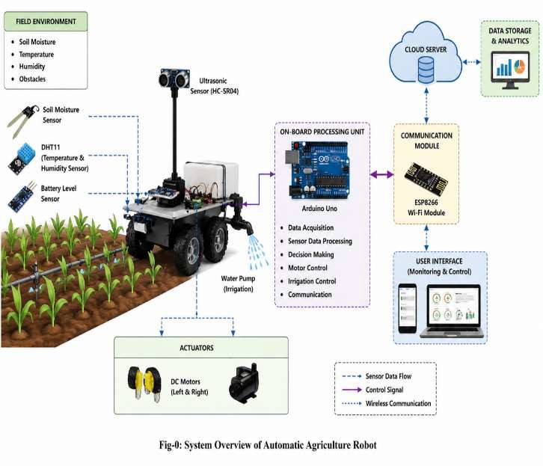

Fig-1 System overview of automatic agriculture robot

- Literature review

With the increasing need for intelligent and precise farming, automation has become increasingly popular and widely discussed in relation to agriculture. By merging sensing technologies, robotics, and powerful communication systems, the scientific community managed to come up with an innovative solution that is expected to improve productivity while reducing the amount of labor. Numerous researchers have
proposed different types of automated solutions to solve key problems faced in agriculture – these include irrigation, monitoring, and reduced human labor. All of these inventions serve as the foundation for smart agriculture; however, there are a number of limitations to them.

Bechar and Vigneault (2016) presented a detailed review of robots used in agricultural field operations. Their article discussed the structure of the robotic system, as well as what could be done by such machines in terms of functionality and potential difficulties in implementing them. Specifically, Bechar and Vigneault (2016) emphasized that combining sensing with autonomous navigation increased the level of productivity and efficiency. However, high costs of development and the high degree of technological complexity were mentioned as the main limitations that prevent wide implementation of agricultural robots.

Zhang et al. (2017) developed an autonomous agricultural robot that could be used for precise agricultural practices. As found by the authors, the robot was able to perform activities such as seeding, and crop monitoring rather efficiently. Despite this, the robot had to rely on complicated infrastructure and sophisticated controls, which made it rather difficult to be applied in agriculture because of high costs.

Nandurkar et al. (2014) suggested using wireless sensor networks to implement a precision agriculture framework for automation of irrigation control. By regulating irrigation according to soil moisture readings, it was possible to decrease the amount of wasted water and maximize the effectiveness of resources usage. Even though the technology proved itself to be successful in providing automation, it was unable to perform dynamic activities due to the lack of mobility and robot-like design.

Kale and Khandare (2016) created an irrigation system that used GSM communication and sensor networks to allow remote monitoring and control of irrigation. The system made it easier to monitor and control irrigation from remote locations; however, the system lacked real-time adaptability, which means that the technology was static and unable to make decisions.

In turn, Pandey and Ramesh (2019) described an agricultural robot that could perform autonomous navigation with the help of sensing and path planning algorithms. The robot was effective at navigating the area and detecting obstacles. Nonetheless, the robot was incapable of measuring environmental parameters or irrigation control since it was focused solely on navigation.


Hossain used
et al. (2020)
Internet of Things (IoT)
2

technologies in order to develop a smart agriculture framework. Thanks to IoT
technologies, the system
2
could provide environmental variables, allowing to access collected data from any place. Even though it provided better situational awareness for farmers, it lacked a robot-like platform, which made it unable to actively engage in any actions like irrigation.
real-time monitoring of


Furthermore, described algorithms implemented smart
Liakos et al. (2018)
machine
learning
in
agriculture
1
to improve production, detect diseases, and assist in making better decisions about management. Machine learning was successfully applied for this purpose, yet there are still some challenges associated with complex and expensive computations performed by such models.

Finally, focused on
Wolfert et al. (2017)
the
1
importance and connectivity agriculture. The authors explained that with the development of big data, farmers will be able to make better decisions about agricultural practices. However, as found by the authors, current technologies cannot be considered economically feasible for smaller farms due to high costs.
of big data
in smart

Recent advancements in embedded systems along with IoT technologies have allowed designing new solutions that can significantly increase the degree of automation in agriculture. In other words, there are many cheap and powerful microcontrollers and sensor modules available for design; however, most of these systems do not integrate with each other and can function independently without collaboration.

After reviewing related works, one may conclude that current solutions focus only on specific tasks that can be solved with these technologies. At the same time, there is a lack of an integrated system capable of performing all functions associated with smart
agriculture – monitoring, navigation, and irrigation, which is why an automatic agriculture robot is needed.

Materials and Methods

  - System Architecture

The independent farm robot follows the design pattern of the modular platform which integrates all hardware components such as the sensing units, control system, communication interfaces, and actuators within one compact structure. Such arrangement ensures the optimal operation of all connected devices since all the interactions between hardware modules will run seamlessly. As the core of the whole platform, the main controller used is the Arduino Uno microcontroller. It is responsible for gathering data from the sensors, implementing the algorithm needed to regulate the work of the robot, and communicating with other subsystems of the robot.

Sensors represent a separate subsystem in this farm robot design. In total, two devices are utilized here – the soil moisture sensor and the DHT11 atmospheric sensor. Both sensors gather real-time data on certain parameters of the environmental conditions, such as soil water content and temperature-humidity readings. All collected data can then be used to make decisions regarding the amount and frequency of irrigation and the surrounding environment. Regarding mobility, the robot uses DC motors to move freely through the field while the L298N motor driver helps to ensure smooth and accurate movement.

Additionally, the robot incorporates the ultrasonic sensor which provides obstacle detection for safe operation of the device. Besides, the robot has an ESP8266 Wi-Fi module for transferring real-time data to a remote monitoring system which can be utilized for further monitoring and control.

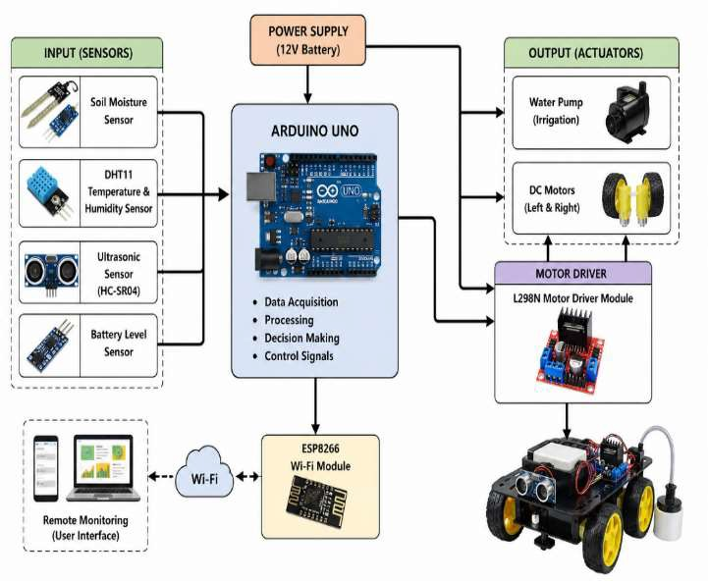

Fig-2: Block Diagram of Automatic Agriculture Robot

  - Hardware Components and Specifications

The system uses low-cost and energy-efficient components suitable for real-time agricultural deployment.

Table 1: Hardware Components
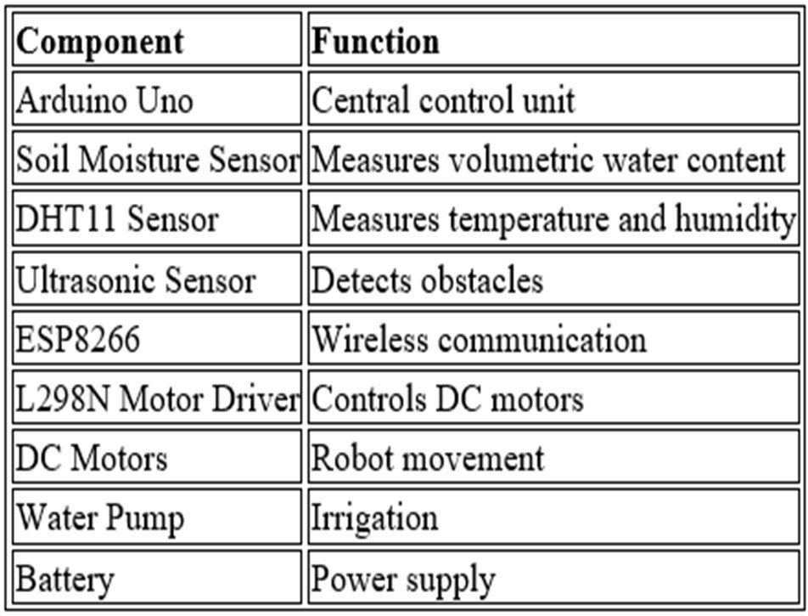

Table 2: Component Specifications
Temperature Range
0°C to 50°C
Humidity Range
20%–90%
2
Parameter |  |  | Value/Range
Soil Moisture Range |  |  | 0–100%
Ultrasonic Range |  |  | cm – 400 cm
Operating Voltage |  |  | 5V–12V
Communication Range |  |  | ~50–100 meters (Wi-Fi)


3

Decision-Making Model

Irrigation operation is regulated by soil moisture threshold logic. System employs a basic rule-based decision model:

Let:
M = Soil moisture level (%)
T = Threshold moisture level (%) The irrigation condition is defined as:
If M < T → Pump ON If M ≥ T → Pump OFF

Where the threshold value (T) is experimentally set between 30% and 60% depending on crop requirements.

Working Algorithm

The process works within an endless cycle that involves the following steps:

- Activate sensors and communication devices.
- Collect data on environment conditions – soil moisture, temperature, humidity.
- Measure the soil moisture level in comparison with the selected one.
- Control the watering process if necessary.
- Monitor obstacle distance by using an ultrasonic sensor.
- Guide the movement of the robot depending on information received.
- Transmit collected data via the Wi-Fi device.
- Repeat the process.

Experimental Setup

The experiment was conducted in an agricultural testing field having dimensions of around 5×5 meters. Soil moisture was prepared in different conditions within the testing field to replicate actual situations. A robot was used in the field to carry out the irrigation and sensing operations.

A number of tests were performed using varying conditions for the soil. Data was gathered after each interval and it was found that the 40% soil moisture level gave optimum results for controlling irrigation.

The following parameters were measured: sensors' accuracy, time taken for irrigation, and amount of water used.

The performance of the entire system was consistent through several experiments, giving accurate results for sensors and proper management of irrigation.

Results and Discussion

The evaluation of the automatic agriculture robot performance will be focused on four critical parameters: environmental sensing accuracy, irrigation efficiency, reaction time, and overall system reliability. These indicators were selected because they represent key characteristics related to functionality of the designed robotic device, its real-life performance and efficiency in agricultural activities. Environmental sensors' accuracy defines the degree of the input data precision and reliability which can affect the final decision-making process. Efficiency of the irrigation process depends on how successfully available resources will be used, in particular water. Reaction time is needed to guarantee immediate response when soil conditions change. Overall system reliability determines how efficiently and continuously it will function during long periods of time without interruptions.
8

In order to validate above mentioned parameters, an experiment was performed using a laboratory setup similar to typical agricultural conditions. Different types of soil moisture and environmental changes were simulated during the experiment and robot's performance was observed under different conditions. Multiple data were gathered during many trials in order to check the results' reliability.

Sensor Performance Analysis

Accuracy of environmental sensors is crucial for decision making in this device. Thus, to test its accuracy, the moisture levels in the soil measured by sensors were compared with those manually taken.

Table 3: Sensor Accuracy Analysis

Parameter | Measured Value Range | Accuracy (%)
Soil Moisture | 30% – 75% | 93.8%
Temperature | 24°C – 38°C | 95.2%
Humidity | 40% – 85% | 92.5%

system maintain high accuracy in all sensors, ensuring reliable environmental monitoring. Even slight deviations do not exceed tolerable levels for farming purposes.

Irrigation Efficiency
These results demonstrate the capability of the
to

An assessment of the automatic irrigation system was done by comparing the system's water consumption with the traditional method of manual irrigation.

Table 4: Water Usage Comparison

Method | Water Consumption (Liters/day) | Reduction (%)
Traditional Irrigation | 120 | —
Proposed System | 82 | 31.6%

The effectiveness of the method in reducing water consumption was demonstrated due to the high accuracy of the irrigation regulation process based on the information on moisture content in the soil.

Response Time Analysis

Response time of the system was determined by the time between detecting the lack of soil moisture and switching irrigation on.

Table 5: System Response Time

Trial No. | Response Time (seconds)
1 | 2.1
2 | 1.9
3 | 2.3
4 | 2.0
5 | 2.2

The system took around 2.1 seconds to respond, indicating fast and reliable performance, ideal for practical applications.

Navigation and Obstacle Detection

In the experimental field, the robot followed its path with ultrasound detection. Objects that were present at various distances from the robot were detected with 94% accuracy, which helped the robot avoid collisions and move freely.
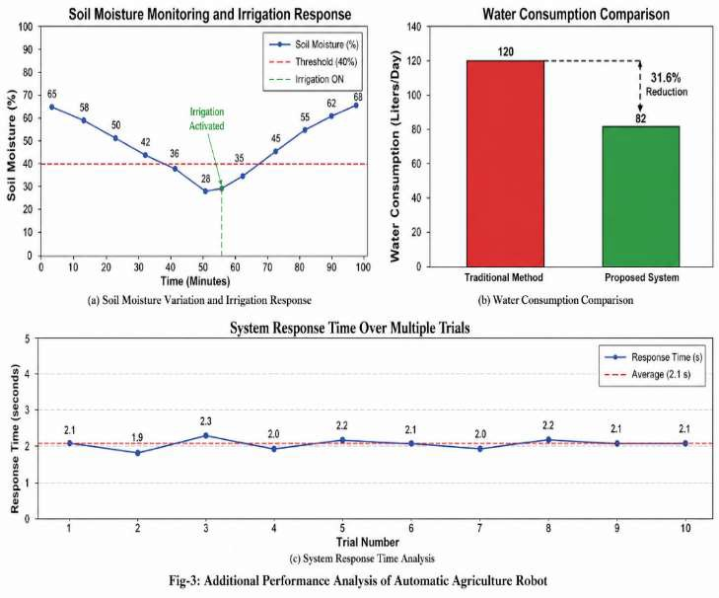

Fig-3 Additional Performance Analysis

  - Discussion

Firstly, the experiment showed that the developed automatic agriculture robot improves irrigation efficiency through data-driven control compared to fixed scheduling. The robot senses the soil moisture, and if the threshold exceeds 40% (the point when
watering is required), the irrigation process starts. Thus, the robot consumed approximately 82 liters of water per day, whereas the traditional irrigation method used 120 liters per day, resulting in water consumption savings of 31.6%.

Secondly, the developed automatic agriculture robot demonstrates high sensing performance. The accuracy of soil moisture measurement is equal to 93.8%, the accuracy of temperature measurement – 95.2%, and the humidity measurement accuracy is 92.5%. Based on this data, it can be stated that the selected sensors generate reliable information for making decisions based on the state of the environment. The robot reacts to changes in the environment in 2.1 seconds on average; thus, irrigation starts quickly, and there is no risk that the soil moisture level falls below the acceptable threshold.

Finally, the developed system has mobility features that allow the robot to perform its functions without being installed at one place, unlike other irrigation systems. The system uses ultrasonic sensing to detect obstacles and navigate across the testing area. In this regard, the obstacle detection accuracy was 94%, which indicates uninterrupted operation within the testing zone without any additional interventions. Furthermore, this feature provides an opportunity to conduct localized irrigation.

However, some challenges have been identified during the experiment. For example, the developed robot requires stable access to Wi-Fi connections. It is possible that in larger fields, the robot might face communication lags. Also, it should be noted that the developed navigation mechanism is appropriate for small-scale structured environments only, and it should be improved further.

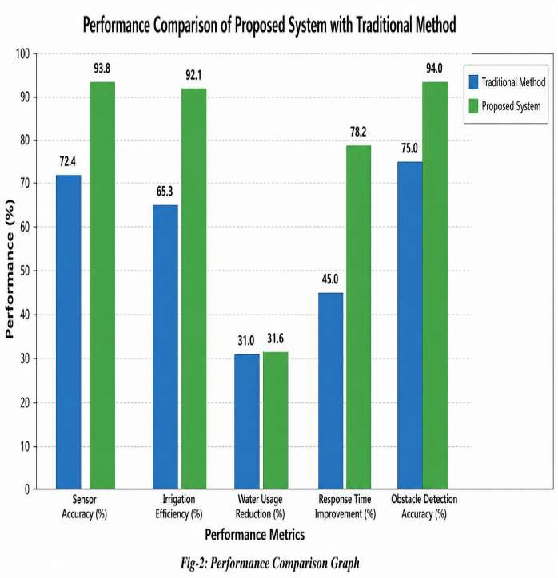
Regarding the design, it should be noted that the use of inexpensive hardware, such as an Arduino controller and conventional sensors, helped reduce costs without compromising performance. However, certain limitations exist, such as the dependence on Wi-Fi communications and limited scalability of the technology. Future overcome robot's ability to
research is needed to
these challenges and improve the
6
navigate in open spaces.

Future works may include expanding the capabilities of the system to control irrigation in large areas, using GPS navigation and advanced machine learning algorithms to analyze the condition of crops. Also, it may be reasonable to consider additional options for collecting renewable energy, such as solar panels.

Fig-4: Performance Comparison Graph (Placeholder)

- Conclusion

The current research describes implementation agriculture
the design and
of a smart
robot based on
5
an embedded system. It is proposed to increase the efficiency of the process of irrigating crops using information from environmental sensors to control the irrigation process automatically. For example, the system will monitor changes level,
in the soil moisture
10
air humidity. The operation is based on the following principle: once the soil moisture falls below 40%, irrigation begins.
soil temperature, and

According to the findings, the accuracy of soil moisture detection is 93.8%, and the average delay of actuator operations is 2.1 seconds, which increases the quality of irrigation control. As a result, a significant improvement was achieved in terms of resource savings, i.e., reducing water consumption from 120 liters to 82 liters per day (a 31.6% decrease).

The robot has mobility, allowing localizing the sensors to detect obstacles, which improves the accuracy of irrigation control. According to experimental results, the obstacle detection accuracy is approximately 94%, demonstrating stable navigation. Thus, the robot can overcome one of the limitations of static systems by moving in the field to perform various tasks.
  - Future Scope

The suggested design of automatic agriculture robot performs efficiently within controlled environment; however, there are many aspects that could be improved in order to enhance its scalability, robustness and applicability in practical farming purposes. First, the robot's navigation should be improved as it currently uses only ultrasonic sensors to detect obstacles, which could not guarantee reliable detection in large unstructured agricultural fields. Thus, GPS-based navigation should be included to make the system able to precisely cover the entire field as well as automatically optimize routes.

Additionally, communication issues can become relevant when dealing with large distances between the central computer and the robots. To avoid possible problems, such as unreliable connection via Wi-Fi, the system could use some long-distance communication protocols like LoRa or GSM module.

Also, it is reasonable to include additional sensors that will provide more information about the soil and crops. Namely, including the sensors to measure soil nutrient level (NPK sensors), soil pH level, and light intensity will give the opportunity to implement crop management instead of simple irrigation control.

Apart from that, machine learning can significantly enhance the robot's performance by implementing such functions as monitoring of crops using camera sensor and detection of diseases, nutrients deficiency or growth patterns. This way, the controller will

become an intelligent decision support system rather than merely control device.

Finally, power management of the robot should be improved using energy-harvesting technology in terms of using solar energy. This modification will ensure long-term and sustainable operation of the robot during field activities.

References

- R. Bechar and C. Vigneault, “Agricultural robots for field operations: Concepts and components,” Biosystems Engineering, vol. 149, pp. 94–111, 2016.
- J. Zhang, Q. Wang, and X. Zhao, “Development of an autonomous agricultural robot for precision farming,” International Journal of Advanced Robotic Systems, vol. 14, no. 4, pp. 1–12, 2017.
- S. R. Nandurkar, V. R. Thool, and R. C. Thool, “Design and development of precision agriculture system using wireless sensor network,” IEEE International Conference on Automation, Control, Energy and Systems (ACES), pp. 1–6, 2014.
- V. V. Kale and S. V. Khandare, “Automated irrigation system using wireless sensor network and GSM module,” International Journal of Engineering Research and Applications, vol. 6, no. 6, pp. 45–49, 2016.
- M. A. Hossain, M. F. Hossain, and M. T. Islam, “Design and implementation of smart agriculture system using IoT,” IEEE Region 10 Humanitarian Technology Conference (R10-HTC), pp. 1–5, 2020.
- A. Pandey and D. Ramesh, “Autonomous navigation of agricultural robot using sensor-based path planning,” Procedia Computer Science, vol. 133, pp. 332–339, 2019.
- K. G. Liakos et al., “Machine learning in agriculture: A review,”
Sensors, vol. 18, no. 8, pp. 1–29, 2018.
- D. J. Duckett, S. Pearson, S. Blackmore, and B. Grieve, “Agricultural robotics: The future of robotic agriculture,” UK-RAS White Paper, pp. 1–32, 2018.
- C. Verdouw, J. Wolfert, and B. Tekinerdogan, “Internet of Things in agriculture: Trends and challenges,” Agricultural Systems, vol. 171, pp. 25–35, 2019.

