Practices of Physical Education Teachers in Teaching Physical Education and Sports: An Analysis
Kristine Marie T. Ronario ^{1 *}
¹ Dean, School of Physical Education and Sports, City College of Tagaytay, Tagaytay City,
Cavite, Philippines

Abstract
This descriptive-comparative research examined the physical education (PE) teaching programs and practices of State Universities and Colleges in CALABARZON. The evaluation employed five key variables, which were backed by interviews with PE teachers. The results indicated that successful PE programs must align with established standards and guidelines, meet PE goals, foster overall fitness, foster teamwork and cooperation, and have systematic monitoring and evaluation of students. When it comes to leadership, teachers are expected to be masters of activities, well-rounded communicators, and logical in their approach to teaching. They are supposed to encourage the less-active students, make learning fun and acknowledge differences. In terms of overall class procedures, educators need to keep proper records of progress, record attendance effectively, oversee proper activities in case of students with medical excuses and offer differentiated learning experiences. The use of technology in PE, the creation of technology-limited students’ modules, the regular application of warm-up and cool-down activities, and the use of proper assessment rubrics were also highlighted. PE teachers are expected to offer ample space to conduct activities, maintain sufficient lighting and ventilation, frequently check equipment and facilities, demonstrate activities clearly to avoid injuries, keep track of the medical condition of students, and have basic first-aid knowledge to provide a safe and healthy environment. Regarding student behavior, students ought to treat teachers with respect, cooperate to learn new skills, deliver performances, and have fun during PE lessons. The study recommends that the instructional model and action plan developed, particularly Tantang’s Model, be adopted by PE teachers to create effective learning experiences and improve physical education instruction.
Keywords: Physical Education; Instructional Programs; Practices in Teaching PE; Tantang’s Model
Introduction
Physical education is a process through which an individual obtains optimum mental, social, emotional and physical fitness through physical activities. Physical education is part of education which takes place through activities, which involves the motor mechanism of human body which results in an individual’s formulating behavior patterns. Sharman, (2021). According to National Association of Sport and Physical Education (NASPE), well managed, safe, systematic, progressive, purposeful and informative physical education programs and classes can significantly contribute to enhancement of health and well-being of students. Students must demonstrate competency in many movement forms and proficiency in a few movement forms, applies movement concepts and principles to the learning and development of motor skills, exhibits a physical active lifestyle, achieves and maintains health-enhancing level of physical fitness, demonstrates responsible personal and social behavior in physical activity settings, demonstrates understanding and respect for differences among people in physical activity settings and understands that physical activity provides opportunities for enjoyment, challenge, self-expression and social interactions. On the other hand, the instructional program in physical education is the place to teach skills, strategies, concepts, and essential knowledge concerning the relationship of physical activity to physical fitness, motor skill, cognitive and affective development and a place of understanding the contribution of physical activity to total well-being. It is a place to challenge, build confidence, encourage creativity, advance critical action skills, instill commitment to personal wellness, and foster respect for others. It is also a place to introduce an awareness of the development and maintenance of optimal levels of health-related physical fitness. ( Bucher and Krotee, 2002). Realizing the impact of physical education programs on the total well-being of students. The researcher explored, through this study, the analysis of the physical education instructional programs and practices of the State Universities and Colleges schools in CALABARZON. The study involved the evaluation on the physical education instructional programs through the five major variables namely, meeting physical education objectives, leadership (teachers conduct), general class procedures, methods and techniques, student conduct and safe and healthful environment. The results of the evaluation were supported by an interview with the teachers of physical education. After the evaluation took place, a proposed new instructional model and action plan was made.

Methodology

This descriptive comparative research, adapted the questionnaire on the “Criteria for Evaluating Physical Education Instructional Program” of Krotee (2012) to assess the best practices on physical education programs of State Universities and Colleges in CALABARZON based on five major variables namely: (1) Meeting Physical Education Objectives, (2) Leadership (Teaching Conduct), (3) General Class Procedures, Methods and Techniques, (4) Student Conduct and (5) Safe and Healthful Environment. Qualitative data was collected and summarized to determine practices in teaching physical education. Below is the likert scale used in the questionnaire
5.00 - 4.20 Strongly Agree (Always Practiced)
4.19 - 3.40 Agree (Most Practiced)
3.39 - 2.60 Neutral (Sometimes Practiced)
2.59 –1.80 Disagree (Less Practiced)
1.79 - 1.00 Strongly Disagree (Not Practiced)

Results and Discussion

This study evaluated the physical education instructional programs through the five major variables namely, meeting physical education objectives, leadership (teachers conduct), general class procedures, methods and techniques, student conduct and safe and healthful environment. The results of the evaluation were supported by an interview with the teachers of physical education. The findings of the study guide the proposed new instructional model applicable to the locale of study will be made. The following summarizes the results of the study:

Profile of the student respondents
The total number of respondents was 383, higher than the expected respondents as determined by the Slovins formula. Profile of the student respondents in terms of age. The findings show that 221 or 58 % of the respondents are 20 years old and below; 146 or 38 % are 21-25 years old; and 16 or 4 % are 26 years old and above. Results reveal that most of the student respondents are 20 years old and below. The student respondents are 138 or 36 % male; and 245 or 64 % female. According to the findings, most of the respondents are female. In terms of year level, the results show that 40 or 11% are first year students; 207 or 54 % are second year; 78 or 20 % are third year; and 58 or 15 % are fourth year. The results indicate that most of the respondents are at the second-year level. In terms of school, 126 or 33 % were enrolled in Cavite State University, 47 or 12 % were enrolled in Laguna State Polytechnic University, 70 or 18 % were enrolled in Batangas State University, 61 or 16 % were enrolled in University of Rizal System and 79 or 21 % were enrolled in Southern Luzon State University.

Assessment of Physical Education Instructional Programs
In terms of Meeting Physical Education Objectives, statements 1, 5 and 6 have the highest weighted average. The weighted meaning of the responses is ranging from 4.21-4.47. The total weighted mean is 4.33 with verbal interpretation of strongly agree. The computed standard deviation is ranging from 0.96-1.04 making the results homogenous. In terms of Leadership (Teaching Conduct), statements 2, 3, 7 and 9 have the highest weighted average. The weighted mean of the response ranges from 4.37-4.50. The total weighted mean is 4.43 with verbal interpretation of strongly agree. The computed standard deviation is ranging from 0.95-1.02, making the results homogenous. In terms of General Class Procedures, Methods, and Techniques, statements 7, 8 and 9 have the highest weighted average. The weighted mean of the response ranges from 4.28-4.39. The total weighted mean is 4.35 with verbal interpretation strongly agree. The computed standard deviation is ranging from 0.94-1.04 making the results homogenous. In terms of Student Conduct, statements 3, 6 and 10 have the highest weighted average. The weighted mean of the response ranges from 4.30-4.44. The total weighted mean is 4.37 with verbal interpretation of strongly agree. The computed standard deviation ranging from 0.93-1.00 making the results homogenous. In terms of a Safe and Healthful Environment, statements 1, 5 and 10 have the highest weighted average. The weighted mean of the response ranges from 4.18-4.41. The total weighted mean is 4.31 with verbal interpretation of strongly agree. The computed standard deviation is ranging from 0.93-1.07 making the results homogenous. In summary, the assessment based on meeting physical education objectives, leadership (teachers conduct), general class procedures, methods and techniques, student conduct and safe and healthful environment have a weighted mean ranging from 4.31-4.43. The overall weighted mean is 4.31 with verbal interpretation of strongly agree.

Assessment of the respondents on physical education instructional programs when grouped according to profile
In the assessment on physical education instructional programs of SUC’S in CALABARZON when grouped according to their age. Since the p-value of 0.1719 is not less than 0.05 level of significance, then results failed to reject the null hypothesis. Thus, there is no sufficient evidence to conclude that there is a significant difference in the assessment of the respondents on physical education instructional programs of SUC’s in CALABARZON when grouped according to their age. In the assessment on physical education instructional programs of SUC’S in CALABARZON when grouped according to their sex. Since the p-value of 0.0965 is not less than 0.05 level of significance, then failed to reject the null hypothesis. Thus, there is no sufficient evidence to conclude that there is a significant difference in the assessment of the respondents on physical education instructional programs of SUC’s in CALABARZON when grouped according to their sex. In the assessment on physical education instructional programs of SUC’S in CALABARZON when grouped according to their year level, since the p-value of 0.7773 is not less than 0.05 level of significance, then failed to reject the null hypothesis. Thus, there is no sufficient evidence to conclude that there is a significant difference in the assessment of the respondents on physical education instructional programs of State Universities and Colleges schools in CALABARZON when grouped according to their year level. In the assessment on physical education instructional programs of SUC’S in CALABARZON when grouped according to their schools, since the p-value of 0.4368 is not less than 0.05 level of significance, then failed to reject the null hypothesis. Thus, there is no sufficient evidence to conclude that there is a significant difference in the assessment of the respondents on physical education instructional programs of SUC’s in CALABARZON when grouped according to their school.

Practices of physical education teachers in teaching physical education and sports
In terms of the practices of physical education teachers in teaching physical education, the results suggest that for schools to develop and provide quality physical education instructional programs teachers and schools must be able to meet the objectives of the subject, provide proper leadership, methods, and techniques, monitor student conduct and performances, and provide safe and healthful environment for students

Conclusion
The evaluation of physical education teaching programs in the five State Universities and Colleges (SUCs) in CALABARZON showed that students felt that PE goals are effectively met, which enables them to become physically, socially, emotionally, and mentally fit. Teacher leadership was identified to have a significant impact on the learning process, whereas classroom procedures and learning environments were deemed effective and conducive to student learning. Students were also well conversant with PE goals, processes and classroom expectations and stressed the need to maintain a safe and healthy environment to avoid risks in activities. Overall, the PE instructional programs of the five SUCs were considered effective in promoting students’ well-being. The results also indicated that there were no significant differences in the program assessment based on the age, sex, year level, or school, which showed that there was a consistent PE instruction across the SUCs. According to the program evaluation and teacher interviews, the effective PE programs must adhere to the standards and guidelines, support the overall fitness, teamwork, and involve systemic monitoring and evaluation. Teachers are expected to be strong leaders with strong communication and inclusive teaching practices and encourage less-active students and meet their individual needs. They are expected to keep proper records, organize attendance effectively, offer diverse and activities that are technology-based, create modules that do not require high access to technology, and use appropriate warm-up, cool-down, and assessments. It is also necessary to provide sufficient facilities, safe equipment, proper demonstrations, and basic first-aid preparedness and the students are supposed to demonstrate respect, cooperation, responsibility, and enjoyment in PE classes. Tantang’s Model can be adopted by PE teachers to create effective learning experiences and improve physical education instruction.
Tantang’s Model
Rationale: Tantang’ s Model of Teaching Physical Education was named after the nickname of the proponent. This model was made through the evaluation of physical education instructional programs and practices of the five SUC’s in CALABARZON namely: Cavite State University, Laguna State Polytechnic University, Batangas State University, University of Rizal System, and Southern Luzon State University. The model is based and includes the top best practices considered by the respondents. This model will improve the teaching of physical education in colleges and universities.
Physical education teachers aim to provide high-quality, standard based and safe physical education instruction; also to expose students to a variety of activities for them to develop the knowledge, skills, and confidence to let them appreciate a lifetime of physical activity, health, and total wellbeing.

Objectives: To create effective learning experiences for students; To focus on achieving the goals of physical education, leadership (teaching conduct), general class procedures, methods, and techniques, a safe and healthy environment, and student behavior based on Krotee's Criteria in Evaluating Physical Education Instructional Programs; To provide a high quality, standard based and safe physical education instruction according to Tantang model 5 easy steps.

Model of Instruction:
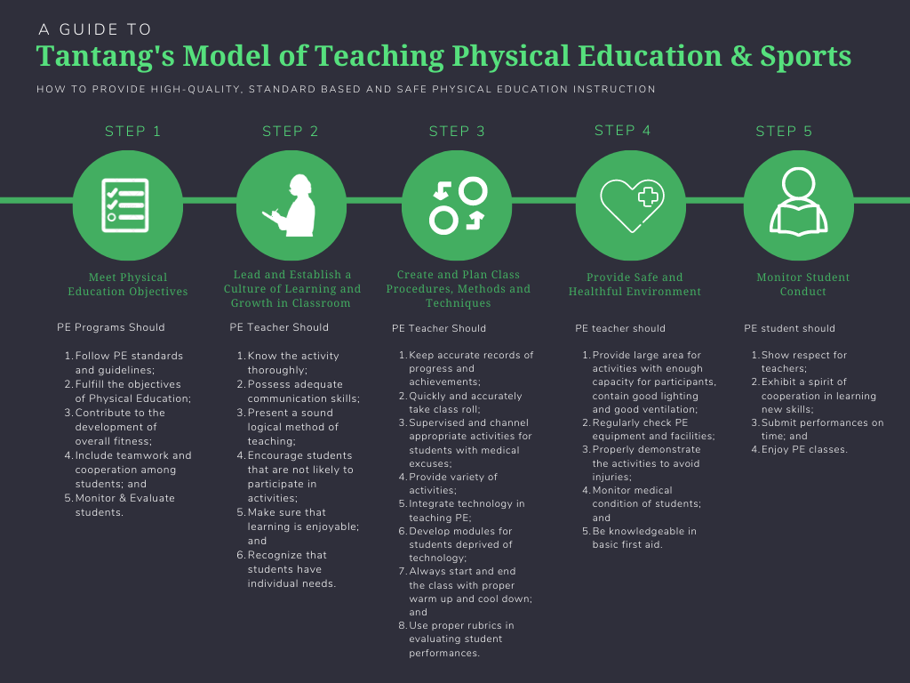

Figure Description:

Step 1. Meet Physical Education Objectives. In meeting physical education objectives, physical education programs should follow PE standards and guidelines, fulfill the objectives of PE, contribute to the development of overall fitness, include teamwork and cooperation among students and monitor & evaluate students.
Step 2: Lead and Establish a Culture of Learning and Growth in Classroom. The teachers should know the activity thoroughly, possess adequate communication skills, present a sound logical method of teaching, encourage students that are not likely to participate in activities, make sure that learning is enjoyable and recognize that students have individual needs.
Step 3: Create and Plan Class Procedures, Methods and Techniques. Physical education teacher should keep accurate records of progress and achievements, quickly and accurately take class roll, supervised and channel appropriate activities for students with medical excuses, provide variety of activities, integrate technology in teaching PE, develop modules for students deprived of technology, always start and end the class with proper warm up and cool down and use proper rubrics in evaluating student performances.
Step 4: Provide Safe and Healthful Environment. Physical education teacher should provide large area for activities with enough capacity for participants, contain good lighting and good ventilation, regularly check PE equipment and facilities, properly demonstrate the activities to avoid injuries, monitor medical condition of students and be knowledgeable in basic first aid.
Step 5: Monitor Student Conduct. Physical education students should show respect for teachers, exhibit a spirit of cooperation in learning new skills, submit performances on time and enjoy PE classes.

References:
1. Aktop, A., & Karahan, N. (2012). Physical education teachers’ views of effective teaching methods in physical education. Procedia – Social and Behavioral Sciences, 46, 1910–1913.
2. Allen, R. (2002). Using assessment data to monitor physical education programs. Journal of Physical Education, Recreation & Dance.
3. Blanco, M., & Eitland, E. (2020). Preparing facilities for students’ return in the wake of COVID-19.
4. Calderón, A., Scanlon, D., & Moody, B. (2021). An integrated blended learning approach for physical education teacher education programmes. Physical Education and Sport Pedagogy.
5. Casey, A., & Kirk, D. (2021). Models-based practice in physical education. Routledge.
6. Cheon, S. H., Reeve, J., & Moon, I. S. (2012). Teacher-focused intervention to help physical education teachers become more autonomy supportive. Journal of Sport and Exercise Psychology, 34, 365–396.
7. Davis, L. (2020). Faculty beliefs concerning the preparation of PETE students. The Physical Educator.
8. Espiña-Verano, M. L. (2017). Performance of physical education teachers in Samar Island (Doctoral dissertation).
9. Boschman, F., McKenney, S., & Voogt, J. (2015). Teachers’ use of TPACK in collaborative design. Computers & Education, 82, 250–262.
10. Filiz, B., & Konukman, F. (2020). Teaching strategies during COVID-19. Journal of Physical Education, Recreation & Dance, 91(9), 48–50.
11. Garcia, J. P. (2021). Teaching strategies of PE instructors. International Journal of English Literature and Social Sciences.
12. Hsu, P. S. (2016). Beliefs and barriers about technology integration. TechTrends, 60(1), 30–40.
13. Ibañez, W. T. (2022). Teaching in the new normal. Multicultural Education.
14. Kliziene, I., Cizauskas, G., & Zaicenkoviene, K. (2021). Effects of PE programs on well-being. IJERPH.
15. Krotee, M. L., & Bucher, C. (2012). Management of physical education and sport (12th ed.). McGraw-Hill.
16. Kwon, E. H. (2020). Review of online learning in PETE. Journal of Physical Education and Sport.
17. Likoko, S., Mutsotso, S., & Nasongo, J. (2013). Instructional materials and facilities. International Journal of Science and Research.
18. MacPhail, A., Tannehill, D., & Borghouts, L. (2021). Instructional alignment in PETE. Physical Education and Sport Pedagogy.
19. Metzler, M., & Colquitt, G. (2021). Instructional models for physical education. Routledge.
20. Ningthoujam, R., Nongthombam, B., & Sunderchand, M. (2017). Innovative teaching methods. International Journal of Community Research and Review.
21. Ntoumanis, N. (2012). Motivation in sport and PE. Human Kinetics.
22. O’Brien, W., Adamakis, M., O’Brien, N., et al. (2020). PE teacher education during COVID-19. European Journal of Teacher Education.
23. Panganiban, T. D. C. (2019). Quality assessment of PE programs. Jurnal SPORTIF.
24. Reeve, J., & Cheon, S. H. (2021). Autonomy-supportive teaching. Educational Psychologist.
25. Tanucan, J. C., Hernani, M. R., & Diano, F. Jr. (2021). Filipino PE teachers’ TPACK. International Journal of Information and Education Technology.
26. Yu, J., & Jee, Y. (2020). Online classes in PE during COVID-19. Education Sciences.
27. Zach, S., Cohen, R., & Arnon, M. (2020). Motivational climate in PE classes. The Physical Educator.

Ethical Considerations
Ethical Approval
This study was conducted in accordance with ethical standards for research involving human participants. Prior to data collection, permission was obtained from the concerned university authorities and participants were informed about the purpose of the study. Participation was voluntary and respondents were assured that their identities and responses would remain confidential and used solely for academic and research purposes. Informed consent was secured from all participants before the administration of the survey and interviews.

Conflict of Interest

The authors declare that there is no conflict of interest regarding the publication of this research. The study was conducted independently and was not influenced by any financial, personal, or institutional relationships that could be perceived as a potential conflict.

Data Availability
The data that support the findings of this study are not publicly available due to privacy and confidentiality agreements with the participants and participating institutions. However, anonymized data may be made available by the corresponding author upon reasonable request for academic and research purposes.

