VULNERABILITY OF COASTAL INFRASTRUCTURE IN CONGO-BRAZZAVILLE TO CLIMATE
Joëlle Claude ZOU-MASSENGO, Cris Chesnel MAKETO and Gaston SAMBA
Centre de Recherche et d’Etudes sur l’Environnement (CR2E)
École Normale Supérieure, Marien Ngouabi University, Brazzaville, Congo
BP 3162 Brazzaville, Congo site www.cr2e.cg
Correspondence: zjoelleclaude@gmail.com / +242 06 885 29 50
Abstract:
This study aims to analyze vulnerability of Congolese coastline to climate change. To carry out our study, we used climate, demographic, economic, and cartographic data, as well as data from field observations. Our methodology approach is based on data collection, vulnerability analysis, a diachronic approach, data analysis, participatory mapping, and statistics processing. Main results show that climate change on coast is reflected in a trend toward higher temperatures and a slight decrease in precipitation. Impacts of climate on coastal ecosystems, economic activities, and human settlements reveal the coast's significant vulnerability to climate change.
Keywords: adaptation, climate change, impact, vulnerability.
Introduction
Climate change is one of the most significant threats to our environment and our economic and social well-being. The negative effects of climate change are already being felt worldwide, and many communities, particularly in developing countries, are becoming increasingly vulnerable (Wicander et al., 2016, p. 8). For example, the work of the French Research Institute for Development (IRD, 2013, p. 45) highlights that more than 60% of African coastal areas will be threatened by rising sea levels by 2050. Congolese coastline is far from immune to the expected negative consequences of global warming, as ocean surface temperatures are rising steadily (Ibiassi et al., 2013, p. 6). It risks becoming increasingly vulnerable due to the environmental problems currently observed (floods, coastal erosion) . Based on the preceding reflections, a key observation emerges regarding the Congolese coastline. Current climate change represents one of the threats to the coastal environment. Coastal regions are severely affected by its impacts, despite their significant economic importance. Last two decades have been devoted to numerous studies (Niazi S., 2011; World Bank, 2021 and 2020; FAO, 2018; USAID, 2017; Baijot E., 2013 ; PRCM, 2011 ; Corcoran E. et al., 2009) on climate change and its impacts on various ecosystems in Africa. These studies analyze the impacts of rainfall variability on coastal ecosystems. Several identified impacts are mentioned: coastal erosion, flooding, ocean submersion, and shoreline retreat. At the national level, literature focused on analyzing the climate of Congolese coast remains sparse and scarce despite work of Kid'Ndila MC D (2024, p. 58), Maketo C. C. (2025 ; 2022), N'daba E. S. (2017), Samba G. (2020), Ibiassi M. G et al. (2021, p. 418) and Massouangui-K. et al. (2023, p. 162).

- Presentation of study area
Located in southwestern Congo, the Congolese coastline (Figure 1) lies precisely between 4° and 5° south latitude and 11° and 13° east longitude. It stretches 170 km in length and 60 km in width. This region is bordered to the north by Gabon, to the south by Angola (Cabinda), to the east by the Mayombe mountain range, and to the west by the Atlantic Ocean. It covers an area of approximately 13,500 km² , representing 4% of the national territory. It is home to numerous public facilities that are vulnerable to climate change.
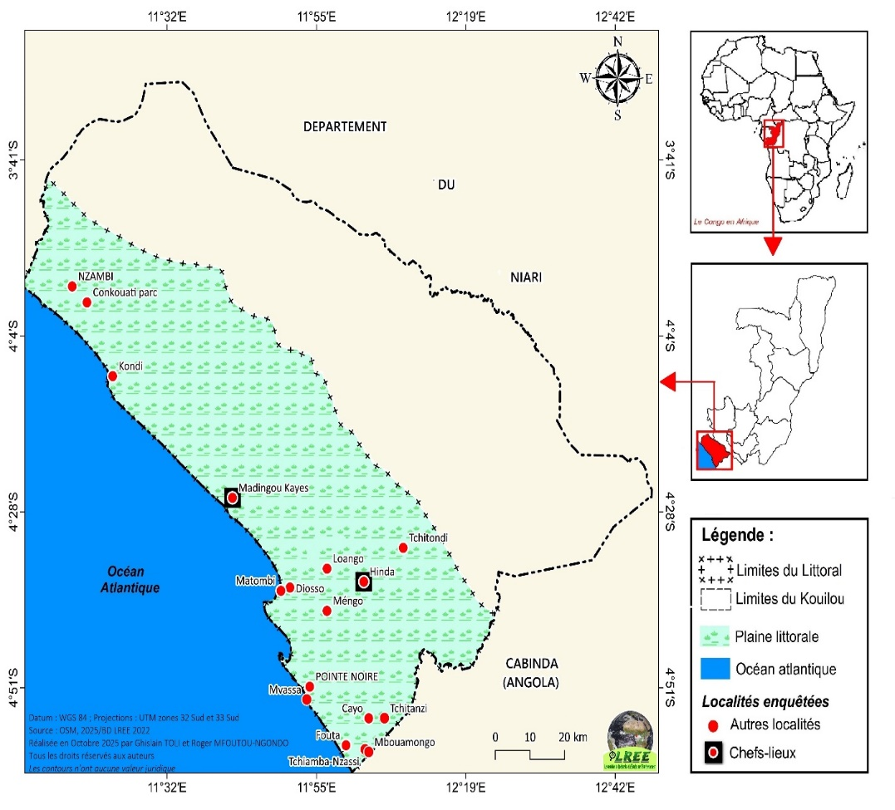Figure 1: localisation of study area

- Data and methods used
  - Data
To achieve the main objectives of this study, we used:
- climate data provided by the National Meteorological Service of Congo (ANAC), they were collected and integrated into the database of the Research and Studies Centre on the Environment (CR2E). These are mainly daily data on rainfall and air temperatures from 1929 to 2022;
- The socio-demographic data comes from the work of the National Institute of Statistics (INS, 2020), the Ministry of Construction, Urban Planning, City and Living Environment (2016);
- The economic data comes from the work of the United Nations Human Settlements Programme (UN-HABITAT, 2012) and the National Institute of Statistics (INS, 2020) relating to the city of Pointe-Noire and the department of Kouilou;
- The data from direct field observation concerns photos taken in several localities on the Congolese coast: Pointe-Noire, Loango, Diosso , Matombi , Bas-Kouilou, Pointe Indienne, Hinda, Madingou-Kayes, Ndjéno , Mvassa , Fouta, Tchiamba-Nzassi , Mbouamongo , Tchitanzi , Cayo, Tchitondi . The localities of Nzambi, Kondi and the Conkuati-Douli Reserve , initially planned, were not observed due to their inaccessibility;
- The Landsat satellite image data comes from the American Copernicus mission and was obtained through Google Earth Pro software in 2026. These images refer to the Bay of Pointe-Noire over a period of 40 years (1985-2025).

  - Methods used
Several methods were applied in this study:
- Data collection was carried out through interviews, direct observation, and the analysis of meteorological and demographic archives. The investigations focused on the impacts and local adaptation strategies. Documentary research allowed us to utilize documents (dissertations, theses, reports, articles, books, presentations, and book chapters) on climate change. The libraries we consulted included the FLASH library, the ENS library, and the GBU library. In addition, consulting websites proved invaluable.
- surveys were conducted in several villages along the Congolese coast (Table 1). The individuals targeted by this work were heads of households, farmers, and resource persons. This category of respondents was chosen because they live near the coastline. The fieldwork itself lasted two months. We conducted the surveys between 2024 and 2025. Data were collected using a questionnaire designed for the respondents, which clearly outlined the tasks to be performed . The total sample consisted of 191 respondents distributed across 13 localities.
- data processing were done using software such as Word for text entry and processing; Excel for creating graphs of climate data and calculating statistical parameters (mean, standard deviation and coefficient of variation, anomalies and moving averages), demographic and economic data.
- The diachronic approach allowed us to assess the retreat of the coastline at the Bay of Pointe-Noire from December 1985 to June 2025. Such a regressive evolution was carried out using Google Earth Pro.
- analysis identified areas within our study zone exposed to climate risks and assessed their frequency if no adaptation measures are taken. This method was implemented using a coastal vulnerability assessment grid.
- mapping has allowed us to understand the involvement of coastal populations in shaping their rapidly changing living environment, enabling them to better manage it. This mapping provides a tool for gaining a better understanding of the environment and the coastal community's perception of current environmental challenges.
To complete this study, we used statistical methods, including the calculation of the arithmetic mean, standard deviation, and coefficient of variation. These statistical methods are described by Samba G. (2014, p. 21).
- Results
  - Climate change
- Rainfall trends along the Congolese coast
Interannual rainfall trends shows an alternation of periods of deficit and surplus. However, from 1929 to 2022, years with deficits outweighed years with surplus rainfall. The rainfall trend remained unstable until the end of the 1960s before increasing in 2022 (Figure 2).

Figure 2: Interannual evolution of precipitation from 1952 to 2022 (data source: ANAC, 2025)
- Interannual temperature changes
Figure 3 shows the interannual temperature trend along the coastline. This trend is marked by two periods: the first is characterized by a decrease in temperatures until the 1980s. The second marks a rising temperature trend until 2024. The average annual temperature is 25°C.

Figure 3: Interannual temperature evolution from 1950 to 2024 (data source: ANAC, 2025)
  - Impacts of climate on public infrastructure
Climate change is exacerbating the environmental problems observed by the surveyed population. Table 1 lists some of the impacts of climate change: shoreline and beach loss, biodiversity loss, flooding, and coastal erosion. These pose a serious threat to the coastal ecosystems of the Congo.
Table 1: Impacts of climate on the coastline
Climate impacts | Number cited | Frequency in %
Loss of shoreline and beach | 72 | 37.7
Coastline retreat | 93 | 48
Coastal erosion | 44 | 23
Loss of biodiversity | 110 | 57.5
Destruction of human settlements | 36 | 18.8
Floods | 35 | 18.3
Total obs. | 191 | 100
Source : personal survey, 2025
- Coastal erosion and shoreline retreat
For several years now, the coastline has been receding due to coastal erosion. Landsat satellite images of Pointe-Noire Bay (Figure 4) indicate a shoreline retreat of 71.2 meters over the past forty years (1985-2025). This is leading to shoreline loss and flooding of settlements located near the coast. Economic activities (tourism, fishing, and industry) are also threatened by this coastal retreat. Given that the Congolese coastal zone constitutes a fragile natural environment, it is subject to coastal erosion. Pointe-Noire Bay is particularly vulnerable to climatic hazards.
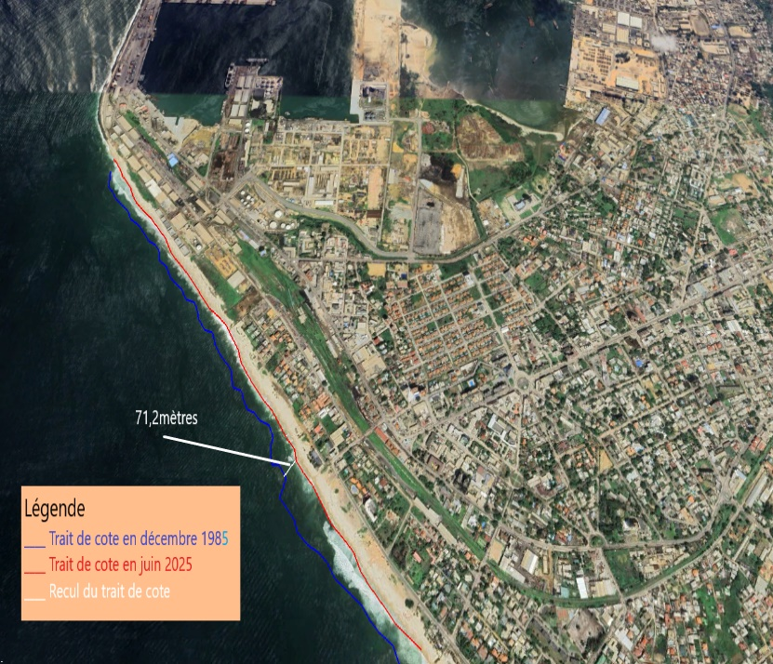
Figure 3: Coastal erosion on the bay of Pointe-Noire (data source: Landsat, 2026)
- Risk of flooding of human settlements
Our field observations reveal that Congolese coastline faces numerous environmental challenges. Coastal flooding and repeated heavy rainfall are destroying roads and infrastructure located near the coast. Since the early 2000s, Congolese coastline has been experiencing intense flooding. During the rainy season, some areas are permanently flooded. This is observed in certain neighborhoods of city of Pointe-Noire: La Base, Saint Pierre, and Matendé, leading to the spread of wastewater (figure 1) and the transmission of epidemiological diseases linked to stagnation of polluted water. Among diseases affecting coastal populations are malaria and cholera.

Plate 1: Human settlements threatened by water
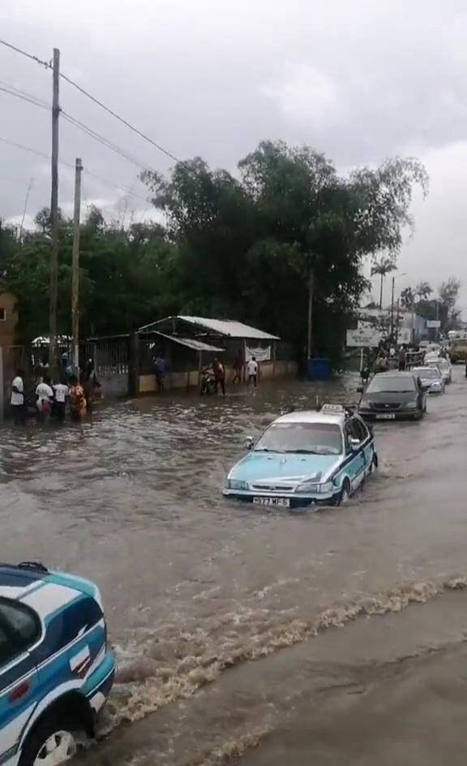  Photo 1: Flooding of an urban thoroughfare in the Tchiali district (photo taken in Maketo, 2022) | 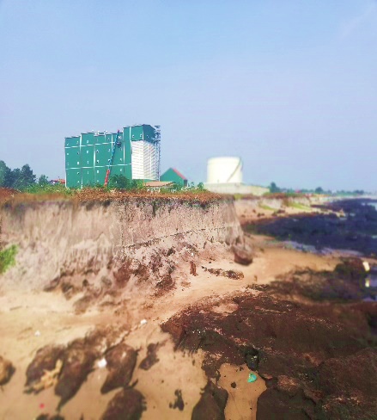  Photo 2: Coastal erosion at Songolo (photo taken in Mfoutou , 2023)

  - Vulnerability of public infrastructure to climate change
Depending on climate change, public infrastructure along Congolese coastline will be subject to coastal erosion and shoreline retreat. Several settlements located in Matombi , Songolo, Kounda, and even Tchilassi are threatened with destruction. Our field observations indicate that Songolo estuary in Pointe-Noire Bay is experiencing dramatic erosion. The CORAF site is no exception: erosion is exposing metal pipe carrying liquid hydrocarbon waste. In Tchilassi , the fishermen's homes and historic Loango cemetery are suffering significant socioeconomic and environmental consequences. If no action is taken, Climate change threatens habitats along Congolese coastline. Figure 5 illustrates vulnerability of infrastructure bordering Congolese coast. Threat of flooding is particularly acute in city of Pointe-Noire.
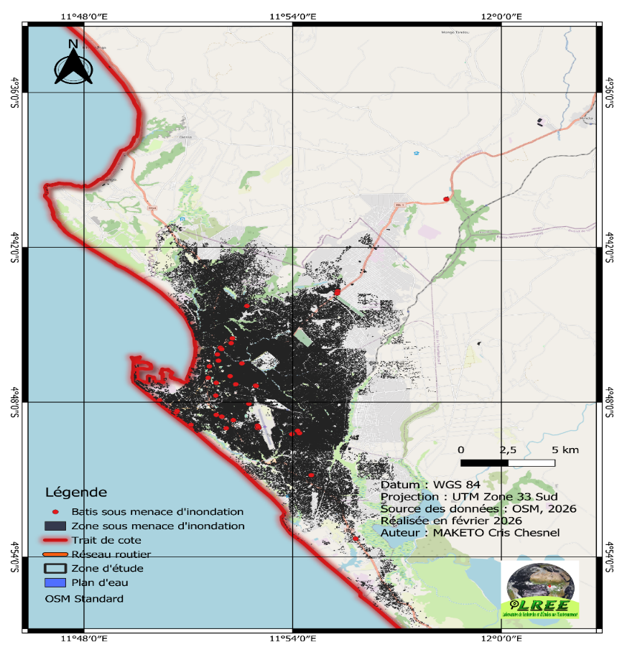
Figure 5: Map of the vulnerability of the Congolese coastline to flooding (data source: OSM, produced by Maketo, 2026)
Discussion
infrastructure along Congolese coast is bearing brunt of climate change: shoreline and beach loss, flooding, and coastal erosion. These phenomena threaten not only human activities but also urban infrastructure, especially in Pointe-Noire metropolitan area. Our results are similar to those obtained by Maketo C. C. (2022) and N'daba E. S. (2017). According to current climate trends, climate change will increase the risk of flooding and coastal erosion. If no action is taken by Congolese public authorities, biodiversity loss will be observed in this area. Work of Samba G. (2020) and Rénatura Congo (2012) reached same conclusions as ours. On the coast of Tetouan in Morocco, risk of flooding could cause considerable damage and have detrimental socio-economic impacts on health and community well-being. In Senegal, Palmarin coast is highly vulnerable to climate change, particularly projected rise in sea level. Physical conditions are unfavorable, and economic activities (tourism and fishing) are increasingly intense.
Conclusion
This study aims to contribute to the analysis of the vulnerability of public infrastructure along the Congolese coast to climate change. Results show that Congolese coastal zone has a humid tropical climate. Over the period from 1950 to 2022, rainfall patterns were unstable. Given that no territory is immune to climate change, our study area is no exception. Its consequences are evident : rising sea levels, saltwater intrusion, and coastal erosion. Currently, erosion in Loango Bay is destroying beaches and small cliffs and threatening National Route 5, which connects Pointe-Noire and Kouilou department. Average coastal erosion is resulting in the displacement of coastal populations, causing material and economic losses. Coastal erosion threatens homes, roads, and businesses. With future climate projections, Congolese coast will experience flooding, and poorest populations will be most affected. These impacts will spread and worsen, further threatening people's lives and livelihoods, while also damaging region's economy and ecosystems. Looking ahead, it would be valuable to conduct studies on perceptions and local adaptation strategies of coastal populations and to assess the vulnerability of coastline to climate change.
References
Baijot Etienne, 2013 : Établissement de la stratégie nationale de gestion intégrée des zones côtières au Sénégal, Hamburg, 105 p.
Banque Mondiale, 2020 : Effets du changement climatique sur l’érosion et les inondations côtières au Bénin, en Côte d’Ivoire, en Mauritanie, au Sénégal et au Togo, Rapport technique, Washington DC, 52 p.
Banque Mondiale, 2021 : Pratiques de gestion des zones côtières en Afrique de l’Ouest, Revue des mesures existantes et envisageables de mitigation et d’adaptation face aux risques d’érosion côtière et de submersion marine, Washington DC, 32 p.
FAO, 2018 : Inventaire floristique et faunique de mangroves et des zones humides côtières du Benin, Cotonou, 88 p.
Ibiassi Mahoungou Godeffroy, Maniaka Fred William., Pongui Espérance Anaelle, 2019 : Changements climatiques et risques environnementaux du littoral congolais, 8 p.
INS, 2020 : Annuaire statistique de Pointe-Noire 2018, Pointe-Noire, 309 p.
INS, 2024 : Cinquième Recensement Général de la Population et de l’Habitat (RGPH-5), Résultats préliminaires, Rapport, Brazzaville, 51 p.
Maketo Cris Chesnel, 2022 : Les enjeux d’adaptation de la ville de Pointe-Noire au climat, Mémoire de master, Ecole Normale Supérieure, Université Marien Ngouabi, Brazzaville, 75 p.
Maketo Cris Chesnel, 2025 : Impacts du climat sur les écosystèmes de mangroves dans la zone côtière congolaise, in Actes du colloque de l’Association Internationale de Climatologie « Climat, agriculture, ressources en eau, tourisme et développement » du 08 au 12 juillet 2025 à l’Université d'Abomey-Calavi (Cotonou), 6 : 760-765.
Maketo Cris Chesnel, Toli Ghislain et Samba Gaston, 2025 : Vulnérabilité de la ville de Pointe-Noire face au climat, in Mouthou Jean Luc et Mizhaire Hilarion Bagel, Défis, vulnérabilité et résilience des villes congolaises, Paris, Éd. L’Harmattan, 20 : 77-97 p.
Massouangui-Kifouala Martin, 2022 : Évolution récente et future des précipitations du site urbain de l’agglomération de Pointe-Noire, République du Congo, Université Marien Ngouabi, Faculté des Lettres, Arts et Sciences Humaines, Brazzaville, 14 p.
Mfoutou Ngondo Roger, 2026 : Vulnérabilité du littoral congolais face aux changements climatiques, Mémoire de master, Ecole Normale Supérieure, Université Marien Ngouabi, Brazzaville, 63 p.
Ministère de la Construction, de l’Urbanisme, de la Ville et du Cadre de Vie, 2016 : Schéma Directeur d’Urbanisme (SDU) de Pointe-Noire, Rome, 88 p.
N’daba Emercia Stevan, 2017 : Vulnérabilité du littoral congolais aux changements climatiques, Mémoire de master, Ecole Normale Supérieure, Université Marien Ngouabi, Brazzaville, 60 p.
PRCM, 2011 : À la découverte de l’environnement côtier et marin en Afrique de l’Ouest, Cahier de connaissances, Document réalisé dans le projet de l’UICN, Bissau, 84 p.
Samba Gaston, 2014 : Le Congo-Brazzaville, Climat et environnement, Paris, Éd. L’Harmattan, 155 p.
Samba Gaston, 2020 : Le climat du Congo-Brazzaville, Paris, Éd. L’Harmattan, Coll. « Études africaines », 241 p.
USAID, 2017 : Évaluation de la vulnérabilité au changement climatique dans les régions de mangrove en Sierra Léone, Rapport abrégé, Accra, 52 p.
Wicander Sylvia, Munroe Robert, Colleen Corrigan, Helfgott Ariella, Meghan Bailey, Ampomah Gifty, Aliou Diouf et Devisscher Tahia, 2016 : Planification de la résilience et de l’adaptation pour les communautés des aires protégées, Guide par étapes, Cambridge, 112 p.

