Potential Use of Spent Coffee Grounds for Functional Food: Blibliometric Review
*Nadhirah Ramadhani Yalfi, Fauzan Azima, Tuty Anggraini
Department of Food Technology and Agricultural Product, Faculty of Agricultural Technology, Andalas University
ABSTRACT
This study aims to analyze the research landscape of spent coffee grounds (SCG) as a value-added resource, particularly in the context of functional food development and sustainability. SCG, a major by-product of the global coffee industry, is increasingly recognized for its rich content of bioactive compounds, including polyphenols, dietary fiber, and other functional components. To explore the development of this research field, a bibliometric analysis was conducted using literature data obtained from the Scopus database. The search employed the keywords “spent coffee grounds,” “functional food,” and “value added,” with publications limited to the period 2006–2026 and English-language articles. The collected data were extracted in “.RIS” format and analyzed using VOSviewer version 1.6.19 to evaluate publication trends, leading publishers, and keyword co-occurrence networks. The results reveal a significant increase in research activity, particularly after 2020, indicating growing scientific interest in SCG valorization. Food Chemistry was identified as the most productive journal, followed by LWT and Food Research International. Keyword analysis highlights that research is primarily focused on antioxidant activity, dietary fiber, and bioactive compounds, while emerging topics include fermentation processes, nutritional enhancement, and food product applications such as bakery products. Overlay visualization further demonstrates a transition from early compositional studies to more recent application-oriented research. In conclusion, SCG has evolved from being considered a low-value waste material into a promising resource for sustainable functional food development. However, further research is required to address challenges related to safety, standardization, and clinical validation. This study provides a comprehensive overview of current research trends and supports future efforts in advancing SCG utilization within a circular bioeconomy framework.
Keywords: spent coffee grounds, functional food, bioactive compounds, bibliometric analysis, sustainability
INTRODUCTION
The global coffee industry generates approximately 6–8 million tons of spent coffee grounds (SCG) annually, with every gram of ground coffee producing approximately 0.91 grams of residual material (Bevilacqua et al., 2023; Sukmanov et al., 2025). Traditionally viewed as waste destined for landfills, SCG has been reconceptualized as a valuable resource following accumulating evidence of substantial bioactive compound retention despite beverage extraction (Melikoglu, 2025). These residues contain complex arrays of polyphenols, dietary fiber, proteins, and essential minerals, with total phenolic contents typically ranging from 9–29 mg of gallic acid equivalents per gram of dry weight (Ramón-Gonçalves et al., 2019). Chlorogenic acid emerges as the predominant phenolic compound, complemented by caffeine, trigonelline, melanoidins, and other bioactive components that persist in SCG following standard coffee preparation methods (Ramón-Gonçalves et al., 2019; Navarro-Hoyos et al., 2025). The compositional complexity of SCG, which varies based on coffee species, roasting levels, geographic origin, and brewing methodology, positions it as a multifunctional ingredient with significant potential for functional food development (Nemzer et al., 2025). SCG decomposition in landfills generates substantial quantities of carbon dioxide and methane annually, creating concurrent environmental and economic imperatives for waste valorization (Melikoglu, 2025; Lauberts et al., 2022).
The valorization of SCG aligns with circular bioeconomy principles, transforming an agro-industrial burden into high-value functional food ingredients while simultaneously addressing sustainability objectives (Urugo et al., 2025). Recent research has demonstrated that SCG can improve metabolic parameters in animal models of diet-induced metabolic syndrome and reduce energy consumption in human subjects, providing scientific justification for functional food applications (Bevilacqua et al., 2023). Advanced extraction technologies including ultrasound-assisted, microwave assisted, and deep eutectic solvent methodologies enable efficient recovery of bioactive compounds with demonstrated antioxidant, anti-inflammatory, metabolic, neuroprotective, and antimicrobial properties (Ramadan et al., 2025; Silva et al., 2026; Park & Kim, 2026). Successful integration of SCG into diverse food matrices, ranging from bakery products to fermented beverages, has been achieved while maintaining bioactivity and acceptable sensory characteristics (Choe, 2025; Berktaş et al., 2026). However, realizing the full potential of SCG as a sustainable functional food ingredient requires addressing key challenges, including food safety concerns, regulatory harmonization, standardization of processing protocols, and validation through human clinical trials to support health claims and facilitate commercial application (Melikoglu, 2025; Yin et al., 2026). This bibliometric review synthesizes current scientific evidence regarding SCG composition, extraction technologies, functional food applications, documented health benefits, and future research priorities, providing a comprehensive foundation for advancing SCG valorization within the global food system.
MATERIALS AND METHOD
Data sources
Literature data on coffee grounds were obtained from the Scopus database. References regarding coffee grounds as a source of value-added products were sourced from Scopus due to its more comprehensive and extensive data coverage. The keywords used in the Scopus search were “spent coffee grounds,” “functional food,” and “value added.” The retrieved scientific literature was required to include at least one of these keywords, terms, or phrases in the title, abstract, article content, or keywords. The selected literature was limited to publications from the past 16 years (2006–2026) and restricted to those published in English.
Data extraction and analysis
Data extraction and analysis were conducted by compiling information from existing scientific literature, including titles, abstracts, keywords, and relevant articles. Following the extraction process, the collected data were analyzed to gain a deeper understanding and interpretation. The gathered literature was stored in “.RIS” format and subsequently exported to VOSviewer software version 1.6.19 for further bibliometric analysis (van Eck and Waltman, 2020). The parameters employed in the analysis included publication trends, analysis of contributing publishers, keyword co-occurrence networks, and overlay visualization.
Term map
VOSviewer is a software tool used to analyze and visualize bibliometric data derived from databases, particularly in the form of terms appearing in the titles, abstracts, and keywords of selected literature. The data visualization is presented as a bubble map, where each bubble represents a word or phrase found in the literature. The color of each bubble indicates the number of citations of publications containing that term, while the distance between bubbles reflects the frequency of co-occurrence between two terms (Arifah et al., 2022).
RESULT AND DISCUSSION
Publication trends
The latest research data were collected and recorded as of April 12th, 2026, from the Scopus database. A total of 1,596 records were initially identified based on the selected keywords related to spent coffee grounds (SCG) and their potential as functional food ingredients. After the screening process, 1,565 records were excluded due to irrelevant topics, while no records were removed due to missing abstracts, and one duplicate article was identified. Consequently, a total of 30 relevant publications were included for bibliometric analysis. Fig. 2 illustrates the publication trends over the past 20 years, covering the period from 2006 to 2026.
The observed publication trend indicates that research on SCG remained minimal during the early years (2006–2011), with no recorded publications. Initial studies began to emerge between 2012 and 2013, although in very limited numbers. From 2014 to 2018, the number of publications fluctuated at a low level, suggesting that the topic was still in its early stage of development. A notable increase in research output was observed starting in 2020, where the number of publications reached its peak. This rise may be associated with the growing global interest in sustainability, waste valorization, and circular bioeconomy approaches, particularly in the food sector.
Furthermore, the increasing awareness of SCG as a rich source of bioactive compounds, such as antioxidants and dietary fiber, has contributed to its growing research interest. In recent years (2023–2026), the number of publications has shown a consistent upward trend, reflecting the expanding exploration of SCG in functional food applications and bioprocessing technologies. Several countries have also begun to recognize the potential of SCG as a sustainable resource, contributing to the increasing volume of research in this field. Overall, these findings indicate that SCG has gained significant attention as an innovative and sustainable material, particularly in the development of value-added food products.
Figure 1. Flow diagram of the search strategy

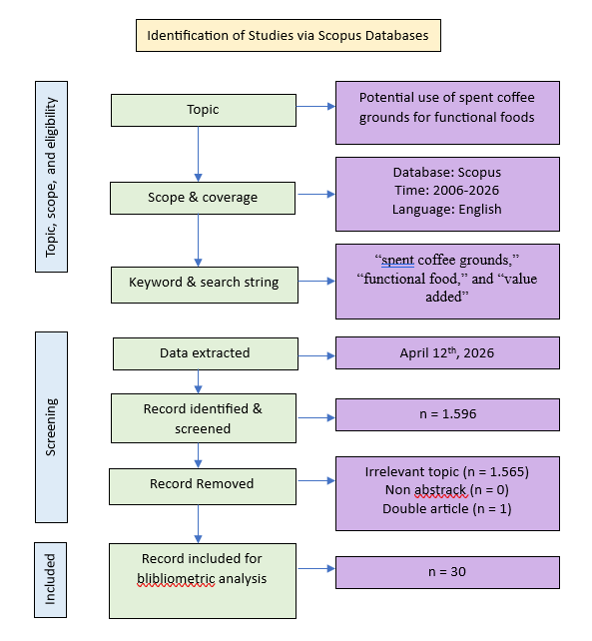

Figure 2. Publications Trends on Potential Use of Spent Coffee Grounds for Functional Food

Analysis of Top Contributing Publishers
The most productive publisher identified in this study is Food Chemistry, with a total of 12 publications related to spent coffee grounds as a value-added resource. Among the analyzed publishers, LWT and Food Research International also show notable contributions, with 4 and 3 publications, respectively. Although numerous publishers are involved in this research area, only a few demonstrate a relatively high level of productivity. Identifying these key publishers is important, as it can provide direction and valuable references for future research development. A detailed summary of publishers and their respective publication counts is presented in Table 1.
Table 1. Top Contributing Publishers

No. | Publisher | Publications
1 | Food chemistry | 12
2 | LWT | 4
3 | Food research international | 3

Keyword co-occurence network and overlay
Figure 3. Keyword Co-occurrence Network

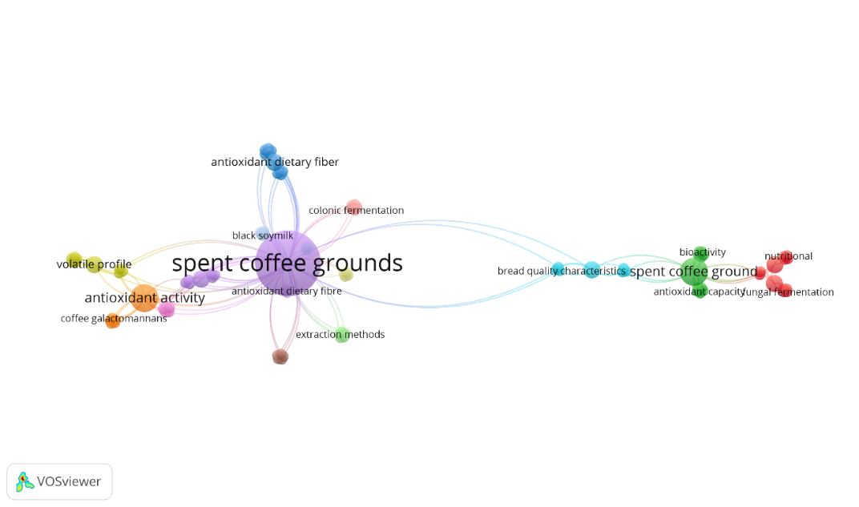
The bibliometric analysis indicates that spent coffee grounds serve as the central focus of research, as reflected by their position as the main node with strong connections to multiple thematic clusters. This suggests that studies on spent coffee grounds are inherently interdisciplinary, encompassing areas such as food science, nutrition, and bioprocessing. One prominent cluster is associated with antioxidant and functional properties, including terms such as antioxidant activity, antioxidant dietary fiber, coffee galactomannans, and volatile profile. This highlights that a substantial body of research has focused on the bioactive potential of spent coffee grounds, particularly their antioxidant capacity and relevance for functional food applications, as well as their contribution to aroma-related characteristics. Another important cluster relates to food applications, where the connection to bread quality characteristics indicates increasing interest in incorporating spent coffee grounds into food products, especially bakery items, with the aim of enhancing nutritional value while maintaining product quality.
Figure 4. Keyword Co-occurrence Overlay
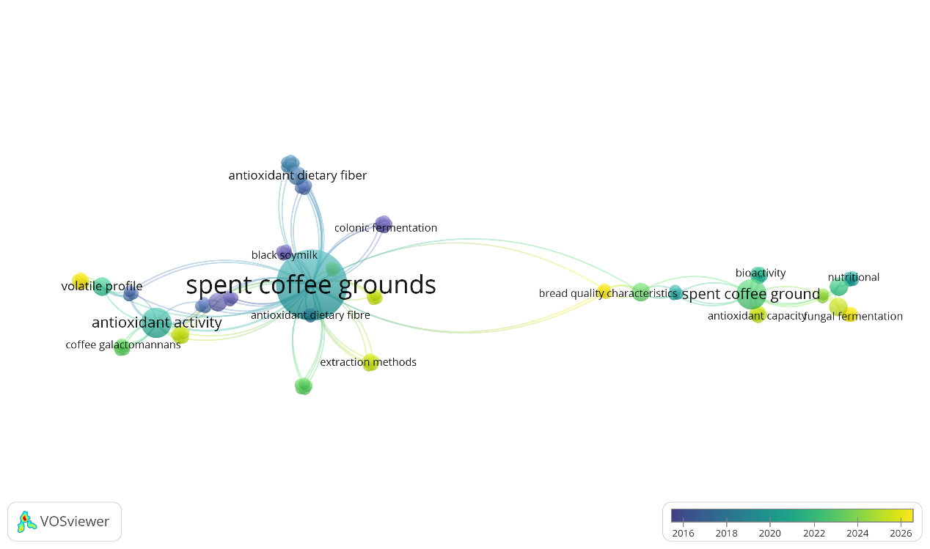

In addition, a cluster involving terms such as fungal fermentation, bioactivity, nutritional, and colonic fermentation reflects a growing emphasis on bioprocessing approaches and health-related functionalities. This suggests that fermentation technologies are being explored to improve the nutritional profile and bioactivity of spent coffee grounds, as well as their potential role in gut health through prebiotic effects. The presence of extraction methods as a linked term further indicates ongoing efforts to optimize the recovery of valuable compounds, supporting their utilization as value-added ingredients. The overlay visualization reveals a temporal shift in research trends. Earlier studies (2016–2019) primarily focused on the characterization of chemical composition and antioxidant properties, as indicated by keywords such as antioxidant activity and volatile profile. This was followed by a transition phase (2020–2022) emphasizing functional properties and health implications, including antioxidant dietary fiber and colonic fermentation. More recent studies (2023–2026) demonstrate a shift toward application-oriented research, highlighted by terms such as fungal fermentation, nutritional, and bread quality characteristics. Overall, these findings illustrate a clear progression from fundamental characterization to functional exploration and, ultimately, to practical applications, underscoring the increasing recognition of spent coffee grounds as a valuable resource for sustainable and functional product development in the food and nutraceutical sectors.
CONCLUSION
This bibliometric study highlights the increasing scientific interest in spent coffee grounds as a sustainable and value-added resource. The findings demonstrate a clear progression of research from initial studies focusing on chemical composition and antioxidant properties to more recent investigations emphasizing functional food applications and bioprocessing technologies. The dominance of key journals such as Food Chemistry, LWT, and Food Research International further reflects the growing importance of SCG within the food science domain.
Keyword analysis reveals that antioxidant activity, dietary fiber, and bioactive compounds remain central research themes, while emerging topics such as fermentation, nutritional enhancement, and product development indicate a shift toward practical applications. The observed publication trends confirm that SCG is increasingly recognized for its potential in supporting sustainability and circular economy initiatives.
Despite these promising developments, several challenges must be addressed to fully realize the potential of SCG, including ensuring food safety, establishing standardized processing methods, and validating health benefits through clinical studies. Future research should focus on these aspects to facilitate the large-scale application and commercialization of SCG-based products. Overall, SCG represents a promising alternative ingredient with significant potential to contribute to sustainable food systems and innovative functional food development.
REFERENCES
- Arifah, F. H., Nugroho, A. E., Rohman, A., & Sujarwo, W. (2022). A Bibliometric Analysis of Preclinical Trials of Andrographis Paniculata (Burm.F.) Nees in Diabetes Mellitus. South African Journal of Botany, 151, 128–143. https://doi.org/10.1016/j.sajb.2021.12.011
- Berktaş, S., İncegül, Y., & Çam, M. (2026). An Approach to the Evaluation of Spent Coffee Grounds: Use in Functional Apricot Bar Formulation. Journal of Food Process Engineering, 49(1). https://doi.org/10.1111/jfpe.70315
- Bevilacqua, E., Cruzat, V., Singh, I., Rose”Meyer, R., Panchal, S., & Brown, L. (2023). The Potential of Spent Coffee Grounds in Functional Food Development. Nutrients, 15(4). https://doi.org/10.3390/nu15040994
- Choe, U. (2025). Valorization of Spent Coffee Grounds and their Applications in Food Science. Current Research in Food Science, 10. https://doi.org/10.1016/j.crfs.2025.101010
- Lauberts, M., Mieriņa, I., Pals, M., Latheef, M. A., & Shishkin, A. (2022). Spent Coffee Grounds Valorization in Biorefinery Context to Obtain Valuable Products Using Different Extraction Approaches and Solvents. Plants, 12(1). https://doi.org/10.3390/plants12010030
- Melikoglu, M. (2025). Coffee Waste Valorization: A Comprehensive Review of Recent Advancements and Future Directions for a Circular Bioeconomy. Food Chemistry, 497. https://doi.org/10.1016/j.foodchem.2025.147004
- Navarro-Hoyos, M., Vargas-Huertas, L. F., Chacón-Vargas, J. D., Leandro-Aguilar, V., Alvarado-Corella, D., Vega-baudrit, J., Romero-Esquivel, L. G., Sánchez-Kopper, A., Monge-Navarro, A., & Araya-Sibaja, A. (2025). HRMS Characterization and Antioxidant Evaluation of Costa Rican Spent Coffee Grounds as a Source of Bioactive Polyphenolic Extracts. Foods, 14(3). https://doi.org/10.3390/foods14030448
- Nemzer, B., Al-Taher, F., Abshiru, N., & Mejia, E. G. de. (2025). Coffee and Coffee By-Products as Multifunctional Foods and Ingredients. Annual Review of Food Science and Technology, 17. https://doi.org/10.1146/annurev-food-052924-114847
- Park, M., & Kim, K. (2026). Functional Valorization and Bioactivity Enhancement of Spent Coffee Grounds Through Lactic Acid Fermentation. Fermentation, 12(2). https://doi.org/10.3390/fermentation12020096
- Ramadan, M., Fadel, A., Bahi, A., Alajlani, S., Neyadi, M. S. S. A., Alshamsi, E., Naser, S., Shahbaz, H., Samuel, R., & Ranneh, Y. (2025). Optimizing Chlorogenic Acid Extraction from Spent Coffee Grounds: A Comparative Review of Conventional and Non‐Conventional Techniques. Food Science & Nutrition, 13(7). https://doi.org/10.1002/fsn3.70315
- Ramón-Gonçalves, M., Alcaraz, L., Ferreras, S. P., León-González, M., Conrado, N. R., & López, F. (2019). Extraction of Polyphenols and Synthesis of New Activated Carbon from Spent Coffee Grounds. Scientific Reports, 9(17706). https://doi.org/10.1038/s41598-019-54205-y
- Ramón-Gonçalves, M., Gómez-Mejía, E., Rosales-Conrado, N., León-González, M., & Madrid, Y. (2019). Extraction, Identification and Quantification of Polyphenols from Spent Coffee Grounds by Chromatographic Methods and Chemometric Analyses. Waste Management, 96, 15-24. https://doi.org/10.1016/J.WASMAN.2019.07.009
- Silva, C. N. da, Prado, T. R., Buarque, F. S., & Ribeiro, B. D. (2026). Sustainable Valorization of Spent Coffee Grounds: Phenolic Compound Extraction Using Hydrophobic Eutectic Solvents. Processes, 14(7). https://doi.org/10.3390/pr14071109
- Sukmanov, V., Komar, O., Sukmanov, O., & Likholip, I. (2025). Use of Spent Coffee Grounds in the Technologies of Functional Food Products and its Effect on Human Health. Human and Nation”s Health. https://doi.org/10.31548/humanhealth.3.2025.80
- Urugo, M. M., Getachew, P., Lambe, B. T., Yohannis, E., Afework, A., Meteke, N., Yasin, S., Milkias, M., Tola, Y. B., Teka, T. A., Gemede, H. F., & Worku, M. (2025). Green Valorization of Coffee Industry Residues: Emerging Innovations and Their Role in Sustainable Food and Feed Applications. Applied Food Research, 5(2). https://doi.org/10.1016/j.afres.2025.101181
- Van Eck, N.J & Waltman, L. (2020). VOSviewer. Leiden University, Leiden.
- Yin, H., Jiang, Y., Zhong, Y., & Deng, Y. (2026). Upcycling Coffee By-Products into Functional Ingredients: A Review on Sustainable Processing, Health Benefits, and Food Applications. Comprehensive Reviews in Food Science and Food Safety, 25(1). https://doi.org/10.1111/1541-4337.70401

