Science and Technology in the Mughal Period
MD AZAHARUDDIN
HISTORY TEACHER
Abstract:
The Mughal era, spanning from 1526 to 1707 AD, marked the dawn of a new chapter in the history of India—a period that ushered in a golden age for education, the arts, and, alongside them, science and technology. While this era significantly advanced the economy, it was particularly distinguished by the priority accorded to architecture and the sciences; specifically, great strides were made in the fields of astronomy, metallurgy, medicine, the arts, and military science. During this time, scholars, physicians, and artisans from various lands converged upon India, contributing significantly to the development of sculpture and scientific endeavors. Today, the diverse intellectual traditions and scientific contributions of the Mughals are regarded as profoundly significant in the shaping of Indian society.
Index Terms: Mughal Empire, Science and Technology, Astronomy, Medicine, Architecture, Agriculture, Metallurgy, Military Technology, Gun Powder

- INTRODUCTION
The first major conflict along this path—specifically, the formidable military campaign led by Babur in 1526—paved the way for the establishment of a vast Mughal Empire across the Asian continent. Beyond Babur, rulers such as Jahangir and Shah Jahan also brought immense renown to the Mughal court through their contributions to architecture and the sciences. During the Mughal era, various scholars from Persia brought a diverse array of disciplines—including science, irrigation systems, metallurgy, medicine, and military strategy—under a single unified umbrella. Consequently, a unique synthesis of Indian and Persian scientific traditions emerged during this period, enabling the Mughals to achieve significant advancements in both the arts and military technology. Furthermore, the Mughals maintained and curated various types of scholarly journals, utilizing them to foster a deeper understanding and internal assimilation of the most modern intellectual practices of the time. A closer examination of the scientific currents—both theoretical and technological—that flourished during this era reveals that their development unfolded as part of a broader, continuous process aimed at elevating the Islamic world to an entirely new level of intellectual achievement.
Method: The type of research used is library research or literature study where researchers rely on various literature to obtain research data and use a qualitative approach because the data produced is in the form of words or descriptions. Library research or literature research is research where the place of study is literature or literature. In this study, research was conducted by utilizing studies which were similar or related. The research method used is a qualitative research method. MethodQualitative research is research that holistically intends to understand the phenomenon of what is experienced by the research subject, be it behavior, perception, motivation or action, and descriptively in the form of words and language, in a special natural context and by utilizing various methods. natural.". Library research or literature study has several characteristics, namely: Researchers deal directly with data not directly from the field, library data is generally a secondary source and not original data from first hand, library data is not limited by space and time.

II. DEVELOPMENT OF SCIENCE AND TECHNOLOGY IN THE MUGHAL PERIOD
2.1 Astronomy and Mathematics
The concept of a long-standing exchange between Persian scientists and Indian scientific traditions ushered in a new chapter during the Mughal historical era in India. This was because, at that time, various branches of astronomy—including almanacs and astrology—helped propel Indian science into a new realm of exploration. This influence is most notably evident throughout the period beginning with Babur, where the presence of various astronomers and scholars was ubiquitous; among them, Mulla Chand stands out as a particularly significant figure, for he utilized astronomical principles within scholarly texts to foster the development of both traditional learning and empirical science. During this era, astrology and astronomy within the Mughal Empire were inextricably intertwined. Astrologers at various Mughal royal courts meticulously studied planetary movements to cast horoscopes for the monarchs—a practice deemed indispensable for undertakings related to architecture, commerce, and warfare. Furthermore, the construction projects of that era—encompassing architectural structures, domes, grand mansions, and gardens—relied heavily on the application of various geometric principles. The distinctive square layouts found in these gardens, for instance, were adopted from Persian traditions. Indeed, the geometric, spatial, and mathematical concepts embedded within Mughal architecture continue to provide a distinct framework that resonates within the realm of modern mathematics to this day.
2.2 Medicine and Healthcare
Medicine in the Mughal period was influenced primarily by the Unani system of medicine, which had its origins in Greek medical traditions and was further developed in the Islamic world. The Unani system was introduced into India by Persian and Central Asian physicians and became widely practiced during the Mughal era.
Mughal emperors often maintained royal physicians known as hakims. These physicians treated members of the royal family as well as important nobles. Medical knowledge during this period combined Greek theories, Persian practices, and indigenous Indian herbal traditions.
Hospitals and charitable medical institutions were established in several cities. Physicians studied anatomy, pharmacology, and herbal medicine. They prepared medicines using plant extracts, minerals, and animal products.
Several important medical texts were written during this period. Scholars compiled books describing diseases, treatments, and medicinal plants. The Mughal court encouraged the translation of medical works from Arabic and Persian into local languages, which helped spread medical knowledge more widely.
Public health practices were also influenced by traditional knowledge about hygiene, diet, and environmental conditions. Although medical science had not yet reached modern standards, Mughal medicine represented a significant stage in the development of healthcare in South Asia.

2.3 Architecture and Engineering
Architecture was one of the most remarkable achievements of the Mughal period and reflects advanced knowledge of engineering and construction techniques. Mughal architecture combined Persian, Central Asian, and Indian styles to create magnificent buildings.
Major architectural achievements include:
- Humayun’s Tomb
- Fatehpur Sikri
- Red Fort in Delhi
- Taj Mahal
- Jama Masjid
The construction of these monuments required sophisticated engineering techniques. Builders used mathematical planning, symmetrical designs, and strong structural foundations. The use of double domes, arches, minarets, and marble inlay work demonstrates high technical skill.
Water engineering also played an important role in Mughal architecture. Mughal gardens such as the Shalimar Gardens in Kashmir were designed using Persian garden concepts known as Charbagh, where water channels divided the garden into four symmetrical parts.
The ability to transport heavy stones, carve marble, and construct massive domes indicates advanced knowledge of materials and engineering methods.

2.4 Agricultural Technology
Agriculture formed the economic foundation of the Mughal Empire. The state revenue system depended heavily on agricultural production, and therefore agricultural improvement was extremely important.
Farmers used several technological methods to increase productivity. Irrigation systems such as canals, wells, and Persian wheels helped supply water to agricultural fields. The Persian wheel (rahat) was widely used to lift water from wells and rivers for irrigation.
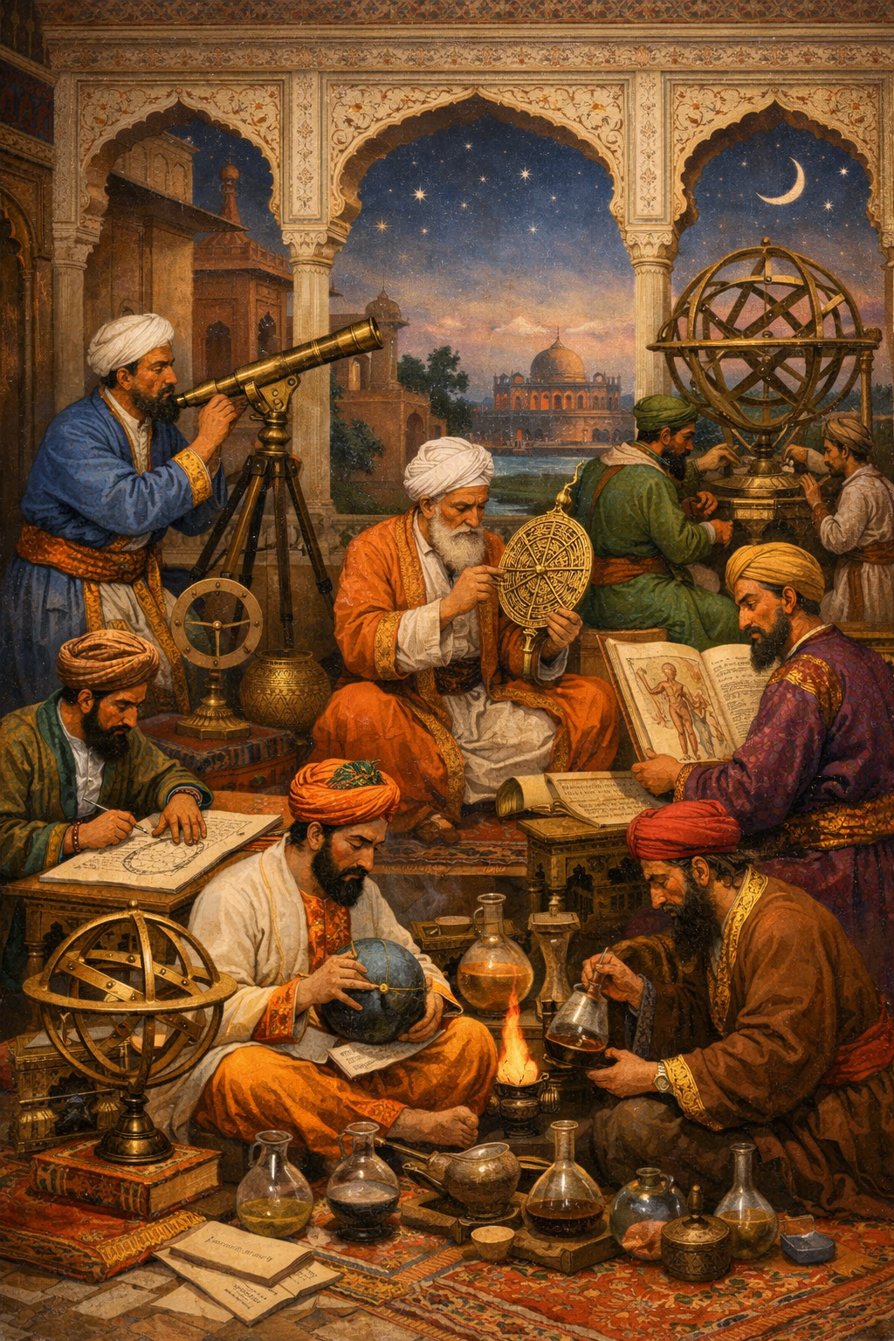
Fig-1
Unani Medicine and Gun powder (Chemical Weapon)
The Mughal administration also introduced improved crop patterns and encouraged the cultivation of new crops. Important crops during this period included:
- Wheat
- Rice
- Barley
- Cotton
- Sugarcane
- Indigo
New crops such as tobacco and maize were introduced during the Mughal era due to global trade connections.
The famous Mughal administrative document Ain-i-Akbari, written by Abul Fazl, provides detailed information about agricultural practices, crop varieties, and irrigation systems used during the reign of Emperor Akbar.

2.5 Metallurgy and Craft Production
Metallurgy and craftsmanship were highly developed during the Mughal period. Skilled artisans produced metal weapons, tools, jewelry, and decorative objects.
Iron and steel production was particularly important. Indian wootz steel, famous for its strength and sharpness, was used to manufacture high-quality swords and weapons. Mughal weapons such as swords, daggers, and armor were admired for their craftsmanship.
Goldsmiths and silversmiths created intricate ornaments for the royal court. Decorative techniques such as enamel work (meenakari) and inlay work were widely practiced.
Other important crafts included:
- Textile production (especially silk and cotton fabrics)
- Carpet weaving
- Pottery and ceramics
- Stone carving
- Ivory carving
These industries combined artistic skill with technological knowledge and played a vital role in the Mughal economy.

2.6 Military Technology
Military technology was another area where the Mughal Empire demonstrated significant innovation. Babur introduced gunpowder technology into Indian warfare, which transformed military strategy.
Important Mughal military technologies included:
- Cannons (artillery)
- Matchlock guns (muskets)
- Fortification engineering
- War elephants equipped with armor
Mughal artillery was highly effective during major battles such as the First Battle of Panipat (1526). Heavy cannons were used to break enemy formations and destroy fortifications.
Fort construction also improved during this period. Massive forts such as the Agra Fort, Lahore Fort, and Delhi Red Fort were built with strong defensive walls, watchtowers, and strategic gateways.
The Mughal army also used advanced logistical systems for transporting weapons, supplies, and troops across long distances.
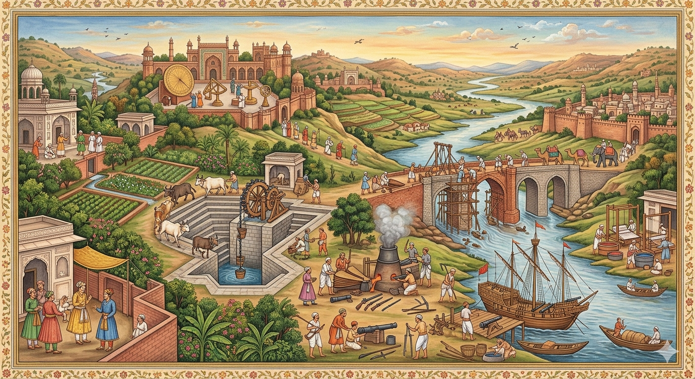
Fig-2
Develop Drain,boat and Brdige in 1529

III. SCIENTIFIC KNOWLEDGE AND CULTURAL EXCHANGE
The Mughal Empire served as a bridge between different intellectual traditions. Scholars from Persia, Central Asia, and India interacted in Mughal courts, leading to the exchange of ideas.
Emperor Akbar played a particularly important role in encouraging intellectual dialogue. He established translation projects in which Sanskrit texts were translated into Persian. Important works such as the Mahabharata (Razmnama) and Ramayana were translated during his reign.
This exchange of knowledge allowed Mughal scholars to access diverse scientific traditions, including Indian astronomy, Persian medicine, and Central Asian mathematics.
Libraries were also established in royal courts, where manuscripts on science, medicine, philosophy, and literature were preserved and studied.

IV. LIMITATIONS OF SCIENTIFIC DEVELOPMENT
Despite these achievements, scientific development during the Mughal period had certain limitations. Much of the knowledge remained practical rather than theoretical. Scientific research was often dependent on royal patronage rather than independent institutions.
Furthermore, there were no universities or formal scientific academies comparable to those emerging in Europe during the same period. As a result, scientific discoveries were not systematically documented or widely disseminated.
Political instability after the reign of Aurangzeb also affected intellectual and technological progress.

V. CONCLUSION
During the Mughal era, science and technology established a new paradigm for education, economics, and social sciences—particularly in the fields of medicine, metallurgy, agriculture, and military science. Scholars arriving from Persia elevated the standard of education in India to unprecedented heights. It goes without saying that the Mughal rulers played a pivotal role in fostering and promoting education, culture, and scientific innovation upon their arrival in India. During this period, special allocations were earmarked from the royal treasury specifically to support scientific endeavors. As a result, we observe remarkable achievements across various domains: in architecture—exemplified by monuments such as the Taj Mahal; in metallurgy; and in military science—notably the introduction and use of artillery, which dates back to the reign of Babur. Thus, the science and technology of the Mughal era stand as a profound and invaluable testament in the history of India, Asia, and the world at large.
References
- Habib, I. (1999). The Agrarian System of Mughal India. Oxford University Press.
- Richards, J. F. (1995). The Mughal Empire. Cambridge University Press.
- Alam, M., & Subrahmanyam, S. (2012). Writing the Mughal World. Columbia University Press.
- Kumar, S. (2008). The Emergence of the Mughal Empire. Permanent Black.
- Chandra, S. (2007). Medieval India: From Sultanate to the Mughals. Har-Anand Publications.
- Gumilar, Setia. (2017). Historiografi Islam dari Masa Klasik Hingga Modern. Bandung: Pustaka Setia

