COMPARATIVE ANALYSIS OF PWM AND SPVPWM TECHNIQUES FOR TRANSFORMER TRANSIENTS IN SERIES VOLTAGE COMPENSATION

Abstract
The increasing integration of power electronic devices in electrical power systems has intensified the need for effective control techniques capable of minimizing transformer transient disturbances in series voltage compensation applications. This study investigates and compares the performance of Pulse Width Modulation (PWM) and Space Vector Pulse Width Modulation (SVPWM) techniques in controlling transformer transients and improving overall compensation system performance. The analysis focuses on critical parameters such as transient response characteristics, harmonic distortion, voltage stability, switching efficiency, and power quality enhancement.
A detailed simulation model of a transformer-based series voltage compensator is developed using MATLAB/Simulink to evaluate the operational behaviour of both modulation strategies under different loading and disturbance conditions. The comparative results indicate that the SVPWM technique achieves improved voltage utilization, faster dynamic response, and reduced Total Harmonic Distortion (THD) when compared with conventional PWM methods. In contrast, PWM demonstrates easier implementation and reduced computational requirements, which may be advantageous in less complex applications. The research further highlights the influence of modulation strategies on transformer stress reduction and transient mitigation within modern compensation systems.
The outcomes of this work provide a useful reference for the design and optimization of efficient series voltage compensation systems aimed at enhancing power system reliability, stability, and power quality.

Keywords:
Pulse Width Modulation (PWM), Space Vector Pulse Width Modulation (SVPWM), Transformer Transients, Series Voltage Compensation, Total Harmonic Distortion (THD), Power Quality, Voltage Stability, Power Electronics, MATLAB/Simulink, Dynamic Response.

ORGANIZATIONAL CHART

Admire Janga (Team Leader)

Chinhoyi University of Technology
Industrial Electronics Department
Calvin Chimanyiwa
(Chairperson)
Chimanyiwa Calvin
Janga Admire
Figure 1: Organizational Chart

Introduction

Voltage sag is one of the most common power quality problems affecting modern electrical power systems and is responsible for significant equipment malfunction, transformer losses, and reduced system reliability. During voltage sag conditions, transformers may experience magnetic flux distortion and core saturation, resulting in high inrush currents that can trigger over-current protection and cause compensation failure. In series voltage compensation systems, a short delay in sag detection and voltage injection further increases the risk of transformer transient disturbances.
To minimize these effects, effective control techniques are required for fast and stable voltage compensation. Pulse Width Modulation (PWM) and Space Vector Pulse Width Modulation (SVPWM) are widely used switching techniques in power electronic compensation systems due to their ability to regulate voltage and improve system performance. While PWM offers simple implementation, SVPWM provides better voltage utilization and reduced harmonic distortion.
This study presents a comparative analysis of PWM and SVPWM techniques for controlling transformer transients in series voltage compensation systems. A MATLAB/Simulink model was developed to evaluate the performance of both methods under voltage sag conditions based on parameters such as transient response, harmonic distortion, and voltage stability. The results obtained from the simulations were used to determine the most effective control technique for transformer transient mitigation and improved power system performance.

Literature Review

Power quality disturbances, particularly voltage sag, have attracted significant attention in modern electrical power systems due to their adverse effects on sensitive equipment and industrial processes. Voltage sag is defined as a temporary reduction in supply voltage, typically caused by faults, sudden load changes, or switching operations within the network. According to several studies, voltage sag contributes to a large percentage of power system failures and operational interruptions, making effective compensation techniques essential for maintaining system stability and reliability.
Series voltage compensation methods such as the Dynamic Voltage Restorer (DVR) have been widely adopted for mitigating voltage sag by injecting the required compensating voltage into the system. Researchers have shown that DVR systems are effective in restoring load voltage

and improving power quality during transient disturbances. However, the response time of the compensator and the control strategy used significantly influence the overall performance of the system, especially during sudden voltage variations.
Transformer transient behavior during voltage sag compensation has also been investigated by several authors. It has been reported that the delay between sag detection and compensation may lead to transformer core saturation and magnetic flux imbalance, resulting in high inrush currents. These transient currents can trigger protective devices and reduce the effectiveness of the compensation system. Therefore, proper control techniques are necessary to minimize transformer stress and improve compensation reliability.
Pulse Width Modulation (PWM) is one of the most commonly used switching techniques in power electronic converters due to its simplicity and ease of implementation. Previous studies have demonstrated that PWM provides effective voltage regulation and stable switching control in compensation systems. However, conventional PWM techniques may produce higher harmonic distortion and lower DC bus voltage utilization under certain operating conditions.
Space Vector Pulse Width Modulation (SVPWM) has gained considerable attention as an advanced modulation technique for power electronic applications. Researchers have shown that SVPWM offers improved voltage utilization, lower Total Harmonic Distortion (THD), and better dynamic response compared to conventional PWM methods. In addition, SVPWM provides more efficient switching patterns, which contribute to reduced power losses and enhanced system performance.
Although several studies have examined PWM and SVPWM techniques independently, limited research has focused specifically on their comparative performance in controlling transformer transients during series voltage compensation. Therefore, this study aims to compare both modulation techniques using MATLAB/Simulink simulations to determine the most effective approach for reducing transformer transients, minimizing harmonic distortion, and improving overall compensation system performance.

Methodology

This research adopted a simulation-based approach to investigate the performance of PWM and SVPWM techniques in controlling transformer transients during series voltage

compensation. The methodology consisted of system modeling, component selection, simulation, and comparative performance analysis using MATLAB/Simulink.
Initially, an extensive review of journals, textbooks, research papers, and technical articles was conducted to understand voltage sag disturbances, transformer inrush currents, and existing voltage compensation techniques. The study focused on the effects of voltage sag on transformer operation and the role of inverter-based compensation methods in minimizing transient disturbances. PWM and SVPWM control methods were also studied to understand their switching characteristics and suitability for voltage sag compensation applications.
Following the research phase, the required system components were selected and modelled in MATLAB/Simulink. The developed system included a three-phase programmable AC source, multi-winding transformer, voltage source inverter (VSI), rectifier units, anti-parallel thyristor-diode switches, capacitor filters, and series RLC loads. A delta-star transformer rated at 220V/220V was incorporated to improve system protection and reduce harmonic distortion. A six-IGBT universal bridge inverter with a DC-link capacitor was used to generate the compensation voltage required during sag conditions.
The complete simulation model was designed to include both voltage sag compensation and transformer inrush current mitigation circuits. Voltage and current measurement units were connected throughout the system to monitor performance parameters. PWM and SVPWM pulse generation techniques were implemented separately using a discrete synchronous six-pulse generator to control the switching operation of the VSI and compensation units.
The system was simulated under different load conditions using both PWM and SVPWM control methods. Performance analysis was carried out by observing parameters such as transient response, voltage stability, harmonic distortion, and compensation effectiveness. The outputs obtained from the simulations were then compared to determine the most effective modulation technique for minimizing transformer transients and improving the performance of the series voltage compensation system.

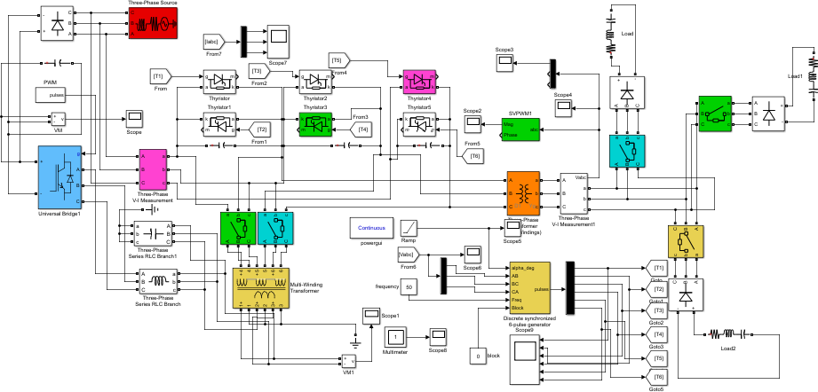

Figure 2: Simulation model with PWM technique

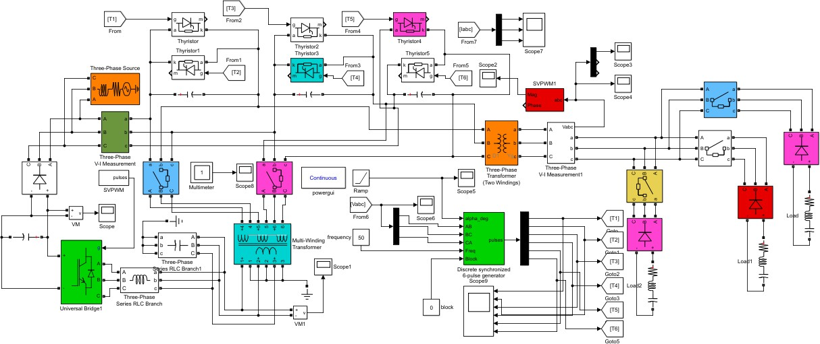
Figure 3: Simulation model with SVPWM technique

Results and Discussion

The developed MATLAB/Simulink model was simulated using both PWM and SVPWM control techniques to evaluate their effectiveness in controlling transformer transients during series voltage compensation. The analysis was performed under different loading conditions

by observing the output load current, load voltage, and transformer magnetic flux characteristics.
Initially, the PWM-based compensation system was simulated with a single load connected to the network. During the interval between 0.42 s and 1.4 s, the compensation unit was not activated, and a high inrush current was observed in the load current waveform due to transformer transient effects. The magnetic flux waveform also exhibited significant transient behavior during this period, indicating transformer core saturation caused by voltage sag conditions. After the activation of the inrush current mitigation and compensation units, the load current gradually reduced to a stable value with smoother waveform characteristics. The output load voltage also became more stable after compensation, demonstrating the effectiveness of the PWM-based voltage compensation system in improving system performance.
Further analysis was conducted using the SVPWM control technique. Similar to the PWM operation, high inrush current was observed during the uncompensated period between 0.42 s and 1.4 s. However, after the compensation system was introduced, the current waveform stabilized with reduced transient effects and improved waveform quality. To evaluate system performance under varying load conditions, additional parallel loads were connected to the system after 3.22 s. This resulted in a temporary increase in inrush current and transient magnetic flux due to the sudden load change. Nevertheless, the mitigation and compensation units successfully restored the system to stable operating conditions within a short duration.
Comparative analysis of both techniques showed that the SVPWM method provided better transient suppression and voltage compensation performance than the conventional PWM technique. The SVPWM-controlled system produced lower harmonic distortion, smoother current waveforms, and improved voltage stability under dynamic loading conditions. These results indicate that SVPWM is a more efficient and reliable control strategy for transformer transient mitigation in series voltage compensation systems.

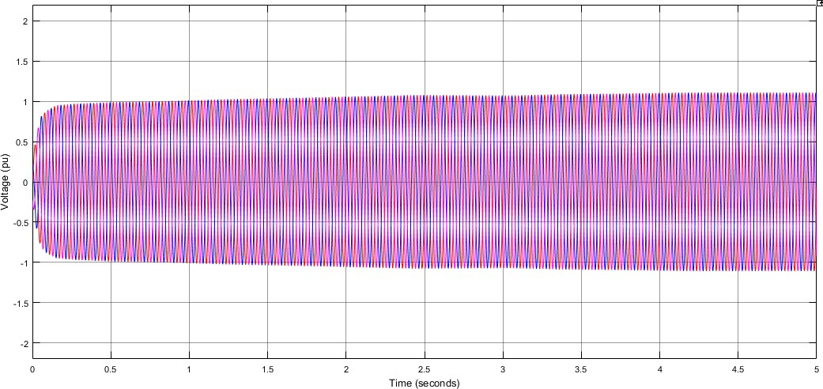

Figure 4: Source voltage (PWM technique)

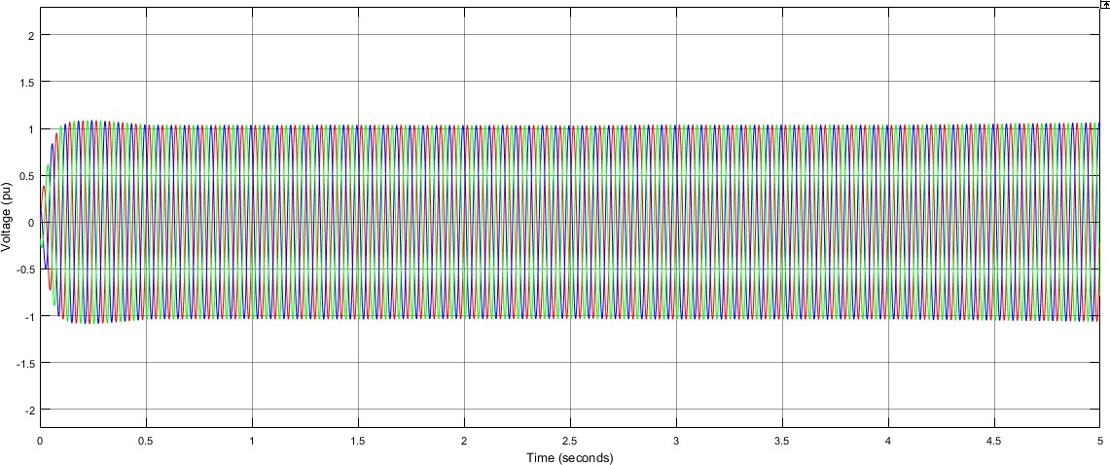

Figure 5: Load voltage (PWM technique)

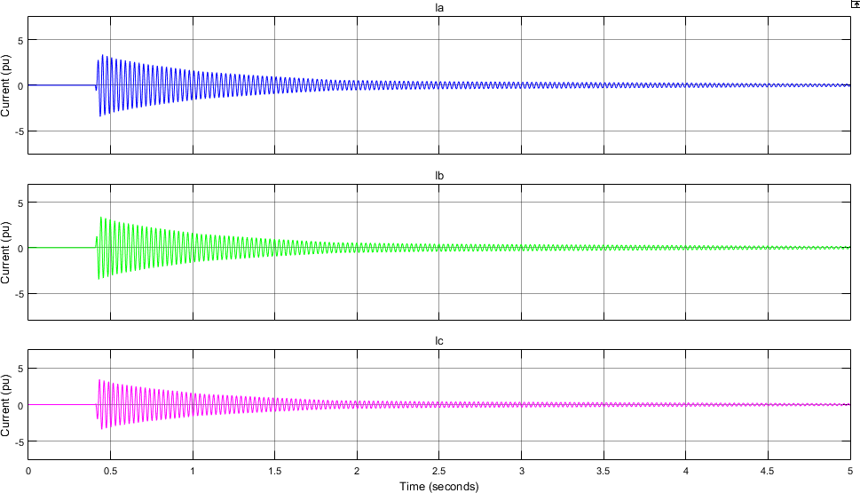

Figure 6: Load current (PWM technique)

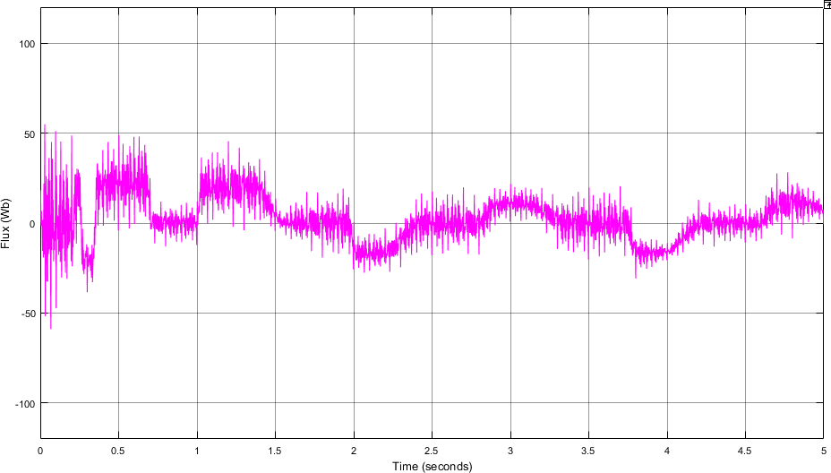

Figure 7: Load transformer magnetic flux (PWM technique)

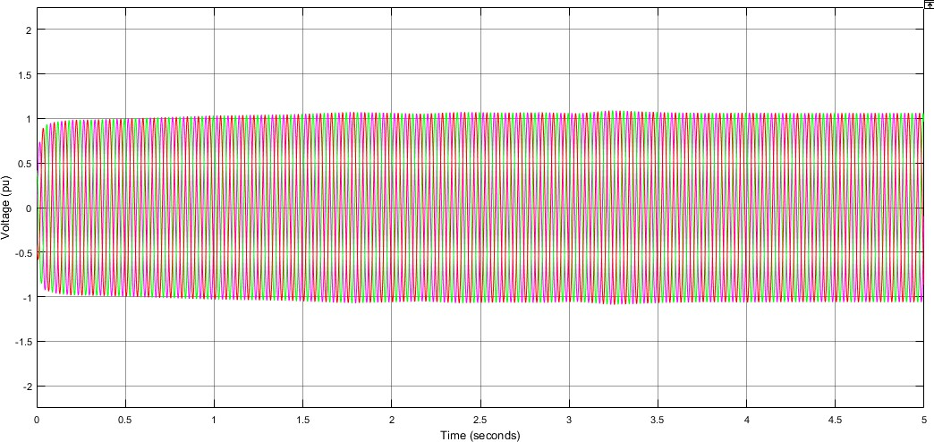

Figure 8: Source voltage (SVPWM technique)

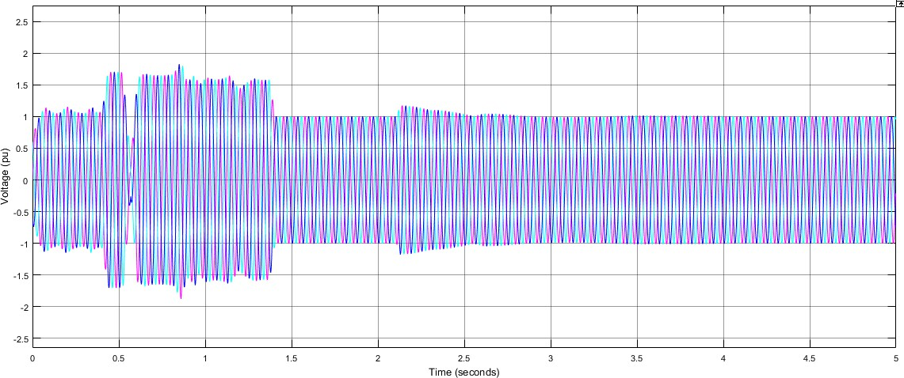

Figure 9: Load voltage (SVPWM technique)

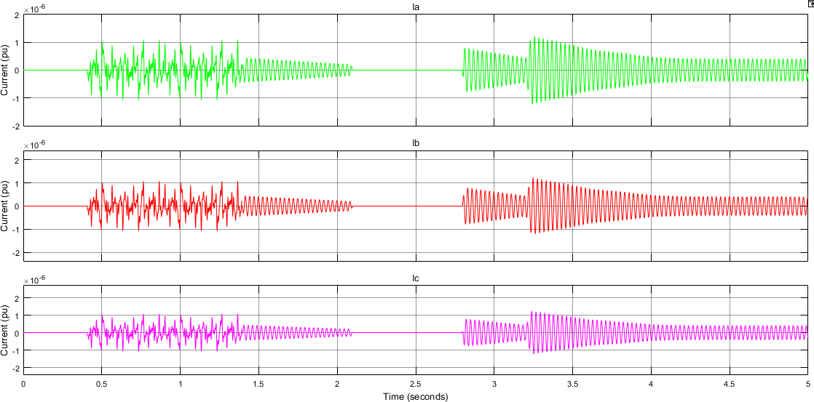

Figure 10: Load current (SVPWM technique)

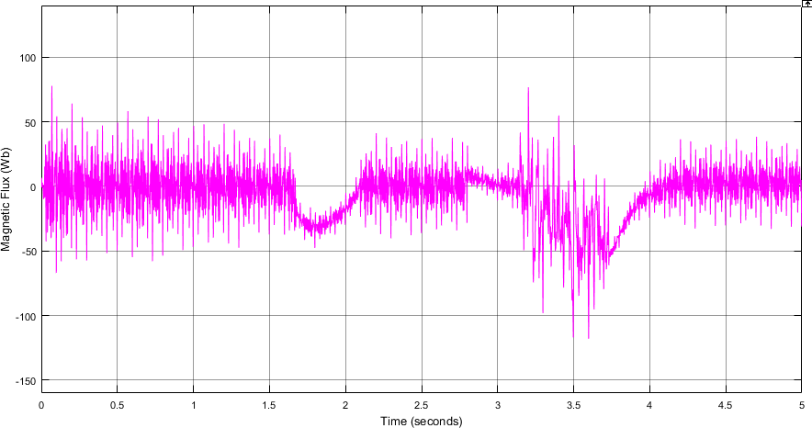
Figure 11: Load transformer magnetic flux (SVPWM technique)

Conclusion

This research focused on the mitigation of transformer transients and voltage sag disturbances in power systems using PWM and SVPWM control techniques. An effective series voltage compensation and inrush current mitigation system was successfully designed and implemented in MATLAB/Simulink. The developed model incorporated essential components such as a multi-winding transformer, voltage source inverter (VSI), series inverter, rectifier units, circuit breakers, and load protection devices to achieve stable and reliable system operation during voltage sag conditions.
Simulation results obtained from different loading conditions demonstrated that both PWM and SVPWM techniques were capable of reducing transformer transients and improving voltage compensation performance. However, comparative analysis revealed that the SVPWM technique provided superior performance compared to conventional PWM. SVPWM achieved lower harmonic distortion, smoother voltage compensation, improved transient response, and more effective control of transformer inrush currents. These improvements contributed to enhanced power quality, increased system stability, and better operational reliability.
The study therefore concludes that SVPWM is a more efficient control technique for transformer transient mitigation in series voltage compensation systems. The research also provided a deeper understanding of transformer transient behaviour, particularly the occurrence of inrush currents during voltage sag conditions and demonstrated practical methods for controlling such disturbances using power electronic compensation techniques. Overall, the project presents a reliable and effective approach for improving power system performance under transient and voltage sag conditions.

References
- Harasis, S., Khan, I., & Massoud, A. M. (2024).
Investigating the Impact of PWM Schemes on Transient Response of Power Converters: Comparative Study Between SPWM, SVPWM, and THIPWM. IEEE Energy Conference (ENERGYCON), 2024.
- Xie, W., Xiao, F., Tu, C., et al. (2023).
Suppression strategy for the inrush current of a solid-state transformer caused by the reclosing process.
- Martínez, G., Corcoles, F., & Bogarra, S. (2023).
Saturation curve estimation of three-legged three-phase transformers using inrush current waveforms.
IEEE Transactions on Power Delivery, 2023.
- Thongsan, T., & Chatchanayuenyong, T. (2023).
A Simple and Fast Voltage Disturbance Detection and Voltage Reference Generation Approach for Dynamic Voltage Restorer.
ECTI Transactions on Electrical Engineering, Electronics, and Communications, 2023.
- Nguyen Le, H.-P., Pham, K. D., & Pham, N. T. (2024).
Analyses, Modelling, and SVPWM Control of a Three-Level T-NPC Inverter to Reduce Common-Mode Voltage.
IEEE Access, 2024.

