Development and Implementation of a Web-Based Human Resource Management System of The Great Plebeian College
Stephany M. Ochave¹, Christian Paul O. Cruz², Mia Myca N. Tresenio³, Polinne Mari M. Rabina⁴,
Miah Claire S. Corpuz⁵
Department of Information Technology, Pangasinan State University – Alaminos City Campus, Philippines
stephanymochave@gmail.com¹, cocruz@psu.edu.ph², treseniomia@gmail.com³, rabinapolinne.26@gmail.com⁴, corpuzmiahclaire@gmail.com⁵
Abstract - This study focused on the design and development of a web-based Human Resource Management System (HRMS) for The Great Plebeian College. This study addressed limitations in the institution’s existing manual, paper-based human resource processes, which were inefficient, time-con suming, and highly prone to data inaccuracies. These encountered difficulties made it clear that a reliable, efficient, and technology-driven HR management system solution was necessary. The developed system used the Rapid Application Development (RAD) model, which emphasized iterative development, rapid prototyping, and constant end-user involvement throughout the system development lifecycle. Using the Rapid Application Development (RAD) methodology enabled regular feedback and timely feature refinement by ensuring close alignment with actual institutional requirements. The developed HRMS included system features such as centralized employee information management, QR code–based attendance monitoring, leave requests processing, role-based access control, and report generation. Based on the ISO 25010 quality attributes, our evaluation found that the HRMS significantly improved the operational efficiency, data accuracy, security, and accessibility of HR records. Thus, the study documented a smooth transition from traditional manual HR management to a web-based solution that provides employees with an accessible digital platform, highlighting the role of information technology in improving management of an institution such as The Great Plebeian College.
Keywords: Human Resource Management System (HRMS), QR Code, The Great Plebeian College
INTRODUCTION
In today’s digital era, the growing reliance on technology had transformed how organizations manage information, communication, and operations, offering improved efficiency, security, and data accessibility. Despite these advancements, many institutions continue to depend on manual and paper-based systems for managing records, which are prone to data loss, misplacement, security risks, and inefficiencies in retrieval and storage. These challenges were particularly evident in Human Resource Management, where accurate, timely, and organized employee data were essential for compliance, decision-making, and operational effectiveness.
Educational institutions require efficient HR systems to manage diverse personnel, including teaching and non-teaching staff, while adhering to regulatory and administrative demands. Manual HR processes often consume excessive time and physical space, limiting HR personnel’s ability to focus on strategic initiatives. Recent studies highlighted that web-based and electronic Human Resource Management Systems (EHRMS) significantly improved service quality, reduced processing time and costs, enhanced data accuracy, and increased employee satisfaction by enabling centralized record management and self-service access.
The Great Plebeian College, a private academic institution in Alaminos City, Pangasinan, Philippines, currently relies on manual HR processes for employee hiring, record management, processing of leave requests, attendance monitoring, and document retrieval, resulting in inefficiencies and operational difficulties. To address these challenges, this
study proposed the design and development of a web-based Human Resource Management System tailored to the institution’s needs. The system aimed to streamline employee record management, attendance monitoring, leave processing, and document generation, thereby reducing reliance on paper-based procedures. By implementing this digital solution, the institution was expected to improve HR operational efficiency, optimize resource utilization, and enhance transparency and accessibility of employee information. Furthermore, this study contributed to the broader understanding of digital transformation in educational institutions by demonstrating how web-based HR systems could support effective workforce management and institutional sustainability.
IV. Methodology
The development of the Human Resource Management System (HRMS) for The Great Plebeian College effectively utilized the Rapid Application Development (RAD) model. According to Martin, RAD's core principle is meeting urgent commercial demands by delivering reliable applications efficiently. This model served as a dynamic Software Development Life Cycle (SDLC) that prioritized speed, adaptability, and integrating continuous user feedback. Unlike rigid, linear traditional models, RAD emphasizes iterative prototyping and end-user collaboration throughout the process. This methodology facilitated flexible adjustments and early testing, which ensured the final system was robust and closely aligned with stakeholder needs, thereby enhancing user acceptance and overall project success through its responsive and participatory framework.
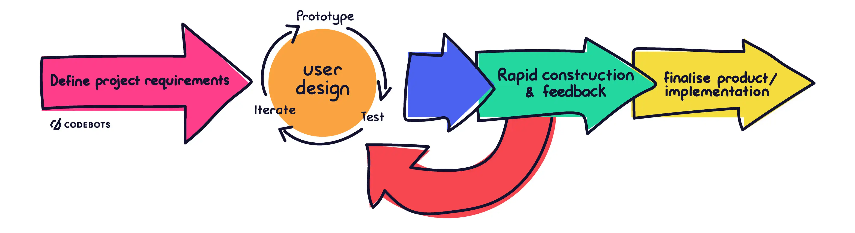
Fig. 1. Rapid Application Development (RAD) Methodology
The following are the phases of Rapid Application Development: At this stage, the proponents and the users of the locale communicated to establish the project's goals and expectations, as well as any current or anticipated challenges that will need to be addressed. The first phase involved identifying and outlining the core requirements of the Human Resource Management System (HRMS) through direct engagement with the HR head, administrators, and staff of The Great Plebeian College via interviews and discussions. During this stage, users and developers worked hand in hand to craft the system’s structure and interface using Figma and Draw.io. This phase led to the development of essential components such as the record keeping leave requests management, leave requests processing and attendance monitoring, as well as a secure login interface. This phase is the stage where the system moved from conceptual design to the actual development. This phase focused on building working modules quickly and refined them through continuous user feedback. The Release Phase is the concluding stage of the RAD process, where the system transitioned from development to deployment. This phase ensured that the Human Resource Management System (HRMS) is fully prepared for real-world use by HR personnel and employees.

The collection of data took place at the Human Resource Office of The Great Plebeian College, which is prominently located in Gen. Montemayor St., Alaminos City, Pangasinan. A purposive sampling technique was carefully used to identify respondents with professional backgrounds highly relevant to the study's objectives. The target population specifically included individuals working in the diverse fields of Information Technology, Human Resources, Academic Personnel, and Others, such as Admins and general staff. The proponents employed various instruments and methodologies to gather the necessary data comprehensively for the study. An interview guide, comprising a set of prepared questions, was utilized by the proponents to facilitate and guide them during the interview process. An unstructured interview is an interview session where the proponents did not prepare a fixed set of questions ahead of time, allowing for more flexible and spontaneous discussions. Library research involves gathering information from physical sources such as printed books and tangible materials physically found within a library's collections. Lastly, internet research involves gathering data through online resources, including various websites and digital publications.
The researchers employed Use Case Diagrams to elucidate the interactions between diverse user groups, including HR staff, department heads, and employees, and the Human Resource Management System (HRMS) platform. Use Case Descriptions were utilized to provide a detailed exposition of core HRMS functionalities, such as the systematic organization of employee information, the meticulous monitoring of attendance records, and the comprehensive oversight of the entire recruitment and onboarding process. Flowcharts were constructed to map critical processes, specifically the monitoring of employee attendance, the efficient processing of leave requests, and the secure management of employee documentation. An Entity-Relationship Diagram (ERD) was developed to illustrate the relationships between key entities, including employees, departments, attendance data, recruitment initiatives, and user accounts, within the database structure. This methodological approach facilitated the systematic collection of quantitative data through a structured and standardized instrument, wherein a predefined set of questions was administered to the participant pool.
Scale | Statistical Limits | Level of Acceptability | Descriptive Interpretation
5 | 4.21 – 5.0 | Strongly Agree | The system’s features and functions are fully manifested and clearly observable.
4 | 3.41 – 4.20 | Agree | The system’s features and functions are consistently noticeable and well-demonstrated.
3 | 2.61 – 3.40 | Neutral | The system’s features and functions are adequately shown and meet expected standards.
2 | 1.81 - 2.60 | Disagree | The system’s features and functions appear inconsistently and need improvement.
1 | 1.00 - 1.80 | Strongly Disagree | The system’s features and functions are not observable or fall short of expectations.

Table 1. Scale of Measurement
To effectively assess the level of acceptability and overall performance of the Human Resource Management System (HRMS), the proponents will employ a Likert scale measurement tool ranging from 1 to 5, providing a spectrum of responses. This standardized scale will enable the systematic and objective categorization of user feedback by allowing respondents to express their degree of agreement or satisfaction with various aspects of the system's functionality and user interface. This scale was vital for the proponents, as it enabled them to quantify qualitative feedback collected from HR administrators, IT Experts, and general staff members across different departments. By mapping descriptive levels, such as "strongly disagree" to "strongly agree," to numerical limits, the scale successfully structured the subjective data gathered. This process provided a clear, measurable view of the system's performance, which allowed them the easy identification of both system strengths and critical improvement areas that require further attention and refinement.
RESULTS AND DISCUSSION
The Human Resource Management System (HRMS) at The Great Plebeian College was architecturally designed based on a robust Three-Tier Architecture, meticulously comprising the Presentation Layer, the critical Application Layer, and the foundational Data Layer. This architectural approach was strategically adopted to significantly enhance modularity across all system components, improve scalability to effectively meet evolving organizational needs and increasing data loads, and ensure the long-term maintainability of the system's infrastructure, thereby guaranteeing its operational efficiency and longevity.
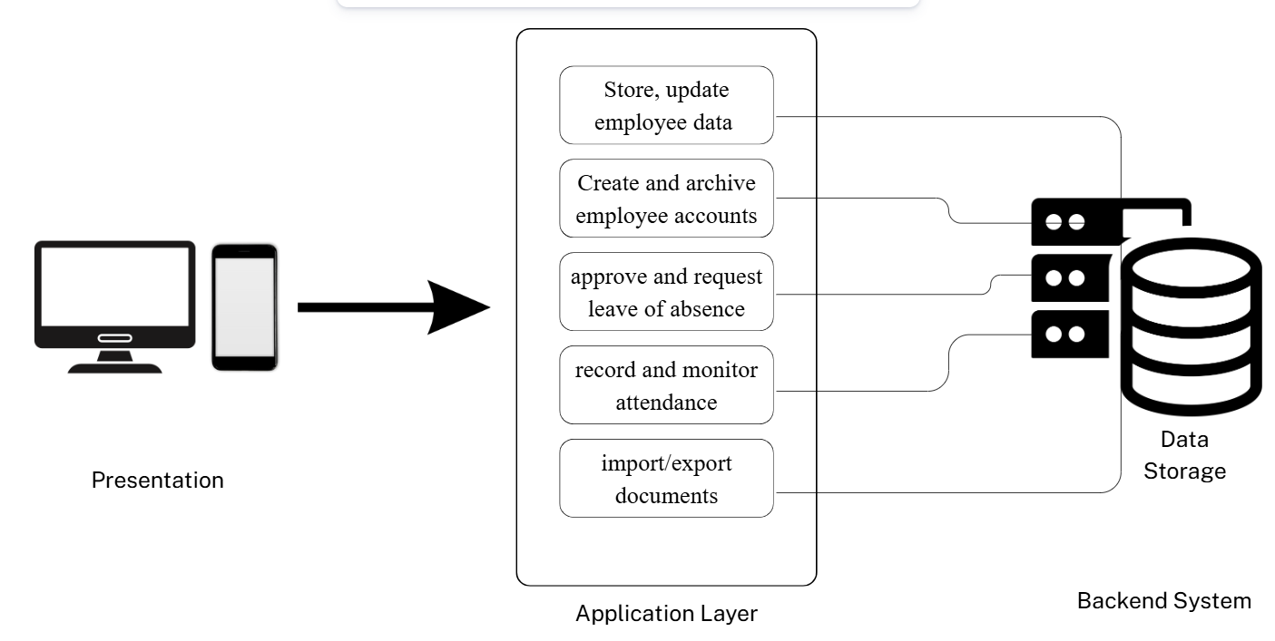
Fig 2. Web-Based HRMS Three Tier Architecture
The presentation tier provides the interface through which users, such as HR staff, interact with the system. This layer utilizes web technologies to display information and collect user input via forms and navigation elements. The application tier manages core system functions, including employee data handling, user account management, and report generation. It acts as a mediator between the user interface and the database, processing user commands according to established organizational protocols and workflows. Finally, the data tier is responsible for data storage, retrieval, and maintenance, ensuring data integrity and security.
Within the described HRMS, a typical user interacts with the system by accessing it to oversee and manage their attendance records. These inputs are then processed by the application tier, which organizes and updates employee data based on predefined criteria. HR personnel use the system to maintain employee files, monitor attendance trends, and generate analytical summaries. Each function within the application tier communicates with the data tier to retrieve or update necessary records. This design ensures a smooth flow of information and promotes a unified and structured approach to managing human resource records and monitoring attendance patterns. By separating the system into presentation, application, and data storage tiers, each component can focus on its specific tasks, thereby increasing overall efficiency and user satisfaction.
THE DEVELOPED FEATURES OF HR MANAGEMENT SYSTEM
Login Page. This is the first page that the users will see in accessing the system. To login, users will be asked to input their employee identification and password, then they will be directed to their own respected profile dashboards according to their role, such as system administrator, department heads, and employees. The login page features a clean and intuitive design, ensuring a seamless and user-friendly experience from the moment users access the system. A clear company logo and a brief welcome message are displayed to reinforce brand identity and create a positive first impression. The page also incorporates a responsive design, ensuring optimal viewing and functionality across various devices, including desktops, tablets, and smartphones.
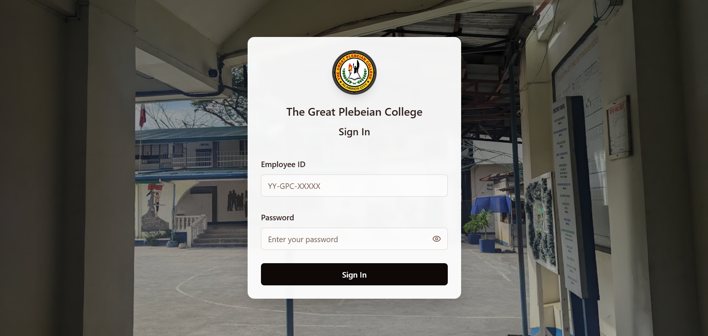
Fig. 3. The Login Page
System Administrator Dashboard. This serves as a central hub, providing an overview of organizational data. Upon accessing the dashboard, the system administrator is presented with information pertaining to key operational areas, including employee management, attendance tracking, document control, and organizational structure. The interface features a real-time display of employee attendance, highlighting the number of employees that are currently absent, present, and late. Furthermore, the displayed calendar allows the administrator to easily select dates and view all approved leave of absence requests for that specific day. A left-side navigation menu offers direct access to the management modules for Employees, organizational structure, attendance, leave, documents, loyalty awards programs, and system settings. This consolidated design enhances operational oversight by making all essential data immediately accessible upon login, enabling quick, data-driven decisions.
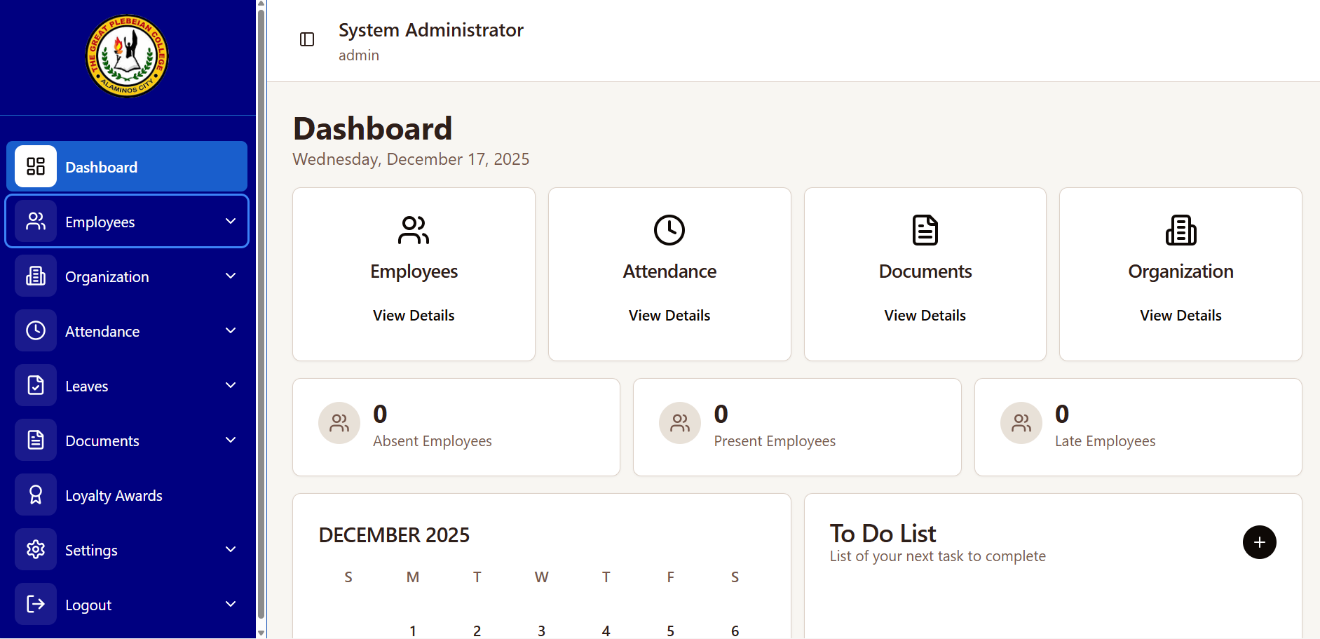
Fig. 4. System Administrator’s Dashboard of the System
Employee Management Page. This dedicated section provides a comprehensive suite of tools for managing employee-related information and tasks. Upon accessing the Employee Management page, administrators can view a detailed list of active and inactive employees, along with key information such as their department, job title, and contact details. This page offers functionalities to add new employees, edit existing employee profiles, and deactivate employee accounts. A search and filtering system allows administrators to sort the employees according to their departments. This page is designed to streamline HR processes and ensure efficient management of the institution's workforce by providing a centralized platform for managing employees and departments.
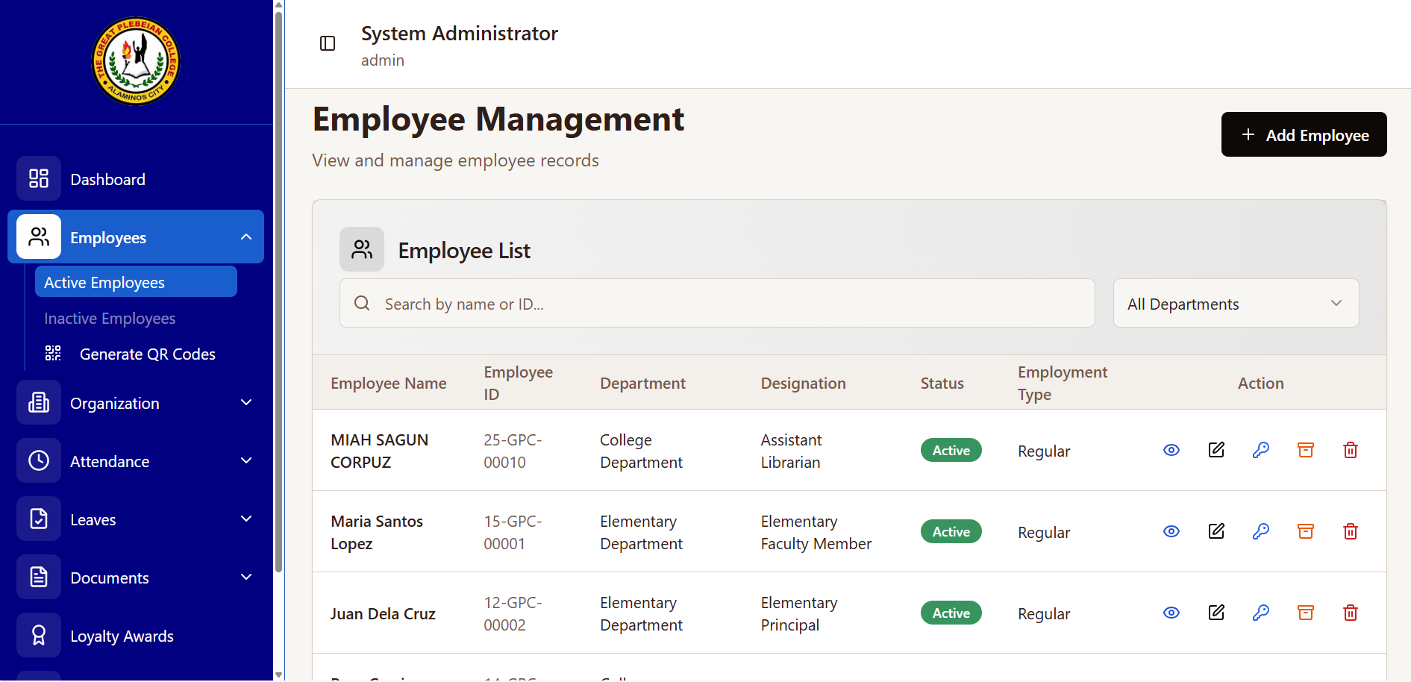
Figure 5. Employee Management Page
Organization Page. This page allows the administrator to view and manage employee records. Upon access, the system presents a list of active employees, displaying key information such as Name, ID, Department, Designation, Status, and Employment Type. The "Add Employee" button is prominently displayed, allowing for the creation of new profiles. The search bar enables quick filtering by name or ID, and the department filter allows for viewing specific departments. For each record, action buttons provide options to view, edit, reset passwords, archive, or delete. This page provides a centralized platform for managing all aspects of employee information and access within the organization.
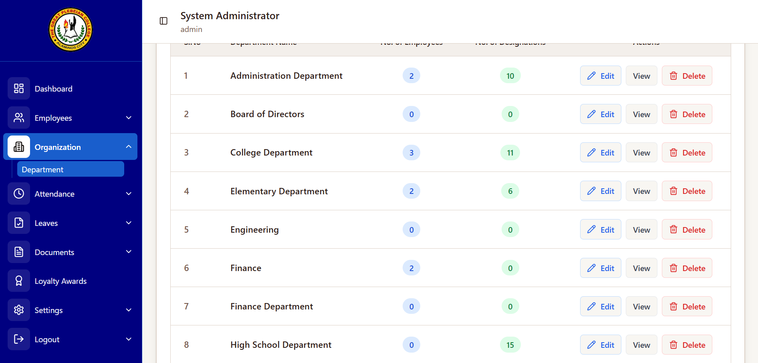
Figure 6. Organization Page
Attendance Tracking. For tracking the attendance of the institution’s employees, a modern attendance management system that leverages QR code technology to streamline and enhance employee time tracking accuracy. Upon arrival and departure, security personnel stationed at the entrance will utilize dedicated guard accounts on scanning devices to scan unique QR codes assigned to each employee. Each scan promptly records the time of entry and time of exit, ensuring comprehensive and reliable attendance data collection. This feature eliminates manual processes, reduces delays, and provides a real-time overview of employee presence. The collected data can then be used to monitor attendance trends, manage workforce allocation, and improve overall operational efficiency.
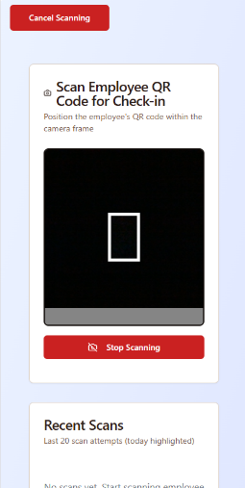
Figure 7. QR Code Scanning for Attendance (Mobile View)
Attendance List. HR administrators also gain access to a comprehensive attendance list compiled from the guard's scans. The system automatically calculates and displays the number of minutes an employee is late, facilitating prompt identification of tardiness. Furthermore, HR administrators and Department Heads have the capability to generate customizable attendance reports. These reports can be categorized to provide insights on a daily, weekly, and monthly basis, offering a flexible overview of attendance trends and patterns within the institution. This data-driven approach supports effective workforce management and resource allocation.
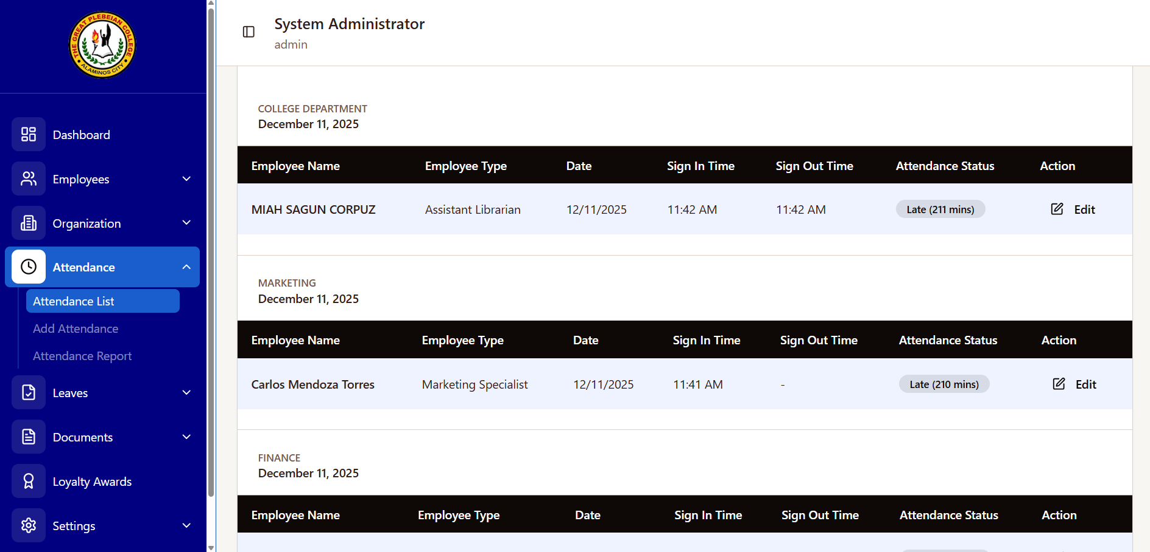
Figure 8. Attendance List
Leave Management. In managing leave requests, a streamlined system automates the process. Employees file requests digitally, allowing HR and Department Heads to view remaining balances for transparency. Once submitted, Department Heads assess operational feasibility before HR performs final verification and updates digital records. Upon approval, formal leave slips are accessible, and administrators can export comprehensive daily, weekly, or monthly CSV reports to enhance institutional record-keeping and facilitate more effective workforce planning.
In filing of leave request, employee can easily access a module that asks them what type of leave, the starting and ending date of their leave, as well as the reason for their leave. Employees can also view how many times they have taken their leave and the remaining leaves they can still take to ensure accurate record-keeping while providing management with necessary documentation for the approval process through a streamlined interface that simplifies communication between staff and human resources for organizational management.
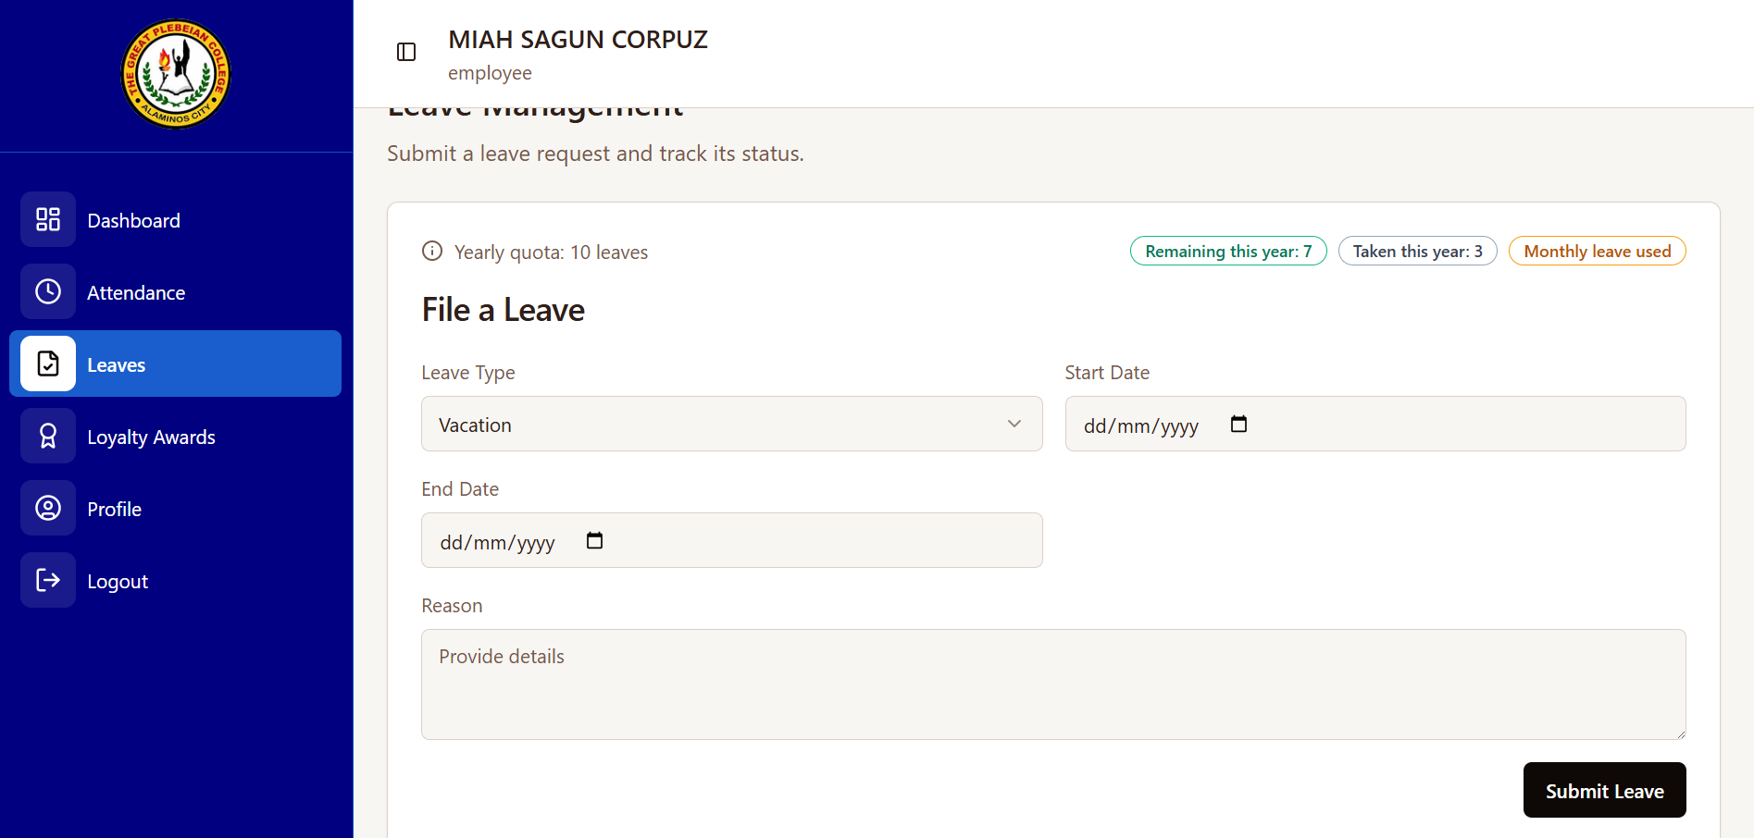
Figure 9. Filing of Leave Requests
Upon employee’s submission of a leave application, the department head can access a centralized dashboard to review the request, which displays the employee's name, identification, leave type, and specific dates. The interface provides the supervisor with the necessary context, including the employee's stated reason, to make an informed decision. Based on this information, the department head can then formally recommend the request for further approval or reject it directly within the system.
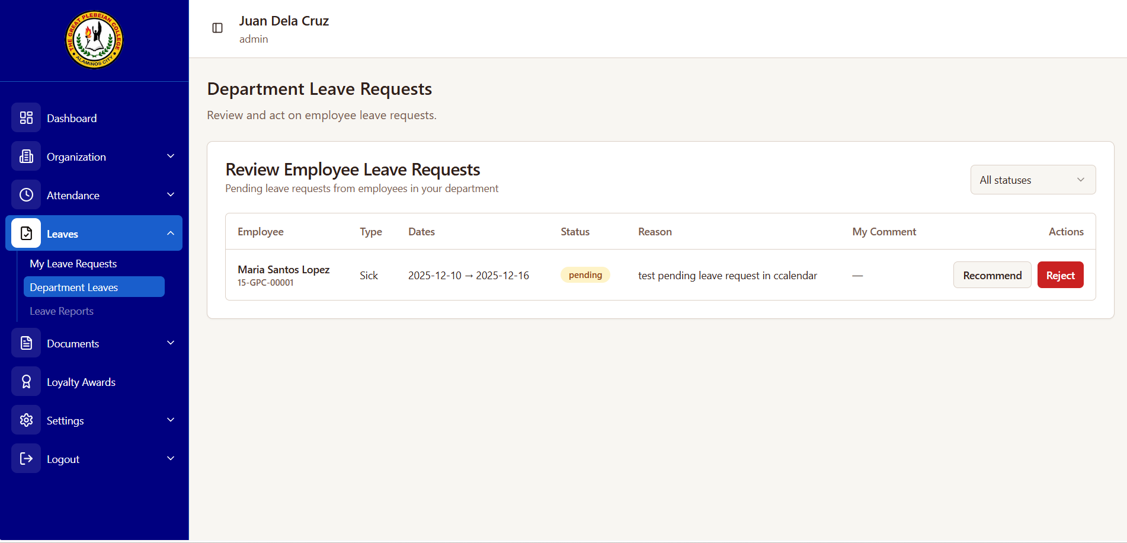
Figure 10. Leave Requests on Department Head’s Account
Following the department head’s preliminary review and recommendation, the System Administrator ultimately serves as the final authority for all leave request approvals. From this centralized dashboard interface, the administrator can efficiently view and assess comprehensive details for each pending request. This includes the employee's name, ID, and department, as well as the specific dates, leave type, current status, and detailed justification. This complete visibility ensures all organizational policies are thoroughly met during the verification process, enabling consistent and compliant final decisions. The interface is designed to support a streamlined workflow for reviewing, comparing, and authorizing employee time-off, thereby maintaining organizational standards.
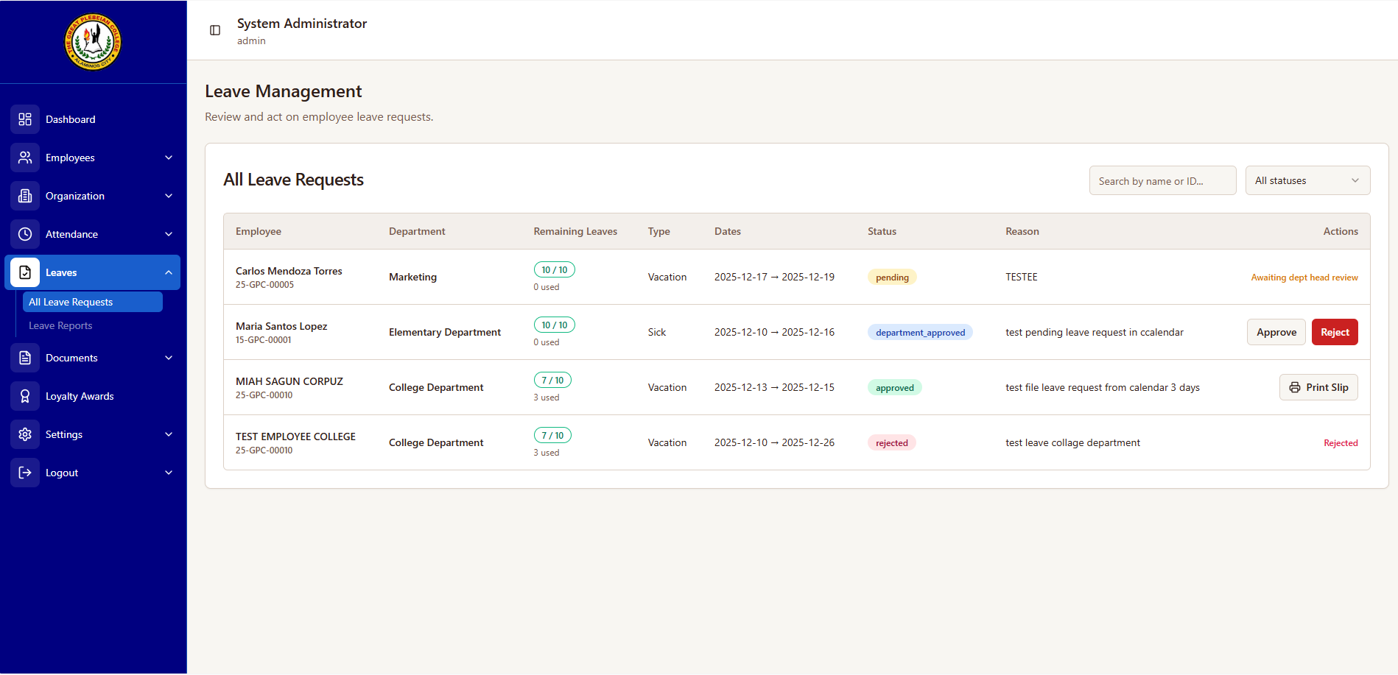
Figure 11. Leave Requests on System Administrator Account
Record Management. For managing records, a centralized records management system is implemented to streamline and secure access to employee records such as Certificates of Employment (CoE), Personal Data Sheet (PDS), loyalty awards, and service records. Instead of physically submitting a request, users can simply click a print or download buttons within the system to view available documents or records. Upon clicking either of the buttons, the system instantly generates the requested document based on the employee's profile and employment history. The documents can be printed directly or download to be edited. The HR administrator maintains oversight of the system, ensuring data accuracy and security protocols are followed. This system provides immediate access to essential employee records, enhancing efficiency and convenience while maintaining data integrity.
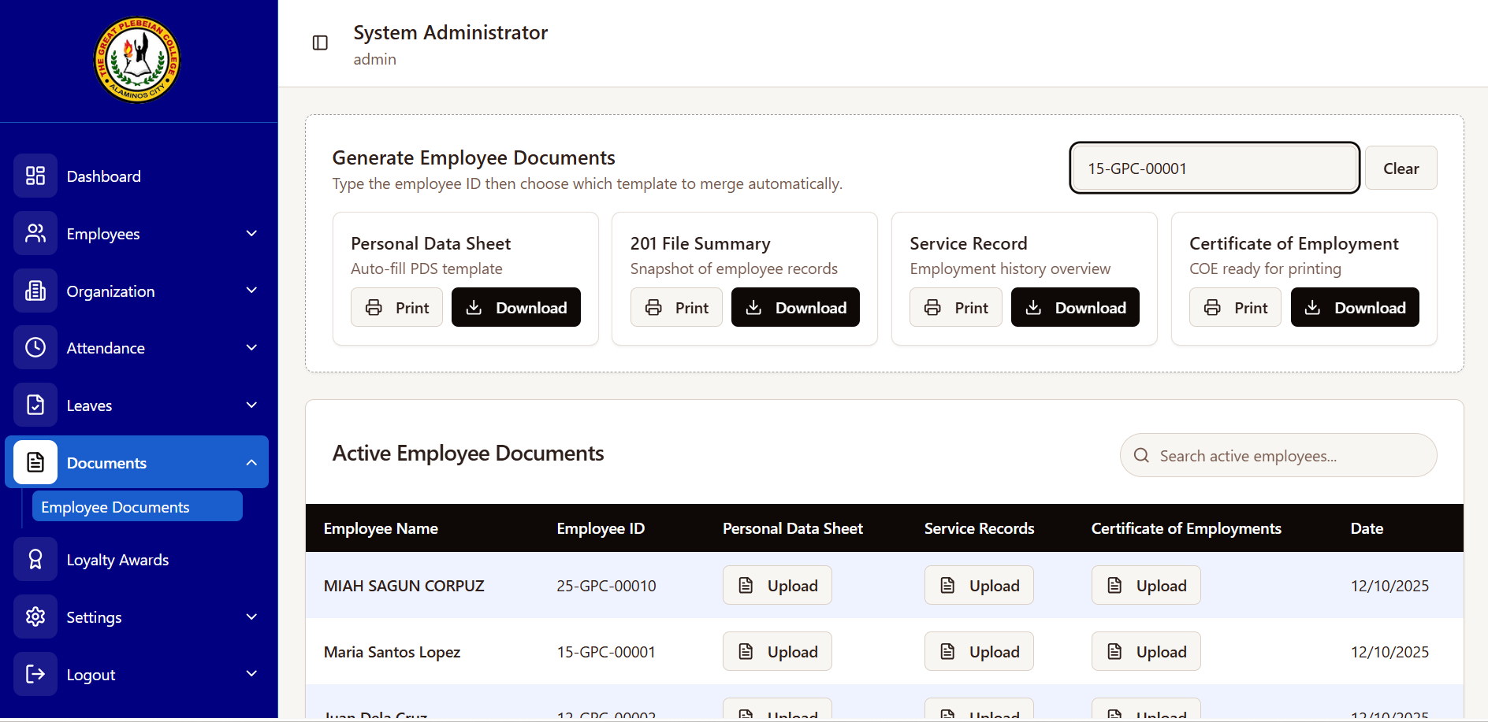
Figure 12. Record Management
Department Head’s Dashboard. This is the middle level access. This serves as management hub that balances personal accountability with administrative oversight for department heads. By integrating a personalized profile and attendance tracking—complete with QR code functionality and sign-in status—with a calendar for leave management, the interface provides a snapshot of daily operations. An intuitive navigation sidebar empowers leaders to manage organizational structures, employee attendance, and document control, ensuring all departmental data and recognition programs are accessible from a single, high-level view.
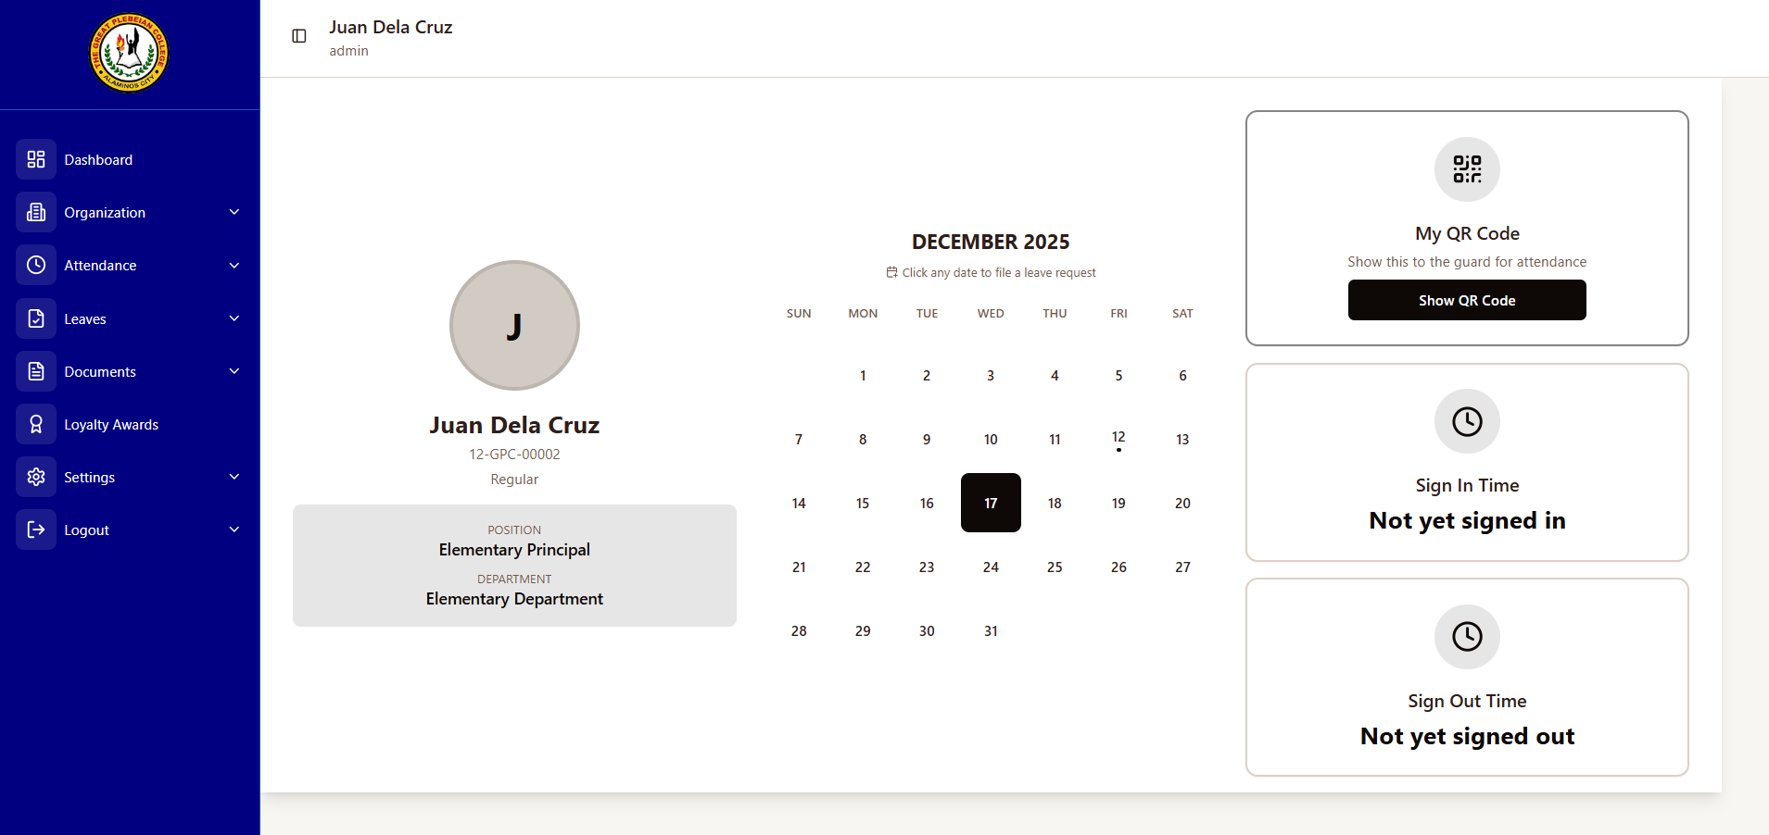
Figure 13. Department Head’s Dashboard
Employee Dashboard. The Employee Dashboard represents the lower-level access of the system, serving as a user-friendly personal portal designed to streamline daily administrative tasks for faculty and staff. It provides an immediate overview of the user's profile and employment status, alongside real-time attendance tracking that includes daily sign-in/out times and a quick-access QR code for campus entry. Additionally, an interactive calendar enables efficient leave management, while the simplified navigation sidebar ensures that attendance history, loyalty awards, and profile settings are always accessible at a glance. This interface promotes individual accountability and efficiency.
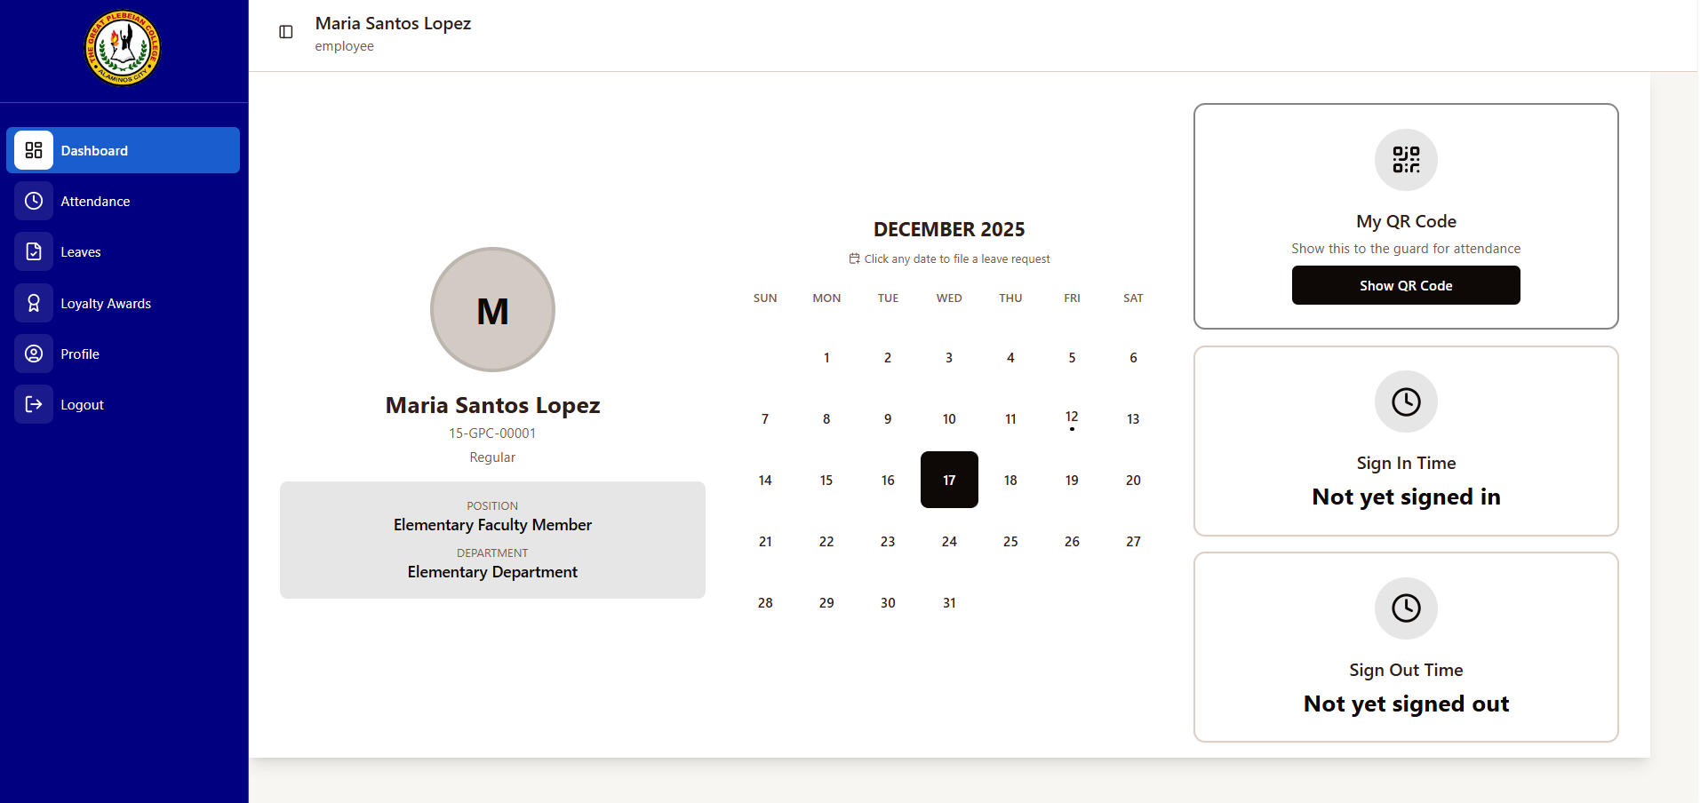
Figure 14. Employee Dashboard
The implementation of an integrated feedback feature within the HRMS has proven to be an exceptionally valuable asset for driving user-centric development. After each interaction with the system, such as submitting a leave request or updating personal information, employees are seamlessly invited to rate their experiences and leave detailed reviews. This process provides the HR department with critical, real-time insights into user satisfaction and system performance. This proactive approach not only allows for the timely resolution of any technical or usability issues that may arise but also strategically strengthens employee relationships by showcasing a genuine, transparent commitment to continuous improvement. The substantial data collected through this ongoing feedback mechanism has been instrumental in systematically refining system features and aligning them more closely with practical user expectations and daily workflows. Consequently, the HR department can efficiently use this analyzed feedback to accurately identify pain points, intelligently prioritize development efforts, and ensure that the HRMS remains a responsive, user-centric tool that effectively meets the evolving needs of the entire organization.
Category | Mean | Description
Functionality | 3.53 | Agree
Efficiency | 3.47 | Agree
Compatibility | 3.35 | Agree
Usability | 4.08 | Agree
Security | 3.58 | Agree
Maintainability | 3.73 | Agree
Portability | 3.77 | Agree
Overall Average Weighted Mean | 3.64 | Agree
Table 2. Summary Table of Overall Ratings
The developed HRMS performed strongly, with a 3.64 average, interpreted as "Agree." Usability (4.08) highlighted a user-friendly design. Maintainability (3.73) and portability (3.77) scored well, suggesting easy updates and adaptability. Functionality (3.53), security (3.58), and efficiency (3.47) confirmed effectiveness. Compatibility (3.35) scored positively, showing integration. These results suggest the HRMS meets goals, enhancing efficiency and satisfaction at The Great Plebeian College.
CONCLUSION
The developed HRMS effectively mitigates manual HR inefficiencies through its intuitive interface and streamlined, automated data management processes. It significantly enhances operational efficiency, boosts user satisfaction among staff, and empowers data-driven, evidence-based HR decisions for leadership. The system's modular and scalable design further ensures long-term adaptability to evolving organizational needs and future growth. Future research might delve deeper into the longitudinal impact of these features on overall organizational performance and user satisfaction levels, with a specific focus on integrating advanced performance assessment analytics and sophisticated employee engagement tools.
REFERENCES
- Bannikov, S.A., & Abzeldinova K.T. (2021). Digital Transformation of HR Management System. Proceedings of International Scientific and Practical Conference “Russia 2020 - a new reality: economy and society” (ISPCR 2020). https://doi.org/10.2991/aebmr.k.210222.011
- Zhang, J., & Chen, Z. (2023). Exploring Human Resource Management Digital Transformation in the Digital Age. Journal of the Knowledge Economy (2024) 15:1482–1498. https://doi.org/10.1007/s13132-023-01214-y
- Haji, L. M., Shukur, H. M., Zeebaree, S. M., Zebari, R. R., Hussan, B. K., & Jader, O. H. (2021). Design and Implementation of Electronic Enterprise University Human Resource Management System. IOP Science. Retrieved from doi.org/10.1088/1742-6596/1804/1/012058
- Dhanawade, M.S. (2024). Selection and Benefits of Human Resource Information System (HRIS). ShodhKosh: Journal of Visual and Performing Arts, 5(1), 1951–1958., doi.org/10.29121/shodhkosh.v5.i1.2024.1978
- Showkat Ara Khanam (2023), Exploring Human Resources Information Systems (HRIS) in Practice: A Case Study of World Education & Immigration Counseling Services. Thoughts on Economics, Retrieved from https://www.researchgate.net/publication/383792394_Exploring_Human_Resources_Information_Systems_HRIS_in_Practice_A_Case_Study_of_World_Education_Immigration_Counseling_Services
- Mukherjee, A. & Mukherjee, T. (2022). HR Record Keeping a Study of Transition from Manual to Digital Platform. Kripa Drishti Publications. Retrieved from https://www.researchgate.net/profile/Tanupriya-Mukherjee/publication/375632162_HR_Record_Keeping_A_Study_of_Transition_from_Manual_to_Digital_Platform/links/65582bd3b86a1d521bf01ce8/HR-Record-Keeping-A-Study-of-Transition-from-Manual-to-Digital-Platform.pdf
- Wang, T., Li N., Li, H. (2021) Design and Development of Human Resource Management Computer System for Enterprise Employees. Retrieved from https://doi.org/10.1371/journal.pone.0261594
- Mohamed, S.A., Mahmoud, M.A., Mahdi, M.N., & Mostafa, S.A. (2022) Improving Efficiency and Effectiveness of Robotic Process Automation in Human Resource Management. Retrieved from https://doi.org/10.3390/su14073920
- Ghedabna, L., Ghedabna, R., Imtiaz, Q., Faheem, M.A., Alkhayyat, A., & Hosen, M.S. (2024) Artificial Intelligence in Human Resource Management: Revolutionizing Recruitment, Performance, and Employee Development. Nanotechnology Perception. Retrieved from https://www.researchgate.net/publication/384556983_Artificial_Intelligence_in_Human_Resource_Management_Revolutionizing_Recruitment_Performance_and_Employee_Developmentrtificial Intelligence in Human Resource Management: Revolutionizing Recruitment, Performance, and Employee Development
- Fetalvero, S. (2024). Predictors of Attitude and Intention to Use E-Recruitment among Human Resource Management Practitioners in the Province of Romblon. Romblon State University Research Journal. Retrieved from https://ejournals.ph/article.php?id=25032
- Ruiz, L., Benitez, J., Castillo, A., & Braojos, J. (2024). Digital Human Resource Strategy: Conceptualization, Theoretical Development, and an Empirical Examination of its Impact on Firm Performance. Retrieved from https://doi.org/10.1016/j.im.2024.103966
- Dela Cruz, C., Ramirez, L., & Soriano, J. (2021). Digital HR Transformation in Philippine Higher Education: An e-HRM Perspective. Southeast Asian Journal of Education and Innovation. Retrieved from https://documents1.worldbank.org/curated/en/099925001062333685/pdf/P17757402843a10c90b3e30308406a38304.pdf
- Ralutin, J. G. (2024). Development of Human Resource Management System for Kalinga State University. AIDE Interdisciplinary Research Journal. Retrieved from https://doi.org/10.56648/aide-irj.v8i1.116
- Manahan J., Lacatan L.L., & Miguel A. (2023). Implementation of PRIME-HRM Program Using Cloud-Based Technology. Technium Science. Retrieved from https://doi.org/10.47577/technium.v4i9.7415
- Ganguly, A., & Satsangi, A. (2022). Human Resource Information System (HRIS) Efficacy in the Coming Decades. International Journal of Creative Research Thoughts. https://ijcrt.org/papers/IJCRT2207517.pdf
- Galorio, J., Paglinawan A., Mata J., Guray C.B. (2024). Human Resource Management in Education: A Systematic Review. Asian Journal of Education and Social Sciences. Retrieved from https://doi.org/10.9734/ajess/2024/v50i71446
- Bangura, S. (2024). Human Resource Information System (HRIS): Navigating the Implementation, Challenges, and Benefits. International Journal of Business & Management Studies. Retrieved from https://doi.org/10.56734/ijbms.v5n10a3
- Morten, H. (2024). Concurrent or Retrospective Thinking Aloud in Usability Tests: A Meta-Analytic Review. ACM Transactions on Computer-Human Interaction. https://doi.org/10.1145/3665327
- Raka, S. J., & Setyohadi, D. B. (2021). Measuring User Satisfaction in Website Usability by Considering. JOIV. Retrieved from https://dx.doi.org/10.30630/joiv.5.3.512
- Ahmad, N., & Hamid, N. M. (2021). Performing Usability Evaluation on Multi-Platform. Retrieved from http://dx.doi.org/10.3991/ijim.v15i10.20429
- Cuison, F. P., Dacanay, E. G., Malaya, A. N., & Munar, E. A. (2022). Information management system for research of Don Mariano Marcos Memorial State University–South La Union Campus. Indonesian Journal of Electrical Engineering and Computer Science. Retrieved from https://doi.org/10.11591/ijeecs.v28.i3.pp1668-1675
- Javier, B. S., & Liquigan, F. F. (2024, June). Design, Development and Testing of a Human Resource Information System for Cagayan State University. International Journal of Arts, 136-143. Retrieved from https://www.ijase.org/index.php/ijase/article/view/344/239
- Ceccacci, S., Generosi, A., Giraldi, L., Mengoni, M., & Villafan, J. (2022). A Test Management System to Support Remote Usability Assessment of Web Applications. MDPI, 1-24. Retrieved from https://www.mdpi.com/2078-2489/13/10/505
- Canencia, O. P., Lomibao, L. S., & Quinito, F. B. (2024). Performance And Usability Evaluation of The University Science and Technology of Southern Philippines Accreditation Online Management System. Retrieved from https://www.researchgate.net/publication/370101581_PERFORMANCE_AND_USABILITY_EVALUATION_OF_THE_UNIVERSITY_OF_SCIENCE_AND_TECHNOLOGY_OF_SOUTHERN_PHILIPPINES'_ACCREDITATION_ONLINE_MANAGEMENT_SYSTEM

