Assessing the Impact of Community Policing on Public Trust: Community Perspectives and Effectiveness in Sivasagar, Assam

ABSTRACT:
Extant literature in India has extensively examined the relationship between police effectiveness and public perceptions, however certain areas still lack enough research. The eastern part of the country particularly Assam, despite its demographic significance and socio-political sensitivities remains largely understudied in the context of community policing. In districts such as Sivasagar, where historical exposure to insurgency and ethnic complexities demands a nuanced policing model, the dynamics of community engagement and citizen-led initiatives remain underexplored.
This study seeks to identify the extent to which perceived police effectiveness influences public trust and cooperation, mediated by citizen satisfaction, within the specific context of Sivasagar, Assam. Employing a quantitative, descriptive, and exploratory design, primary data were collected from 80 residents through structured surveys. The dataset was analysed using inferential statistical techniques to examine both direct and mediated relationships.
The findings revealed both direct and indirect significant positive effects of perceived police effectiveness on public trust and cooperation, with citizen satisfaction serving as a key mediating factor. The study offers practical insights and actionable recommendations for police departments and policymakers. Additionally, it holds theoretical and practical implications for enhancing public perception and strengthening police–community relations in regions facing complex socio-political dynamics.
Keywords
Community Policing, Police Effectiveness, Public Trust, Mediation Analysis, Perception Studies

“Community policing is not a program, but a philosophy that guides police management style and operational strategies. It emphasizes the establishment of working partnerships between police and communities to reduce crime and enhance safety” - Trojanowicz, R. & Bucqueroux,
Introduction
The principle that "the police are the public and the public are the police," as articulated by Sir Robert Peel, underscores the foundational philosophy of community policing a collaborative approach to law enforcement that seeks to minimize the distance between citizens and police. Community policing is not merely a set of programs but a philosophy centred on partnership, trust-building, and shared responsibility for public safety. Its success hinges on transparent communication, responsiveness to community concerns, and the active involvement of both officers and citizens. Public trust and confidence in the police are critical for ensuring legitimacy, promoting cooperation, and enhancing the effectiveness of law enforcement. A trusting relationship not only improves safety outcomes but also supports officer well-being and fosters public endorsement of policing efforts. In democratic societies, the perception of the police as fair, accountable, and empathetic actors is essential for sustaining justice and social harmony.

Concept of Community Policing
Community policing is a wide-ranging, dynamic philosophy that focuses on cooperative efforts among police and the public to ensure safety and trust. Instead of a rigid model, it is a variety of practices including beat patrol and neighbourhood watch programs, problem-solving projects, and community forums. It is founded on transparency, accountability, and responsiveness and reorganizes police-civil society relations by encouraging collective responsibility for public safety. Regardless of differences in interpretation, the heart of community policing is one of partnerships and addressing the causes of crime by being actively engaged with the community.
Changes in Policing
Policing in 19th-century American cities was predominantly decentralized and neighborhood-based but plagued by corruption, inefficiency, and political interference. Reform began with New York's 1857 Metropolitan Police Bill, inspired by Sir Robert Peel’s London model, introducing state oversight that later extended to cities like Baltimore and Chicago. The Progressive Era further advanced police reform by promoting professionalism, standardized practices, and civil service systems. Organizations like the National Prison Association advocated for nonpartisan, trained police forces, leading to gradual adoption of civil service reforms—beginning with New York in 1883 and Chicago in 1895.

A key turning point came with the 1894 Lexow Commission, which exposed widespread police corruption in New York. Under Theodore Roosevelt’s leadership as Police Commissioner, significant reforms followed, including improved recruitment, performance standards, and anti-corruption measures. Roosevelt’s emphasis on portraying police as heroic crime fighters shaped public perception, though this model often conflicted with later philosophies. In contrast, modern community policing emphasizes collaboration, problem-solving, and trust-building with the public, marking a shift from enforcement-centric to community-oriented strategies.
Community Policing in India.
Community Policing in India
Community policing in India emerged prominently during the 1980s and gained momentum in the 1990s as part of broader police reform initiatives rooted in democratic values. Reform commissions consistently recommended its adoption to enhance public trust and improve the police's image. Historically, the concept finds its roots in indigenous systems like the panchayats, where community participation in local justice was integral. This tradition weakened under British colonial rule but gradually resurfaced post-Independence.
The operationalization of community policing in India has largely been driven by state-level innovations and committed officers implementing context-specific models. Several states have since institutionalized dedicated community policing units, typically headed by senior officers such as Inspectors General or Deputy Inspectors General. These initiatives have demonstrated positive outcomes—particularly in improving community relations, aiding crime prevention, and ensuring peace during unrest. However, despite these successes, the approach remains unevenly implemented, underscoring the need for a standardized, nationwide institutional framework to fully integrate community policing into the Indian policing system.

Objectives of the Study
- To assess the awareness and participation of citizens in community policing in Sivasagar.
- To examine the perceived effectiveness of community policing initiatives.
- To evaluate the impact of community policing on public trust and cooperation.
- To identify challenges and suggest improvements in community policing practices.

Review of Literature
The evolving landscape of community policing in Assam reflects a blend of traditional grassroots engagement and modern technological interventions. Malakar (2025) documents the Guwahati City Police’s launch of a WhatsApp helpline, enabling 24/7 reporting and direct monitoring by senior officers marking a shift towards citizen-centric, intelligence-led policing. Sentinel Digital Desk (2024) highlights the introduction of Nagarik Samitis, neighbourhood watch programs, and advanced crime mapping as institutional efforts to rebuild trust, despite ongoing challenges like alleged police excesses.
Historical frameworks such as the Village Defence Organizations (Theories and Concept of Community Policing, 2024), with over 11,000 rural units, showcase Assam’s early attempts at participatory policing. Project Prahari, launched in 1996 and expanded by 2001, has effectively addressed witch-hunting and superstition in over 80 villages through self-governance groups, livelihood support, and community management structures, though sustainability remains an issue due to systemic gaps (Assam Police, 2021). The Bureau of Police Research and Development (2023) also emphasizes the strategic role of youth in community policing, promoting civic participation and resilience through multi-agency collaboration.
Project Aashwas, launched in 2001, represents a child-centric and trauma-informed model aimed at conflict-affected communities, especially children, by addressing emotional recovery and trust-building (Theories and Concept of Community Policing, 2024). Collectively, these studies illustrate a transition toward inclusive, culturally rooted, and technologically supported models of policing, relevant not only for Assam but for broader applications in India’s Northeast.

Discussion:
This study examines the status and challenges of community policing in Sivasagar district of Assam, a region of strategic relevance yet largely underexplored in policing research. Findings indicate moderate citizen awareness of community policing initiatives, but participation remains low due to institutional limitations, outreach deficits, and entrenched mistrust. While areas with active programs report improved police–citizen communication, effectiveness is often depended upon individual officers rather than systemic application. A significant connection was found between how effective people think the police are, how satisfied they feel, and how much they trust the police. This highlights the key role of fair practices and community involvement in earning public trust and strengthening police legitimacy. Structural limitations such as inadequate staffing, lack of trained personnel, minimal incentives, and exclusion of marginalized groups continue to undermine these efforts. The research emphasizes the need for dedicated community policing units, institutional policy frameworks, and inclusive practices involving women and youth to enhance local ownership and responsiveness. Theoretically, the study contributes to literature on policing in conflict-sensitive areas, illustrating how trust is shaped more by everyday interactions and perceived fairness than enforcement capacity alone. The conclusions drawn exhibit two main areas of focus for policymakers: improving operational capability and fostering credibility that is focused on the community.
Methodology and Method
The study is situated within a descriptive, mixed-methods framework, designed to examine the complex relationship between public perception of police performance and community trust, cooperation, and satisfaction. The integration of basic statistical analysis with qualitative interpretation allowed the study to capture both the measurable dimensions of citizen responses and the nuanced insights behind public sentiment toward community policing initiatives.
To operationalise this methodology, primary data were collected from 80 residents of the Sivasagar district in Assam using a structured survey instrument. The survey was designed to gather both quantitative data—such as demographic distribution, awareness levels, participation rates, and perceived outcomes and qualitative responses reflecting citizens’ attitudes, experiences, and expectations regarding community policing.
Quantitative data were analysed using descriptive statistics, enabling the identification of key trends, such as the extent of awareness, participation in safety efforts, perceived effectiveness of initiatives, and challenges encountered. This included calculating frequencies and percentages across various response categories, thereby providing a data-driven foundation for assessing public sentiment.
Qualitative responses, derived from open-ended questions, were subjected to thematic interpretation. Recurring themes were identified in relation to police approachability, communication gaps, and barriers to public involvement. This thematic layer of analysis added depth to the statistical findings, highlighting the lived experiences and contextual realities that influence public trust and cooperation in policing.
This approach addresses the following research focus areas:
- How perceived police performance shapes citizen trust and willingness to cooperate with law enforcement.
- The extent and impact of community policing awareness and participation.
- Public evaluation of the effectiveness of community policing compared to traditional approaches.
- Major operational challenges and community expectations shaping police-community engagement.
Through this method, the study offers grounded insights into how community policing efforts are received at the grassroots level and the sociocultural dynamics influencing police-public relationships in a region marked by political sensitivity and a legacy of under-policing.

Data Collection
Data were collected through structured surveys administered to 80 residents of Sivasagar district, Assam. A purposive sampling method was used to select participants living in areas where community policing initiatives had been implemented. This ensured that responses were directly relevant to the study’s objectives.
The survey was conducted between January and April 2025 through in-person interviews. Respondents were informed about the purpose of the study, and their consent was obtained prior to participation.
The structured questionnaire included both closed and open-ended questions, covering awareness of community policing, participation in local initiatives, perceptions of police behaviour, impact on safety, and willingness to cooperate with the police. Participants were also asked about the challenges they observed in the implementation of community policing in their area.
This approach allowed for the collection of both quantitative and qualitative data, offering a balanced understanding of community perspectives on policing in the region.
Data Analysis & Findings
The study explored how people’s perception about police performance influences their trust and readiness to cooperate with the police, and how this is linked to their satisfaction with policing. Data were collected from 80 residents of Sivasagar district, Assam, through structured surveys. The gender distribution showed 56% of respondents were female and 44% male, indicating higher female engagement in community safety matters. Awareness of community policing was widespread, with 88% of participants acknowledging familiarity with such initiatives. Moreover, 71% of the respondents had observed activities like beat patrols, public meetings, or outreach efforts in their locality.
Participation in community safety efforts was reported by 51% of the respondents, reflecting moderate civic involvement. Respondents identified key improvements resulting from community policing, including enhanced safety (49%), improved police public relations (29%), and quicker response to complaints (21%). However, 19% reported no visible change, suggesting a need for more consistent implementation.
Community members also shared their experiences with police behaviour. A large proportion (43%) described police officers as very approachable, while 39% found them somewhat approachable. Regarding personal safety, 39% felt significantly safer since the introduction of community policing, though 19% saw no difference.
When asked whether community policing had helped solve local problems such as drug abuse, theft, or youth unrest, 56% said it had, and 33% felt it had helped to some extent. Despite these positives, several challenges were identified. The most common issue cited was a lack of citizen involvement (64%), followed by insufficient follow-up (39%), weak communication from the police (29%), low public trust (27%), and limited resources (29%).
It is noteworthy that 70% of the respondents expressed a willingness to contribute to community policing in the future, and 46% believed that such initiatives were much more effective than traditional policing approaches like FIRs and routine patrolling. Another 43% considered them somewhat more effective.
The analysis highlights a clear connection between perceived police effectiveness and public trust and cooperation. Citizens who were satisfied with community policing efforts were more likely to trust the police and actively participate in safety initiatives. These findings underscore the value of community engagement, transparent policing, and consistent follow-up in enhancing police public relations in socio-politically sensitive regions like Sivasagar.

Trends in Perceived Police Effectiveness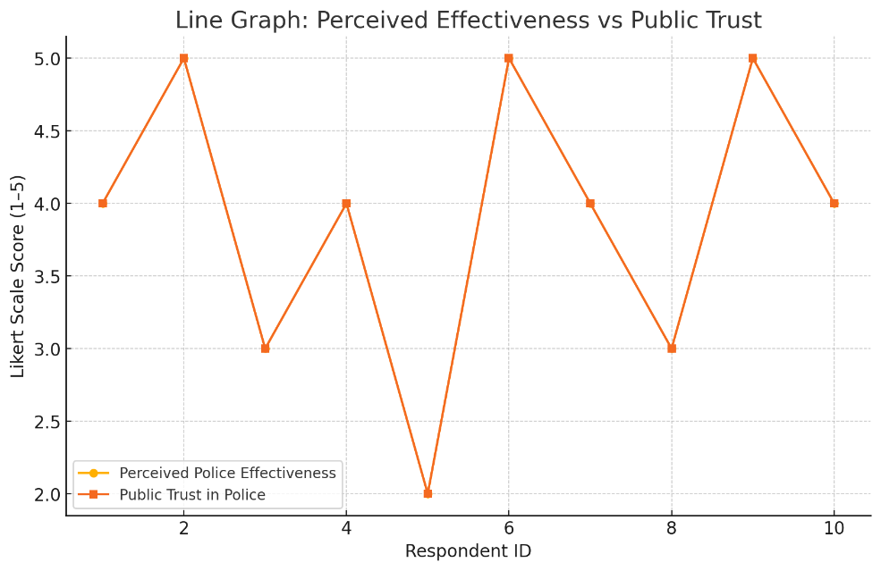
Note: The line graph illustrates ratings from 10 respondents on Perceived Police Effectiveness and Public Trust, both measured on a 5-point Likert scale. The parallel trend suggests a positive correlation as perceived effectiveness rises, trust increases. This supports Objective 3, highlighting those improved police performance boosts public confidence and underscores the value of performance-driven community policing.
Limitations
This study reflects perceptions at a specific point in time and may not capture ongoing changes in community policing practices. As data were self-reported, responses may be influenced by personal bias or social desirability. The purposive sampling, while useful for targeted insights, limits generalisability to the broader population. Additionally, the detail in responses to open-ended questions varied, which may have affected the depth of qualitative analysis. Despite these limitations, the study offers useful insights into public attitudes and challenges related to community policing in Sivasagar.

Challenges
- Low civic engagement persists despite high awareness, indicating a disconnect between public knowledge and actual participation in community policing.
- Efforts often lack continuity, with many initiatives implemented in isolation and without structured follow-up mechanisms.
- Communication gaps between police and citizens hinder trust-building, limiting transparency and cooperative action.
- Resource limitations both technological and human undermine the sustainability of participatory policing models in peripheral regions.
- Historical grievances and inconsistent policing responses have led to a trust deficit, particularly in areas with past insurgency and ethnic tensions.

Suggestions
To strengthen community policing frameworks, it is crucial to institutionalize practices through the establishment of dedicated units, sustained financial support, and seamless integration into routine policing operations. Structured mechanisms for citizen participation and community-based monitoring should be developed to ensure shared responsibility and enhance public ownership of safety outcomes. Leveraging multilingual digital technologies can address communication barriers and foster real-time responsiveness between police and diverse communities. Capacity-building initiatives must focus on equipping frontline personnel with skills in cultural sensitivity, conflict resolution, and procedural justice. Additionally, fostering inter-agency coordination and securing targeted funding are essential for addressing operational constraints, particularly in border and conflict-sensitive regions. In Assam, the Community Liaison Groups (CLGs), established as part of citizen-centric policing initiatives, have shown measurable impact. According to the Bureau of Police Research and Development’s internal assessment (BPR&D, 2022), over 800 CLGs were operational across Assam by late 2022, playing a pivotal role in mitigating communal tensions, particularly in districts like Barpeta and Kokrajhar. A joint initiative between Assam Police and the NGO ‘Aide et Action’ (2021–2023) in Dibrugarh and Sonitpur further demonstrated that youth engagement programs led to a 37% reduction in petty crimes, as noted in their project outcome report (Aide et Action, 2023). The North East Network’s study on gender-responsive policing in Assam (August 2023) highlighted improved accessibility to police services for women and marginalized groups, especially through proactive women police cells. Drawing from these region-specific experiences, it is essential that community policing models in other Northeastern states such as Manipur, Meghalaya, and Nagaland be locally adapted to address ethnic diversity, geographic isolation, and the legacy of armed conflict. Finally, embedding restorative policing practices and creating platforms for public dialogue can play a transformative role in rebuilding trust, enhancing legitimacy, and promoting inclusive security governance.
Conclusion:
Community policing in Sivasagar, Assam, signifies a shift towards people-centric policing in a region historically affected by insurgency and marked by cultural diversity. Local initiatives such as beat patrols and public outreach have fostered early signs of trust and collaboration between police and citizens. However, irregular participation, communication gaps, and inadequate institutional support limit the sustainability and scalability of these efforts. To strengthen impact, community policing must be institutionalized through dedicated units, formal training, resource support, and the integration of communication technologies. The Sivasagar model offers valuable insights for culturally responsive and inclusive policing across Assam and India’s Northeastern region.

References:
- Law Enforcement Action Partnership, Sir Robert Peel’s Policing Principles, n.d., https://lawenforcementactionpartnership.org/peel-policing-principles/.

- Brogden, Mike, and Nijhar, Preeti. Community Policing. United Kingdom, Taylor & Francis, 2013.
https://www.google.co.in/books/edition/Community_Policing/4WMQBAAAQBAJ?hl=en&gbpv=1
(Page- 1)
- Palmiotto, M. (1999). Community Policing: A Policing Strategy for the 21st Century. United States: Aspen.
- Community Policing in India: https://egyankosh.ac.in/bitstream/123456789/38941/1/Unit-4.pdf Last accessed on 15/09/2024
- Aide et Action. (2023). Community youth engagement for safer neighbourhoods: Outcome report 2021–20s23. Aide et Action India.
- Bureau of Police Research and Development. (2022). Assessment report on Community Liaison Groups (CLGs) in Assam. Ministry of Home Affairs, Government of India.
- North East Network. (2023, August). Towards gender-responsive policing in Assam: Progress and challenges. Guwahati: NEN Publications.
- Assam Police. (2021). Project Prahari: Community empowerment against superstition and witch-hunting. Assam Police Department.
- Bureau of Police Research and Development. (2023). Youth engagement in community policing: Strategies and outcomes. Ministry of Home Affairs, Government of India.
- Malakar, R. (2025). Digital policing and public engagement in Assam: A case study of Guwahati City Police. Journal of Policing and Society, 17(1), 45–58.
- Sentinel Digital Desk. (2024, February 10). Assam police strengthen community ties with Nagarik Samitis and crime-mapping tools. The Sentinel.
- Theories and Concept of Community Policing. (2024). Participatory policing in India: Models from Assam and beyond. North East Police Studies Series, Volume 3.

Law Enforcement Action Partnership, Sir Robert Peel’s Policing Principles, n.d., https://lawenforcementactionpartnership.org/peel-policing-principles/. Last Accessed on 15/05/25.
Brogden, Mike, and Nijhar, Preeti. Community Policing. United Kingdom, Taylor & Francis, 2013. https://www.google.co.in/books/edition/Community_Policing/4WMQBAAAQBAJ?hl=en&gbpv=1 (Page- 1) Last Accessed on 22/05/25.
Palmiotto, M. (1999). Community Policing: A Policing Strategy for the 21st Century. United States: Aspen. Last Accessed on 20/06/25.
Community Policing in India: https://egyankosh.ac.in/bitstream/123456789/38941/1/Unit-4.pdf Last accessed on 15/09/2024.

