SMART DISASTER MANAGEMENT SYSTEM
AI Agent–Based Framework for Real-Time Damage Assessment and Response Coordination

Nikhila Rame
Assistant Professor
Dept. of Computer Science and Engineering (Data Science) B V Raju Institute of Technology
Narsapur, India nikhila.r@bvrit.ac.in

Arya Krishna Kumar
Dept. of Computer Science and Engineering (Data Science) B V Raju Institute of Technology
Narsapur, India aryakrishnakumar971@gmail.com

Inturi Jaishnavi
Dept. of Computer Science and Engineering (Data Science) B V Raju Institute of Technology
Narsapur, India jaishnaviinturi@gmail.com

Gujjula Rajavenkat Reddy
Dept. of Computer Science and Engineering (Data Science) B V Raju Institute of Technology
Narsapur, India rajavenkatv5@gmail.com

Abstract—Natural disasters such as floods, earthquakes, and cyclones cause extensive damage to infrastructure, human life, and the economy, making rapid and accurate situational as- sessment critical for effective rescue and recovery. Traditional disaster response often depends on manual surveys and delayed reporting, resulting in slow decision-making, suboptimal resource allocation, and limited situational awareness in the early stages of an event.This paper presents a Smart Disaster Management System that leverages deep learning and AI agent–based decision support to automate damage assessment, survivor detection with geolocation, and recovery cost estimation from aerial imagery in near real time.
The proposed framework employs an automated analytical pipeline to process aerial images obtained from drones, which facilitates the detection of compromised infrastructure, the iden- tification of impacted individuals, and the mapping of their coor- dinates onto geographic information system layers to enhance the efficacy of targeted rescue operations.. A data-driven recovery cost estimation module predicts monetary loss and indicative restoration timelines using features derived from observed dam- age patterns and contextual regional attributes. On top of these perception and prediction components, a multi-agent frame- work—comprising decision-making and learning agents—scores and prioritizes actions, balances trade-offs between life-saving op- erations and infrastructure restoration, and continuously refines its policies based on past rescue outcomes.By synthesizing AI- enhanced visual capabilities, geospatial analytical methodologies, cost prediction frameworks, and adaptive agentic governance within a cohesive operational framework, the proposed system endeavors to minimize manual labor, accelerate responsiveness, and augment the precision and transparency of decision-making processes in disaster management.
Index Terms—YOLOv8, AI Agent, Drone Imagery, Damage Detection, Person Detection, Geospatial Analytics, and Recovery Cost Estimation

- Introduction
Floods, earthquakes, cyclones, and landslides relentlessly test our societies’ toughness, throwing essential services into chaos, forcing entire communities from their homes, and
wrecking both public facilities and private possessions. In addition to the immediate fatalities, these occurrences fre- quently instigate cascading failures, including the breakdown of transportation networks, power outages, and interruptions to healthcare and communication systems, which serve to prolong recovery efforts and exacerbate the overall socio- economic ramifications.Even with the improvements in satel- lite constellations, communication networks, and contempo- rary remote sensing technologies that have improved access to data connected to disasters, but many operational routines still do not fully utilise their full potential. Field groups remain obligated to create textual reports, conduct manual inspections, and communicate updates via hierarchical channels, all of which unavoidably cause delays and errors. As a result, decision-makers frequently have to work with sporadic and partial information, which makes it more difficult to prioritise solutions in situations that are changing quickly.
During the critical early hours of a disaster, operational efficacy is directly impacted by a lack of timely and high- resolution situational awareness. It may be difficult for author- ities to distinguish between zones that are mildly and seriously impacted, which could lead to either an overallocation or an underallocation of scarce resources.In the absence of a comprehensive overview regarding survivor distribution and infrastructure conditions, the routing of rescue teams or the planning of logistics tends to be predominantly heuristic and reliant on experiential knowledge rather than being grounded in empirical evidence.
Recent advancements in AI-powered computer vision and unmanned aerial vehicles offer a practical way to fill this information gap. Drones possess the capability to swiftly survey extensive areas, navigate over debris or inundated terrain, and capture detailed aerial imagery that elucidates building conditions, road accessibility, and crowd locations, while deep learning algorithms can autonomously analyze

these images to identify structural damage, obstructed roads, and human presence at scale.
This research tries to eliminate such insufficiency through bringing a Smart Disaster Management System that leverages image analysis along with Artificial Intelligence agents to facilitate continuous decision-making process. This process uses images obtained from drones and collectively identifies damage, locates people who are in need of immediate rescue with the help of geolocation and estimates total recovery costs. Artificial agents are leveraged to provide decision support for actions and synchronize analytical outputs. By blending accu- rate image analysis, geospatial mapping, cost modeling, and agent based synchronization, the proposed methodology tries to eliminate tremendous manual work, increase the latency and improve the recovery of damaged regions through proper allocation of resources in disaster management system.
- Literature Survey
Researchers have investigated post-disaster damage assess- ment, with a focus on effective data collection and processing techniques.Lozano and Tien examined various tools used for post-disaster damage assessment of building and lifeline in- frastructure systems, including satellite imagery, UAVs, and LiDAR sensors. Their investigation made clear how crucial coordinated data collection and metadata integration are to precise damage assessment. However, the authors noted that the lack of an integrated platform and the fact that current tools function in separate domains make it difficult to accomplish fast, thorough, and coordinated catastrophe assessment [1].
Managing post-disaster reconstruction involves numerous organizational and operational challenges. To determine the main obstacles in post-disaster reconstruction management, Puri et al. carried out a thorough literature assessment of papers published between 2000 and 2023. The study divided 223 issues into categories pertaining to finance, quality, com- munity, management and cooperation, legislation and policy, resources, and physical natural causes. The results highlighted how ineffective post-disaster cost planning and insufficient damage analysis seriously impede rescue attempts and inter- fere with vital services [2].
Miri et al. has interviewed 18 experts who have expertise in healthcare, emergency and disaster management to understand the damage caused to hospitals and healthcare services during post disaster in Iran. To quickly recover from the loss of disaster we must assess the level of damage and prioritize what needs to be fixed prior. This paper focuses on the need for the post disaster healthcare assessment system[3].
Akhyar et al. emphasize the importance of deep learning in the management of natural disasters. The author studied many existing papers to understand how Artificial Intelligence is crucial throughout disaster management. This focuses on disasters like floods, earthquakes, forest fires, and landslides using satellite and drone images, and uses ai to detect damage levels and helps to make faster decision making. This review highlights the use of deep learning like CNN based models that can help to easily identify the disaster severity. [4].
This paper talks about the importance of rehabilitation centers during post disaster in India. It emphasizes that post disaster rehabilitation centers will provide immediate relief, bring back livelihood, and help in coordinating reconstruction. This paper also addresses the challenges faced in post disaster rehabilitation due to lack of proper coordination, gaps in the policy, and lack of proper coordination. So, this document stresses the need for advanced rehabilitation centers that can effectively help in post disaster rescue. Nations around the world and big international outfits [5].
This paper discusses the repair plan of infrastructure sys- tems like electricity, water supply and transportation. It empha- sizes its importance by showing the interconnection between the systems. It also mentions that the existing methods only focus on economic recovery and tend to forget social impacts caused by the disaster. So, the authors, Huang and wang propose a plan that consider both the social and economic impacts. This is done using optimization models that help decision makers to choose which should be repaired first based on the severity [6].
This research paper focusses mainly on post disaster man- agement where they assess damage level to recovery needs in step-by-step processes. This is created by collecting large volumes of data after the disasters and assessing physical damage and estimated losses in livelihood and production and based on this they calculate recovery needs in short term for immediate relief and medium and long term for development and reconstruction. This recovery method has become a foundation for national recovery strategy [7].
Union Nations Development Programme(UNDP) has intro- duced a Post Disaster Needs Assessment (PDNA) which was accepted way by United Nations, European Union and World Bank. This was introduced because, back then each organi- zation was doing this process independently which resulted in effort duplication, inaccurate and no proper coordination between organizations. So, all these organizations created this PDNA technology that will evaluate the damage, economic loss and how much time it takes to recover back from the disaster. Since it is globally accepted way it keeps all the nations aligned and recover faster from the disaster [8].
F. Cavallo, G. Ireland, and S. McCarthy review and analyze different approaches that research use for assessing the damage long with their needs post disasters. The article shares the pros and cons of different studies which discuss how people currently measure what was lost, how much of the resources are needed and how decisions are made post disasters. The authors analyze each and every assessment method such as how fast they are, how computable they are, if they are reliable or not if yes how useful they are for recovery planning. They also highlight gaps and challenges of the current methodolo- gies which also guide the researchers for developing any other resources for betterment of recovery planning.[9]
Kopika et al. has clearly described the importance of know- ing about the damage level of roads and buildings. He empha- sized the importance of faster assessment of damage level. So, he proposed a multi-level damage assessment function

that uses satellite images and uses deep learning models like CNN to assess the damage. The damage assessment is done in different levels from an overview of damaged area or not to detailed damage of infrastructure like roads and bridges. Therefore, using this damage multi-level wise architecture will help in timely damage assessment and help in recovery planning [10].
Z.Zheng, X. Li, X. Xu, and L. Zhu discuss a methodology to analyze building damage through satellite images where in infrastructure like buildings are strictly analyzed before and after a disaster-strike like earthquakes or landslides. This methodology uses a deep learning model which takes the images of buildings prior to disaster and compares these images with post disaster images to know how many buildings have damaged or the severity of the disaster [11]. The model doesn’t look into the images pixel by pixel but instead looks at a building as a whole to decode the level of damage incurred. The model was successfully tested on real images and has proved to work accurately with acceptable speed making it reliable for any and every emergency scenario.
In another research work, J. Gu, Y. Wang, and H. Li talk about latest enhancements made where the scientists use remote sensing and deep learning to identify building damage quickly after any disasters like earthquakes and landslides. They also emphasize on the significance of immediate and faster building damage detection that can help allocate any resources without loosing much of response time. The pa- per also provides exposure to the complications that people generally face when they deal with post disaster management with aerial imagery [12]. The paper also gives an elaboration on the history of post disaster management beginning with how people used monitor the images manually then to older computer algorithms to analyze how much severe the damage is and finally to the latest inventions helping people fasten the process of rescue and recovery.
S. Hallegte, A. Vogt-Schilb, M. Banglore and J. Rozenberg collectively wrote a book which has a completely different perspective on natural disasters and the way of managing them. On the contrary to above papers, this research paper emphasizes that even though disasters strike as a whole, poor people and rich people take them in a very different way. The damage of the disaster cannot be measured merely using damages caused to buildings and crops because the poor are affected by disasters in a lot more terrible way. They argue that we must focus on handling such disasters by proper communication and by bringing diverse people together to recover from the aftereffects of the disaster [13]. They also suggest a need to highly educate the people to overcome the adverse impact of disasters.
In the research paper written by R. Gupta, R. Hosfelt , S. Sanjeev , N. Patel, B. Goodman, J. Doshi, E. Heim, H. Choset, and M. Gaston describe how they made a large dataset of millions of images which consists of buildings after a disaster- strike and a corresponding label which says “no damage” or destroyed. The authors present their way of collecting and labelling the data such that computers can learn patterns with
the right quantity and quality of data [14]. They also show how xBD datasets can be used to train deep learning models which automatically detect the buildings that are damaged. Due to the large and diverse data as xBD datasets consists of data of different disasters, people can work faster to develop the models and get quicker results.
In another research paper, S. Havivi, E. Yaari, A. Turbi, and their co-authors state the advancement of using SAR(Synthetic Aperture Radar) images and optical images together such that even slightest damage can be accurately identified as SAR images excel even in clouds or at night ,while optical images win with clear visual details when the weather is good [15]. The reason they state for combining both the remote sensing data is that damage detection especially in rural areas as buildings are far more spread out than they are in urban scenarios. Therefore, by combing both damage detection has proved to be fruitful and accurate just by using a single image. This also helps in planning and allocating the resources accordingly.

- Existing Work
Prioritywork on post disaster management strictly empha- sizes the lack of a comprehensive view of disaster to get to a decision increasing response times. They emphasize the need for blending all the data acquisition sources like satellites, drone imagery, LiDAR, and in-situ sensors to effectively doc- ument damage to both structural and lifeline infrastructures. Lozano and Tien (2023) conducted an examination of these methodologies which proved that every other tool excels in its respective domain, but a lack of an integrated platform can make the results of each tool futile as the latency can increase highly when monitored one after the other. This also causes the decisions to get delayed, ultimately making no significant use of tools deployed.
Additional researchers have focused on the pros and cons of post disaster planning and allocation of resources for recovery of the damaged areas. Puri et al. (2024) undertook an analysis of 66 scholarly articles and identified 223 unique challenges, which were divided into several segments like resource allocation, management and collaboration, legislative and policy frameworks, quality assurance, final considerations, community dynamics, physical challenges, and natural phe- nomena. Their work reveals that without accurate damage assessments and financial planning allocation of adequate amount of resources for reconstruction can get the recovery and might also lead to over-usage or under-usage of the needed resources.
Even though international frameworks, such as UNDP Post- Disaster Needs Assessment (PDNA), do provide proper assess- ments to assess the recovery expenditure, the process of post disaster management has proved to be very time consuming and labor-intensive. Talking about the existing deep learning models, there are enough deep learning models which use the convolutional neural network architecture to analyze the drone imagery, no model so far accurately predicts the amount of

building damaged, or the severity of roads damaged specif- ically. Considering all the research findings, our proposed model outputs a comprehensive view on disaster management beginning from collection of drone imagery, applying models like damage detection model which is further divided into road damage model and building damage model and a person detection model for identifying survivors who are in need of rescue or resources by sending their geolocation and lastly a regression model for computing recovery cost. Parallel to this, an AI agent works on helping with the decision-making process by reducing response times and making post disaster management efficient.
- System Design
The overall architecture is divided into modules and the pipeline follows an event-based approach starting from data acquisition of aerial images to final decision using AI agents for rescue and recovery planning
- Perception and Ingestion Layer
Drones continuously capture images of areas which have been damaged extensively and are sent to a designed storage location where a automated monitoring python library called watchdog detects new inputs and triggers the downstream components like models to work on the newly obtained images.
- Damage Detection Branch
The damage detection branch is further divided into two segments where in the first segment is about road detection and the other segment is about building damage. There are two models serving this purpose. The images are processed by the models to identify the areas of severe damage and ultimately providing the outputs like bounding boxes, seg- mentation masks and severity classification masks and severity classification levels that set out the magnitude and nature of the damage.
Satellite images and create three models for damage assess- ment , people detection and Recovery Estimation, and integrate this with real time dashboards and send alerts to the rescue team.
- Person Detection Branch
Furthermore, Complementary to damage detection, a person detection model is also run to detect images. The model is exclusively trained using YOLOv8 on top view images to mimic real world environment. This uses a dedicated deep learning model to detect the individuals and get the location using QGIS framework to raise the alerts regarding potential rescue targets
- Geospatial Mapping and Feature Extraction
A geospatial processing module integrates outputs from both road damage model and building damage model as well with drone metadata like GPS tags, altitude and camera parameters to estimate the exact location of survivors. This location is further used to alert the concerned regarding the individuals who are in dire need of rescue or resources. On top of the digital maps to get an estimate of how bad the disaster has been, how many buildings were damaged, how many roads were damaged etc., this could also help in the coming layers of estimating the recovery cost.
- Analytics and Decision-Support Layer
The features that have been extracted function as inputs to a regression-based model for estimating recovery costs, which forecasts financial losses and indicative timeframes for recovery at regional or zonal levels. These forecasts, in con- junction with the fundamental damage and survivor indicators, are utilized by a decision-support module that systematically prioritizes response actions based on criteria including life- saving potential, accessibility, and projected economic reper- cussions. A rule-based decision-making agent systematically ranks potential actions through the application of weighted scoring functions, while an ancillary policy analysis com- ponent scrutinizes historical disaster data and prior response results to facilitate the ongoing refinement of prioritization parameters.

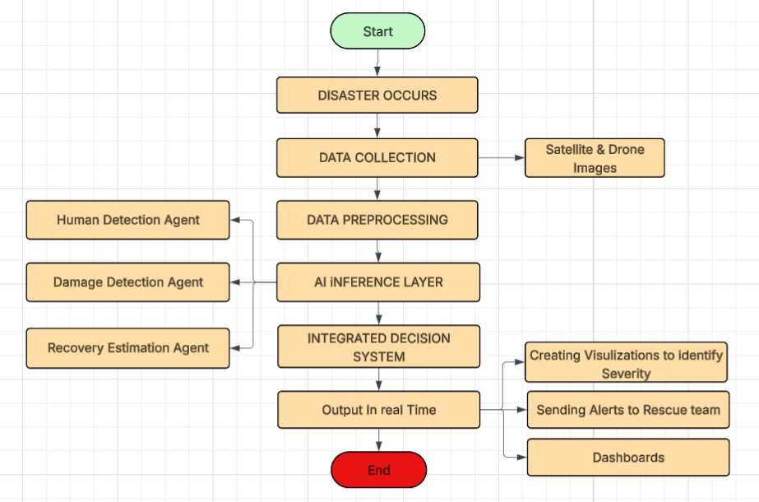
Fig. 1. DFD 2

The Fig 1 Diagram explains the clear workflow of the project where, when disaster occurs, we collect drone and
- Implementation
- Data Ingestion and Monitoring
The implementation begins with a file-based ingestion layer where drone operators or autonomous UAV missions upload images to a predefined directory structure, optionally tagged with mission identifiers and timestamps. A service constructed utilizing the Python programming language, which leverages the capabilities of the watchdog library, monitors this specific directory for the occurrence of creation events, mitigates the effects of rapid influxes, and subsequently adds newly identified image pathways to a processing queue.

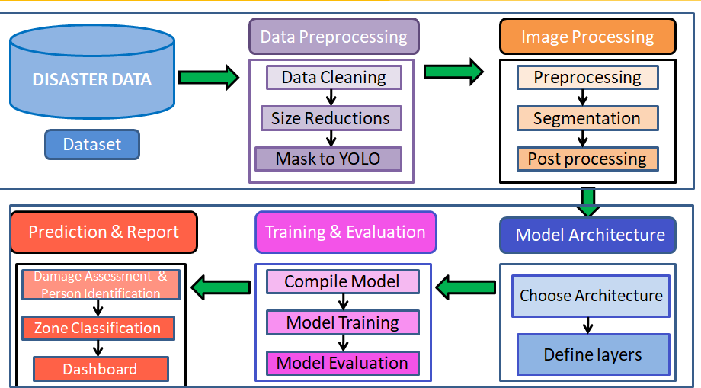

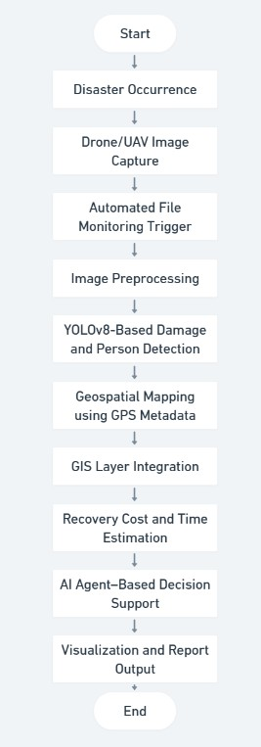
Fig. 2. PipeLine For Smart Disaster Management

The Fig 2 clearly demonstrates the workflow where when the disaster occurs, we capture the images and when an image entered the Folder it auto-triggered the models for damage and person detection using YOLOV8 and uses GIS layer to find the location of the person and calculate recovery cost and time and provide alerts and create real time dashboards.
- Damage Detection Models
The damage detection branch is further divided into two segments where in the first segment is about road detection and the other segment is about building damage. There are two models serving this purpose. The dataset for road damage is taken from Roboflow where in the total size is 1018 records out of which 702 are allocated for training while 212 images are used for validation and 104 images are used for testing purpose. On the other hand, the building damage dataset has been taken from Rescuenet which consisted of disaster effected images along with their masks. Due to the huge size of the dataset, we have performed various preprocessing techniques
Fig. 3. System Architecture

in order to smoothen the computation and increase the correct- ness of the data. They include retaining only the images which have a valid corresponding masks and we ultimately reduced the size to total 1847 images where in 1200 images were dedicated for training while 318 images were allocated for validation and the remaining 329 images were used for testing purpose. We utilized four major classes -Building no damage, Building minor damage, Building total destruction, Building major damage and trained, other classes like water, pole and background were removed for the betterment of model. The masks were also converted to Yolo format for training the model.
The Fig 1 Diagram explains the clear workflow of the project where, when disaster occurs, we collect drone and Satellite images and create three models for damage assess- ment , people detection and Recovery Estimation, and integrate this with real time dashboards and send alerts to the rescue team.
The Fig 3 shows the System Architecture Which involves Data preprocessing where Data is cleaned , size is reduced and masks are converted into Yolo format and images are pro- cessed to create YOLOv8 models and then create Dashboard which shows damage , Zone classification and triggers based on the priority.
- Person Detection and Geolocation
The dataset contains over 5000 images in which 4041 images are exclusively dedicated for training the model while 1144 images are for validation and remaining 570 images are used for testing purpose. The individual detection model represents a variant of YOLOv8, which has been specifically trained utilizing a dataset hosted on Roboflow that comprises top-view imagery of individuals.Each image is processed via this model during the inference phase in order to produce bounding boxes that indicate the likely locations of survivors. Subsequently, the identified positions of detected individu- als, compromised structures, and obstructed thoroughfares are projected and integrated into Geographic Information System (GIS) layers employing QGIS alongside geospatial processing libraries. One of the major challenge is getting geolocation from the drone’s camera view is a bit of a challenge in this project. Although QGIS serves exactly that purpose, mapping

the coordinates to what the drone sees is quite a difficult task as drone coordinates are dynamic and keep changing due to the difference in altitude, camera angle and movement. Due to the absence of precise camera calibration, the coordinates extracted from the QGIS do not align with the live drone information and therefore making direct implementation of that segment unreliable at this stage.
- Recovery Cost Estimation
The recovery cost estimation module uses a regression model particularly random forest with 5 input features. The dataset was prepared using the classes predicted by the building damage detection model and road damage detection model. The classes are Building no damage, Building minor damage, Building total destruction, Building major damage and Km destroyed. For calculating recovery cost and time, the higher weightage is given to Building total destruction and Km damaged as they play a significant role in estimating the time and cost..
- AI Agent–Based Decision Support
The proposed system employs multi agent framework which leverages three agents-a Perception agent, a Decision agent and a Learning agent. They collectively work to help prioritize the disaster-affected zones in real time. The perception agent first aggregates all the outputs from the models used including people detected, damage classification, road blockage assess- ment, and cost estimation into a disaster vector S=[p,d,r,c] where p denotes the people detected, d denotes severity of the building damage, r is an indicator of road blockage and c represents the cost. The state is evaluated by the decision agent using a weighted multi-criteria scoring function. The score is calculated by assigning random weights reflecting the importance of each factor. A learning agent looks after this aspect, continuously refining weights based on the feedback to make sure importance are given to each factor accordingly and accurately. This formulation allows the system to auto- matically learn the right rescue priorities ensuring continuous decision support throughout.
- Experimental Results
The person detection model trained on top view images from Roboflow dataset accommodates diverse types of images of survivors and has successfully achieved strong performance with an mAp@0.5 of 0.93, precision of 0.94, and recall of
0.87. These results convince that the models robustness in identifying the people under different conditions such as partial occlusions caused due to debris or any lighting conditions and small object sizes due to aerial view.

Coming to road damage detection model, achieved an mAp@0.5 of 0.89 with a classification accuracy of 92%, effectively classifying between different classes in rescue net dataset such as road-clear or road-blocked. Furthermore, the building damage detection model trained using the rescue net dataset has achieved net dataset has achieved a performance

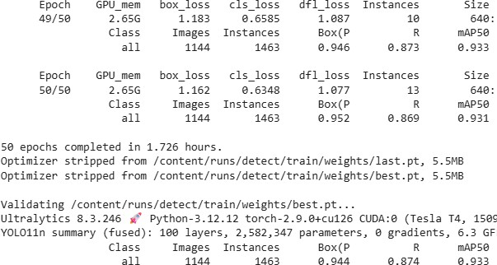

Fig. 4. Model Output - Person Detection
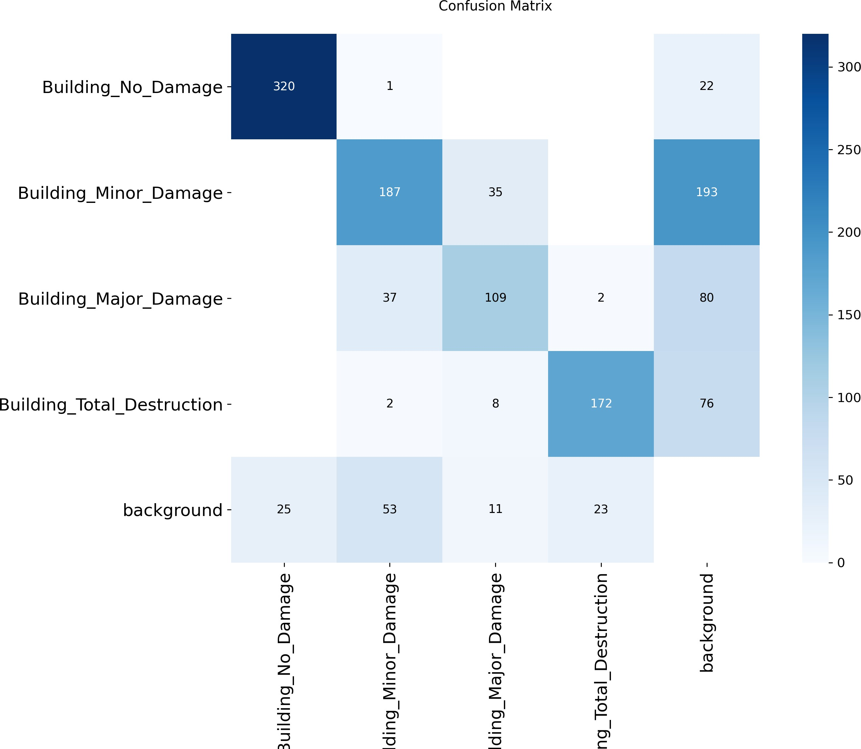

Fig. 5. Confusion Matrix - Building Damage Detection

of mAp@0.5 of 0.92 and an accuracy of 93% across various classes like building major classes, building minor damage, building no damage, building destruction. Moreover, the end- to-end evaluation of the system right from the beginning to end has proved its efficiencies in other aspects such as deployment, latency, alerting etc. making this viable for faster yet efficient disaster management. From the moment the image is taken from the drones to the further process like monitoring service like watchdog triggering downstream processing components like damage detection, person detection and other models like regression models exclusively used for recovery cost. Furthermore, the intervention of AI agents helps in faster decision-making process which reduces the latency of allo- cating resources if needed. The whole process takes about 85 milliseconds per image on a normal GPU. Since the system is both fast and accurate, it can come very much in handy in case of emergencies.
The imaging performance of the proposed system is pre- sented in Table I and Table II. The detection models achieve high accuracy according to Table I because person detection reaches an mAP@0.5 value of 0.93 and road and building

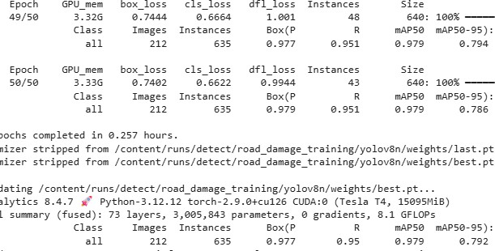

Fig. 6. Model Output - Road Damage Detection

TABLE I
Detection Model Performance Metrics

Model | mAP@0.5 | Precision | Recall
Person Detection | 0.93 | 0.94 | 0.87
Road Damage | 0.97 | 0.97 | 0.95
Building Damage | 0.74 | 0.75 | 0.72

damage detection exceeds 92% accuracy which proves their ability to analyze images. The system shows high computa- tional efficiency according to Table II because damage detec- tion takes 28 to 30 milliseconds and the complete imaging system functions at 85 milliseconds which allows for imme- diate disaster evaluation.
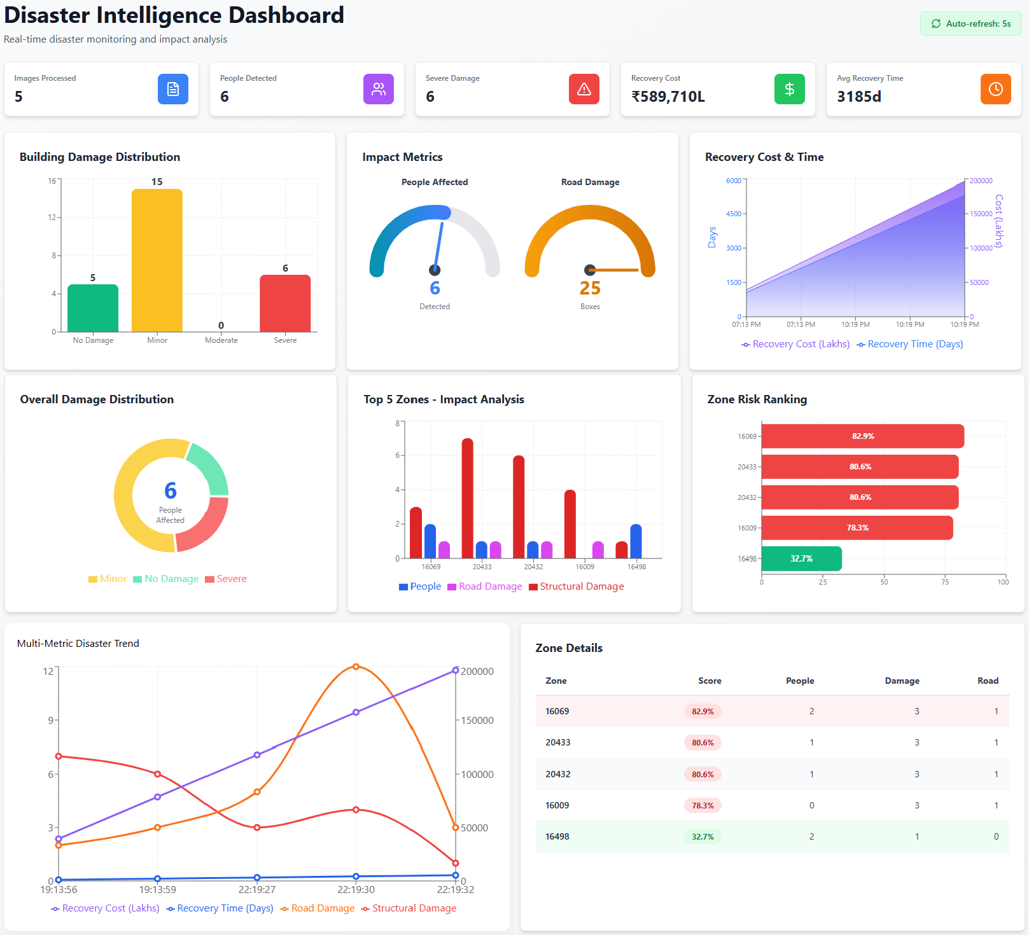
Fig. 7. Dashboard

- Discussion
Our Smart Disaster Management shows how we can fas- ten the process of post disaster management using Artificial Intelligence. The deep learning models “see” the drone view image and analyze the areas which need immediate help or
TABLE II
System Latency Metrics

Component Latency (ms)
Damage Detection 28-30
End-to-End Pipeline 85

have damaged extensively, locate people through geospatial mapping and raise alerts who are in dire need of rescue or resources and finally give out an estimate of recovery cost using straight forward regression models. Parallelly, AI agents are also used to help with the decision-making process to help in knowing what to prioritize the most. All this flow simultaneously help plummet the response time and increase overall effectiveness. Automation reduces the need for human intervention by reducing the number of errors and decreasing the latency. However, there are a number of obstacles that need to be addressed. The diversity of the datasets has a huge impact on the accuracy of the models developed. Popular Datasets like rescue net might not be able to fully capture the environmental circumstances. When it comes to geolocation, drone elevation, camera calibration and GPS issues can be the cause of the defects. As of recovery costs, the shortage of the historical datasets might have an adverse impact on the accuracy of regression models.
- Conclusion
This research proposes a Smart Disaster Management Sys- tem that collects aerial-view images from drones in a collective manner and identifies damage and people who need immediate help through geospatial mapping and makes use of regression models for estimating recovery costal using artificial intelli- gence. By employing a watchdog-based pipeline and modular components, the system seeks to automatically transform the drone images to valuable and actionable insights.
This architecture is meant to get accustomed to different Disaster scenarios and eventually learn more as more data sources keep adding in.The system is still in need of practical testing to see if it works as intended in real disaster environ- ment. Our proposed framework demonstrates that amalgamat- ing visual processing, person detection and geolocation and delivering recovery costs is not just possible but is necessary and practical. This integration will greatly help in accurate synchronization of actions and situations and improve how disasters are managed in real life.
References
- J.-M. Lozano and I. Tien, “Data collection tools for post-disaster damage assessment of building and lifeline infrastructure systems,” International Journal of Disaster Risk Reduction, Art. no. 103819, 2023.
- A. Puri, M. Elkharboutly, and N. Ameer Ali, “Identifying major challenges in managing post-disaster reconstruction projects: A critical analysis,” International Journal of Disaster Risk Reduction, vol. 107, Art. no. 104491, 2024.
- J. Miri et al., “Post-disaster damage and loss assessment in the Iranian healthcare sector: A qualitative interview study,” BMC Health Services Research, 2024.

- A. Akhyar, M. A. Zulkifley, J. Lee, T. Song, J. Han, C. Cho, S. Hyun, Y. Son, and B.-W. Hong, “Deep artificial intelligence applications for natural disaster management systems: A methodological review,” Ecological Indicators, vol. 163, Art. no. 112067, 2024.
- National Institute of Disaster Management (NIDM), “Post-Disaster Needs Assessment (PDNA) Handbook,” Government of India Publica- tion, 2019.
- M. K. Ahmad, “Role of post-disaster rehabilitation agencies in India: A review,” International Journal of Reviews and Research in Social Sciences, vol. 6, no. 2, pp. 194–198, 2018.
- United Nations, European Union, and World Bank, “Post-Disaster Needs Assessment Guidelines: Volume A,” Global Facility for Disaster Reduction and Recovery (GFDRR), 2013.
- United Nations Development Programme (UNDP), “Post-Disaster Needs Assessment (PDNA),” UNDP Publication, 2013.
- F. Cavallo, G. Ireland, and S. McCarthy, “A systematic review of post- disaster damage and needs assessment methodologies,” International Journal of Disaster Risk Reduction, vol. 31, pp. 106–118, 2018.
- N. Kopiika, A. Karavias, P. Krassakis, Z. Ye, J. Ninic, N. Shakhovska,
N. Koukouzas, S. Argyroudis, and S.-A. Mitoulis, “Rapid post-disaster infrastructure damage characterisation enabled by remote sensing and deep learning technologies: A tiered approach,” University of Birming- ham, Centre for Research and Technology Hellas, Brunel University London, and bridgeUkraine.org, 2023.
- Z. Zheng, X. Li, X. Xu, and L. Zhu, “Building damage assessment for rapid disaster response,” Remote Sensing of Environment, vol. 267, 2021.
- J. Gu, Y. Wang, and H. Li, “Advances in rapid damage identification methods for post-disaster building recognition using remote sensing and deep learning: A review,” Buildings, vol. 14, no. 4, 2024.
- S. Hallegatte, A. Vogt-Schilb, M. Bangalore, and J. Rozenberg, Un- breakable: Building the Resilience of the Poor in the Face of Natural Disasters, World Bank Publications, 2017.
- R. Gupta, R. Hosfelt, S. Sajeev, N. Patel, B. Goodman, J. Doshi,
E. Heim, H. Choset, and M. Gaston, “Creating xBD: A dataset for assessing building damage from satellite imagery,” in Proceedings of the IEEE/CVF Conference on Computer Vision and Pattern Recognition (CVPR) Workshops, 2019.
- S. Havivi, E. Yaari, A. Tubi, et al., “Damage assessment in rural environments following natural disasters: Combining SAR and optical remote sensing,” International Journal of Environmental Research and Public Health, 2022.

