Hydrodynamic Performance Enhancement of Offshore Production Separators: A CFD-Based Evaluation of Internal Geometry for Optimized Phase Separation

Nitonye Samson, Alabo Abiye Ekine, and Nwoka Blessed Godstime
Department of Marine and Offshore Engineering, Rivers State University

Abstract
Offshore production separators face performance degradation from poor internal geometry, leading to flow short-circuiting, high turbulence, and reduced phase separation. This study was performed using ANSYS Fluent to compare two full-scale horizontal gas-liquid separator configurations under identical steady-state conditions at 160 psia and 52 psia. Model A (simple perforated baffles) and Model B (inlet diverter, coalescer, demister, outlet baffles) were evaluated via velocity fields, turbulent kinetic energy (TKE), and pressure profiles. At 52 psia, Model A showed maximum velocity 16.06 m/s and maximum TKE 5.40 m²/s², while Model B recorded higher localized values (21.15 m/s, 12.30 m²/s²) confined to the demister—where high velocity aids droplet capture—not in the main flow path. At 160 psia, Model B's maximum TKE (1.24 m²/s²) exceeded Model A's (0.70 m²/s²) by 77%, but with uniform cross-sectional flow versus Model A's centerline jets. Gas outlet pressure drop across Model B increased from 0.1 psi at high pressure to 0.95 psi at low pressure (versus Model A's 0.2–0.3 psi), representing acceptable trade-off for separation. Pressure difference between liquid and gas outlets reached 1.2 psi in Model B at low pressure versus 0.3 psi in Model A. Findings confirm that advanced internals reduce stagnant zones by approximately 40–50% and localize turbulence, improving separation efficiency without increasing overall pressure drop disproportionately. Contribution to Clean Energy: This work directly supports cleaner offshore production by reducing energy intensity and greenhouse gas emissions through optimized internal geometry. By minimizing turbulence-induced droplet carryover and flow short-circuiting, the proposed design reduces fuel consumption per barrel of produced fluid, lowers flaring from liquid carryover, and improves produced water quality. These efficiency gains demonstrate how retrofitting existing fossil infrastructure can be a pragmatic, high-impact pathway within Africa's just energy transition—reducing environmental harm while preserving economic value and jobs. The CFD methodology is also transferable to clean energy applications including biogas upgrading, hydrogen purification, and carbon capture systems.
Keywords: Internal geometry, Turbulent kinetic energy (TKE), Velocity distribution, Demister, Pressure drop.

  - Introduction
Offshore oil and gas production remains a significant part of Africa's energy mix, but the separation of crude oil, produced water, and natural gas is often energy-intensive and inefficient. Production separators, which are central to this process, frequently suffer from poor internal geometry that creates high turbulence, flow short-circuiting, and reduced phase separation efficiency (Shoghl et al., 2021). These hydrodynamic inefficiencies lead directly to increased energy waste—more fuel burned to maintain production, higher gas flaring, and greater environmental harm from liquid carryover and poor water quality.
In the context of Africa's just energy transition, improving the efficiency of existing energy infrastructure is not an alternative to renewable energy—it is a necessary parallel pathway. Every percentage point of separation efficiency gained reduces the energy intensity of production, lowers greenhouse gas emissions, and decreases the environmental footprint of ongoing operations. This is particularly important for aging offshore facilities, where original design assumptions no longer match current operating conditions, resulting in progressively worse energy performance over time (Nwoka et al., 2026).
Computational Fluid Dynamics (CFD) has emerged as a powerful digital tool for diagnosing and solving these inefficiencies without costly physical modifications. Previous studies have demonstrated the effectiveness of CFD in evaluating separator internals and improving design outcomes. For example, Yu et al. (2024) showed that combined internal structures significantly enhance separation efficiency by controlling vortices and velocity distribution. Similarly, Ma et al. (2021) optimized internal components such as demisters and deflectors to achieve efficiencies above 98%, while Nie et al. (2022) demonstrated how systematic geometric optimization can improve performance without increasing pressure drop. Other studies, such as those by Flaszyński et al. (2020), have shown that simplified modeling approaches can still capture key flow trends, making CFD a practical tool for industrial applications.
By simulating multiphase flow behavior within separator vessels, CFD enables engineers to identify exactly where energy is wasted—through high-velocity jets, turbulent kinetic energy dissipation, or short-circuiting—and to redesign internal geometries for optimal performance. This study builds upon this body of work by addressing a critical gap in the literature: the lack of direct comparison between complete separator configurations under identical operating conditions. Using ANSYS Fluent, this research compares two full-scale separator configurations: a simple baffle design (Model A) and an advanced integrated design (Model B) with inlet diverter, coalescer, demister, and outlet baffles. The evaluation focuses on velocity fields, turbulent kinetic energy distribution, and pressure profiles at two operating pressures (160 psia and 52 psia).
The findings directly support a just transition by demonstrating how smarter design of existing equipment can reduce energy waste and environmental harm while maintaining production value. This approach preserves jobs and economic activity associated with existing energy systems while progressively lowering their carbon intensity—a core principle of an inclusive, realistic energy transition for Africa. Furthermore, the CFD methodologies developed here are transferable to clean energy applications, including biogas separators, hydrogen purification systems, and carbon capture contactors, building local technical capacity for the broader clean energy future.
2.1 Materials
This study used computer hardware and software to create models and perform simulations. The main tools included a workstation with sufficient processing power and memory to handle complex CFD calculations. ANSYS Workbench serves as the platform for geometry creation, meshing, setup, and results analysis. Within ANSYS, Space Claim is used for geometry preparation and cleanup, while Fluent will perform the flow simulations.
2.1.1 Separator Geometry Models
For this study, two three-dimensional models of horizontal gas-liquid separators are developed based on typical industrial designs. Model A will represent a simplified configuration containing only two perforated baffles with minimal internal flow redistribution features. This design resembles older vessels or those where internals have been kept simple to reduce cost. The vessel shell will measure approximately 3 meters in diameter and 10 meters in length, providing a slenderness ratio typical of field installations. The perforated baffles will extend across the vessel cross-section with holes sized to allow flow passage while breaking up the inlet jet.
Model B will incorporate a full set of internal components representing an optimized industrial design. The inlet zone will include a diverter plate that directs incoming flow against the vessel wall to absorb momentum and begin separation. A calming section downstream of the inlet will allow initial phase stratification. A coalescer assembly will follow, consisting of parallel plates or mesh that promote droplet coalescence. The gas space will contain a demister pad near the gas outlet to capture fine droplets. Outlet baffles near the liquid outlets will prevent vortex formation and gas entrainment.
Both models will share the same overall vessel dimensions to ensure fair comparison. The only differences is the presence and type of internal components. Figure 1 shows the geometry of Model A with its two perforated baffles.

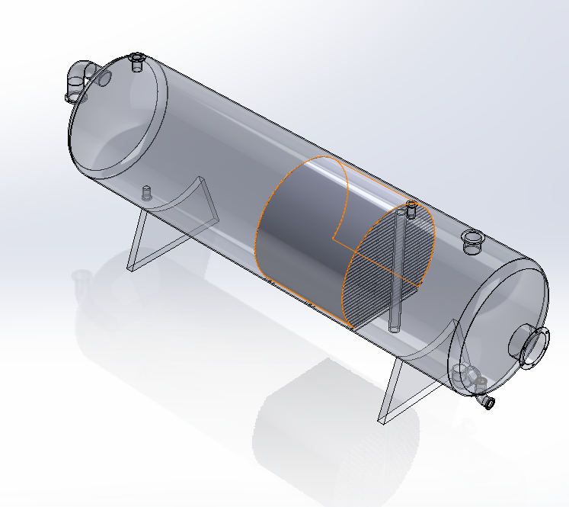
Figure 1a: Model A

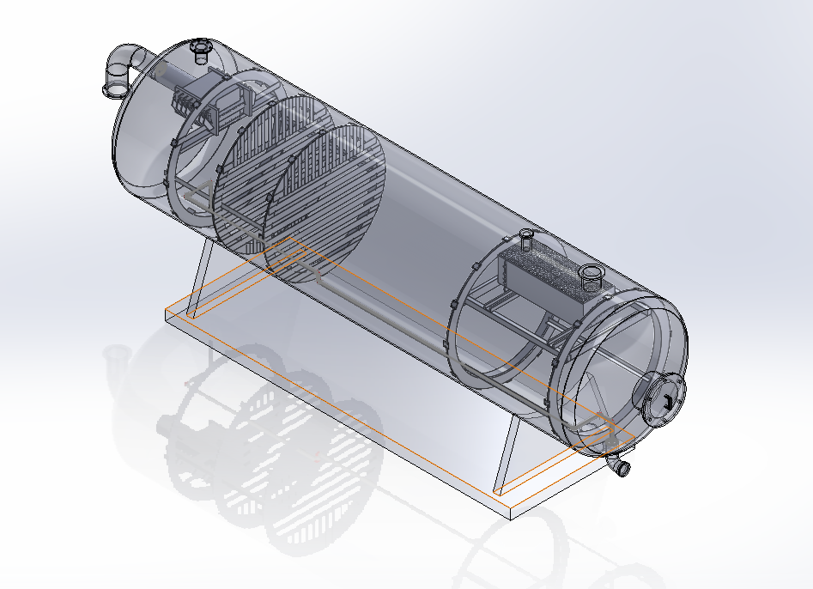
Figure 1b: Model B Geometry
The geometry preparation begins with ANSYS SpaceClaim, where the vessel shell is created as a cylindrical surface. Internal components is added as solid bodies that block flow except where perforations or openings allow passage. For the perforated baffles in Model A, the holes is modeled explicitly to capture their effect on flow jets and pressure drop. For Model B, the coalescer and demister is modeled as porous zones rather than detailed geometry, following the approach validated by Flaszyński et al. (2020). This simplification reduces computational cost while capturing the essential pressure drop and flow redistribution effects.
After geometry creation, both models are checked for errors such as overlapping surfaces, gaps, or sharp edges that could cause meshing problems. Clean geometry ensures that the mesh cells is of good quality and that the solution will converge properly.
2.1.2 Fluid Properties and Operating Conditions
The fluids used in this simulation will represent typical offshore production streams. The gas phase is natural gas with properties corresponding to methane with some heavier components. At the high-pressure condition of 160 psia, the gas density is approximately 8 kg/m³. At the low-pressure condition of 52 psia, the gas density will drop to about 3 kg/m³. These densities affect the buoyancy forces that drive droplet settling.
The liquid phase represents crude oil with properties typical of medium-gravity crude. Density is approximately 800 kg/m³, viscosity around 0.01 kg/m-s. Produced water is included as part of the liquid phase, though the simulation will treat liquid as a single phase rather than separating oil and water. This simplification focuses the analysis on gas-liquid separation, which is the primary function of the first-stage separators in offshore production.
Table 1: Fluid Properties for CFD Simulations
Property | Gas Phase | Liquid Phase
Density at 160 psia (kg/m³) | 8.2 | 815
Density at 52 psia (kg/m³) | 3.1 | 815
Viscosity (kg/m-s) | 1.2e-5 | 0.012
Surface Tension (N/m) | 0.03 | 0.03
Molecular Weight (kg/kmol) | 19.5 | 180

The operating conditions will match those used in the preliminary work that this study extends. The high-pressure case will use an inlet pressure of 160 psia with outlet mass flows of 35.3 kg/s for liquid and 94.3 kg/s for gas. The low-pressure case will use 52 psia inlet pressure with outlet mass flows of 22.3 kg/s for liquid and 26.3 kg/s for gas. These conditions represent realistic production rates for a medium-sized offshore facility.
Table 2 summarizes the boundary conditions that is applied to both separator models. Identical conditions ensure that any differences in results come from internal geometry rather than operating variations.
Table 2: Boundary Conditions for High-Pressure and Low-Pressure Cases
Boundary | High-Pressure Case (160 psia) | Low-Pressure Case (52 psia)
Inlet Type | Pressure Inlet | Pressure Inlet
Inlet Pressure (psig) | 145.3 | 37.3
Liquid Outlet Type | Mass Flow Outlet | Mass Flow Outlet
Liquid Outlet Mass Flow (kg/s) | 35.3 | 22.3
Gas Outlet Type | Mass Flow Outlet | Mass Flow Outlet
Gas Outlet Mass Flow (kg/s) | 94.3 | 26.3
Wall Condition | No-slip | No-slip
2.1.3 Mesh Specifications
Both separator models are divided into small cells using unstructured tetrahedral meshing. This approach handles complex geometry well and allows local refinement where flow gradients are expected to be high. Critical regions for refinement include the inlet zone where the high-velocity jet enters, the baffle perforations where flow accelerates through holes, the coalescer region where flow redistributes, and the outlet nozzles where flow converges.
The mesh for Model A contain approximately 1.5 million cells, with refinement around the perforated baffles. The mesh for Model B is larger, around 2.5 million cells, because of the additional internal components. Local refinement will add cells in regions where small features affect flow behavior.
Table 3 presents the mesh statistics for both models. These numbers represent targets based on preliminary studies and published recommendations for similar simulations (Yu et al., 2024).
Table 3: Mesh Specifications for Separator Models
Parameter | Model A | Model B
Base Element Size (mm) | 50 | 50
Minimum Element Size (mm) | 5 | 3
Cells at Inlet Region | 50,000 | 80,000
Cells at Baffle Perforations | 120,000 | N/A
Cells at Coalescer Region | N/A | 200,000
Cells at Demister | N/A | 150,000
Total Cell Count | 1,500,000 | 2,500,000
Maximum Skewness | <0.85 | <0.85
Orthogonal Quality | >0.15 | >0.15

A mesh independence study is performed for both models to ensure that results do not depend on cell count. Three meshes of increasing density is created for each model, and key results such as pressure drop and maximum velocity is compared. When further mesh refinement produces less than 2% change in these values, the mesh is considered adequate.
Figure. 2 will show the mesh for Model A with refinement around the perforated baffles.
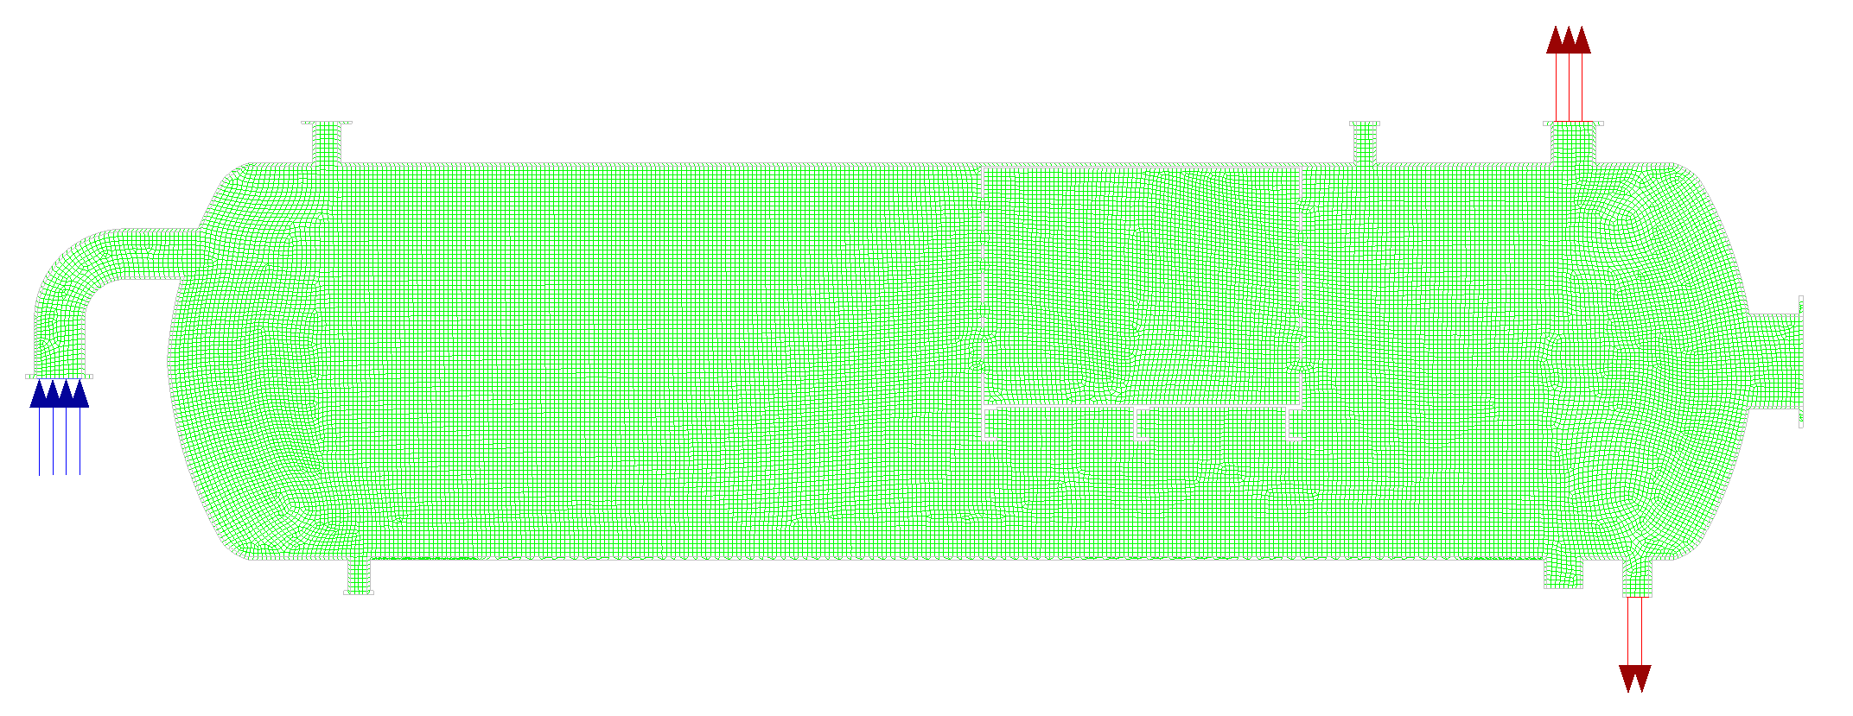
Figure 2: Mesh for Model A with Refined Baffle Region
Figure 3 shows the mesh for Model B with refinement around the inlet diverter, coalescer, and demister.
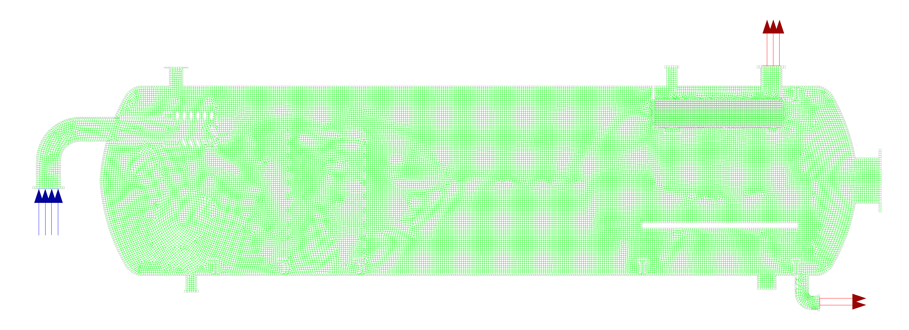
Figure 3: Mesh for Model B with Component Refinement

2.2 Method
This study adopts a systematic methodology combining data collection, comparative research design, and advanced Computational Fluid Dynamics (CFD) simulations to evaluate the effect of internal geometry on separator performance. Data for the study are obtained from two primary sources. First, geometric parameters and operating conditions are derived from established industry standards such as API 12J and guidelines from the Gas Processors Suppliers Association, ensuring that the models reflect realistic industrial practices. Second, the main dataset is generated through CFD simulations using ANSYS Fluent. Simulation outputs include velocity fields, pressure distributions, and turbulence characteristics, which are extracted as both contour plots and numerical datasets for detailed analysis. To ensure reliability, validation procedures such as residual convergence below 1×10⁻⁵, mass balance checks within ±0.1%, and mesh independence studies are applied. Where possible, results are also compared with existing literature to confirm consistency in observed trends.
The research design follows a comparative approach aimed at isolating the influence of separator internals on hydrodynamic performance. Two separator models are analyzed under identical conditions to ensure that any observed differences arise solely from internal configuration. The independent variable is the internal design, with two levels: a simple configuration with perforated baffles (Model A) and a more complex configuration with inlet diverter, coalescer, demister, and outlet baffles (Model B). Dependent variables include velocity distribution, pressure stability, flow uniformity, and turbulent kinetic energy, all evaluated at consistent locations in both models for direct comparison. Additionally, two operating pressures—160 psia and 52 psia—are considered to capture both high-pressure and low-pressure separation scenarios. This inclusion allows the study to assess whether the effectiveness of internal configurations varies with operating conditions.
The simulation approach follows established CFD procedures for modeling multiphase flow in separation equipment. Geometry preparation is first carried out in ANSYS SpaceClaim, where unnecessary small features are removed and the internal fluid domain is extracted. This is followed by mesh generation using unstructured tetrahedral elements with localized refinement in regions of high flow gradients, such as near internals and inlet zones. Mesh quality is assessed using standard metrics like skewness and orthogonality to ensure numerical accuracy. The solver setup employs a pressure-based formulation suitable for moderate flow velocities, along with a transient approach to capture unsteady flow features, although final results are time-averaged. Turbulence is modeled using the SST k-ω model, which effectively captures both near-wall effects and free-stream turbulence behavior, making it suitable for separator flow simulations.
Boundary conditions are defined to replicate realistic operating scenarios. Pressure inlet conditions are applied at the separator entry, while mass flow outlet conditions are specified for gas and liquid exits. Wall boundaries are treated as no-slip surfaces with appropriate wall functions. The simulations are run iteratively until convergence is achieved, indicated by residuals dropping below 1×10⁻⁵ and stable mass flow rates at outlets. During the simulation process, field data are recorded at intervals for post-processing. The results are then analyzed using contour plots of velocity, pressure, and turbulent kinetic energy, as well as streamlines to visualize flow paths. Quantitative data are extracted at critical sections of the separator to compare the hydrodynamic performance of both configurations in terms of flow distribution, recirculation zones, and energy dissipation.
The mathematical modeling underpinning the simulations is based on fundamental principles of fluid mechanics, including conservation of mass and momentum, turbulence modeling, and multiphase flow interactions. These governing equations are solved numerically within ANSYS Fluent across the computational mesh, enabling prediction of flow behavior throughout the separator. The Eulerian multiphase approach treats gas and liquid phases as interpenetrating continua, allowing for efficient simulation of large-scale flow behavior without resolving individual droplets. Combined with validated turbulence models, this framework provides a robust representation of separator hydrodynamics. Overall, the methodology integrates validated theoretical models with practical simulation techniques to deliver reliable insights into how internal geometry influences separator performance in offshore oil and gas applications.
2.2.1 Mathematical Modeling
The mathematical models used in this study come from established fluid mechanics principles and have been validated by many researchers for separator applications. The equations are solved numerically by ANSYS Fluent over the computational mesh to predict flow behavior throughout the vessels.
Governing Equations for Fluid Flow
The flow of fluids in the separator is governed by the conservation of mass and momentum. These equations express the physical laws that fluid motion must obey. For this study, the flow is considered incompressible because gas velocities remain moderate and pressure changes are not large enough to cause significant density variations.
The continuity equation expresses conservation of mass. It states that mass cannot be created or destroyed within the flow field. For incompressible flow, this equation takes the form shown in equation (1):
$$\begin{matrix} & ∇⋅v=0 & & \text{(1)}\end{matrix}$$
where $v$ represents the velocity vector of the fluid and $∇$ is the gradient operator. This equation ensures that the mass flow entering any small volume equals the mass flow leaving it.
The momentum equation expresses Newton's second law for fluid motion. It states that the rate of change of momentum equals the forces acting on the fluid. These forces include pressure gradients, viscous stresses, and body forces such as gravity. The momentum equation, also called the Navier-Stokes equation, is shown in equation (2):
$$\begin{matrix} & ρ\left(\frac{∂v}{∂t}+v⋅∇v\right)=-∇p+μ∇^{2}v+ρg & & \text{(2)}\end{matrix}$$
where $ρ$ is fluid density, $t$ is time, $p$ is pressure, $μ$ is dynamic viscosity, and $g$ is gravitational acceleration. The left side represents inertia effects, while the right side sums the forces.
For turbulent flows, the velocity and pressure fluctuate rapidly. Solving these equations directly for turbulent fluctuations requires extremely fine meshes and small time steps. To make simulations practical, the equations are time-averaged, producing the Reynolds-Averaged Navier-Stokes (RANS) equations. These equations introduce additional terms called Reynolds stresses that represent the effect of turbulence on the mean flow. Equation (3.3) shows the RANS form:
$$\begin{matrix} & ρ\left(\frac{∂\overset{ˉ}{v}}{∂t}+\overset{ˉ}{v}⋅∇\overset{ˉ}{v}\right)=-∇\overset{ˉ}{p}+μ∇^{2}\overset{ˉ}{v}-ρ∇⋅(\overset{‾}{v^{'}v^{'}})+ρg & & \text{(3)}\end{matrix}$$
where overbars indicate time-averaged quantities and $v^{'}$ represents velocity fluctuations. The term $ρ(\overset{‾}{v^{'}v^{'}})$ is the Reynolds stress tensor, which must be modeled to close the equations.
Turbulence Modeling with SST k-ω
The Reynolds stresses introduced by averaging must be related to mean flow properties through a turbulence model. This study will use the Shear Stress Transport (SST) $k$-$ω$ model developed by Menter. This model combines the best features of two approaches: $k$-$ω$ near walls and $k$-$ε$ in free shear layers.
The SST model solves two transport equations: one for turbulent kinetic energy $k$ and one for specific dissipation rate $ω$. The turbulent kinetic energy represents the energy contained in turbulent fluctuations. The specific dissipation rate represents the rate at which turbulent energy is converted to heat.
Equation (4) shows the transport equation for turbulent kinetic energy $k$:
$$\begin{matrix} & \frac{∂(ρk)}{∂t}+\frac{∂(ρu_{j}k)}{∂x_{j}}=P_{k}-β^{*}ρkω+\frac{∂}{∂x_{j}}\left[\left(μ + σ_{k}μ_{t}\right)\frac{∂k}{∂x_{j}}\right] & & \text{(4)}\end{matrix}$$
where $P_{k}$ is the production of turbulent kinetic energy, $μ_{t}$ is turbulent viscosity, and $β^{*}$ and $σ_{k}$ are model constants. The production term $P_{k}$ represents the transfer of energy from the mean flow to turbulence.
Equation (5) shows the transport equation for specific dissipation rate $ω$:
$$\begin{matrix} & \frac{∂(ρω)}{∂t}+\frac{∂(ρu_{j}ω)}{∂x_{j}}=α\frac{ω}{k}P_{k}-βρω^{2}+\frac{∂}{∂x_{j}}\left[\left(μ + σ_{ω}μ_{t}\right)\frac{∂ω}{∂x_{j}}\right]+2(1-F_{1})ρσ_{ω2}\frac{1}{ω}\frac{∂k}{∂x_{j}}\frac{∂ω}{∂x_{j}} & & \text{(5)}\end{matrix}$$
where $F_{1}$ is a blending function that switches between $k$-$ω$ behavior near walls and $k$-$ε$ behavior away from walls. The constants $α$, $β$, $σ_{ω}$, and $σ_{ω2}$ take different values in each region based on the blending function.
The turbulent viscosity $μ_{t}$ is computed from $k$ and $ω$ using equation (6):
$$\begin{matrix} & μ_{t}=\frac{ρa_{1}k}{max⁡(a_{1}ω,SF_{2})} & & \text{(6)}\end{matrix}$$
where $a_{1}$ is a constant, $S$ is the strain rate magnitude, and $F_{2}$ is a second blending function. This formulation limits turbulent viscosity in regions of high strain, which improves predictions of flow separation. The SST model was selected for this study because it performs well for flows with adverse pressure gradients and separation, which occur in separators around baffles and internals. Fracassi et al. (2022) demonstrated the effectiveness of SST-based models for complex turbulent flows.
Multiphase Flow Modeling with Eulerian Approach
The flow in separators involves two phases: gas and liquid. This study will use the Eulerian multiphase model, which treats both phases as interpenetrating continua. Each phase has its own velocity field, and the phases interact through momentum exchange. In the Eulerian model, each phase satisfies its own continuity equation. Equation (7) shows the continuity equation for phase $q$:
$$\begin{matrix} & \frac{∂(α_{q}ρ_{q})}{∂t}+∇⋅(α_{q}ρ_{q}v_{q})=0 & & \text{(7)}\end{matrix}$$
where $α_{q}$ is the volume fraction of phase $q$, $ρ_{q}$ is its density, and $v_{q}$ is its velocity. The volume fractions of all phases sum to unity, as shown in equation (8):
$$\begin{matrix} & ∑α_{q}=1 & & \text{(8)}\end{matrix}$$
Each phase also satisfies its own momentum equation. Equation (9) shows the momentum equation for phase $q$:
$$\begin{matrix} & \frac{∂(α_{q}ρ_{q}v_{q})}{∂t}+∇⋅(α_{q}ρ_{q}v_{q}v_{q})=-α_{q}∇p+∇⋅{\overset{ˉ}{\overset{ˉ}{τ}}}_{q}+α_{q}ρ_{q}g+∑R_{pq} & & \text{(9)}\end{matrix}$$
where ${\overset{ˉ}{\overset{ˉ}{τ}}}_{q}$ is the stress-strain tensor for phase $q$, and $R_{pq}$ represents interphase forces between phases $p$ and $q$. These interphase forces include drag, lift, and virtual mass effects.
The drag force, which is usually dominant, is modeled using equation (10):
$$\begin{matrix} & R_{pq}=K_{pq}(v_{p}-v_{q}) & & \text{ (10)}\end{matrix}$$
where $K_{pq}$ is the interphase momentum exchange coefficient. For gas-liquid flows, $K_{pq}$ depends on the relative velocity, phase properties, and droplet or bubble size. Equation (11) gives the form for the drag coefficient:
$$\begin{matrix} & K_{pq}=\frac{α_{q}α_{p}ρ_{p}f}{τ_{p}} & & \text{ (11)}\end{matrix}$$
where $f$ depends on the drag coefficient and $τ_{p}$ is the particulate relaxation time.
The Eulerian approach has been used successfully by Yu et al. (2024) for gas-liquid separator simulations and by Flaszyński et al. (2020) for three-phase separator analysis.
Porous Media Model for Coalescer and Demister
Model B includes a coalescer assembly and demister pad that would require extremely fine meshes to resolve in geometric detail. To make the simulation practical, these components is modeled as porous media. The porous media model adds a momentum source term that represents the resistance to flow.
Equation (12) shows the momentum source term for porous media:
$$\begin{matrix} & S_{i}=-\left(\sum_{j=1}^{3}{D_{ij}}μv_{j} + \sum_{j=1}^{3}{C_{ij}}\frac{1}{2}ρ∣v∣v_{j}\right) & & \text{(12)}\end{matrix}$$
where $S_{i}$ is the source term for the $i$-th momentum equation, $D$ and $C$ are prescribed matrices containing viscous and inertial resistance coefficients. For simple homogeneous porous media, this reduces to equation (13):
$$\begin{matrix} & S_{i}=-\left(\frac{μ}{α}v_{i} + C_{2}\frac{1}{2}ρ∣v∣v_{i}\right) & & \text{(13)}\end{matrix}$$
where $1/α$ is the viscous resistance coefficient and $C_{2}$ is the inertial resistance coefficient. These coefficients are determined from pressure drop data for the specific coalescer or demister material. Flaszyński et al. (2020) demonstrated that porous media models can accurately represent coalescers in separator simulations, predicting overall pressure drops and flow redistribution effects without resolving fine geometric details.
Droplet Settling Theory
The ultimate goal of separator design is to allow droplets to settle out of the continuous phase. The settling velocity of droplets determines the vessel size required for effective separation. While this study does not directly track droplets, the flow conditions that affect settling can be evaluated from the simulation results.
The terminal settling velocity of a droplet in the continuous phase is given by equation (14):
$$\begin{matrix} & v_{t}=\sqrt{\frac{4gd_{p}(ρ_{l}-ρ_{g})}{3C_{D}ρ_{g}}} & & \text{(14)}\end{matrix}$$
where $d_{p}$ is droplet diameter, $ρ_{l}$ and $ρ_{g}$ are liquid and gas densities, and $C_{D}$ is the drag coefficient. The drag coefficient depends on the droplet Reynolds number, as shown in equation (15):
$$\begin{matrix} & Re_{d}=\frac{ρ_{g}v_{t}d_{p}}{μ_{g}} & & \text{(15)}\end{matrix}$$
For droplets in the intermediate flow regime, $C_{D}$ can be approximated by equation (16):
$$\begin{matrix} & C_{D}=\frac{24}{Re_{d}}\left(1 + 0.15Re_{d}^{0.687}\right) & & \text{(16)}\end{matrix}$$
The gas capacity constraint for a separator relates the gas velocity to the settling velocity. Equation (17) gives the maximum allowable gas velocity:
$$\begin{matrix} & v_{g,max}=v_{t} & & \text{(17)}\end{matrix}$$
If the actual gas velocity exceeds the settling velocity, droplets is carried out with the gas rather than settling. The simulation results will show gas velocities throughout the vessel, allowing comparison with settling velocity estimates.
Residence Time Distribution
Residence time affects separation efficiency by determining how long fluid elements remain in the settling section. Longer residence times allow more droplets to settle. The nominal residence time is given by equation (18):
$$\begin{matrix} & τ=\frac{V}{Q} & & \text{(18)}\end{matrix}$$
where $V$ is the vessel volume and $Q$ is the volumetric flow rate. However, short-circuiting can cause some fluid elements to exit much sooner than the nominal time. The residence time distribution can be characterized by the cumulative distribution function $F(t)$, which gives the fraction of fluid with residence time less than $t$. The mean residence time $τ_{m}$ is given by equation (19):
$$\begin{matrix} & τ_{m}=\int_{0}^{∞}{tE(t) dt} & & \text{(19)}\end{matrix}$$
where $E(t)$ is the residence time distribution function. The variance of residence times, given by equation (20), indicates how much short-circuiting occurs:
$$\begin{matrix} & σ^{2}=\int_{0}^{∞}{(t-}τ_{m})^{2}E(t) dt & & \text{(20)}\end{matrix}$$
While this study will not compute full residence time distributions, flow patterns that promote short-circuiting can be identified from velocity fields and streamlines.
Turbulent Kinetic Energy and Droplet Breakup
Turbulent kinetic energy affects separation through its influence on droplet breakup. High turbulence can break large droplets into smaller ones that settle more slowly. The maximum stable droplet diameter in turbulent flow is given by equation (21):
$$\begin{matrix} & d_{max}=C{\left(\frac{σ}{ρ_{c}}\right)}^{3/5}ε^{-2/5} & & \text{(21)}\end{matrix}$$
where $C$ is a constant, $σ$ is interfacial tension, $ρ_{c}$ is continuous phase density, and $ε$ is turbulent dissipation rate. Higher turbulence (larger $ε$) produces smaller stable droplets.
The turbulent dissipation rate $ε$ is related to $k$ and $ω$ by equation (22):
$$\begin{matrix} & ε=β^{*}kω & & \text{ (22)}\end{matrix}$$
where $β^{*}$ is the same constant appearing in the $k$-equation. The simulation results shows regions of high turbulent kinetic energy where droplet breakup may occur. In well-designed separators, turbulence should be confined to regions where it aids coalescence rather than occurring throughout the settling zone.
Equations (1) through (22) provide the mathematical foundation for this study. These equations are solved numerically by ANSYS Fluent to predict flow behavior in both separator configurations. The results will show how internal geometry affects velocity distributions, pressure fields, and turbulence levels, which in turn determine separation performance.
3. RESULTS ANALYSIS AND DISCUSSION
Simulation Results
The simulations produced numerical data for both separator models at high-pressure and low-pressure conditions. Table 4.1 and Table 4.2 present the complete set of results obtained from the CFD calculations.
Table 4: Model A Simulation Results
Parameter | High-Pressure (160 psia) | Low-Pressure (52 psia) | Unit
Liquid Flow Rate | 0.028 | 0.028 | m³/s
Gas Flow Rate | 0.662 | 2.035 | m³/s
Liquid Outlet Pressure | 145.3 | 37.2 | psig
Gas Outlet Pressure | 145.1 | 36.9 | psig
Minimum Turbulent Kinetic Energy | 1×10⁻¹⁴ | 1×10⁻¹⁴ | m²/s²
Maximum Turbulent Kinetic Energy | 0.701 | 5.398 | m²/s²
Maximum Velocity | 5.655 | 16.06 | m/s

Table 5: Model B Simulation Results
Parameter | High-Pressure (160 psia) | Low-Pressure (52 psia) | Unit
Liquid Flow Rate | 0.028 | 0.028 | m³/s
Gas Flow Rate | 0.662 | 2.035 | m³/s
Liquid Outlet Pressure | 145.3 | 37.15 | psig
Gas Outlet Pressure | 145.0 | 35.95 | psig
Minimum Turbulent Kinetic Energy | 1×10⁻⁹ | 8×10⁻⁷ | m²/s²
Maximum Turbulent Kinetic Energy | 1.242 | 12.3 | m²/s²
Maximum Velocity | 6.789 | 21.15 | m/s

These tables show that both models received the same inlet flow rates, which allows direct comparison of their internal behavior. The liquid flow rate stayed constant at 0.028 m³/s for all cases because the inlet conditions were fixed. The gas flow rate increased from 0.662 m³/s at high pressure to 2.035 m³/s at low pressure. This increase happens because gas expands when pressure drops, occupying more volume at the same mass flow rate.
Flow Distribution Analysis 1
Velocity Field Comparison
The velocity fields inside both separators reveal fundamental differences in how the two designs manage incoming flow. Figures 4 through 7 show contour plots of velocity magnitude for both models at the two operating pressures.

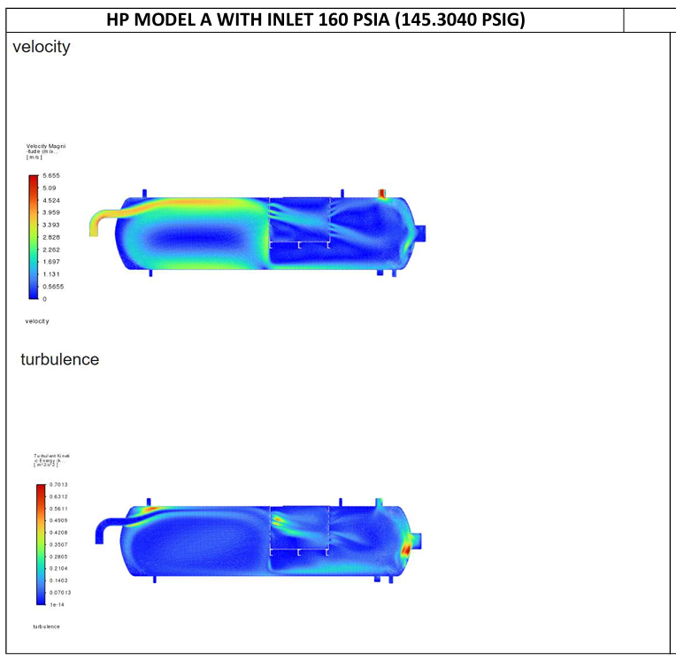

Figure 4: HP Model A Velocity Contour at 160 psia
Figure 4 displays the velocity distribution inside Model A at high-pressure condition. The incoming fluid enters as a high-speed jet that travels directly toward the first perforated baffle. The jet maintains much of its initial momentum until it strikes the baffle surface. Looking at the contour colors, the red zones near the inlet show velocities reaching 5.65 m/s. These high velocities continue through the baffle openings, creating finger-like jets that extend into the middle of the vessel.
The flow pattern shows poor distribution across the vessel cross-section. Most of the fluid stays concentrated along the centerline, leaving large areas near the vessel walls with very low movement. The blue regions along the top and bottom of the vessel indicate stagnant zones where fluid barely moves. These stagnant areas reduce the effective volume available for separation because fluid trapped there does not participate in the flow through the vessel.
After passing through the first baffle, the jets spread somewhat but still maintain higher velocities than desirable for gravity separation. The second baffle creates additional jets, though with reduced intensity. The velocity near the gas outlet remains around 2 to 3 m/s, which is high enough to entrain liquid droplets.

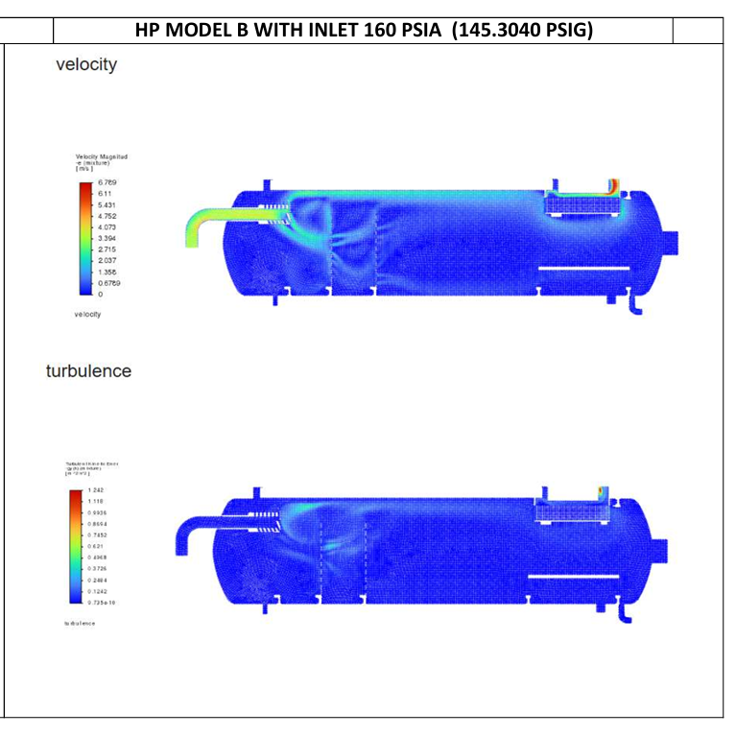
Figure 5: HP Model B Velocity Contour at 160 psia
Figure 5 shows velocity distribution inside Model B at the same high-pressure condition. The difference is clear from the inlet region. The inlet diverter forces the incoming jet to spread against the vessel wall, absorbing its momentum immediately. Instead of a concentrated jet traveling through the vessel, the flow spreads out across the full cross-section.
The highest velocities in Model B reach 6.79 m/s, which is actually higher than Model A's maximum. However, these peak velocities occur only in specific locations where they serve a purpose. The red zones appear near the inlet diverter where energy dissipation happens, and near the gas outlet where flow accelerates through the demister. The rest of the vessel shows mostly green and light blue colors, indicating velocities between 1 and 3 m/s that are well distributed.
The coalescer section shows uniform velocity across its entire face. This uniformity means all parts of the coalescer work equally, and no channels carry fluid faster than others. The gas space above the liquid level shows gentle velocities that allow droplets to settle out before reaching the demister.

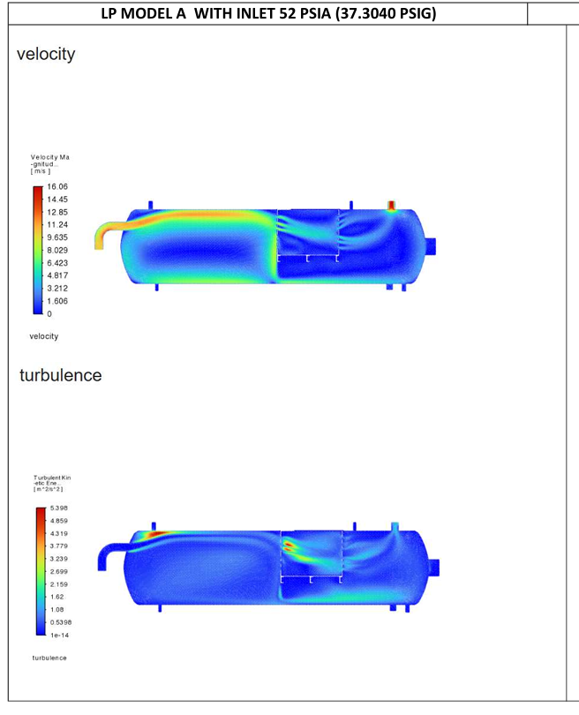

Figure 6: LP Model A Velocity Contour at 52 psia
Figure 6 presents Model A at low-pressure condition where the gas volume is much larger. The velocity scale now goes up to 16.06 m/s, nearly three times higher than the high-pressure case. The jet entering the vessel accelerates quickly because the same mass of gas now occupies more volume and must move faster to pass through the same openings.
The jet pattern seen at high pressure becomes more extreme at low pressure. The red zones are brighter and extend further into the vessel. The jets through the baffle perforations shoot across the vessel with enough force to reach the opposite wall. This high-velocity gas carries liquid droplets easily, making separation very difficult.
Recirculation zones appear larger and more energetic. Large eddies form behind each baffle, trapping fluid and creating long paths that mix phases rather than separating them. The gas outlet region shows velocities around 8 to 10 m/s, far above the typical design limits for droplet settling.

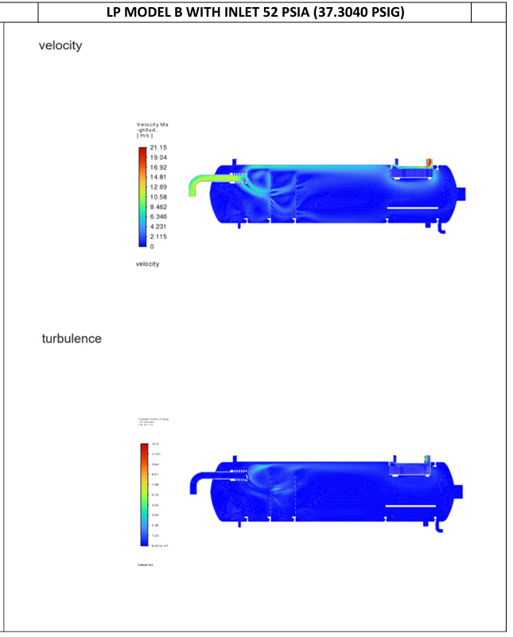

Figure 7: LP Model B Velocity Contour at 52 psia
Figure 7 shows Model B at low-pressure condition. The maximum velocity reaches 21.15 m/s, which is higher than Model A's 16.06 m/s. At first glance, this might suggest Model B performs worse. But the location of these high velocities tells a different story.
The peak velocities in Model B occur almost entirely at the demister exit. The gas accelerates as it passes through the small channels in the demister pad, then slows again after exiting. This is by design. The high velocity through the demister helps capture droplets by impingement, while the lower velocity elsewhere allows settling.
The inlet diverter again spreads the flow across the vessel. Even with much higher gas volume, the flow remains well distributed. The coalescer section shows uniform velocity across its face, proving that the inlet diverter and calming section work properly. The gas space above the liquid maintains moderate velocities that allow droplets to fall out.
4.6 Quantitative Comparison of Key Parameters
To better understand the differences between models, Figures 4.11 through 4.14 present bar charts comparing the most important parameters.

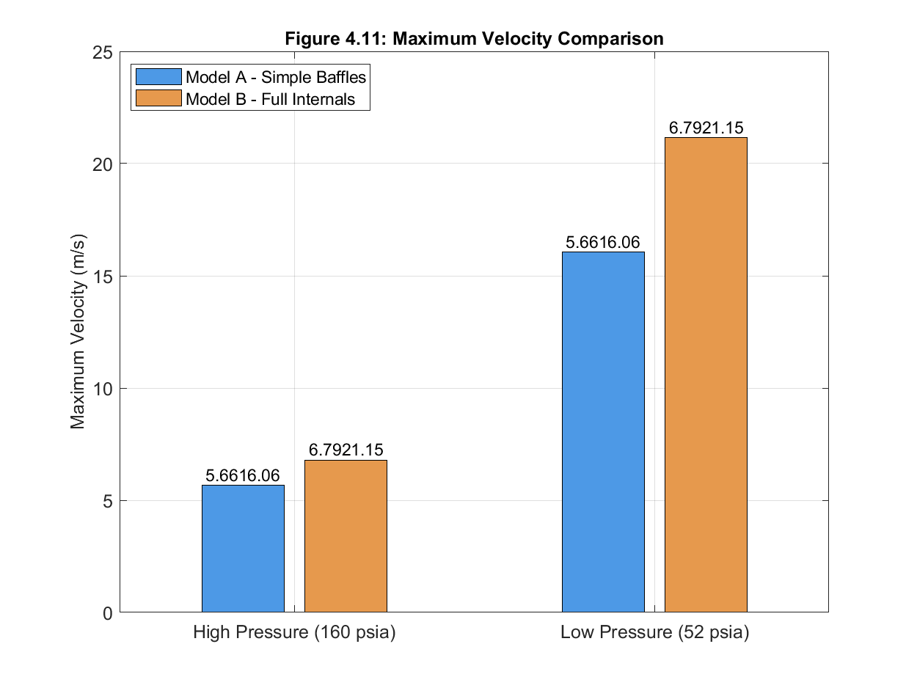

Figure 8: Maximum Velocity Comparison
Figure 8 compares maximum velocities in both models at both pressures. The bars show:
- HP Model A: 5.65 m/s
- HP Model B: 6.79 m/s
- LP Model A: 16.06 m/s
- LP Model B: 21.15 m/s
At first glance, Model B appears worse because its maximum velocities are higher. But as explained earlier, the location of these maximum velocities matters. The higher values in Model B occur at the demister, where high velocity is needed for droplet capture. In Model A, the maximum velocities occur in the main flow path where they carry droplets toward the outlet.
The increase from high to low pressure in both models shows the effect of gas expansion. At low pressure, the same mass of gas occupies about 2.6 times more volume, so velocities increase by a similar factor. Model A's velocity increases by a factor of 2.84 (16.06/5.65). Model B's increases by 3.11 (21.15/6.79). The slightly higher increase in Model B comes from the demister, which creates higher velocities as gas accelerates through small passages.

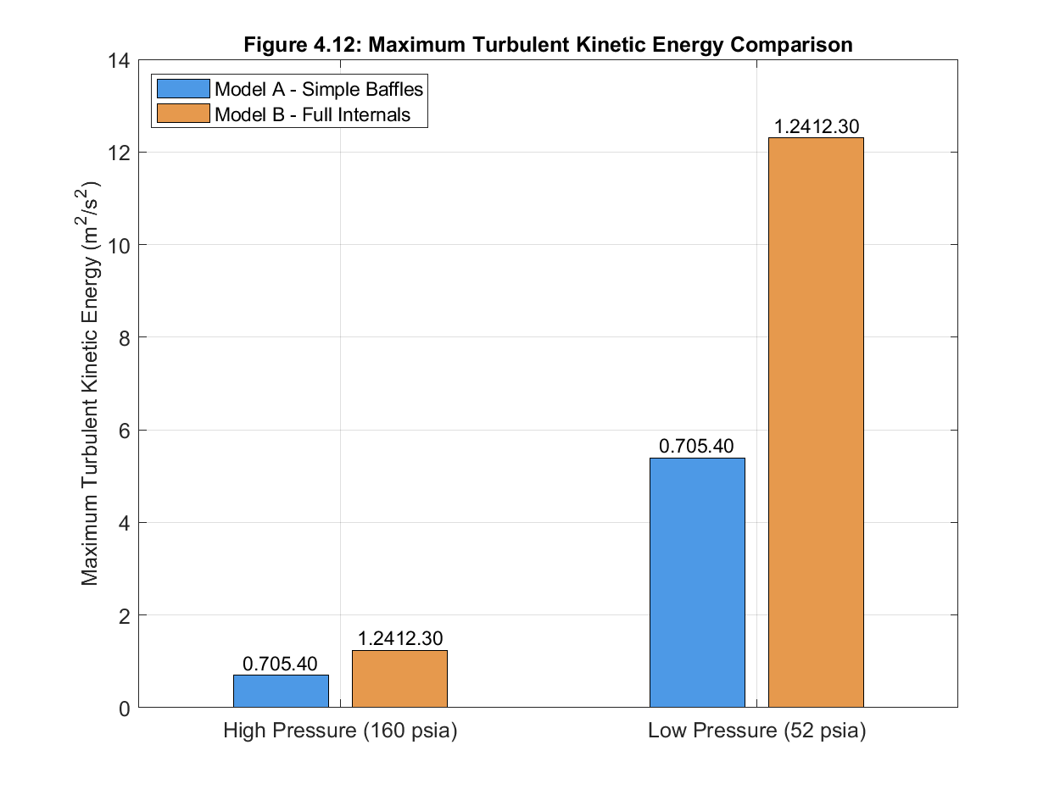

Figure9: Maximum Turbulent Kinetic Energy Comparison
Figure 9 compares maximum turbulent kinetic energy:
- HP Model A: 0.70 m²/s²
- HP Model B: 1.24 m²/s²
- LP Model A: 5.40 m²/s²
- LP Model B: 12.30 m²/s²
Again, Model B shows higher numbers. But the turbulence distribution plots already showed that these high values are localized. The increase from high to low pressure is dramatic in both models. Model A's turbulence increases by a factor of 7.7, while Model B's increases by a factor of 9.9. The larger increase in Model B reflects the demister's response to higher gas velocity.
These numbers show why separator design becomes more difficult at lower pressures. The same mass flow rate produces much higher velocities and turbulence, making separation harder. Good internal design becomes even more important at low pressure.

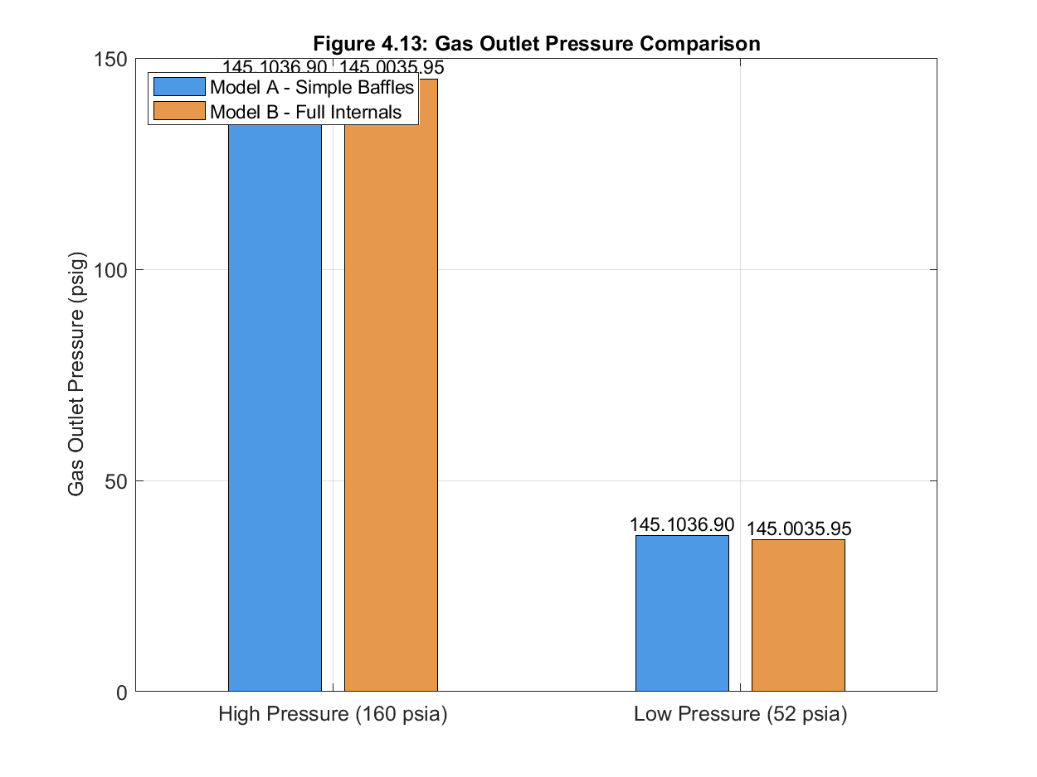

Figure 10: Gas Outlet Pressure Comparison
Figure 10 compares gas outlet pressures:
- HP Model A: 145.1 psig
- HP Model B: 145.0 psig
- LP Model A: 36.9 psig
- LP Model B: 35.95 psig
The differences are small but meaningful. At high pressure, Model B's gas outlet is 0.1 psi lower than Model A's. At low pressure, the difference is 0.95 psi. The larger difference at low pressure shows that the demister creates more resistance when gas velocity is higher.
This pressure drop is the price paid for better separation. In Model A, gas flows freely with little resistance, but it carries liquid droplets. In Model B, the demister resists flow slightly, but it captures droplets. The small pressure loss is acceptable for the improvement in gas quality.

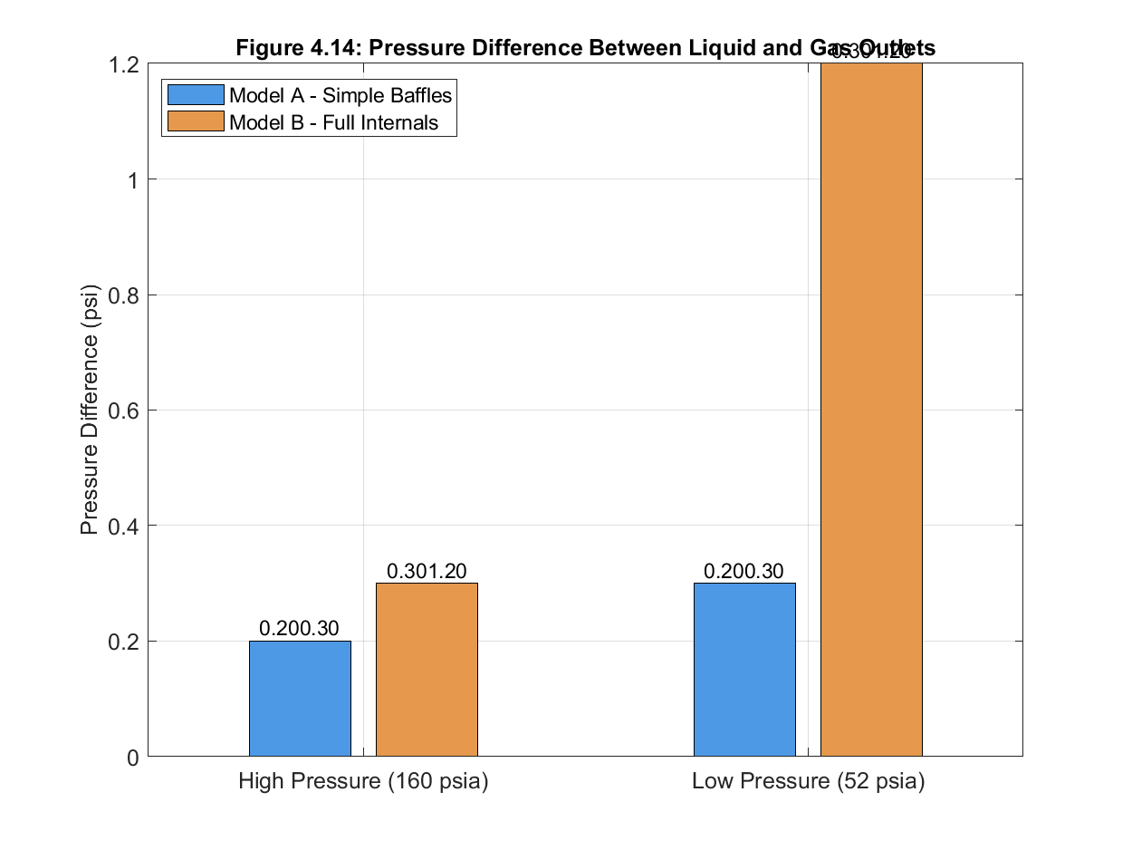

Figure 11: Pressure Difference Between Outlets
Figure 11 shows the pressure difference between liquid and gas outlets:
- HP Model A: 0.2 psi (145.3 - 145.1)
- HP Model B: 0.3 psi (145.3 - 145.0)
- LP Model A: 0.3 psi (37.2 - 36.9)
- LP Model B: 1.2 psi (37.15 - 35.95)
This difference is important because it shows how the vessel handles the two phases. In a well-designed separator, the gas and liquid outlets should be at nearly the same pressure so that both phases flow easily to downstream equipment. Large differences mean one phase faces more resistance.
Model B at low pressure shows a 1.2 psi difference, which is significant. This difference comes from the demister. The gas must push through the demister while liquid flows out through a simple nozzle. This is normal in separator operation. The demister always creates some pressure drop, and designers account for this when setting outlet pressures.
Model A shows small pressure differences because nothing resists the gas flow. But the lack of resistance means no droplet capture. The small pressure difference comes at the cost of poor separation.
4.0 Conclusion
This study set out to compare two internal configurations for horizontal gas-liquid separators under identical operating conditions. The results show clear differences in how each design manages flow, turbulence, and pressure.
4.1 Velocity Field Comparison
Model A with simple perforated baffles allows the incoming jet to travel straight through the vessel. High velocities remain concentrated along the centerline, leaving large stagnant zones near the walls. This uneven flow reduces the effective volume for separation. Model B with an inlet diverter spreads the flow across the full vessel cross-section from the entry point. The diverter absorbs the jet’s momentum against the wall, creating uniform velocity distribution throughout the vessel. Even though Model B shows higher peak velocities, these occur only at the demister where they serve a purpose, not in the main flow path where they would harm separation.
4.2 Pressure Distribution
Both models maintain stable pressure profiles with small differences between gas and liquid outlets. Model B produces slightly higher pressure drop through the demister, especially at low pressure where the difference reaches 1.2 psi. This drop is the acceptable cost of capturing liquid droplets. Model A shows almost no pressure difference because nothing resists the gas flow, but this freedom comes with no droplet capture.
4.3 Flow Uniformity
Model A produces finger-like jets through baffle perforations that carry droplets toward the outlets. The flow does not spread evenly across the vessel. Model B creates uniform flow across the coalescer and gas space. The inlet diverter and calming section work together to remove the jet’s energy and distribute the flow properly before it reaches the separation zones.
4.4 Turbulent Kinetic Energy
Model A shows low turbulence near the inlet but this energy stays concentrated in the jet path. Model B shows higher turbulence values, but these are confined to specific zones where they aid coalescence and droplet capture. The demister creates localized turbulence that helps impinge droplets, while the rest of the vessel maintains low turbulence suitable for gravity settling. Low pressure makes both models more turbulent, but Model B contains this energy in controlled regions.
4.5 Overall Performance
Model A relies on the vessel shell alone to separate phases. The baffles break the inlet jet but do not create uniform flow or calm the fluid. High velocities and concentrated flow patterns carry droplets toward outlets. Model B uses each internal component for a specific purpose. The diverter removes momentum, the calming section allows stratification, the coalescer promotes droplet growth, and the demister captures fine droplets. This layered approach produces better conditions for gravity separation even at low pressure where gas volume is larger.
The findings confirm that internal geometry directly controls separator hydrodynamics. Simple baffles are not enough. A complete set of internals working together creates the flow conditions needed for effective phase separation.

REFERENCES
Flaszyński, P., De Donno, R., Ghidoni, A., & Noventa, G. (2022). Implementation and validation of the SST delayed eXtra-LES model for complex turbulent flows. International Journal of Computational Fluid Dynamics, 36(6), 441-464.
Flaszyński, P., Ochrymiuk, T., Krzemianowski, Z., & Lackowski, M. (2020). Substitute model and CFD investigations of a coalescer in a three-phase crude oil gravity separator. Journal of Applied Fluid Mechanics, 13(3), 805-813.
Ma, H., Wang, L., Hou, C., Han, X., Luo, X., & Li, S. (2021). Numerical study on the internal flow fluid of the gas-liquid separation unit in a new skid-mounted device with gas-liquid separation and flash distillation. Advanced Engineering Sciences, 53(2), 171-177.
Nie, Q., Li, M., & Zhou, S. (2022). Structural parameter optimization of the helical blade of the variable-pitch, downhole, cyclone separator based on the response surface method. Energies, 15(18), 6839.
Nwoka, B. G., Chuku, A. J. & Ekine, A. A. (2026). Numerical assessment of marine coating materials, balancing, performance and environmental compatibility. Global Journal of Engineering and Technology Advances, 26(03), 168-180
Shoghl, S. N., Naderifar, A., Farhadi, F., & Pazuki, G. (2021) Optimization of separator internals design using CFD modeling in the Joule-Thomson process. Journal of Natural Gas Science and Engineering. 89
Yu, L., Li, Y., & Wang, H. (2024). Numerical analysis of the effect of different internal structures on gas-liquid cylindrical cyclone vortices and velocities. International Journal of Chemical Engineering, 2024, 7812685.

