Sonika Thakur
Assistant Professor, Lovely professional University, Jalandhar

DETECTION OF PHISHING URLs IN BIG DATA USING CART ALGORITHM

INTRODUCTION
B
IG DATA refers to a large number of datasets. Weblogs, call logs, medical records, military surveillance, photo archives, and other types of large, complex datasets are examples of big, complex data that cannot be processed with database queries because it is stored in both structured and unstructured forms [1]. The world produces vast amounts of data every day. It is being further fueled by the increasing use of social media, digital media [3], and the Internet of things.

Amandeep Kaur
Assistant Professor, Lovely professional University, Jalandhar

The rate of data growth is surprising, and this rate is very fast, with variety (not always structured) and a wealth of information that can be a key to gaining valuable knowledge in businesses. "Big data"[2] refers to a collection of data sets so big and intricate that they are hard to process with standard database management systems (RDBMS [3], for example, which are hard to handle large volumes of data, hard to classify unstructured data, lack high velocity because they are built for fixed data holding rather than fast growth, and will prove to be very expensive even if used to handle and store "Big data") or data processing applications [2]. Data in big data is vast, fast, and highly unstructured, hence it does not suit typical relational database systems. Large organisations may be well-equipped with database management tools to perform this work, but the volume of data generated each day easily outstrips the tool's capabilities. Big data [1] processing is now much more affordable thanks to open-source technologies, cloud computing, and cheaper hardware. Many hidden insights are implied by a large volume of data. The ability to quickly analyse large amounts of data is necessary to learn about a variety of topics, including customers, industry trends, advertising and marketing campaigns, equipment monitoring and performance analysis, and much more [3]. This is a major reason why many large organisations require powerful big data analytics techniques and technology [1].

Characteristics of big data
Big Data is important because it helps businesses gather, store, manage, and process vast amounts of data at the right speed and moment to gain the necessary insights. Big data [2] has four dimensions, according to Gartner: volume, diversity, velocity, and veracity, or data quality. Big data [1] generators need to maintain vital raw data qualities (Veracity) while producing scalable data (Volume) of various kinds (Variety) at controllable generation rates (Velocity). These four characteristics—volume, velocity, variety, and veracity—also referred to as the "4 V's"—have thus been used to define big data. More information on these features is provided in the ensuing subclauses [4]:
A. Volume: - Big Data is the term used to describe a vast amount of data. The size of the data is a critical factor in determining its value. Moreover, whether a certain data set qualifies as Big Data or not depends on the amount of data. That being said, one of the aspects of "Big Data" that needs to be taken into account is "Volume".

Variety: - Variety encompasses a broad spectrum of structured and unstructured data types and sources. Before now, the majority of programs only assessed databases and spreadsheets as data sources. Analysis applications now consider data in the form of emails, photos, videos, PDFs, audio, and so forth. There are issues with data mining, storage, and analysis because of the variety of unstructured data available.

Velocity: - The rate at which data is generated is referred to as "velocity." How quickly the data is generated and processed to meet demands determines its true potential. The rate at which data is ingested from sources like business processes, application logs, networks, social media sites, sensors, mobile devices, and so forth is known as big data velocity. There is a constant and massive flow of data.

Variability: - This is a reference to the occasional inconsistency that data may show, which makes it difficult to handle and manage data effectively.

Malicious URLs
URLs are now frequently used as a conduit for illegal online activities like spamming, phishing, drive-by downloads, and information warfare [6]. Fraudulent websites are often used by attackers to disseminate malicious software or steal identities. There is an immediate need for a mechanism to identify malicious URLs [7] from large volumes, high velocity, and high variety of data. Techniques are classified into two types: technical and non-technical approaches [8].
.
Anti- Phishing Techniques
Technical
Non- Technical
Data Mining
Blacklist

Figure 1: Anti-Phishing Technique
Data mining [5] and blacklisting techniques are further divisions of the technical approach. A common method that many browsers use to shield their users from malicious websites is the blacklist. Online databases like URIBL [8], SORBS [7], and Phish Tank [6] keep a list of URLs that have been blacklisted. These online working groups offer a list of malicious websites that have been submitted by volunteers or gathered by web crawlers and verified by some trustworthy back-end systems. The disadvantage of the blacklist approach [9] is that while it has very little overhead, it does not offer full protection because only about 55% of malicious websites are included in blacklists. The fact that malicious websites are not included in the blacklist before being discovered is another disadvantage of this strategy.
All of the online working group blacklist databases [8] have developed to the point where they now resemble big data. Big data is nothing more than a collection of datasets, and data mining algorithms [10] are used to extract useful information from these datasets and give them context. The analysis of large, complex datasets using data mining techniques makes it possible to find patterns or discover new information. It entails the systematic analysis of sizable data sets. Data modeling, which aids in making predictions about new data, can be produced by data mining techniques. Classification models are used to manage data [9].

LITERATURE REVIEW
The prevalence of phishing attacks has increased to the point where it is now a global issue. Phishing exploits private user data for nefarious purposes. An abundance of anti-phishing techniques [9] has been proposed to check these malicious activities. As previously mentioned, in addition to the blacklist method that is currently employed by many browsers, numerous anti-phishing tools [10] have been introduced, including TrustWatch, eBay Toolbar, SpoofGuard, Netcraft Anti-Phishing Toolbar, and others. However, some of these programs, such as TrustWatch and SpoofGuard, incorrectly classify as phishing websites some of the reliable websites. Many researchers have worked on phishing detection techniques using data mining algorithms [11]. Data mining algorithms [12] are useful. Data mining techniques allow for the instant identification of phishing websites.

To determine which data mining algorithm would work best for a phishing scenario, numerous algorithms have been compared. One of the papers compares six data mining algorithms [11]. The research is primarily concerned with predicting phishing websites for e-banking. Among the data mining methods employed for this are JRip, PART, PRISM, C4.5, CBA (Correlation Based Ensemble), and MCAR (Multi Classification Association Rule). After the phishing websites are analyzed, 27 features are retrieved from the URL and domain identity [10], security and encryption, source code, page style and contents, web address bar, and human factors associated with the sites. A training data set for phishing has been created and six algorithms have been applied to it. JRip offers the MCAR technique and the highest error rate [18].
Yang, et al. (2017) [17] proposed a novel approach for detecting malicious URLs using a combination of feature engineering and CART algorithm. Their method achieved high accuracy in identifying malicious URLs in a big data environment.
Liu, et al. (2018) [18] developed a hybrid model integrating CART with other machine-learning algorithms for the detection of malicious URLs. Their approach demonstrated improved performance compared to standalone CART models.
Zhang, et al. (2019) [19] conducted a comparative study evaluating the effectiveness of CART and other machine-learning algorithms in detecting malicious URLs. Their findings highlighted the superior performance of CART in terms of accuracy and computational efficiency.
Chen, et al. (2020) [17] proposed an ensemble learning framework that incorporates multiple CART models to enhance the detection of malicious URLs in big data. Their approach demonstrated robustness and scalability in real-world scenarios.

DATA MINING TECHNIQUES FOR MALICIOUS URLs DETECTION
Large pre-existing databases are examined using data mining to produce new information. Data mining algorithms [10] are used to produce information from this big data. Data mining-based approaches are significant because they can identify malicious URLs as soon as a user tries to access them. A classifier that can identify malicious URLs can be built using a variety of data mining algorithms. Using the WEKA tool [11], the SimpleCART algorithm has been examined in this paper to assess its accuracy.
CART (Classification and Regression Tree) analysis is a simple Cart method. The acronym for the Classification and Regression Tree algorithm is CART [11]. Leo Breiman developed it in the early 1980s. It is also utilized for prediction and data exploration. Regression and classification trees are classification techniques that use historical data to build decision trees. To create decision trees, CART uses a learning sample [12], which is a collection of historical data with preassigned classes for each observation.
The binary decision tree can be generated by the classification approach known as Simple Cart (Classification and Regression Tree) [13]. It only produces two children because the output is a binary tree. To select the ideal splitting attribute, entropy is used. To deal with the missing data, Simple Cart ignores that record. The training data work best with this algorithm. A learning technique [14] called classification and regression trees (CART) decision trees can produce classification or regression trees as results, depending on whether the data set is numeric or categorical.

Working of CART
Using binary splits, the algorithm recursively divides the training data into smaller subsets [14]. All of the training data is stored at the root node of the tree, from which it recursively divides the data into smaller subsets until a stopping condition is satisfied. Based on the values of each feature, the algorithm chooses a threshold and a feature at each node of the tree that best divides the training data into two groups [13]. For this, the feature and threshold that maximizes the information gain a measure of how well a split separates the data or the Gini impurity is selected. Every node in the tree splits the data into two smaller subsets, and the process is repeated recursively until a stopping condition is met [12]. The stopping criterion could be a minimum number of instances in each leaf node, a maximum depth for the tree, or other specifications. The built tree can be used to make predictions by climbing it from the root node to a leaf node that corresponds to the input data. The prediction for regression problems is the leaf node's average of the target values [11]. The majority class in the leaf node is the prediction for classification problems.
A split's Gini impurity [13] in a decision tree algorithm can be used to assess its quality. It determines the probability of a random sample being incorrectly classified. The probability that a randomly chosen element from the set would have the wrong label if its label were assigned at random using the label distribution of the subset is measured by the Gini impurity [14]. One can compute a node's Gini impurity using the formula below:

G = 1-$\sum_{i=1}^{c}{{pi}^{2}}$

where c denotes the number of classes and pi denotes the likelihood that a randomly selected node element will be classified as class i.
Let's look at an illustration of how to apply the CART algorithm to a binary classification issue [15]. Assume for the moment that we have a patient dataset that includes details about the patient's age, gender, blood pressure, cholesterol, and presence or absence of heart disease. We would like to create a decision tree to assess a new patient's risk of heart disease based on factors such as age, gender, blood pressure, and cholesterol. First, we determine the dataset's overall Gini impurity [15]. Assume that out of the 250 patients in the dataset, 100 have heart disease and the remaining 150 do not.
The impurity in Gini is
G = 1-$\sum_{i=1}^{c}{{\left(\frac{100}{250}\right)}^{2}-{\left(\frac{150}{250}\right)}^{2}}$

We compute the Gini impurity for each split, taking into account all potential split points. Assume that 55 years is the split point at which the minimum Gini impurity [15] occurs. Patients 55 years of age or younger and patients older than 55 made up the two subsets from which we separated the data. For these subsets, we construct two new nodes and determine the Gini impurity [15] of each node. We then take into account every input variable and potential split point. Assume that the first split variable we select is age. Suppose that the maximum tree depth of two is the stopping criterion that we set. This is how the final decision tree would appear [16]:

BP<=120?
HDL<=50
Yes
No
Yes
No
HD
No
HD
No
Age<=55
Figure 2: Data classification process

Based on their age, blood pressure, and cholesterol level, a new patient's likelihood of developing heart disease can be predicted using this decision tree [16].
The process has been divided into multiple stages. We used the Waikato Environment for Knowledge Analysis (WEKA) tool to analyze the CART algorithm [11]. The WEKA tool's [11] CART function builds a decision tree after evaluating the training set. The following are the various steps needed to analyze the CART algorithm, as depicted in Figure 3:
- Collection of malicious URLs from Wiktionary_en_2012-07-21.hdt i.e. which is a Bigdata dataset.
- Extraction of features of malicious URLs.
- Using the features that were extracted, training and testing datasets were created.
- Using a training dataset and a decision tree classifier model, CART is trained.
- Using a classifier model, the testing dataset's missing values are predicted.
- Classifier model evaluation using various parameter values.
Better results would be obtained because the dataset is checked more precisely the more rules there are. This indicates that better optimised decision trees are produced when the number of instances in the training dataset is increased.
Figure 3: Workflow diagram
Start
Collection of URLs
Extraction of features
Creation of training and test dataset
Training of CART algorithm
Decision tree
Analysis of decision tree using test dataset
End

Collection and extraction
To distinguish between phishing and legitimate websites, a collection of both kinds of websites is made. Phishing websites can be distinguished from genuine websites by several characteristics. Both authentic and fraudulent websites are gathered from Wiktionary_en_2012-07-21.hdt. A total of thirty-two phishing website features have been extracted. Phishing websites can have a variety of characteristics, such as an IP address in the URL, the @ symbol, a redirect to a different website, the inability to right-click, the use of pop-up windows, etc.

Creating datasets
A training dataset is generated using the previously extracted features. WEKA supports the creation of the training dataset as an arff file. The training dataset is used to build classifier models and train the data mining algorithm. WEKA first performs pre-processing on the training dataset. There are 4000 and 800 URLs in the training dataset. A 500 URL test dataset has been produced.

Preprocessing of training dataset and Training of CART algorithm
A dataset is preprocessed when it is loaded into WEKA. Following preprocessing, an attribute list with values is displayed. The relation name "malicious" refers to the training dataset that was used in this analysis. There are 750 instances and 33 attributes in total. The output attribute "Result" has a class value of 1 for fake websites and -1 for genuine websites.
The training dataset is used to train algorithms, and the classifier models they create are saved for use in website prediction. The saved classifier model of CART following training with a training dataset of 750 instances is referred to as "training CART." The size of the tree produced by CART is 45, meaning that there are 45 nodes in total, of which 28 are leaves. One way to visualize the classifier model is as a tree.

Testing of CART algorithm
Only when a trained classifier model performs well during testing can it be applied to predictions. Via the testing dataset, the classifier model's accuracy is determined. The missing values are present in the testing dataset. The classifier predicts these missing values, after which a confusion matrix is generated. The previously saved classifier model is loaded, and it is then reevaluated using the test dataset. There are 300 websites in this testing dataset. Of these, 200 are phishing websites, of which the saved classifier model predicted 154 to be phishing, and 100 are legitimate websites, of which the model predicted 94 to be legitimate. Following the creation of a prediction confusion matrix, a success rate of 0.826 and an error rate of 0.163. Consequently, the classifier model's accuracy, which was trained on 750 examples, is 83.6%.

Result Analysis
The decision tree produced by CART after it was trained using a training dataset including 600 URLs is shown in Fig. 4. There are 45 nodes in the tree, of which 15 are leaf nodes.
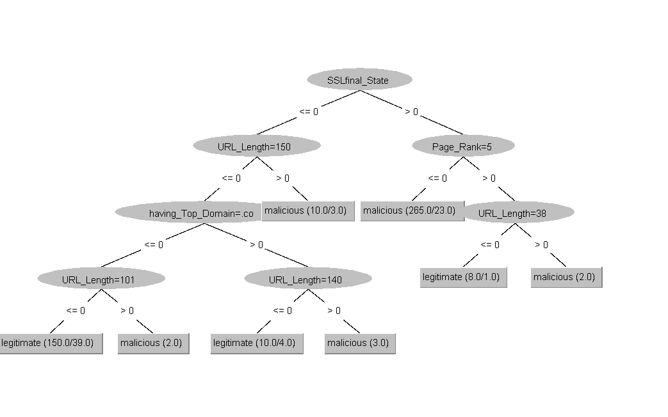Figure 4: : Decision tree generated using training dataset of 600 URLs
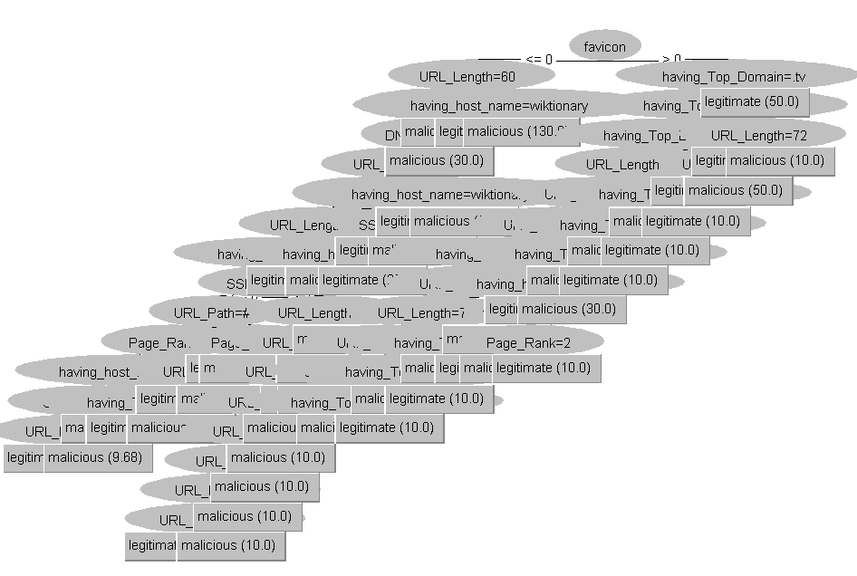
Figure 5: Decision tree generated using training dataset of 6000 URLs

There is now a training dataset with 6000 URLs. A decision with 60 nodes is produced if CART is trained in WEKA using a training dataset of 6000 URLs, of which 37 are leaf nodes (fig. 5).

Using either the classifier model or the decision tree, every URL in the testing dataset is predicted. As an instance moves through the tree's nodes, it is categorized as either phishing or not. An instance receives a prediction each time it travels through the nodes and reaches the leaf node [11]. Alternatively, it may be said that an instance will only receive a forecast when it reaches any leaf node. This allows for the classification of every case in the testing dataset as either phishing or authentic [11]. Every instance of the test dataset must traverse along a greater number of edges in a decision tree with more nodes. Better results would be obtained because the dataset is checked more precisely the more rules there are. This indicates that better-optimized decision trees [11] are produced when the number of instances in the training dataset is increased.

conclusion
A collection of massive datasets is known as big data. To determine the characteristics of such URLs, one can use a large data set of malicious URLs. The use of malicious URLs in online crimes has increased significantly. Thus, it is imperative to recognize these URLs. To extract the properties of URLs, large datasets containing both malicious and normal URLs are used. Diverse methodologies have been employed to regulate the malevolent assaults. To find these URLs, a variety of instruments and software are employed. The majority of technologies, such as blacklist [13], APWG [14], and Google Safe Browsing [15] API, are used to identify harmful URLs; nevertheless, they do not offer total protection because only roughly 55–65% of the dangerous URLs are included in their databases. Regularly, data mining techniques [10] are employed to identify potentially harmful URLs. Data mining techniques first extract the suspicious site's features and cross-reference them with the given classification. The CART data mining algorithm has been examined. The outcome demonstrates that the CART algorithm has an 83% accuracy rate in identifying dangerous URLs.

References
[1] B. Due, M. Kristiansen, R. Colomo-Palacios, and D. H. T. Hien, “Introducing Big Data Topics: A Multicourse Experience Report from Norway,” Proc. 3rd Int. Conf. Technol. Ecosyst. Enhancing Multicult., pp. 565–569, 2015.
[2] C. Snijders, U. Matzat, and U. Reips, “‘Big Data’: Big Gaps of Knowledge in the Field of Internet Science,” Int. J. Internet Sci., vol. 7, no. 1, pp. 1–5, 2012.
[3] A. B. M. Moniruzzaman and S. A. Hossain, “Nosql database: New era of databases for big data analytics-classification, characteristics and comparison,” Nosql database New era databases big data Anal. Charact. Comp., vol. 6, no. 4, pp. 1–14, 2013.
[4] B. Schoenborn, Big Data Analytics Infrastructure for Dummies. 2014.
[5] Pang-Ning Tan, Introduction to Data Mining, Second Edi. Pearson, 2006.
[6] “Phish Tank Out of the net, into the tank,” 2010. [Online]. Available: http://www.phishtank.com.
[7] “Surbl,.” [Online]. Available: http://www.surbl.org/lists.
[8] “URIBL.com,” 2012. [Online]. Available: http://www.uribl.com/about.shtml.
[9] I. H. Witten, E. Frank, and M. a Hall, Data Mining: Practical Machine Learning Tools and Techniques (Google eBook). 2011.
[10] P. J. Han Jiawei, Kamber Micheline, DATA MINING Concept and Techniques, Third Edit. kaufmann Morgan, 2012.
[11] M. Hall, E. Frank, G. Holmes, B. Pfahringer, P. Reutemann, and I. H. Witten, “The WEKA data mining software,” SIGKDD Explor. Newsl., vol. 11, no. 1, p. 10, 2009.
[12] A. Ahrary, “Big Data,” pp. 116–120, 2013.
[13] J.Makey, “Blacklists Compared.,” 2010. [Online]. Available: http://www.sdsc.edu/˜jeff/spam/.
[14] “APWG. 2010 1st Quarter Report,” 2011. [Online]. Available: http://www.antiphishing.org/reports/apwg.
[15] “Google Safe Browsing API - Google Code,” 2010. [Online]. Available: http://code.google.com/apis/safebrowsing/.
[16] R. Jabri and B. Ibrahim, "Phishing Websites Detection Using Data Mining Classification," Transactions on Machine Learning and Artificial Intelligence, vol. 3, no. 4, 2015.
[17] G. K. Gupta, Introduction to Data Mining with Case Studies, Prentice-Hall Of India Pvt. Limited, 2011.
[18] J. Han and M. Kamber, Data Mining Concepts and Techniques, Elsevier, 2006.
[19] M. Kantardzic, Data Mining Concepts, Models, Methods, and Algorithms, Wiley Publication, 2011.

