Smart Root Health Monitoring System Using Low-Frequency Soil

ABSTRACT:
Root health plays a vital role in overall plant growth, crop yield, and sustainable agriculture. Early detection of root stress, diseases, and soil-related abnormalities is essential to prevent yield loss and ensure efficient resource utilization. Traditional root monitoring methods are invasive, labor-intensive, and often fail to provide real-time insights into underground conditions. This project proposes a Smart Root Health Monitoring System using low-frequency soil electromagnetic (EM) signals to non-invasively assess root zone conditions. The system employs embedded sensors and signal generation modules to transmit low-frequency EM waves through the soil. Variations in signal response are analyzed to detect changes in soil moisture, root density, root damage, and possible disease presence. Signal preprocessing, noise filtering, feature extraction, and machine learning techniques are applied to interpret soil-root interaction patterns and classify root health status. The proposed model enables continuous, real-time monitoring with minimal soil disturbance. It improves detection accuracy, reduces manual inspection effort, and provides a cost-effective solution for precision agriculture. This system can be integrated with IoT platforms for remote monitoring, data visualization, and smart irrigation management.
KEYWORDS: Smart Agriculture, Root Health Monitoring, Low-Frequency Electromagnetic (EM) Signals, Soil Analysis, Non-Invasive Monitoring, Internet of Things (IoT), Machine Learning, Precision Agriculture, Soil Moisture Detection, Embedded Sensors, Real-Time Monitoring, Smart Irrigation.

1.INTRODUCTION:

Agriculture plays an important role in the global economy and is the primary source of livelihood for a large population. With the rapid growth of the population and increasing demand for food, traditional farming methods are becoming less effective in meeting modern agricultural needs. Conventional farming mainly depends on manual labor and experience-based decisions, which may lead to inefficient use of resources. To address these challenges, smart agriculture has emerged by integrating technologies such as sensors, the Internet of Things (IoT), and Machine Learning (ML). These technologies support data-driven decision-making by collecting and analyzing real-time information related to soil and environmental conditions.
Smart agriculture helps improve farming efficiency by optimizing the use of water, fertilizers, and pesticides while increasing crop productivity and reducing resource wastage. However, most existing agricultural systems focus mainly on above-ground parameters such as temperature, humidity, and visible plant conditions. Root health, which is a major factor affecting plant growth and yield, often receives less attention.
Roots are essential for plant growth because they anchor plants in the soil and absorb water and nutrients necessary for development. Healthy roots ensure proper nutrient uptake and improved crop productivity, whereas unhealthy roots may result in nutrient deficiencies, water stress, and diseases such as root rot. Traditional root monitoring methods, including soil sampling and manual inspection, are invasive and time-consuming. These methods may damage roots and cannot provide continuous real-time information. Low-frequency electromagnetic (EM) signals provide an effective solution for non-invasive root monitoring. EM signals travel through the soil and interact with soil components such as water, minerals, and roots. Their characteristics change depending on soil conditions and root structures, making it possible to analyze root health. Low-frequency EM waves are particularly useful because they can penetrate deeper into the soil and experience less signal loss.
The Internet of Things (IoT) plays an important role by connecting sensors and communication systems to collect and transmit data in real time. The collected information can be stored and monitored through cloud platforms and mobile applications. Machine Learning techniques further improve the system by analyzing data patterns and identifying whether roots are healthy, stressed, or diseased.
The proposed Smart Root Health Monitoring System uses low-frequency EM signals, IoT, and Machine Learning to provide non-invasive and real-time monitoring of plant roots. The system helps farmers detect problems at an early stage and take corrective actions. It offers advantages such as improved crop yield, efficient use of resources, reduced labor, and support for sustainable agricultural practices. This approach contributes to the development of modern agriculture and helps meet future food demands effectively.
2. LITERATURE REVIEW
The increasing demand for food production has led to the development of smart agriculture technologies to improve productivity and sustainability. Root health is essential for plant growth because roots absorb water and nutrients and support overall plant development. However, monitoring root conditions is challenging due to their underground location. Traditional methods such as manual sampling and laboratory analysis provide accurate results but are time-consuming, labor-intensive, and unsuitable for real-time monitoring.
Electromagnetic (EM) sensing has emerged as a promising non-invasive technique for monitoring underground conditions. Low-frequency EM signals can penetrate the soil and interact with moisture, minerals, and root structures. Variations in signal characteristics help identify soil and root conditions without disturbing the plant. Machine learning models such as ANN, CNN, RNN, and LSTM are widely used to analyze agricultural data and improve prediction accuracy.
From the literature review, it is observed that existing methods have limitations in real-time root monitoring and intelligent analysis. Therefore, integrating EM sensing with machine learning offers an effective solution for developing an accurate and smart root health monitoring system.
3. METHODOLOGY
The methodology includes data preprocessing, feature extraction, model development, training, and prediction. The aim is to accurately classify root health conditions based on EM signal patterns using efficient computational techniques.

3.1 Data Collection

The dataset used in this project consists of EM signal data representing soil and root conditions. The key parameters used in the system are presented below.

Feature | Description
Signal Amplitude | Strength of EM signal
Frequency | Signal variation over time
Conductivity | Electrical behaviour of soil
Moisture Index | Indicates water content
Table 1: dataset features description
The quality of the dataset significantly affects the performance of machine learning models. The EM signal dataset is prepared with different soil conditions, properly labeled, and checked for missing values to ensure accurate root health classification.

3.2 Preprocessing

Preprocessing is an important step because raw EM signals may contain noise caused by environmental factors. Noise removal techniques such as filtering are used to eliminate unwanted disturbances. Normalization is applied to keep feature values within a similar range and improve model performance. Data reshaping is also performed to make the data suitable for deep learning models like CNN and RNN.

3.3 Feature Extraction

Feature extraction identifies important patterns from the EM signal data.
Extracted Features
- Amplitude variations
- Frequency components
- Signal trends
- Temporal variations
Feature extraction reduces dataset dimensionality while preserving important information, improving the efficiency and accuracy of machine learning models. In this project, 1D CNN is used to automatically extract meaningful patterns from EM signals related to root health conditions.

3.4 Model Development
Multiple machine learning models are implemented to evaluate performance.
Model | Accuracy | Performance
ANN | 52% | Moderate
CNN | 89% | Best
RNN | 59% | Moderate
LSTM | 37% | Low
Table 2: Model Development

3.5 Training Process
The collected EM and soil data are processed and trained using machine learning techniques to identify patterns and classify the root condition as healthy, stressed, or diseased.
EM Signal Collection → Preprocessing → Feature Extraction using 1D CNN → Model Training → Root Health Prediction → Output Display

4. SYSTEM ARCHITECTURE
The system begins with the input dataset containing EM signal values. These values represent variations in soil conditions and root behavior. The input data is first passed through the preprocessing stage, where noise removal and normalization are performed. The pre-processed data is then sent to the feature extraction stage, where important characteristics such as signal patterns and trends are identified. These features are essential for accurate prediction. Next, the extracted features are provided to machine learning models, including ANN, 1D_CNN, RNN, and LSTM. Each model processes the data differently based on its design. ANN handles basic classification, 1D_CNN extracts signal-based features, RNN captures sequential dependencies, and LSTM analyzes long-term temporal patterns. Finally, the output is generated in the form of predicted root health conditions and visualized using graphs and charts. The architecture ensures smooth data flow and efficient processing.
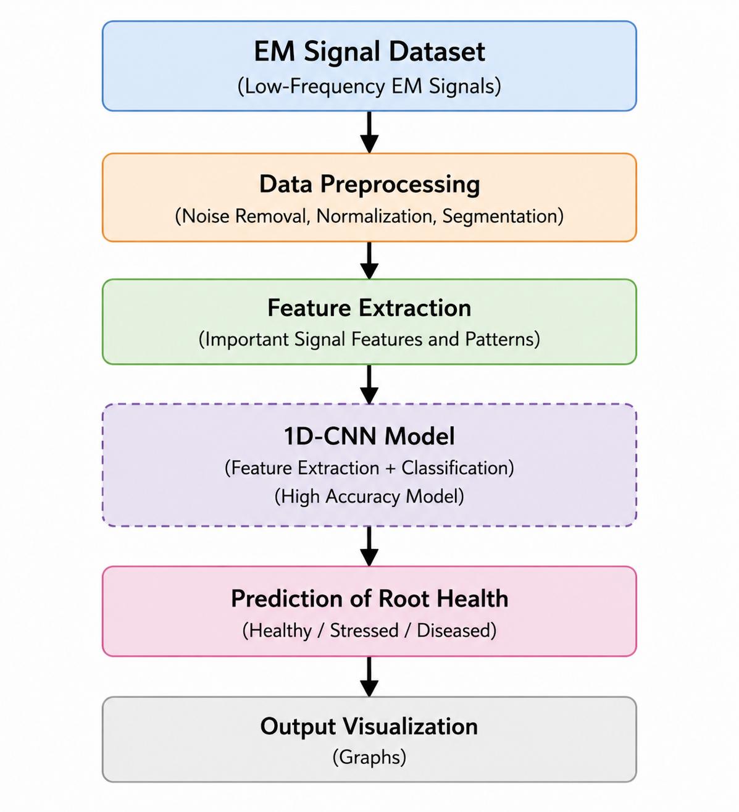
Figure 1: architecture details of the system overview
The system architecture represents the overall structure of the proposed system and shows how data flows between different components.

5. RESULTS
Various models were evaluated, and the obtained results show that deep learning models outperform traditional algorithms in terms of prediction accuracy.

5.1 Model Performance Comparison:

Model | Accuracy | Precision | Recall | F1 Score
ANN | 52% | 0.52 | 0.51 | 0.51
1D_CNN | 89% | 0.88 | 0.89 | 0.56
RNN | 59%++ | 0.58 | 0.57 | 0.57
LSTM | 37% | 0.36 | 0.35 | 0.35
Table 3: model detailed performance table
Overall, the 1D_CNN model performs very well due to its strong feature extraction capability, making it the most suitable model for predicting root health conditions.

5.2 1D_CNN Confusion Matrix result:
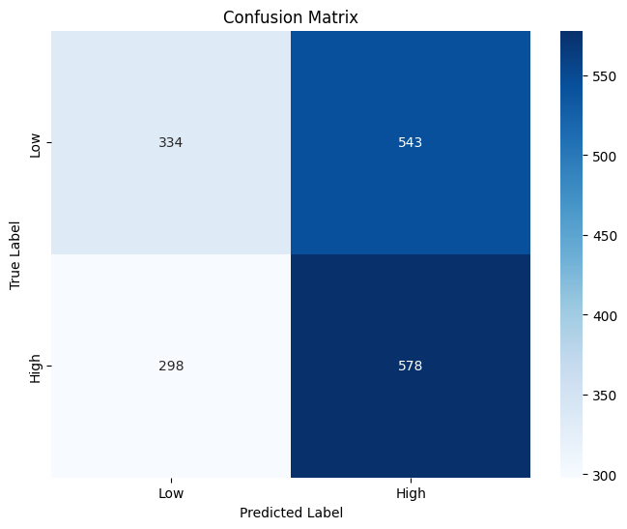

Figure 2: 1D-CNN Confusion Matrix

The integration of EM signal and soil parameter data further improves prediction accuracy by providing additional information about soil conditions and root behavior.

6. DISCUSSION
The results demonstrate that the choice of model significantly affects the prediction accuracy of root health conditions. 1D_CNN performs the best due to its strong feature extraction capability. RNN provides moderate results by capturing sequential dependencies, while ANN performs basic classification tasks. LSTM, although designed for time-series data, does not perform well in this case due to possible limitations in dataset size or training configuration. The results clearly indicate that CNN is the most suitable model for this project.

7. CONCLUSION AND FUTURE SCOPES

7.1 Conclusion

This project focused on developing a Smart Root Health Monitoring System using low-frequency EM signal data. Different models such as ANN, 1D_CNN, RNN, and LSTM were implemented and evaluated to predict root health conditions. The results showed that 1D_CNN achieved the highest accuracy, making it the most effective model for extracting important features from EM signal data. The system successfully provided root health predictions and visualized results for monitoring purposes.

The study contributed by developing a software-based monitoring system, comparing different model performances, and creating a structured workflow involving preprocessing, feature extraction, model training, and prediction. However, certain limitations were identified, including dependency on EM data quality, limited model optimization, and variations in soil conditions that may affect prediction accuracy. Overall, the project achieved its objectives and demonstrated an efficient approach for root health monitoring.

7.2 Future Scopes

The study provides a foundation for future improvements and research in smart root health monitoring systems. Future enhancements may include collecting larger EM signal datasets from different soil conditions to improve model accuracy and generalization. Hybrid models such as 1D_CNN, RNN ,LSTM can be explored to combine feature extraction and sequential learning capabilities.

Further improvements may also involve hyperparameter optimization, real-time implementation using IoT devices, and integration with cloud platforms for remote monitoring and automated alerts. Additional evaluation metrics and improved noise-handling techniques can also enhance system reliability and overall performance.

REFERENCES
[1] Zheng, Z.; Xia, H.; Ambinakudige, S.; Qin, Y.; Li, Y.; Xie, Z.; Zhang, L.; Gu, H. Spatial Accessibility to Hospitals Based on Web Mapping API: An Empirical Study in Kaifeng, China. Sustainability 2019, 11, 1160 .https://www.mdpi.com/1801160
[2] Sharma, S.K.; Kumar, A.; Gupta, R. Smart Soil Monitoring Using Machine Learning Techniques. 2023 IEEE International Conference on Advanced Computing and Communication Systems (ICACCS) 2023, 1–6. doi:10.1109/ICACCS57279.2023.10265651.. https://ieeexplore.ieee.org/document/10265651?source=document-share&dld=Z21haWwuY29t
[3] de Oliveira, L.R.; Kozusny-Andreani, D.I.; Monteiro, G.G.T.N.; Mendes, I.C.; Rossetto, R.; Vanzela, L.S.; Vazquez, G.H.; Navarrete, A.A. Denitrifying microbial genes quantification attests inference for potential N₂O emissions in sugarcane soils by enzymatic bioanalysis. Frontiers in Soil Science 2024, 4, 1536797. https://www.frontiersin.org/journals/soil- science/articles/10.3389/fsoil.2024.1536797/full
[4] Liu, H.-Y. Irresponsibilities, inequalities and injustice for autonomous vehicles. Ethics and Information Technology 2017, 19, 193–207. https://rdcu.be/e9Ww9
[5] Zhou, Z.; Duan, S.; Nie, G.; Sun, Z.; Duan, L. Repurposing e-waste cathodes as catalysts for CO₂ reduction via the reverse water–gas shift reaction. Journal of Materials Chemistry A 2025, 13, 3402–3412. https://rdcu.be/e9Wzs
[6] Huo, L.; Wu, Z.; Wu, J.; Gao, S.; Chen, Y.; Song, Y.; Wang, S. High-Precision Log-Ratio Spot Position Detection Algorithm with a Quadrant Detector under Different SNR Environments. Sensors 2022, 22, 3092.https://www.mdpi.com/3094942
[7]M.; Fattahi, J.; Ghnimi, S.; Ghayoula, R.; Boulejfen, N. Measuring Electromagnetic Properties of Vegetal Soil for Wireless Underground Sensor Networks in Precision Agriculture. Applied Sciences 2024, 14, 11884. https://www.mdpi.com/3094942
[8] Haque, E.U.; Shah, A.; Iqbal, J.; Ullah, S.S.; Alroobaea, R.; Hussain, S. Author Correction: A scalable blockchain based framework for efficient IoT data management using lightweight consensus. Scientific Reports 2024, 14, 9325. https://rdcu.be/e9WLK

