Implementation of Facilities Management in GBI Mosques: A Comparative Study with Conventional Mosques

Muhammad Adam bin Shaharuddin¹, Norsyazwana Jenuwa^{1*}, Norhafizah Yusop¹, Suhaila Ali¹

¹Department of Built Environment Studies and Technology, Faculty of Built Environment, Universiti Teknologi MARA, Perak Branch, 32610 Seri Iskandar, Perak, Malaysia

* Corresponding Author e-mail: syazwana@uitm.edu.my

ABSTRACT

This study examines the implementation of facilities management (FM) in Green Building Index (GBI)-certified mosques compared to conventional mosques in Malaysia. The research aims to identify differences in FM practices, challenges encountered, and potential areas for improvement, particularly for conventional mosques. A qualitative research approach was adopted, involving semi-structured interviews with mosque committee members, maintenance personnel, and volunteers. The collected data were analysed using thematic analysis, resulting in five key themes: funding, capacity and expertise, community awareness, structured versus reactive FM approaches, and knowledge sharing. The findings indicate that GBI-certified mosques demonstrate more systematic and proactive FM practices, including scheduled maintenance, proper documentation, and stronger financial support through corporate social responsibility (CSR) initiatives and government funding. Despite these advantages, GBI mosques still face challenges in managing advanced technical systems due to limited specialised expertise. In contrast, conventional mosques tend to rely on donations and volunteer efforts, often adopting reactive maintenance strategies that limit long-term planning and efficiency. Additionally, community awareness of sustainability practices is relatively lower in conventional mosques. Nevertheless, there is evidence of gradual improvement, with conventional mosques beginning to adopt basic sustainable practices, supported by knowledge sharing from GBI mosques. Overall, this study highlights the importance of strategic planning, capacity building, and community engagement in enhancing FM practices.

Keywords: Sustainable Religious Architecture, Facilities Management, Green Building Index, Challenges Sustainability

INTRODUCTION

Facilities management (FM) has received growing attention in recent years as a key factor in ensuring the efficient operation of various types of buildings, particularly in relation to sustainability. In the case of religious institutions such as mosques, which function not only as places of worship but also as important community centres, effective FM practices are essential. This is supported by Khan (2020), who describes mosques as spaces that promote peace within the community. The importance of FM becomes even more significant in light of increasing concerns over environmental impact, rising operational costs, and the need to maintain a safe and comfortable environment for worshippers.

As the global population continues to grow, the relationship between human development and the use of natural resources becomes increasingly significant. Recent projections indicate that the world’s population will exceed 8.5 billion by 2030, reach 9.7 billion by 2050, and surpass 11 billion by 2100 (Sadigov, 2022). This rapid growth has direct implications for various aspects of society, including religion. In Islam, the number of followers is expected to increase from 1.8 billion in 2015 to nearly 3 billion by 2060 (Conrad Hackett, 2018), reflecting a steady rise in the demand for religious facilities such as mosques.

As the number of worshippers increases, more mosques will be required to accommodate the growing population. However, this expansion also raises concerns regarding environmental sustainability, as new developments may contribute to pollution and resource depletion. Therefore, the adoption of sustainable building practices and green facilities is essential. Green facilities are recognised as an effective approach to minimising the negative environmental impact of buildings while enhancing occupant well-being (Ruda, 2023; Ghasan Alfalah, 2020).

Despite these benefits, the implementation of sustainable construction practices in Malaysia remains relatively limited. Applying such standards to mosque development can improve environmental performance, enhance comfort for worshippers, and ensure higher levels of cleanliness. This aligns with Islamic teachings, where cleanliness and maintenance of mosques are strongly emphasised. A Hadith narrated by Aisha (RA) highlights the importance of building and maintaining clean and pleasant mosques. Therefore, this study aims to improve facilities management practices in GBI-certified mosques in Malaysia.

LITERATURE REVIEW

Facilities Management in Religious Institutions
Facilities Management is widely recognised as a multidisciplinary field that integrates people, processes, and the built environment to ensure functionality and performance (Isa, 2016). According to Amaratunga (2000), FM encompasses a broad scope of activities that contribute to the effective management of built assets. Similarly, the International Facilities Management Association (IFMA) defines FM as a profession that coordinates the physical workplace with people and organisational processes.

In the context of religious institutions, FM plays a critical role in maintaining facilities, ensuring cleanliness, and providing a conducive environment for worship and community activities. Mosques, in particular, require consistent maintenance due to their high occupancy during daily prayers and religious events. Ineffective FM can lead to deterioration of building conditions and increased maintenance costs. A notable example is the closure of Masjid Kristal in Terengganu due to structural deterioration, which required significant rectification costs (Zulkifli, 2022; Salim, 2022).

In Malaysia, Figure 1, where approximately 63.5% of the population is Muslim (Department of Statistics Malaysia, 2020), mosques are widely distributed across both urban and rural areas. Most mosques are managed by local committees, often consisting of volunteers responsible for administrative and maintenance functions (Zafirah Ab Muin, 2016). However, such management structures may limit the effectiveness of FM due to constraints in expertise, resources, and organisational capacity.

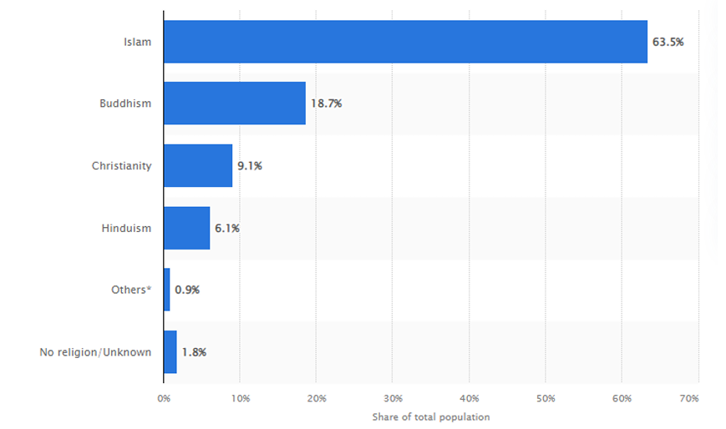
Figure 1: Percentage of Malaysian population by religion in 2020

Previous studies highlight that effective FM enhances operational efficiency and improves user satisfaction. It also enables predictive maintenance, reducing long-term costs and preventing unexpected failures (Amaratunga, 2000). Maimunah Sapri (2016) identified five key drivers of effective FM in mosques: organisational structure, knowledge and skills, knowledge sharing, teamwork, and change management. These factors serve as important benchmarks for improving FM practices in religious institutions.

Sustainability and Green Building Standards

Sustainability in building management has gained global importance due to increasing concerns over environmental degradation and resource depletion. Green building standards have been developed worldwide to promote environmentally responsible construction and operation practices. Examples include LEED (USA), Green Star (Australia), Green Mark (Singapore), and CASBEE (Japan) (Bahaudin, 2014).
In Malaysia, the Green Building Index (GBI) is one of the primary tools used to assess building sustainability. Established in 2008 by Pertubuhan Akitek Malaysia (PAM), GBI evaluates buildings based on six key criteria: Energy Efficiency, Indoor Environmental Quality, Sustainable Site Planning and Management, Materials and Resources, Water Efficiency, and Innovation. Buildings are rated as Certified, Silver, Gold, or Platinum based on their total score. Another certification system, GreenRE, introduced by the Real Estate and Housing Developers’ Association (REHDA), also promotes sustainable practices in the property sector refer Figure 2. Both GBI and GreenRE provide structured frameworks for improving environmental performance and reducing carbon emissions.
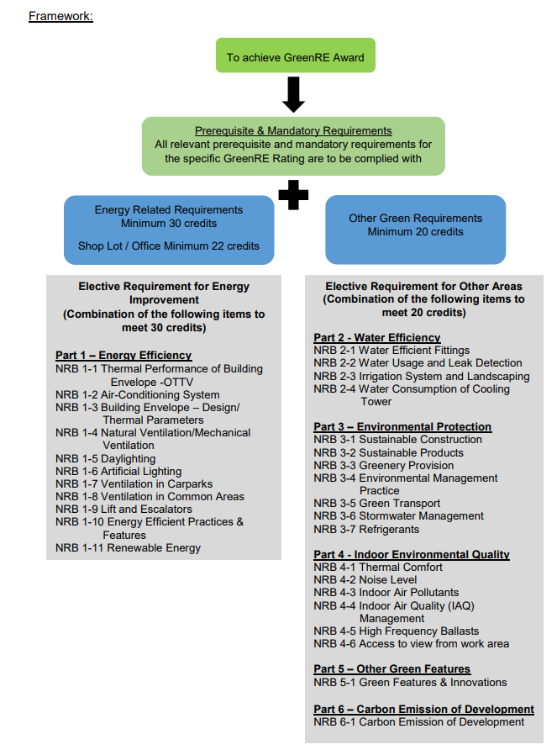
Figure 2: Framework for guideline in future banks (GreenRE, 2023)

The adoption of green building standards can significantly reduce energy consumption, operational costs, and environmental impact. For mosques, implementing such standards aligns with Islamic principles of environmental stewardship and responsible resource management. Therefore, integrating sustainability into mosque design and operation is not only environmentally beneficial but also spiritually meaningful.

Facilities Towards Sustainable Mosques

Facilities in mosques encompass physical structures, systems, and services that support religious and community activities. Due to the increasing number of worshippers, mosques are significant consumers of energy and water, particularly for lighting, cooling, and ablution purposes. Therefore, sustainable FM practices are essential in reducing resource consumption and environmental impact. Common sustainable strategies in mosques include the use of energy-efficient lighting, solar panels, natural ventilation, and water-saving systems. For example, Masjid Bandar Universiti in Seri Iskandar incorporates skylights and open courtyards to maximise natural lighting and reduce energy usage (Aziz, 2022). Similarly, natural ventilation systems, such as the use of perforated walls in Musalla Al-Abrar, enhance airflow and thermal comfort.

Water efficiency is particularly important in mosques due to the frequent use of water for ablution. Studies have shown that the use of self-closing taps and sensor-based systems can significantly reduce water wastage (Zaeid, 2017; Ahmad Faisol Yusof, 2020). Additionally, HVAC systems play a crucial role in maintaining thermal comfort while optimising energy consumption (Harsritanto, 2021). Integrating FM practices with GBI standards allows mosques to achieve sustainability goals while improving user comfort and operational efficiency.

Role of Technology and Smart Facilities Management

The advancement of digital technologies has transformed FM into a more efficient and data-driven discipline. Smart Facilities Management (Smart FM) incorporates technologies such as Internet of Things (IoT), Artificial Intelligence (AI), Building Information Modelling (BIM), and Digital Twins to enhance building performance. Smart FM enables real-time monitoring, predictive maintenance, and efficient resource management. For example, IoT sensors can monitor energy usage, indoor air quality, and occupancy levels, allowing facility managers to optimise operations. Digital twin technology provides virtual models of buildings, enabling better planning and maintenance strategies (Obaidullah & Hakimi, 2024).

In mosque environments, Smart FM can improve energy efficiency, reduce water consumption, and enhance user comfort. It also supports better maintenance planning and reduces operational disruptions. Furthermore, the adoption of such technologies aligns with Islamic values of stewardship (khalifah) and moderation, which emphasise responsible use of resources.

Challenges in Facilities Management for Sustainable Mosques

Despite growing awareness of sustainability, several challenges hinder the effective implementation of FM in mosques. One of the primary challenges is the lack of knowledge and awareness regarding sustainable practices (Maimunah, 2014; Yamin, 2021). Many mosque committees lack the technical expertise required to manage modern facilities and implement green technologies. Financial constraints are another major barrier. Most mosques rely on government funding and public donations, limiting their ability to invest in advanced FM systems and sustainable technologies (Elmualim, 2009). Additionally, the shortage of skilled personnel and reliance on volunteer-based management further complicate FM implementation (Zafirah Ab Muin, 2024).

Other challenges include lack of leadership, inadequate guidelines, and limited resources. These issues are not unique to Malaysia, as similar barriers have been identified in countries such as the United States and the United Kingdom (Yamin, 2021). Overall, addressing these challenges requires a comprehensive approach, including capacity building, financial support, and policy development. Strengthening FM practices in mosques is essential to achieving sustainability goals and ensuring the long-term functionality of these important community institutions.

METHODOLOGY

Research methodology refers to the systematic process used to conduct a research study, ensuring that the research objectives are effectively achieved. This study adopts a structured approach consisting of three main stages: topic selection and literature review, data collection, and data analysis.

In the first stage, a relevant research topic on facilities management in GBI-certified mosques was identified. The research aim, objectives, and questions were then developed based on the identified problem. A literature review was conducted to establish a theoretical foundation and support the development of interview questions.

The second stage involves data collection using a qualitative approach through structured interviews and observations. The research population consists of mosque committee members and facilities management staff. Based on a preliminary survey, the average number of committee members is approximately 26 per mosque. However, this study focuses on four mosques (two GBI-certified and two conventional), resulting in an estimated population of 104 individuals. From this population, a sample of 8 respondents was selected, with 2 respondents from each mosque. Purposive sampling, specifically homogeneous sampling, was applied to select respondents with relevant knowledge in facilities management, sustainability, and GBI practices.

In the final stage, data were analysed using content analysis to identify key themes and patterns. Atlas.ti software (version 8.4.3) was used to assist in data organisation and interpretation. This methodology ensures a systematic and reliable approach to achieving the research objectives.

FINDINGS AND ANALYSIS

The analysis of qualitative data has generated several interpretive themes that provide deeper insights into the differences between GBI-certified and conventional mosques in terms of facilities management practices. These themes highlight underlying patterns, challenges, and opportunities that influence the effectiveness of sustainable implementation.

One of the most prominent themes identified is funding. The findings indicate that GBI-certified mosques benefit from stronger financial support, particularly from corporate sponsors and government agencies. This is largely driven by corporate social responsibility (CSR) initiatives, where organizations are more inclined to contribute to sustainable and high-profile projects. In contrast, conventional mosques rely heavily on public donations, especially Friday collections and Ramadan contributions. This limited and inconsistent funding structure restricts their ability to implement long-term sustainability initiatives. As a result, financial capacity becomes a key determinant in adopting sustainable facilities management practices.

Another significant theme is capacity and expertise. Despite having advanced systems, GBI-certified mosques still face technical challenges due to limited expertise in managing specialized systems such as solar panels and water treatment technologies. The need for continuous training and skilled contractors highlights a gap between technological adoption and human capability. On the other hand, conventional mosques often depend on volunteers and external contractors, with no formal facilities management structure in place. This reliance results in less efficient maintenance practices and limited technical knowledge, further widening the gap between both mosque types.

The theme of community awareness also reveals clear differences. GBI mosques demonstrate higher levels of environmental awareness and community engagement through organized activities such as recycling programs and sustainability campaigns. These initiatives not only promote environmental responsibility but also strengthen the relationship between mosque management and the community. Conversely, conventional mosque communities tend to focus primarily on functional aspects, such as comfort for prayer, with minimal involvement in sustainability practices. This lack of awareness limits the potential for community-driven improvements in facilities management.

In terms of operational practices, the theme of structured versus reactive facilities management highlights a critical distinction. GBI-certified mosques adopt a proactive approach, utilizing tools such as Building Energy Management Systems (BEMS) and scheduled maintenance plans. This systematic approach ensures efficiency, reduces long-term costs, and supports sustainability goals. In contrast, conventional mosques generally practice reactive maintenance, addressing issues only when they arise or when complaints are made. This approach may lead to higher long-term costs and reduced operational efficiency.

Lastly, the theme of knowledge sharing and gradual adoption demonstrates a positive opportunity for improvement. GBI mosques actively share knowledge and best practices with other mosques, fostering collaboration and promoting sustainable development. Meanwhile, conventional mosques tend to adopt small-scale improvements, such as using LED lighting and water-saving measures, based on their financial capabilities. Although these changes are incremental, they represent an important step towards sustainability.

CONCLUSION

This study highlights the key differences in facilities management practices between GBI-certified mosques and conventional mosques, with a particular focus on funding, capacity and expertise, community awareness, operational approaches, and knowledge sharing. The findings reveal that GBI-certified mosques generally demonstrate more structured and sustainable practices, supported by stronger financial backing from corporate sponsors and government agencies. This financial advantage enables them to implement advanced systems and proactive maintenance strategies.

However, despite these strengths, GBI mosques still face challenges related to technical expertise and the availability of skilled personnel to manage specialized systems. This indicates that sustainability is not solely dependent on infrastructure but also on human capacity and continuous training. On the other hand, conventional mosques are often constrained by limited funding and rely heavily on donations, which affects their ability to adopt long-term sustainability initiatives. Their facilities management practices are typically reactive, and they depend on volunteers or external contractors with limited expertise.

Nevertheless, conventional mosques show potential for improvement through gradual adoption of sustainable practices, such as energy-efficient lighting and water-saving measures. The role of community awareness is also significant, as higher engagement levels in GBI mosques contribute to better sustainability outcomes.
In conclusion, improving facilities management in mosques requires a balanced approach that includes financial support, capacity building, and increased awareness. Collaboration and knowledge sharing between GBI-certified and conventional mosques can further enhance sustainable practices and ensure long-term benefits for both the environment and the community.

ACKNOWLEDGEMENT

The authors would like to acknowledge the support of Universiti Teknologi MARA (UiTM), Cawangan Seri Iskandar, Perak, Malaysia for providing the facilities and support on this research.

REFERENCES

- Ahmad Faisol Yusof, M. Z. (2020). A study of mosque water consumption using self closing tap. Journal of Islam and Contemporary Society.
- Aziz, A. (2022, October 24). MBU bukan sekadar tempat solat, himpun aktiviti komuniti untuk manfaat setempat. Retrieved from Astro Awani: https://www.astroawani.com/berita-malaysia/mbu-bukan-sekadar-tempat-solat-himpun-aktiviti-komuniti-untuk-manfaat-setempat-387475
- Conrad Hackett, M. L. (2018). The demographic factors that make Islam the world’s fastest-growing major religious group. Scripta Insituti Donneriani Aboensis, 11-14.
- Department of Statistics Malaysia. (2023, August 30). Kawasanku. Retrieved from OpenDOSM: https://open.dosm.gov.my/dashboard/kawasanku
- Department of Statistics Malaysia. (2024, July 31). The Population of Malaysia. Retrieved from OpenDOSM: https://open.dosm.gov.my/dashboard/population
- Dilanthi Amaratunga, D. B. (2000). Assessment of Facilities Management Performance. MCB University Press, 66-75.
- Ghasan Alfalah, T. Z. (2020). A review of sustainable facility management research. Sustainable Cities and Society 55 (2020).
- Green Building Index. (n.d.). GBI Tools. Retrieved from Green Building Index: https://www.greenbuildingindex.org/
- GreenRE. (2023, June). Design Reference Guide (Non-Residential Building) Version 4.0. Retrieved from GreenRE: https://www.greenre.org/assetuploads/files/NRB_v4_0_r13(1).pdf
- Khan, M. S. (2020). Shaping an Architecture for the Muslim Community of Northern Ontario . The Faculty of Graduate Studies Laurentian University Sudbury, Ontario, Canada, 11.
- Maimunah Sapri, Z. A.-T. (2014). Barriers In Managing Mosque Facilities: Towards Sustainable Facilities Management Approach . Centre for Real Estate Studies (CRES), Faculty of Geoinformation and Real Estate, Universiti Teknologi Malaysia.
- Obaidullah HAKIMI, H. L. (2024). Digital twin-enabled smart facility management: A bibliometric review. Frontiers of Engineering Management, 32–49.
- Ruda, A. (2023). Perception of Green Facility Management. International Journal of Public Administration, Management and Economic Development.
- Sadigov, R. (2022). Rapid Growth of the World Population and Its Socioeconomic Results. The Scientific World Journal.
- Salim, Z. (2022, April 1). RM2 Juta Baik Pulih Masjid. Retrieved from Berita Harian: https://www.bharian.com.my/berita/wilayah/2022/04/941302/rm2-juta-baik-pulih-masjid-kristal
- Yamin, R. A. (2021). Eco-Mosque: Overview, Potential and Challenges of Implementation in Malaysia. Ikim Journal Islam and the Contemporary World, 77-97.
- Zaeid, R. A. (2017). Water use and time analysis in ablution from taps. Application water science.
- Zulkifli, A. M. (2022, January 30). Terengganu’s Crystal Mosque struggles to regain its shine. Retrieved from Malaysia Now: https://www.malaysianow.com/news/2022/01/30/terengganus-crystal-mosque-struggles-to-regain-its-shine
- Zulkifli, M. A. (2022, April 06). 'Tropical brutalism' of Musalla Al Abrar in Sungai Penchala makes its attraction. Retrieved from Bernama News: https://www.bernama.com/en/news.php?id=2069306

