Extreme Heat and Health: Protecting Populations in a Warming Climate Through Evidence-Based Public Health Strategies

Aditi Munmun Sengupta*

MBBS, MS, PhD, Harvard Medical School Post Graduate Association member

Corresponding author

Dr. Aditi Munmun Sengupta

Address: 172 A Beharampur Road, NH-12, Ranaghat, Nadia- 741201, West Bengal, India

Phone no: +91-9674131369(M)

E mail: sengupta2aditi@gmail.com

Orcid ID: https://orcid.org/0000-0003-4142-5331

Abstract
Extreme heat has emerged as one of the leading weather-related causes of mortality worldwide and represents an escalating public health challenge in the context of global climate change. Increasing ambient temperatures are associated with heat-related illnesses, cardiovascular and respiratory complications, renal dysfunction, mental health impacts, reduced labor productivity, and rising healthcare expenditures. Vulnerable populations—including older adults, infants, individuals with chronic diseases, outdoor workers, low-income households, and socially isolated individuals—experience disproportionate health risks due to physiological susceptibility and socioeconomic inequities. Urbanization further intensifies exposure through the urban heat island effect, amplifying health disparities in densely populated communities. This review synthesizes current scientific evidence regarding the health consequences of extreme heat, identifies populations at greatest risk, examines the economic burden imposed on healthcare systems and society, and discusses evidence-based mitigation and adaptation strategies. Effective interventions include expanding access to cooling centers and affordable air conditioning, increasing urban green infrastructure, strengthening heat early-warning systems, improving occupational protections, enhancing community engagement, and integrating climate resilience into public health policy. A coordinated multisectoral approach involving healthcare professionals, policymakers, urban planners, and local communities is essential to reduce heat-related morbidity and mortality as global temperatures continue to rise.
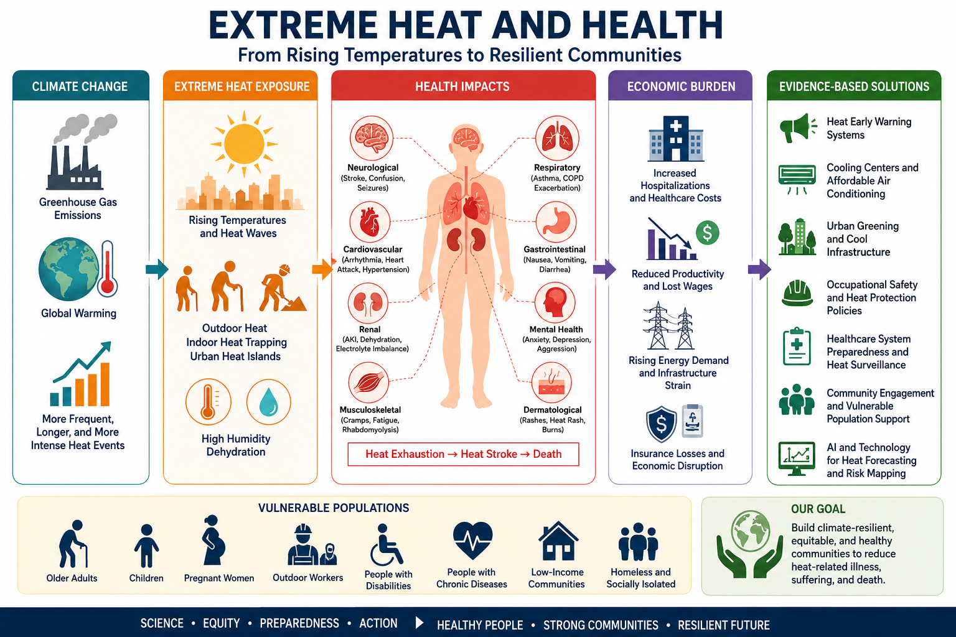
Graphical abstract: The figure illustrates how climate change drives extreme heat, causing multisystem health effects and economic losses, while emphasizing evidence-based interventions that enhance resilience, equity, preparedness, and community protection.
Keywords: Extreme heat, climate change, heat-related illness, public health, urban heat islands, climate resilience

Introduction
Extreme heat has become one of the most significant environmental threats to human health in the twenty-first century. Climate change has increased both the frequency and intensity of heat waves across many regions of the world, leading to substantial increases in heat-related illness and mortality (Intergovernmental Panel on Climate Change [IPCC], 2023). Unlike hurricanes, floods, or tornadoes, heat waves often develop gradually and therefore receive comparatively less public attention despite causing a greater cumulative burden of disease and death (World Health Organization [WHO], 2024).
In the United States alone, thousands of emergency department visits, hospitalizations, and preventable deaths occur annually because of extreme heat, while the true burden is likely underestimated due to underreporting and indirect heat-related deaths (Centers for Disease Control and Prevention [CDC], 2024). Beyond mortality, excessive heat places enormous pressure on healthcare systems, electrical infrastructure, agriculture, transportation, and workforce productivity.
Public health experts increasingly recognize that extreme heat represents not merely an environmental issue but a multidimensional challenge involving medicine, economics, social equity, infrastructure, and climate adaptation. Protecting communities requires scientific understanding alongside coordinated policy interventions that reduce exposure and strengthen resilience.

Health Effects of Extreme Heat
Heat affects virtually every organ system. Under normal physiological conditions, the human body maintains a stable internal temperature through sweating, vasodilation, and behavioral adaptation. However, prolonged exposure to high environmental temperatures overwhelms these thermoregulatory mechanisms, resulting in progressive physiological dysfunction (Bouchama & Knochel, 2002).
Clinical manifestations range from mild heat cramps and dehydration to heat exhaustion and life-threatening heat stroke. Heat stroke constitutes a medical emergency characterized by a core body temperature exceeding 40°C accompanied by neurological dysfunction and multiorgan failure (Bouchama & Knochel, 2002).
Extreme heat also exacerbates existing chronic diseases. Cardiovascular patients experience increased myocardial workload because peripheral vasodilation and dehydration reduce circulating blood volume while increasing cardiac demand. Respiratory illnesses worsen due to concurrent ozone formation and wildfire smoke exposure during heat events (Romanello et al., 2024). Heat exposure additionally contributes to acute kidney injury through dehydration and electrolyte imbalance, particularly among outdoor laborers.
Mental health consequences are increasingly recognized. Elevated temperatures have been associated with increased psychological stress, anxiety, sleep disturbance, aggression, psychiatric hospitalizations, and suicide risk (Romanello et al., 2024). These effects demonstrate that heat is not solely an environmental hazard but also a determinant of mental well-being.

Populations at Greatest Risk
Although heat affects entire communities, vulnerability is not distributed equally.
Older adults possess diminished sweating capacity, impaired cardiovascular reserve, and reduced thirst perception, limiting their ability to regulate body temperature effectively (WHO, 2024). Infants and young children similarly have immature thermoregulatory systems, increasing susceptibility to dehydration and hyperthermia.
Individuals with cardiovascular disease, diabetes mellitus, chronic kidney disease, obesity, neurological disorders, and respiratory illnesses experience disproportionately greater risks because these conditions impair physiological adaptation to heat (CDC, 2024).
Outdoor workers—including construction workers, agricultural laborers, delivery personnel, and emergency responders—are exposed to prolonged environmental heat while performing physically demanding tasks. Occupational heat stress contributes to reduced productivity, dehydration, accidents, and increased mortality (International Labour Organization [ILO], 2024).
Socioeconomic inequality substantially amplifies vulnerability. Low-income households frequently lack access to air conditioning or face financial barriers to operating cooling systems due to rising electricity costs. Homeless populations encounter continuous environmental exposure with limited access to hydration or shelter.
Social isolation represents another overlooked determinant. Older adults living alone may have no family members or neighbors available to recognize early symptoms of heat illness or facilitate emergency medical care.

Economic Burden of Extreme Heat
Extreme heat imposes substantial direct and indirect economic costs.
Healthcare expenditures increase through emergency department visits, hospital admissions, ambulance utilization, intensive care treatment, and rehabilitation for heat-related illnesses. Simultaneously, chronic disease exacerbations increase healthcare resource utilization during prolonged heat events (Romanello et al., 2024).
Labor productivity declines significantly under high temperatures. Agricultural workers, manufacturing personnel, transportation workers, and construction employees experience reduced work capacity due to necessary rest periods and increased physiological strain. These productivity losses translate into billions of dollars in annual economic costs globally (ILO, 2024).
Energy demand also rises sharply during heat waves as cooling requirements increase. Electrical grids become vulnerable to overload, leading to power outages that further increase health risks, particularly among medically vulnerable individuals dependent on electrically powered medical equipment.
Infrastructure deterioration, wildfire response, drought impacts, and reduced educational productivity further expand the economic consequences of extreme heat beyond healthcare alone.

Urban Heat Islands and Environmental Justice
Urban environments frequently experience temperatures several degrees higher than surrounding rural areas because asphalt, concrete, and buildings absorb and retain solar radiation while vegetation is limited. This phenomenon, known as the urban heat island effect, disproportionately affects densely populated neighborhoods with limited tree canopy and green spaces (IPCC, 2023).
Historically disadvantaged communities often experience greater exposure because of inadequate housing quality, reduced green infrastructure, and limited access to cooling resources. Consequently, climate change has become both a public health issue and an environmental justice concern.
Expanding parks, urban forests, reflective roofing, permeable surfaces, and shaded public spaces reduces local temperatures while improving cardiovascular health, air quality, biodiversity, and mental well-being.

Evidence-Based Public Health Solutions
Reducing heat-related morbidity and mortality requires comprehensive interventions operating at individual, community, healthcare, and governmental levels.
Heat early-warning systems enable timely public communication before dangerous temperatures occur. Meteorological forecasting integrated with public health messaging allows healthcare facilities, emergency services, and local governments to activate preparedness plans.
Affordable access to air conditioning remains one of the most effective interventions for preventing heat-related mortality. Financial assistance programs, energy subsidies, and community cooling centers reduce exposure among economically vulnerable populations.
Healthcare systems should implement standardized heat preparedness protocols, including risk screening for vulnerable patients, medication review, hydration counseling, and telehealth monitoring during heat waves.
Urban planning strategies should prioritize tree planting, expanded green infrastructure, cool roofs, reflective pavements, and climate-resilient housing. These interventions simultaneously reduce environmental temperatures and improve population health.
Community-based interventions are equally important. Neighbor-to-neighbor wellness checks, volunteer outreach, public education campaigns, and partnerships with local organizations help identify socially isolated individuals before medical emergencies develop.
Occupational protections should include scheduled rest breaks, shaded recovery areas, hydration stations, heat acclimatization programs, and flexible work schedules during extreme temperature events.

Future Directions
Climate projections indicate that extreme heat events will become increasingly frequent, prolonged, and intense throughout the coming decades (IPCC, 2023). Future public health strategies must therefore transition from reactive emergency responses toward proactive climate adaptation.
Emerging technologies—including wearable physiological sensors, artificial intelligence-based heat forecasting, satellite thermal mapping, and precision public health surveillance—offer opportunities for earlier identification of high-risk populations and targeted interventions.
Further interdisciplinary research is needed to quantify long-term cardiovascular, neurological, renal, and mental health outcomes associated with repeated heat exposure. Economic evaluations should also examine the cost-effectiveness of preventive interventions such as urban greening and residential cooling assistance.

Conclusion
Extreme heat represents one of the most significant and preventable environmental health threats facing modern societies. Its effects extend beyond heat stroke to include cardiovascular disease, respiratory illness, renal dysfunction, mental health disorders, and substantial economic losses. Climate change is increasing both the frequency and severity of heat events, making adaptation an urgent public health priority. Protecting vulnerable populations requires coordinated action involving healthcare providers, governments, urban planners, employers, and local communities. Investments in equitable cooling access, resilient infrastructure, green urban development, occupational safety, and community engagement can substantially reduce preventable illness and mortality. Strengthening climate resilience today will protect both current and future generations from one of the defining public health challenges of the twenty-first century.

References
Bouchama, A., & Knochel, J. P. (2002). Heat stroke. The New England Journal of Medicine, 346(25), 1978–1988. https://doi.org/10.1056/NEJMra011089
Centers for Disease Control and Prevention. (2024). Heat and health. https://www.cdc.gov/heat-health
Intergovernmental Panel on Climate Change. (2023). Climate change 2023: Synthesis report. IPCC. https://www.ipcc.ch/report/ar6/syr/
International Labour Organization. (2024). Ensuring safety and health at work in a changing climate. https://www.ilo.org
Romanello, M., Di Napoli, C., Green, C., et al. (2024). The 2024 report of the Lancet Countdown on health and climate change: Facing record-breaking threats from delayed action. The Lancet. https://doi.org/10.1016/S0140-6736(24)01867-3
World Health Organization. (2024). Heat and health. https://www.who.int/news-room/fact-sheets/detail/climate-change-heat-and-health
Disclosures
Contribution of authors : AMS- Concept development and literature review, manuscript
Writing.
Acknowledgement: Harvard T.H. Chan School of Public Health, Partners in Health ( Boston, MA, United States)
Financial Disclosures: None
Conflicts of Interest: There are no conflicts of interest.
Ethical declaration: This material is the authors’ own original work, which has not been
previously published elsewhere.

