Application of scanning electron microscopy unravelling the seed coat micro morphology and FESEM-EDAX characterization of selected species of the genus Rotala L.(Lythraceae) in India

ABSTRACT
The genus Rotala L. is one of the largest genera in the family Lythraceae. It is an aquatic or amphiphytic genus. Most members inhabit in permanent or temporary lateritic pools, some grows in paddy fields and others in marshy areas. There are about 75 species of Rotala distributed globally. In India, the genus is represented by 36 species. The taxonomic identification from the rest genera is simple and identification within the genus is difficult This genus is characterised by having reticulate, undulate and verrucate type of seed surface sculpturing. So, this work focuses on the taxonomic identification of some species in this genus distributed in India based on their seed coat morphological features.

Keywords: Identification; India; Lythraceae; Morphology; Rotala; Scanning Electron Microscope; Seed Coat

INTRODUCTION
The genus Rotala L. (Lythraceae) is distributed tropically and subtropically. It is represented globally by 44 species (Mabberley, 2005), with the highest distribution in tropical Asia (Cook, 1979). After Cook’srevision, it is represented, as per the revised estimate,in India by 29 species, of which 24 are from Peninsular India (Joseph &Sivar 1988, 1989; Pradeep & al. 1990;Mathew &Lekshminarasimhan, 1990;Yadav & al.2010; Prasad & al. 2012; Gaikwad & al. 2013; Prasad & Raveendran 2013 a, b; Sunil & al. 2013; Anto&al. 2014;Ratheesh Narayanan & al. 2014; Lemiya&Pradeep 2015; Nandakumar 2018; Prasanth &Sardesai 2022).Species of the genus Rotala are grouped under two categories, based on the nature of their habitat, viz., obligate aquatics, which grow in shallow water, and semi aquatics or terrestrials, which thrive in marshy lands. Most of the aquatic species are characterized by what is called 'Hippuris syndrome' (Cook 1978): erect, unbranched stems with simple, elongate leaves borne in symmetrical whorls, "heterophylly manifesting itself as variation in some leaves in each whorl and individual leaf shape and size." Among the Indian species, this syndrome is displayed by R. verticillarisL., R. mexicana (only where it grows as an emergent aquatic), R. cookie K.T. Joseph &Sivar., and R. vasudevanii K.T. Joseph &Sivar. Most other species have deccussate leaves, while R. floribunda (Wight) Koehne has alternate ones, and R. occultiflora has leaves disposed in whorls of 3. Leaf and flower arrangements have been taken as an important taxonomic character in this genus by many authors. Koehne (1903) divided the genus into two sections based on these characters: Sect. Hippiuridum with whorled/alternate leaves and flowers,and Sect. Enantiorotala with decussate leaves and flowers, but species like R. mexicana, and R. myriophylloides Welw. ex Hierndisplay that both their characteristics depending upon whether they are growing as aquatics or terrestrials. Consequently,Cook (1978, 1979) considered these characters to be direct responses to the aquatic environment and that these 'Hippurismimics' do not constitute a single phyletic group. Cook (1979) has also found that the genus is very uniform and does not yield a satisfactory subgeneric classification into natural subgeneric groups. Seed coat characteristics have been successfully employed to solve taxonomic problems and elucidate phylogenetic relationships. Seed micromorphological studies using FESEM and EDAX have proven to be powerful tools for investigating features of taxonomic significance. Seed micromorphological characters are conserved and stable and thus used to solve many taxonomic ambiguities. Anatomical and seed micromorphological features can be used in taxonomic analysis for the identification of plants and establishing genetic relationships to solve taxonomic disputes.
The genus Rotala includes annual herbaceous plants, that inhabit permanent and seasonal lateritic pools, depressions of lateritic rocks with rich humus deposits, paddy fields, and marshy areas. Leaves are alternate, opposite, or whorled. It may be petiolate or sessile, lanceolate or narrow needle-like, or bimucronate at apex, margins are entire, and the colour ranges from bright green to reddish, based on light intensity and nutrient availability in the habitat. Seeds are oval, spherical or. Flowers are bracteate and bracteolate, with calyx lobes 3-5, small, corolla lobes 3-5 or absent in some, and nectar scales are seen in most species. Stamens 3-5, inserted at the base of the calyx tube. Ovary ellipsoid, style short, stigma capitate, capsule globose, seeds ovoid, brownish, 10-15 per fruit. The seed micromorphological features of Rotala have not been fully explored so far; hence, the present study mainly focused on the seed coat characterization of selected species of Rotala from India to fill this gap.
METHODOLOGY
SAMPLE COLLECTION SITE AND PERIOD
Rotala species were collected from various locations in Kerala for seed morphological studies from June 2024 to January 2026 (Table 1). Fresh plant specimens of selected species of Rotala were preserved in formalin or FAA for further morphological characterization. The plant taxa selected for the present study include R. cheruchakkiensis ,R. densiflora, R. indica,R. kasaragodensis,R. macrandra, R. malabarica,R. malampuzhensis, R. meenkulamensis, R. mexicana and R. occultiflora. Identification of selected taxa was done by observing their morphological characteristics with the help of available floras and literature and it was also compared with authenticated herbarium specimens deposited in the herbarium of University of Calicut (CALI), the voucher specimens were also deposited in the herbarium of St. Joseph’s College (Autonomous), Devagiri, Calicut (DEV) for future reference.
TAXON SAMPLING
To obtain seeds, mature seeds of Rotala plants were removed from fruits, collected during field visits, in the fruiting season.
LIGHT MICROSCOPIC ANALYSIS OF SEEDS
Mature seeds of plants were passed through an ethanol series (60- 80%) for 1 to 3 minutes to remove the debris present on the surface. External color, shape, size (length and width), and hilum were observed using binocular dissecting microscope, placed in Plant Anatomy Lab Department of Botany, Govt.College, Kasaragod, Vidyanagar,Kerala, India.
SCANNING ELECTRON MICROSCOPIC ANALYSIS OF SEEDS
For SEM, seeds were immersed in absolute ethanol and left for a minute for drying. This step was carried out for a finer and detailed study of seeds. Then, the seeds were mounted on stubs in different positions, and gold coating was performed in the sputtering chamber using spi-model™. In all cases, seeds of at least 10 samples of each species were analyzed, characterized, and photographed with a Scanning Electron Microscope (model JOEL/FE, VERSION 4, JSM IT 800). The following Seed characters were observed: The length of surface sculpture and anticlinal and periclinal wall.
ANALYTICAL TECHNIQUES FOR FESEM AND EDAX ANALYSIS
Field Emission Scanning Electron Microscopy (FESEM) is employed to explore the micro structural characteristics of Rotala species in conjunction with Energy Dispersive X-ray Analysis (EDAX) to delineate the elemental composition of its seeds. The imaging provided by FESEM facilitates high-resolution of seed coat morphology, whereas the EDAX analysis permits the identification of critical minerals. Through this comprehensive methodology, we aspire to elucidate the structural and elemental features that are fundamental to the plant’s ecological resilience and pharmacological capabilities, thereby offering significant contributions to the fields of conservation biology.
CHEMICALS AND SAMPLE PREPARATION
In this investigation, a diverse array of chemical agents was employed to prepare seed samples of Rotala species for Field Emission Scanning Electron Microscopy (FESEM) and Energy Dispersive X-ray Spectroscopy (EDAX) analyses, thereby enhancing the clarity and resolution of specific structural and elemental features.
SPUTTER-COATING TECHNIQUE
To facilitate the preparation of samples for FESEM analysis, a sputter-coating technique was implemented, which necessitated the uniform deposition of a thin layer of gold or platinum onto the surfaces of the samples. This conductive coating effectively mitigated charging artifacts and enhanced image quality under highvacuum conditions, thereby enabling precise visualization of surface characteristics such as trichomes and cellular textures at the microscopic scale. Regarding EDAX profiling, no supplementary chemicals were directly introduced to the samples, as this technique is predicated on the detection of characteristic X-rays emitted from the elemental constituents of the samples when subjected to an electron beam bombardment. This analytical approach permitted a non-destructive evaluation of vital minerals including carbon (C), oxygen (O), calcium (Ca), magnesium (Mg), potassium (K), and trace metals, which are pivotal for elucidating the elemental composition of seed coats of Rotala species. The integration of these chemical preparations andanalytical methodologies facilitated a holistic understanding of the seed coat surface and elemental characteristics of the plant, bolstering insights into its prospective medicinal and ecological adaptations.In the current study, seed coat morphology and FESEM-EDAX of ten seeds of Rotala species was studied, i.e., R. cheruchakkiensis,R. densiflora, R. indica,R. kasaragodensis,R. macrandra, R. malabarica,R. malampuzhensis, R. meenkulamensis, R. mexicana and R. occultiflora(Table 1).Images of some studied Rotala species are shown in Fig. 1&Fig. 2
Table 1. Collecting data on the Rotala species selected for the seed coat micromorphology and FESEM-EDAX studies.
SI No. | Taxa | Habitat | Geographical coordinates | Details of plant specimens studied
1 | R. cheruchakkiensis Anto P.V., Devikrishna C.S., Jacob Abraham Pulickal, Vraghese C. D. and Ignatius Antony | Wet lateritic soil | 12º28ʹ87ʺ N  75º23ʹ80ʺ E | Karinthalam, Kasaragod District, Kerala State,  Suvarnika.V., 10409, DEV, 17/07/2024
2 | R. densiflora (Roth ex Roem.  &Schult.) Koehne | Dry paddy field | 11º 84ʹ67ʺ N  76º06ʹ31ʺ E | Kattikkulam, Wayanad District, Kerala State,  Suvarnika. V., 10406, DEV, 10/01/2024
3 | R. indica (Willd.) Koehne | Wet paddy field | 12º22’35” N  75º04ʹ28ʺ E | Thannott, Ravaneshwar, Kasaragod District, Kerala State,  Suvarnika.V., 10410, DEV, 13/11/2025
4 | R. kasaragodensis K.S. Prasad & Raveendran | Seasonal lateritic pool | 12º14ʹ25ʺ N  75º13ʹ55ʺ E | Velichamthodu,Cheemeni,Kasaragod District, Kerala State,  Suvarnika.V., 10403, DEV, 13/09/2024
5 | R. macrandra Koehne | Wet paddy field | 12º39ʹ69ʺ N  75º39ʹ69ʺ E | Vellamthatta, Ravaneshwar,Kasaragod District, Kerala State,  Suvarnika.V., 10408, DEV, 06/01/2025
6 | R. malabarica Pradeep, K.T.  Joseph &Sivar. | Seasonal lateritic pool | 12º28ʹ87ʺ N  75º23ʹ80ʺ E | Karinthalam, Kasaragod District, Kerala State,  Suvarnika.V., 10404, DEV, 10/10/2024
7 | R. malampuzhensis R.V. Nair ex C.D.K. Cook | Seasonal lateritic pool | 12º26ʹ49ʺN  75º18ʹ37ʺ E | Kayyur, Kasaragod District, Kerala State,  Suvarnika.V., 10402, DEV, 25/09/2024
8 | R. meenkulamensis K.S. Prasad & K. Ravi | Seasonal lateritic pool | 12º28ʹ87ʺ N  75º23ʹ80ʺ E | Meenkulam,Pyyannur Kannur District, Kerala State,  Suvarnika.V., 10411, DEV, 15/10/2025
9 | R. mexicana Schltdl. & Cham. | Wet lateritic soil | 12º14ʹ25ʺ N  75º13ʹ55ʺE | Velichamthodu, Cheemeni, Kasaragod District,  Kerala State, Suvarnika.V., 10405, DEV,  24/09/2024
10 | R. occultiflora Koehne | Seasonal lateritic soil | 12º28ʹ87ʺ N  75º23ʹ80ʺ E | Karinthalam, Kasaragod District, Kerala State,  Suvarnika.V., 10403, DEV, 13/09/2024

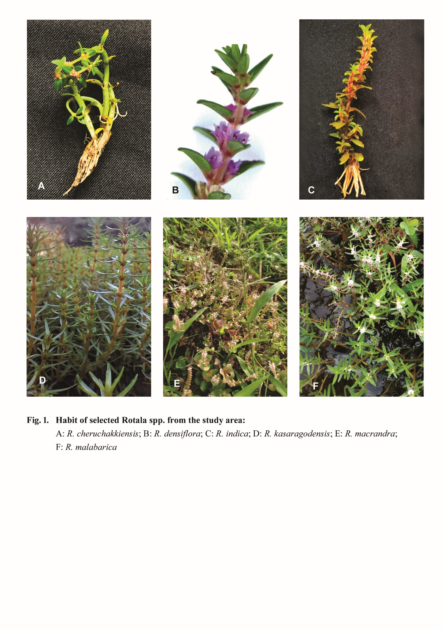
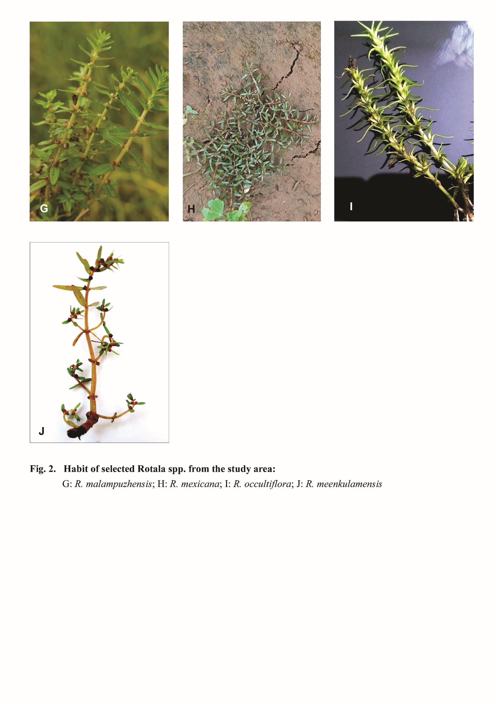

RESULT
General seed coat characters of the genus Rotala are discussed below:
The dominant seed shape was ovate and obovate (fig. 3). Seeds of all the studied species were found with
smooth surface and with terminal hilum.The seed of R. occultiflora was observed with a maximum length of 297.8 mm to width of 115.6 mm. Length to width ratio of seeds was also calculated (Table. 2), and it was found that the maximum L/W ratio was observed in R. occultiflora i.e., 2.576mm.

Table 2. Seed micro morphological characteristics of studied Rotala spp.

Species | Seed shape | Seed colour | Seed length | Seed width | Seed L/W ratio | Hilum | Trichomes
R. cheruchakkiensis | Round elliptic | Golden brown | 452.1mm | 334.8mm | 1.350mm | Acute | Present
R. densiflora | Oval | Pale brown | 440.5mm | 359.1mm | 1.226mm | Acute | Absent
R. indica | Elliptic | Pale brown | 425.2mm | 335.4mm | 1.267mm | Acute | Present
R. kasaragodensis | Obovate | Pale brown | 3.824mm | 3.022mm | 1.265mm | Rounded | Absent
R. macrandra | Obovate | Pale brown | 374.0mm | 199.2mm | 1.877mm | Acute | Absent
R. malabarica | Ovate | Dark brown | 692.9mm | 600.2mm | 1.154mm | Acute | Absent
R. malampuzhensis | Obovate | Dark brown | 637.7mm | 518.4mm | 1.230mm | Acute | Absent
R. meenkulamensis | Ovate | Pale brown | 670.3mm | 576.2mm | 1.163mm | Acute | Absent
R. mexicana | Elliptic | Pale brown | 269.2mm | 170.4mm | 1.579mm | Acute | Absent
R. occultiflora | Elliptic | Dark brown | 297.8mm | 115.6mm | 2.576mm | Acute | Absent

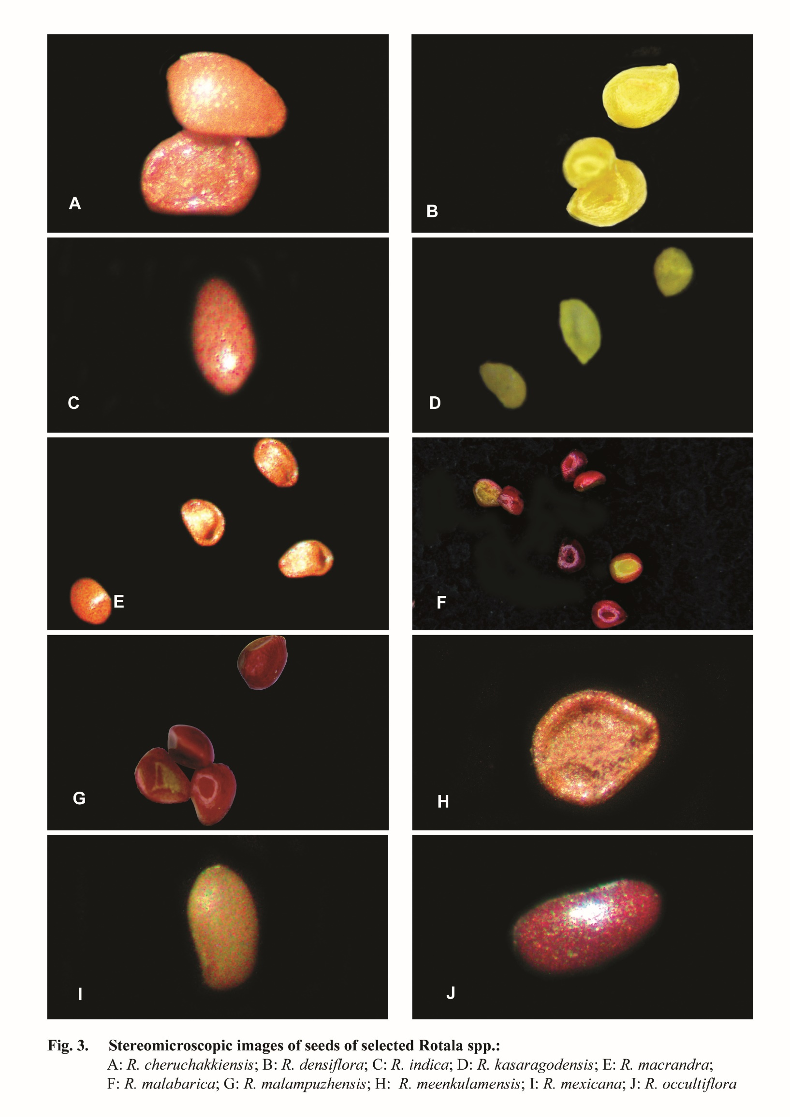

1.1. R. cheruchakkiensis Anto P.V., Devikrishna C.S., Jacob Abraham Pulickal, Vraghese C. D. and Ignatius Antony:
R. cheruchakkiensis is the smallest species in the genus Rotala, with a height about 3cm. Golden to brownish coloured seeds are seen. The number of seeds per fruit are 8-9.The seed shape was flattened oval and the texture was smooth. The compression was lateral, while the hilum was terminal. The length of the seed was 452.1 mm, whereas the width of the seeds was 334.8 mm, while length to width ratio of 1.350mm was recorded. Fig.(4) represent the FE-SEM results of R. cheruchakkiensis, that indicates smooth seed sculpturing with epidermal hairs. Seed coat ornamentation is reticulate. Wings are absent on seed coat surface. Outer epidermal cell shape and anticlinal wall shape are irregular; anticlinal wall texture is folded. Anticlinal wall is thickened and its level is shallow. Periclinal wall is thickened, convex shaped and its texture is reticulate.
The morphological variation of the seeds seems to reflect the geographical distribution of taxa, but adaptation may have played an important evolutionary role. R. cheruchakkiensisis considered as highly endemic, it emerges during first rainy seasons of the month June and completes its life cycle within 1-2 months.

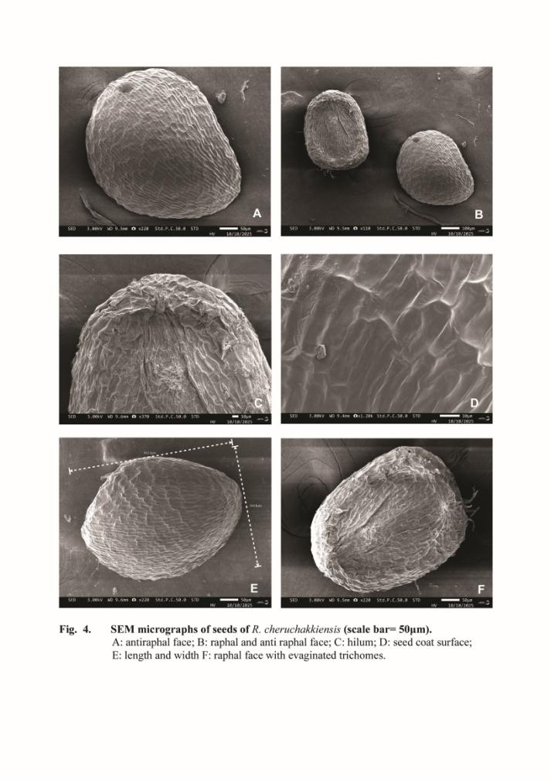
1.2. R. densiflora (Roth ex Roem. &Schult.) Koehne

R. densiflora is usually growing in paddy fields and marshy areas. Stem is highly branched and produces dense flowers towards the stem apex. The number of seeds per fruit are 10-12, which are pale brown in colour.The seed shape was triangular ovoid and the texture was smooth. The hilum was terminal. The length of the seed was 440.5 mm, whereas the width of the seeds was 359.1 mm, while length to width ratio was 1.226mm. Fig.(5) represent the FE-SEM images of R. densiflora. seed sculpturing or seed coat ornamentation was reticulate and without epidermal hairs. Wings are absent on seed coat surface. Outer epidermal cell shape and anticlinal wall shape are irregular; anticlinal wall texture is folded. Anticlinal wall is thickened and its level is shallow. Periclinal wall is thickened, convex shaped and its texture is reticulate.

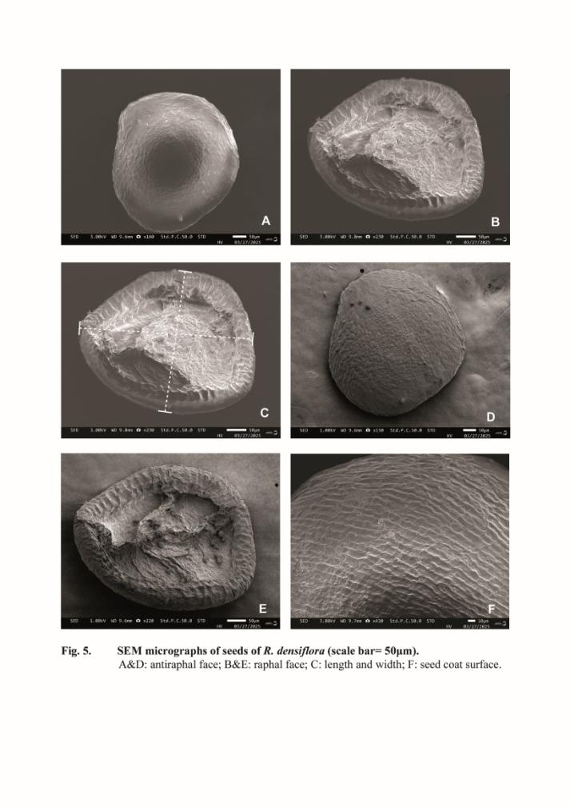

1.3. R. indica (Willd.) Koehne

R. indica in habits paddy field and temporary lateritic pools. The plants may have white to reddish colour according to the habitat. Flowers are light rose in colour.The number of seeds per fruit are 10-12.The seed shape was oval; seed coat ornamentation reticulate. The compression was lateral, while the hilum was terminal. The length of the seed was 425.2 mm, whereas the width of the seeds was 335.4 mm, while length to width ratio of 1.267mm was recorded. Fig.(6) represent the FE-SEM results of R. cheruchakkiensis, that indicates smooth seed sculpturing with epidermal hairs. Seed coat ornamentation is reticulate. Wings are absent on seed coat surface. Outer epidermal cell shape was polygonal; anticlinal wall texture was reticulate. Anticlinal wall was thickened and shallow. Periclinal wall was thickened with reticulate texture; convex level. Trichomes present on seed coat.
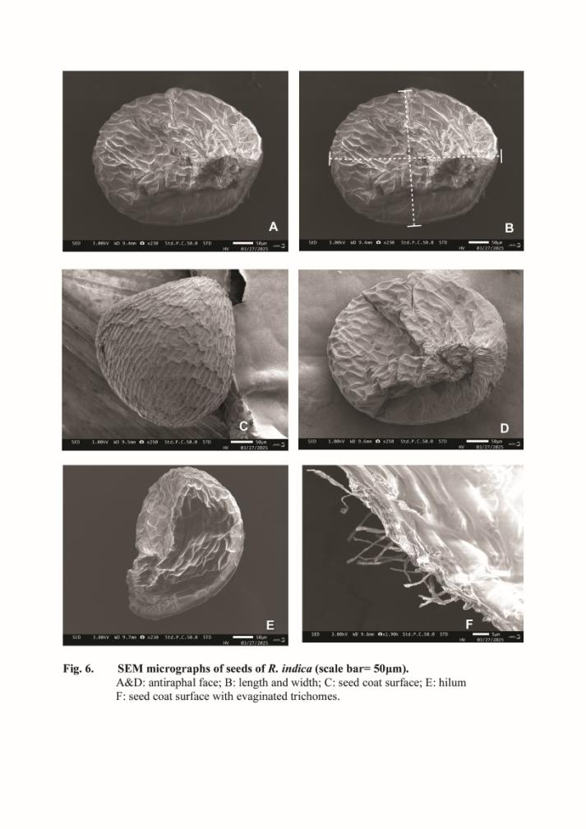

1.4. R. kasaragodensis K.S. Prasad & Raveendran

R. kasaragodensis is usually found in the emergent marshy areas of temporary lateritic pools and paddy fields. Stem was erect and leaves arranged in cluster. Companulate, pink coloured flowers are produced singly from nodal regions. Leaves are narrow and needle like. Capsule was oblong with 10 ten seeds, which are pale brown in colour.The seed shape was obovate and the texture was wrinkled. The hilum was terminal and rounded. The length of the seed was 3.824 mm, whereas the width of the seeds was 3.022 mm, while length to width ratio of 1.265mm was recorded (Fig.(4)). Epidermal hairs usually absent. Seed coat ornamentation was wrinkled. Wings are absent on seed coat surface. Outer epidermal cell shape and anticlinal wall shape are irregular; anticlinal wall texture is folded. Anticlinal and periclinal wall are thickened.
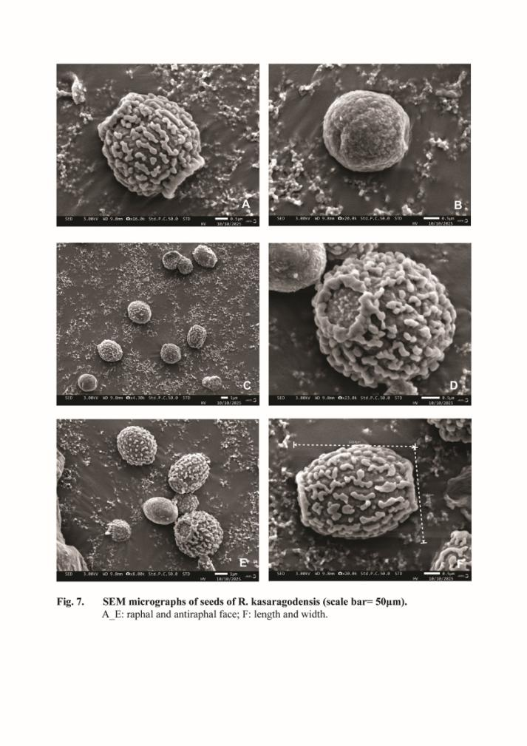

1.5. R. macrandra Koehne

R. macrandra is growing in lateritic pools and marshy areas. Dimorphic leave are seen in this species; stem is white to reddish in colour. Flowers are pink and anthers exceeds the corolla tube. Golden to brownish coloured seeds are seen. The number of seeds per fruit are 8-9.The seed shape was obovate and seed colour was pale brown. hilum was terminal. The length of the seed was 374.0 mm, whereas the width of the seeds was 199.2mm, while length to width ratio of 1.877mm was recorded. Fig. 4. represents the FE-SEM results of R. macrandra. Seed coat surface shows reticulate ornamentation. Epidermal hairs or trichomes are absent. Seed coat ornamentation is reticulate. Wings are absent on seed coat surface. Outer epidermal cell shape and anticlinal wall shape are irregular; anticlinal wall texture is smooth. Anticlinal wall is thickened and its level is shallow. Periclinal wall is thickened; convex shaped.

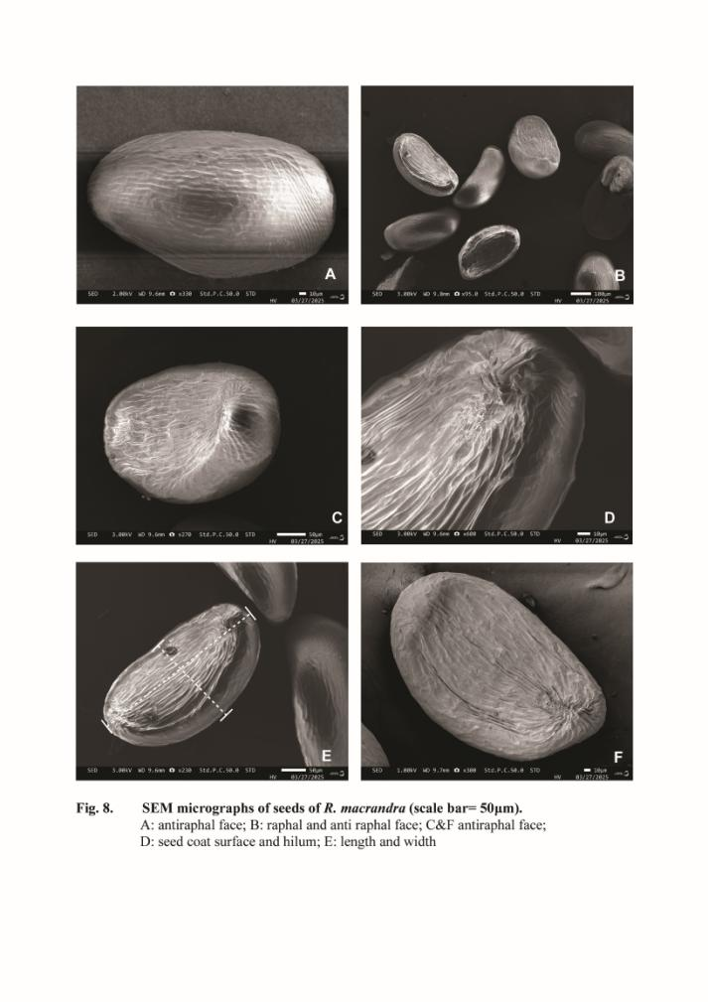
R. malabarica Pradeep, K.T. Joseph &Sivar.

R. malabarica is a herbaceous plant growing in seasonal lateritic pools. Its stem is quadrangular, leaves bimucronate, flowers are pentamerous. Seeds are dark brown in colour. The number of seeds per fruit are 10-12.The seed shape was oval and the texture was smooth. The compression was lateral, while the hilum was terminal. The length of the seed was 692.9 mm, whereas the width of the seeds was 600.2 mm, while length to width ratio of 1.154mm was recorded. Fig. 9&10 represents the FE-SEM results of R. malabarica. Seed coat surface is irregular polygonal. Wings are absent on seed coat surface. Outer epidermal cell shape and anticlinal wall shape are irregular; anticlinal wall texture is smooth. Anticlinal wall is thickened and its level is shallow. Periclinal wall is thickened, convex shaped and its texture is reticulate.
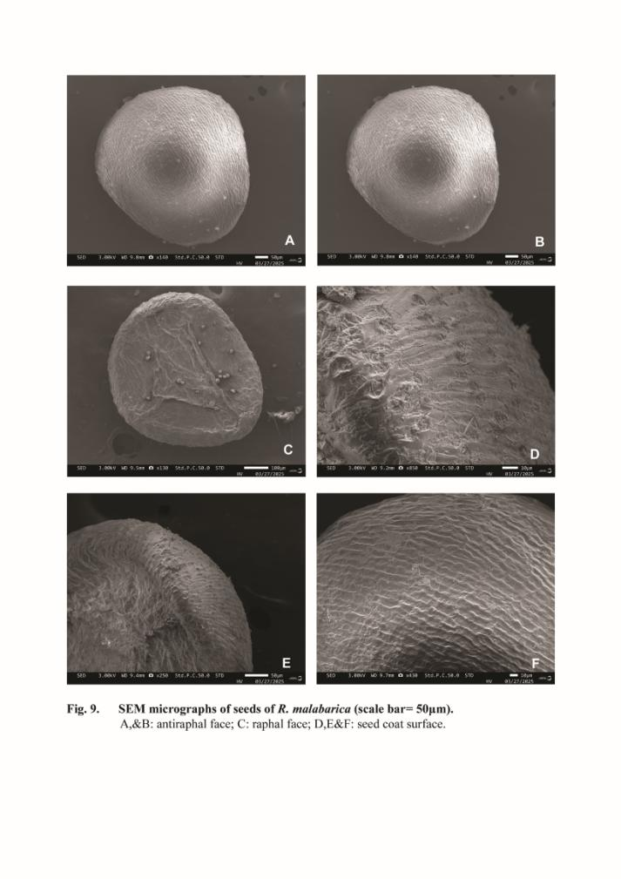
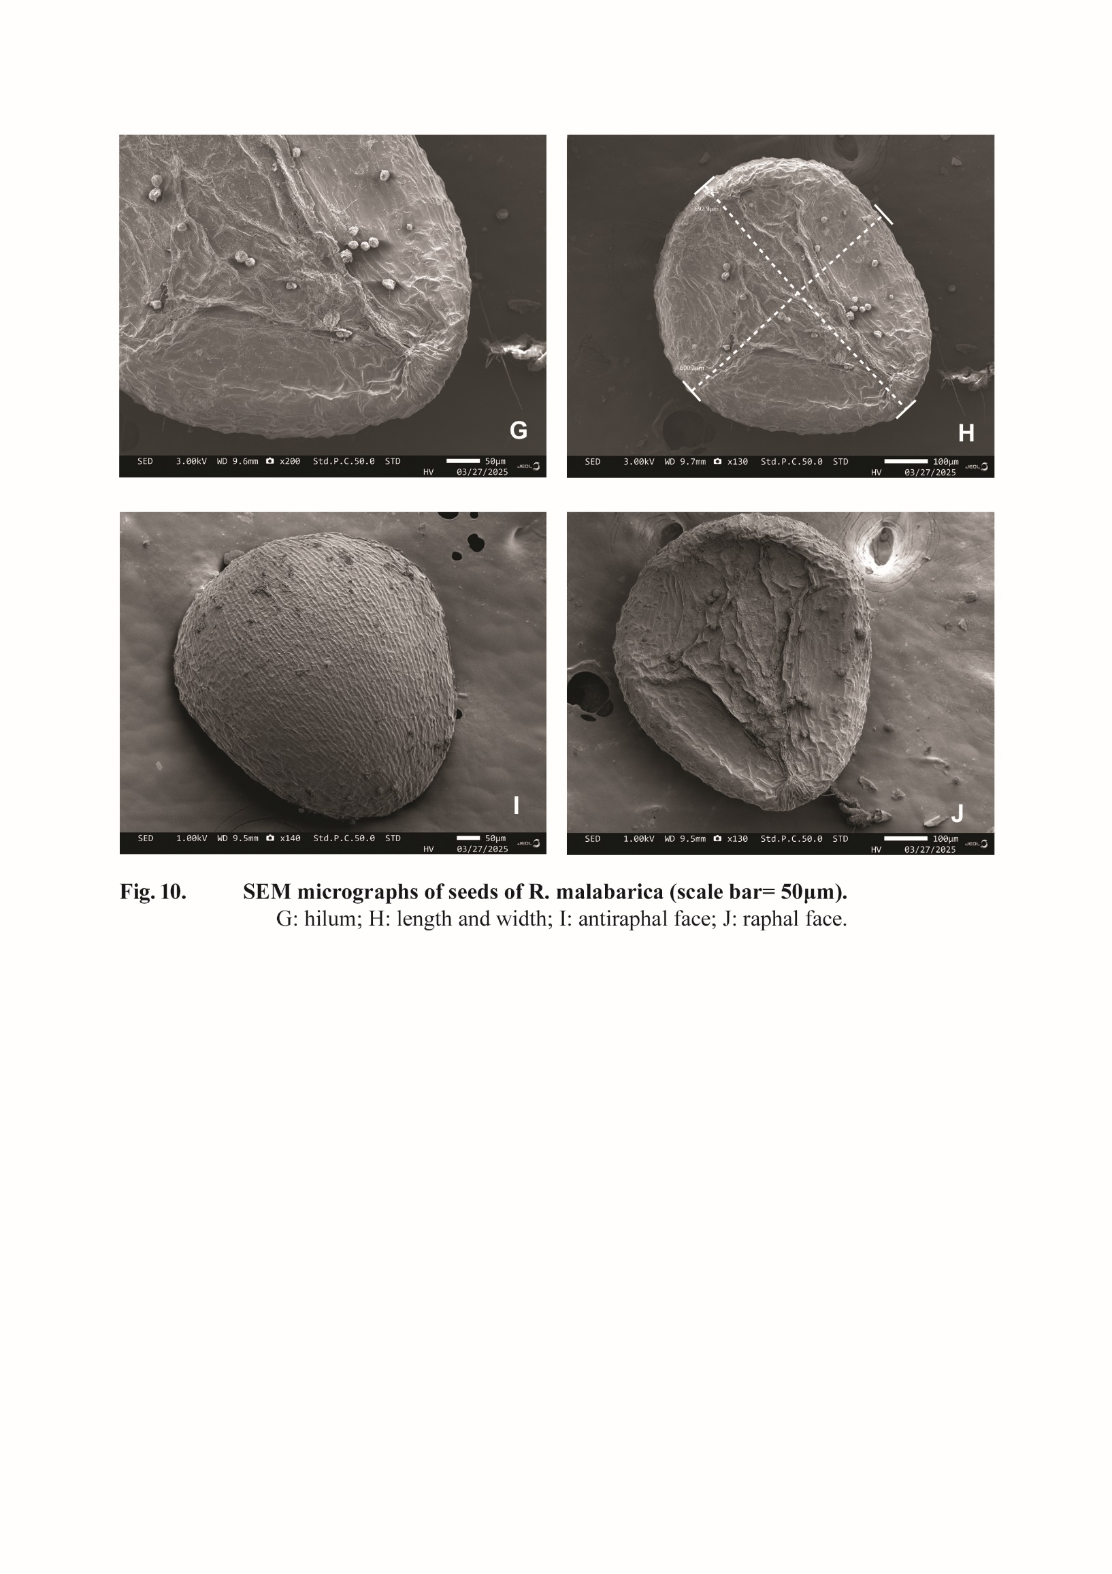
1.7. R. malampuzhensis R.V. Nair ex C.D.K. Cook

R. malampuzhensis is growing in seasonal lateritic pools. Its stem is cylindrical, leaves lanceolate, flowers are tetramerous. Seeds are dark brown in colour. The number of seeds per fruit are 8-10.The seed shape was obovate and the texture was smooth. The hilum was terminal and acute. The length of the seed was 637.7mm, whereas the width of the seeds was 518.4 mm, while length to width ratio of 1.230mm was recorded. Fig. 11 represents the FE-SEM results of R. malampuzhensis. Seed coat surface is irregular polygonal. Wings are absent on seed coat surface. Outer epidermal cell shape is irregular polygonal and anticlinal wall is thin ;texture is smooth. Periclinal wall is thick, convex and its texture is reticulate. Trichomes are absent on seed coat surface.
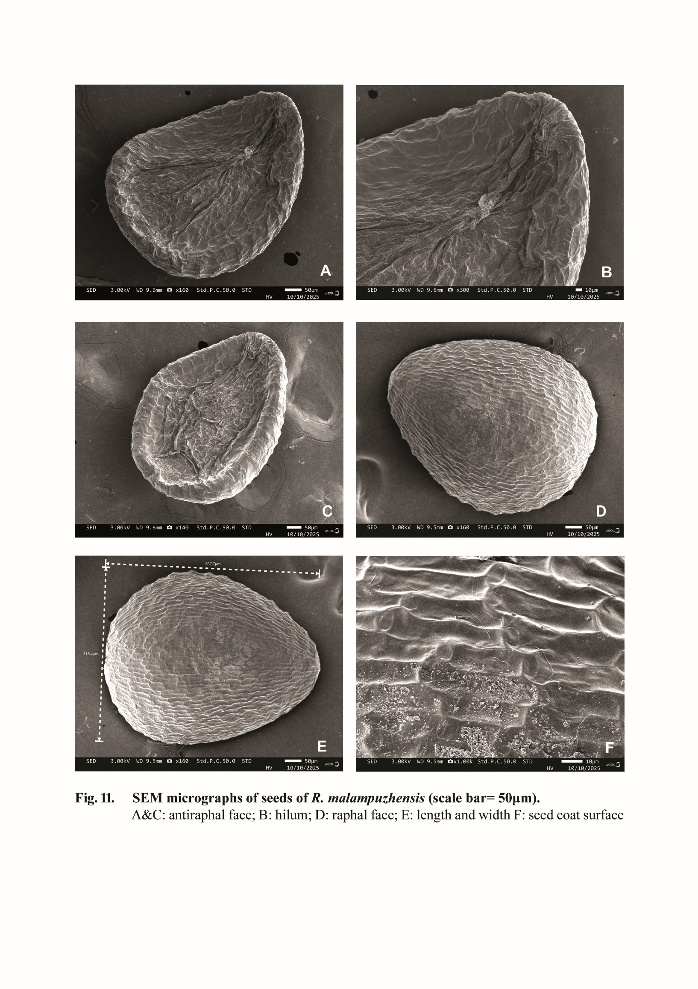

1.8. R. meenkulamensis K.S. Prasad & K. Ravi

R. meenkulamensis is a highly endemic species growing in seasonal lateritic pools with high humus content. Its stem is quadrangular and flattened at the base; flowers are pentamerous. Seeds are pale brown in colour. The number of seeds per fruit are 10-12.The seed shape was oval and the texture was smooth. The hilum was terminal. The length of the seed was 670.3mm, whereas the width of the seeds was 576.2 mm, while length to width ratio of 1.163mm was recorded. Fig. 12 represents the FE-SEM results of R. meenkulamensis. Seed coat surface is irregular. Wings and trichomes are absent on seed coat surface. Outer epidermal cell shape and anticlinal wall shape are irregular; anticlinal wall texture is smooth. Anticlinal wall is thin and its level is shallow. Periclinal wall is thickened, convex shaped and its texture is reticulate.
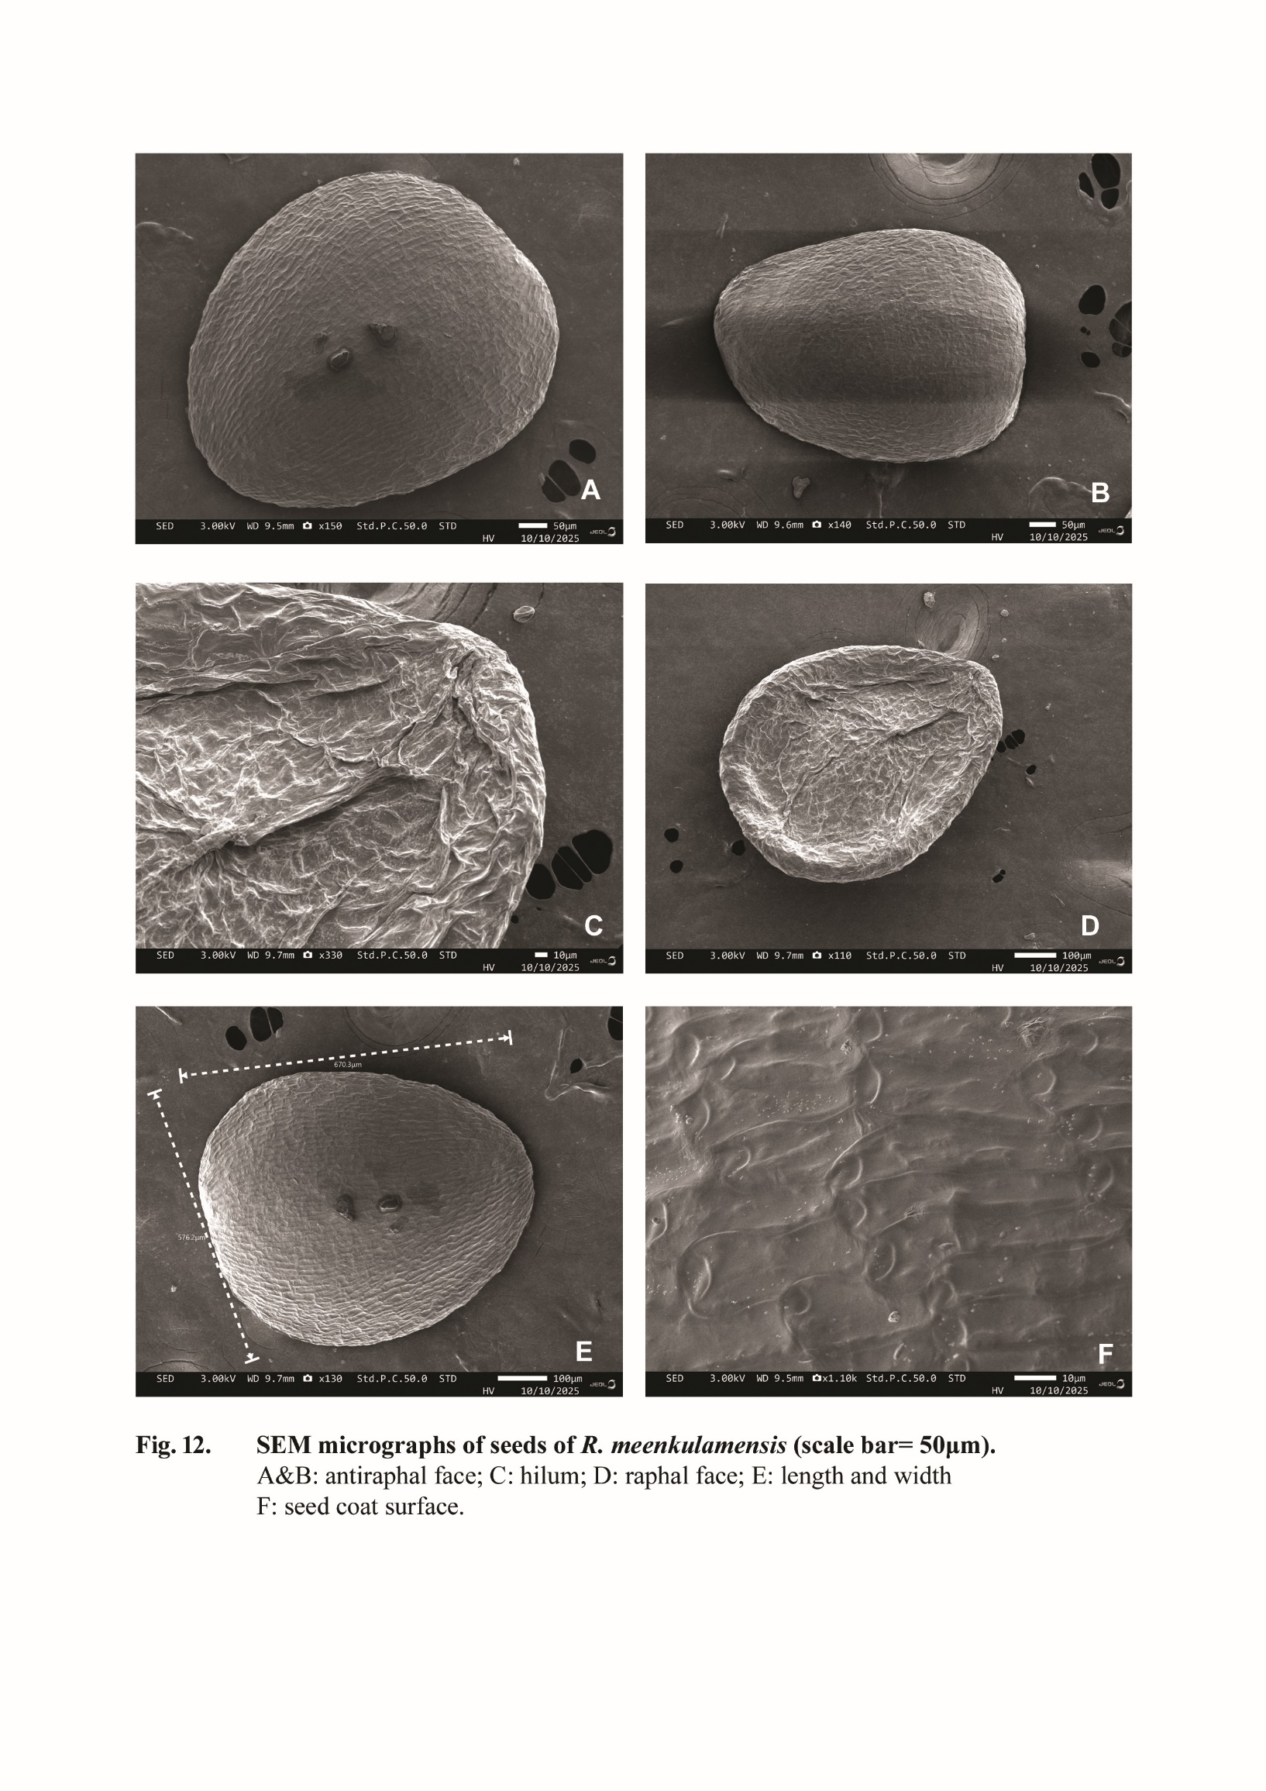
1.9. R. mexicana Schltdl. & Cham

R. mexicana is a herbaceous plant growing in wet lateritic soils. Its stem is cylindrical, leaves leanear, narrow and opposite in phyllotaxy. Flowers are Pink coloured. Seeds are elliptic and pale brown in colour.
The number of seeds per fruit are 10-12.The seed shape was oval and the texture was smooth. The compression was lateral, while the hilum was terminal. The length of the seed was269.2mm, whereas the width of the seeds was 170.4 mm, while length to width ratio of 1.579mm was recorded. Fig. 13 represents the FE-SEM results of R. mexicana. Hilum is acute,seed coat surface is striate. Wings and trichomes are absent on seed coat surface. Outer epidermal cell shape and anticlinal wall shape are irregular; anticlinal wall texture is smooth. Anticlinal wall is thin and its level is shallow. Periclinal wall is thickened; convex shaped
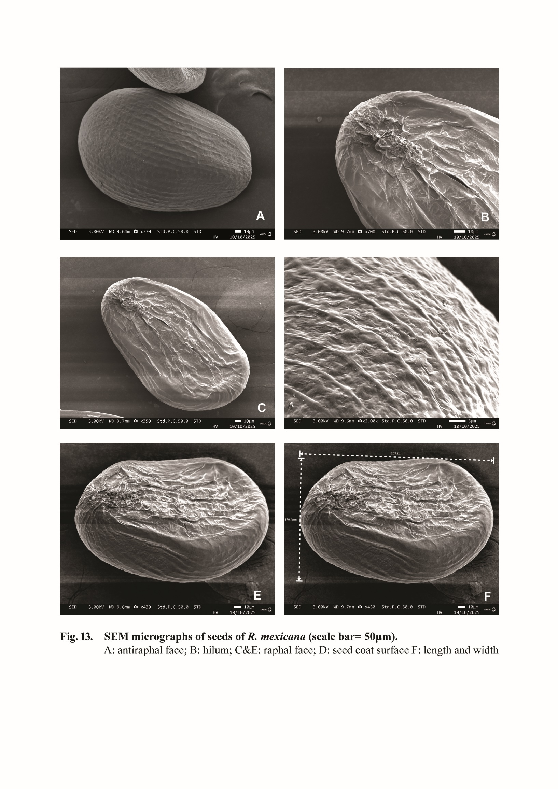
1.10.R. occultiflora Koehne

This plant is growing in lateritic seasonal pools. Stem is white to reddish according to the habitat. Leaves are narrow and linear. Flowers are whitish, companulate with 4 lobes. Fruit is a capsule, 8-10 seeds per fruit, seed shape is elliptical to pear shaped and dark brown in colour. The seed shape was oval and the texture was smooth. The compression was lateral, while the hilum was terminal. The length of the seed was 297.8mm, whereas the width of the seeds was 115.6 mm, while length to width ratio of 2.576mm was recorded. It shows the largest seed length to width ratio, among the studied species of Rotala (Fig. 14). Hilum is acute,seed coat surface is striate. Wings and trichomes are absent on seed coat surface. Outer epidermal cell shape and anticlinal wall shape are irregular; anticlinal wall texture is smooth. Anticlinal wall is thin and its level is shallow. Periclinal wall is thick with striate texture; convex shaped

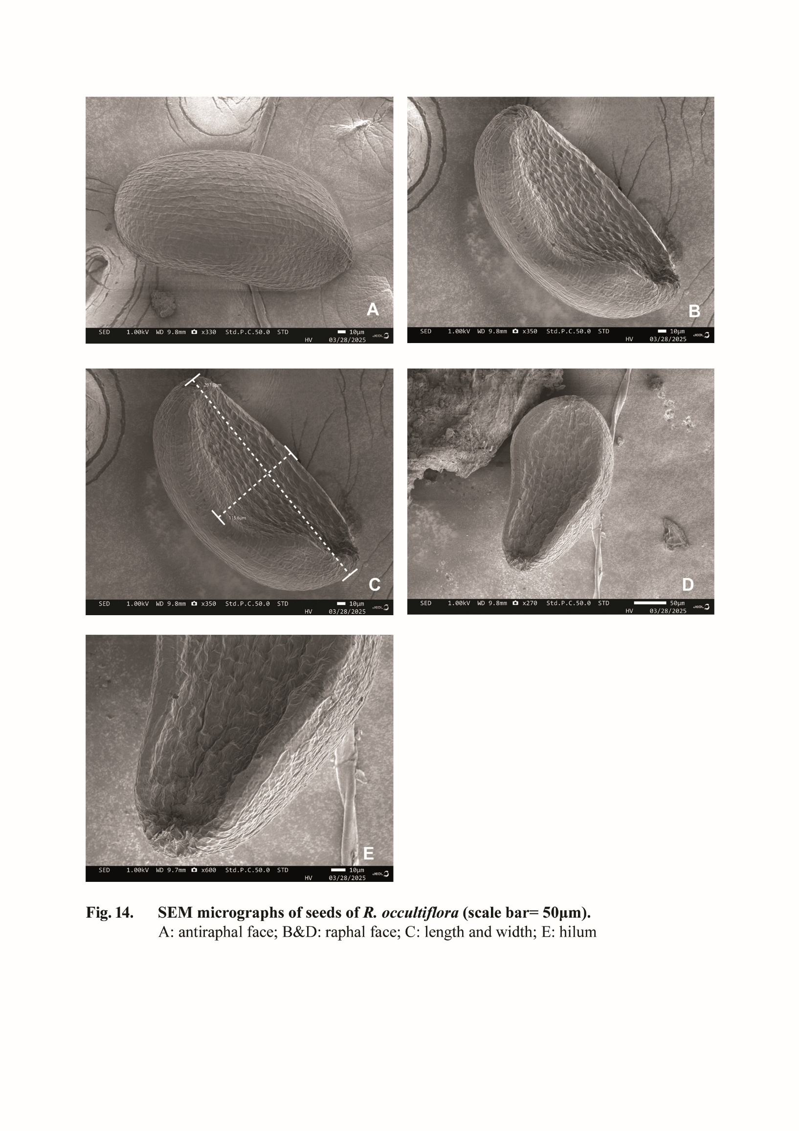

DISCUSSION
In this study, we found that, in most species, the seed coat is reticulate type. R. indica and R.cheruchakkiensis shows the presence of trichomes on seed coat surface. In the present study, we also noticed that limited number of seeds, 10-12, are seen in all the studied species and almost all are different sized. The species like R. kasaragodensis, R. mexicana, R. meenkulamensis are highly endemic and distributed in specific localities of lateritic area. Seeds of R. kasaragodensis are spherical and 12 in number in each fruit. Placentation is axile in all studied species; seed coat surface is smooth in appearance.
EDAX ELEMENTAL PROFILE:
The EDAX (Energy Dispersive X-ray Analysis) elemental profiling of Rotala seeds elucidates a
quantitative distribution of vital minerals and elements (Fig 15-24). The EDAX spectrum delineates significant elements, with pronounced peaks for carbon (C), oxygen (O), magnesium (Mg), potassium (K), alongside trace quantities of Sodium (Na), Aluminium (Al),Silicon, Sulfur (S) and Calcium (Ca). Carbon and Oxygen acts as vital regulators of seed dormancy, longevity and seed germination. Calcium and Potassium gives structural stability and initial nutrition to seed coat. Potassium is present at intermediate levels and is recognized for its role in the regulation of turgor pressure in seed coat. Micronutrients, including Silicon and Aluminium, although present in diminished concentrations, are essential for providing structural rigidity and cellular health. Chlorine controls chemical scarification and also releases dormancy.

These observations, represented in spectra from four distinct regions (Area 1, Area 2, Area 3, and Area 4. etc..), accentuate the variability in elemental distribution, thereby providing insights into the functional adaptations and mineral storage capacities of the seed. The EDAX spectra furnish a spatial analysis of mineral composition, illustrating how elemental concentrations fluctuate across the seed surface, which may correlate with specific physiological or ecological functions of Rotala species.The collective findings of these analyses demonstrate that Rotala species possesses both structural and biochemical adaptations that are highly conducive to its indigenous habitat.The microscopic examinations and FESEM (Field Emission Scanning Electron Microscopy) investigations of trichomes, seed coat configurations, and hilum shape in conjunction with the EDAX elemental profiling, present a holistic perspective on the seed’s
functionality. The FESEM analysis further elucidated the distribution of essential elemental profiles across the seed surface, indicating pathways for crucial nutrient interactions.
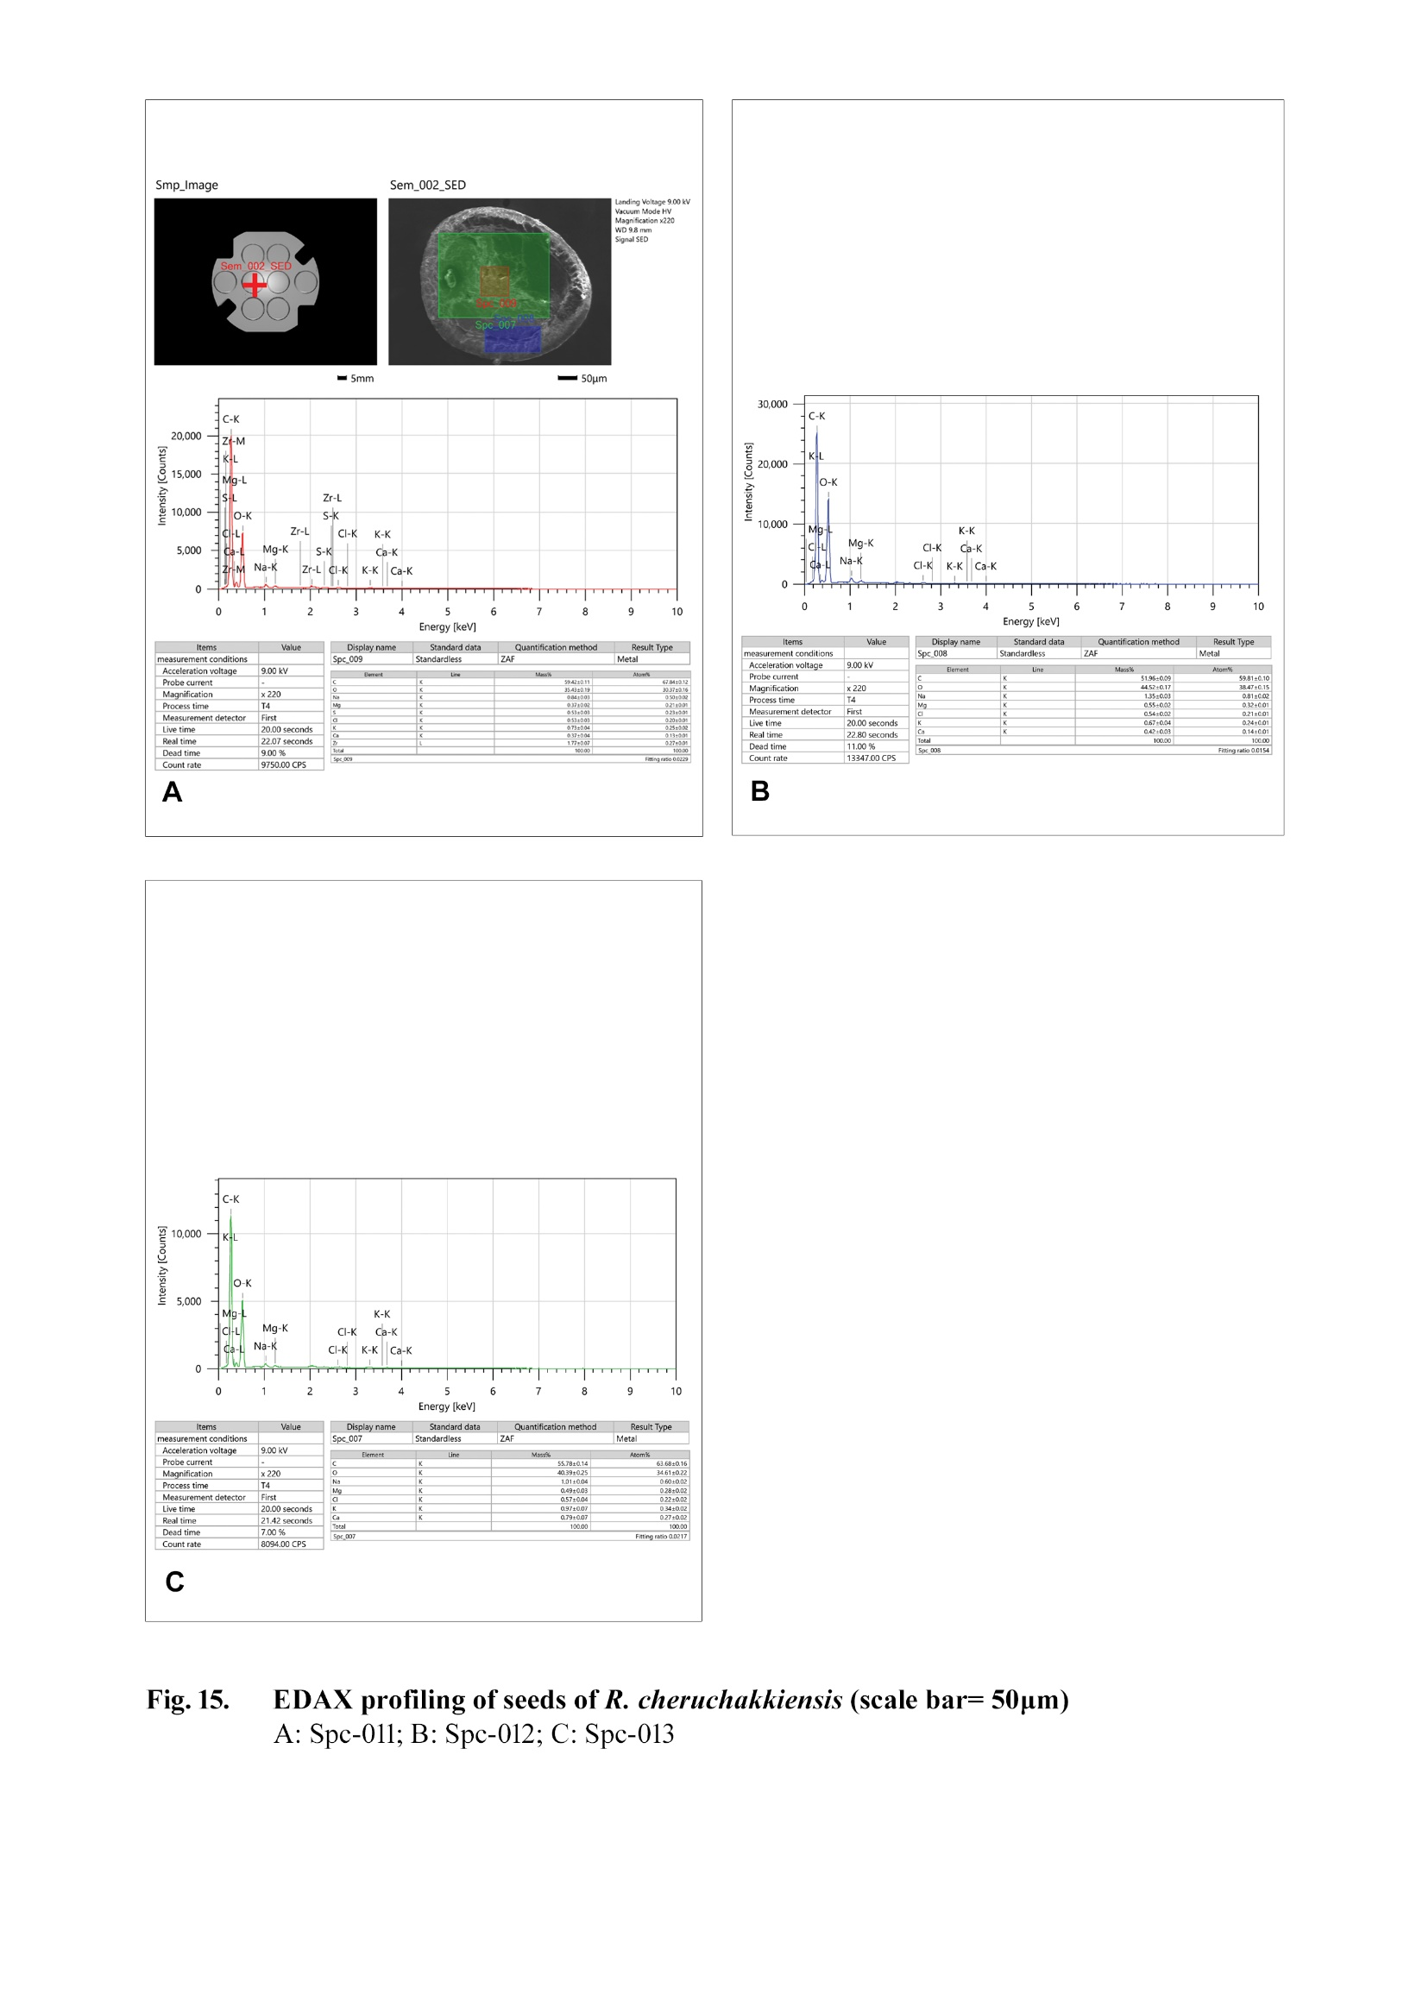
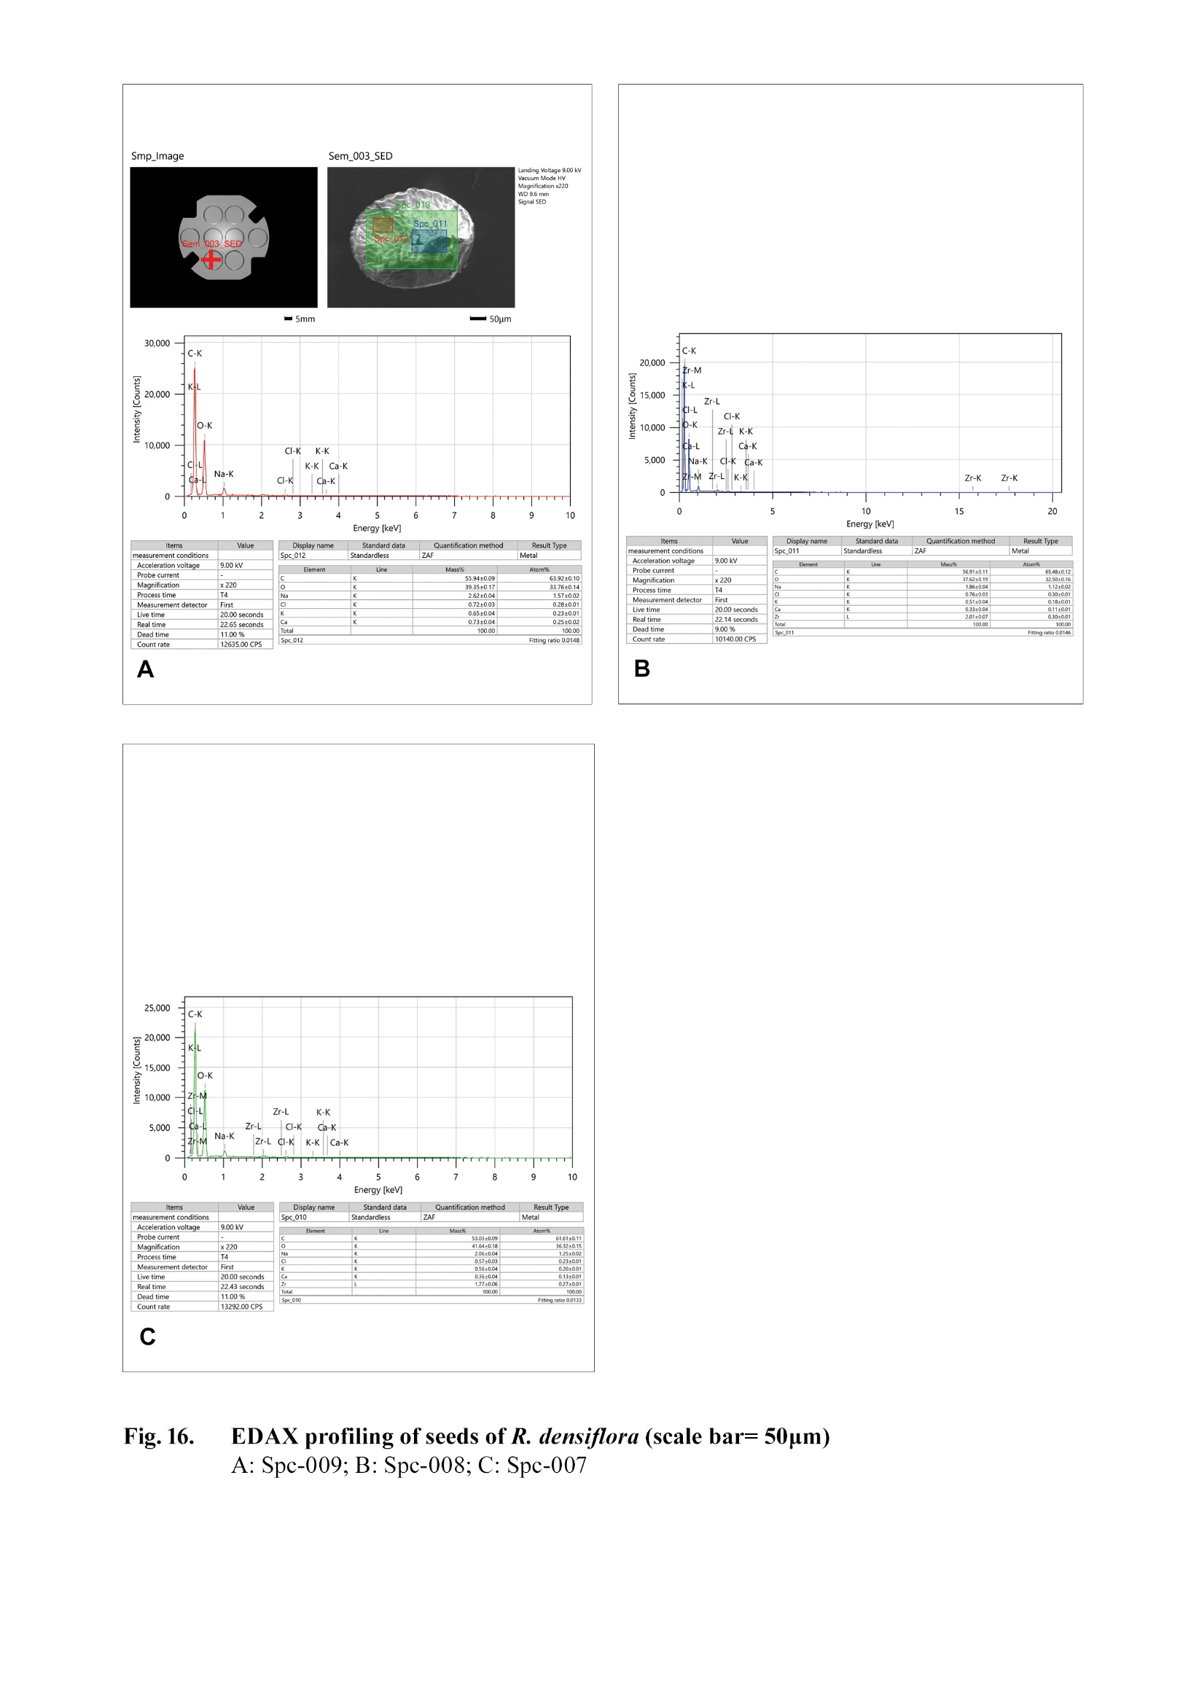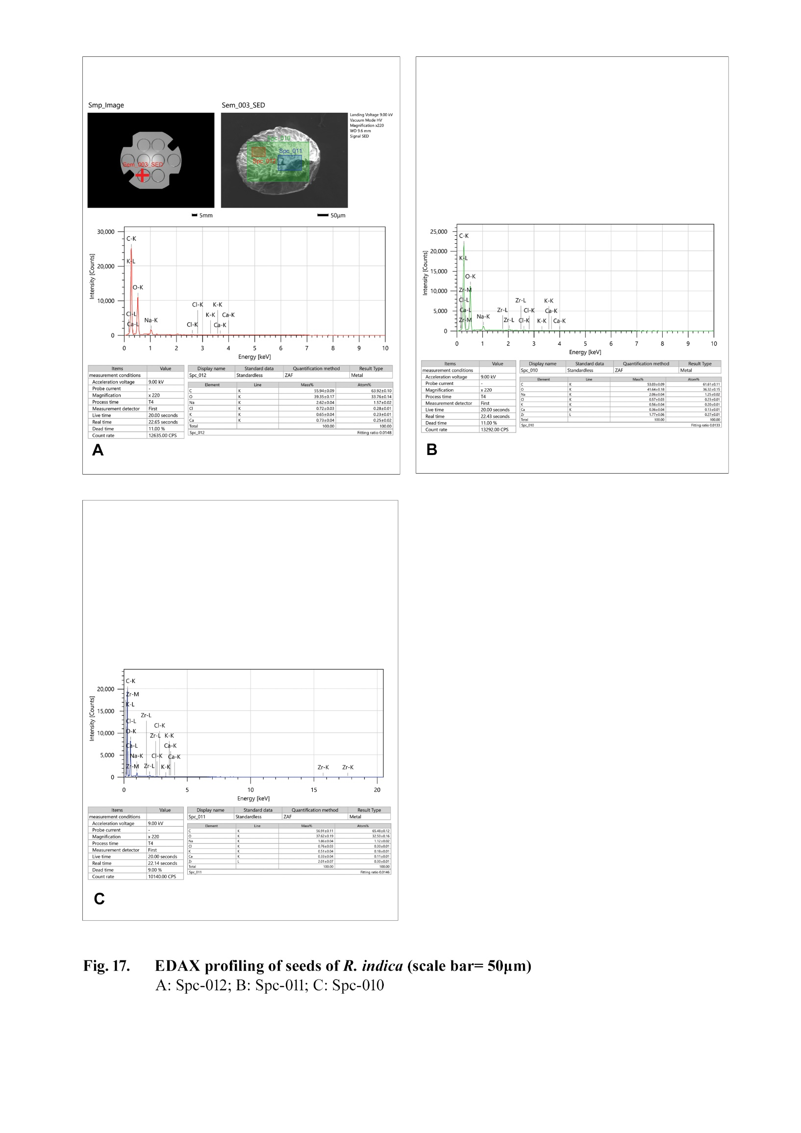

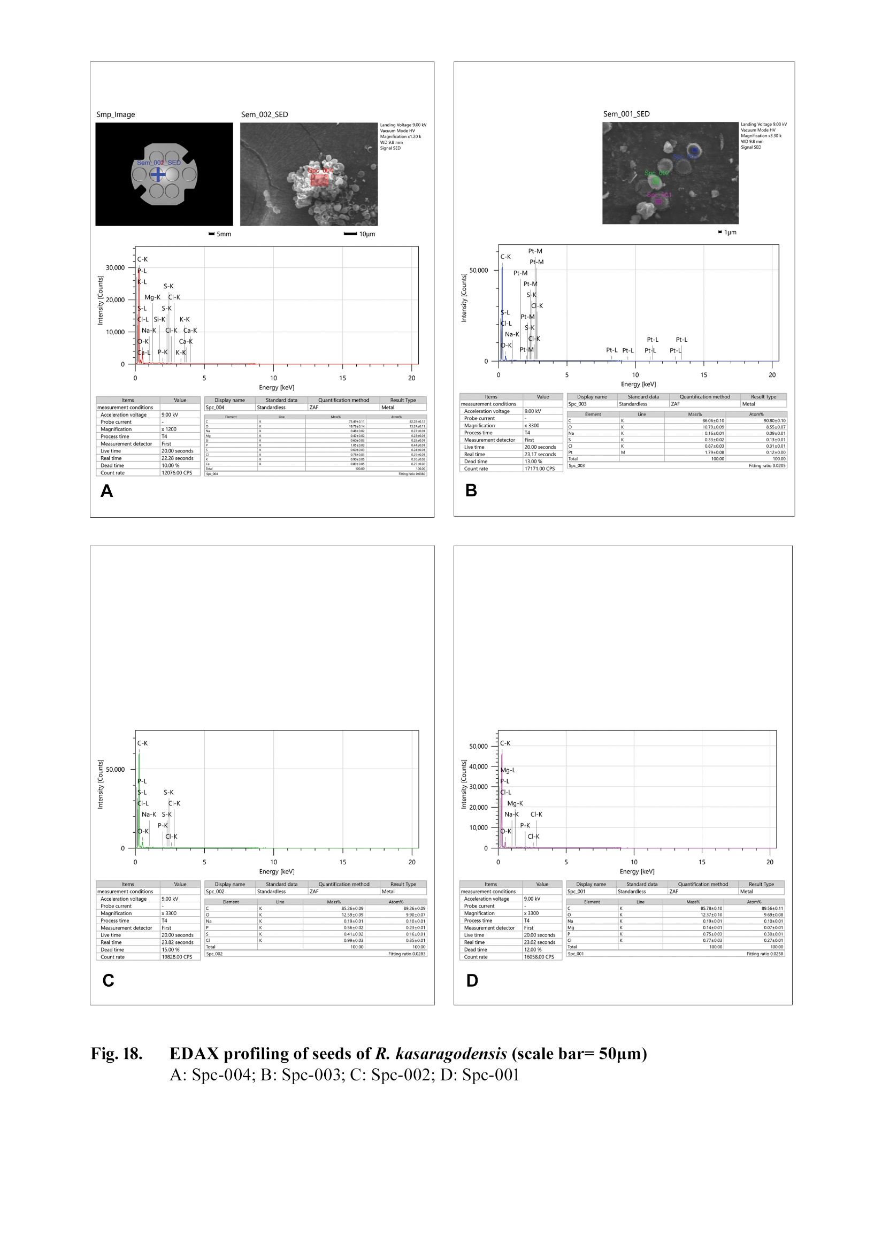

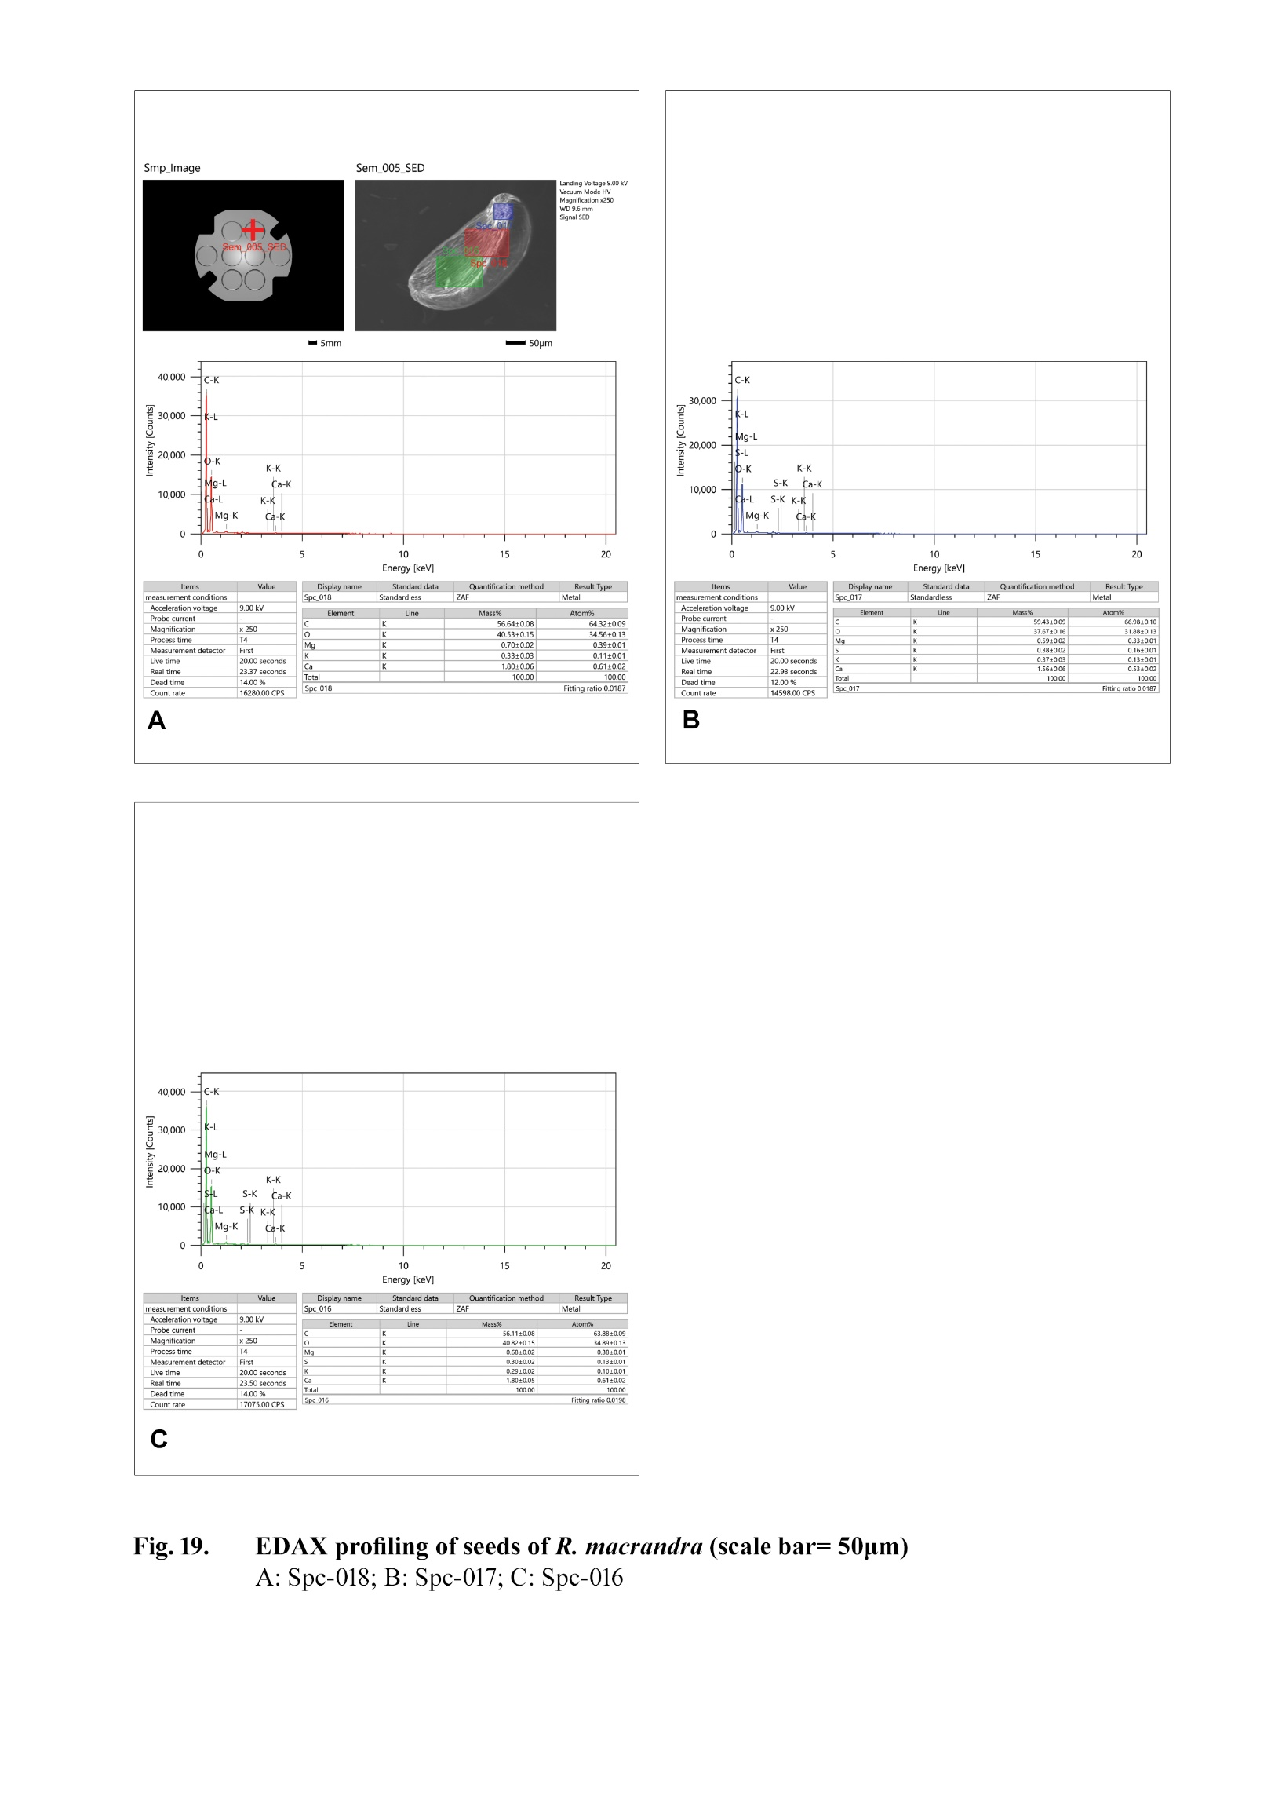
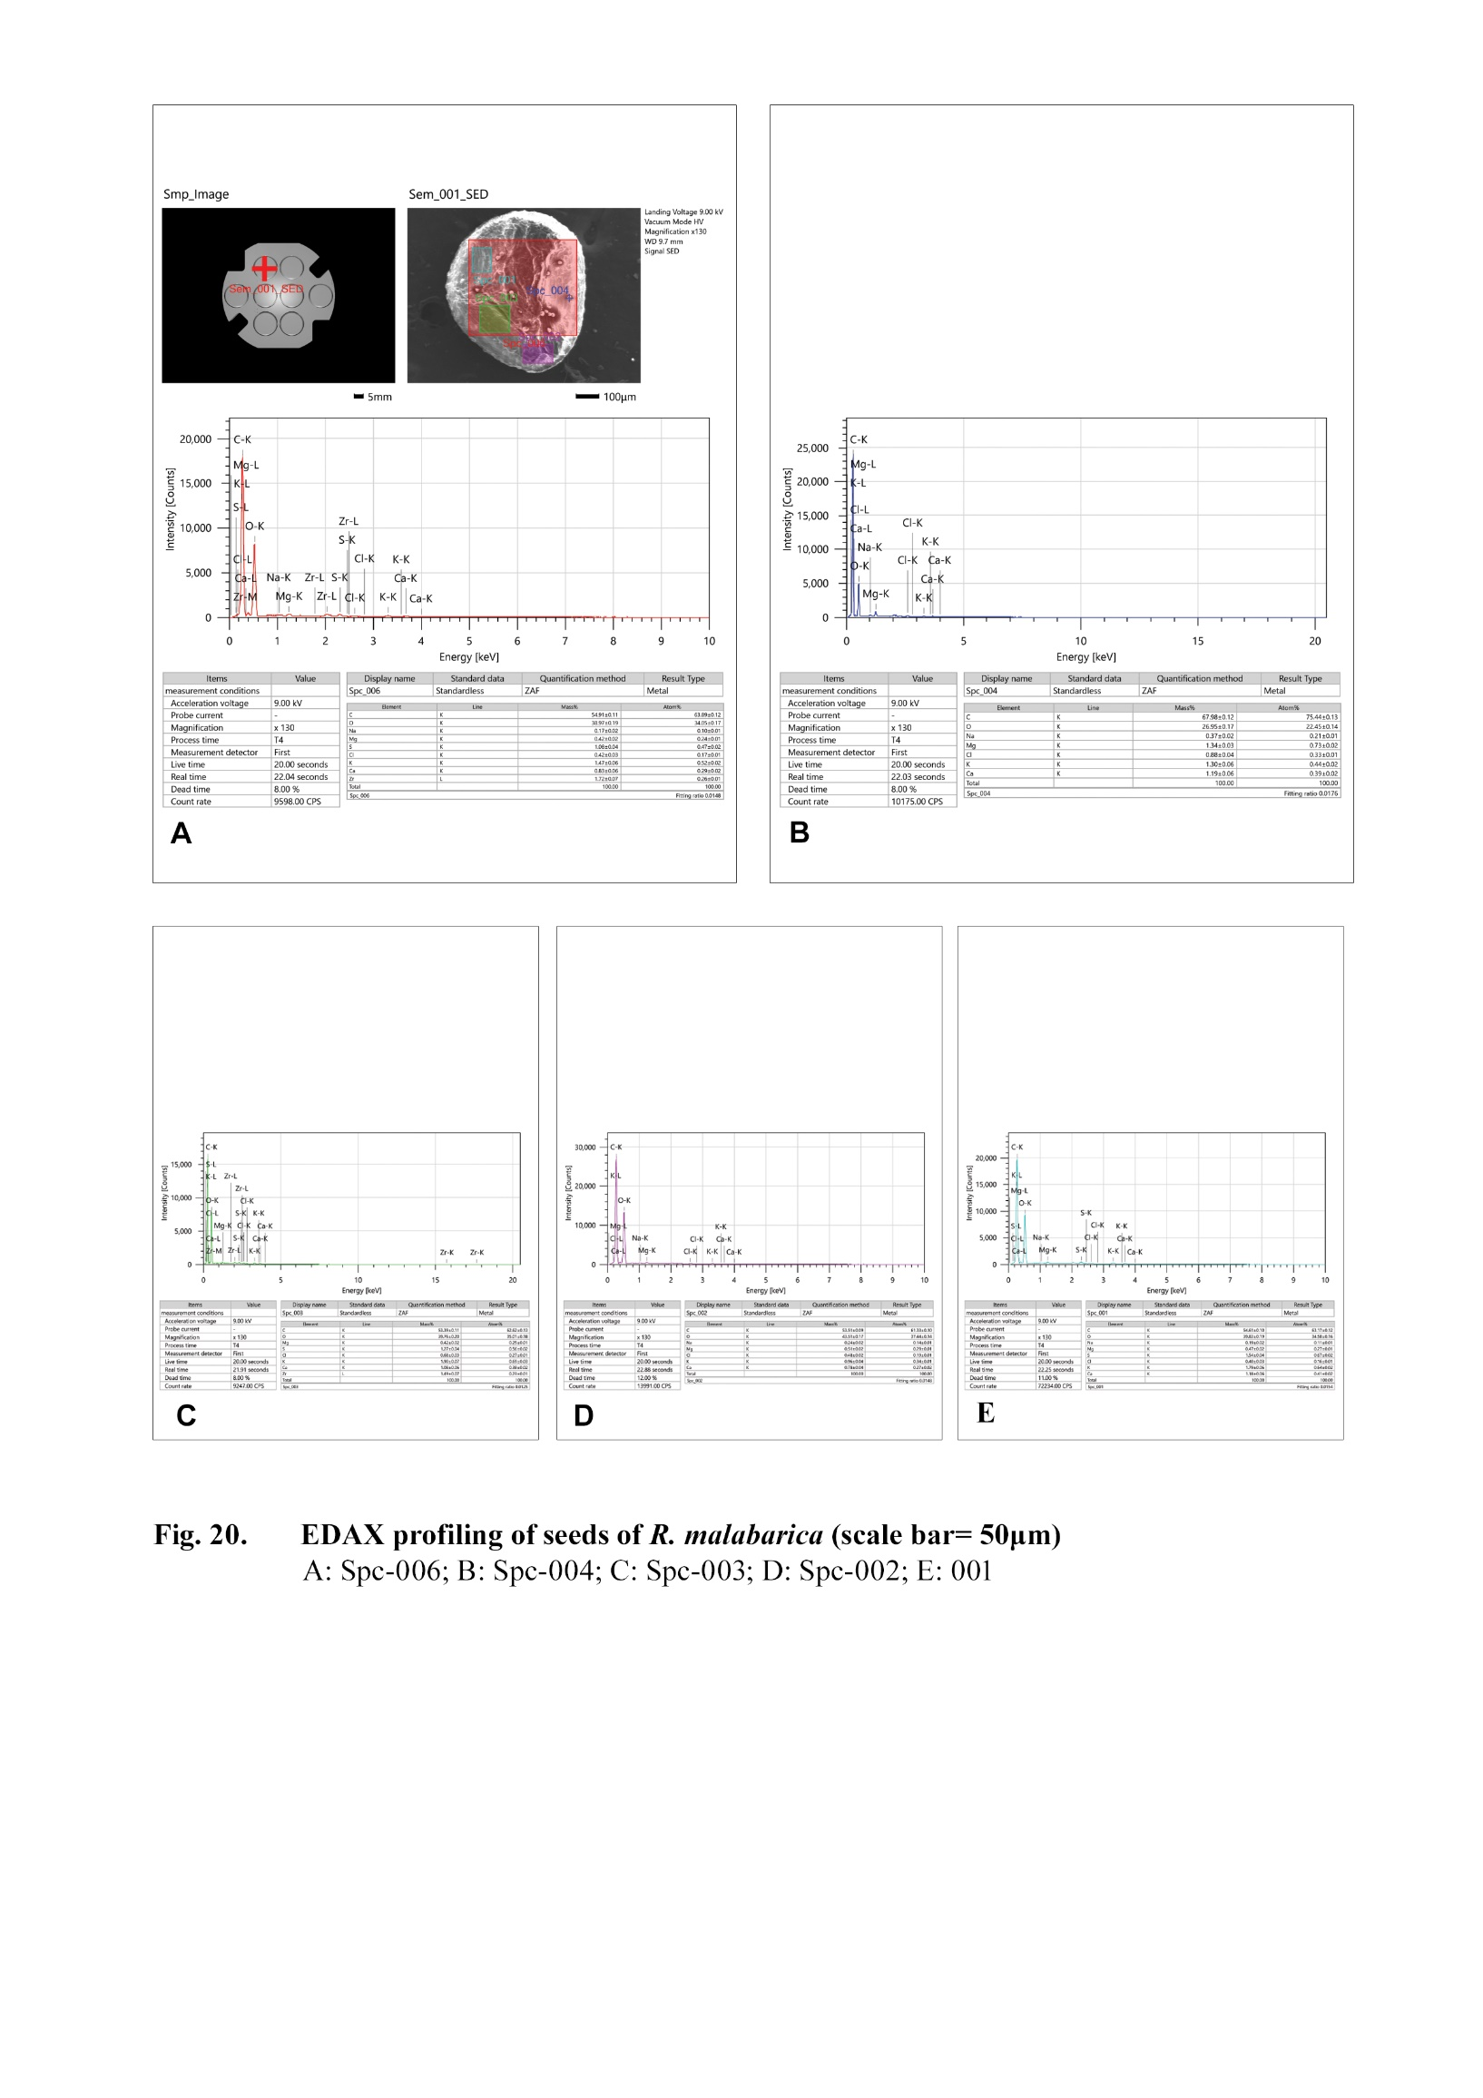
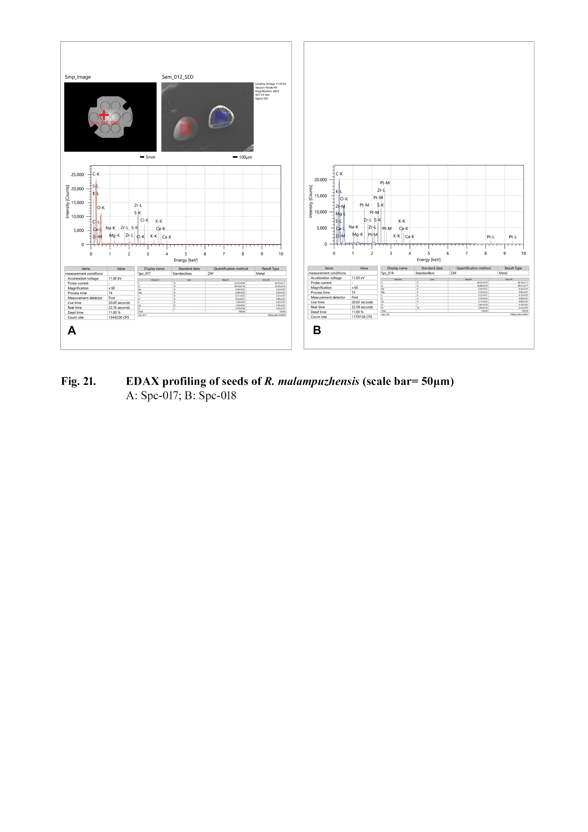
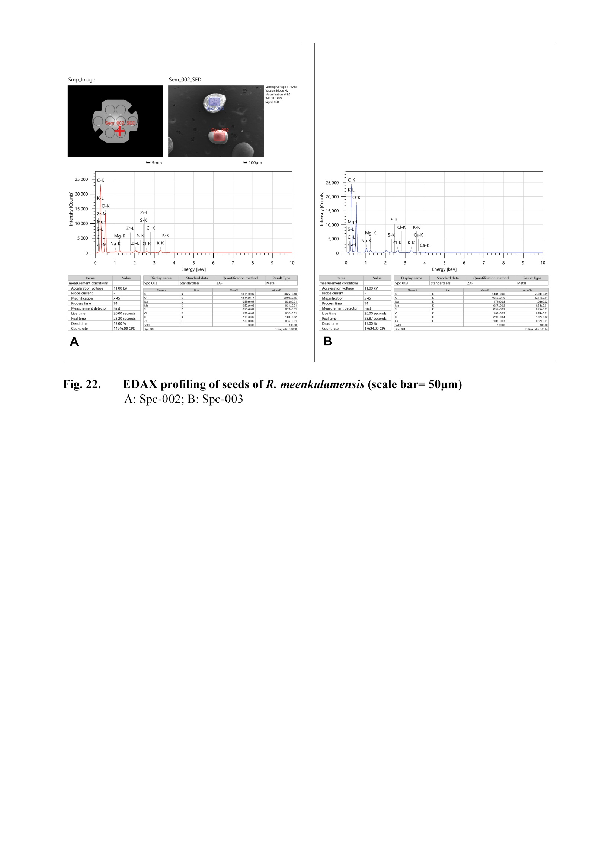

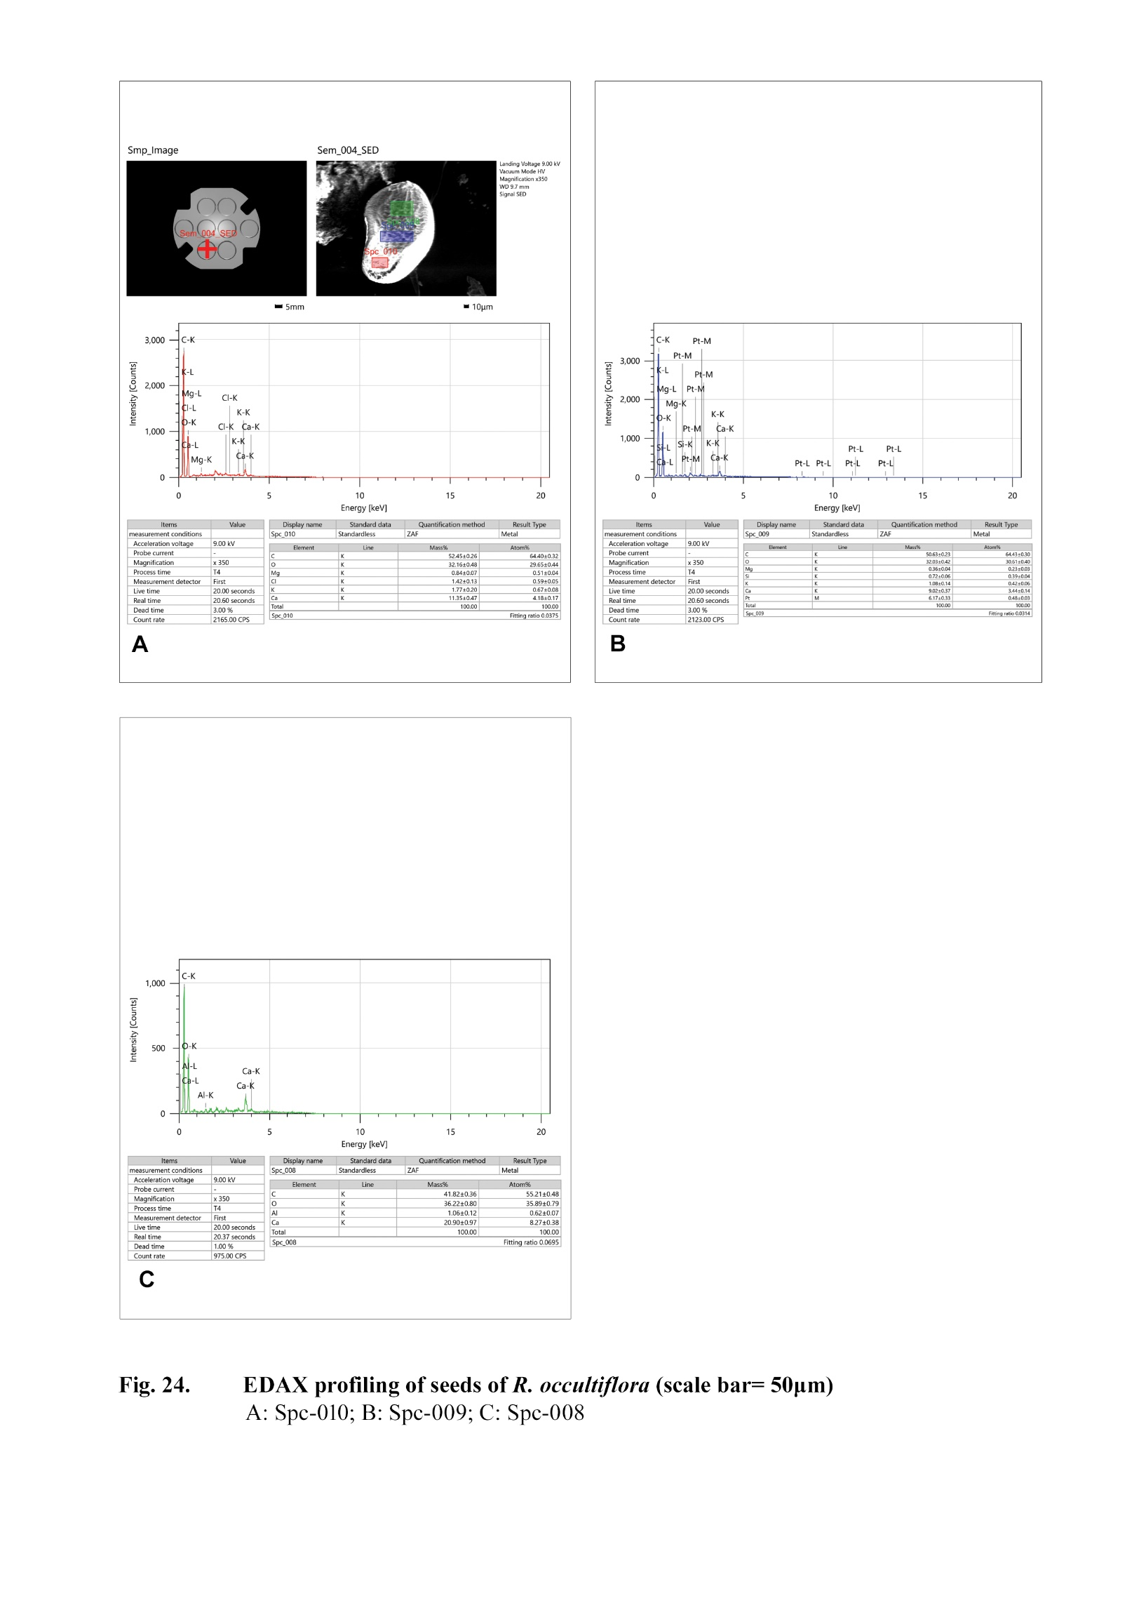

CONCLUSION

From the above results, it can be seen that a clear cut distinction can be made between taxa based on the main external morphology of seeds. Seed morphological characters provide an aid in distinguishing various species and support their placement in different clades. The present study indicates that the use of seed morphological characters is a useful parameter for species identification of species in the genus Rotala. In addition to the morphological characters of seeds, texture and sculpturing of features of the external seed coat show variations among species and can be proved essential systematically. It can be concluded from the findings of the current studies that macro and micromorphological characteristics of seeds are considered diagnostic at both generic and specific level of plant species among the wide range of taxa. We recommend that future studies on Rotala plants with special reference to macro and micromorphological characters of seeds will provide a new perspective for understanding the habitat and dispersal features of the species.Moreover, the elemental composition of seeds of Rotala is significantly impacted by environmental variables, including the quality of water and soil. Seed coat act as a source of various essential and nonessential elements, which may shows slight variation in quantity according to the plant species. Lateritic soil is acting as source of various elements. It may also affect the plant as it is usually growing in lateritic pools and marshy areas.

ACKNOWLEDGEMENTS
I express my gratitude to the authorities of St. Joseph’s College (Autonomous), Devagiri, Kozhikkode, Kerala and Govt. College, Vidyanagar, Kasaragod, Kerala for providing essential laboratory facilities. I also extend my thanks to Dr. Biju P, Professor, Department of Botany, Govt. College, Vidyanagar, Kasaragod, Kerala for providing proper guidance during plant collection and identification.
REFERENCES
- Anto, P.V., Jacob, C.S., Abraham, P., Varghese, M.C. & Antony, I. 2014: A new species of
RotalaL. (Lythraceae) from the lateritic hills of Thrissur district, Kerala, India. -International
Journal of Advanced Research 2(11): 532-535.

- Arabhi, P. & Nair, M.C. 2019: Seasonal vegetation shift and wetland dynamics in vulnerable
granitic rocky outcrops of Palghat Gap of southern Western Ghats, Kerala, India. -Journal of
threatened Taxa 11(12):
14518-14526. https://doi.org/10.11609/jott.4732.11.12.14518- 14526

- Baskin, C.C., Baskin, J.M., & Chester, W. 2002: Effects of flooding and temperature on
dormancy break in seeds of the summer annual mudflat species Ammannia coccinea and
Rotalasp. (Lythraceae). -Wetlands 22(4): 661-668. https://doi.org/10.1672/0277
5212(2002)022[0661:EOFATO]2.0.CO;2

- Bhowmik, S., Saha, M. & Datta, B.K. 2012: Extended distribution of Rotala rotundifolia
(Buch.-Ham. exRoxb.) Koehne (Lythraceae) from India. -Journal of Biological Sciences 3:
48-50.

- Blancaver, M.E., Itoh, K. & Usui, K. 2001: Resistance of Rotala indica Koehne var.
UliginosaKoehne to sulfonylurea herbicides. -Weed Biology and Management 1(4): 209-215.
https://doi.org/10.1046/j.1445-6664.2001.00035.x

- Cook, C D K., 1978: The Hippuris syndrome; in Essays in plant taxonomy (ed. H E Street)
(London: Academic Press). pp. 163-176. Cook, C.K. 1979: A revision of the genus
Rotala(Lythraceae). -Boissiera 29: 1-156.
- Cowling, R.M. 2001: Endemism. In: Simson, A.L. (ed.) Encyclopedia of biodiversity.
Academic Press, 2: 497-507. https://doi.org/10.1016/B0-12-226865- 2/00103-6

8. Gaikwad, S.P., Sardesai, M.M. & S. R. Yadav. 2013: Rotalasahyadricasp. nov. (Lythraceae)
From Western Ghats, India. -Nordic Journal of Botany 32(5): 575-577.
https://doi.org/10.1111/j.1756- 1051.2013.00322.x

9. IUCN. 2010: Guidelines for using the IUCN Red List Categories and Criteria: Version 8.
Prepared by the Standard and Petitions Subcommittee. Available from: http://www.iucnredlist.
org.104Anatomy & taxonomic treatment in Rotala

10. IUCN. 2012: Red List Plants of India. IUCN Red List of Threatened Species. Version 2012.
2. www.iucnredlist.org.

11. IUCN. 2014: Guidelines for using the IUCN Red List Categories and Criteria: Version 11.
Prepared by the Standard and Petitions Subcommittee, 87 pp. Available from:
http://www.iucnredlist. org.

12. Joseph, K.T. &Sivarajan, V.V. 1988: Rotalacookii: A new species of Lythraceae from India
Showing HippurisSyndrome. -Plant Systematics and Evolution 159: 141-144.
https://doi.org/10.1007/BF00937431

13. Joseph, K.T. &Sivarajan, V.V. 1989: RotalaLinn. (Lythraceae) in peninsular India. -Proc. Ind.
Acad. Sci. (Plant.Sci.) 99: 179-197. https://doi.org/ 10.1007/bf03053593

14. Koehne, A. 1903: Rotalain Das Pflanzenreich (ed. A Engler) (Lipzig: W Engelmann) 17. Heft
(IV. 216), pp. 22-42.

15. Lemiya, K.M. & Pradeep, A.K. 2015: A new species of Rotala(Lythraceae) from Kerala, India.
– Rheedea25: 159-163. https://dx.doi.org/10.22244/rheedea.2015.25.02.17

16. Mabberley, D.J. 2005: The Plant Book. Cambridge Univ. Press.
https://doi.org/10.1017/9781316335581

17. Mathew, S.P. &Lakshminarasimhan, P. 1990: Rotalaandamanensis– A new species of
Lythraceae from the Andaman Islands. -Bulletin of the Botanical Survey of India 32: 189-191.

18. Pradeep, A.K., Joseph, K.T. &Sivarajan, V.V. 1990: Rotalamalabarica, A new species of
Lythraceaefrom India. -Botanical Bulletin of Academia Sinica 31: 59-61.

19. Prasad, K.S., Biju, P., Raveendran, K. & Bhat, K.G. 2012: Rotalatulunadensissp. nov.
(Lythraceae) from Kerala, India. -Nordic Journal of Botany 30: 59-60.
https://doi.org/10.1111/j.1756-
1051.2011.01275.x

20. Prasad, K.S. & K. Raveendran. 2013a: A New species of RotalaL. (Lythraceae) from Kerala,
India. – Taiwania-58(2): 104-107. https://doi.org/10.6165/tai.2013.58.104

21. Prasad, K.S. & Raveendran, K. 2013b: Rotalakasaragodensis(Lythraceae), a new species from
Kerala, India. -Edinburgh J. Botany 70(3): 451-454.
https://doi.org/10.1017/S0960428613000140

22. Prasanth, A. &Sardesai, M.M. 2022: Rotalabiglandulosa(Lythraceae), A new species of
macrophyte from high-level ferricretes of the northern Western Ghats, India. -Folia
Geobotanica57(3): 201-212. https://doi.org/10.1007/s12224- 022-09418-x

23. Richardson, I.K. 1978: Endemic Taxa and the Taxonomist In: Street, H.E. (ed.) Essays in Plant
Taxonomy, Academic Press, London. pp. 245-262.

24. Sunil, C.N., Shaju, T., Nandakumar, M. K., Sivadasan, M. &Alfarhan, A.H. 2014:
Rotala dhaneshiana, a new species of Lythraceae from India. -Phytotaxa 188(4): 227-232.
https://doi.org/10.11646/PHYTOTAXA.188.4.5

25. Sunil, C.N., Ratheesh Narayanan, M.K., Nandakumar, M.K., Jayesh, P.J., Abdul Jaleel, V. &
Anil Kumar, N. 2013: Rotala khaleelianasp. nov. (Lythraceae), A new species from lateritic
hills of Kannur, Kerala,India. -International Advanced Research 1(2): 14- 16.

26. Turril, W.B. 1964: Plant Taxonomy, Phytogeography and Plant ecology. In: Vistas Botany,
Vol. IV, Pergamon Press, London.

27. Watson, K.M. & Pradeep, A.K. 2015: A new species of Rotala(Lythraceae) from Kerala, India.
- Rheedea, 25(2): 159-163. https://doi.org/10.22244/rheedea.2015.25.02.17

28. Yadav, S.R., Malpure, N.V. &Chandore, A.N. 2010: Rotalabelgumensis(Lythraceae) from the
Western Ghats, India. -Nordic Journal of Botany 28: 499- 500. https://doi.org/10.1111/j.1756-
1051.2009.00612.x

